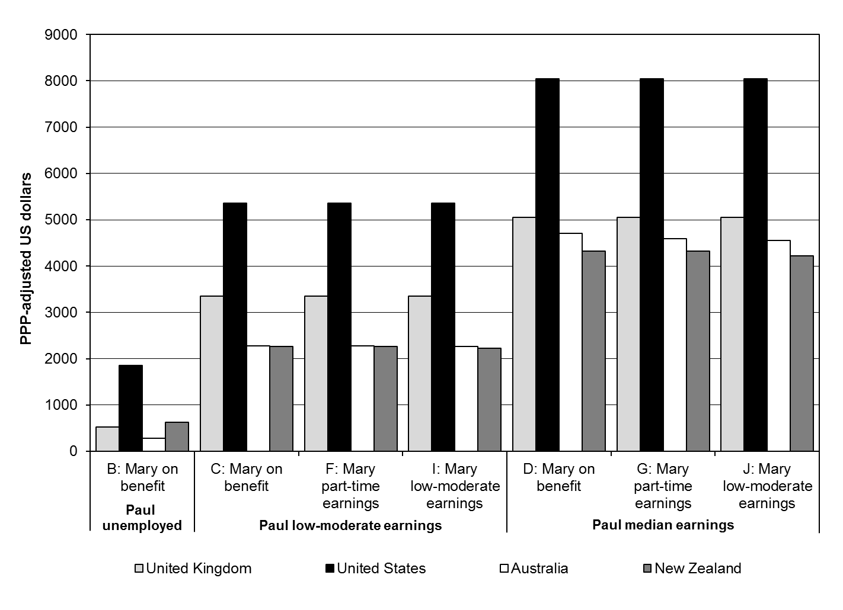
Figure 1. Annual Child Maintenance Obligations in Seven* Paying Scenarios
Notes: See Table 2 and 3 for earnings levels.
Source: Authors’ calculations of each country’s respective policies.
*There are a total of 10 scenarios, but in scenarios A, E and H, no child maintenance is paid.

