Author’s post-print of Thorpe, Deborah E. "British Library, MS Arundel 249: Another Manuscript in the Hand of Ricardus Franciscus." Notes & Queries 61 (2014): 189-196.

BRITISH LIBRARY, MS ARUNDEL 249: ANOTHER MANUSCRIPT IN THE HAND OF RICARDUS FRANCISCUS
London, British Library, MS Arundel 249 is a two-part manuscript. The second part, spanning folios 9r-120v, comprises fifteenth and sixteenth-century religious tracts, Latin and English phrases, poetry, grammar, and a large compilation of letters of which at least one refers to the composition of letters. However, it is with the first part (ff. 1r-8v) that this article is concerned. Its contents are the Latin text Tractatus de quatuor virtutibus by Martin of Braga, or Pseudo-Seneca (ff. 1r-5v) ; an Oration to Christ (f. 6r); a prayer to the Virgin Mary (ff. 6v-7v); and various notes. The palaeographical features of the first text in Arundel 249, Tractatus de quatuor virtutibus, suggest that it is in the hand of Ricardus Franciscus. There is linguistic evidence to suggest that Franciscus was a either a French-trained scribe working in England, or else an English scribe who spent considerable time in France. This attribution adds one more manuscript to his oeuvre of texts copied for English patrons.
This article uses two types of palaeographical evidence in identifying the scribal hand of Tractatus de quatuor virtutibus. The first is the unconscious features of the hand, which are the most idiosyncratic and inimitable aspects of the scribe’s work. These characteristics, which include the duct of the script, the shape of miniscule letters, the thickness of strokes, and the execution of connections between strokes, are looked to for conclusive evidence that the scribe was Ricardus Franciscus. The second type is the conscious features of the hand, the primarily decorative characteristics, such as strap-work, decorative ascenders, and enlarged majuscule initial letters. It is the visually-striking nature of these features that first suggests that Tractatus de quatuor virtutibus was the work of Franciscus. However, as decorative features were most imitable and most likely to be imitated, by other scribes, these conscious features are referred to only as supporting evidence. The article also makes reference to the variability within the work of scribes, especially those whose oeuvre extended over a long career of copying.
The hand of Tractatus de quatuor virtutibus in Arundel 249 is most similar to Oxford, Bodleian Library, MS Laud Misc. 570, a manuscript that Franciscus marked with his initials on folio 23v. The aspect of the script is the same, especially due to the duct of initial and medial s and f, which lean slightly towards the next graph. Looking closer at the letter forms, initial and medial s is long in both manuscripts, with a stem that is thick in the centre and a tapering top and bottom (figure 2, line 3, ‘suam’; figure 3, line 1, ‘puissant’). Miniscule f also displays this tapered shape in both manuscripts (figure 1, line 13, ‘efficiunt’; figure 3, line 7, ‘faire’). s in final position is always kidney-shaped and spiky, with a curled uplift at the head which provides the effect of a horn (figure 2, line 1, ‘amabilitatis’; figure 3, line 7, ‘vous’). Miniscule g of Arundel 249 has two types: the first has an inconspicuous tail which curves very slightly to the left, then to the right at its tip, as in ‘igitur’ (figure 1, line 11), and the second has a heavier, longer tail that runs horizontally to the left, beneath the line of the text, as in ‘graciam’ (figure 2, line 1). In Laud Misc. 570, the first type of g has a similar hairline tail and slightly-curved back to that of Arundel 249 (figure 3, line 2, ‘greigneur’). The second type has a thicker tail, which glides to the left along the same path as that of Arundel 249 (figure 3, line 4, ‘largesse’). Miniscule h of both Arundel 249 and Laud Misc. 570 has an arch that begins at the base of the shaft and the ascender loops back, with a hairline stroke, towards the shaft (figure 2, line 5, ‘hanc’; figure 3, line 26, ‘chascun’). Miniscule r in initial and final positions is always modern r in both manuscripts and it is always z-shaped when it follows a rounded graph (figure 1, line 1, ‘tractatus’ and line 1, ‘libri’; figure 3, line 1 ‘seigneur’ and line 3, ‘prince).
There are also similarities in the conscious features of the script of Arundel 249 and Laud Misc. 570. For example, majuscule A is the same in the two manuscripts (figure 2, line 10, ‘Amen’; figure 3, line 12, ‘Ay’). There are some majuscule letters that are different, such as some instances of P, with a line through its back in Laud Misc. 570, compared with a punctus in its bowl in Arundel 249 (figure 3, line 13, ‘Prince’, figure 1, line 14, ‘Prudencia’). However, aside from the decorative features, the basic shape of P is similar in the two manuscripts, with a short descender and a large bowl that forms a sharp point at its bottom. In addition, many examples of the letter P in Laud Misc. 570 do have the distinctive punctus in the bowl that is seen in Arundel 249 (see f. 25r, line 7, ‘Prince’). This variability attests to the susceptibility of the conscious features of a script to its scribe’s stylistic alterations.
Laud Misc. 570 features calligraphic tall ascenders on the first letters of headings and explicits. This can be seen in a heart shape on the letter D in the first line of figure 3. The first heart begins from the ascender of the D of ‘Duc’, formed by two separate loops which overlap in the middle. The first heart interlocks with a second to its right, and the interlocking sections are finished with loops. There is a similar heart-shaped ascender in Arundel 249 (figure 1, line 1). The heart is less ornate in the Arundel manuscript and lacks much of the strapwork detail of Laud Misc. 570. However, the general shape of the interlocking hearts is the same.
One of the most visually-distinctive features of the work of Franciscus is the scrolls entwined around ascenders, often containing inscriptions. These scrolls appear in both Arundel 249 and Laud Misc. 570 (figure 1, line 1, ‘liber’; Laud Misc. 570, f. 29v, line l, ‘La’), albeit Franciscus shaded the inner side of the curled scroll in the latter, but not the former. Franciscus was not the only scribe who gave his ascenders scrolls and calligraphic flourishes such as heart-shaped ascenders were easily imitable. However, when these decorative features are combined with the unconscious characteristics of the script described above, they provide yet more evidence that Arundel 249 was written by Ricardus Franciscus.
There are certain Franciscus manuscripts that differ considerably from Arundel 249. For example, there are several contrasts in the unconscious characteristics of the hand of Oxford, Bodleian Library, MS Ashmole 764. The second type of miniscule g has a much heavier tail than in either Arundel 249 or Laud Misc. 570 (Ashmole 764, f. 7r, lines 9-10, ‘dreggis’). The arch of h in Ashmole 764 begins further up the shaft than it does in Arundel 249, and the ascender hooks rightwards then joins the shaft with a straight, hairline stroke (Ashmole 764, f. 7r, line 3, ‘which’). The conscious features also differ. For example, majuscule E contrasts in Arundel 249 and Ashmole 764 (figure 1, line 26, ‘Et’; Ashmole 764, f. 7r, line 6, ‘Empire’). These variations can be explained by a change in the repertoire of Franciscus over time. Laud Misc. 570, one of the earliest works of Franciscus, also differs considerably from Ashmole 764. Its palaeographical features align more closely with other early examples of his hand, such as Cambridge, Cambridge University Library, MS 7870, which was written in 1450. For example, the h of both Laud Misc and CUL 7870 has an arch that joins the shaft at its base, rather than further up the shaft as it does in Ashmole 764 (CUL 7870, f. 68r, line 17, ‘choses’). Ashmole 764 was produced twenty-five years later than Laud Misc 570 and CUL 7870. Therefore, it is likely that Arundel 249 is an example of the hand of Franciscus at an early point in his career, before he pushed towards the more formal textura script that is witnessed by Ashmole 764.
The palaeographical details are convincing evidence that Tractatus de quatuor virtutibus in Arundel 249 is in the hand of Ricardus Franciscus. It remains to consider the relationship between this manuscript and others that were written by the same scribe. Folio 1r of Tractatus de quatuor virtutibus in Arundel 249 presents heraldic arms, in colours and gold, which are hitherto unidentified (figure 1). They are quarterly 1 and 4 azure 3 escallops or; 2 and 3 argent a chevron sable between 3 [unidentifiable] gules. David Thompson has suggested that it is possibly the arms of the Malet and Lyons family of Somerset. The hand of Franciscus has already been identified in several manuscripts relating to the College of Arms, demonstrating his involvement in the milieu of arms and pedigrees for at least part of his career. Franciscus wrote a grant of arms for the Tallow Chandler’s Company of the City of London dated 1456, which was granted and sealed by John Smert, Garter King of Arms. He wrote Nancy, Archives Departmentales de Meurthe et Moselle, MS H. 80, Statutes of the Order of the Garter, in French, dated 1467 and signed it ‘R. Franceys s.R’ in which the ‘s.R’ may mean ‘scriba/sub Rege’, i.e. ‘written for the king’. Finally, he wrote Ashmole 764, which includes heraldic texts, in Latin, English, and French, and was owned by John Smert.
Catherine Nall has already identified another manuscript containing a text on the four cardinal virtues copied by Ricardus Franciscus, in this instance a French translation of Braga’s Latin text. In this manuscript, CUL 7870, the text of Jean Courtecuisse’s French translation with commentary of Des quatre vertus ascribed to Seneca (ff. 24r-67v), was written by Franciscus and dated, to 1450. This manuscript also contains two similar texts on virtuous behaviour that are not in the hand of Franciscus: John of Wales’s Latin text, Breviloquium de virtutibus antiquorum principum et philosophorum (ff. 1-22v) and another unidentified French text on the virtues. Laud Misc. 570 also contains John of Wales’s Breviloquium (ff. 1-23), in this instance in the hand of Franciscus. CUL 7870 was owned by William Worcester, and Laud Misc. 570 by his master, Sir John Fastolf. The attribution of Arundel 249 to Ricardus Franciscus increases the number of texts that he copied on the four cardinal virtues. We now know that he copied the Latin text Tractatus de quatuor virtutibus by Martin of Braga (Arundel 249), Courtecuisse’s French translation of Braga’s text (CUL 7870), and a similar text by John of Wales (Laud Misc. 570).
Catherine Nall’s discovery that Jean Courtecuisse’s text in CUL 7870 was in the hand of Ricardus Franciscus demonstrated that he copied a translation that brought classical ideas of the four virtues to northern Europe. The attribution of Arundel 249 to Franciscus reinforces this by showing that he made multiple copies of this type of text, including a copy of the Latin text by Martin of Braga that acted as a source for Courtecuisse’s translation. Until now, copies of texts relating to the virtues by Franciscus had been associated with Sir John Fastolf and his servant William Worcester. The appearance of an ornately-illuminated, as-yet unidentified, coat of arms on the Martin of Braga text in Arundel 249 demonstrates that this aspect of his copying was undertaken for at least one more patron. The similarities in the palaeographical features between Arundel 249 and Laud Misc. 570, together with the nature of the texts, indicates that Franciscus also copied the Tractatus de quatuor virtutibus in around 1450.
Previously, we have known that Franciscus worked for a time for the Kings of Arms, and that at other times he worked for patrons such Fastolf and Worcester. London, British Library, MS Arundel 249 shows elements of both of these types of copying, which forms a clearer link between his bureaucratic work in copying grants of arms, statutes and heraldic texts, and his contribution towards the dissemination of literary texts. The attribution of Tractatus de quatuor virtutibus to Franciscus adds one more text on the four cardinal virtues to Franciscus’s oeuvre. It testifies to a strong engagement with this type of text by Franciscus and his patrons in the early years of his career.
DEBORAH THORPE
University of York

Figure 1: London, British Library, MS. Arundel 249, folio 1r
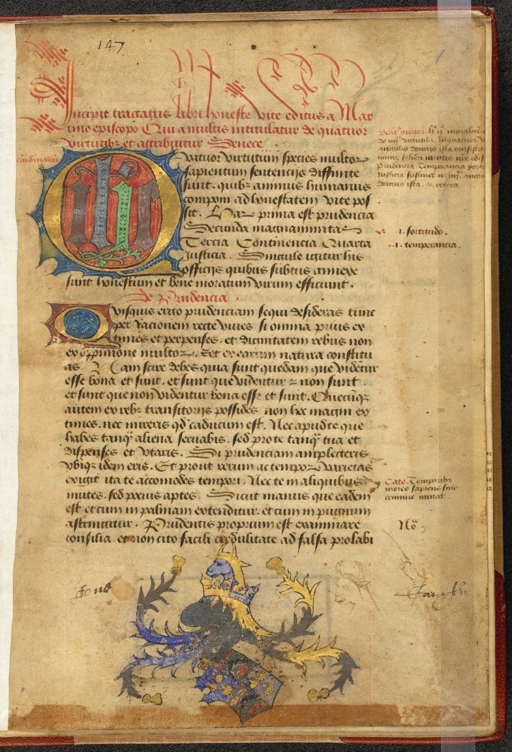
Figure 2: London, British Library, MS. Arundel 249, folio 5v
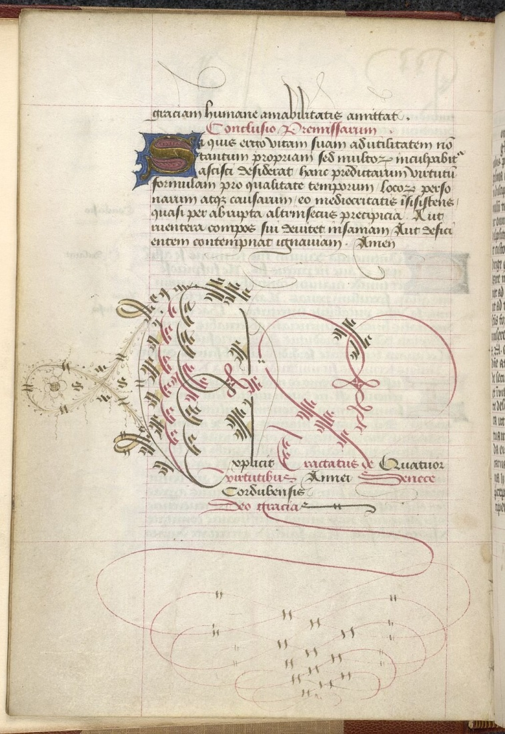
Figure 3: Oxford, Bodleian Library, MS Laud Misc. 570, folio 24v. By permission of the Bodleian Libraries, University of Oxford.
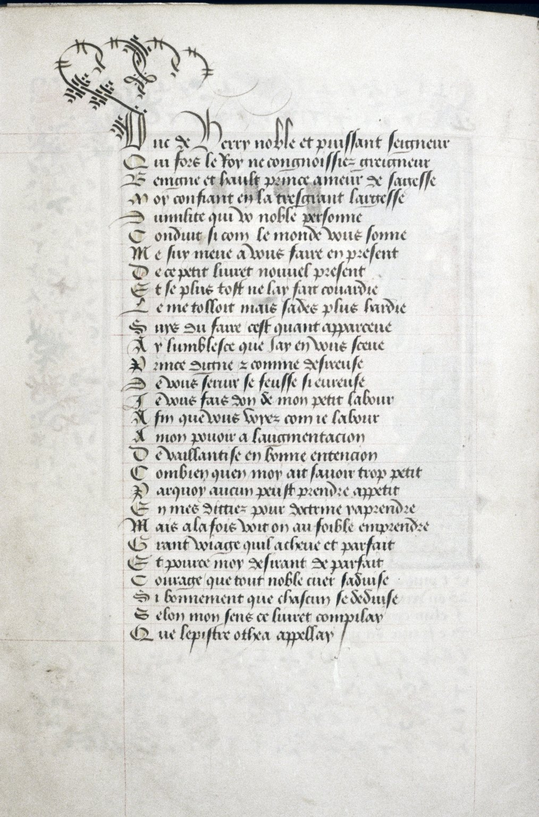

See Daniel Wakelin, Humanism, Reading, and English Literature 1430-1530 (Oxford, 2007), 2; Emil J. Polak, Medieval and Renaissance Letter Treatises and Form Letters: A Census of Manuscripts Found in Part of Western Europe, Japan, and the United States of America, Davis Medieval Texts and Studies (Leiden, 1994), IX, 323; A Fifteenth-Century School Book, From a Manuscript in the British Museum (Ms. Arundel 249), ed. William Nelson (Oxford, 1956); and Ewald Flügel, ed., ‘Kleinere Mitteilungen aus Handschriften’, Anglia, xiv (1892), 498.
For the text of the Tractatus de quatuor virtutibus by Martin of Bragba or Pseudo Seneca, see L. R. Lind and Albert Rapp, ‘A Manuscript of the Tractatus de Quattuor Virtutibus’, Speculum, viii (1933), 255-7. See also J. B. Lightfoot, St. Paul’s Epistle to the Philippians (London, 1903), 332 (n.1), in which Lightfoot points out that though the scribe of London, British Library, MS Arundel 249 attributed the text to the true author, Martin of Braga, in the title he replicated the attribution to Seneca that he evidently found in his exemplar in the explicit.
The name appears in a book of the statutes of London (San Marino, Huntington Library, MS HM 932) and his initials are in a manuscript in the same hand (Oxford, Bodleian Library, MS Laud Misc. 570). See Lisa Jefferson, ‘Two Fifteenth-Century Manuscripts of the Statutes of the Order of the Garter,’ in English Manuscript Studies 1100-1700, (1995), V, 19; Kathleen Scott, Later Gothic Manuscripts 1390-1490, A Survey of Manuscripts Illuminated in the British Isles (London, 1996), ii, 319. For lists of the works in the hand of Franciscus, see Jefferson, ‘Two Fifteenth-Century Manuscripts’, 19, which lists thirteen manuscripts in the hand of Ricardus Franciscus; Scott, Later Gothic Manuscripts, ii, 319, which lists nine manuscripts; Martha Driver, ‘“Me fault faire”: French Makers of Manuscripts for English Patrons’, in Language and Culture in Medieval Britain: The French of England, c.1100-c.1500, ed. Jocelyn Wogan-Browne et al (Woodbridge, 2009), 420-43 (appendix), which lists fifteen Franciscus manuscripts; Catherine Nall, ‘Ricardus Franciscus Writes for William Worcester’, Journal of the Early Book Society, xi (2008), 209-10, in which Nall attributed Cambridge, Cambridge University Library, MS Additional 7870 to Franciscus, which extended the list to sixteen manuscripts, and also Catherine Nall, Reading and War in Fifteenth-Century England: From Lydgate to Malory (Woodbridge: 2012), 41-3. For the most recent discussion of Franciscus’s work, which consolidated these lists, discussed the attribution and some of the uncertainty over it and added one more recently-identified manuscript see Holly James-Maddocks and Deborah Thorpe, ‘A Petition Written by Ricardus Franciscus’, Journal of the Early Book Society, xv (2012), 245-75. None of these lists attributed Arundel 249 to Franciscus.
Lisa Jefferson pointed out that the ‘minor emendations, alterations and small additions to the text’ of the Nancy manuscript were those that could only have been introduced by someone who was fully fluent in continental French, not just Anglo Norman (Jefferson, ‘Two Fifteenth-Century Manuscripts’, 32). Richard Hamer showed variant spellings that were introduced by Franciscus when he copied English, which he argued suggested that he was French (see R. Hamer, ‘Spellings of the Fifteenth-Century Scribe Ricardus Franciscus’, in Five Hundred Years of Words and Sounds: A Festschrift for Eric Dobson, ed. E. G. Stanley and D. Gray [Cambridge, 1983], 66-73). For a counter argument that Franciscus was a London scrivener, see Malcolm Parkes, Their Hands Before Our Eyes: A Closer Look at Scribes : the Lyell Lectures Delivered in the University of Oxford, 1999 (Aldershot, 2008), 117. Holly James-Maddocks has questioned whether ‘Franceys’ may have been an English scribe who went to Normandy with the Fastolf circle of patrons during the 1430s (see Holly James-Maddocks, ‘Collaborative Manuscript Production: Illuminators and their Scribes in Fifteenth-Century London’ [PhD diss., University of York, August 2013], I, chapter one).
Scott, Later Gothic Manuscripts, ii, 318.
Scott, Later Gothic Manuscripts, ii, 318; Driver ‘Me fault faire’, 429. As Martha Rust comments in Imaginary Worlds in Medieval Books: Exploring the Manuscript Matrix (New York; Hampshire, 2007), 167, if this scribe had remained anonymous then he would surely have been known as the ‘Scroll-Work Scribe’.
Scott, Later Gothic Manuscripts, ii, 328
I would like to thank Robert Kinsey for his assistance in investigating this coat of arms.
David Thompson, Descriptive Catalogue of Middle English Grammatical Texts (New York and London, 1979), 233.
Jefferson, ‘Two Fifteenth-Century Manuscripts’, 19.
Ibid.
Scott, Later Gothic Manuscripts, ii, 319.
Nall, ‘Ricardus Franciscus’, 207.
O. Pӓcht and J.J.G Alexander, Illuminated Manuscripts in the Bodleian Library (Oxford, 1966-73), I, 54-5, item 695. See Driver ‘Me fault faire’, 435-8.
British Library, Catalogue of Illuminated Manuscripts, <http://www.bl.uk/catalogues/illuminatedmanuscripts/> Arundel 249, f. 1 [accessed November 2013].
British Library, Catalogue of Illuminated Manuscripts, <http://www.bl.uk/catalogues/illuminatedmanuscripts/> Arundel 249, f. 5v [accessed November 2013].

