Received 00th January 20xx,
- . Green Chemistry Centre of Excellence, Department of Chemistry, University of York, York YO10 5DD, U.K.
- Corresponding Author
Accepted 00th January 20xx
DOI: 10.1039/x0xx00000x
www.rsc.org/
Unavoidable Food Supply Chain Waste: Acid-free Pectin extraction from Mango Peel via Subcritical Water
H. Xiaª and A. S. Matharu^{a*}
Mango peel is the major by-product of mango processing, which compromises 7 – 24 % of total mango weight. In this study, pectin was extracted from mango peel waste by using subcritical water extraction (SWE) in the absence of mineral acid. A highest yield of 18.34 % was achieved from Kesar variety and the pectin was characterised with ATR-IR, TGA and ¹³C solid NMR to confirm the structure. The degree of esterification (DE) of pectin was analysed with both titrimetry and ¹³C solid NMR, resulting in high DE (> 70 %) for all three varieties (Keitt, Sindhri and Kesar). This is the first report on acid –free subcritical water extraction of pectin from mango peel, which provides a green route for the valorisation of mango peel waste and contributes as a source of biobased materials and chemicals for a sustaianble 21st century.
Introduction

Sustainability is a much-used modern day buzz word that encompasses economic, social and environmental values, i.e the three pillars of sustainability. Sustainable development is development that meets the needs of the present without compromising the ability of future generations to meet their own needs. These definitions developed at the end of the last Century are continually being refined through the outcomes of the UN Sustainable Development Summit (25th September 2015) which adopted the document entitled, “Transforming our world: the 2030 Agenda for Sustainable Development” setting out 17 Sustainable Development goals (SDGs) to end poverty, protect the planet, and ensure prosperity for all.

In order to establish a biobased materials and chemicals for a sustainable 21st Century then we must take heed of SDG 12 which strives to ensure sustainable consumption and production patterns; promote resource and energy efficiency, sustainable infrastructure, and provides access to basic services, green and decent jobs and a better quality of life for all. Key targets of SDG 12 include the substantial reduction of waste generation through prevention, reduction, recycling and reuse and the notion of a systemic approach and cooperation among actors operating in the supply chain, from producer to final consumer which are relevant to Sustainable Chemistry for the 21st Century.

Valorisation of unavoidable food supply wastes represents an interesting Faraday Discussion as they are a valuable source of biobased chemicals, materials and bioenergy. Food waste is a global problem with in excess of 1.3 billion tonnes wastes every year which is rather ironic as close to 1 billion people suffer from severe chronic malnutrition¹. Unavoidable food supply chain wastes are those predominantly as a result of processing from farm to fork which account for approx. 40% losses in some cases. There is potential chemical value proposition associated this resource beyond bioenergy, for example anaerobic digestion, and most certainly landfill, in the form of chemicals and materials. In this discussion paper we focus on unavoidable food supply chain wastes, in particular mango peels.

Mangoes (Mangifera indica) are the second most important tropical fruit after banana. According to FAO, global mango production in 2014 exceeded 45 M tonnes². Peel is the major by-product of industrial mango processing, which consists 7 – 24 % of total mango weight³. In recent years, it has been widely reported as a rich source of many valuable compounds, such as polyphenols, carotenoids, enzymes and dietary fibre^{4,5}.

Pectin is a family of complex heteropolysaccharides consisting of a few hundred to about 1000 D-galacturonic acid (GalA) units⁶. It is the major component of cell walls, which is distributed in the primary cell wall of all plant⁷. Pectin is widely used as a gelling, thickening and stabilizing agent in the food and cosmetic industries⁸ as well as in pharmaceutical industries⁹. It has been reported to be effective in removing lead and mercury from the gastrointestinal tract and respiratory organs, favourably influences cholesterol levels in blood, treatment of iron deficiency anaemia and many other health issues¹⁰.

Pectin extraction from mango peel has been studied by many researchers with various techniques. Rehman et al. used conventional heating (80 ºC, 120 min) in the presence of aqueous sulfuric acid (pH 2.5) to afford 21 % (by wt) pectin yield¹¹. Banerjee et al., using lemon juice instead of conventional mineral acids as solvent and combining sonication, reported a pectin yield of 26 % but with a low degree of esterification¹². Maran et al. reported microwave-assisted extraction (413 W, pH 2.7, 134 s and solid–liquid ratio of 1:18 g/mL) to furnish 28 % (by wt) of pectin¹³.

In recent years, subcritical water extraction (SWE) has attracted increasing attention as a promising green extraction technique due to its selectivity and efficiency¹⁴. Pectin has been reported extracted by SWE from apple pomace and citrus peel^{15,16}. However, there is no report on SWE of pectin from waste mango peel using acid-free conditions.

This is the first study that reports subcritical water extraction (both batch and flow) of pectin from mango peel waste. Prior to extraction, the peel was subjected to heptane and ethanol hot extraction to remove surface waxes and alcohol sugars. The extracted pectin was analysed by ATR-IR, TGA and ¹³C solid NMR to confirm the structure. The degree of esterification of pectin was also determined by both titrimetry and NMR methodology.
Materials and Methods
Materials. Three different mango varieties (Keitt, Sindhri and Kesar) were bought from local supermarkets. The mangoes were peeled using a stainless steel knife and the excess of flesh was removed with the blunt edge of the knife. After that the peel was air dried for about two weeks until constant weight.

Ethanol/ heptane extraction. The dried mango peel (40 g) was soaked in 400 mL ethanol and heptane, respectively and heated under reflux for 2 hours. Thereafter, the mixture was cooled, filtered and extract was concentrated (rotary evaporator), while the mango peel residues were air dried until constant weight.

Subcritical water extraction (SWE). The dried mango peel post ethanol/ heptane extraction was then subjected to subcritical water extraction with both flow and batch systems. For flow systems, the dried mango peel (6-10 g) was loaded into a pressurised stainless steel vessel and heated at 175 °C, with a flow rate of 3 mL min⁻¹ for 15 min. For batch system, the dried mango peel (5 g) was loaded into a pressurised stainless steel vessel with 200 mL deionized water. The mixture was heated at different temperatures (75, 100, 125 and 150 °C) for 2 h.

Pectin precipitation. The extract from SWE added to twice the volume of ethanol and left overnight to allow precipitation. Thereafter, the resultant mixture was centrifuged (3500 rpm for 16 min) and the ensuing pellet was washed with 20 mL ethanol and centrifuged under the same condition again. The crude pellet (pectin) was then washed with hot ethanol, filtered and dried under warm air flow until constant weight.

ATR-IR analysis was performed using a Bruker VERTEX 70 infrared spectrometer including an ATR probe with a Golden gate attachment. The scanning number of each sample was 4 and the wavelength range was between 4000 cm⁻¹ and 800 cm⁻¹.
Thermogravimetric analysis (TGA) was performed on a PL Thermal Science STA 625. About 10.0 mg of sample was weighed accurately into an aluminium pan and analysed against an empty aluminium reference pan under a flow of nitrogen gas, from 20 °C to 625 °C at a heating rate of 10 °C min⁻¹.

¹³C solid NMR CPMAS was performed on a 400 MHz Bruker Avance III HD spectrometer equipped with a Bruker 4mm H(F)/X/Y triple-resonance probe and 9.4T Ascend® superconducting magnet. The CP experiments employed a 1 ms linearly-ramped contact pulse, spinning rates of 12000 ± 2 Hz, optimized recycle delays of 3 seconds, spinal-64 heteronuclear decoupling (at νrf=85 kHz) and are a sum of 600-800 co-added transients. Chemical shifts were reported with respect to TMS, and were referenced using adamantane (29.5 ppm) as an external secondary reference.

GC-MS analysis was performed on a Perkin Elmer Clarus 500 Gas chromatography and Clarus 560S Mass spectrometer equipped with a DB5-HT column (30 m, 0.25 m, 0.25 μm) and autosampler. The oven was programmed to maintain the temperature at 50 °C for 4 minute followed by heating at 10 °C min⁻¹ up to 290 °C and held for 10 minutes. The identified compounds were indicated by comparison with the NIST library of compounds.

HPLC analysis was performed to analyse the sugar content in SWE extracts using a HP1100 instrument, equipped with a 100-sample autosampler, quad-pump and both diode array (DAD) and evaporating light scattering (ELSD) detectors. Standard samples of levoglucosan, rhamnose, xylose, fructose, glucose and sucrose were used to prepare the calibration curve.

Degree of esterification (DE) of pectin was determined by both titrimetry and NMR method. The titrimetry was carried out according to Mizote et al.’s method. Pectin (2 g) was added to 200 mL mixture of water – concentrated hydrochloric acid – 2-propanol (90 + 10 + 100) with stirring for 15 min. It was then filtered and washed with 65% 2-propanol until the filtrate was free of chloride. The pectin was then dried in an oven until constant weight. The dried pectin (0.5 g) was loaded into a conical flask, moistened with small amount of 65% 2-propanol and then dissolved in 100 mL distilled water. The solution was titrated with 0.1 M NaOH solution to neutral and the volume was recorded as V₁. Then 30.0 mL of 0.1 M NaOH was added into the flask with stirring for 30 min. After that, an equivalent amount of 0.1 M HCl solution was added and the mixture was titrated again with 0.1 M NaOH. The volume of NaOH consumed was recorded as V₂. The degree of esterification is calculated according to equation 1:
$DE=\frac{V_{2}}{V_{1}+V_{2}} ×100\%$ (1)
For NMR method, the DE was calculated from ¹³C solid NMR spectra, according to equation 2¹⁷:
$DE=\frac{I\left(esterified carboxyl group\right)}{I\left(esterified carboxyl group\right)+I\left(non-esterified carboxyl group\right)}$ (2)
Results and Discussion
Ethanol/ heptane extraction
The yield of extracts from ethanol/ heptane extraction is concluded in table 1. For all three varieties, the yields of extracts from ethanol extraction (EE) are much higher than those from heptane extraction (HE). The Keitt mango peel has the highest EE yield among three varieties (15.4 %). The extract was analysed by GC-MS and the result is shown in figure 1 along with the major components listed in table 2. It can be observed that the ethanol extract of Keitt mango peel mainly consists of some compounds from breakdown of cellulose and hemicellulose (1,2 and 4)¹⁸ and some fatty acids and their esters (5 and 6).
Table 1. Ethanol/ heptane extraction yield of waste mango peel
 | Yield (% by wt)
Variety | Keitt | Sindhri | Kesar
Ethanol extraction | 15.4 | 6.4 | 6.0
Heptane extraction | 1.4 | 1.6 | 1.7

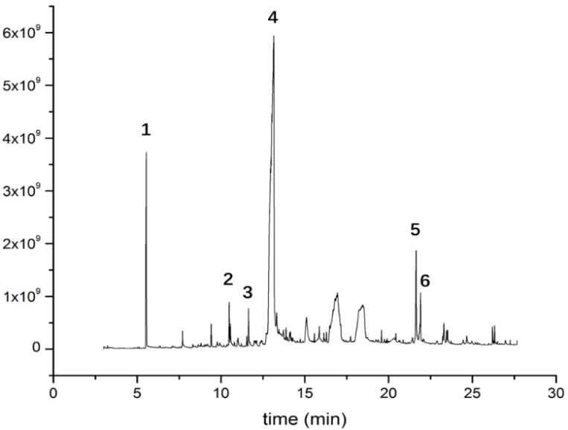
Figure 1. GC-MS chromatogram of mango peel ethanol extract (Keitt variety)
Table 2. Major components in mango peel ethanol extract (Keitt variety)
Peak | Compound
1 | Furfural
2 | 2-furaldehyde diethyl acetal
3 | 2,3-Dihydro-3,5-dihydroxy-6-methyl-4H-pyran-4-one (DDMP)
4 | 5-(Hydroxymethyl) furfural
5 | Palmitic acid
6 | Hexadecanoic acid, ethyl ester

Sugar analysis
The sugar content in ethanol extract was analysed by HPLC and the result is shown in figure 2. It can be seen that fructose is the most abundant sugar in all three varieties, accounting for at least 75 % of total amount. In particular, Keitt has much higher contents of both levoglusosan and glucose compared with the other two varieties, but rhamnose was not detected in it. Kesar has the highest sucrose content among three varieties, followed by Sindhri.
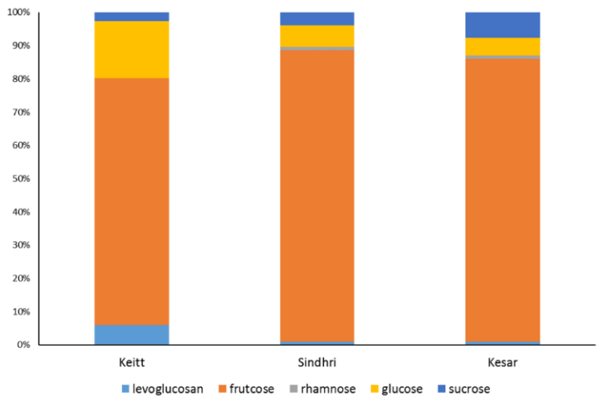
Figure 2. Sugar content of mango peel ethanol extracts
Pectin yield
The pectin yields of SWE with both flow system (all three varieties) and batch system (Sindhri post ethanol extraction) are shown in figure 3 and 4, respectively. In flow system, the highest yield was achieved with Kesar variety post ethanol extraction (18.34 %). Keitt variety also gained a similar yield of 18.31 %, but it was from post heptane extraction. Sindhri has the lowest pectin yield. A conventional acid extraction was also undertaken for comparison (HCl, pH 2.5, 80 °C, s-w ratio = 1:40, 2 h). Interestingly, the yield was only 4.88 %, which is much lower than that reported in literature, and lower than SWE acid-free extraction.
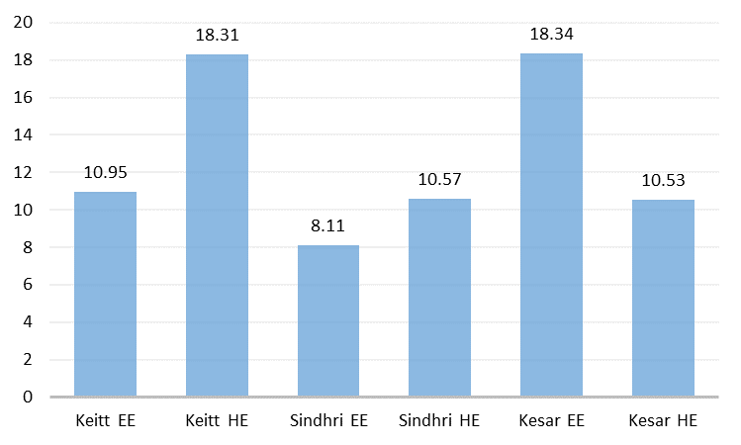
Figure 3. Mango peel pectin yield (%) from subcritical water extraction (flow system)
As for batch system, the highest pectin yield was gained at 100 °C (8.68 %), which is slightly higher than that from flow system. It is noticeable that the yield undergoes a significant decrease between 125 and 150 °C, indicating that the majority of pectin was broken down during long process of heating at high temperature.

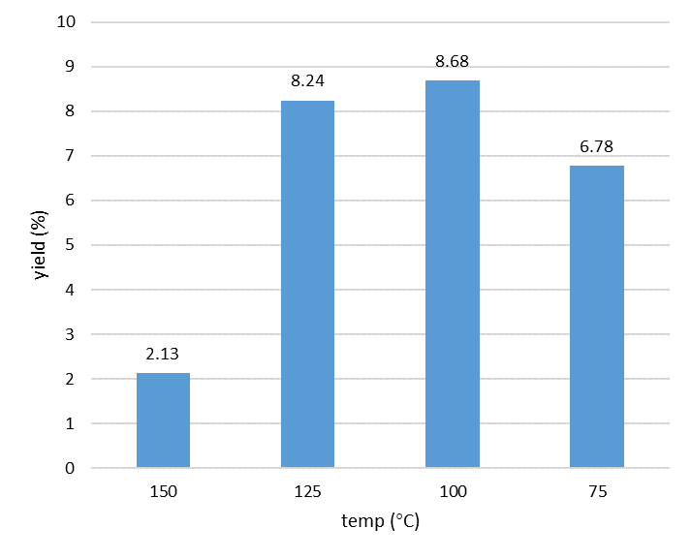
Figure 4. Mango peel pectin yield (%) from subcritical water extraction batch system (Sindhri)

ATR-IR analysis
The ATR-IR spectra of mango peel pectin from flow system are shown in Figure 5. The combination of carbonyl absorption bands at 1730 cm⁻¹ (methyl ester) and 1600 cm⁻¹ (free carboxylic acid) suggests the presence of pectin, and the ratio of their peak areas indicates the degree of esterification for the pectin. Visually, Keitt HE has the highest degree of esterification while Sindhri EE has the lowest. Apart from these two peaks, some other characteristic absorption peaks, such as the broad O−H stretch around 3300 cm⁻¹ (hydrogen-bonded hydroxyl groups), C−H stretch at approximately 3000 cm⁻¹ (alkyl groups), and intense C−O stretches between 1200 and 1000 cm⁻¹ also confirmed the existence of pectin.

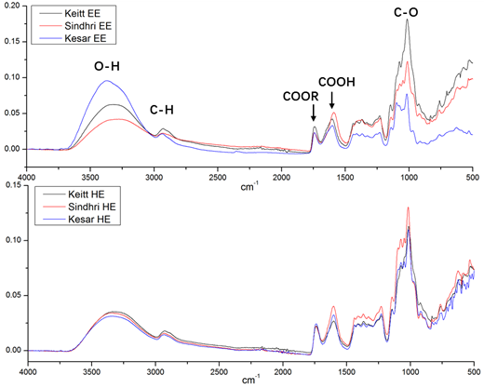Figure 5. ATR-IR spectra of mango peel pectin from SWE flow system
The ATR-IR spectra of Sindhri EE pectin from SWE batch system are shown in figure 6. It can be observed that the intensity of absorption band of methyl ester group (1730 cm⁻¹) gradually increases from 75 to 125 °C. However, when the temperature reaches 150 °C, it dramatically drops to a low intensity, which indicates the low degree of esterification or low pectin content in 150 °C extract.
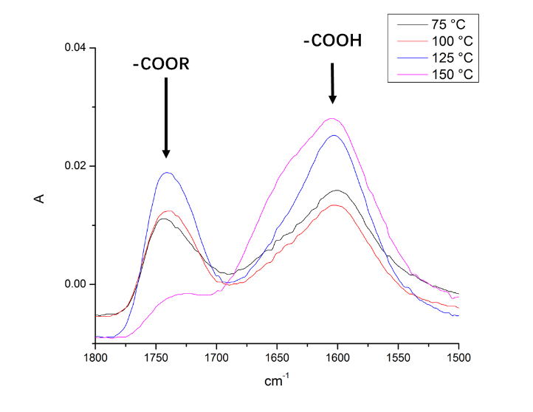
Figure 6 ATR-IR spectra of mango peel pectin from SWE batch system.
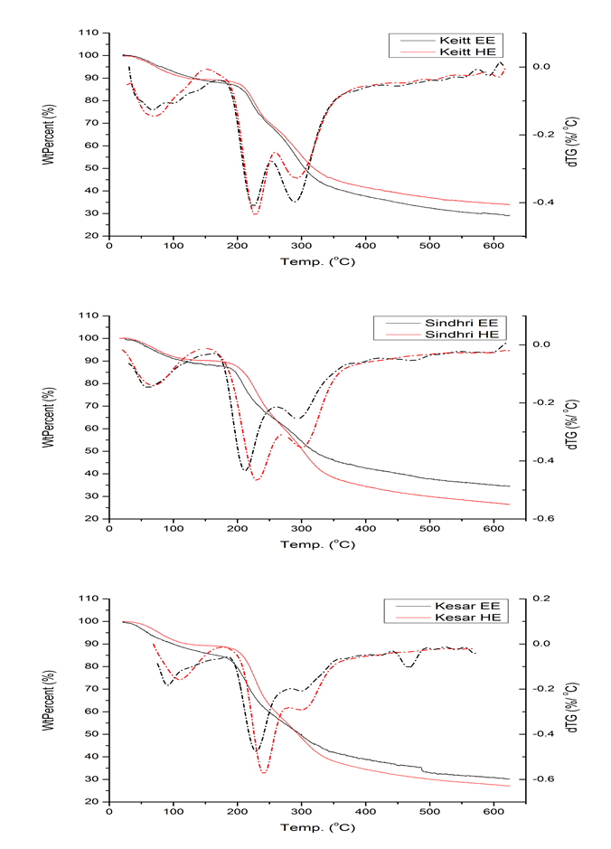
Thermogravimetric Analysis
Figure 7. TGA and DTG traces of mango peel pectin from SWE flow system
The TGA and dTG analysis reveals the thermal properties for mango peel pectin samples (figure 7, flow system). Each sample has three major processes of mass loss. The first ranging from 60 to 120 °C is due to the removal of water followed by the second between 200 and 250 °C is attributed to pectin decomposition. Kesar variety has the largest mass loss during this period (32 %), followed by Sindhri (26 %)and Keitt (20 %). The third main decomposition around 300 °C is probably due to some residual cellulose and/or starch in the samples. A qualitative analysis was carried out to confirm the presence of starch in the sample (see supporting information). A blue-black colouration with respect to iodide solution was observed for certain samples.

¹³C Solid NMR analysis
The solid-state ¹³C NMR spectrum of mango peel pectin is shown in figure 8. The strong resonance at 171.08 ppm is attributed to the C-6 carbonyl (ester and carboxylic acid) carbon of pectin, while the resonances at 102.79 and 81.38 ppm can be assigned to the anomeric C-1 carbon and C-4 carbon, respectively. Furthermore, the intense peaks in the region of 60 to 90 ppm are from carbons of pyranoid ring (C-2, 3, 5), while the weak resonance at 53.72 ppm is attributed to the methyl carbons of methyl ester (COOCH₃)¹⁹.
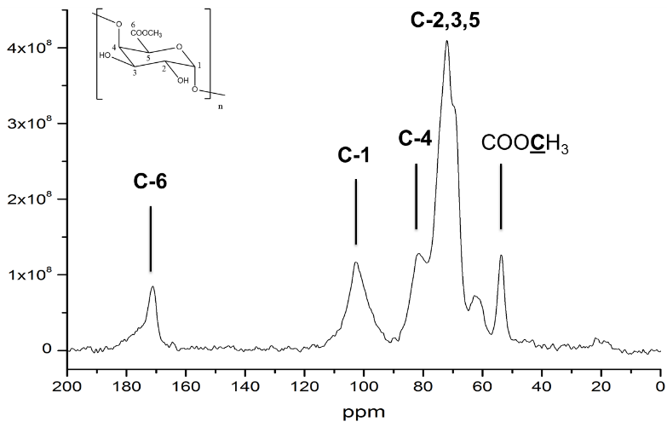
Figure 8. ¹³C solid NMR spectrum of mango peel pectin (Keitt EE)
Degree of esterification
Table 3. Degree of esterification (DE) of mango peel pectin.
Variety | DE / %
 | titrimetry | NMR
Keitt | 76.80 | 82.44
Sindhri | 70.22 | 76.43
Kesar | 74.35 | 80.66
The degree of esterification of mango peel pectin is listed in table 3. All three varieties have high degree of esterification (DE >50 %). It can be observed that the results from two different methods have a difference for about 6 % but nevertheless are in suitably close agreement.
Conclusions
Waste mango peels as an exemplar of an unavoidable food supply waste represents an interesting renewable resource that affords pectin with high degree of esterification. Although, not shown here the resultant pectin can then be re-introduced in to the food supply chain as an additive thus promoting nutrition. In such a way, added beneficial chemical value is gained from unavoidable food supply chain wastes which otherwise may be left to rot or sent for anaerobic digestion. Thus, waste to landfill is minimised, resource is recovered and re-used promoting a future circular economy and is commensurate with UN Sustainable Development Goals²⁰.

Thus, we have demonstrated the first subcritical water extraction of pectin from mango peel waste in the absence of any mineral acid. Three different global varieties were studied (Keitt, Sindhri and Kesar) and the highest pectin yield (18.34 %) was achieved at a temperature of 175 °C, flow rate of 3 mL min⁻¹ for 15 min from Kesar variety post ethanol extraction. The degree of esterification of pectin was determined by both titrimetry and NMR method and all three varieties have high DE over 70 %. Meanwhile, some other valuable compounds were also explored via ethanol extraction prior to subcritical water extraction. Fructose, glucose and sucrose are the most abundant sugars in mango peel waste. Furfural and HMF, which can be used as potential platform molecules, were also obtained as the major components in ethanol extracts from mango peel.
Acknowledgements
H.X. would like to thank the Department of Chemistry for a Wild Scholarship to pursue Ph.D. studies.
Notes and references
- T. E. Quested, A. D. Parry, S. Easteal and R. Swannell, Nutr. Bull., 2011, 36, 460–467.
- FAOSTAT MANGO, http://www.fao.org/faostat/en/#data/QC (accessed on 20/01/2017).
- N. Berardini, M. Knödler, A. Schieber and R. Carle, Innov. Food Sci. Emerg. Technol., 2005, 6, 442–452.
- C. M. Ajila, K. A. Naidu, S. G. Bhat and U. J. S. P. Rao, Food Chem., 2007, 105, 982–988.
- M. H. A. Jahurul, I. S. M. Zaidul, K. Ghafoor, F. Y. Al-Juhaimi, K. L. Nyam, N. A. N. Norulaini, F. Sahena and A. K. Mohd Omar, Food Chem., 2015, 183, 173–180.
- P. Sriamornsak, Silpakorn Univ. Int. J., 2003, 3, 207–228.
- B. L. Ridley, M. A. O’Neill and D. Mohnen, Pectins: Structure, biosynthesis, and oligogalacturonide-related signaling, 2001, vol. 57.
- D. Mohnen, Curr. Opin. Plant Biol., 2008, 11, 266–277.
- J. H. Guo, G. W. Skinner, W. W. Harcum and P. E. Barnum, Pharm. Sci. Technolo. Today, 1998, 1, 254–261.
- B. R. Thakur, R. K. Singh, A. K. Handa and M. A. Rao, Crit. Rev. Food Sci. Nutr., 1997, 37, 47–73.
- Z. U. Rehman, A. M. Salariya, F. Habib and W. H. Shah, Jour. Chem.Soc.Pak., 2004, 26, 73–76.
- J. Banerjee, R. Vijayaraghavan, A. Arora, D. R. MacFarlane and A. F. Patti, ACS Sustain. Chem. Eng., 2016, 4, 5915–5920.
- J. P. Maran, K. Swathi, P. Jeevitha, J. Jayalakshmi and G. Ashvini, Carbohydr. Polym., 2015, 123, 67–71.
- A. G. Carr, R. Mammucari and N. R. Foster, Chem. Eng. J., 2011, 172, 1–17.
- X. Wang, Q. Chen and X. Lü, Food Hydrocoll., 2014, 38, 129–137.
- H. Ueno, M. Tanaka, M. Hosino, M. Sasaki and M. Goto, Sep. Purif. Technol., 2008, 62, 513–516.
- A. S. Matharu, J. A. Houghton, C. Lucas-Torres and A. Moreno, Green Chem., 2016, 337, 695–699.
- X. Tong, Z. Liu, J. Hu and S. Liao, Appl. Catal. A Gen., 2016, 510, 196–203.
- A. Sinitsya, J. Copiková and H. Pavliková, J. Carbohyd. Chem., 1998, 17, 279–292.

20 http://www.un.org/sustainabledevelopment/sustainable-development-goals/. (accessed on 20/01/2017).
Supporting information

Iodine solution test
The presence of starch was tested with the addition of amylase into pectin sample. 0.05 g of sample was weighed and added into 5 mL distilled water in a test tube with stirring for about 30 min until fully dissolved. Then about 1 mL of KI/I₂ solution was added into the test tube and the colour change was observed. The results are shown in table S1.
Table S1. KI/I₂ solution test for the presence of starch in mango peel pectin
Sample | Component | Colour change after KI/I₂ added
1 | Commercial starch | Dark blue
2 | Mango peel pectin | Dark blue
3 | Mango peel pectin + amylase | No change
4 | Commercial pectin | No change

