The National Certification Programme for Cardiovascular Rehabilitation – aiming to improve practice.
Gill Furze, Professor, Cardiovascular Rehabilitation, Coventry University, Coventry, UK and Joint Chair, BACPR/NACR National Certification Programme for Cardiovascular Rehabilitation (NCP_CR). Email: education@bacpr.com
Simon Nichols, Research Associate, University of Hull, Hull, UK and Exercise Physiologist, Hull Cardiac Rehabilitation Programme, City Health Care Partnership CIC, Hull, UK.
Patrick Doherty, Professor, Cardiovascular Health, University of York, York, UK and Director, National Audit of Cardiac Rehabilitation / Joint Chair, NCP_CR
Sally Hinton, Executive Director, British Association for Cardiovascular Prevention and Rehabilitation (BACPR), London, UK
Alison Iliff, Health and Wellbeing Programme Manager, Public Health England, Yorkshire and the Humber Centre, Leeds, UK and Ordinary Officer, BACPR
Joseph Mills, Consultant Cardiologist, Liverpool Heart and Chest Hospital NHS Foundation Trust, Liverpool, UK and President, BACPR.

Cardiovascular disease (CVD) continues to be a leading cause of mortality and morbidity in the UK.¹ It is also a leading contributor to health inequalities; reducing excess deaths from coronary heart disease in the most deprived fifth of areas would have the greatest impact on the life expectancy gap in England.²
Cardiovascular rehabilitation (CR) is a multi-faceted secondary prevention programme which aims to improve outcomes for people with CVD, with strong evidence of clinical and cost-effectiveness,³ and is recommended by the National Institute for Health and Care Excellence (NICE).⁴ ⁵ The evidence-based service standards for delivery⁶ ⁷ include centre or home-based options (equally effective⁸), by a multi-disciplinary team supported by community services (such as smoking cessation). The British Association for Cardiovascular Prevention and Rehabilitation (BACPR) recommends that a CR programme should be based on seven components which have health behaviour change and education at their core (Fig 1.). Quality assurance of CR delivery is monitored, assessed and findings published, annually, by the British Heart Foundation funded National Audit of Cardiac Rehabilitation (NACR) based at the University of York. The NACR collects both programme and patient-level data from a majority of CR programmes across most of the UK (with the exception of Scotland). To ensure data security and quality NACR data is hosted by NHS Digital.

[INSERT FIG 1 ABOUT HERE]

INEQUITY IN CR DELIVERY
Despite its strong evidence-base and existing standards for service delivery, it has become apparent from NACR reports over recent years that CR is not delivered equitably across the UK.⁹ Although there are exemplary programmes, many clearly find the BACPR standards for CR delivery to be aspirational.¹⁰ Additionally, it is difficult for commissioners, service leads and patients to know whether a particular CR programme does meet minimum standards. Concerns about the quality of some CR programme delivery led the BACPR council and the team at NACR to collaborate on the development of a UK-wide programme for voluntary certification of whether CR programmes meet minimum standards for CR delivery.

MINIMUM STANDARDS FOR CERTIFICATION OF CR SERVICES
We undertook a three-stage process¹⁰ to: 1) capture the views of commissioners, service staff and patients on whether a certification programme was needed, and what would be included in the process; 2) develop minimum standards for certification; and 3) pilot the certification processes.
The minimum standards were developed by a group of experts in CR (both academic and clinical) based on the published BACPR standards⁶ (Table 1). Where possible, the minimum standards are developed from median UK data given in the NACR Annual Report, and these standards are uprated each year following publication of new NACR data. It is hoped that, by annually uprating the minimum standards against the published data, it will be possible over time to drive improvements in UK delivery of CR to match the best reported worldwide. In future, as NACR data quality improves, it will be possible to assess patient-level outcomes for CVD risk factor reduction and incorporate targets for these to be met as part of the certification process.

[INSERT TABLE 1 ABOUT HERE]

THE NATIONAL CERTIFICATION PROGRAMME FOR CARDIOVASCULAR REHABILITATION
Following the successful pilot, the BACPR/NACR National Certification Programme for Cardiovascular Rehabilitation (NCP_CR) was launched in July 2015, and this enables CR programmes to voluntarily apply for assessment against the minimum standards. Guidance is available from education@bacpr.com which outlines the application process and gives the current minimum standards. CR programmes can request their NACR NCP_CR report and use this to assess whether they are likely to meet the minimum standards. Following payment of a small fee (to cover administration costs) they can apply for an assessment to be undertaken by three independent members of the NCP_CR assessment panels. From this they receive feedback on whether they meet current minimum standards or not. Those that successfully meet standards are certified for three years, and are given guidance on improvements that will be required prior to recertification. These successful programmes can use the BACPR/ NACR certified logo on their paperwork for the three year certification period. Those that are unsuccessful are given guidance of what needs to be done to meet the minimum standards, and this can include mentorship from a certified programme if wished. To date, 18 CR programmes have successfully met the minimum standards for certification, from 24 applications.

EXPERIENCE OF ACHIEVING CERTIFICATION: VIEW FROM A COMMUNITY CR PROGRAMME
Programme certification not only offers an opportunity for CR programmes to be recognised for high quality care, but also to undertake an objective self-driven reflective appraisal of the programme’s strengths and unharnessed potential. During the application process, programmes are encouraged to critically evaluate current local practice and identify their own strategies for service development. The assessment panel encourage this approach and provide advice and support to each team to help them achieve their objectives. The identification of specific developmental strategies is essential if UK CR teams are to continue to strive towards health care excellence.
Comprehensive programme feedback provided during the application process will help CR specialists justify further training and continuing professional development. Locally, programme certification will improve patient care through continually rising standards amongst programmes maintaining their certified status. Whilst certification will ensure the implementation of minimum standards, the three-yearly review process also aims to drive excellence amongst teams who are already surpassing the minimum standards.
The UK has a track record for driving excellence in CR. One of the challenges of contemporary health care remains service inequality. The NCP_CR has the potential to ensure equitable service provision, improve patient outcomes and deliver international excellence in CR. It is hoped that NHS commissioners will demand nothing less than a CR service with these aspirations. NCP_CR is one method in which CR programmes can demonstrate this commitment.

CONCLUSION
The National Certification Programme for Cardiovascular Rehabilitation has been successfully launched within the UK. Currently it is a voluntary programme, but it is hoped that commissioners of CR will increasingly request programmes to demonstrate that they meet these minimum standards in order to improve care and outcomes for people with CVD over the next few years. Ensuring equity of access to CR and improving consistency of delivery should increase long-term behaviour change and contribute to a reduction in CVD-related health inequality. For further details and copies of the Guidance for applicants (which includes the full minimum standards) please email: education@bacpr.com

References

1. Townsend N, Bhatnagar P, Wilkins E, Wickramasinghe K, Rayner M. Cardiovascular disease statistics, 2015. London: British Heart Foundation, 2015.
2. Public Health England Epidemiology and Surveillance team. The Segment Tool. 2016; Available from: http://fingertips.phe.org.uk/profile/segment.
3. Anderson L, Oldridge N, Thompson DR, Zwisler A-D, Rees K, Martin N, Taylor RS. Exercise-based cardiac rehabilitation for coronary heart disease: Cochrane systematic review and meta-analysis. Journal of the American College of Cardiology 2016;67(1):1-12.
4. National Institute for Health and Care Excellence. Myocardial infarction: cardiac rehabilitation and prevention of further cardiovascular disease. CG172. London: NICE, 2013.
5. National Institute for Health and Care Excellence. Chronic heart failure: management of chronic heart failure in adults in primary and secondary care, CG108. London: NICE, 2010.
6. British Association for Cardiovascular Prevention and Rehabilitation. Standards and core components of cardiovascular prevention and rehabilitation: 2nd Edition. London: BACPR, 2012.
7. National Institute for Health and Care Excellence. Cardiac rehabilitation services: commissioning guide. London: NICE, 2013.
8. Taylor RS, Dalal H, Jolly K, Zawada A, Dean SG, Cowie A, Norton RJ. Home-based versus centre-based cardiac rehabilitation. Cochrane Database of Systematic Reviews 2015(8).
9. National Audit of Cardiac Rehabilitation. Annual statistical report 2015. London: British Heart Foundation, 2015.
10. Furze G, Doherty P, Grant-Pearce C. Development of a UK National Certification Programme for Cardiac Rehabilitation (NCP_CR). British Journal of Cardiology 2016;23(2).

Figure 1.
The seven core components of cardiovascular rehabilitation (BACPR 2012)
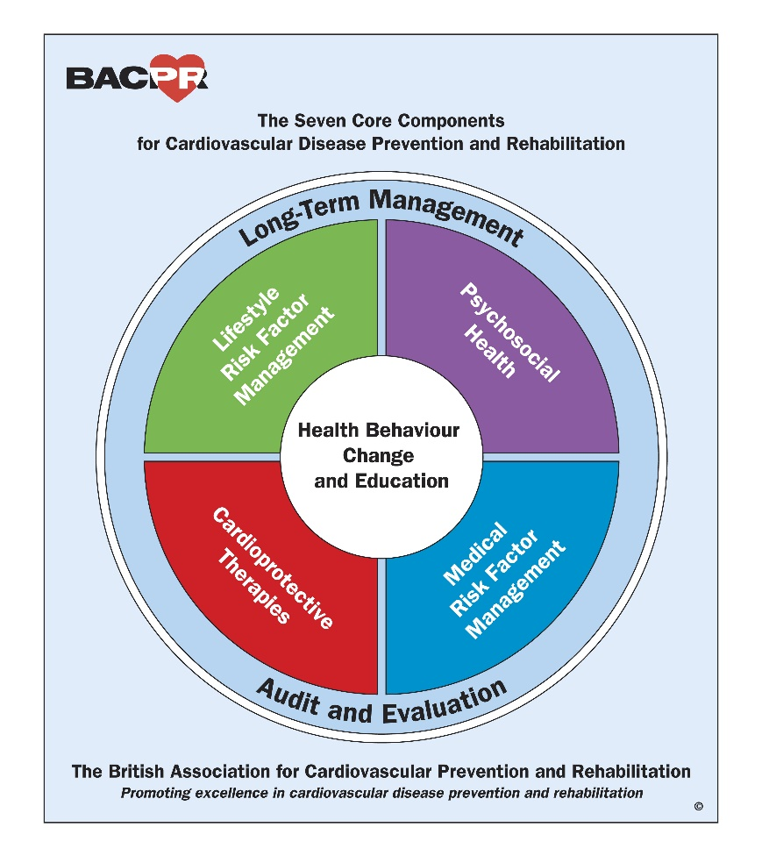

Table 1
The 2016 minimum standards for certification of cardiac rehabilitation programme delivery and the data which demonstrates that they are met.
Minimum standard | Data requirement
1. The delivery of the seven core components of CR | Named lead for each component
2. An integrated multidisciplinary team | At least three professions within the team
3. Identification, referral and recruitment of eligible patient populations | Offered at least to priority groups of myocardial infarction, post revascularisation, heart failure
4. Early initial assessment and reassessment of patient needs and | % patients with recorded a) baseline assessment  & b) end of CR assessment is ≥ national median
5. Early provision of a CR programme with defined pathway of care | Time from referral to start of CR is ≤ national median  Duration of CR programme is ≥ national median
6. Submission of patient data to National Audit | Valid NACR NCP_CR report.

