Rad Stats Conference 27 February 2016
Statistics of Crises in the UK and EU

Child poverty

Jonathan Bradshaw
Social Policy Research Unit
University of York

Outline

This paper begins with a review of trends in child poverty in the United Kingdom up to the financial crisis. Then it assesses the impact of the policies of the Coalition Government 2010-2015 relating to child poverty and the current child poverty situation. It then seeks to draw lessons from these contrasting periods. Finally it ends with a brief commentary on the current controversy about the measurement of child poverty.

Before the crisis

Figure 1 shows that the Thatcher Government presided over a more than doubling of child poverty.

Figure 1: Child Poverty rates % children in households with contemporary equivalent income less than 60% median. Source: DWP Households below average income.
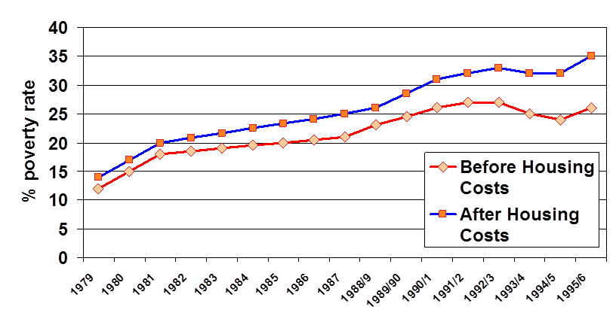

Then between the mid-1990s and 2010 the child poverty rate in the UK fell by substantially more than any other country in the Luxembourg Income Study. In fact most countries experienced increases over that period. This reduction was achieved by policy, including the introduction of the minimum wage, real increases in cash benefits, record high rates of employment of both men and women and increased social spending on health, education and childcare services. The outcomes for children also improved. The UNICEF (2007) Innocenti Report Card 7 had the UK at the bottom of the league table of child well-being. When this was updated in UNICEF (2013) in Report Card 12 the UK had moved to the middle of the league table of OECD countries. National data also had the majority of child well-being indicators moving in the right direction (Bradshaw 2011 and 2016). These advances was also accompanied by an institutional transformation in favour of children, the apotheosis of which was the passing of the Child Poverty Act 2010. This set child poverty targets:
- Relative low income = Equivalised net household income less than 60% median 2020 target: <10% of children
- Combined low income and material deprivation = Material deprivation >20% and equivalised net household income less than 70% median 2020 target: <5% of children
- ‘Absolute’ low income= Equivalised net household income falling below 60% of the ‘adjusted base amount’ 2020 target: <5% of children
- Persistent poverty= Equivalised net household income less than 60% of median for 3 years prior to current year 2020 target <7% of children.

Figure 2 shows that these targets were broadly on the right course before the crisis in 2007/8.
The relative child poverty rate continued to fall after the crisis thanks to the anti-cyclical policies of the Brown Labour Government.

Figure 2: Child poverty Act targets progress to 2013/14 and the trend needed to reach the 2020 targets. DWP (2015) Households below average incomes.
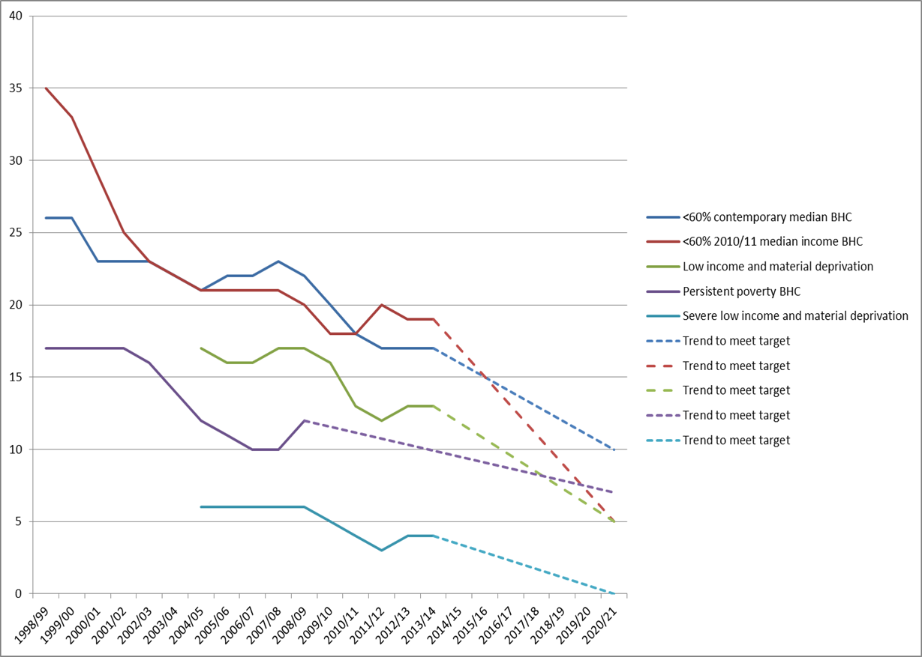

These policies changed after the election of the Coalition in 2010. They chose to reduce the deficit by austerity measures – mainly cutting public expenditure. Those cuts mainly fell on working age benefits – pensioners were protected by the triple lock. These cuts were associated with an odious rhetoric of ‘strivers and skivers’ from Ministers including the Prime-Minister and the Chancellor, which was taken up by the gutter press and awful television programmes such as Benefits Street. A tougher sanctions regime was introduced and many excluded from benefits altogether, finding themselves dependent on food banks, whose services grew exponentially. The new working age benefit Universal Credit which was supposed to operate from October 2013 and might have offset some of the impact of the cuts on children, was mired in computer problems. It is now not going to be fully operational by 2021 and may never work. Meanwhile it has been emasculated by the cuts announced in the summer budget 2015.

The Coalition’s aspiration to cut the deficit by 2015 failed as the economy grew more slowly and much of the expenditure savings was given away in tax cuts.

Unexpectedly headline child poverty rate did not increase – or at least not by 2013/14 the latest data we have. This was partly because the cuts took time to be rolled out, but mainly because median incomes, and therefore the poverty threshold, fell. However the anchored child poverty rate after housing costs has already begun to increase and the deprivation rates of households with children increased. 67% of poor children now have a working parent - up from 57% in 2007/8 but there has been a drop in child poverty in lone parent families from 38% to 26%.

There have been a number of analyses of the distributional consequences of the austerity measures over the period 2010-2015 ( see for example Reed and Portes 2014) and they all find that it is families with children at the bottom of the income distribution that have taken the biggest hit in lost income. Pensioners were hardly touched. Analysis (Beatty and Fothergill 2013) of the cuts in local government funding also show it is those local authorities with the highest child poverty rates have had the largest cuts. Hence the suggestion that we were all in it together was a lie. Austerity has been unfair distributionally, generationally and spatially.

Despite this, when the Conservative Government was elected in 2015 they announced a further £25 billion cuts again mainly in working age benefits. Some of the cuts to tax credits in the Welfare Reform and Work Bill were rejected by the House of Lords, but they are still to be incorporated into Universal Credit as it is rolled out. Meanwhile in-work benefits are frozen, pensioners are still protected by the triple lock and benefit income is being hit by the bedroom tax, the local rent limits and the localisation of council tax benefit. Migrants have become the focus of increased restrictions on their entitlements. The safety net is becoming increasingly unsafe (Bradshaw 2015). The (hidden) objective is to bring spending down to the level of the USA (see Figure 3).

Figure 3: Spending as a proportion of GDP (IMF WEO database October 2015)
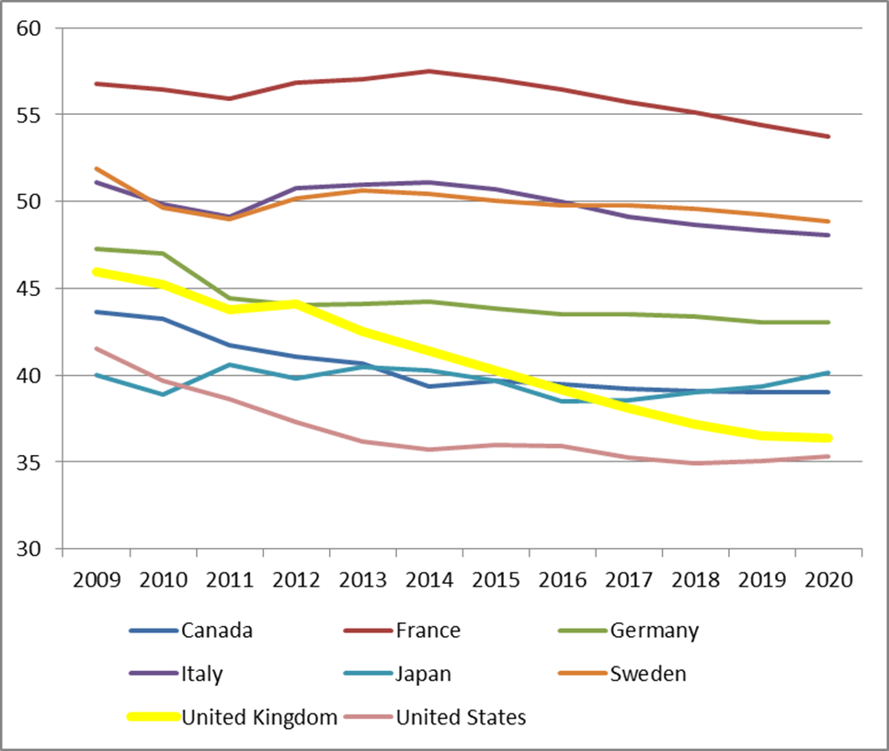

The Institute for Fiscal Studies (Hood and Johnson 2016) has now produced estimates showing that it is families with children who will lose most over the period 2015-2019 and (Brown and Hood 2016) predict that relative child poverty would rise from 17.8% in 2015/16 to 25.7% in 2020/2, increasing the number of poor children by 1.2 million and reversing most of the progress made since 1997/98.

Over a million are using food banks annually. We are already not doing well on many child health indicators – particularly our under five mortality rates (Taylor-Robinsom et al 2014). The youth suicide has stopped falling. Child subjective well-being is probably falling. Child homelessness is on the rise.

What are the lessons?

Social policy is the key to child poverty – wages matter and can be regulated, but the higher minimum wage, badged mischievously as the National Living Wage, is not going to do much for child poverty. Also although unemployment is bad, work is the not the solution to child poverty – family benefits are – and uprating them is critical. Of course having two earners helps and childcare is critical to that, but childcare can be provided in a regressive manner.

Child poverty measurement
The Coalition Government launched a consultation on child poverty measurement in 2013. The proposasl to replace income based measures were repudiated by almost all commentators and it sunk without trace (Cooper and Stewart 2013) . But Ian Duncan Smith included the abolition of the Child Poverty Act targets in the 2015 Work and Welfare Reform Bill. Four new statutory measures were proposed:
- children in workless households,
- children in long-term workless households,
- educational attainment at Key Stage 4 (GCSE) for all children and
- for disadvantaged children.
The House of Lords opposed these changes and the Government eventually agreed to publish the income based measures, but not as targets. The Government has also now asked the Child Poverty Unit to come about with a portfolio of indicators of life chances (see CPAG 2016) and consult on them. So watch this space.

Epilogue 14 July 2016
The DWP poverty figures for 2014/15 published in June 2016 showed an increase in the child poverty rate (BHC) of two percentage points over the year before to 19%. https://www.gov.uk/government/statistics/households-below-average-income-199495-to-201415. A new report on persistent child poverty showed an increase from 6.3% in 2013 to 9.1% in 2014. https://www.ons.gov.uk/peoplepopulationandcommunity/personalandhouseholdfinances/incomeandwealth/articles/persistentpovertyintheukandeu/2014

References

Beatty, C. & Fothergill, S. (2013). Hitting the Poorest Places Hardest: The local and regional impact of welfare reform. Sheffield: Centre for Regional Economic and Social Research, Sheffield Hallam University.

Bradshaw, J. (ed) (2011) The well-being of children in the United Kingdom, Third Edition, Bristol: Policy Press.

Bradshaw, J. (2016) (Ed) The well-being of children in the UK (4th edition). Bristol: Policy Press

Bradshaw, J., (2015) The erosion of the UK safety net, Discover Society, 3 January 2015
http://discoversociety.org/2015/01/03/the-erosion-of-the-uk-safety-net/

Brown, J. and Hood, A. (2016) Living standards, poverty and inequality in the UK: 2015-16 to 2020-21. London: Institute for Fiscal Studies.

CPAG (2016) Life chances indicators: submission by CPAG.

Cooper, K. and Stewart, K. (2013) Does money affect children’s outcomes? A systematic review. Joseph Rowntree Foundation. https://www.jrf.org.uk/sites/default/files/jrf/migrated/files/money-children-outcomes-full.pdf

DWP (2015) Households below average income: 1994/1995 to 2013/2014, London: DWP (www.gov.uk/government/statistics/householdsbelow-average-income-19941995-to-20132014).

Hood, A. and Johnson, P. (2016) “Are we ‘all in this together’?” London: Institute for Fiscal Studies. http://www.ifs.org.uk/publications/8210 (accessed on 01.04.2016).

Reed, H. and Portes, J. (2014) Cumulative Impact Assessment. A research report by Landman Economics and the National Institute of Economic and Social Research for the Equality and Human Rights Commission. Research report 94.

Taylor-Robinson, D., Bradshaw, J. Barr, B. and Whitehead, M. (2014) Child mortality in the UK, The Lancet, Volume 384, Issue 9958, Page 1923, 29 November 2014 doi:10.1016/S0140-6736(14)62271-6 http://www.thelancet.com/journals/lancet/article/PIIS0140-6736(14)62271-6/fulltext

UNICEF (2007) Child poverty in perspective: An overview of child wellbeing in high income countries, Innocenti Report Card no 7, Florence: UNICEF Innocenti Research Centre.

UNICEF (2013) Child well-being in rich countries: A comparative overview, Innocenti Report Card no 11, Florence: UNICEF Office of Research.

http://blogs.lse.ac.uk/politicsandpolicy/plans-to-axe-child-poverty-measures-have-no-support-among-experts/

