Interactions in Water-Ionic Liquid Mixtures: Comparing Protic and Aprotic Systems
Joshua E. S. J. Reid,^{1,2} Richard J. Gammons,³ John M. Slattery,³ Adam J. Walker² and Seishi Shimizu^{1*}
¹York Structural Biology Laboratory, Department of Chemistry, University of York, Heslington, York YO10 5DD, United Kingdom.
²TWI Ltd., Granta Park, Great Abington, Cambridge CB21 6AL, United Kingdom.
³Department of Chemistry, University of York, Heslington, York YO10 5DD, United Kingdom.

Corresponding Author:

Seishi Shimizu
York Structural Biology Laboratory, Department of Chemistry, University of York, Heslington, York YO10 5DD, United Kingdom.
Tel: +44 1904 328281, Fax: +44 1904 328281, Email: seishi.shimizu@york.ac.uk

Abbreviations

KB, Kirkwood-Buff; IL, Ionic Liquid; AIL, aprotic ionic liquid; PIL, protic ionic liquid; [Ch][NTf₂], Cholinium bis(trifluoromethanesulfonimide); [DMEtAH][NTf₂], N,N-dimethylethanolammonium bis(trifluoromethanesulfonimide); [DMEtAH][Pr], N,N-dimethylethanolammonium propionate; [BMIm][BF₄], 1-Butyl-3-methylimidazolium tetrafluoroborate; [EMIm][BF₄], 1-ethyl-3-methylimidazolium tetrafluoroborate; [EMIm][OTf], 1-ethyl-3-methylimidazolium trifluoromethanesulfonate;

Abstract

The sensitivity of ionic liquids (ILs) to water affects their physical and chemical properties, even at relatively low concentrations, yet the structural thermodynamics of protic IL (PIL)-water systems at low water concentrations still remains unclear. Using the rigorous Kirkwood-Buff theory of solutions, which can quantify the interactions between species in IL-water systems solely from thermodynamic data, we have shown that (1) Between analogous protic and aprotic ILs (AILs), the AIL cholinium bis(trifluoromethanesulfonyl)imide ([Ch][NTf₂]) shows stronger interactions with water at low water concentrations, with the analogous PIL N,N-dimethylethanolammonium bis(trifluoromethanesulfonyl)imide ([DMEtAH][NTf₂]) having stronger water-ion interactions at higher water contents, despite water-ion interactions weakening with increasing water content in both systems. (2) Water has little effect on the average ion-ion interactions in both protic and aprotic ILs, aside from the AIL [Ch][NTf₂], which shows a strengthening of ion-ion interactions with increasing water content. (3) Self-association of water in both PIL-water systems leading to the presence of large aggregates of water in IL-rich compositions has been inferred. Water-water interactions in [DMEtAH][NTf₂] were found to be similar to dialkylimidazolium AILs, whereas these interactions were much larger in the PIL N,N-dimethylethanolammonium propionate ([DMEtAH][Pr]), attributed to the change in anion-water interactions.

Introduction

Ionic liquids (ILs) are promising alternative solvent media for physical, chemical and biological processes, largely due to the “tunable” properties of these solvents, which can be changed by careful selection of both cation and anion. ¹⁻⁴ Potential applications utilising ILs include natural product extraction, ⁵ biomass processing, ⁶⁻⁹ anhydrous fuel cells ¹⁰⁻¹³ and catalysis. ¹⁴⁻¹⁸ There are, broadly speaking, two classes of ILs: aprotic ionic liquids (AILs), where the formal charge center of the cation is typically formed from non-reversible alkylation of a heteroatom, and protic ionic liquids (PILs), whose ion charges depend on proton transfer equilibrium between a Brønsted acid and a suitable base. ¹⁹⁻²¹ The chief advantage of PILs is that they are often significantly cheaper alternative to their aprotic counterparts, due to their simple, atom economical and efficient synthesis. ^{22, 23}

Both PILs and AILs tend to be quite hygroscopic and it is well known that their physical properties, structure and dynamics are significantly affected by the presence of water, even at low concentrations.^{5, 6, 24-28} The origins of these effects are generally not well understood and the molecular basis for the different behavior of AIL-water and PIL-water mixtures has not previously been described on a rigorous statistical thermodynamic basis. Here we aim to clarify the difference between a selection of AIL-water mixtures and PIL-water mixtures. Prior to demonstrating that the structure of IL-water mixtures is a still a controversial and poorly-understood subject, we emphasize first of all that the study of water-IL mixtures is of practical importance. This is because of the following reasons: (1) finer tuning of IL physical and solvation properties can be achieved through mixing with other solvents, especially with water; ²⁴⁻²⁶ (2) residual water is often present in IL samples from their synthesis and the hygroscopic nature of many ILs will inevitably introduce small amounts of water when they are utilized unless they are prepared, stored and handled under anhydrous conditions, ^{27, 28} so that permitting residual water in ILs seems to be more sustainable due to the energy required for the removal of water; (3) The costs associated with using an IL-water mixture for a given process in place of the pure IL would be significantly reduced, due to the typical high costs of ILs with respect to water; (4) the addition of molecular solvents, such as water, to ILs can have anti-solvating effects, leading to the precipitation of a dissolved species; ^{5, 6} (5) water is regarded as the “greenest” solvent. ²⁹⁻³²

How does the behavior of water molecules vary, depending on the IL to which they have been added? In our previous work, we utilized the rigorous Kirkwood Buff (KB) theory of solutions to answer this question for three dialkylimidazolium ionic liquid systems. ³³ At the lowest measured concentrations, water molecules become dispersed within each IL system, with the preference of water-water interactions increasing with increasing water concentration. We also showed that for the three systems studied, the average ion-ion interactions are not weakened significantly in the presence of low concentrations of water. This paved a way towards resolving the controversial question of how low concentrations of water affect the local interactions in aprotic imidazolium IL systems. ³³⁻³⁶ Here we extend our clarification on the structure and interaction of IL-water systems at higher water concentrations, encompassing both protic and aprotic ILs.

In the context of IL-water mixtures, the following important questions have been posed in the literature, and have not been answered clearly.

Question 1 Does water interact more strongly with protic ILs than with aprotic ILs?
That protic cations interact more strongly with water than their aprotic counterparts has been demonstrated by a comparison of the transport properties of analogous imidazolium aprotic and protic ILs, the cause of which was attributed to the tertiary N-H site of protic cations being able to hydrogen bond strongly with water, whereas the quaternary nitrogen on the aprotic cations could not. ³⁷ It is expected that there would be some hydrogen bonding interactions from the C-H sites on the aprotic cations with water, in particular from the hydrogen on the C₂ position on the imidazolium ring. However, these types of hydrogen bond will also be present on the protic cations of analogous structure and will be significantly weaker than those involved with the N-H sites on the protic cations. This was complemented by a study of the effects of water on the vibrational spectra of two PILs; 1-ethylimidazolium trifluoromethanesulfonate ([EIm][OTf]) and 1-ethylimidazolium bis(trifluoromethanesulfonyl)imide ([EIm][NTf₂]), where similar water-cation vibration modes were observed in both systems. ³⁸ The study also showed water-anion vibrational modes in the [EIm][OTf] system but not in the [EIm][NTf₂] system. These results suggest that water interacts differently between the two PILs and more favorably with [EIm][OTf] than with [EIm][NTf₂], contradicting the assumption that interactions between anion and water are related to the pKa_{(aq)} of the conjugate acid. This view was best rationalised by the different polarization between the two PILs, not simply the acidity of the precursor acid; water in a PIL such as methylammonium nitrate ([MA][NO₃]) becomes depolarized to a greater extent than in dialkylimidazolium ILs due to the strong, directional hydrogen bonds. ³⁹

While the above investigations of analogous AIL and PIL mixtures with water appear to suggest stronger interactions between water and PILs, this does not represent a complete picture of IL-water interactions. The interactions between water and ILs have been inferred from the excess molar volume ($V_{m}^{E}$) and partial molar volume of species ($V_{i}$) of these binary systems from extensive density data. ⁴⁰⁻⁴⁵ The resultant deviations of molar volume from additivity suggest that both protic and aprotic ILs demonstrate weakening ⁴⁶⁻⁴⁹ and strengthening of interactions between ions and water. ⁵⁰⁻⁵² The fact that both classes of ILs can demonstrate both strengthening and weakening of interactions with water implies that ionicity alone cannot explain the strength of interaction. (Indeed, as will be shown in this paper, partial molar volume does not infer a single interaction, but rather a combination of numerous interactions.)

Question 2 Does the presence of water weaken ion-ion interactions in PILs?
It has been suggested that contact ion pairs (CIPs) as opposed to solvent-separated ion pairs (SIPs) were most prominent in PIL-water mixtures featuring triethylammonium methanesulfonate ([TEA][MS]) even at very high water concentrations. ⁵³ This was supported by DFT calculations of the binding energy of aggregates of water and PILs at different compositions, finding that CIPs are more preferential at lower water configurations, and SIPs are more preferential at higher water concentrations. This is supported by the work of Greaves et al., demonstrating that certain PILs retain structural features in the presence of water, suggesting that water does not reduce the strength of ion-ion interactions. This is the opposite to how the precursor materials behave in mixtures with water. ⁵⁴ However a study of the effect of water on the shear thinning of the PIL diethanolammonium acetate ([DEtA][ Ac]) suggested that less than molar equivalent quantities of water disrupt interactions between ions. ⁵⁵ Indeed, it has been suggested from studies of the viscosity of PIL-water systems that the presence of water disrupts ion-ion interactions through hydrogen bonding interactions. ^{52, 56} A recent study on the transport properties and local interactions within species in mixtures of water and the PIL diethylmethylammonium methanesulfonate [DEMA][MS] gave evidence from 1H NMR and IR spectroscopy to show that cation-anion hydrogen bonding interactions weaken with increasing water concentration. ⁵⁷ This evidence was a justification for the observed increase in the self-diffusion coefficients (from both pulsed field gradient NMR and conductivity measurements) observed for the species within these systems. Taken all of the above into consideration, there is no consensus as to whether water strengthens or weakens the IL-IL interaction.

Question 3 Does the structure of PIL-water systems reflect homogeneous mixing or the formation of heterogeneous structures?
Homogeneous distributions of water within mixtures have been reported by molecular dynamics simulations of the protic IL ethylammonium nitrate ([EA][NO₃]). ⁵⁸ This view is contradictory to a combined neutron diffraction and computational study of [EA][NO₃] and water mixtures, which suggest that the local structure of each component resembles that of the pure materials in the polar domains. ⁵⁹ The study did suggest that a modification of the PIL nanostructure is observed due to swelling of polar regions, increasing the interfacial curvature around the non-polar regions (the cation alkyl chain). The formation of heterogeneous structures in polar solvents is also supported by the Far-IR study of PILs in polar solvents. ⁶⁰ This difference in the observed mixing behavior of water and protic ILs has been emphasized further by ethylammonium formate ([EA][Fr]) mixtures with water. The static dielectric constant, ε₀, of the [EA][Fr]-water system showed consistent ε₀ values up to 60% mole fraction of water. ⁶¹ However, measurements of polarity of [EA][Fr]-water systems with the probe molecule 12’-apo-b-carotenoic-12’-acid showed additivity of the observed polarity. ⁶² The fact that these different spectroscopic techniques seem to offer contradictory conclusions for identical water-PIL systems shows that there is still a poor understanding of the mixing behavior of these systems. Indeed, a lack of the theoretical basis behind some of the experimental techniques often leads to a misinterpretation of the results that feeds controversy.

There is still much uncertainty as to how the species in IL-water mixtures interact. We wish to answer these three questions in this paper for six selected ILs, to showcase how the KB theory of solutions can help to better understand the complex nature of IL-water systems. To do this, we calculate the specific KB interaction parameters for water-water, water-ion and ion-ion interactions for these IL-water systems. ⁶³⁻⁶⁷ The KB-based approach has a proven track record in clarifying the mechanism of solvation in many systems, ranging from biochemical processes to pharmaceutical formulations. ⁶⁸⁻⁷⁷ It has also been applied by Almasy et al. to reveal the structure of water-[BMIm][BF₄] in the water-rich region. ⁷⁸ The theoretical framework of the KB theory has previously been useful in revealing the mechanism of biphasic extraction and the solvation of solvatochromic dyes in IL-water mixture. ^{79, 80} The combination of molecular dynamics and KB theory has also given valuable insight into a number of multicomponent systems featuring ionic liquids in terms of radial distribution functions associated with the individual ions. ⁸¹⁻⁸³

In this paper we characterize, through the KB theory, water-water, ion-water and ion-ion interactions in six different IL-water mixtures. While it is not possible to investigate all of the diverse classes of ILs in a single study, these six systems were chosen because they represent a range of varying hydrophobicity and include both protic ILs (N,N-dimethylethanolammonium bis trifluoromethanesulfonimide ([DMEtAH][NTf2]) and N,N-dimethylethanolammonium propionate ([DMEtAH][Pr])) and aprotic ILs (cholinium bis trifluoromethanesulfonimide ([Ch][NTf₂]),1-Butyl-3-methylimidazolium tetrafluoroborate ([BMIm][BF4]), 1-ethyl-3-methylimidazolium tetrafluoroborate, ([EMIm][BF4]) and 1-ethyl-3-methylimidazolium trifluoromethanesulfonate ([EMIm][OTf])) (fig.1). Thus we can begin to understand the interactions in these specific IL-water systems, and comment on how variations of anion and cation structure influence these interactions. It is worth noting that any IL-water mixture can be studied using our approach if the required water activity and density data for the binary mixtures are known. Assisted by the theoretical foundation of the KB theory, we address the questions regarding the structure of and interactions in IL-water systems.

Theory and Experimental

2.1. The Kirkwood-Buff theory of binary mixtures

Based upon the rigorous statistical thermodynamic KB theory for binary mixtures, thermodynamic data can be used to reveal the structure of IL-water mixtures. ^{33, 63-67, 74} A more detailed discussion on the derivation of the KB parameters as used in this work has been shown before now,³³ and has been reproduced here in a condensed form. Consider a mixture of water ($i=1$) and IL ($i=2$). Following the standard approach well-established for dissociative species, we consider the (averaged) ions of the ILs as the species 2 (because the composition is always equivalent, it is not possible to study the effects of changing the number of cations or anions independently due to the charge neutrality requirement). ^{33, 66, 67, 70} As in previous KB approaches to ionic solutions, ^{33, 66 ,67, 70} cations and anions of varying size asymmetry have been assumed to be treated as single species as “a collection of indistinguishable ions”. ^{33, 66, 67, 70}

Our goal is to determine the KB integral between species $i$ and $j$, defined as follows: ^{33, 63-77}
$G_{ij}=∫dr4πr^{2}\left[g_{ij}\left(r\right)-1\right]$ (1)
where $g_{ij}\left(r\right)$ is the radial distribution function between the species $i$ and $j$, separated at the distance $r$. $G_{ij}$ usually takes negative values, reflecting the contributions from small $r$ where $g_{ij}\left(r\right)=0$ due to steric repulsion, which contributes negatively to $G_{ij}$; however, if an attractive interaction exists between $i$ and $j$, $g_{ij}(r)$ exhibits peak values much greater than 1, which contributes positively to $G_{ij}$; if species $j$ is excluded from $i$, the depletion of $g_{ij}(r)$ contributes negatively to $G_{ij}$. Thus $G_{ij}$ reflects the excluded volume, as well as attraction and repulsion between $i$ and $j$. Following what is customary, we present our theory on a microscopic (molecular) scale using the Boltzmann constant $k$ and the KB integrals measured in m³ (or other units for volume). In the analysis of experimental data, it is customary to use the macroscopic (molar) scale, namely, the gas constant $R$ instead of $k$ and cm³ mol⁻¹ or m³ mol⁻¹ as the units of the KB integrals. The conversion between the two scales can easily be made by the use of Avogadro’s constant.

The KB integrals can be determined through the following well-known formulae: ^{33, 63-77}
$G_{11}=\frac{n_{2}V_{2}^{2}n}{n_{1}D}-\frac{1}{n_{1}}+kTκ_{T}$ (2)
$G_{21}=-\frac{nV_{1}V_{2}}{D}+kTκ_{T}$ (3)
$G_{22}=-\frac{1}{n_{2}}+\frac{n_{1}V_{1}^{2}n}{n_{2}D}$ (4)
where $n_{i}$ and $V_{i}$ respectively express the concentration and the partial molar volume of species $i$, and $κ_{T}$ is the isothermal compressibility (typically of negligible contribution to KBI values); $n=n_{1}+n_{2}$ has also been used. $D$ is the key quantity for KB integral determination: ^{63-77?}
$D=\frac{x_{1}}{kT}{\left(\frac{∂μ_{1}}{∂x_{1}}\right)}_{T,P}={\left(\frac{∂\ln{a_{1}}}{∂\ln{x_{1}} }\right)}_{T,P}$ (5)
where $μ_{i}$ , $x_{i}$ and $a_{i}$ respectively express the chemical potential, the mole fraction and the activity of the species $i$. The equivalence of the eqn. (2)-(5) to the ones used in our previous paper is proven in Appendix A.

$V_{1}$ and $V_{2}$, as well as the excess volumes, have been employed in the literature to characterize the interactions between the species. In contrast, Appendix B shows that $V_{1}$ and $V_{2}$ actually contain several KB integrals, demonstrating that it is hard to separate one type of intermolecular interaction from the other simply by using the volumetric data alone.

2.2. Quantifying the closeness to phase separation

To compare quantitatively how close IL-water mixtures are to phase separation, we appeal to the thermodynamic criterion for phase stability, namely$x_{2}\left(\frac{∂\ln{γ_{2}}}{∂x_{2}}\right)>-1$ where $γ_{i}$ is the activity coefficient of the species $i$. ⁸²⁻⁸⁴ Using eqn. (5), this translates to the following condition
$D=x_{2}{\left(\frac{∂μ_{2}}{∂x_{2}}\right)}_{T,P}>0$ (6)
The D parameter summarizes the change in chemical potential of a given species with respect to its composition within a defined mixture. Using the Gibbs-Duhem equation, the single parameter accounts for the thermodynamic behavior of the species within a multicomponent system (in our case, the IL and water). This $D$ can also be measured by scattering experiments; by straightforward algebra, this $D$ can be linked directly to the variance of mole fraction related to the zero wave vector value of the concentration-concentration structure factor,$S_{cc}\left(0\right)$ as ^{78, 84-89}
$D=\frac{x_{1}x_{2}}{S_{cc}(0)}-1$ (7)

2.3. Water activity and density data

The calculation of KB integrals requires experimental data as input: vapor pressure and density of IL-water mixtures. Water activity data on three IL-rich mixture systems have been taken from our previous papers, ^{79, 80} which include cholinium bis(trifluoromethylsulfonyl)imide ([Ch][NTf₂]), N,N-dimethylethanolammonium bis(trifluoromethylsulfonyl)imide ([DMEtAH][NTf₂]) and N,N-dimethylethanolammonium propionate ([DMEtAH][Pr]).⁹⁰ The structures of the ILs from our previous work vary both the anion and cation structure, as well as featuring both protic and aprotic ILs. The aprotic cation cholinium ([Ch]) and the protic cation N,N-dimethylethanolammonium ([DMEtAH]) are often regarded as being “green” cations due to their favourable biodegradability, and low mutagenicity and toxicity. ⁹¹⁻⁹³

Since the densities of the above three IL-water mixtures have not been reported in the literature to the best of our knowledge, we have we have measured the density of these three IL-water mixtures over the whole composition range, using an Anton Paar DSA5000 density meter. The results can be found in the supplementary information document (fig. S1a – S1c). The synthetic procedure and characterization of the protic IL [DMEtAH][Pr] and the aprotic IL [Ch][NTf₂] are also summarized in the supplementary information document. The protic IL [DMEtAH][NTf₂] was purchased from Bioniqs Ltd., was of biochemical purity (≥99%) and used without further purification.

In addition, we utilise data sets of water activity ^{94, 95} and density ^{96, 97} of the three IL-water mixtures featuring the ILs 1-butyl-3-methylimidazolium tetrafluoroborate ([BMIm][BF₄]), 1-ethyl-3-methylimidazolium tetrafluoroborate ([EMIm][BF₄]) and 1-ethyl-3-methylimidazolium trifluoromethanesulfonate ([EMIm][OTf]). The structures of all ILs used in this study are summarized in fig. 1. The experimental water activity and density data have been utilized in fig. 2, with subsequent differentiation producing the D value (eqn (5)) as shown in fig. 3 which is used to calculate all KB integrals (eqn (2)-(4)).

3. Results and Discussion

3.1. Does water interact more strongly with protic or aprotic ILs? (Question 1)

To answer this question, we utilize the values of the ion-water interaction parameter, G₂₁, for all six systems. Two pairs of ILs have been selected to compare the ion-water interactions in protic and aprotic ILs; one representing hydrophobic ILs, the other representing the hydrophilic ILs from this study.

Hydrophobic ILs
Both the [Ch][NTf₂] and [DMEtAH][NTf₂] feature the bis(trifluoromethanesulfonyl)imide anion, near-universally regarded as extremely hydrophobic, ammonium cation (quaternary for the aprotic, tertiary for the protic) and hydroxyl functional group on the cation. (The similarity in ion structure results in comparable average ion size, which can be inferred roughly by the partial molar volume of the ILs at $n_{1}→0$, i.e., 169.45 cm³ mol⁻¹ for [DMEtAH][NTf₂] and 176.47 cm³ mol⁻¹ for [Ch][NTf₂]). Despite the similarity in structure, the two ILs exhibit distinctly different degrees of interaction with water. At the lowest comparable measured concentration of water (x₁ = 0.073), The AIL [Ch][NTf₂] shows more favorable ion-water interactions than the PIL [DMEtAH][NTf₂] (fig. 4). Both ILs feature hydroxyl functional groups on the cation (at position 2 in fig. 1 for both ILs), which are expected to act as hydrogen bond donors towards water, as well as with the anion. ^{98, 99} Protic ionic liquids have often been described as having strong, directional hydrogen-bonding networks present as a result of the charge transfer formation of ions, in some cases also being compared to water. ¹⁰⁰ This can create strong differences in the local structure of analogous protic and aprotic ILs. ¹⁰¹ As a result, it is likely that the availability of the hydroxyl groups on the cation (at position 2 in fig. 1 for [DMEtAH][NTf₂]) to form hydrogen bonds with at low water concentrations is restricted. As the ion-ion interactions in AILs are typically dependent on diffuse electrostatic interactions, there is less restriction to the ion-water mode of interaction through hydrogen bonding.

With increasing water concentration, ion-water interactions become less preferential in both systems; however, for the [Ch][NTf₂] system G₂₁ decreases more drastically, eventually becoming more negative than for [DMEtAH][NTf₂] at around x₁ ≈ 0.20. This implies more preferential ion-water interactions in the PIL than in the analogous AIL at x₁ > 0.20. At these higher water concentrations, it is likely that a reorganization of water in the AIL takes place, resulting in an increase in the strength of water-water interactions. This is supported by an increase in G₁₁ (fig. 5) from large and negative values at low water concentration (similar to what has been shown before in AILs ³³) to large and positive values, larger than in [DMEtAH][NTf₂] at around x₁ ≈ 0.20. (Note that, due to the inherent difficulties in measuring low water activity, the values of $G_{11}$ should be considered only indicative of qualitative trend at this end.)

Hydrophilic ILs
While not analogous in structure, the PIL [DMEtAH][Pr] and the AIL [EMIm][OTf], represent the most hydrophilic of the ILs from this study. Here, note that [EMIm][OTf] is larger in size than [DMEtAH][Pr] (which can be inferred roughly by their respective pure-phase partial molar volumes, namely 94.13 cm³ mol⁻¹ for [EMIm][OTf] and 76.69 cm³ mol⁻¹ for [DMEtAH][Pr]). Over the entire comparable compositions, [EMIm][OTf] exhibits greater G₂₁ values than [DMEtAH][Pr] (fig. 4). This result conveys that water-ion interactions are more favorable in [EMIm][OTf] than in [DMEtAH][Pr] at the concentration range studied. While the structures of these two ILs are distinctly different, they both feature anions and cations that could form hydrogen bond interactions with water. (The hydrogen at the C₂ position of the imidazolium ring of the cation and the oxygen atoms on the triflate anion for [EMIm][OTf]; the hydroxyl and tertiary ammonium groups on the cation and the oxygen atoms on the propionate anion for [DMEtAH][Pr]). The triflate anion has been shown from classical MD simulations to able to form strong hydrogen bonds with water at low concentrations through the oxygen atoms. ^{102, 103} Even at greater water concentrations, the anions of aprotic ILs such as [BMIm][BF₄] and [EMIm][OTf] have shown to significantly interact with water, resulting in a picture of water-anion networks. ^{104, 105} Note that the stronger water-ion interaction of the PIL is observed over the entire concentration range studied here, unlike the case of the hydrophobic ILs, for which the relative strength of ion-water interaction was shown to depend strongly on water concentration.

3.2 Does water weaken ion-ion interactions in PILs? (Question 2)

To answer this question, we assess the dependence of water mole fraction on the ion-ion KB parameter, G₂₂ (fig. 6). For all but one IL-water systems (that of [Ch][NTf2]), we find that there is relatively small decrease of G₂₂ with increasing water content. The degree of weakening of ion-ion interactions is seemingly comparable for these systems, despite the wide variety of IL structures present. This relatively small decrease in G₂₂ suggests that ion-ion interactions are relatively unchanged by the presence of water. This is in agreement with previous studies into the liquid structure and interactions in PIL systems upon addition of water. ^{53, 54} It has previously been shown that G₂₂ has little impact on the chemical potential of water, which in turn is reinforced by the relatively small change observed for the preferential solvation of ions (G₂₁ – G₂₂) (fig. 7). ³³ As well as establishing that ion-ion interactions are relatively unaffected by the presence of water, fig. 7 demonstrates that ion-water interactions are preferable to ion-ion interactions over the studied concentration range. In comparing the estimated Log₁₀P values for each IL (fig. S4) to fig. 7, we are unable to find any correlation. This is likely a result of concentration differences: Log₁₀P values are representative of preferential interactions of IL at low concentrations in water, whereas we report on the preferential interactions of ILs with low concentrations of water present.

3.3 Does the structure of PIL-water systems reflect homogeneous mixing or the formation of heterogeneous structures? (Question 3)

From G₂₂ we have shown there is little change in the ion-ion interaction strength (fig. 6) in PILs in the presence of water, implying that the structure of the PIL remains relatively unchanged. If we consider as well the water-water interactions for these systems, we find that for both PILs, G₁₁ is large and positive at the concentration range of this study (fig. 5). This behavior of water-water interactions is distinctly different than observed in any of the AILs in this study. Despite this, strong aggregation of water at low concentrations has been observed in other systems using KB theory, such as sucrose-water ¹⁰⁶ and dimethyl sulfoxide (DMSO)-water mixtures. ¹⁰⁷ (Note that large positive and negative KB integrals have been reported in the past to contribute to discussion on binary systems. ^{108, 109})
To clarify the effect of such strong self-association on the mixing behavior of PIL-water systems, we turn to the well-established thermodynamic criteria for phase separation based on eqns (5, 6) (fig. 3). This parameter has been used to clarify the phase behavior of numerous binary systems which are close to phase separation. ^{78, 85-89, 110} For the PIL [DMEtAH][Pr], the values of D increase with increasing water concentration, implying an increased stability in the system. As a result, the lowest values of D occur at the lowest water concentrations, which is rationalized by the presence of strong water association at low water concentrations (fig. 5). The PIL [DMEtAH][NTf₂] shows a weak dependence of D on water concentration. The values of D for this system are markedly lower than for [DMEtAH][Pr], suggesting a more heterogeneous structure of the system. This could be rationalized by the greater degree of water-water interactions in [DMEtAH][NTf₂], as shown by G₁₁. This is to be expected, as the [NTf₂] anion is widely regarded as being more hydrophobic than the [Pr] anion. For both PILs the values of D are away from phase separation (D = 0), suggesting that the PIL-water system is stable despite the presence of water-rich clusters (fig. 3).

The three dialkylimidazolium ILs show similar trends, with variation of anion having a greater effect on D than variation of cation. Within the concentration range studied, all systems are away from phase separation; [EMIm][OTf] is close to ideal mixing. The only system showing a tendency towards phase separation (D = 0) is [Ch][NTf₂]. This is consistent with the phase separation behavior of the [Ch][NTf₂]-water system at certain temperature and compositions,^{111, 112} however our values of D suggest that the system is stable within the composition range studied.
Nonetheless, the KB interaction parameters in the [Ch][NTf2] IL-water system are distinctly different to that of any other in this study. We hypothesize that this due to a combination of two different aspects of IL-water mixtures. The first is a difference in the ability to form heterogeneous liquid structures within the pure IL to form polar and non-polar domains. The resultant liquid structure can then accommodate water within the polar, hydrophilic domains, while being excluded from the non-polar, hydrophobic domains. ^{113, 114} The second is the ability to form hydrogen-bonding interactions with water. While there has been no study on the liquid structure of this pure IL to the best of our knowledge, the absence of a long, lipophilic functional group on either the anion or cation of the IL suggests a more homogeneous structure of pure [Ch][NTf2]. Additionally, the [NTf2] anion has been shown before now to interact weakly with water through hydrogen bonds, ^{37, 38} while only the hydroxyl group of the cholinium cation (position 6, fig. 1 for [Ch][NTf₂]) is likely to form hydrogen bonds with water. The result is an IL with apparent low compatibility with water at high concentrations, as we have shown in this study. However further experimental evidence of the specific molecular interactions and the mesoscopic structure of [Ch][NTf2] and its mixtures with water are required to confirm this hypothesis.

4. Conclusions

Based upon the rigorous statistical thermodynamic theory, the Kirkwood-Buff (KB) theory of solutions, ^{33, 60-64, 74,} interactions between solvent species within six IL-water mixtures have been calculated using only density and water activity data of the mixtures, covering a selection of both protic and aprotic ILs that represent different structural characteristics seen in these classes of salts. ^{33, 60-64, 74} Through the above combination of theory and experimental data, we were able to answer the questions originally posed in the introduction.

For analogous ILs, the AIL [Ch][NTf₂] has greater preference of ion-water interactions at low concentrations, with the PIL [DMEtAH][NTf₂] exhibiting greater preference of ion-water interactions at higher water concentrations (question 1). This is rationalised by a strong increase in the water-water interaction strength with increasing water concentration in [Ch][NTf₂]. In contrast, we show that the AIL [EMIm][OTf] exhibits stronger ion-water interactions than the PIL [DMEtAH][Pr] over the studied concentration range (question 1). We propose that this is due to the relative difference of the highly ionic nature of [EMIm][OTf] in comparison to [DMEtAH][Pr].

We show that the ion-ion interaction strength is not greatly affected by the presence of water for either PIL (question 2). The significance of this result is that while water-ion interactions in the example PILs are preferential to the ion-ion interactions at the concentrations studied (fig. 7), the structure of the IL portion of the mixture strongly resembles that of the pure system for both PILs in this study (fig. 6).

We clarify the mixing behavior of the two PIL-water systems using the “closeness to phase separation” parameter (question 3). For both [DMEtAH][NTf₂] and [DMEtAH][Pr], we find that the systems are closer to stable phase behavior than phase separation (fig. 3), despite the strong water-water interactions observed in both PILs (fig. 5) and the relatively unchanged ion-ion interactions in the presence of water. We also demonstrate the stark contrast between the analogous PIL and AIL, with [Ch][NTf₂] showing a decrease of phase stability with increasing water concentration.

Acknowledgments

The authors gratefully acknowledge the financial support of the Engineering and Physical Sciences Research Council (EPSRC) through an industrial CASE award (to JESJR) and the BBSRC through a DTA award (to RJG) and the Gen Foundation (to SS). All original data supporting this study are provided as figures and tables in the supplementary information accompanying this paper.

ASSOCIATED CONTENT

Supporting Information
The Supporting Information is available free of charge on the ACS Publications website.
Preparation of N,N-dimethylethanolammonium propionate; Preparation of choline bis (trifluoromethanesulfonyl)imide; Density of the three IL-water systems featuring the ILs [DMEtAH][Pr], [DMEtAH][NTf₂] and [Ch][NTf₂] with increasing mole fraction of IL (x₂); Fitting functions for experimental thermodynamic data; Prediction of log₁₀P(1-octanol/water) partition coefficients.

Appendices

Appendix A

Here we show that eqn. (4)-(6) are equivalent to the following expressions in our previous paper³³:
$G_{11}=\frac{1}{n_{1}}\left[kT\frac{n_{2}V_{2}}{n_{1}}{\left(\frac{∂n_{1}}{∂μ_{1}}\right)}_{T,P}-1\right]+kTκ_{T}$ (A1)
$G_{12}=-kT\frac{V_{1}}{n_{1}}{\left(\frac{∂n_{1}}{∂μ_{1}}\right)}_{T,P}+kTκ_{T}$ (A2)
$G_{22}=kT\frac{V_{1}^{2}}{n_{2}V_{2}}{\left(\frac{∂n_{1}}{∂μ_{1}}\right)}_{T,P}-\frac{1}{n_{2}}+kTκ_{T} =-kT\left(1-\frac{1}{n_{2}V_{2}}\right)\frac{V_{1}}{n_{1}}{\left(\frac{∂n_{1}}{∂μ_{1}}\right)}_{T,P}-\frac{1}{n_{2}}+kTκ_{T}($A3)
We have used the following relationship in combination to eqn. (A1)-(A3)
$\frac{kT}{n_{1}}{\left(\frac{∂n_{1}}{∂μ_{1}}\right)}_{T,P}={\left(\frac{∂\ln{a_{1}}}{∂\ln{n_{1}}}\right)}_{T,P}^{-1}={\left(\frac{∂\ln{n_{1}^{vap}}}{∂\ln{n_{1}}}\right)}_{T,P}^{-1}$ (A4)
where $a_{1}$ is the activity of water and $n_{i}^{vap}$ is the concentration of water in the vapour phase.

Let us show that Eq. (A1) is equivalent to Eq. (A2). This goal is equivalent to showing that
$D=\frac{V_{2}nn_{1}}{kT}{\left(\frac{∂μ_{1}}{∂n_{1}}\right)}_{T,P}$ (A5)
The equivalence between eqn. (5) and (A5) can be demonstrated straightforwardly by using
$\left(\frac{∂n_{1}}{∂x_{1}}\right)=n^{2}V_{2}$ (A6)
Using eqn. (A5) and (A6), the equivalences between eqn. (3) and (A2), as well as eqn. (4) and (A3) can be proven straightforwardly.

Appendix B

Partial molar volumes and excess molar volumes are widely used to probe intermolecular interactions in IL-water mixture. Here we show that they are determined by a combination of intermolecular interactions defined via the KB theory. This can be demonstrated easily by solving the simultaneous equations consisting of the following (that can be derived from the Gibbs-Duhem equations or directly from the grand partition function):
$\left(n_{1}G_{11}+1\right)V_{1}+n_{2}G_{12}V_{2}=kTκ_{T}$ (B1)
and the isobaric isothermal Gibbs-Duhem equation:
$n_{1}V_{1}+n_{2}V_{2}=1$ (B2)
We obtain
$V_{1}=\frac{RTκ_{T}-G_{12}}{\left[1+n_{1}\left(G_{11}-G_{12}\right)\right]}$ (B3)
$V_{2}=-\frac{n_{1}(RTκ_{T}-G_{11})}{n_{2}\left[1+n_{1}\left(G_{11}-G_{12}\right)\right]}$ (B4)
Swapping the indexes 1 and 2 also yields a pair of equations which describes $V_{1}$ and $V_{2}$ in terms of $G_{12}$ and $G_{22}$. Thus $V_{1}$ and $V_{2}$ do not correspond to any one single KB integral, especially away from dilute concentration range of 1 or 2, showing that they contain different interactions (water-water and water-IL) at the same time.

Note here that the adoption of “indistinguishable ion” as species 2 has been necessitated by the experimental constraint the number of cations and anions in the system cannot be changed independently. The possibility of overcoming this constraint in simulation has been proposed.¹¹⁵

References
- Angell, C. A.; Byrne N.; Belieres, J. P. Parallel Developments in Aprotic and Protic Ionic Liquids: Physical Chemistry and Applications. Acc. Chem. Res. 2007, 40, 1228-1236.
- Walker, A. J. Protic Ionic Liquids and their Potential Industrial Applications. Chim. Oggi. 2007, 25, 17-19.
- Hallett, J. P.; Welton, T. Room-Temperature Ionic Liquids. Solvents for Synthesis and Catalysis. 2. Chem. Rev. 2011, 111, 3508-3576.
- Angell, C. A.; Ansari, Y.; Zhao, Z. F. Ionic Liquids: Past, Present and Future. Faraday Discuss. 2012, 154, 9-27.
- Poole, C.F.; Poole, S. K. Extraction of Organic Compounds with Room Temperature Ionic Liquids. J. Chromatogr. A. 2010, 1217, 2268-2286.
- Swatloski, R. P.; Spear, S. K.; Holbrey, J. D.; Rogers, R. D. Dissolution of Cellose with Ionic Liquids. J. Am. Chem. Soc. 2002, 124, 4974-4975.
- Kilpelainen, I.; Xei. H.; King, A.; Granstrom, M.; Heikkinen, S.; Argyropoulos, D. S. Dissolution of Wood in Ionic Liquids. J. Agri. Food Chem. 2007, 55, 9142-9148.
- Verdia, P.; Brandt, A.; Hallett. J. P.; Ray, M. J.; Welton, T. Fractionation of Lignocellulosic Biomass with the Ionic Liquid 1-butylimidazolium Hydrogen Sulfate. Green Chem. 2014, 16, 1617-1627.
- Wang, H.; Gurau, G.; Rogers, R. D. Ionic Liquid Processing of Cellulose. Chem. Soc. Rev. 2012, 41, 1519-1537.
- Xu, W.; Angell, C. A. Solvent-Free Electrolytes with Aqueous Solution-Like Conductivities. Science 2003, 302, 422-425.
- MacFarlane, D. R.; Forsyth, M.; Howlett, P. C.; Pringle, J. M.; Sun, J.; Annat, G.; Neil, W.; Izgorodina, E. I. Ionic Liquids in Electrochemical Devices and Processes: Managing Interfacial Electrochemistry. Acc. Chem. Res. 2007, 40, 1165-1173.
- Armand, M.; Endres, F.; MacFarlane, D. R.; Ohno, H.; Scrosati, B. Ionic-Liquid Materials for the Electrochemical Challenges of the Future. Nature Mater. 2009, 8, 621-629.
- MacFarlane, D. R.; Tachikawa, N.; Forsyth, M.; Pringle, J. M.; Howlett, P.C.; Elliott, G.D.; Davis, J.H.; Watanabe, M.; Simon, P.; Angell, C.A. Energy Applications of Ionic Liquids. Energy Environ. Sci. 2014, 7, 232-250.
- Sheldon, R. Catalytic Reactions in Ionic Liquids. Chem. Commun., 2001, 3, 2399-2407.
- Walker, A. J.; Bruce, N. C. Cofactor-Dependent Enzyme Catalysis in Functionalized Ionic Solvents. Chem. Commun., 2004, 22, 2570-2571.
- Walker, A. J.; Bruce, N. C. Combined Biological and Chemical Catalysis in the Preparation of Oxycodone. Tetrahedron 2004, 60, 561-568.
- Welton, T. Ionic Liquids in Catalysis. Coord. Chem. Rev. 2004, 248, 2459-2477.
- Pârvulescu, V. I.; Hardacre, C. Catalysis in Ionic Liquids. Chem. Rev. 2007, 107, 2615-2665.
- Yoshizawa, M.; Xu, W.; Angell, C. A. Ionic Liquids by Proton Transfer: Vapor Pressure, Conductivity, and the Relevance of ∆pKa from Aqueous Solutions. J. Am. Chem. Soc. 2003, 125, 15411-15419.
- Greaves, T. L.; Drummond, C. J. Protic Ionic Liquids: Properties and Applications. Chem. Rev. 2008, 108, 206-237.
- Greaves, T. L.; Drummond, C. J. Protic Ionic Liquids: Evolving Structure-Property Relationships and Expanding Applications Chem. Rev. 2015, 115, 11379-11448.
- Chen, L.; Sharifzadeh, M.; Mac Dowell, N.; Welton, T.; Shah, N.; Hallett, J. P. Inexpensive Ionic Liquids: [HSO4]-Based Solvent Production at Bulk Scale. Green Chem. 2014, 16, 3098-3106.
- George, A.; Brandt, A.; Tran, K.; Nizan S. Zahari, S. M. S.; Klein-Marcushamer, D.; Sun, N.; Sathitsuksanoh, N.; Shi, J.; Stavila, V.; et al.; Design of Low-Cost Ionic Liquids for Lignocellulosic Biomass Pretreatment. Green Chem. 2015, 17, 1728-1734.
- Khodadadi-Moghaddam, M.; Habibi-Yangjeh, A.; Gholami, M. R.Solvatochromic Parameters for Binary Mixtures of an Ionic Liquid with Various Protic Molecular Solvents. Monatsh. Chem. 2009, 140, 329-334.
- Trivedi, S.; Malek, N. I.; Behera, K.; Pandey S. Temperature-Dependent Solvatochromic Probe Behavior within Ionic Liquids and (Ionic Liquid + Water) Mixtures. J. Phys. Chem. B 2010, 114, 8118-8125.
- Khupse, N. D.; and Kumar, A. Delineating Solute−Solvent Interactions in Binary Mixtures of Ionic Liquids in Molecular Solvents and Preferential Solvation Approach. J. Phys. Chem. B 2011, 115, 711-718.
- Seddon, K. R.; Stark, A.; Torres, M. J. Influence of Chloride, Water, and Organic Solvents on the Physical Properties of Ionic Liquids. Pure Appl. Chem. 2000, 72, 2275-2287.
- Cao, Y. Y.; Chen, Y.; Sun, X. F; Zhang, Z. M.; Mu, T. C.; Water Sorption in Ionic Liquids: Kinetics, Mechanisms and Hydrophilicity. Phys. Chem. Chem. Phys., 2012, 14, 12252-12262
- Clark, J. H.; Tavener, S. T. Alternative Solvents: Shades of Green. Org. Process Res. Dev. 2007, 11, 149-155.
- Kerton, F. Alternative Solvents for Green Chemistry; The Royal Society of Chemistry: Cambridge, 1st edn., 2009.
- Henderson, R. K.; Jiménez-González, C.; Constable, D. J. C.; Alston, S. R.; Inglis, G. G. A.; Fisher, G.; Sherwood, J.; Binks, S. P.; Curzons, A. D. Expanding GSK's Solvent Selection Guide – Embedding Sustainability into Solvent Selection Starting at Medicinal Chemistry. Green Chem. 2011, 13, 854-862.
- Welton, T. Solvents and Sustainable Chemistry. Proc. R. Soc. A 2015, 471, 20150502/1-20150502/26.
- Reid, J. E. S. J.; Walker, A. J.; Shimizu, S. Residual Water in Ionic Liquids: Clusterd or Dissociated? Phys. Chem. Chem. Phys. 2015, 17, 14710-17418.
- Cammarata, L.; Kazarian, S. G.; Salter, P. A.; Welton, T. Molecular States of Water in Room Temperature Ionic Liquids. Phys. Chem. Chem. Phys. 2001, 3, 5192-5200.
- Widegran, J. A.; Laesecke, A.; Magee, J. W. The effect of Dissolved Water on the Viscosities of Hydrophobic Room-Temperature Ionic Liquids. Chem. Commun. 2005, 12, 1610-1612.
- Jacquemin, J.; Husson, P.; Padua, A. A. H.; Majer, V. Density and Viscosity of several pure and water-saturated ionic liquids. Green Chem. 2006, 8, 172-180.
- Yaghini, N.; Nordstierna, L.; Martinelli, A. Effect of Water on the Transport Properties of Protic and Aprotic Imidazolium Ionic Liquids - An Analysis of Self-Diffusivity, Conductivity, and Proton Exchange Mechanism. Phys. Chem. Chem. Phys. 2014, 16, 9266-9275.
- Yaghini, N.; Pitawala, J.; Matic A.; Martinelli, A. Effect of Water on the Local Structure and Phase Behavior of Imidazolium-Based Protic Ionic Liquids. J. Phys. Chem. B. 2015, 119, 1611-1622.
- Zhan, S.; Wendler, K.; Site, L. D.; Kirchner, B. Depolarization of Water in Protic Ionic Liquids. Phys. Chem. Chem. Phys. 2011, 13, 15083-15093.
- Dagade, D. H.; Madkar, K. R.; Shinde, S. P.; Barge, S. S. Thermodynamic Studies of Ionic Hydration and Interactions for Amino Acid Ionic Liquids in Aqueous Solutions at 298.15 K. J. Phys. Chem. B 2013, 117, 1031-1043.
- Skowronek, J.; Geppert-Rybczyńska, M.; Jacquemin, J.; Goodrich, P.; Vicente, J. A.; Chorazeski, M.; Jezak, S.; Zorebski, M.; Zorebski, E.; Zarska, M.; et al.; Acoustic and Volumetric Properties of Diluted Solutions of Water in Ionic Liquids. J. Solution Chem. 2015, 44, 824-837.
- Bahadur, I.; Letcher, T. M.; Singh, S.; Redhi, G. G.; Venkatesu, P.; Ramjugernath, D. Excess Molar Volumes of Binary Mixtures (An Ionic Liquid + Water): A Review. J. Chem. Thermodynamics 2015, 82, 34-46.
- Łuczak, J.; Hupka, J.; Thӧming, J.; Jungnickel, C. Self-Organization of Imidazolium Ionic Liquids in Aqueous Solution. Colloids and Surfaces A: Physiochem. Eng. Aspects 2008, 329, 125-133.
- Bowers, J.; Butts, C. P.; Martin, P. J.; Vergara-Guiterrez, M. C.; Heenan, R. K. Aggregation Behavior of Aqueous Solutions of Ionic Liquids. Langmuir 2004, 20, 2191-2198.
- Claudio, A. F. M.; Neves, M. C.; Shimizu, K.; Lopes, J. N. C.; Freire, M. G.; Coutinho, J. A. P. The Magic of Aqueous Solutions of Ionic Liquids: Ionic Liquids as a Powerful Class of Catanionic Hydrotropes. Green Chem. 2015, 17, 3948-3963.
- Rodriguez, H.; Brennecke, J. F. Temperature and Composition Dependence of the Density and Viscosity of Binary Mixtures of Water + Ionic Liquid. J. Chem. Eng. Data 2006, 51, 2145-2155.
- Anouti, M.; Caillon-Caravanier, M.; Dridi, Y.; Jacquemin, J.; Hardacre, C.; Lemordant, D. Liquid Densities, Heat Capacities, Refractive Index and Excess Quantities for {Protic Ionic Liquids + Water} Binary System. J. Chem. Thermodynamics 2009, 41, 799-808.
- Wang, S.; Jacquemin, J.; Husson, P.; Hardacre, C.; Costa Gomes, M. F. Liquid–Liquid Miscibility and Volumetric Properties of Aqueous Solutions of Ionic Liquids as a Function of Temperature. J. Chem. Thermodynamics 2009, 41, 1206-1214.
- Singh, D.; Singh V.; Gardas, R. L. Volumetric and Acoustic Properties of a DBU (1,8-Diazobicyclo[5.4.0]undec-7-ene) Based Protic Ionic Liquid in Water at T = (293.15 to 328.15) K. J. Solution Chem. 2015, 44, 634-651.
- Anouti, M.; Vigeant, A.; Jacquemin, J.; Brigouleix, C.; Lemordant, D. Volumetric Properties, Viscosity and Refractive Index of the Protic Ionic Liquid, Pyrrolidinium Octanoate, in Molecular Solvents. J. Chem. Thermodynamics 2010, 42, 834-845.
- Anantharaj, R.; Banerjee, T. Phase Behavior of Catalytic Deactivated Compounds and Water with 1-ethyl-3-methylimidazolium Acetate [EMIM][OAc] Ionic Liquid at T = 298.15–323.15 K and p = 1 bar. J. Ind. Eng. Chem. 2012, 18, 331-343.
- Chen, J.; Chen, L.; Lu, Y.; Xu, Y. Physicochemical Properties of Aqueous Solution of 1-methylimidazolium Acetate Ionic Liquid at Several Temperatures. J. Mol. Liq. 2014, 197, 374-380.
- Stange, P.; Fumino, K.; Ludwig, R.Ion Speciation of Protic Ionic Liquids in Water: Transition from Contact to Solvent-Separated Ion Pairs. Angew. Chem. Int. Ed. 2013, 52, 2990-2994.
- Greaves, T. L.; Kennedy, D. F.; Weerawardena, A.; Tse, N. M. K.; Kirby, N.; Drummond, C. J. Nanostructured Protic Ionic Liquids Retain Nanoscale Features in Aqueous Solution While Precursor Brønsted Acids and Bases Exhibit Different Behavior. J. Phys. Chem. B 2011, 115, 2055-2066.
- Burrell, G. L.; Dunlop, N. F.; Separovic, F. Non-Newtonian Viscous Shear Thinning in Ionic Liquids. Soft Matter 2010, 6, 2080-2086.
- Zarrougi, R.; Dhabbi, M.; Lemordant, D. Transport and Thermodynamic Properties of Ethylammonium Nitrate–Water Binary Mixtures: Effect of Temperature and Composition. J. Solution Chem. 2015, 44, 686-702.
- Yaghini, N.; Garaga, M.; Martinelli, A. Transport Properties, Local Coordination, and Thermal Stability of the Water/Diethylmethylammonium Methanesulfonate Binary System. Fuel Cells, 2016, 1, 46-54.
- Docampo-Álvarez, B.; Gómez-González, V.; Méndez-Morales, T.; Carrete, J.; Rodriguez, J. R.; Cabeza, Ó.; Gallego, L. J.; Varela, L. M. Mixtures of Protic Ionic Liquids and Molecular Cosolvents: A Molecular Dynamics Simulation. J. Chem. Phys. 2014, 140, 214502/1-214502/10.
- Hayes, R.; Imberti, S.; Warr, G. G.; Atikin, R. How Water Dissolves in Protic Ionic Liquids. Angew. Chem. Int. Ed., 2012, 51, 7468-7471.
- Fumino, K.; Fossog, V.; Stange, P.; Wittler, K.; Polet, W.; Hempelmann, R.; Ludwig, R. Ion Pairing in Protic Ionic Liquids Probed by Far-Infrared Spectroscopy : Effects of Solvent Polarity and Temperature. ChemPhysChem. 2014, 15, 2604-2609.
- Huang, M. M.; Weingärtner, H. Protic Ionic Liquids with Unusually High Dielectric Permittivities. ChemPhysChem. 2008, 9, 2172-2173.
- Ekimova, M.; Frӧhlich, D.; Stalke, S.; Lenzer, T.; Oum, K. Probing the Local Polarity of Alkylammonium Formate Ionic Liquids and Their Mixtures with Water by Using a Carbonyl Carotenoid. ChemPhysChem. 2012, 13, 1854-1859.
- Kirkwood, J. G.; Buff, F. P. The Statistical Mechanical Theory of Solutions. I. J. Chem. Phys. 1951, 19, 774-777.
- Hall, D.G. Kirkwood-Buff Theory of Solutions. An Alternative Derivation of Part of it and some Applications. Trans. Faraday Soc. 1971, 67, 2516-2524.
- Chitra, R.; Smith, P. E. Molecular Association in Solution: A Kirkwood−Buff Analysis of Sodium Chloride, Ammonium Sulfate, Guanidinium Chloride, Urea, and 2,2,2-Trifluoroethanol in Water. J. Phys. Chem. B 2002, 106, 1491-1500.
- Ben-Naim, A. Molecular Theory of Solutions; Oxford University Press: Oxford, 2006
- Ploetz, E. A.; Smith, P. E. Local Fluctuations in Solution Mixtures. J. Chem. Phys. 2011, 135, 044506/1-044506/8.
- Shimizu, S. Estimating Hydration Changes Upon Biomolecular Reactions from Osmotic Stress, High Pressure, and Preferential Hydration Experiments. Proc. Natl. Acad. Sci. USA 2004, 97, 1195-1199.
- Shimizu, S.; Boon, C.L. The Kirkwood-Buff Theory and the Effect of Cosolvents on Biochemical Reactions. J. Chem. Phys. 2004, 121, 9147-9155.
- Shimizu, S.; McLaren, M. W.; Matubayasi, N. The Hofmeister Series and Protein-Salt Interactions. J. Chem. Phys. 2006, 124, 234905/1-234905/4.
- Booth, J. J.; Abbott, S.; Shimizu, S. Mechanism of Hydrophobic Drug Solubilization by Small Molecule Hydrotropes. J. Phys. Chem. B 2012, 116, 14915-14921.
- Shimizu, S.; Booth, J. J.; Abbott, S. Hydrotropy: Binding Models vs. Statistical Thermodynamics. Phys. Chem. Chem. Phys. 2013, 15, 20625-20632.
- Shimizu, S.; Matubayasi, N. Preferential Solvation: Dividing Surface vs Excess Numbers. J. Phys. Chem. B 2014, 118, 3922-3930.
- Shimizu, S.; Matubayasi, N. Hydrotropy: Monomer–Micelle Equilibrium and Minimum Hydrotrope Concentration. J. Phys. Chem. B 2014, 118, 10515-10524.
- Shimizu, S. Caffeine Dimerization: Effects of Sugar, Salts, and Water Structure. Food Funct. 2015, 6, 3228-3235.
- Stenner, R.; Matubayasi, N.; Shimizu, S. Gelation of Carrageenan: Effects of Sugars and Polyols. Food Hydrocolloid. 2016, 54, 284-292.
- Shimizu, S.; Abbott, S. How Entrainers Enhance Solubility in Supercritical Carbon Dioxide. J. Phys. Chem. B, 2016, 120, 3713-3723.
- Almasy, L.; Turmine, M.; Perera, A. Structure of Aqueous Solutions of Ionic Liquid 1-Butyl-3-methylimidazolium Tetrafluoroborate by Small-Angle Neutron Scattering. J. Phys. Chem. B 2008, 112, 2382-2387.
- Sanders, M. W.; Wright, L.; Tate, L.; Fairless, G.; Crowhurst, L.; Bruce, N. C.; Walker, A. J.; Hembury, G. A.; Shimizu, S. Unexpected Preferential Dehydration of Artemisinin in Ionic Liquids. J. Phys. Chem. A 2009, 113, 10143-10145.
- Wright, L.; Sanders, M. W.; Tate, L.; Fairless, G.; Crowhurst, L.; Bruce, N. C.; Walker, A. J.; Hembury, G. A.; Shimizu, S. Hydrophilicity, the Major Determining Factor Influencing the Solvation Environment of Protic Ionic Liquids. Phys. Chem. Chem. Phys. 2010, 12, 9063-9066.
- Smiatek, J. Osmolyte Effects: Impact on the Aqueous Solution around Charged and Neutral Spheres. J. Phys. Chem. B 2014, 118, 771-782.
- Lesch, V.; Heuer, A.; Holm, C.; Smiatek, J. Solvent Effects of 1-Ethyl-3-methylimidazolium Acetate: Solvation and Dynamic Behavior of Polar and Apolar Solutes. Phys. Chem. Chem. Phys. 2015, 17, 8480-8490.
- Lesch, V.; Heuer, A.; Holm, C.; Smiatek, J. Properties of Apolar Solutes in Alkyl Imidazolium-Based Ionic Liquids: The Importance of Local Interactions ChemPhysChem 2016, 17, 387-394.
- Friedman, H. L.; Ramanathan, P.S. Theory of Mixed Electrolyte Solutions and Application to a Model for Aqueous Lithium Chloride-Cesium Chloride. J. Phys. Chem. 1970, 74, 3756-2765.
- Prigogine, I.; Defay R.; Everett, D. H. Chemical Thermodynamics (Treatise of Thermodynamics); Longmans, Green and co.: London, 1954.
- Andon, R. J. L.; Cox, J. D.; Herington, E. F. G. Phase Relationships in the Pyridine Series. Part 6. The Thermodynamic Properties of Mixtures of Pyridine, and of Three of its Homologues, with Water. Trans. Faraday Soc. 1957, 53, 410-426.
- Almasy, L.; Jancso, G. Small-Angle Neutron Scattering and Kirkwood–Buff Integral Study of Aqueous Solutions of Pyridine. J. Mol. Liq. 2004, 113, 61-66.
- Bhatia, A. B.; Thornton, D. E. Structural Aspects of the Electrical Resistivity of Binary Alloys. Phys. Rev. B 1970, 2, 3004-3012.
- Nishikawa, K. Simple Relationship between the Kirkwood-Buff Parameters and the Fluctuations in the Particle Number and Concentration Obtained by Small Angle X-ray Scattering. Application to Tert-Butyl Alcohol and Water Mixtures. Chem. Phys. Lett. 1986, 132, 50-54.
- Walker, A. J. Liquids. US Pat., 8 784 686 B2, 2015
- Ventura, S. P. M.; e Silva, F. A.; Gonçalves, A. M. M.; Pereira, J. L.; Gonçalves, F.; Coutinho, J. A. P. Ecotoxicity Analysis of Cholinium-Based Ionic Liquids to Vibrio Fischeri Marine Bacteria. Ecotox. Environ. Safe 2014, 102 48-54.
- Reid, J. E. S. J.; Sullivan, N.; Swift, L.; Hembury, G. A.; Shimizu, S.; Walker, A. J. Assessing the Mutagenicity of Protic Ionic Liquids using the Mini Ames Test. Sustain. Chem. Process 2015, 3, 17/1-17/10.
- Jordan, A.; Gathergood, N. Biodegradation of Ionic Liquids - A Critical Review. Chem. Soc. Rev. 2015, 44, 8200-8237.
- Katayanagi, H.; Nishikawa, K.; Shimozaki, H.; Miki, K.; Westh, P.; Koga, Y. Mixing Schemes in Ionic Liquid−H₂O Systems: A Thermodynamic Study. J. Phys. Chem. B 2004, 108, 19451-19457.
- Kato, H.; Nishikawa, K.; Murai, H.; Morita, T.; Koga, Y. Chemical Potentials in Aqueous Solutions of Some Ionic Liquids with the 1-Ethyl-3-methylimidazolium Cation. J. Phys. Chem. B 2008, 112, 13344-13348.
- Rilo, E.; Pico, J.; García-Garabal, S.; Varela, L. M.; Cabeza, O. Density and Surface Tension in Binary Mixtures of CnMIM-BF₄ Ionic Liquids with Water and Ethanol. Fluid Phase Equilib. 2009, 285, 83-89.
- Vercher, E.; Orchillés, A. V.; Miguel, P. J.; Martínez-Andreu, A. Volumetric and Ultrasonic Studies of 1-Ethyl-3-methyl-imidazolium Trifluoromethanesulfonate Ionic Liquid with Methanol, Ethanol , 1-Propanol , and Water at Several Temperatures. J. Chem. Eng. Data 2007, 52, 1468-1482.
- Khan, I.; Kurina, K. A.; Sintra, T. E.; Saraiva, J. A.; Pinho, S. P.; Coutinho, J. A. P. Assessing the Activity Coefficients of Water in Cholinium-Based Ionic Liquids: Experimental Measurements and COSMO-RS Modeling. Fluid Phase Equilib. 2014, 361, 16-22.
- Willcox, J. A. L.; Kim, H.; Kim, H. J. A Molecular Dynamics Study of the Ionic Liquid, Cholinium Acetate. Phys. Chem. Chem. Phys. 2016, 18, 14850-14858.
- Fumino, K.; Wulf, A.; Ludwig, R. Hydrogen Bonding in Protic Ionic Liquids: Reminiscent of Water. Angew. Chem. Int. Ed. 2009, 48, 3184-3186.
- Moshovi, A. M.; Dracopoulos, V. Structure of Protic (HCnImNTf2, n=0–12) and Aprotic (C1CnImNTf2, n=1–12) Imidazolium Ionic Liquids: A Vibrational Spectroscopic Study. J. Mol. Liq. 2015, 210, 189-199.
- Chang, T. M.; Dang, L. X.; Devanathan, R.; Dupuis, M. Structure and Dynamics of N,N-Diethyl-N-methylammonium Triflate Ionic Liquid, Neat and with Water, from Molecular Dynamics Simulations. J. Phys. Chem. A 2010, 114, 12764-12774.
- Haron, N.; Sairi, N. A.; Lee, V. S. Microstructures, Interactions and Dynamics Properties Studies of N-Methyldiethanolamine + Guanidinium Triflate Ionic Liquid + Water Tertiary System at the Standard Temperature. Mol. Simulat. 2016, 42, 655-666.
- Schröder, C.; Rudas, T.; Neumayr, G.; Benkner, S.; Steinhauser, O. On the Collective Network of Ionic Liquid / Water Mixtures. I. Orientational Structure. J. Chem. Phys. 2007, 127, 234503/1-234503/9.
- Haberler, M.; Schröder, C.l; Steinhauser, O. Hydrated Ionic Liquids with and without Solute: The Influence of Water Content and Protein Solutes. J. Chem. Theory Comput. 2012, 8, 3911-3928.
- Shimizu, S. Sucrose-Water Mixture: From Thermodynamics to Solution Structure. Chem. Phys. Lett. 2013, 582, 129-133.
- Perera, A.; Mazighi, R. On the Nature of the Molecular Ordering of Water in Aqueous DMSO Mixtures. J. Chem. Phys. 2015, 143, 154502/1-154502/11.
- Nishikawa, K.; Kodera, Y.; Iijima, T. Fluctuations in the Particle Number and Concentration and the Kirkwood-Buff Parameters of tert-Butyl Alcohol and Water Mlxtures Studied by Small-Angle X-ray Scattering. J. Phys. Chem. 1987, 91, 3694-3699.
- Almasy, L.; Cser, L.; Jansco, G. Kirkwood-Buff Integrals in Aqueous Solutions of 3-Methylpyridine. J. Mol. Liq. 2002, 101, 89-98.
- Nishikawa, K.; Kasahaea, Y.; Ichioka, T. Inhomogeneity of Mixing in Acetonitrile Aqueous Solution studied by Small-Angle X-ray Scattering. J. Phys. Chem. B 2002, 106, 693-700.
- Nockemann, P.; Binnemans, K.; Thijs, B.; Parac-Vogt, T. N.; Merz, K.; Mudring, A.; Menon, P. C.; Rajesh, R. N.; Cordoyiannis, G.; Thoen, J.; et al.; Temperature-Driven Mixing-Demixing Behavior of Binary Mixtures of the Ionic Liquid Cholinium Bis(trifluoromethylsulfonyl)imide and Water. J. Phys. Chem. B 2009, 113, 1429-1437.
- Costa, A. J. L.; Soromenho, M. R. C.; Shimizu, K.; Marrucho, I. M.; Esperanca, J. M. S. S.; Lopes, J. N. C.; Rebelo, L. P. N. Liquid-Liquid Equilibrium of Cholinium-derived Bistriflimide Ionic Liquids with Water and Octanol. J. Phys. Chem. B 2012, 116, 9186-9195.
- Hanke, C. G.; Lynden-Bell, R. M. A Simulation Study of Water−Dialkylimidazolium Ionic Liquid Mixtures. J. Phys. Chem. B 2003, 107, 10873–10878.
- Köddermann, T.; Wertz, C.; Heintz, A.; Ludwig, R. The Association of Water in Ionic Liquids: A Reliable Measure of Polarity. Angew. Chem., Int. Ed. 2006, 45, 3697–3702.
- Schnell, S. K.; Englebienne, P.; Simon, J. M.; Krüger, P.; Balaji, S. P.; Kjelstrup, S.; Bedeaux, D.; Bardow, A.; Vlugt, T. J. H. How to Apply the Kirkwood-Buff Theory to Individual Species in Salt Solutions. Chem. Phys. Lett., 2013, 582, 154-157.

Figures
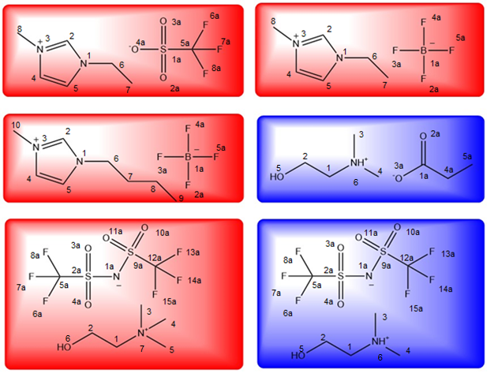
Figure 1: The structures of the six ionic liquids in this study; the aprotic ILs in red: [EMIm][OTf], [EMIm][BF₄], [BMIm][BF₄], and [Ch][NTf₂], and protic ILs in blue: [DMEtAH][Pr] and [DMEtAH][NTf₂]. The selection of IL systems allows for a systematic comparison of analogous protic and aprotic ILs, as well as the comparison of a common protic IL structure with three common aprotic imidazolium ILs.
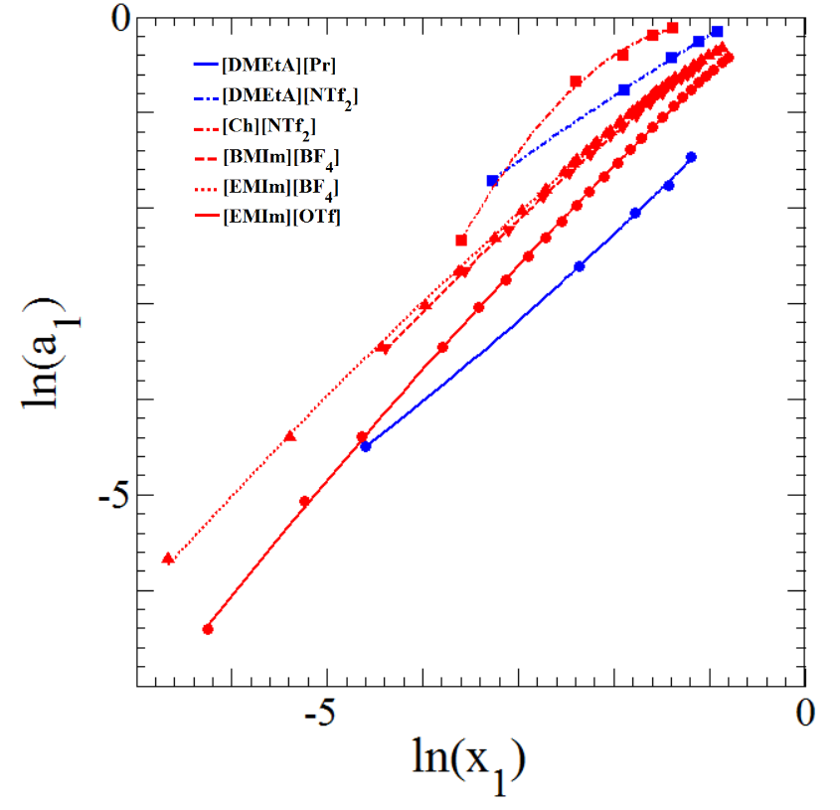
Figure 2: Dependence of the activity of water ($\ln{a_{1}})$ on the mole fraction of water dissolved in IL ($ln⁡x_{1}$). Fitting functions of the plots are used to calculate the KB parameters. Coefficients of the fitting functions are summarized in table S3.

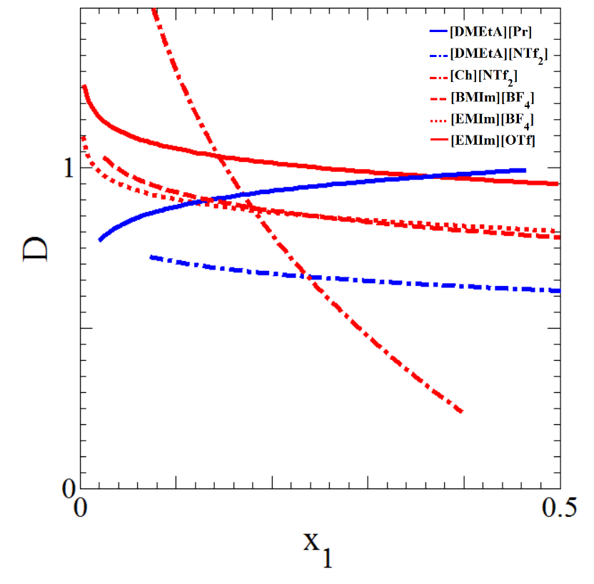
Figure 3: The D factor for each system as calculated from equation 5.

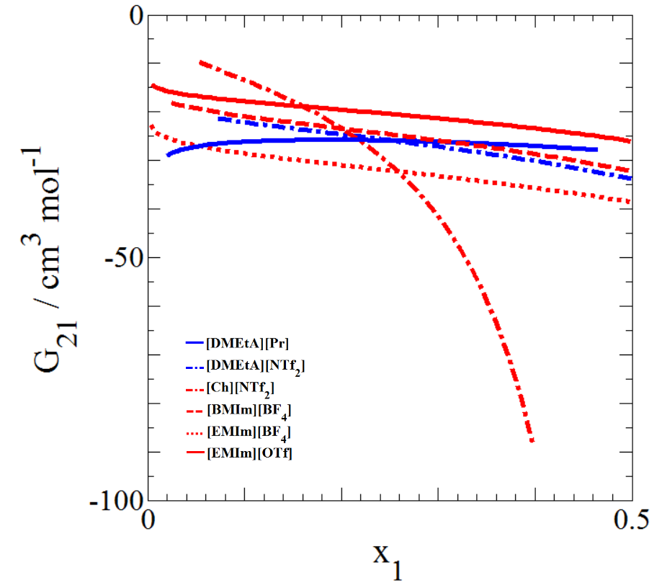

Figure 4: The dependence of water-ion Kirkwood Buff Integral G₂₁ (cm³ mol⁻¹) on water mole fraction (x₁) for the six systems studied as calculated by equation (3).

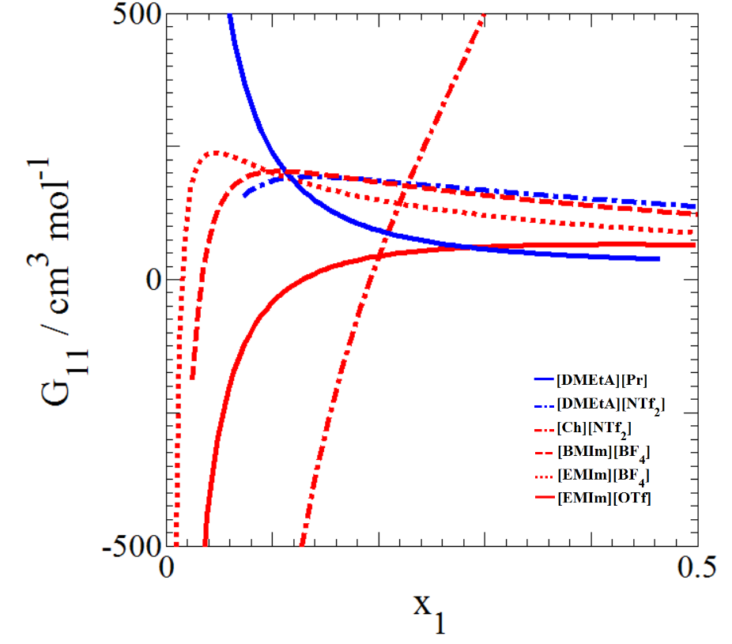
Figure 5: The dependence of water-water Kirkwood Buff Integral G₁₁ (cm³ mol⁻¹) on water mole fraction (x₁) for the six systems studied as calculated by equation (2).

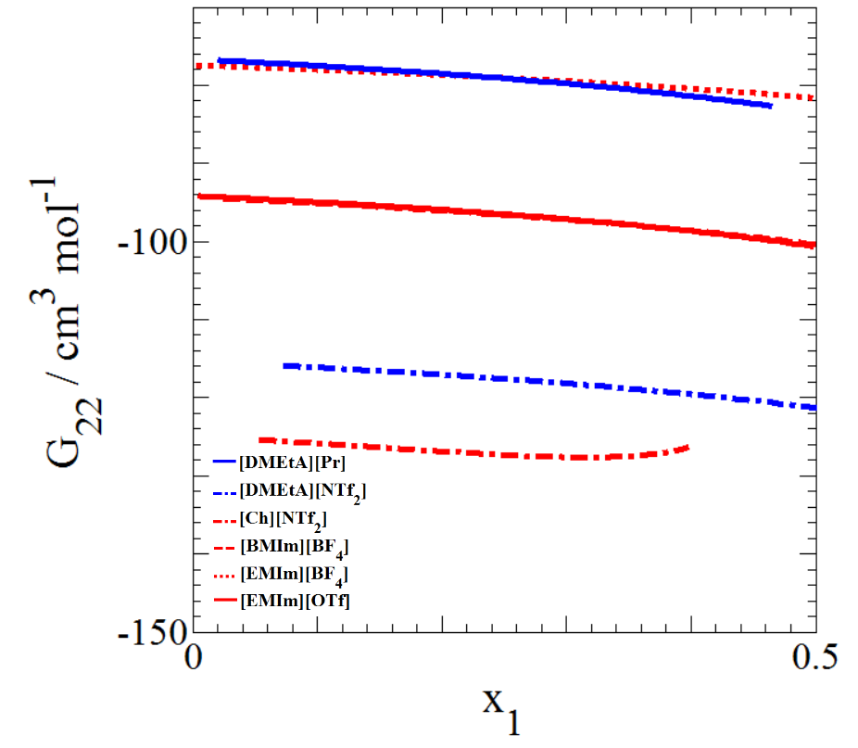

Figure 6: The dependence of ion-ion Kirkwood Buff Integral G₂₂ (cm³ mol⁻¹) on water mole fraction (x₁) for the six systems studied as calculated by equation (4).

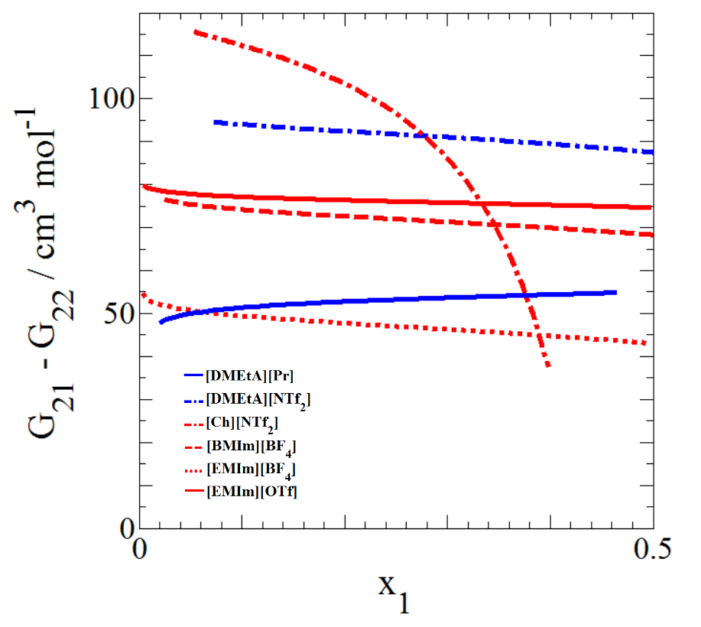
Figure 7: Dependence of preferential solvation of ions, (G21 – G22) on the mole fraction of water ($x_{1}$) for each system.³³

TOC Graphics

