An ‘unkindness’ of ravens? Measuring prosocial preferences in Corvus corax

Megan L. Lambertª, Jorg J.M. Massen^{b}, Amanda M. Seed^{c}, Thomas Bugnyar^{b,d} & Katie E. Slocombe^{a*}

ªDepartment of Psychology, University of York, UK
^{b}Department of Cognitive Biology, University of Vienna, Austria
^{c}School of Psychology and Neuroscience, University of St. Andrews, UK
^{d}Haidlhof Research Station, University of Vienna and University of Veterinary Medicine, Vienna, Austria

* Corresponding author

Correspondence to: Katie Slocombe, katie.slocombe@york.ac.uk. Department of Psychology, University of York, UK YO10 5DD. +44(0) 1904 322905

Abstract
In recent years there has been considerable research effort to determine whether other species exhibit prosocial motivations parallel to those of humans; however these studies have focused primarily on primates, and with mixed results. We presented captive ravens with a modified prosocial choice task which aimed to address several criticisms of previous methods by including a stringent pre-training regime and a setup that disentangles motivation to provision a conspecific from motivation to feed next to one. In this task subjects (N=6) received no rewards for themselves but could choose to deliver food rewards to either a conspecific or an empty, inaccessible compartment. Subjects did not demonstrate any prosocial tendencies (i.e., they did not preferentially choose to reward a conspecific over the empty compartment), and instead often ceased pulling on test trials when they received nothing for themselves (up to 70% of 80 trials with a partner present, up to 83% of 40 trials in a non-social control condition). The relationship between the subject and the partner had no influence on the subject’s choices; however subjects were more likely to pull immediately after performing socio-agonistic displays. Our results contribute to a growing body of evidence that despite their sophisticated social cognitive abilities and range of cooperative behaviours exhibited in the wild, un-paired (or unbonded) ravens do not seem to act to benefit conspecifics in the absence of immediate self-gain.

Keywords: altruism, avian cognition, corvid, Corvus corax, prosociality, raven

Humans’ extreme prosocial, or ‘other-regarding’ behaviour, is unparalleled in nature and is often cited as a defining characteristic of humanity that facilitates human cooperation on a global scale and may have played a key role in the evolution of our complex culture and technology (Fehr & Fischbacher, 2003). Despite its significance, the questions of whether humans alone possess intrinsic prosocial motivations, and how our unique levels of prosociality evolved have historically remained unanswered. In recent years, however, these topics have become the centre of much empirical focus and theoretical debate (Burkart & van Schaik, 2010; Burkart, Hrdy, & Van Schaik, 2009; Burkart & van Schaik, 2016; Silk & House, 2011; Thornton & McAuliffe, 2015).
Examples of prosocial behaviour can ostensibly be found throughout the animal kingdom, but the question remains as to whether, on a proximate level, these behaviours are governed by the same underlying psychological mechanisms (i.e., other-regarding concern) as those that prompt many human prosocial behaviours (de Waal & Suchak, 2010; Jensen, Vaish, & Schmidt, 2014). Recent research has aimed at probing the motivational mechanisms underpinning prosociality in other species, yet this has proved difficult to test. For example, a report that rats (Rattus norvegicus) behave prosocially toward conspecifics due to an empathetic concern for their welfare (Ben-Ami Bartal, Decety, & Mason, 2011) was later refuted by a lower-level explanation that subjects were motivated by a desire for social contact rather than empathy (Silberberg et al., 2013).
In the last decade there has been a surge of research aimed at investigating prosociality in nonhuman animals in controlled laboratory settings in order to tease apart these factors. One of the most widely used paradigms for measuring prosocial tendencies in other species is the prosocial choice task (Silk et al., 2005), a provisioning paradigm where subjects may choose between two options, one of which delivers food to both the subject and a nearby conspecific (prosocial choice; often denoted as the 1/1 option with payoffs for the donor and recipient, respectively) and the other which provides food to only the subject (selfish choice; 1/0 option). Reward distributions may also be manipulated so that subjects do not receive any rewards for either choice but rather may incur a slight cost for pulling to donate food to a recipient (0/1 option), or must forgo a qualitatively better reward for a less-preferred reward in order to also benefit their partner (HQ-0 versus LQ-HQ; Sterck et al. 2015). To further examine the motivations behind prosociality, many researchers have focussed on the inter-individual differences in prosocial tendencies based on the relationship between the subject and the partner. In all cases, prosocially motivated subjects are expected to preferentially choose the option which benefits a conspecific at little or no cost to themselves.
Several variations of the prosocial choice task have been used with a range of nonhuman species, with most available data coming from the primate order, and with equivocal results. While some studies have reported other-regarding preferences in several primate species (chimpanzees, Pan troglodytes: (Horner, Carter, Suchak, & de Waal, 2011); capuchins, Cebus apella: (Lakshminarayanan & Santos, 2008; Takimoto, Kuroshima, & Fujita, 2010); macaques, Macaca fascicularis: (Massen, van den Berg, Spruijt, & Sterck, 2010); marmosets, genus Callithrix: (Burkart, Fehr, Efferson, & van Schaik, 2007; Mustoe, Cavanaugh, Harnisch, Thompson, & French, 2015); tamarins, Sanguinus oedipus: (Cronin, Schroeder, & Snowdon, 2010; Hauser, Chen, Chen, & Chuang, 2003)) other studies with the same species, and in some cases the same individuals, have found contrasting results (chimpanzees: (Jensen, Hare, Call, & Tomasello, 2006; Silk et al., 2005; Vonk et al., 2008; Yamamoto & Tanaka, 2010); capuchins: (Burkart & Van Schaik, 2012); macaques: (Burkart & Van Schaik, 2012); tamarins: (Cronin, Schroeder, Rothwell, Silk, & Snowdon, 2009; Stevens, 2010)).
These differences have been attributed to various contextual factors and methodological differences between studies including the visibility of food rewards, the relationship between the subject and the recipient and the subjects’ understanding of the task (Burkart & Rueth, 2013; Cronin, 2012). For example, when confronted with the same paradigm used with primates, pre-school age children fail to show prosociality in a cost-free (1/1) version of the task, but are prosocial in a costly (0/1) version – a finding that has been attributed to the higher attentional demands of the cost-free version rather than a lack of prosociality (Burkart & Rueth, 2013). Prosocial behaviour may additionally be dependent on the ability to appreciate others’ goals or needs, and may thus only be expressed in response to signs of need by the recipient (Cronin, 2012; Horner et al., 2011; Schwab, Swoboda, Kotrschal, & Bugnyar, 2012; Vonk et al., 2008). A few studies have examined the effect of the recipient’s behaviour on the subject’s choices to determine whether direct requests or expression of interest in the reward affect the likelihood of prosocial choices by subjects. Those that have, have provided mixed results with reports of cottontop tamarins and chimpanzees being less likely to choose the prosocial option on trials where their partner reached out for the reward (Cronin et al., 2009) or produced begging gestures (Horner et al., 2011). In contrast, other studies have reported begging gestures to have no effect on chimpanzee subject choices (Vonk et al., 2008), whilst general attention getting behaviours by the partner such as food grunts or hitting the caging had a positive effect on prosocial choices (Horner et al., 2011).
Recently, Tan et al. (2015) and Marshall-Pescini et al. (2016) highlighted several methodological limitations with the current paradigms used to test prosocial preferences in nonhuman animals; namely, that very few (Tan et al. calculated 40.9%) include the necessary pre-test to ensure that subjects understand the test setup, and those that do may not be adequately counterbalanced to prevent location biases that may arise from pretraining. Additionally, in studies using a setup where subjects choose between two horizontally aligned trays, it may be difficult to disentangle motivation to provision a conspecific from motivation to feed next to one (Jensen et al., 2006; Tan, Kwetuenda, & Hare, 2015). In order to rule out these confounds in the future the authors suggest a number of methodological changes including a strict self-regard pre-test and counterbalancing to avoid location biases (Marshall-Pescini et al., 2016; Tan et al., 2015).
The discrepancies in the current literature highlight the need to explore this topic not only by using consistent methodology between species (e.g. (Burkart et al., 2014)) that addresses weaknesses in the standard paradigms used, but also by using multiple tasks with the same species (and subjects where possible) before drawing general conclusions on the presence or absence of a particular predisposition (Kim, Martinez, Choe, Lee, & Tomonaga, 2015; Tan et al., 2015). Additionally, research with other species outside of the primate order is needed in order to gain a broader understanding of the various factors that may give rise to prosocial behaviour such as breeding system, cognitive ability and social tolerance.
Corvids are frequently cited alongside primates for their complex social cognitive abilities (Emery & Clayton, 2004; Seed, Emery, & Clayton, 2009). Ravens, for example, are able to recognize third-party relationships among both in-group and out-group conspecifics (Massen, Pašukonis, Schmidt, & Bugnyar, 2014) and adjust their pilfering strategies depending on the presence and inferred visual perspectives of others (Bugnyar, 2011). In addition, corvids exhibit a range of cooperative behaviours including food sharing among conspecifics (von Bayern, de Kort, Clayton, & Emery, 2007) as well as the formation of affiliative relationships characterized by agonistic support (Fraser & Bugnyar, 2012) and post-conflict consolation and reconciliation (Fraser & Bugnyar, 2010).
Recently, several versions of the prosocial choice task have been used with corvids with results that mirror some chimpanzee studies. Using a setup similar to that used with chimpanzees (Silk et al., 2005), Di Lascio et al. (2013) allowed captive ravens to open one of two boxes, allowing access to food rewards for either themselves and a partner in a neighbouring compartment, or only themselves. The authors found no evidence for prosociality. Importantly, however subjects continued to choose at random in a post-test condition aimed at exploring whether they understood the consequences of their choices. The negative results of this study may therefore reflect a lack of understanding the apparatus rather than indifference to the partner’s payoffs, thus highlighting the importance of conducting knowledge tests prior to testing. Using a slightly modified version of this paradigm, Schwab et al. (2012) found that jackdaws (Corvus monedula) preferentially chose the reward option that simultaneously benefitted a conspecific, but primarily when the conspecific had already approached that option – a result that the authors attribute to stimulus/local enhancement rather than proactive prosociality. When presented with tokens that could only be exchanged by the partner for a reward, Massen et al. (2015) found that subadult ravens generally preferred to cache the tokens rather than transferring them to conspecifics. Finally, in contrast to these negative results, using a group-service paradigm (cf. (Burkart et al., 2014)), Horn et al. (2016) found that azure-winged magpies (Cyanopica cyana) do proactively provide food to their group members at very high rates. Nevertheless, overall these previous studies suggest that some species of corvid are not proactively prosocial. There is, however, the possibility that a lack of prosocial performance may alternatively be explained by the peripheral demands of particular prosocial tasks. Convergent evidence from different paradigms is, therefore, needed to resolve tension between naturally occurring cooperative behaviours and inconclusive performance on experimental tasks to date.
The present study builds on previous work on prosociality in ravens (Di Lascio et al., 2013; Massen, Lambert, et al., 2015) by testing this species in a task comparable to that frequently used with primates (e.g., (Burkart et al., 2007; Jensen et al., 2006; Massen et al., 2010; Massen, Luyten, Spruijt, & Sterck, 2011; Stevens, 2010)) while incorporating a pre-test condition for understanding of the apparatus, which will allow for further direct comparisons in test performance between corvids and other species. We gave a prosocial choice task to the same group of ravens tested in Massen et al.’s (2015) study (including two birds that did not participate in Massen et al.’s study) similar to that commonly used with primates. Several important modifications were made to the methods in order to overcome previously identified weaknesses in the paradigm (see methods and discussion). In this study, subadult ravens were paired with affiliate and non-affiliate partners in a paradigm in which subjects could choose between a tray that delivered food to a conspecific partner in a neighbouring compartment (0/1 option) or a tray that delivered food to an empty compartment (0/0 option). We predicted that, if subjects were proactively prosocial, they would be willing to incur a small cost by pulling the tray which delivered food to a conspecific more often than they would pull the same tray in a non-social control condition; a trend which might be more likely to appear in affiliate dyads. Alternatively, if the birds were not prosocial, we expected them to pull either tray at random or to cease pulling when they did not receive any rewards for themselves.
Rather than acting as definitive evidence of a lack of prosociality in other species, negative results of previous studies may be attributed to several key methodological factors such as the complexity of the setup (see Horner et al. 2011 for discussion), failure to examine differences in affiliative relationships (e.g., Silk et al. 2005), confounds of social facilitation (e.g., Jensen et al. 2006) and the attentional demands of a food reward in front of the subject’s compartment (Burkart & Rueth, 2013). We incorporated several key features into our test that address each of these potential issues by requiring subjects to pass an extensive pre-test for understanding of the apparatus, testing subjects with multiple partners of varying affiliation and using a setup that counters any potential social facilitation biases or distraction from visible food rewards in front of the subject’s compartment.

METHODS

Subjects and test site
Subjects came from a group of 12 hand-reared ravens. Nine of the birds participated in the study (subadults less than 3 years of age (Ratcliffe & Rose, 2010): 3 females and 4 males; adults: 1 male and 1 female): 1 as a subject only, 3 as partners only and 5 as both partners and subjects (counterbalanced between subject-first or partner first). Participation in training and testing sessions was voluntary. The 3 birds who did not participate in the study were not willing to reliably enter the testing area of the enclosure and the three birds who only participated as partners were not comfortable in the central testing compartment where subjects (a.k.a. donors) were tested.
All subadult birds hatched in 2012 (see supplementary material for detailed subject list), and the adult male and female hatched in 2011 and 2010, respectively. All subjects were housed together as a single social group at the Haildhof Research Station in Bad Vöslau, Austria. Feedings occurred twice daily in the mornings and afternoons and consisted of a mixture of dairy items, meat, bread, vegetables and fruits. Birds had ad libitum access to water in both the home aviary and testing compartments.
Ethical approval for this study was granted by the Department of Biology Ethics Committee, University of York, and by the ethical board of the behavioural research group at the faculty of Life sciences, University of Vienna (case number: 2015-003). Prior to this study the birds had participated in a number of physical and social cognitive experiments, including several studies on cooperative string pulling and prosociality (e.g., (Massen, Lambert, et al., 2015; Massen, Ritter, & Bugnyar, 2015). The birds also briefly participated in a cooperative string pulling experiment during the study (Asakawa-Haas, Schiestl, Bugnyar, & Massen, 2016); however, the setup for the current study was novel to the birds and took place in separate compartments from the previous studies.

Social data
Data on dominance and affiliation were collected to determine subject-partner dyads (affiliation data) and to examine whether differences in rank between the subject and the partner influenced subject choices during testing (dominance data).
Dominance: Dominance rank data were collected from monopolization experiments conducted during the time of the experiment, which consisted of presenting the group with two large pieces of partially frozen meat, a highly valued and easily monopolizable resource, for 30 minutes. All displacements during this time were recorded and later entered into a matrix with actors in rows and recipients in columns. Matman (version 1.1; de Vries et al. (1993)) was used to calculate Landau’s linearity indexes (h’). A significant linear hierarchy was identified throughout the study (h’= 0.581, N = 11, P < 0.01), based on 244 interactions and 18.18% of unknown relationships. These data were converted into relative rank difference scores for each dyad by subtracting the partner’s rank (ranging from 1 to 11) from the subject’s rank and using the value as an independent variable in the analyses. Rank difference scores ranged from -4 to 9.
Affiliation: Data on affiliative relationships were extracted from a database of ongoing focal observations taken from April to September 2014. During this time each individual was filmed for 5 continuous minutes, two to three times per week. Each individual’s frequency of allopreening and contact sitting with all other individuals was coded from video observations, and this number was then normalized per individual by calculating a percentage of affiliative interactions per partner, or relationship quality score. When selecting dyads, affiliate partners were selected as those birds whose relationship quality score with the subject was greater than zero, meaning they engaged in affiliative behaviours (preening, contact sitting) with, and spent time in close proximity to the subject. Non-affiliates were selected as neutral birds (relationship quality score =0) which did not have a particularly affiliative or agonistic relationship with the subject. For cases of less socialized, or lower-ranking birds (JO, RY), affiliates were chosen as those individuals who, based on the observation of the experimenters, had the least amount of agonistic interactions with the subject, also reflecting a relationship quality score of zero.

Dyads
In order to investigate potential effects of recipient identity on prosocial preferences, each subject was paired with one of two partners, one of whom was an affiliate and the other a non-affiliate (all dyads listed in ESM Table 2). These two partners were of opposite sex such that each bird was tested with a male and female partner (e.g. if the affiliate was male, the chosen non-affiliate was female, and vice versa). The sex of the affiliate partner was additionally counterbalanced so that half of the birds were paired with a female affiliate partner and male non-affiliate partner, whereas the other half were paired with male affiliates and female non-affiliates. This meant that across birds we could expect to detect independent effects of sex and relationship quality. Roles were never reversed within dyads to prevent potential reciprocity biases.

Setup and apparatus
Training and testing took place in a compartment attached to the home aviary (7 x 1.7m). When in the testing compartment, birds were visually isolated from the rest of the group but remained in auditory contact. The testing compartment could be further subdivided into three smaller, adjoining compartments (see figure 1). Subjects were always trained and tested in the middle of these compartments (106 x 170 x 250cm), and during testing a group mate (referred to as the ‘partner’) was present in either one of the side compartments (297 x 170 x 250cm). Mesh windows (55 x 23 cm) were present in the dividing walls between the middle and side compartments so that birds had visual access to one another, and these windows could be removed during training to allow birds to walk in between the compartments. The experimenter stood in front of the middle of these compartments to bait and operate the apparatus throughout training and testing sessions.

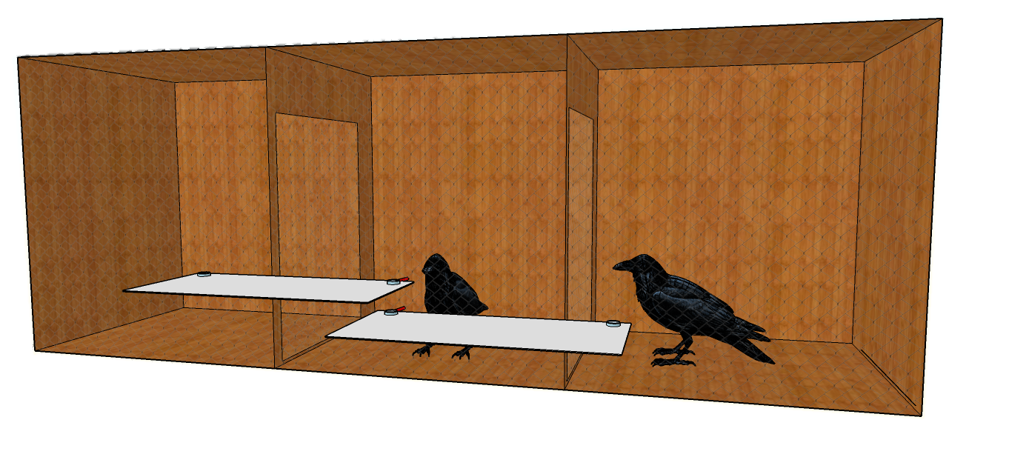
Figure 1. Test setup with subject in middle compartment and partner in one of the side compartments. Opaque trays the subject could choose to pull illustrated.

The apparatus consisted of two opaque, sliding trays, each of which could be temporarily mounted on one of two vertically aligned Perspex shelves that were affixed to the outer front of the testing compartments. Each tray spanned from the centre of the middle (subject’s) compartment to one of the side compartments, and both trays vertically overlapped by 10cm in front of the middle compartment such that during trials subjects were given a choice between an upper and a lower tray (see figure 1 for example). The trays were designed in this vertical manner to remove the confound associated with horizontally aligned trays, that prosocial choices may simply reflect a desire to be physically close to the social partner and to pull the nearest available tray from their preferred location. Each tray featured small cups fixed to each end to deliver food to middle and side compartments.
At the beginning of a trial, the trays were pushed forward so that the rope attached to the front of each tray was within reach of the subject. Subjects made a choice by pulling one of these ropes to slide the tray into reach of their compartment (and consequently one of the side compartments). Once the subject pulled one of the ropes, the experimenter pulled back the alternative tray so that the rope was no longer within reach. Importantly, the trays could also be switched between trials so that the tray that delivered a reward to the left or right compartment could be randomized between upper and lower shelves within a testing session (see figure 2).

2a)
2b)

Figure 2. Testing apparatus showing different tray configurations used within a testing session, with the upper tray delivering to either the left (figure 2a) or right (figure 2b) compartment.

Training
Prior to beginning testing, each subject completed a series of training steps to familiarize them with the apparatus and ensure that they understood the consequences of their choices. Given the cognitive demands of the apparatus, we considered demonstration of understanding the apparatus a vital prerequisite for starting test trials (see Tan et al. 2015 and Marshall-Pescini et al. 2016 for discussions). Subjects were always trained in the middle compartment. Training took place between May 2014 and January of 2015. A schematic of each of the training steps is featured in ESM figure 1.
Step 1: In the first training step both trays were baited in the 1/0 position (1/0 denotes payoffs to subject and partner compartments, respectively), such that choosing either the upper or lower tray provided a reward to the subject. This step allowed birds to learn to pull the string and also allowed for any potential tray biases to be measured. Birds completed one session of 20 trials pulling either tray before moving on to Step 2.
Step 2: One tray was baited in the 1/0 position while the other was baited in the 0/0 position, so that birds needed to pay attention to where the food was placed before pulling. Criterion was set at a minimum of 15/20 trials correct (i.e., pulling the tray with the food on it) in each of two consecutive sessions, with the trays in a different position (upper left or upper right; see figure 2) for each session. Subjects completed this step within 2-6 sessions (median: 3 sessions, or 60 trials).
Step 3: Both of the mesh windows were removed so that the subject could travel freely between the three compartments, and the trays were baited only on the outer sides (0/1). This step allowed subjects to learn that food rewards were delivered to the adjacent compartments, and again allowed for the measurement of any potential biases for the upper or lower tray. When beginning this step the birds had to initially be cued by the experimenter to the location of the food after pulling the string. Subjects met criterion after completing two consecutive sessions of 20 trials (40 trials total) pulling either tray to retrieve the food in the other compartments without any cuing from the experimenter. Once a bird met criterion in the session, in the following session the position of the trays was switched, so that, for example, in session 1 the upper tray delivered to the left compartment while in session 2 the lower tray delivered to the left compartment. Subjects completed Step 3 within 2-8 sessions (median: 4 sessions, or 80 trials).
Step 4: This final step ensured that subjects were attending to where each tray delivered food. Both trays were baited in the 0/1 position (delivering food to only the outside compartments) and the mesh window to one of the side compartments was closed while the other remained open. The position of the opening was alternated across sessions. In addition, the position of the trays was pseudo-randomized throughout each session so that for half of the 20 trials the lower tray delivered to the accessible compartment. There were no more than 4 consecutive trials of any tray position, so that subjects could not learn any association or preference for one tray throughout the session. In order to complete the fourth training step and proceed to testing, subjects needed to choose the correct (delivering food to the accessible compartment) tray a minimum of 15 trials within a session, for two consecutive sessions. Subjects completed Step 4 within 5-35 sessions (median: 9.5 sessions, or 190 trials). One subject, LO, had met criterion on numerous training sessions but not consecutively; in order to avoid overtraining her we advanced her to testing after 35 training sessions, in which she met criterion in two of her last four sessions.

TESTING

Conditions
Each subject was tested in three conditions: 1) an affiliative condition, 2) a non-affiliative condition and 3) a non-social control condition, where no partner was present. Subjects received two sessions, each containing 20 trials, and in each condition the position of the partner (left or right compartment) was counterbalanced within dyads and between sessions. The order of sessions was: NSC, Dyad 1, Dyad 2, Dyad 2, Dyad 1, NSC. Dyad 1 was pseudorandomized across subjects as to whether the partner was an affiliate or non-affiliate partner. The relative payoffs for subjects and partners were the same in each test condition, such that subjects never received a reward for pulling on a test trial, but partners received one eighth a piece of Frolic©, a preferred food, if the tray corresponding to their compartment was pulled.

Test trials
Test sessions were conducted in the mornings from 08:30-11:00, before the regularly scheduled feeding time. Trials began when the trays were pushed forward so that the ropes were within reach, and lasted until the subject made a choice or until 45 seconds had elapsed. A choice was counted when the subject pulled the tray so that it moved; if the subject touched the strings without moving the tray this was not counted as a choice.
Each test trial had three possible outcomes:
Prosocial - Subject pulls the tray that delivers food to the recipient’s compartment.
Asocial – Subject pulls the tray that delivers food to the empty compartment.
No pull – Subject does not pull either tray within 45s.
In order to ensure that birds were motivated to pull the trays, test trials were interspersed with motivation trials in which both of the trays were baited as 1/0, so that subjects could choose either tray to retrieve a reward for themselves only. Each testing session included 5 motivation trials: two at the beginning and subsequently one after every five test trials.

Behavioural data
For each test session, the behaviour of the subject and the partner, and the subject’s choices (including those in the non-social control condition) were coded in the Observer XT Version 10. A random selection of 20% of 34 (N = 7) sessions was independently re-coded by a research assistant uninvolved in the study and blind to the affiliation between subject and partner. A reliability score for each behaviour was calculated using SPSS, with Cohen’s kappa scores ranging from 0.66 to 0.91 (see Table 1 for individual behaviour scores). Interobserver reliability for pulling (no pull, asocial or prosocial), our main dependent variable, was excellent (Cohen’s kappa = 0.98).

Table 1. Behaviours coded from test sessions.

Category |  |  | Behaviour | Definition
Subject behaviour |  |  | Subject vocalize | Subject vocalizes whilst in sight. Vocalizations are considered one discrete response until bird has stopped vocalizing for at least 5s, in which case a new bout begins. Cohen’s kappa = 0.87.
 |  |  | Subject display | Subject erects feathers and assumes posture consistent with self-aggrandizing display. May be accompanied by vocalizations (described in (Boeckle, Szipl, & Bugnyar, 2012)). Cohen’s kappa = 0.82.
 |  |  | Subject at partner window | Subject stands directly in front of window separating subject/partner compartments, facing window. Cohen’s kappa = 0.83.
Partner behaviour |  |  | Partner vocalize | Partner vocalizes while in sight. Vocalizations are considered one discrete response until bird has stopped vocalizing for at least 5s, in which case a new bout begins. Cohen’s kappa = 0.91.
 |  |  | Partner display | Partner erects feathers and assumes posture consistent with self-aggrandizing display. May be accompanied by vocalizations (Boeckle et al., 2012). Cohen’s kappa = 0.66.
 |  |  | Partner directed attention-getting behaviour | Partner performs either of two behaviours:  - Interact with tray: partner contacts either of the experimental shelves in front of their compartment with the beak (e.g., pecking or biting).  - Peck window: Partner pecks at mesh window separating subject/partner compartments. Usually this occurs as just one quick peck, but if they are pecking rapidly in succession this is considered one discrete event as well until there is a pause of two seconds between pecks. Cohen’s kappa = 0.70.

Ethogram of subject and partner behaviours coded throughout test sessions and used as independent variables in the analyses. Reliability scores for each behaviour are included in the definition.

Analyses
All data were analysed in IBM SPSS Statistics version 21, with the significance level set at P < 0.05. First, we employed two-tailed non-parametric tests on repeated measures data (e.g. Wilcoxon signed ranks test) using either a corrected prosocial tendency measure (discussed below) or proportional data to explore if as a group, the subjects’ choices varied between conditions. Given the small sample sizes we report exact p values (Mundry & Fischer, 1998). We then examined choice data at the level of each individual bird using chi-square goodness of fit tests to compare the proportion of no-pull responses across the three conditions, and binomial tests to examine prosocial choices within affiliate and non-affiliate conditions, with each individual’s expected proportion of prosocial choices calculated by the number of times the subject delivered food to the corresponding compartment in the non-social control condition. Binomial tests were additionally used to measure individual biases for a particular tray (chance = 0.5; data presented in ESM Table 4). Two subjects, LO and AD, failed to complete their last non-social control session due to lack of motivation and breeding respectively, therefore only their first three sessions (one non-social control, affiliate and nonaffiliate test session) were used in non-parametric analyses.
After analysing the raw data across conditions we then used Generalized Linear Mixed Models (GLMMs) to examine the relative influence of various factors on test performance. GLMM 1 examines the influence of factors relating to the subject-partner relationship on corrected prosocial tendency (CPT) values and GLMMs 2 and 3 measure how the subject and partner’s behaviour, as well as subject’s performance in the training sessions, predicted subject choices on a trial-by-trial basis. The full model is reported for all GLMMs (Burnam & Anderson, 2014; Whittingham, Stephens, Bradbury, & Freckleton, 2006).

GLMM1: Corrected prosocial tendency and dyad relationship
To correct for potential side preferences, a prosocial tendency score was calculated for each testing session. This was calculated in two steps: (i) for each test session to determine how much the subject’s preference for the tray delivering food to the partner’s compartment deviated from their preference for the tray that delivered to the same compartment in the non-social control condition as determined: (Prosocial pulls for partner’s compartment in test/total pulls in test)-(number of pulls for same compartment in control/total pulls in control). (ii) Depending on how large the subject’s initial preference for delivering food to a particular compartment was in the non-social control they may have had more or less space to increase or decrease this preference in test trials, so a corrected prosocial tendency was calculated using the formula Pt’=Pt/Deviation Space (cf. Massen et al. 2011). Deviation space was calculated depending on whether the prosocial tendency was positive (DevSpace=1-side preference in NSC), or negative (DevSpace= side preference in NSC). These calculations provided each subject with one corrected prosocial tendency score per dyad session, and two prosocial tendencies per partner (one for when the partner is on the left, the other for when the partner is on the right).
The rank difference between subject and partner, the relative sex of the partner (same sex versus opposite sex) and the affiliation between the partner and the subject (affiliate, non-affiliate) were entered as fixed factors into a model with a normal distribution and identity link function, with CPT as the dependent variable. The CPT for each session was entered as one data point (N = 24 from 6 individuals) and subject and partner were entered as random factors to control for multiple sampling of individuals.

GLMMs 2&3: Subject/partner behaviour and subject choices.
The aim of GLMMs 2 and 3 was to investigate, on a trial by trial basis, the influence of the subject’s and partner’s behaviour on whether or not the subject chose to pull (GLMM2, dependent variable: ‘pull’ (yes/no)) and when they did pull, whether they chose prosocially or asocially (GLMM3, dependent variable: ‘choice’; all no-pull trials excluded). Both GLMMs were modelled with a binomial distribution and a logit link function. Each trial, rather than session, was entered as a data point in both models (N = 479 for GLMM 2 and N = 293 for GLMM 3) with subject identity, partner identity and session number entered as random factors to control for multiple sampling at these different levels. The same fixed factors were used for both models: subject display, subject at partner window, subject vocalize, partner vocalize, partner display, and partner directed attention-getting behaviour. Partner displays were analysed separately from partner attention-getting behaviour as the former may, in some contexts, be considered agonistic (Braun & Bugnyar, 2012) and consequently may have a differing influence on the subject’s choices. These behavioural fixed factors were formatted as binary data to determine whether subjects’ choices in each trial could be predicted by whether or not partners or subjects performed certain behaviours during the time immediately before subjects made a choice (the time period from choosing in the last trial until the next choice). To determine whether subjects’ performance on the test trials was influenced by how quickly they demonstrated understanding of the apparatus in the training, we also included each subject’s total number of trials to criterion for training steps 1-4 as a fixed factor.

RESULTS

Pulling versus not pulling
Rather than continuing to pull throughout the sessions, most of the birds ceased pulling on 14 to 74% of trials (median: 32%), while continuing to pull on 87-100% (median: 97%) of the motivation trials that were interspersed throughout the session. There was no significant difference in the proportion of pulls when a partner was present or not present (control sessions versus test sessions grouped; Wilcoxon signed ranks test: N = 6, Z = -0.105, P = 0.938), or between control, affiliate and non-affiliate conditions (Friedman’s ANOVA: N = 6, χ² = 0.095, P = 0.994). Individual chi-square goodness of fit tests comparing rates of pulling across all three conditions revealed that one subject pulled significantly more in the non-social control condition than in affiliate and non-affiliate conditions (NO: χ² = 15.250, P < 0.001), while another subject pulled significantly less in the affiliate condition than in the non-affiliate and non-social control conditions (JO: χ² = 14.535, P = 0.001). For the remaining subjects there was no difference in pulling across conditions (ESM table 3).

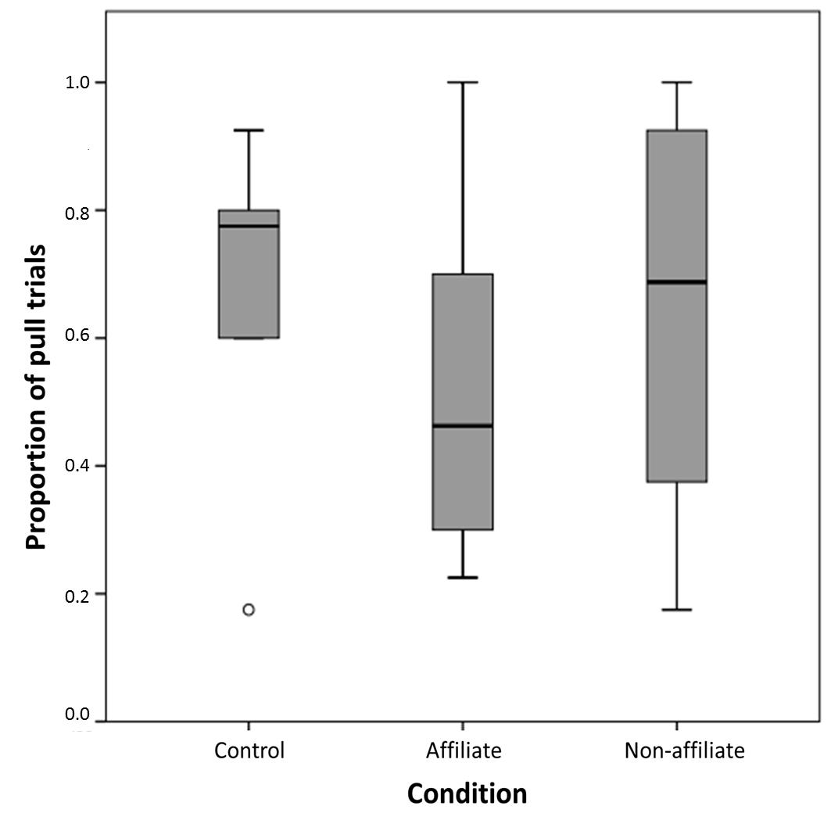
Figure 3. Boxplot illustrating the median proportion of trials in each condition where subjects chose to pull. Boxplots show minimum and maximum values, median and 25th and 75th percentiles. Open circle denotes outlier.

Prosocial pulls
Overall, when subjects did pull, there was no significant difference in the proportion of prosocial pulls toward affiliates or non-affiliates (Z = -0.734, N = 6, P = 0.563) and similarly no significant difference between affiliate and non-affiliate conditions when corrected prosocial tendency was used as the dependent variable (Z = -1.363, N = 6, P = 0.219). On an individual level, none of the subjects demonstrated any significant prosocial tendencies in either the affiliate or non-afffiliate conditions (individual binomial tests, P > 0.132; Table 2), or chose prosocially above chance in any test session with any partner (see ESM Table 4). Instead, when pulling, 5 of 6 subjects showed significant preferences for one tray, with four individuals preferring the upper tray and one individual preferring the lower tray (ESM Table 4). Each subjects’ prosocial pulls, and number of pull trials per session is listed in ESM table 4.
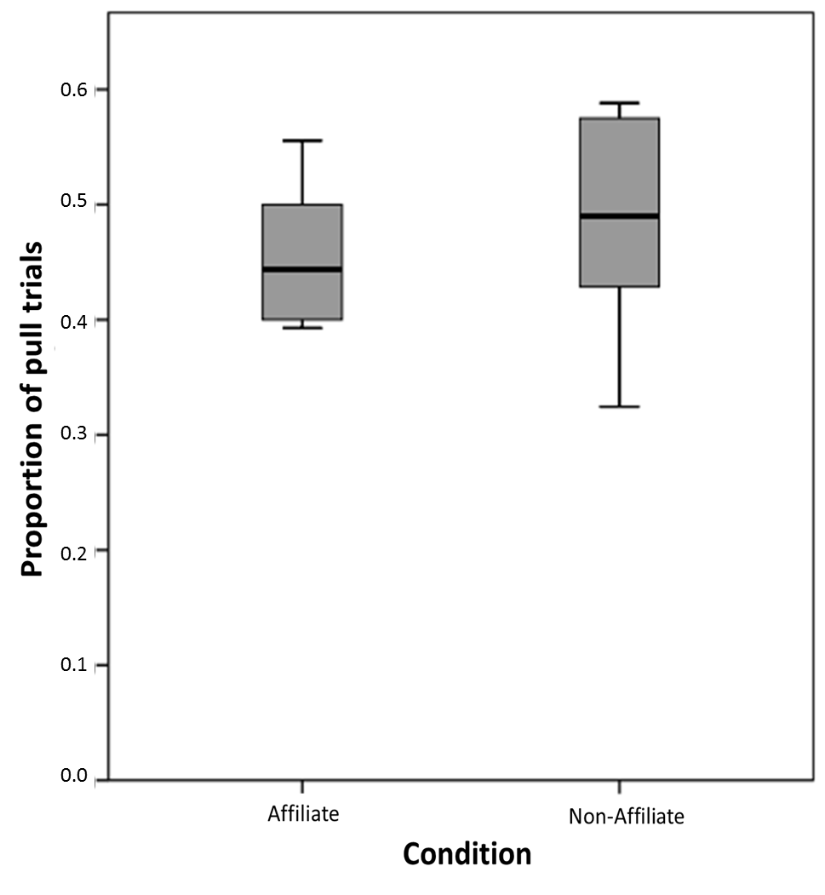
Figure 4. Boxplot illustrating proportion of pull trials in affiliate or non-affiliate conditions when subjects pulled prosocially (pulled the tray that delivered to the partner’s compartment). Boxplots show minimum and maximum values, median and 25th and 75th percentiles.

Table 2. Individual prosocial preferences.
Subject | Expected proportion | Observed proportion
 |  | Affiliate | Non Affiliate
Joey | 0.46 | 0.42; P=0.998 | 0.32; P=0.133
Nobel | 0.31 | 0.56; P=0.223 | 0.27; P=0.962
George | 0.42 | 0.39; P=0.929 | 0.48; P=0.679
Louise | 0.44 | 0.40; P=0.731 | 0.50; P=0.629
Adele | 0.53 | 0.50; P=0.881 | 0.58; P=0.683
Rocky | 0.43 | 0.47; P=0.917 | 0.43; P=1.000

Results of individual binomial tests on total number of prosocial pulls, with chance level set as number of pulls delivered to the same compartment in control condition.

Behavioural data and partner identity

GLMM1: Corrected prosocial tendency and dyad relationship
To determine whether the subject’s prosocial tendency was influenced by various aspects characterising the relationship between the subject and the partner, we ran a GLMM with corrected prosocial tendency (CPT) as the dependent variable. Relative sex of the partner (F_{1,20} = 0.662, coefficient = 0.134 + 0.165, p = 0.425), affiliation (F_{1,20} = 3.600, coefficient = -0.286 + 0.151, p = 0.072) and relative rank of the partner (F_{1,20} = 0.135, coefficient = -0.008 + 0.021, p = 0.717), did not significantly predict subjects’ overall prosocial tendency.

GLMM2: Pulling and partner/subject behaviour
In order to determine whether the behaviour of the subject or partner had any effect on whether or not the subject inhibited pulling on a trial by trial basis, we ran a binomial GLMM with the binary dependent variable of pull or no pull (see Table 3). Subjects were significantly more likely to pull immediately after they displayed (figure 5), and showed a trend for pulling immediately following directed attention-getting behaviour by the partner such as pecking at the tray or the window. Displays by the partner, vocalizations by the subjects and whether or not the subject spent time at the window to the partner’s compartment had no significant effect on whether or not subjects pulled. Additionally, the rate of pulling was not predicted by subjects’ performance in the training sessions.

Table 3. Pulling and subject/partner behaviour.

 | F value | df1 | df2 | Coefficient | P-value
Partner directed attention getting behaviour | 3.827 | 1 | 471 | 0.661+ 0.338 | 0.051
Partner display | 1.454 | 1 | 471 | -0.555+ 0.460 | 0.228
Partner vocalize | 0.185 | 1 | 471 | 0.152 + 0.354 | 0.667
Subject display | 3.964 | 1 | 471 | 1.664+ 0.836 | 0.047
Subject at partner window | 0.066 | 1 | 471 | -0.070+ 0.272 | 0.798
Subject vocalize | 0.308 | 1 | 471 | 0.272+0.489 | 0. 579
Subject training performance | 0.276 | 1 | 471 | 0.002 + 0.005 | 0.600

GLMM2 assessed with binomial generalized linear mixed model (GLMM) with logit link function (N = 479 data points). Dependent variable was pull or no pull and subject, partner and session were entered as random factors. Test statistics (significant results in bold) and coefficients using ‘pull’ as the reference category + standard error are shown.

Figure 5. Proportion of trials in which subjects pulled the tray or didn’t pull the tray after displaying or not displaying.

GLMM3: Prosocial choices and partner/subject behaviour
In order to determine whether the behaviour of the subject or partner had any effect on whether or not the subject chose prosocially on a trial by trial basis, we ran a binomial GLMM with the binary dependent variable of prosocial or asocial pull. Displays and vocalizations by the partner or subject, attention getting behaviour by the partner and whether the subject was at the partner window immediately before pulling had no significant influence on whether or not the subject chose prosocially (table 4). Additionally, choices were not predicted by subjects’ performance in the training sessions.

Table 4. Prosocial choices and subject/partner behaviour.

 | F | df1 | df2 | Coefficient | P-value
Partner directed attention getting behaviour | 0.039 | 1 | 285 | 0.056 + 0.283 | 0.845
Partner vocalize | 0.454 | 1 | 285 | -0.224 + 0.332 | 0.501
Partner display | 0.001 | 1 | 285 | -0.014 + 0.434 | 0.974
Subject display | 1.383 | 1 | 285 | 0.600 + 0.510 | 0.241
Subject at partner window | 1.240 | 1 | 285 | -0.307 + 0.276 | 0.266
Subject vocalize | 0.000 | 1 | 285 | -0.005 + 0.398 | 0.991
Subject training performance | 0.031 | 1 | 285 | 0.000 + 0.001 | 0.861

GLMM3 assessed with binomial logit link function (N=293 data points). Dependent variable was prosocial or asocial pull and subject, partner and session were entered as random factors. Test statistics and coefficients + standard error are shown.

DISCUSSION
Despite meeting strict pre-training criterion for understanding of the apparatus, none of the birds demonstrated significantly prosocial or asocial tendencies when paired with affiliates or non-affiliates. These results are similar to those of chimpanzees, where subjects showed no difference in choices between control and partner conditions (Jensen et al., 2006; Silk et al., 2005; Vonk et al., 2008), or between different partner types such as kin or non-kin, dominants or subordinates ((Jensen et al., 2006; Silk et al., 2005; Vonk et al., 2008), but see (Horner et al., 2011)). On an individual level, no bird chose prosocially above chance in any test session with any partner, suggesting that the birds did not act with any regard to the identity or presence of their partner in the neighbouring compartment. While alternative explanations have been offered for the negative results of previous studies (e.g., a lack of understanding, or attentional demands of visible food rewards) our revised methodology aimed to rule out many of these alternatives so that the most likely conclusion would be that subjects were not prosocial in this task. Although the large number of trials most birds required to pass the training steps, indicates the possibility they may not have fully understood the apparatus cannot be eliminated, these preliminary results contribute to a growing body of evidence that corvids, and ravens in particular, consistently do not choose to benefit a conspecific if there is no direct benefit to themselves (Di Lascio et al., 2013; Massen, Lambert, et al., 2015; Schwab et al., 2012).
In addition to pulling prosocially or asocially, the birds in this study could also not pull on test trials; which indeed was expected if the birds were indifferent to the gains of their partners, as subjects were never rewarded on test trials. Instead of continuing to pull throughout the sessions, most of the birds did cease to pull on test trials when they received nothing for themselves, but continued to pull on the motivation trials that were interspersed throughout the session. This lack of pulling occurred evenly across all sessions and did not increase with experience. At the group level, there was no difference in pulling between affiliates and non-affiliates. Similarly, the chimpanzees in Jensen et al.’s 2006 study did not pull when they received no rewards for themselves, but continued to pull on knowledge probe trials when they could retrieve the food delivered to the neighbouring compartment.
On a trial-by-trial basis, subjects were significantly more likely to pull after socio-agonistic displays than when they did not perform such displays. This finding is surprising as it could be predicted that subjects would choose not to act after performing a status show-off toward the partner. In other corvid species (e.g., rooks), food offering may serve a costly signalling function to convey information about the quality of the donor, with more dominant individuals transferring significantly more food items to conspecifics (Scheid, Schmidt, & Noe, 2008). This may be one possibility for the increased number of pulls following dominance displays by the subjects in our study, however if this were the case it would be expected that subjects would choose prosocially, rather than at chance, after displaying. An alternative explanation is that displays corresponded with a heightened level of arousal and thus a greater likelihood of interacting with objects in the subject’s immediate environment, similar to the displays of chimpanzees (Goodall, 1964). Future studies could explicitly test this possibility by examining other markers of arousal (e.g. general activity level) and whether these vary systematically with displays.
There was a trend for subjects to pull more just after partners performed attention-getting behaviours, which may have aroused the subject or drawn their general attention to the trays. However, neither the behaviour of the partner nor the subject predicted prosocial or asocial choices. This suggests that rather than demonstrating needs or goals to the subject, the partner’s behaviour may have incited an increase in general arousal that tended to prompt the subject to pull a tray, but without specifically aiming to reward the partner. Such results should be taken into consideration when interpreting one-choice tasks such as the group service paradigm (e.g., (Burkart et al., 2014)), in which choosing to pull by the subjects results in only one (prosocial) outcome, in contrast to the prosocial or asocial choices afforded to subjects in this study. In one-choice tasks, when multiple partners are present in the enclosure and directing their attention to rewards it may incite subjects to pull significantly more than in control conditions, regardless of what the desired outcome is.
This study introduces several methodological changes aimed at providing a more stringent assessment of prosocial tendencies. In particular, we modified the apparatus so that the position of the reward trays could be randomized throughout trials. Subjects had to first meet criterion with a strict, multi-step training scheme in which the tray position was frequently switched, so that they had to constantly attend to where each tray delivered rewards. This same randomized scheme was used in testing sessions so that if subjects were other-regarding they had to constantly attend to the position of their trays and alter their choice of the upper or lower tray within a session to deliver rewards to their partner. Although the majority of birds developed preferences for a particular tray when pulling, we do not believe this necessarily reflects any lack of understanding on the part of the birds, as subjects received equal rewards for pulling either tray (i.e., no rewards on test trials and one reward on motivation trials), and consequently there is no cost or benefit to switching tray preferences unless the birds are motivated to provision conspecifics. Instead, switching the trays throughout trials prevents any biased responding from resulting in a significantly prosocial preference. In addition, studies using two compartments typically reward subjects for delivering food to the neighbouring compartment during pre-training, which may result in these same preferences persisting throughout testing sessions when a partner is present (Tan et al., 2015). We used three compartments and ensured birds had equal experience of being rewarded for pulling and retrieving rewards from both prosocial and non-social compartments. We additionally modified the trays so that they were vertically aligned in the centre of the subject’s compartment, thus controlling for the possibility that subjects might choose a prosocial option because they prefer to be located or feed near conspecifics and simply pulled the tray closest to their preferred location, rather than being prosocially motivated.
It could be argued that the dynamic nature of the tray and partner positions may have made the tests overly complex and thus difficult for the birds to understand. For example, birds met criterion on the final training step after a median of 9.5 sessions, or 190 trials. It is possible that in such a large number of trials birds may have learnt a local contingency rule that enabled them to pass the training step, without fully understanding the apparatus. If this was the case, we would expect that test performance would potentially differ for individuals who required more trials to pass training and may have not fully understood the apparatus. Our results do not, however, support this idea, as individuals’ performance in the test trials could not be explained by how quickly they met the pre-training criterion. Unfortunately it is difficult to assess how training performance compares to other tasks or other species as many studies either do not require subjects to meet criterion for knowledge of task contingencies (reviewed in (Marshall-Pescini et al., 2016; Tan et al., 2015)) or do not report the number of trials that subjects needed to reach this criterion (Burkart et al., 2007; Cronin et al., 2010; Mustoe et al., 2015). Those that have included this information are additionally difficult to compare as they require the subjects to attend to different features of the task such as the location of food or the quality of the food. For example, the subjects in Cronin et al. (2009) were required to reliably choose the baited tray among two vertical trays (each tray could be baited on either the donor’s side or the recipient’s side) and to retrieve the food from the location to which it was delivered. In this case subjects needed a median of 70 trials to meet criterion. This is most similar to our training steps 2 and 3, in which subjects were required to attend to which tray held the reward (Step 2) and retrieve the food from the location corresponding to the tray pulled (Step 3; median of 60-80 trials to criterion for both steps). In a similar paradigm using different reward distributions, capuchin monkeys required a median of 100 trials in order to reliably choose a tray with two high-value rewards over a tray with one high value and one low value reward (Lakshminarayanan & Santos, 2008). In the current setup the ravens were required to constantly reassess which of the equally-baited trays delivered food to the accessible compartment, the location of which additionally varied across sessions. Given the rigorous nature of this training scheme it might be expected that subjects would require more trials to reach criterion. In addition to including such pre-tests in future studies (Marshall-Pescini et al., 2016; Tan et al., 2015), we suggest that providing data on the number of trials or sessions to reach this criterion will allow for between-species and between-task comparisons that will aid in designing future paradigms.
One of the primary limitations of this study is the small sample size. These results need further replication with a larger number of individuals, while continuing to examine prosocial preferences on an individual level. In particular, if the birds had shown variation in prosocial choices across sessions, the small sample size and design of the study may have made it difficult to draw firm conclusions about the influence of relative sex, rank and affiliation on choice behaviour. However, given that no birds chose the prosocial choice above chance in any session, there was little variation available for these factors to account for. Our results are consistent with previous studies that have found no evidence for prosociality in captive ravens using different methods, including token exchange (Massen, Lambert, et al., 2015) and allowing conspecifics to access food rewards (Di Lascio et al., 2013). These results should be interpreted with caution, however, given the high number of trials required to meet pre-test criterion which suggests that the task may have proved overly complex for some of the subjects, and therefore these subjects may have lacked full understanding of the task. Our data ultimately build upon the results of (Massen, Lambert, et al., 2015) and (Di Lascio et al., 2013) to provide preliminary, convergent evidence that ravens do not preferentially act to benefit conspecifics, and highlight the need to conduct further research with larger numbers of this species using simplified, but comparable tasks which explicitly test for understanding of the apparatus prior to testing.
Notably, this study was performed with mainly sub-adult birds that had not yet formed the species-typical monogamous pair bonds which have been predicted to show the strongest expression of prosociality in other species (Cronin, 2012), and may not yet have fully developed their social cognitive abilities. The social world of a (sub) adult raven that does not have a pair-bond and territory yet is arguably more complex than that of an adult pair-bonded bird as during this time the birds form large aggregations that also consist of smaller, socialized subgroups (Braun, Walsdorff, Fraser, & Bugnyar, 2012). It is during this period that the birds must keep track of complex dominance hierarchies and form their own affiliate relationships. Sub-adult ravens are already capable of understanding third-party relationships among conspecifics (Massen et al., 2014) and additionally, the birds in this study have already shown that they attend to the identity and relative efforts and payoffs of cooperative partners (Asakawa-Haas et al., 2016; Massen, Ritter, et al., 2015), and thus it would be expected that a similar level of understanding would operate in the present study. In order for prosocial tendencies to emerge in this task however, prosocial motivation, in additional to social cognitive skill, is needed. It thus appears that the ravens’ performance in this task may be attributed to a lack of prosocial motivation in this particular context.
In sum, in this study we introduced several methodological changes that may benefit future tests of prosocial preferences, including a rigorous counterbalancing scheme, strict pre-training criterion for understanding the task and interspersed motivation trials showing that failure to pull was not explicable by a general learned irrelevance. Using these methods we show that when given the option to benefit conspecifics at a small cost to themselves, ravens do not choose to do so, regardless of conspecific identity or behaviour – a result that thus far appears consistent in this species across several different paradigms, suggesting that ravens may have earned their collective name, an “unkindness”.

References
Asakawa-Haas, K., Schiestl, M., Bugnyar, T., & Massen, J. J. M. (2016). Partner choice in raven (Corvus corax) cooperation. PLoS ONE, 11(6), e0156962 http://dx.doi.org/10.1371/journal.pone.0156962
Ben-Ami Bartal, I., Decety, J., & Mason, P. (2011). Empathy and pro-social behavior in rats. Science, 334(6061), 1427-1430 http://dx.doi.org/10.1126/science.1210789
Boeckle, M., Szipl, G., & Bugnyar, T. (2012). Who wants food? Individual characteristics in raven yells. Animal Behaviour, 84(5), 1123-1130 http://dx.doi.org/10.1016/j.anbehav.2012.08.011
Braun, A., & Bugnyar, T. (2012). Social bonds and rank acquisition in raven nonbreeder aggregations. Animal Behaviour, 84(6), 1507-1515 http://dx.doi.org/10.1016/j.anbehav.2012.09.024
Braun, A., Walsdorff, T., Fraser, O. N., & Bugnyar, T. (2012). Socialized sub-groups in a temporary stable Raven flock? Journal of Ornithology, 153, 97-104 http://dx.doi.org/10.1007/s10336-011-0810-2
Bugnyar, T. (2011). Knower–guesser differentiation in ravens: others' viewpoints matter. Proceedings of the Royal Society of London B: Biological Sciences, 278(1705), 634-640 http://dx.doi.org/10.1098/rspb.2010.1514
Burkart, J., & van Schaik, C. (2010). Cognitive consequences of cooperative breeding in primates? Animal Cognition, 13(1), 1-19 http://dx.doi.org/10.1007/s10071-009-0263-7
Burkart, J. M., Allon, O., Amici, F., Fichtel, C., Finkenwirth, C., Heschl, A., . . . van Schaik, C. P. (2014). The evolutionary origin of human hyper-cooperation. Nat Commun, 5 http://dx.doi.org/10.1038/ncomms5747
Burkart, J. M., Fehr, E., Efferson, C., & van Schaik, C. P. (2007). Other-regarding preferences in a non-human primate: Common marmosets provision food altruistically. Proceedings of the National Academy of Sciences of the United States of America, 104(50), 19762-19766 http://dx.doi.org/10.1073/pnas.0710310104
Burkart, J. M., Hrdy, S. B., & Van Schaik, C. P. (2009). Cooperative breeding and human cognitive evolution. Evolutionary Anthropology, 18(5), 175-186 http://dx.doi.org/10.1002/evan.20222
Burkart, J. M., & Rueth, K. (2013). Preschool children fail primate prosocial game because of attentional task demands. PLoS ONE, 8(7), e68440 http://dx.doi.org/10.1371/journal.pone.0068440
Burkart, J. M., & Van Schaik, C. P. (2012). Group service in macaques (Macaca fuscata), capuchins (Cebus apella) and marmosets (Callithrix jacchus): A comparative approach to identifying proactive prosocial motivations. Journal of Comparative Psychology, 127(2), 212-215 http://dx.doi.org/10.1037/a0026392.
Burkart, J. M., & van Schaik, C. P. (2016). Revisiting the consequences of cooperative breeding. A response to Thornton & McAuliffe (2015). Journal of Zoology, 229(2), 77-83 http://dx.doi.org/10.1111/jzo.12322
Burnam, K. P., & Anderson, D. R. (2014). Model selection and multimodel inference. New York: Springer.
Cronin, K. A. (2012). Prosocial behaviour in animals: the influence of social relationships, communication and rewards. Animal Behaviour, 84(5), 1085-1093 http://dx.doi.org/10.1016/j.anbehav.2012.08.009
Cronin, K. A., Schroeder, K. K. E., Rothwell, E. S., Silk, J. B., & Snowdon, C. T. (2009). Cooperatively breeding cottontop tamarins (Saguinus oedipus) do not donate rewards to their long-term mates. Journal of Comparative Psychology, 123(3), 231-241 http://dx.doi.org/10.1037/a0015094
Cronin, K. A., Schroeder, K. K. E., & Snowdon, C. T. (2010). Prosocial behaviour emerges independent of reciprocity in cottontop tamarins. Proceedings of the Royal Society B: Biological Sciences, 277(1701), 3845-3851 http://dx.doi.org/10.1098/rspb.2010.0879
de Vries, H., Netto, W. J., & Hanegraaf, P. L. H. (1993). Matman: a program for the analysis of sociometric matrices and behavioural transition matrices. Behaviour, 125(3), 157-175 http://dx.doi.org/doi:http://dx.doi.org/10.1163/156853993X00218
de Waal, F. B. M., & Suchak, M. (2010). Prosocial primates: selfish and unselfish motivations. Philosophical Transactions of the Royal Society B-Biological Sciences, 365(1553), 2711-2722 http://dx.doi.org/10.1098/rstb.2010.0119
Di Lascio, F., Nyffeler, F., Bshary, R., & Bugnyar, T. (2013). Ravens (Corvus corax) are indifferent to the gains of conspecific recipients or human partners in experimental tasks. Animal Cognition, 16(1), 35-43 http://dx.doi.org/10.1007/s10071-012-0548-0
Emery, N., & Clayton, N. (2004). The mentality of crows: Covergent evolution of intelligence in corvids and apes. Science, 306, 1903-1909 http://dx.doi.org/10.1126/science.1098410
Fehr, E., & Fischbacher, U. (2003). The nature of human altruism. Nature, 425(6960), 785-791 http://dx.doi.org/10.1038/nature02043
Fraser, O. N., & Bugnyar, T. (2010). Do ravens show consolation? Responses to distressed others. PLoS ONE, 5(5), e10605 http://dx.doi.org/10.1371/journal.pone.0010605
Fraser, O. N., & Bugnyar, T. (2012). Reciprocity of agonistic support in ravens. Animal Behaviour, 83(1), 171-177 http://dx.doi.org/http://dx.doi.org/10.1016/j.anbehav.2011.10.023
Goodall, J. (1964). Tool-using and aimed throwing in a community of free-living chimpanzees. Nature, 201(4926), 1264-1266 http://dx.doi.org/10.1038/2011264a0
Hauser, M. D., Chen, M. K., Chen, F., & Chuang, E. (2003). Give unto others: genetically unrelated cotton-top tamarin monkeys preferentially give food to those who altruistically give food back. Proceedings of the Royal Society B-Biological Sciences, 270(1531), 2363-2370 http://dx.doi.org/10.1098/rspb.2003.2509
Horn, L., Scheer, C., Bugnyar, T., & Massen, J. J. M. (2016). Proactive prosociality in a cooperatively breeding corvid, the azure-winged magpie (Cyanopica cyana). Biology Letters, epub ahead of print: October 18, 2016 http://dx.doi.org/10.1098/rsbl.2016.0649
Horner, V., Carter, J. D., Suchak, M., & de Waal, F. B. M. (2011). Spontaneous prosocial choice by chimpanzees. Proceedings of the National Academy of Sciences, 108(33), 13847-13851 http://dx.doi.org/10.1073/pnas.1111088108
Jensen, K., Hare, B., Call, J., & Tomasello, M. (2006). What's in it for me? Self-regard precludes altruism and spite in chimpanzees. Proceedings of the Royal Society B: Biological Sciences, 273(1589), 1013-1021 http://dx.doi.org/10.1098/rspb.2005.3417
Jensen, K., Vaish, A., & Schmidt, M. F. H. (2014). The emergence of human prosociality: aligning with others through feelings, concerns, and norms. Frontiers in Psychology, 5, 822 http://dx.doi.org/10.3389/fpsyg.2014.00822
Kim, Y., Martinez, L., Choe, J., Lee, D.-J., & Tomonaga, M. (2015). Orangutans (Pongo spp.) do not spontaneously share benefits with familiar conspecifics in a choice paradigm. Primates, 56(2), 193-200 http://dx.doi.org/10.1007/s10329-015-0460-8
Lakshminarayanan, V. R., & Santos, L. R. (2008). Capuchin monkeys are sensitive to others' welfare. Current Biology, 18(21), R999-R1000 http://dx.doi.org/10.1016/j.cub.2008.08.057
Marshall-Pescini, S., Dale, R., Quervel-Chaumette, M., & Range, F. (2016). Critical issues in experimental studies of prosociality in non-human species. Animal Cognition, 19(4), 679-705 http://dx.doi.org/10.1007/s10071-016-0973-6
Massen, J. J. M., Lambert, M., Schiestl, M., & Bugnyar, T. (2015). Subadult ravens generally don't transfer valuable tokens to conspecifics when there is nothing to gain for themselves. Frontiers in Psychology, 6, 885 http://dx.doi.org/10.3389/fpsyg.2015.00885
Massen, J. J. M., Pašukonis, A., Schmidt, J., & Bugnyar, T. (2014). Ravens notice dominance reversals among conspecifics within and outside their social group. Nat Commun, 5 http://dx.doi.org/10.1038/ncomms4679
Massen, J. J. M., Ritter, C., & Bugnyar, T. (2015). Tolerance and reward equity predict cooperation in ravens (Corvus corax). Scientific Reports, 5 http://dx.doi.org/10.1038/srep15021
Massen, J. J. M., van den Berg, L. M., Spruijt, B. M., & Sterck, E. H. M. (2010). Generous leaders and selfish underdogs: pro-sociality in despotic macaques. PLoS ONE, 5(3), e9734 http://dx.doi.org/10.1371/journal.pone.0009734
Massen, J. M., Luyten, I. A. F., Spruijt, B., & Sterck, E. M. (2011). Benefiting friends or dominants: prosocial choices mainly depend on rank position in long-tailed macaques (Macaca fascicularis). Primates, 52(3), 237-247 http://dx.doi.org/10.1007/s10329-011-0244-8
Mundry, R., & Fischer, J. (1998). Use of statistical programs for nonparametric tests of small samples often leads to incorrect P values: examples fromAnimal Behaviour. Animal Behaviour, 56(1), 256-259 http://dx.doi.org/10.1006/anbe.1998.0756
Mustoe, A. C., Cavanaugh, J., Harnisch, A. M., Thompson, B. E., & French, J. A. (2015). Do marmosets care to share? Oxytocin treatment reduces prosocial behavior toward strangers. Hormones and Behavior, 71, 83-90 http://dx.doi.org/10.1016/j.yhbeh.2015.04.015
Ratcliffe, D., & Rose, C. (2010). The Raven. London: Bloomsbury Publishing.
Scheid, C., Schmidt, J., & Noe, R. (2008). Distinct patterns of food offering and co-feeding in rooks. Animal Behaviour, 76, 1701-1707 http://dx.doi.org/10.1016/j.anbehav.2008.07.023
Schwab, C., Swoboda, R., Kotrschal, K., & Bugnyar, T. (2012). Recipients affect prosocial and altruistic choices in jackdaws, Corvus monedula. PLoS ONE, 7(4), e34922 http://dx.doi.org/10.1371/journal.pone.0034922
Seed, A., Emery, N., & Clayton, N. (2009). Intelligence in corvids and apes: A case of convergent evolution? Ethology, 115(5), 401-420 http://dx.doi.org/10.1111/j.1439-0310.2009.01644.x
Silberberg, A., Allouch, C., Sandfort, S., Kearns, D., Karpel, H., & Slotnick, B. (2013). Desire for social contact, not empathy, may explain “rescue” behavior in rats. Animal Cognition, 17(3), 609-618 http://dx.doi.org/10.1007/s10071-013-0692-1
Silk, J. B., Brosnan, S. F., Vonk, J., Henrich, J., Povinelli, D. J., Richardson, A. S., . . . Schapiro, S. J. (2005). Chimpanzees are indifferent to the welfare of unrelated group members. Nature, 437(7063), 1357-1359 http://dx.doi.org/10.1038/nature04243
Silk, J. B., & House, B. R. (2011). Evolutionary foundations of human prosocial sentiments. Proceedings of the National Academy of Sciences, 108, 10910-10917 http://dx.doi.org/10.1073/pnas.1100305108
Sterck, E. H. M., Olesen, C. U., & Massen, J. J. M. (2015). No costly prosociality among related long-tailed macaques (Macaca fascicularis). Journal of Comparative Psychology, 129(3), 275-282 http://dx.doi.org/10.1037/a0039180
Stevens, J. R. (2010). Donor payoffs and other-regarding preferences in cotton-top tamarins (Saguinus oedipus). Animal Cognition, 13(4), 663-670 http://dx.doi.org/10.1007/s10071-010-0309-x
Takimoto, A., Kuroshima, H., & Fujita, K. (2010). Capuchin monkeys (Cebus apella) are sensitive to others' reward: an experimental analysis of food-choice for conspecifics. Animal Cognition, 13(2), 249-261 http://dx.doi.org/10.1007/s10071-009-0262-8
Tan, J., Kwetuenda, S., & Hare, B. (2015). Preference or paradigm? Bonobos show no evidence of other-regard in the standard prosocial choice task. Behaviour, 152(3-4), 521-544 http://dx.doi.org/10.1163/1568539X-00003230
Thornton, A., & McAuliffe, K. (2015). Cognitive consequences of cooperative breeding? A critical appraisal. Journal of Zoology, 295(1), 12-22 http://dx.doi.org/10.1111/jzo.12198
von Bayern, A. M. P., de Kort, S. R., Clayton, N. S., & Emery, N. J. (2007). The role of food- and object-sharing in the development of social bonds in juvenile jackdaws (Corvus monedula). Behaviour, 144, 711-733 http://dx.doi.org/10.1163/156853907781347826
Vonk, J., Brosnan, S. F., Silk, J. B., Henrich, J., Richardson, A. S., Lambeth, S. P., . . . Povinelli, D. J. (2008). Chimpanzees do not take advantage of very low cost opportunities to deliver food to unrelated group members. Animal Behaviour, 75(5), 1757-1770 http://dx.doi.org/10.1016/j.anbehav.2007.09.036
Whittingham, M. J., Stephens, P. A., Bradbury, R. B., & Freckleton, R. P. (2006). Why do we still use stepwise modelling in ecology and behaviour? Journal of Animal Ecology, 75(5), 1182-1189 http://dx.doi.org/10.1111/j.1365-2656.2006.01141.x
Yamamoto, S., & Tanaka, M. (2010). The influence of kin relationship and reciprocal context on chimpanzees' other-regarding preferences. Animal Behaviour, 79(3), 595-602 http://dx.doi.org/10.1016/j.anbehav.2009.11.034

