Consistent ozone-induced decreases in pasture forage quality across several grassland types and consequences for UK lamb production

Authors: Felicity Hayes¹*, Gina Mills¹, Laurence Jones¹, John Abbott², Mike Ashmore³, Jeremy Barnes⁴, J Neil Cape⁵, Mhairi Coyle⁵, Simon Peacock⁴, Naomi Rintoul⁵, Sylvia Toet⁵, Kerstin Wedlich⁵, Kirsten Wyness^{1,4}

¹Centre for Ecology and Hydrology, Deiniol Road, Bangor, Gwynedd, LL57 2UW, UK.
² Ricardo-AEA, The Gemini Building, Fermi Avenue, Harwell, Didcot, OX11 0QR, UK
³Environment Department, University of York, Heslington, York, YO10 5DD, UK
⁴School of Biology, Newcastle University, Newcastle Upon Tyne, NE1 7RU, UK
⁵Centre for Ecology and Hydrology, Bush Estate, Penicuik, Midlothian, EH26 0QB, UK

* Corresponding author: Tel: 44 (0) 1248 374500
Email: fhay@ceh.ac.uk

Abstract
In this study we have demonstrated that rising background ozone has the potential to reduce grassland forage quality and explored the implications for livestock production. We analysed pasture samples from seven ozone exposure experiments comprising mesotrophic, calcareous, haymeadow and sanddune unimproved grasslands conducted in open-top chambers, solardomes and a field release system. Across all grassland types, there were significant increases in acid detergent fibre, crude fibre and lignin content with increasing ozone concentration, resulting in decreased pasture quality in terms of the metabolisable energy content of the vegetation. We derived a dose-response function for metabolisable energy of the grassland with ozone concentration, applicable to a range of grassland types, and used this to predict effects on pasture quality of UK vegetation at 1km resolution using modelled ozone data for 2007 and for predicted higher average ozone concentrations in 2020. This showed a potential total reduction in lamb production in the UK of approximately 4% in 2020 compared to 2007. The largest impacts were in geographical areas of modest ozone increases between the two years, but where large numbers of lambs were present. For an individual farmer working to a very small cost margin this could represent a large reduction in profit, both in regions where the impacts per lamb and those where the impacts per km² of grazing land are largest. In the short term farmers could adapt their lamb management in response to changed forage quality by additional supplementary feed of high metabolisable energy content. Nationally this increase in annual additional feed in 2020 compared to 2007 would be 2,166 tonnes (an increase of 0.7%). Of added concern are the longer-term consequences of continual deterioration of pasture quality and the implications for changes in farming practices to compensate for potential reductions in livestock production capacity.

Keywords: grazing, air pollution, pasture quality, livestock production, ozone, metabolisable energy, sheep, lambs

- Introduction
Current ozone concentrations are known to decrease crop yields and affect crop quality, with global agricultural economic losses estimated to be $17 - $35 billion annually (Avnery et al., 2011a). Crops that have been demonstrated to be sensitive to ozone include wheat (e.g. Piikki et al., 2008, Pleijel et al., 2007), potato (e.g. Donnelly et al., 2001, Vandermeiren et al., 2005) and tomato (e.g. Bermejo, 2002, Calvo et al., 2007). However, in addition to effects on agricultural crops that are used directly as a food source, several individual experiments have shown effects on yield and quality of component species of pasture used for animal grazing. Globally, in 2000, the area of pasture and fodder crops was 3.5 million km², representing 26% of the world land area and 70% of the world agricultural area (FAOSTAT). Across Europe, the total fodder area (grasslands and fodder crops) comprises 43% of the utilised agricultural area. This land is grazed by approximately 100 million sheep and 89 million cattle (including 23 million dairy cattle), the majority of which are dependent on managed pasture or grassland for a significant portion of their diet (FAOSTAT). In this study, for the first time, ozone impacts on pasture quality from experiments on different types of grassland have been analysed using common methodology to allow development of common dose-response functions. To demonstrate the potential spatial extent of ozone-induced reductions on pasture quality and consequent effects on lamb production, worth £980million in the UK in 2010 (UK agriculture) and contributing 9.5% of global sheepmeat exports in 2012 (nationalsheep.org.uk), the response functions have been applied to UK data at 1km² resolution.

Some deleterious effects of ozone on yield of pasture have been previously demonstrated (e.g. Pleijel et al., 1996). Most such studies have focussed on reductions in the legume fraction as this could affect productivity of ruminant herbivores that feed on the pasture either directly via grazing or through silage production due to the higher nitrogen content of legumes. Reductions in the legume fraction, but not the grass fraction, of harvested biomass as a result of ozone exposure have been demonstrated using both intact managed pasture (Fuhrer, 1994, Fuhrer et al., 1994), Trifolium repens – Lolium perenne mixtures established in field conditions from seed (Wilbourn et al., 1995), and T. repens – L. perenne established in mesocosms (Hayes et al., 2009). Similarly, reductions in the clover:grass ratio due to ozone have been reported by Nussbaum et al. (1995) and Heagle et al. (1989) using T. repens and L. perenne and T. repens and Festuca arundinacea respectively, which can also occur if the above-ground biomass of the grass component increases due to reduced competition from the legume content. Reductions in N-fixation in clover in response to increasing ozone concentrations have also been shown (Hewitt et al., 2014), implying a reduced nitrogen content of the clover component of the pasture.

Forage quality is influenced by combinations of several factors including content of desirable nutrients e.g. protein as well as the composition of the cell wall, which must be broken down as part of the digestive process for the nutrients to be released. Any ozone-induced decrease in forage quality could be via changes in species composition, changes to individual component species such as altered plant structure or changes to biosynthesis or partitioning of secondary metabolites. One of the measures that integrates the nutrient content and digestibility aspects of forage quality is ‘Relative Feed Value’ (RFV). It has been demonstrated that early season ozone exposure (non-filtered air + 50 ppb) of Poa pratensis in mesocosms decreased RFV by 8%, despite no reduction in biomass production (Bender et al., 2006). Nutritive quality of Trifolium subterraneum was decreased by 20% with ozone concentrations of approximately 56 ppb compared to charcoal-filtered air (Sanz et al., 2005), in addition to a decrease in biomass. The change in nutritive quality in the Sanz et al. (2005) study was shown to be due to increased concentrations of “acid detergent fibre” (ADF), “neutral detergent fibre” (NDF) and lignin. In addition, the RFV of clover monocultures has been shown to be 2.4 times greater than that of equivalent grass (L. perenne) mesocosms (González-Fernández et al., 2008), implying that a decrease in clover content of pasture would cause a decrease in RFV. However, these studies have assessed impacts on vegetation representative of high quality, productive grasslands. To date there have been no studies on ozone effects on the overall quality of pasture in low production semi-natural grasslands, where species such as clover would constitute a much smaller component.

Quality of forage has been shown in previous studies to be an important factor influencing liveweight gain of lambs, with liveweight gain being much lower (86g per day) when grazing grass compared to clover (123g per day, Court et al. 2008). Several other studies have shown a link between the metabolisable energy of the feed and liveweight gain of sheep and/or lambs, but these often compared only two metabolisable energy feeds, which were contrasting in species composition, making these unsuitable to derive a response relationship (e.g. Black et al., 2007 using grass compared to clover, Ramirez-Restrepo et al., 2004 comparing Lotus spp. to a Lolium/Trifolium mixture, and Speijers et al., 2005 comparing Lotus, red clover and rye grass). A feeding trial in Oman, with the chemical composition of the different feeds balanced in terms of crude protein and vitamins and minerals, showed that for Omani lambs the relationship between metabolisable energy and liveweight gain was linear with diet formulations between 8.67 and 11.2 MJ ME/kg DM (Mahgoub et al., 2000), with the rate of growth also being linear throughout the trial for each of the different diets.

To date, the majority of studies investigating the effects of ozone on pasture quality have used highly productive grass-clover mixtures; however, a considerable amount of grazing occurs on lower-quality grasslands. In the UK 5.6 million hectares (23% of the UK land area) is ‘rough grazing’, comprising many different species, including grasses and related vegetation, and is largely grazed by sheep. The vegetation present is variable and depends on soil type, climate (particularly rainfall) and management. This compares to 6.1 million hectares of ‘permanent grassland and pasture’ of higher quality and widely used for sheep, beef and dairy production, and 1.2 million hectares of ‘rotational grassland’ of highest quality and suited to silage making or feeding to milking cows (ukagriculture.com). The large proportion of rough grazing land shows that it is therefore also important to consider the impact of ozone on lower quality grasslands when investigating potential damage to pasture quality caused by ozone pollution, and that on this type of land sheep production is more likely to be affected than other livestock.

In previous studies where pasture quality has been investigated, typically only two or three ozone treatments were used in an individual study, and the parameters measured and the methodology for forage quality analysis varied between studies. In addition, the size of effects of ozone on quality may be influenced by the species composition of the vegetation, for example, it has been shown that the size of the effect of ozone on nutritive quality of P. pratensis varied according to the species that it was grown with (Bender et al., 2006). In this study, pasture samples were taken from ozone experiments on seven semi-natural grasslands using in-situ or mesocosm approaches to test the hypothesis that exposure to ozone decreases pasture quality. By using the combined data set from this range of experimental studies, each with different species composition and using a variety of ozone treatments, widely applicable dose-response relationships have been obtained for forage quality parameters, such as RFV and metabolisable energy. These relationships were applied spatially to investigate the extent of current (2007) and future (2020) ozone pollution impacts on pasture quality to test the hypothesis that marginal increases in ozone concentrations would be sufficient to further decrease pasture quality. The implications of these effects are discussed in relation to farm management practices and potential reductions in meat production, using lamb production as an example.

- Materials and Methods
2.1 Plant material and ozone exposure
Harvested plant material from a range of studies of ozone impacts on grasslands conducted in the UK was used. Summary details of the individual studies, including sub-treatments such as drought and N addition from which this harvested material was obtained are provided in Table 1. Experiments in solardomes and Open-Top chambers used mixed-species mesocosms of vegetation, whereas the field-release experiment used intact vegetation. The grassland vegetation used can be separated into four categories: calcareous, conservation-grade haymeadow, mesotrophic and sand dune grasslands, with the highest legume content present in the sand dune grasslands, an intermediate amount present in the calcareous grassland and a very small amount of legumes in the haymeadow. No legumes were present the mesotrophic grassland communities used in this study. The range of ozone treatments of each individual study is also shown in Table 1. For all analysis, 24h mean ozone concentration was chosen as the input parameter to avoid uncertainty associated with use of a threshold concentration (e.g. 40 in AOT40, see Simpson et al., 2007), night-time as well as daytime ozone is included, and previous publications of results from these studies have indicated a linear relationship with this parameter and biological effects on grassland (e.g. Hayes et al., 2011, Hewitt et al., 2014). As this study was considering full canopy effects, it was not possible to use a flux-based parameter such as POD₁ as stomatal conductance data was only available for a small number of individual species for some of the experiments and a full canopy flux-effect model was not available for any of the grassland types. Seasonal 24h mean ozone concentrations were calculated from raw hourly mean ozone data either for the duration of the experiment for experiments lasting less than one year, or for each current growing season for the longer experiments.

For each individual experiment, harvested above-ground plant material representing the whole community was dried to constant weight in an oven immediately after cutting. Where necessary, individual pot/plot replicates were bulked to give samples large enough for analysis (>150g of dried plant material).

2.2 Forage quality analysis
All samples from all contributing studies were sent for analysis to the same specialist laboratory (AUNIR, Towcester, UK). Each sample was individually ground, and near infrared reflectance spectroscopy was used for analysis of neutral detergent (NDF) and acid detergent (ADF) fractions, crude fibre, protein, sugar, lignin and fat content. This method of analysis measures the chemical composition of samples based on the principle that each component chemical has unique infrared absorption and radiation scattering properties which can be used to differentiate the components within the sample. As the vegetation in the samples was predominantly grass, the laboratory’s own grass standards were used for calibrations. The mean and range of values for the parameters measured (% content) is shown in Table 2.

Table 1: Brief summary/overview of component experiments
 | Experiment, type of grassland and reference | Location | Exposure System and number of treatments | Range of O₃ treatments (24h mean) | Length of exposure, years of exposure | Species | Sub-treatments and years used in analysis (if more than one year of exposure)
1. | Calcareous grassland  (Hayes et al., 2012) | CEH-Bangor, North Wales | Solardome. 8 ozone treatments | 17 - 73 ppb | 12 weeks in both 2009 and 2010 | 7 species mixtures of Lotus corniculatus, Helianthemum nummularium, Campanula rotundifolia, Scabiosa columbaria, Sanguisorba minor, Briza media, Festuca ovina | Well-watered/drought, 2010
2. | D. glomerata-R. acris mesotrophic grassland  (Cape 2010) | CEH-Bangor, North Wales | Solardome, 8 ozone treatments | 19 - 71 ppb | 8 weeks in 2009 | 2 species mixutres of Dactylis glomerata, Ranunculus acris | Reduced-water/well-watered/wet
3. | L. hispidus-A. odoratum mesotrophic grassland  (Wyness 2011) | CEH-Bangor, North Wales | Solardome, 5 ozone treatments | 16 - 90 ppb | 18 weeks in 2007 and 2008 | 2 species mixutres of Leontodon hispidus, Anthoxanthum odoratum
4. | L. hispidus-D. glomerata mesotrophic grassland (Hayes et al., 2011) | CEH-Bangor, North Wales | Solardome. 5 ozone treatments | 16 - 90 ppb | 18 weeks in 2007 with recovery in 2008 | 2 species mixutres of Leontodon hispidus, Dactylis glomerata
5. | D. glomerata-R. acris mesotrophic grassland  (Wagg et al., 2012) | CEH-Bangor, North Wales | Solardome. 8 ozone treatments | 17 - 93 ppb | 12 weeks in 2008 | 2 species mixutres of Dactylis glomerata, Ranunculus acris | Reduced-water/well-watered
6. | Sand dune grassland  (Cape 2012) | University of Newcastle | OTC. 4 ozone treatments | 21 - 51 ppb | Since 2007 | Legume rich community comprising many species. | 2009
7. | Keenley haymeadow (Ungrazed plots) (Wyness 2011) | Northumberland | Field-release (free air). 3 ozone treatments | 28 - 88 ppb | Since 2008 | Many species, comprising grasses, legumes and forbs | +/- nitrogen (all ungrazed), 2009, 2010 and 2011
8. | Keenley haymeadow (Grazed plots) (Wedlich et al 2012) | Northumberland | Field-release (free air). 3 ozone treatments | 28 - 57 ppb | Since 2008 | Many species, comprising grasses, legumes and forbs | 2010 and 2011 (all grazed)

Table 2: Mean and range of values for the parameters measured (% content) across all samples
 | Experiment | Protein | NDF | ADF | Lignin | Sugar | Fat | Crude Fibre
1. | Calcareous grassland | 8.0  (4.3 – 12.4) | 54.3  (39.9 – 71.0) | 39.38  (30.0 – 45.5) | 7.4  (6.6 – 8.1) | 6.3  (4.4 – 8.6) | 3.0  (2.3 – 3.8) | 32.0  (22.0 – 38.3)
2. | D. glomerata-R. acris mesotrophic grassland | 5.9  (2.2 – 6.6) | 54.9  (50.3 – 56.5) | 35.4  (21.7 – 29.7) | 7.1  (2.8 – 4.1) | 23.6  (13.5 – 19.1) | 3.6  (1.9 – 2.6) | 28.3  (18.6 – 26.0)
3. | L. hispidus-A. odoratum mesotrophic grassland | 3.8  (4.3 – 7.4) | 58.4  (45.1 – 68.2) | 32.7  (34.9 – 35.6) | 6.5  (6.0 – 7.7) | 20.6  (22.2 – 27.1) | 2.6  (3.3 – 3.7) | 26.2  (27.9 – 29.1)
4. | L. hispidus-D. glomerata mesotrophic grassland | 4.8  (2.5 – 5.6) | 56.7  (52.0 – 70.6) | 34.1  (30.0 – 40.0) | 6.8  (5.9 – 8.2) | 22.1  (19.8 – 22.3) | 3.1  (2.3 – 2.7) | 27.3  (23.9 – 31.9)
5. | D. glomerata-R. acris mesotrophic grassland | 7.9  (8.3 – 14.3) | 63.9  (60.0 – 67.7) | 33.6  (28.6 – 37.0) | 4.5  (3.9 – 6.2) | 13.3  (9.0 – 13.6) | 3.1  (2.6 – 4.2) | 29.1  (24.2 – 30.0)
6. | Sand dune grassland | 8.2  (4.4 – 12.0) | 58.8  (52.6 – 63.1) | 39.9  (34.5 – 50.9) | 9.0  (7.8 – 10.6) | 8.7  (6.6 – 11.3) | 3.2  (2.4 – 4.1) | 30.9  (26.1 – 40.3)
7. | Keenley haymeadow (ungrazed plots) | 10.5  (7.2 – 13.9) | 62.8  (54.1 – 69.0) | 36.9  (31.2 – 42.2) | 6.9  (5.2 – 8.7) | 11.5  (6.4 – 16.8) | 2.4  (1.8 – 2.9) | 30.1  (24.4 – 33.9)
8. | Keenley haymeadow (grazed plots) | 11.6  (7.2 – 13.4) | 61.1  (48.0 – 66.9) | 35.4  (31.7 – 41.7) | 6.9  (6.2 – 8.0) | 12.5  (10.2 – 23.7) | 2.5  (1.4 – 2.8) | 28.6  (24.9 – 33.7)

2.3 Data analysis and calculation of forage quality parameters
Due to variation in values of each measured parameter between experiments, sub-treatments and years, datasets were standardised. As the lowest ozone treatment for the different experiments was very variable and in some cases may already be high enough to cause effects (for example in the free-air system, where the lowest treatment was ambient air), a regression approach for each experimental dataset using all datapoints within each dataset (even the ‘control’ treatment) was used and the measured response value was expressed relative to the extrapolated value at 0 ppb ozone. This method allows each control, as well as each treatment, a unique position on the x-axis and thus, any small effects of ozone on the control treatments, as a result of the different ozone concentrations in the different control treatments, to be accounted for. Each sub-treatment or year within an experiment was considered an individual dataset for this standardisation purpose, and each measured parameter was standardised separately. Mean values per ozone treatment (for each sub-treatment and/or year if relevant) were then calculated based on the standardised data, and these mean values were used in subsequent analysis.

Total ‘yield’ of each parameter was the combination of the percentage component (quality) of the vegetation sample and above-ground biomass. For consistency, these were calculated based on treatment mean biomass (per year and sub-treatment) as in many cases individual samples had been bulked for forage quality analysis.

For all quality and quantity parameters, linear regression was used to calculate the change in individual quality parameters with increasing ozone concentration. The significance of the relationship was analysed using Minitab (Version 15) and calculation of the critical ozone concentration for a significant effect of ozone (from a starting concentration of 30 ppb and using 95% confidence intervals) was carried out using Sigmaplot (Version 12.3). 30 ppb was chosen as the starting concentration as this is the current mean ozone concentration at European rural monitoring sites (EEA, 2015).

Digestible dry matter (DDM) was calculated according to Mertens (1987)
%DDM = 88.9 – (0.779*ADF)
Where ADF represents the acid detergent fraction (%)

Voluntary dry matter intake was predicted from NDF using the equations of Mertens (1987)
DMI = 120/NDF
Where NDF represents the neutral detergent fraction (%)

Relative feed value (RFV) was calculated from dry matter intake and digestible dry matter (DDM) using the equations of Linn and Martin (1989).
RFV = (DDM*DMI)/1.29
Where DDM and DMI are the percentage of digestible dry matter and the voluntary dry matter intake, respectively, calculated by reference to a digestible DM intake that has been adopted to standardise forage containing 53% NDF and 41% ADF to a RFV of 100.

Digestible energy (DE) of the forage (for sheep) was calculated according to the equations of Fonnesbeck and Harris (1981).
DE (in Mcal/kg) = 3.887 – (0.0313 * NDF) + (0.186 * lignin).

Metabolisable energy (ME) was calculated according to the conversion of Johnson (1972)
ME = DE * 0.82

DE and ME were converted into MJ/kg using the equation
1 calorie = 4.184 joules

To determine the relationship between ME and ozone exposure, a mixed model in R (R Development Core Team, 2010) was used to allow calculation of the common slope of the regression response for the different contributing experiments, as actual values of ME were required for subsequent analysis (rather than a relative response).

2.4 Calculation of changes in liveweight gain in sheep
Relationships between energy intake and liveweight gain were derived from McDonald et al. (2002), where calculations were made based on maintenance metabolisable energy requirements. The relationship between liveweight gain and daily energy requirements (in MJ) were modified to account for the daily dry matter intake of the animals (given in McDonald et al, 2002) to obtain relationships of liveweight gain based on metabolisable energy requirements per kg of forage. The relationship used was:

Liveweight gain of lambs and sheep
LWgain_{lambsandsheep} (g/day) = 24.06*ME_{pasture} - 164.56

The distribution of lambs in the UK was obtained at 2km x 2km resolution (Agcensus 2004 data; http://edina.ac.uk/agcensus/), and the numbers of lambs were distributed equally between each of the four component 1km x 1km gridsquares.

Spatially explicit ozone concentrations were available at 1x1 km from the FRAME model in CEH, using a 5-year average for 2002-2006. Data for the future scenario were available at 10x10 km from the Ozone Source Receptor Model (OSRM, Hayman et al., 2010), established for 2007 and forecast for 2020 based on emissions projections under the DECC UEP43 energy projection, interpolated linearly between the time points. The OSRM provides an average concentration throughout the surface boundary layer and the model outputs were adjusted to give concentrations at the top of the canopy using the tabulated correction factors in the ICP Modelling and Mapping manual (LRTAP, 2010). The projections to 2020 used 2007 as the base year for climatic influences on ozone, therefore the broad spatial pattern did not change, but the magnitude changed to reflect changes in precursor chemicals. These modelled ozone concentrations were used to calculate the metabolisable energy of the grassland within each 1 x 1 km gridsquare, and from these, the effects on the potential liveweight gain of lambs under the different ozone scenarios was calculated.

Due to the different flock management regimes of upland lambs compared to lowland lambs, their location was differentiated by using an upland mask based on the combination of altitude and vegetation type used in the UK Countryside Survey (© Database Right/Copyright NERC– Centre for Ecology & Hydrology), which separated upland gridsquares from lowland gridsquares (Carey et al., 2008). Although the number of rearing days is not fixed in farm management practices, as an indication of potential response for the purposes of this study it was assumed that for lowland flocks, lambs were reared on the pasture for 112 days, after which 80% of the lambs were slaughtered ‘for the table’, and for upland flocks it was assumed that lambs were reared for 224 days, after which 50% were slaughtered ‘for the table’ (Chris Short, University of Gloucestershire, pers. comm.).

2.5 Supplementary feeding
To maintain high growth rates, additional concentrate feed is given to lambs. ‘Long-keep’ lambs have a target weight gain of 80-100g per day (Eblex Sheep BRP Manual 5, 2005). Using the metabolisable energy requirements for growth and the amount of forage eaten per day, the amount of energy required from supplementary feed can be calculated for an anticipated target weight gain of 100g per day. These values of forage eaten and energy requirements are different for lambs of different sizes, therefore, in this study calculations were made for lambs of 25kg (consuming 0.5kg forage (dry weight) per day and with a daily ME requirement of 6MJ) and for lambs of 35kg consuming 0.845kg of forage (dry weight) per day and with a daily ME requirement of 9MJ) using information from McDonald et al. (2002). With a decrease in pasture quality, an increase in energy from supplementary feeding would be required to maintain growth rate at 100g per day. Based on a recommended supplementary feed recipe of 12.5 MJ/Kg metabolisable energy (Eblex Sheep BRP Manual 9, 2009), the amount of feed required per lamb was calculated according to pasture quality. Although there is some divergence in the amount of supplementary feed needed for lambs of different size at very low pasture quality, within the ‘normal’ range of 6-10 MJ/Kg for the ME of pasture, the amount of feed required is similar for lambs of both sizes and therefore a mean response for all lambs was used as the pasture quality was within this range (6 – 9 MJ/kg in the component experiments). The equation used was:

Concentrate feed required (kg) = 0.6 – 0.0538 * ME_{pasture}

- Results
There was a decrease in pasture quantity, equating to a decrease in plant growth, with increasing ozone exposure when all grassland types were combined (p=0.023, using grassland type as a factor in GLM, Figure 1). Although there was some variation in the relationship between plant biomass and 24h ozone between different experiments and subtreatments, all showed a decrease in pasture quantity with increasing ozone concentration (Figure 1a) and there was no significant difference in the slope of the relationships between experiments. The slopes were broadly similar with the exception of sand dune grassland, which appeared to be more sensitive to ozone (in terms of biomass) than the other grassland communities studied, although this difference in sensitivity was not statistically significantly different (GLM p>0.05). A single response function through all datapoints is shown in Figure 1a, but due to the different ranges of ozone treatments for the different experiments, resulting in a greater influence of those with the largest range of ozone treatments, this single response function has a slope very different to the mean and median slopes. The mean slope of the trendlines is shown in Figure 1b, together with the 10th and 90th centile of the slopes. Applying the resulting function the decline in biomass (pasture quantity) at 60 ppb ozone (24h mean) relative to 30 ppb was a mean of 7% (range 0% – 50% depending on the vegetation community).
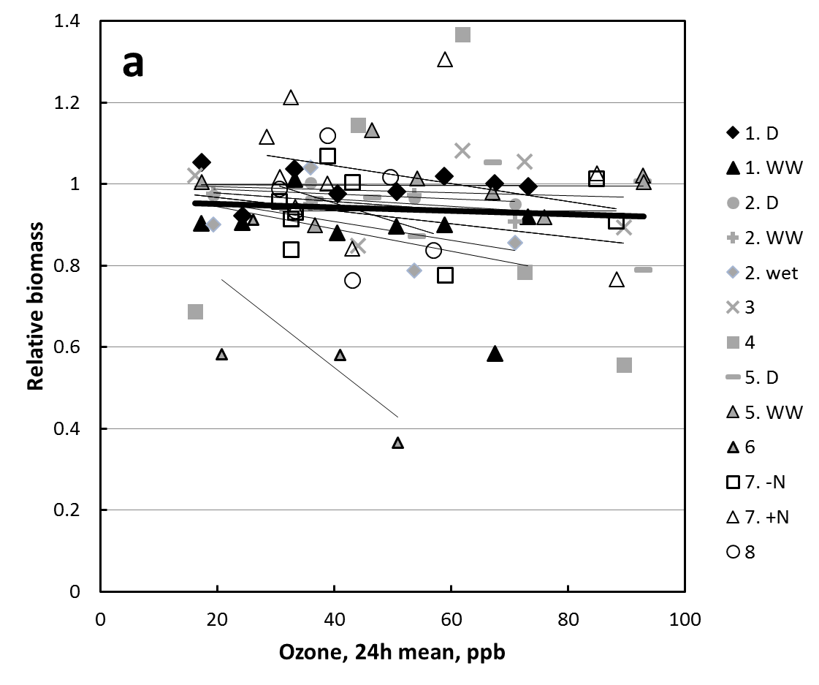
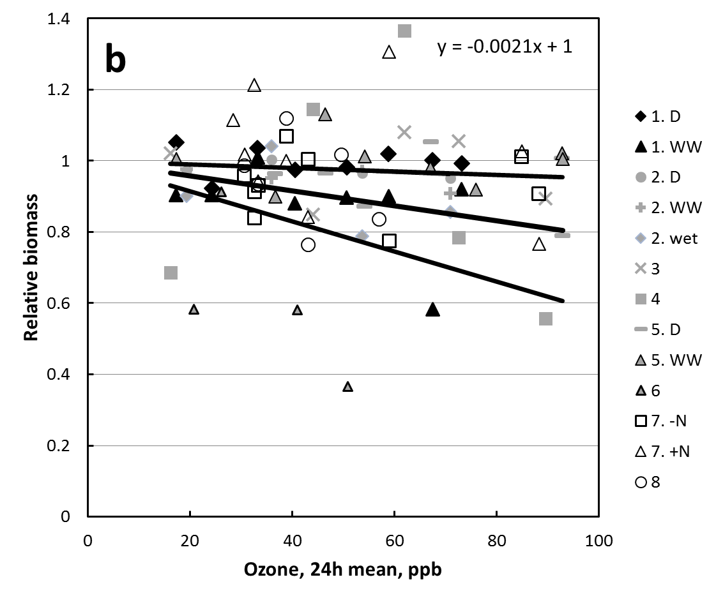
Figure 1: Relationship between ozone concentration (24h mean) and relative biomass for grassland vegetation subsequently used for forage quality analysis. Different experiments and their sub-treatments are identified by number (see Table 1 for full details) and coded according to vegetation type. For multi-year experiments, points are plotted separately for each year, but are not identified with individual symbols in the key. ‘a’ shows trendlines for the individual experiments and subtreatments, together with the regression through all datapoints in bold. ‘b’ shows the mean slope of the trendlines, together with the 10th and 90th centile of the slopes, with the equation of the mean slope shown.

3.1 Quality parameters
The measured ‘desirable’ quality parameters of fat, sugar and protein, which increase the nutritional value of forage, showed no statistically significant effects of increasing ozone concentration (data not presented). In contrast, ‘undesirable’ quality parameters generally showed an increase in concentration with increasing ozone exposure. ADF, lignin and crude fibre content showed significant increases in concentration with increasing ozone exposure (Figure 2; p=0.001, p<0.001, p=0.005respectively), whereas NDF showed no significant effect of ozone exposure (data not presented). Although there was variation in the slope of the response line to ozone for the different grassland types, these were not statistically different from each other allowing all data to be combined. The ozone concentrations required for a significant increase in these parameters compared to the content at 30 ppb ozone were 48 ppb for ADF, 50 ppb for crude fibre and 48 ppb for lignin (this concentration was not calculated for the remaining quality parameters as the response to ozone was not statistically significant).
Figure 2: Effect of ozone on the content of (a) Acid Detergent Fibre, (b) lignin and (c) crude fibre in grassland samples. The different types of grassland are indicated by different symbols and the component experiments identified by number (see Table 1 for full details). The statistical significance of the response relationships are ADF p=<0.001; lignin p=<0.001; crude fibre p=<0.005.

3.2 Quantity parameters
When the treatment biomass was combined with the quality data and used to calculate the quantity or ‘yield’ of each parameter in the vegetation, the net effect of quality and quantity was for no change in overall pasture yield of fat and protein in response to ozone (Figure 3). However, there was a significant decrease in yield of sugar in response to increasing ozone (Figure 3c, p=0.034) and the ozone concentration required for a significant decrease in sugar yield compared to the content at 30 ppb ozone was 59 ppb.

Any change in pasture biomass can have a large influence on the total yield of the parameters such as protein. For the majority of vegetation communities in these studies, any change in concentration within the grassland was offset by changes in the grassland biomass. The response of fat, protein and sugar yield to ozone for sand dune grassland was larger than for the other grassland types due to the large impact of ozone on the biomass of this type of grassland.
Figure 3: Effect of ozone on the yield of (a) protein, (b) fat and (c) sugar in grassland vegetation in response to ozone exposure. The different types of grassland are indicated by different symbols and the component experiments identified by number (see Table 1 for full details). The significances of the response relationships are: protein ns; fat ns; sugar p=0.034.

3.3 Derived quality parameters
The Relative Feed Value decreased with increasing ozone concentration (p=0.017; Figure 4). An increase in ozone concentration from 30 ppb to 40 ppb decreased RFV of pasture by approximately 1%, whilst an increase in ozone concentration to 60 ppb decreased RFV by approximately 5.5%.

Metabolisable energy of the vegetation (for sheep) decreased with increasing ozone concentration (Figure 5, p=0.002). The intercept of the slopes for the different grassland types was significantly different, but there was no improvement to the model by fitting a separate slope to each line, therefore a common slope was fitted. In the mixed model we have assumed, in addition to a common slope treated as a fixed effect, a common intercept for all grassland types, with a random deviation from that intercept for each grassland type. This model is:
The model given by equation gives an estimated value for the parameter (slope) of -0.011194, with standard error of 0.0035 (t-value -3.18). The common intercept is estimated as 7.93 with standard error 0.242 (p=0). The variance terms and are estimated as 0.288 and 0.178. The response relationship used was therefore determined to be:

ME_{pasture} (MJ/kg) = -0.011194 * O_{3 24h} + 7.93.

Combining this equation with that for liveweight gain of lambs in response to ME_{pasture} gives a relationship of:

LWgain_{lambsandsheep} (g/day) = 26.35 – 0.2692*O₃ (ppb)

Figure 4: Effect of ozone on the Relative Feed Value (RFV) of grassland vegetation, where the RFV was calculated using measured parameters from the raw data. The different types of grassland are indicated by different symbols and the component experiments identified by number (see Table 1 for full details). p=0.004

Figure 5: Effect of ozone on calculated metabolisable energy from forage (for sheep) (p=0.002). The different types of grassland are indicated by different symbols and the component experiments identified by number (see Table 1 for full details). The overall response function is indicated, and the trendlines for the individual grassland relationships are also shown. The dotted horizontal line indicates the calculated minimum level of metabolisable energy for lamb growth (6.84 MJ/kg). Also shown are datapoints available from published literature for clover using the combined data from González-Fernández et al. (2008) and Sanz et al. (2005) using Trifolium repens and Trifolium subterraneum respectively (these points were not included in the analysis or the overall response function, but are shown for information as these are more representative of high-quality pasture and this is referred to in the discussion).

3.4 Changes in liveweight gain.
The mean predicted increase in 24h ozone concentration for the UK between 2007 and 2020 was 2.98 ppb (from 30.86 to 33.84 ppb). However, the range for the individual gridsquares was from 0 to 8 ppb, with the largest increases occurring in southern and central England (Figure 6) where the ozone concentrations are predicted to increase from 28 to 34 ppb, potentially resulting in an 8% decrease in liveweight gain per lamb. Taking into account lamb distribution (Figure 6d), there is a large variation in the magnitude of predicted change in daily liveweight gain per gridsquare in 2020 compared to 2007 (Figure 7), with the largest reductions predicted to occur generally in northern and southwest England, and in Wales. These areas are where predicted ozone increases are moderate, but these correspond with areas of large lamb numbers (Figure 6). In some other areas, the predicted change in daily liveweight gain was very small bringing down the 50th centile (based on liveweight gain per gridsquare) to a reduction of 15g per day. Reflecting the larger decreases elsewhere in the country, the 75th centile was a reduction of 53g per day and the 90th centile was a reduction of 114g per day. At the end of the normal growing periods for upland and lowland lambs, this would result in a difference in final weight of 3.64% and 4.36% in upland and lowland lambs respectively in 2020 compared to 2007 (Table 3).

These reductions in liveweight gain assume that farmers will not change their lamb and pasture management in response to ozone. However, it is likely that instead of selling lambs below target weight, farmers will fatten the lambs for longer, or will supplement their dietary intake with concentrate feed. The predicted reductions in liveweight gain due to ozone could be mitigated by an average 0.6% increase in supplementary feeding for upland lambs and 0.8% increase for lowland lambs compared to the quantities used in 2007 (Table 3), representing a total increase of 2,166 tonnes in 2020 compared to 2007, with the pattern of effect reflecting that of predicted changes in daily liveweight gain (Figure 7).

Table 3: Predicted effects on meat production, based on liveweight gain and additional supplementary feed required based on the required dietary intake to maintain liveweight gain for 2020 compared to 2007 ozone concentrations for total lamb production of upland and lowland lambs across the UK.

 | Reduction in Liveweight Gain in 2020 compared to 2007 | Additional concentrate feed requirements in 2020 compared to 2007
Upland
Total weight change | 494 tonnes | 1,106 tonnes
% change | 3.6% weight loss | 0.63% increased feed
Lowland
Total weight change | 474 tonnes | 1,061 tonnes
% change | 4.4% weight loss | 0.76% increased feed
Total (all lambs) | 968 tonnes | 2,167 tonnes

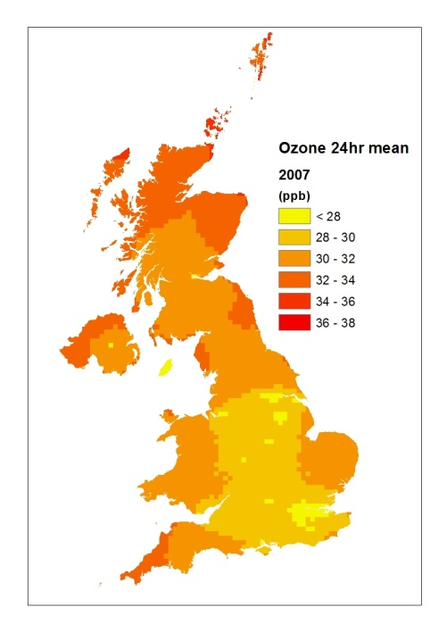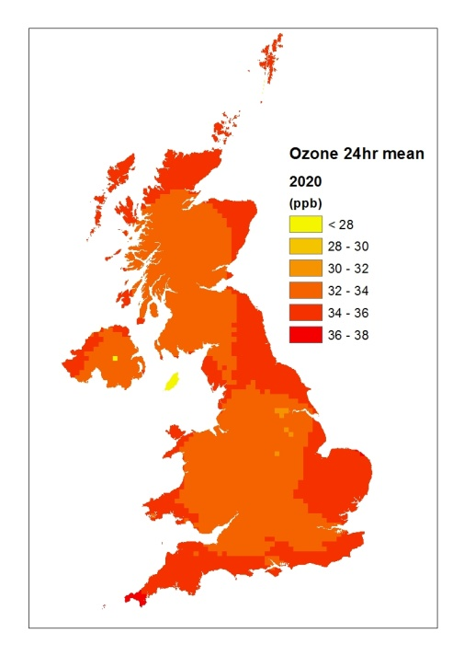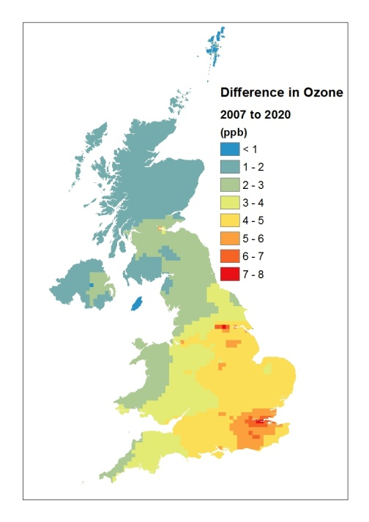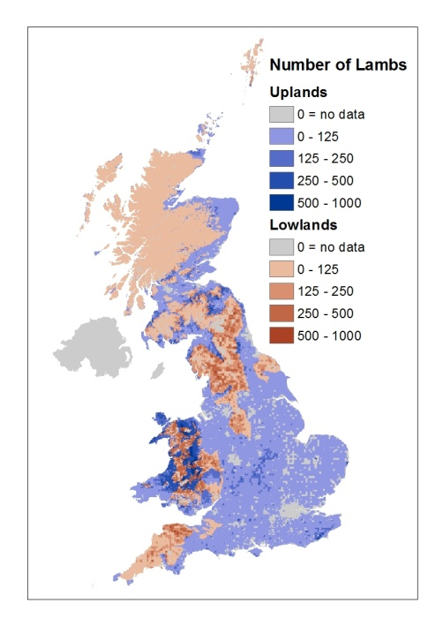
Figure 6: Predicted ozone concentrations in a) 2007, b) 2020 and c) the difference between 2020 and 2007, and d) lamb numbers per km².

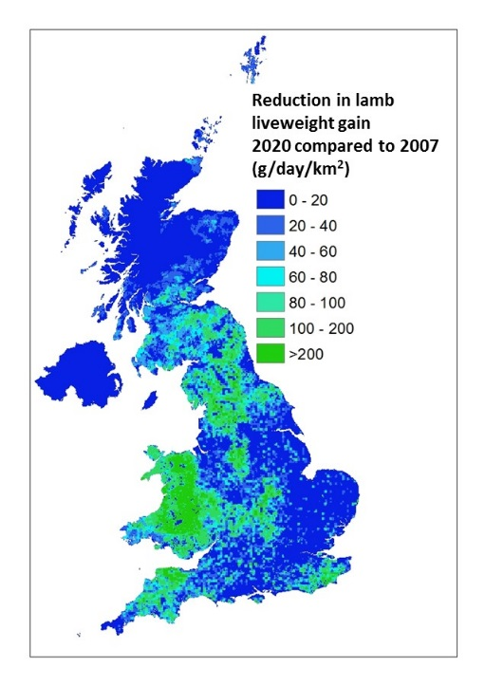
Figure 7: Predicted reduction in daily liveweight gain in lambs per 1km x 1km gridsquare in 2020 compared to 2007 ozone concentrations, scaling impact per lamb by lamb numbers to show where economic impact is likely to be greatest in the UK.

- Discussion
This study has shown that the quality of pasture of several grassland types was altered by exposure to increasing background ozone in experiments with ozone concentrations ranging from 17-93 ppb. The vast majority of experimental datapoints are within the range of current and near-future ozone scenarios in Europe, where there are many examples of 24h mean concentrations over June, July and August of greater than 40 ppb (e.g. Kulkarni et al., 2013) and which can currently exceed 50 ppb at some sites. Rather than through a decrease in the content of ‘desirable’ characteristics such as protein, the changes occurred via an increase in the ‘undesirable’ parameters such as lignin, resulting in a decrease in digestibility of the forage. The NDF fraction of forage consists of partially digestible cell-wall constituents (primarily cellulose, hemicelluloses, lignin, silica and insoluble N), whereas ADF consists of the least digestible cell wall constituents and is inversely related to digestibility (Van Soest, 1994). Other data from the studies used here suggest that this is due to changes in plant structure or physiology in response to ozone rather than to changes in species composition. This is in agreement with previous studies where the ADF, NDF and lignin content increased with elevated ozone in T. subterraneum (Sanz et al., 2005) and Briza maxima (Sanz et al., 2011), and increased lignin content was found in T. repens and T. pratense exposed to ozone in a free-air fumigation system (Muntifering et al., 2006). Some other studies have shown that the content of ‘desirable’ parameters such as protein can also increase with increasing ozone exposure (e.g. protein content of wheat, Pleijel et al., 1997), although this did not occur in the current study. Due to the different nutritional quality of different species, changes in species composition as a result of ozone exposure may also affect the nutritional quality of the pasture. The relative change in nutritive quality in response to ozone was similar for all of the different grassland vegetation mixtures used in the component studies, and there was no difference in the relative response of forage quality in mesocosms compared to that of the open-field study. There were also no significant differences between simple species mixtures and species rich communities. Given that we have included data from four grassland types and several sub-treatments, we are confident that the relationships found are widely applicable to a range of temperate grassland types.

As a consequence of these changes in pasture quality, our study has shown that liveweight gain in lambs could be reduced by ozone, if farmers do not compensate by providing additional feed. The size of the effect was variable across the UK and in some regions where the predicted increases in ozone concentration were largest, the effect on pasture quality could give reductions in liveweight gain per lamb of 8% in 2020 compared to 2007. However, the spatial pattern of lamb numbers meant that the largest reductions in liveweight gain per gridsquare tended to occur where the predicted increases in ozone concentrations were moderate but these coincided with areas of high lamb density. Therefore from a lamb production viewpoint, both of these combinations could represent a substantial loss of production for farmers in areas where predicted impacts are highest. Although these losses could be partially offset in the short-term by increased use of concentrate feed, in the longer-term a sustained deterioration in pasture quality could be a concern, particularly as lamb and sheep production in the UK already has very small profit margins, and in some cases current pasture quality may not be much above the minimum level for lamb growth.

The DECC UEP43 emissions scenario used in this study predicted fairly modest increases in ozone concentrations between 2007 and 2020. Even so, reductions in lamb liveweight gain were predicted. It is anticipated that a similar scale of losses could occur for farmers across NW Europe and in the USA, where large numbers of lambs are reared for meat production and ozone concentrations are also predicted to increase over the coming years (Royal Society, 2008). Our calculations indicate that if pasture quality declines with an increase in ozone concentration from 20ppb to 30ppb, then the liveweight gain per lamb could decrease by 12%. The predicted reductions in potential liveweight gain of lambs demonstrated in this study are of a similar magnitude to some ozone-sensitive crops and trees, for example, wheat in Europe has been predicted to have average yield losses of an additional 3-5% in 2030 compared to 2000 when using the SRES A2 scenario (Avnery 2011a and b) and biomass losses of an additional 4% for trees in 2050 conditions compared to current concentrations have been predicted (Wittig et al., 2009).

Ozone concentrations further into the future than 2020 are more difficult to predict, partly due to uncertainties of precursor emissions and the influence of climate on ozone production. Some models e.g. the ACCMIP series include a large influence of sea surface temperature (Lamarque et al., 2013). There is also a wide range of emission scenarios for precursors and in addition model chemical schemes vary greatly in complexity, particularly for the range of non-methane VOCs that are simulated. Although some of the IPCC 5th Assessment Report (AR5) climate projections assume declines in emissions of precursor compounds such as NO_{x} (e.g. the representative concentration pathways, RCPs 2.6 and 4.5;, van Vuuren et al., 2011) and therefore a subsequent reduction in ozone concentrations, other projections e.g. RCP8.5 show increases in predicted ozone despite this due to increased stratospheric influx and increased emissions of methane (Young et al., 2013). Many studies consider that although the ozone daily profile may be altered, the ozone concentrations over land will increase further (Royal Society, 2008; Szopa et al., 2013) which could further decrease pasture quality and therefore lamb production. Ozone concentrations are predicted to be much higher in countries such as India, Turkey and the USA in the future, where lamb production is also important and therefore the deterioration in pasture quality in these countries due to elevated ozone concentrations may be substantial.

This study assumed that the reduction in metabolisable energy of grassland with increasing ozone concentration was the same in high quality improved grassland as in the lower quality conservation grade grasslands of the experiments used to derive the function. There is some data in the literature supporting this assumption, in that the slope of the relationship between ozone and metabolisable energy used in the current study was similar to that calculated using the combined data from González-Fernández et al., 2008 and Sanz et al., 2005 (using T. repens and T. subterraneum respectively), but further experimental evidence would be needed to verify this. In addition, other factors such as increased N deposition may alter sensitivity of a grassland to ozone, although no significant effects on sensitivity were found between the two N treatments of one of the component experiments of the current study (Wyness, 2011). The response of the different pasture types to ozone were most different to each other in terms of biomass, and less so for the quality parameters. In addition, the community type that is most sensitive to ozone may vary according to which quality parameter is being considered, for example, calcareous grassland was one of the more ozone sensitive communities in terms of crude fibre, but less sensitive when considering lignin. It is possible that changes in forage quality would be different in higher quality pasture, particularly as high quality pasture contains a large proportion of legumes, which are known to be sensitive to ozone (e.g. Hayes et al., 2007). However, the additional data presented in Figure 5, together with the common slope across experiments with a range of legume contents from the component experiments of this study implies that the slope of the response of forage quality to ozone exposure was not altered with different pasture types. In the current analysis, no account was taken of the duration of the experiment, or any carry-over or cumulative effect of ozone exposure, although it is possible that cumulative or carry-over effects of ozone on the vegetation could have occurred. In addition, linear regression lines were fitted to all data as there was no evidence of non-linear effects of ozone on forage quality from this dataset.

Although not a component of the RFV and DDM calculated, sugar content of vegetation is also thought to be related to digestibility of the vegetation, with high sugar content a desirable feature of pasture (e.g. Ellis et al., 2011). The decreased sugar yield in response to ozone in the experiments described here gives further indication that pasture quality was reduced by ozone. In addition, it has been demonstrated that methane emissions from sheep production are affected by diet and that methane emissions are lower with a diet of grasses with higher sugar content (Hybu Cig Cymru, 2011). Since our results show a decrease in sugar content with increasing ozone concentration, the potential exists for ozone to be indirectly leading to an increase in methane emissions but this needs further study for verification.

Quantification of ozone effects on lamb production in this study has used the numbers of lambs being slaughtered for meat production, but there are other impacts that could occur as a consequence of an ozone-induced reduction in pasture quality. For the purposes of the current study it has been assumed that lambs will be reared for a standard length of time and that the total liveweight gain will be reduced by ozone, however, an alternative response from a farmer may be to keep the lambs for a longer time until the desired weight is achieved. There could also be implications for the lambs retained for flock replacement and wool production. Numbers and health of lambs produced by a ewe may be influenced by the weight of the breeding ewe, which is also thought to be affected by the pasture quality (Eblex, 2008). Effects on meat production via effects on silage quality have not been determined, but one of the factors determining the quality of silage is the quality of grassland used to make the silage. The figures calculated in this study are therefore likely to be an underestimate of the total impacts of ozone on lamb production and the sheep industry.

In conclusion, this study has shown that across four upland grassland types, statistically significant reductions in individually measured components of pasture quality, such as ADF, lignin and crude fibre could occur with mean ozone concentrations of only 48 ppb compared to values at 30 ppb, and that these translate into derived pasture quality measures that reduce livestock production. Modelled surface ozone concentrations for 2000 and projections for 2050 using the ACCENT (Atmospheric Composition Change: the European Network) 2030 results show concentrations in this range during the summer months for Europe, North America and South and East Asia (Royal Society, 2008). However, as there was a linear decline in pasture quality with increasing ozone exposure, reduced livestock production may also occur in other regions, where smaller increases in ozone concentration are predicted. This study has indicated that livestock production may already be negatively impacted by ambient ozone pollution in these regions and that further reductions in production due to ozone pollution are likely over the coming decades.

Acknowledgements
This work was funded by the UK Department for Environment, Food & Rural Affairs (Defra) project numbers CPEA33, AQ0815, AQ3510 and NE0117, and the Centre for Ecology and Hydrology, project number NEC04951.

References
Avnery S, Mauzerall DL, Liu JF, Horowitz LW (2011a) Global crop yield reductions due to surface ozone exposure: 1. Year 2000 crop production losses and economic damage. Atmospheric Environment 45:2284-2296.

Avnery S, Mauzerall DL, Liu JF, Horowitz LW (2011b) Global crop yield reductions due to surface ozone exposure: 2. Year 2030 potential crop production losses and economic damage under two scenarios of O₃ pollution. Atmospheric Environment 45:2297-2309.

Bender J, Muntifering RB, Lin JC, Weigel HJ (2006) Growth and nutritive quality of Poa pratensis as influenced by ozone and competition. Environmental Pollution 142:109-115.

Bermejo V, Gimeno BS, Grandos I, Santamaria J, Irigoyen JJ, Bermejo R, Porcuna JL, Mills G (2002) Investigating indices to explain the impacts of ozone on the biomass of white clover (Trifolium repens L. cv Regal) at inland and coastal sites in Spain. New Phytologist 156:43-55.

Calvo E, Martin C, Sanz MJ (2007) Ozone sensitivity differences in five tomato cultivars: Visible injury and fruits. Water Air and Soil Pollution 186:167-181.

Cape JN (2010) Effects of Ground Level Ozone on Vegetation. Centre for Ecology and Hydrology, 30pp. (CEH Project Number: C03108) (Unpublished)
Cape JN (2012) Effects of Ground Level Ozone on Vegetation. Centre for Ecology and Hydrology, 30pp. (CEH Project Number: C03108) (Unpublished)

Carey PD, Wallis S, Chamberlain PM, Cooper A, Emmett BA, Maskell LC, McCann T, Murphy J, Norton LR, Reynolds B, Scott WA, Simpson IC, Smart SM, Ullyett JM. (2008) Countryside Survey: UK Results from 2007. NERC/Centre for Ecology & Hydrology, 105pp. (CEH Project Number: C03259).

Court J, Webbware J, Hides S (Eds) (2008) Sheep farming for meat and wool. Landlinks Press, Australia. ISBN-13: 978-0643092945.

Donnelly A, Lawson T., Craigon J, Black CR, Colls JJ, Landon G (2001) Effects of elevated CO₂ and O₃ on tuber quality in potato (Solanum tuberosum L.). Agriculture Ecosystems and Environment 87:273-285.

Eblex Sheep BRP Manual 9, 2009. Improving Ewe nutrition for better returns. http://www.eblex.org.uk/documents/content/returns/brp_l_sheepsbrp_manual_12_-_improving_ewe_nutrition_for_better_returns031210.pdf

Eblex Sheep BRP Manual 5, 2005. Target store lambs for better returns. http://www.eblex.org.uk/documents/content/returns/brp_l_sheepsbrp_manual_5_-_target_store_lambs_for_better_returns.pdf

Eblex Sheep BRP Manual 11, 2008. Target Ewe fertility for better returns.
http://www.eblex.org.uk/documents/content/returns/brp_l_sheepsbrp_manual_11_-_target_ewe_fertility_for_better_returns.pdf

EEA (2015) The European environment — state and outlook 2015: synthesis report, European Environment Agency, Copenhagen.

Ellis JL, Dijkstra J, Bannink A, Parsons AJ, Rasmussen S, Edwards GR, Kebreab E, France J (2011) The effect of high-sugar grass on predicted nitrogen excretion and milk yield simulated using a dynamic model. Journal of Dairy Science 94:3105-3118.

Fuhrer J (1994) Effects of ozone on managed pasture 1. Effects of open-top chambers on microclimate, ozone flux and plant growth. Environmental Pollution 86: 297-305.

Fuhrer J, Shariatmadari H, Perler R, Tschannen W, Grub A (1994) Effects of ozone on managed pasture 2. Yield, species composition, canopy structure and forage quality. Environmental Pollution 86:307-314.

González-Fernández I, Bass D, Muntifering R, Mills G, Barnes J (2008) Impacts of ozone pollution on productivity and forage quality of grass/clover swards. Atmospheric Environment 42:8755-8769.

Hayes F, Jones MLM, Mills G, Ashmore M (2007) Meta-analysis of the relative sensitivity of semi-natural vegetation species to ozone. Environmental Pollution 146:754-762.

Hayes F, Mills G, Ashmore M (2009) Effects of ozone on inter- and intra-species competition and photosynthesis in mesocosms of Lolium perenne and Trifolium repens. Environmental Pollution 157:208-214.

Hayes F, Mills G, Harmens H, Wyness K (2011) Within season and carry-over effects following exposure of grassland species mixtures to increasing background ozone. Environmental Pollution 159:2420-2426.

Hayes F, Williamson J, Mills G (2012) Ozone pollution affects flower numbers and timing in a simulated BAP priority calcareous grassland community. Environmental Pollution 163:40-47.

Hayman GD, Abbott J, Davies TJ, Thomson CL, Jenkin ME, Thetford R, Fitzgerald P. (2010) The ozone source–receptor model – A tool for UK ozone policy. Atmospheric Environment 44 (34):4283-4297.

Heagle AS, Rebbeck J, Shafer SR, Blum U, Heck WW (1989) Effects of long-term ozone exposure and soil-moisture deficit on growth of a ladino clover - tall fescue pasture. Phytopathology 79:128-136.

Hewitt DKL, Mills G, Hayes F, Wilkinson S, Davies W (2014) Highlighting the threat from current and near-future ozone pollution to clover in pasture. Environmental Pollution 189:111-117.

HM Treasury (2003) The Green Book: Appraisal and Evaluation in Central Government. Available at http://greenbook.hm-treasury.gov.uk. Accessed March 2013.

Hybu Cig Cymru (2011). Reducing methane emissions through improved lamb production. Available at www.hccmpw.org.uk. Accessed March 2013

Hybu Cig Cymru. Creep Feeding. Available at www.hccmpw.org.uk. Accessed March 2013

Jones L, Provins A, Harper-Simmonds L, Holland M, Mills G, Hayes F, Emmett BA, Hall J, Sheppard LJ, Smith R, Sutton M, Hicks K, Ashmore M, Haines-Young R. (2014). A review and application of the evidence for nitrogen impacts on ecosystem services. Ecosystem Services 7, 76–88.

Kulkarni PS, Bortoli D, Silva AM. (2013). Nocturnal surface ozone enhancement and trend over urban and suburban sites in Portugal. Atmospheric Environment 71, 251-259.

Lamarque J-F, Schindell DT, Josse B, Young PJ, Cionni I, Eyring V, Bergmann D, Cameron-Smith P, Collins WJ, Doherty R, Dalsoren S, Faluvegi G, Folberty G, Ghan SJ, Horowitz LW, Lee YH, MacKenzie IA, Nagashima T, Naik V, Plummer D, Riahi M, Rumbold ST, Schulz M, Skeie RB, Stevenson DS, Strode S, Sudo K, Szopa S, Voulgarakis A, Zeng G (2013). The Atmospheric Chemistry and Climate Model Intercomparison Project (ACCMIP): overview and description of models, simulations and climate diagnostics. Geoscientific Model Development 6, 179-206

Linn JG, Martin NP (1989) Forage quality tests and interpretation. Minnesota Ext. Serv. AG-FO-2637. University of Minnesota.

LRTAP Convention (2010). Chapter 3 of the LRTAP Convention Manual of Methodologies for Modelling and Mapping Effects of Air Pollution. Mills G. et al. (Eds). Available at http://icpvegetation.ceh.ac.uk/

McDonald P, Edwards RA, Greenhalgh JFD, Morgan CA, Sinclair LA, Wilkinson RG (2002) Animal Nutrition (6th Edition). Pearson Education Ltd, Essex.

Mertens DR (1987) Predicting intake and digestibility using mathematical models of ruminal function. Journal of Animal Science 64:1548-1558.

Muntifering RB, Chappelka AH, Lin LC, Karnosky DF, Somers GL (2006) Chemical composition and digestibility of Trifolium exposed to elevated ozone and carbon dioxide in a free-air (FACE) fumigation system. Functional Ecology 20:269-275.

National Sheep. http://www.nationalsheep.org.uk/ Accessed October 2014.

Nussbaum S, Geissmann M, Fuhrer J (1995) Ozone exposure-response relationships for mixtures of perennial ryegrass and white clover depend on ozone exposure patterns. Atmospheric Environment 29:989-995.

Piikki K, De Temmerman L, Ojanpera K, Danielsson H, Pleijel H (2008) The grain quality of spring wheat (Triticum aestivum L.) in relation to elevated ozone uptake and carbon dioxide exposure. European Journal of Agronomy 28:245-254.

Pleijel H, Danielsson H, Emberson L, Ashmore MR, Mills G (2007) Ozone risk assessment for agricultural crops in Europe: Further development of stomatal flux and flux-response relationships for European wheat and potato. Atmospheric Environment 41:3022-3040.

Pleijel H, Karlsson GP, Sild E, Danielsson H, Skarby L, Sellden G (1996) Exposure of a grass-clover mixture to ozone in open-top chambers – Effects on yield, quality and botanical composition. Agriculture, Ecosystems and Environment 59:55-62.

Pleijel H, Ojanpera K, Mortensen L (1997) Effects of tropospheric ozone on the yield and grain protein content of spring wheat (Triticum aestivum, L.) in the Nordic countries. Acta Agriculturae Scandinavica, Section B — Soil & Plant Science 47:20-25.

R Development Core Team (2010) R: A language and environment for statistical computing. Vienna, Austria: R Foundation for Statistical Computing. Retrieved from www.http://R-project.org.

Royal Society (2008) Ground-level ozone in the 21st century: future trends, impacts and policy implications. Science Policy Report 15/08. The Royal Society, London, UK.

Sanz J, Muntifering RB, Bermejo V, Gimeno BS, Elvira S (2005) Ozone and increased nitrogen supply effects on the yield and nutritive quality of Trifolium subterraneum. Atmospheric Environment 39:5899-5907.

Sanz J, Bermejo V, Muntifering R, Gonzalez-Fernandez I, Gimeno BS, Elvira S, Alonso R (2011) Plant phenology, growth and nutritive quality of Briza maxima: Responses induced by enhanced ozone atmospheric levels and nitrogen enrichment. Environmental Pollution 159:423-430.

Simpson D, Ashmore MR, Emberson L, Tuovinen JP (2007) A comparison of two different approaches for mapping potential ozone damage to vegetation. A model study. Environmental Pollution 146: 715-725.

Szopa S, Balkanski Y, Schulz M, Bekki S, Cugnet D, Fortens-Cheiney A, Turquety S, Cozic A, Deandreis C, Hauglustaine D, Idelkadi A, Lathiere J, Lefecre F, Marchand M, Vuolo R, Yan N, Dufresne JL. (2013) Aerosol and ozone changes as forcing for climate evolution between 1850 and 2100. Climate Dynamics 40:2223-2250.

UK Agriculture. http://www.ukagriculture.com. Accessed March 2013

Van Dingenen R, Dentener FJ, Raes F, Krol MC, Emberson L, Cofala J (2009) The global impact of ozone on agricultural crop yields under current and future air quality legislation. Atmospheric Environment 43:604-618.

Van Soest P (1994) Nutritional ecology of the ruminant, Second Edition. Cornell University Press, New York, USA.

Van Vuuren DP, Edmonds J, Kainuma M, Riahi K, Thomson A., Hibbard K, Hurtt GC, Kram T, Krey V, Lamarque J-F, Masui T, Meinshausen M, Nakicenovic N, Smith SJ, Rose SK (2011). The representative concentration pathways: an overview. Climatic Change 109, 5-31.

Vandermeiren K, Black C, Pleijel H, De Temmerman L (2005) Impact of rising tropospheric ozone on potato: effects on photosynthesis, growth, productivity and yield quality. Plant Cell and Environment 28:982-996.

Wagg S, Mills G, Hayes F, Wilkinson S, Cooper D, Davies WJ (2012) Reduced soil water availability did not protect two competing grassland species from the negative effects of increasing background ozone. Environmental Pollution 165:91-99.

Wedlich KV (2009) Impacts of tropospheric ozone on semi-natural ecosystems. PhD thesis, University of York.

Wedlich KV, Rintoul N, Peacock S, Cape JN, Coyle M, Toet S, Barnes J, Ashmore M (2012) Effects of ozone on species composition in an upland grassland. Oecologia 168:1137-1146.

Wilbourn S, Davison AW, Ollerenshaw JH (1995) The use of an unenclosed field fumigation system to determine the effects of elevated ozone on a grass clover mixture. New Phytologist 129:23-32.

Wittig VE, Ainsworth EA, Naidu SL, Karnosky DF, Long SP. (2009) Quantifying the impact of current and future tropospheric ozone on tree biomass, growth, physiology and biochemistry: a quantitative meta-analysis. Global Change Biology 15, 396-424.

Wyness KVR (2011) Ozone and Nitrogen Controls on Carbon Allocation within Plants and Soil. PhD thesis, University of Newcastle.

Young PJ, Archibald AT, Bowman KW, Lamarque J-F, Naik V, Stevenson DS, Tilmes S, Voulgarakis A, Wild O, Bergmann D, Cameron-Smith P, Cionni I, Collins WJ, Dalsgren SB, Doherty RM, Eyring V, Faluvegi G., Horowitz LW, Josse B, Lee VH, MacKenzie IA, Nagashima T, Plummer DA, Riahi M, Rumbold ST, Skeie RB, Shindell DT, Strode SA, Sudo K, Szopa S, Zeng G (20103). Pre-industrial to end 21st century projections of tropospheric ozone from the Atmospheric Chemistry and Climate Model Intercomparison Project (ACCMIP). Atmospheric Chemistry and Physics 13, 2063-2090.

