How do gloves affect cutaneous sensibility in medical practice? Two new applied tests
Peter Mylon¹, Matt J Carré¹, Nicolas Martin², Roger Lewis¹
¹Department of Mechanical Engineering, The University of Sheffield, UK
²School of Clinical Dentistry, University of Sheffield, UK

Corresponding Author
Roger Lewis, The Department of Mechanical Engineering, The University of Sheffield, Mappin Street, Sheffield, S1 3JD.

Email: roger.lewis@sheffield.ac.uk; Tel: +44 114 2227838

Abstract
In order to quantify the effect of medical gloves on tactile performance, two new Simulated Medical Examination Tactile Tests have been developed to replicate the tactile and haptic ability required in medical examinations: the ‘Bumps’ test and the ‘Princess and the Pea’ (P&P) test. A pilot study was carried out using 30-40 subjects for each test in order to investigate the suitability of the tests for medical glove evaluation. Tests were performed with latex and nitrile examination gloves, and without gloves. Following the tests, small-scale studies were carried out to investigate the effect of various design parameters, such as material stiffness and tactile exploration method. In the ‘Bumps’ test, subjects performed significantly better in the ungloved condition, and there were ‘almost significant’ differences between the gloves, with the thinner latex gloves performing better than the thicker nitrile gloves. Both finger orientation and surface lubrication were found to have a significant effect on results, indicating that these need to be clearly defined in the test procedure. In the ‘P&P’ test, no significant effect of hand condition was found, suggesting that haptic sensing is less affected by medical gloves than cutaneous sensibility. Other factors such as material stiffness, technique and test orientation had a more significant effect. The SMETT ‘Bumps’ test has potential as a clinical manual performance evaluation tool, and may be used to evaluate the relative effects of different gloves. The SMETT ‘P&P’ test is a valid measure of haptic or tactile performance, but should not be used in glove evaluation. Both tests could have further applications, such as in the assessment of neurological impairment or aptitude testing for potential surgeons.

Keywords
Tactile sensation, medical examination, gloves, touch

1. Introduction
Tactile sensation plays a critical role in medical practice, both in diagnosis and in treatment. Tactile exploration allows clinicians to identify abnormalities and areas of interest in tissue, while tactile feedback is also a crucial component of grasping and manipulation, enabling clinicians to apply the appropriate forces to tissues and to grasp instruments with sufficient, but not excessive force.
Placing a barrier, such as a glove, between the sensory receptors in the skin and the surface being explored or object being manipulated will inhibit tactile ability. Studies that have attempted to quantify the effect of medical gloves using existing sensibility tests (e.g., Semmes-Weinstein Monofilaments, two-point discrimination) have shown a clear loss of cutaneous sensibility when wearing gloves compared to bare hands [1, 2], but the extent to which clinical performance is affected has seen less attention.
The importance of glove use for infection control is no longer disputed, but studies have shown that confidence in glove performance has an effect on the level of compliance with guidelines on glove use. A 1994 survey of health care workers [3] found that a perceived “interference with technical skills” was a common obstacle to compliance with universal precautions. A recent study [4] showed more specifically that some clinicians removed gloves to perform certain tasks requiring a greater level of sensibility, such as finding a pulse. So there is clearly a perception that gloves inhibit clinical performance.
The research also showed that a significant proportion of clinicians perceived differences in tactile performance between glove types. However, studies that have attempted to compare the tactile performance of different examination and surgical gloves using standard methods such as the Semmes-Weinstein Monofilaments Test [2, 5] and the Roughness Discrimination Test [6] have not found significant differences between the gloves. Furthermore, these methods do not replicate well the tactile performance required in clinical tasks. In order to investigate the disparity between perceived and measured differences in performance and to understand the contribution of specific glove properties such as material, thickness and surface texture to tactile inhibition, better tactile tests are needed, with greater resolution that allows differentiation between current glove designs, and that better simulate clinical practice. The results of testing can then be used to inform glove design, with the ultimate goal of bringing clinical tactile performance with gloves closer to that experienced with bare hands. This paper describes the development and validation of two new tactile tests that aim to simulate the tactile performance required in clinical practice, and reports the results of glove comparison experiments.

2. Test Development

2.1 Background
Medical examinations involve different forms of tactile exploration, including feeling for surface irregularities, such as thyroid nodules, and feeling changes in stiffness under the surface, such as in a breast examination. Gnaneswaran et al. [7] designed a test intended to simulate ‘feeling the human skin for diagnosis’, which used a sponge on which raised spots of glue were arranged in a regular pattern. Blindfolded subjects explored the surface with gloved and ungloved fingertips, and were asked to indicate when they identified a raised spot.
The scores were compared for different hand conditions (bare hands, latex and vinyl gloves, powdered and non-powdered), and hand condition was found to have a significant effect on performance. Although the test method had a number of shortcomings, it showed promise as a glove evaluation tool, and so the concept was built upon to form a new battery of Simulated Medical Examination Tactile Tests (SMETT) that evaluate subjects’ ability to detect changes in geometry and stiffness.

2.2 SMETT ‘Bumps’
There were three main issues identified with the original test: a lack of randomisation which led to significant learning (the subjects knew where to expect the raised spots); the coarseness of the original raises spots (approximately 13 mm diameter), which made them very easy to detect; and a lack of resolution in the tests – since raised spots were all the same size, it was likely that they would either all be detected, or none.
After a number of iterations, a new ‘Bumps’ test was produced that addressed these issues by:
- reducing the size of the raised spots;
- varying the size so that tactile sensation could be quantified as a threshold level at which the irregularity can be detected;
- randomly dispersing the spots in a grid that included a number of ‘blanks’.
In order to produce consistent bump sizes and shapes, to eliminate changes in surface roughness and to improve the durability of the test, the ‘Bumps’ apparatus was manufactured using 3D printing. A CAD model of the test apparatus was created in SolidWorks and printed on an Objet Eden260V™ printer (Objet Ltd, Rehovot, Israel), which uses polymer jet technology to create models from polymer resin, in a similar way to an inkjet printer, creating layers by selective deposition of droplets and curing each layer with a UV lamp to build up a 3D structure. A soft elastomer (TangoBlackPlus™, Objet Ltd) was selected for the printing. The CAD model consisted of a 140x140x5mm flat plate from which 26 raised hemispheres protruded in a 7x7 formation (23 of the locations were blank). The diameters of the bumps ranged from 100 to 600 microns (which was found in preliminary testing to be the range in which the detection rate was non-zero, but less than 100%) in increments of 20 microns. The bumps were distributed so as to appear random to test participants. A schematic is shown in Figure 1.
 | 600 |  | 100 |  | 320
540 | 260 | 360 | 280 | 400 |  | 220
580 | 500 |  | 160 |  | 560 | 120
 | 200 | 340 |  | 140
 |  | 520 | 440 |  | 480 | 380
 | 180 | 240 | 460 |  | 300
 |  |  |  |  | 420
Figure 1. Schematic of nominal bump diameters (microns) and locations for SMETT 'Bumps' final design (not to scale).
The resolution of the Objet printer, according to the manufacturer [8], was 600 dpi in the x- and y-axes, and 1600 dpi in the z-axis, which correspond to a layer thickness of 16µm and a droplet width of 40µm. Clearly this means that the printer was unlikely to reproduce exactly a hemisphere of 100µm diameter. The geometry of the prototype was measured using a microscope and image analysis software. The deviation from the CAD model dimensions is shown in Figure 2. Almost all of the bumps were larger in diameter than specified in the CAD model (possibly due to the spreading of the polymer droplet before it had been cured by the UV lamps) with the error being as much as 62% for the smallest bumps, but the accuracy was much better for most of the range.

Figure 2. Manufacturing errors in 3D printing of 'Bumps' prototypes.
A recessed reference grid was included, and a separate frame with a guide was printed from VeroBlue™ (Objet Ltd), a hard plastic. The final design can be seen in Figure 3. The sliding rail can be removed and turned 90°, and includes notches that mate with grooves on the frame to locate the rail in a row or column.
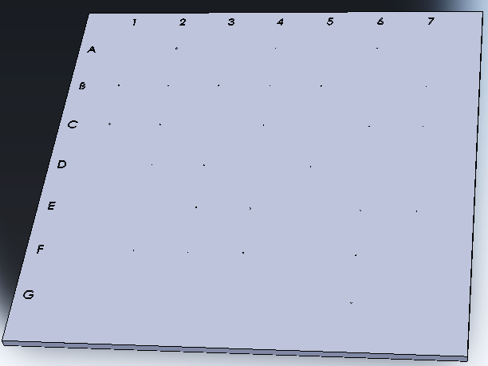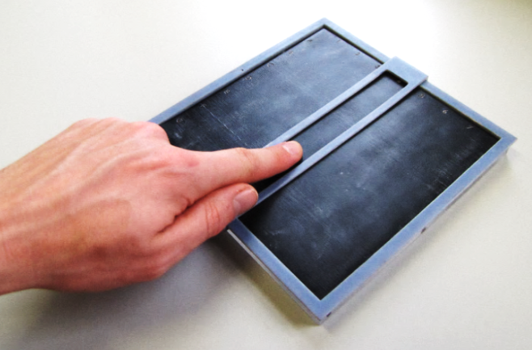
(a)
(b)

Figure 3. SMETT ‘Bumps’ final design (a) CAD model and (b) finished test.

2.3 SMETT ‘P&P’
In order to simulate detection of hard lumps under the surface, a test was also developed on the principle of ‘The Princess and the Pea’.
The apparatus consisted of two parts: a printed base in VeroBlue™; and a matrix made from Room Temperature Vulcanising (RTV) Silicone (Silskin 10, MB Fibreglass; Shore A Hardness: 13) that was intended to simulate the feel of human tissue. The silicone was found to be too stiff and not lifelike, so silicone “deadener” fluid (dimethylpolysiloxane), which is used to soften RTV silicone and produce a fleshy “feel”, was introduced to the mix. Samples were produced in which the proportions of deadener in the silicone were varied between 1:10 and 1:2, and it was initially decided that a 1:5 ratio of deadener to silicone resulted in the most useable and realistic stiffness. Flesh-coloured dye was also included to give a more realistic look and to obscure the location of the protrusions.
The resulting apparatus is shown in Figure 4. It consisted of a 140x140x2mm plate with 27 conical protrusions with hemispherical ends of 5mm diameter. The heights of the top of the protrusions varied between 2.5mm and 14.5mm above the base,. A permanent mould was produced from aluminium to avoid the model deforming more around the edges than the centre. The height of the edges above the base was 22mm, to give 20mm of silicone when full.
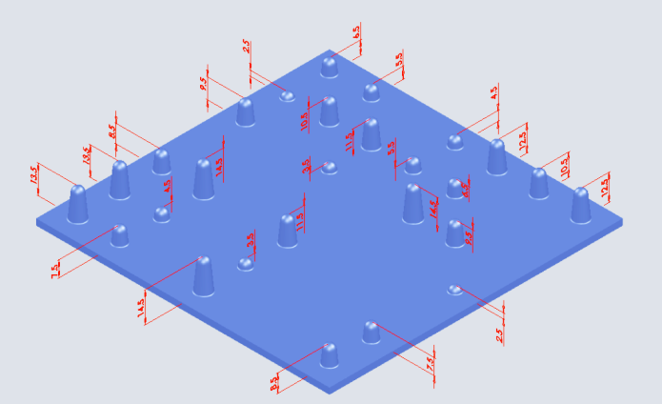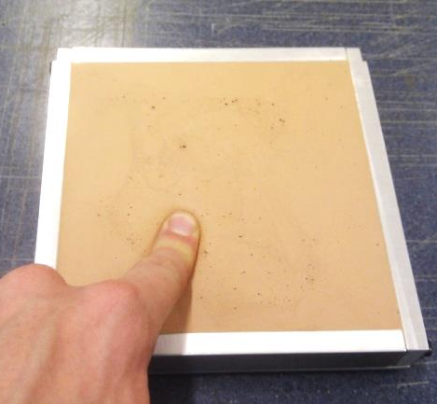
(a) (b)
Figure 4. SMETT 'Princess and the Pea' (a) CAD model and (b) after moulding.
After preliminary tests were carried out in which the apparatus was placed on a 6-axis force plate (HE6X6-10, Advanced Mechanical Technology, Inc.) it was decided to use a 30N force in order to detect a reasonable number of protrusions. A grid drawn onto the silicone to allow the researcher to identify which protrusions were detected and to assist the subject in staying within the row or column, and a small mark was placed in one corner to aid with orientation.

3. Experimental design
All the tests protocols, along with participant information sheets and consent forms, were approved by The University of Sheffield Research Ethics Committee. Test subjects were recruited from a number of sources including first year mechanical engineering students and general surgeons. 34 subjects volunteered (26 male and 8 female) to participate in the ‘Bumps’ test and 39 (35 male and 4 female) in the ‘P&P’. None had any known sensorimotor deficiencies or other major health problems. Their ages ranged from 20 to 59.
Two glove types were used: Finex PF™ latex examination gloves and Finite P Indigo AF nitrile examination gloves (PolycoHEALTHCARE, Enfield, UK). The within-subjects factor in the test was hand condition, consisting of three levels: ‘No Gloves’, ‘Best-Fit Latex’ and ‘Best-Fit Nitrile’. The subjects were allowed to choose the size of glove that fitted them best for each type, with some help from the researcher.

3.1 Test Procedures
‘Bumps’. It was found that the coefficient of friction of the rubber, particularly with skin, was very high, and the vibrations made identification of the bumps difficult. Talcum powder was therefore sprinkled onto the surface as a lubricant, spread around and any loose particles brushed off. The subject was shown the test rig and told that there were bumps of different sizes on the surface which they would be asked to identify. They were then blindfolded and the orientation of the rig was randomised. They were asked to explore the surface of the rubber by drawing the index finger of their dominant hand across the surface in rows or columns and to indicate if they felt any ‘bumps’. The guide was used to keep the fingertip in one row or column at a time. The subject was allowed to explore the area at their own pace and to go back and forwards until they were sure about how many bumps they could identify in that row or column. The researcher had a schematic of the test area and marked those bumps that were identified. The test was then repeated with each hand condition, with a different orientation, and with the talcum powder being reapplied when necessary. The order of the hand conditions was randomised.
‘Princess and the Pea’. The apparatus was placed on the force plate on a standard desk at which the subject was seated. The orientation of the rig with regard to the subject was randomised.
The force measurement was started, and the subject was directed to manually explore the silicone column by column (they were not blindfolded), as in the ‘Bumps’ test, although the compliance of the material necessitated more of a ‘prodding’ technique. The participant was told to watch the force plate display and to use as much force as necessary without going over the indicated maximum force. They were asked to signal verbally when they identified any hard lumps below the silicone. Once they had explored the whole area, the force measurement was stopped. The whole process was repeated with each hand condition, with the orientation of the apparatus being changed each time (there being four orientations in 90° increments). At the end of the testing, subjects were asked to rate their perceived performance in the three conditions on a scale of their choosing, so that a performance twice as good as another would get twice the score and so forth.
Nine participants performed the initial tests and a number of issues were found with the apparatus. The force required to detect even the larger protrusions was causing moderate to severe hand fatigue in participants, requiring them to rest between tests. It was also noted by the general surgeon that the force required was much greater than in a real medical examination. The stiffness of the silicone also appeared to increase over the time of the testing (5 days). It was therefore decided to remould the silicone with a higher ratio of deadener to silicone (3:10), and to reduce the force limit to 18N.
A further 20 participants were tested over nine days, and the rig again hardened over time. It was thought that this might be due to further curing of the silicone, despite the fact that the setting time stated by the manufacturer is 50 to 60 minutes. The deadener was not believed to leach in the same way that silicone oil (another softener) is reported to, and there was no evidence of leaching. This moulding was also somewhat inconsistent, with stiffer regions and parts that did not cure as well. The ratio of deadener to silicone was again increased to 7:20 for a further moulding on which the final 10 participants were tested over eight days, keeping the limit at 18N.

4. Results

4.1 SMETT ‘Bumps’
The results are shown in Figure 5, separated into mean detection rates for each size of bump. The results of two subjects were excluded due to significant abnormalities in the results in all hand conditions (a number of non-detections of large bumps despite detections of much smaller ones). The abnormalities may have been due to insufficient lubrication with talcum powder. It can be seen that bumps start to be detected above 140 microns, and at 320 microns, the bump was detected by all subjects in two of the three hand conditions.

Figure 5. Mean detection rates per bump for 32 subjects wearing nitrile and latex gloves and ungloved (with 95% confidence intervals of the difference to the ungloved condition; levels of hand condition separated horizontally for clarity).
The mean detection rates for the whole range of bumps and in the range 140-320µm are shown in Figure 6. The highest mean detection rate was achieved in the ungloved condition, while subjects scored lower on average with latex gloves than with nitrile.

Figure 6. Results of the SMETT 'Bumps' testing, showing mean detection rates across the full range of bumps and in the range 140-320µm (n=32).
Figure 7 shows the mean differences in performance of the two gloved conditions to the bare-handed condition, expressed as a percentage of the mean ungloved performance.

Figure 7. Mean difference in performance (detection rate) to the ungloved condition of subjects wearing latex and nitrile examination gloves in the SMETT 'Bumps' test as a percentage of mean ungloved performance, showing results across the full range of bumps and in the range 140-320µm (with 95% confidence intervals).
Subjects scored significantly less in the gloved conditions than in the ungloved condition. The differences are more pronounced when narrowing the range, but there do not appear to be significant differences in performance between the gloved conditions.
Each data set was tested for normality with the Shapiro-Wilk test, which is most appropriate for small data sets. Two of the treatments (hand conditions) for the full range and all three for the 140-320µm range showed significant non-normality. The non-parametric Wilcoxon Signed Ranks Test was therefore used to analyse the significance of differences between pairs of treatments. This compares the mean ranks of the samples rather than mean scores. While this means that the assumption of normal distribution of the population is not necessary, the significance of the results may be less apparent than in a standard paired t-test. The results of the Wilcoxon Signed Ranks tests for pairs of treatments for both the full range and the narrowed range are shown in Table 1.
Table 1. Significance of paired differences for SMETT 'Bumps' .
100-600µm | Latex | Nitrile | 140-320µm | Latex | Nitrile
No Gloves | S (0.001) | S (0.017) | No Gloves | S (0.001) | S (0.010)
Latex |  | NS (0.080) | Latex |  | NS (0.065)

It can be seen that there are no statistically significant differences in performance between the latex and nitrile gloves, but the difference is more pronounced (p=0.065) when the smaller and larger bumps are ignored.

4.2 SMETT ‘P&P’
The results of the SMETT ‘P&P’ testing are shown in Figure 8. As well as the overall mean detection rate for the three hand conditions, the results are separated into the three mouldings.

Figure 8. Mean detection rate across three mouldings of the SMETT ‘P&P’ test for the ungloved condition and two gloved conditions.
Overall, subjects detected the most protrusions in the ungloved condition, followed by ‘Best Fit Latex’ and ‘Best Fit Nitrile’, but the trend was not the same across the mouldings. The individual scores were also normalised to remove the effect of changes in stiffness by dividing each score by the subject mean (across all treatments) and multiplying by the grand mean (all subjects, all treatments). The mean difference in performance between each of the gloved conditions and the ‘No Gloves’ condition, expressed as a percentage of the mean ‘No Gloves’ score, is shown for each moulding, overall and for the normalised scores in Figure 9.

Figure 9. Relative performance of latex and nitrile gloves on SMETT 'P&P' performance across the different mouldings (with 95% confidence intervals).
The Shapiro-Wilk test showed that overall results were normal for all treatments (p ≥ 0.60). However, significance testing showed that hand condition did not have a significant effect on detection rate (p = 0.685, ANOVA). Normalising the results as described increased the deviation of the gloved conditions from normality, decreased significance as measured by the non-parametric Friedman test (p = 0.943), and did not significantly alter the means. In paired t-tests between the hand conditions, the overall scores all correlated well together (0.920-0.952, p < 0.001), suggesting that the test is not giving random outputs, but measuring subject tactility. However, none of the paired differences were statistically significant (p ≥ 0.396; see Table 2).
Table 2. Significance of paired differences in ‘SMETT’ P&P tests.
 | Latex | Nitrile
No Gloves | NS (0.557) | NS (0.396)
Latex |  | NS (0.748)

Shapiro-Wilk tests for normality on each treatment and ANOVA tests for significance of hand condition were performed with the results separated into the three mouldings. The results are shown in Table 3.
Table 3. Statistical significance of hand condition for the three mouldings.
Moulding | Normality | p (ANOVA)
1 | 0.258-0.553 | 0.248
2 | 0.216-0.505 | 0.304
3 | 0.007-0.443 | 0.991

Although hand condition is still not significant, the results suggest that the stiffer silicone produced more significant differences between glove types although, as previously noted, it felt unrealistic and caused hand fatigue very quickly.
One assumption of the test was that the detection rate would decrease with increasing depth of the protrusion below the surface, until a threshold depth where the protrusion could not be felt at the specified force limit. It is easier to record from the CAD model the height of the top of the protrusion above the base. The depth below the surface can be approximated by subtracting this value from the full depth of 20mm. The relationship between protrusion height and mean detection rate across all mouldings is shown in Figure 10.

Figure 10. Mean detection rate (all mouldings) against height of protrusion from base with latex and nitrile examination gloves and ungloved, with 95% confidence intervals and linear trend lines with correlations (treatments separated horizontally for clarity). (R² values refer to (top to bottom): no gloves; Latex; Nitrile)
There is a similar linear trend for each hand condition, with good correlation. The detection rates with the three hand conditions cannot be differentiated statistically at any height. In Figure 11, the results are separated into mouldings rather than hand conditions. It can be seen that there are large differences in detection rates between the final moulding and the first two, and that the variation in the results is largest for the first moulding.

Figure 11. Mean detection rate (all hand conditions) against height of protrusion from base for each moulding, with 95% confidence intervals and linear trend lines with correlations (treatments separated horizontally for clarity).
There are some anomalous results, particularly for the 11.5mm high protrusion in the first moulding. A possible explanation could be found in the inconsistency of moulding, since the short working time of the silicone meant that thorough mixing was not always achieved before the silicone started to set, and air bubbles may also have formed under the surface. Location could also be a factor. It can be seen from Figure 4(a) that the two 11.5mm protrusions are near the centre, while the 12.5mm protrusions, which show a slightly below-trend detection rate in two of the mouldings, are on the edge. The angle of attack of the finger could mean that protrusions on the edge were more easily obscured, or the extra stiffness contributed by the frame could be a factor.

5. Further investigations and test refinement

5.1 SMETT ‘Bumps’
During the testing, a number of possible issues with the testing procedure and the design of the rig emerged. It can be seen from Figure 12 that there are some unexpected dips in the detection rate across all treatments at certain diameters, particularly the 340µm diameter bump. It was also noted that some bumps (particularly 160, 180 and 240µm) were easier to detect in one orientation than other, which might suggest some non-sphericity in the bumps, and could affect the results given that orientation was varied between tests.

Figure 12. Mean detection rate in the SMETT 'Bumps' Mark III for all treatments.
As discussed previously, the friction levels were very high when the rubber was not lubricated with talcum powder, and the level of lubrication could affect the detection rate. Finally, it was also noted during testing that technique varied between subjects in terms of angle of attack of the finger, with some placing the terminal phalanx flat on the surface, while others had it almost perpendicular to the surface with only their fingertip in contact with the rubber (see Figure 13).
proximal
distal
(b)
(a)
Figure 13. Technique variations in the SMETT 'Bumps' test: (a) flat terminal phalanx; (b) perpendicular phalanx.
This variation in technique could have a number of effects. Johansson and Vallbo [9] found that the innervation density, particularly of the nerve fibres close to the surface of the skin that detect edge contours and were more useful in identifying Braille [10], was much higher in the distal half of the terminal phalanx than in the proximal half. Because of the shape of the fingertip, holding the finger flat could also mean that bumps close to the frame were more likely to be missed as the fingertip would butt against the guide. The orientation of the test could also have a similar effect, with the end bumps on rows being more likely to be overlooked or obscured by the finger hitting the guide.
Preliminary data from bare-handed testing on the effect of orientation, lubrication and technique suggested that both lubrication and technique were important factors in the detection rate, while orientation was less important, and would be made negligible with randomisation of the orientation. It is recommended that the talcum powder lubrication regime and technique (flat or perpendicular fingertip) be specified more explicitly for future testing in order to produce repeatable results.

5.2 SMETT ‘P&P’: stiffness
It is clear from the ‘P&P’ results that the most significant factor in detection rate was the moulding (p<0.0001 in one-way ANOVA), the difference being apparently due to large variations in stiffness. It was therefore important for validation of the test to determine the hardening or stiffening behaviour of the silicone over time. Stiffness tests were performed on the silicone usinf bespoke test apparatus [11], beginning shortly after the third and final moulding had been poured (see Figure 14). Measurements were taken on 7 separate occasions up to 46 days after moulding.

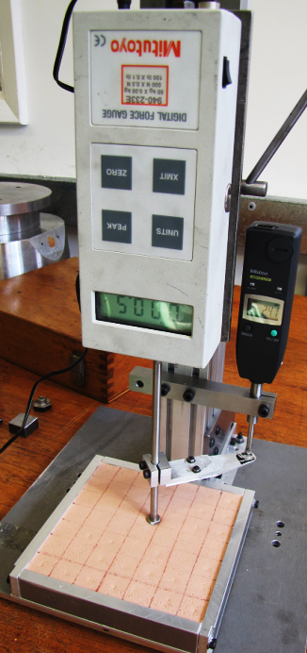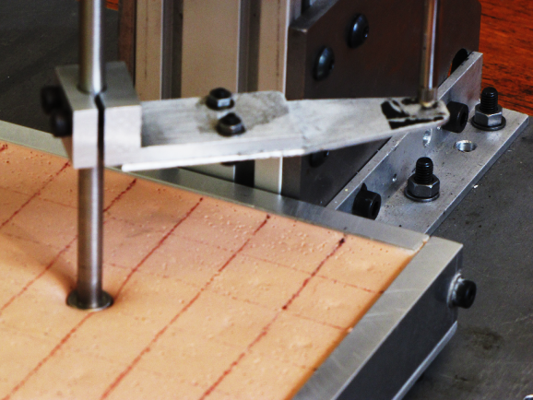
Figure 14. Stiffness testing rig.
The deflection under a 2N load is plotted over the period of the tests in Figure 15. The relationship approximates to a power law (R² = 0.936), so that the rate of change in stiffness reduces over time.

Figure 15. Variation in deflection of P&P rig under 2N load over time.
In the final test, the force was increased steadily up to 24N to determine the force-deflection curve at larger forces comparable to those used in the tactility tests. The results are shown in Figure 16.

Figure 16. Force-deflection curve for final test (46 days after moulding).
The relationship between force and deflection (and hence between stress and strain) is nonlinear, with stiffness increasing at higher forces. This resembles the stress-strain relationship obtained from in vivo human calf measurements [12], although the stiffness is somewhat less for the silicone. However, the range of values was fairly large, and the range of stiffnesses throughout the human body would be expected to be much larger. Given the similarity in the curves, the silicone appears to be an acceptable simulation of body tissue for the purpose of this test.
‘P&P’ tests were carried out 10 and 46 days after moulding using the same subject in an ungloved condition, and with the test in the same orientation. The detection rate was reduced by almost half from 85 to 48% for a stiffness increase of approximately 200%. This confirms what was observed in the larger-scale testing in the difference between mouldings.

5.3 SMETT ‘P&P’: other factors
Besides the issue of matrix stiffness, a number of possible issues with the apparatus and procedure were identified during the testing, and further investigations were carried out to assist in refining the test. As mentioned previously, there were some concerns that, because of the way the silicone was compressed to well below the top of the frame, the angle of attack of the finger might mean that those protrusions around the edge might be missed in certain orientations (see Figure 17). The added stiffness contributed by the frame might also make detection of edge protrusions harder than those in the centre.
(a)
(b)
Figure 17. Effect of technique on detection in 'P&P': (a) flat and (b) perpendicular.
It was also considered that the technique used – whether the terminal phalanx was parallel or perpendicular to the surface – might have an effect on detection in the same way as with the ‘Bumps’ test. Finally, the maximum allowed force will clearly affect the detection rate, and will also affect the level of hand fatigue.
Preliminary data from bare-handed testing on the effect of orientation, technique and maximum force suggested that both orientation and technique were important factors in the detection rate. Detection rates were much higher when using the fingertip than the flat phalanx. The effect of orientation was already moderated by the randomisation included in the test procedure, but it is further recommended that subjects should be instructed to stick to one technique throughout the tests. If the technique is to be specified, it is suggested that the flat phalanx is used, since more fatigue occurred when using the fingertip, and more damage to the rig from fingernails is possible. In order to ensure when using this technique that the protrusions around the edge are not missed, it is proposed that the area of the silicone be enlarged to include a buffer area around the edge.

6. Discussion

6.1 Effect of gloves on tactile sensation
Of the two new Simulated Medical Examination Tactility Tests, only the ‘Bumps’ test produced significant differences between hand conditions. In this test, tactile performance was found to be significantly better in the ungloved condition than when gloved. This matches the findings of previous studies using other cutaneous sensibility tests such as roughness discrimination [13].
Although no significant differences in performance between the two glove types were found in this study, the p value of the difference (p = 0.065) was only slightly above the significance level of 0.050, with the nitrile gloves performing better than the latex. One possible explanation for this result could be the glove thickness, with Indigo nitrile gloves having an average thickness of 74µm, and the Finex PF™ latex gloves being 123µm thick on average [13]. Thicker gloves could be expected to attenuate the tactile signal by deforming when going over a bump, so that skin deformation is reduced. This is evident in the lower performance achieved using multiple layers of latex gloves in both the preliminary testing in this study, and in von Frey hair testing [14], compared to single-layer gloves and bare hands.
In the ‘P&P’ test, hand condition had no significant effect. Differences in stiffness where protrusions occur are felt as a change in the resistive force opposing the downward movement of the finger. It seems probable that this involves more haptic than tactile sensing (i.e., muscle sensors rather than skin), in which case, adding a thin barrier between the finger and the silicone is unlikely to have as significant an effect on performance as it does on the ‘Bumps’ test.

6.2 Suitability of the tests for medical glove evaluation
In terms of ability to evaluate the effect of gloves on tactile performance and discriminate between them, the ‘Bumps’ test shows the most promise. While the mean difference in scores between the latex and nitrile gloves did not quite reach significance, the suggested improvements in the test method (a more repeatable method of surface lubrication and clearer instructions on technique) might reduce the p value. Testing with a wider range of gloves from different manufacturers, including sterile surgical gloves and ‘double gloving’ (two layers of gloves, often used when there is an increased infection risk) would be expected to produce some significant differences.
As regards the ‘P&P’ test, the lack of differences found in the testing, even between gloved and ungloved performance, suggest that it is not a useful tool for glove evaluation. The difficulties with stiffening over time, requiring regular re-moulding, also make the test fairly impractical for regular glove testing. It is, however, a reasonable simulation (at low force levels) of medical examination.

6.3 Other applications
Both test methods outlined here simulate aspects of medical examinations, but also tactile and haptic exploration in general, and hence have wider applications. They are more realistic simulations of the tactile sensibility needed for everyday tasks than the Semmes-Weinstein Monofilaments or two-point discrimination tests. Applications might include assessment of neurological impairment (such as after a stroke) or aptitude testing for potential surgeons or other roles requiring fine cutaneous sensibility.

7. Conclusions
Two novel test methods for evaluating tactile performance in medical examination have been presented. Testing with latex and nitrile gloves and bare-handed showed that the SMETT ‘Bumps’ has potential as a tool for medical glove evaluation, although further refining of the method is required in order to improve repeatability. The SMETT ‘P&P’ is a valid measure of tactile or haptic performance, but test scores do not appear to be sufficiently affected by the introduction of gloves to warrant further development as a glove evaluation tool.

Funding
This work was supported by the Engineering and Physical Sciences Research Council [Doctoral Training Grant] and BM Polyco Ltd.

References

1. Bucknor A, Karthikesalingam A, Markar SR, Holt PJ, Jones I and Allen-Mersh TG. A comparison of the effect of different surgical gloves on objective measurement of fingertip cutaneous sensibility. Ann R Coll Surg Engl. 2011; 93: 95-8.

2. Johnson RL, Smith HM, Duncan CM, Torsher LC, Schroeder DR and Hebl JR. Factors that influence the selection of sterile glove brand: a randomized controlled trial evaluating the performance and cost of gloves. Canadian Journal of Anesthesia. 2013: 1-9.

3. Williams COB, Campbell S, Henry K and Collier P. Variables influencing worker compliance with universal precautions in the emergency department. Am J Infect Control. 1994; 22: 138-48.

4. Mylon P, Lewis R, Carré MJ, Martin N and Brown S. A study of clinicians' views on medical gloves and their effect on manual performance. Am J Infect Control. 2014; 42: 48-54.

5. Tiefenthaler W, Gimpl S, Wechselberger G and Benzer A. Touch sensitivity with sterile standard surgical gloves and single-use protective gloves. Anaesthesia. 2006; 61: 959-61.

6. Nelson JB and Mital A. An ergonomic evaluation of dexterity and tactility with increase in examination/surgical glove thickness. Ergonomics. 1995; 38: 723-33.

7. Gnaneswaran V, Mudhunuri B and Bishu RR. A study of latex and vinyl gloves: Performance versus allergy protection properties. International Journal of Industrial Ergonomics. 2008; 38: 171-81.

8. Objet Ltd. http://www.stratasys.com/3d-printers/design-series/objet-eden260vs, Accessed 30/9/16.

9. Johansson RS and Vallbo AB. Tactile sensory coding in the glabrous skin of the human hand. Trends Neurosci. 1983; 6: 27-32.

10. Phillips JR, Johansson RS and Johnson KO. Representation of braille characters in human nerve fibres. Exp Brain Res. 1990; 81: 589-92.

11. Mylon P. Performance of Medical Gloves. PhD Thesis, Department of Mechanical Engineering. Sheffield: The University Of Sheffield, 2012.

12. Manschot JFM and Brakkee AJM. The measurement and modelling of the mechanical properties of human skin in vivo—I. The measurement. J Biomech. 1986; 19: 511-5.

13. Mylon PT, Buckley-Johnstone L, Lewis R, Carré MJ and Martin N. Factors influencing the perception of roughness in manual exploration: Do medical gloves reduce cutaneous sensibility? Proceedings of the Institution of Mechanical Engineers, Part J: Journal of Engineering Tribology. 2015; 229: 273-84.
14. Shih RH, Vasarhelyi EM, Dubrowski A and Carnahan H. The effects of latex gloves on the kinetics of grasping. International Journal of Industrial Ergonomics. 2001; 28: 265-73.

