The vulnerability of organic archaeological remains to environmental change: A lesson from Star Carr
Short title: Organic remains at risk from environmental change
Kirsty High^{1*}, Nicky Milner², Ian Panter³, Beatrice Demarchi², & Kirsty Penkman¹
¹ Department of Chemistry, University of York, York, YO10 5DD, UK
² Department of Archaeology, University of York, The King’s Manor, York, YO1 7EP, UK
³ York Archaeological Trust, 47 Aldwark, York, YO1 7BX, UK
*: Kirsty.high@york.ac.uk

Classification: Physical sciences: Environmental sciences
Biological sciences: Anthropology
Keywords: organic archaeology; geochemistry; environmental change; analytical chemistry

Examples of wetland deposits can be found across the globe, and are known for preserving organic archaeological and environmental remains that are vitally important to our understanding of past human-environment interactions. The Mesolithic site of Star Carr (Yorkshire, UK) represents one of the most influential archives of human response to the changing climate at the end of the last glacial in Northern Europe. This is largely due to the exceptional preservation of its organic remains; a hallmark of the site since its discovery in 1948. Disturbingly, recent excavations have hinted that the geochemistry of the site is no longer conducive to such remarkable survival of organic archaeological and environmental materials. Microcosm (laboratory-based) burial experiments have been undertaken, alongside analysis of artefacts excavated from the site, in order to assess the effect of these geochemical changes on the remaining archaeology. By applying a suite of macroscopic and molecular analyses, we demonstrate that the geochemical changes at Star Carr are contributing to the inexorable and rapid loss of valuable archaeological and palaeoenvironmental information, with global implications for other wetland sites, particularly archaeological sites preserved in situ.
Significance statement: Wetland deposits provide a unique repository of archaeological and environmental information, preserving organic remains rarely found elsewhere. Star Carr is an impressive example, having provided unique evidence for human interactions with the landscape at the end of the last ice-age. Tragically, here we provide experimental evidence that human modifications of the local environment are leading to changes in the site geochemistry resulting in the rapid loss of bone and wood artefacts. Our research demands a re-assessment of the assumption that sites such as Star Carr should be preserved in situ for the benefit of future researchers, and illustrates that consideration of the burial environment needs to be undertaken before such a policy is pursued.
\body
Globally, wetland and peatland deposits are an invaluable source of archaeological information, preserving organic materials and macro-remains that are rarely found elsewhere¹. However, these sites are also extremely sensitive to environmental changes, particularly to changes in the water-table²⁻⁴. Understanding how changing environmental conditions and geochemical parameters affect organic preservation in archaeological sites has become increasingly important as both human and climate-driven modifications of wetland environments continue to occur worldwide^{5,6}. This is of particular imperative as a strategy of preserving archaeological sites in situ has become more and more prevalent since the advent of the Valetta Treaty⁷, which is based on the principle that avoiding excavation protects the archaeology for the benefit of future researchers.
The wetland site of Star Carr has yielded remarkably well-preserved organic remains, including 22 red-deer antler headdresses thought to be used in shamanic rituals⁸ and 97 % of the Mesolithic antler barbed points found in Britain⁹ (SI Figure 1). The exceptional preservation of macrofossils and pollen has also allowed detailed reconstruction of the environmental context of the site¹⁰; as such, Star Carr is an important archive of human response to the end of the last glacial in Northern Europe. Sadly, the site also represents a lesson in the immense impact that human driven environmental change can have on our cultural heritage: during excavations between 2006 and 2010, an alarming level of deterioration of both bone and wood was reported. Some bone samples were found demineralised (familiarly termed ‘jellybones’), and much of the wood excavated was flattened and extremely crumbly (Figure 1)¹¹. This is in stark contrast to the outstanding quality of the organic remains uncovered in the initial excavations in the 1940s¹² and 1980s¹³. In addition, the loss of palynological information recently reported¹⁰ is testament to the fragility of the palaeoenvironmental remains.
This accelerated deterioration has been attributed to modification of the water-table at Star Carr via the insertion of a series of field drains in 2000 AD. As a result, the water-table now lies below the cultural layers in parts of the site^{14, 15}. Organic preservation at wetland sites is primarily achieved through the suppression of aerobic microbial activity through constant waterlogging^{16, 17}. At Star Carr, alongside this loss of waterlogging, high concentrations of sulfur have been identified. This is thought to originate from pre-Holocene pyrite-rich Kimmeridge and Speetum marine clay deposits underlying the archaeology-containing peats¹⁴.The combination of the introduction of oxygen to the sediments along with theses sulfur-rich deposits has led to oxidation of sulfides to sulfuric acid, causing sediment pH as low as 2¹⁴. However, robust data linking these environmental changes with the striking organic deterioration witnessed within 30 years at Star Carr was severely lacking¹¹, making an informed decision on the appropriate management of the site impossible. Focussing on the effects of site acidity on the macroscopic and archaeological remains, we undertook laboratory-based experiments to investigate the behaviour of bone¹⁸ and wood¹⁹ in high concentrations of sulfuric acid. Results indicated that acidification is a major factor leading to the demineralisation of bone and cellulose depletion in wood (Figure 1).
However, acidity is unlikely to be the sole factor facilitating organic diagenesis at Star Carr. Therefore, to achieve a more realistic representation of the burial environment, we constructed three microcosms in the laboratory²⁰: A, containing sand; B, containing garden compost; and C, containing peat collected from the Star Carr site. Saturated, fluctuating and dry zones were established within each and a range of materials buried for 12 months in each zone (Figure 2).
Material was selected to enable direct comparison with material excavated both from the Star Carr site and those used in previously reported lab-based experiments in acid^{18,19} (SI Table 1). This consisted of: archaeological and modern wood, archaeological bone and modern bone, and modern sheep bone that had been demineralised by treatment in hydrochloric acid (to be comparable to the ‘jellybones’ excavated from Star Carr¹¹).
After 12 months of burial, the levels of deterioration in experimental material was compared to that in archaeological bone and wood excavated from Star Carr itself, employing a suite of analytical techniques: an initial assessment by visual and mass loss analysis, followed by chiral amino acid analysis (AAR) and powder X-ray diffraction (p-XRD) for bone, and infrared spectroscopy (FTIR) and pyrolysis gas chromatography (py-GC) for wood. Our approach has demonstrated that under the extreme geochemical conditions identified in areas of the Star Carr site, both bone and wood are at critical risk of rapid and irreversible deterioration, with critical implications for any organic materials remaining in situ at the site.
Results
Geochemical parameters support validity of microcosm conditions
A geochemical survey carried out in 2009 recorded low pH in large parts of the Star Carr site, although localised variations were seen, appearing to correlate to the distribution of underlying pyrite-rich clay lenses¹⁴. Further geochemical analysis was carried out as part of this study, and concurred with the previous geochemical survey; regions of high acidity (~ pH 2) existed within close proximity to more neutral areas (SI Figure 2).
To enable comparison between the microcosm experiment and the in situ burial environment, we measured pH and redox potential in each microcosm zone at the end of the experiment (Figure 2). Redox and pH are intrinsically linked, and can provide an indication of the potential for organic remains to survive²¹. Redox potentials > 400 mV reveal highly oxidative sediments, which can correlate to high levels of microbial activity and by proxy, low propensity for organic material to survive^{20,22}.
A highly oxidative and acidic environment is demonstrated in microcosm C in all 4 zones (Figure 2), and is comparable to that observed in substantial areas of Star Carr site¹⁴. The reduced pH in zone C4 (dry) can be explained by the presence of oxygen causing increased oxidation of sulfides, which are present in high abundance in the peat at Star Carr¹⁴, to sulfuric acid.
In contrast, moderate pH and redox values are seen throughout microcosms A and B, with the exception of the aerated zone of microcosm B, where a redox potential > 400 mV and almost neutral pH provides ideal conditions for extensive microbial colonisation²⁰, and in the saturated zone of microcosm A, where a neutral pH and low redox potential confirms the absence of oxygen.
Rapid loss of hydroxyapatite under conditions equivalent to those of Star Carr
Remarkable visual transformation of all mineralised bones excavated from microcosm C was seen after only 12 months burial, appearing swollen and lightened in appearance (SI Figure 3), with an increased mass (SI Table 2). Conversely, in microcosms A and B, minimal deterioration resulted in little or no mass loss in all mineralised bone. The reverse was seen for demineralised ‘jellybone’ samples: complete disappearance in the saturated regions of both A and B, and high mass loss in the fluctuating and dry zones shows that demineralised bone is rapidly lost under certain geochemical and hydrological conditions. In microcosm C however, the ‘jellybone’ samples appeared relatively intact and displayed a lower mass loss than those excavated from microcosms A and B (SI Table 2).
All mineralised bone samples from hydrated environments in microcosm C displayed a p-XRD pattern characteristic of gypsum (calcium sulfate; Figure 3), rather than the broadened hydroxyapatite peaks characteristic of unaltered bone mineral²³. This is to our knowledge the first instance of this definitive transformation in buried bone; we hypothesise that in hydrated zones, dissolution of the HA occurs, followed by recrystallization, incorporating sulfur from the sediments to form gypsum. Incorporation of sulfur also explains the mass increase observed and is consistent with our previous experiments carried out in sulfuric acid only¹⁸. In contrast, the bone mineral appeared unaltered (compared to the starting material) for the samples from microcosms A and B (Figure 3).
Minimal differences in amino acid concentration were observed in most samples, attributed to the short time-scale of the experiment. However, a small reduction in total amino acid content in the archaeological bone (Star Carr rib) buried in microcosms A and B suggests loss of the protein fraction of the bone (SI Figure 4). The total amino acid concentration was apparently also reduced in many of the samples from microcosm C, but mass balance indicates that this is likely to be an artefact of the mass gain observed rather than indicative of protein loss.
Aspartic acid (Asx) racemisation has been employed as an indicator of collagen damage^{24, 25}. For most modern bone samples this remained unaltered in all microcosms. However, in the archaeological bone, although variability is high, a slightly elevated Asx racemisation indicates some collagen damage, with the highest values observed in microcosm C (SI Figure 4). This concurs with the slightly reduced amino acid content also observed.
Chemical degradation of lignin under conditions equivalent to those of Star Carr
Minimal visual alteration was observed in wood samples after 12 months. As for the bone samples, a clear mass gain was observed in many wood samples from microcosm C, indicating uptake of chemical species from the burial environment (SI Table 3).
Lignin defunctionalisation occurred in all modern wood samples from hydrated zones of microcosm C. In the FTIR spectrum, this manifests as the complete disappearance of the absorbance at 1240 cm⁻¹, characteristic of the methoxy group on lignin and therefore signifying defunctionalisation of the lignin polymers²⁶ (Figure 4). This was confirmed by increased concentrations of phenol (defunctionalised lignin) and almost complete loss of other lignin degradation products observed using py-GC^{27 ,28} (SI Figure 5). Lignin is normally found largely intact in waterlogged archaeological samples as it is chemically stable and resistant to most forms of microbial attack^{28, 29}; indeed, no evidence for lignin defunctionalisation was seen in samples from microcosms A or B.
The continued presence of low intensity absorbance peaks at 1325 and 1375 cm⁻¹ in microcosm C samples from hydrated zones indicates that at least some cellulose remains in situ. As cellulose is normally far more readily lost through chemical hydrolysis, its survival (despite the defunctionalisation of the more stable lignin) is surprising. However, analysis by py-GC showed an absence of peaks due to cellulose, suggesting that although cellulose may have been present, it was partially degraded and therefore lost during sample preparation for GC (SI Figure 5). Analysis by both FTIR and py-GC indicated minimal chemical or biological deterioration of cellulose in samples from microcosms A and B.
Degradation in material excavated from Star Carr post-2007 supports microcosm data
Macroscopic preservation of archaeological bone samples excavated post-2007 varied greatly across the Star Carr site. In areas of the site that had always been dryland, bone tended to be chalky and brittle; in contrast, in waterlogged parts of the site, bone was often ‘jelly-like’ due to demineralisation. A single bone analysed from the 1948 excavations was incredibly robust in comparison, with very little discolouration. These differences across the site indicate differing mechanisms of diagenesis. This is confirmed by AAR analysis: total amino acid concentrations were very low in the chalky dryland bones (demonstrating depletion of bone protein) but elevated in the wetland bones (indicating depletion of bone mineral) (Figure 5). Asx racemisation levels (D/Ls) were elevated in all the dryland bones, significantly exceeding, for example, racemisation reported in a ~112 ka rhino bone from Kirkdale (D/L = 0.13)³⁰ (Figure 5). This indicates loss of quaternary structure in any collagen still remaining²⁵. Conversely, many of the bones defined as ‘jellybone’ display a similar Asx D/L value to modern untreated bone (approximately 0.06), signifying that the remaining collagen is relatively intact. However, it is impossible to determine how much structurally compromised collagen may have been lost post-demineralisation, resulting in a reduced apparent level of racemisation.
Differing diagenetic mechanisms across the site are also evidenced by analysis of the bone mineral: some samples excavated from the wetland had turned to ‘jelly’, others to gypsum. In the ‘jellybone’ samples, characteristic hydroxyapatite peaks were completely absent from the p-XRD patterns, whilst in other bones, peaks characteristic of gypsum were seen (Figure 3). This transformation to gypsum confirmed the observations in the experimental burials and demonstrates that equivalent diagenetic processes occurred in the microcosms, indicating that these artificial environments accurately mimic in situ diagenesis.
Archaeological wood from Star Carr has been found exclusively in the wetland parts of the site, attributed to the rapid deterioration of archaeological wood commonly seen in non-waterlogged contexts^{31, 32}. Although wood excavated was soft, it was still visually identifiable and comparable in appearance to wood excavated from waterlogged sites of similar age³².
Molecular analysis of samples excavated in 2013 indicates that whilst cellulose had been depleted, it was not completely lost; peaks relating to cellulose were detected using both FTIR and py-GC. In addition, lignin was still present in the majority of samples, although an increased concentration of phenol and slight splitting of the FTIR peak at 1240 cm⁻¹ indicates defunctionalisation^{26, 28} (Figure 4; SI Figure 5).
Discussion
These microcosm experiments have highlighted extremely rapid alterations observed in both bone and wood buried in peat from Star Carr. Whilst previous experiments in acid alone had shown that hydroxyapatite rapidly deteriorates at low pH¹⁸, extending the study into a more realistic representation of the burial environment at Star Carr has provided critical evidence that both bone and wood are at immediate risk at the site. Specifically, we have shown that soil water content is a major influence in the rapidity at which organic material is lost, consolidating a number of field based studies^{4, 33}.
Under the low pH – high redox potential conditions present in Star Carr peat (microcosm C), we have shown that hydroxyapatite rapidly dissolves, and when sulfur is present, complete transformation of the bone apatite to gypsum is observed, reported here for the first time. Critically, the short time scale of this experiment (12 months) highlights the alarming rate at which this process can occur, raising concerns for the continued survival of bone buried at Star Carr and archaeological sites with similar conditions; indeed analysis of several archaeological bones from excavations at Star Carr has shown that this has already occurred in areas of the site. The long-term effect of this alteration of hydroxyapatite on the collagen is uncertain. However, binding interactions with the mineral are vital to the survival of proteins in biominerals over long time-scales³⁴, and hydroxyapatite is known to protect collagen by excluding enzymes and reactive chemical species³⁵. It is therefore reasonable to assume that a change in its structure would be detrimental. As the survival of collagen in archaeological bone is essential for the extraction of data for radiocarbon dating³⁶, species identification³⁷ and dietary isotope analysis³⁸, understanding the diagenetic processes affecting collagen is crucial.
Analysis of archaeological materials shows different modes of bone deterioration across Star Carr. In the dryland areas, a HA shell is left behind after collagen depletion, and in the wetland regions the opposite occurs to leave a collagen-rich ‘jellybone’. This is likely to be the result of extreme variations in the geochemistry of the sediments. The formation of ‘jellybones’ is almost certainly the result of dissolution of HA to buffer acidic sediments; critically, laboratory-based experiments have shown that archaeological bone is less able to mitigate acidity via this mechanism¹⁸, and will therefore be more at risk in acidic sediments than modern material.
Although degradation in archaeological wood from Star Carr was not as advanced as in bone, extensive defunctionalisation of lignin occurred in microcosm C (Star Carr peat) within only 12 months. It is possible that this was biologically driven, but as lignin is normally resistant to biological decay^{29, 31}, a chemical mechanism is more likely.
The Star Carr sediment used in the microcosm experiments had a lower pH than has been recorded at the site itself, although geochemical analysis indicates that areas of the site remain highly acidic. Critically, this has allowed an assessment of how organic materials may be affected if the site continues to change. As the water table has recently dropped to below the archaeological zone^{14, 15}, the archaeologically-bearing sediments are likely to continue to oxidise, becoming even more acidic. These microcosm experiments have shown that if this occurs, bone mineral is likely to rapidly undergo a transformation to gypsum, and lignin in wood is vulnerable to chemical degradation. Both processes will result in the loss of unique archaeological evidence. As such, any bone and wood artefacts left in situ at the site are at immediate risk of increased deterioration or eventual loss.
Drying out of the site also puts organic material at greater risk of deterioration via biological processes, particularly wood. Studies have demonstrated that microbial activity is a major factor in organic deterioration^{28,} ³⁹, and that biological activity is supressed at low pH, as at Star Carr⁴⁰. There has been a lack of evidence for microbial activity in microcosm C, even where oxygen is present; however the loss of ‘jellybone’ samples in the microbially-rich microcosms (sand and compost) indicates that exposed collagen would be rapidly lost were biological activity feasible. As the reported drying out of the sediments¹⁴ is likely to result in increased fungal and microbial activity, this could result in the unmitigated loss of any remaining archaeological bone. Furthermore, laboratory-based and field experiments have shown that a water-table which fluctuates through the archaeology is more detrimental than a stagnant environment^{4, 18}.
Star Carr has served as an excellent case study, with the rapidity of geochemical changes allowing the site to be studied on a research project timescale. However, the implications of this research are global. Although sites with pH as low as Star Carr may appear rare, the high oxygen – high sulfur content conditions that have allowed this to occur are certainly not unique. Examples of high sulfur content wetlands occur world-wide, for example the Iberian Peninsula, where extensive pyrite deposits underlie flooded wetlands⁴¹. Coastal wetland areas also typically have high sulfur contents, originating from the marine environment⁴². As potential threats to wetlands (for example from pollution, changes in land use, or land drainage) continue to occur on an unprecedented scale^{6, 43}, it is increasingly likely that other waterlogged archaeological sites are at risk from similar processes to those seen at Star Carr. Whilst some studies have shown that rewetting of drained archaeological sites can be achieved^{5, 44}, the success of such a strategy when acidification has already occurred has not to our knowledge been investigated. Indeed, the severity of the decay seen in artefacts recently excavated from Star Carr show that any damage caused to organic remains themselves is rapid and irreversible.
By employing a range of macro and molecular analyses, our research has shown that determining the geochemistry of the burial environment is critical in determining the feasibility for organic remains to be preserved in situ, a policy now pursued globally for archaeological sites. The rapid degradation that we have observed demonstrates the significant influence that changes in water management practices in wetland and peatland areas have on the preservation of organic remains, with a devastating effect on the value of the archaeological and palaeo-environmental information that can be retrieved from these sites. Potential geochemical changes should therefore be carefully considered, and play a role in informing the future management and successful preservation of archaeological sites.
From a Chemistry perspective, the tragic deterioration of the Star Carr site has provided a unique opportunity to understand diagenetic processes that are normally invisible over research project timescales. But from a Cultural Heritage perspective, this is an irreplaceable loss of unique archaeological and environmental evidence, and the lessons learnt should be used to safeguard other wetland sites at risk from environmental changes across the globe.
Materials and Methods
Lab based burials
‘Fluctuating’ and ‘saturated’ zones for each soil type were set up in the same 25 L fermentation vessels; practical difficulties in achieving low water content at the top of the microcosms meant that separate smaller containers were ultimately used for ‘dry’ zones. The ‘fluctuating’ and ‘saturated’ zones were established by means of the addition of deionised water at regular intervals, raising the water level to the top of the ‘fluctuating’ zone. A tap affixed to the bottom of each microcosm then allowed the slow reduction of water levels to the top of the ‘saturated’ zone, replicating a waterlogged burial environment. Water levels were monitored in the fluctuating/saturated zones by means of a tube affixed to the side of the vessel. Within each zone, a range of types of bone and wood were buried. The material was chosen in order to be comparable to previously reported experiments in acid only^{18, 19} as well as to provide a comparison of archaeological materials (SI Table 1).
Analytical techniques
Geochemical analysis
Geochemical analysis was carried out immediately upon excavation of a soil sample, by the addition of minimal amounts of deionised water. Redox measurements were carried out using a field probe (Hanna Instrument), and pH measurements also using a field probe (Hanna Instrument) for in-field measurements, or a glass pH probe (Denver Instrument) calibrated between pH 4 and 7 for measurements within the laboratory.
Chiral amino acid analysis
Bone samples for chiral amino acid were prepared in triplicate according to protocol reported elsewhere^{18,} ⁴⁵.
The total amino acid concentration was determined by summing the concentrations of all amino acids present. The original mass of bone was then used to calculate the relative concentrations of amino acid in the bone sample. The degree of racemisation in Asx was calculated by determining the concentration of d-Asx and l-Asx to determine a D/L value, or ratio.
Powder- X-ray diffraction
All p-XRD analysis was carried out using a Bruker-AXS D8 diffractometer fitted with a copper anode (1.54 λ) and a rotating position sensitive detector. Powdered bone samples were packed into an aluminium plate with a shallow circular well, and loaded onto a rotating sample holder. For analysis, the X-ray generator was set to 40 KV and 30 mA and samples scanned between 24-36 º2θ using a scan rate of 0.3 seconds/step and an increment of 0.025 degrees²³.
FT-Infrared spectroscopy
A sub-sample of air-dried wood was sliced with a scalpel. Analysis was carried out on a Vertex 70 FTIR spectrometer fitted with an ATR unit. A resolution of 4 cm⁻¹ was used to scan between 600 and 3600 cm⁻¹ using an averaged 16 scans³⁹.
Pyrolysis gas Chromatography
Surface samples of the wood samples were cut, dried and ground to a powder. Approximately 1 mg sub samples were weighed into a quartz crucible and placed into a heated filament pyroprobe unit (CDS pyroprobe 5150, Chemical Data Systems). Samples were cleaned by heating to 290 ºC for 15 seconds in the presence of helium, followed by pyrolysis at 610 ºC for 15 seconds. This was coupled to a trace GC Ultra gas chromatograph (Thermo Fisher) fitted with a flame ionisation detector and a fused silica capillary column (Thermo Trace TR-5; 30 m x 0.25 mm). The valve oven, transfer line and GC inlet were held at 310 ºC, and the oven temperature at 50 ºC for 5 minutes, and separation achieved using a ramp rate of 4 ºC/min to 320 ºC, with a helium carrier gas at 2 mL/min⁴⁶. Retention times of key structural compounds were assigned based on published mass spectrometry data⁴⁶.
Acknowledgements
This research has been carried out as part of a CASE studentship funded by the Natural Environment Research Council (NE/H01781X/1) and York Archaeological Trust.
The excavations at Star Carr have been funded by: European Research Council (POSTGLACIAL project, No. 283938), The British Academy (SG-44333, SG-47081, SG-50217), English Heritage (grant numbers 5536, 6064, 6793 and 6796), NERC (NE/I015191/1), and the Vale of Pickering Research Trust. We would like to thank the landowner of Star Carr, English Heritage and Natural England for granting permission to excavate. AAR analyses were undertaken with support from the Leverhulme Trust.
Thanks to Paul Elliot, Adrian Whitwood, Brendan Keely, Adam Pinder, Sheila Taylor and Matt Pickering for access to analytical instrumentation and technical guidance. Further thanks to Becky Knight and Mike Bamforth for help with in-field sampling and supplying archaeological samples. Microcosms were excavated by Lucy Dawson as part of a summer project at the University of York, and AAR analysis of archaeological samples carried out by Becky Rhodes as part of an undergraduate Master’s project.
References
- Bain, C.G. et al. IUCN UK Commission of Inquiry on Peatlands. IUCN UK Peatland Programme, Edinburgh (2011)
- Caple, C. Towards a benign reburial context: the chemistry of the burial environment. Conserv. Manag. Archaeolog. Sites 6, 155-165 (2004)
- Powell, K.L., Pedley, S., Daniel, G. & Corfield, M. Ultra-structural observations of microbial succession and decay of wood buried at a Bronze Age archaeological site. Int. Biodeter. Biodegr. 47, 165-173 (2001)
- Williams, J. et al. Re-watering of the Iron Age Causeway at Fiskerton, England. In: Karrs, H. & van Heeringen (Eds) Preserving archaeological remains in situ, proceedings of the 3rd conference (Amsterdam). Pp 181-198 (2006)
- Light, S. S. & Dineen, J.W. Water control in the Everglades: A historical perspective. In: Davis, S.M. & Ogden, J.C (Eds) Everglades: The ecosystem and its restoration. Pp 47-84 (1994)
- Kirwan, M.L. & Megonigal, J.P. Tidal wetland stability in the face of human impacts and sea-level rise. Nature 504, 53-60
- Council of Europe: European Convention on the protection of the archaeological heritage (1992)
- Little, A. et al. Technological Analysis of the World’s Earliest Shamanic Costume: A Multi-Scalar, Experimental Study of a Red Dear Headdress from the Early Holocene Site of Star Carr, North Yorkshire, UK. PloS One 11 (4). (2016)
- Milner, N., Taylor, B., Conneller, C. & Schadla-Hall, T. Star Carr: Life in Britain after the Ice Age. Council for British Archaeology, York (2013).
- Albert, B., Innes, J., Blackford, J., Taylor, B., Conneller, C. & Milner, N. Degradation of the wetland sediment archive at Star Carr: An assessment of current palynological preservation. J. Arch. Sci. Reports 6, 488-495 (2016).
- Milner, N. et al. From riches to rags: organic deterioration at Star Carr. J. Archaeol. Sci. 38, 2818-2832 (2011)
- Clark, J.G.D. Excavations at Star Carr. Cambridge University Press, Cambridge (1954)
- Mellars, P. & Dark, P. Star Carr in Context. Cambridge (1998).
- Boreham, S. et al. Geochemical indicators of preservation status and site deterioration at Star Carr. J. Archaeol. Sci. 38, 2833-2857 (2011).
- Brown, T., Bradley, C., Grapes, T. & Boomer, I. Hydrological Assessment of Star Carr and the Hertford Catchment, Yorkshire, UK. J. Wetl. Arch. 11, 36-55 (2011).
- Pollard, A.M. The chemical nature of the burial environment, in: Corfield, M., Hinton, P., Nixon, T. & Pollard, M (Eds) Preserving archaeological remains in situ: proceedings of the 1st conference. Pp 60-65 (1996).
- Holden, J. et al. Hydrological controls of in situ preservation of waterlogged archaeological deposits. Earth-Sci. Rev. 78, 59-83 (2006)
- High, K., Milner, N., Panter, I. & Penkman, K.E.H. Apatite for destruction: investigating bone degradation due to high acidity at Star Carr. J. Archaeol. Sci. 59, 159-168 (2015).
- High, K., Penkman, K.E.H., Milner, N. & Panter, I. Fading Star: Towards understanding the effects of acidification on organic remains (wood) at Star Carr. In: Grant, T. & Cook, C (Eds) Proceedings of the 12th ICOM-CC-WOAM conference, (Istanbul 2013).
- Lillie, M. & Smith, R. The in situ preservation of archaeological remains: using lysimeters to assess the impacts of saturation and seasonality. J. Archaeol. Sci. 34, 1494-1504 (2007).
- Caple, C., 1994. Reburial of waterlogged wood, the problems and potential of this conservation technique. Int. Biodeter. Biodegr.34(1), 61-72 (1994).
- Patrick, W.H. & Mahaptra, I.C. Transformation and availability to rice of nitrogen and phosphorus in waterlogged soils. Adv. Agron. 20, 323-359 (1968).
- Person, A., Bocherens, H., Saliege, J.F., Paris, F., Zeitoun, V. & Gerard, M. Early diagenetic evolution of bone-phosphate – an X-ray-diffractometry analysis. J. Archaeol. Sci. 22, 211-221 (1995).
- Child, A.M., Gillard, R.D. & Pollard, A.M. Microbially-induced promotion of amino acid racemization in bone: isolation of the microorganisms and the detection of their enzymes. J. Archaeol. Sci. 20, 159-168 (1993).
- Collins, M.J., Waite, E.R. & van Duin, A.C.T. Predicting protein decomposition: the case of aspartic-acid racemization kinetics. Philos. T. Roy. Soc. B 354, 51-64 (1999).
- Pandey, K.K. & Pitman, A.J. FTIR studies of the changes in wood chemistry following decay by brown-rot and white-rot fungi. Int. Biodeter. Biodegr.52, 151-160 (2003).
- Hatcher, P.G. Dipolar-dephasing 13C NMR studies of decomposed wood and coalified xylem tissue: Evidence for chemical structural changes associated with defunctionalisation of lignin structural units during coalification. Energy & Fuels 2, 48-58 (1984).
- Martinez, A.T. et al. Biodegradation of lignocellulosics: microbial, chemical and enzymatic aspects of the fungal attack of lignin. Int. Microbiol. 8, 195-204 (2005).
- Blanchette, R. A review of microbial deterioration found in archaeological wood from different environments. Int. Biodeter. Biodegr. 46, 189-204 (2000).
- Buckley, M., & Collins, M. J. Collagen survival and its use for species identification in Holocene-lower Pleistocene bone fragments from British archaeological and paleontological sites. Antiqua 1, 1-7 (2011).
- Jones, M. & Eaton, R. Conservation of Ancient Timbers from the sea. In: May, E. & Jones, M. (Eds) Conservation Science: Heritage Materials. RSC publishing, Cambridge (2006).
- Taylor, M. Flag Fen: the wood. Antiquity 66, 476-498 (1992).
- Matthiesen, H., Dunlop, A.R., Jensen, J.A., de Beer, H. & Christensson, A. Monitoring of preservation conditions and evaluation of decay rates of urban deposits – results from the first five years of monitoring at Bryggen in Bergen. In: Karrs, H. & van Heeringen (Eds), Preserving archaeological remains in situ, proceedings of the 3rd conference (Amsterdam). Pp 163-174 (2006).
- Demarchi, B. et al. Protein sequences bound to mineral surfaces persist into deep time. eLife (in press: DOI 27th September 2016; manuscript number: 19-04-2016-RA-eLife-17092R1).
- Nielsen-Marsh, C.M., Hedges, R.E.M., Mann, T. & Collins, M.J. A preliminary investigation of the application of differential scanning calorimetry to the study of collagen degradation in archaeological bone. Thermochimica Acta 365, 129-139 (2000).
- Hedges, R. E. M. & Law, I. A. The radiocarbon dating of bone. App. Geochem. 4, 249-253 (1989).
- Buckley, M. & Collins, M. J. Collagen survival and its use for species identification in Holocene-lower Pleistocene bone fragments from British archaeological and paleontological sites. Antiqua 1, 1-7 (2011).
- Ambrose, S.H. & DeNiro, M.J., 1986. Reconstruction of African human diet using bone collagen carbon and nitrogen isotope ratios. Nature 319, 321-32 (1986).
- Gelbrich, J., Mai, C. & Militz, H. Chemical Changes in wood degraded by Bacteria. Int. Biodeter. Biodegr. 61, 24-32 (2008).
- Russell, J. B., & Dombrowski, D. B. Effect of pH on the efficiency of growth by pure cultures of rumen bacteria in continuous culture. Appl. Environ. Microb. 39, 604-610 (1980).
- López-Merino, L., Cortizas, A.M. & López-Sáez, J.A. Human-induced changes on wetlands: a case study from NW Iberia. Quat. Sci. Rev. 30, 2745-2754 (2011)
- Adams, D.F., O. Farwell, S., Robinsons, E., Pack, N.R. & Bamesberger, W.L. Biogenic sulfur source strengths. American Chemical Society 15 1493-1498 (1981)
- Lamers, L.P.M., els ten Dolle, G., Van den Berg., S.T.G., van Delft, S.P.J. & Roelofs, J.G.M. Differential responses of freshwater wetland soils to sulphate pollution. Biogeochemistry 55, 87-102.
- Brunning, R. et al. Saving the Sweet Track: The in situ preservation of a Neolithic wooden trackway, Somerset, UK. Conserv. Manag. Archaeolog. Sites 4, 3-20.
- Kaufman, D. S., & Manley, W. F., 1998. A new procedure for determining DL amino acid ratios in fossils using reverse phase liquid chromatography. Quat. Sci. Rev. 17, 987-1000 (1998)
- Van Bergen, P.F., Poole, I., Ogilvie, T., Caple, C. & Evershed, R. Evidence for demethylation of syringyl moieties in archaeological wood using pyrolysis-gas chromatography/mass spectrometry. Rapid Commun. Mass Spectrom. 14, 71-79 (2000)

Figures
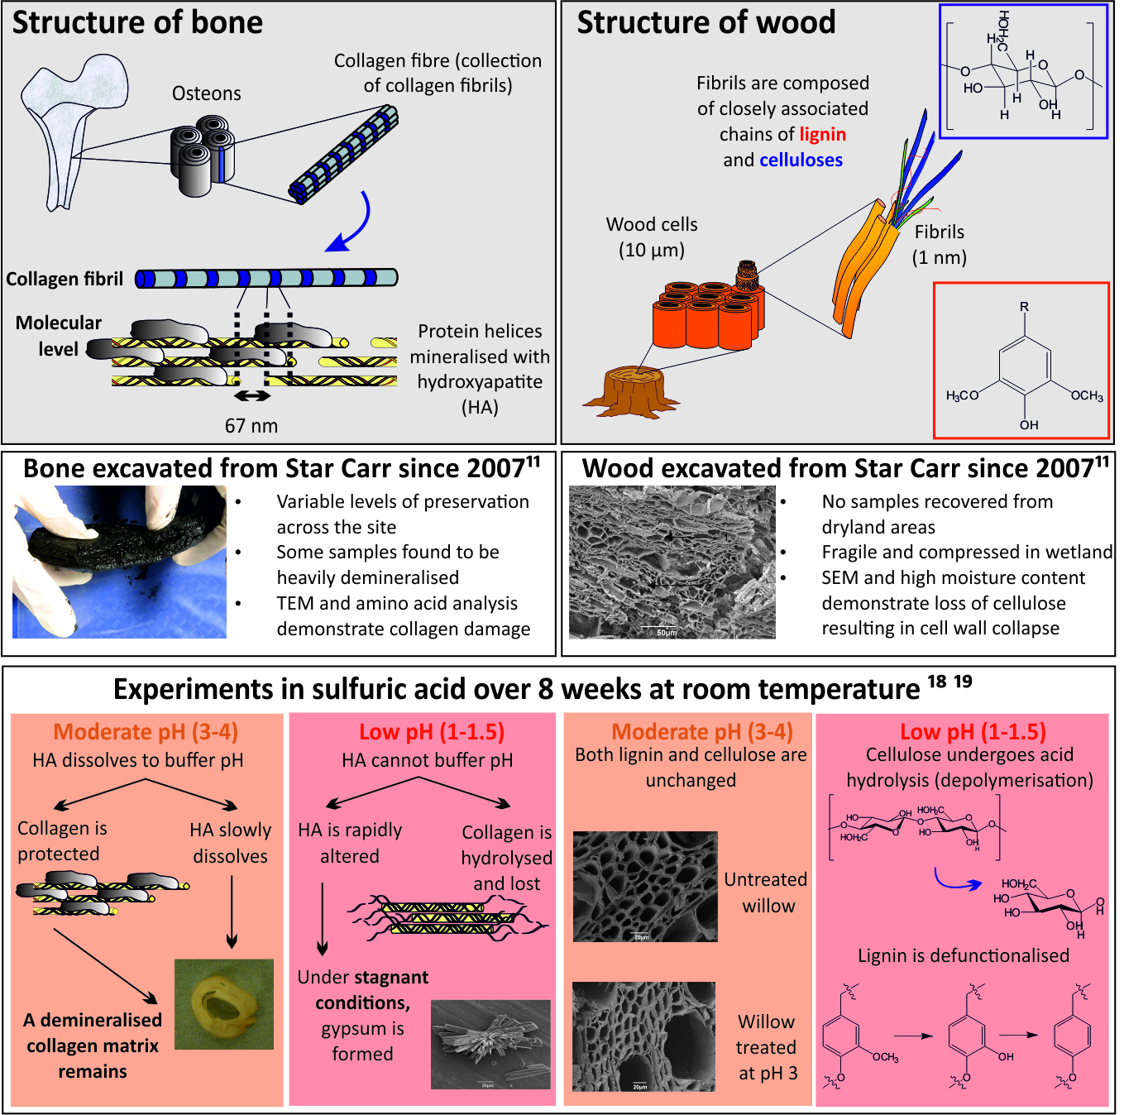
Figure 1: Schematic of related research at Star Carr. Schematics showing the basic structure of bone and wood; summary of observations reported following excavations at Star Carr in 2006 – 2010¹¹; and summary of previous laboratory-based experiments, reporting changes observed collagen and hydroxyapatite (HA) in bone¹⁸ and lignin and cellulose in wood¹⁹.
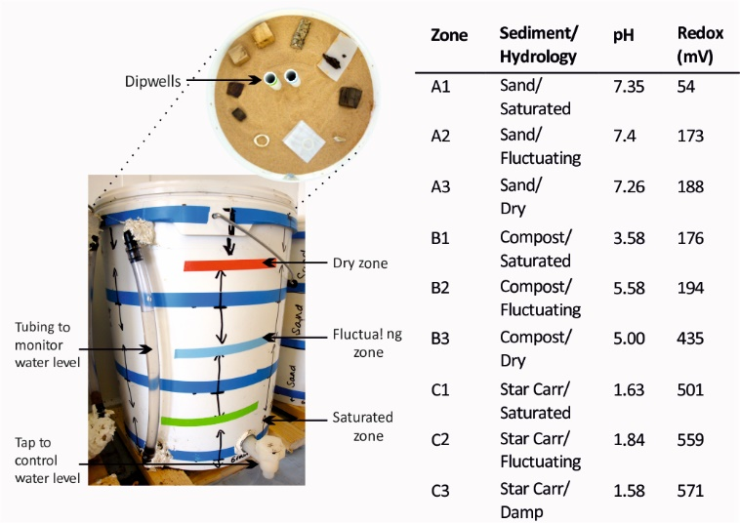
Figure 2: Experimental microcosms allowing assessment of sediment type and hydrological conditions on organic decay. Three microcosms were set up in 25 L fermentation buckets. A set of material was laid out in each of the 10 zones as shown. Table displays pH and redox values for each zone, recorded on excavation.
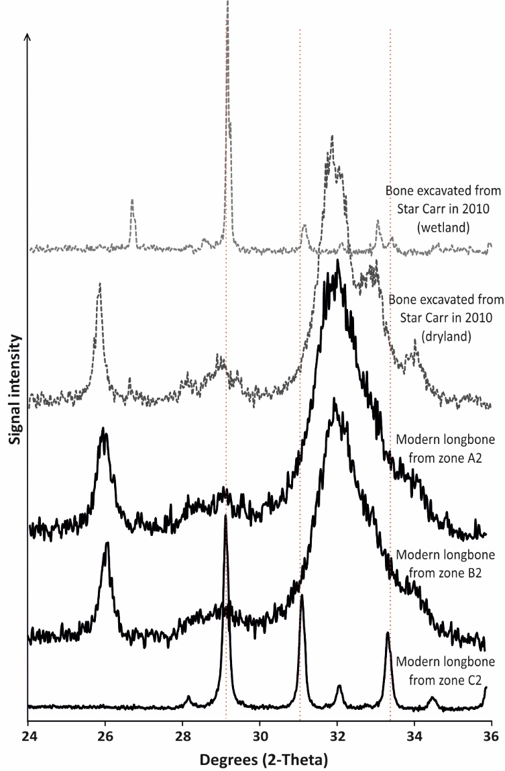
Figure 3: p-XRD demonstrates significant alteration of HA in microcosm C. p-XRD patterns for modern longbone excavated from zone 2 (fluctuating) from C (Star Carr), B (compost) and A (sand). Whilst no alteration from fresh bone (characterised by broad, ill-defined peaks) is seen in microcosms A and B, complete alteration of HA is observed in microcosm C, with bone buried for 12 months displaying the characteristic diffraction pattern of gypsum (indicated by dotted lines). Archaeological bone excavated from the dryland part of Star Carr in 2008 shows dominance of HA (the slight splitting of the peak at 32 degrees is the result of increased HA crystallinity caused by diagenesis), but material from the wetland area of the site confirms the gypsum transformation observed under microcosm experimental conditions.
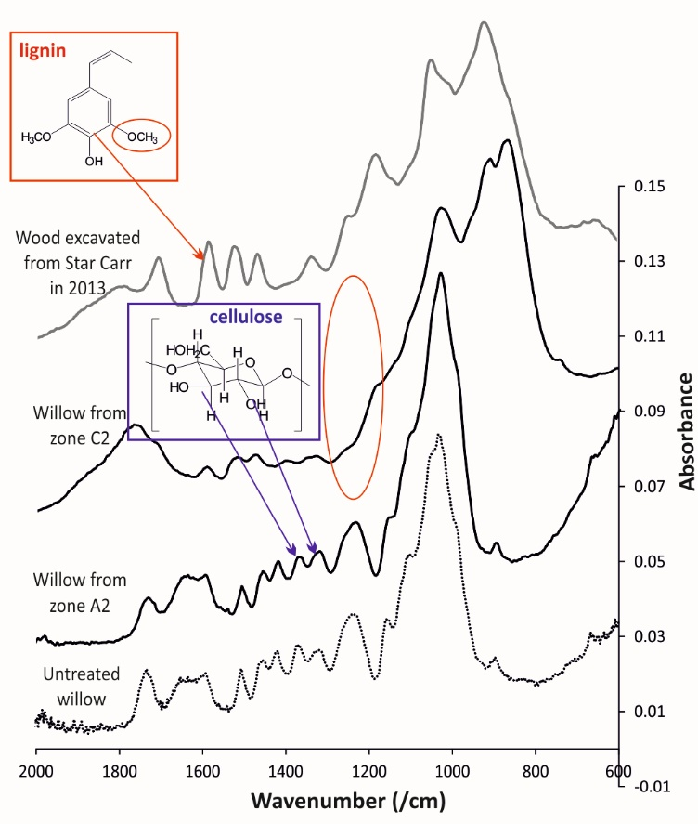
Figure 4: FTIR analysis demonstrates defunctionalisation of lignin in microcosm C. Spectra from untreated willow compared to willow buried in sand (A2) and Star Carr peat (C2) for 12 months. Loss of cellulose in the C2 sample is shown by a slight reduction in intensity of the peaks at 1325 and 1375 cm⁻¹(characteristic of CH₂ groups in cellulose); defunctionalisation of lignin is indicated by loss of the peak attributed to CH₃O groups at 1240 cm⁻¹ (circled). For comparison, a sample of wood excavated from Star Carr in 2013 is shown. Cellulose peaks at 1325 and 1375 cm⁻¹ also remain, while splitting and a decreased intensity of the 1240 cm⁻¹ lignin peak indicates that lignin has become defunctionalised.

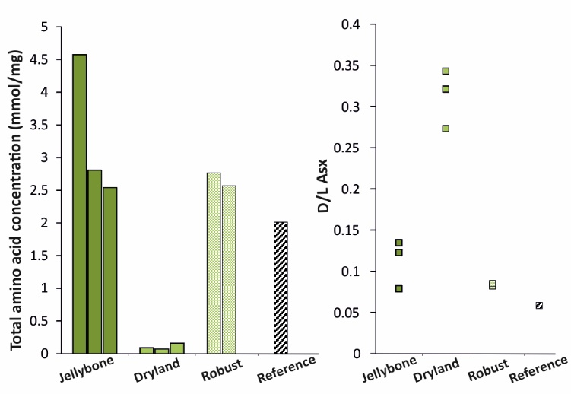
Figure 5: Amino acid analysis shows differing mechanisms of bone degradation at Star Carr. A comparison of the total amino acid concentration (left) and Asx racemisation values (right) for bones excavated from Star Carr in 2013 from the wetland (classified as ‘jellybone’ or ‘robust’) and dryland, compared to a modern sheep bone as a reference. Low amino acid concentrations and high Asx racemisation in the dryland bones suggests collagen damage, whereas elevated concentrations and low racemisation in the wetlands indicates loss of bone mineral.

