Alternate thermoregulation and functional binding of Escherichia coli Type 1 fimbriae in environmental and animal isolates
Running title: Low temperature T1F expression and binding in planta
Authors: Jacqueline Marshall¹, Yannick Rossez¹, Geoffrey Mainda² , David. L. Gally², Tim Daniell^{1,3}, Nicola Holden*¹
Address: 1 - The James Hutton Institute, Invergowrie, Dundee, UK, DD2 5DA
2 – Roslin Institute and Royal (Dick) School of Veterinary Studies, Edinburgh, UK, EH25 9RG
3 – Department of Animal and Plant Sciences, University of Sheffield, Sheffield S10 2TN, UK
* corresponding author: nicola.holden@hutton.ac.uk; (tel) +44 1382568700
Key words: adhesin, pili, mannosides, plants, animals, T-RLFP
Word count: 3600
Figures & Tables: 2 Tables, 3 Figs, 1 supplementary table, 1 supplementary figure
Abstract
Type 1 fimbriae (T1F) are well characterised cell surface organelles expressed by Escherichia coli and required for adherence to mannosylated host tissue. They satisfy molecular Koch’s postulates as a virulence determinant and a host-adapted role has been reinforced by reports that T1F expression is repressed at sub-mammalian temperatures. Analysis of a group of 136 environmental and animal E. coli isolates that express T1F at 37 °C showed that 28 % are also capable of expression at 20 ºC, in a phase variable manner. The heterogeneous proportions varied widely, and although growth temperature impacted the total proportion expressing T1F, there was no direct correlation between growth at 37 and 20 °C, indicative of differences in thermoregulation of the genetic switch (fimS) that controls phase variation. Specificities of the adhesin (FimH) also varied between the isolates: most bound to α-(1-3) mannan and yeast extracts as expected, but some recognised β-(1-4)-mannans and N-linked glycoproteins from plants, and T1F from two of the isolates mediated binding to plant roots. The results expand our view of a well described adherence factor to show alternative expression profiles and adhesin specificities, which in turn may confer an advantage for certain isolates in alternative hosts and habitats.
Introduction
Escherichia coli is commonly associated with mammalian hosts, where it normally colonises the intestinal tract as a commensal. However, members of the species are also found in the wider environment, such as water and soil (Brennan et al., 2010) and plants (Holden et al., 2009). Presence outside of mammalian hosts is commonly thought to arise from faecal contamination, although there is good evidence to show that some members of the E. coli species can become ‘naturalised’ to alternative hosts and habitats (Walk et al., 2007, Walk et al., 2009). Indeed, characterisation of E. coli from an agricultural trial site argued against a direct association between slurry treatment and incidence of soil- and plant-derived E. coli (Holden et al., 2013). One of the main environmental factors to differentiate these strains from those that are animal-associated is temperature.
The presence of E. coli in secondary hosts or habitats raises questions about the factors required for growth and colonisation. Attachment is a prerequisite for host colonisation, and Type 1 fimbriae (T1F) is a widely distributed adherence factor in E. coli. The adhesin, FimH, normally presented on the tip of a fimbrial shaft, recognises α-(1-4)-linked mannose present in N-linked glycoproteins on host cell surfaces, especially abundant in mammalian urinary tract epithelial cells (Jones et al., 1995, Sokurenko et al., 1997, Schembri et al., 2000). T1F are defined as a virulence factor in animal hosts (Bergsten et al., 2005) and their phase variable expression results in heterogeneous populations. The promoter for the fim cluster is in an invertible element (fimS) which in the ‘on’ orientation drives expression of the fim genes (Gally et al., 1996). This genetic switch is under the control of two recombinases, FimB and FimE (Klemm, 1986, Holden et al., 2007). Expression of T1F has been well characterised for animal-derived strains and shown to be temperature controlled, so that it is normally only induced at animal host-relevant temperatures and repressed at lower temperatures (Dorman & Ni Bhriain, 1992, Olsen et al., 1998).
A group of genetically diverse Escherichia coli isolated from a barley field trial had exhibited significant differences in biofilm formation, at both 37 ºC and at 20 ºC (Holden et al., 2013). Since the biofilm matrix often includes T1F, we hypothesised that it would only be present in biofilms formed at temperatures relevant to mammalian hosts and not to wider environments. Therefore, the expression and potential functions of T1F was measured from a diverse group of environmental isolates in comparison with mammalian-derived isolates.
Material and Methods
E. coli bacteria were grown in LB media at 37 ºC, with ampicillin (AP) (50 µg ml⁻¹) or chloramphenicol (25 µg ml⁻¹), as required.
fimS orientation screens: E. coli strains MG1655 (Blattner et al., 1997) or Sakai (Dahan et al., 2004) were used as controls. Cultures were inoculated from single colonies and grown in 5 ml media at 37 °C statically for 18-24 hours, sub-inoculated at 1:100 dilution and grown at either 20 °C or 37 °C for 48 or 24 hours, respectively. 100 µl samples were boiled for 5 minutes, diluted 1:10 in water and 1µl was used for PCR with primers 2535 (5’- GCCGGATTATGGGAAAGA) and 3137 (5’- GCCGCTGTAGAACTGAGG) and Taq DNA polymerase (Roche), annealing temp of 56.5 °C for 25 cycles. 10 µl of PCR product was incubated with 1 unit Hinf1 restriction enzyme for 2 hours at 37 °C. Low-throughput analysis digestion products were resolved on a 2 % agarose gel or a 10 % polyacrylamide TBE gel. The expected product sizes of fimS were: OFF = 200 bp + 402 bp; ON = 122 bp + 480 bp; uncut DNA = 602 bp. High-throughput screening T-RFLP was performed as described by (Deng et al., 2010). Briefly, fluorophore-conjugated primers (2535-FAM and 3137-atto-565) were used with three or four samples from three independent experimental replicates of animal or environmental isolates, respectively. Digested samples were run on an ABI 3730 sequencer and raw data processed through Genemapper. Peaks with < 1% of fluorescence and minor peaks or artefacts present in undigested controls and not the expected size were removed. Unequal sample variances necessitated the removal of eleven samples with signals below the average fluorescence signal, presumably due to incomplete PCR. Minor differences in the length and sequence of PCR products meant that the peak bin sizes varied across isolates, i.e. fimS(ON) ranged between 115 and 119 bp (FAM-labelled) and 478-480 bp (atto565-labelled); fimS(OFF) ranged between 197 and 199 bp (atto565-labelled) with no variation in the 403 bp FAM-labelled peak. The forward primer (2535-FAM) yielded a 2.2-fold higher average fluorescence signal than the reverse primer (3137-atto565) (P > 0.001), presumably as a result of primer efficiency and/or fluorescence detection. However, the primer output signals correlated strongly for both fimS orientations and temperatures (R² = 0.94 and 0.97 for 37 ºC, and 0.92 and 0.89 for 20ºC, ON or OFF respectively).
Yeast cell agglutination: Yeast cells (Saccharomyces cerevisiae) were grown overnight at 37 °C shaking in LB, washed in PBS and diluted 1:10 in PBS ± 1% (w/v) mannose. 15 µl of yeast mixture was mixed with 15 µl of E. coli (grown as described above) on a glass slide. Visible agglutination was scored as positive (clump formation) or negative (no clumps, confirmed by microscopy). T1F-dependent yeast agglutination was defined as mannose sensitive (MSYA).
Root binding with mannose inhibition: fimA-H was cloned from E. coli isolates JHI-5025 and JHI-5039 with primers fimA_Sacl (5'-CCGAGCTCGACTGCCCATGTCGATTT) and fimH_Xbal (5'-GCTAGTCTAGACGTGCAGGTTTTTAGCTT) using the SacI and XbaI sites in pBAD18 (Guzman et al., 1995) for high copy-number, or pWSK29 (Wang & Kushner, 1991) for low copy-number resulting in plasmids pBAD18-25 and pBAD18-39, and pWSK29-25 and pWSK29-39, respectively. Single-copy pWSK29 was used because induction of pBAD18-derived plasmids resulted in high background levels of binding in the ELISA (not shown). E. coli AAC185A transformed with pBAD18-25, pBAD18-39, pBAD18, pWSK29-25, pWSK29-39, or pWSK29 overnight cultures was sub-inoculated (1:100) into LB-AP media with 0.02% arabinose and incubated for 3 hours at 37 ºC with aeration for pBAD18-derived plasmids, or 5 mM IPTG and incubated for 16 hours at 37 ºC with aeration for pWSK29-derived plasmids. The cell density was adjusted to 0.02 at OD₆₀₀ (~ 1 x 10⁷ cfm ml⁻¹) in sterile PBS with or without 1 % D-(+)-mannose. Spinach plants (var. Amazon) were grown from seed in general compost under a 16 / 8 hour light / dark regime at ~20 °C, 65 % humidity, for three weeks. The roots were detached, washed in sterile distilled water and the fresh weight recorded. The roots were inoculated with the bacterial suspension for 2 hours at 18 ºC, washed vigorously 3 times in 20 ml sterile PBS using a vortexer and homogenised with a sterile mortar and pestle. Ten-fold serial dilutions were incubated on MacConkey’s agar containing ampicillin for viable bacterial counts. The number of bacteria recovered from the roots was expressed as a percentage of the initial inoculum termed ‘factor change’.
ELISA and inhibition assays: The enzyme-linked immunosorbent assay (ELISA) was based on (Rossez et al., 2014). Spinach extracts enriched in glycoproteins, and complex yeast cell wall proteins were disrupted using liquid nitrogen (Dunn & Wobbe, 2001, Karlova et al., 2006). Microtitre plates were coated with purified polysaccharides of β-(1-4) D-mannan from carob (Megazyme, Bray, Ireland), α(1-3)-mannan from Saccharomyces cerevisiae (Sigma Aldrich), yeast extracts or plant glycoproteins (50 μg per well) in 0.05 M carbonate buffer (pH 9.6). Bacteria were grown as for the root binding assay 100 μl added per well at a cell density of 0.4 (OD₆₀₀), ± 1 % D(+)-mannose. After 2 hours the wells were washed three times with TBS, incubated with anti-E. coli antibody (Abcam, Cambridge, UK) 1:500 in TBS for 1 hour, washed three times with TBS, incubated with 100 μl of horseradish peroxidase anti-rabbit IgG conjugate (Invitrogen) 1:1000 for 1 hour, and washed three times with TBS. The colour reaction was developed with ABTS (2,2’-azino-bis(3-ethylbenz-tiazoline-6-sulfonic acid, diammonium salt) and the values from six technical replicates measured at 405 nm in a SpectraMax M5 multiplate reader (Molecular Devices).
Statistical analysis: Data was collected from at least two independent experimental replicates. Viable counts were expressed as cfu g⁻¹ (fresh tissue) transformed to log₁₀. ELISA absorbance (405 nm) data was normalised to the negative, no substrate controls. The statistical significance was evaluated with Student’s t-test or one-way analysis of variance using Excel (Microsoft), Prism (GraphPad software Inc.) or Genstat (VSN International) and results considered as significant for a P ≤ 0.05.
Results
T1F expression and fimS orientation of environmental E. coli isolates
We examined expression of T1F in 88 environmental isolates at 37 ºC and at 20 ºC from determination of the phase variable promoter orientation, fimS. The reference E. coli K-12 strain MG1655 was included as a laboratory-adapted reference, which does not express fimA below 30 °C (Olsen et al., 1998). When cultured at 37 ºC, 86 of the isolates contained a mixture of fimS DNA in the ON and OFF orientation: one isolate contained OFF fimS only (JHI-5008), and no PCR product was detected from another (JHI-5044). However, when cultured at 20 ºC, 19 of the isolates were also found to contain a mixture of fimS in the ON and OFF orientations, while the remaining 69 isolates, including E. coli MG1655, contained only OFF orientation fimS (Fig. 1 for example profiles). Functional production of T1F at 20 ºC was confirmed by mannose-sensitive yeast agglutination (MSYA) for all 19 isolates.
To determine whether low temperature expression of T1F was limited to environmental isolates, an additional 57 E. coli isolates derived from animals were examined by MSYA at 20 ºC compared to 37 ºC. These included 20 bovine faecal isolates, 15 isolates from canine UTIs, and 21 human isolates associated with urinary tract infections or meningitis (Supplementary Table 1). Ten of the 56 isolates grown at 37 ºC did not display MSYA, and of the remaining 46, 19 were able to agglutinate yeast after being grown at 20 ºC. This equated to 41.3 % of the animal isolates that produce T1F at at both 20 ºC and 37 ºC. The comparable proportion for the environmental isolates was 21.8 %, whilst combining all of the 135 E. coli isolates tested resulted in 27.9 % capable of low-temperature T1F expression.
To accurately quantify the proportion of ON and OFF fimS, a T-RFLP approach was used for a sub-set of 45 environmental and animal isolates, comprising all of the isolates that exhibited low temperature expression of T1F, plus five that only expressed T1F at 37 ºC: four environmental, 1 animal isolate and strain MG1655 (Table 1). The T-RFLP used established PCR primers for fimS together with an asymmetric HinfI restriction site (Gally et al., 1996) and the proportion of fimS (ON) was determined from the primer that generated a stronger signal (2535-FAM). The profiles for fimS ON and OFF DNA confirmed the presence of both orientations of the invertible fimS element. There was a wide variation in the level of fimS (ON) DNA, which was most strongly affected by the culture temperature, with a significantly higher amount detected for cultures grown at 37 ºC compared to 20 ºC (p >0.001): average of 53.8 % (range 25 - 78 %) and 20.4 % (range 0 - 68 %), respectively (Table 1, Supplementary Fig. 1). This is clearly demonstrated by taking an arbitrary ‘threshold’ e.g. 25 % fimS (ON): 75 % OFF, for just three isolates fell below at 37 ºC in contrast to 31 of the isolates below this level when grown at 20 ºC. The source of isolation also had an impact, with a higher proportion of environmental isolates containing fimS (ON) DNA (65 %) compared to the animal-associated isolates (43 %), but only when cultured at 37 ºC with no difference at 20 ºC ( of 20.6 %). There was a poor correlation between the amount of fimS (ON) at either temperature (R² = 0.25), indicating that the differences in fimS (ON) DNA was not due to a common factor, such as altered growth rate or lower cell density at the lower temperature (Supplementary Fig. 1). However, high levels of fimS (ON) DNA (> 64 %) occurred for two of the environmental isolates at both temperatures.
Mannose binding and specificity of T1F
To understand the biological context of low-temperature expression of T1F, specificity for different mannose-containing substrates was tested by ELISA, reflecting different host / habitats, for 24 isolates: 19 environmental isolates able to express T1F at low-temperature plus five isolates that did not. Binding to α−(1-3) mannans and yeast cell wall extracts (which contain α−(1-3) mannans), to represent mannosylated N-glycoproteins found in animal cell membranes was compared to the alternative linkage of mannosylation that occurs in plant cell walls, β−(1-4) mannans, and mannose-containing glycoproteins derived from spinach (Fig. 2). Binding varied considerably, but the highest levels of binding occurred with α−(1-3) mannans followed by spinach N-linked glycoproteins for cultures grown at 37 °C. Individual isolates capable of low-temperature T1F expression demonstrated amongst the highest total values, e.g. JHI-5005, 5043, 5039, 5045 and 5025 for yeast and α−(1-3) mannans (Figs. 2a,b). Relatively high binding at 20 °C occurred for isolate JHI-5039 to β−(1-4) mannans and N-linked glycoproteins, and for isolate JHI-5005 to N-linked glycoproteins (Figs. 2c,d). The mannose binding pocket was 100 % conserved in all isolates. Three isolates with significantly weaker binding to α(1-3) mannans (Z score <1, Table 2), (5043, 5045, 5054), contain substitutions at A119, which is associated with low affinity binding (Rodriguez et al., 2013). There were no shared changes in the mannose-binding domain (residues 1-158 of mature FimH) that accounted for significantly stronger binding to β(1-4) mannans or N-linked glycoproteins (Z score >1, Table 2).
Isolates expressing T1F at low temperature adhere to plant roots
To test whether low-temperatures expression of T1F may facilitate adherence to plant tissue, the structural and secretion genes of the T1F operon, fimAICDFGH, for two of the isolates that demonstrated functional binding at 20 ºC were selected for further investigation (JHI-5025, JHI-5039). Induction of plasmid-borne fimA-H resulted in strong MSYA, whereas un-induced transformed cultures and the empty vector did not exhibit any yeast cell agglutination. T1F derived from JHI-5039 bound to β-(1-4) mannan to significantly higher levels than JHI-5025, as measured by ELISA (Fig. 3a). No binding was observed for the negative control and addition of free mannose significantly reduced the level of binding. Mannose-sensitive binding to yeast extract was higher for T1F derived from JHI-5025 confirming the previous results (Figs. 2a and 3b), and significantly higher for the induced compared to the un-induced cultures. Binding of a fim- strain transformed with the fimA-H plasmids was assessed on spinach roots. A significant increase in adherence occurred for fimA-H derived from both isolates, especially for isolate JHI-5025, compared to the un-induced cultures, and the binding was sensitive to 1 % mannose (Fig. 3c). Mannose is also present in the hemicellulose component of plant cell walls but can be masked by pectin polysaccharides. However, treatment with pectate lyase did not significantly reduce adherence (not shown), indicating that plant mannans recognised by T1F were not masked by pectin.
Discussion
Type 1 fimbriae (T1F) is an adherence factor that is common in E. coli and other members of the Enterobacteriacae, and has been particularly well-characterised in uropathogenic E. coli and the commensal-derived isolate, MG1655. Structure-function analysis of the adhesin, FimH, has shown affinity for α-D-mannosides (Krogfelt et al., 1990, Hung et al., 2002, Bouckaert et al., 2005, Rodriguez et al., 2013) and regulation of T1F is complex, subject to multiple environmental cues (Holden & Gally, 2004). The finding of expression of T1F at sub-mammalian relevant temperatures in certain E. coli isolates indicates a functional requirement, which may be for adaptation to secondary hosts or habitats during an environmental phase of the lifecycle of E. coli.
The E. coli isolates tested here exhibited the highest level of affinity for α-(1-3) mannans, albeit with wide variation, whereas binding to purified β−(1-4) mannans was much rarer. Some isolates were also able to bind to N-linked plant glycoproteins. (Spinach was used as it is associated with food-borne outbreaks of E. coli e.g. (Cooley et al., 2007)). Diversity in T1F specificity for mannose-containing targets suggests differences in the FimH structure and/or in its presentation on the fimbrial rod, between the isolates (Duncan et al., 2005). Conservation of the mannose binding pocket (Bouckaert et al., 2005) was reflected by binding of the isolates to α(1-3) mannans and sequence variation has only been reported in EHEC isolates (Hung et al., 2002), which do not express T1F (Roe et al., 2001). The lack of obvious shared changes in the mannose-binding domain of isolates that interacted with β(1-4) mannans or N-linked glycoproteins, and the fact that the MBD of three of the isolates was conserved with isolate MG1655, indicates that the functional basis must lie elsewhere. The affinity of FimH for α-D-mannosides is 2.3 µM with the strongest binding shown for heptyl α-D-mannopyranoside (Bouckaert et al., 2005). In plant cell walls, mannose is present in hemicellulose polysaccharides (Marcus et al., 2010), or in N-linked glycoproteins in the form of high-mannose (Lerouge et al., 1998), covalently bound to N-acetylglucosamine by β−(1-4) linkage as ‘oligomannose’, or as a ‘hybrid’ with other monosaccharides. Recognition of β−(1-4) mannans and plant-derived N-linked glycans appeared to overlap for isolate JHI-5039 at 20 °C and T1F derived from this isolate, as well as isolate JHI-5025, facilitated mannose-sensitive binding to spinach roots. This supports a previous report indicating a role for T1F binding to the roots of grass plants (Poa pratensis) for related members of the Enterobacteriaceae (Haahtela et al., 1985).
Multiple adherence factors are encoded by E. coli, the complement of which can confer tissue tropism for particular isolates, e.g. for UPEC (Sauer et al., 2000). Another temperature-regulated fimbriae, E. coli common pilus (ECP), has been shown to mediate binding of pathogenic E. coli to arabinosyl residues in spinach cell walls (Rossez et al., 2014). The contribution of T1F-dependent binding to spinach roots here was small, although the host strain, E. coli K-12, does not (in our hands) colonise plants well (Holden et al., 2013). Therefore, it is likely that multiple adherence factors are involved in plant host attachment, with different functional targets.
The regulatory mechanism underpinning low-temperature expression of T1F is, as yet, undefined and to our knowledge, this is the first report of E. coli fimS recombination and T1F expression at 20 °C. Furthermore, it is apparently a reasonably common phenotype occurring in 38 of the 147 isolates tested. Growth temperature is still an important factor in T1F expression, with higher proportions of fimS ON occurring at 37 ºC, whereas the source of isolation, either animal or environmental, had only a marginal impact (only at 37 ºC and not 20 ºC), indicating that for the isolates examined here, low-temperature expression of T1F did not appear to be a consequence of recent host or habitat-association. Phylogenetic analysis has shown divergence in the environmental isolates (Holden et al., 2013) and it is likely that they contain differences in their regulatory networks linked to thermoregulation. The accumulation of E. coli genomic sequences continues to expand the diversity of the species and alternate expression of a colonisation factor may simply be a reflection of bet-hedging (Veening et al., 2008) for a mesophilic species that encounters a wide range of secondary hosts and / or alternative habitats.

Funding
This work was supported by Scottish Government Rural and Environment Science and Analytical Services strategy funding to JM, TD and NJH; the Leverhulme Trust (RPG-096 to YR and NJH); BBSRC Institute Strategic Programme funding (BB/J004227/1 to DLG) and a Commonwealth Scholarship Commission PhD (ZMSC-2012-640 to GM). TD is part funded by the HEFCE N8 AgriFood Catalyst grant.
Acknowledgments
We would like to thank Ashleigh Holmes for critical reading of the manuscript.
Tables
Table 1 E. coli isolates that expressed T1F at 20 ºC. The average fluorescence signal from T-RLFP data at 20 °C or 37 ºC is shown, with T1F expression from MSYA or fimS (ON) PCR detection indicated by ‘(Yes)’ or ‘No’. ‘Yes/No’ refers to a weak MSYA; ND refers to not determined. (See Supplementary Table 1 for the full dataset).
Sample ID | Source | T-RFLP (MSYA/ fimS) 37°C | T-RFLP (MSYA/ fimS), 20°C
ZB-026 | Animal: bovine faecal isolate | 0.249 (Yes) | 0.254 (Yes)
ZB-085 | Animal: bovine faecal isolate | 0.484 (Yes) | 0.414 (Yes)
ZB-166 | Animal: bovine faecal isolate | 0.440 (Yes) | 0.115 (Yes)
ZB-174 | Animal: bovine faecal isolate | 0.393 (Yes) | 0.348 (Yes)
ZB-191 | Animal: bovine faecal isolate | 0.353 (Yes) | 0.260 (Yes)
ZB-193 | Animal: bovine faecal isolate | 0.300 (Yes) | 0.066 (No)
ZB-213 | Animal: bovine faecal isolate | 0.387 (Yes) | 0.179 (Yes)
ZB-243 | Animal: bovine faecal isolate | 0.254 (Yes) | 0.042 (Yes)
ZB-254 | Animal: bovine faecal isolate | 0.432 (Yes) | 0.039 (Yes)
ZB-280 | Animal: bovine faecal isolate | 0.465 (Yes) | 0.067 (Yes)
2213N0172 | Animal: bovine faecal isolate | 0.449 (Yes) | 0.130 (Yes)
ZB-375 | Animal: bovine faecal isolate | 0.410 (Yes) | ND (Yes)
C1711/01 | Animal: canine UTI | 0.445 (Yes) | 0.088 (Yes)
C1766/01 | Animal: canine UTI | 0.534 (Yes) | 0.218 (Yes)
ZAP617 | Animal: human meningitis | 0.568 (Yes) | 0.204 (Yes)
ZAP618 | Animal: human meningitis | 0.557 (Yes) | 0.234 (No /Yes)
ZAP631 | Animal: human UTI | 0.557 (Yes) | 0.249 (Yes)
MG1655 | Animal: human reference | 0.505 (Yes) | 0.033 (No)
AUTI_07 | Animal: human UTI | 0.553 (Yes) | 0.311 (Yes)
AUTI_47 | Animal: human UTI | 0.528 (Yes) | 0.279 (Yes)
CFT073 | Animal: human UTI | 0.400 (Yes) | 0.026 (Yes)
JHI-5009 | Environment: barley grain | 0.479 (Yes) | 0.036 (No)
JHI-5012 | Environment: barley grain | 0.703 (Yes) | 0.100 (Yes)
JHI-5039 | Environment: barley roots | 0.769 (Yes) | 0.482 (Yes)
JHI-5042 | Environment: barley roots | 0.682 (Yes) | 0.102 (No)
JHI-5001 | Environment: bovine slurry | 0.476 (Yes) | 0.029 (No)
JHI-5005 | Environment: bovine slurry | 0.764 (Yes) | 0.678 (Yes)
JHI-5088 | Environment: bovine slurry | 0.700 (Yes) | 0.467 (Yes)
JHI-5034 | Environment: compost | 0.702 (Yes) | 0.247 (Yes)
JHI-5043 | Environment: compost | 0.781 (Yes) | 0.509 (Yes)
JHI-5045 | Environment: compost | 0.767 (Yes) | 0.464 (Yes)
JHI-5025 | Environment: soil | 0.597 (Yes) | 0.238 (Yes)
JHI-5051 | Environment: soil | 0.706 (Yes) | 0.034 (Yes)
JHI-5053 | Environment: soil | 0.582 (Yes) | 0.121 (Yes)
JHI-5054 | Environment: soil | 0.757 (Yes) | 0.646 (Yes)
JHI-5058 | Environment: soil | 0.597 (Yes) | 0.043 (Yes)
JHI-5062 | Environment: soil | 0.629 (Yes) | 0.032 (No)
JHI-5065 | Environment: soil | 0.557 (Yes) | 0.069 (Yes)
JHI-5066 | Environment: soil | 0.518 (Yes) | 0.079 (Yes)
JHI-5067 | Environment: soil | 0.602 (Yes) | 0.065 (Yes)
JHI-5068 | Environment: soil | 0.569 (Yes) | 0.058 (Yes)
JHI-5069 | Environment: soil | 0.715 (Yes) | 0.533 (Yes)
JHI-5071 | Environment: soil | 0.574 (Yes) | 0.243 (Yes)
JHI-5079 | Environment: soil | 0.722 (Yes) | 0.086 (Yes)

Table 2 FimH mannose binding domain (MBD) variations. Amino acid substitutions are compared to FimH_{MG1655} accession AAA97216; those in italics were reported previously (Bouckaert et al., 2006). Isolate names in bold text show significantly higher binding (Z score >1) for at least one substrate, at either 37 or 20 °C.
Isolate | Z score: α(1-3)man (37, 20) |  | Z score: β(1-4)man (37, 20) |  | Z score: N-glycoprotein (37, 20) |  | AA substitutions
5001 | 0.26 | -0.85 | -0.67 | -0.81 | 1.55 | 0.09 | V27A, V30A
5005 | 1.08 | 2.34 | 3.09 | 0.38 | 0.95 | 3.50 | none
5009 | -0.41 | -0.85 | -0.41 | -0.39 | 0.32 | -0.38 | V27A, S69A
5012 | 1.01 | -0.27 | -0.72 | -0.49 | -0.77 | -0.61 | V27A
5025 | 0.12 | 1.31 | 0.39 | 1.51 | -0.25 | -0.17 | none
5034 | 0.73 | 1.04 | -0.37 | -0.82 | 0.28 | -0.80 | V27A
5039 | 0.08 | 2.00 | -0.73 | 3.55 | -0.98 | 1.39 | V27A, D37H
5042 | 2.41 | 0.19 | -0.81 | 0.04 | -3.16 | -0.94 | V27A
5043 | -1.69 | 0.10 | 0.37 | -0.04 | 1.23 | 0.43 | V27A, A119V
5045 | -1.71 | -0.30 | -0.14 | -0.52 | -0.76 | -0.03 | V27A, A119V
5051 | 0.31 | -0.89 | 0.59 | -0.78 | 0.95 | -0.43 | V27A
5053 | 0.57 | 0.38 | -1.01 | -0.34 | 0.22 | 0.09 | V27A, G66S
5054 | -1.67 | -0.78 | -0.21 | -0.03 | 0.66 | 0.94 | V27A, A119V
5058 | 0.87 | -0.95 | -0.35 | -0.40 | -0.15 | -0.43 | V27A
5062 | -0.71 | -0.99 | -0.94 | -0.03 | -1.16 | 0.35 | V27A
5065 | -0.71 | -0.68 | 0.33 | 0.33 | 0.13 | -1.82 | V27A
5066 | -0.64 | -0.42 | -0.19 | 0.26 | -0.29 | -0.24 | V27A
5067 | -0.18 | -0.57 | 2.15 | -0.21 | 0.10 | 0.32 | V27A
5068 | 0.52 | -0.60 | 1.33 | -0.30 | -0.04 | -0.94 | V27A
5069 | 0.42 | 1.71 | -0.77 | -0.73 | 0.11 | -0.20 | V27A
5071 | 0.81 | 0.66 | 0.38 | 1.52 | 0.61 | 0.39 | none
5079 | 0.07 | -0.36 | -0.68 | -0.19 | -0.75 | -0.31 | V27A
5088 | -1.38 | -0.40 | 0.10 | -0.15 | 1.42 | 0.37 | V27A
MG1655 | -0.17 | -0.82 | -0.74 | -1.37 | -0.22 | -0.58 | reference
Footnote: Z scores were determined from the ELISA data shown in Fig. 2.

Figure Legends
Figure 1 Composite gel showing examples of HinfI digested fimS at 20 and 37ºC.
A selection of fimS digestion products grouped by culture temperature of 20 °C or 37 °C. The isolate numbers correspond to each lane are indicated, as well as the markers from the 100 bp ladder (left) and on the ON and OFF specific bands (right). MSYA refers to mannose-sensitive yeast agglutination for each isolate under the two temperatures, either positive () or negative (x). EHEC and K-12 refer to E. coli strains Sakai (serotype O157:H7) and MG1655 (serotype K-12), respectively.

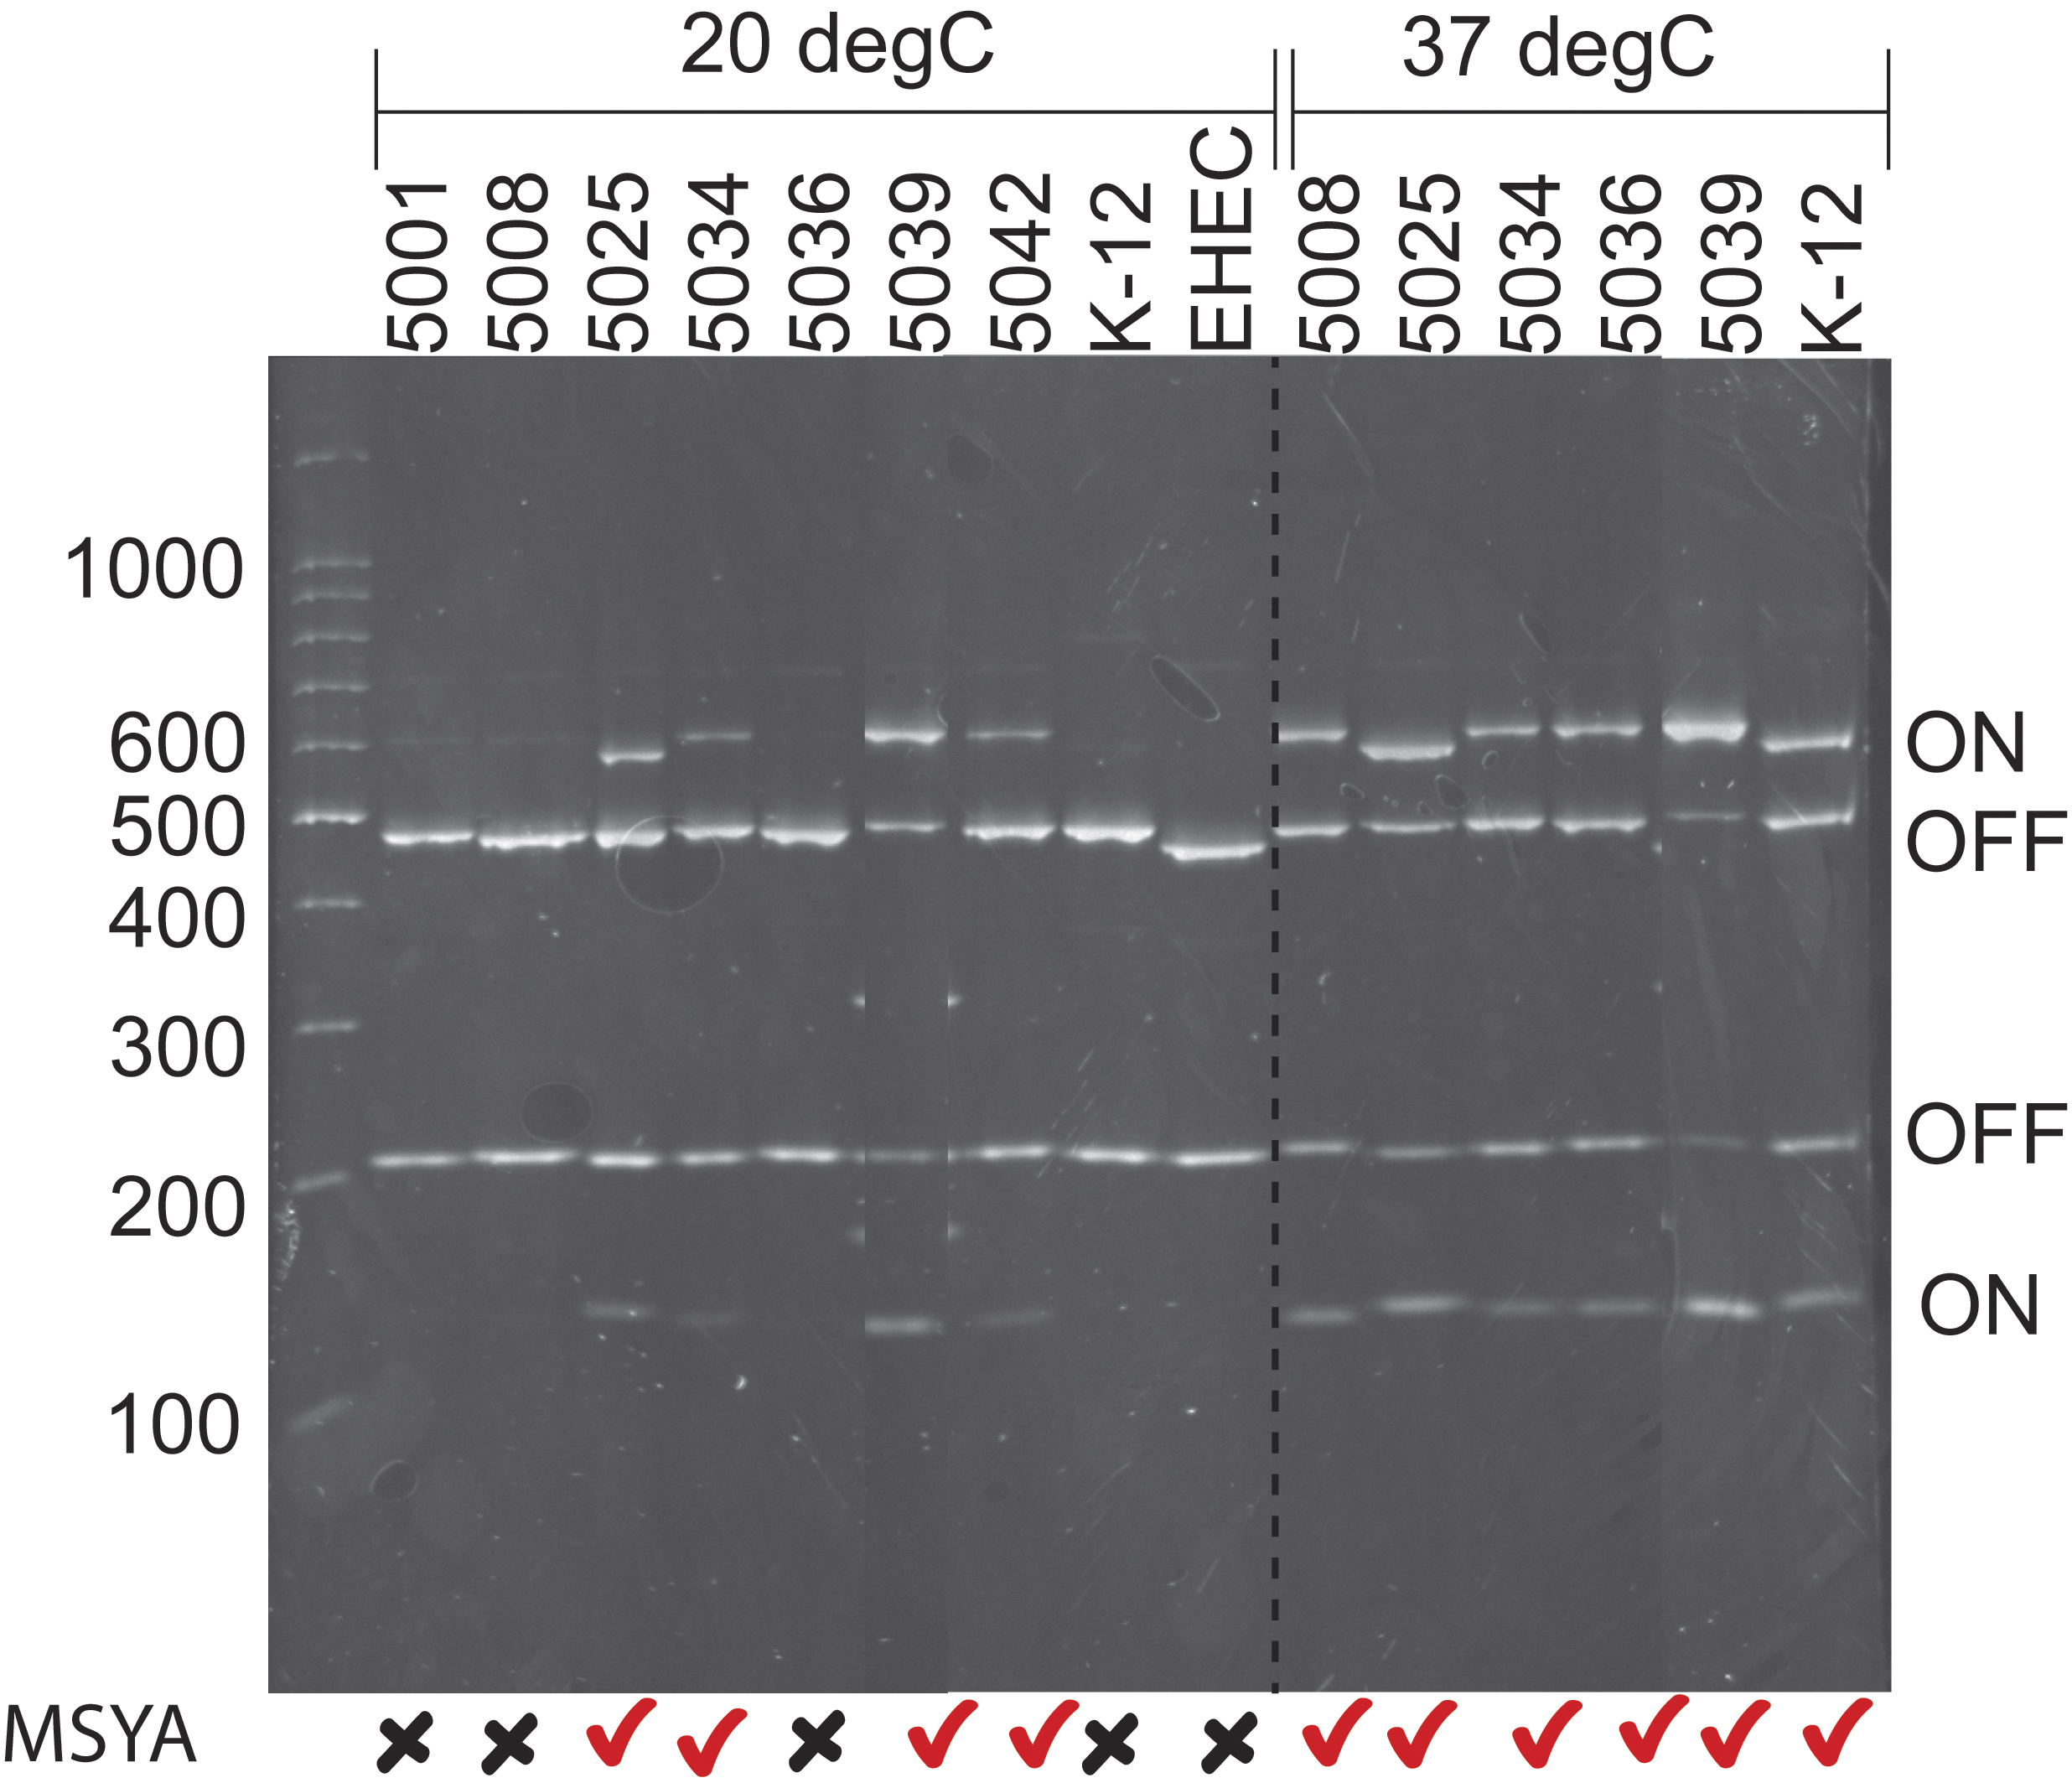

Figure 2 Variation in T1F specificity
Binding of the E. coli isolates to different mannose-containing substrates. The bar charts show the average absorbance (Abs. 405nm) and standard deviation from the ELISA for each of the isolates grown at 20 °C (blue bars - 20C) or 37 °C (orange bars - 37C) and bound to yeast cell wall (CW) extract (A); α-(1-3) mannan (B); β-(1-4) D-mannan (C), or spinach N-linked glycoproteins (D). Isolates JHI-5001, 5009, 5042, 5062 and MG1655 were not capable of low temperature expression of T1F.

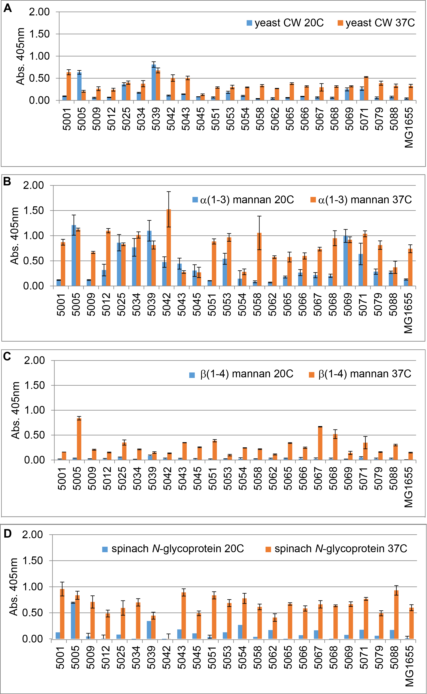

Figure 3 Functional binding of T1F from isolates capable of low-temperature T1F expression
E. coli AAEC185A transformed with pWSK29-25 (5025), pWSK29-39 (5039) and T1F induced with IPTG (filled bars – ‘+’) or un-induced (open bars – ‘-‘), before binding to (A) β-(1-4)-D-mannan; or (B) yeast cell wall extract, and measured by ELISA (Abs 405 nm). E. coli AAEC185A transformed with pBAD18-25 (5025), pBAD18-39 (5039) or pBAD18 (control) and T1F induced with arabinose (filled bars – ‘+’) or un-induced ((open bars – ‘-‘), before binding to (C) spinach roots. The data are expressed as the number of bacteria recovered from roots as a proportion of the initial inoculum. D-(+)-mannose was added to 1 % (w/v) where indicated.

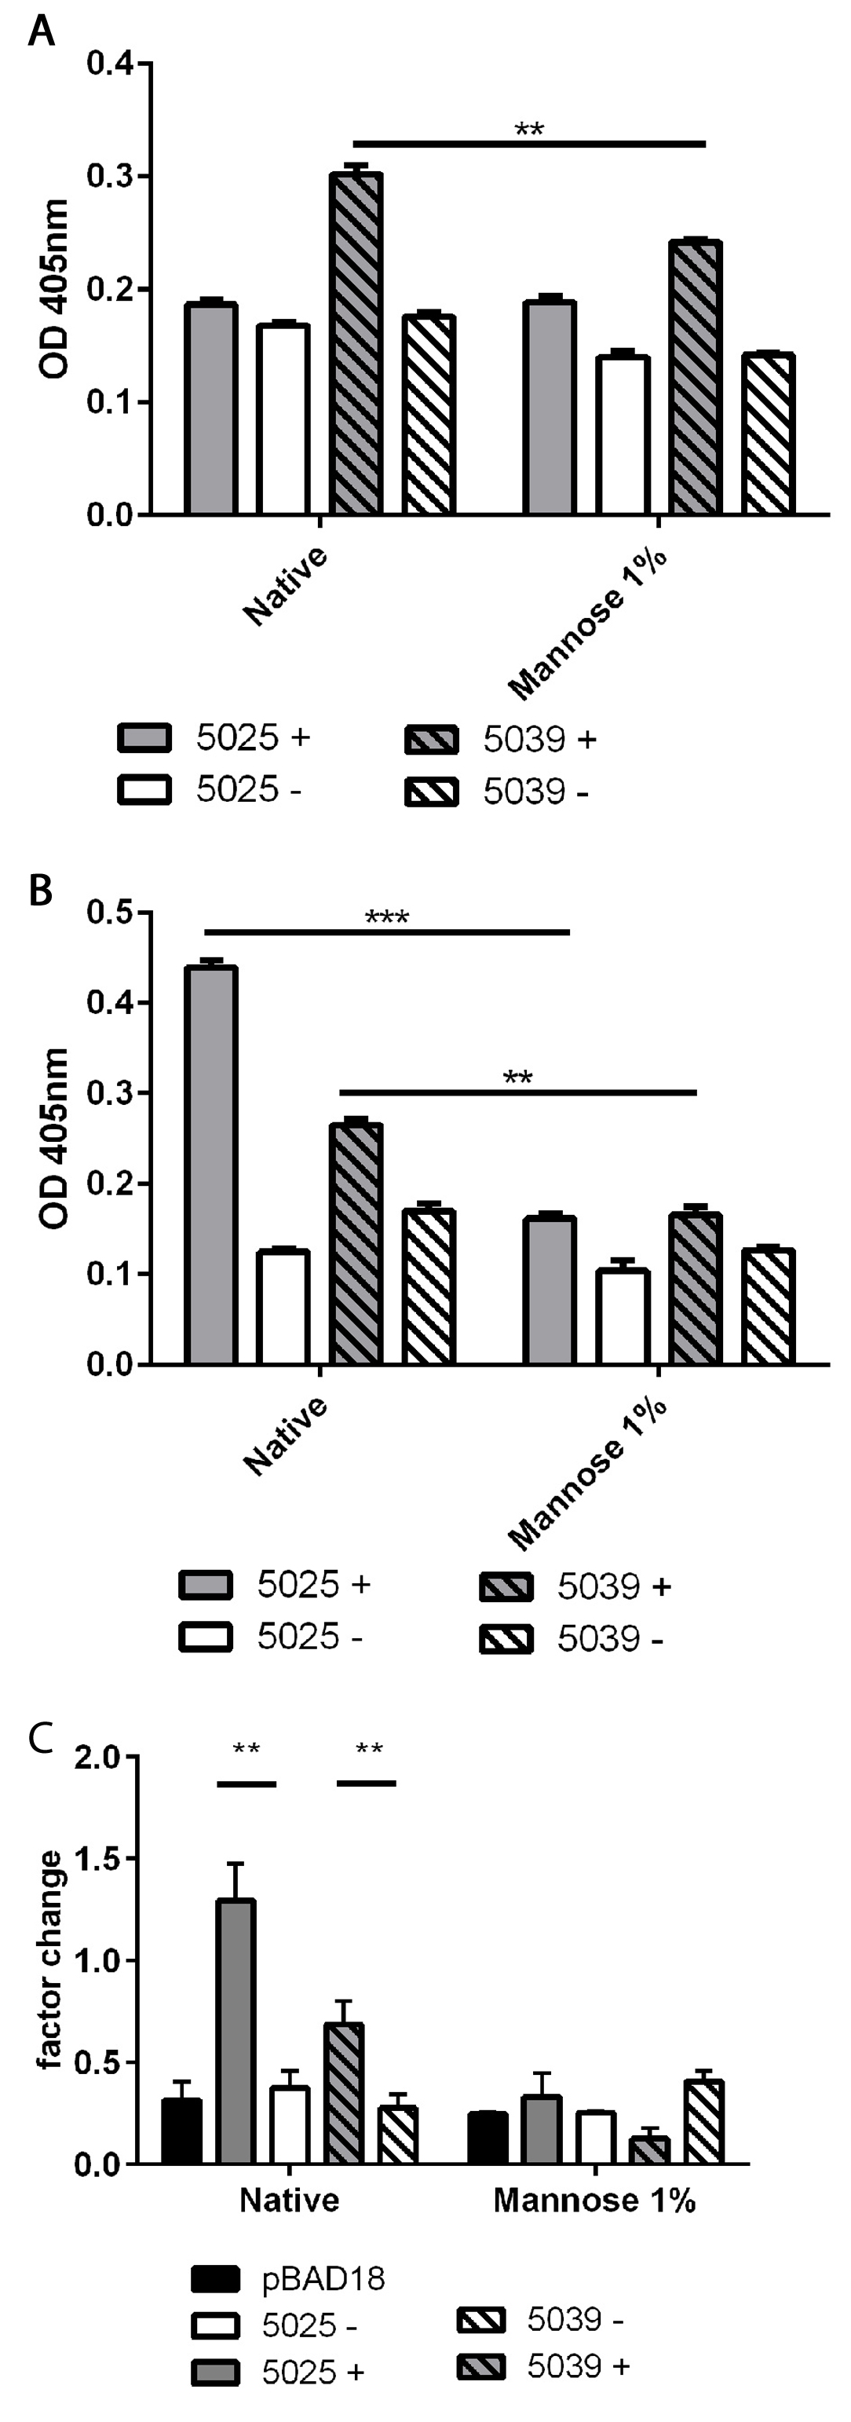

Supplementary Figure 1 T-RFLP analysis of fimS orientation.
The data for relative abundance of the HinfI digestion products derived from the 2535 primer (479 bp = ON) is plotted for 20 °C ‘vs’ 37 °C. The ‘best fit’ line has been plotted and the correlation value is shown.

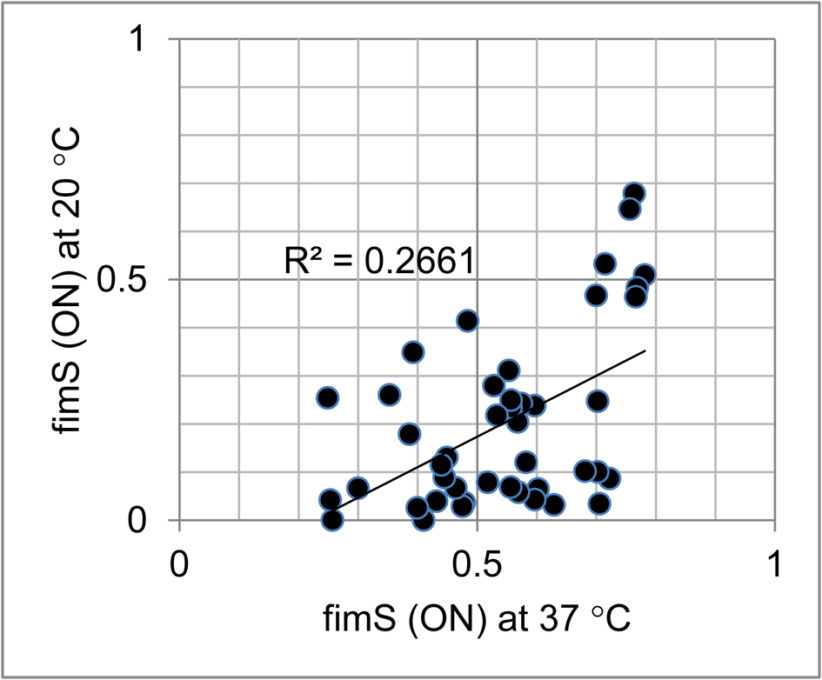

References
Bergsten G, Wullt B & Svanborg C (2005) Escherichia coli, fimbriae, bacterial persistence and host response induction in the human urinary tract. Int J Med Microbiol 295: 487-502.
Blattner FR, Plunkett Gr, Bloch CA, et al. (1997) The complete genome sequence of Escherichia coli K-12. Science 277: 1453-1462.
Bouckaert J, Mackenzie J, De Paz JL, et al. (2006) The affinity of the FimH fimbrial adhesin is receptor-driven and quasi-independent of Escherichia coli pathotypes. Mol Microbiol 61: 1556-1568.
Bouckaert J, Berglund J, Schembri M, et al. (2005) Receptor binding studies disclose a novel class of high-affinity inhibitors of the Escherichia coli FimH adhesin. Mol Microbiol 55: 441-455.
Brennan FP, Abram F, Chinalia FA, Richards KG & O'Flaherty V (2010) Characterization of environmentally persistent Escherichia coli isolates leached from an Irish soil. Appl Environ Microbiol 76: 2175-2180.
Cooley MB, Chao D & Mandrell RE (2007) Escherichia coli O157:H7 on spinach and lettuce; environmental investigations in the Salinas region of pre-harvest contamination. Phytopathol 97: S138-S139.
Dahan S, Knutton S, Shaw RK, Crepin VF, Dougan G & Frankel G (2004) Transcriptome of enterohemorrhagic Escherichia coli O157 adhering to eukaryotic plasma membranes. Infect Immun 72: 5452-5459.
Deng H, Zhang B, Yin R, Wang HL, Mitchell SM, Griffiths BS & Daniell TJ (2010) Long-term effect of re-vegetation on the microbial community of a severely eroded soil in sub-tropical China. Plant Soil 328: 447-458.
Dorman CJ & Ni Bhriain N (1992) Thermal regulation of fimA, the Escherichia coli gene coding for the type 1 fimbrial subunit protein. FEMS Microbiol Lett 78: 125-130.
Duncan MJ, Mann EL, Cohen MS, Ofek I, Sharon N & Abraham SN (2005) The distinct binding specificities exhibited by enterobacterial type 1 fimbriae are determined by their fimbrial shafts. J Biol Chem 280: 37707-37716.
Dunn B & Wobbe CR (2001) Preparation of protein extracts from yeast. Current protocols in molecular biology / edited by Frederick M Ausubel [et al] Chapter 13: Unit13.13.
Gally DL, Leathart J & Blomfield IC (1996) Interaction of FimB and FimE with the fim switch that controls the phase variation of type 1 fimbriae in Escherichia coli K-12. Mol Microbiol 21: 725-738.
Guzman LM, Belin D, Carson MJ & Beckwith J (1995) Tight regulation, modulation and high-level expression by vectors containing the arabinose P-BAD promoter. J Bacteriol 177: 4121-4130.
Haahtela K, Tarkka E & Korhonen TK (1985) Type 1 fimbria-mediated adhesion of enteric bacteria to grass roots. Appl Environ Microbiol 49: 1182-1185.
Holden N, Pritchard L & Toth I (2009) Colonization outwith the colon: plants as an alternative environmental reservoir for human pathogenic enterobacteria. FEMS Microbiol Rev 33: 689-703.
Holden N, Blomfield IC, Uhlin B-E, Totsika M, Kulasekara DH & Gally DL (2007) Comparative analysis of FimB and FimE recombinase activity. Microbiology 153: 4138-4149.
Holden NJ & Gally DL (2004) Switches, cross-talk and memory in Escherichia coli adherence. J Med Microbiol 53: 585-593.
Holden NJ, Wright F, MacKenzie K, Marshall J, Mitchell S, Mahajan A, Wheatley R & Daniell TJ (2013) Prevalence and diversity of Escherichia coli isolated from a barley trial supplemented with bulky organic soil amendments: green compost and bovine slurry. Lett Appl Microbiol 58: 205–212.
Hung CS, Bouckaert J, Hung D, et al. (2002) Structural basis of tropism of Escherichia coli to the bladder during urinary tract infection. Mol Microbiol 44: 903-915.
Jones CH, Pinkner JS, Roth R, Heuser J, Nicholes AV, Abraham SN & Hultgren SJ (1995) FimH adhesin of type 1 pili is assembled into a fibrillar tip structure in the Enterobacteriaceae. Proc Natl Acad Sci USA 92: 2081-2085.
Karlova R, Boeren S, Russinova E, Aker J, Vervoort J & de Vries S (2006) The Arabidopsis SOMATIC EMBRYOGENESIS RECEPTOR-LIKE KINASE1 protein complex includes BRASSINOSTEROID-INSENSITIVE1. Plant Cell 18: 626-638.
Klemm P (1986) Two regulatory fim genes, fimB and fimE, control the phase variation of type 1 fimbriae in Escherichia coli. EMBO J 5: 1389-1393.
Krogfelt KA, Bergmans H & Klemm P (1990) Direct evidence that the FimH protein is the mannose-specific adhesin of Escherichia coli type 1 fimbriae. Infect Immun 58: 1995-1998.
Lerouge P, Cabanes-Macheteau M, Rayon C, Fischette-Laine AC, Gomord V & Faye L (1998) N-glycoprotein biosynthesis in plants: recent developments and future trends. Plant Molecular Biology 38: 31-48.
Marcus SE, Blake AW, Benians TAS, et al. (2010) Restricted access of proteins to mannan polysaccharides in intact plant cell walls. Plant J 64: 191-203.
Olsen PB, Schembri MA, Gally DL & Klemm P (1998) Differential temperature modulation by H-NS of the fimB and fimE recombinase genes which control the orientation of the type 1 fimbrial phase switch. FEMS Microbiol Lett 162: 17-23.
Rodriguez VB, Kidd BA, Interlandi G, Tchesnokova V, Sokurenko EV & Thomas WE (2013) Allosteric coupling in the bacterial adhesive protein FimH. J Biol Chem 288: 24128-24139.
Roe AJ, Currie C, Smith DG & Gally DL (2001) Analysis of type 1 fimbriae expression in verotoxigenic Escherichia coli: a comparison between serotypes O157 and O26. Microbiology 147: 145-152.
Rossez Y, Holmes A, Lodberg-Pedersen H, Birse L, Marshall J, Willats WGT, Toth IK & Holden NJ (2014) Escherichia coli common pilus (ECP) targets arabinosyl residues in plant cell walls to mediate adhesion to fresh produce plants. J Biol Chem 289: 34349-34365.
Rossez Y, Holmes A, Wolfson EB, Gally DL, Mahajan A, Pedersen HL, Willats WGT, Toth IK & Holden NJ (2014) Flagella interact with ionic plant lipids to mediate adherence of pathogenic Escherichia coli to fresh produce plants. Environ Microbiol 16: 2181–2195.
Sauer FG, Mulvey MA, Schilling JD, Martinez JJ & Hultgren SJ (2000) Bacterial pili: molecular mechanisms of pathogenesis. Curr Opin Microbiol 3: 65-72.
Schembri MA, Hasman H & Klemm P (2000) Expression and purification of the mannose recognition domain of the FimH adhesin. FEMS Microbiol Lett 188: 147-151.
Sokurenko EV, Chesnokova V, Doyle RJ & Hasty DL (1997) Diversity of the Escherichia coli type 1 fimbrial lectin - Differential binding to mannosides and uroepithelial cells. J Biol Chem 272: 17880-17886.
Veening JW, Smits WK & Kuipers OP (2008) Bistability, epigenetics, and bet-hedging in bacteria. Ann Rev Microbiol, Vol. 62 p.^pp. 193-210. Annual Reviews, Palo Alto.
Walk ST, Alm EW, Calhoun LM, Mladonicky JM & Whittam TS (2007) Genetic diversity and population structure of Escherichia coli isolated from freshwater beaches. Environ Microbiol 9: 2274-2288.
Walk ST, Alm EW, Gordon DM, Ram JL, Toranzos GA, Tiedje JM & Whittam TS (2009) Cryptic lineages of the genus Escherichia. Appl Environ Microbiol 75: 6534-6544.
Wang RF & Kushner SR (1991) Construction of versatile low-copy-number vectors for cloning, sequencing and gene expression in Escherichia coli. Gene 100: 195-199.

