**UNIVERSITY OF YORK**

**Social Policy Research Unit**

24 October 2016

**WHICH LOCAL AUTHORITIES ARE MOST UNEQUAL?[1]**

[Jonathan Bradshaw](https://pure.york.ac.uk/portal/en/researchers/jonathan-richard-bradshaw(905fa104-a977-4863-83ff-cf28283fe3a2)/profile.html) and [Karen Bloor](http://www.york.ac.uk/healthsciences/our-staff/karen-bloor/)

**Background**

Income inequality is assessed at the national level using household survey data [to produce](https://www.ons.gov.uk/peoplepopulationandcommunity/personalandhouseholdfinances/incomeandwealth/bulletins/theeffectsoftaxesandbenefitsonhouseholdincome/financialyearending2015/relateddata)  a variety of statistics including the Gini coefficient and the 80/20 ratio. At local authority and small area level this is not possible, at least not without special local sample surveys. An alternative is to use the [Index of Deprivation 2015](https://www.gov.uk/government/statistics/english-indices-of-deprivation-2015) which is based on administrative data and can be used to explore inequality at a spatial level.

**Method**

In this analysis we use the overall Index of Deprivation score which is derived from the (weighted) scores of seven domains: Income Deprivation (22.5%), Employment Deprivation (22.5%), Education, Skills and Training Deprivation (13.5%), Health Deprivation and Disability (13.5%), Crime (9.3%), Barriers to Housing and Services (9.3%), and Living Environment Deprivation (9.3%). The spatial level used here is the Lower-layer Super Output Area which are small areas designed to be of a similar population size, with an average of approximately 1,500 residents or 650 households. There are 32,844 Lower-layer Super Output Areas (LSOAs) in England.

Three measures of inequality at local authority level are derived: the proportion of LSOAs in each LA area in the top and bottom of the national quintile and decile distribution and the standard deviation of the mean ranks of LSOAs for each LA.

**Results**

**Quintiles**

The four local authorities with the highest percentage of LSOAs in the bottom quintile of the national distribution are Knowsley (61.2%), Liverpool (60.7%), Nottingham (60.4%) and Barking and Dagenham (59.1). However they are not the most unequal – Knowsley and Barking and Dagenham do not have any LSOAs in the top quintile of the national distribution and Liverpool and Nottingham have only 2% and 4% in the top quintile. Thus they are rather homogenous – homogenously deprived.

It is slightly arbitrary where the line is drawn, but among the fifty most deprived LAs in England the following have the lowest 20/80 ratios – that is they have high proportions of LSOAs in the bottom and the top quintiles of the national distribution – they are the most unequal.

|  |  |  |
| --- | --- | --- |
|  | % LSOAs in bottom quintile | % LSOAs in top quintile |
| Walsall | 46 | 13 |
| Hartlepool | 43 | 12 |
| St Helens | 39 | 10 |
| North East Lincs | 39 | 14 |
| Bolton | 38 | 15 |
| Newcastle upon Tyne | 36 | 19 |
| Redcar and Cleveland | 35 | 14 |
| Sheffield | 35 | 18 |
| Preston | 34 | 17 |

At the other end of the distribution the 16 LAs with the highest proportion of LSOAs in the top quintile of the national distribution have no LSOAs in the bottom quintile. The most unequal of the richest LAs are

|  |  |  |
| --- | --- | --- |
|  | % LSOAs in bottom quintile | % LSOAs in top quintile |
| Central Bedfordshire | 3 | 49 |
| York | 4 | 48 |
| Cheltenham | 11 | 44 |

There is no LA which has an even (equal) distribution of LSOAs over the quintiles but Bury comes closest and Dudley, Worcester and North Tyneside have a fairly equal distribution in the bottom and top quintiles.

|  |  |  |  |  |  |
| --- | --- | --- | --- | --- | --- |
|  | Quintiles 1 | 2 | 3 | 4 | 5 |
| Bury | 20% | 20% | 21% | 20% | 19% |
| Dudley | 21% | 23% | 19% | 15% | 20% |
| Worcester | 21% | 13% | 21% | 24% | 22% |
| North Tyneside | 21% | 24% | 13% | 19% | 23% |

**Deciles**

The analysis above is based on quintiles. The picture changes somewhat if we focus on deciles and the proportion of LSOAs in the bottom and top 10% of the national distribution. Out of the most deprived 50 LAs the following are the most unequal.

|  |  |  |
| --- | --- | --- |
|  | % LSOAs in bottom decile | % LSOAs in top decile |
| Bradford | 33 | 5 |
| Salford | 29 | 4 |
| St. Helens | 24 | 3 |
| Sheffield | 23 | 10 |
| Newcastle upon Tyne | 22 | 11 |
| Leeds | 22 | 9 |
| Redcar and Cleveland | 22 | 6 |
| South Tyneside | 22 | 3 |
| Wirral | 21 | 9 |
| Norwich | 20 | 7 |
| Walsall | 20 | 7 |
| Bolton | 20 | 7 |
| Sefton | 20 | 5 |
| Derby | 19 | 11 |
| Coventry | 18 | 3 |
| Stockton-on-Tees | 18 | 7 |

Of the fifty richest LAs Solihull stands out as the most unequal with 12% LSOAs in the bottom decile and 30% in the tope decile.

**Standard deviation**

Perhaps the most efficient statistic to represent inequality at the spatial level is the standard deviation of the LSOA mean ranks for each LA. The most 30 most unequal and 30 most equal LAs are listed below. It can be seen that the most unequal (and equal) LAs are quite a mixed bag and not perhaps the ones that might be expected to appear – Solihull (affluent West Midlands), Kingston, Gloucester, Worcester. However they are unequal!

|  |  |  |  |
| --- | --- | --- | --- |
|  | 30 most equal LAs |  | 30 most unequal LAS |
| West Somerset | 2880 | Solihull | 10707 |
| Barking | 3208 | Stockton | 10572 |
| Newham | 3351 | Sheffield | 10523 |
| Hackney | 3597 | Derby | 10475 |
| Hart | 3813 | Kingston | 10402 |
| North Norfolk | 4376 | Wirral | 10392 |
| Purbeck | 4433 | Leeds | 10248 |
| Eden | 4469 | Basildon | 10236 |
| Islington | 4587 | North East Lincs | 10199 |
| Rutland | 4635 | Newcastle | 10199 |
| Waltham | 4643 | Middlesborough | 10071 |
| Uttlesford | 4707 | Gloucester | 10060 |
| Wokingham | 4763 | Warrington | 10035 |
| Forest Heath | 4898 | Bolton | 10023 |
| North Dorset | 4919 | Cheltenham | 9984 |
| South Cambridgeshire | 4992 | Darlington | 9892 |
| Lambeth | 5079 | North Tyneside | 9829 |
| Torridge | 5134 | Havant | 9820 |
| Forest of Dean | 5153 | Preston | 9803 |
| Cotswold | 5307 | Hartlepool | 9774 |
| Stratford | 5319 | Redcar and Cleveland | 9733 |
| South Holland | 5343 | Worcester | 9661 |
| Vale of White Horse | 5359 | Oldham | 9656 |
| Waverley | 5392 | Walsall | 9633 |
| West Devon | 5399 | Stockport | 9617 |
| Tandridg | 5420 | Dudley | 9610 |
| Blaby | 5427 | Redditch | 9600 |
| Slough | 5441 | Bradford | 9578 |
| South La | 5459 | Wigan | 9556 |
| Mid Suff | 5470 | West Lancs | 9530 |

**Discussion**

There is a debate to be had about the spatial scale at which inequality makes sense. Local authority level may well be too small. Wilkinson and Pickett[2] found that the association between inequality and health strengthened the larger the spatial area covered by the study. A poor neighbourhood may not have poor health because of the inequality within it. It may have poor health because it is deprived in relation to the wider society. Nevertheless the figure below shows that there is a moderate association between the LA rank on the ID health domain (y axis low rank worst) and the degree of inequality in deprivation in LSOAs (x axis SD of the mean) within that local authority.[3]

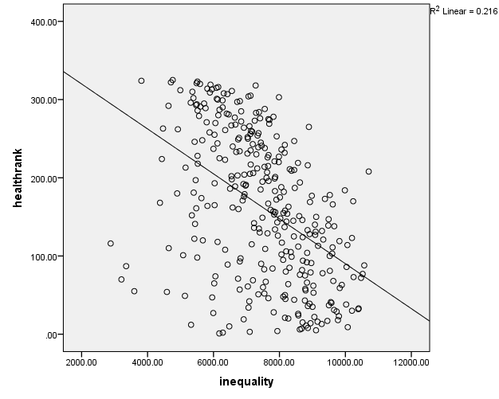

Excel spreadsheets with the results for all LAs can be requested from [jonathan.bradshaw@york.ac.uk](mailto:jonathan.bradshaw@york.ac.uk)

1. Grateful for comments from Richard Wilkinson and David Taylor-Robinson
2. Wilkinson, R. and Pickett, K. (2006) Income inequality and population health: A review and explanation of the evidence, *Social Science & Medicine* 62 (2006) 1768–1784
3. Similar results were found using the Townsend index of deprivation and mortality rates in Ben-Shlomo, Y., White, I. and Marmot, M. (1996) Does the variation in the socioeconomic characteristics of an area affect mortality? *BMJ*  312, 20, 1013-4.