((Supporting Information can be included here using this template))

Copyright WILEY-VCH Verlag GmbH & Co. KGaA, 69469 Weinheim, Germany, 2013.

Supporting Information

Spray-cast multilayer organometal perovskite solar cells fabricated in air

Author(s), and Corresponding Author(s)* David. K. Mohamad, Jonathon Griffin, Christopher Bracher, Alexander T. Barrows and David G. Lidzey*
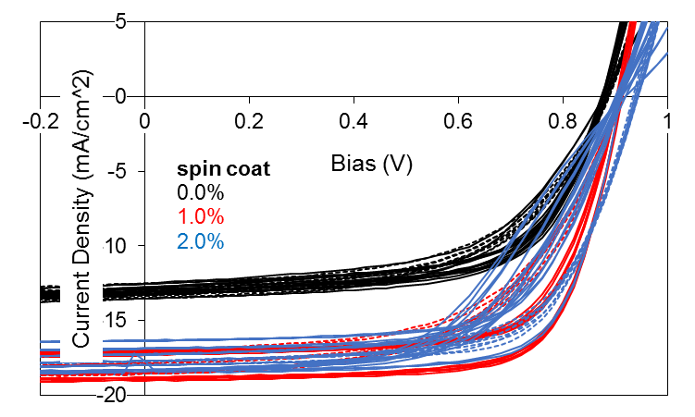
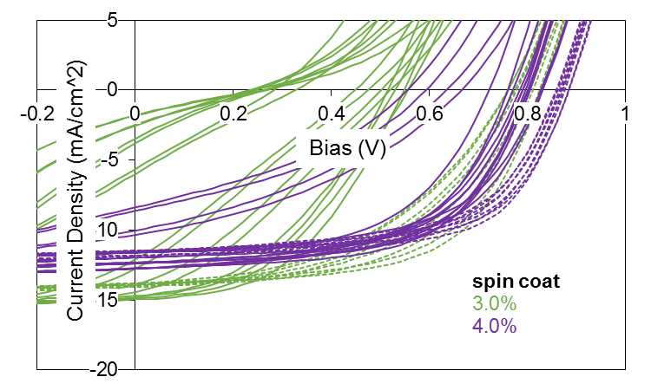
Figure S1 - The effect of HI concentration in spin-coated PSCs. PEDOT:PSS and PCBM layers are spin-coated. Solar cell J-V traces measured under 1Sun AM1.5G irradiation whilst cycling applied bias from -1V to +1V and back again.

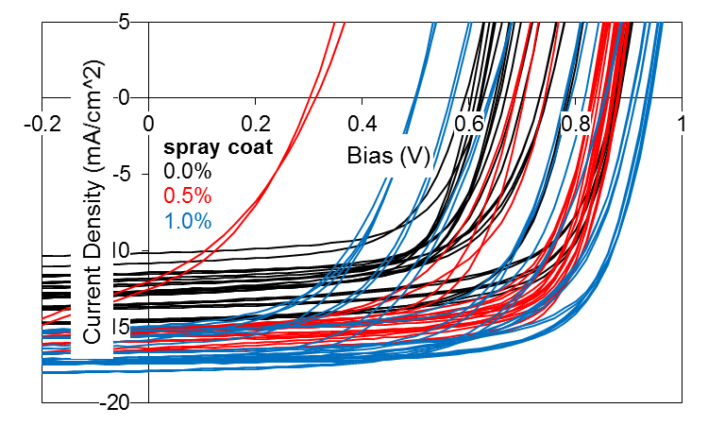
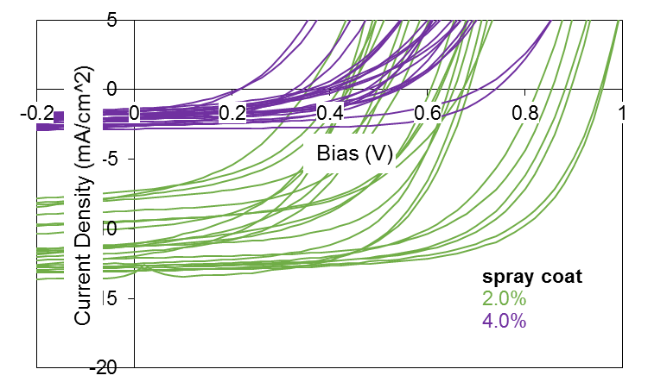
Figure S2 - The effect of HI concentration in spray-coated PSCs. PEDOT:PSS and PCBM layers are spin-coated. Solar cell J-V traces measured under 1Sun AM1.5G irradiation whilst cycling applied bias from -1V to +1V and back again.

Condition | Low Humidity (30%) | High Humidity (55%)
PCE (%) | 10.7 (10.3±0.5) | 8.2 (9.2±0.7)
FF (%) | 67 (66±2) | 60 (59±5)
J_{sc} (mA/cm²) | 17.3 (16.8±0.8) | 16.0 (15.3±0.8)
V_{oc} (V) | 0.93 (0.93±0.01) | 0.96 (0.92±0.04)
Table S1 – Performance metrics of perovskite solar cells (Device C) prepared at low and high-humidity. Perovskite precursor has been prepared by spray-casting but PCBM and PEDOT:PSS and PCBM layers have been spin-cast. Champion cell data is shown in bold. Average and standard deviations are displayed in parenthesis
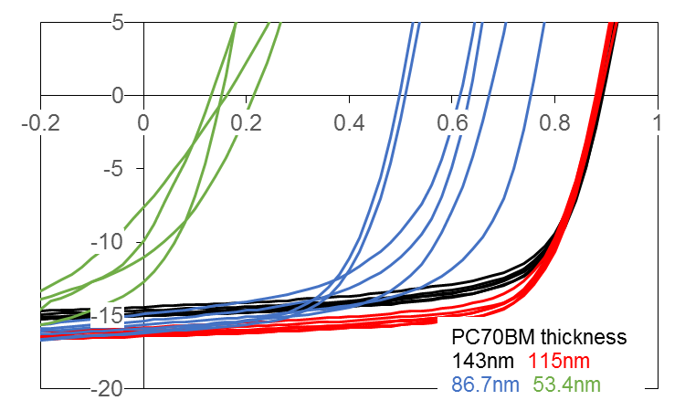
Figure S3 – The effect of spin-coated PCBM thickness in all-spin cast PSCs. Solar cell J-V traces measured under 1Sun AM1.5G irradiation whilst cycling applied bias from -1V to +1V and back again.

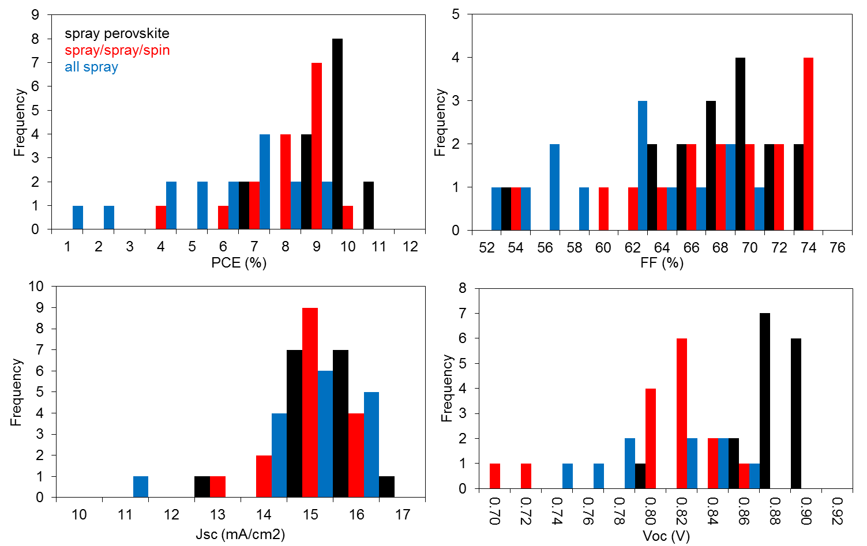
Figure S4 – Histograms of performance metrics from Devices C to E measured from +1 to -1V J-V sweeps under 1 Sun simulated AM1.5G irradiation.

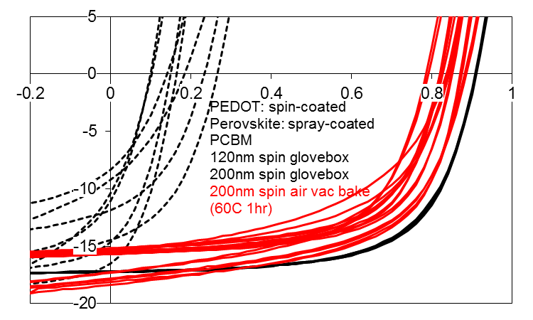
Figure S5 – The effect of spin-coated PCBM thickness in PSCs containing spray-cast MAPbI_{3-x}Cl_{x}. PEDOT:PSS layers are spin-coated. Solar cell J-V traces measured under 1Sun AM1.5G irradiation whilst cycling applied bias from -1V to +1V.
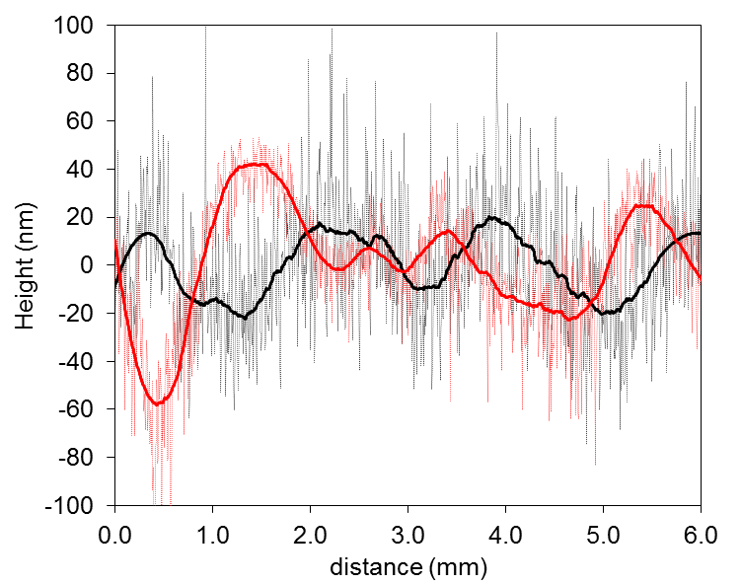
Figure S6 – Surface profiles of spin-coated Device A (black lines) and spray-coated Device C (red lines). Raw data is plotted with thin dotted-lines and filtered data with thick solid-lines.
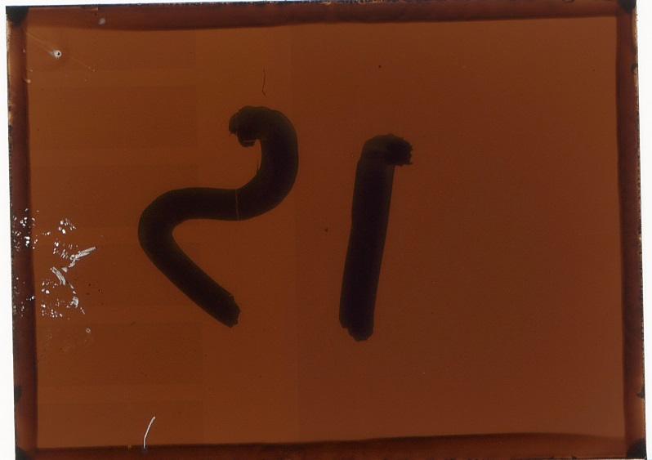
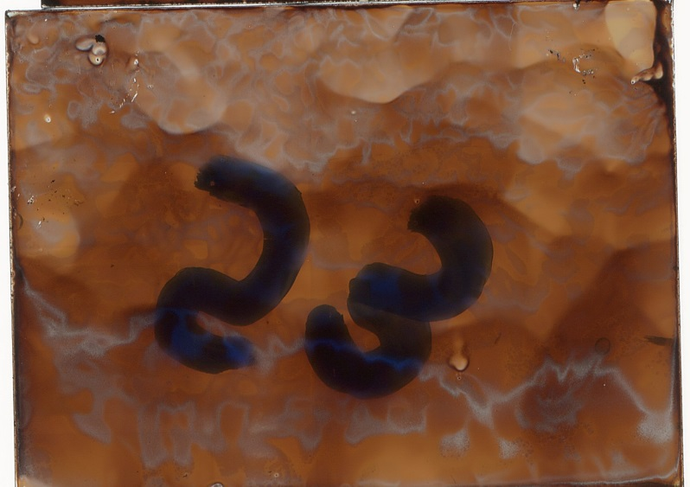
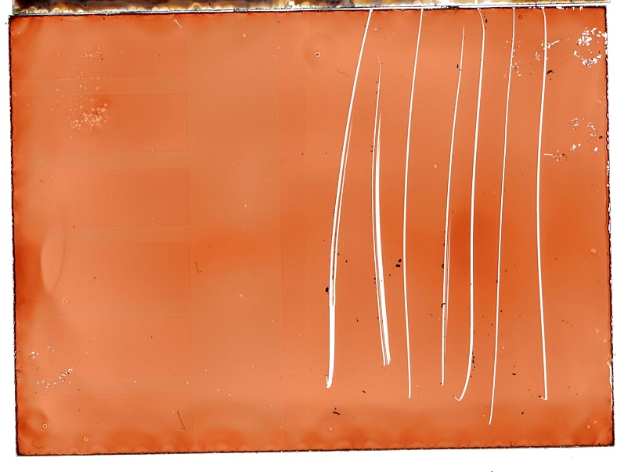
Figure S7 – (from top to bottom) Transmission images of PEDOT:PSS(spin)/MAPbI_{3-x}Cl_{x}(spin), PEDOT:PSS(spin)/MAPbI_{3-x}Cl_{x}(spray) and spray-cast PCBM of ITO glass recorded with a flatbed scanner (Substrates have dimensions of 20x15mm).
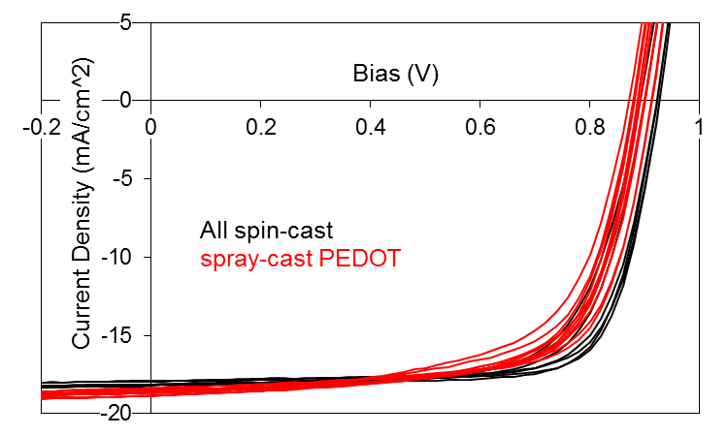
Figure S8 - Demonstration of spray-coated PEDOT:PSS. Solar cell J-V traces measured under 1 Sun AM1.5G irradiation whilst cycling applied bias from -1V to +1V and back again. Device A (black lines) and Device B (red lines). Perovskite precursor and PC70BM layers have been spin-coated.
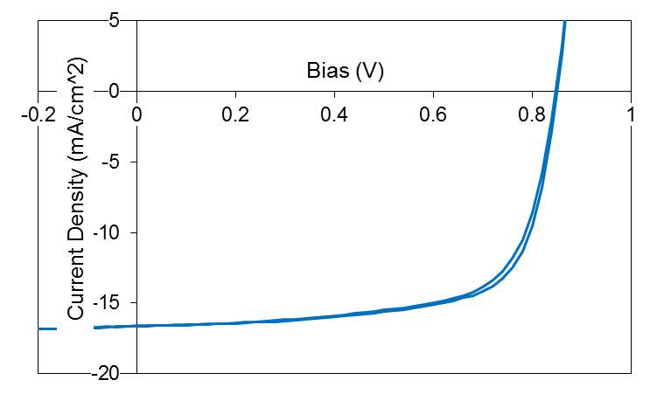
Figure S9 – The effect of hysteresis on the all-sprayed. Solar cell J-V traces measured under 1Sun AM1.5G irradiation whilst cycling applied bias from -1V to +1V and back again (0.4 Vs⁻¹)
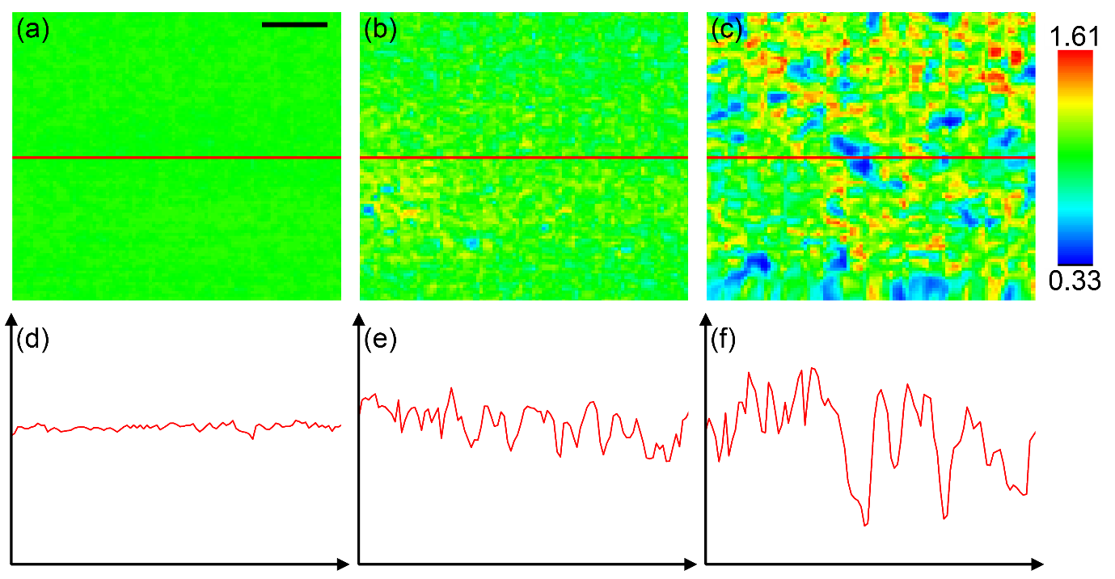
Figure S10 – LBIC images with corresponding horizontal sections from spin-cast Device A (a & d), spray-cast Device C Area 1 (b & e) and Area 2 (c & f). 20um scale bar inset. Section and image data are plotted on matching scales.

