Cognitive Flexibility, Heart Rate Variability, and Resilience Predict Fine-Grained Regulation of Arousal During Prolonged Threat

Lea K. Hildebrandt*, Cade McCall, Haakon G. Engen, and Tania Singer
Max Planck Institute for Human Cognitive and Brain Sciences, Leipzig, Germany

*corresponding author:
Lea Hildebrandt,
Max Planck Institute for Human Cognitive and Brain Sciences,
Stephanstraße 1a, 04103 Leipzig, Germany
+49 341 9940-2691
hildebrandt@cbs.mpg.de

Abstract
Emotion regulation in the ongoing presence of a threat is essential for adaptive behavior. Threatening situations change over time and, as a consequence, require a fine-tuned, dynamic regulation of arousal to match the current state of the environment. Constructs such as resilience, cognitive flexibility and heart-rate variability have been proposed as resources for adaptive emotion regulation, especially in a moment-to-moment fashion. Nevertheless none of these constructs has been empirically related to the dynamic regulation of arousal as it unfolds over the course of a prolonged threatening episode. Here we do so by placing participants in a threatening and evolving immersive virtual environment called “Room 101”, while recording their skin conductance. Subsequently, participants rated their subjective arousal continuously over the course of the experience. Participants who had shown greater cognitive flexibility in a separate task, i.e. less task switching costs when switching to evaluating the valence of positive stimuli, showed better regulation of physiological arousal (skin conductance level), during less threatening phases of Room 101. Individuals with higher trait resilience and individuals with higher resting heart rate variability showed more regulation in terms of their subjective arousal experience. The results indicate that emotional, cognitive, and physiological flexibility support nuanced adaptive regulation of objective and experienced arousal in the ongoing presence of threats. Furthermore, the results indicate that these forms of flexibility differentially affect automatic and objective versus reflective and subjective processes.

Introduction
Threatening situations often fluctuate in the intensity of experienced threat over a prolonged period of time. Walking down an eerie alley at night, for example, will feel more threatening when passing a dark passage than when reaching a street light. In general, an adaptive response to such changing environmental demands is characterized by high flexibility, enabling nuanced adjustments to behavior to match those demands (e.g. Kashdan & Rottenberg, 2010; Ottaviani, Shapiro, & Couyoumdjian, 2013). This is especially crucial during threatening situations, where a quick response might be decisive for survival and wellbeing. Flexibility thus represents a form of regulation that is in line with the external environment. In the literature, signs of such flexibility have been observed at three distinct but interrelated levels: cognitive flexibility, heart rate variability, and resilience. Here we study the relationship between each of these constructs and moment-to-moment changes in arousal within a threatening environment.
Cognitive flexibility refers to the ability to flexibly adapt processing to changing environmental information (Cañas, Quesada, Antolí, & Fajardo, 2003; Dennis & Vander Wal, 2009; Geurts, Corbett, & Solomon, 2009; Ionescu, 2012). This flexibility depends on strong executive control, particularly in terms of efficient shifting of attentional and cognitive resources to processing of new information while inhibiting the previously relevant information (Miyake et al., 2000) In the experimental context, cognitive flexibility has thus been operationalized as cognitive task switching, whereby participants alternate between evaluating different aspects of stimuli (Ionescu, 2012). Cognitive flexibility is likely critical in a threatening situation, where ongoing cognitive processes need to be inhibited and resources shifted to processing the current threat. Indeed, inflexibility in shifting and inhibition has been related to a threat bias found in anxiety (Eysenck, Derakshan, Santos, & Calvo, 2007; Mogg & Bradley, 1999; Mogg et al., 2000; Sheppes, Luria, Fukuda, & Gross, 2013) and depression (Whitmer & Banich, 2007), which is characterized by both a facilitated attention to threatening stimuli and a failure to disengage from them (for a review, see Cisler & Koster, 2010). For example, Paulitzki, Risko, Oakman, and Stolz (2008) used a task switching task to show that the higher the participants’ fear of spiders, the more accelerated engagement with (i.e. shifting to) and decelerated disengagement from (i.e. shifting from or inhibiting) fear-relevant pictures compared to neutral pictures. Although a bias towards detecting threats might be adaptive (“When in doubt, prepare for the worst.”), this research suggests that an exaggerated focus on threatening stimuli including a difficulty to disengage from those stimuli (i.e. cognitive inflexibility) is maladaptive.
The two components of the threat bias, facilitated attention and difficulty in disengagement, are due to an imbalance of two different mechanisms: increased stimulus-driven automatic and decreased top-down strategic processing, respectively (Cisler & Koster, 2010; Eysenck et al., 2007). This imbalance is associated with inefficient cortical (dis-)inhibition of subcortical structures (for details, see Friedman, 2007; LeDoux, 2000, 2012; Thayer, Ahs, Fredrikson, Sollers, & Wager, 2012; Verkuil et al., 2010). Dynamic (dis-)inhibition is thus a component of self-regulation and allows for flexible cognitive responses to the ever-changing nature of threats in the environment.
Heart rate variability (HRV) – reflecting vagally-mediated cardiac control and sometimes referred to as autonomic flexibility (e.g. Friedman, 2007; Kok & Fredrickson, 2010; Schmitz, Krämer, Tuschen-Caffier, Heinrichs, & Blechert, 2011) – has been suggested as a proxy for efficient cortical-subcortical integration (Friedman, 2007; Porges, 1995; Thayer et al., 2012; Thayer & Lane, 2000, 2009; but see Jennings, Allen, Gianaros, Thayer, & Manuck, 2015, who show independent relationships of HRV and resting cerebral blood flow on non-affective executive functions). Correspondingly, higher compared to lower HRV is related to efficient cognitive processing, especially with regards to enhanced executive functions including inhibition (Hansen, Johnsen, & Thayer, 2003; Hovland et al., 2012; Krypotos, Jahfari, van Ast, Kindt, & Forstmann, 2011; Park, Van Bavel, Vasey, & Thayer, 2012; Thayer, Hansen, Saus-Rose, & Johnsen, 2009). For example, individuals with higher HRV engage slower with, but disengage faster from, fearful faces compared to individuals with lower HRV, an effect which has been shown to depend on subcortical and cortical processing, respectively (Park, Van Bavel, Vasey, Egan, & Thayer, 2012; Park, Van Bavel, Vasey, & Thayer, 2013).
HRV is also related to context-specific emotional responses. Ruiz-Padial, Sollers, Vila, and Thayer (2003) showed that high, in contrast to low, HRV is related to more differentiable, stimulus-matching startle responses (a defensive reflex to a sudden onset of threat, which is potentiated with increasing fear; Lang, Bradley, & Cuthbert, 1990) within neutral, positive, and negative contexts. In more general terms, higher HRV has been associated with successful emotion regulation (for a review, see Appelhans & Luecken, 2006).
Resilience is a third construct associated with flexibility in the literature. It is defined as the ability to achieve a positive psychological outcome despite having been exposed to life adversities (Rutter, 2006) and is the outcome of successful emotion regulation (Min, Yu, Lee, & Chae, 2013; Troy & Mauss, 2011; Tugade & Fredrickson, 2006). For example, widows high in previously assessed trait resilience showed a relatively lower post-loss decrease in positive emotions (Ong, Fuller-Rowell, & Bonanno, 2010). On a smaller time scale, resilience is the capacity to dynamically modulate the level of control over one’s impulses to match the current environmental demands (Block & Kremen, 1996), a definition that is very similar to the notion of flexibility as discussed above. In a study by Waugh, Thompson, and Gotlib (2011), highly resilient individuals, in contrast to less resilient participants, were better able to match their emotional responses (facial muscle activity) to changing emotional stimuli and showed no carry-over effect on startle responses of negative stimuli. Resilience is thus not only a broad-scale ability to readjust after significant life events, but also embraces differences in small scale emotional reactivity to and, especially, regulation and recovery from stressors.
These three different forms of flexibility have repeatedly been linked in the literature. HRV is related to emotion regulation (Appelhans & Luecken, 2006), resilience (e.g. Souza et al., 2007) and cognitive flexibility (e.g. Park et al., 2012; 2013). To close the circle, cognitive flexibility, especially when processing affective information has also been related to resilience and emotion regulation (Genet & Siemer, 2011; Genet, Malooly, & Siemer, 2013; Malooly, Genet, & Siemer, 2013). For example, Genet and colleagues found that participants who efficiently switched from evaluating negative or to evaluating positive aspects of stimuli also had better reappraisal abilities (Malooly et al., 2013). Conversely, slower switching from evaluating negative and faster switching from evaluating positive stimuli predicted greater use of rumination as emotion regulation strategy (Genet et al., 2013). Similarly, Ottaviani and colleagues (Ottaviani, Medea, Lonigro, Tarvainen, & Couyoumdjian, 2015; Ottaviani et al., 2013) have related both cognitive inflexibility and lower HRV to worry and rumination.
In sum, cognitive flexibility, HRV, and resilience are interrelated constructs that likely enable a flexible, nuanced response to changing environmental demands in threatening situations. Research so far has shown that inflexibility is maladaptive (see Bitsika, Sharpley, & Peters, 2005; Charney, 2003; Cisler & Koster, 2010; Friedman, 2007), but that research has usually focused on reactivity to, and recovery from, short static threats (such as startles or pictures), or on retrospective reports of past negative life events. Hence, we know little about the influence of these forms of flexibility in a moment-to-moment basis in the ongoing and unpredictable presence of threats. Accordingly, the aim of the current study was to investigate whether individual differences in cognitive flexibility, HRV, and resilience predict the fine-grained dynamics of the threat response during a prolonged, ever-changing, and unpredictable threatening experience.
We designed such an evolving threatening experience using an immersive virtual environment (IVE) in which participants are exposed to intermittent and prolonged threats for five minutes (“Room 101”). As a proxy for dynamics in the threat response, we measured both physiological and subjectively rated arousal continuously. Increased physiological arousal is a key feature of the threat response, signaling mobilization of the body for defensive behaviors (such as fight or flight, Cannon, 1929) and can be measured using skin conductance (SCL, Bradley, Codispoti, Cuthbert, & Lang, 2001). Subjective ratings of arousal are generally (Mauss, Levenson, McCarter, Wilhelm, & Gross, 2005) – as well as in the task presented here (McCall, Hildebrandt, Bornemann, & Singer, 2015) – coherent with SCL. By measuring both SCL and subjective ratings of arousal, we hoped to gain a complete picture of objective and experienced arousal.
We expected that all three measures of flexible cognitive-affective regulation (resilience, HRV, and cognitive flexibility) would be related to arousal as it rises and falls in response to changes in the threatening nature of the environment. In particular, we expected that high flexibility would be especially effective in phases that depend on regulation, i.e. in the prolonged presence or after the disappearance of a potential threat. Such a result would lend support to a nuanced allocation of resources that matches the environmental demands. We had no hypotheses regarding differential effects of flexibility on the two different measures of arousal. Instead, we hoped to shed light on the congruencies and differences between these measures.
Method
Participants
The present study was part of a larger longitudinal study on the effects of mental training (The ReSource Project, for details see Singer, Kok, Bornemann, Bolz, & Bochow, 2015). Before participation, participants were extensively screened and, among others, only selected if they did not have any neurological or psychological disorder (the latter defined as being symptom-free for at least two years). We particularly ensured that the participants did not have any ongoing affective disorders by conducting computer-based diagnostic clinical screening for psychological disorders, including depression and anxiety disorders (DIA-X, Wittchen & Pfister, 1997), as well as by excluding participants who scored high on the Major Depression Inventory (Bech, Rasmussen, Olsen, Noerholm, & Abildgaard, 2001) or the trait subscale of the State-Trait Anxiety Inventory (Laux, Glanzmann, Schaffner, & Spielberger, 1981). In addition, selected participants fulfilled the MRI safety requirements (incl. no obesity; no cardiovascular disease, pacemakers or artificial heart valves; and no medication that affects the central nervous system)¹. The data presented here were collected at baseline prior to any intervention.
We invited 327 participants to this part of the study, of which 15 did not complete the current experiment. Out of these 15, 11 felt dizzy or nauseated in the immersive virtual environment, 3 found Room 101 too frightening, and 1 could not be run due to technical problems. In addition, the skin conductance data of 6 participants was not available due to problems recording the physiological data. The data of 6 additional participants was unusable due to signal dropout or gross artifacts. Data of 300 participants remained for analyses (172 women; Age: mean = 40.65, SD = 9.35). Out of these 300, the heart rate variability could not be calculated for 3 participants due to technical problems (2) or gross artifacts (1), which left 297 datasets for the HRV analysis (173 women; Age: mean = 40.73, SD = 9.33). Finally, of the 300, we had 297 complete datasets of the task switching task (172 women; Age: mean = 40.65, SD = 9.33), and completed resilience questionnaires for 295 participants (174 women; Age: mean = 40.56, SD = 9.36). For 274 participants we had all five datasets. The study was approved by the Research Ethics Committees of the University of Leipzig (376/12-ff) and the Humboldt University in Berlin (2013-02, 2013-29, 2014-10; Mathematisch-Naturwissenschaftliche Fakultät II). Participants gave written informed consent for all of the procedures.
Materials
Immersive virtual environment and display devices. A stereoscopic head-mounted display (HMD, NVIS nVisor SX60 with integrated Sennheiser headphones) enabled participants to experience the immersive virtual environment (IVE) while walking around freely. The head and right hand were tracked, using custom made markers on the HMD and around the wrist, by a 10 camera system (Vicon MX3+) and tracking software (Vicon Tracker). The position and orientation data were streamed to a second computer that rendered the virtual world using Vizard 4.0. Subjective arousal was assessed with a “playback” of the IVE using a standard desktop monitor and headphones (procedure described below).
Physiological equipment. Physiological signals were recorded using a Biopac (Biopac Systems Inc., Santa Barbara, CA) MP150 acquisition system and AcqKnowledge 4.3 software at a sampling rate of 2000Hz. For skin conductance, we used a wireless Biopac BioNomadix amplifier for electrodermal activity (BN-PPGED), a 15 cm BioNomadix dual electrode lead (BN-EDA-LEAD2), and pre-gelled, disposable Ag/AgCl foam electrodes (Biopac, EL507). The electrodes were placed on the middle phalanges of the left middle and index fingers. Heart rate was recorded using a Biopac BioNomadix electrocardiography (BN-RSPEC) amplifier, a (45 cm) 3-lead set (BN-EL45-LEAD3), and pre-gelled, disposable Ag/AgCl foam electrodes (Swaromed, Nessler Medizintechnik, Innsbruck, Austria). The electrodes were placed on the sternal end of the right clavicle, the left mid-clavicle (grounding), and the lower left ribcage. Facial (startle) EMG and respiration were also recorded but are not presented here. Events in the IVE were recorded in a parallel channel by connecting the rendering computer and the AcqKnowledge computer via network.
Procedure and Measures
Arousal was continuously measured during Room 101 (SCL) and the playback (subjective arousal). Cognitive flexibility was assessed with a task switching task, HRV was measured during a baseline measurement, and resilience was determined using a questionnaire.
Room 101, the baseline, and the playback were part of the same experimental session. The session started with an introduction of the two experimenters and some time to acclimatize to the lab, during which a short health questionnaire (incl. questions about current dizziness, motion sickness, and phobias) was filled in. Subsequently, the electrodes and tracking markers were attached, and the baseline was carried out. Then, three unrelated tasks were executed, followed by Room 101. After a short recovery period of usually not more than 5 minutes, the playback was carried out.
The task switching task was part of a bigger testing session of different, unrelated behavioral tasks, which never happened on the same day as, but up to 5 weeks apart from, the Room 101 session. The questionnaire was part of a big battery of questionnaires (see Singer et al., 2015) that were completed online within 5 weeks of the two test sessions. Participants were not restrained in their consumption of caffeine or nicotine before any of the experimental sessions.
The HRV baseline. A two-minute baseline measurement was carried out at the beginning of the session. Often in the existing literature, a 5-minute baseline is implemented for measuring resting HRV. Our baseline is two minutes because we had certain time constraints due to the test session being part of a long day of testing. Although RMSSD, the time-domain measure of HRV we used here, has been shown to be reliable also for short recordings (see Nussinovitch et al., 2011; Task Force, 1996), it should be noted that the short baseline recording might limit the validity for measuring trait differences. Before the baseline measurement, participants were instructed to sit in a chair for two minutes and relax without closing their eyes or crossing their feet. Physiological signals, including electrocardiogram (ECG), were recorded, which allowed us to calculate HRV. The period between the hook-up of the electrodes and the baseline measurement was usually only a few minutes (5 to 8). Although we did so for efficiency sake, this did not provide a great deal of time for participants to acclimatize to the hook-up.
Room 101. Room 101 is a 3D digital IVE that was designed to incorporate different threats in a changing, complex, and naturalistic environment. In total, Room 101 takes 5:06 minutes to complete. It starts as a bare room slightly lit by fluorescent tubes, containing a number of wooden crates scattered and stacked in its middle and corners. To get participants to move around the room and notice the various stimuli, they have the task to collect jars by touching them with their virtual hand as they appear sequentially throughout the room. While progressing through the task, the participants traverse different phases of low threat (only ambient sounds), intermittent threats (such as exploding crates and neon tubes, or gunshots) and prolonged threats (such as the floor collapsing; see figure 1 for a timeline of Room 101 and https://youtu.be/Lnl8opbaP4U for a video of the environment). The exact design of Room 101 is described elsewhere in greater detail (McCall et al., 2015). The prolonged threats are especially interesting with regard to our hypotheses, as they allow for online regulations: 1) Spiders fill the room ( for 55 seconds), 2) four explosions destroy the floor aside from four remaining I-beams, revealing a 3.5m drop to the concrete floor beneath (60 seconds), and 3) a monstrous, hissing spider appears from an exploding crate (20 seconds). If participants had stated to be spider phobic (16 participants) or afraid of heights (13 participants), we replaced the spiders by snakes or reduced the drop of the floor to a few centimeters, respectively².
The playback. The playback was designed to obtain a continuous measure of subjectively experienced arousal. It is a simulation, including audio, of the participants’ (first person) viewpoint during Room 101, which is played back to them on a desktop computer. During the playback, the participants’ task was to watch the playback and continuously rate how aroused they had felt during every moment in Room 101, using the scroll wheel of the computers’ mouse. Scrolling would move a small horizontal line up or down on a vertical sliding scale, which was visible on the right side of the screen. Below and above this scale, respectively, we indicated the range of the scale: “little emotionally aroused” to “highly emotionally aroused”. In the beginning, the horizontal line was in the middle of the scale, but we asked the participants to initially indicate on the scale how aroused they remembered to have been during the instructions of Room 101.
Task switching task. The task switching task (Engen & Singer, in preparation) was based on the tasks of Whitmer and Banich (2007) and Genet and Siemer (2011). The task was designed to measure shifting between different rules of how to categorize the stimulus. The stimuli were words from the LANG database (Kanske & Kotz, 2010), selected on basis of the highest combination of ratings for valence and arousal. The words varied on three features: the valence (positive vs. negative), the color (blue vs. red), and the grammatical category (noun vs. adjective). Three different rules existed, one affective and two non-affective. For the affective rule, participants evaluated the valence of the word (Val). For the non-affective rules, participants either evaluated the word’s color (Col) or the grammar of the word (Gra). The task consisted of 3 blocks of 122 pseudo-randomized trials each. Words were presented on a desktop computer screen and were visible until the participant had responded by pushing a key. The response keys were the 1 and 3 keys on the number pad of the keyboard. Assignment of keys to responses was counterbalanced. The design is further described elsewhere (Engen & Singer, in preparation).
Resilience Questionnaire. We assessed trait resilience with the Ego-Resilience Scale (ER89, Block & Kremen, 1996). The ER89 consists of 14 items related to bouncing back after everyday stress and openness to new experiences (e.g. “I quickly get over and recover from being startled”, “I usually succeed in making a favorable impression on people”).
Preprocessing and data reduction
Skin Conductance Level. Skin conductance preprocessing was conducted in Matlab (The MathWorks, Inc., Natick, Massachusetts, US). First, data were downsampled to 500 Hz and gross artifacts, likely due to participants’ touching of the electrodes while moving in Room 101, were identified and corrected using an algorithm. The artifacts were characterized by spontaneous, immediate jumps of the skin conductance level to a higher or lower level. The algorithm scanned the absolute sample-by-sample differences and flagged those that exceeded 0.05 microsiemens per sample of 500 msec, which proved to be sensitive to the artifacts but insensitive to naturally occurring changes. Subsequently, the algorithm went through the artifacts, calculated for each artifact the change of skin conductance between the samples before and after, and subtracted this difference from all samples starting at the artifact to the end of the recording. Data were then further downsampled to 1Hz and centered on the first sample of the instructions preceding Room 101 in order to minimize between subject differences in baseline skin conductance level due to electrode placement, physical differences, and etc.
Subjective Ratings of Arousal. The continuous subjective rating measured during the playback was downsampled to 1Hz.
Heart Rate Variability. The ECG data was exported from Acqknowledge to a custom Python-based program. This program identified the R peaks by searching for local maxima within a certain window after the last R peak and allowed us to scroll through the data and change the location of misplaced R markers. Moreover, it allowed us to (linearly) interpolate up to four missing R peaks and exclude regions that were not salvageable. This program also provided the duration of the RR intervals. Subsequently, the RR interval data were fed into Kubios (Tarvainen, Niskanen, Lipponen, Ranta-Aho, & Karjalainen, 2014). Kubios was used to calculate the square root of the mean squared differences of successive RR intervals (RMSSD), which is a measure for vagally-mediated heart rate variability (Task Force, 1996) and has been suggested for short recordings (Nussinovitch et al., 2011).
Task Switching. Trials were characterized based on the task set (Val, Col, Gra) of the current and the previous trial. Mean reaction times (see Table 1) of the possible 9 trial types were calculated: 3 repeated task set trial types (Col to Col, Gra to Gra, Val to Val), and 6 switch trial types (Col to Val, Col to Gra, Val to Col, Val to Gra, Gra to Col, Gra to Val).
Non-affective task switching costs were defined as the difference in reaction times between non-affective switching trials and non-affective repetition trials. This calculation was carried out separately for Col and Gra trials and those resulting values were averaged:
Switch costs between non-affective task sets:
SwitchNA = mean( (Col to Gra-Gra to Gra), (Gra to Col-Col to Col))
Switching costs to affective task sets was defined as the difference in reaction times between switch-to-Val trials and repeated-Val trial. To remove general switching ability, we subtracted the matching non-affective task switching costs from this value. Finally, we averaged over switching from Col and Gra to Val:
Switch costs to affective task sets:
SwitchTo = mean[ ((Col to Val-Val to Val)-(Col to Gra-Gra to Gra)),
((Gra to Val-Val to Val)-(Gra to Col-Col to Col))]
Switching costs from and affective task set were calculated analogously:
Switch costs from affective task sets:
SwitchFrom = mean[ ((Val to Col-Col to Col)-(Gra to Col-Col to Col))
((Val to Gra-Gra to Gra)-(Col to Gra-Gra to Gra))]
SwitchTo and SwitchFrom were separately calculated for positively and negatively valenced stimuli (SwitchToP, SwitchToN, SwitchFromP, SwitchFromN). It has to be noted that the SwitchTo and SwitchFrom measures are not calculated in the traditional way (cf. Genet & Siemer, 2011; Whitmer & Banich, 2007), as we wanted - and our design allowed us – to control for general, non-affective sources of switching abilities (i.e. by subtracting it) when calculating the affective switching costs (SwitchTo and SwitchFrom).
Data Analysis
To be able to shed light on the dynamics of arousal, we analyzed the complete time series of skin conductance levels and subjective ratings by running 306 separate sample-wise regression analyses (one per second) for each combination of predictor variable (the switching costs, ER89 scores, or RMSSD) and dependent variable (SCL or subjective rating). We corrected for multiple comparisons (between the 306 tests) using cluster-based permutation testing that accounted for the maximum length of significant streaks in the permuted data. Streaks are periods of sequential samples for which the (sample-wise) regressions reached significance. This method is a novel approach tailored to our time-series data, but it is based on nonparametric ERP and fMRI analyses (e.g. Maris & Oostenveld, 2007; Nichols & Holmes, 2001, Hayasaka & Nichols, 2003).
Approximately 5% of the 306 regressions in one of our analyses will be significant by chance (false positives). In these time series data, however, correct positives will likely occur in sequential samples due to their temporal dependency, i.e. differences in flexibility will predict differences in arousal over several seconds.
In order to determine a cut-off for significant streak length, we permuted the scores on the predictor variable 1000 times (i.e. randomly assigned a predictor value to a time-series), ran the 306 second-wise regression analyses for every permutation, and saved the length of the longest streak in every permutation in order to determine the random distribution of streak lengths. If a streak in the original analysis (the unpermuted data) was longer than 95% of the streaks in that distribution, then it survived this multiple comparisons correction.
It must be noted, though, that this method does not allow us to find short-lived differences such as those found in reactivity (e.g. startles), but is rather aimed at discovering differences in regulation during prolonged periods. To visualize the differences, the average values of participants scoring above versus below the median of the predictor were plotted. All analyses were carried out in Matlab and all variables were winsorized at 3 standard deviations from the mean to remove outliers (SCL and subjective ratings on a sample-wise level). Descriptive statistics and intercorrelations of the independent variables can be found in table 2 in the appendix (see table 3 in the supplementary materials for differences in gender, age, and BMI).
Results
Task Switching
Switching costs between non-affective task sets. SwitchNA was unrelated to skin conductance or ratings in the second-wise regressions (Figure 4).
Switching costs to affective task sets. SwitchToP predicted SCL but not ratings (Figure 5), whereas SwitchToN was related to neither of these measures. In particular, participants who had lower switching costs when switching to positive affective task sets (SwitchToP) had lower SCL during the less threatening phase between phases of prolonged threat – the spiders and the explosion of the floor.
Switching costs from affective task sets. The second-wise regressions revealed that differences in SwitchFromN predicted differences in subjective ratings during the floor epoch: Participants who had lower switching costs, i.e. could switch more efficiently, from negative stimuli rated their arousal as higher during the most threatening epoch (the exploded floor, Figure 6, but see ²). SwitchFromP did not predict subjective ratings or skin conductance levels.
Heart Rate Variability
Higher HRV was related to lower subjective ratings of arousal during the regulation phases (i.e. when the threat had been present for a while or had disappeared) of prolonged threats (Figure 3). In two of the three prolonged threat phases – the spiders and the floor – this effect was present. Participants with higher HRV, as compared to those with lower HRV, thus had a similar subjective reactivity to the onsets of threats but regulated after the initial evaluation of the threat.
Resilience
The second-wise regressions (Figure 2) of SCL and subjective ratings on the ER89 revealed that ratings but not SCL were predicted by the ER89. Higher ER89 was associated with lower ratings of arousal during the first prolonged threat (spiders). This difference in ratings remained significant throughout the rest of the experience with the exception of a short interruption following the appearance of the big spider from the exploding crate.
Discussion
The aim of the current study was to test how different features of flexibility in cognitive-affective regulation modulate dynamic arousal responses during an evolving threatening episode. Participants walked through an immersive virtual environment, Room 101, in which threats emerged and subsided repeatedly over a five minute period. During this experience, we measured skin conductance levels (SCL). Immediately afterwards, participants provided a continuous rating of their subjective arousal during the experience. In addition, we measured three individual differences as proxies for different facets of flexible cognitive-affective regulation. As a measure of cognitive flexibility, we used an affective task-switching task. As a proxy for autonomic flexibility, we recorded vagally-mediated resting HRV. As a measure of affect regulation, we asked participants to complete a trait resilience questionnaire (ER89; Block & Kremen, 1996). Our analysis focused on whether these measures predicted fine-grained regulation of arousal during the prolonged threatening experience in Room 101.
All three measures of flexibility predicted arousal during this sustained experience of threat, although they did so in different ways and during different parts of the experience. Interestingly, the two measures of arousal (SCL and subjective ratings) were differentially related to the different measures of flexibility. Resilience, autonomic flexibility, and cognitive flexibility in switching away from negative stimuli predicted differences in subjective ratings, but not in SCL. In contrast, cognitive flexibility in switching to positive stimuli predicted differences in SCL only. Several possible interpretations exist for this pattern of findings for each of these types of flexibility as well as for the interrelationships between them.
In terms of cognitive flexibility, our findings were specific to affective task switching (i.e., switching from or to consciously evaluating affective features of stimuli). We did not find an effect of general cognitive flexibility, as measured by task switching between purely non-affective tasks (SwitchNA). In earlier research, both affective and non-affective task switching were shown to be independent predictors of broad measures of emotion regulation: rumination, reappraisal ability, or resilience (Genet et al., 2013; Genet & Siemer, 2011; Malooly et al., 2013). But unlike in those previous studies, we measured both affective and non-affective switching in the same task, which enabled us to calculate the costs or benefits of switching to or from evaluating affective stimuli over and above general non-affective switching. Moreover, here we focused on small-scale arousal dynamics as a measure of direct affective responding. Our data therefore suggest that the flexible processing of specifically affective information leads to differences in these arousal dynamics. This confirms the importance of affective information processing for an adaptive threat response (see Thayer & Lane, 2000).
In particular, we found that an individual’s ability to switch to evaluating positive stimuli (SwitchToP) and to switch away from evaluating negative stimuli (SwitchFromN) affected arousal. Based on the assumption that both of these measures reflect the individual's ability to disengage from threats, we had expected that they would predict reduced arousal during and following the presence of threats. Counter to our expectations, SwitchToP and SwitchFromN differentially affected physiological and subjective arousal. Specifically, SwitchToP was related to SCL, whereas SwitchFromN predicted differences in subjective arousal. These differential findings are in line with the conclusion of Cisler and Koster (2010) that facilitated attention, here reflected in low SwitchTo costs, is an immediate, automatic response that reflects the bottom-up processing of affective information. In contrast, disengagement, i.e. SwitchFrom, is related to top-down regulation. This may explain why we found that the relatively automatic physiological response to threat was related to SwitchTo costs while the relatively conscious and reflective subjective assessment of arousal was related to SwitchFrom costs. In other words, the distinction between automatic and strategic processes in the threat bias may not only emerges during reaction time tasks (for a review, see Cisler & Koster, 2010), but also in physiological and subjective arousal during threat.
We had expected that facilitated attention to negative stimuli (SwitchToN), as an indicator of threat bias, would lead to increased arousal to negative stimuli. Instead, we found that facilitated processing of positive aspects of the environment, i.e. lower SwitchToP, predicted decreased physiological arousal (i.e., SCL) during threat, particularly during a period in Room 101 when threats were subsiding. A few studies have previously indicated that the threat bias might actually consist of a lack of a bias towards positive stimuli that is found in healthy participants (e.g. Garner, Mogg, & Bradley, 2006; Taylor, Bomyea, & Amir, 2011; see also Deveney & Deldin, 2006). Our data suggest that this bias toward the positive affects moment-to-moment changes in physiological arousal, even during a negative, threatening situation.
The ability to efficiently disengage from evaluating negative aspects of stimuli (SwitchFromN) predicted differences in subjective ratings of arousal. Surprisingly, this effect was in the opposite direction of what we had expected: Lower SwitchFromN predicted higher subjective ratings of arousal during one of the most frightening episodes (when the floor collapsed). One possible explanation is that participants who have high switching costs also have difficulties disengaging with negative aspects of the environment on a broader scale, i.e. they worry and ruminate. This is in line with earlier findings that suggest that cognitive flexibility is decreased during states of worry and rumination (Ottaviani et al., 2015, 2013), as well as in trait ruminators (Davis & Nolen-Hoeksema, 2000). According to Borkovec’s (1994) avoidance model of worry (AMW), the chronic preparation for negative events when worrying actually buffers the effects of that event (Behar, DiMarco, Hekler, Mohlman, & Staples, 2009; Borkovec, 1994; Newman & Llera, 2011). Along these lines, the participants in our study who worry (i.e., who do not successfully disengage from negative stimuli) might have buffered their experience of arousal. Consequently, those participants might have utilized a successful yet – in the longer run – maladaptive emotion regulation strategy (Nolen-Hoeksema, Wisco, & Lyubomirsky, 2008).
Our proxy for autonomic flexibility, HRV, also predicted differences in experienced ratings of arousal during Room 101. HRV predicted decreased subjective arousal during both the exploded-floor-epoch and during the spider-epoch. Specifically, the effect of HRV emerged only in later phases of these prolonged threats and the subsequent less threatening phases, but not during the onsets of threats or phases with intermittent threats. This effect is thus very specific to phases that allow for regulation. It might be somewhat surprising that individual differences in HRV were only predictive of subjective ratings of arousal and not of physiological arousal (SCL) during threat, as both reflect activity of the autonomic nervous system. However, it should be emphasized that we measured HRV in a trait-like fashion during a baseline measurement, whereas SCL was measured during a threatening experience. Electrodermal activity, including skin conductance level, reflects activity of mainly the sympathetic branch of the autonomic nervous system (but see Boucsein, 2012, for a discussion of possible sweat gland innervations), whereas vagally-mediated HRV is a measure of parasympathetic inhibition of heart rate. The parasympathetic and the sympathetic nervous systems are not necessarily antagonistic but can also be coactive (Berntson, Cacioppo, & Quigley, 1991). The relationship between the two systems is complex and a flexible parasympathetic nervous system at rest does not inevitably imply that the sympathetic nervous system is equally flexible and responsive during threat. Therefore, HRV seems to rather reflect a general capacity for regulation of arousal on a subjective, experiential level. Further research could explore this online relationship between HRV and sympathetic flexibility in the presence of threat (see supplementary materials for an analysis of the relationship between task HRV and subjective ratings).
In terms of resilience, our proxy for more global emotion regulation abilities, we found that highly resilient individuals reported lower subjective arousal than less resilient participants. This effect emerged at the first opportunity to regulate during the presence of a prolonged threat and remained until the end of the task. As such, resilience seems to have a rather broad effect on subjective experience. Because the arousal rating was assessed after Room 101, it reflects retrospective, conscious self-reported evaluations of the experience (see McCall et al., 2015). The ER89 (Block & Kremen, 1996), our measure of resilience, is also a self-report measure of emotional experience. Given that fact, the relationship between these two measures could reflect the role of self-perception in reports of emotional experience.
More interestingly, highly resilient individuals (re-)evaluated their experience as less threatening, even though their objective, i.e. physiologically measured, levels of arousal (SCL) during Room 101 were comparable to those of less resilient individuals. Notably, the effects of resilience on subjective arousal were context-sensitive. Highly resilient participants did not rate their arousal in general as lower, but rather showed the same level of subjective arousal as less resilient participants in the beginning of the experience. The rated arousal did not diverge until the first episode of prolonged threat (the spiders). This pattern indicates that highly resilient participants do not simply underestimate their general arousal level across all portions of a threatening experience. Instead, their subjective reports of arousal reflect relatively nuanced differences that only emerge as an experience unfolds into a prolonged opportunity to regulate and recover. The current data therefore provide a snapshot of how the emotion regulation abilities associated more generally and on a broad scale with resilience (Min et al., 2013; Troy & Mauss, 2011; Tugade & Fredrickson, 2004, 2006) might function also during a small scale response to a dynamic and threatening experience.
Although the effect of resilience and HRV on subjective arousal is similar to that of SwitchFromN, the mechanism and consequences might differ. In contrast to the possibly maladaptive emotion regulation strategy associated with SwitchFromN (i.e., worry and rumination; Borkovec, 1994; Nolen-Hoeksema et al., 2008; Ottaviani et al., 2015), HRV and resilience have been related to adaptive emotion regulation strategies, such as reappraisal (Min et al., 2013; Volokhov & Demaree, 2010). According to one influential model (Thayer and Lane, 2000), HRV is a proxy for the efficient prefrontal inhibition and disinhibition of subcortical structures that is necessary for an adaptive balance between bottom-up and top-down processing. This model further suggests that the neural network that regulates HRV overlaps with networks involved in attention and executive control (Thayer & Lane, 2000). Within the present data set, resilience, HRV, and SwitchToP are correlated, suggesting that they may indeed reflect the same or related underlying mechanisms. Nevertheless, exploratory analyses (see supplementary materials) also showed that HRV and resilience account for distinct portions of the variance in subjective arousal ratings. Indeed, a recent study and update to the Thayer & Lane 2000 model could not confirm that resting cerebral blood flow in those neural regions mediates the relationship between HRV and executive functions (Jennings et al., 2015). Nevertheless, Jennings and colleagues – who used non-affective working memory, perceptual-motor-, and interference tasks – did find some relationships between HRV and different executive functions, especially with the Stroop task which depends on inhibition. In addition, they did not exclude the possibility that “areas related to vagal control also relate to the executive control functions during emotion regulation” (p.221). As mentioned above, the current study suggests that executive control is important in the presence of affective stimuli for the regulation of arousal during threat. HRV might therefore be associated with efficient cognitive processing of affective information in the moment and should, in turn, enable resilient, adaptive emotion regulation strategies (Thayer & Lane, 2000). Further research should continue to explore the interrelationships between these different facets of flexible self-regulation to determine whether and when their underlying mechanisms overlap.
Further research should also investigate the differential effects of these different forms of flexibility on subjective versus physiological arousal (SCL). Prior research using this paradigm demonstrated coherence between those two measures across time (McCall et al., 2015), yet here we found uniquely subjective effects of HRV, resilience and SwitchFromN task switching, and uniquely physiological effects of SwitchToP task switching. Throughout this discussion we have presented several possible explanations for this pattern of results, but we can draw no firm conclusions. Future work will need to determine whether or not differential findings between subjective and physiological arousal are actual features of the threat response or are simply a matter of methodological variance.
To conclude, we conducted this study to investigate how the dynamics of both subjective and objective arousal during a threatening episode are influenced by individual differences in resilience, HRV, and cognitive flexibility. We did so using a novel paradigm that allowed us to look at the time course of both physiological and subjective arousal as they unfolded over the entire experience. The precisely timed and controlled nature of the virtual environment allowed us to contrast the responses of different types of individuals. Together the findings presented here indicate that these three forms of flexible regulation have significant effects on the way arousal unfolds during a frightening experience. Further research will need to explore whether these differences in the moment-to-moment regulation of arousal have consequences for long-term wellbeing.

References
Appelhans, B. M., & Luecken, L. J. (2006). Heart rate variability as an index of regulated emotional responding. Review of General Psychology, 10(3), 229–240. doi:10.1037/1089-2680.10.3.229
Bech, P., Rasmussen, N.-A., Olsen, L. R., Noerholm, V., & Abildgaard, W. (2001). The sensitivity and specificty of the Major Depression Inventory, using the Present State Examination as the index of diagnostic validity. Journal of Affective Disorders, 66(2), 159–164. doi:10.1186/1471-244X-7-39
Behar, E., DiMarco, I. D., Hekler, E. B., Mohlman, J., & Staples, A. M. (2009). Current theoretical models of generalized anxiety disorder (GAD): Conceptual review and treatment implications. Journal of Anxiety Disorders, 23(8), 1011–1023. doi:10.1016/j.janxdis.2009.07.006
Berntson, G. G., Cacioppo, J. T., & Quigley, K. S. (1991). Autonomic determinism: the modes of autonomic control, the doctrine of autonomic space, and the laws of autonomic constraint. Psychological Review, 98(4), 459–87. doi:10.1037/0033-295X.98.4.459
Bitsika, V., Sharpley, C. F., & Peters, K. (2010). How is resilience associated with anxiety and depression? Analysis of factor score interactions within a homogeneous sample. German Journal of Psychiatry, 13, 9–16.
Block, J., & Kremen, A. M. (1996). IQ and ego-resiliency: Conceptual and empirical connections and separateness. Journal of Personality and Social Psychology, 70(2), 349–361. doi:10.1037//0022-3514.70.2.349
Borkovec, T. D. (1994). The nature, functions, and origins of worry. In G. Davey & E. Tallis (Eds.), Worrying: Perspectives on Theory, Assessment, and Treatment (pp. 5–33). Sussex, England: Wiley & Sons.
Bradley, M. M., Codispoti, M., Cuthbert, B. N., & Lang, P. J. (2001). Emotion and motivation I: Defensive and appetitive reactions in picture processing. Emotion, 1(3), 276–298. doi:10.1037//1528-3542.1.3.276
Cañas, J., Quesada, J. F., Antolí, A., & Fajardo, I. (2003). Cognitive flexibility and adaptability to environmental changes in dynamic complex problem-solving tasks. Ergonomics, 46(5), 482–501. doi:10.1080/0014013031000061640
Cannon, W. B. (1929). Bodily Changes in Pain, Hunger, Fear, and Rage. New York: Appleton-Century-Crofts.
Charney, D. S. (2003). The psychobiology of resilience and vulnerability to anxiety disorders: implications for prevention and treatment. Dialogues in Clinical Neuroscience, 5(3), 207–221.
Cisler, J. M., & Koster, E. H. W. (2010). Mechanisms of attentional biases towards threat in anxiety disorders: An integrative review. Clinical Psychology Review, 30(2), 203–16. doi:10.1016/j.cpr.2009.11.003
Davis, R. N., & Nolen-Hoeksema, S. (2000). Cogitive inflexibility among ruminators and nonruminators. Cognitive Therapy and Research, 24(6), 699–711. doi:10.1023/A:1005591412406
Dennis, J. P., & Vander Wal, J. S. (2009). The Cognitive Flexibility Inventory: Instrument Development and Estimates of Reliability and Validity. Cognitive Therapy and Research, 34(3), 241–253. doi:10.1007/s10608-009-9276-4
Deveney, C. M., & Deldin, P. J. (2006). A preliminary investigation of cognitive flexibility for emotional information in major depressive disorder and non-psychiatric controls. Emotion, 6(3), 429–37. doi:10.1037/1528-3542.6.3.429
Engen, H. G., & Singer, T. (in preparation). Neural and Behavioral Correlates of Emotional Task Switching.
Eysenck, M. W., Derakshan, N., Santos, R., & Calvo, M. G. (2007). Anxiety and cognitive performance: attentional control theory. Emotion, 7(2), 336–53. doi:10.1037/1528-3542.7.2.336
Friedman, B. H. (2007). An autonomic flexibility-neurovisceral integration model of anxiety and cardiac vagal tone. Biological Psychology, 74(2), 185–99. doi:10.1016/j.biopsycho.2005.08.009
Garner, M., Mogg, K., & Bradley, B. P. (2006). Fear-relevant selective associations and social anxiety: absence of a positive bias. Behaviour Research and Therapy, 44(2), 201–17. doi:10.1016/j.brat.2004.12.007
Genet, J. J., Malooly, A. M., & Siemer, M. (2013). Flexibility is not always adaptive: affective flexibility and inflexibility predict rumination use in everyday life. Cognition & Emotion, 27(4), 685–95. doi:10.1080/02699931.2012.733351
Genet, J. J., & Siemer, M. (2011). Flexible control in processing affective and non-affective material predicts individual differences in trait resilience. Cognition & Emotion, 25(2), 380–8. doi:10.1080/02699931.2010.491647
Geurts, H. M., Corbett, B., & Solomon, M. (2009). The paradox of cognitive flexibility in autism. Trends in Cognitive Sciences, 13(2), 74–82. doi:10.1016/j.tics.2008.11.006
Hansen, A. L., Johnsen, B. H., & Thayer, J. F. (2003). Vagal influence on working memory and attention. International Journal of Psychophysiology, 48(3), 263–274. doi:10.1016/S0167-8760(03)00073-4
Hovland, A., Pallesen, S., Hammar, Å., Hansen, A. L., Thayer, J. F., Tarvainen, M. P., & Nordhus, I. H. (2012). The relationships among heart rate variability, executive functions, and clinical variables in patients with panic disorder. International Journal of Psychophysiology : Official Journal of the International Organization of Psychophysiology, 86(3), 269–75. doi:10.1016/j.ijpsycho.2012.10.004
Ionescu, T. (2012). Exploring the nature of cognitive flexibility. New Ideas in Psychology, 30(2), 190–200. doi:10.1016/j.newideapsych.2011.11.001
Jennings, J.R., Allen, B., Gianaros, P.J, & Thayer, J.F. (2015). Focusing neurovisceral integration: Cognition, heart rate variability, and cerebral blood flow. Psychophysiology, 52(2), 214-224. doi:10.1111/psyp.12319
Kanske, P., & Kotz, S. A. (2010). Leipzig Affective Norms for German: a reliability study. Behavior Research Methods, 42(4), 987–91. doi:10.3758/BRM.42.4.987
Kashdan, T. B., & Rottenberg, J. (2010). Psychological flexibility as a fundamental aspect of health. Clinical Psychology Review, 30(7), 865–78. doi:10.1016/j.cpr.2010.03.001
Kok, B. E., & Fredrickson, B. L. (2010). Upward spirals of the heart: autonomic flexibility, as indexed by vagal tone, reciprocally and prospectively predicts positive emotions and social connectedness. Biological Psychology, 85(3), 432–6. doi:10.1016/j.biopsycho.2010.09.005
Krypotos, A.-M., Jahfari, S., van Ast, V. a, Kindt, M., & Forstmann, B. U. (2011). Individual Differences in Heart Rate Variability Predict the Degree of Slowing during Response Inhibition and Initiation in the Presence of Emotional Stimuli. Frontiers in Psychology, 2(October), 278. doi:10.3389/fpsyg.2011.00278
Lang, P. J., Bradley, M. M., & Cuthbert, B. N. (1990). Emotion, attention, and the startle reflex. Psychological Review, 97(3), 377–95. doi:10.1037/0033-295X.97.3.377
Laux, L., Glanzmann, P., Schaffner, P., & Spielberger, C. D. (1981). Das State-Trait Angstinventar (Testmappe mit Handanweisung, Fragebogen STAI-G Form X1 und Fragebogen STAI-G form X2). Weinheim: Beltz.
LeDoux, J. E. (2000). Emotion circuits in the brain. Annual Review Neuroscience, 23, 155–184. doi:10.1146/annurev.neuro.23.1.155
LeDoux, J. E. (2012). Rethinking the emotional brain. Neuron, 73(4), 653–76. doi:10.1016/j.neuron.2012.02.004
Malooly, A. M., Genet, J. J., & Siemer, M. (2013). Individual differences in reappraisal effectiveness: the role of affective flexibility. Emotion, 13(2), 302–13. doi:10.1037/a0029980
Maris, E., & Oostenveld, R. (2007). Nonparametric statistical testing of EEG- and MEG-data. Journal of Neuroscience Methods, 164(1), 177–190. doi:10.1016/j.jneumeth.2007.03.024
Mauss, I. B., Levenson, R. W., McCarter, L., Wilhelm, F. H., & Gross, J. J. (2005). The tie that binds? Coherence among emotion experience, behavior, and physiology. Emotion, 5(2), 175–90. doi:10.1037/1528-3542.5.2.175
McCall, C., Hildebrandt, L. K., Bornemann, B., & Singer, T. (2015). Physiophenomenology and recall of arousal during threatening experience. Consciousness and Cognition, 38, 60-70.. doi:10.1016/j.concog.2015.09.011
Min, J.-A., Yu, J. J., Lee, C.-U., & Chae, J.-H. (2013). Cognitive emotion regulation strategies contributing to resilience in patients with depression and/or anxiety disorders. Comprehensive Psychiatry, 54(8), 1190–7. doi:10.1016/j.comppsych.2013.05.008
Miyake, A., Friedman, N. P., Emerson, M. J., Witzki, A. H., Howerter, A., & Wager, T. D. (2000). The unity and diversity of executive functions and their contributions to complex “Frontal Lobe” tasks: a latent variable analysis. Cognitive Psychology, 41(1), 49–100. doi:10.1006/cogp.1999.0734
Mogg, K., & Bradley, B. P. (1999). Some methodological issues in assessing attentional biases for threatening faces in anxiety: A replication study using a modified version of the probe detection task. Behaviour Research and Therapy, 37(6), 595–604. doi:10.1016/S0005-7967(98)00158-2
Mogg, K., Bradley, B. P., Dixon, C., Fisher, S., Twelftree, H., & McWilliams, A. (2000). Trait anxiety, defensiveness and selective processing of threat: an investigation using two measures of attentional bias. Personality and Individual Differences, 28(6), 1063–1077. doi:10.1016/S0191-8869(99)00157-9
Newman, M. G., & Llera, S. J. (2011). A novel theory of experiential avoidance in generalized anxiety disorder: A review and synthesis of research supporting a contrast avoidance model of worry. Clinical Psychology Review. doi:10.1016/j.cpr.2011.01.008
Nichols, T. E., & Holmes, A. P. (2001). Nonparametric Permutation Tests for functional Neuroimaging Experiments: A Primer with examples. Human Brain Mapping, 15(1), 1–25. doi:10.1002/hbm.1058
Nolen-Hoeksema, S., Wisco, B. E., & Lyubomirsky, S. (2008). Rethinking Rumination. Perspectives on Psychological Science, 3(5), 400–424. doi:10.1111/j.1745-6924.2008.00088.x
Nussinovitch, U., Elishkevitz, K. P., Kaminer, K., Nussinovitch, M., Segev, S., Volovitz, B., & Nussinovitch, N. (2011). The efficiency of 10-second resting heart rate for the evaluation of short-term heart rate variability indices. PACE - Pacing and Clinical Electrophysiology, 34(11), 1498–1502. doi:10.1111/j.1540-8159.2011.03178.x
Ong, A. D., Fuller-Rowell, T. E., & Bonanno, G. A. (2010). Prospective predictors of positive emotions following spousal loss. Psychology and Aging, 25(3), 653–60. doi:10.1037/a0018870
Ottaviani, C., Medea, B., Lonigro, A., Tarvainen, M., & Couyoumdjian, A. (2015). Cognitive rigidity is mirrored by autonomic inflexibility in daily life perseverative cognition. Biological Psychology, 107, 24–30. doi:10.1016/j.biopsycho.2015.02.011
Ottaviani, C., Shapiro, D., & Couyoumdjian, A. (2013). Flexibility as the key for somatic health: From mind wandering to perseverative cognition. Biological Psychology, 94(1), 38–43. doi:10.1016/j.biopsycho.2013.05.003
Park, G., Van Bavel, J. J., Vasey, M. W., Egan, E. J. L., & Thayer, J. F. (2012). From the heart to the mind’s eye: cardiac vagal tone is related to visual perception of fearful faces at high spatial frequency. Biological Psychology, 90(2), 171–8. doi:10.1016/j.biopsycho.2012.02.012
Park, G., Van Bavel, J. J., Vasey, M. W., & Thayer, J. F. (2012). Cardiac vagal tone predicts inhibited attention to fearful faces. Emotion, 12(6), 1292–302. doi:10.1037/a0028528
Park, G., Van Bavel, J. J., Vasey, M. W., & Thayer, J. F. (2013). Cardiac vagal tone predicts attentional engagement to and disengagement from fearful faces. Emotion, 13(4), 645–56. doi:10.1037/a0032971
Paulitzki, J. R., Risko, E. F., Oakman, J. M., & Stolz, J. A. (2008). Doing the unpleasant: How the emotional nature of a threat-relevant task affects task-switching. Personality and Individual Differences, 45(5), 350–355. doi:10.1016/j.paid.2008.05.003
Porges, S. W. (1995). Orienting in a defensive world: Mammalian modifications of our evolutionary heritage. A polyvagal theory. Psychophysiology, 32, 301–318. doi:10.1111/j.1469-8986.1995.tb01213.x
Ruiz-Padial, E., Sollers, J. J., Vila, J., & Thayer, J. F. (2003). The rhythm of the heart in the blink of an eye: emotion-modulated startle magnitude covaries with heart rate variability. Psychophysiology, 40(2), 306–13. doi:10.1111/1469-8986.00032
Rutter, M. (2006). Implications of resilience concepts for scientific understanding. Annals of the New York Academy of Sciences, 1094, 1–12. doi:10.1196/annals.1376.002
Schmitz, J., Krämer, M., Tuschen-Caffier, B., Heinrichs, N., & Blechert, J. (2011). Restricted autonomic flexibility in children with social phobia. Journal of Child Psychology and Psychiatry, and Allied Disciplines, 52(11), 1203–11. doi:10.1111/j.1469-7610.2011.02417.x
Sheppes, G., Luria, R., Fukuda, K., & Gross, J. J. (2013). There’s more to anxiety than meets the eye: isolating threat-related attentional engagement and disengagement biases. Emotion, 13(3), 520–8. doi:10.1037/a0031236
Singer, T., Kok, B. E., Bornemann, B., Bolz, M., & Bochow, C. A. (2015). The ReSource Project. Background, Design, Samples, and Measurements. Leipzig: Max Planck Institute for Human Cognitive and Brain Sciences.
Souza, G. G. L., Mendonça-De-Souza, A. C. F., Barros, E. M., Coutinho, E. D. S. F., Oliveira, L., Mendlowicz, M. V, … Volchan, E. (2007). Resilience and vagal tone predict cardiac recovery from acute social stress. Stress, 10(4), 368–74. doi:10.1080/10253890701419886
Tarvainen, M. P., Niskanen, J.-P., Lipponen, J. A., Ranta-Aho, P. O., & Karjalainen, P. A. (2014). Kubios HRV--heart rate variability analysis software. Computer Methods and Programs in Biomedicine, 113(1), 210–20. doi:10.1016/j.cmpb.2013.07.024
Task Force of The European Society of Cardiology and The North American Society of Pacing and Electrophysiology (1996). Heart Rate Variability: Standards of Measurement, Physiological Interpretation, and Clinical Use. European Heart Journal, 17, 354–381. doi:10.1161/01.CIR.93.5.1043
Taylor, C. T., Bomyea, J., & Amir, N. (2011). Malleability of attentional bias for positive emotional information and anxiety vulnerability. Emotion, 11(1), 127–138. doi:10.1037/a0021301.Malleability
Thayer, J. F., Ahs, F., Fredrikson, M., Sollers, J. J., & Wager, T. D. (2012). A meta-analysis of heart rate variability and neuroimaging studies: implications for heart rate variability as a marker of stress and health. Neuroscience and Biobehavioral Reviews, 36(2), 747–56. doi:10.1016/j.neubiorev.2011.11.009
Thayer, J. F., Hansen, A. L., Saus-Rose, E., & Johnsen, B. H. (2009). Heart rate variability, prefrontal neural function, and cognitive performance: the neurovisceral integration perspective on self-regulation, adaptation, and health. Annals of Behavioral Medicine : A Publication of the Society of Behavioral Medicine, 37(2), 141–53. doi:10.1007/s12160-009-9101-z
Thayer, J. F., & Lane, R. D. (2000). A model of neurovisceral integration in emotion regulation and dysregulation. Journal of Affective Disorders, 61(3), 201–16. doi:10.1016/S0165-0327(00)00338-4
Thayer, J. F., & Lane, R. D. (2009). Claude Bernard and the heart-brain connection: further elaboration of a model of neurovisceral integration. Neuroscience and Biobehavioral Reviews, 33(2), 81–8. doi:10.1016/j.neubiorev.2008.08.004
Troy, A. S., & Mauss, I. B. (2011). Resilience in the face of stress: emotion regulation as a protective factor. In S. M. Southwick, B. T. Litz, D. Charney, & M. J. Friedman (Eds.), Resilience and Mental Health: Challenged Across the Lifespan (pp. 30–44). Cambridge: Cambridge University Press.
Tugade, M. M., & Fredrickson, B. L. (2004). Resilient individuals use positive emotions to bounce back from negative emotional experiences. Journal of Personality and Social Psychology, 86(2), 320–33. doi:10.1037/0022-3514.86.2.320
Tugade, M. M., & Fredrickson, B. L. (2006). Regulation of Positive Emotions: Emotion Regulation Strategies that Promote Resilience. Journal of Happiness Studies, 8(3), 311–333. doi:10.1007/s10902-006-9015-4
Verkuil, B., Brosschot, J., Gebhardt, W., & Thayer, J. (2010). When worries make you sick: A review of perseverative cognition, the default stress response and somatic health. Journal of Experimental Psychopathology, 1(1), 87–118. doi:10.5127/jep.009110
Volokhov, R. N., & Demaree, H. a. (2010). Spontaneous emotion regulation to positive and negative stimuli. Brain and Cognition, 73(1), 1–6. doi:10.1016/j.bandc.2009.10.015
Waugh, C. E., Thompson, R. J., & Gotlib, I. H. (2011). Flexible emotional responsiveness in trait resilience. Emotion, 11(5), 1059–67. doi:10.1037/a0021786
Whitmer, A. J., & Banich, M. T. (2007). Inhibition Versus Switching Deficits in Different Forms of Rumination. Psychological Science, 18(6), 546–553. doi:10.1111/j.1467-9280.2007.01936.x
Wittchen, H. U., & Pfister, H. (1997). Diagnostisches Expertensystem für psychische Störungen (DIA-X). Frankfurt: Swets & Zeitlinger.

Footnotes

¹ We did, however, include 9 participants who took medication to reduce high blood-pressure, as well as 23 who took thyroid medication, 1 who took insulin, 1 who took medication to treat inflammatory bowel disease, 1 who took medication to reduce stomach acid secretion, 28 women who took oral contraceptives, 8 who said they regularly used pain killers, and 4 participants who took antihistamines regularly. Except for the blood-pressure medicine, the groups of participants who took any of the other medicine did not differ from the rest of the participants on the mean of the dependent variables. The nine participants who took blood-pressure medicine had a significantly lower mean Skin Conductance Level (M = -.05, SD = 1.79, F(1,298) = 6.64, p = .011) than the other participants (M = .88, SD = 1.04). Excluding the nine participants did not change the general pattern of results (see supplementary materials).
² The participants who reported a phobia of heights and, as a consequence, experienced a version of the world without the collapsing floor, did not statistically differ from the other participants on the average dependent variables. The spider phobic participants who experienced a spider-free version of the world had a significantly higher mean subjective arousal rating (M = .66, SD = .11, F(1,298) = 7.81, p = .006) than the participants who carried out the spider version (M = .54, SD = .17). Excluding the participants who had the spider-free version did not change the results reported here (see supplementary materials).
Tables
Table 1.
Mean and standard deviations of the reaction times on the different trial types of the Task Switching Task.
 | Val  repeat | Col  repeat | Gra  repeat | Col to Val | Gra to Val | Val to Col | Gra to Col | Val to Gra | Col to Gra
M | 1473.76 | 1706.94 | 1628.52 | 1683.67 | 1690.22 | 2089.53 | 2080.65 | 2106.97 | 2139.12
SD | 311.91 | 422.10 | 403.87 | 347.25 | 340.10 | 421.18 | 421.12 | 493.72 | 489.53

Table 2.
Descriptive statistics and intercorrelations of the independent variables.
Measure | M | SD | 1. | 2. | 3. | 4. | 5. | 6. | 7.
1. Heart Rate Variability (HRV) | 0.05 | 0.02
2. Resilience (ER89) | 2.04 | 0.36 | 0.16**
3. Switch between non-affective task sets (SwitchNA) | 438.57 | 254.49 | 0.07 | -0.03
4. Switch to positive task set (SwitchToP) | -210.45 | 330.39 | 0.14* | 0.12* | -0.19**
5. Switch to negative task sets (SwitchToN) | -243.74 | 314.16 | 0.06 | 0.08 | -0.15** | 0.22***
6. Switch from positive task sets (SwitchFromP) | -5.13 | 206.62 | 0.02 | 0.02 | -0.56*** | 0.10⁺ | 0.03
7. Switch from negative task sets (SwitchFromN) | -15.18 | 207.07 | -0.00 | 0.09 | -0.58*** | 0.22*** | 0.11⁺ | 0.26***

Notes: + p < 0.1, * p < 0.05, ** p < 0.01, *** p < 0.001.

Figure Captions
Figure 1. Timeline of Room 101, an immersive virtual environment in which the participants are exposed to different prolonged and intermittent threats during 5:06 minutes. Prolonged threats (dark red) include spiders or an exploded floor that reveals a 3.5 meter drop. Intermittent threats (intermediate red) periods consist of startling threats such as explosions (vertical lines). During the less threatening epochs (light red), only ambient sounds are present.
Figure 2. Skin conductance levels (top) and subjective arousal ratings (bottom) regressed sample-wise on reaction time costs of switching between non-affective task sets (SwitchNA) scores. Means and standard errors (shaded) of low (light blue) and high (dark blue) SwitchNA scores (determined via median split) are plotted. Green areas represent cluster-corrected (based on 1000 permutations) significant differences. Raw t-statistics (and gridlines at -2 and 2 for orientation) are included on top of the two subplots. SwitchNA did not predict differences in arousal.
Figure 3. Skin conductance levels (top) and subjective arousal ratings (bottom) regressed sample-wise on reaction time costs of switching to positive task sets (SwitchToP) scores. Means and standard errors (shaded) of low (light blue) and high (dark blue) SwitchToP scores (determined via median split) are plotted. Green areas represent cluster-corrected (based on 1000 permutations) significant differences. Raw t-statistics (and gridlines at -2 and 2 for orientation) are included on top of the two subplots. Lower SwitchToP predicted lower skin conductance levels starting at the end of the spiders epoch and lasting throughout less threatening phases until the beginning of the second prolonged threat, the floor epoch.
Figure 4. Skin conductance levels (top) and subjective arousal ratings (bottom) regressed sample-wise on reaction time costs of switch from negative task sets (SwitchFromN) scores. Means and standard errors (shaded) of low (light blue) and high (dark blue) SwitchFromN scores (determined via median split) are plotted. Green areas represent cluster-corrected (based on 1000 permutations) significant differences. Raw t-statistics (and gridlines at -2 and 2 for orientation) are included on top of the two subplots. Lower SwitchFromN predicted higher subjective arousal rating during the exploded-floor epoch.
Figure 5. Skin conductance levels (top) and subjective arousal ratings (bottom) regressed sample-wise on RMSSD of Heart Rate Variability (HRV) scores. Means and standard errors (shaded) of low (light blue) and high (dark blue) RMSSD (determined via median split) are plotted. Green areas represent cluster-corrected (based on 1000 permutations) significant differences. Raw t-statistics (and gridlines at -2 and 2 for orientation) are included on top of the two subplots. Higher RMSSD predicted lower subjective arousal ratings during and after the two longest threat epochs, the spiders and the exploded-floor epoch.
Figure 6. Skin conductance levels (top) and subjective arousal ratings (bottom) regressed sample-wise on resilience (ER89) scores. Means and standard errors (shaded) of low (light blue) and high (dark blue) ER89 scores (determined via median split) are plotted. Green areas represent cluster-corrected (based on 1000 permutations) significant differences. Raw t-statistics (and gridlines at -2 and 2 for orientation) are included on top of the two subplots. High ER89 scores predicted lower subjective arousal ratings starting after the onset of the first prolonged threat, the spider epoch.

Tables
Table 1.
Mean and standard deviations of the reaction times on the different trial types of the Task Switching Task.
 | Val  repeat | Col  repeat | Gra  repeat | Col to Val | Gra to Val | Val to Col | Gra to Col | Val to Gra | Col to Gra
M | 1473.76 | 1706.94 | 1628.52 | 1683.67 | 1690.22 | 2089.53 | 2080.65 | 2106.97 | 2139.12
SD | 311.91 | 422.10 | 403.87 | 347.25 | 340.10 | 421.18 | 421.12 | 493.72 | 489.53

Table 2.
Descriptive statistics and intercorrelations of the independent variables.
 | M | SD | 1. | 2. | 3. | 4. | 5. | 6. | 7.
1. Heart Rate Variability (HRV) | 0.05 | 0.02 | 1
2. Resilience (ER89) | 2.04 | 0.36 | 0.16** | 1
3. Switch between non-affective task sets (SwitchNA) | 438.57 | 254.49 | 0.07 | -0.03 | 1
4. Switch to positive task set (SwitchToP) | -210.45 | 330.39 | 0.14* | 0.12* | -0.19** | 1
5. Switch to negative task sets (SwitchToN) | -243.74 | 314.16 | 0.06 | 0.08 | -0.15** | 0.22*** | 1
6. Switch from positive task sets (SwitchFromP) | -5.13 | 206.62 | 0.02 | 0.02 | -0.56*** | 0.10⁺ | 0.03 | 1
7. Switch from negative task sets (SwitchFromN) | -15.18 | 207.07 | -0.00 | 0.09 | -0.58*** | 0.22*** | 0.11⁺ | 0.26*** | 1

Notes: + p < 0.1, * p < 0.05, ** p < 0.01, *** p < 0.001.

Figure Captions
Figure 1. Timeline of Room 101, an immersive virtual environment in which the participants are exposed to different prolonged and intermittent threats during 5:06 minutes. Prolonged threats (dark red) include spiders or an exploded floor that reveals a 3.5 meter drop. Intermittent threats (intermediate red) periods consist of startling threats such as explosions (vertical lines). During the less threatening epochs (light red), only ambient sounds are present.

Figure 2. Skin conductance levels (top) and subjective arousal ratings (bottom) regressed sample-wise on reaction time costs of switching between non-affective task sets (SwitchNA) scores. Means and standard errors (shaded) of low (light blue) and high (dark blue) SwitchNA scores (determined via median split) are plotted. Green areas represent cluster-corrected (based on 1000 permutations) significant differences. Raw t-statistics (and gridlines at -2 and 2 for orientation) are included on top of the two subplots. SwitchNA did not predict differences in arousal.

Figure 3. Skin conductance levels (top) and subjective arousal ratings (bottom) regressed sample-wise on reaction time costs of switching to positive task sets (SwitchToP) scores. Means and standard errors (shaded) of low (light blue) and high (dark blue) SwitchToP scores (determined via median split) are plotted. Green areas represent cluster-corrected (based on 1000 permutations) significant differences. Raw t-statistics (and gridlines at -2 and 2 for orientation) are included on top of the two subplots. Lower SwitchToP predicted lower skin conductance levels starting at the end of the spiders epoch and lasting throughout less threatening phases until the beginning of the second prolonged threat, the floor epoch.
Figure 4. Skin conductance levels (top) and subjective arousal ratings (bottom) regressed sample-wise on reaction time costs of switch from negative task sets (SwitchFromN) scores. Means and standard errors (shaded) of low (light blue) and high (dark blue) SwitchFromN scores (determined via median split) are plotted. Green areas represent cluster-corrected (based on 1000 permutations) significant differences. Raw t-statistics (and gridlines at -2 and 2 for orientation) are included on top of the two subplots. Lower SwitchFromN predicted higher subjective arousal rating during the exploded-floor epoch.

Figure 5. Skin conductance levels (top) and subjective arousal ratings (bottom) regressed sample-wise on RMSSD of Heart Rate Variability (HRV) scores. Means and standard errors (shaded) of low (light blue) and high (dark blue) RMSSD (determined via median split) are plotted. Green areas represent cluster-corrected (based on 1000 permutations) significant differences. Raw t-statistics (and gridlines at -2 and 2 for orientation) are included on top of the two subplots. Higher RMSSD predicted lower subjective arousal ratings during and after the two longest threat epochs, the spiders and the exploded-floor epoch.

Figure 6. Skin conductance levels (top) and subjective arousal ratings (bottom) regressed sample-wise on resilience (ER89) scores. Means and standard errors (shaded) of low (light blue) and high (dark blue) ER89 scores (determined via median split) are plotted. Green areas represent cluster-corrected (based on 1000 permutations) significant differences. Raw t-statistics (and gridlines at -2 and 2 for orientation) are included on top of the two subplots. High ER89 scores predicted lower subjective arousal ratings starting after the onset of the first prolonged threat, the spider epoch.
Figures
Figure 1

Figure 2
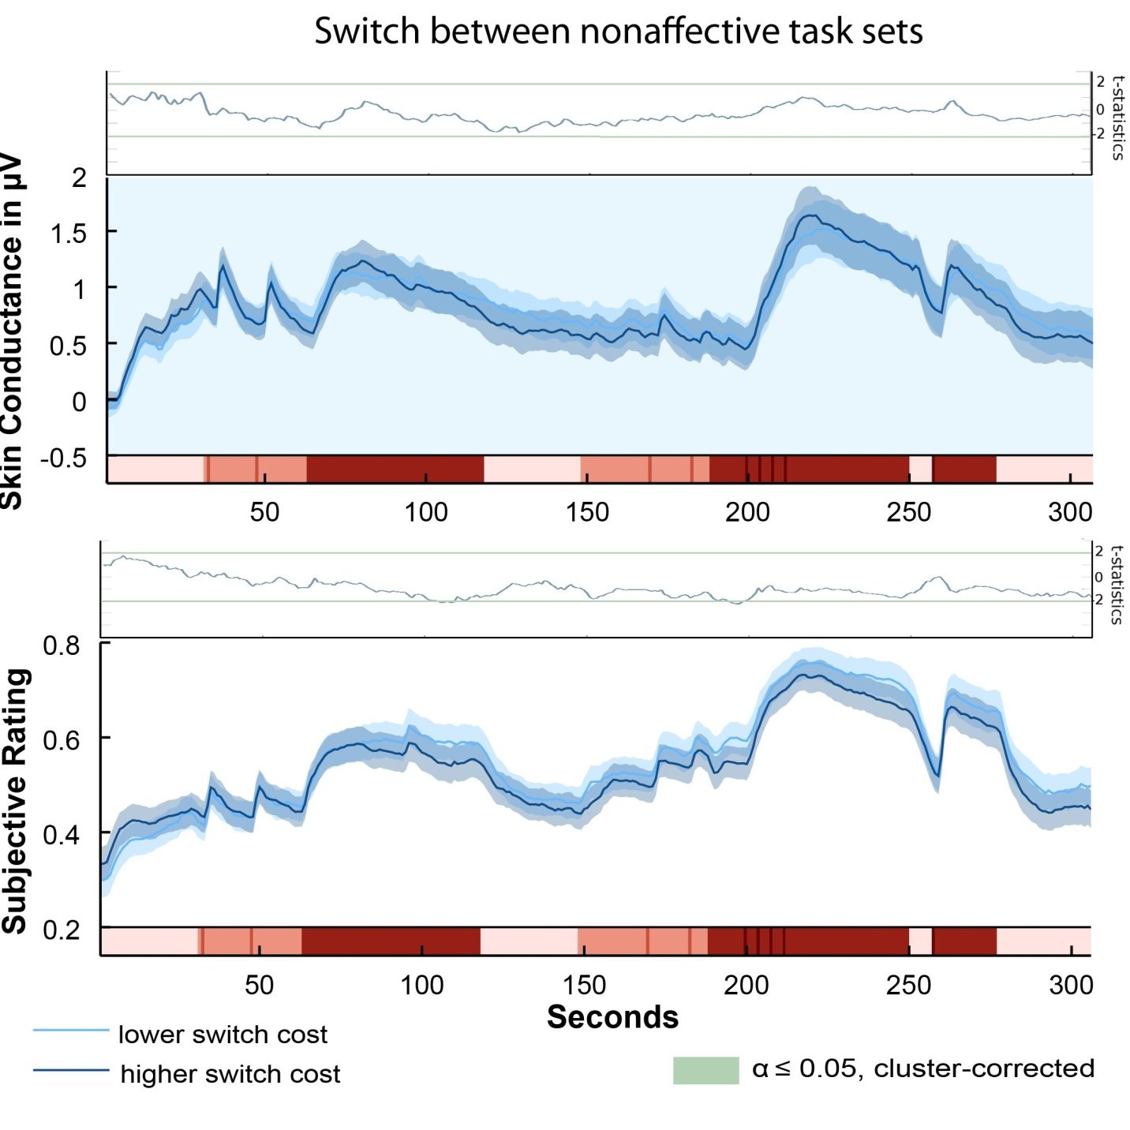

Figure 3
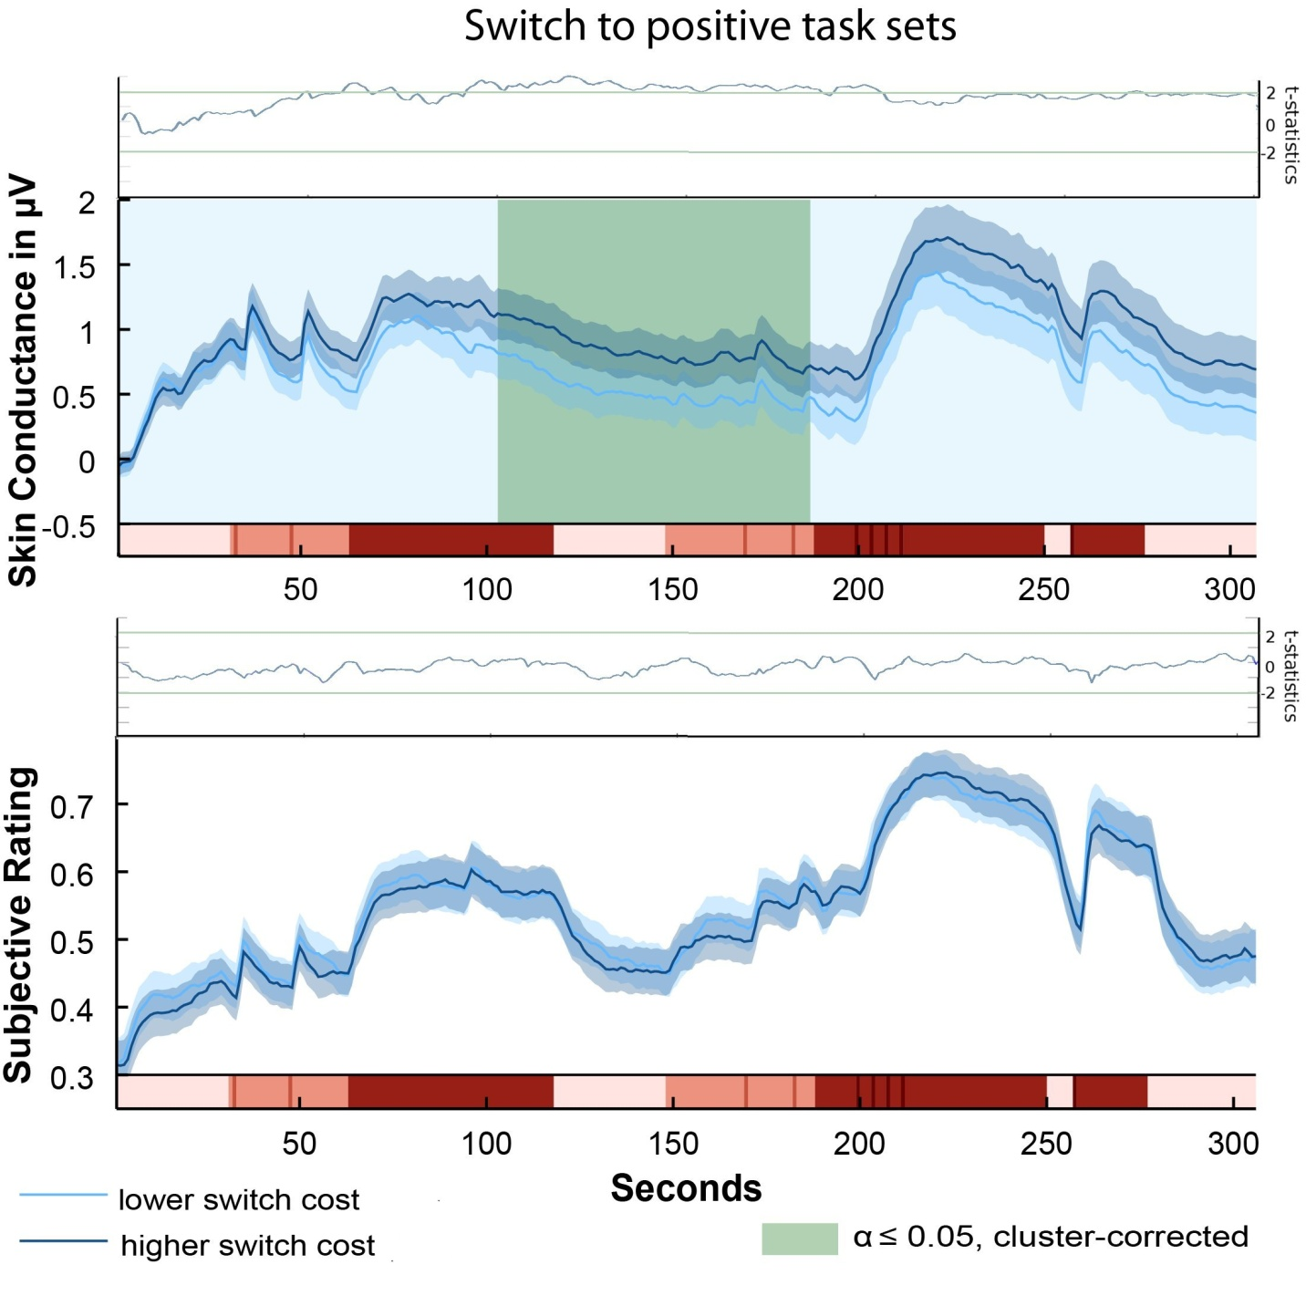

Figure 4
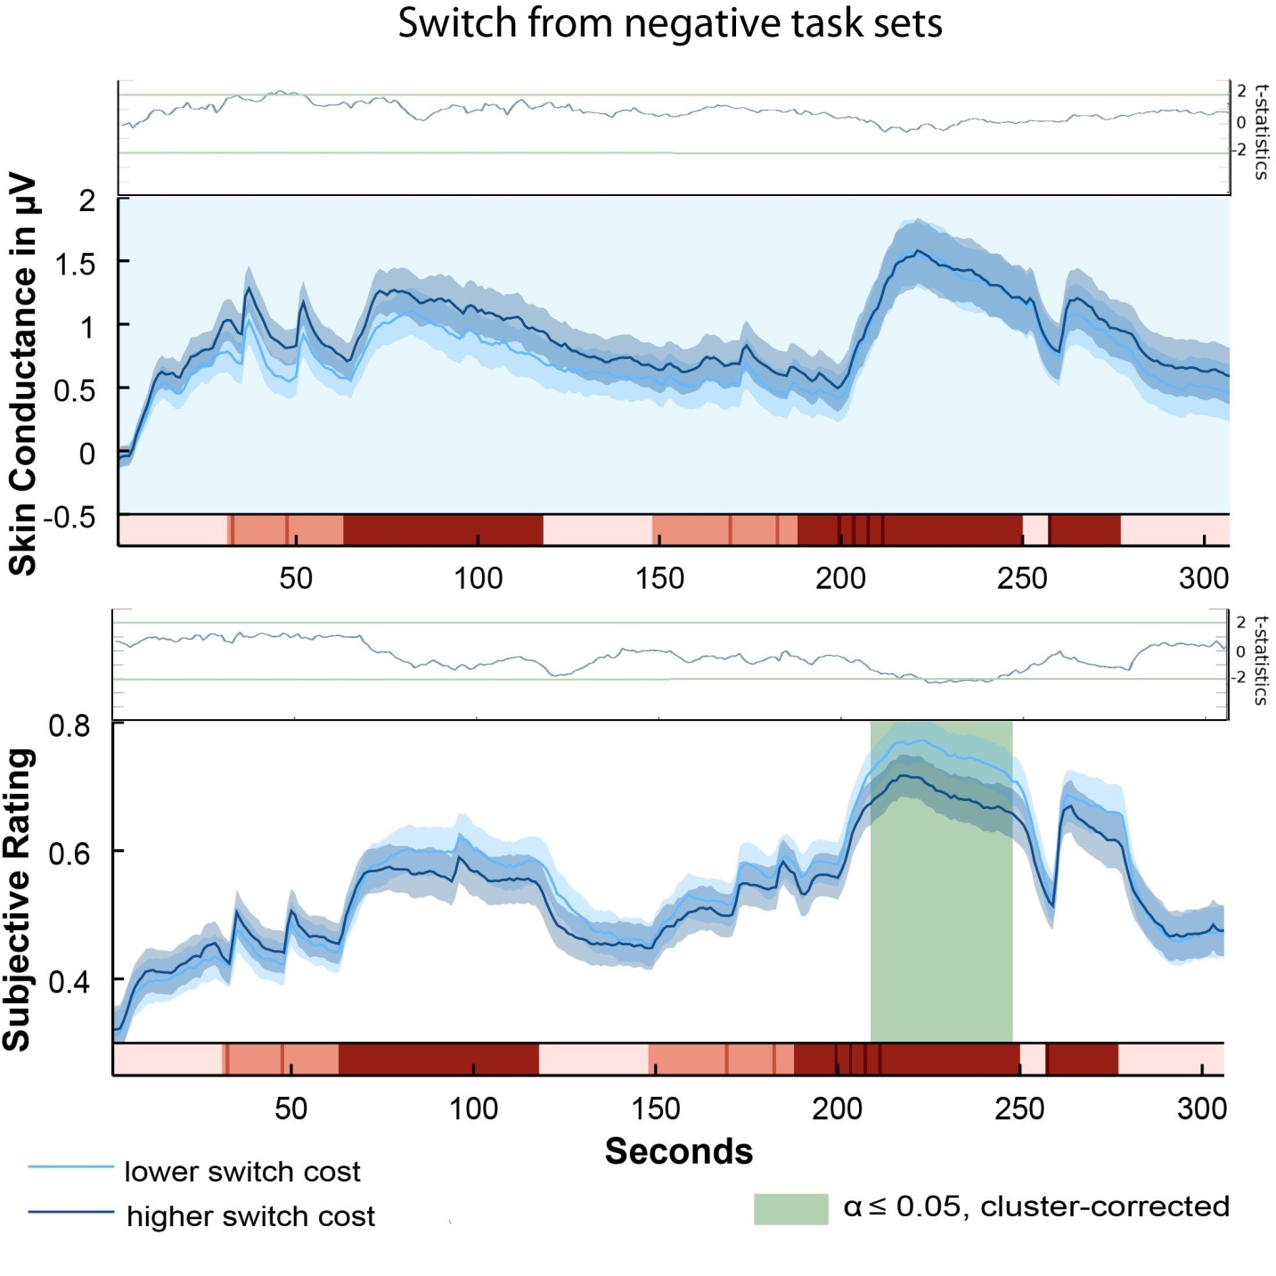
Figure 5
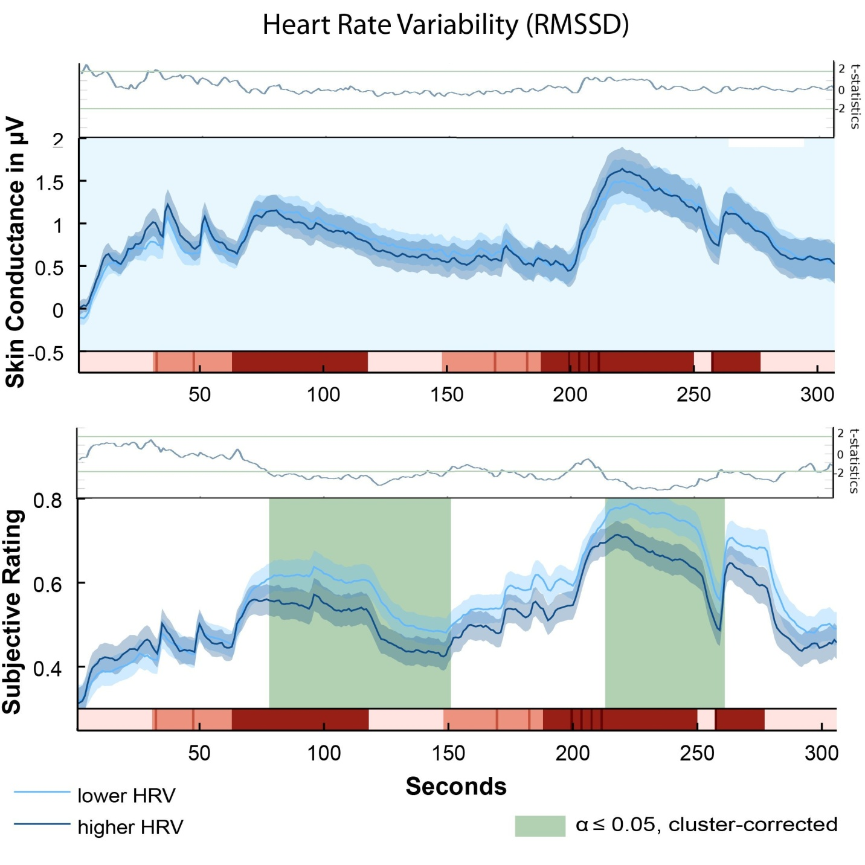

Figure 6
