Received 00th January 20xx,
- Department of Chemistry, University of York, Heslington, York, YO10 5DD, Phone +44(0)1904322534, +44(0)1904322610, Fax: +44(0)1904322516 E-mail: jason.lynam@york.ac.uk; john.slattery@york.ac.uk
Electronic Supplementary Information (ESI) available: CIF data, experimental details, DFT methods and coordinates See DOI: 10.1039/x0xx00000x
Accepted 00th January 20xx
DOI: 10.1039/x0xx00000x
www.rsc.org/
Access to novel fluorovinylidene ligands via exploitation of outer-sphere electrophilic fluorination: new insights into C-F bond formation and activation
Lucy M. Milner, Lewis M. Hall, Natalie E. Pridmore, Matthew K. Skeats, Adrian C. Whitwood, Jason M. Lynam* and John M. Slattery*
Metal vinylidene complexes are widely encountered, or postulated, as intermediates in a range of important metal-mediated transformations of alkynes. However, fluorovinylidene complexes have rarely been described and their reactivity is largely unexplored. By making use of the novel outer-sphere electrophilic fluorination (OSEF) strategy we have developed a rapid, robust and convenient method for the preparation of fluorovinylidene and trifluoromethylvinylidene ruthenium complexes from non-fluorinated alkynes. Spectroscopic investigations (NMR and UV/Vis), coupled with TD-DFT studies, show that fluorine incorporation results in significant changes to the electronic structure of the vinylidene ligand. The reactivity of fluorovinylidene complexes shows many similarities to non-fluorinated analogues, but also some interesting differences, including a propensity to undergo unexpected C-F bond cleavage reactions. Heating fluorovinylidene complex [Ru(η⁵-C₅H₅)(PPh₃)₂(C=C{F}R)][BF₄] led to C-H activation of a PPh₃ ligand to form an orthometallated fluorovinylphosphonium ligand. Reaction with pyridine led to nucleophilic attack at the metal-bound carbon atom of the vinylidene to form a vinyl pyridinium species, which undergoes both C-H and C-F activation to give a novel pyridylidene complex. Addition of water, in the presence of chloride, leads to anti-Markovnikov hydration of a fluorovinylidene complex to form an α-fluoroaldehyde, which slowly rearranges to its acyl fluoride isomer. Therefore, fluorovinylidenes ligands may be viewed as synthetic equivalents of 1-fluoroalkynes providing access to reactivity not possible by other routes.
Introduction
The unique properties of the carbon-fluorine bond can enhance many fundamental properties of biologically relevant molecules including bioavailability, metabolic stability and lipophilicity, with approximately 30 % of agrochemicals and 20 % of all pharmaceuticals now containing fluorine.¹⁻⁹ The use of ¹⁸F-labelled imaging agents in positron emission tomography (PET) is also a highly active area of medical research.^{10, 11} As such, new facile and selective synthetic methods for the introduction of fluorine into organic frameworks are highly desirable. Of particular interest are examples which offer high selectivity, controlled regiochemistry that is complementary to other methodologies and/or the ability to synthesise C-F bonds in less common environments.
The development of novel catalytic procedures for C-F bond formation is highly desirable and can offer significant advantages over traditional stoichiometric processes. Recent years have seen many advances using enzymatic-,¹² organo- or photo-catalytic¹³ methods for the synthesis of fluoro-organic compounds. Alongside these, transition-metal-promoted reactions have played an increasingly prominent role,¹⁴ particularly in the formation of aryl fluorides.¹⁵ Complementary studies on C-F bond cleavage^{4,16-20} and hydrodefluorination by metal complexes provide insight into the functionalization of readily available fluorine-rich substrates. ^{13, 21-23}
Metal-mediated C-F bond forming methodologies using both nucleophilic and electrophilic sources of fluorine have been developed.^{5, 6, 15, 24} Our interest has focused on reactions involving electrophilic fluorinating reagents, a number of which are commercially available.^{25, 26} They have been utilized in metal-catalyzed C-F bond formation reactions, which are believed to proceed either by oxidative fluorination of palladium²⁷⁻²⁹ or silver³⁰ to form a high-oxidation-state metal-fluoride complex,³¹ followed by C-F reductive elimination, or through single-electron processes with either copper³² or palladium catalysts.^{2,33-35} In addition, a wealth of Lewis-acidic-metal-mediated electrophilic fluorination reactions have been developed, which do not involve metal-based redox chemistry.³⁶⁻³⁹
We have recently described a new mechanism for the formation of C-F bonds within the coordination sphere of a redox-active metal complex using electrophilic fluorinating reagents (Scheme 1a).^{40, 41} Reaction of pyridylidene complex [I] with a latent source of “F⁺” results in selective C-F bond formation to give [II]⁺. Reaction of [II]⁺ with a further equivalent of 1-fluoro-2,4,6-trimethylpyridinium (FTMP) salt (in the presence of a
Scheme 1. Outer sphere electrophilic fluorination of an organo-ruthenium complex. “F+” = [FTMP]BF4, Selectfluor or N-fluorobenzenesulfonimide (NFSI).
catalytic amount of a base), or [I] with two equivalents of FTMP, gives the difluorinated analogue [III]⁺. Experimental and computational studies indicate that this process involves direct
fluorination of the ligand, without Ru-F bond formation, and is hence referred to as an outer-sphere electrophilic fluorination (OSEF) reaction.
We believe that the OSEF reaction in Scheme 1a is a general process and recent reports that an outer-sphere fluorination step may be involved in palladium-catalysed C-F bond formation⁴² and the fluorination of alkyne ligands in the coordination sphere of platinum⁴³ support this idea. It is therefore important to gain a deeper understanding of the scope of OSEF reactions and the reactivities of the novel fluorinated ligand systems that are formed.
The conversion of [I] to [II]⁺ may be viewed as the transformation of an alkenyl ligand to a fluorinated carbene (Scheme 1b) and by analogy we postulated that the corresponding reaction of an alkynyl ligand via OSEF might provide facile and selective formation of very unusual fluorovinylidene ligands (Scheme 1c). Fluorovinylidene complexes have rarely been described - limited examples of dimeric iridium⁴⁴⁻⁴⁷ and iron⁴⁸ complexes have been reported via activation of fluorinated organic precursors such as H₂C=CHF (iridium) and CF₂(COCl)₂ (iron). Since the availability of these precursors with a range of substitution patterns is restricted, this approach does not represent a general method for the synthesis and exploitation of fluorovinylidenes complexes, and hence their reactivity is largely unexplored. However, the potential importance of these ligands as intermediates in catalytic processes is highlighted by the large number of catalytic reactions that proceed via non-fluorinated vinylidene intermediates.⁴⁹⁻⁵²
We now demonstrate the successful preparation of fluorovinylidene complexes by OSEF from readily available, non-fluorinated alkynes. Studies of their reactivity clearly demonstrate that these complexes may indeed provide important routes to fluorinated compounds. The fluorovinylidenes ligands may act as a fluoroalkyne equivalent therefore offering access to reactivity patterns of compounds which are otherwise difficult to prepare and handle.

Scheme 2. (i) CH₂Cl₂ solution, - 2,4,6-trimethylpyridine. * NFSI was used as the fluorinating agent. (ii) CH₂Cl₂ solution, - “HF” (iii) CH₂Cl₂ solution, 4 hr, r.t., - dibenzothiophene.
Results and discussion
(i) Synthesis and Characterization of fluorine- and trifluoromethyl-containing vinylidene complexes.
By analogy with related electrophilic additions (H⁺,⁵³ Cl₂, Br₂, I₂,⁵⁴ Au(PPh₃)⁺⁵⁵), the electrophilic fluorination of the alkynyl ligand in [Ru(η⁵-C₅H₅)(-C≡CR)(PPh₃)₂] to give fluorinated vinylidenes was targeted. Complexes based on the [Ru(η⁵-C₅H₅)(-C≡CPh)(PPh₃)₂] were selected as metal-based precursors as they are readily available from the reaction between [Ru(η⁵-C₅H₅)Cl(PPh₃)₂] and a wide range of terminal alkynes.⁵⁶ Treatment of a CH₂Cl₂ solution of [Ru(η⁵-C₅H₅)(-C≡CPh)(PPh₃)₂], [1a], with [FTMP]BF₄, [2a]BF₄, resulted in an instantaneous colour change from a yellow to a dark green solution from which the fluorinated vinylidene complex [Ru(η⁵-C₅H₅)(=C=C{F}Ph)(PPh₃)₂]BF₄, [3a]BF₄, could be isolated in excellent yield (Scheme 2a). No intermediates were observed by NMR spectroscopy between 195 K and 295 K, supporting the hypothesis that [3a]BF₄ is being formed by direct fluorination of the alkynyl ligand. Complex [3a]BF₄ could also be prepared in a
Table 1. Summary of ¹³C NMR data and lowest energy bands in the absorption spectra of vinylidene complexes. Experimental data were recorded at a concentration of ca. 1 mmol dm⁻³ in CH₂Cl₂ solution.
Complex | ¹³C δ M=C / ppm | λ_{max} /nm | λ_{max} / nm (calc)
[3a]BF₄ | 389.0 | 691 | 730
[3b]BF₄ | 383.5 | 684 | 720
[3c]BF₄ | 389.9 | 698 | 764
[3d]N(SO₂Ph)₂ | 392.4 | 644 | 655
[4a]PF₆ | 355.5 | 524 | 537
[7a]BF₄ | 340.0 | 488 | 452
[8a^{Cl}]BF₄ | 353.5 | 615 | 702
[8a^{Br}]BF₄ | 340.3 | 627 | 647
[8^{Br}]Br₃ | 339.3 | 626 | -
[8a^{I}]I₃ | 323.6 | 619 | 668

one-pot procedure by treatment of the vinylidene complex [Ru(η⁵-C₅H₅)(=C=C{H}Ph)(PPh₃)₂]⁺, [4a]⁺, with base to generate [1a] in situ followed by reaction with [2a]BF₄. This reaction also proceeds in the absence of added base, but the reaction is slightly slower, requiring ca. 30 mins to reach completion.
Analogous reactions of ruthenium alkynyl complexes containing both electron-releasing and electron-withdrawing substituents
([1b]-[1d], Scheme 2a) and with a range of electrophilic fluorinating reagents (NFSI, [2b]BF₄ and Selectfluor, [2c](BF₄)₂) with no notable difference in reaction outcome, demonstrating the generality of the approach. However, reaction of [1a] with 1-fluoropyridinium tetrafluoroborate, [2d]BF₄, resulted in the formation of the disubstituted vinylidene complex [5a]BF₄ (Scheme 2b), whose structure was confirmed by X-ray crystallography (E.S.I.). Complex [5a]BF₄ appears to have been formed by formal nucleophilic aromatic substitution of [2d]BF₄ by the alkynyl ligand in [1a] with concomitant loss of HF.
In a similar manner to electrophilic fluorination, the electrophilic incorporation of -CF₃ groups into the framework of organic compounds is also desirable.^{10, 39, 57, 58} There are only limited examples of CF₃-substituted vinylidene complexes, all of which are dimeric species formed from the activation of H₂C=CHCF₃.⁴⁶ The reaction between [1a] and Umemoto’s reagent, [6]BF₄, (a latent source of “CF₃⁺”) resulted in the selective formation of [Ru(η⁵-C₅H₅)(=C=C{CF₃}Ph)(PPh₃)₂]BF₄, [7a]BF₄ (Scheme 2c). The structure of [7a]BF₄ was confirmed by a single crystal X-ray diffraction study (ESI).
To the best of our knowledge complexes [3]BF₄ are the first examples of fluorovinylidene ligands in mononuclear metal species, and access to these complexes has allowed an
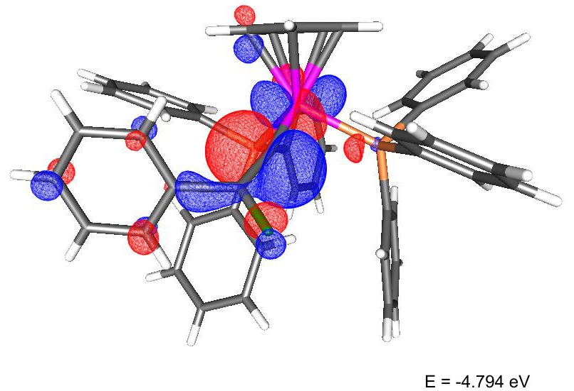
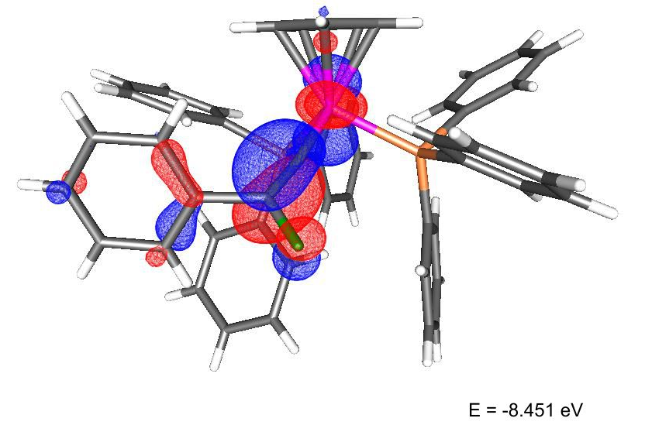
Figure 1. LUMO (top) and HOMO (bottom) of [3a]⁺
evaluation of the effects of fluorine incorporation into vinylidene ligands. For example, the ¹⁹F NMR spectrum of [3a]⁺ displayed a singlet resonance at δ -208.7 for the fluorine atom of the vinylidene ligand and the ¹³C{¹H} NMR spectrum exhibits a doublet of triplets at δ 389.0 (²J_{CF} = 39.3 Hz, ²J_{CP} = 16.2 Hz) for the metal-bound carbon atom and a doublet at δ 196.7 (¹J_{CF} = 222.1 Hz) for the fluorine-bearing carbon atom. These resonances are shifted ca. 30 ppm and 70 ppm downfield, respectively, when compared to the hydrogen-substituted analogue [4a]PF₆. Indeed the metal-bound carbon is observed at one of the lowest reported chemical shifts for a vinylidene α-carbon.^{59, 60} In CD₂Cl₂ solution the ¹H, ³¹P and ¹⁹F NMR spectra of [3a]BF₄ showed no change on cooling to 195 K, indicating that the vinylidene was undergoing rapid rotation on the NMR timescale
The deep green colour of the fluorovinylidene complexes is due to an absorption band at ca. 690 nm, which showed no significant solvatochromism (ESI). With the aid of TD-DFT studies this transition was shown to be dominated by HOMO → LUMO character. In the HOMO (Figure 1) a fluorine lone pair has an anti-bonding interaction with the π-system of the vinylidene ligand (which is itself anti-bonding with respect to a metal-centred orbital). The LUMO has a contribution from a p-orbital on the fluorine and an orbital based on the metal-bound carbon.
Additional spectroscopic data of the other halogen-substituted vinylidene complexes [Ru(η⁵-C₅H₅)(=C=C{E}C₆H4-4-R)(PPh₃)₂]X⁵⁴
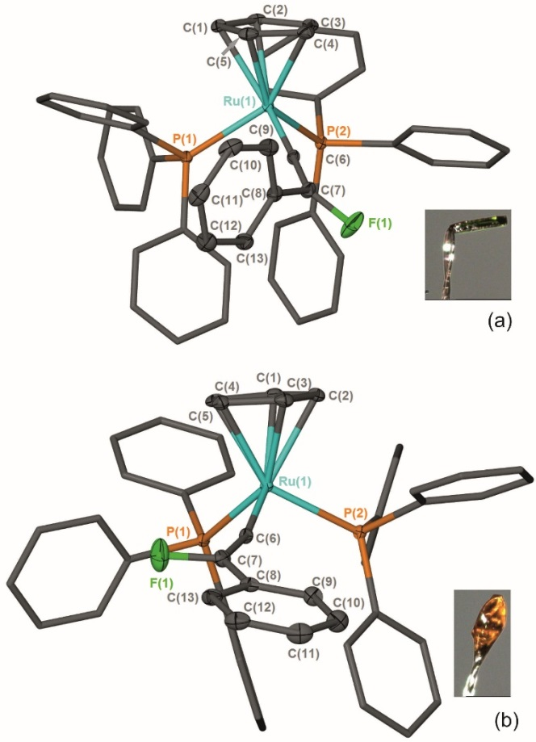
Figure 2. Solid-state structures of the [3a]⁺ cation found in (a) green crystals and (b) orange crystals. Hydrogen atoms removed for clarity and thermal ellipsoids (where shown) are at the 50 % probability level.
(E = Cl,‡ Br and I) and the CF₃-containing complex, [7a]BF₄, support an interplay between σ- and π-effects on the energy of the ILCT (Table 1). Good π-donors (e.g. F, Cl) raise the energy of the HOMO, thereby lowering the energy of the ILCT. In contrast, the strongly (-I) electron-withdrawing groups, such as CF₃ in [7a]BF₄ display a higher energy transition, presumably due to an opposite effect. This effect is supported by the bathochromic shift observed in methoxy-substituted [3c]BF₄ and the hypsochromic shift in [3b]BF₄. The interplay between σ- and π- effects appears to also be manifested in the chemical shift of the metal bound carbon atom, as the CF₃-subsituted vinylidene ligand has a chemical shift similar to [4a]PF₆, but the halogen-substituted variants have a chemical shift range of 66 ppm.
Complex [3a]PF₆ crystallises as two different polymorphs, which have significantly different photophysical properties in the solid state (Figure 2). One is orange (λ_{max}= 742 nm) and one green (λ_{max}= 692 nm) and they differ primarily in the orientation of the fluorine atom and phenyl group of the vinylidene ligand and the geometry around the β-carbon (ESI). Dissolution of both crystals in CH₂Cl₂ gave essentially identical UV-vis and NMR spectra showing that the two crystalline forms convert to the same species in solution. We propose that the observed species is a time-averaged signal for the different rotameric forms. Different agostic isomers of the same organometallic complex have been shown to produce crystals with markedly different electronic spectra,⁶¹ however, in the case of [3a]PF₆ subtle changes to the structure in the solid state has a pronounced effect on the photophysical properties of the system by altering the energy of the ILCT transition.
(ii) Reactions of fluorine-containing vinylidene complexes
a) Attempted displacement of FC≡CPh
The facile syntheses of complexes [3]BF₄ has allowed an exploration of the reactivity of these species to evaluate the effects of fluorine incorporation into vinylidene ligands. In the case of half-sandwich ruthenium complexes with either mono-
Scheme 3. (i) NCMe, 50 °C, 14 d. X⁻ = BF₄⁻ or N(SO₂Ph)₂⁻.
^{62,} ⁶³ or di-substituted vinylidene ligands⁶⁴ reaction with NCMe has been shown to reverse the alkyne-vinylidene tautomerisation and generate [Ru(η⁵-L)(NCMe)(PPh₃)₂]⁺, (L = C₅H₅, [9]⁺) liberating the corresponding alkynes HC≡CR and PhC≡CR respectively. These studies have permitted detailed kinetic insight into the nature of the alkyne-vinylidene interconversion.⁶⁵ However, heating a sample of [3a]⁺ in NCMe-d₃ did not result in an analogous reaction to form [9]⁺ and FC≡CPh. Instead, the major product from the reaction was [10a]BF₄, in which a coordinated alkene ligand has been formed from a combination of vinylidene and phosphine ligands, the latter having undergone an orthometallation process (Scheme 3). The ³¹P NMR spectrum of [10a]BF₄ exhibits two resonances at δ 46.6 (dd, ³J_{PF} = 48.6 Hz; ³J_{PP} = 4.4 Hz) and δ 42.3 (dd, ³J_{PF} = 16.2 Hz; ³J_{PP} = 4.4 Hz) confirming the presence of two different phosphorus environments. Resonances at δ -143.4 (app. dt, ³J_{PF} = 48.6 Hz; ³J_{HF} = 16.9 Hz; ³J_{PF} = 16.2 Hz) in the ¹⁹F NMR spectrum, δ 4.69 (ddd, ³J_{HF} = 16.9 Hz; ²J_{PH} = 5.0 Hz; ³J_{PH} = 1.7 Hz) in the ¹H NMR spectrum and 113.7 (dt, ¹J_{CF} = 243.0 Hz; ²J_{CP} = 5.6 Hz) and 25.9 (ddd, ¹J_{CP} = 75.1 Hz; ²J_{CF} = 7.8 Hz; ²J_{CP} = 2.7 Hz) in the ¹³C{¹H} spectrum demonstrated that the fluorinated alkene ligand was present.
Other products form on heating at higher temperature (80 °C), but after ca. two weeks at 50 °C, the reaction was reasonably selective (70% conversion based on ³¹P NMR spectroscopy). A complex related to [10a]BF₄ has been reported previously from the nucleophilic attack of PPh₃ at a coordinated (protio)vinylidene.⁶⁶ It is proposed that [10a]BF₄ is formed by initial loss of PPh₃, followed by attack of the free phosphine at the metal-bound carbon of the fluorovinylidene. C-H activation and hydride migration subsequently leads to [10a]BF₄. This is supported by the fact that the dppe-containing fluorovinylidene complex [Ru(η⁵-C₅H₅)(=C=C{F}Ph)(dppe)]N(SO₂Ph)₂, [3e]N(SO₂Ph)₂ (prepared from [Ru(η⁵-C₅H₅)(-C≡CPh)(dppe)] and 2b) is unchanged on heating at 100 °C for 14 days in NCMe-d₃. These data indicate that the conversion of the fluorovinylidene to its alkyne form does not proceed under any of these conditions.
b) Reaction of fluorovinylidene complex with pyridine: C-H and C-F bond activation.
Many of the catalytic applications of ruthenium vinylidene complexes exploit the electrophilicity of the metal-bound
Scheme 4 (i) pyridine, 20 ºC, < 5 min. (ii) pyridine, -HF, 20 ºC, 10 days.
carbon atom.^{49, 50, 52, 67} For example, we have recently demonstrated that nucleophilic attack by pyridine at a coordinated vinylidene was a key step in ruthenium-mediated C-H functionalization reactions,⁶⁸ a process whereby the formation of pyridylidene-containing intermediates plays an important role. Dissolution of [3a]BF₄ in pyridine results in the immediate formation of the vinyl complex [Ru(η⁵-C₅H₅)(-C{py}=C{F}Ph)(PPh₃)₂]BF₄, (py = pyridine), [11]BF₄ (Scheme 4), demonstrating that the incorporation of the fluorine substituent does not inhibit nucleophilic attack at the metal-bound carbon. In CD₂Cl₂ solution the ¹⁹F NMR spectrum of [11]BF₄ exhibited a doublet resonance at δ -71.1 (⁴J_{PF} = 20.1 Hz) and the ³¹P{¹H} a corresponding resonance at δ 44.0 (d, ⁴J_{PF} =20.3 Hz): the ESI-MS demonstrated that a single pyridine had added to the ruthenium complex. The structure of [11]BF₄ was confirmed by X-ray crystallography (Figure 3), which showed that the alkenyl ligand had adopted a Z-configuration. We have previously proposed that this type of alkenyl complex was a key intermediate in the direct C-H functionalization of the pyridine,⁶⁸ and the previous inability to observe such a species was principally owing to its low intrinsic concentration due to competitive deprotonation of the vinylidene ligand. Evidently, the presence of the fluorine atom allows for the observation and characterization of this species.
On standing in pyridine solution, [11]BF₄ underwent a further reaction to give [12]BF₄ and free PPh₃. Monitoring this reaction by NMR spectroscopy indicated that this process proceeds through a number of phosphorus- and fluorine-containing intermediates. The molecular structure of [12]BF₄ (as its pyridine solvate) showed that this species was a novel pyridylidene complex had been formed by activation of a C-H bond of the pyridine group in [11]BF₄, incorporation of a second pyridine molecule and formal loss of HF, the fate of which could not be determined.
A potential mechanism for the conversion of [3a]BF₄ to [12]BF₄ was investigated by a DFT study. Given the changes in molecularity during the proposed mechanism there are significant differences in the relative zero-point-energy-corrected electronic energies (E_{SCF+ZPE}) and Gibbs energies of different states. The following discussion refers solely to the Gibbs energies at 298 K, although both are presented in Figure
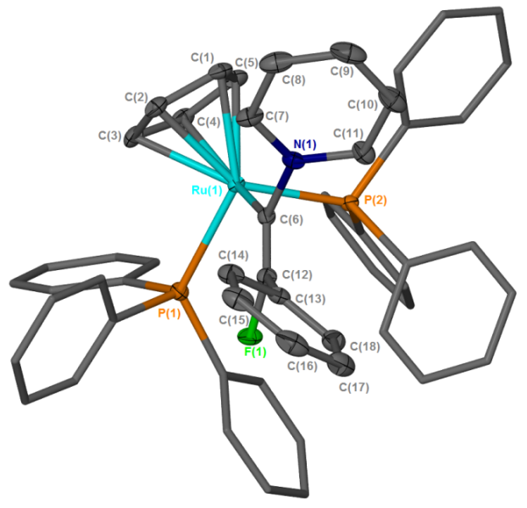
Figure 3. Solid-state structure of the cation [11]⁺, hydrogen atoms omitted for clarity, thermal ellipsoids (where shown) are at the 50 % probability level.
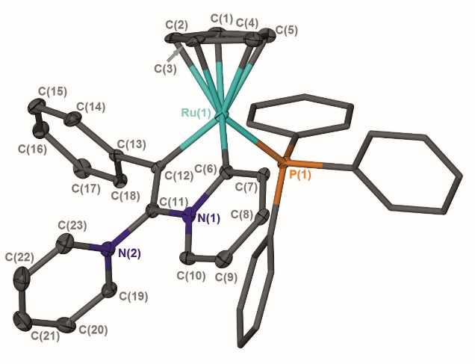
Figure 4. Solid-state structure of one of the two crystallographically independent cations in the structure of [12]BF₄.pyridine, hydrogen atoms omitted for clarity, thermal ellipsoids (where shown) are at the 50 % probability level
5. In the first step, nucleophilic attack of pyridine occurs at the metal-bound carbon atom of the vinylidene in [3a]⁺ (taken as the reference point for the calculations) to give [11-Z]⁺ through transition state TS_{[3a]+[11-Z]+}. The fact that [11]⁺ is predicted to be lower in energy than [3a]⁺ and TS_{[3a]+[11-Z]+} is reasonably accessible (ΔG‡₂₉₈ + 100 kJ mol⁻¹) is consistent with the experimental observation of fast formation of [11]BF₄.

Figure 5. Potential energy surface for the proposed mechanism of formation of [12]⁺ from [3a]⁺. E_{SCF+ZPE} (top) and Gibbs energies at 298.15 K (bottom), relative to [3a]⁺ and two molecules of pyridine, are shown in kJ mol⁻¹. Calculations are at the (RI-)PBE0-D3/def2-TZVPP//(RI-)BP86/SV(P) level with COSMO solvation in pyridine. [Ru] = [Ru(η⁵-C₅H₅)(PPh₃)].

The next stages in the reaction pathway are directly related to previous studies on pyridine C-H activation.^{68, 69} Loss of PPh₃ from [11]⁺ leads to intermediate [A]⁺. Formation of agostic complex [B]⁺ followed by C-H activation via TS_{[B]+[C]+} leads to hydride complex [C]⁺ which may then undergo a subsequent migration to afford [D]⁺. A subsequent isomerisation to the lower energy isomer [E]⁺ then occurs. Formal elimination of HF must then occur to give [12]⁺ although attempts to model elimination of HF from [E]⁺ via a pyridine-induced E₂-process were unsuccessful. However, deprotonation of [E]⁺ (or hydride complex [C]⁺) may occur in pyridine solution to afford [F] and [HNC₅H₅]⁺. Defluorination may now occur through TS_{[F][G]+} in which the [HNC₅H₅]⁺ aids the loss of the fluorine to give (after coordination of the triple bond in [G]+ to the metal) alkyne complex [H]⁺. Nucleophilic attack by pyridine through TS_{[H]+[12]+} then gives the observed product [12]⁺, which is also the lowest point on the potential energy surface (-45 kJ mol⁻¹).
The calculations indicate that the nucleophilic attack by pyridine of [3a]⁺ to give the E-isomer ([11-E]⁺) of the complex is both kinetically (TS_{[3a]+[11-E]+} +155 kJ mol⁻¹) and thermodynamically unfavorable (+65 kJ mol⁻¹) when compared to the formation of the Z-isomer. This appears to be due to an unfavourable interaction between the PPh₃ ligands and the Ph-group of the alkenyl ligand in the E-isomer. In contrast, however, defluorination from [F] is far more accessible from the E-isomer of the alkene complex ([F-E]) than from the Z-isomer (TS_{[F-E][G]+} +140 kJ mol⁻¹; TS_{[F-Z][G]+} +173 kJ mol⁻¹, see ESI for full E- and Z-pathways). There are a number of possible points on the PES where interconversion of the E- and Z-isomers may occur. For example, previous calculations indicate that the vinylidene complexes, [I-Z]⁺ and [I-E]⁺ (Figure 6a) would be readily accessible from complexes such as [A]⁺.³⁹ Rotation of vinylidene ligands, which will interchange the E- and Z- isomers, is a low energy process.^{70, 71} We tentatively propose that at some point following state [11-Z^{]+} the system isomerises and follows the E-isomer pathway.
Figure 6. Calculations at the (RI-)PBE0-D3/def2-TZVPP//(RI-)BP86/SV(P) level with COSMO solvation in pyridine. [Ru] = [Ru(η⁵-C₅H₅)(PPh₃)]. E_{SCF+ZPE} (top) and Gibbs energies at 298.15 K (bottom), relative to [3a]⁺, pyridine and PPh₃.
The formation of [11]⁺ is rapid and a second, slower, reaction subsequently gives [12]⁺. In addition to supporting our previous observation that the [Ru(η⁵-C₅H₅)(PPh₃)]⁺ fragment may selectively activate pyridine in the 2-position,^{68, 72} the DFT study also provides an explanation as to why no alkenylated pyridine is observed in the fluorine-containing system. The key transition state in this process involves C-N bond cleavage in [F-E] via TS_{[F-E][J-E]} which at +150 kJ mol⁻¹ lies higher in energy than TS_{[F-E][G]+} (Figure 6b) implying that defluorination is preferred to C-N bond cleavage.
It appears that C-F bond cleavage in this system occurs by an acid-assisted fluoride abstraction. This process is related to Hughes’ studies on half-sandwich iridium complexes in which α-fluoride abstraction leads to a cationic carbene complex.^{73, 74}
In this case, a cationic alkyne complex is the product of the fluoride loss from the β-position of complex [F], which then undergoes nucleophilic attack by pyridine.
c) Hydrolysis of fluorovinylidenes complexes: formation of an α-fluoroaldehyde and acyl-fluoride.
The observation that fluorovinylidenes ligands are susceptible to nucleophilic attack, in a similar way to their non-fluorinated analogues, prompted us to explore this type of reaction with a view to generating fluorinated organic molecules. Vinylidene complexes are well known to undergo hydrolysis and hydration via nucleophilic attack of water at the α-carbon of the
Scheme 5. (i) CD₂Cl₂, + N^{n}Bu₄Cl, - N^{n}Bu₄BF₄, R. T., 14 d. (ii) CD₂Cl₂, + N^{n}Bu₄Cl, - N^{n}Bu₄(SO₂Ph)_{2,} R. T. (iii) 6d, R. T.
vinylidene.^{75, 76} The products of hydration depend on the ligands present at the metal. Careful design has allowed the development of Ru-catalysts for the anti-Markovnikov hydration of terminal alkynes via vinylidene intermediates.^{77-81,82} We were therefore interested in understanding the reactivity of [3]BF₄ with water. However, [3a]BF₄ proved to be relatively stable in the presence of water, in the absence of other additives. Addition of either stoichiometric or excess water to a CH₂Cl₂ solution of [3a]BF₄ at room temperate did not result in an immediate reaction. Addition of one equivalent of a base, 1,4-diazabicyclo[2.2.2]octane (DABCO), and water (either stoichiometric water or ten equivalents) resulted in the formation of a number of new compounds. The major new species were identified, by ³¹P{¹H} NMR spectroscopy, as [Ru(η⁵-C₅H₅)Cl(PPh₃)₂], [13], and, remarkably, [Ru(η⁵-C₅H₅)(C≡CPh)(PPh₃)₂], [1a] the latter corresponding to the formal loss of “F⁺” from the fluorovinylidene.⁸³ Monitoring the reactions over an extended period (c.a. two weeks) at room temperature showed almost total conversion to [13]. Heating the reactions at 50 °C increased the rate of conversion but not the final product distribution. This should be contrasted with the reaction of [4a]⁺ with water which results in the formation of [Ru(η⁵-C₅H₅)(CO)(PPh₃)₂]⁺ and toluene.⁷⁶
In contrast, hydrolysis of [3a]BF₄ in the presence of chloride as an additive (introduced as N^{n}Bu₄Cl.H₂O§) results in the selective, if slow, formation of [Ru(η⁵-C₅H₅)Cl(PPh₃)₂], [13] and the acyl-fluoride 14 (Scheme 5a), which has resulted from formal hydration of the vinylidene ligand and isomerisation of the resulting α-fluoroaldehyde (vide infra). Compound 14 was identified on the basis of characteristic resonances in the ¹⁹F (δ 43.7, t, ³J_{HF} =1.5 Hz), ¹H (δ 3.84, d, ³J_{HF} =1.5 Hz), and ¹³C{¹H} NMR spectra (δ 39.2, d, ²J_{CF} = 54 Hz, CH₂; 162.1, d, ²J_{CF} = 362.3 Hz, COF) matching those previously reported.⁸⁴ Monitoring the reaction by NMR spectroscopy demonstrated that [13] and 14 were formed at approximately the same rate. Compound 14 was isolated by sublimation and proved to be highly moisture sensitive.
The formation of 14 is somewhat surprising as it appears that either fluoro- or phenyl-migration must have occurred. Given that the reaction of [3a]BF₄ with NCMe did not give rise to the alkyne FC≡CPh and [9]BF₄ (which would also require F or Ph migration) it might be presumed that these are high-energy pathways in this system, although phenyl-migration in di-substituted vinylidene complexes is well established.^{64, 85-88} In order to gain further mechanistic insight into this process, the ¹³C-enriched vinylidene complex [3a-¹³C]BF₄ was prepared and subjected to an identical reaction with N^{n}Bu₄Cl.H₂O (Scheme 5b). Analysis of the resulting ¹⁹F NMR spectra demonstrated that the resonance for 14 now appeared as a doublet (¹J_{CF} = 361.4 Hz) with no evidence of a species with the labelled atom in the alternative position. Repeating the reaction with [3a]⁺ as the benzenesulfonimide salt (prepared from [1a] and NFSI) also gave 14, indicating that the source of the fluorine was the vinylidene ligand not the [BF₄]⁻ counteranion.
Hydrolysis of the dppe-containing complex [3e]N(SO₂Ph)₂ in the presence of chloride (as N^{n}Bu₄Cl.H₂O) is much faster than the PPh₃-containing analogue. At room temperature rapid formation of [Ru(η⁵-C₅H₅)Cl(dppe)], [15] and the α-fluoroaldehyde 16 (identified by resonances in the ¹H and ¹⁹F NMR spectra at δ 9.72 (dd, ³J_{HF} = 7.6 Hz, ⁵J_{HH} = 0.7 Hz and δ -191.7 (dd, ²J_{HF} = 47.0 Hz, ³J_{HF} = 7.6 Hz) respectively) was observed, Scheme 5c.⁸⁹ Over the course of 6 days the resonances for 16 decreased in intensity to be replaced by those for 14. It is proposed that anti-Markovnikov hydration of the vinylidene^{77-79,82} occurs to give 16 which then undergoes a slower isomerisation to 14. DFT calculations indicate that 16 is 97 kJ mol⁻¹ higher in energy (ΔG₂₉₈) than 14 so this conversion is thermodynamically favoured and aldehydes such as 16 have been reported to be unstable.⁹⁰ The overall process is summarised in Scheme 5d.
The reaction of metal alkynyl complexes (derived from terminal alkynes) with “F⁺” followed by hydrolysis and liberation of α-fluoroaldehydes represents a stepwise functionalization of alkynes with the incorporation of both new functionality and the generation of a new stereocentre. This type of reactivity is highly desirable as the fluorinated vinylidene ligands are effectively acting as synthetic equivalents of 1-fluoroalkynes. Work is underway in our groups to exploit these stoichiometric observations for the development of catalytic protocols for combined alkyne functionalization and fluorination.
Conclusions
The reaction between alkynyl complexes [1] and electrophilic fluorinating and trifluoromethylating agents offers a highly selective and simple route for the direct formation of C-F and C-CF₃ bonds and the construction of novel fluorinated vinylidene ligands. Although the addition of other electrophiles to alkynyl complexes has been reported, it is remarkable that the highly-oxidising sources of “F⁺” result in selective C-F bond formation rather than direct fluorination of the metal complexes. These data demonstrate that OSEF (or analogous trifluoromethylation) represents a complementary approach to current metal-mediated routes for electrophilic C-F bond formation and may be applicable to a range of organometallic systems.
As the new fluorinated ligands were retained within the coordination sphere of ruthenium it was possible to evaluate the effects of incorporation of the fluorine and explore subsequent reactivity. Reactions of fluorovinylidene complexes with nucleophiles such as pyridine and water show many similarities to the reactivity of non-fluorinated vinylidenes. As these²⁵ are important intermediates in a range of metal-catalysed reactions, this suggests that access to fluorinated analogues offers new opportunities for the formation of novel fluorinated organic compounds without re-writing the rule book in terms of their reactivity. Indeed, our observation of anti-Markovnikov hydration of fluorovinylidenes, a key reaction of non-fluorinated analogues, to form both new functionality and a new stereocentre in the α-fluoroaldehyde products supports this argument. In addition to applications in synthesis, the introduction of fluorine into ligands of organometallic complexes may significantly alter metal-ligand bonding and, for example, may be used to blue-shift the emission from luminescent iridium complexes.⁹¹⁻⁹⁴ In summary, it has been demonstrated how OSEF allows for the facile formation of C-F (and C-CF₃ bonds) in metal alkynyl complexes to be achieved and that C-F bond cleavage, assisted by a pyridinium salt, may occur from the β-position of an organic ligand.
Acknowledgements
We thank the EPSRC (DTA studentship to LMM and computational equipment EP/H011455/1 and EP/K031589/1) and the University of York (PhD Studentship to LMH and Summer studentship to MKS) for funding. The insightful comments of Professors Duncan Bruce and Robin Perutz on this work are gratefully acknowledged.
Notes and references
‡ [6a^{Cl}]BF₄ was prepared by a new method from [1a] and N-chlorosuccinamide, [6a^{Br}]BF₄ was synthesised from one equivalent of Br₂ and NaBF₄, see E.S.I.
§ The ratio of N^{n}Bu₄Cl to H₂O was shown to be ca 1:1 by elemental analysis.

1. X. Yang, T. Wu, R. J. Phipps and F. D. Toste, Chemical Reviews, 2014, DOI: 10.1021/cr500277b.
2. Z. Jin, B. Xu and H. G. B., Aldrichimica Acta, 2012, 45, 67-83.
3. T. Besset, T. Poisson and X. Pannecoucke, Chem.-Eur. J., 2014, 20, 16830-16845.
4. T. Furuya, A. S. Kamlet and T. Ritter, Nature, 2011, 473, 470-477.
5. T. Liang, C. N. Neumann and T. Ritter, Angew. Chem. Int. Ed., 2013, 52, 8214-8264.
6. X. Yang, T. Wu, R. J. Phipps and F. D. Toste, Chem. Rev., 2015, 115, 826-870.
7. T. Furuya, J. E. M. N. Klein and T. Ritter, Synthesis, 2010, 2010, 1804-1821.
8. C. N. Neumann and T. Ritter, Angew. Chem. Int. Ed., 2015, 54, 3216-3221.
9. M. G. Campbell and T. Ritter, Org. Process Res. Dev., 2014, 18, 474-480.
10. S. Purser, P. R. Moore, S. Swallow and V. Gouverneur, Chem. Soc. Rev., 2008, 37, 320-330.
11. E. Lee, A. S. Kamlet, D. C. Powers, C. N. Neumann, G. B. Boursalian, T. Furuya, D. C. Choi, J. M. Hooker and T. Ritter, Science, 2011, 334, 639-642.
12. D. O’Hagan and H. Deng, Chem. Rev., 2015, 115, 634-649.
13. S. M. Senaweera, A. Singh and J. D. Weaver, J. Am. Chem. Soc., 2014, 136, 3002-3005.
14. T. Ahrens, J. Kohlmann, M. Ahrens and T. Braun, Chem. Rev., 2015, 115, 931-972.
15. M. G. Campbell and T. Ritter, Chem. Rev., 2015, 115, 612-633.
16. M. Reinhold, J. E. McGrady and R. N. Perutz, J. Am. Chem. Soc., 2004, 126, 5268-5276.
17. E. Clot, O. Eisenstein, N. Jasim, S. A. Macgregor, J. E. McGrady and R. N. Perutz, Acc. Chem. Res., 2011, 44, 333-348.
18. B. Procacci, Y. Jiao, M. E. Evans, W. D. Jones, R. N. Perutz and A. C. Whitwood, J. Am. Chem. Soc., 2015, 137, 1258-1272.
19. M. E. Evans, C. L. Burke, S. Yaibuathes, E. Clot, O. Eisenstein and W. D. Jones, J. Am. Chem. Soc., 2009, 131, 13464-13473.
20. E. Clot, C. Mégret, B. M. Kraft, O. Eisenstein and W. D. Jones, J. Am. Chem. Soc., 2004, 126, 5647-5653.
21. M. F. Kuehnel, D. Lentz and T. Braun, Angew. Chem. Int. Ed., 2013, 52, 3328-3348.
22. M. K. Whittlesey and E. Peris, ACS Catalysis, 2014, 4, 3152-3159.
23. G. Meier and T. Braun, Angew. Chem. Int. Ed., 2009, 48, 1546-1548.
24. A. J. Cresswell, S. G. Davies, P. M. Roberts and J. E. Thomson, Chem. Rev., 2015, 115, 566-611.
25. A. G. Gilicinski, G. P. Pez, R. G. Syvret and G. S. Lal, J. Fluorine Chem., 1992, 59, 157-162.
26. E. W. Oliver and D. H. Evans, J. Electroanal. Chem., 1999, 474, 1-8.
27. T. Furuya and T. Ritter, J. Am. Chem. Soc., 2008, 130, 10060-10061.
28. T. Furuya, D. Benitez, E. Tkatchouk, A. E. Strom, P. Tang, W. A. Goddard and T. Ritter, J. Am. Chem. Soc., 2010, 132, 3793-3807.
29. N. D. Ball and M. S. Sanford, J. Am. Chem. Soc., 2009, 131, 3796-3797.
30. P. Tang, T. Furuya and T. Ritter, J. Am. Chem. Soc., 2010, 132, 12150-12154.
31. C-F reductive elimination from a Au(III) fluoride, generated by oxdiation of a Au(I) complex by XeF2 has also been reported, N. P. Mankad, F. D. Toste, Chem. Sci, 2012, 3, 72-76.
32. C. R. Pitts, S. Bloom, R. Woltornist, D. J. Auvenshine, L. R. Ryzhkov, M. A. Siegler and T. Lectka, J. Am. Chem. Soc., 2014, 136, 9780-9791.
33. K. M. Engle, T.-S. Mei, X. Wang and J.-Q. Yu, Angew. Chem. Int. Ed., 2011, 50, 1478-1491.
34. A. R. Mazzotti, M. G. Campbell, P. Tang, J. M. Murphy and T. Ritter, J. Am. Chem. Soc., 2013, 135, 14012-14015.
35. J. R. Brandt, E. Lee, G. B. Boursalian and T. Ritter, Chem. Sci., 2014, 5, 169-179.
36. L. Hintermann and A. Togni, Angew. Chem. Int. Ed., 2000, 39, 4359-4362.
37. S. Piana, I. Devillers, A. Togni and U. Rothlisberger, Angew. Chem. Int. Ed., 2002, 41, 979-982.
38. M. Althaus, C. Becker, A. Togni and A. Mezzetti, Organometallics, 2007, 26, 5902-5911.
39. J. Charpentier, N. Früh and A. Togni, Chem. Rev., 2015, 115, 650-682.
40. L. M. Milner, N. E. Pridmore, A. C. Whitwood, J. M. Lynam and J. M. Slattery, J. Am. Chem. Soc., 2015, 137, 10753-10759.
41. UK Pat., GB1421598.2, 2014.
42. C. Testa, J. Roger, S. Scheib, P. Fleurat-Lessard and J.-C. Hierso, Adv. Synth. Catal., 2015, 357, 2913-2923.
43. J. Berger, T. Braun, R. Herrmann and B. Braun, Dalton Trans., 2015, DOI: 10.1039/C5DT02306H.
44. M. E. Slaney, D. J. Anderson, M. J. Ferguson, R. McDonald and M. Cowie, J. Am. Chem. Soc., 2010, 132, 16544-16558.
45. M. E. Slaney, M. J. Ferguson, R. McDonald and M. Cowie, Organometallics, 2012, 31, 1384-1396.
46. M. E. Slaney, D. J. Anderson, M. J. Ferguson, R. McDonald and M. Cowie, Organometallics, 2012, 31, 2286-2301.
47. D. J. Anderson, R. McDonald and M. Cowie, Angew. Chem. Int. Ed., 2007, 46, 3741-3744.
48. W. Schulze and K. Seppelt, Inorg. Chem., 1988, 27, 3872-3873.
49. B. M. Trost, M. U. Frederiksen and M. T. Rudd, Angewandte Chemie, 2005, 44, 6630-6666.
50. B. M. Trost and A. McClory, Chemistry-an Asian Journal, 2008, 3, 164-194.
51. C. Bruneau and P. H. Dixneuf, Acc. Chem. Res., 1999, 32, 311-323.
52. C. Bruneau and P. H. Dixneuf, Angew. Chem. Int. Ed., 2006, 45, 2176-2203.
53. M. I. Bruce and R. C. Wallis, Aust. J. Chem., 1979, 32, 1471-1485.
54. M. I. Bruce, G. A. Koutsantonis, M. J. Liddell and B. K. Nicholson, J. Organomet. Chem., 1987, 320, 217-227.
55. L. Ciano, N. Fey, C. J. V. Halliday, J. M. Lynam, L. M. Milner, N. Mistry, N. E. Pridmore, N. S. Townsend and A. C. Whitwood, Chem. Commun., 2015, 51, 9702-9705.
56. M. I. Bruce, A. G. Swincer and R. C. Wallis, J. Organomet. Chem., 1979, 171, C5-C8.
57. D. O'Hagan, Chem. Soc. Rev., 2008, 37, 308-319.
58. W. K. Hagmann, J. Med. Chem., 2008, 51, 4359-4369.
59. M. I. Bruce, Chem. Rev., 1991, 91, 197-257.
60. O. J. S. Pickup, I. Khazal, E. J. Smith, A. C. Whitwood, J. M. Lynam, K. Bolaky, T. C. King, B. W. Rawe and N. Fey, Organometallics, 2014, 33, 1751-1761.
61. E. F. van der Eide, P. Yang and R. M. Bullock, Angew. Chem. Int. Ed., 2013, 52, 10190-10194.
62. R. M. Bullock, Journal of the Chemical Society, Chemical Communications, 1989, 0, 165-167.
63. M. Bassetti, V. Cadierno, J. Gimeno and C. Pasquini, Organometallics, 2008, 27, 5009-5016.
64. Y. Mutoh, K. Imai, Y. Kimura, Y. Ikeda and Y. Ishii, Organometallics, 2010, 30, 204-207.
65. J. M. Lynam, Chem.-Eur. J., 2010, 16, 8238-8247.
66. K. Onitsuka, M. Nishii, Y. Matsushima and S. Takahashi, Organometallics, 2004, 23, 5630-5632.
67. B. M. Trost and R. C. Livingston, J. Am. Chem. Soc., 2008, 130, 11970-11978.
68. D. G. Johnson, J. M. Lynam, N. S. Mistry, J. M. Slattery, R. J. Thatcher and A. C. Whitwood, J. Am. Chem. Soc., 2013, 135, 2222-2234.
69. A. Škríba, J. Schulz and J. Roithová, Organometallics, 2014, 33, 6868-6878.
70. M. J. Cowley, J. M. Lynam, A. C. Whitwood, M. J. Cowley, J. M. Lynam and A. C. Whitwood, Dalton Trans., 2007, 39, 4427-4438.
71. G. Consiglio and F. Morandini, Inorganica Chimica Acta, 1987, 127, 79-85.
72. J. M. Lynam, L. M. Milner, N. S. Mistry, J. M. Slattery, S. R. Warrington and A. C. Whitwood, Dalton Trans., 2014, 43, 4565-4572.
73. R. P. Hughes, R. B. Laritchev, J. Yuan, J. A. Golen, A. N. Rucker and A. L. Rheingold, J. Am. Chem. Soc., 2005, 127, 15020-15021.
74. R. P. Hughes, Eur. J. Inorg. Chem., 2009, 2009, 4591-4606.
75. C. Bianchini, J. A. Casares, M. Peruzzini, A. Romerosa and F. Zanobini, J. Am. Chem. Soc., 1996, 118, 4585-4594.
76. M. I. Bruce and A. G. Swincer, Aust. J. Chem., 1980, 33, 1471-1483.
77. B. Breit, U. Gellrich, T. Li, J. M. Lynam, L. M. Milner, N. E. Pridmore, J. M. Slattery, A. C. Whitwood, B. Breit, U. Gellrich, T. Li, J. M. Lynam, L. M. Milner, N. E. Pridmore, J. M. Slattery and A. C. Whitwood, Dalton Trans., 2014, 43, 11277-11285.
78. D. B. Grotjahn, C. D. Incarvito and A. L. Rheingold, Angew. Chem. Int. Ed., 2001, 40, 3884-+.
79. D. B. Grotjahn and D. A. Lev, J. Am. Chem. Soc., 2004, 126, 12232-12233.
80. T. Suzuki, M. Tokunaga and Y. Wakatsuki, Organic Letters, 2001, 3, 735-737.
81. M. Tokunaga, T. Suzuki, N. Koga, T. Fukushima, A. Horiuchi and Y. Wakatsuki, J. Am. Chem. Soc., 2001, 123, 11917-11924.
82. F. Chevallier and B. Breit, Angew. Chem. Int. Ed., 2006, 45, 1599-1602.
83. A similar conceptual loss of "F+" was observed in the case of the metallocyclic complex [III]+, although it does appear to be coupled to a hydrolysis reaction.
84. R. T. C. Brownlee and D. J. Craik, Org. Magn. Resonance, 1981, 15, 248-256.
85. Y. Ikeda, T. Yamaguchi, K. Kanao, K. Kimura, S. Kamimura, Y. Mutoh, Y. Tanabe and Y. Ishii, J. Am. Chem. Soc., 2008, 130, 16856-16857.
86. Y. Mutoh, Y. Ikeda, Y. Kimura and Y. Ishii, Chem. Lett., 2009, 38, 534-535.
87. M. Otsuka, N. Tsuchida, Y. Ikeda, Y. Kimura, Y. Mutoh, Y. Ishii and K. Takano, J. Am. Chem. Soc., 2012, 134, 17746-17756.
88. K. Kanao, Y. Ikeda, K. Kimura, S. Kamimura, Y. Tanabe, Y. Mutoh, M. Iwasaki and Y. Ishii, Organometallics, 2013, 32, 527-537.
89. S. T. Purrington, N. V. Lazaridis and C. L. Bumgardner, Tetrahedron Lett., 1986, 27, 2715-2716.
90. D. D. Steiner, N. Mase and C. F. Barbas, Angew. Chem. Int. Ed., 2005, 44, 3706-3710.
91. A. B. Tamayo, B. D. Alleyne, P. I. Djurovich, S. Lamansky, I. Tsyba, N. N. Ho, R. Bau and M. E. Thompson, J. Am. Chem. Soc., 2003, 125, 7377-7387.
92. S. J. Lee, K.-M. Park, K. Yang and Y. Kang, Inorg. Chem., 2009, 48, 1030-1037.
93. C.-H. Yang, M. Mauro, F. Polo, S. Watanabe, I. Muenster, R. Fröhlich and L. De Cola, Chem. Mater., 2012, 24, 3684-3695.
94. F. Kessler, Y. Watanabe, H. Sasabe, H. Katagiri, M. K. Nazeeruddin, M. Gratzel and J. Kido, J. Mater. Chem., 2013, 1, 1070-1075.

