Electronic Supplement for
Balloon-borne measurement of the aerosol size distribution from an Icelandic flood basalt eruption
D. Vignelles^{1*}, T.J. Roberts¹, E. Carboni², E. Ilyinskaya³, M. Pfeffer⁴, P. Dagsson Waldhauserova^{5,6,7}, A. Schmidt³, G. Berthet¹, F. Jegou¹, J.-B. Renard¹, H. ólafsson⁸, B. Bergsson⁴, R. Yeo⁴, N. Fannar Reynisson⁴, R.G. Grainger², B. Galle⁹, V.Conde⁹, S. Arellano⁹, T. Lurton¹, B. Coute¹ and Vincent Duverger¹
¹ LPC2E/CNRS / Université d’Orléans, 3A, Avenue de la Recherche Scientifique 45071 Orléans, France
² COMET, Atmospheric, Oceanic and Planetary Physics, University of Oxford, Parks Road, Oxford, OX1 3PU, U.K.
³ School of Earth and Environment, University of Leeds, LS2 9JT, Leeds, UK
⁴ Icelandic Meteorological Office, Bústaðavegi 7-9, 150 Reykjavik, Iceland
⁵ University of Iceland, Departments of Physical and Earth Sciences, Reykjavik, Iceland
⁶ Agricultural University of Iceland, Faculty of Environment, Hvanneyri, Iceland
⁷ Czech University of Life Sciences Prague, Prague, Czech Republic
⁸ University of Iceland, Icelandic Meteorological Office and Institute for Meteorological Research, Reykjavík, Iceland
⁹ Chalmers University of Technology, Department of Earth and Space Sciences, Hörsalsvägen 11, 412 96 Gothenburg, Sweden
*corresponding author: damien.vignelles@cnrs-orleans.fr

Contents:
- Appendix 1: CALPUFF forecast from the Icelandic Meteorological office
- Appendix 2: Aerosol size distribution as a function of altitude
- Appendix 3: Size distribution in number and volume for each Zone and shape parameters for volume log normal fits
- Appendix 4: Column SO₂ density measured by Holuhraun DOAS
Appendix 1: CALPUFF forecast from the Icelandic Meteorological office
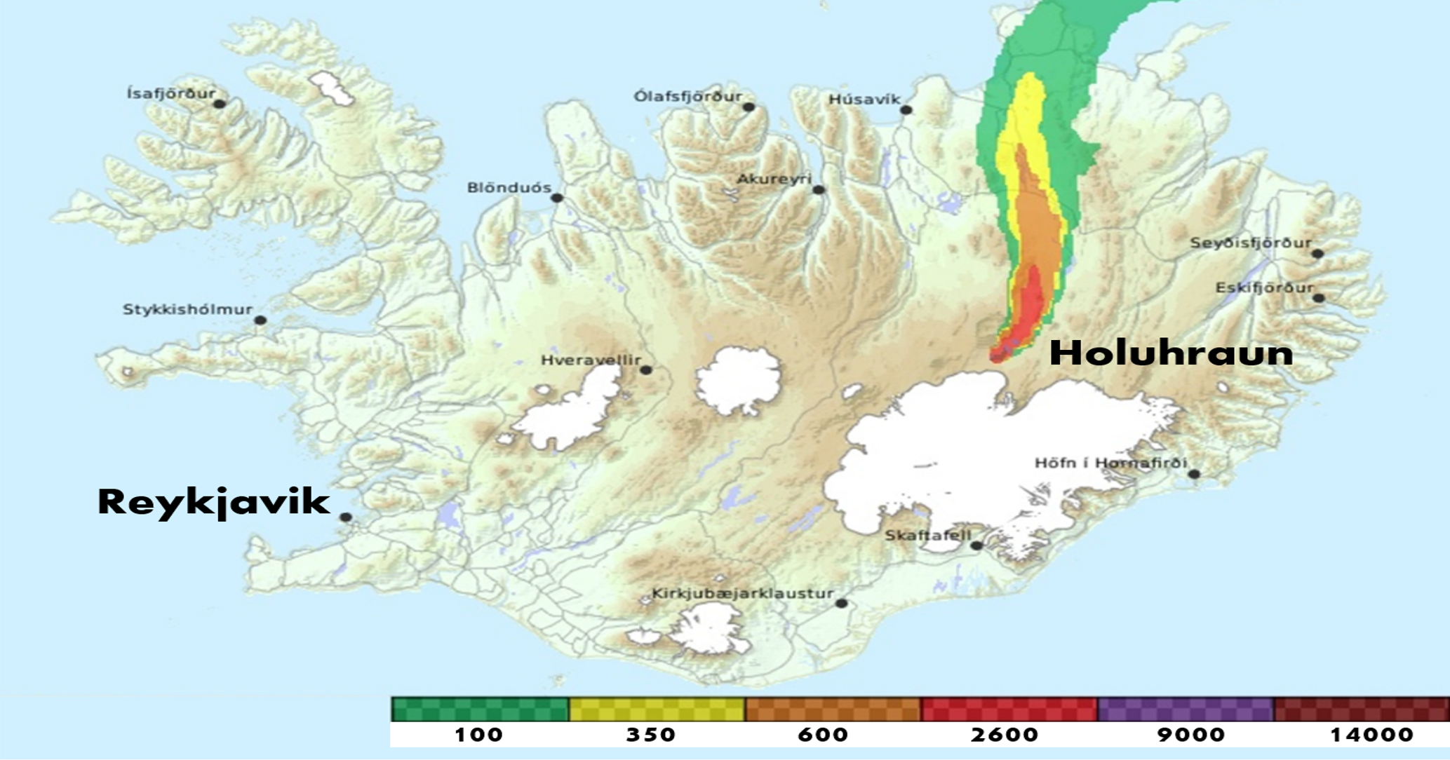
Figure A1. Forecast from the Iceland Meteorological Office (CALPUFF model) showing the direction of the plume dispersion and the concentration of SO₂ in µg.m⁻³ at 22UTC on January 22nd, within 30 minutes of the balloon launch. This forecast calculated by the model CALPUFF was used in the field to select the balloon launch location.
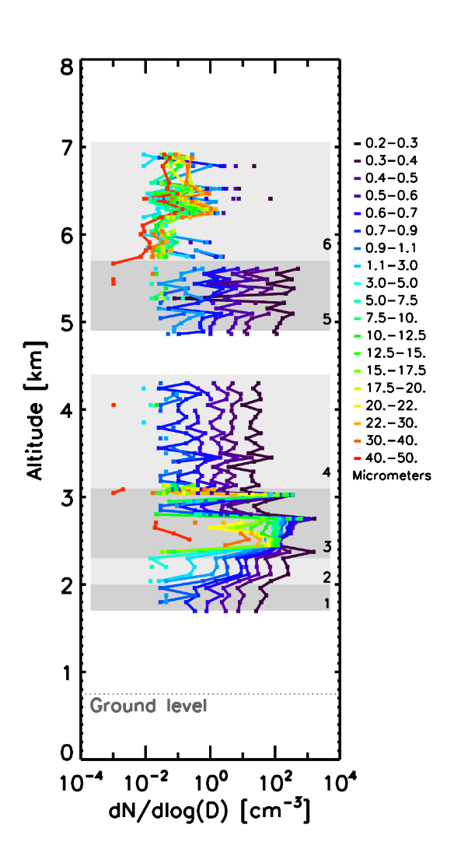
Appendix 2: Aerosol size distribution as a function of altitude
Figure A2. Normalized concentration of aerosols as a function of altitude in dn/dLog(d) where n is the number concentration and d the mean diameter of the class size. Each color is relative to a size class expressed in diameter in micrometer, the key is on the right.

Appendix 3: Size distribution in number and volume for each Zone and shape parameters for volume log normal fits.

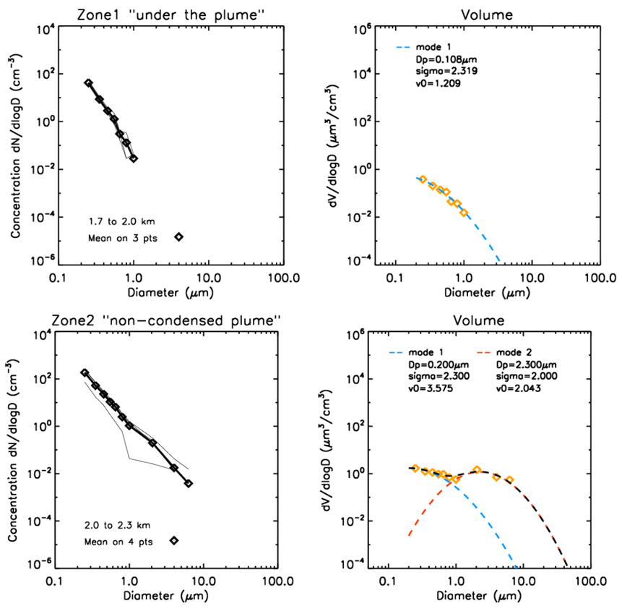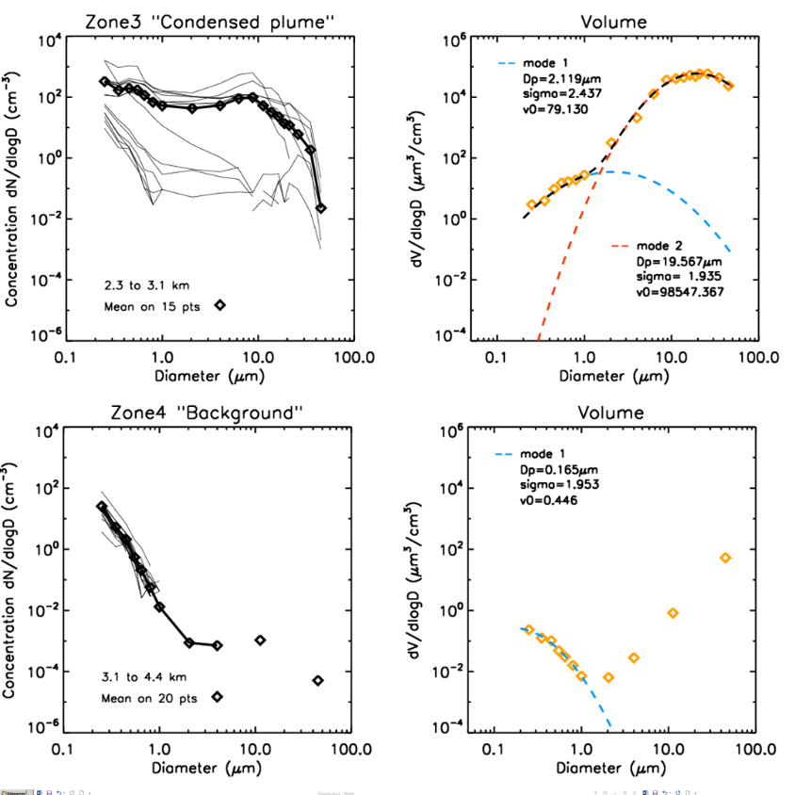

Figure A3. Size-distribution in particle number concentration (left) and by particle volume concentration (right) with lognormal fit for Zones 1 to 4. Left panel: the particle number distribution (dn/dLog(d)), measured in 19 size bins from 0.2 µm to 100 µm, the thick black line with diamond represents mean distribution over measurements represented in thin grey lines. Right panel: volume distribution calculated for each average size distribution. We assume spherical particles with diameter centered on the mean diameter of each size class.

Appendix 4: Column SO₂ density measured by DOAS scanning spectrometer at Holuhraun

Figure A4. Time series collected on January 22nd 2015 of SO₂ column density as measured by NOVAC scanning DOAS positioned 10 km from the eruption site. The average SO₂ column density is 200 DU and the emission rate is 400 kg/s.

