A Luta Continua: Contending high and low carbon energy transitions in Mozambique

Joshua Kirshner

Introduction
With the discovery of significant coal and gas resources in the past decade, Mozambique has gained attention as an important energy frontier globally. The coal and gas bonanza, however, presents complex political and planning challenges for the country. Just over two decades ago a protracted civil war ended, and today Mozambique is widely viewed as an African post-conflict success story (Vines, 2013). Its economy grew at an average rate of 7.5% annually for much of the past two decades, joining South Africa and Nigeria as one of the top three recipients of foreign direct investment in sub-Saharan Africa in 2013 (Castel-Branco, 2015). Yet the growth has been highly unequal, with limited reduction in relative or absolute levels of poverty, and the country is still very poor by nearly any standard.
Recent offshore gas discoveries in the Rovuma Basin, on the northern border with Tanzania, could make Mozambique one of the world’s largest exporters of liquefied natural gas. In parallel, landlocked Tete province has become Africa’s second most important coal-producing region (IEA, 2014). The coal and gas rush is expected to spur export growth but also investments in domestic power generation, potentially reworking the country’s energy system in the coming years.
Alongside the interest in Mozambique’s hydrocarbons resources, there are mounting concerns over climate change. With one of Africa’s longest coastlines, Mozambique is vulnerable to climate risks, including flooding, cyclones, sea level rise and rapid urban migration (Castán Broto et al, 2015). These pressures have raised the profile of renewable energy technologies (RETs) with the government seeking donors and investors in this area (Cuamba et al, 2013). Yet as in other African countries, the state’s interest in RETs is tempered by the push to reduce energy poverty more broadly. Mozambique has among sub-Saharan Africa’s lowest electrification rates, with 21% of its population of 23 million estimated to have regular access to on-grid electricity by 2011 (EdM, 2011). A further 11% is believed to have access through off-grid sources (FUNAE, 2012) while 80% rely on biomass as their sole source of energy (Cuvilas et al., 2010).
Frelimo (Frente de Libertação de Moçambique), the party of government since Mozambique gained independence in 1975, aims to balance maximizing the benefits of resource extraction for export-led growth with reducing domestic energy poverty. Frelimo claims it seeks to keep energy affordable for ordinary citizens and energy-intensive users alike. The latter consists of several megaprojects concentrated near the capital, Maputo, and in emerging extractive zones in the north. The state’s focus is on grid-based electrification, but increasingly it sees potential for distributed and small-scale renewables, particularly for dispersed rural populations.
Among alternative energies, solar PV is the most important and is playing a growing role in the country’s electrification. Between 2000 and 2011, the Energy Fund (FUNAE), a state agency, with the support of European and Asian donor organizations, installed over 1.2 MW of solar PV capacity. FUNAE calculates that some 1.5 million residents benefited from the systems by 2012, representing about 0.8 Wp per person (FUNAE, 2012). While the quantity in wattage is small, its ability to improve rural health and education is deemed significant (Cuamba et al, 2013). Solar PV installations have focused on these rural services, with former Energy Minister Salvador Namburete claiming that in 2014 micro-scale solar PV projects were used to electrify 700 schools, 600 health centres and 800 other public buildings in rural areas, at a total cost of US$51 million (MacauHub, 2014). Additionally, FUNAE has estimated over 60 potential micro-hydropower projects with up to 1000 MW capacity. Despite growing interest, only a handful of micro-hydro systems were implemented in recent years (Mika, 2014).
This chapter offers a sketch of Mozambique’s contending pathways to expanding energy access. It addresses the following question: in the context of significant fossil fuel resources discoveries, what is the role of RETs and why are they being promoted? The chapter begins by reviewing the concept of energy transitions and outlining some of the recent high-carbon developments in the country. It then examines changes in Mozambique’s energy provision system and identifies the actors engaged in efforts to reach the energy poor. This sets a context for an empirical exploration of four small-scale renewable energy projects, representing a range of technologies and sources of finance, in the third section. A final section presents a discussion of these projects and reflects on Mozambique’s incomplete energy transition.
Methodologically, the chapter draws on a series of interviews with government officials, policymakers, representatives of utilities, donors, businesses and NGOs conducted in Maputo and Beira in 2013-2014, along with site visits to energy service projects, part of a larger study funded by the UK’s ESRC. The analysis builds on insights developed in studies of energy access in low-income countries that suggest energy transitions cannot be achieved in isolation from other aspects of socio-economic development (Ulsrud et al, 2015; Tawney et al, 2015; Murphy, 2001). It also engages with research that argues historical shifts, or transitions, in energy systems can be understood in spatial and place-specific terms as well as temporal ones (Bridge et al, 2013; Hansen and Coenen, 2014). This chapter argues that energy interventions from the state and donors in Mozambique—including on-grid and off-grid initiatives—are largely led by technology. As such, they do not adequately consider the social, cultural and economic conditions of energy users, especially in rural areas. With some exceptions, these interventions have adopted a centralised management approach focused on connecting institutions rather than providing direct access for people.

Is there a high carbon transition in Mozambique?
Energy transition is often defined within policy circles as moving towards a low carbon economy, for instance the UK government’s aim to reduce carbon emissions by 80% by 2050. Within energy studies more broadly, the notion of transition is used analytically to address major historical shifts in energy systems at national and global scales (Smil, 2005). This work shows that historical energy transitions have been associated with broad social change, such as industrialisation and urbanisation (Geels, 2002; Bridge et al, 2013).
Yet in many parts of the global south, energy transition implies a significant increase in the availability and affordability of modern energy services. In some contexts, this may entail an increase in carbon intensity, such as through the switch from household fuelwood to grid electricity (Bridge et al, 2013). As elsewhere in sub-Saharan Africa, historically limited energy provision has meant fossil fuels are not embedded in the social and economic landscape of Mozambique to the same extent as wealthier countries (Bridge et al, 2013). Many of the built environments and accoutrements of fossil fuel capitalism, however, such as gas pipelines and thermal power plants, are gaining a foothold in Mozambique amid the extractive resources boom.
The pathway to development the Mozambican state has pursued since the early 1990s is centred on energy and mineral extractive megaprojects, which have prioritized the needs of heavy industrial users and exports to regional energy markets, particularly South Africa’s. This has proceeded alongside the large-scale privatization of state assets, as more than one thousand state-owned enterprises and state shares in many companies were sold off to private investors in the early 1990s (Castel-Branco, 2015).
Unlike neighbouring South Africa and Zambia, Mozambique is not a historically important minerals producer, existing below the radar for global mining companies. This changed in 2008, when visiting geologists in Tete province confirmed the coal seam beneath Moatize basin forms part of the world’s largest untapped coal deposit, with over 23 billion metric tonnes of coal, or enough to fire all the coal plants in the USA for 25 years (Besharati, 2012). The deposits are rich in coking coal, used for steel production, and thermal coal, which lacks export value but can be used for power generation (see Figure 1). Benefitting from buoyant world market conditions in the 2000s, Tete attracted a surge of investment with coal becoming Mozambique’s second largest export earner by 2012 (Besharati, 2012).
But the coal operations have faced ongoing logistical and infrastructural gaps and declining global coal prices since 2013. The two largest investors, Brazil’s Vale and UK-based Rio Tinto, sold all or part of their concessions in 2014 (Castel-Branco, 2015). The coal complex in Moatize risks becoming an extractive resource-based enclave with weak linkages to local enterprises, foreign ownership of capital, and export of goods with limited or no value added (Bloch and Owusu, 2012; Magrin and Perrier-Bruslé, 2011). These factors combine to create a downward cycle for local development, raising costs of living and creating few jobs, despite high levels of capital investment and elevated local expectations, or imaginaries, of a resources boom (Arias et al, 2014; Büscher, 2014; Kirshner and Power, 2015).
Nevertheless, several investors plan to build coal-fired power plants at mining sites, an effort supported by the state-owned electricity utility Electricidade de Moçambique (EdM). These energy generation projects underpin growing trade and investment ties, particularly with the emerging powers, such as China, Brazil and India (Dadwal, 2011). According to EdM, these thermal power plants will fill a supply gap until new hydropower and gas facilities become available in the 2020s, enabling electrification in underserved regions without raising energy prices. Mozambique’s electricity pricing is currently among the highest in the SADC region, despite being the second largest energy producer in SADC (Nhamire and Mosca, 2014).
The proposed coal-fired power stations, if completed, would commit Mozambique to a high-carbon development pathway that may be difficult to reverse. Arguing for the pragmatic necessity of coal to stabilize the supply of energy in Mozambique, a Vale official explained:
“Coal will allow Mozambique to have competitive power. You have to respect international standards for environmental emissions. But coal is a good in-between. You can build the power plant and then generate gas and hydro facilities. There is a big gap. Only coal can fill it. The gas and new hydro will only come on-stream in 2018 or 2020, and meanwhile Mozambique is growing a lot. So coal is unavoidable” (Lamarie, 2013).
In this view, the persistence of coal in Mozambique’s political economy of energy does not preclude the development of cleaner alternatives. The boom in the country’s extractives sector could potentially reshape state budgets and spending priorities, in turn supporting alternative energy technologies. Using hydrocarbon revenue windfalls to fund RETs could increase energy access rates in rural areas, adding employment and reversing jobless development. Thus far however the state’s campaign to reduce energy poverty has focused on grid extension, with small-scale RETs pursued in remote locales with low levels of consumption and where the grid is unexpected to reach. Significant socio-economic and regional inequalities are thus reflected in access to the grid.

Mozambique’s changing energy landscape
Following a history of Portuguese colonial rule, anti-colonial struggle and civil war, Mozambique’s energy sector remains underdeveloped. Yet it has expanded in recent years amid rapid—albeit unequal—economic growth. Set up by the state in 1977, EdM is responsible for transmission, distribution and some generation. Before independence in 1975, thermal power plants were the major source of electricity, with some input from hydropower supplying localised grids (Cuamba et al., 2013).
This changed with the opening of Cahora Bassa dam in 1974, completed in the last year of Portuguese rule, which reduced thermal in favour of hydropower. Cahora Bassa is located on the Zambezi River in Tete province, until then viewed by colonial planners as a remote outpost (Newitt, 1995). One of the last major infrastructure projects built in Africa during the turbulent period of decolonization, Cahora Bassa remains the largest hydroelectric scheme in southern Africa with 2075 MW capacity (Cuamba et al, 2013). The independent power producer Hidroeléctrica de Cahora Bassa (HCB) began operations in 1977, supplying power to the South African and Zimbabwean grids while producing some 90% of the electricity consumed in Mozambique. In 2007—over 30 years after independence—HCB passed from Portuguese to majority (85%) Mozambican ownership, when Portugal (needing funds to reduce its budget deficit to meet EU regulations) agreed to sell most of its equity.
Mozambique produces a huge surplus of hydroelectricity at Cahora Bassa, but it must observe pre-independence agreements between Portugal and South Africa that committed over 85% of the dam’s output to supply South Africa’s Eskom as a means to finance the project (Isaacman and Isaacman, 2013). Some 65% of HCB’s production, or 1500 MW of electricity, is currently exported to South Africa via Apollo substation in Mpumalanga, with a portion re-imported into southern Mozambique on lines owned by Eskom (KPMG, 2013). What resources there are for domestic consumption are highly unevenly distributed, with the BHP Billiton Mozal aluminium smelter, near the South African border, consuming fully two-thirds of all electricity generated in Mozambique. Moreover the existing system for electricity transmission and distribution is obsolete, after decades of limited financial investment (see Figure 2).
The government has responded to these constraints by promoting the construction of several large hydropower facilities. The largest is Mphanda Nkuwa, sited 60 km downstream from Cahora Bassa on the Zambezi River, at an estimated cost of US$2.2 billion (KPMG, 2013). The project has World Bank support and a mix of South African, Brazilian and Chinese investors. The state-owned China State Grid Corporation gained a majority stake in late 2013 through a process that lacked competitive bidding (Ribeiro, 2015), while the dam’s construction depends on Eskom’s commitment to buy most of its electricity. The project is expected to displace 1,400 households and indirectly affect 200,000 Mozambicans’ livelihoods once completed (Morissey, 2013; Isaacman and Sneddon, 2003).
Facing a growing supply shortfall, EdM has begun purchasing more expensive power from Gigawatt Mozambique, a private firm that is 40% owned by the South African firm Gigajoule. Gigawatt invested $320 million in a 110 MW gas-fired power plant in Ressano Garcia, on the South African border (KPMG, 2013; Nhamire and Mosca, 2014). A further 300 MW of gas-fired plants are planned for the southern region, reflecting Mozambique’s newfound gas wealth and the state’s aim to increase domestic use (Gqada, 2013). In parallel, EdM has invested in comprehensive grid extension since 2009, with Swedish and Norwegian technical support, aiming to reach all district capitals (Cipriano et al., 2015). Along with upgrading Maputo’s electricity infrastructure, the grid connected to 125 of 128 district capitals by 2014 (Ouchim, 2013).
Despite this expansion of the centralised network, Mozambique’s electrification has been geographically uneven, with grid extension focused on urban spaces and exports to regional markets. Access to grid electricity in Mozambique thus reflects the colonial-era development of natural resources, regional transport corridors, ports and urban centres. Given the large, scattered rural population and high unit costs of grid extension, low electrification rates prevail. The prioritisation of some places and forms of electricity deemed worthy of supply also shapes what constitutes ‘off grid’ (cf. Ferguson, 2005).
Increasingly, the Mozambican government supports decentralised energy for off-grid spaces, such as solar PV mini-grids, which can reach further into rural areas and create new possibilities for sustainable energy access. But as in other low-income countries, the resources and attention dedicated to improving rural household energy use seem incommensurate with the problem’s magnitude (Sagar, 2005). Further, as noted elsewhere in this book, evidence that small-scale renewables can actually facilitate energy access remains patchy and limited.

Mobilizing renewable energies
At the heart of how RETs have been mobilized in Mozambique is the state agency responsible for expanding energy access for rural people, Fundo de Energia (National Energy Fund, FUNAE). FUNAE was established in 1997 with Danish assistance. It initially supplied diesel generators and kerosene as a means of addressing energy poverty in rural communities, but its focus has shifted to promoting, supplying and financing renewable sources of energy. While FUNAE has developed some micro-hydro and pilot wind projects, its main focus is on solar PV systems. The agency is funded through the state budget, with revenues from taxes and levies from petroleum and electricity concessions, along with donor support. By agreement with EdM, FUNAE works in areas projected to be >10 km from the grid within five years (Ouchim, 2013). Inter-agency planning, coordination and capacity building, however, have been minimal.
Acting independently of FUNAE, Deutsche Gesellschaft für Internationale Zusammenarbeit (German International Cooperation, GIZ) is also supporting RETs in Mozambique under the Energising Development (EnDev) programme. EnDev is a partnership between the Netherlands, Germany, Norway, Australia, UK and Switzerland that cooperates in several African, Latin American and Asian countries. GIZ serves as lead agency in implementing EnDev. In Mozambique, EnDev is called Programa de Acesso ao Serviço de Energia Moderna em Moçambique (Access to Modern Energy Services – Mozambique, AMES-M). It focuses on rehabilitating colonial-era micro hydro mills, improving their capacity and efficiency. GIZ’s work with RETs in Mozambique began in the early 1990s (Mika, 2014).
Since the 2000s, FUNAE has worked with a number of donors and development agencies in deploying RETs in projects for supplying electricity for social uses in off-grid environments, including school lighting, water pumps and vaccine refrigeration. These projects use localised mini-grids or stand-alone systems, usually supplied by solar PV, which provide electricity to schools, clinics, administrative posts and other rural institutions. FUNAE has also supplied micro-hydro systems for decentralised generation, but only in upland Manica and Zambézia provinces (Mika, 2014). FUNAE has replicated its model for solar PV across the country, extending its geographic reach but also limiting local involvement in project design. Scholars have cautioned against uncritically accepting local participation as a universal good (e.g. Mohan and Stokke, 2000). Yet evidence suggests devolution and local input in energy projects offers consumers a stake in deciding how electricity can be used and made relevant to their lives (Ulsrud et al., 2015).
The growing public use of solar PV (and to a lesser extent micro-hydro) has become a testing ground for its further development as a means to provide domestic energy services. Since 2010, FUNAE has initiated projects focused on households, small businesses and villages, which include mini-grids and stand-alone solar home systems (SHS) in homes and businesses. Here, FUNAE is actively involved in the production of solar PV within the rural economy, procuring systems of less than 100w that can be bought by households and commercial enterprises through long-term loans, which are underwritten by FUNAE. Beneficiaries view solar energy as appropriate for lighting, phone charging and refrigeration. Solar electricity has not replaced the need for biomass energy, however, as capacity is normally insufficient for an electric cooker coil’s current (cf. Mavhunga, 2013). Given difficulties in maintenance and repair, many of FUNAE’s systems have been abandoned. Theft of solar panels is a frequent problem, reflected in a second-hand trade in panels found in some municipal markets.
Until recently, Mozambique lacked capacity in the solar manufacturing, with systems and components all imported. This mostly consisted of Chinese equipment, often sourced from South Africa by cross-border traders and sold in urban market stalls or electronics shops. Chinese components are cheapest on the market but widely viewed as unreliable. The need to import PV equipment has decreased with FUNAE’s development of Mozambique’s first solar module assembly plant, supported by a US$13 million concessional loan from India. The FUNAE plant, which opened in Beluluane, outside Maputo in late 2013, aims to produce 5MW of capacity annually, reducing imports and lowering costs in the solar PV systems, which are primarily intended for use by FUNAE in its projects (Namburete, 2014).
FUNAE has also sought to establish favourable contracts in order to diversify the range of solar PV available. In 2013, it awarded a contract to the German firm Fosera to install pico solar systems (5 volts max) in schools and homes in Manica province (Pedro, 2013). Fosera established a subsidiary in Maputo assembling pico-solar units from parts manufactured in Thailand, including solar lanterns and solar phone chargers (Cuamba, 2014). More recently, FUNAE managed the development of PV mini-grids in northern Niassa province, a project financed by the South Korean government. As solar PV has increased in both scope and visibility, it has come to be regarded as a status symbol in many rural settings, such that there is a growing market demand for installation extending beyond FUNAE’s programmes.
The following section explores the deployment and uses of RETs in Mozambique through a focus on four small-scale energy projects in the central provinces of Manica and Zambézia (see Figure 1). Four key points emerge from the discussion. First, the emphasis in these projects, especially those supported by FUNAE, has been on connecting rural institutions rather than households. Second, despite technical challenges with solar energy, solar panels are taking on new uses in many rural communities. Third, many of the projects are centrally managed, with limited local input in design and operations. The projects are thus led by technology rather than by the people they aim to serve. This has especially been the case with FUNAE while GIZ has taken a more bottom-up approach, albeit on a smaller scale. Fourth, solar energy has not replaced ‘non-modern’ fuels such as charcoal for cooking and heating. Micro hydro systems fulfil a range of basic energy needs, given their higher capacities, but are limited to sites with feasible terrain. Overall, these RET projects are reshaping Mozambique’s energy landscape, proceeding alongside but also constrained by conventional grid expansion.

Observing four off-grid energy projects
Chinhambuzi, Manica province
In March 2013, FUNAE inaugurated a solar PV mini-grid, with financial support from Belgium, in Chinhambuzi, Manica province. Belgian Technical Cooperation (BTC), having cooperated with FUNAE for several years, installed the mini-grid system. The solar mini-grid supplies power to a primary school, clinic, police station, several teachers’ houses, the local authority’s residence, and 10 bancas fixas. But ordinary residents in the administrative post (Chinhambuzi sede) and several nearby villages remain unconnected.
Many residents wish to be connected but capacity constraints have prevented it. The system has 3.6kWp of capacity, or up to five kW, which is insufficient for linking households to the three km network. The majority of residents use wood and charcoal for cooking and heating water. The teachers’ houses are furnished with lamps and a refrigerator, with electricity provided until 8:00 PM. The shopkeepers pay 70 MZN per month ($2.50) for electricity, a tariff used to support a security guard. The tariff appears unrelated to operations costs while payments go to the village chief who chairs an oversight committee. The teachers and local authority’s staff do not pay any tariff for their electricity, while the shopkeepers’ usage is unmetered. Given their lack of access, some residents have considered connecting spontaneously, although this might stress the system and cause outages for shopkeepers, who use high current-drawing freezers. The load will likely increase, as shopkeepers acquire TVs, electric fans and other small appliances. The system is managed from the provincial capital Chimoio, without means to locally monitor capacity or demand.
Even if they could connect, most PV mini-grids and household PV systems produce low-power direct current (DC) electricity. As noted above, these systems work for lighting and some small appliances but not electric cookers. The demand for solar electricity in Chinhambuzi has outpaced the system’s capacity and the mini-grid scarcely accommodates future growth. It will be important to consider the system’s configuration and pricing so that energy services can provide useful outcomes to a wider group of consumers.

Mavonde, Manica province
Mavonde village is a 1.5 hour drive along an ungraded road from the district capital of Manica, near the Zimbabwean border. Many residents cross the border daily and have kinship and business ties on both sides. The area is affected by gold panning, involving domestic and Chinese operations, and according to residents we consulted, harming river ecosystems and causing soil erosion.
FUNAE manages a solar project in Mavonde, financed by the World Bank’s Energy Reform and Access Programme (ERAP). Starting in 2009, FUNAE installed solar stand-alone systems at the primary school, clinic and administrative post headquarters, and in eight shops and households in Mavonde sede and Nhandiro, a smaller village six km up the road. During our visit, however, most of the systems were not working. The beneficiaries had agreed to repay their loans to FUNAE, but many of the systems were down for over a year, and users had stopped payment. FUNAE prepared contracts for the SHS users, but eight months later the contracts were not being honoured by both parties.
FUNAE provides SHS to households in Mavonde through soft loans that it underwrites. If the equipment fails there is some measure of security, as users can request repairs or delay payments. Most residents trust the technology, but many are frustrated by FUNAE’s lagging maintenance. Only two of 10 solar-powered street lights were working, both situated near the local authority’s residence. Repairs often face lengthy delays, given insufficient staffing in FUNAE’s provincial office. We saw public notices for residents interested in SHS to register at the administrative headquarters. The local authority told us they received 65 such requests in one week. A female shopkeeper said she prefers a loan from FUNAE rather than buying panels in Manica, where she must pay cash up-front. At first she was sceptical of solar energy but now recognises its multiple benefits, especially for freezing fish and meat, which otherwise must be dried for storage.
The shopkeepers in Mavonde tend to be more affluent than other villagers, and many have worked seasonally in Chimoio, Beira and as far away as Johannesburg. FUNAE’s systems have has the perhaps unintended effect of raising shopkeepers’ profits, increasing inequalities. The majority of local residents are dispersed in smaller settlements, preferring to live near their farm plots (machambas), which are difficult for FUNAE to reach.
Along with FUNAE’s installations, in Nhandiro one sees solar panels purchased independently by residents, suggesting increasing demand for solar electricity. During our visit, a group of men sat around a table drinking beer beside a banca fixa, enjoying the shopkeeper’s hi-fi system powered by a DIY solar panel. The local chief seemed proud of FUNAE’s solar systems, even if the majority of them did not work.

Chua, Manica province
Chua is located in Maridza administrative post, in Manica district. The village has experience with micro hydro power for decades, with several hydraulic grinding wheels dating from the early 1960s. GIZ’s AMES-M programme, in collaboration with its local partner organisation Kwaedza Simukai Manica (KSM), aims to rehabilitate eight micro-hydro-powered maize mills in Chua and nearby villages, improving milling and generating electricity to support local development. Following a consultative survey, the project began in 2008 with a €64,000 budget (Zana, 2007).
One of the more successful schemes is in Chua, owned and operated by a middle aged man, Mr. Lino Ndacada. The system has 22 kW of capacity and connects to a mill and a mini-grid that extends for three km. By day it powers the mill and by night it supplies electricity. The mini-grid connects to 25 houses, with a further 50 houses benefitting from battery charging, thus affecting some 450 people. It also connects to a village business hub with several bancas fixas. Households pay a fixed 200-250 MZN per month ($7.00-8.50) and shops pay 300 MZN ($10) for electricity consumption. Many systems use locally-made turbines, while the generators are imported from Germany. GIZ aims to improve the reliability of local turbines. Many of the water canals and tanks, however, are not lined with concrete, with some water lost or silted (Mika, 2014).
GIZ’s experience in training local people to develop and operate micro-hydro systems contrasts with FUNAE’s more top-down form of management. There were reported productivity gains in milling, along with capacity-building in operations, repairs and management for systems owners and operators (Zana, 2007). The micro-hydro schemes are owned individually, while the mini-grid networks are owned by communities. GIZ and KSM facilitated a hybrid financing scheme with soft loans for hardware such as turbines and grants to support mini-grid installation.
In Chua, the micro-hydro scheme runs through the initiative of local people of very limited resources, with GIZ providing support. Consumers pay for electricity that is managed as a local enterprise. Ndacada has repaid his five-year loan and wants to build an additional system. He has identified a site on the Chua River and wants to employ local residents to develop it. He told us he bought a motorcycle and paid his seven children’s school fees with earnings from the micro-hydro system. Overall, the project builds on existing knowledge, uses locally-suited technology and is based on proven demand for electricity. According to several villagers, the system’s configuration and prices reflect consumers’ needs and expectations.

Majaua-Maia, Zambézia province
In Majaua-Maia, a village in Zambezia province, FUNAE has set up a project to rehabilitate a defunct mini-hydro system. Inaugurated in 2013, the EU provided financing of €2.5 million. The Portuguese engineering firm Canas installed the system.
The project aims to rejuvenate a mini-hydro plant that powered a fazenda (plantation) owned by Mr. Maia, a Portuguese landowner, since the 1960s (the nearby village is partly named for him). Mr. Maia allegedly abandoned the fazenda in 1980 during the height of Mozambique’s civil war. The main house, a blue-tiled country villa, fell into decline, and the hydro system was neglected. FUNAE’s project aims to benefit 20,000 residents (5,000 households) in Majaua-Maia and six surrounding villages, three primary schools, a clinic and six grinding mills.
Majaua-Maia is a three-hour drive from the district capital, Milange, on a dirt track that skirts the Malawian border. The facility has 767 kW of capacity and is situated on the Ruo River, a tributary of the Shire. Canas installed a German Ossberger cross-flow turbine while the generator is made by Efacec of Portugal. The turbine sat in a customs terminal in the Beira port for over a year before Canas gained permission to bring it into the country (Canas, 2013). The project’s initial phase involved installing a four km high-voltage network, to be extended 40 km in a second phase, generating 3,500 MWh/year. All homes, schools, a clinic and shops along the existing line are connected. Each household has one light bulb and a power point. During our visit, however, households and shopkeepers were not paying a tariff for electricity, as the project was in test phase (Quelhas, 2014).
Canas sourced most of the system’s construction inputs from Portugal. It features state-of-the-art equipment while the powerhouse is an imposing, brightly-painted concrete edifice. Apart from supplying energy access as a technical ‘fix’, however, a community needs assessment and locally-suited energy services appeared lacking. Notably, the local grinding mills were not connected to the mini-grid during our visit. Powering these mills is a key priority for residents, particularly women; ground cornmeal (xima) is a staple food in the region. Women must wade across the Ruo to use a diesel-generator-powered mill across the border in Malawi, often with children in tow. FUNAE intends to connect the local mills, but had not yet done so.
The project’s fiscal (supervisor), Mr. Sala, is from the city of Beira, and his two young assistants are from Nampula and Quelimane, provincial centres. This seems a missed opportunity to train local youth for such positions. Operators will likely be recruited from Maputo, Beira or Quelimane, and it might prove difficult to attract skilled personnel to this isolated community with poor roads, or retain them for long. Regarding uses of electricity, we observed three video clubs showing movies, mainly Jackie Chan films dubbed in the local language, chiChewa. School-age children frequented these clubs, with no admission charged. We heard sound systems competing from a cluster of bancas fixas. Only one had a refrigerator powered by the mini-grid, along with a desktop computer to burn music CDs and videos.
Limited capacity building has occurred around uses of electricity thus far, despite potential economic opportunities requiring relatively little capital investment, such as milling, welding or food processing. One household was distilling liquor from corn and sugarcane, but without electricity. Our interviews suggest most households cook with charcoal and wood, and some struggle to afford charcoal. This raises questions as to what kind of changes to local energy systems are most important to rural people and how energy access ranks in comparison with other improvements, such as in agriculture, health care or education (cf. Murphy, 2001).
Electricity consumption in Majaua-Maia is unmetered, with residents benefiting from free electricity, at least in the short term. Introducing a tariff may prove difficult, given the possible costs. FUNAE had not tested a payment system or undertaken consultative research; it was unclear if non-payers will eventually be disconnected. When fully operational, Majaua-Maia’s network will be one of the largest mini-grids in southern Africa (Quelhas, 2014). The project is ambitious, but gaps in local engagement and capacity building around the technology remain. Greater involvement in early design stages might better inform energy planners about local priorities, constraints and expectations.

Conclusion
The Mozambican government aims to expand access to affordable, reliable and sustainable energy services for the population while also increasing the use of renewables, two goals that can be in tension with one another. Led by FUNAE, RETs have emerged in relation to the changing landscape of the electricity grid, on the one hand, and demands for multiple forms of energy service, on the other.
While solar PV as a decentralized system can seemingly be installed in any rural area sufficiently distant from the existing grid, in practice this process of installation has been highly uneven. The goals of claiming access to electricity in different administrative districts may obscure the uneven way it is installed. Such projects, for example, are rarely sited in the most remote areas of the district, serving to make rural electrification appear socially and spatially more inclusive than it actually is in practice. This dynamic is found in the case studies of Chinhambuzi and Mavonde. The use of micro hydro, in contrast, is limited to places with suitable terrain. Yet it can achieve higher capacities to support a range of energy needs.
Despite its emphasis on connecting rural institutions, FUNAE has begun to include household energy in its projects through mini-grids and SHS. The approach is broadly pro-poor, with price supports and soft loans for end-users, but relies on state procurement and donor financing. FUNAE’s operations are coordinated within a single body, suggesting a centralised form of management for delivering decentralised energy services, with resulting gaps in local participation in project design and implementation. In Majaua-Maia, for example, women’s priorities were side-lined while free electricity provision may create unrealistic expectations, as witnessed in the three video clubs operating simultaneously. Training of local youth in the project’s development in Majaua-Maia was minimal while economic opportunities created by the new technology were largely overlooked, giving the project an ‘enclave’ quality, with little connection to the surrounding economy and everyday practices (c.f. Ferguson, 2005). A similar pattern can be observed with solar PV in Chinhambuzi and Mavonde, which has mostly benefitted government workers and shopkeepers rather than ordinary residents.
GIZ has taken a different approach that is designed to scale-up based on local demand. While also reliant on donor financing and technical expertise, it emphasises local entrepreneurship, training and stakeholder engagement around micro hydro generation, as seen in Chua. GIZ has an innovative business model, underscoring the value of local engagement through demand-based energy planning. Overall, fostering locally-suited technologies and business models is an ongoing challenge.
In tandem, expansion of the national grid is further shaping the available space for off-grid renewables. Extending the grid remains an important aspect of state-led modernization efforts, particularly following newly exploited coal and gas resources in the past decade. Rapid grid extension could disrupt the scaling up of distributed energy as more localities are connected, slowing the transition to renewables.
Despite these challenges, solar PV and micro hydro are increasingly viewed as sources of power that can deliver basic needs, from lighting for education to refrigeration for vaccines, the operations of rural government offices and increasingly the mobile phone economy. Yet such forms of energy services leave much of what constitutes energy demand in Mozambique unchanged. In the case of solar PV, currently the primary source of alternative energy, the systems are ill-equipped to power electric cooking, appliances of various kinds or even significant levels of computing or entertainment technologies. Often developed as one-off installations, recurring problems with maintenance, operating costs and theft further limit the ways these technologies are embedded in the rural economy. RETs may still be far from dislodging fossil fuels in Mozambique, yet they have clearly joined growing public debates about the country’s energy future.
This chapter has presented a key challenge for researchers of energy transitions: what is the relationship between high and low carbon energy development in a context of limited energy access? More contextually-sensitive and comparative research in rural and urban settings is needed on mobilizing renewables as development technologies in order to address this question. This might include examining supply chains, increasing local content provision, and efforts to reduce costs and increase the security of supply for RETs. Further research should also engage with the uses of renewables in Mozambique’s expanding peri-urban areas, thus far overlooked by state- and donor-supported energy service projects, and examine what energy transitions look like in these emerging sites. Finally, following Huber (2015), there is a need to scale up the analysis to consider the ways that uneven energy access reflects and intersects with larger patterns of social inequality.

References
Arias, Martín; Atienza, Miguel; and Cademartori, Jan. ‘Large mining enterprises and regional development in Chile: between the enclave and the cluster.’ Journal of Economic Geography 14 (2014): 73-95.

Besharati, Neissan. Raising Mozambique: Development through coal. South African Institute for International Affairs, Governance of Africa’s Resources Programme, Policy Briefing No. 56, Johannesburg (2012).

Bloch, Robin and Owusu, George. ‘Linkages in Ghana’s gold mining industry: challenging the enclave thesis.’ Resources Policy 37 (2012): 434-442.

Bridge, Gavin; Bouzarovski, Stefan; Bradshaw, Michael; and Eyre, Nick. ‘Geographies of energy transition: space, place and the low-carbon economy.’ Energy Policy 53 (2013): 331-340.

Büscher, Bram. ‘Investing in irony? Development, improvement and dispossession in southern African coal spaces.’ European Journal of Development Research (2014): 1-18.

Canas, Victor. Canas, interview with author, 5 November, 2013.

Castán Broto, Vanesa; Ensor, Jonathan; Boyd, Emily; Allen, Charlotte. Participatory Planning for Climate Compatible Development in Maputo, Mozambique. London: UCL Press, 2015.
Castel-Branco, Carlos Nuno. ‘Growth, capital accumulation and economic porosity in Mozambique: social losses, private gains.’ Review of African Political Economy 41, no. 1 (2015): 26-48.
Cipriano, Amílcar; Waugh, Colin; and Matos, Mathikizana. The Electricity Sector in Mozambique: An Analysis of the Power Sector Crisis and its Impact on the Business Environment. Maputo, USAID Mozambique, 2015.

Cuamba, Boaventura. University of Eduardo Mondlane, interview with author, 3 September, 2014.

Cuamba, Boaventura; Cipriano, Amílcar; and Jaime Turatsinze, Ruth Henrique. Investment Incentives for Renewable Energy in Southern Africa: The Case of Mozambique. Winnipeg: International Institute for Sustainable Development, Trade Knowledge Network, 2013.

Cuvilas, Carlos Alberto; Jirjis, Raida; and Lucas, Carlos. ‘Energy situation in Mozambique: A review.’ Renewable and Sustainable Energy Reviews 14 (2010): 2139-2146.

Dadwal, Shebonti. India and Africa: Towards a Sustainable Energy Partnership. Johannesburg, South African Institute for International Affairs, Occasional Paper No. 75, 2011.

Electricidade de Moçambique (EdM). Relatório Anual de Estadística. Maputo: EdM, 2011.

Ferguson, James. ‘Seeing like an oil company: Space, security, and global capital in neoliberal Africa.’ American Anthropologist 107, no. 3 (2005): 377-382.

Fundo de Energia (FUNAE). Bodas de Cristal. Maputo: FUNAE, 2012.

Geels, Frank. ‘Technological transitions as evolutionary reconfiguration processes: A multi-level perspective and case study.’ Research Policy 31 (2002): 1257-1274.

Gqada, Ichumile. A boom for whom? Mozambique’s natural gas and the new development
opportunity. Johannesburg: South African Institute for International Affairs, Occasional Paper No. 151, 2013.

Hansen, Teis and Coenen, Lars. ‘The geography of sustainability transitions: review, synthesis and
reflections on an emerging research field.’ Environmental Innovation and Societal Transitions (2014): 1-18.

Huber, Matthew. ‘Theorising energy geographies.’ Geography Compass 9, no. 6 (2015): 327-338.
International Energy Agency (IEA). Africa Energy Outlook - A Focus on Energy Prospects in sub-Saharan Africa. Paris: IEA, 2014.

Isaacman, Allen and Isaacman, Barbara. Dams, Displacement and the Delusion of Development: Cahora Bassa and its legacies in Mozambique, 1967-2007. Athens: Ohio University Press, 2013.

Isaacman, Allen and Sneddon, Chris. ‘Portuguese colonial intervention, regional conflict and post-
colonial amnesia: Cahora Bassa dam, Mozambique 1965-2002.’ Portuguese Studies Review 11, no. 1 (2003): 207-236.

KPMG. Mozambique - Country Mining Guide. Cape Town: KPMG International, 2013.

Kirshner, Joshua and Power, Marcus. ‘Mining and extractive urbanism: postdevelopment in a Mozambican boomtown.’ Geoforum 61 (2015): 67-78.

Lamarie, Cedric. Vale Mozambique, interview with author, 6 October, 2013.

Lindell, Ilda. ‘The multiple sites of urban governance: insights from an African city.’ Urban Studies 45, no. 9 (2008): 1879-1901.

MacauHub (2014) Mozambique to spend US$530 in rural electrification over five years, http://www.macauhub.com.mo/en/2014/04/25/mozambique-to-spend-us530-million-in-rural-electrification-over-five-years/ (Accessed August 6th 2015).

Magrin, Géraud and Perrier-Bruslé, Laetitia. ‘New geographies of resource extraction.’ Echo Géo 17 (2011): 1-11.
Mavhunga, Clapperton Chakanetsa. ‘Cidades Esfumaçadas: Energy and the Rural-Urban Connection in Mozambique.’ Public Culture 25, no. 2 (2013): 261-271.

Menezes, Miquelina. Director, FUNAE, interview with author, 23 September, 2013.

Mika, Lasten. Practical Action, interview with author, 25 August, 2014.

Mohan, Giles and Stokke, Kristian. ‘Participatory development and empowerment: The dangers of localism.’ Third World Quarterly 21, no. 2 (2000): 247-268.

Morrissey, James. ‘Zuma, Guebuza ignore effect of new hydro dam on residents.’ Mail & Guardian,
November 22, 2013. At: http://mg.co.za/article/2013-11-22-00-zuma-guebuza-ignore-effect-of-new-hydro-dam-on-residents (Accessed June 11, 2014).

Murphy, James. ‘Making the energy transition in rural East Africa: is leapfrogging an alternative?’ Technological Forecasting & Social Change 68 (2001): 173-193.
Namburete, Fernando. FUNAE, interview with author, 7 August, 2014.

Newitt, Malyn. A History of Mozambique. Bloomington: University of Indiana Press, 1995.

Nhamire, Borges and Mosca, João. Electricidade de Moçambique: Mau Serviço, Não Transparente e Politizada. Maputo: Centro de Integridade Pública, 2014.

Ouchim, Joaquim. EdM, interview with author, 8 November, 2013.

Pedro, Valeriano. Fosera Southern Africa, interview with author, 7 November, 2013.

Quelhas, Jaime. FUNAE delegation in Manica, interview with author, 10 August, 2014.

Ribeiro, Daniel. ‘Mozambique: Energy for whom and for what?’ Presentation at Energy for Development in Mozambique, workshop hosted by Durham University and University of Eduardo Mondlane, Maputo, 17 March, 2015.

Sagar, Ambuj. ‘Alleviating energy poverty for the world’s poor.’ Energy Policy 33, no. 11 (2005): 1367-1372.

Smil, Vaclav. Energy at the Crossroads: Global Perspectives and Uncertainties. Cambridge: MIT Press, 2005.

Tawney, Letha; Miller, Mackay; and Bazilian, Morgan. ‘Innovation for sustainable energy from a pro-poor perspective.’ Climate Policy 15, no. 1 (2015): 146-162.

Ulsrud, Kirsten; Winther, Tanja; Palit, Debajit; and Rohracher, Harald. ‘Village-level solar power in Africa: Accelerating access to electricity services through a socio-technical design in Kenya.’ Energy Research and Social Science 5 (2015): 34-44.

Vines, Alex. Mozambique’s 20 Years of Peace at Risk? London: Chatham House, 11 April, 2013.

Zana, Crispen. Technical Appraisal for Micro Hydro Project Proposal in Chua Village, Manica District, Manica Province: a project between GTZ-AMES-M and Kwaedza Simukai Manica. Maputo: GTZ, 2007.

Zitamar News. ‘Shanghai Electric closing in on 300MW Tete power plant deal,’ December 11th, 2015, at: http://zitamar.com/shanghai-electric-closing-in-on-300mw-tete-power-plant-deal/ (Accessed December 16th 2015).

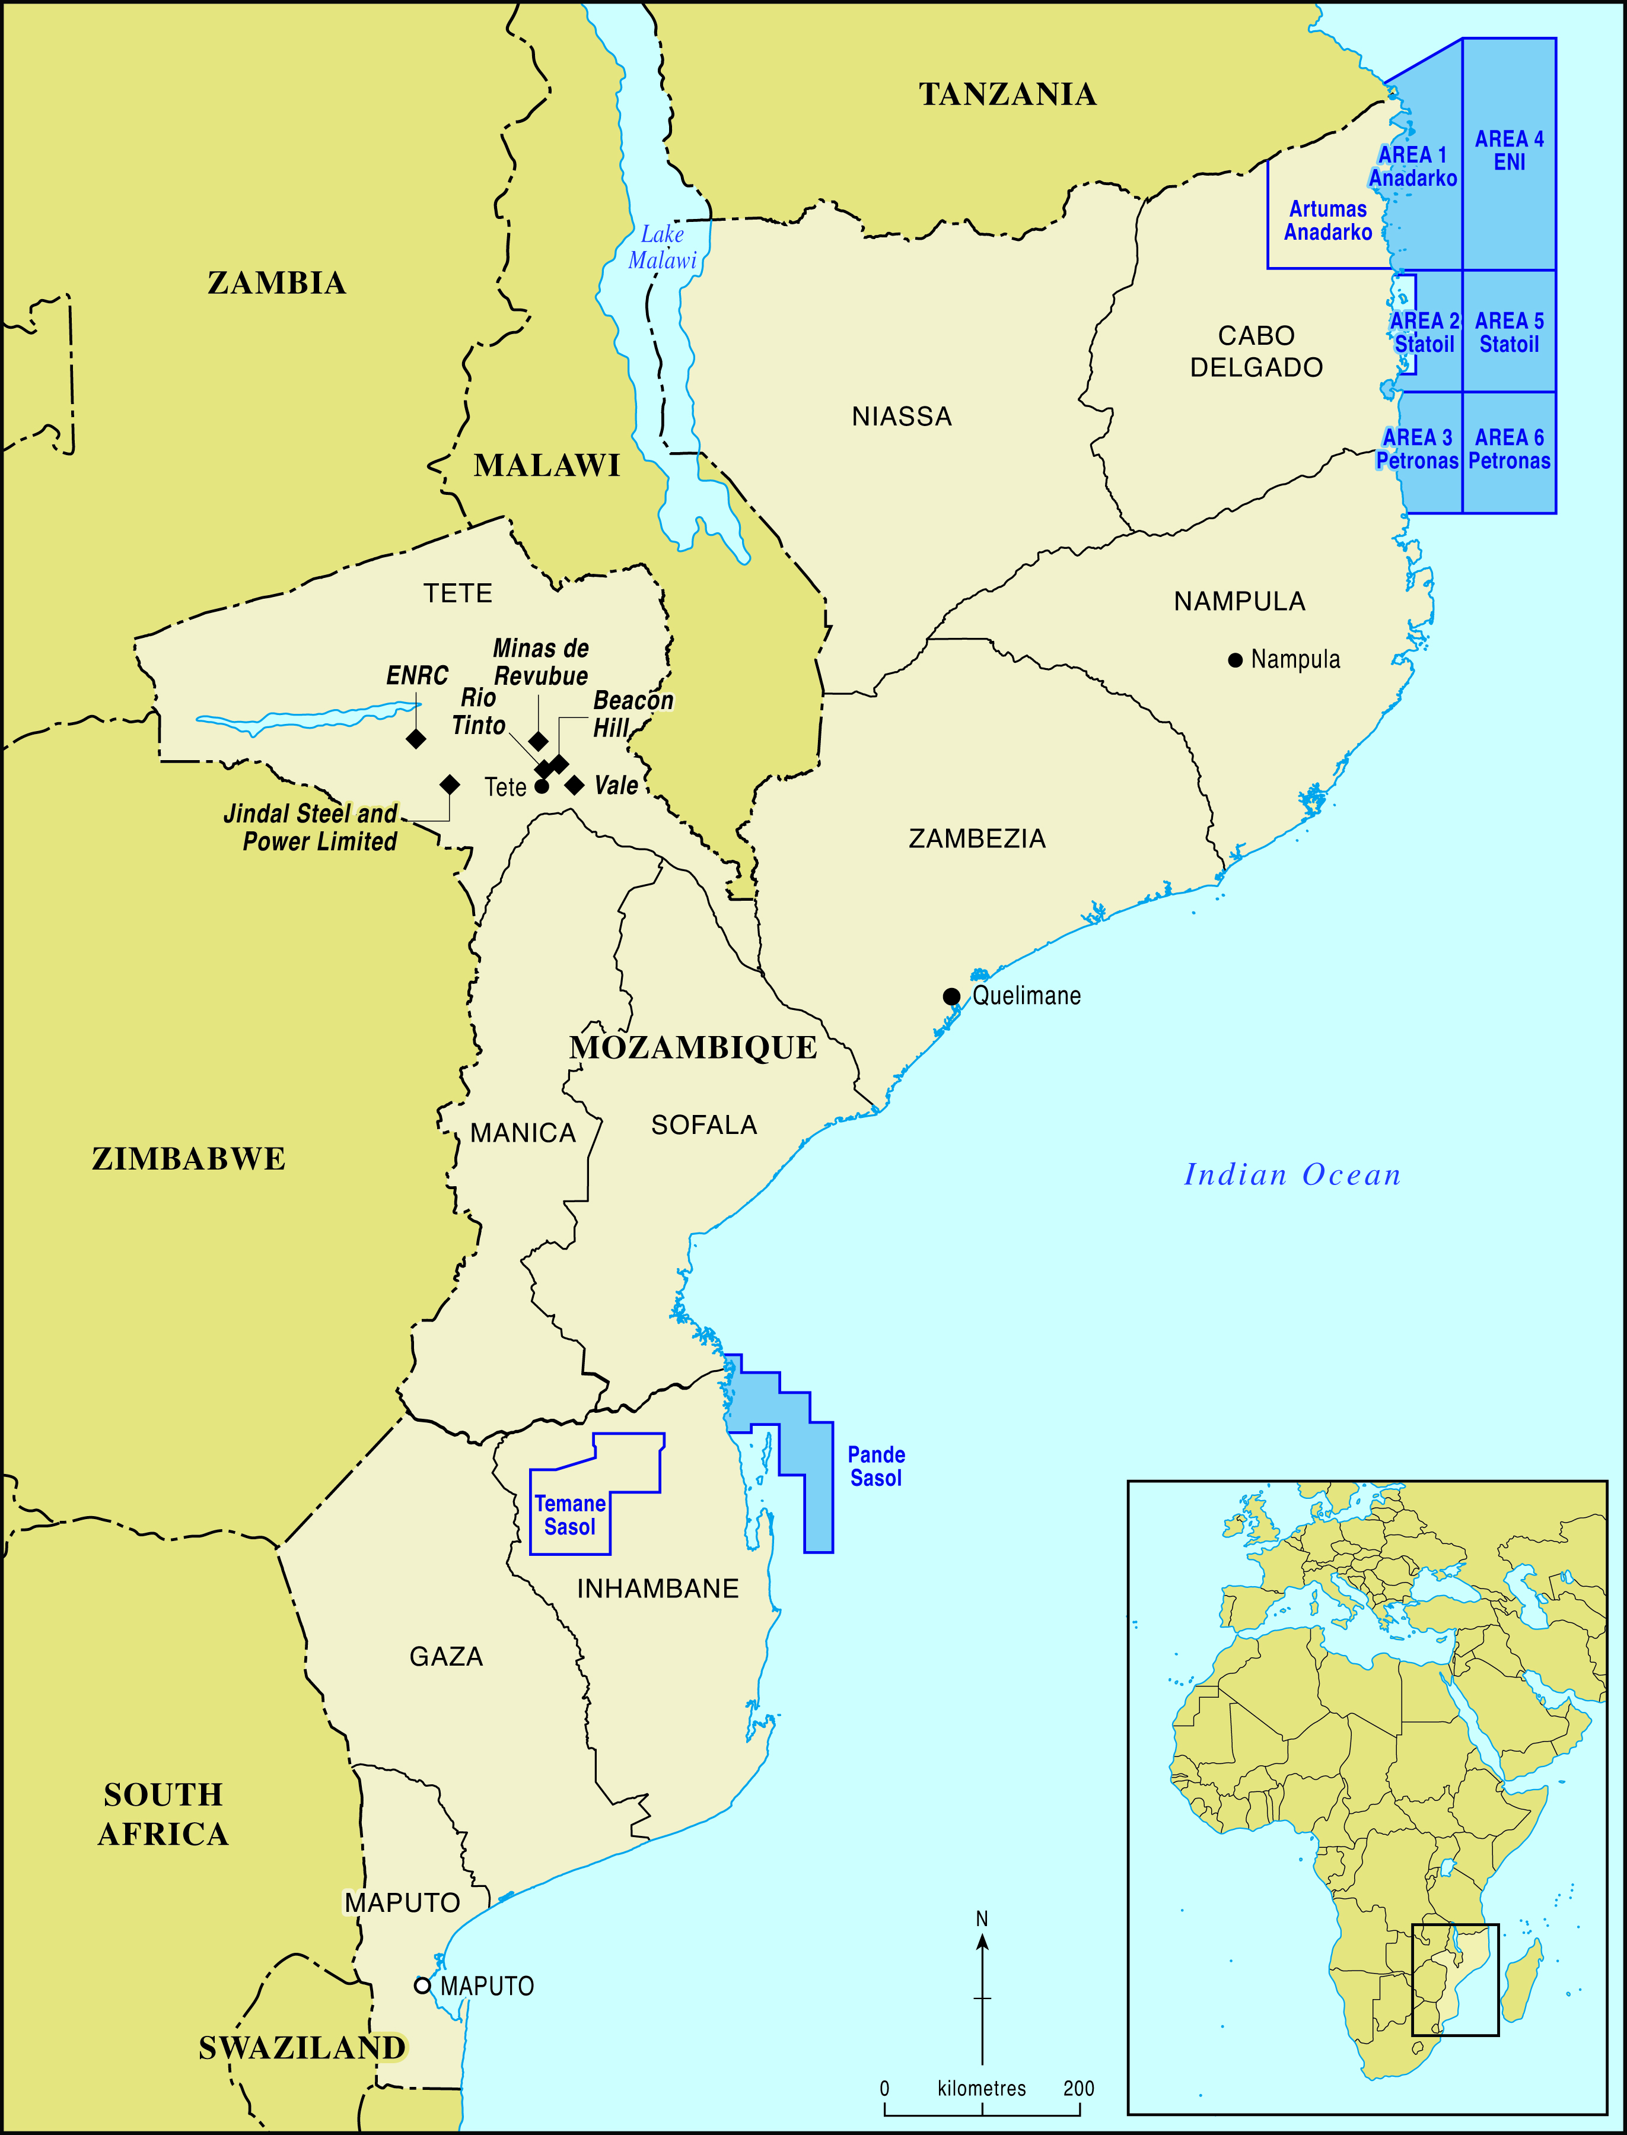

Figure 1: Sites of coal and gas extraction in Mozambique

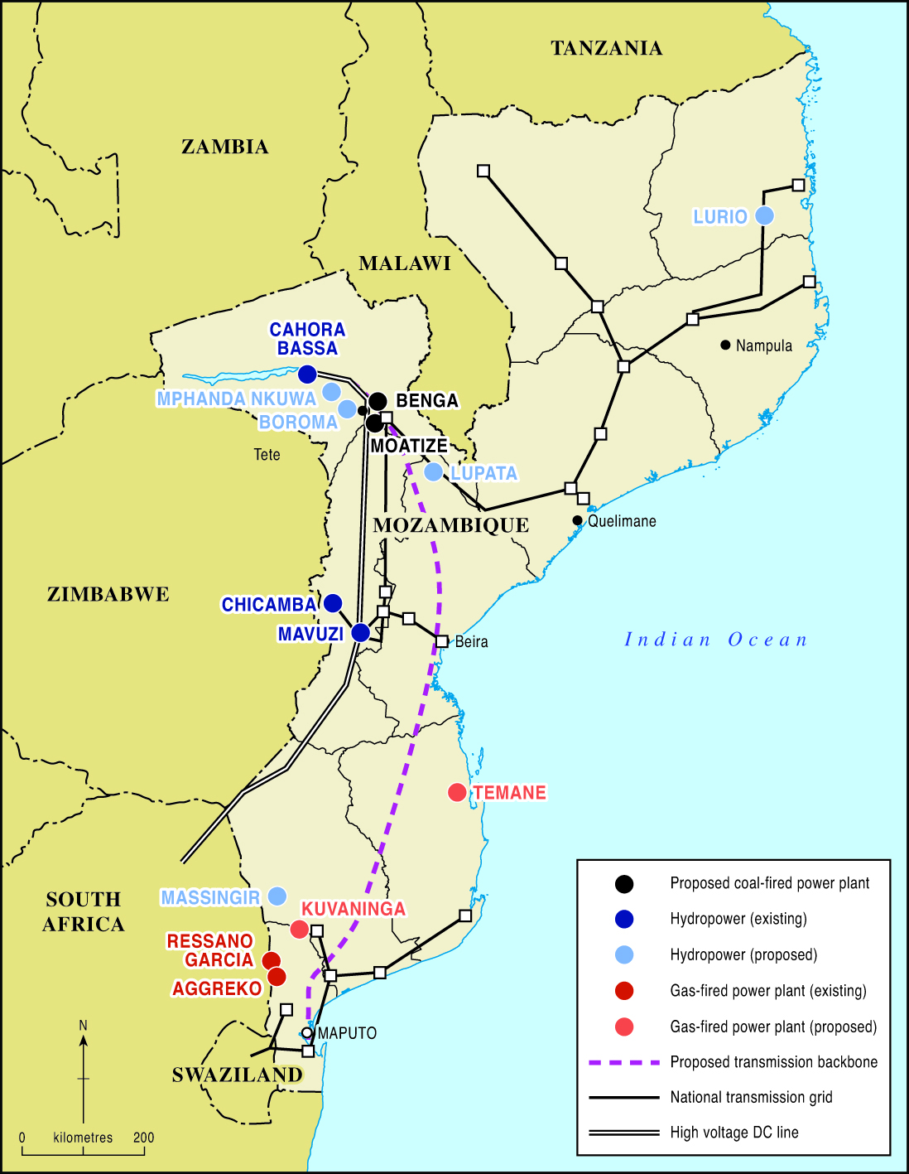

Figure 2: Mozambique’s main electricity generation and transmission infrastructure

Endnotes

The Rising Powers, Clean Development and the Low Carbon Transition in Sub-Saharan Africa (Ref: ES/J01270X/1).
Mining firms planning coal-fired power generation in Tete include Vale of Brazil, India’s International Coal Ventures and UK’s Ncondezi Energy, which entered a joint venture in 2015 with China’s Shanghai Electric Power to develop a 300MW plant (Zitamar News, 2015).
Isaacman and Isaacman (2015) have observed Cahora Bassa was the largest dam in the world constructed for the specific purpose of exporting energy out of the country.
Donors include the World Bank, the European Union and the Governments of Belgium, the Netherlands, Portugal, India and South Korea (Menezes, 2013).
The administrative post (posto administrativo) is Mozambique’s smallest territorial unit, below the district and province. Here it refers to the local authority’s residence and government offices.
A banca fixa, or “fixed stall,” is sanctioned by the local authorities and differs from ambulatory vendors or informal bancas, which can be harassed by police as being illegal (see Lindell, 2008).
Even if power levels were sufficient for cooking, PV users would need to purchase an inverter to convert the electricity from direct current (DC) to alternating current (AC) (Murphy, 2001).
Daniel Jones, University of Edinburgh, personal communication.
Thanks to Marcus Power for this insight.

