Importance of micropore-mesopore interfaces in CO2-capture by carbon-based materials

Gema Durá,[a] Vitaliy L. Budarin,[a] Jose A. Castro-Osma,[b] Peter S. Shuttleworth,[c] Sophie C. Z. Quek,[a] James H. Clark,[a]* and Michael North[a]*

[a] Dr. G. Durá, Dr. V. L. Budarin, Ms S. C. Z. Quek, Prof. J. H. Clark, Prof. M. North  
Green Chemistry Centre of Excellence, Department of Chemistry  
The University of York, York, YO10 5DD (UK)  
E-mail: james.clark@york.ac.uk; michael.north@york.ac.uk

[b] J. A. Castro-Osma   
Universidad de Castilla-La Mancha, Departamento de Química Inorgánica, Orgánica y Bioquímica-Centro de Innovación en Química Avanzada (ORFEO-CINQA), Instituto Regional de Investigación Científica Aplicada-IRICA, 13071-Ciudad Real, Spain.

[c] Dr. P. S. Shuttleworth   
Departamento de Física de Polímeros, Elastómeros y Aplicaciones Energéticas, Instituto de Ciencia y Tecnología de Polímeros, CSIC, c/Juan de la Cierva 3, 28006 Madrid, Spain.

Supporting information for this article is given via a link at the end of the document.

**Abstract:** Mesoporous carbonaceous materials (Starbons®) derived from low value/waste bio-resources separate CO2 from CO2 / N2 mixtures. Compared to Norit activated charcoal (AC), Starbons® have much lower microporosities (8-32% versus 73%) yet adsorb up to 65% more CO2. The presence of interconnected micropores and mesopores is responsible for the enhanced CO2 adsorption. The Starbons® also showed three-four times higher selectivity for CO2 adsorption rather than N2 adsorption compared to AC.

Separation of CO2 from other gases is a key part of technological processes in the energy sector. Thus, post-combustion carbon capture relies on the separation of CO2 from the other components of flue gas (predominantly N2),[[1]] whilst purification of natural gas from landfill, biogas plants or some gas-fields relies on the separation of CO2 from the combustible components of natural gas (predominantly CH4).[[2]] Methods to capture CO2 include: chemical absorption, physical adsorption, cryogenic separation and membrane separation.[[3]] Adsorption-based methods such as pressure-swing, vacuum-swing and temperature-swing adsorption, are the most promising technologies for CO2 capture due to the low cost, controllability, simplicity, low energy demand, high adsorption capacity and easy regeneration of the adsorbents. Porous materials which have been studied as adsorbents include: zeolites,[[4]] activated carbon[[5]] and metal-organic frameworks (MOFs).[[6]] Of these, carbon based materials have the advantages of: fast adsorption/desorption kinetics, high surface area, large pore volume, low density, reusability, minimal costs, potentially environmentally benign nature, chemical inertness and high thermal stability.

The Clark group has developed a template-free route to obtain mesoporous materials from abundant, renewable waste resources such as starch or alginic acid, leading to mesoporous carbons known as Starbons®.[[7]] These materials have been shown to have applications in areas including: catalysis, dye adsorption, and chromatographic separation. Established wisdom[[8]] is that microporous solids (preferably with pore diameters less than 0.8 nm[8a]) are optimal for gas separation, so mesoporous carbons such as Starbon® would not be expected to perform well in this application. Never the less, we decided to investigate the application of these materials to CO2 separation.

The nature of Starbons® (functional groups present, surface area, average pore radius etc) varies depending on the temperature at which the polysaccharide is carbonised and the characterisation of these materials has been reported previously.[7] Therefore, a range of Starbons® were prepared as previously reported[7] with carbonisation temperatures of 300 to 1200 oC and are herein referred to as S300, A1200 etc depending on their parent material (starch or alginic acid). FTIR, Raman and solid state NMR spectra along with combustion analysis data and SEM images for these materials is given in the supporting information and shows that as the carbonisation temperature increases to 600–800 oC, the materials dehydrate and become more graphitic in nature. As a reference material we chose commercially available Norit activated carbon (AC) which is a widely used microporous form of carbon.[[9]] The surface area, pore volume and pore radius of all the materials were determined by porosimetry with N2 at 77 K (Table 1) and the resulting adsorption isotherms and pore radius distribution plots are given in the supporting information. The AC, S800 and A800 samples had similar particle size distributions of 3-70 m.

|  |  |  |  |  |  |
| --- | --- | --- | --- | --- | --- |
| **Table 1.** Porosimetry data for the carbonaceous materials used in this work. | | | | | |
| Material | SBET (m2/g) | Vtotal (cm3/g) | Vmicropore (cm3/g) | %  micropore | Average pore  radius (nm) |
| AC | 798 | 0.6 | 0.42 | 73.4 | 2.1 |
| S300 | 241 | 1.1 | 0.09 | 8.1 | 19.7 |
| S450 | 448 | 1.3 | 0.21 | 16.6 | 22.2 |
| S650 | 826 | 1.3 | 0.39 | 30.0 | 16.3 |
| S800 | 895 | 1.3 | 0.40 | 31.9 | 12.4 |
| S1000 | 862 | 1.3 | 0.39 | 29.7 | 14.7 |
| S1200 | 678 | 1.4 | 0.30 | 21.0 | 17.5 |
| A300 | 304 | 1.2 | 0.14 | 11.6 | 8.6 |
| A550 | 500 | 1.0 | 0.23 | 23.0 | 6.9 |
| A800 | 931 | 1.4 | 0.39 | 27.7 | 5.9 |
| A1000 | 675 | 1.4 | 0.27 | 18.5 | 6.4 |
| A1200 | 427 | 1.1 | 0.16 | 13.9 | 6.3 |

The data in Table 1 show that as expected all of the Starbon® materials have higher total pore volumes than AC, but much lower micropore volumes indicating that they are predominantly mesoporous materials. Thus, whereas 73% of the pores in AC are micropores, only 8–32% of the pores in Starbon® are micropores. This is also reflected in the average pore radius data which for starch-derived Starbons® are an order of magnitude greater than for AC and for alginic acid-derived Starbons® are 3–4 times greater than for AC. The BET surface areas for Starbons® increase up to pyrolysis temperatures of 800 oC and then decrease at higher pyrolysis temperatures. This is consistent with dehydration and expulsion of steam at lower temperatures creating pores whilst at higher temperatures, partial graphitization reduces the pore sizes and hence the surface area. The adsorption isotherms showed that the pores in starch-derived Starbons® were disordered slit-shaped (H3-type isotherm according to IUPAC classification), whilst those in alginic acid-based Starbons® were interconnected ink-bottle shaped (H2-type isotherm).[[10]]

The CO2 adsorption properties of the powdered carbonaceous materials were measured under pressure-swing conditions. The materials were first dried (16 hours at 110 °C, then cooled under vacuum), then subjected to five cycles of pressurise to 5 or 10 bar with CO2 for 30 minutes then subject to vacuum at room temperature until the mass had dropped to the value recorded after drying. The mass difference between the end of the pressurization and vacuum steps was used to calculate the number of mmols of CO2 adsorbed per gram of sample. Figure 1 shows the average data (over the five cycles) obtained when the samples were pressurised to 5 bar (for 10 bar data see supporting information). The CO2 adsorbance obtained for AC (2.0 mmol CO2 g-1) was in good agreement with that reported in the literature (2.1 mmol CO2 g-1).[[11]]



**Figure 1.** CO2 adsorption data for powdered AC, and Starbon® materials. The data given is the average of five measurements and the error bars represent the highest and lowest measurements for each material.

It is apparent from Figure 1 that some of the Starbon® samples could outperform the CO2 adsorption capacity of AC by up to 50% (and by up to 65% at 10 bar CO2 pressure). For both starch- and alginic acid-derived Starbons® the optimal results were obtained using material which had been carbonised at 800 oC and corresponds to the material with the highest total surface area and smallest average pore radius (Table 1). Materials which had been carbonised at low temperatures (300-500 oC) performed very poorly, whilst material which had been carbonised at 650 oC had a similar CO2 adsorption capability to AC. The decrease in CO2 adsorption capacity on materials pre-treated above 800 oC was much more pronounced for alginic acid-based materials than for those based on starch. The rates of adsorption (at 5 and 10 bar CO2 pressure) and desorption (at atmospheric pressure) were also determined (data in supporting information) for AC, S800 and A800 and showed no significant differences between the three materials. At 5 bar CO2 pressure, the materials were all saturated in 30minutes whilst at 10 bar pressure, saturation occurred in 10 minutes. When left standing exposed to the atmosphere, complete loss of CO2 occurred by a first order process over 20 minutes. These results show that the data presented in Figure 1 represent equilibrium adsorption data rather than any kinetic difference between the samples. They also show that S800 and optimally A800 have improved CO2 adsorption capacities compared to AC whilst retaining the favourable rates of adsorption and desorption associated with AC. Since A800 was the optimal material for CO2 adsorption, its reusability was further investigated and no significant loss of activity was seen over 15 cycles of pressure swing CO2 capture and release (data in supporting information).

To investigate the nature of the CO2 adsorption by the Starbons®, the enthalpy of adsorption at 308 K of all of the materials was measured on a simultaneous thermal analyser (STA) capable of simultaneously measuring mass and heat flow changes during adsorption and desorption phenomena allowing direct measurement of the heat of adsorption as the ratio of these two parameters. This approach is more accurate than estimation of isosteric heat of adsorption based on adsorption isotherms.[[12]] The data for S800 (which adsorbed the most CO2 under these constant pressure, gas-composition swing conditions) are shown in Figure 2 (see supporting information for data for other samples). The powdered sample was alternately exposed to a flow of pure N2 and pure CO2 and Figure 2 shows that the CO2 adsorption process on Starbon® materials is completely reversibly at constant temperature and pressure as the gas composition changes. The rate of CO2 adsorption and desorption is clearly also extremely rapid under these conditions. The sample mass changes allow the CO2 adsorption to be determined at constant pressure and the same qualitative trend was observed as for the data in Figure 1, with the starch and alginic acid derived Starbons® prepared at 800 oC having the highest CO2 adsorptions (data in supporting information).

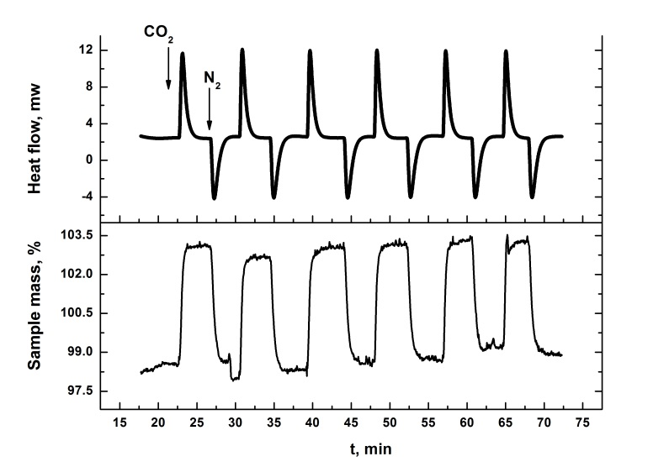

**Figure 2.** STA plots of mass and heat flow change during six cycles of CO2 adsorption and desorption using powdered S800 at 308 K. The mass increases and positive heat flows coincide with the gas flow being changed from 100% N2 to 100% CO2. The mass decreases and negative heat flows coincide with the gas flow being changed back to 100% N2.

Figure 3 shows the resulting adsorption enthalpies obtained for each of the materials. All the materials have CO2 adsorption enthalpies in the range of -14 to -22 kJ mol-1(CO2). These are in between values of heat of carbon dioxide vaporisation (10.3 kJ mol-1)[[13]] and sublimation (26.1 kJ mol-1)[[14]] and indicate that for all of these materials (including activated carbon), CO2 physisorption is the predominant adsorption mechanism. The Starbon® materials prepared at low carbonisation temperatures (S300, S450, A300) had CO2

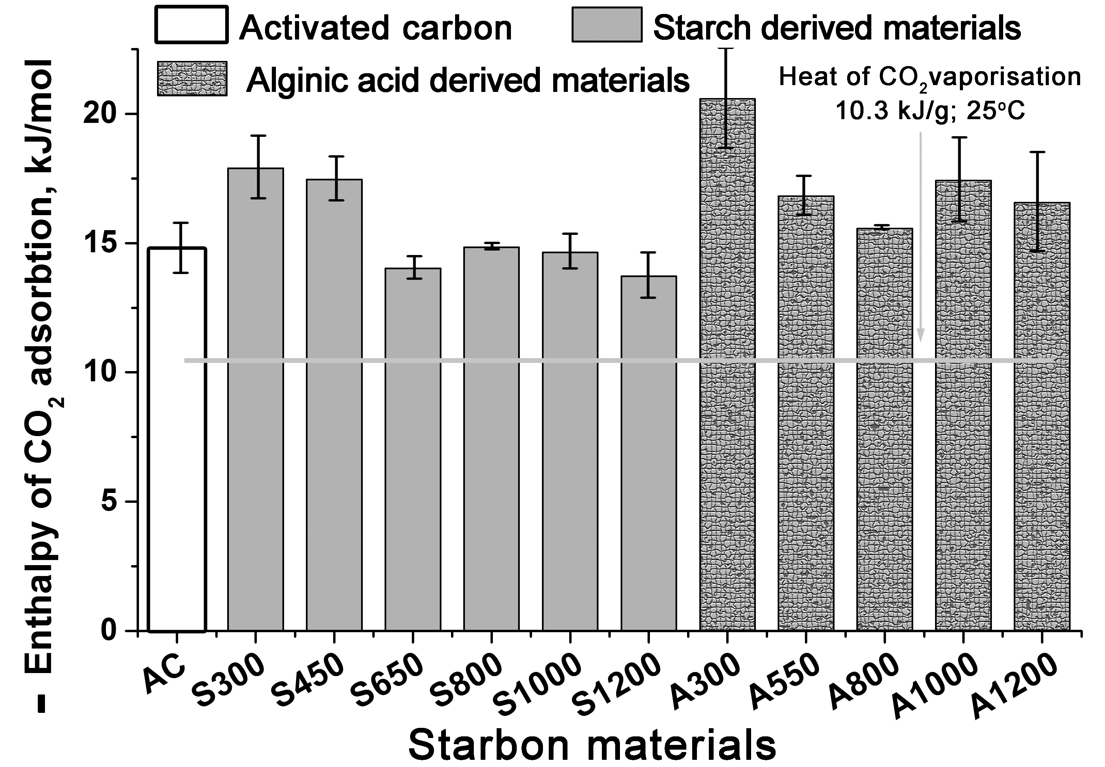

**Figure 3.** Enthalpies of CO2 adsorption for powdered AC and Starbon® materials at 308 K. The data given is the average of six adsorption and desorption cycles with error bars based on the standard deviations.

adsorption enthalpies which were rather more negative (-18 to -21 kJ mol-1(CO2)) than the other materials and this may indicate,that for these materials, a small amount of CO2 is chemisorbed to oxygen-containing groups which have survived the low temperature carbonisation (see supprting information).

Combining the data in Figure 2 and Figure 3, it is apparent that Starbon® materials can physisorb far more CO2 than can be physisorbed by AC which is proposed to be a result of a significantly higher entropy of adsorption associated with the larger degree of freedom of CO2 molecules adsorbed on the surface of Starbon®. In other words, CO2 molecules adsorbed on the Starbon® surface are less restricted and have higher mobility than CO2 molecules adsorbed on the AC surface.[14] This phenomenon could be partially related to differences in pore structure distribution of these two different types of materials and to the larger micro-meso pore interface for Starbon materials. The most active Starbon® materials (S800 and A800) have the same micropore volumes as that of AC (0.4 cm3 g-1) (see Table 1), so the additional physisorbed CO2 must be associated with their mesoporous networks. The AC and Starbon® materials possess a range of micropore and mesopore volumes as detailed in Table 1, so the STA and porosimetry data was further analysed to identify the key Starbon® textural parameters that control CO2 adsorption. Application of the partial least squares regression approach (Figure 4) showed that the CO2 adsorption is not affected by the mesopore volume, but does depend on the micropore volume and the product of the micropore and mesopore volumes and could be fitted to equation 1 with an R2 value of 0.98 (Figure 4). This indicates that the CO2 is being physisorbed into the micropores, most of which are only accessible via mesopores and it is this greater accessibility of the micropores that is responsible for the enhanced CO2 adsorption of the Starbon® materials.

$$M_{ads}^{{CO}_{2}}=0.095+2.10*V_{micro}+3.51*V_{micro}*V_{meso} (1)$$

The two most active mesoporous materials (S800 and A800) were selected along with AC to study the selectivity for CO2 versus N2 adsorption at both 298 and 323 K using porosimetry to measure the mass of gas adsorbed at pressures of 0-1 bar. Figure 5 shows the results obtained for powdered S800 (see supporting information for other adsorption isotherms). As shown in Table 2, both S800 and A800 showed much greater

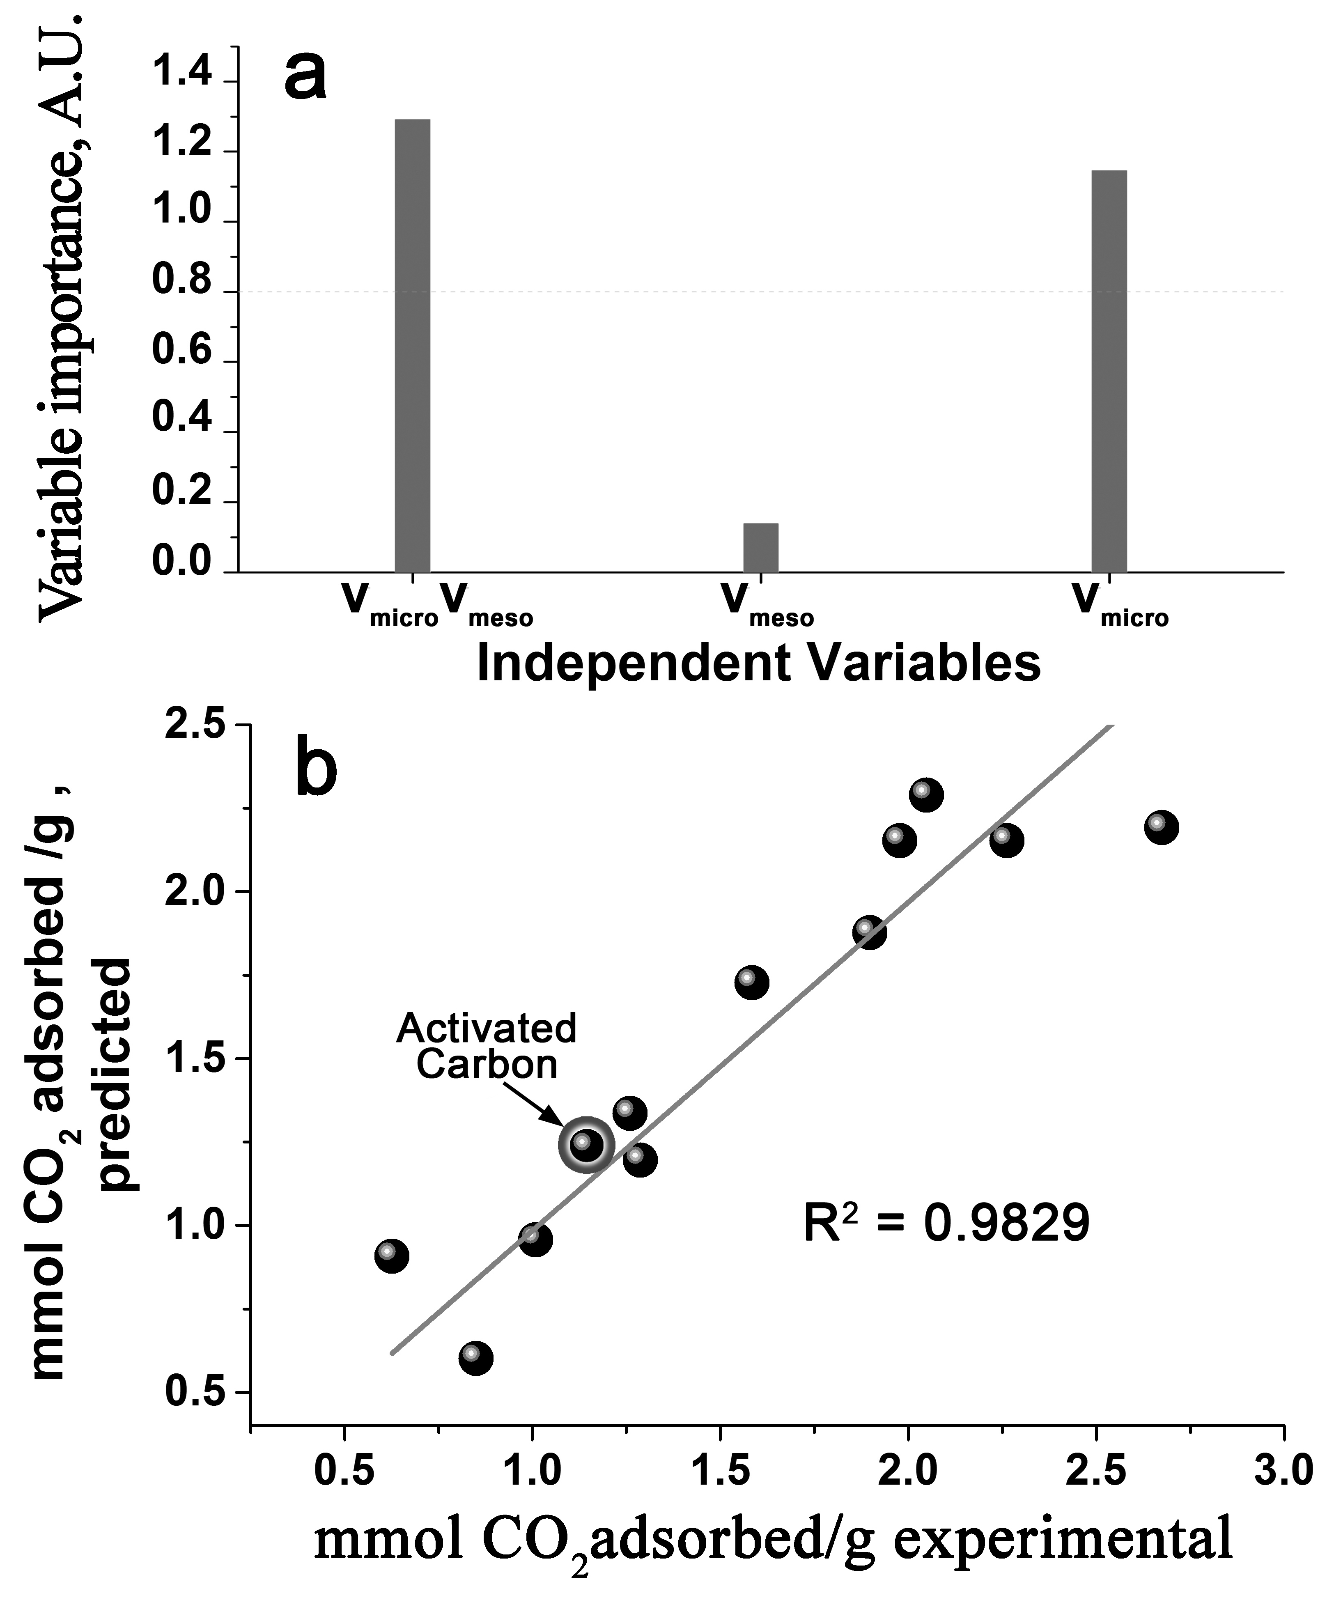

**Figure 4.** a) Analysis of the relative importance of micropore volume (Vmicro), mesopore volume (Vmeso) and the product of Vmicro and Vmeso in CO2 adsorption by AC and Starbons®. b) The correlation between CO2 adsorption data obtained from experiment and estimated from the mathematical model.

|  |  |  |
| --- | --- | --- |
| **Table 2.** Selectivities for CO2 adsorption versus N2 adsorption. | | |
| Material | T (K) | CO2 / N2 selectivity |
| AC | 298 | 5.4 |
| AC | 323 | 4.0 |
| S800 | 298 | 14.0 |
| S800 | 323 | 20.3 |
| A800 | 298 | 14.8 |
| A800 | 323 | 14.4 |



**Figure 5.** CO2 and N2 adsorption isotherms for S800. Solid lines CO2 and dotted lines N2 adsorption. Filled symbols 298 K, empty symbols 323 K.

selectivity for CO2 adsorption than N2 adsorption (between 14:1 and 20:1) compared to AC (between 4:1 and 5.4:1). Notably, whereas for AC the selectivity decreases from 5.4:1 to 4:1 as the temperature is raised from 298 to 323 K, for S800 and A800 the selectivity remains over 14:1 at 323 K which is the approximate temperature of flue gas and hence the preferred temperature for CO2 separation within a carbon capture unit.

Additional experiments were carried out with CO2 / N2 gas mixtures using STA to investigate the selective adsorption of CO2 at 298 K and 1 bar total gas pressure (data in supporting information). Under these conditions, AC showed its maximum CO2 adsorption at all gas compositions containing at least 50% CO2, whilst S800 and A800 both showed the maximum CO2 adsorption for all gas compositions containing at least 25% CO2. Thus, the enhanced CO2 selectivity seen with Starbon® materials is retained when mixtures of CO2 and N2 are present.

Since CO2 in flue gas is saturated with water vapour, the effect of water on the adsorption of CO2 was investigated at 298K by STA using CO2 which had been pre-saturated with water. Under these conditions, there was a 10-20% reduction in the CO2 adsorption capacity of powdered AC, S800 and A800, but the capacity of A800 diminished the least and the Starbon® materials maintained their advantage over AC. Water adsorption isotherms were obtained for AC, S800 and A800. The adsorption of water at P/P0 = 0.7 was also investigated for the starch derived Starbons® and was found to be very low (0.08 (for S1000) to ­0.3 (for S300) mmol H2O g-1). (Data given in supporting information).

In contrast to established understanding, mesoporous carbons have been shown to possess superior CO2 adsorption properties to microporous activated carbon. Both the amount of CO2 adsorbed and the selectivity for CO2 adsorption rather than N2 adsorption are improved, giving the materials potential applications in carbon capture from power station flue gases. Thermodynamic measurements indicate that the CO2 is captured by a physisorption mechanism which involves both direct and indirect (via mesopores) access to the micropores within the material. This opens a new approach to design efficient adsorbents which are optimal for CO2 separation. Such a technology could be based on controlling the micro/meso porosities of carbonaceous materials including screening of different precursors, methods for their carbonisation and chemical activation of the mesoporous carbon. Furthermore, the low adsorption enthalpy associated with CO2 physisorption means that the process is rapidly reversible without requiring large energy input, so that CO2 capture and release can occur under pressure swing rather than temperature swing conditions. Whilst MOFs and MOF-hybrid materials have been shown to exhibit higher CO2 adsorptions (up to 4.23 mmol CO2 g-1 at ambient temperature and pressure),[6f] this is at the expense of more complex and expensive syntheses and slower adsorption and desorption kinetics.

Acknowledgements

The authors thank Programa Operativo FSE 2007-2013 Castilla-La Mancha for funding a fellowship to GD. PSS gratefully acknowledges the Spanish Ministry Economy and Competitivity (MINECO) for a Ramón y Cajal fellowship (RYC-2014-16759), a research project (CTQ2014-52899-R) and a proyecto de I+D+I para jóvenes investigadores (MAT2014-59674-JIN). JACO acknowledges financial support from the Plan Propio de la Universidad de Castilla-La Mancha.

**Keywords:** • CO2 capture • Mesoporous • Separation • Carbon

[1] For reviews see: a) R. Thiruvenkatachari, S. Su, H. An, X. Yu, *Progress Energy Combustion Sci.* **2009**, *35*, 438–455; b) R. Notz, I. Tönnies, N. McCann, G. Scheffknecht, H. Hasse, *Chem. Eng. Technol.* **2011**, *34*, 163–172; c) J. Oexmann, A. Kather, S. Linnenberg, U. Liebenthal, *Greenhouse Gas Sci. Technol.* **2012**, *2*, 80–98; d) M. Zaman, J. H. Lee, *Korean J. Chem. Eng.* **2013**, *30*, 1497–1526.

[2] a) R. W. Baker and K. Lokhandwala, *Ind. Eng. Chem. Res.* **2008**, *47*, 2109–2121; b) Z. Xiang, X. Zhou, C. Zhou, S. Zhong, X. He, C., Qin, D. Cao, *J. Mater. Chem.* **2012**, *22*, 22663–22669; c) S. Chaemchuen, N. A. Kabir, K. Zhou, F. Verpoort, *Chem. Soc. Rev.* **2013**, *42*, 9304–9332.

[3] For reviews see: a) S. Choi, J. H. Drese, C. W. Jones, *ChemSusChem* **2009**, *2*, 796–854; b) D. M. D’Alessandro, B. Smit, J. R. Long, *Angew. Chem. Int. Ed.* **2010**, *49*, 6058–6082; c) Y.-S. Bae, R. Q. Snurr, *Angew. Chem. Int. Ed.* **2011**, *50*, 11586–11596; d) Q. Wang, J. Luo, Z. Zhong, A. Borgna, *Energy Environ. Sci.* **2011**, *4*, 42–55; e) B. P. Spigarelli, S. K. Kawatra, *J. CO2 Utilization* **2013**, *1*, 69–87.

[4] a) W. Gao, D. Butler, D. L. Tomasko, *Langmuir* **2004**, *20*, 8083–8089; b) R. V. Siriwardane, M.-S. Shen, E. P. Fisher, *Energy Fuels* **2005**, *19*, 1153–1159; c) K. S. Walton, M. B. Abney, M. D. LeVan, *Microporous Mesoporous Mater.* **2006**, *91*, 78–84; d) P. D. Jadhav, R. V. Chatti, R. B. Biniwale, N. K. Labhsetwar, S. Devotta, S. S. Rayalu, *Energy Fuels* **2007**, *21*, 3555–3559; e) F. N. Ridha, Y. Yang, P. A. Webley, *Microporous Mesoporous Mater.* **2009**, *117*, 497–507; f) A. Zukal, I. Dominguez, J. Mayerová, J. Čejka, *Langmuir* **2009**, *25*, 10314–10321; g) H. Deng, H. Yi, X. Tang, Q. Yu, P. Ning, L. Yang, *Chem. Eng. J.* **2012**, *188*, 77–85.

[5] a) R. V. Siriwardane, M.-S. Shen, E. P. Fisher, J. A. Poston, *Energy Fuels* **2001**, *15*, 279–284; b) J. Przepiórski, M. Skrodzewicz, A. W. Morawski, *App. Surface Sci.* **2004**, *225*, 235–242; c) S. Himeno, T. Komatsu, S. Fujita, *J. Chem. Eng. Data* **2005**, *50*, 369–376; d) P. J. M. Carrott, I. P. P. Cansado, M. M. L. Ribeiro Carrott, *App. Surface Sci.* **2006**, *252*, 5948–5962.

[6] For reviews see: a) Z. Xiang, D. Cao, J. Lan, W. Wang, D. P. Broom, *Energy Environ. Sci.* **2010**, *3*, 1469–1487; b) J.-R. Li, Y. Ma, M. C. McCarthy, J. Sculley, J. Yu, H.-K. Jeong, P. B. Balbuena, H.-C. Zhou, *Coord. Chem. Rev.* **2011**, *255*, 1791–1823; c) G. Férey, C. Serre, T. Devic, G. Maurin, H. Jobic, P. L. Llewellyn, G. De Weireld, A. Vimont, M. Daturi, J.-S. Chang, *Chem. Soc. Rev.* **2011**, *40*, 550–562; d) K. Kenji Sumida, D. L. Rogow, J. A. Mason, T. M. McDonald, E. D. Bloch, Z. R. Herm, T.-H. Bae, J. R. Long, *Chem. Rev.* **2012**, *112*, 724–781; e) Z. Zhang, Y. Zhao, Q. Gong, Z. Li, J. Li, *Chem. Commun.* **2013**, *49*, 653–661; f) Z. Zhang, Z.-Z. Yao, S. Xiang, B. Chen, *Energy Environ. Sci.* **2014**, *7*, 2868–2899.

[7] a) V. L. Budarin, J. H. Clark, J. J. E. Hardy, R. Luque, K. Milkowski, S. T. Tavener, A. J. Wilson, *Angew. Chem., Int. Ed.* **2006**, *45*, 3782–3786; b) R. J. White, V. L. Budarin, J. H. Clark, *ChemSusChem* **2008**, *1*, 408­–411; c) R. J. White, C. Antonio, V. L. Budarin, E. Bergström, J. Thomas-Oates, J. H. Clark, *Adv. Funct. Mater.* **2010**, *20*, 1834–1841; d) M.–M. Titirici, R. J. White, N. Brun, V. L. Budarin, D. S. Su, F. del Monte, J. H. Clark, M. J. MacLachlang, *Chem. Soc. Rev.* **2015**, *44*, 250–290.

[8] a) V. Presser, J. McDonough, S.-H. Yeon, Y. Gogotsi, *Energy Environ. Sci.* **2011**, *4*, 3059–3066; b) A. Samanta, A. Zhao, G. K. H. Shimizu, P. Sarkar, R. Gupta, *Ind. Eng. Chem. Res.* **2012**, *51*, 1438–1463; c) A.-H. Lu, G. P. Hao, *Annu. Rep. Prog. Chem., Sect. A: Inorg. Chem.* **2013**, *109*, 484–503; d) Y. Zhao, X. Liu, Y.Han, *RSC Adv.* **2015**, *5*, 30310–30330.

[9] The amount of CO2 adsorbed is known not to depend on physical parameters such as surface area, pore volume, and micropore volume which may differ between activated carbons. Hence, Norit activated charcoal is representative of all microporous carbons: B. Guo, L. Chang, K. Xie, *J. Nat. Gas. Chem.* **2006**, *15*, 223–229

[10] a) K. S. W. Sing, D. H. Everett, R. A. W. Haul, L. Moscou, R. A. Pierotti, J. Rouquérol, T. Siemieniewska, *Pure Applied Chem.* **1985**, *57*, 603–619; b) F. Rojas, I. Kornhauser, C. Felipe, J. M. Esparza, S. Cordero, A. Domínguez, J. L. Riccardo, *Physical Chemistry Chemical Physics* **2002**, *4*, 2346–2355.

[11] W. Travis, S. Gadipelli, Z. Guo, *RSC Adv.* **2015**, *5*, 29558–29562.

[12] D. Wu, J. J. Gassensmith, D. Gouvêa, S. Ushakov, J. F. Stoddart, A. Navrotsky, *J. Am. Chem. Soc.* **2013**, *135*, 6790–6793.

[13] K. H. Yung, *J. Phys. Chem.* 1995, 99, 12021–12024.

[14] http://webbook.nist.gov/cgi/cbook.cgi?ID=C124389&Mask=4#Thermo-Phase.

**Entry for the Table of Contents** (Please choose one layout)

Layout 1:

|  |  |  |  |  |
| --- | --- | --- | --- | --- |
| COMMUNICATION | | | | |
| **Using waste to capture waste:** Mesoporous carbons (Starbons®) derived from waste biomass show enhanced CO2 capture capacities and enhanced selectivities for CO2 over N2 compared to microporous activated carbon, an effect which is due to the presence of micropore-mesopore interfaces. |  |  |  | Gema Durá, Vitaliy L. Budarin, Jose A. Castro-Osma, Peter S. Shuttleworth, Sophie C. Z. Quek, James H. Clark,]* Michael North*  Page No. – Page No.  Importance of micropore-mesopore interfaces in CO2-capture by carbon-based materials |
|  |  |

|  |  |  |
| --- | --- | --- |
|  |  |  |

1.
2.
3.
4.
5.
6.
7.
8.
9.
10.
11.
12.
13.
14.