AFFECTIVE SANCTUARIES: UNDERsTANDING Maggie’s AS THERAPEUTIC LANDSCAPES

Abstract
Since 1996 Maggie’s has led a new approach to cancer support that emphasises the empowering potential of the designed environment for its users. This paper draws on qualitative research from two separate projects undertaken with staff, visitors and volunteers at ten Maggie’s Centres, exploring their experiences of Maggie’s environments, and their use of internal spaces and garden areas. Maggie’s has been most often noted for the buildings it commissions, but we argue that the gardens prompt a re-evaluation of the integrated healing environment. Locating our research in health geography debates, Maggie’s buildings and gardens are situated as contemporary examples of therapeutic landscapes. The Centres open up debates about the capacity of the designed environment to enhance the experience of wellbeing. This is achieved through the provision of communal areas within which visitors can find private places for emotional retreat, encouraging the experience of affective sanctuary.

Keywords: Maggie’s; healthcare architecture; restorative gardens; therapeutic landscapes; cancer care.

Introduction
This paper brings together recent research into the buildings and gardens of Maggie’s, a series of non-clinical centres open to those with cancer, their families and friends (Butterfield, 2014a, Butterfield & Martin, 2014, Martin 2014; 2015; 2016). These Centres are located beside regional hospitals, primarily in the UK and now expanding internationally. Maggie’s provides a holistic programme of care, information about cancer and psychological support to its visitors, and the Centres are staffed by healthcare professionals with backgrounds in oncology, including clinical psychologists, cancer support specialists and welfare advisors. Independent of other healthcare providers, Maggie’s offers complimentary services to those in hospitals, within a series of striking buildings designed by some of the most globally renowned architects (Jencks, 2015). Because of its collaborations with such celebrated architectural practices, to date much attention has focused on the role of Maggie’s buildings in the support it offers, whether in journalists’ reports (Heathcote, 2011; Rose, 2010) or in academic studies (Martin, 2015; 2016; Van der Linden, Annemans and Heylighen, 2015; 2016). In this paper, by bringing research findings from two separate projects together (Butterfield 2014a; Martin 2016), we are able to offer a more pronounced emphasis on the gardens and highlight the affects emerging from the sites’ interior and exterior designs, and how they relate to each other, in order to explore Maggie’s Centres as integrated healing landscapes.
In this paper, we draw on our research at Maggie’s in order to characterise Maggie’s Centres as physical and psychosocial environments, tied together through the personal and social meanings their users attribute to them. Combining our findings offers synergies and helps us to better understand the significance of Maggie’s gardens and buildings to those who use them routinely and frequently, often in times of heightened medical need. By bringing together our findings we arrive at new ways of conceptualising the Centres: specifically, in this paper, we make the argument that Maggie’s Centres be thought of as contemporary forms of ‘therapeutic landscape’. By doing so, we align our findings with those of health geographers who have identified the importance of place in culturally attuned accounts of the experience of health, illness and well-being (Gesler, 1992; Williams, 2007), and we add to that literature through our analysis of the ways in which Maggie’s environments are active in helping their visitors to shape their responses to cancer. Moreover, we extend the understanding of how therapeutic landscapes are experienced by and known to those using them to situate our research within wider arguments about a sense of place that is affectively encountered and emotionally resonant (Anderson, 2006; Davidson, Bondi and Smith, 2007).
We begin by outlining a brief description of Maggie’s, its history and its design principles. An overview is then provided of the ‘therapeutic landscape’ strand of health geography research, before we move onto a description of our research methods and a synopsis of our main findings. This paper offers a synthesis of research projects whose findings are also explored elsewhere (Butterfield, 2014a; 2014b; Martin 2015; 2016); in this paper, we draw out key themes in how our research participants (including staff, visitors and volunteers) reflected upon the buildings and gardens, in order to articulate an understanding of the Centres as designed environments that are instrumental in the crafting of caring and supportive atmospheres. We conclude by arguing for the importance of creating spaces of sanctuary and sociability, for those who wish to use them, in the routine experience of health and well-being in contemporary societies (Conradson, 2007; Cattell et al., 2008).

Maggie’s Cancer Caring Centres

Maggie’s founder was Maggie Keswick, a garden designer and historian, who died from cancer in 1995, just before the opening of the first Centre in Edinburgh in the following year. Since her death, Keswick’s husband, the architectural writer Charles Jencks, has worked as an advocate for the empowering potential of architecture in the delivery of healthcare. He locates the spaces commissioned by Maggie’s as part of a wider move in healthcare settings ‘towards more humane and varied building types’ (Jencks and Heathcote, 2010, p.14) that provide person-centred care. Maggie’s Centres are domestic in scale, offering a striking visual contrast to their large neighbouring hospitals. The Centres sit within towns, cities and regions that vary by size, socio-demographic factors and historical development; consequently, Centres are located in global economic hubs (e.g. Hong Kong and London), in large post-industrial cities (e.g. Glasgow and Swansea), and in towns that are important to their rural hinterlands (e.g. Cheltenham and Inverness). The Maggie’s portfolio comprises a set of qualitatively different buildings, with the provision of designed gardens where space allows. Although each building is planned according to the same design principles (Maggie’s, 2012), these instructions to architects lack the technicalities of detailed site-specific briefs and adopt a narrative approach instead. That is, architects are asked to achieve certain atmospheres in the buildings that can act to mute, distract and counter-act the confusion and anxieties typically associated with a cancer diagnosis and treatment. A variety of domestic spatial forms are suggested in the advice to architects; for example, the kitchen area (Figure 1) is emphasised as important to creating a welcoming space (Martin, 2016). Avoiding a catalogue of technical requirements means that there is no generic design rolled out formulaically across sites - rather, the individual buildings could be said to share family resemblances. Different site designs arise for multiple reasons, including the different aesthetic styles of architects and because some buildings have adapted existing structures (e.g. Edinburgh), whereas other Centres are completely new builds (e.g. London). Holding these architectural cousins together is the organisation’s belief in the salutogenic potential of the built environment within practices of care or, as Jencks terms it, the ‘architectural placebo effect’ (2015, p.22).

[FIGURE 1 ABOUT HERE]

Despite some challenging urban sites, Maggie’s has always considered its outdoor spaces, gardens and views carefully, and has collaborated with many well-known landscape designers (Jencks, 2015). Most recent Centres include areas where each designer has presented their interpretation of a contemporary healthcare garden, with a stronger integration of the garden from the start of the design process, and this can be seen in Centres such as London (2008), Cheltenham (2010), Glasgow Gartnavel (2011) and Lanarkshire (2014). There are parallels with the architectural design in that, whilst each garden is unique, across sites certain ideas, features and qualities are shared. So, for example, in attempting to bring the inside and outside into greater contact, each garden includes areas easily accessible from the main kitchen space of the building. In Centres where the interior and exterior designs are developed in a fully integrated way, it is possible to see how, in each case, the garden design engages with and, indeed, completes the building design (Figures 2 & 3). As noted above, Maggie’s is mostly associated with the commissioning of innovative architecture and yet there is an opportunity to explore how the gardens can act as part of a broader process that helps people through illness (Hartig and Cooper Marcus, 2006). Indeed, by bringing findings from both projects together in this paper, we wish to highlight the importance of the outside spaces to the overall emotional pull that many of our participants reported when speaking of their Centre, and argue for a more rounded understanding of what Maggie’s environments offer to their visitors. Maggie’s Centres do not merely make the case for a fuller understanding of the role of architecture in shaping our experience of health and illness (for this, see Martin 2016), but rather prompt a consideration of the wider environment, inside and out, in its capacity to affect our sense of wellbeing and act in therapeutic ways.

[FIGURES 2&3 ABOUT HERE]

Healing places, therapeutic landscapes

In advancing the argument that Maggie’s Centres offer case studies of designed environments acting as ‘therapeutic landscapes’, we align our research within the arguments about healing places articulated by Gesler (1992) and other health geographers (e.g., Curtis et al., 2007; Martin et al., 2005; Williams, 2007). Put simply, therapeutic landscapes are places that encourage feelings of wellbeing amongst their users. Gesler’s early research in this area explored historical associations between particular places and healing practices (1993; 1996; 1998), pointing the way for researchers to explore other locations in light of his findings. The term has been used to understand institutional sites, such as hospitals (Gesler et al., 2004) and mental health units (Wood et al., 2013), but also spaces that are more open in function, such as public parks (Laws, 2009). The scope of the therapeutic landscape idea has extended significantly since Gesler’s original use (1992): so, we find it used to understand the role of the home (Williams, 2002), gardens (Hickman, 2013), allotments (Milligan, Gatrell and Bingley, 2004) and even the body itself (English, Wilson and Keller-Olaman, 2008) in processes of healing. Beyond curative spaces, therapeutic landscapes have been understood as integral to feelings of wellbeing, whether sensed in private locations, such as places of retreat (Conradson, 2007), or in communal settings, such as public libraries (Brewster, 2014). What ties therapeutic landscapes together are the multiple levels at which they are approached by individuals in need of care: Gesler argues that ‘healthy places’ are not just dependent on the physical characteristics of a site, but involves the sense of place that people ascribe to it (2003, p.18). This sense of place is built up through lived experiences and involves the transference of moral, value and aesthetic judgements to a site.
Gesler identifies four different environments that contribute to a restorative place; the natural, the built, the symbolic and the social (2003, p.7). He argues that each ‘environment’ is inter-related and that the natural and built environments affect our emotions, but also the meanings (symbols) and communitas (social activity) that deepen our affective ties to place. This aligns with Davidson, Bondi and Smith’s characterisation of an approach to geography which is affectively resonant, and which understands ‘emotion - experientially and conceptually - in terms of its socio-spatial mediation and articulation rather than as entirely interiorised subjective mental states’ (2007, p.3). Extending this point, it suggests an intertwined understanding of emotion and geography in terms of spatial atmospherics that are indeterminate and contingent on the actions and understandings of those who, quite literally, make sense of the space (Anderson, 2009). This is not least in the case of architectural design, where buildings must always be held to be incomplete cultural forms, dependent on the spatial and affectual practices of those inhabiting the built environment (Kraftl and Adey, 2008; Kraftl, 2010; Lees, 2001). Accepting these arguments leads to a sense of place that is layered, perceived in different ways and at different times, with these plural understandings held in balance. It brings a relational understanding of the dynamics underscoring the restorative potential of particular places (Conradson, 2005), and takes us towards a definition of the therapeutic landscape as ‘a moving space that unfolds within and through interactions with the environment (including other humans as well as non-humans), rather than a fixed geographical location’ (Doughty 2013, p.141). It is within this type of understanding that we locate Maggie’s buildings and gardens as therapeutic landscapes that assist experiences of emotional retreat alongside healing practices of everyday sociality, in order to forge spaces for dialogue and encounter between and within individuals. The Centres become what we term ‘affective sanctuaries’; that is, they are places that allow for personal reflection within the often public experiences of cancer treatments, and they also help to cultivate emotional relationships between people and cherished places (Davidson, Bondi and Smith, 2007), at times of heightened need.

Methods

This paper brings together findings from our two separate research projects, undertaken across ten Maggie’s Centres. Butterfield’s research covered four sites between 2010 and 2013, and Martin’s covered seven sites between 2012 and 2015. One Centre was visited by both researchers. We draw out summary themes from participants in all four countries where Maggie’s currently operates (England, Scotland, Wales and China), and in the full variety of settings in which the Centres can be found. These range from sites in dense urban locations to Centres that primarily serve a more dispersed and rural regional population. Staff, visitor and volunteer perspectives were explored in both projects.
In Martin’s project, 22 semi-structured interviews were carried out with staff members, as well as one volunteer interview (19 female, 3 male). Following a purposive sampling strategy, the study ensured a range of perspectives were represented in the interview data from different categories of staff members, including Centre Heads, Cancer Support Specialists, Clinical Psychologists, Welfare Benefits Advisors and Fundraiser Organisers. In addition, 12 focus groups were carried out with 66 centre users in total (45 female, 21 male), with participants recruited using sign-up sheets in the Centres. One of these focus groups was with seven volunteers. The interviews and focus groups used similar topic guides, with questions touching on participants’ experience of Maggie’s buildings and probing comparisons with other healthcare buildings they knew. In addition, quotes from the architectural brief were selected to prompt discussion of individuals’ priorities for their Centre and their use of the space; in the focus groups, images of other Centres (typically not known by participants) were used to prompt discussion of their aesthetic preferences and how that mapped onto their experience of their own Centre.
Butterfield’s research gathered data using both observational tools and interviews. Space syntax methods were used to track activity in the garden spaces, generating quantitative data that revealed patterns of use of the garden, and these were supplemented by qualitative methods. The core of Butterfield’s research was a set of photo-elicitation interviews where staff and visitors took their own photographs of the gardens; in total, 125 interviews were carried out (38 male, 87 female). For practical reasons (the health, mobility and time constraints of participants) a photo-elicitation exercise was developed where participants were given a digital camera and invited to take their own four photographs of the case study gardens. Their photographs were immediately transferred to a laptop and provided the focus for a short oral interview where participants were encouraged to discuss each image, explaining why they took it and what it said about the garden for them (e.g., Figure 4). All data were then analysed using Framework, a qualitative data management tool developed by the National Centre for Social Research (Spencer & Ritchie, 1994; Spencer et al., 2003; NatCen, 2011).

[FIGURE 4 ABOUT HERE]
Photo-elicitation

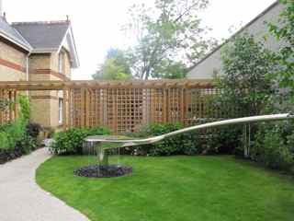

Walking down the path with the fountain – it’s coming on a little journey. I always stop and look at that and think about the water going all the way back again. I always follow the curves in my mind. It’s a stopping point for me. I instinctively do it. I don’t think about it.

Figure 3.2. MC28 woman with cancer (2012)

Figure 4: Maggie’s Cheltenham (2012) (MC28 woman with cancer)

Sanctuary and Sociability: Maggie’s as therapeutic landscapes

Both projects were able to reveal some of the networks and affordances presented by the buildings and gardens. In Martin’s research, conversations often touched upon definitions of the essence of a Maggie’s Centre; in one group, a participant defined ‘everything that Maggie’s is about - it’s sanctuary and peace’. The capacity of the Centres to allow time for peaceful reflection was a shared quality across buildings and gardens often very different, materially and aesthetically, from each other. Careful analysis of the data revealed how the designed spaces at Maggie’s, both inside and out, can provide specific and unique opportunities for care in ways that are highly charged for individuals (both visitors and staff alike). So, data from Butterfield’s photo elicitation exercises reveal how participants would respond to different aspects of the garden in deeply subjective ways whereby, for example, sensing a particular plant would trigger intimate memories for visitors. Similarly, members of staff in Martin’s study specified in their interviews how particular places in their Centres, often rooms set apart from busier areas and with a view to the outside, were used by individuals as spaces of respite from the emotional demands of their cancer treatment, or from caring for loved ones. These examples of individual areas within Centres have cumulative effects and can enhance the healing ethos of a healthcare community, thereby contributing to the wellbeing of its users.
A key theme across projects was appreciation by respondents when the Centres had successfully brought qualities of the outside garden and green spaces inside the building, for example, through easily accessible courtyards and the generous provision of natural light (Figure 5). Furthermore, Butterfield’s (2014a & b) research shows how the Maggie’s gardens provide specific opportunities for care and contribute to the overall healing atmospheres of the Centres. Participants highlighted certain qualities or what are described as ‘essences’ that the gardens offered (with varying degrees of effectiveness). These essences were identified as thresholds, sensory richness, density of time and homeliness (Butterfield 2014a & b). The gardens acted as useful thresholds (Figure 6). They helped people reach Maggie’s and once there the garden spaces provided a particular type of sanctuary, a sensory richness and the opportunity to experience time in different ways.

[FIGURES 5 and 6 ABOUT HERE]

Participants drew personal symbolism from the gardens that they related to their own state of being or indeed more specifically to their experiences of cancer. They also described how some of the gardens contributed a sense of intimacy but also interconnectedness. This suggested that the gardens contribute to the overall sense of ‘feeling at home’ at the Centres, a response which was repeated by participants across both projects. The research also revealed a correlation between participant engagement with the designed spaces and the care those spaces were receiving. It also revealed some of the ways the spaces can support staff.
As staff at Maggie’s have observed, when people are unwell, in shock or dying they often experience a crisis that challenges perception, purpose and meaning (Lee, 2012, p.8-12). Their gardens offer thresholds at a physical, cognitive and symbolic level. Indeed the specific affordances of a garden are quite different to, and sometimes much stronger than, the effects of architecture (Grahn et al., 2010). These affordances included a sensory richness and a different sense of time provided by the gardens. For one participant:

The garden and green spaces are areas to take you away from the hustle and bustle of everyday life and give you the opportunity to stop, look around and appreciate nature. Admire the blooms, enjoy the fragrance, listen to the joyful singing of birds, feel the wind and warm sunshine on your face. This takes you away from cancer and who would dare to say it does not help in the healing process. (Male Centre user)

What emerged was evidence of a particular type of sanctuary within the gardens. Participants described their experiences of the gardens enhancing feelings of calmness, privacy and containment but also, specifically, a sense of intimacy. The research also revealed that the gardens supported staff by providing refuge from the emotional demands of their work; moreover, it appeared important that staff were not only supported by, but actively engaged with, the garden. The gardens helped with their work by offering a focus for conversation for therapeutic work, softening the experience for visitors and offering different spaces for different conversations.
Across sites, the idea that these gardens and buildings should facilitate different conversations suggests the dialogical qualities of these spaces; through their architecture and garden design, Maggie’s creates places that are neither neutral nor nondescript, but rather emotionally charged. In doing so, the Centres afford different qualities of conversation about the placing of illness in everyday life; they help to create what we call ‘narratives of resilience’, whereby individuals may articulate their understandings of their cancer and begin to craft their response. Maggie’s Centres create such an affective sense of place, for many of the visitors we interviewed, because of the powerful interplay between internal and external spaces. One participant in Martin’s research spoke for many others when noting that Maggie’s was somewhere she would often not discuss cancer at all. This was in contrast to many other places, clinical and otherwise, where she felt her identity was shaped in large part by her diagnosis. The trees and plants visible within buildings offer a chance to escape the immediate pressures of individuals’ changed lives, and the buildings themselves assert a palpable presence that holds the space open for different forms of conversational dialogue. Such a relational sense of place, between people, space and the affective ties between them, opens up an understanding of the complex composition and intimate experience of the designed environment in the experience of wellbeing (Conradson, 2005).
This sense of place is achieved in sites where spectacular façades and architectural forms may belie the quotidian social practices and familiar objects greeting visitors within the Centres. Elsewhere, Martin has written of the efficacy of everyday artefacts and spaces in orchestrating the support offered in Maggie’s (2016): these include the kitchen areas that are written into the architectural brief as crucial to establishing a welcoming and relaxed atmosphere (Maggie’s, 2012), but also a multiplicity of everyday objects, such as non-clinical books in the library areas and low coffee tables (rather than high desks) around which therapeutic work can take place (Martin, 2015). Together, these combine to create an anti-institutional landscape, or affectively resonant space of respite: for one focus group member ‘all a Maggie’s needs is a kitchen table and the kettle and the welcome’. Maggie’s provides centres of sociability that allow what has been termed ‘the freedom to tarry’ (Cattell et al., 2008, p.554). The communal areas of these Centres, notwithstanding the quiet reflections they facilitate, help to create enabling spaces. Running through the design principles are instructions to encourage individual visitors to approach the Centres on their own terms, by giving them enough visibility of the space to feel comfortable about participating in group conversations or not (Jencks and Heathcote 2010, p.219-222). Visitors repeatedly suggested that this is how they felt, and the material affordances of the Centres themselves allowed for these feelings (Rose, Degen and Basdas, 2010).

Conclusion

Overall the combined findings suggest that Maggie’s Centres are healing places; they are sociable spaces, within which visitors can be guided towards feelings of sanctuary. Alongside communal spaces designed for conversations about cancer with peers and professionals, Maggie’s Centres offer individuals places for emotional retreat, and the time to reflect upon a sense of self which is altered, but not purely defined, by cancer. Visitors reported that they used their centres in different ways and for different purposes; sometimes for sociability and peer support, and sometimes for emotional retreat or affective sanctuary. The buildings and gardens offer the flexibility of function that is an aspiration in each Maggie’s Centre (Jencks 2015, p.28-31). Not only this, but also the intersection between the spatial contexts and temporal aspects of the individual’s response to cancer is made clear through these Centres. Through the garden spaces in particular, amongst spaces of sociability, Maggie’s can be seen to offer places in which people can access a deeply subjective time for personal reflection, away from the institutional timetables they fit into elsewhere. In so doing, they can provide places of physical and affective sanctuary, where the designed environment assumes a form of agency, acting as a calming presence in the individual’s encounter with a cancer diagnosis. The Centres evoke spatial atmospherics of care that are forged through the relations between an ‘ensemble of elements’ and artefacts that comprise the ‘aesthetic object’ (in these cases, the buildings and gardens) and the practices and meanings attributed to them by ‘the perceiving subject’, or centre user (Anderson, 2009, p.79).
In the varieties of encounter many respondents reported in Maggie’s, we are reminded of Gesler’s multi-faceted definition of the therapeutic landscape as simultaneously ‘a product of the human mind and of material circumstances’ (1992, p.743). In suggesting this, we avoid any suggestion that Maggie’s offers a checklist of design features that can be applied in different places with predictable results. As Gesler et al. argue (2004, p.126), such an approach can go only so far in guiding the physical design of particular sites, but cannot anticipate the social and symbolic qualities of place. Rather, Maggie’s design principles (2012) prompt buildings and gardens brought into being through the social practices they host and help to enact; for such extraordinary spaces, they help to organise very ordinary encounters and acts of kindness, between healthcare professionals, volunteers and visitors. And it is in their ‘everyday’ spaces, such as the kitchen table or the garden threshold that Maggie’s offer examples of places where people encounter each other, where they mingle and linger, often for no particular purpose, but to therapeutic ends (Cattell et al., 2008).

Acknowledgements
Butterfield’s research was part of her ESF-funded PhD at Falmouth University and awarded by the University of Arts London. Martin’s research was supported by funding from the Foundation for the Sociology of Health and Illness, and has been guided at every step by support from colleagues at York, most especially Sarah Nettleton. At Maggie’s both researchers owe many thanks to Lesley Howells, the Research Lead, for her support throughout both projects, and also all the individual Centre heads, staff members, volunteers and visitors who gave their time so generously to participate in the research.
References
Anderson, B. (2009). Affective atmospheres. Emotion, Space & Society, 2, 77-81.
Brewster, L. (2014). The public library as therapeutic landscape: A qualitative case study. Health & Place, 26, 94-99.
Butterfield, A. (2014a) Resilient Places? Healthcare Gardens and the Maggie’s Centres, PhD Thesis, University of Arts, London and Falmouth University.
Butterfield, A. (2014b). The Garden Essences. In Jencks, C (Ed.) Architecture of Hope (p.98-109). London: Francis Lincoln.

Butterfield, A. and Martin, D. (2014) Exploring the role of architecture and gardens at Maggie's Cancer Care Centres. Psycho-Oncology, 23, s.3, 318-319.

Cattell, V., Dines, N., Gesler, W. & Curtis, S. (2008). Mingling, observing, and lingering: Everyday public spaces and their implications for well-being and social relations. Health & Place, 14, 544-561.
Conradson, D. (2005). Landscape, care and the relational self: Therapeutic encounters in rural England. Health & Place, 11, 337-48.
Conradson, D. (2007). The experiential economy of stillness: Places of retreat in contemporary Britain. In Williams, A. (Ed.) Therapeutic Landscapes (pp.33-48). Aldershot: Ashgate.
Curtis, S., Gesler, W., Fabian, K., Francis, S. & Priebe, S. (2007). Therapeutic landscapes in hospital design: A qualitative assessment by staff and service users of the design of a new mental health inpatient unit. Environment and Planning C: Government and Policy, 25, 591-610.
Davidson, J., Bondi, L. & Smith, M. (Eds) (2007). Emotional Geographies. Aldershot: Ashgate.
Davidson, J., & Milligan, C. (2004). Embodying Emotion, Sensing Space: Introducing Emotional Geographies. Social and Cultural Geography, 5, 523-532.
Doughty, K. (2013). Walking together: the embodied and mobile production of a therapeutic landscape. Health & Place, 24, 140-6.
English, J., Wilson, K., & Keller-Olaman, S. (2008). Health, Healing and Recovery: Therapeutic Landscapes and the Everyday Lives of Breast Cancer Survivors. Social Science & Medicine, 67, pp. 68-78.
Gesler, W. (1992). Therapeutic landscapes: Medical issues in light of the new cultural geography. Social Science & Medicine, 34, 735-746.
Gesler, W. (1993). Therapeutic landscapes: theory and a case study of Epidauros, Greece. Environment and Planning D: Society & Space, 11, 171-189.
Gesler, W. (1996). Lourdes: healing in a place of pilgrimage. Health & Place, 2, 95-105.
Gesler, W. (1998). Bath’s reputation as a healing place. In Kearns, R. and Gesler, W. (Eds). Putting health into place (pp.17-35). Syracuse: Syracuse University Press.
Gesler, W. (2003). Healing Places. Oxford: Rowman & Littlefield.
Gesler, W., Bell, M., Curtis, S., Hubbard, P. & Francis, S. (2004). Therapy by design: evaluating the UK hospital building program. Health & Place, 10, 117-128.
Grahn, P., Tenngart Ivarsson, C., Stigsdotter, U. & Bengtsson, I. (2010) Using Affordances as a Health-promoting Tool in a Therapeutic Garden. In Ward Thomson, C., Aspinall, P. & Bell, S. (Eds) Innovative Approaches to Researching Landscape and Health (120-161). London: Routledge.
Hartig, T. & Cooper Marcus, C. (2006). Healing gardens: places for nature in health care. The Lancet, 368, 536-537.
Heathcote, E. (2011) Building Hope. The Financial Times, December 11. Available at: http://www.ft.com/cms/s/2/518e88fa-20df-11e1-8133-00144feabdc0.html. Accessed 12/12/2015.

Hickman, C. (2013). Therapeutic landscapes: a history of English hospital gardens since 1800. Manchester: Manchester University Press.
Jencks, C. & Heathcote, E. (2010). The Architecture of Hope. London: Frances Lincoln
Jencks, C. (2015). The Architecture of Hope. 2nd ed. London: Frances Lincoln
Kraftl, P. (2010) Geographies of architecture: The multiple lives of buildings. Geography Compass, 4, 402-415.
Kraftl, P. and Adey, P. (2008) Architecture/affect/inhabitation: geographies of being-in buildings. Annals of the Association of American Geographers, 98, 213-231.
Laws, J. (2009). Reworking therapeutic landscapes: The spatiality of an ‘alternative’ self-help group. Social Science & Medicine, 69, 1827-1833.

Lee, L. (2012). Maggie’s Principles and Practices. London: Maggie’s Cancer Caring Centres.

Lees, L. (2001) Towards a critical geography of architecture: the case of an ersatz Colosseum. Ecumene, 8, 51-86.
Maggie’s (2012) Architectural Brief. London: Maggie’s Cancer Caring Centres. Available at: https://www.maggiescentres.org/media/uploads/file_upload_plugin/maggies-architectural-brief/architectural_brief_maggies.pdf. Accessed 12/12/2015.

Martin, D. (2014) The choreography of the kitchen table: the agency of everyday spaces in the experience of care. Psycho-Oncology, 23, s.3, 203-204.

Martin, D. (2015) Between Bodies and Buildings: the place of comfort within therapeutic spaces. Materialities of Care conference, University of York, September 16-17.

Martin, D. (2016). Curating space, choreographing care: the efficacy of the everyday. In Bates, C., Imrie, R. & Kullman, K. (Eds.). Design as Caring in an Urban World. Oxford: Wiley-Blackwell.
Martin, G., Nancarrow, S., Parker, H., Phelps, K., & Regen, E. (2005) Place, policy and practitioners on rehabilitation, independence and the therapeutic landscape in the changing geography of care provision. Social Science & Medicine, 61, 1893-1904.
Milligan, C., Gatrell, A. and Bingley, A. (2004) ‘Cultivating health’: therapeutic landscapes and older people in Northern England. Social Science & Medicine, 58, 1781-1793.
National Centre For Social Research Qualitative Research Unit (NATCEN) (2011) www.natecen.ac.uk. Accessed 12/12/2015

Rose, G., Degen, M. and Basdas, B. (2010) More on big things: building events and feelings. Transactions of the Institute of British Geographers, 35, 334-349.
Rose, S. (2010) Maggie’s Centres: Can architecture cure cancer? The Guardian, May, 6. Available at: http://www.theguardian.com/artanddesign/2010/may/06/maggies-centres-cancer-architecture . Accessed 12/12/2015.

Spencer, L., & Richtie, J. (1994) ‘Qualitative data analysis for applied policy research’, in Bryman, A., & Burgess, R.G. (eds.) Analysing Qualitative Data. London. Routledge.

Spencer, L., Ritchie, J., Lewis, J., & Dillon, L. (2003) Quality in Quality Evaluation: A Framework for Assessing Research Evidence. London: Government Chief Social Researcher’s Office.

Van der Linden, V., Annemans, M. & Heylighen, A. (2016) “You’d want an energy from a building”: Use experience of healing environment in a Maggie’s Cancer Caring Centre. Proceedings of the 3rd European Conference on Design4Health. Sheffield, July 13-15.
Van der Linden, V., Annemans, M. & Heylighen, A. (2016) Architects’ approaches to healing environment in a Maggie’s Cancer Caring Centre. The Design Journal (forthcoming).
Williams, A. (2002) Changing geographies of care: employing the concept of therapeutic landscapes as a framework in examining home space. Social Science & Medicine, 55, 141-154.
Williams, A. (Ed.). (2007). Therapeutic landscapes. Aldershot: Ashgate.
Woods, V., Curtis, S., Gesler, W., Spencer, I., Close, H., Mason, J., & Reilly, J. (2013). Creating ‘therapeutic landscapes’ for mental health carers in inpatient settings: A dynamic perspective on permeability and inclusivity. Social Science & Medicine, 91, 122-129.

Figures
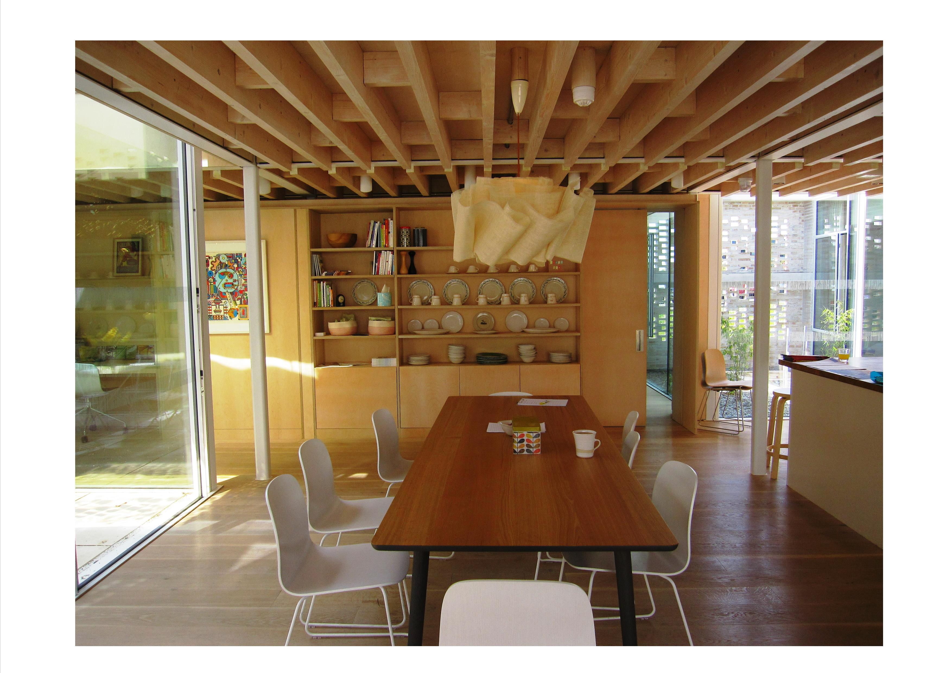
Figure 1: Maggie's Lanarkshire, kitchen table, 2015 (Source: Martin)
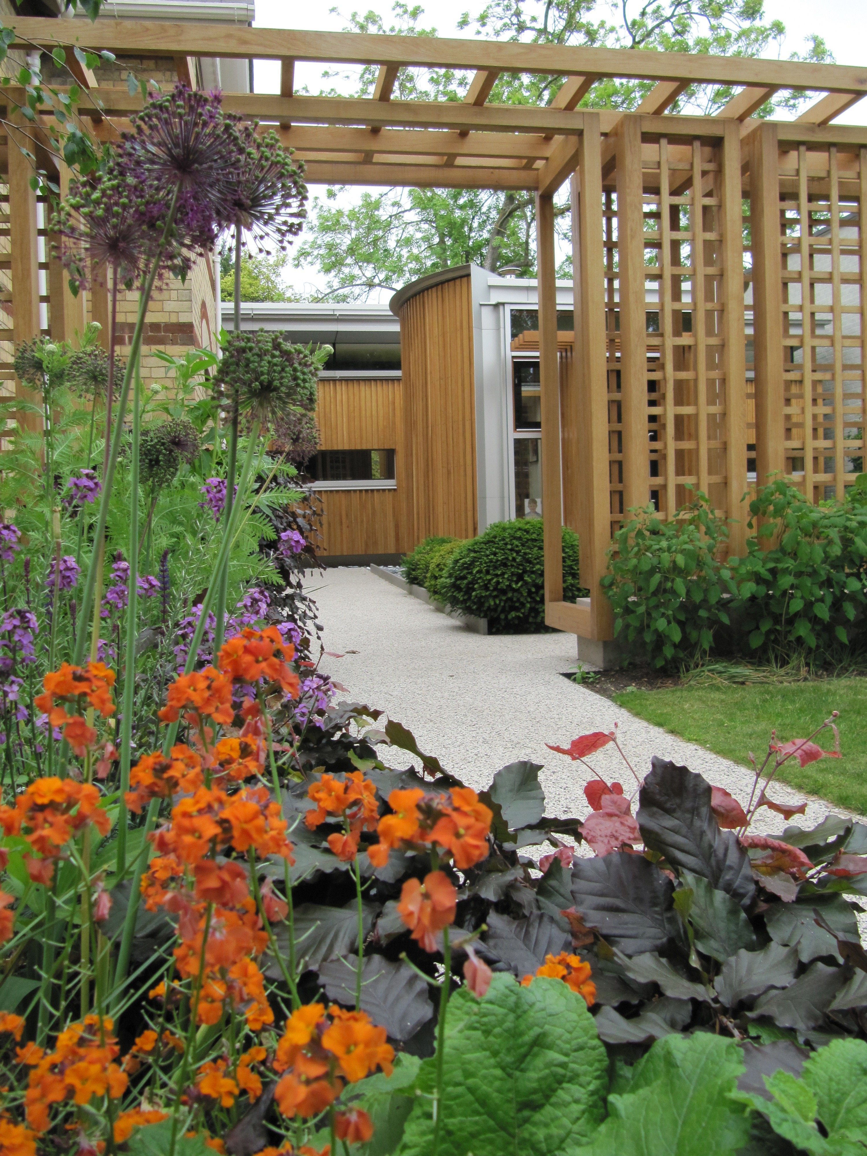
Figure 2: Maggie’s Cheltenham, view looking towards Centre and inner garden, 2011 (Source: Butterfield)

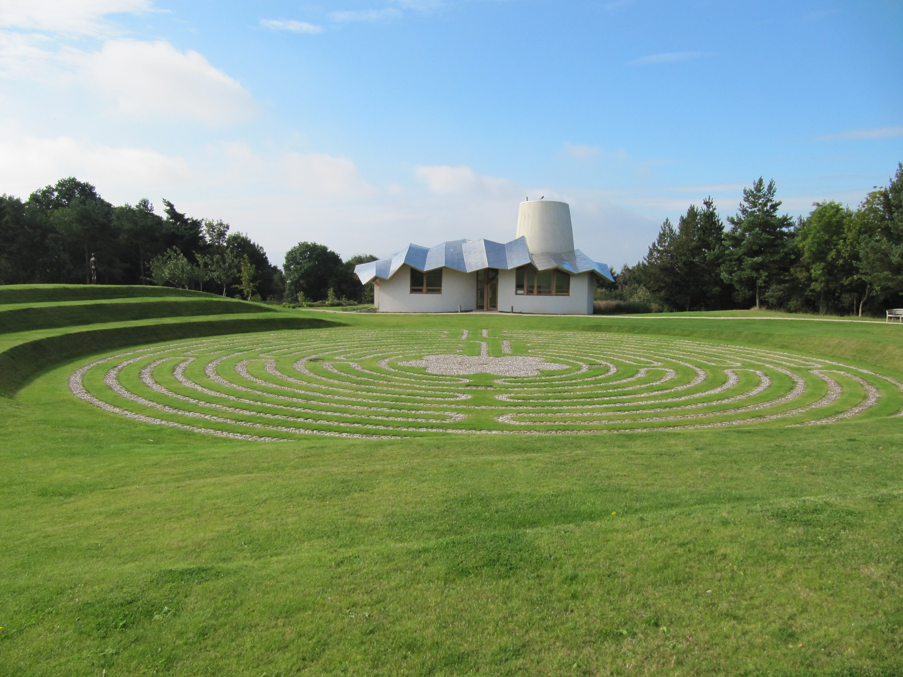
Figure 3: Maggie’s Dundee, building & labyrinth, 2011 (Source: Butterfield)
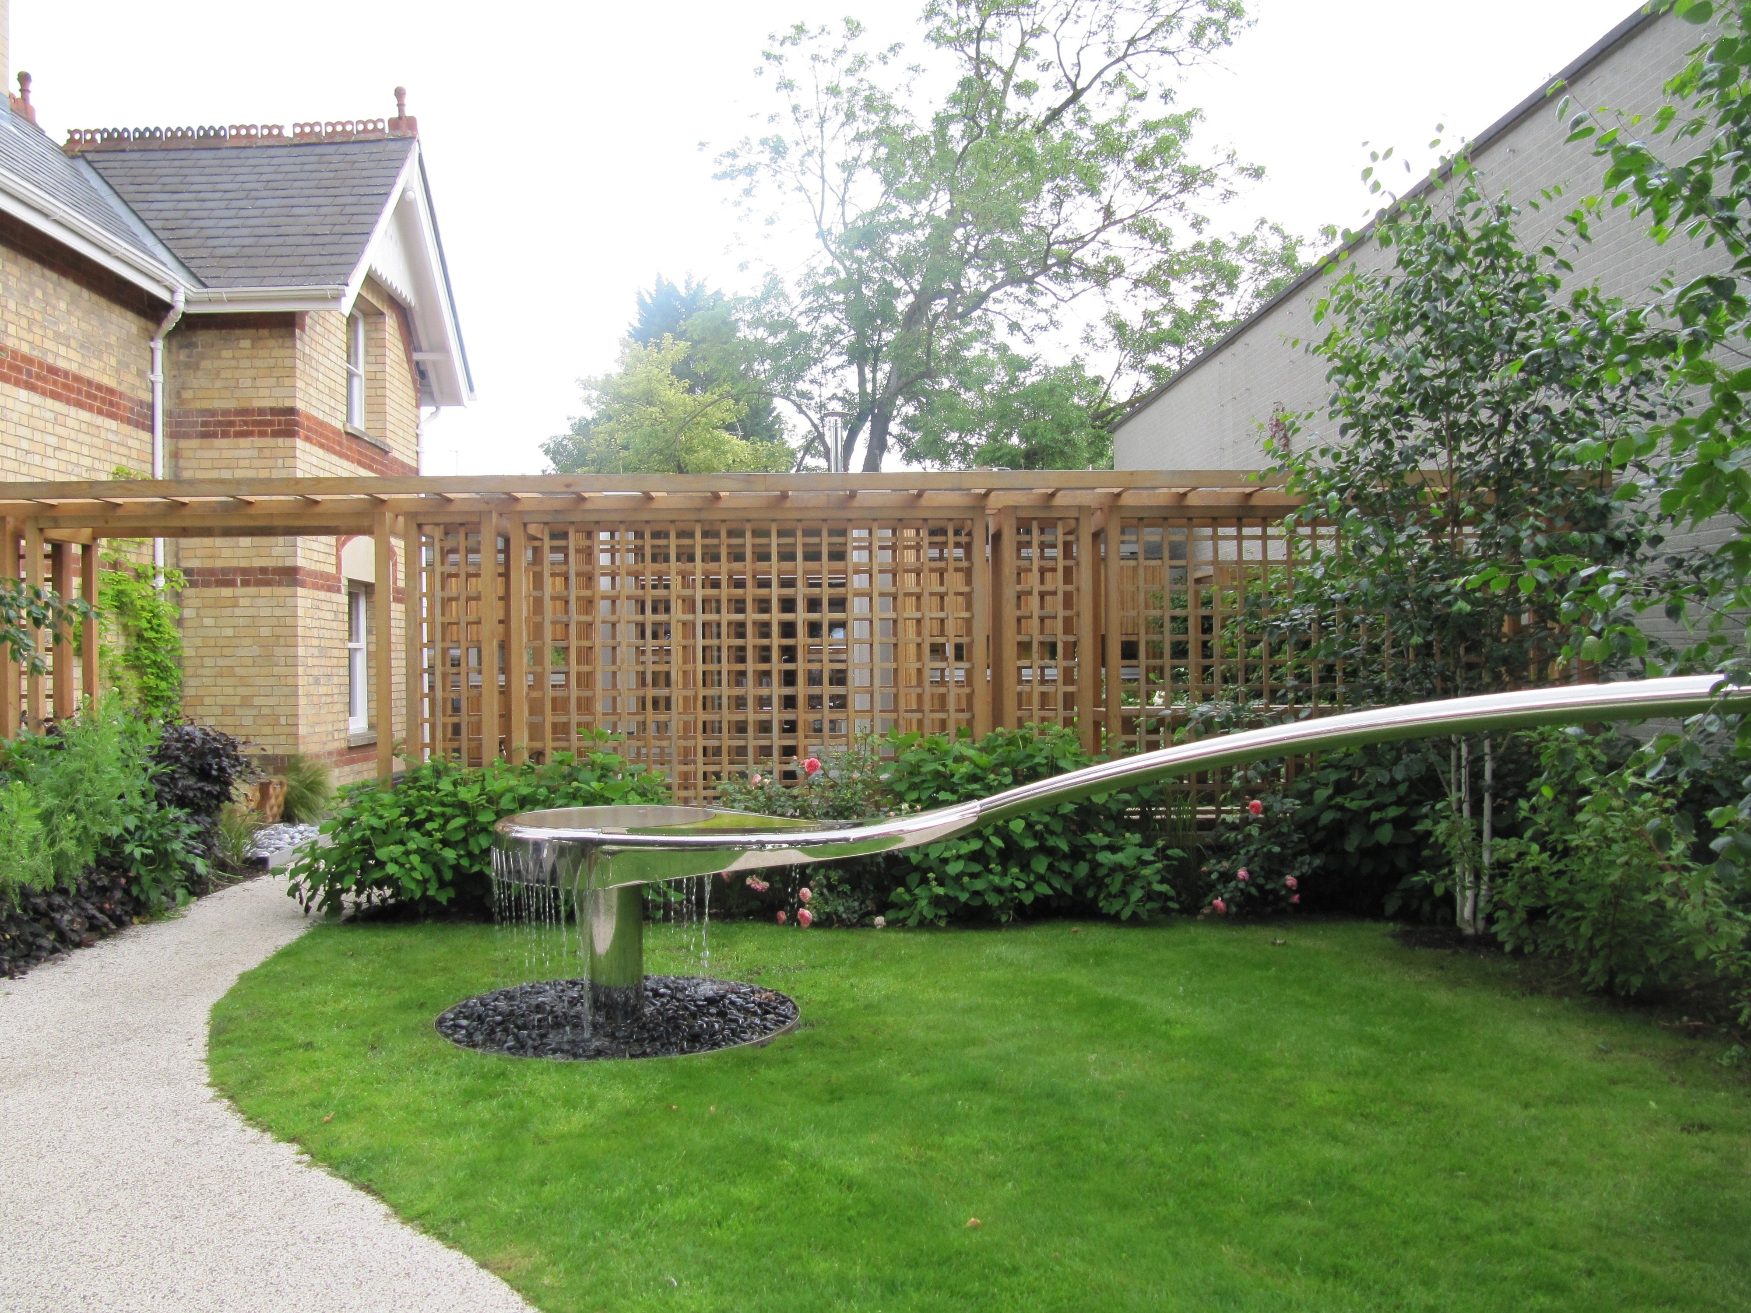
Figure 4: Photo-Elicitation example [participant’s words and photograph], Maggie’s Cheltenham, 2012 (Source: Butterfield)
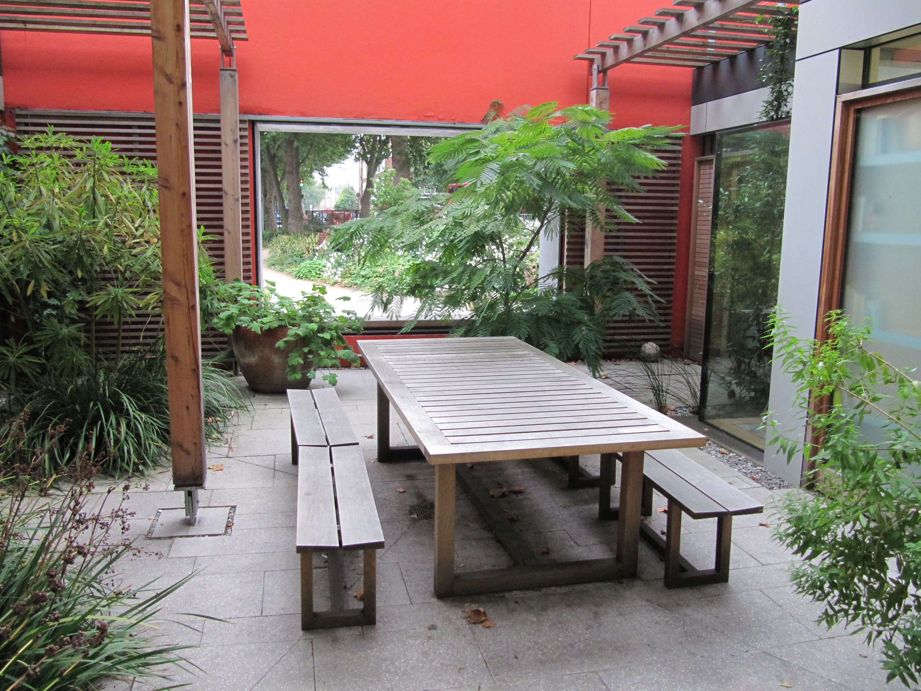
Figure 5: Maggie’s London inner courtyard and framed open window, 2012 (Source: Butterfield)
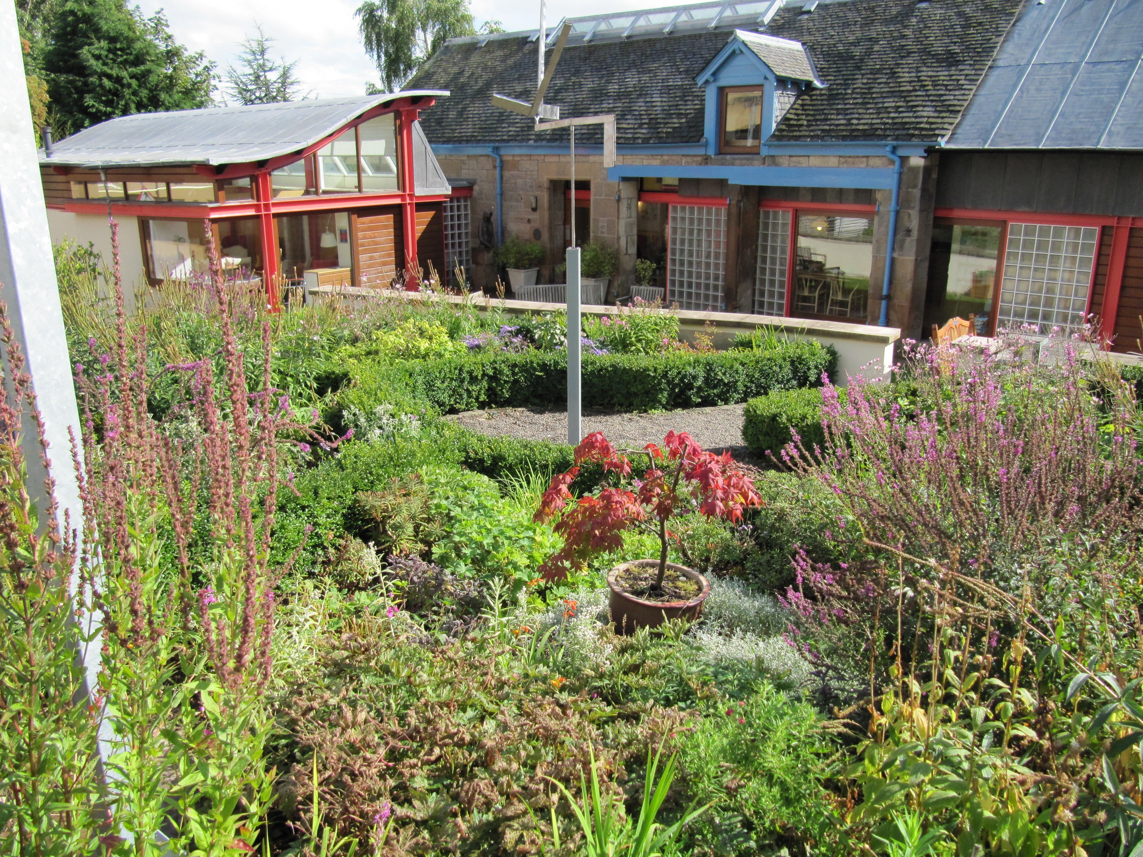
Figure 6: Maggie’s Edinburgh, view of front garden looking towards the Centre, 2011 (Source: Butterfield)

