Out of Sound, out of Mind: Noise control in early nineteenth-century lunatic asylums in England and Ireland
Katherine Fennelly

In his fictionalised account of the life of notorious eighteenth-century highwayman Jack Sheppard, novelist William Harrison Ainsworth led his protagonist to the Bethlem Lunatic Asylum to visit his mother. Ainsworth drew on accounts of the institution to colour and soundtrack his description of Bethlem. On ‘feeing the porter’ and passing through a gate into the asylum, Sheppard was struck by a ‘deafening clamour, resounding on all sides’ (Ainsworth 1839, 235-6; Arnold 2008, 97-8). Sheppard’s impression of Bethlem was intimately bound up with sensory engagement and noise in particular. Lunacy reformers and institutional architects of the early nineteenth century were aware of the importance of the sensory environment in the running and management of asylums. The control of sound for the benefit or treatment of the patients was central to the didactic writing of reformers like Samuel Tuke of the York Retreat, and attempts at noise control can be seen in the architecture and material arrangement of the buildings. Patients were classified according to their ‘noisiness’ and door locks were sometimes selected for their acoustic properties. Asylum soundscapes were also unintentionally characterised by the architecture, the vaulting in their roofing and the coverings on floors and walls.
In his book on Victorian soundscapes, John Picker notes that the imposition of ‘quiet tenor’ of ‘middle-class domesticity’ on the streets of Victorian cities began mid-century (2003, 43). This research seeks to explore the ‘quiet tenor’ that Picker refers to on the interior of buildings in the late Georgian period, by exploring the various different sensory concerns that were built into the design of public asylums. Building on archaeological approaches to the material culture of mental illness (Piddock 2007; Psota 2011), and recent scholarship on sensory experience in asylums (MacKinnon 2003), this paper will examine noise and sound control in early nineteenth-century lunatic asylum buildings, using two main case studies as representative samples of the systems in England and Ireland, with reference to other notable examples. These buildings were amongst the first generation of asylums to be purpose built with moral and therapeutic management practices in mind. This paper will argue that reformers and architects were aware of the effect of the aural environment on patients housed in asylums, and will assess the extent to which their efforts (intentional or otherwise) were successful.
The interior sensory environment of the lunatic asylum was central to the management of the institution and the experience of the inmate (whether staff or patient), and was key to the almost continuous reform and modification of asylum architecture in the British Isles from the early nineteenth century. Light and fresh air were important in choosing sites, and dictated the use of interior spaces, while sound and noise determined the spatial organisation of patients. Though other aspects of the sensory environment were important, the treatment of noise and sound will be focused on here as a distinctive and material feature of asylums.
Sound plays a key role in the popular portrayal of historical asylums and in museum displays: padded cells, for example, have become aesthetic shorthand for madness and incarceration. The sensory affordances of the asylum architecture in this context are as central to the cultural memory of their use as the aesthetic impact of disused asylum buildings (as Godsen [2004, 171] contends with regard to sensory responses). The aural environment of asylum interiors was also characterised by the sounds of patients themselves, which determined the patient’s spatial classification (MacKinnon 2003, 73-5). Despite the centrality of noise in the cultural memory and historical representation of asylums, approaches to asylum architecture, supervision and control generally have tended to focus more on visual evidence and oral testimony.
The case studies that will form the focus of this paper are the West Riding District Asylum (1818), and the Maryborough District Asylum (1833) (Fig. 1). The West Riding Asylum was located in Wakefield in the West Riding of Yorkshire, England, 18km south-east of Leeds. The Maryborough asylum was constructed outside of the town of Maryborough (now Portlaoise), 80km south-west of Dublin in Ireland. The similarities in architecture between these two buildings, and their construction between the early nineteenth-century asylum reform Acts which made provision for the construction of provincial asylums and the 1845 County Asylums Act which established the Commissioners in Lunacy, make them ideal case studies for examining the practical application of reform rhetoric in this formative period. The case studies were chosen for their influence on or representation of other institutions. Wakefield’s design influenced the architecture of other British asylums; the building’s distinctive octagonal towers were replicated at Dumfries in Scotland, while the H-plan was adopted for use at the Hanwell Asylum (Richardson 1998, 164), where influential asylum reformer John Conolly was visiting physician when he published his influential treatise on asylum design in 1847. Maryborough Asylum was one of nine provincial asylums to be constructed in Ireland between 1825 and 1835. Therefore, the two case studies are representative of the architectural trends of the period.

Background: lunatic asylums for the poor
The widespread construction of lunatic asylums in the early nineteenth century reflected a drive towards urban and social improvement near the end of the eighteenth century. Historian Asa Briggs (2002, 2) termed this movement the ‘Age of Improvement’, when the spirit of ‘progress’ ushered in with the European period of intellectual Enlightenment inspired moral, economic, technological, civic and urban improvement and change. The improvement and development of cities during this period required the moral reform and strict ordering of certain sections of society, namely the criminal, the sick and the insane; social ordering was achieved through the construction of dedicated public institutions (Tarlow 2007, 136).
Dedicated lunatic asylums began to proliferate across Europe from the late eighteenth century, set apart from preceding ‘madhouses’ by their provincial character, strict classification and management practices. A notable early example of a ‘reformed’ and improved asylum was the York Retreat outside York, England, a private asylum established by William Tuke, and run along moral lines informed by Tuke’s Quaker beliefs. William was succeeded by his grandson Samuel, a vocal proponent of the construction of reformed and improved asylums for the reception of the lunatic poor. Tuke is notable in the history of medicine for being an active advocate of the idea of ‘moral management’, a care-taking approach to management that promoted patients’ self-control and minimal restraint under supervision (Porter 2004, 212-14; Yanni 2007, 24). Tuke was a prominent reformer, but he was not unique. Tuke was one of several didactic authors who penned treatise on the proper care and management of the mentally ill, as well as the nature of insanity and the specifications for asylum construction (Conolly 1847; Crowther 1838; Ellis 1838; Hallaran 1818; Pinel 1806). These authors set lunatic asylums apart from their institutional peers like prisons and Houses of Industry (a precursor to the workhouse system) proposing that asylums were ‘domestic’ institutions and should be run as such.
The first district asylums for the poor were constructed in England following the 1808 County Asylums Act, and in Scotland and Ireland contemporaneously. In Ireland, nine public asylums constructed between 1825 and 1835 were all variations of two plans designed by institutional architect Francis Johnston (more famous for his work on Dublin’s General Post Office), and his nephew William Murray. Johnston was the first choice architect for the Irish Board of General Control who oversaw the construction of the asylums; the Board’s choice of Johnston reflected a greater degree of governmental control over provincial asylum building in Ireland than elsewhere in the British Isles. In England, county asylums were overseen by local groups of magistrates and rather than appointing an architect, the plan for new asylums was subject to architectural competitions. The chosen design for Wakefield was by local architects Watson and Pritchett. Like Watson and Pritchett, Johnston was advised to design an asylum similar to the York Retreat. His objections to the reuse of a prison in Co. Roscommon as a provincial asylum indicates that Johnston was broadly aware of trends in asylum design, and the requirements for the practice of moral management, such as strict patient classification and the provision of recreation space for patients (NAI - OPW 999/784, 16-18).
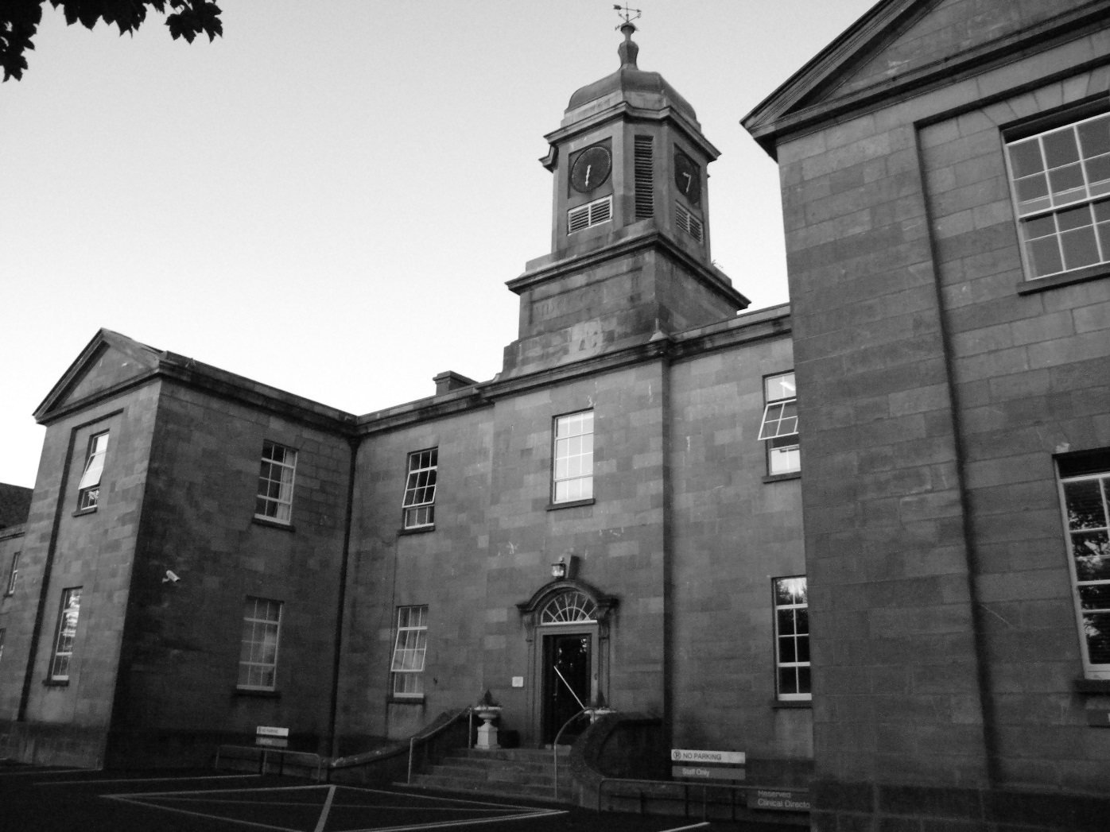
Figure 1: Elevation of administration block of Maryborough District Lunatic Asylum building.
The new open, ordered architecture of the asylums reflected increased regulation in urban planning during the late Georgian period. The buildings were largely symmetrical and geometric in shape; the two examples studied here were shaped into an H (Wakefield) and a K (Maryborough). The asylums were surrounded by landscaped grounds for the use of the patients, and which made use of illusionary features as a means of security, such as ‘ha-has’ or raised lawns. Unlike convict gaols such as those located in the neighbourhood of the asylums at Wakefield and Maryborough, lunatic asylums were built to facilitate a management style based on middle-class domestic ideals.

Methods
In contrast with anthropological approaches to studying sound which use sound recording methods (see Feld and Brenneis 2004), historical asylum soundscapes were reconstructed from documentary sources for the purpose of this research. As the asylums in question had undergone substantial development since their construction, the interior fabric and layouts were significantly different. As such, recording inside the buildings would not have been useful as modifications, plastering, resurfacing and weathering of the buildings mean that the original effects of noise and light have been altered since construction. In order to reconstruct the historical sonic environment, the documentary record was used critically to inform on the representation and accounts of material culture. The documentary record not only offers accounts on how sensory concerns were materialised, but also reinforces and informs on the discourse surrounding sensory concerns (Joyce 2005, 147). By examining the sensory and material affordances attributed to material culture (as described in the historical record), their significance (whether intentional or otherwise) may be determined (Hurcombe 2008, 537).

“Objectionable Sounds”: Keys and Locks
Tuke was a vocal proponent of the ‘domestic’ asylum, reasoning that increased attention to neatness and comfort in the lives of the patients was advantageous in treating them (1813, 103). ‘Domestic’ hierarchies informed the social make-up of the institution. Keys were indicators of authority in domestic households in Georgian Britain, as were access privileges. As such, keys were rationed within the household; they were generally entrusted to a few people, and domestic keys were generally under the ownership of the patriarch, the head of the house (Vickery 2009, 42-3). A similar familial power relationship was practiced in asylums, between keepers and patients, and management and keepers. The Manager and Matron were assigned parental roles over all inmates, staff and patients alike. Where total access privileges belonged to the Manager and Matron, however, keys were delegated out to keepers. The relationship between patients and keepers was defined by a power structure based on key possession and access control. Keys made noise when attached to the uniforms of keepers or carried in their hands. The unseen aural presence of a keeper within the corridor both reinforced the security of the institution, and also lessened the sense of isolation in the sleeping rooms (Fig. 2).
Keys and locks feature prominently in museum collections on the history of mental health. At the Stephen Beaumont Museum in Wakefield, for example, keys are suspended from the uniforms of male and female mannequins representing keepers and nurses. Their display suggests that ‘locking’ and security were central to the management of the buildings, the internal atmosphere and the legacy of the asylum. However, the popular representation of locks, bolts and heavy keys as symbolic of institutional control runs contrary to the intentions of the reformers and architects behind the construction of early asylums. Keys were symbolic of status and power, but the locks were, in some cases, reflections of counter-institutionalising the asylum environment.

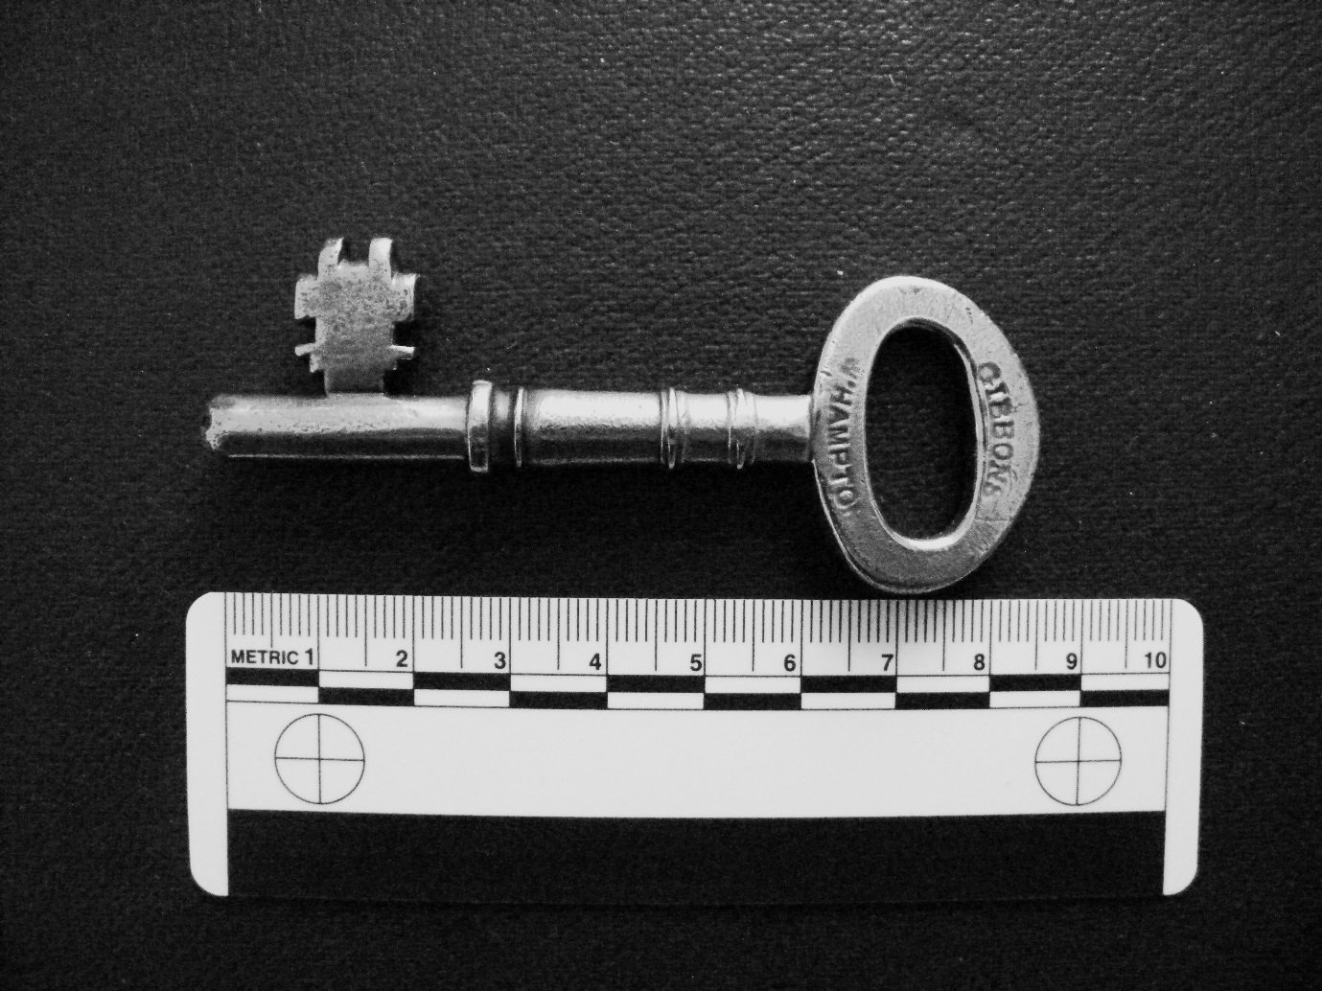
Figure 2: Asylum corridor key (late nineteenth century).
Tuke notes in his 1813 Descriptions of the York Retreat that the doors to the private asylum’s 30 patient rooms were equipped with a spring mortice lock. He points out that though the doors also had bolts, they were rarely used as the sound was a cause of some objection for the patients (Tuke 1813, 101) - the ‘grating sound’ of the bolt being drawn across the lock apparently causing ill-ease amongst the patients. Tuke addressed this problem further by encasing door locks in leather to muffle them (Laffey 2003, 1293). Tuke’s observations on the patients’ reactions to bolt locks influenced the architects of the nearby West Riding Asylum in Wakefield. The Wakefield architects, acting on specifications for the building penned by Tuke in 1814, made a point of omitting bolts entirely from patient rooms. Instead, patient rooms were secured by strong half mortice locks. The architects pointed out that, as well as removing the offending sound, the use of mortice instead of bolts saved some expense. The architects also made a point of highlighting their features for quiet observation: by placing a removable panel in each room door, patients could be observed from the outside without the keeper opening and closing the door (Watson and Pritchett 1819, 31). A similar observation method was practiced at the Hanwell Asylum in Middlsex. In his treatise on the construction of asylums, Conolly remarked that some patients at Hanwell found the experience of being supervised disturbing. In order to minimise patient knowledge of supervision, inspection-plates on the doors were fitted with a cover that made no noise (1847, 24). This feature, adapted from the ‘panoptic’ style of Jeremy Bentham’s prisons, promoted self-regulation by the patients, while at the same time going some way towards preserving their comfort. While this may seem paternalistic and intrusive, the reformers and architects were intent on minimising disturbance of the patients through noise.
On the contrary, contemporaneous Irish asylums do not evidence the same concerns. This is likely due to only partial engagement on the reformers and architects part with reform literature on asylum construction, a drawback to Ireland’s centralised system which oversaw provincial asylum building. The Board of General Control’s choice of a single architect in Johnston betrays a lack of interest in appointing an architect with extensive experience in the ‘reformed’ asylums. This indifference is further supported by the Board’s refusal of the services of James Bevans, a London-based architect, asylum reform scholar and son of the York Retreat architect John Bevans. James Bevans had been nominated for the job by the then secretary to the Lord Lieutenant of Ireland, Robert Peel and had furnished the Board with his designs and a short manuscript about asylum construction. Despite Bevan’s expertise in asylums, a heated letter exchange between Bevans and the Board between 1817 and 1818 indicates that the Board had passed his designs to their nominated architect Johnston rather than consider Bevans himself (NAI - OPW 999/784). Johnston picked various features from these designs to combine with his own ideas, which were informed by his previous design experience with Dublin’s Richmond Asylum. It is reasonable therefore to assume that Bevans expertise on the features to be included in asylum design, informed by extensive research into moral management and patient classification, were taken on board by Johnston in developing his prototype (SPH – F/8). However, as neither Johnston nor his nephew Murray were dedicated asylum architects, they were not as informed on fashionable reform practices in England as the architects of Wakefield who were following Tuke’s own advice.
Drawings of the cell doors and security doors for the Irish asylums at Carlow, Co. Carlow and Clonmel, Co. Tipperary show that they were secured by a large bolt and a padlock; there is no evidence in the drawing that any attempt was made to muffle the sound. Johnston and Murray’s asylums were ostensibly built with the bare principles of moral management in mind, evidenced by their provision for classification in their asylum designs. Despite the architectural provision for moral management, however, the application of that management practice was not always implemented thoroughly in the furnishings.

Classification and ‘Noisy Patients’
Reformers were concerned with the effect of one patient on another; separating noisy or disruptive patients from recovering patients was of central importance (Piddock 2007, 39). The separation and classification of patients according to varying degrees of illness (as well as by gender and sometimes class) was a feature that set the reformed asylums apart from their predecessors. However, early on there was no widespread consensus on the nature of classification. Scottish asylum architect William Stark, for example, recommended that patients be separated spatially according to sixteen different classifications including gender, class, and varying degrees of illness such as ‘frantic’, ‘incurable’ and ‘convalescent’ (recovering). The logic behind his recommendations was that violence and intimidation could occur where only a broad classification was practiced (Stark 1810, 23).
Sound and noise factored significantly into this. Patients themselves made noise, and this noise was indicative of their classification on admission (MacKinnon 2003, 78). Irish physician John Jacob noted that the interior soundscapes of the lunatic asylum were dominated by patients, and that patient noise had a negative effect on other patients. Jacob challenged any commentator who had entered a lunatic asylum to consider how a recovering and calm patient could be benefited from the presence of other lunatics, “their incoherent talk, their cries, their moans, their indescribable utterances of all imaginable fancies” (1833, 29). Silence and noise were key categories of classification and treatment of recovering patients or those suffering extreme mania.
Sound and other senses (or rather the deprivation of them) played a central part in the treatment of extreme mania in the early asylums. In cases of extreme mania at the Retreat, disruptive patients were placed in a darkened room, and deprived of light and sound (Tuke 1813, 164). This method of isolation, used to encourage the patients to sleep, and thus calm them down was furthered by William Saunders Hallaran, physician to the House of Industry and lunatic asylum in Cork, Ireland. Hallaran practiced the isolation of manic or violent patients in darkened, quiet rooms with the addition of a ‘hammock’ in which the patient could be bound to be kept prostrate, secure and ‘warm’ (1818, 97). In these case sensory isolation and confinement were closely linked to restraint and both Tuke and French asylum reformer Phillippe Pinel were quick to note that in most cases a ‘strait-waistcoat’ was preferable to isolation; Pinel went so far as to note that the confinement of patients in a lying position (using chains) at his asylum, the Bicetre asylum, caused patients to become agitated. Instead, he encouraged movement, albeit with the patient’s limbs bound in the stiff cloth of the ‘strait-waistcoat’ (1806, 186).
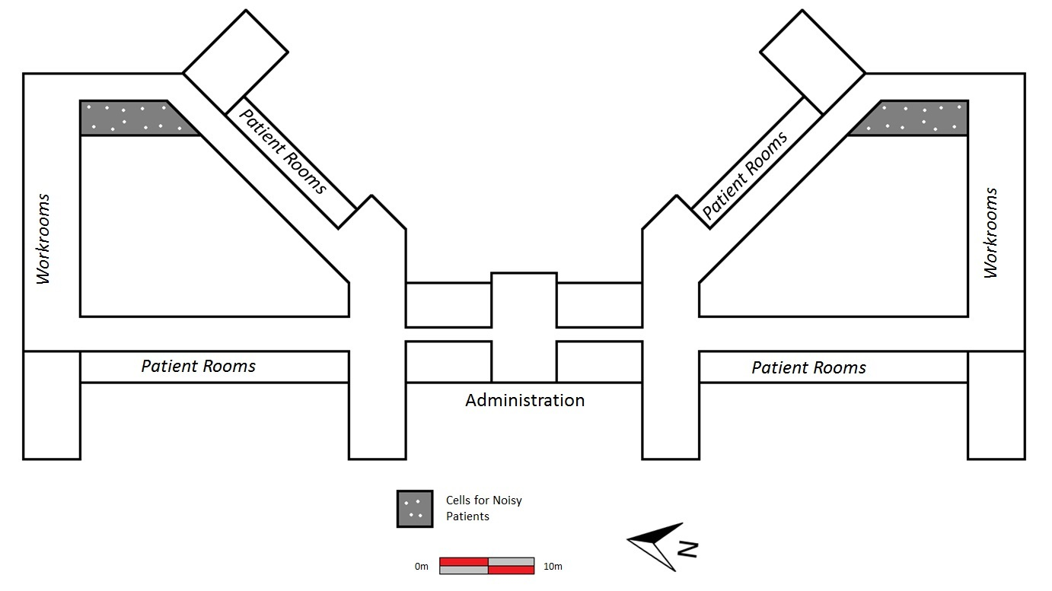
Figure 3: Plan of Maryborough District Lunatic Asylum
Concern over patient disruption was addressed by architects in the separation of patient spaces. Convalescent patients were housed separately from refractory (acute) patients, who were in turn sometimes separate from other denominations such as ‘aged’. In Derby County Asylum (1851), refractory patients were housed to the rear on each side of the building, where their corridors ran perpendicular to corridors for ‘moderately tranquil’ patients in the extreme wings to either side, with ‘aged and infirm’ accommodated towards the centre (Thompson and Goldin 1975, 74-5). Staggering spatial organisation and making patient corridors self-contained effectively tackled the problem of echoing patient noise. At Maryborough and Carlow, noisy patients were housed in separate, contained corridors to the rear of the institution (Fig. 3). On the Carlow plans, noisy rooms are labelled as ‘cells’, in contrast to the ‘sleeping rooms’ elsewhere in the asylum (IAA - MC 137). Aside from being smaller, it is unclear what the difference was between the interior of ‘cells’ and ‘sleeping rooms’, although it is possible that ‘cells’ were temporary and used when necessary. One noticeable difference in plan was that the noisy patient cells faced the interior courtyards of the Irish asylums, rather than out onto the grounds as with the other ground floor rooms. By focusing sound into the interior courtyards, the asylum maintained disturbances within the closed structure.

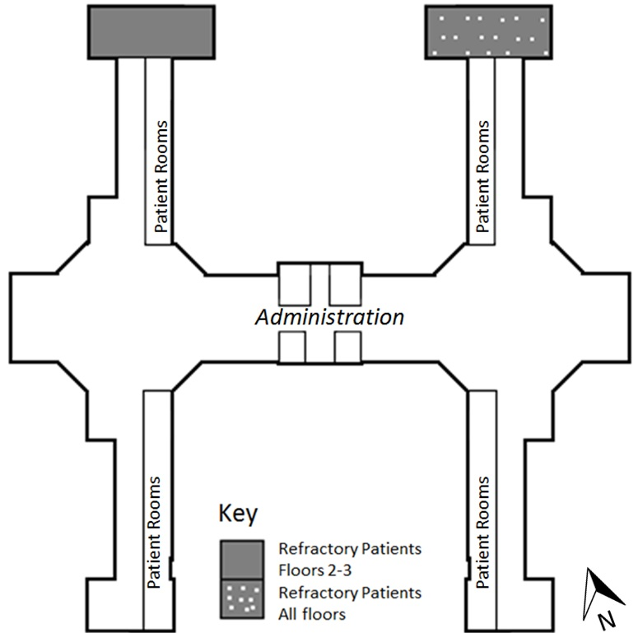
Figure 4: Plan of West Riding District Lunatic Asylum (not to scale)

In order to maintain secure (and consequently quieter) spaces and limit traffic, a closed corridor system was implemented in Wakefield. Accommodation for particularly noisy patients was provided in a closed wing with separate privy and outdoor courtyards on the north-east wing of the ground floor (Fig. 4). The north-east and north-west wings of the second and third floors were also given over to the refractory patients, but the ground floor was for particularly ‘violent, noisy and dirty’ patients (Watson and Pritchett 1819, 27). The floors of these three rooms were paved with a large single flag with a drainage channel cut into the centre, for hygiene purposes. The single flag may also have been an effective (though probably unintentional) means of noise control. Noise may be circulated through breaks in a surface (Moore 1967, 22); a sealed surface such as a single flag potentially meant that sound had less surfaces to bounce against. The walls of this room were also boarded to a height of seven feet to protect patients from harming themselves against the brickwork (Watson and Pritchett 1819, 27). Wooden coverings on the wall were permeable, and would have absorbed sound better than brick.
Noise and classification concerns are also seen in the placement of baths in the asylum buildings. Baths were a shared space between patients and staff. At Wakefield Asylum, baths were separated entirely from patient sleeping rooms, located off access stairwells in the two octagonal towers of the asylum. This allowed for ease of access from inside the building through doors and ante-rooms leading to the patient corridors. The separation of the baths also facilitated ventilation through the stairwell and windows. The allocation of a separate space for bathing the patients meant that the sound of the patient was contained in the bathing room. Separating patient spaces from utility spaces was a central concern for the Wakefield architects, but cannot be said to be universal. Concern with separating patient and staff spaces was not reflected in the designs of Maryborough and Carlow over fifteen years later. For convenience purposes, patient baths at those asylums were situated at the ends of corridors, in separate rooms the size of patient rooms (IAA - MC 137). The situation of the baths in the patient corridors, and the lack of provision for a separate entrance or ventilation would have amplified any noise made in the baths in the sealed interiors of the cell corridors. Rather, the placement of baths in the Johnston and Murray asylums reflect a concern with security over noise as patient baths abutted keeper’s quarters.

Corridors: facilitators of light and noise
Even as spatial arrangement caused unintentional noise issues, conversely noise control may have been catered for unintentionally by the designs architects employed. A common architectural feature in both Ireland and England was the use of vaulted ceilings on interior corridors, one of the various aspects of neo-classical architecture employed by asylum architects, including Palladian facades and extensive grounds (McCullough and Mulvin 1987, 45). This style set them apart from institutional contemporaries (prisons and workhouses) due to their aesthetic relationship with Georgian ‘house’ styles. The architects were very conscious of any features that might give the asylum a gaol-like aesthetic, such as bars; at Wakefield, for example, patient rooms had windows that were adjustable to allow air inside, with bars disguised as sashes (Watson and Pritchett 1819, 31). The determination of asylum authorities to reduce overtly institutional qualities is reflected in the replacement of flagged floors at the Maryborough Asylum at the end of the nineteenth century, due to the ‘prison-like’ appearance of the flagstones. The wooden floors, treated with bees-wax and polished, were deemed to be more home-like (PP 1899, 187). Tunnel vaulting in corridors and patient rooms supported floors above and maximised light distribution from the high windows set in patient rooms and at the ends of corridors. Light was important to early reformers like Tuke and was reflected in the design of Stark’s Glasgow asylum. Tuke lamented that his own institution had patient rooms to either side of the corridors, reducing light; he goes on to praise Stark’s asylum, which had windows on one side of the corridors, with rooms on the other, therefore maximising light distribution (1813, 106). Stark’s technique was mirrored at Wakefield and in Johnston and Murray’s designs for Maryborough and Carlow. At Maryborough and Carlow, the ceiling vaults in the corridors were cut to facilitate the small narrow windows set into the corridor walls which faced the patient rooms (see Fig. 5). The adoption of this form of room arrangement indicates an awareness of the benefits of natural light, whether for economic (cost saving) motives, or as a form of treatment.

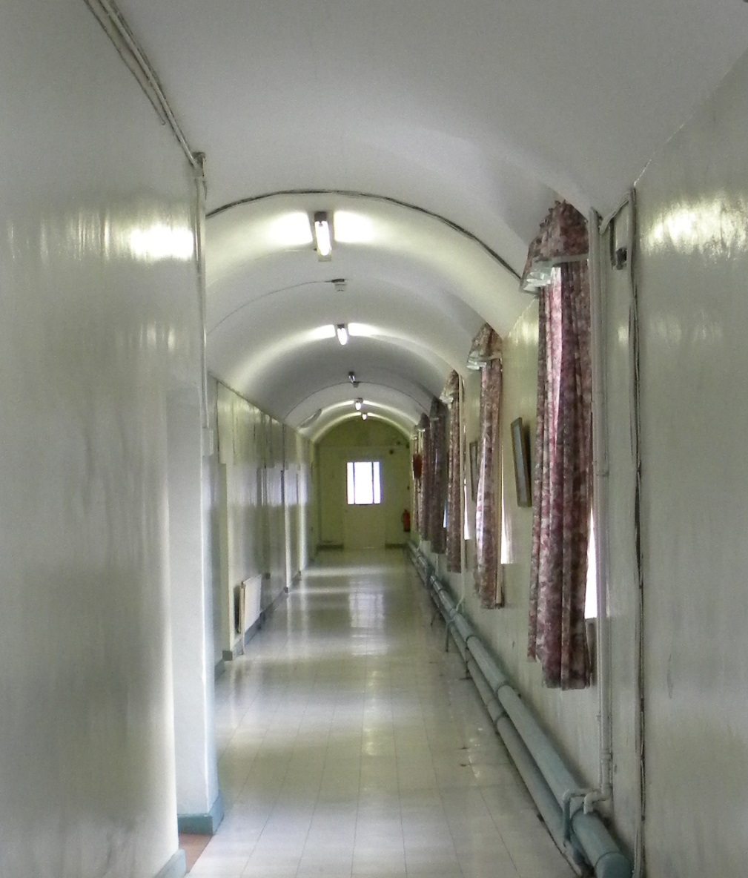
Figure 5: Interior vaulting of asylum corridor (ground floor).
The vaulted ceilings served an apparently unintentional purpose beyond aesthetics and support: noise control. Vaulted ceilings, in corridors or patient rooms, created a series of wide concave arches. In acoustic terms, a concave ceiling focuses and concentrates sound, rather than scattering it (Moore 1967, 22). Sound bouncing off of a tunnel vault would focus back on the surface immediately underneath creating an echo but not scattering it, where a flat surface would scatter the sound. This had the effect of minimising the number of surfaces against which the sound could bounce (Moore 1967, 22-3). As the patient rooms and the corridors at Wakefield were vaulted, sound made inside the room or inside the corridor, would be largely contained there. The convex rounded cills installed in patient rooms in Maryborough and Carlow for the security of the patients may have had the opposite effect, dispersing the sound around the small room (Moore 1967, 22); however the dimensions of the rooms would have contained that noise. It is not clear from didactic writing or the writing of the architects themselves if the use of vaulting as an acoustic feature was intentional; the main purpose of the vaults was to support the floors above. However, architects would have been aware of the acoustic properties of vaulted ceilings in historic buildings across Europe, notably in the gothic churches of York Minster and St. Denis near Paris which had since their construction shaped and influenced the music that was performed in them (Long 2005, 11).
The efficacy of vaulting in containing or focusing noise was also dependent on the floor and walls against which sound could reflect. Original floor coverings are not well documented in architectural records for asylum buildings, but based on the record of changes in the later nineteenth century and the standing remains, it is possible to speculate. The patient room corridors in the Maryborough Asylum were originally flagged – they may even have been tiled. Tiles and flagstones created echoing, creating unnecessary noise. Therefore, the noise-focusing features of the vaults were necessary to contain noise and echoing in the corridors.
On the upper levels, the floors were wooden; wood is more porous than stone, and is therefore more efficient in noise absorption. Therefore, the upper levels (though not vaulted) were better constructed to allow for sound control. In Johnston’s first asylum, the Richmond Asylum in Dublin, convalescent patients were housed in the east and west wings of the north range, in closed areas with wider views than elsewhere in the asylum (IAA - MC 416). Therefore, it is reasonable to assume that convalescent patients at Maryborough and the provincial asylums would have been housed on the west-facing first and second floor corridors of the asylum, as the rooms would have been quieter and brighter.
Despite the best efforts of the architects, however, noise travelled through the asylums due in large part to patients themselves. A commentator on asylums in Britain who visited Wakefield in the early nineteenth century remarked that new patients to the asylum were distressed by the cries and moans of resident patients (Smith 1999, 163). Though the closed corridor system was ideal for containing sound, it also created unnecessary echoing. This was addressed in later asylums. When Colney Hatch was constructed as a second asylum for Middlesex in 1848, the new building was distinctive for its long corridor, nearly a quarter of a mile long, which connected the patient corridors (Richardson 1998, 168). This improvement on the earlier asylum plans and based on their shortcomings, would have been more suitable for diffusing sound.

Noise, Language and Resistance
As excessive noise was a symptom of extreme mental illness in the early asylums, the use of noise as a tool for resistance to the asylum is inextricably bound up in treatment. Therefore, resistance to the asylum’s sonic environment is difficult to separate from patient illness in the historic records. As patients and staff became more actively involved in asylum life, they made use of standardised cutlery, food receptacles, uniforms and hygiene requirements which in turn minimised their cultural indicators and their scope for material resistance to asylum norms. As MacKinnon has noted in her work on asylum soundscapes in Australia, the cultural and linguistic diversity of the asylum and its soundscape is not reflected in the material culture of asylums; she extends this lack of cultural diversity to a ‘sonic imperialism’ at work, notably in the imposition of English as the dominant spoken language (2003, 78). In Irish asylums this poses interesting questions about the social and linguistic make up of asylum inmates (patients and staff) who were mainly comprised of working class or paupers.
The Irish asylum hierarchy was dominated by the manager and physician, whose language for official communication was English, regardless of cultural diversity within the asylum. In 1817, the governors of the Richmond District Asylum in Dublin called for the compilation of ‘Rule Boards’ to be displayed in day rooms (NAI - RDLA, 12/9/1817); the rules were drafted in English, despite the probability that many people in the asylum may have spoken Irish, as a first or second language. Though Irish was in decline as a language in the nineteenth century, the number of native and fluent Irish speakers at the beginning of the century has been estimated at 3.5 million (O'Néill 2005:285). The written composition of ‘rules’ for patients in English at the Richmond Asylum further reinforces the point that English was to be the official language spoken and displayed in the government-sponsored institution, without provision for any who could not read or understand it. This form of cultural colonialism presented an opportunity for resistance. Irish may have been used as a linguistic and sonic tool of resistance and identity within the asylum, similar to the use of Irish by female anti-treaty prisoners in the 1920s who were incarcerated in Dublin during the Irish Civil War (Casella 2009, 180).

Conclusion
The architects and reformers responsible for constructing lunatic asylum buildings in the early nineteenth century were concerned primarily with the cure and quick turnaround of pauper patients. Part of the process of ‘curing’ the patient was the provision of a domestic style institution that promoted patient comfort within the institution, and safety from themselves and from the world outside.
Architecture or materials that sought to manage the ‘institutional sounds’ of keys and bolts were not widespread in the early asylums. However, Tuke’s description of the effect of these sounds on his patients and the adoption of his suggestions by the Wakefield architects evidences the importance placed on the sonic environment in the early nineteenth century. A growing awareness of the importance of the sonic environment was explicitly addressed in the strict classification, separation and treatment of ‘noisy’ patients, which became standard practice in England and Ireland by the mid-nineteenth century. The architect’s designs were helped or hindered by the materials and designs they adopted. Where vaulted ceilings helped to focus sound, the popular security feature of closed corridors inhibited the dispersal of noise. Despite their best efforts, the architects’ and reformers’ ability to contain patient noise, particularly in large public asylums was limited. Making noise was one of the only means of resistance open to the patients. Further research may consider the potential for different cultures and linguistic groups within the asylums, and how they negotiated the cultural homogeneity of the asylum system.
Despite multiple methods devised to control and contain unwelcome noise, the problem could only be managed, not eliminated entirely. The early asylums were succeeded by larger institutions like Colney Hatch, where the issues of enclosed corridors were addressed by the sheer scale of the asylum, though features like vaulted ceilings and closed corridors were retained. As asylums expanded, an increasingly specialised industry grew up around them, developing innovative new technologies such as padded rooms, which contained the sound of patients during bouts of mania. Indeed, where padded cells have become synonymous with the ‘institutional’ and ‘carceral’ aesthetic of asylums in the popular imagination, these devices were, in fact, part of a long tradition of sound control and patient management. What the attempts of reformers like Tuke and architects like Johnston, Watson and Pritchett show is that the sonic environment has been an aspect of asylum design from at least the end of the eighteenth century. This study has argued that the sonic environment was fundamental to the design and management of therapeutic environments, and that the sounds, as well as the sights, of the asylum play an important role in understanding these institutions.

Acknowledgements
Dr. Dolly Mackinnon, Professor Eleanor Casella, Dr. Julie-Marie Strange, Urban History Group, Maarten Walraven and the staff of St. Fintan’s Hospital, Portlaoise.

Katherine Fennelly,
Department of Archaeology, University of Manchester,
Katherine.le.fennelly@gmail.com

Bibliography
Ainsworth, W. H. 1839. Jack Sheppard: A Romance. London: Richard Bentley.
Arnold, C. 2008. "Bedlam : London and madness". London: Simon & Schuster.
Briggs, A. 2000. The Age of Improvement, 1783-1867. 2nd ed. Harlow: Pearson Education Limited.
Casella, E.C. 2009. “Written on the Walls: Inmate Graffiti within Places of Confinement.” In The Archaeology of Institutional Life, edited by A. M. Beisaw and J.G. Gibb, 172-186. Tuscaloosa: The University of Alabama Press.
Conolly, J. 1847. The construction and government of lunatic asylums and hospitals for the insane. London: John Churchill.
Crowther, C. 1838. Observations on the Management of Madhouses, illustrated by occurences in the West Riding and Middlesex Asylums. Translated by. London: Simpkin, Marshall, and Co.
Ellis, W. C. 1838. A Treatise on the Nature, Symptoms, Causes, and Treatment of Insanity. London: Samuel Holdsworth.
Feld, S. and D. Brenneis. 2004. "Doing Anthropology in Sound". American Ethnologist 31 (4): 461-474.
Godsen, C. 2004. “The Past and Forgein Countries: Colonial and Post-Colonial Archaeology and Anthropology”. In A Companion to Social Archaeology, edited by L. Meskell and R.W. Preucel, 161-178. Oxford: Blackwell Publishing.
Hallaran, W. S. 1818. Practical Observations on the Causes and Cure of Insanity. Cork: Edwards and Savage.
Hurcombe, L. 2008. ‘A sense of materials and sensory perception in concepts of materiality’. World Archaeology 39 (4): 532-545.
Jacob, J. 1833. Observations and Suggestions on the Management of Maryborough District Lunatic Asylum. Dublin: P. Dixon Hardy.
Joyce, R. A. 2005. “Archaeology of the Body”. Annual Review of Anthropology, 34: 139-58.
Laffey, P. 2003. "Psychiatric Therapy in Georgian Britain". Psychological Medicine 33: 1285-1297.
Long, M. 2005. Architectural Acoustics. London: Elsevier Academic Press.
MacKinnon, D. 2003. "Hearing Madness: the Soundscapes of the Asylum". In 'Madness' in Australia: Histories, Heritage and the Asylum, edited by C. Coleborne and D. Mackinnon, 73-82. Queensland: University of Queensland Press.
McCullough N. and V. Mulvin. 1987. A Lost Tradition: the nature of architecture in Ireland. Dublin: Gandon Editions.
Moore, J. E. 1967. Design for good acoustics. 2nd ed. London: Architectural Press.
O'Néill, D. “A case of Irish/ An Gahaeilge in the Irish Republic.” In Rebuilding the Celtic Languages: Reversing the Language Shift in the Celtic Countries, edited by D. O'Néill, 276-321. Ceredigion: Y Lolfa.
Picker, J.M. 2003. Victorian Soundscapes. Oxford: Oxford University Press.
Piddock, S. 2007. A Space of their Own: the Archaeology of Nineteenth-century Lunatic Asylums in Britain, South Australia and Tasmania. New York: Springer.
Pinel, P. 1806. Traité médico-philosophique sur l'aliénation mentale. Translated by D. D. Davis. London: Mssrs Cadell and Davis.
Porter, R. 2004. Madmen: a social history of madhouses, mad-doctors and lunatics. Stroud: Tempus Publishing Limited.
Psota, S. 2011. "The Archaeology of Mental Illness from the Afflicted and Caretaker Perspective: a Northern California Family’s Odyssey". Historical Archaeology 45 (4): 20-38.
Richardson, H. (ed) 1998. English Hospitals 1660-1948: a survey of their architecture and design. Swindon: Royal Commission on the Historical Monuments of England.
Smith, L.D. 1999. Cure, Comfort and Safe Custody. London: Leicester University Press.
Stark, W. 1810. Remarks on the construction of public hospitals for the cure of mental derangement Glasgow: James Hedderwick and Co. .
Tarlow, S. 2007. The Archaeology of Improvement, 1750-1850. Cambridge: Cambridge University Press.
Thompson, J. D. and G. Goldin. 1975. The hospital: a social and architectural history. New Haven: Yale University Press.
Tuke, S. 1813. Description of the Retreat, an institution near York for Insane Persons of the Society of Friends. York: W. Alexander.
Vickery, A. 2009. Behind Closed Doors: at home in Georgian England. London: Yale University Press.
Watson, C. and J. P. Pritchett (eds.) 1819. Plans, elevations, sections, and description of the pauper lunatic asylum at Wakefield. York: W. Alexander.
Yanni, C. 2007. The Architecture of Madness: Insane Asylums in the United States. Minneapolis: University of Minnesota Press.

List of Abbreviations
IAA- MC: Irish Architectural Archive - Murray Collection of Architectural Drawings..
PP: British Parliamentary Papers, 1899 [C.9479], The forty-eighth report (with appendices) of the inspectors of lunatics (Ireland).
NAI - OPW 999/784: The National Archives of Ireland - Commissioners for General Control and Correspondence for Superintending and Directing the Erection, Establishment and Regulation of Asylums for the Lunatic Poor in Ireland..
NAI – RDLA: The National Archives of Ireland - Richmond District Lunatic Asylum Minute Books.
SPH - F/8: St. Patrick’s Hospital Archive, Dublin - “Plan of a Provincial Lunatic Asylum for Ireland for the Accommodation of 100 Patients by F. Johnston, Arch. November 1817.”

