Exchange bias effects in Heusler alloy Ni2MnAl/Fe bilayers

Tomoki Tsuchiya1, Takahide Kubota2, Tomoko Sugiyama2, Teodor Huminiuc3, Atsufumi Hirohata4, and Koki Takanashi2

*1Department of Material Science, Graduate School of Engineering, Tohoku University, Sendai 980-8579, Japan*

*2Institute for Materials Research, Tohoku University, Sendai 980-8577, Japan*

*3Department of Physics, University of York, York YO10 5DD, England*

*4Department of Electronics, University of York, York YO10 5DD, England*

E-mail: t.tomoki@imr.tohoku.ac.jp, tkubota@imr.tohoku.ac.jp

**Abstract**. Ni2MnAl Heusler alloy thin films were epitaxially grown on MgO(100) single crystal substrates by ultra-high-vacuum magnetron sputtering technique. X-ray diffraction and transmission electron microscopy observation revealed that the structures of all the Ni2MnAl thin films were *B*2-ordered regardless of the deposition temperature ranging from room temperature to 600ºC. The temperature dependence of electrical resistivity showed a kink about 280 K, which was consistent with a reported value of the Néel temperature for antiferromagnetic *B*2-Ni2MnAl. The magnetization curves of Ni2MnAl/Fe bilayer samples showed a shift caused by the interfacial exchange interaction at 10 K. The maximum value of the exchange bias field *H*ex was 55 Oe corresponding to the exchange coupling energy *J*k of 0.03 erg/cm2.

1. Introduction

Full-Heusler type Ni2MnAl alloy is one of materials changing its magnetic properties depending on the chemical ordering showing antiferromagnetism and ferromagnetism for *B*2 and *L*21 phases, respectively. There is a great deal of experimental knowledge especially for bulk Ni2MnAl alloys. Many studies on bulk Ni2MnAl alloys were objected to the ferromagnetic shape memory applications.1-6) Kainuma *et al*. investigated structural and magnetic properties of Ni-Mn-Al ternary alloys systematically, and reported that the order-disorder (*L*21/*B*2) transition temperature of the Ni2MnAl alloy was about 500 K.1-3) The Curie temperature and the Néel temperature were also reported as 721 K and 265 K, respectively, for bulk Ni2MnAl alloy.7) According to pioneering experimental work done by Ziebeck and Webster,8) the configuration of the spin moments of the Mn atoms is helical in antiferromagnetic Ni2MnAl. However, recent theoretical calculations proposed a collinear spin configuration of Mn moments for the antiferromagnetic *B*2 Ni2MnAl.9,10) On the contrary to the majority of investigation on the bulk materials, there were very few reports on thin film samples.4,11,12) Dong *et al*. grew Ni2MnAl films on III-V semiconductor substrates by molecular beam epitaxy technique and succeeded in fabricating epitaxially grown *L*21- and *B*2-ordered Ni2MnAl films at substrate temperatures of 400ºC and 180ºC, respectively12). They also fabricated an antiferromagnetic Ni2MnAl/ferromagnetic Ni2MnGe bilayer sample, and reported a shift in the magnetization curve induced by exchange bias effect at the interface at 10 K. However, systematic investigation on the exchange bias effect in Heusler alloy systems is still lacking. In this paper we epitaxially grew Ni2MnAl/Fe bilayer samples with different substrate temperatures for the deposition of the Ni2MnAl layer, and investigated the exchange bias effect in comparison to structural, magnetic and transport properties of the Ni2MnAl films.

1. Experimental methods

Samples were deposited by an ultra-high-vacuum combinatorial magnetron sputtering system with a stacking structure of Al (3 nm)/Fe (3 nm)/Ni2MnAl (100 nm)/MgO(100) single crystal substrate. The surfaces of the MgO substrates were cleaned by argon ion milling. The Ni2MnAl layer was deposited by co-sputtering technique using Ni, Mn, and Al metal targets, and the film composition was found to be Ni52Mn25Al23(at.%) which was examined by inductively coupled plasma optical emission spectroscopy technique. The deposition temperature (*T*sub) was varied from room temperature (RT) to 600ºC in 100ºC increment. The thickness of Ni2MnAl layer (*t*NMA) was fixed as 100 nm, because the exchange bias shift decreased with *t*NMA and disappeared for *t*NMA below 10 nm (see supplementary data). The Fe layer and Al capping layer were deposited at RT. The crystalline structure was characterized by x-ray diffraction (XRD) and high resolution transmission electron microscopy (HRTEM). The surface morphology was observed by atomic force microscopy (AFM). Magnetization (*M* – *H*) curves were measured by a superconducting quantum interference device (SQUID). Magnetic field was applied parallel to the <100> direction of the MgO substrate, which corresponded to the <110> direction of both Ni2MnAl and Fe layers when the films were grown epitaxially. The maximum applied magnetic field was 0.5 T. Measurement temperatures for *M* – *H* curves were 10, 100, 200 and 300 K. The exchange bias effect was measured after cooling down to 10 K from 300 K in a magnetic field of 1 T. Electrical resistivity was measured by van der Pauw technique 13).

1. Result and discussion

## Structural properties of Ni2MnAl films

Figure 1 shows AFM images of the Ni2MnAl films deposited at RT and 600ºC. A scan area is 500 × 500 nm2. Average surface roughness (*R*a) values are 0.26 nm and 1.02 nm for the deposition temperatures of RT and 600ºC, respectively. Many small grain-like structures are found in figure 1(a), on the other hand, some deep holes are seen in figure 1(b) which is probably due to the increased grains sizes of the Ni2MnAl layer for the high temperature deposition. Figure 2 shows out-of-plane XRD patterns of Ni2MnAl films grown onto MgO(100) single crystalline substrates. All films exhibit the superlattice (002) diffraction in addition to the fundamental (004) diffraction showing the formation of the *B*2 phase. The results of *φ*–scans are shown for Ni2MnAl deposited at RT and 600ºC in figure 3. Both samples exhibited four-fold symmetry of (220) diffractions which confirms the epitaxial growth of the Ni2MnAl films and the intensities of diffraction peaks drastically increase with increasing *T*sub. In addition, no (111) diffraction peaks of the *L*21 structure are observed even for the film deposited at 600ºC. Such a trend is the same for all the samples in this study. Figures 4(a) and 4(b) show a bright field HRTEM image of the samples deposited at RT and 600ºC. It is confirmed that the Ni2MnAl films grow epitaxially on the MgO substrate and all layer is continuous. Additionally, figure 4(c) shows the selected area diffraction pattern at the interface of MgO/Ni2MnAl deposited at RT. The Ni2MnAl (002) diffraction spots associated with the *B*2 phase are observed in figure 4(c). On the other hand, the (111) diffraction is not observed and thus the absence of the *L*21-ordering is confirmed for the Ni2MnAl film deposited at RT. The Ni2MnAl film deposited at 600ºC showed a similar result, which showing the Ni2MnAl (002) diffraction spots and no (111) diffraction. The long-range ordering parameter of the *B*2 phase is estimated using the following equation:

*SB*2 = {[*I*(002)exp./*I*(004)exp.] / [*I*(002)sim./*I*(004)sim.]}1/2, (1)

where *I*(hkl)exp. (sim.) represents the experimental (simulated) integrated intensity of (*hkl*) diffraction. *I*sim is calculated as follows:

*I*sim = *I* × *m*-1 × (1-*e*(2*μt*/sinθ)), (2)

where *I*, *μ*, *t*, θ, *m* is the simulated powder diffraction intensity, the linear absorption coefficient, the film thickness, the diffraction angle and the multiplicity, respectively. The term “1-*e*(2*μt*/sinθ)” is the geometry factor. *SB*2 as a function of the substrate temperature is summarized in figure 5. *SB*2 slightly increases with increasing *T*sub, showing the maximum value of 0.6 for *T*sub = 600ºC. According to reports by Kainuma *et al*.,4-6) bulk Ni2MnAl forms the *L*21 phase by annealing below 500ºC, however, our samples show no *L*21 ordering.

Macintosh HD:Users:tomo:Desktop:figure8a_b.pdf

**Figure 1.** The AFM images of the Ni2MnAl layer deposited at (a) RT and (b) 600ºC.

Macintosh HD:Users:tomo:Desktop:presentation, report:my paper:Ni2MnAl/Fe:J_phys_D:figure:figure1.eps

**Figure 2.** The out-of-plane XRD patterns of the Ni2MnAl thin films. The deposition temperatures were varied from room temperature to 600ºC (from the bottom to top).

Macintosh HD:Users:tomo:Desktop:presentation, report:my paper:Ni2MnAl/Fe:J_phys_D:figure:figure2a.eps Macintosh HD:Users:tomo:Desktop:presentation, report:my paper:Ni2MnAl/Fe:J_phys_D:figure:figure2b.eps

**Figure 3.** *φ*–scans of the Ni2MnAl films deposited at (a) RT and (b) 600ºC.

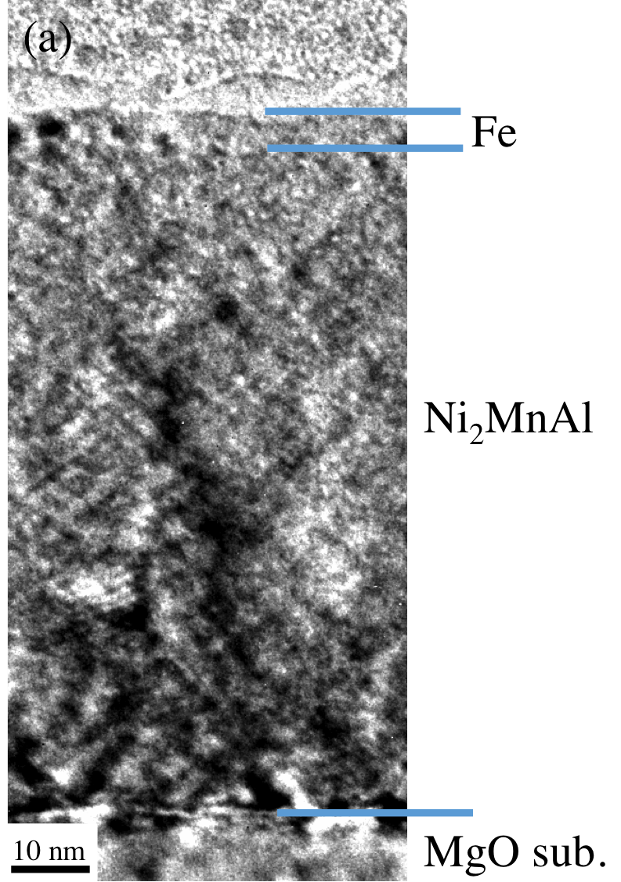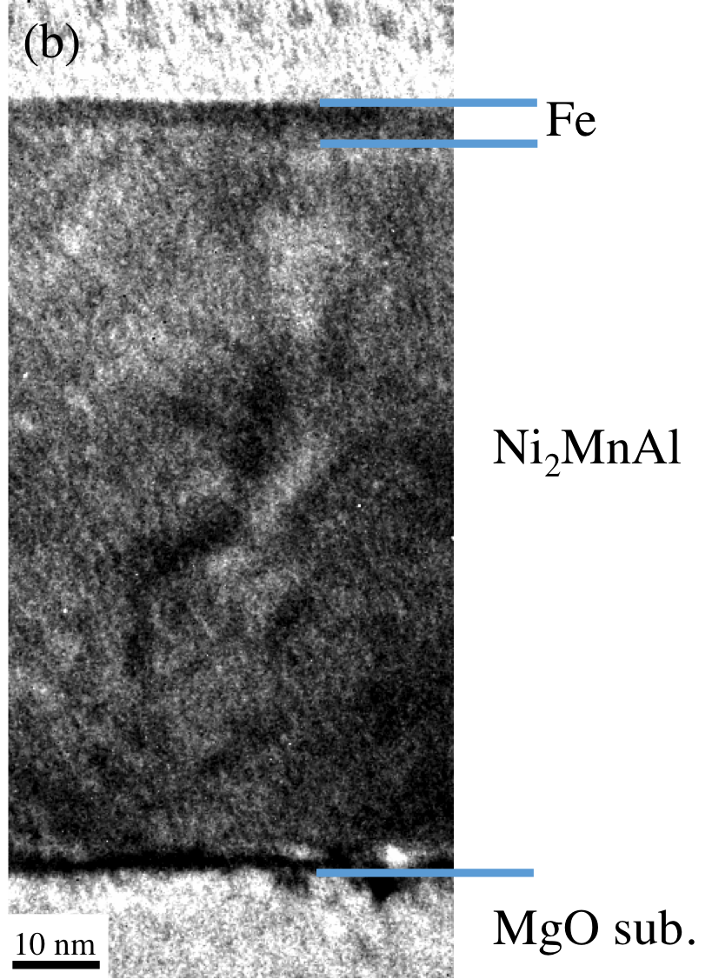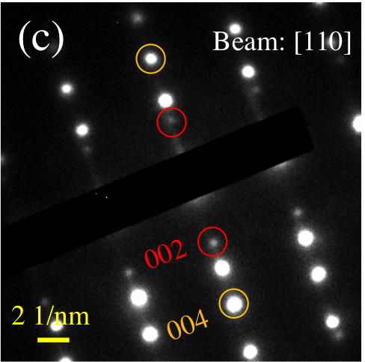

**Figure 4.** HRTEM observation: Bright field image of the sample deposited at (a) RT and (b) 600ºC and (c) the selected area diffraction pattern of the sample deposited at RT.

Macintosh HD:Users:tomo:Desktop:presentation, report:my paper:Ni2MnAl/Fe:J_phys_D:figure:G_SB2_JpD.eps

**Figure 5.** The substrate temperature dependence of the long-range ordering parameter *SB*2 for Ni2MnAl thin films.

## Magnetic and transport properties of Ni2MnAl films

*M* – *H* curves of Ni2MnAl films (without an Fe layer on the top) were also measured between 10 K and 300 K. No spontaneous magnetization was observed for the all samples regardless of the substrate temperature, even at 10 K. This was consistent with the absence of the ferromagnetic *L*21 phase as revealed by the structural analyses. Figure 6(a) shows the temperature dependence of the electrical resistivity of the Ni2MnAl films with an Fe layer on the top. The sample deposited at room temperature shows a negative temperature coefficient, whereas the other samples show a positive temperature coefficient similarly to metallic behavior. Another important feature in figure 6(a) is a kink as indicated by the arrow for each curve except for *T*sub = RT. Such a kink was theoretically predicted as a result of the fluctuation of the sublattice magnetizations for antiferromagnetic materials near the Néel temperature,14) and experimentally reported for some of antiferromagnetic bulk alloys, such as, Mn-Ir15) and Mn-Pt16). The temperatures where the kink appears are regarded as the Néel temperatures and summarized in figure 6(b). The “Néel temperature” increases with *T*sub from 220 K to 280 K, which was slightly lower than the previously reported values of the Néel temperature for bulk *B*2-ordered Ni2MnAl alloys.1,8)

Macintosh HD:Users:tomo:Desktop:presentation, report:my paper:Ni2MnAl/Fe:J_phys_D:figure:figure5a_2.epsMacintosh HD:Users:tomo:Desktop:presentation, report:my paper:Ni2MnAl/Fe:J_phys_D:figure:G_TN_JpD2.eps

**Figure 6.** (a) Temperature dependences of electrical resistivity of Ni2MnAl. Arrows indicate the “kinks”. (b) The substrate temperature (*T*sub) dependence of the temperatures for the “kink”.

## Exchange bias effects in Ni2MnAl/Fe bilayer samples

Exchange bias effects were investigated in Ni2MnAl/Fe bilayer samples. Figure 7 shows magnetization curves of the samples measured at 10 K, 100 K and 300 K for Ni2MnAl deposited at RT and 600ºC. The *M* – *H* curves for the other *T*sub are not shown here because of those similarities. The shifts in the *M* – *H* curves were confirmed at 10 K, for all the samples except for *T*sub = 600ºC, which showed no definite shift within the measured temperatures. Above 100 K, the shifts disappeared for all the samples, which suggests that the blocking temperature of the Ni2MnAl/Fe bilayer is below 100 K. The substrate temperature dependence of the exchange bias field (*H*ex) is summarized in figure 8. The maximum value of *H*ex is measured to be 55 Oe, corresponding to the exchange coupling energy *J*k (= *H*ex∙*M*s∙*d*Fe) of 0.03 erg/cm2, where *M*s and *d*Fe are the saturation magnetization and thickness of the Fe layer, respectively. It is worth to be mentioned that *H*ex decreases slightly with increasing *T*sub up to 400ºC and then drastically decreases above 500ºC which is a different trend from that of the *T*sub dependence of *SB*2 as shown in Figure 5. From the *ab initio* calculation and bulk studies, 1-3, 8-10) the antiferromagnetic coupling of the magnetic moments of the Ni2MnAl films are expected to increase with increasing *SB*2. However, the present results imply that *SB*2 is not a critical factor on the magnitude of the exchange bias effect for the Ni2MnAl/Fe bilayer. One possible origin for explaining the present *T*sub dependence on *H*exis that our bilayers are dominated by a change of the antiferromagnetic domain size depending on the grain size of the Ni2MnAl layer. In other words, according to a theoretical model by Malozemoff17) and some following works,18-20) the finite size of antiferromagnetic domains plays an important role for maintaining the exchange bias effect. In the case of the present epitaxially grown Ni2MnAl films, the size of crystallographic grains is expected to increase with increasing *T*sub as shown in figure 1. Therefore the size of antiferromagnetic domain may increase with *T*sub, resulting in the small exchange bias.

Macintosh HD:Users:tomo:Desktop:presentation, report:my paper:Ni2MnAl/Fe:J_phys_D:figure:figure6a.epsMacintosh HD:Users:tomo:Desktop:presentation, report:my paper:Ni2MnAl/Fe:J_phys_D:figure:figure6b.eps

**Figure 7.** The magnetization curves of the Ni2MnAl/Fe bilayers measured at 10, 100 and 300 K. The Ni2MnAl films were deposited at (a) RT and (b) 600ºC.

Macintosh HD:Users:tomo:Desktop:figure7.pdf

**Figure 8.** The substrate temperature (*T*sub) dependence of the exchange bias field (*H*ex) in the Ni2MnAl/Fe bilayers.

1. Conclusion

Ni2MnAl thin films with *B*2 ordering were epitaxially grown on MgO(100) substrates at substrate temperatures ranging from room temperature to 600ºC. The long-range order parameter *SB*2 slightly increased with increasing *T*sub, taking the maximum value of 0.6 for the sample deposited at 600ºC. The temperature dependence of electrical resistivity exhibited a kink for each sample except for that grown at *T*sub = RT, corresponding to the Néel temperature of the antiferromagnetic Ni2MnAl. The hysteresis loop shift was observed at 10 K for the Ni2MnAl/Fe bilayers except for that grown at *T*sub = 600ºC. No shift was observed above 100 K, implying that the blocking temperature of the Ni2MnAl/Fe bilayer was below 100 K. The maximum *H*ex was 55 Oe for the sample deposited at room temperature corresponding to the exchange coupling energy *J*k of 0.03 erg/cm2.

Acknowledgements

This work was partially supported by Heusler Alloy Replacement for Iridium (HARFIR) under the Strategic International Cooperative Research Program (SICORP) from Japan Science and Technology Agency and the 7th Framework Programme (NMP3-SL-2013-604398) by the European Commission. A part of this work was done by a cooperative program (No. 15G0413) of the CRDAM-IMR, Tohoku University. TT and TK would like to thank I. Narita of CRDAM-IMR, Tohoku Univ. for his technical support.

References

1. Sutou Y, Ohnuma I, Kainuma R and Ishida K 1998 *Metall. Mater. Trans. A* **29A**, 2225.
2. Gejima F, Sutou Y, Kainuma R and Ishida K 1999 *Metall. Mater. Trans. A* **30A**, 2721.
3. Kainuma R, Gejima F, Sutou Y, Ohnuma I, Ishida K 2000 *Mater. Trans. Jpn. Inst. Metal* **41** 943
4. Srivastava V K, Srevastava S K, Chatterjee R, Gupta G, Shivprasad S M, Nigam A K 2009 *Appl. Phys. Lett.* **95** 114101
5. Acet M, Duman E, Wassermann E F, Mañosa L, Planes A 2002 *J. Appl. Phys.* **92** 3867
6. Morito S, Kakeshita T, Hirata K, Otuska K 1998 *Acta Mater.* **46** 5377
7. Paduani C, Migliavacca A, Sebben M L, Ardisson J D, Yoshida M I, Soriano S, and Kalisz M 2007 *Solid State Commun*. **141** 145
8. Ziebeck K R A, and Webster P J 1975 *J. Phys. F: Metal Phys.* **5** 1756
9. Galanakis I, and Şaşıoğlu E 2011 *Appl. Phys. Lett.* **98** 102514
10. Szunyogh L, Khmelevskyi S, Simon E 2015 *Phys. Rev. B* **92** 054438
11. Lund M S, Dong J W, Lu J, Dong X Y, Palmstrøm C J, and Leighton C 2002 *Appl. Phys. Lett.* **80** 4798
12. Dong X Y, Dong J W, Xie J Q, Shih T C, McKernan S, Leighton C, and Palmstrøm C J 2003 *J. Cryst. Growth* **254** 2134 384
13. van der Pauw L J 1958 *Philips Res. Rep.* **13** 1
14. Suezaki Y, and Mori H, 1969 *Prog. Theor. Phys.* **41** 1177
15. Umetsu R Y, Miyakawa M, Fukamichi K, and Sakuma A 2004 *Phys. Rev. B* **69** 104411
16. Umetsu R Y, Fukamichi K, and Sakuma A 2006 *Mater. Trans.* **47** 2
17. Malozemoff A P 1987 *Phys. Rev. B* 35 3679(R)
18. Nowak U, Usadel K D, Keller J, Miltényi P, Beschoten B, and Güntherodt G, 2002 *Phys. Rev. B* **66** 014430
19. Keller J, Miltényi P, Beschoten B, Güntherodt G, Nowak U, and Usadel K D 2002 *Phys. Rev. B* **66** 014431
20. O’Grady K, Fernandez-Outon L E, Vallejo-Fernandez G 2010 *J. Magn. Magn. Mater* **322** 883