EVALUATION OF CLUSTER COMMUNITY DEVELOPMENT COUNCIL (CCDC) PILOT PROJECT

FINAL REPORT

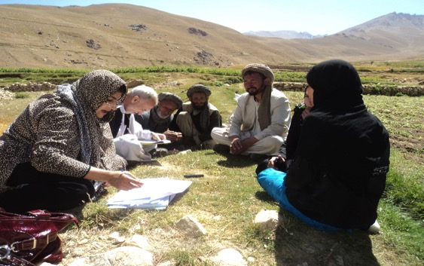

Submitted to

The Islamic Republic of Afghanistan’s
Ministry of Rural Rehabilitation & Development (MRRD)
and
National Solidarity Programme (NSP)

By
Post-war Reconstruction and Development Unit
University of York
and
Tadbeer, Kabul

June 2015
EVALUATION TEAM AND ROLES

Principle Investigator and Team Leader: Professor Sultan Barakat
Co-Investigator and Afghan Team Leader: Mohammad Ehsan Zia
Co-Investigator and Lead Researcher: Dr Thomas Waldman
Evaluation Manager: Dr Kenneth Bush

Field Evaluation Team Members:

Lead Researcher: Ehsan Shayegan
Bamian Team Leader: H. Natiq
Nangahar Team Leader: A. Sherzai
Balkh Team Leader: S. Saifi

ACKNOWLEDGEMENTS

This report presents the independent findings from the ‘Impact Evaluation of the Cluster Community Development Council (CCDC) Pilot Project’. The evaluation was commissioned by the Ministry of Rural Rehabilitation and Development of the Islamic Republic of Afghanistan [MRRD/NSPIII/CN/759] and was undertaken by a multi disciplinary team from the University of York’s Post-war Reconstruction and Development Unit in partnership with the Kabul-based Tadbeer Consulting.

The field work was carried out between September 2014 and March 2015 and covered the following NSP supported communities:

CCDCs: Etifaq, Azadi, Sarab; Guhdar, Nargis, Shibar; Hisarshai, Motahida, Itehad.

CDCs: Akhwanzadagan, Bazar Kalay, Batton, Darbazala, Ba-ar, Pioywolu, Kariz and Hajyan, Miran and Malikan, Zargaran and Baba; Qalacha, Baghalak, Dhanai Ghudar, Kharzari, Kham, Qalai Wakil, Gunbad, Paynmori, Sadbag; Mashi, Yakatoot, Zambokan, Ali Kayee, Khwaja Muhamad Aslam, Naydaraz, Ghazi Abad Baala, Haji Ali Arabi, Sayed Ghiasuddin Peer.

This complex evaluation was made possible by the enthusiastic support as well as the generous and candid contributions from various individuals, groups and institutions. In particular, the team would like to thank the Afghan community representatives, civil society groups, and various representatives of governmental and non-governmental organisations as well as United Nations and bilateral aid agencies, for their participation in the evaluation.

This kind of evaluation can only be successful when the commissioning body believes genuinely in the value and importance of “lesson-learning”. Throughout the process, colleagues from the NSP were eager to discover and better understand the evidence of their work on the ground and have furnished the team with all the required documentation and reports. We would like to recognize in particular the excellent support the team received from Abdul Rahman Ayubi, Jovitta Thomas and Brigitta Bode.

Within our evaluation team, the final drafting of the report and the pulling together of the data fell to my colleague Thomas Waldman who did an outstanding job under very demanding circumstances. Mohammad Ehsan Zia demonstrated exceptional leadership on the ground that made this work possible.

We would like to recognize the contributions of Mark Evans from the University of Canberra, Alexandra Lewis and Genevieve Davies who provided support during the early stages of setting up the evaluation. We are particularly grateful to Sally Clark from the PRDU for her administrative support throughout the project.

Professor Sultan Barakat
Evaluation Team Leader

York, June 2015

TABLE OF CONTENTS

Evaluation Team and Roles

Acknowledgements

Contents

Figures

Abbreviations

Executive Summary

1. Introduction and Conceptualisation

1.1 Objectives

1.2 Conceptual Framework

1.3 The National Solidarity Programme

1.4 The Cluster Community Development Council (CCDC) Pilot Project

2. Study Methodology

2.1 Sampling

2.2 Field Research Components

2.3 Data Collection Methods

3. Findings

3.1. National Level Dynamics

3.2 Province Level Findings

3.2.1 Introduction

3.2.2 Bamian

3.2.3 Balkh

3.2.4 Nangahar

3.3 General Province Level Findings

3.3.1 Political-economy analysis

3.3.2 Provincial and district context

3.3.3 Critical factors

4. Conclusions

4.1 Meeting Objectives

4.2 Critical Factors

4.3 Strengths

4.4 Weaknesses

5. Recommendations

5.1 Moving Forward

5.2 Principles of Expansion

5.3 Operational Requirements

References

APPENDIX A: CCDC Survey

APPENDIX B: CCDC Researcher Observation Sheet

APPENDIX C: CDC Survey

APPENDIX D: Village Profile Survey

APPENDIX E: Community Focus Group Discussions

APPENDIX F: Community Observation Sheet

APPENDIX G: Key Stakeholder Interview Schedule

FIGURES

Tables
Table 2.1 Type of CCDC Project funded in the provinces
Table 2.2 Project selection
Table 3.1 Community features (Bamian)
Table 3.2 Project type and outcome (Bamian)
Table 3.3 Project prioritisation (Bamian)
Table 3.4 Relationship with district authorities (Bamian)
Table 3.5 Impact on traditional roles and community voice (Bamian)
Table 3.6 Gender dynamics (Bamian)
Table 3.7 Community Features (Balkh)
Table 3.8 Project type and outcome (Balkh)
Table 3.9 Project prioritisation (Balkh)
Table 3.10 Relationship with district authorities (Balkh)
Table 3.11 Impact on traditional roles and community voice (Balkh)
Table 3.12 Gender dynamics (Balkh)
Table 3.13 Community features (Nangahar)
Table 3.14 Project type and outcome (Nangahar)
Table 3.15 Project prioritisation (Nangahar)
Table 3.16 Relationship with district authorities (Nangahar)
Table 3.17 Impact on traditional roles and community voice (Nangahar)
Table 3.18 Gender dynamics (Nangahar)

Maps
Map 3.1 Bamian Province
Map 3.2 Bamian Province Districts
Map 3.3 Guhdar CCDC
Map 3.4 Nargis CCDC
Map 3.5 Kaloye Sufla CCDC
Map 3.6 Balkh Province
Map 3.7 Balkh Province Districts
Map 3.8 Etifaq CCDC
Map 3.9 Sarab CCDC
Map 3.10 Azadi CCDC
Map 3.11 Nangahar Province
Map 3.12 Nangahar Province Districts
Map 3.13 Itehad
Map 3.14 Motahida
Map 3.15 Hisarshahi

Photos
Photo 3.1 CCDC members mapping the area
Photo 3.2 Community members implementing a CCDC project in Bamian
Photo 3.3 Bamian community members selling their produce on the road
Photo 3.4 CCDC member meeting in Bamian
Photo 3.5 Community members in a Bamian CCDC
Photo 3.6 Women community member FGD in Bamian
Photo 3.7 CCDC members in Balkh
Photo 3.8 The clinic in Mashi CDC
Photo 3.9 Inside the clinic
Photo 3.10 Constructed road
Photo 3.11 The graveled road, CCDC project
Photo 3.12 Water well
Photo 3.13 The damaged culvert
Photo 3.14 CCDC members in Balkh
Photo 3.15 Women FGD in Balkh
Photo 3.16 Canals in Itehad CCDC
Photo 3.17 CCDC members in Nangahar
Photo 3.18 CCDC members mapping the area

List of Abbreviations

ARTF | Afghanistan Reconstruction Trust Fund
CDC(s) | Community Development Council(s)
CDP | Community Development Plan
CCDC(s) | Cluster Community Development Council(s)
CCDP | Cluster Community Development Plan
CIDA | Canadian International Development Agency
DAB | Da Afghanistan Bank
DFID | Department For International Development
EC | European Community
FP(s) | Facilitating Partner(s)
GTZ | Deutsche Gesellschaft fur Technische Zusammenarbeit
IDA | International Development Association
JICA | Japan International Cooperation Agency
MIS | Management Information System
MRRD | Ministry for Rehabilitation and Rural Development
NABDP | National Area Based Development Programme
NEEP | National Emergency Employment Programme
MISFA | Micro Finance Investment Support Facility of Afghanistan
NGO | Non-governmental Organisation
NSP | National Solidarity Programme
OC | Oversight Consultant
OM | Operations Manual
PRT(s) | Provincial Reconstruction Teams
USAID | US Agency for International Development
WB | World Bank

EXECUTIVE SUMMARY

Introduction

This report presents the findings from the ‘Impact Evaluation of the Cluster Community Development Council (CCDC) Pilot Project’ undertaken by the Post-war Reconstruction and Development Unit (PRDU) and Tadbeer on behalf of the Ministry of Rural Rehabilitation and Development (MRRD) of the Islamic Republic of Afghanistan.

The objectives of this evaluation are to assess the effectiveness of the pilot project in relation to two closely inter-related dimensions: design and impact evaluation. The research has been guided by the following overarching question:

What has been the overall impact of the CCDC Pilot Project in terms of improving socio-economic welfare, social cohesion and governance for development among rural communities in Afghanistan?

The evaluation has also considered a number of other related issues, including the design of the programme, the strengths and weaknesses of clustering, the potential challenges and opportunities for scaling up the use of CCDCs, and the contextual factors at the provincial, district and community levels that might influence clustering outcomes.

Due to the lack of reliable quantitative baseline data, and in order to capture the nuances and complexities within CCDCs, the study adopts an in-depth qualitative case study methodology grounded in an understanding of the objectives, rationale and intervention logic of the clustering project.

The CCDC pilot aims to develop guidelines and criteria for the clustering process, cluster-based subproject appraisal, and project implementation. It aims to develop formal mechanisms for pooling resources and training in effective clustering implementation. The four main objectives of the clustering pilot are to: (1) to promote the clustering of Community Development Councils (CDCs) in priority provinces to further enhance the capacity and sustainability of CDCs; (2) promote greater solidarity among CDCs; (3) promote greater coordination between CDCs and local authorities; and to (4) improve the quality of life in the project communities. The project will also help link CDCs to District Development Assemblies (DDAs) and facilitate the preparation of more efficient and effective District Development Plans

In evaluating the extent to which the pilot project has met its objectives, the findings rely primarily on the information, insights, stories and perspectives of those involved in or benefitting from clustering, including CCDC members, CDC members and villagers in CCDC communities as well as a number of district level actors. Additional insights were gathered from NSP and Facilitating Partner representatives. This range of views at all levels has guarded against intentionally misleading responses and allowed the evaluation to explore the broad scope of the project.

Methodology

In addition to information gathered during the initial desk-review period and literature review, the evaluation findings are derived primarily from field research carried out in the three Afghan provinces in which CCDCs have been established: Bamian, Balkh and Nangahar. This field research has been supported through interviews with key respondents in Kabul and in the three provinces.

Participatory methods have enabled the team to conduct a highly nuanced qualitative evaluation. Close consultation with MRRD and NSP personnel was important in accessing high-quality data as well as in finalising the design of the evaluation. The evaluation principally utilises a qualitative approach involving FGDs and interviews in 3 provinces, 9 CCDCs and 27 CDCs. At the CDC level, four FGDs were held with different groups of community members: general project beneficiaries, relatively richer community members, relatively poorer community members, and women. In all, 108 such FGDs were conducted.

Conclusions

The pilot project has had mixed success in achieving its stated objectives and some CCDCs have been clearly more successful than others. On the whole, CCDCs have overseen largely successful projects that have brought real, if mixed, developmental, governance and social gains to communities. The processes of CCDC formation, project prioritisation, decision-making mechanisms, meeting effectiveness, community updating and project monitoring do not appear to have been beset by any major problems beyond expected issues, most of which FPs have been able to resolve.

Indeed, FPs have played an important and sometimes critical role in ensuring the smooth functioning of CCDCs. Nevertheless, worrying weaknesses – such as discontinuation of the CCDC, undermining of CDCs, the creation of lingering disputes and animosities, poor levels of transparency, and elite manipulation – were apparent in some cases.

The positive outcomes noted above, while indicative of the potential inherent in clustering, do not in our opinion constitute the kind of outcomes we expected clustering to generate, either in terms of magnitude, scale or scope. The common practice of dividing cluster budgets into a number of small scale projects is symptomatic of this.

Beyond these general conclusions, another major finding was that outcomes were very much dependent on contextual conditions – especially at the provincial level – and successful outcomes could be attributed to the convergence of a number of positively aligned ‘critical factors’. Chief among these were secure environment, geographical proximity or coherence, a positive motivation to cluster, project type and immediate or direct beneficial outcomes (in promoting positive outcomes in other areas, such as social cohesion).

When implemented well, clustering has several notable strengths: it allows communities to implement larger projects than are not possible at the CDC level (although this has not always occurred in practice); it promotes inter-community unity, solidarity and voice; it enables enhanced capacity building at the cluster level; it promotes the emergence of new leadership; and it fills a developmental vacuum at the sub-district level.

Weaknesses of the model are apparent with respect to the tendency of clustering, in some cases, to create tensions at the community level (primarily regarding project prioritisation disputes, which can linger beyond the project life cycle); the greater opportunities for elite manipulation it affords; the dilution of NSP benefits in certain areas; and the way in which it introduces certain operational problems and risks.

Overall, this evaluation suggests that in general the strengths of clustering outweigh the weaknesses. Moreover, the potential inherent in the clustering model is clear and the apparent weaknesses can all be mitigated to some extent provided the right approach is adopted moving forward and if the steps we lay out in the Recommendations are broadly followed.

Recommendations

Clustering should be used as a primary mechanism through which to drive forward development and economic growth in Afghanistan, because it serves as a bridge between the benefits generated by CDCs at the village level and broader national level development strategies. This evaluation suggests that the potential for clustering to be moved to this next phase is there, but this will require a new ambitious agenda that differs in a number of ways from that implemented under the pilot project. In some cases, this will entail revised strategies, new forms of collaborative working, and a bold new vision for what clustering might achieve.

If clustering is to be expanded and rolled out at a wider level, then monitoring protocols should be put in place to collect actionable data to ensure that scaled up investment contributes demonstrably to the achievement of commensurate returns. This should also be evident in increased developmental returns to communities. Equally important is the need to ensure that CDCs continue to form the basic unit of village level governance. Any expansion of clustering should not be undertaken at the expense of the work done through CDCs.

The proposed clustered approach would consist of the following elements:

- Larger projects capable of promoting measurable growth, investment in productive infrastructure, and employment.
- Greater top-down state facilitation, control and planning over the clustering process, rooted in national development plans.
- Whole-of-government involvement and coordination in bringing together a broader range of government stakeholders from relevant ministries.
- This should be done in ways that increase the potential for increasingly complex and technical projects while not undermining the sense of local ownership.
- This will entail a broader discussion concerning project choice, and when necessary phased or restricted funding where the will, appetite or capacity to implement larger projects is not yet optimal.
- Strategic flexibility in expansion and context-based roll-out based on clear criteria.
- Participatory forms of contextual analysis (encompassing conflict and political-economy analysis) should underpin the design, monitoring, and evaluation of clustered and non-clustered projects.
- A communication strategy that clearly distinguishes clustering activities from CDC activities, so as to avoid confusion and to mobilize and harness on-going support before, during and after the initiative.
- New approaches to, and investment in, enhanced facilitation, incorporating a mix of NGOs, private sector involvement and technical specialists.

1 INTRODUCTION AND CONCEPTUALISATION

The study team at the PRDU, University of York, UK and Tadbeer submits this Draft Report presenting findings from the ‘Evaluation of Cluster Community Development Council (CCDC) Pilot Project (Reference No. MRRD/NSPIII/CN/759), conducted on behalf of the Ministry of Rural Rehabilitation and Development (MRRD) of the Islamic Republic of Afghanistan. This study has been carried out on the basis of the Inception Report submitted to the National Solidarity Programme (hereinafter either ‘the NSP’ or ‘the Programme’) on 16 July 2014.

The NSP introduced a pilot project for clustering community development councils (CCDCs) on 30 December 2008. It was funded by the Japanese Social Development Fund with a budget of $10m. The pilot project has been implemented in 3 provinces: Nangahar, Balkh and Bamyan. This evaluation has examined whether the pilot project has met its objectives and considers the conditions, requirements and potential for wider use of the clustering concept. The focus of the evaluation is on the role of CCDCs in contributing to community welfare, linking local governance processes an promoting social cohesion.

This Final Report presents the findings from the evaluation. To help the reader appreciate where how the findings were reached, the annexes include a detailed description of the approach and methodology, as well as the survey questions utilised during the evaluation.

1.1 Objectives

The overall objectives of this evaluation, as detailed in the TORs, are seven-fold:

- To estimate overall impacts of the CCDC Pilot Project in improving socio-economic welfare, social cohesion and local governance for development;

- To assess impacts of key design variations introduced in the project on development outcomes;

- To assess the interaction of the project with pre-existing contextual factors;

- To analyse the strengths and weaknesses of the CCDC modality;

- To identify the challenges and risks entailed in implementing CCDC processes at a wider level;

- To provide policy recommendations on how the challenges and risks entailed in scaling-up CCDC processes can be addressed; and,

- To recommend changes to the CCDC Pilot Project’s design and/or implementation mechanism, should the project be scaled-up in spite of risks and challenges.

1.2 Conceptual Framework

The objectives of the evaluation have been informed throughout by a comprehensive awareness of the NSP in relation to its design and implementation, based on extensive previous research and evaluation of the programme, as conducted by the PRDU between 2005 and 2013. In particular, as emphasised by the TORs, this evaluation is grounded in the recognition that:

- The NSP facilitates and enables community driven subprojects rather than implementing development on behalf of communities;

- The NSP’s development objective is to strengthen community level governance for development and to improve rural community access to social and productive infrastructure and services, and,

- The NSP is based on a ‘community-wide’ approach to recovery and development.

The evaluation also recognises that the CCDC Pilot Project originated after a spontaneous pooling of resources by existing CDCs. The formalization of these arrangements therefore represents the NSP’s recognition of needs on the ground, responding to CDC behaviour and the demands of rural communities, so as to implement a rigorous and accountable system through which allocated resources might be shared.

The CCDC project aims to develop the clustering method by preparing guidelines and criteria for the clustering process, cluster-based subproject appraisals, and cluster-based subproject implementation in consultation with organizations that already have experience with clustering. It has not innovated the clustering model, just the clustering mechanism and the formalised framework.

The current evaluation is grounded in an understanding of the purpose of the CCDC project. Specifically, its objectives are:

- Improving the welfare of communities by financing larger subprojects that cannot be financed under NSP due to budget constraints;
- Enhancing the capacity and sustainability of CDCs;
- Promoting solidarity among CDCs;
- Promoting coordination between CDCs and local authorities and DDAs.

The main inputs intended to bring about such outcomes are twofold: 1) community-based institution and capacity building, and 2) investment through block grants for the implementation of projects.

1.2.1 Technical approach

Given the nuanced and complex nature of this change process, the study mainstreamed a finely-grained and in-depth qualitative approach in this evaluation. Our technical approach to the evaluation involved the collection, using a rigorous sampling methodology and standardized tools and instruments, of qualitative as well as some quantitative data.

Each of these two components feeds into one another such that the assessment of the CCDC’s design and relation to community welfare is informed by empirical results of the impact evaluation; conversely, the results chain or intervention logic, which underlies the design of the NSP, helped to guide the selection of research questions and specific criteria/indicators for measurement as part of the impact evaluation. Five elements underpinned this approach and are outlined below.

First, given the people-centred approach of the NSP and of the CCDC impact evaluation, the use of participatory methods – using mixed methods with an emphasis on gathering qualitative data – was deemed appropriate in order to accommodate the different types of community development projects and the complex decision-making processes within the NSP, especially at the community level. Close consultation with CCDC Pilot Project staff and all participants, especially at the community level, was essential in collecting the data, and the study team sought their collaboration in completing the design of the methodology.

CDCs helped in introducing us to the community and working with us to identify the sample of participants. We were not naive about potential problems involved in giving them such a role and every effort was made to ensure that they did not attend meetings once respondents had been identified for interviews and focus group discussions, however their knowledge and wisdom was used where appropriate.

Second, as explained below, the process of identifying the specific impacts of the CCDC project outputs on processes of economic, social, cultural and political development required in-depth interviews, qualitative surveys and focus groups. The study has been nuanced in weighing up the many factors involved, including: the impact of CCDC pilot programmes on community development; the capacity of CCDC processes to reach and represent multiple demographic groupings, including men, women, children, the poor, elderly and other vulnerable groups; the impact of CCDC processes on the integration of communities with district level governance; and, so on.

Third, in understanding the flexibility of the Project to address and respond to development needs and district integration, the team considered how such flexibility is accommodated within both the design and through the capabilities of stakeholders to follow and apply the CCDC logic, in addition to exploring the opportunities and outcomes of revising clustering frameworks through reporting and feedback mechanisms. Through this inquiry, the essential question of sustainability in rural development programming – through the structure of the NSP – will be brought to the surface. The research team will also seek to understand the impact of NSP development projects independent of other initiatives that are being carried out by international, regional and national actors.

Fourth, the study promoted an integrated approach to the evaluation of rural development in Afghanistan achieved through clustering, by considering the different social, economic and welfare needs of surveyed communities. This approach appreciates that communities in Balkh, Bamian, and Nangarhar have diverse development needs and require flexible, adaptable frameworks to meet their priorities, so that adaptive evaluation strategies are necessary to fully evaluate the extent to which CCDCs assist them in reaching their goals. The clustering of CDC operations requires a coordinated transition of assistance delivery that benefits all included communities and feeds back into local integration at the district level. Positive rural development programmes utilizing the new CCDC structure will be understood primarily according to welfare, social, cultural, economic and political dimensions, particularly in its capacity to promote social cohesion across communities and thereby to assist in solidifying relationships for cooperation and peacebuilding.

Fifth, this study paid particular attention to the degree of participation by community members in negotiating the terms of the clustering of their CDC projects. This is significant as for many rural communities, planning for and making decisions about their development is a core principle of the NSP and is intertwined with their active engagement in peace processes and social cohesion. The participatory nature of the NSP and the resulting creation of CDCs has led to the generation of local sub-projects that are owned by communities and therefore support the acceptance of development programming and contribute to the legitimacy of the state. It is therefore vital that CCDC processes do not undermine the agency of any participating communities and that they do not become dominated by powerful stakeholders.

1.2.3 Evaluation questions and issues

The evaluation, as noted above, is divided between two closely inter-related dimensions: design and impact evaluation. These enquiries are guided by the evaluative questions identified below, which also prioritise the evaluation of one central issue – namely:

What has been the overall impact of the CCDC Pilot Project in terms of improving socio-economic welfare, social cohesion and governance for development among rural communities in Afghanistan?

More broadly, the following questions and issues have been examined based on, and adapted from, the objectives of the evaluation.

CCDC design level

- What are the strengths and weaknesses of the CCDC modality?
- How have key design variations in the CCDC Pilot Project influenced and impacted development outcomes for rural communities?
- What are the political, economic, legal, financial, administrative challenges/risks in scaling-up the CCDC modality and how can they be addressed?
- What are the recommended changes in the pilot project’s design and/or the implementation mechanism for potential scaling-up of the CCDC modality?

NSP output, outcome and impact level

- Does participation in the CCDC project improve the socio-economic welfare of the communities? If so, how? If not, why not?
- Does participation in the CCDC project improve social cohesion among the communities? If so, how? If not, why not?
- Does participation in the CCDC project strengthen CDCs’ capacity? If so, how? If not, why not?
- Does participation in the CCDC project lead to better linkages with local government, civil society organizations and/or donors? If so, how? If not, why not?
- How well has the pilot done in terms of making sure that the communities have a greater degree of ability to work together, resolve conflict and overcome individual interest for the sake of collective benefit? Are there examples of them managing the commons in a sustainable, equitable and participatory way?
- What role did customary/religious law and norms play in such a process? To what extent were those abilities imparted to them by the FPs and the programme?
- Would the CCDCs ever be in a position to work with other authorities and ministries responsible for the management of natural resources to make sure that those resources are governed for the collective benefit of the communities?
- Does participation in the CCDC project have any other positive impacts? If so, what?
- How does design variation influence the process and outcome of the project?
- What are the contextual factors that influence the effectiveness of the process and outcomes of the project?

1.3 The National Solidarity Programme (NSP)

The NSP was launched in 2003 and subsequently rolled out in three phases: (1) 2003-2007, (2) 2007-2010 and (3) 2010-2015. It is financed by the International Development Agency (IDA) of the World Bank; the Afghanistan Reconstruction Trust Fund (ARTF); the Japan Social Development Fund (JSDF); and other bilateral donors. The programme is managed by the Afghan Ministry of Rural Rehabilitation and Development (MRRD) but it is also inter-ministerial and whole-of-government. At the field level, NSP is implemented by 19 international and 12 national NGOs and UN-HABITAT which act as facilitating partners (FPs) and provide technical support.

NSP operates in all of Afghanistan’s 34 provinces and to date more than 90% of communities have been mobilised. 32,905 Community Development Councils (CDCs) have been elected in 397 districts. By June 2014, 80,378 projects had been initiated. This represented a combined budget of around $1.5bn. In 2012-13, the Afghan budget allocated US$236 million to fund NSP, making it the largest development project in the country. There are around 3,195 Facilitating Partner staff and 896 NSP staff.

It is important to remember that the NSP has also had to contend with considerable security challenges in many of the areas it has been implemented, whether due to localised conflict or the effects of the wider Taliban insurgency. NSP was designed when the expected context was ‘post-conflict’ and it was widely understood as a peacebuilding programme. But, instead it has had to proceed alongside an intensifying insurgency and a large-scale foreign military presence.

1.3.1 Principles and objectives of NSP

The goal of NSP is to ‘reduce poverty through empowering communities with regard to improved governance, and social, human and economic capital’ through a community-wide approach to development. The programme facilitates and enables community driven subprojects rather than implementing development projects on behalf of communities. The programme seeks to strengthen community level governance and improve rural access to social and productive infrastructure and services by channeling resources to democratically elected CDCs and building the capacity of CDCs.

It operates according to the principles of: participatory and inclusive decision-making; gender equity; transparency; and accountability. Communities are empowered to make decisions and manage resources during all stages of the project cycle. It promotes sustainable forms of inclusive local governance, rural reconstruction and poverty alleviation.

NSP has four key elements in terms of its implementation on the ground, which:

- Facilitate the formation of inclusive community institutions, democratically elected through secret ballot to reach consensus on priorities and subproject activities, develop subproject proposals and implement subprojects.

- Build the capacities of CDC and community members in participation, consensus-building, accounting, procurement and contract management, operations and maintenance and monitoring.

- Provide block grants to fund approved subprojects.

- Link CDCs to government agencies, NGOs and donors to improve access to services and resources.

At its core, NSP develops the ability of Afghan communities to identify, plan, manage and monitor their own recovery and development. Capacity building within the programme focuses on male and female CDC members in terms of financial management, procurement, technical skills, monitoring and transparency. CDCs also build on customary governance norms (ashar) and traditional community institutions (shura) using participatory processes of decision-making, incorporating both upward and downward accountability mechanisms, and ensuring the inclusion of women and other vulnerable minority groups. The programme also promotes the linkage of CDCs to other government agencies, NGOs and donors to improve access to services and resources. As such, it is multi-stakeholder and multileveled.

1.3.2 Technical issues

The programme facilitates the formation of democratically elected and gender-balanced Community Development Councils (CDCs) through secret ballot, universal suffrage elections (at least 60% of eligible voters must vote in order for the election to be considered valid). CDCs lead in identifying and prioritizing the needs of the community through an inductive and inclusive model that results in a Community Development Plan (CDP). Once approved, portions of block grants are transferred to a bank account established by the CDC (for procurement and implementation).

CDCs are comprised of representatives elected from clusters of between five and twenty families in the community, each which picks a male and female representative. CDCs have an executive council with a President, Deputy President, Secretary and Treasurer. Projects are approved if: agreed through village-wide consultation process; they provide equitable access; are technically and financially sound; have an operation and maintenance plan; and are funded by the community up to a level of 10% of total costs (including labour and material contributions). Also, NSP has a ‘negative list’ of projects not eligible for receiving funds (mosque construction, land purchases, salaries to CDC members, purchase of weapons, etc).

In some cases, existing power-holders were integrated into a CDC. In other cases, the traditional shura and the CDC fulfill separate functions; while a CDC is responsible for development activities, shuras have generally continued to take responsibility for decision-making on other community matters, such as social and religious issues. Yet, there have been CDCs which have expanded their role to include wider community decision-making and the resolution of various forms of community disputes. In some such cases, the shura has essentially disappeared altogether.

In terms of the gender dimension, since the inclusion of women in the election of CDCs and the development process is a required step before submission of a project proposal for NSP funding, FPs have had to find ways to get the community’s consensus on the involvement of women. This has resulted in a variety of forms of CDCs, such as mixed CDCs and women-only CDCs. Even when mixed CDCs are formed, some have meetings with men and women sitting together, and others have separate discussions. In some communities women-only sub-committees and working groups have also been established, which then feed their opinions into the CDC.

1.3.3 Facilitating Partners

The Facilitating Partners play a key role in the program, constituting the link between provincial level officials of the NSP and communities. FPs are contracted by the NSP to provide technical support and guidance to communities in fulfilling program activities and community development plans.

Among the key functions of the FPs in the project cycle are: working with local leaders to mobilize and inform the entire community; organising CDC elections according to the program’s guidelines; assisting CDCs to hold inclusive consultations to produce Community Development Plans (CDPs) and sub-project proposals; helping communities procure goods and services in the market; providing technical assistance; providing training in book-keeping, procurement and other skills; and conducting monitoring and reporting.

The technical skills of FP staff is a key factor determining the successful election, facilitation and training of CDC and the nature of the relationship between the communities and the FP can shape communities’ perception towards the CDC and NSP in general. As such, ‘facilitation is not only technical but also relational’ and the trust of the community in the FP is extremely important.

FPs have also developed an advocacy and networking capacity in the form of a Facilitating Partners Representative Group (FPRG) to coordinate their activities and suggest policy and programming changes. For instance, the body, amongst other things, pushed for the incorporation of CDCs into the constitution.

1.3.4 Sub-projects

Subproject grants equate to $200 per family, up to a maximum of $60,000. The average grant is $33,000. Projects cover all areas of priority investments, including: clean drinking water; sanitation, small-scale irrigation; roads and structures; schools; village electrification. Participating villages have received only one round of grants and, once completed, villages have no assurance of when they will receive further NSP activities. In the third phase of NSP, there are repeater block grants available in 12,000 villages from Phase 1.

Generally projects fall under one of 5 categories:

1) Transportation: tertiary road, pathways, culvert

2) Water and sanitation: shallow wells, water supply network

3) Irrigation: canal, stream, gabion, protection, dam/reservoir

4) Power: micro-hydro, solar, diesel generator, power lines

5) Other: community centre, school building

1.4 The Cluster Community Development Council (CCDC) Pilot

There was a spontaneous clustering and pooling of resources (grant allocations) by existing CDCs, during the first phase of NSP. It became evident that individual communities were struggling to implement rural infrastructure, such as roads connecting a number of communities. Such common needs of multiple communities required joint design, planning and budget management thus allowing them to implement larger subprojects benefitting multiple communities simultaneously. As the NSP operational manual states: ‘The CCDC project offers an opportunity for more extensive development planning, with identified priorities addressed through subproject implementation impacting a larger number of beneficiaries in a wider geographical area.’

Clustering in the first instance was informal – there were no clear guidelines or procedures for the effective clustering of resources and activities. Resulting projects were affected by a number of implementation challenges due to a lack of knowledge and experience as well as other limitations. Clustering was thus formalised by NSP, recognising the need on the ground. The CCDC Pilot Project was established by NSP on 30 December 2008. It was implemented by the NSP in collaboration with the World Bank and financed by JSDF with a budget of $10m. The pilot has been implemented in 6 Districts within the 3 Provinces of Balkh, Bamyan and Nangahar. An annex on clustering has been added to the NSP Operational Manual.

It should be noted that the pilot built on earlier experiences of JSDF in Afghanistan through its Inter-Communal Development Project (IRDP) which ran between 2005 and 2010 in Kandahar, Balkh and Bamian and led by JICA. The IRDP was modeled on NSP and involved the clustering of between five and seven CDCs in order to be able to respond to development needs beyond individual CDCs. 19 CCDCs were created and these executed 22 projects.

The IRDP was conceived following a survey of rural areas which conveyed the opinion that CDCs were too small and unable to answer all the community’s needs. Communities were isolated and not communicating while conflicts between communities existed in some areas and they therefore need a mechanism to communicate with each other. The focus was on development with projects including schools, clinics, roads, dams, electricity and so on. The NSP was interested in this model and so put together a consultation team led by Peter Spink along with an Afghan team which conducted visits to the provinces to study the IRDP.

A decision was made to put clustering under an NSP umbrella. The situation in the south, and specifically Kandahar, had worsened considerably therefore the decision was taken to replace that province with Nangahar. Also, the number of communities within the clusters under the NSP CCDC would increase to 10.

The CCDC pilot aims to develop guidelines and criteria for the clustering process, cluster-based subproject appraisal, and project implementation. It aims to develop formal mechanisms for pooling resources and training in effective clustering implementation. The four main objectives of the clustering pilot are to: (1) to promote the clustering of Community Development Councils (CDCs) in priority provinces to further enhance the capacity and sustainability of CDCs; (2) promote greater solidarity among CDCs; (3) promote greater coordination between CDCs and local authorities; and to (4) improve the quality of life in the project communities. The project will also help link CDCs to District Development Assemblies (DDAs) and facilitate the preparation of more efficient and effective District Development Plans

A CCDC is a body comprised of the representatives of a minimum of 5 and a maximum of 10 CDCs, and clustered according to: geographical proximity, shared natural and social resources, common development needs and social and cultural ties. Ethnic or tribal exclusivity is not permitted. A CCDC has a standardized 10 members with 4 office bearers (Chairperson; Vice Chairperson; Secretary; Treasurer). Each participating community must have at least one representative in the CCDC. No one (CDC) community may have more than one member serving as an office bearer. The CCDC produces a Cluster Community Development Plan (CCDP) outlining development priorities for the entire cluster, not individual communities.

CCDC Selection and Formation

The NSP will encourage the communities to decide the CDCs with which to cluster, rather than identifying potential clusters first and then seeking the agreement. CDC Chairs will come together at the district level for an introductory meeting, facilitated by the Manager of the NSP PMU and organised by the FP, and the objectives and implementation approach for the CCDC project will be explained. This meeting will be attended by the District Governor and representatives of the District Development Assembly to establish linkages between the CDCs and district representatives from the outset and to promote procedural transparency.

The CDC Chairs will be requested to go back to their CDCs to explain the project and to pass this information on to their communities. Each CDC will be requested to confirm its willingness to participate in the project. The CDCs taking part in the project will be asked to consider with which CDCs to cluster according to the criteria and to identify a volunteer (preferably one from the former CDC Election Committee) to oversee the CCDC election.

A second meeting will be held two weeks later to which all CDC representatives will be invited, to confirm the CDCs making up the different clusters and to elect the Cluster Community Development Councils. Once the clusters have been confirmed in accordance with the criteria, elections to the CCDC will take place.

CCDCs will be established along the same lines as the CDCs making up the cluster. If there are separate male and female sub-committees within any of the participating CDCs, this will be reflected with male and female sub-committees within the CCDC. The guidelines for the formation of different sub-committees and the communication between them within the CDC will remain the same for the CCDC. In keeping with the NSP guidelines, there will not be separate male and female CCDCs at the sub-district level.

Extract from Operational Manual 2012

2. STUDY METHODOLOGY

2.1 Sampling

The sampling techniques to be employed as part of this impact evaluation consisted of two elements: (i) sampling of rural populations; and (ii) sampling of elite stakeholders who were asked to provide data for the study.

The research team consulted NSP and CDC personnel during the sampling process but the selection of the specific locations or households within communities remained independent to protect the overall objectivity of the findings. The goal was to ensure a sample of CCDCs that is as diverse as possible. More specifically though, the focus at the community level was to ‘drill down’ as much as possible in understanding and testing the immediate/long-term, direct/indirect impacts of the CCDC Pilot Project.

The research was particularly interested in comparing the effects of formal clustering on rural development over time, the types of CDCs (mixed or separate men’s and women’s; old or new leadership), and according to the main types of subprojects, for example: recent beneficiaries versus earlier NSP communities; infrastructure projects compared to income generation and/or social protection subprojects; and assessment of the general impacts of the CCDC projects implemented in the community.

2.1.1 Rural populations and participating communities

The sampling of CCDCs and their member CDCs involved a predominantly purposive process. The provinces within which the evaluation was undertaken were selected by the NSP: Bamyan, Balkh and Nangarhar.

The CCDCs considered for inclusion in this study have been identified through a sampling process applied to six districts in the three provinces. Any CCDC which possesses the criteria below was considered for inclusion in the study:

- Accessibility (security and physical access)
- Representativeness (inclusion of all 6 districts in sample)
- Timing of NSP implementation (considering the different period and NSP phases in sample)
- Sectors and subprojects categories (inclusion of different sector and subproject in sample to provide diversity for the study)
- NSP/MRRD approval
- Social representativeness (inclusion of social and ethnical groups, considering Afghanistan’s social structure)

Type of CCDC Project funded in
Bamyan, Balkh and Nangarhar, 2010 to 2013

Category of Project |  | Type of Project | Total
I | Agriculture and Irrigation | Agriculture: 2  Irrigation: 10 | 12
II | Social Development | Education: 7  Health: 1  Rural Development: 13 | 21
III | Infrastructural Development | Power: 9  Transportation: 36  Water & Sanitation: 28 | 45
Table 2.1 Type of CCDC Project funded in the provinces

Criteria for CCDC Case Selection within each Province

The matrix above illustrates the way in which the evaluation compared and contrasted different categories of projects (I. Agriculture/Irrigation; II. Social Development; and III. Infrastructural Development) within, and across, the three selected provinces. The aim was to have one case selected from each category in each province. In practice, due primarily to security constraints, this proved difficult – in Nangahar only agriculture/irrigation and infrastructural projects categories were included. Disaggregation by project category will help us to consider whether different kinds of projects may have different kinds of impact on the three impact areas of the evaluation, namely: social cohesion; local governance for development; and socio-economic welfare.

Project Selection

Based on the selection criteria above and the project categories, the following projects were selected for inclusion in the evaluation sample. It should be noted that the most important criterion for case selection is logistical and security-based, rather than methodological.

 | Province | District | CCDC Name | Cycle | Phase | Sector | Output | SP Status | Accessibility
1 | Balkh | Dehdadi | Etifaq | II+RGBI | Phase IIIB | Social | Clinic  Community centre | Completed | Secure
2 | Balkh | Khulm | Azadi | II | Phase I | Infrastructure | Wells  Road | Completed | Secure
3 | Balkh | Kishindih | Sarab | IV+RGBI | Phase IIIB | Infrastructure | Tertiary road | Completed | Secure
4 | Bamyan | Panjab | Nargis | II | Phase I | Agriculture  Social | Primary school  Canal | Completed | Secure
5 | Bamyan | Panjab | Guhdar | I+II | Phase I+II | Agriculture  Infrastructure | Canal; Wells;  Bridges, walls, roads | Completed | Secure
9 | Bamyan | Shibar | Kaloye Sufla | II+RGBI | Phase IIIB | Social  Infrastructure | Micro-power plants  School rooms | Completed | Secure
6 | Nangarhar | Rodat | Hisarshahi | IV | Phase I | Infrastructure | Pathways  Wells | Completed | Insecure
7 | Nangarhar | Rodat | Itehad | IV | Phase I | Infrastructure | Wells  Pathways and canals | Completed | Insecure
8 | Nangarhar | Rodat | Motahida | IV | Phase I | Infrastructure | Wells  Pathways | Completed | Insecure
Note: Reference for column 'E' " Cycle" information:
- Cycle IV = Oldest communities with NSP started in 2003/2004, first block grant
- Cycle III or II+ = Old communities with NSP started in 2005/2006, first block grant
- Cycle II = Old communities with NSP started in 2006/2007, first block grant
- Cycle I = Communities with NSP started between 2008 & 2011, first block grant
- RBG = Communities now receiving a second block grant phase

Table 2.2 Project selection

The sample provides an adequate diversity and comparability for the purpose of the project as it includes several NSP phases and implementation cycles and a variety of subprojects. Furthermore the issue of accessibility has been considered in selection process. The total sample for the study thus included 3 provinces, 9 CCDCs (3 in each province), 27 CDCs (3 from each of the 9 CCDCs) and their communities.

2.1.2 Key stakeholders

Key stakeholders were also invited to provide input into the study and to reflect upon their experience of clustered and non-clustered sub-projects run through the NSP’s CDCs. These stakeholders include:

- MRRD personnel and leadership (at ministry and line ministry levels, including Provincial Directors of the MRRD and management and technical staff at Afghanistan Institute for Rural Development);
- NSP managers and personnel (at ministry and line ministry levels); NSP engineer who has been involved in implementation of the CCDC project, providing technical support;
- Facilitating Partner representatives and designated NSP managers from the FPs;
- Other ministry representatives relevant to the running of the NSP’s CDCs and Pilot CCDC;
- Key representatives from the Provincial Development Committees, and where possible also District Development Associations, and the district governor.

A high priority was placed on engaging with individuals most closely involved with the implementation, management or monitoring/evaluation of the NSP given their unique and close perspective on the beneficiary experience. A combination of Afghan and international personnel was sought, with a particular emphasis on the former.

2.2 Field Research Components

2.2.1 CCDC level

At the CCDC level, within each of the 9 CCDCs, surveys were conducted with members of the CCDC and a CDC plotting exercise was conducted to ensure that the CDCs surveyed were representative, and placed in the context of non-surveyed CDCs. CCDC members were also asked to note any notable characteristics of the area or the communities that they administer, including: CCDC project sites; nearby resources, waterways, forests, grazing lands, agricultural lands, etc; wealthy, middle income, poor and extreme poor areas (in relative terms); commercial areas and market centres; hospitals, banks, schools, police stations, etc.; NGOs or any other defining features.

At the CCDC level, the research team also completed community Observation Sheets noting and reflecting on the research process, implemented CCDC and CDC projects and their social and economical impacts, vulnerable groups such as women and children, and the welfare and security condition of the community. Finally, project Case Studies were developed based on NSP and FP records, interviews with local people and researcher observations.

2.2.2 CDC level

At the CDC level, within each of the total 9 CCDCs, CDC members were surveyed in structured focus groups involving both mixed and separate men and women CDCs: at least three CDC members provided input into the study from within each of the communities, although this varied in different regions. Individual CCDC members were selected for additional interview.

The researchers also completed a Village Profile survey during the same meeting in which the CDC survey was conducted to identify community demographics and to ensure that all tribes, ethnicities and religious groupings were included in the data findings.

Upon arrival in each CDC community, the research team, in consultation with the CDC members, generated a map of the village, identifying central and peripheral areas. They asked the CDC members to identify where important resources, infrastructure and community buildings are located on the map, including fertile land, water, roads, electrical supplies, schools, mosques, CDC and CCDC projects location and so on. They split the map into zones and the researchers then identified focus group participants for discussions who were, ideally, from central and peripheral areas, and from areas that have high and low levels of access to nearby resources. This allowed for a spectrum of different groups to be included, based on different levels of income. Likewise they considered the vulnerable areas, displaced and migrated people, ethnic dispersion of community members, and their distance from project locations.

2.2.3 Community level

Four further structured focus group discussions were carried out at the community level in each CDC community evaluated. These included:

- One group of specific project beneficiaries (such as farmers, those receiving electricity, those benefitting from a completed road) of varying ages, including young and old men, taken from various areas of the village – central and peripheral, wealthy and poor. These did not include members of the CDC or CCDC, or, as far as possible, individuals with strong community leadership roles.

- One group of women of varying ages, including young and old women, taken from various areas of the village – central and peripheral, wealthy and poor. These women did not include members of the CDC or CCDC.

- One group of poorer community members of varying ages taken from various areas of the village – central and peripheral. These were not also members of the CDC or CCDC.

- One group of wealthier community members of varying ages taken from various areas of the village – central and peripheral. Of course ‘wealthier’ is very much a relative concept in some Afghan communities – members owning more land or other resources compared to other community members were chosen in these cases. These were not also members of the CDC or CCDC.

For community FGDs, researchers used a multistage stratified sampling design and they have considered the ethnic/tribal composition of the communities to enhance the representativeness and inclusiveness of the sample. Each focus group included between 5 and 12 participants selected using the community map and identified using a rigorous sampling strategy. If possible, a range of ages, ethnicities and social circumstances was represented in each focus group in order to capture a number of core variables, including:

- Geographic location: participants from both the centre of the village and the peripheries; minority groups that are not within easy access of the village’s main resources.
- Age: a range of ages in each focus group, including youth and the elderly.
- Identity: a representative sample of the ethnicities and tribal affiliations of the community.
- Social circumstance: people from a range of social background such as agriculturalists, pastoralists, businessmen, displaced groups, returnees, etc.

Finally, a community observation sheet was completed which allowed for a further mechanism for validating data collected through other channels – see below.

2.3 Data Collection Methods

A number of data collection methods were applied in the course of this study. Qualitative and quantitative data were collected through a suite of desk-based and field-based approaches. While the most integral aspect of data collection was field based, the study also drew upon the existing literature regarding: (i) trends and responses to rural development needs in other similar war-torn contexts; (ii) community-driven development in Afghanistan from historical and contemporary perspectives; (iii) the linkages between community driven development (governance and poverty reduction) and intra-community cooperation; and (iv) the NSP as a whole-of-government approach to post-war recovery and state building.

2.3.1 Desk-based methods

The desk-based component of the study included four elements:

- The first was focused on understanding the contemporary situation of rural communities in Afghanistan based on a review of secondary materials.

- The second examined the existing literature on the intersection of community development (particularly community driven development) and perceptions of governance legitimacy or local integration into the district level.

- The third incorporated all existing data collected regarding the NSP and its impact, particularly in terms of CDC operations, rural development and formal and informal CDC clustering.

- The fourth and final examined the contribution of other actors to rural development within Afghanistan.

Throughout this evaluation, measuring the impact of the CCDC on social cohesion was informed around a conceptualisation of social cohesion that takes the term to represent the degree to which vertical (a responsive state to its citizenry) and horizontal (cross-cutting, networked relations among diverse communal groups) social capital intersect. In this sense, it is understood that the more social cohesion exists, the more likely a society will be cohesive and thus possess the inclusive mechanisms necessary for mediating/managing conflict.

2.3.2 Field-based methods

The following methods were applied during the core, field-based portions of the study:

- Semi-Structured Interviews – Interviews were undertaken with key stakeholders, including NSP and MRRD personnel, district governors, representatives of government and DDAs involved with either the NSP and/or with rural community development (as listed above). While NSP and MRRD staff members were the most critical stakeholders, it was also necessary to interview appropriate individuals from the CDCs, particularly those involved in CCDC Pilot Project implementation.

- Focus Group Discussions (FGDs) – Within each of the 27 CDC communities included within the qualitative study, four FGDs were conducted, for a total of 108 focus group discussions.

- Surveys – The research team conducted surveys of NSP beneficiaries. Rather than a single survey, these were modified slightly, while still yielding comparable results. These surveys were comprehensive, including qualitative as well as quantitative data, and reflected the research questions above. A range of question types were utilised, and some space was provided for relatively open-ended questions to capture input which does not neatly fit into a standard survey tool.

- Observation – In parallel to the field-based methods outlined above, the research team also undertook observations of active and completed CDC and CCDC projects in each community surveyed. Here, researchers endeavoured to determine what the advantage was for communities for having larger clustered projects over smaller independent ones, particularly in terms of socio-economic welfare and social cohesion. The effectiveness, efficiency and deliverables of CCDC projects were also assessed.

The field data collection process has been divided into two phases and the researchers have been trained in 10 training sessions, before going to the field (in 1st and 2nd phase of field data collection). The first phase of data collection has been followed by a data validation process and researchers have conducted follow-up interviews with individual CCDC/CDC members.

3 FINDINGS

This chapter presents the main findings of the study, and incorporates the information collected from the extensive desk review of the relevant literature together with the extensive field research conducted in Afghanistan between September and December 2014.

In presenting the findings from the study, it is important to keep in mind the fluidity and complexity of the environment within which the evaluation was conducted. At such a deeply unstable and violent time in the history of Afghanistan, the conduct of evaluations is far from straightforward. The study team had therefore to be flexible and adaptive in its approach to data collection. Nevertheless, the local researchers were ultimately able to reach all the selected communities and conduct a wide range of surveys, interviews and focus group discussions.

Far form being restricted to Kabul, the collaboration between PRDU and Tadbeer allowed the research to primarily be conducted in the field by Afghan researchers. The team of researchers received extensive training by the PRDU team prior to data collection. This period also allowed the data collection tools to be adapted according to Afghan realities, terminologies and local sensitivities.

The first section of this chapter, based primarily on desk-based research, examines the national level dynamics with respect to the trends and dynamics of rural development and local governance within Afghanistan by way of providing context for the subsequent provincial level findings. The second section presents the major findings of the study from the field research conducted in the three provinces of Bamian, Balkh and Nangahar. The third section seeks to pull these findings together by presenting a discussion of political-economy dynamics and an analysis of critical factors.

3.1 National-Level Dynamics

3.1.1 Rural development in Afghanistan

Afghanistan’s population is overwhelmingly rural – 75% live outside regional and provincial centres and are reliant on agriculture and livestock; 59% are dependent on stock-breeding and farming. This is the case despite only 12% of the land being arable, and half that under cultivation. A third of the population live on less than a dollar per day. Livelihoods remain overwhelmingly dependent on rain-fed crops and pasture, while being highly vulnerable to natural disasters, such as repeated droughts. The rural population suffers from a lack of basic infrastructure, up-to-date knowledge of farming methods and agricultural and business skills.

Decades of civil conflict, massive dislocation of population and the inability of authorities to conduct a population census make the categorization of rural life at the sub-district or ‘village’ level a matter of educated guesswork. An estimated 68% of the population have no sustainable access to improved water sources, although it is important to note that the proportion of Afghans with access to improved water sources almost doubled between 2007-08 to 2011-12 from 20% to 39%, and largely as a result of the NSP and other programs. 5.4 million lack access to healthcare, 4.4 million of which are female. Just over 64% of the rural population and 95% of the urban population have electricity. Nearly a third of the population live in poverty. Child malnutrition is amongst the highest in the world. One third of the population is chronically food insecure.

Afghanistan has a rapidly growing population (2.8% annually) and 70% of the population is under 25 years of age, with millions of refugees returning from overseas. Afghanistan’s limited resources of farmland and water are under great pressure. The incidence of poverty remains extremely high, and Afghanistan is ranked among the bottom 15 countries on the UNDP’s Human Development Index.

Afghan communities are known for their sense of independence and self-sufficiency, shaped by a long history of central government absence or ineffectiveness. Today, the government is still often unable to exercise effective control or provide services to many rural areas, and this problem is exacerbated by ongoing conflict and a lack of state consolidation. Historically, there is virtually no tradition of ‘formalised participation in political decision-making or development planning’ and the state’s interaction with local communities has largely been of an extractive and predatory nature, in the form of taxation, conscription and official edicts. As a result, communities are often deeply distrustful of the central government.

Despite good progress in some areas such as enrollment in schools, gender relations in Afghanistan remain conservative and the issue politically charged. The low status of women generally stems from highly unequal gender dynamics, with men having most power both within the family and externally. Women’s ability to control their own decision making as well as lack of contribution to the decision making process deprives them of confidence and social mobility. Husbands and families continue to convey the message that a woman’s place is in the home and that they should not involve themselves in community affairs, leaving women with a very limited social, economic and political space.

3.1.2 Local governance

Sarah Lister writes that, ‘centralised state institutions in Afghanistan have co-existed uneasily with fragmented, decentralised traditional society since attempts at state-building began there’. Communities have established their own rival systems of justice administration that are sometimes integrated into the state but that more commonly function independently of the central government. Lister explains that these and other systems of self-administration historically operated in harmony, but that ‘co-existence broke down as power became highly decentralised and factional leaders, operating in relatively distinct geographic areas, organised loose alliances to gain control of, or resist, the centre’. This led to the separation of tribes from the state, as well as to the rise of warlordism. Today, many Afghan communities remain suspicious of foreign intervention and therefore prefer to administer their own affairs.

The fragmentation of Afghan society is reflected in its governance model. Katja Mielke notes that ‘officially, Afghanistan has a two-tier government system consisting of the national and provincial administrations. Lower-level government bodies are specified in by-laws and include the district level (wuluswāli) as a third administrative tier. These sub-provinces usually, but not necessarily, comprise of one district center/rural municipality’. There are thirty-four provinces, 398 rural districts and 217 urban municipalities in Afghanistan. Each of the thirty-four provinces is represented by an elected Provincial Council and a Provincial Governor, who liaise with the provincial offices of national ministries that are divided by sector.

The provincial administration system was established in 1964 in an ‘attempt to territorialise the rural areas’ and so can still be classed as a relatively recent phenomenon in terms of Afghan’s political development. This was part of a massive modernisation effort, aiming to improve irrigation, agriculture, education, and industry in Afghanistan. Thus, districts remain loosely defined: ‘Currently, district borders are constantly re-negotiated and changed according to powerful local interests and preferences regarding religious, ethnic or tribal representation’. Vast population movements, caused by displacement and forced migration, have also had an impact: communities and villages move in Afghanistan, and so they do not occupy a fixed space. This renders development planning and local administration extremely difficult, as maps and censuses are quickly rendered obsolete.

In rural settings, the Provincial Governor acts as a link between the national level of Government and the district level, where District Governors speak for the development needs of their associated communities. These are commonly administered on a village-by-village basis. Traditionally, the District Governor would then speak directly with local leaders, comprised of religious representatives, Elders or tribal authorities, depending on the location: these would often be individuals who already had some community level authority, for instance, sitting on a Jirga, Maraka, Shura or Mookee.

An important new feature of developmental governance at the sub-provincial level is the creation of District Development Assemblies (DDAs). DDAs were originally implemented in 2006 as part of a joint initiative between UNDP and the Ministry of Rural Rehabilitation and Development’s National Area-Based Development Program (NABDP). The DDAs are democratically elected district level shuras. Their primary functions are focussed on the planning, management, implementation and monitoring of progress of rural development activities at the district level as well as evaluation, mobilising of resources, deciding the priorities of the district, and strengthening of the relationships between villages and conflict resolution. Through local management of these processes, communities are empowered to take ownership of development initiatives. DDAs are tasked to prepare district development plans enabling them to become the grounding link between provincial government, donors and developmental agencies on one side and CDCs on the other.

According to UNDP data, 388 DDAs have now been established out of 402 districts across all 34 provinces across Afghanistan, with an estimated 31% female membership. Three years after their initial formulation, 123 DDAs have held re-elections.Through community consultation, District Development Plans have been prepared in all of the districts, and updated in 123 of these. Members have received training in local governance, conflict resolution, gender equity, finance and procurement, and project implementation and management.

Hamish Nixon writes that ‘community governance in rural Afghanistan thus remains largely informal and varies widely across the country. There are certain general types of institutions and actors that play a role in most but not all communities’ that include ‘individual actors, collective decision-making bodies, and behavioural norms and customs’. Customary law and its associated councils play a big part in this as Jirgas, Marakas, Shura and Mookees administer law.

These community governance institutions are supposedly participatory, consensus-based councils dominated by male elders, which manage local public goods and adjudicate disputes, however many are hierarchical, dominated by power-holders and make arbitrary judgements. Many such traditional leaders are uneducated and do not always represent the needs of the whole community. The functions and power of such traditional bodies vary from region to region due to various socio-cultural differences as well as the impact of decades of conflict and profound demographic change.

Villages also usually have a head-man or malik who liaises with the central government. Local governance is a strictly male dominated activity. The village mullah is also influential in social and religious matters and in relation to family or moral issues. Some communities are dominated by local power-holders, who may be from wealthy families, militias or respected lineages. Initiatives such as the National Solidarity Program can be threatening to such existing power holders at the local level.

The level of tribal involvement in rural governance varies from context to context in Afghanistan: ‘Tribal identity’ is ‘important to some ethnic populations but not to others’, so that it is difficult to generalise about the degree of tribal integration in governance processes. Therefore, it ‘operates in a segmented manner – meaning tribal affiliation has different effects depending on the scale and type of issue at stake, or the degree of territoriality of the tribe in question.’ However, religion is central everywhere, which has led, to some extent, to the politicisation of Islam, as religious leaders and religiously educated individuals play a key role in the resolution of disputes and the interpretation of community needs.

The focus of international aid efforts in Afghanistan after 2001 has largely been concentrated on Kabul-level institutions, leading to a relative neglect of subnational governance and development. This top-down, centralised approach meant little effort has been devoted to understanding on-the-ground dynamics and local concepts.

However, some donors, in collaboration with the Afghan government, have promoted an alternative approach involving engagement at the community level through a model of community-driven development which would more directly respond to and incorporate the needs of ordinary Afghan villagers while building the basis for improved governance connections between the government and the people. The National Solidarity Programme emerged as the principal manifestation of such efforts.

The NSP is a system that has been laid on top of these foundations. It institutionalises the CDCs as a new decision-making component with significant local authority to bring new funding and development projects into communities. Furthermore, the consultative and participatory nature of the CDCs frequently either pushes them into taking on new roles outside of the requirements of the NSP or, in some cases, to develop new ways of working cooperatively with these new bodies (in recognition of their general popularity and importance to ordinary community members).

3.2 Province-Level Findings

3.2.1 Introduction and overview

In this section, the findings from the three provinces are presented. The analysis builds on the discussion presented in the first section, insofar as broad national dynamics, trends and processes shape and feed into the specific outcomes generated by the CCDC intervention.

In presenting these findings, where possible we have attempted to draw out key themes and patterns across cases, while being mindful of inevitable particularities and exceptions. Where exceptions or outlying results are apparent, we have sought to provide further explanation.

A consistent structure is applied to the analysis pertaining to each of the three provinces. In the remainder of this introduction, each element of the structure is elaborated.

3.2.1.1 Provincial and district context

First, a brief overview of the provincial and relevant district contexts is presented. While broad patterns and trends with respect to rural development and governance in Afghanistan are important, it is equally crucial to recognise and understand how the very different geographical, political, social and economic provincial and district contexts impinge on the dynamics of the CCDC pilot implementation. In no sense was the pilot starting from a blank slate across the three provinces or in individual districts. Rather, with respect to each province and district, their particular demographics; geography, agro-ecology; social structure; political cultures; traditional norms; and histories of experience with the central state, the international development community and NSP itself importantly shape the nature of their interaction with the CCDC process. Such contextual dynamics have been considered by the research team.

3.2.1.2 Community conditions

Second, an overview of the demographic, geographic, and social conditions of the CCDC communities in the sample is presented. This covers as far as possible factors associated with CCDC size and proximity of component CCDs, ethnic and religious homogeneity, natural resources, the general prevailing security situation, relative wealth and the overall environmental condition and cleanliness of the area. CCDC community maps – the creation of which was overseen by the Tadbeer field research team – are also presented, showing key community features, geographic attributes, buildings, resources, CCDC/CDC projects and so forth.

3.2.1.3 Project outcomes

Third, an overview of implemented projects in each province and their immediate, direct and intended outcomes is presented. This will include implementation and successful completion of projects, number and extent of beneficiaries, and short-term outcomes. It will also consider the effectiveness and efficiency of the CCDC as an organisational body with respect to its ability to manage local decision-making processes, conduct productive meetings and oversee the planning and implementation of projects.

3.2.1.3 Socio-economic welfare

Fourth, one of the central aims of NSP relates to its intended developmental gains, primarily through improvements to community infrastructure for access to services and by providing a stimulus to the local economy. This study does not attempt to quantify socio-economic outcomes (as comparable or sufficient baseline data was not available). Rather, our approach entails obtaining more qualitative explanations, descriptions and observations of observable gains in welfare as a result of project implementation (primarily through detailed case studies). Such information was obtained through focus group discussions and observation of projects and communities (see Methodology section above).

This evaluation sought to assess the impact of projects on socio-economic conditions, opportunities for income generation and for improved standards of living, both immediately apparent (increase crop yield and so forth) and potential (increased literacy and skills development). While we do consider community perceptions of improvements in the local economy, we focus on tangible gains such as increased electricity supply, improved access to drinking water, reduced travel times to market, gains in local economic activity, and increased agricultural productivity.

3.2.1.4 Governance for development

Fifth, we examine the impact of the project on local level governance. Specifically, these sections incorporate two main perspectives: 1) Internal and horizontal capacities for the governance of development processes at the community level. As such it will consider CCDC/CDC capacity for collective decision-making, improved identification and action on local development priorities; management of the commons and shared resources; and the promotion of linkages with other development actors, local development authorities and civil society organisations. 2) Vertical relationships with other government authorities such as the district governors office, District Development Assemblies (DDAs) and other local authorities at district and provincial levels.

3.2.1.5 Social cohesion

Sixth, we examine the project’s impact on social cohesion, dispute/conflict resolution, focusing on evidence of improved relations between CDCs, villages and community members in general. Identifying outcomes in relation to social cohesion is a difficult task given that the concept itself is somewhat ill-defined and amorphous. Determining valid indicators is also problematic. Most studies concentrate on the number of specific conflicts that have been resolved or a reported reduction in inter- and intra-community and inter-ethnic tensions. The current study seeks to determine whether such processes are similarly apparent with respect to the clustering of CDCs as implemented in the pilot project. Anecdotal evidence with respect to the benefits of clustering in promoting social cohesion was heard during elite interviews conducted in Kabul. The current study seeks to determine, based on first-hand field data, whether such processes are apparent with respect to the clustering of CDCs as implemented in the pilot project.

3.2.1.6 Gender

Finally, we present tentative findings pertaining to gender roles, women’s participation, empowerment and voice. With respect to gender, it is important to note that it is not an explicit primary objective of the pilot to promote gender equality and there is no specific requirement of clustering that every CDC has a female representative on the CCDC. Nevertheless, the pilot project’s impact on female empowerment is nevertheless an important and interesting area of concern for NSP in general, thus we include it alongside our analysis of the other three key areas. Given that the focus on gender equity in governance and participation in the programme’s design is at odds with many traditional Afghan values and practices, the NSP has attempted to institute a flexible approach, mindful of such deeply ingrained social and cultural impediments. Indeed, in this light, a 2004 report noted that the inclusion of women in the programme was ‘a daunting task’.

Although issues of gender equality and the participation of women have not been directly explored throughout this study, it is worth bearing in mind that gender equality has been an explicit objective of the NSP in general. While we cannot offer any substantive conclusions about the gendered impacts of CCDCs we can give a snapshot of the ways in which gender issues have intersected with the operation of the CCDCs, which stems from the levels of women’s participation and representation in the CDC.

3.2.2 Bamian

3.2.2.1 Context

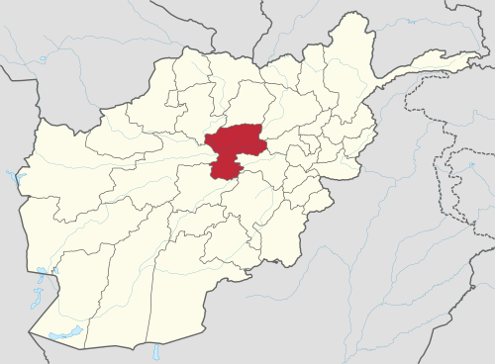
Map 3.1 Bamian Province

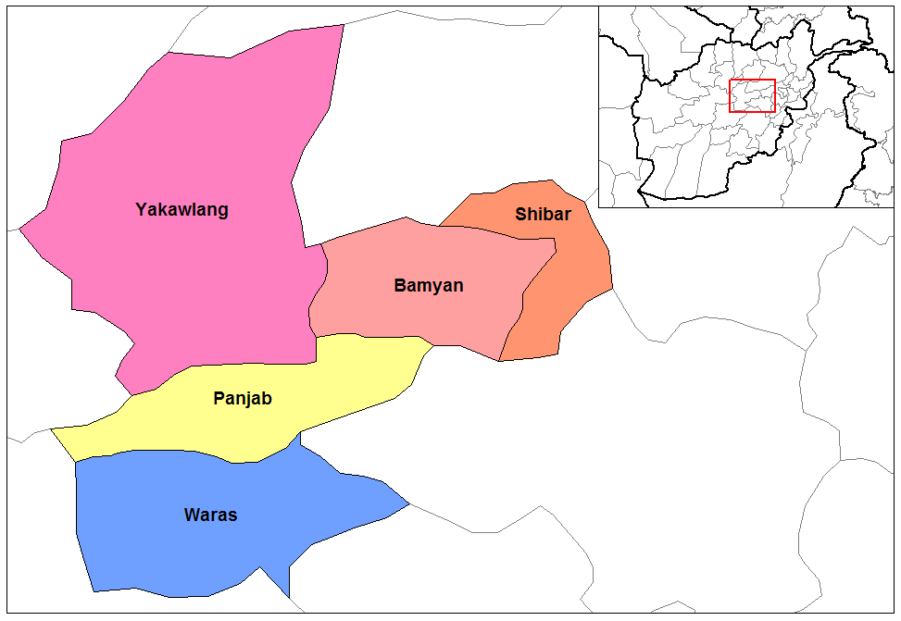
Map 3.2 Bamian Province Districts

Bamian province is located in the central highland of Afghanistan. The dominant ethnic group is Hazara followed by Tajik, Tatar and Pashtun. The main language is Dari, spoken by 96% of the population. Bamian is divided into 7 districts: Panjab, Waras, Bamyan Center, Kohmard, Shibar, Yakawlang and Saighan. The size of the province is around 14,175km², with an estimated population of around 4,327,000. Within this there are 539 CDCs and 7 DDAs. Bamian town serves as the provincial capital.

The region is mountainous with a cold climate. The cultivated areas lie along the river basin where the soil is fertile, though much of the land is high, barren, dry and inaccessible. Land is irrigated by the construction of small channels to draw water from mountain streams. The acute lack of water resources, small land holdings, poor soil quality, and no known abundance of natural resources, Bamian is one of the least agriculturally productive and poorest areas of the country and local inhabitants are resilient, hardworking and patient. As Wily states, ‘the eking out of a living from the land in many parts of Bamyan Province can be a desperate business, but one that the majority are bound to undertake year after year.’ Unsurprisingly, many migrate from the province in search of work and alternative incomes.

In terms of the agro-ecology of the area, the main crops cultivated are wheat, barley, beans and potatoes, though farming is at subsistence level. Given the extremely harsh conditions, sophisticated cropping systems have developed over many generations among rural communities as part of their traditional coping mechanisms. Extensive livestock husbandry (sheep, goats and some cattle) is traditional source of income. A major problem, exacerbated by poverty and over-population, has been the destruction of pasturage and grazing lands through cultivation of traditional upland grazing areas for low yield and high-risk rain-fed wheat (which wastes precious seeds) in years with high precipitation and the collection of woody shrubs for winter fuel.

Whilst there have been some relief efforts and attempts to improve infrastructure, substantial need remains. There are a small number of coal mines, however the potential for these to contribute to the development of the province is limited due to illegal excavation. Minerals and stone may offer the best potential for economic development. Poplar cultivation for building material and roofing poles is a source of extra income for some small farmers.

The provision of basic infrastructure remains a problem in Bamian. The labour force is generally unskilled due to low levels of vocational training and literacy, and a lack of economic opportunity reduces the incentive for people to settle in the province. Schools were mostly destroyed during the conflict or were never there due to discrimination faced by Hazaras from the central government in the past. Migration levels are high, particularly during winter when many travel to the cities due to weather conditions. There is no power grid in Bamian, meaning that electricity is mostly produced through generators.

Local level justice mechanisms are well established in Bamian province. Issues of land ownership and access to resources are the main sources of tension, which often form around ethnic divisions. The role of traditional shuras has diminished due to the presence of CDCs, causing some to feel marginalised. Again, local level dispute resolution mechanisms are well embedded but are seen to be highly flexible in the approach to different kinds of disputes. For instance, communities have established social systems and mechanisms for managing rights to common grazing rights, water and irrigation, either through an elected mirab (water master) or village elders. Irrigation systems are generally small and not so problematic to administer.

State-based and community-based mechanisms work in cooperation with each other, with most disputes resolved at the village level. AREU found that these dispute resolution mechanisms play an important role in maintaining peace and social cohesion within these communities. The conservative nature of the community restricts the participation of women in these mechanisms. As in the other provinces in this study, access is traditionally limited as stepping out of their traditional and accepted societal roles can be seen as shameful or disrespectful to their male family members.

Security in Bamian remains stable, and accessing communities is possible. Occasional expressions of frustration are experienced over a perceived lack of support from the central government despite the good security picture. Instability in some of Bamian’s surrounding provinces prompts fear of a possible spill-over.

Bamian is one of the more progressive areas of Afghanistan in terms of women’s rights, making it one of the safest regions for women. As an FAO report states, ‘in Hazarajat the attitude towards the issue of women and development is more relaxed that in most other parts of the country.’ Bamian had the countries first female provincial governor, Habiba Sarabi, who was appointed in 2008. Despite this remarkable achievement, there has been strong resistance to her position, particularly from men within the community. Bamian has also seen significant improvements in education levels generally, but is now reported to have the highest number of girls in education of all the provinces.

This evaluation covered two districts in Bamian, with two CCDCs in Panjab district (Nargis and Guhdar) and one in Shibar district (Kaloye Sufla). Bamian is primarily comprised of small farmer landowners who mainly work their own land with family labour, and while median farm size has been declining through generational subdivision there are large differences between districts; for instance, farm sizes are higher in Panjab than Shibar and landlessness is more prevalent in Panjab.

Additional day labour is sometimes hired around harvest time paid in kind or in cash. Large landowners are rare, but those that own larger landholdings which cannot be farmed by the family alone, or if they are engaged in some other activity, will usually enter into share-cropping agreements with other small farmers or the landless. The precise crop-share will depend on the respective investments of the landowner and the share-cropper.

Shibar is a relatively small district in population and area under cultivation comprising around 100 villages in 15 main inhabited valleys. The main areas of irrigated agriculture are in the main Shibar valley and a series of side valleys. The upper valleys open onto a high windswept plateau unsuitable for anything except poor rain-fed agriculture and summer pastures. As noted, the district is mainly comprised of small to medium landholdings with few or no large landowners holding more than 5 jeribs of land (around 10%). About half of households are landless or have only their house and kitchen garden, many send family members to work in Kabul, and few have enough land to employ workers, lease out land or enter sharecropping agreements. Shibar district has more rain-fed cultivated land as a proportion of total crop land than Panjab district.

Most valleys in Panjab are typified by polarised land ownership, but with large holdings found in a number of valleys, including Nargis Valley. This area has a long history of Hazara feudal relations landlords possessing vast lands with many client households, although subdivision and sale outside the family has broken down the very large estates. There is an abundance of rain-fed land in Panjab, but the majority of cultivated land is irrigated.

According to tradition, owned land includes the farm in the valley as well as the hills from where the farm receives its water. This means that owners have access to large tracts of hillside some of which might be usable for rain-fed cultivation. As a result common land is fairly scarce but landless workers, tenants or sharecroppers who own livestock are generally able to use their landowner’s grazing area for their own animals as part of their agreement.

Nargis and Guhdar are located in valleys along an east to west axis, separated by a mountain. The Nargis valley runs west out of Panjab centre. After the separating mountain, Guhdar valley, more remote, continues running further west. Much of Nargis valley’s cultivable land held in large, mainly irrigated landholdings (with descendants of one family owning a large proportion of the land) with entire villages where households are landless. Guhdar valley is also characterized by landlordism (and tenants and sharecroppers), but there is not a single dominant landholder.

3.2.2.2 Community conditions

Despite the district level differences outlined above, the three Bamian CCDC communities – Guhdar, Nargis and Kaloye Sufla – are all fairly similar in terms of their basic demographic, geographical and developmental conditions. All are fairly large CCDCs comprising between 5 and 7 CDCs and between 30 and 48 smaller villages. Communication and travel between CDCs in the CCDCs is difficult in all three, particularly in winter, but especially acute in Guhdar CCDC where the communities are spread far apart. The maps below, generated by communities interviewed by teams of evaluators in these provinces, provide an indication of the prominent geographical features of the CCDCs as well as project locations.

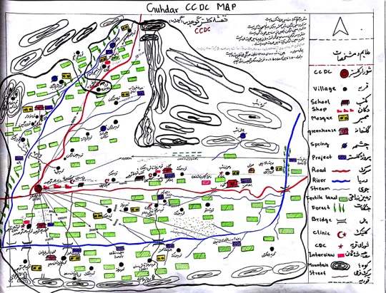
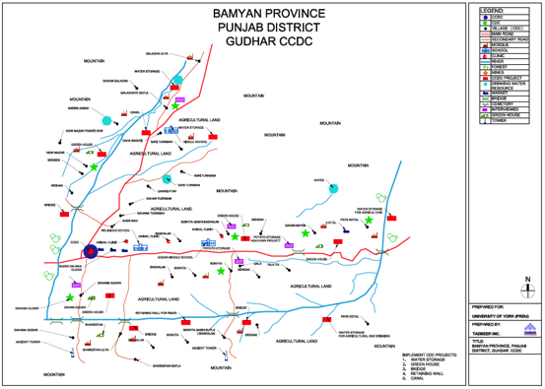
Map 3.3 Guhdar CCDC

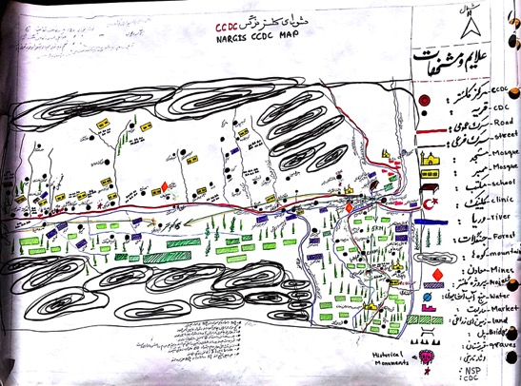
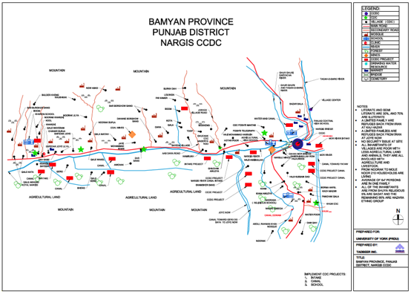
Map 3.4 Nargis CCDC

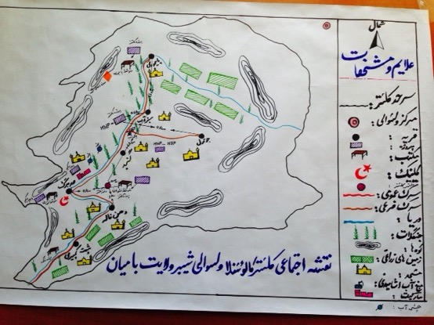

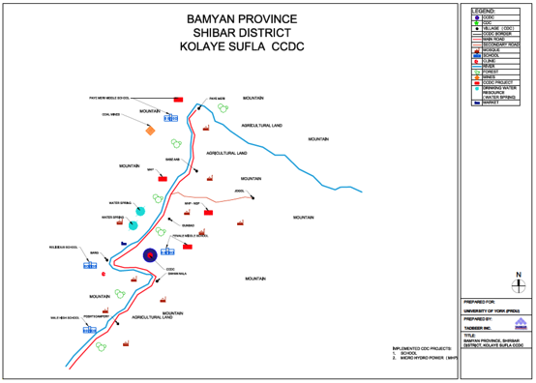
Map 3.5 Kaloye Sufla CCDC

All three Bamian CCDCs are ethnically Hazara (with a small Sadat minority) and religiously homogenous (with only small numbers of religious minorities). They are all static, settled populations. All are safe areas but very poor and largely reliant for their livelihoods on agriculture, livestock and handicrafts (with some small-scale artisanal mining, beekeeping and government jobs).

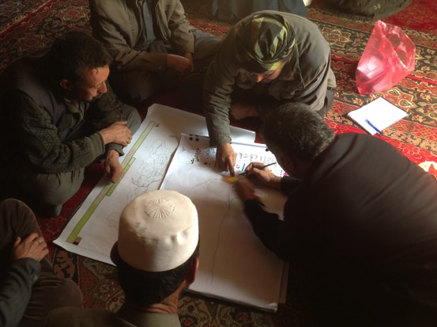
Photo 3.1 CCDC members mapping the area

Community resources are limited, consisting mostly of land for agriculture or grazing, water and forest (two have a small marble and coal mines, but these are government-controlled concessions). While they are situated in a beautiful mountainous region, the communities suffer variably from limited access to drinking water and sanitation, unclean or dusty environments and chronic under-development.

CCDC | CCDC size | CDC proximity | Security | Diversity
Guhdar | -Large  -5 CDCs  -30 villages | Far apart – interaction very difficult | Safe | -Ethnically homogenous  -Religiously homogenous
Nargis | -Large  -6 CDCs  -48 villages | - Located along a valley.  - One (Kham CDC) is in another valley | Safe | -Ethnically homogenous  -Religiously homogenous
Kaloye Sufla | -Large  -7 CDCs  -43 villages | - Located in a line along a river  - Communication between CDCs not too difficult | Safe | -Ethnically homogenous  -Religiously homogenous

CCDC | Relative Wealth | Environment | Resources | Livelihoods
Guhdar  (cont.) | Poor | -Underdeveloped -No sanitation  -Insufficient drinking water  -Not clean | -Water  -Grazing land | -Agriculture  -Livestock  -Handicrafts  -Dairy products
Nargis  (cont.) | Poor | -Not clean  -Limited clean drinking water  -No sanitation | -Fertile land  -Grazing land  -Water  -Small marble mine | -Agriculture  -Livestock  -Beekeeping  -Handicrafts
Kaloye Sufla  (cont.) | Poor | -Fairly clean.  -Dusty air. | -Pasture  -Woods  -Water  -Small coal mine | -Agriculture  -Livestock  -Handicrafts  -Tailoring  -Government
Table 3.1 Community features

3.2.2.2 Project details and immediate outcomes

The projects implemented in the three Bamian CCDCs were:

- Roads, bridges and retaining walls to connect villages; canals for irrigation; and safe drinking water projects (Guhdar)
- Water canals for irrigation; and a school (Nargis)
- Electrification; and school rooms (Kaloye Sufla)

The overall immediate success rate of the CCDC projects in Bamian is very good based on the sample considered in this evaluation. All CCDC projects in Bamian were judged to be successful by CCDC member respondents.

Decisions with regard to projects were taken after individual CDC prioritisation had been considered, meetings held, alternatives discussed and final choices adopted (either by majority voting or reaching consensus through discussion). In one CCDC (Guhdar) it was decided that each CDC would implement projects separately but under the overall direction of the CCDC. In all cases, there was some level of initial disagreement over project choice and not all CDCs felt their priorities were captured by the CCDC but, equally, in all cases this was largely resolved and individual CDCs were judged to be satisfied with the ultimate decision and outcome.

All projects were judged by respondents to be sustainable, based on continued community maintenance and investment and barring any major natural disasters. All the projects are still active and being utilised by the communities.

All projects in the three CCDCs were deemed to have benefitted almost all community members. However, certain individual CDCs or villages did not benefit from projects such as communities in Nargis that are situated above the streamlet and thus did not benefit from the improved irrigation. Thus, the Nargis irrigation canal benefits 70% of community members but the school benefits everyone.

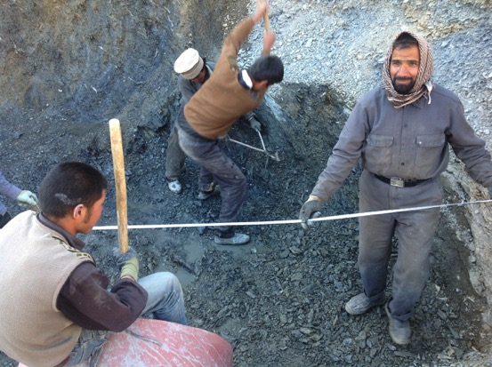
Photo 3.2 Community members implementing a CCDC project in Bamian

In terms of immediate outcomes, CCDC members noted that: canal projects irrigated land in less time and allow for the watering of crops on time; roads and bridges connected villages; wells provided more clean drinking water to community members; schools benefitted both pupils and teachers through job creation and community literacy rates; and electricity reached homes consistently.

CCDC | Project(s) | Success | Sustainable | In use | Benefits all
Guhdar | Bridges/canal/wells | Yes | Yes | Yes | Yes
Nargis | Canal/School | Yes | Yes | Yes | Yes
Kaloye Sufla | Electricity/School | Yes | Yes | Yes | Yes
Table 3.2 Project type and outcome

CCDC | Initial disagreement? (reason) | Resolved? (how) | CDCs satisfied with final choice?
Guhdar | Yes (CDCs far apart, location of project; dividing the budget, few mutual interests) | Yes (CDCs implement separate projects; FP support and encouragement) | Yes
Nargis | Yes (5 CDCs wanted canals; 1 wanted school as had no agricultural land) | Yes (both type of project implemented) | Yes
Kaloye Sufla | Yes (difference of opinion on project) | Yes (majority voting, FP support) | Yes
Table 3.3 Project prioritisation

3.2.2.3 Socio-economic welfare

In general, it can be stated that the CCDC projects generated modest improvements in socio-economic welfare. Community members – who were mainly those working their own land – noted little change in objective conditions, but did note some gains in agricultural productivity, time saving, and an easing of daily life.

The school was seen as providing much needed education and contributing to the future prosperity of communities by increasing literacy rates, with the prospect of children gaining salaried employment and subsequently sending money back to the village. The school has contributed to better quality of life and enhanced education as children have good, clean and comfortable rooms in which to learn – in Kharzari, Nargis, children used to have to work under tents. Also, some community members had managed to progress to university and boys and girls now have the opportunity to marry at an older age (it used to be 13/14 but is now generally early twenties) as they can study and get jobs.

The electrification project has benefitted all members of the community efficiently and economically. This provides light (so villagers do not have to use lamps, which require diesel and cleaning) and children can study at night. The ability of community members to charge phones improves communication and they can watch TV or listen to the radio to expand their knowledge and learn about events throughout Afghanistan and beyond.

New roads and bridges have contributed to some improvements in the local economy and social life more generally: vehicles can more easily get close to where the harvest is collected; goods can be taken to the market or mills much more easily; people can commute in all seasons and visit friends and family; and children can travel much more safely to school (especially in winter). Improved roads have also improved the time people can get sick people or pregnant women to hospital which has saved lives. Connecting villages has also given a boost to the local economy, reduced loss of materials and animals during river crossings, and homes are safer from flooding. The water downstream is also cleaner as animals or people with goods no longer cross directly through the river.

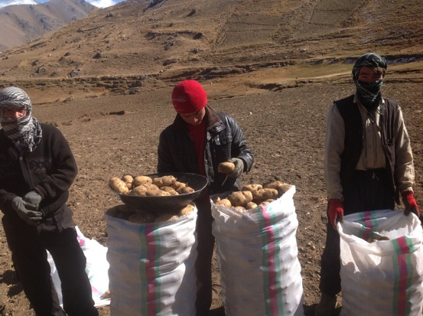
Photo 3.3 Bamian community members selling their produce on the road

Canal, reservoir and irrigation projects have contributed to enhanced agricultural productivity with water reaching the land on time, while allowing the planting of new vegetables (some communities had only been able to grow potatoes previously) which has positive impacts in terms of health and diet. Also, in solving recurrent flooding issues, a great amount of labour time has been saved. It has also served to help green the environment.

Water well projects have increased access to safe sources of drinking water, but were judged to still be inadequate by some community members. As a result, sickness and disease has declined according to community members.

Also, as a direct short term outcome, the local labour required for project implementation has contributed to the local economy by providing daily wages for community members.

Case Study – Kham, Nargis CCDC

At one point in Kham, the canal stream passes five meters above the land to cross the mountain at Bashi Cave. This was built with mud many decades ago but gets destroyed every winter and it has to be rebuilt – the community has a supervisor (Bashi) responsible for keeping the stream working every time it gets damaged by filling any holes with grass. If the water makes a big hole the stream would be destroyed. One time the Bashi didn’t have enough grass so he got in himself and plugged the hole and asked people to bring mud and grass. Also, a kilometer south, the stream on a hillside was in danger and people had to fix it from time to time. Once they were working there and two of them fell down – one was killed, the other badly injured. The weather is cold most of the time and it is hard to keep it working.

Thus, with news of the CCDC budget, the people of Kham only wanted one thing: to build these canals with concrete. There was thus little issue with prioritization and the canal project was identified and work started.

This has changed the life of the people of Kham – there is no more fear about the canal getting damaged or people getting injured; no need for the Bashi; no more recurrent costs of upkeep; and less time, money and effort spend rebuilding the canal. The land gets more water on time which improves productivity – the farmers have more land to cultivate and need work less.

3.2.2.4 Governance for development

Our findings show evidence that the CCDC pilot project has contributed to enhancing community capacity for local developmental governance in the Bamian CCDCs. All CCDCs received training from FPs in finance, procurement, problem solving, and project management. Project selection displayed a marked ability to prioritise effectively, settle disagreements and oversee the effective implementation of projects. There were instances of innovative restructuring and reallocation of budgets. Meetings were held regularly, and generally on a needs basis. Meetings were seen as effective and often involved healthy discussions around issues beyond NSP project implementation (such as rights, community problems, vaccinations, aid during disasters and suggestions for new projects). In Guhdar, for instance, the CCDC decided to lower wedding expenses to free up money for development purposes. There was also evidence of CCDCs interacting with other committees such as the youth committee, scholars shura and savings groups.

Two of the three CCDCs were attempting to get funding for further non-NSP projects. Only in Guhdar was the CCDC not working towards further projects, but this is a CCDC in which the communities are far apart and they had decided to split their project budget allocation between themselves – there was thus little prospect of future collaboration through the CCDC. In Nargis the CCDC is working on other projects (a rice and wheat project from the district government) and is seeking new funding for projects on agriculture, livelihoods, healthy drinking water and electricity supply from NGOs. Kaloye Sufla is similarly seeking funding for agriculture and livelihoods projects.

An interesting indication of improved capacity to manage their own affairs was apparent in Nargis CCDC where the FP engineer came to conduct a survey and prepare technical documents for the canal construction. The engineer got the survey wrong meaning the budget was estimated to be insufficient even with the 10% community contribution. The CCDC thus had to increase their contribution to 30%. Together the council worked to reorganize and budget the project and managed to rebid for a required truck of rocks down to 6000afs from 9000afs. They decided to work together as a community to construct ninety meters of canal, up from the planned fifty meters.

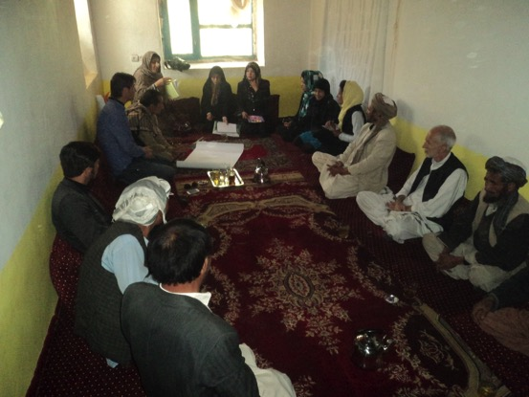
Photo 3.4 CCDC member meeting in Bamian

All CCDCs had good and healthy relationships with the district authorities and the nature of contact was generally conducted on a needs basis. Issues raised in meetings would cover projects, community needs, social problems, disputes and security issues. Also, in all three cases the CCDC had become an important point of contact for the district governor. The relationship also appears to be working the other way around, with the district government using the CCDC as a conduit to provide advice to communities, such as encouraging them to plant trees and clear snow from roads during winter. It also gains information and cooperation from the CCDC on security in the area.

All CCDCs had contacted the District Development Assemblies (as all CCDC/CDC projects have to be approved by the DDA), but there appeared to be some challenges in these relationships. Nargis CCDC had ceased meetings after a disagreement between the DDA and FP over who should pay for the travel costs. In Guhdar, the CCDC contacted the DDA to discuss support with respect to potato storage and seeds, but the meetings did not bring any results. Kaloye Sufla CCDC noted that it prefers to try to deal with its own problems before contacting the DDA.

Similarly with respect to community voice, all CCDCs believed their confidence and bargaining power in relation to local authorities had been significantly increased as a result of working collectively. In Guhdar, the Head of the CCDC represents the communities and seeks to promote their interests when meeting with district authorities – in one instance, the CCDC successfully negotiated with the government to provide more trees and seeds. In some cases, members of the CCDC were also sitting on district government bodies, which appeared to improve access for the CCDC and enhance the nature of the relationship (although specific benefits of this relationship were not elaborated on in responses).

CCDC | Relations with District Authorities | CCDC Point of Contact? | Contact with DDA
Guhdar | -Healthy but not much communication.  -Needs based | Yes | Yes. Help CCDC prepare for interaction with district govt.  CCDC member on DDA.
Nargis | -Good  -District govt attends CCDC meetings  -Discuss projects, needs, social problems, security.  -Needs based | Yes. Effective point of contact for district shuras. | Yes. Problem after disagreement over paying for CCDC travel (AKDN or DDA).
Kaloye Sufla | -Good and improving  -Needs based  -Discuss issues, new projects, dispute settlement, security issues | Yes (CCDC represents the community) | Yes
Table 3.4 Relationship with district authorities

CCDC | Traditional Roles | Community Voice
Guhdar | -Changed: now CCDC resolve disputes  -Consultation with traditional leaders & also on CCDC/CDC  -Good relationship & cooperative | -Strengthened - head of CCDC fights for community interests  -Increased bargaining power and negotiating influence
Nargis | -Consulted and invited to meetings  -Very good relationship  -Leaders encourage development | -Improved: bargaining power increased; go to other organisations collectively
Kaloye Sufla | -Consulted  -Helpful relationship  -CCDC has enhanced local democracy | -Increased voice in relation to local authorities – power to bargain
Table 3.5 Impact on traditional roles and community voice

In terms of the CCDC’s impact on traditional roles, the CCDCs have facilitated new community leadership to emerge. Although, there is some measure of overlap with traditional leadership, CCDCs have encouraged democratic processes and taken over roles and responsibilities that were formerly the preserve of traditional village leaders. Local government authorities now generally approach the CCDC or CDC as their first post of call when interacting with communities. This has not led to any observable frictions or tensions and the relationships between the CCDC and traditional leaders was judged to be healthy, cooperative, constructive and helpful. Traditional leaders were generally consulted about CCDC activities, were involved at all stages of the project cycle, and CCDCs stated that they benefitted from the advice knowledge and experience of traditional leaders. No major conflicts of interest were apparent.

Despite the mostly positive trends outlined above, the picture at the CDC level was somewhat more complicated and concerning. It was noted on a number of occasions that it is the CDCs that primarily act as a form of local government and it appears most community issues are addressed at the CDC level where possible. Some CDCs have implemented other projects and are working on other things beyond the CCDC project, such as dispute settlement, local governance, social and economic affairs, and seeking funding for additional projects from other NGOs and agencies (except Guhdar CCDC).

With these positive aspects of CDCs in mind, some respondents at the CDC level – especially in Guhdar and Nargis CCDCs – claimed that the CCDC had rendered CDCs less active and effective. There was a concern that the CCDC does not fully understand the needs of the individual CDCs given the often large distances between CDCs, and that the existence of the CCDC had reduced the extent of contact between CDCs and the district government and that this might be undermining their voice and representation. It was also claimed that CCDCs are not necessarily more effective than CDCs as villages are far apart and do not have common interests. A respondent from Kham CDC in Nargis noted that,

“The CCDC has complicated our work and weakened the CDC. The CCDC did not allocate resources equally so we were forced to work on canals as we had no choice. Now trust in the CDC is weakened as they did not compensate us for our labour. We do not get updates from the CCDC... Overall, the CCDC had a negative affect; even traditional leaders do not participate.”

3.2.2.5 Social cohesion

Overall, the CCDC project appeared to have increased levels of interaction, communication and cooperation between CDC communities in Bamian. Clustering had promoted greater awareness, equity and mutual learning. Relations between CDCs were judged to have improved. As the women in Sadbag, Kaloye Sufla put it: “The CCDC has made us closer to other CDCs; we have become friends. Before it was hard to meet as we couldn’t go and see them.” Visits between CDCs occur to solve disputes, mediate and help each other. Indeed, this positive dynamic was especially apparent in Kaloye Sufla CCDC:

“We have become stronger, if issues are not solved at the CDC we go to CCDC who connects us as a body and now we think about development beyond our own CDC and support each other economically”

There were also cases of other visits by other CCDCs in different districts to share and learn from each other’s experiences, but this was mainly restricted to the period during project implementation.

In Guhdar, people can now more easily commute from one CDC to the others, and to the district centre. The CDCs can work with each other and if there is an issue that the CDC cannot solve they approach the CCDC and solve the issue collectively. As an example of enhanced solidarity between CDCs, Dahani Guhdar had 40,000afs extra money from the CCDC project and they decided to give it to Qalacha CDC so they could better implement their project.

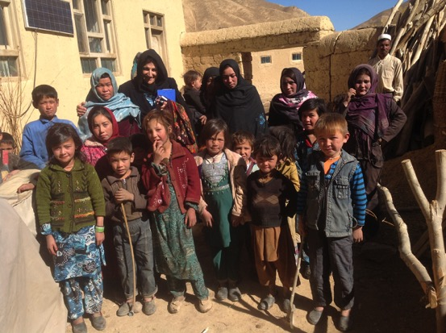
Photo 3.5 Community members in a Bamian CCDC

There were a number of examples provided which suggest the CCDC has taken on a community dispute resolution role on occasion. There was some evidence of CCDC resolving disputes at the CDC level. For instance, a car sale issue was resolved by the CCDC in Nargis CCDC. In Kaloye Sufla, there was a fight between two men over water and one had broken the other’s teeth. The CCDC took an agreement from the two men that they would abide by the CCDC’s judgement. They convinced the man who broke the other man’s teeth to pay for the treatment and ask for forgiveness. In such cases, where the CCDC has helped resolve disputes, they have applied largely traditional means, but the training they received from Facilitating Partners was judged to have been marginally useful also.

However, the extent of this increased cohesion, cooperation and contact was somewhat limited across the Bamian cases and respondents at the CDC level were sceptical as to the extent to which clustering had actually brought them together with other communities. In Dahani Guhdar, in Guhdar CCDC, it was even stated that the CCDC had decreased unity because it turned relationships into a form of business partnership, making them just about profit. They claimed the CCDC was unrepresentative, had not brought communities together and that it just complicates matters. Respondents from Qalai Wakil in Nargis stated that the “CCDC is not fair; there is unequal distribution of resources. Ghawchak and Sabzsang CDCs did not benefit greatly from the CCDC project and most of the funding went to Kham CDC – it created disputes and the FP was not helpful.”

Case Study – Kaloye Sufla CCDC

The CCDC received a budget to build three rooms in Sadbag School and three rooms in Gunbad School. Sadbag School had also received a similar budget from the Directorate of Education for the very same purpose and the money they received from the CCDC was left unused. Although they could have used this money on any other project, they knew that just three rooms in Gunbad School was not sufficient and that they needed to build more rooms so that the children who go to school have a good environment to study.

The CDC members of Sadbag and the people living there decided to give this money to Gunbad CDC to build six rooms instead of three rooms. To show their appreciation, the people from Gunbad CDC gave some money to Sadbag community to buy pipes for a safe drinking water project. This is an indication of the extent the clustering had an impact on the social cohesion of the CDCs within the CCDC.

3.2.2.6 Gender

An increased role for women in decision-making as a result of CCDC processes was apparent and there was some evidence of improved openness of village men to the political and social participation of women. Women have been encouraged to participate in CCDCs, and respondents at the CCDC, CDC and community level universally stated that increasing female participation would be a positive thing. They noted that improving literacy, awareness and experience would help in this respect – schools were deemed especially important. It was also suggested that participation improves when they see other women in leadership roles, thus encouraging them to get involved. There was no observable opposition to women’s involvement in community decision-making, claiming that it is not only a woman’s right to participate but that it would be of great benefit for the community.

CCDC | Female CCDC members | Percentage | Same meeting | Sub-committee | Every CDC
Guhdar | 4 Male  (Women are on sub-committees) | 0 | N/A | No | No
Nargis | 8 Male  2 Female | 20% | Yes | No | No
Kaloye Sufla | 8 Male  6 Female | 43% | Yes | No | No
Table 3.6 Gender dynamics

Where women were not members of the CCDC this was explained as not being due to any gender discrimination per se, but rather as a result of the difficulties involved in women travelling between communities (families do not allow wives or daughters to do this). In Guhdar, women were asked to participate but only two showed interest from Qalacha and Baghalak CDCs. The chief reason for the somewhat poor representation of women on CCDCs was the difficulty women face in travelling the large distances between CDCs. Illiteracy amongst women was also seen as impeding their active participation. Where women were represented within then CCDC they held the same responsibilities as men and were judged to be active in decision-making.

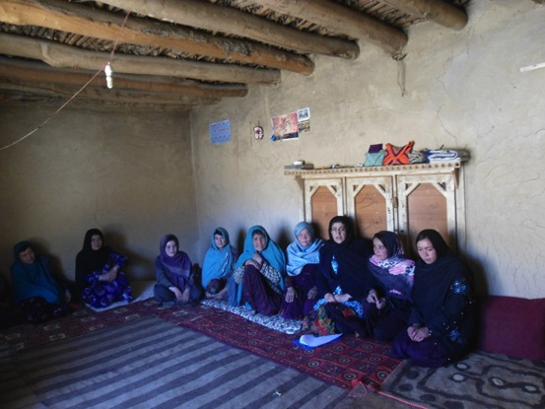
Photo 3.6 Women community member FGD in Bamian

Projects were not always directly beneficial to women. It was stated by community members that projects around tailoring, handicrafts and carpet making would benefit women (and encourage their participation in community development governance). Nevertheless, it is clear the CCDC projects do benefit women in a number of other more general ways.

A particular concern arising from the data collected at the community level, was the extremely limited awareness amongst ordinary women in the villages about CCDC decision-making or project implementation – a number complained they were not updated on projects. Some put this down to their illiteracy, suggesting that men believe they would have nothing to offer. Although not so much an issue in Kaloye Sufla, in both Nargis and Guhdar there was a significant communication gap between the women in CDC communities and the activities of the CCDC – this was largely because women were barely involved or consulted in decision-making at the CDC level (however, they were generally aware of the resulting projects). As the women in Baghalak CDC put it:

“The government, NGOs and men should encourage and provide a platform for women to actively participate along with men towards development. If we have responsibilities it will improve the village but we are not involved.”

The extent of women’s participation appeared to be dependent on the type of projects under consideration. There was one suggestion amongst female community respondents that men believe “that if women come into power they won’t care about men.”

3.2.3 Balkh

3.2.3.1 Context

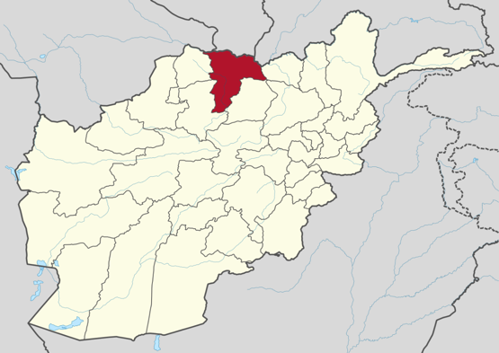
Map 3.6 Balkh Province

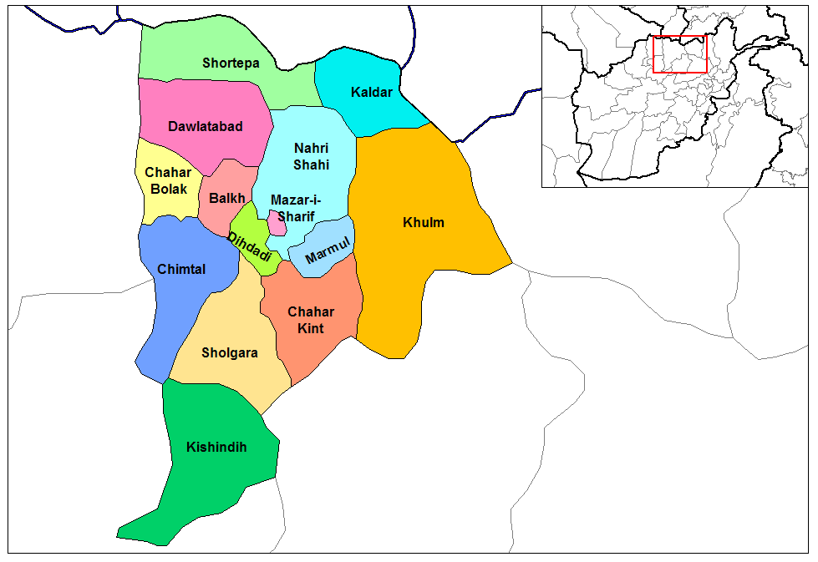
Map 3.7 Balkh Province Districts

Balkh province is located in the North of Afghanistan, sharing a border with Uzbekistan and Tajikistan to the north, as well as Kunduz, Samangan, Sar-e-Pul and Jauzjan provinces. The vast majority of the population are Tajik making the province relatively homogenous, though there are Pashtun, Uzbek, Hazaras, Turkmen, Arab, and Baluch minorities. Dari is the most commonly spoken language, followed by Pashtu, Turkmani and Uzbeki. There is also a nomadic population of Kuchis. The estimated size of the province is 17,248km², with an estimated population of 1,271,400 people, with approximately two-thirds living in rural districts and one-third in urban areas. Within the province there are 676 CDCs and 19 DDAs. Mazar e-Sharif is the province capital, and is one of the country’s largest commercial and financial centres. Mazar is an important trade hub, with imports coming in from Central Asia and natural gas resources utilised to provide power to other areas of Afghanistan.

Balkh’s economy is one of the least agrarian-based in the country. The primary crops industrially cultivated in the agricultural sector are cotton, sesame and tobacco, though cereals and potatoes are mainstay of agricultural production. Ample water sources are available which feed into irrigation systems facilitating agricultural production, alongside good soil quality which allows for extensive double cropping in the northern plain. The province has been poppy free for several years. Half of the province is comprised of mountainous terrain, with the other half flat land. Much of the infrastructure fell into a state of disrepair throughout the conflict in the 1980s and 1990s, particularly the highly war-affected eastern part of the province.

Reconstruction is ongoing but slow. Productive infrastructure such as irrigation networks have largely been repaired, new wells are being excavated, though secondary roads remain in poor condition, and as such the provision of basic infrastructure remains a dominant development issue throughout the province. Around half of all households have access to electricity, which rises to 95% in urban areas in comparison to 75% in Kabul, as well as nearly all having access to community drinking water sources. Mazar e-Sharif hosts a large public hospital, with a network of basic health service provisions at the local level also.

The governance of Balkh province is seen as strong, with the province having achieved a degree of independence from Kabul-based central government structures. Good local security and the elimination of poppy cultivation are cited as examples emanating from this success. Governor Atta Mohammad Noor is the major political actor in the province and has strengthened his power through maintaining a careful balance of power between ethnic-based political parties, and party leaders had close ties with both Governor Atta and local elders.

Local dispute resolution mechanisms are embedded throughout Balkh province, with only more serious disputes being taken to state-level resolution mechanisms. While there are links between local and state level mechanisms, these remain informal. Treatment of women is highly conservative, although there is a reported openness to increasing the opportunities for women to access information on their rights, livelihoods and development projects, as well as to participate in decision-making that affects their daily lives.

Leadership roles for women at the local level have begun to evolve with women gradually taking on greater responsibility in development activities, dispute resolution and microcredit groups. The majority of women are engaged in income generating and mainly gender-specific activities such as tailoring, embroidery, hairdressing, keeping livestock and selling the products, cleaning peas, and shelling walnuts. Some of the younger, literate women in this region are also employed as teachers in local schools. There have been a number of activities throughout the region based on the advancement of women’s rights and developing their skills in productive activities to enable them to generate incomes. Both boys and girls are attending school, and microfinance schemes have been active helping women to earn their own money and exercise more control over their financial activities. Despite these positive changes, child and forced marriage is perhaps the most pervasive in this region of Afghanistan; an issue that many organisations are working to overcome.

This evaluation covered three districts in Balkh: Dehdadi, Khulm and Kishindih. The CCDCs pertaining to these districts are, respectively, Etifaq, Azadi and Sarab.

Close to the provincial capital of Mazar-i-Sharif, Dehdadi district is ethnically diverse, comprised of Tajiks, Uzbeks and Hazaras and smaller groups such as Arabs and Turkmen. Individual villages within the district are typically more ethnically homogenous, though there is significant social and economic interaction between groups. For the most part, ethnic groups are clustered in separate villages within the district. The road infrastructure in the district is fairly well developed with the majority of roads able to take cars in all seasons and good links to markets. Dehdadi is a major producer of cotton, and other trades include jewelry and carpet making. The district accounts for just over 10% of total agricultural production in the province, making it one of the most productive districts. Most of the cultivated land is irrigated but there have been shortages of water due to damage to the water system and breakdown of traditional management arrangements. Mostly single-cropping. 10% of households are landless. The vast majority of households farm their own land, rather than sharecropping. Poor households often rely on casual labour and many resort to begging.

Khulm district is a large province by area, located in the east of the province. As a predominantly agricultural area, the district accounts for just over 10% of the total agricultural production in the province and produces the most fruits and forage in the province. However, poor infrastructure and the poor condition of the roads limits the possibilities for reaching markets beyond the district. Quite a large proportion of the land is forested, pasture, or non-arable. Average land ownership in the district is about 8 jeribs. The district has been repeatedly affected by natural disasters, such as the devastating floods that struck in May 2014.

Kishindih district is located furthest from the provincial centre and has a mixed population of Uzbek, Pashtun, Tajik, and Hazara. It has very poor road infrastructure as well as limited access to social services such as quality health centres, education and electricity. It is located in the more mountainous south of the province. The district is a big producer of sesame but in general has low agricultural production and livestock holdings relative to the two other districts. In contrast to Dehdadi and Khulm, most of the cultivated land in Kishindih is rain-fed. The district has also suffered from recurrent natural disasters, in particular floods which have destroyed agricultural land and other infrastructure. As a result of all these factors, the district is very poor.

3.2.3.2 Community Conditions

The three Balkh CCDC communities – Etifaq, Azadi and Sarab – are all fairly similar in terms of their developmental conditions. Communities do not have access to any specific natural resources of any note (such as mines or forests) beyond the land and water sources. Environmental conditions are dry, dusty and harsh, although Azadi is a little better in this respect. While access to clean drinking water varies, many are reliant on rain water, such as in Sarab and certain CDCs in Azadi. Most communities could be described as lower-middle class, with agriculture and livestock constituting the main sources of income; Etifaq appears to be generally better off than Azadi or Sarab but there are more marginalised communities within the CCDC area, such as Yakatoot. The ethnic composition of the CCDCs differs: Sarab is almost exclusively Tajik while Azadi has a more heterogeneous population made up of Tajiks, Uzbeks and Arabs. Etifaq is comprised mainly of Tajiks and Pushtuns. Religiously, the communities are exclusively Sunni. The security situation in the three CCDCs is judged to be good.

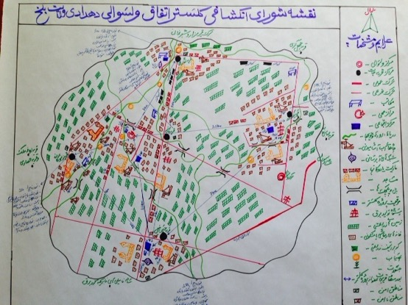
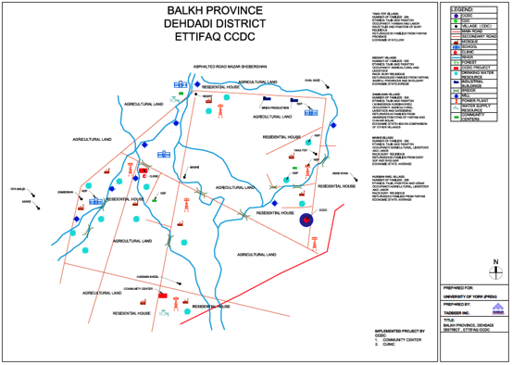
Map 3.8 Etifaq CCDC

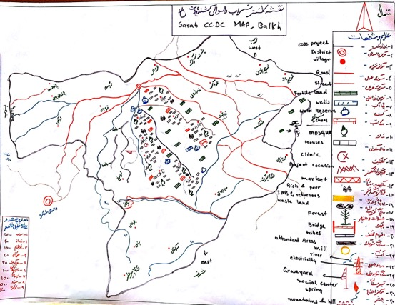

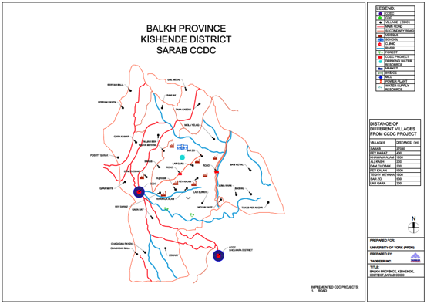
Map 3.9 Sarab CCDC

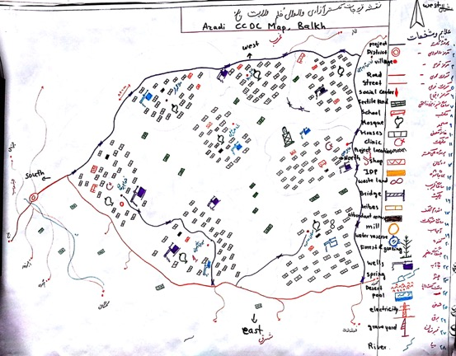

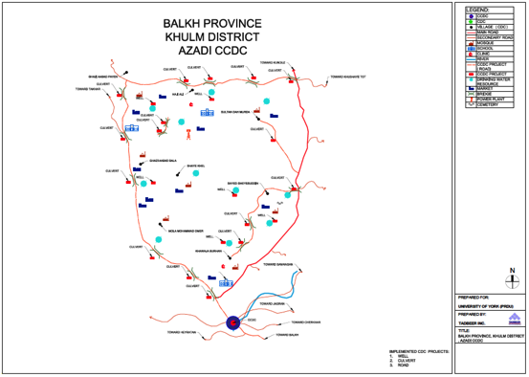
Map 3.10 Azadi CCDC

CCDC | CCDC size | CDC proximity | Security | Diversity
Etifaq | Information not available. | Quite far apart; Yakatoot especially remote. | -Safe  -No-one carrying weapons | -Mixed ethnicity (Tajik, Pushtun, Uzbek, Arab)  -Religiously homogenous (Sunni)
Sarab | -8 CDCs  -17 villages | Average – not too remote | -Safe  -No recent security incidents | -Ethnically homogenous (Tajik)  Religiously homogenous (Sunni)
Azadi | -8 CDCs  -8 villages | Average – not too remote | -Safe  -No major incidents | -Mixed ethnically (Tajik Uzbek and Arab)  -Religiously homogenous (Sunni)

CCDC | Wealth | Environment | Resources | Livelihoods
Etifaq  (cont.) | Average-poor | -Generally clean  -Good air quality | None | Agriculture  Livestock
Sarab  (cont.) | Average-poor | -Not good  -Dusty and hard  -Little greenery  -Limited water | None | Agriculture
Azadi  (cont.) | Average-poor | -Generally good and clean. | None | Agriculture
Table 3.7 Community features

3.2.3.3 Project outcomes

The projects implemented in the three Balkh CCDCs were:

- Community centre and clinic (Etifaq)
- Roads (Sarab)
- Roads and wells (Azadi)

Most of the projects were implemented successfully, if not perfectly. The one exception was the failure of the deep well boring in Azadi CCDC due to the rocky ground – individual smaller shallow water wells were drilled instead. The roads in Sarab and Azadi were successfully constructed: the former is 22.68km long and the latter is 7.13km long with 12 culverts. The community centre in Etifaq has been built but had not yet been inaugurated when the researchers visited the CCDC. The clinic is operating, although it is judged to be in a poor condition.

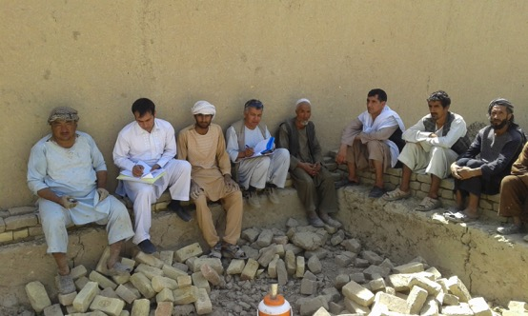
Photo 3.7 CCDC members in Balkh

The projects benefit the vast majority of community members in the relevant CCDC areas. The one major exception is the case of Yakatoot CDC in Etifaq CCDC – Yakatoot disagreed with the choice of projects, refused to pay its 10% contribution and ceased cooperation with the cluster. The CDC claims it has not benefitted from the community centre or clinic given that they are located far from the community (see map). Nevertheless, apparently some villagers from Yakatoot do make use of the clinic (which is located in Mashi CDC, quite far from Yakatoot). The community centre, located in Hussain Khil CDC, is also quite far from other CDCs and thus not benefitting them to a great extent.

Despite the largely successful implementation of the projects, there were serious concerns regarding the sustainability of the projects. Maintenance and protection plans were lacking for the roads and it was suggested that they might not last more than one or two years given damage caused by flooding. While their were signs that the community was prepared to contribute some resources to the continued maintenance of the projects (given their initial investment in them and belief in their worth), their capacity to do so was limited given the high costs involved. Moreover, the fact that none of the Balkh CCDCs continue to function severely undermines the ability to ensure projects are protected and kept in functioning order.

CCDC | Project(s) | Success | Sustainable | In use | Benefits all
Etifaq | Community centre and clinic | Yes | Limited | Yes | No
Sarab | Roads | Yes | Limited | Yes | Yes
Azadi | Roads and wells | Yes and No | Limited | Yes | Yes
Table 3.8 Project type and outcome

CCDC | Initial disagreement? (reason) | Resolved? (how) | CDCs satisfied with final choice?
Etifaq | Yes. Yakatoot against construction of clinic – wanted pipe scheme. | Resolved between all but Yakatoot, which remains in disagreement. | No. Yakatoot not content.
Sarab | No – all villages agreed on the road. | N/A | Yes
Azadi | No – all agreed on road and wells. | N/A | Yes
Table 3.9 Project prioritisation

3.2.3.4 Socio-economic welfare

Community responses suggest modest overall socio-economic gains associated with implemented projects. Positive short-medium term outcomes were especially apparent in relation to road construction (in Sarab and Azadi) which has enabled quicker, easier and significantly cheaper access to markets since their construction. Community members have also been able to travel to district centres and cities to find paid employment. Better roads have also enabled communities to get sick people to hospital more quickly, preventing the deaths that previously occurred due to the uncomfortable and lengthy travel times. The roads also enable children to travel to school, thus improving education levels and literacy rates.

Roads are also responsible for a clearly positive impact with respect to social interaction between communities. This will be discussed further below, but such enhanced social solidarity, unity and community interaction – in part directly as a result of ease of travel and communication – was clearly and consistently referred to at all levels of respondent in the two CCDCs where roads had been implemented. Villagers could more easily visit relatives and people were increasingly attending social events in other communities.

The clinic has around 150 patients daily, has helped to reduce disease, provides better facilities than in the past, and villagers can reach it easily in case of emergency. The clinic offers services in different departments such as pediatrics, vaccination, gynecology and obstetrics, minor surgery, and basic life support. The community no longer pays doctors bills and there is no additional transportation charges for taking patients to the city: in the past, villagers were paying around 500afs travelling to the city and 1000afs for the doctor and other services, which they no longer have to cover. Respondents claimed the clinic had helped reduce disease and has helped with the delivery of babies and the provision of vaccinations. Yet, the clinic clearly suffers from underinvestment. It was described as being in poor condition and not able to fulfil all the needs of the communities. It was described by some respondents as having minimal impact and as not being very effective.

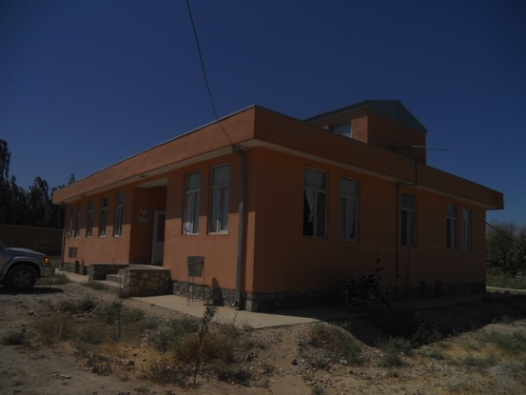
Photo 3.8 The clinic in Mashi CDC

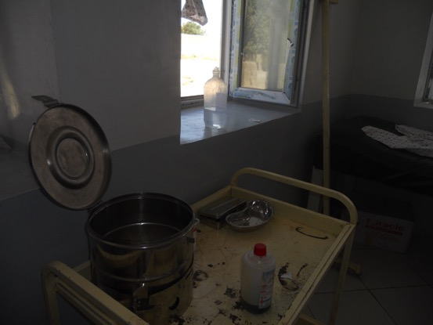
Photo 3.9 Inside the clinic

The community centre supposedly allows the community to come together to hold regular meetings such as CDC shura meetings, capacity building trainings, and short-term literacy and vocational courses for women. Also, it is used to offer religious education for children. However, responses suggest the community centre only really benefits those in the CDC where it is located.

The drinking water wells in Azadi have provided increased levels of safe drinking water and helped to reduce disease according to community respondents.

Also, as a direct short term outcome, the local labour required for project implementation has contributed to the local economy by providing daily wages for community members.

Case Studies – Sarab and Azadi CCDCs

Sarab CCDC

The Sarab CCDC of Kishendi District was initiated in June 2010 through a democratic process in presence of the people, social elders, members of CDC and NSP representatives. There were people from different villages and from different social strata, including women. After the election of the members, they held an internal election among the CCDC members on the same day, selecting members and specifying the responsibility of each member in the CCDC - a sort of internal division of labour.

Thereafter, they worked on prioritizing the project in the presence of eight CDC representatives, social elders and community representatives. Before the prioritizing meeting in the CCDC, CDCs had discussed the priorities of different villages with community members, so they had already prepared the list of their prioritized options. The meeting reached a consensus among all the CDCs and CCDC members, ultimately selecting to construct the 22.68km long road. No disputes were recorded during the prioritizing process because all the villages included in CCDC were seriously challenged by the absence of a proper road connecting them to the clinic, bazaar and district centre. In June 2011 NSP began implementation of the project and it was completed in November 2012 without any social dispute and with the consensus of all the villagers, CCDC members and NSP.

This road is constructed in a very hard geographical area, crossing wild hills and mountains, reaching the villages behind the valleys. Currently, more than 957 families benefit from the road. People regard the road as the most influential project that has been implemented in the past couple years. It has enormously impacted their lives, connecting them to the bazaar, district center and clinic.

Socially, it has connected the villages to the district center which is crucial for better governance and security. Currently, any incident happening in the villages is investigated by the district office via a formal inquiry letter to the CDC of the concerned village. Thereafter they report what has happened in the village. This means the road facilitated a close relationship between the governor and the CDCs in the village, which operates as form of informal security and governance network.

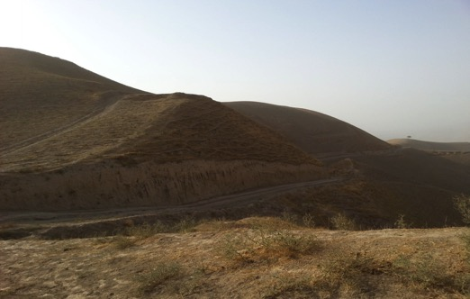Photo 3.10 Constructed road

Previously, it took three to four hours to reach the district center whereas today it takes just 40-60 minutes. Donkey was the most common form of transportation prior to the road construction, whereas today people are going to the bazaar by different types of cars, lorries, four wheelers (Zarang) and motorbikes. In the past, there were many deaths on the road and people were even using carts to carry their patients down the valleys to the clinic.

The road has had a direct economic impact. For instance, the car was charging 4000afs to Sarab bazaar, whereas the people now pay only 1500afs. Also, they can more easily and cheaply take some of their agricultural goods to the bazaar for sale.

Overall, regarding its current functionality, the implementation of the road project is a success case. People have benefitted in an economical, social and political sense. But it is worth noting that since its completion, no protection plan has been made by the CCDC. Currently, it is not in a good condition.

Azadi CCDC

Azadi CCDC is part of Khulm district, constituted in June 2010 through a democratic process of election, under supervision of NSP and community representatives. Azadi CCDC includes eight CDCs (Sultan Damarda, Khaja Borhan, Ghazi Abad Bala, Ghazi Abad Payan, Mullah M. Omar, Shahi Khil, Sayed Ghiasuddin Peer and Haji Ali Arabia). Based on NSP documents, tertiary road gravelling, deep well boring and water tank tower are recorded as Azadi CCDC’s prioritized projects.

The projects have been prioritized on the basis of community needs and people’s views. Each CDC and the community elders and representatives in a gathering with the people of their own villages have discussed and prioritized their needs. Thereafter, the CDC members and community elders have shared them in CCDC’s meetings and finalized the tertiary road gravelling and deep well boring projects as CCDC projects. As per researcher observations and field interviews with NSP representatives, the process of project prioritization has been reported as a consensual process and the people were satisfied with the decisions made by the CCDC with regard to the project type and locations.

The total allocated budget for deep well boring and tank tower was 1,510,133afs: 1,359,119afs was the program budget and AFs151,013 had been paid as a community contribution. The project started in July 2011 and ended in April 2012. But as the result of failed deep well boring project people have spent the budget in drilling water wells in different locations of the CCDC area. Although people were in complete agreement about implementing the deep well boring project, it was challenged by the non-appropriate rocky location. Therefore, they suspended this project and alternatively drilled smaller drinking water wells.

The total allocated budget for tertiary road gravelling (7,130 km long with 12 culverts) was about 5,963,200 afs. The project started in July 2011 and ended in April 2012. Both projects covered eight villages and CDCs. More than 749 families have benefitted from the implemented projects.

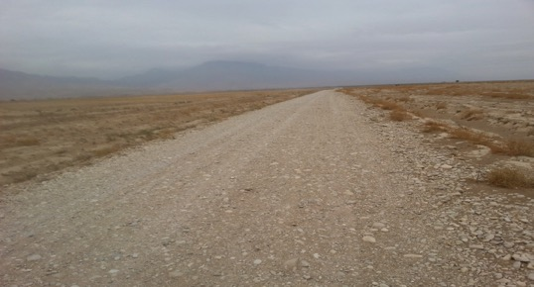
Photo 3.11 The graveled road, CCDC project

In order to assess the projects’ impacts, we need to compare the past and current condition of the community. Economically, the car charge was very expensive in the past. People were paying 500afs for the four-wheeler charges whereas they now pay 100afs going to the bazaar. Previously, they were spending two hours going to the bazaar whereas now they need only 30 minutes. They were buying each tank of drinking water for 200afs and carrying it by four-wheeler (Zarang), charging 500afs. The total amount of money that the residents of a single village had paid, buying 30 tanks of water can be estimated around 6000afs per day. But now, as a result of the drinking water wells, they have access to pure and free drinking water in their own community and the water wells have decreased disease.

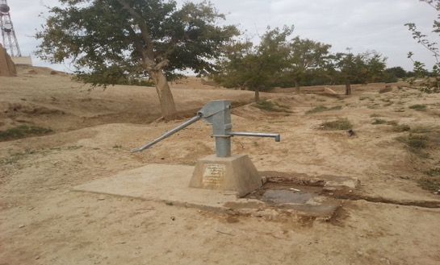
Photo 3.12 Water well

The road used to be in a very bad condition – no car or four-wheelers were easily able to come to the villages. The villages were not connected to each other which negatively influenced the people’s social interaction and integration. But as a result of the graveled road, villages are now connected and the social interaction and unity amongst the people of different villages has been enhanced. Overall the CCDC projects have positively impacted the people’s life. These impacts are manifold and multidimensional.

Currently, no CCDC is active and people are more dependent on the CDCs, which continue to be active in all villages. It is also worth noting that there is currently no protection plan for the implemented projects. Some of the culverts have been damaged but no plans are in place to reconstruct them.

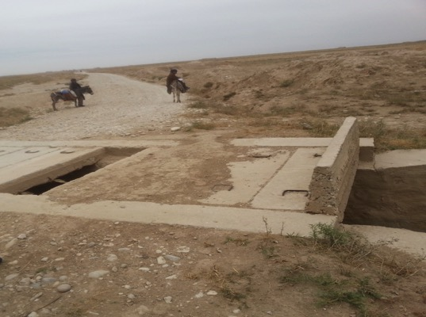
Photo 3.13 The damaged culvert

3.2.3.5 Governance for development

Our findings show evidence that the CCDC pilot project has not significantly contributed to enhancing community capacity for local developmental governance in Balkh province. It is apparent that all CCDCs functioned more or less effectively while they were active but all such gains have largely been lost since the they have ceased to function.

All CCDCs received training from FPs in financial management, procurement, problem solving and project management. Project selection in Sarab and Azadi demonstrated an ability on the part of the CCDCs to prioritise effectively, and oversee the effective implementation of projects. Inter-CCDC visits were also important in sharing and learning. While projects were ongoing, a number of visits took place between CCDCs to view projects and learn from other CCDCs. Etifaq CCDC had visits from and went to visit Tokhta and Khasa CCDCs; Azadi CCDC met the Etifaq CCDC to observe, compare and learn from each other with respect to the efficiency and effectiveness of projects. Sarab CCDC visited the Lalmi and Markaz CCDCs.

Some of these skills and experiences will be no doubt remain with the individuals who learnt them and may be utilised in continuing CDC work, however, as a body, it is clear that the CCDC has not contributed much added value to local developmental governance. None of the CCDCs continue to perform any functions beyond the implementation phase of their projects. None are seeking out new projects as a cluster.

All CCDCs, when functioning, were extremely project focused – especially when compared to CCDCs in other provinces – and did not engage in community functions beyond the immediate parameters and concerns of the project itself. The most likely explanation for this is the clear and strong dominance of community and tribal elders in local affairs, which came up frequently in community level responses. As such, it seems elders worked to restrict the work of the CCDC and this might also account for the discontinuation of the CCDC (although this is conjectural and difficult to support with concrete evidence). Even when active, Etifaq CCDC members noted that the CCDC was not filling a void in local governance, and that it was not involved in any other social, development, economic or political issue on behalf of the member villages. Members also pointed to the added difficulty of decision-making at the cluster level compared to the CDC level.

There was little evidence to suggest the operation of the CCDC had contributed to significant positive gains in terms of component CDC governance capacity. Conversely, the existence of the CCDC did not appear to have actively undermined the operation of CDCs. If anything, the somewhat poor outcomes associated with the CCDC and their ultimate obsolescence underscored the importance of CDCs to community members: overall, it was clear that communities see CDCs as a more relevant, useful and effective instrument of local developmental governance. In many of the villages of Etifaq, community members did not know much about the CCDC and its activities in the area; the CCDC was very passive compared to the CDCs. CDCs, beyond implementing their developmental projects, have been participating regularly in many social issues such as resolving conflicts and meeting with the district governor and DDA.

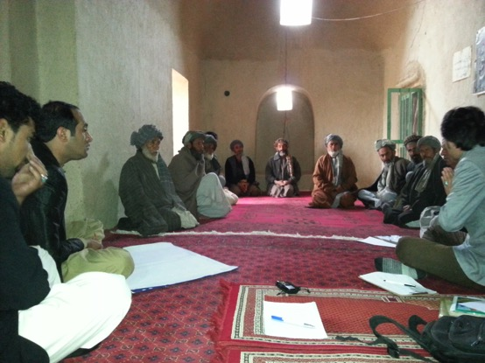
Photo 3.14 CCDC members in Balkh

Observations on CCDC relationships with district authorities can necessarily only be of a limited nature given the discontinuation of the CCDCs: what positive dynamics that may have been apparent during the life of the project have all inevitably subsequently been lost. Overall, however, the potential for improved relationships was apparent. The CCDCs maintained positive, constructive and healthy relationships with district authorities while they were active and met regularly (although interaction with DDAs appears to have been weak: Etifaq CCDC noted they were not invited to DDA meetings). Sarab CCDC had a bridging role between communities and the district governor when it was active.

Such positive relations during project implementation may have some residual benefits (as claimed by Sarab CCDC) in terms of continuing relationships with individual CDCs, but these are likely to be limited: most Balkh CDCs appeared to have good pre-existing (and continuing) relationships with district governors and shuras. The extremely good relationship of CDCs with district authorities underscores the fact that the Balkh communities seem to place much greater faith and value in CDCs compared to the CCDC: respondents noted how they are much more receptive to and cognizant of their needs.

Linked to the above points, similar mixed outcomes with respect to community voice and bargaining power are apparent. According to the CCDC respondents in Etifaq and Sarab, the existence of the CCDC did serve to increase the bargaining power and voice of communities. As proof, Etifaq noted the CCDC’s successful initiative in approaching the district governor to request the equal distribution of irrigation water among the shareholding villages. However, this positive assessment was questioned by Zambokan CDC. Azadi CCDC did not register enhanced bargaining power, claiming that even during project implementation, the CCDC did not discuss any issues with local authorities. Again, of course, any previously purported gains in community voice have subsequently been lost.

A number of community respondents across the Balkh cases noted the poor transparency in CCDC decision-making. It appears people were not really aware of the CCDC process and there were weaknesses in updating to an extent. Almost all FGD respondents in Etifaq noted that there was poor transparency and they were not aware of how CCDC decisions were made. As poor FGD respondents in Zambokan CDC put it,

“We don’t know about the clustering process… only just today did we get to know about the community centre in Hussein Khil when attending a funeral. We are not informed and don’t know about projects.”

In Yakatoot, beneficiaries noted that it was unclear how projects were chosen: “villagers were not consulted and, irrespective of our demands, the CCDC built the clinic in Mashi.”

Similar responses were heard in Azadi. People were generally aware of the CCDC and were occasionally updated but did not know much about its processes. Poor respondents in Sayed Gheysodin Peer stated that “we don’t know about the CCDC, we have not participated in meetings and no-one has told us about the projects … community elders are responsible for such things … they do not update us regularly, we do not know the decision-making process.” In Sarab, the situation was more concerning with a number of FGD respondents suggesting they were not updated regularly and that they had little idea about the CCDC, noting that it was the business of the elders to know about such things (this is discussed further in the political economy section below).

The existence of the CCDC has not significantly impacted on the functions, roles and authority of traditional leaders in the communities. The overarching sense emerging from the data was of the palpable domination of traditional leaders and elites in community affairs, including CDC/CCDC functions. This is not to say elders necessarily subverted or completely dictated CCDC decision-making, but that they exerted a constant influence on CCDC proceedings, and generally in a positive and supportive manner. As community responses underscored, it appears powerful people were very influential in CCDC decision-making processes on the whole.

The CCDCs did not demonstrably facilitate the emergence of new leadership in the community (given the continued dominance of traditional leaders on the CCDCs). There appeared to be significant overlap between CCDC membership and traditional leaders (such as tribal leaders, community elders and religious clergy/scholars). For instance, in Azadi, eight of the CCDC members also sit on the tribal elders council. Those traditional leaders not members of the CCDCs were consulted at all stages, seemingly without exception. Strong community values mean they play a very important role and are involved in all village issues.

Sarab CCDC noted that traditional leaders are aware of and take part in all decisions made by CDC/CCDCs in the community. Yakatoot CDC in Etifaq noted that traditional leaders help resolve conflict, make decisions and consult with the people. Relationships between traditional leaders and CCDCs was unanimously stated to be good and healthy; elders were described as being supportive and helpful throughout the process and that there was no dispute between them and the CCDCs. Sarab CCDC stated that “the Imams and ethnic leaders and other social elders have helped us in all the processes. They were invited in most of our meetings and decision making.”

CCDC | Relations with District Authorities | CCDC Point of Contact? | Contact with DDA
Etifaq | Good, while active. | Yes, while active. | No – not invited to meetings.
Sarab | Good, while active. | Yes, while active. Bridging role. | Yes, while active.
Azadi | Good, while active. | Yes, while active. | Yes, while active.
Table 3.10 Relationship with district authorities

CCDC | Traditional Roles | Community Voice
Etifaq | -Unchanged  -Very good relationship  -Consulted at all stages  -Actively involved | Increased while active
Sarab | -Unchanged – dominant social position  -Very good relationship  -Consulted at all stages  -Big say in decisions | Increased while active
Azadi | -Unchanged  -Very good relationship  -Consulted at all stages  -8 CCDC members on tribal council | No improvements noted.
Table 3.11 Impact on traditional roles and community voice

3.2.3.6 Social cohesion

One almost unambiguously positive outcome of the CCDC pilot in Balkh relates to improved social cohesion. All CCDC displayed clear positive medium-term benefits in this respect. The evidence suggests this is a result of both the projects themselves (namely, roads linking communities) but also the process of CCDC decision-making and implementation itself. Such positive impacts were especially apparent in Sarab and Azadi, both having implemented road projects.

All three CCDCs were, when active, involved in some measure of dispute resolution. All provided examples in this respect, concerning land disputes (in Etifaq and Sarab) and domestic issues. In each case, the CCDC intervened, mediated and facilitated the resolution of these conflicts. Of course, all such benefits have been lost given the discontinuation of the CCDCs but these examples suggest the potential inherent in the CCDCs in this respect, and this is consistent with our findings from the two other provinces.

Sarab CCDC stated how all the villages came together to implement the road project and that “the success case of the road is the result of different individual village contributions. The people became more united than the past and they feel themselves closely related.” They went on to claim that people from different CDCs have become more dependent on each other in terms of making big decisions and that social solidarity had been enhanced between the villages; they invite each other to most events happening in their villages, like marriage parties and funeral ceremonies. Such dynamics were strongly supported by responses at the community level.

Similar impacts were attested to in Azadi CCDC whereby CDCs would meet regularly, work together and learn from each other in implementing the CCDC projects. However, despite these positive effects, and as might be inferred from the preceding sentence, it appears improvements in social cohesion were specifically associated with the implementation period and that some of the benefits have dissipated since projects were completed (communities do not meet to discuss joint development plans and the road quality has deteriorated). The very fact that the CCDCs have not met since suggests any solidarity achieved was of a limited nature and has not encouraged communities to continue to cluster to work on future development projects. Nevertheless, if some measure of social interaction, inter-community understanding and sense of unity has been promoted by the CCDC project, as our findings suggest, this is a tangible positive benefit.

Impacts on social cohesion were more mixed in the case of Etifaq. The CCDC certainly claimed similar positive impacts on cohesion, noting that shared workshops and equal participation in projects served to strengthen social bonds, increase cooperation between the CDC communities, and promote cross-community participation in a variety of social events like marriage parties and religious festivals. According to the CCDC members, it encouraged CDCs to come together to manage local governance and caused them to be more dependent on each other.

Yet, it is also apparent that the existence of the CCDC created conflict and disconnected villages due to the strong disagreements over project choice and location; the CDCs now actively do not wish to cluster on development matters in the future. While alluded to by CCDC respondents, a sceptical attitude on this matter was especially apparent at the community level. Of course, the disagreement with Yakatoot CDC (see Case Study below) is only the most obvious example in this respect and respondents from Zambokan CDC similarly doubted any claimed improvement in social solidarity, arguing that, if anything, it worsened community relations. The CDC is Mashi was similarly ambiguous as to whether the CCDC had contributed to improved inter-community relations.

CASE STUDY - Etifaq CCDC

Soon after the clustering process, the CCDC started to prioritize projects proposed by different villages. While prioritizing the projects, Yakatoot village disagreed with the type and location of the clinic project. The people of Yakatoot demanded their share separately to implement their own project on the basis of their prioritized needs, whereas the CCDC members from other villages collectively decided in favour of construction of the clinic.

Thereafter, with the help of the FP (CHA) they prepared their proposal, which was approved on January 2011. But the dispute between Yakatoot and other villages remains unresolved still today. As a result of the dispute between the villages and Yakatoot, the latter village did not pay the 10% share and never attended subsequent meetings. Now the Clinic has been built in Mashi and the community center in Hussain Khil village. As the result of the dispute among the villages, the clinic project was delayed for six months. The clinic project started in June 2011 and ended in January 2013.

CCDC and CDC members from other villages claim that there was no dispute in prioritizing the types and location of the project, whereas Yakatoot’s CDC and people reject this claim, adding that their prioritized project was never considered by the CCDC.

Now the clinic is located in Mashi village, offering health services in six departments. The patients who come to the clinic for treatment are from the different villages of the CCDC. Compared to other villages, Yakatoot is located far from the clinic, which is more than two hours by walk (with no connecting road). It should be noted, however, that the people of Yakatoot, in spite of not contributing their 10% share, do use the clinic.

It should be noted that the clinic was operational in the cluster area before the establishment of the CCDC. The clinic was housed in rented buildings with poorer facilities and equipment. The newly constructed building has 8 rooms with concreted walls, a cleaner and lighter atmosphere, and safer and bigger rooms – however it is still poor in terms of its equipment and services.

When the CCDC members were asked about the functionality and conditions of the clinic, which they themselves constructed, they said “we don`t know”, because soon after the completion of the projects, the CCDC as a governance structure did not manage to survive due to lack of funding and follow-up by NSP. When the NSP started the implementation of repeater block grants through the re-election of the CDCs in Dehdadi district, this totally put an end to the CCDC process. The multiplicity of actors for different projects and tasks commissioned by NSP were also a major blow. Lack of continuity of the FP further accelerated the death of CCDC - the CCDC was created by CHA, while the new CDCs are created by UN-Habitat.

The project, from an implementation point of view, in terms of the quality of the construction, management of the construction process and accountability can be considered successful. However, currently, the clinic is in poor condition as it is not able to fulfill the people’s needs. The clinic building is being registered as an asset of the Ministry of Public Health and, due to the disappearance of the CCDC, the quality of the services has deteriorated. People are still seeking costly treatment for complicated illnesses in the city. Therefore, it is difficult to identify many tangible positive impacts.

The second project, implemented by Etifaq CCDC, is a community center located in Hussain Khil village. The people in Zambokan and Yakatoot, stated that they are not aware of the community center built by the CCDC in Hussain Khil. Only, Hussain Khil village can use the community center because it is too far from the other villages. Second, the people from the two mentioned villages were not involved in prioritization of this project.

With reference to the three main variables in our evaluation - the impact of projects on social cohesion, socio-economic welfare and local governance - Etifaq CCDC projects can be counted as failures. As the result of the dispute in the process of CCDC projects, the relationships between Yakatoot and other CCDC has been weakened. The impact of the community center on social and economic welfare, local governance and social cohesion in Hussain Khil village might be visible but at the CCDC level it has no tangible impacts.

3.2.3.7 Gender

Most CCDCs had instituted separate women’s only committees or held meetings in separate rooms. Women in Etifaq CCDC have meetings in a separate room then feed into the main CCDC. Sarab has a separate women’s committee and women in Azadi have their own CCDC. The majority of CDCs also had separate women’s committees.

Women were generally described as being involved in CCDC and CDC processes; and they are seen as active and useful members. Some women were even holding office positions in CCDCs and CDCs. A female member of the Etifaq CCDC was also a member of the DDA. In Ali Kayee CDC, the secretary and assistant of the CDC are both female. They gather and represent the views of women in CCDC and CDC decision-making processes and sometimes in monitoring but rarely involved in implementation. So participation was generally good.

Nevertheless, it is clear that participation is limited and peripheral due to traditional values. According to Zambokan CDC, most men do not let their wives or daughters participate. Women do have a say but most decision-making is done by men, therefore they are not equally involved. Women were described as having a “secondary or symbolic role” and that even though they are involved in decision-making they are largely marginalised. Respondents in Etifaq’s Mashi CDC noted that “women are included in decision-making, but after the separate meetings are over men make all the decisions.” Some respondents noted that women are generally not involved in decision-making outside the home. The Azadi CCDC held that because the projects are ‘operational’ women do not play an important role in the CCDC.

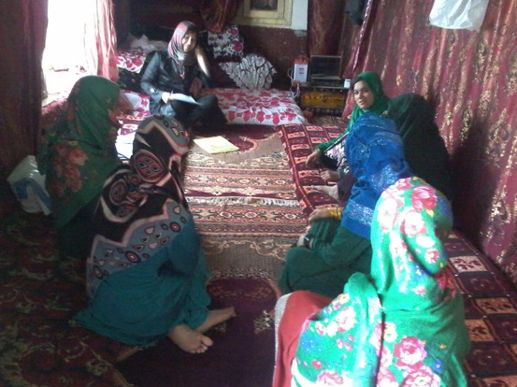
Photo 3.15 Women FGD in Balkh

Respondents generally stated that they had no serious opposition to women’s participation, except that if they are involved it should be in accordance with Sharia. Sarab CCDC noted that “the people believe that women are also capable of participating in such issues and there was not any tradition or belief challenging the women contributions.” Etifaq CCDC stated that “women have a parallel role with the men as CCDC members in all processes. There is no opposition to female participation.”

Almost all respondents supported the idea of increased women’s participation – as the female respondents in Mashi put it, this “should be improved as they represent half of the society.” Respondents believed women members could bring in new projects, help solve women’s problems and represent the views of women in the CDC. They were seen as possessing important knowledge, as being honest and active, and able to make CCDCs and CDCs more aware of social issues.

Respondents believed participation could only truly be enhanced through improved education and literacy for women. Other suggestions were to include women in the same meetings as men more often or offering projects for women.

Finally, it should be noted that women were not involved in project implementation: gender based division of labor excluded them from being involved in the physical work.

CCDC | Female CCDC members | Percentage | Same meeting | Sub-committee | Every CDC
Etifaq | 10 (out of 20) | 50% | No – meet in a separate room then feed into main CCDC | Yes | Yes, except Yakatoot.
Sarab | 12 (out of 24) | 50% | No | Yes, separate women’s CCDC | Yes
Azadi | Women have their own CCDC | N/A | No | Yes, separate women’s CCDC | No
Table 3.12 Gender dynamics

3.2.4 Nangahar

3.2.4.1 Province context

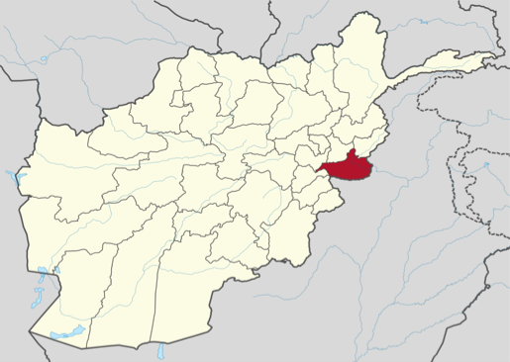
Map 3.8 Nangahar Province

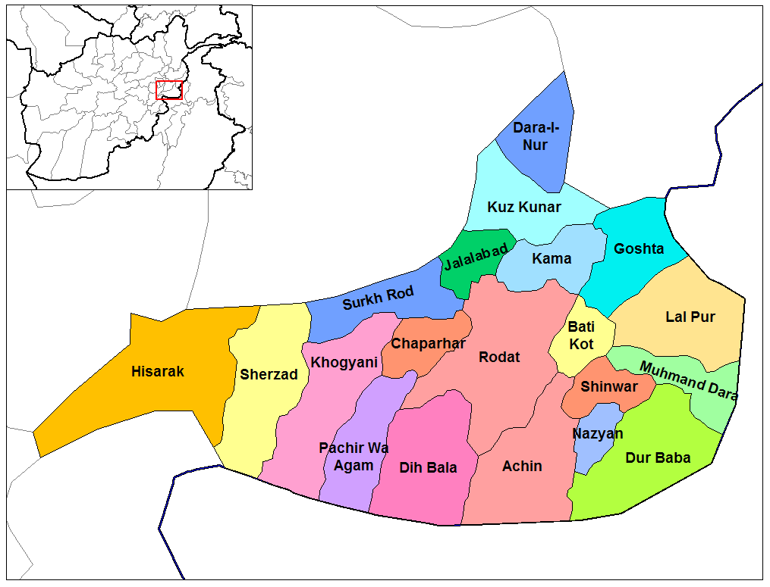
Map 3.9 Nangahar Province Districts

The province of Nangarhar is located in the eastern region of Afghanistan and shares a border with Pakistan. The population is majority Pashtun and culturally relatively homogeneous, with around 10-15% nomadic Kuchis, forming a minority with Pashayee, Tajiks and Gujjars; and due to the fluidity of the border, shares similar tribal structures, language, religion and cultural traditions with neighbouring populations in Pakistan. The size of the province is around 7,727 km², with an estimated population of around 1,462,600. Within the province there are 605 CDCs and 21 DDAs. The provincial capital is Jalalabad.

Nangarhar has a wealth of natural resources: large marble mines, natural forest, abundant water resources and a dam which generates electricity. Major investments have been made in the sectors of agriculture, livestock, infrastructure and governance in recent years and hence all sectors are seeing slow but steady recovery since 2001. Once the centre of Afghanistan’s opium trade, Nangarhar has seen a drastic drop in production due to a government reduction strategy. However, due to the failure to provide alternative means of livelihoods, production is thought to have increased, demonstrating the need for much greater dedication required from the government for alternative livelihood generation in order for this goal to be achieved.

Recovery has been slow and sporadic. The vast majority of the population of Nangarhar is dependent on agriculture and livestock, both of which have been badly affected by the conflict and drought, as well as severe flooding which resulted in damage to essential irrigation systems, as well as causing significant losses of crops, livestock and human life. According to the Department of Agriculture in Jalalabad, there is 97,000 hectares of arable irrigated land across the province, as well as a small amount of rain-fed land for agriculture. Over recent years a trend of multiple cash cropping, improved seeds and fertilisers, and organisations such as the World Bank funding the rehabilitation of irrigations systems have had a positive impact on the recovery of the sector. Nangarhar produces a diversity of cereals, fruits and vegetables.

Education is relatively better than in other areas of the country, with a literacy rate of around 40%. Potable water is available to the majority of the residents of Jalalabad, as is electricity (provided by the Duranta dam), though the rural populations only have access to shallow wells and springs, and many have no access to electricity. There are two large hospitals in the provincial centre, with clinics in every district. The security situation in the province is now good, except for some of the more remote districts and in particular areas of poppy cultivation where it remains unsatisfactory.

Similarly, community-based dispute resolution mechanisms are well embedded in Nangarhar, and these mechanisms are seen to be very flexible to the demands of differing cases. Community-based dispute resolution processes are seen to play an important role in maintaining peace and social cohesion within communities. Principles underlying state-based and community-based dispute resolution are fundamentally different, due to differing emphasis being placed on individual and community rights, restoring peace and punishing guilty parties. Again, community-based and state-based resolution mechanisms work in cooperation with each other.

Women’s roles as decision makers are extremely rare, though there are some examples of older women playing these kinds of roles. The people of this province are conservative and men mostly do not allow women to work. The majority of teenage girls are not in education, as parents prefer that they stay at home and are not associated with boys either at or on the way to school. There are no jobs available for women within the community, and men do not allow women to leave the community to find work. As there are few jobs available for men, and most have to travel to Mazar to find work, it is generally regarded that men should be given priority access to productive activities. Women from this community would not be permitted by the men of their family to travel to the city in order to find work. Most women are illiterate, and female enrolment in education is extremely low.

Due to security restrictions at the time of the evaluation, the data gathering was limited to Nangahar district of Rodat. Rodat is located in the middle of the province, around 20km from Jalalabad. It is bordered by insecure districts on its southern, eastern and western sides contributing to a worsening security situation over recent years. Government officials are nominally in control during daylight hours and along major roads, but the armed opposition moves freely and threatens civilians at night. Most roads are unpaved beyond the main road. While the majority of the cultivable land is irrigated and fertile there is little water available and the area is seriously drought-affected – accordingly, economic activity focuses mostly on trade and small business. There is no central electricity provision and many residents rely on hydropower. Rodat has few strongmen or external patrons situated within the provincial or national government and thus is politically marginalised. Within the district, power is divided.

The district has benefitted from a number of quick impact projects implemented by the Provincial Reconstruction Team. Jackson reports that ‘the PRT funded the digging of irrigation canals and the paving of the district’s main road, alongside support to onion cultivation and trade.’ However, the gains from such projects appear to be minimal and short-lived.

3.2.4.2 Community Conditions

The three Nangahar CCDC communities – Hisarshahi, Itehad and Motahida – are all fairly similar in terms of their demographic, geographical and developmental conditions. All are fairly large CCDCs comprising between 5 and 7 CDCs. Hisarshahi can be distinguished from Itehad and Motahida in so far as it is located closer to the district centre. The populations of the communities are almost exclusively ethnically Pushtun and religiously Sunni.

All three CCDCs have experienced security incidents in recent months and years and while the situation in Itehad and Motahida currently appears to be calm – witnessing only a handful of isolated, albeit serious incidents – the security situation in Hisarshahi is much worse and was described as ‘deteriorating’, with a number of killings and kidnapping reported, armed men operating at night and a decline in girls’ attendance at school.

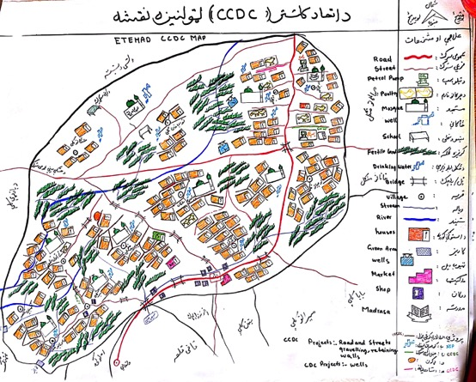
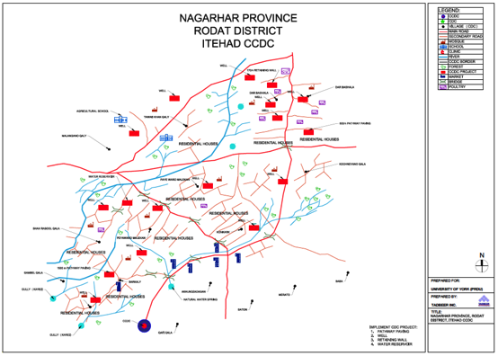
Map 3.10 Itehad CCDC

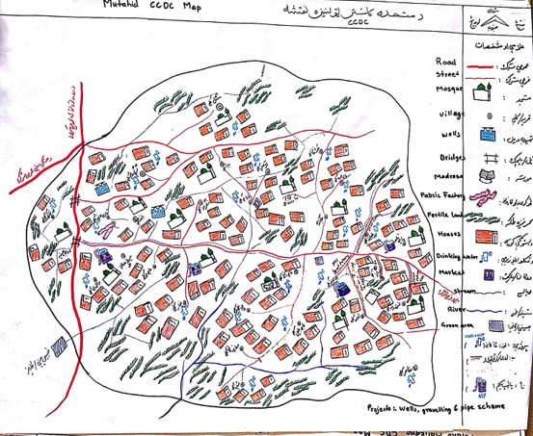
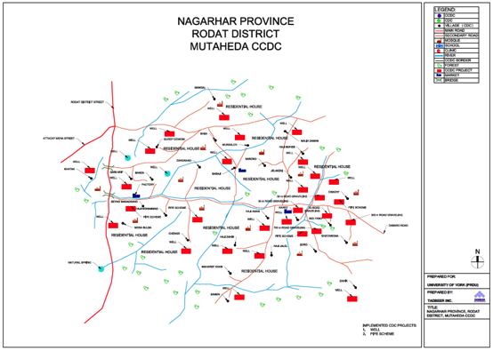
Map 3.11 Motahida CCDC

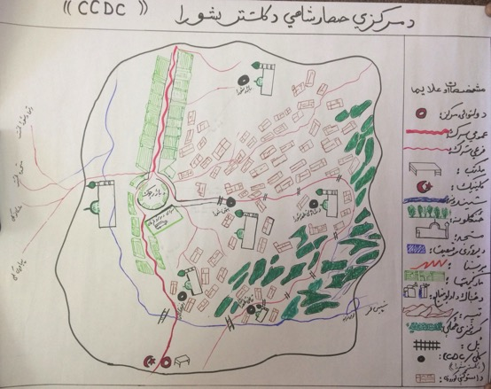
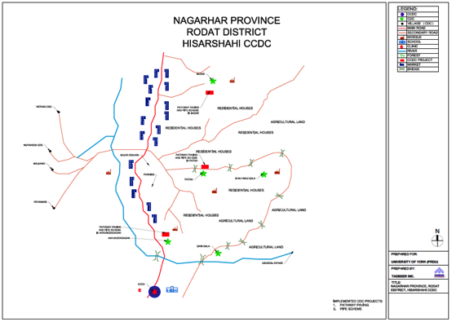
Map 3.12 Hisarshahi CCDC

CCDC | CCDC size | CDC proximity | Security | Diversity
Hisarshahi | 5 CDCs  5 villages | Close and accessible | -Deteriorated  Some security incidents (killings/kidnap)  -Armed men out at night  -Affected girls attendance at school  -Communities concerned | -Ethnically homogenous (Pashtun)  -Religiously homogenous (Sunni)
Itehad | Small  5 CDCs  5 villages | [Awaiting information] | -Satisfactory  -Improving  -Recent shooting of head of security department and colleagues | -Ethnically homogenous (Pashtun)  -Religiously homogenous (Sunni)
Motahida | Medium  7 CDCs  8-9 villages | [Awaiting information] | -Gunmen move during the night  -Person killed recently (reason not known)  -Wedding party attacked | -Ethnically homogenous (Pashtun)  -Religiously homogenous (Sunni)

CCDC | Wealth | Environment | Resources | Livelihoods
Hisarshahi  (cont.) | Poor | -Close to district centre  -Crowded, narrow streets  -Dusty and hot  -Garbage close to houses  -Main road passes through | None of note | -Agriculture  -Livestock  -Shop-keeping  -Daily labour  -Govt employee
Itehad  (cont.) | Poor | -Air quality good  -Clean and healthy  -Safe drinking water for all | None of note | -Agriculture  -Livestock  -Shop-keeping  -Govt employee
Motahida  (cont.) | Poor | -Clean air and environment  -Lack enough water for irrigation | None of note | -Agriculture  -Shop-keeping  -Govt employee
Table 3.13 Community features

3.2.4.2 Project outcomes

The projects implemented in the three Nangahar CCDCs were all fairly similar and included:

- Pathways; drinking water wells (Hisarshahi)
- Pathways protection walls; and canals for irrigation (Itehad)
- Pathways; 6 drinking water wells (Motahida)

The overall success rate – in terms of immediate completion, operation and direct outcomes (i.e. they do what they intend to do) – of the CCDC projects in Nangahar was good based on the sample considered in this evaluation. All CCDC projects were judged to have been successfully implemented by CCDC member respondents. However, there were a number of comments at the community level in Itehad CCDC that some of the projects had potentially damaging effects because canals had been built close to walls and would create humidity in houses.

Decisions with regard to projects were taken after individual CDC prioritisations had been collected and considered, CCDC meetings held, alternatives discussed, and final choices adopted though majority voting or reaching consensus through discussion. The Facilitating Partner in Itehad assisted the CCDC in deciding on their project, where it was decided that each CDC would implement projects separately but under the overall direction of the CCDC. In all CCDCs, there was some level of initial disagreement over project choice and not all CDCs felt their priorities were properly considered or ultimately captured by the CCDC. CDCs were largely judged to be satisfied with the final project choice, although in Motahida there appeared to be some lingering resentment with regard to the final project choice in Miran and Malikan and in Kariz and Hajyan CDCs.

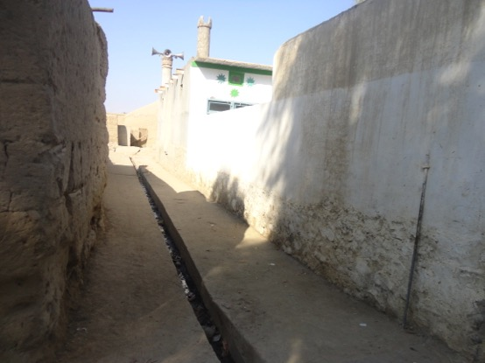
Photo 3.16 Canals in Itehad CCDC

All projects were judged by respondents to be sustainable, based on forecasts of continued community inputs in terms of maintenance and investment (given broad community support and buy-in to the projects). All the projects are still active and being utilised by the communities.

All the projects in the three CCDCs were deemed to have benefitted almost all community members. However, Itehad CCDC suggested they had received an insufficient budget to benefit all the CDCs. There were also some reports that certain communities at the village level did not benefit from the projects, such as Mangal in Baba Zagaran CDC, Motahida CCDC, and villages near Akhwanzadagan in Hisarshahi CCDC. Women in Akhwanzadagan, Hisarshahi CCDC noted that, “all people located nearby benefitted from the project. Some people far away did not benefit.” Respondents in Ba-ar, Itehad CCDC, stated that, “Only two villages – Nawai and Pacha – are not benefitting due to limited budget.”

CCDC | Project(s) | Success | Sustainable | In use | Benefits all
Hisarshahi | Pathways/wells | Yes | Yes | Yes | Yes
Itehad | Pathways, road fixing and protection wall/canal | Yes | Yes | Yes | Mostly
Motahida | Pathways/wells | Yes | Yes | Yes | Yes
Table 3.14 Project type and outcome

CCDC | Initial disagreement? (reason) | Resolved? (how) | CDCs satisfied with final choice?
Hisarshahi | -No major disagreement | -Mutual consensus  -Prioritisation through scoring projects | Yes
Itehad | -One village (Darbazala) disagreed as it did not benefit from planned road  -Different priorities | -Separated funds by village  -FP support | No
Motahida | -No major disagreement | -Discussion and voting  -Mutual consensus | Yes
Table 3.17 Project prioritisation

3.2.4.3 Socio-economic welfare

Determining overall outcomes in socio-economic conditions as a result of the projects is extremely difficult. Nevertheless, community responses suggest modest overall gains, and such positive change can be reasonably inferred from the more immediate successful outcomes generated by implemented projects (such as better roads enabling quicker and easier access to markets). Access to clean water, a reduction in disease, and cleaner village conditions can be considered significant gains in themselves.

New roads, road fixing, pathways and retaining walls can be seen to have had a number of positive socio-economic impacts contributing to modest improvements in the local economy. Goods can be much more easily taken to the market to sell at a higher price and people can be taken to hospital more easily (rather than by donkey or on shoulders). Clean pathways in the villages has resulted in the reduction of diseases (especially malaria) in the community (families used to spend a lot of money on treatment); they have also contributed to a relatively clean living environment in which families feel more comfortable and children can walk around while keeping clean and safe. This is largely due to the fact that there is no more stagnant or polluted water in streets and rain water no longer enters houses.

Washing clothes is also easier as women can pour water out into the canals (they used to throw washing water on pathways which caused conflict between neighbours - now it runs away through canals), and the children are cleaner so less money is spent on washing powder. Respondents also reported that houses have been saved from flood damage due to the building of protective retaining walls. Improved transportation has also apparently enabled more social events within communities due to the ease of getting about. Few negative effects were observed but some respondents did report that the construction of the roads has meant water runs off into some homes, causing damage.

Canal, reservoir and irrigation projects – such as the concreting of canals – have contributed to enhanced agricultural productivity with water reaching the land on time and allowing the planting of new vegetables, which contributes to the improved health of villagers.

The construction of water wells has provided communities with pure and safe drinking water and, as a result, respondents reported a decrease in disease. Importantly, women and children do not have to go so far to collect water – this saves valuable time and energy, allowing women do other household tasks and the children to study.

Some respondents suggested their community’s economic situation had improved as a result of CCDC projects, but given the large amount of other development projects that have been (or are currently being) implemented in the areas under consideration, it is difficult to attribute improvements in this respect to the CCDC project per se. It is certainly possible that improved irrigation and transportation resulting from CCDC projects have contributed to enhancements in the economic conditions of the communities, as attested to in all community level responses.

Also, as a direct short term outcome, the local labour required for project implementation has contributed to the local economy by providing daily wages for community members.

CASE STUDY – Motahida CCDC

Before the CCDC project, the villagers were using spring and Kariz water for drinking, and walking for hours to bring drinking water, which was not pure and clean. Fetching water from Kariz, located outside the village, used to be the duty of the women. They would spend at least 3 hours per day (3 trips daily) only for fetching water in order to supply the required amount of water for the daily consumption of their families (mostly for cooking and drinking).

The population however, always suffered from water shortages as the women who used to carry the main burden of fetching water were not able to supply a sufficient amount of water for bathing and laundry of the family members. As a result, the villagers were not able to maintain the lowest level of family hygiene in order to prevent other easily preventable diseases. This task was particularly hard and pain-staking for women during the rainy and hot seasons. As a result, the female population of the village were not able to take part in other necessary household chores, including economic activities and properly attending to their children. As a female resident of Zargaranoo village said, “I was spending half of my income on treatment of my children, as diarrhoea and other water-born diseases were a common feature of our lives.”

Villagers were asked to identify and prioritize their CCDC projects and submit it to their cluster CDC representatives. Then the cluster executive board discussed and finalized the prioritized projects, went through tendering and biding process, and a contractor was hired to dig drinking wells in the selected areas. A farmer of the village added that, “When I heard that CCDC members were finalising the selection of projects, I approached them and explained the severity of the water problem of our village. The CCDC members were aware of our needs and problems; they agreed and in-listed my village (Meranoo Kalee), now we have clean drinking water at the door-steps of more than 20 families.”

Now women have more time to attend other important household chores, such as looking after the children and maintaining higher levels of hygiene. The responsibility of fetching water is transferred to the family boys and girls bringing water from nearby wells. In addition to freeing the women from this cumbersome task, the main impact of the water project, according to the villagers, is on the household economy. The women now have the opportunity to get involved in economic activities like embroidery and poultry raising. The families are not forced to spend half, or more than half, of their income on medicine and treatment of diarrhoea. Consequently, the male population have more time to spend on economic activities since they are not required to take time off work in order to take their sick children to the hospital in Jalalabad city on regular basis.

3.2.4.4 Governance for development

Outcomes relating to the governance of development present a complicated and mixed picture in Nangahar making generalisations somewhat problematic in this respect. Nevertheless, some prominent outcomes can be established.

In Hisarshahi, the existence of the CCDC has been embraced and the potentialities for bigger, more efficient projects benefitting multiple communities (that could not have been implemented by individual CDCs) was recognised by the CCDC. This positive disposition has led to the CCDC working on development projects beyond NSP, such as a drinking water wells project in the CCDC-relevant CDCs through the support of Save the Children. In Itehad, although the existence of the cluster was not seen in such a positive light (despite initial enthusiasm, they believed it had generated conflict and tensions between communities), the CCDC was nevertheless working on further projects including a canal cleaning and concreting project funded by ADI as well as an AREDEP project concerned with financial funeral assistance for poor community members. Only Motahida CCDC was not working on anything else beyond the project.

It is clear that the CCDCs in Nangahar had to confront a number of significant challenges and opposition to certain aspects of project implementation – the fact these were largely successfully overcome suggests CCDC members had developed important management skills. In Hisarshahi and Itehad, project-based disputes were confronted and successfully resolved by the CCDCs (often with FP support). These involved inter-CDC disagreements as well as more personal (often land ownership based) issues concerning project implementation. For instance, Itehad CCDC helped resolve an issue in which one house owner opposed the implementation of a canal because it crossed his house. After a number of consultations, the CCDC convinced the man that the project was for the welfare of the community and the project was subsequently implemented. The tribal elders on the CCDC were seen as important in assisting in this respect given their experience, knowledge and skills in resolving community conflicts.

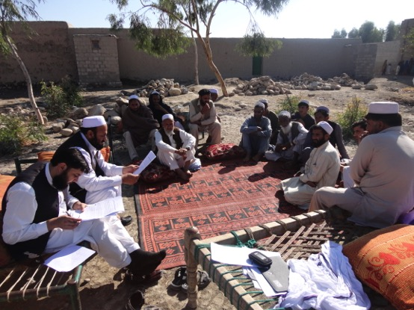
Photo 3.18 CCDC members in Nangahar

While, as demonstrated above, the capacity of the CCDCs with respect to community governance for development can be seen to have been tentatively strengthened through cluster activities (as manifested in capacities for project prioritisation, collective problem-solving and project-based dispute resolution), a particular concern is the effect of this on the capacity and continued development of component CDCs. At the cluster level, this issue was only raised by CCDC respondents from Itehad who, despite working on projects beyond NSP and positive instances of dispute resolution overseen by the CCDC, were not very supportive of continued clustering, believing that it only generates conflict between villages due to differing community needs and priorities.

However, the supposed negative effect of clustering on CDCs was raised a number of times by CDCs respondents themselves, as well as by community members. Beyond claiming clustering had diminished the power of CDCs, they suggested CDCs “should be strengthened as they are experienced in identifying community needs and they have no problems in decision making, transparency and accountability like CCDC.” It is apparent that the existence of the CCDCs had worked to undermine the operation and effectiveness of individual CDCs. In Miran and Malikan CDC, Motahida, it was suggested that people no longer think the CDC exists and the CDC no longer meets since the end of the CCDC project. Such concerns are also borne out by the fact that about half of all the clustered CDCs surveyed in Nangahar were not working on attempting to secure funding for additional development projects.

Traditional leaders are significantly involved in the activities of all three Nangahar CCDCs. In Hisarshahi, one of the two members from each of the five CDCs also has a traditional role (for instance, as community malik). In Itehad, all CCDC members were also members of tribal shuras. In Motahida, the head of the CCDC is also on the tribal shura. Traditional leaders are valued for their wisdom and experience in helping the project process move forward and they are involved and consulted at all stages of the project cycle. Of course, many were members of the CCDC/CDC and so were fully involved in project developments. Generally, other traditional leaders, not on the CCDC, were consulted as normal along with ordinary villagers. Traditional leaders were viewed as being fully cooperative with CCDC activities throughout and their relationship to the CCDC described as good, healthy and supportive. It was claimed that there was no conflict of interest with respect to those traditional leaders that exercised both informal and CCDC governance roles. The community perspective suggests a somewhat more controversial perspective on this issue however and is discussed in greater detail in the political economy section later in this report.

The existence of the CCDC could be seen to have impacted on the functions and authority of traditional leaders in the communities. While the CCDCs did not especially facilitate the emergence of new leadership in the community (given the continued dominance of traditional leaders on the CCDCs), there have been subtle changes in local level governance. Itehad CCDC described the traditional role of maliks being “somehow decreased in social affairs. Previously, all community affairs were in the hands of maliks but now the entire activities are consulted and implemented by the CCDC.” A similar process was observed in Hisarshahi: where previously elders made decisions independently and without sharing information, the CCDC informs community members, while “transparency has been increased and the role of the maliks has been decreased.”

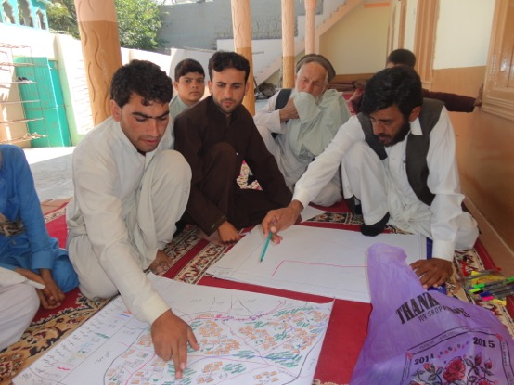
Photo 3.18 CCDC members mapping the area

There was some indication that the CCDCs had served to enhance community voice and bargaining power in relation to government authorities. This dynamic was noted in Hisarshahi: “the CCDC contact the government authorities on behalf of the five CDCs, therefore, the CCDC is now more powerful. The government authorities are respectful to them because they have the support of many villages.” Similarly, Motahida CCDC claimed that since the CCDC represents seven communities, government officials understand the importance of the CCDC.” Furthermore, government authorities have recognised their CCDC as a formal shura. Only in Itehad was no real change in this respect claimed by the CCDC respondents.

All CCDCs stated that they had functioning relationships with district authorities and served as a point of contact for the district governor. The CCDC in Hisarshahi suggested that the “existence of the CCDC improved the relationship between the people and government authorities. Now the people can easily reach the district governor through the CCDC and can share their share their problems and issues with him.” In Itehad and Motahida, no special improvements in relations were noted but they were in contact when issues arose and meetings take place. Both noted that district authorities did not involve themselves in development issues, but occasionally visit project sites. The main reason for contact appeared to be in relation to security matters. The Hisarshahi CCDC noted that,

“Our relationship with the district governor is very good … He always welcomes our programmes and helps us during the implementation of programmes. For instance, he instructs the security departments to take care of project security. We meet monthly to discuss the completed projects, ongoing projects, security issues and problems raised in the villages during these meetings.”

Contact with the district authorities was described as a form of last resort by Itehad CCDC respondents, stating that, “80% of problems and conflicts are addressed through CCDC and when there is any problem submitted at the district, the officials refer the case to the CCDC for further resolving and processing.”

All CCDCs had good and fairly regular contact with District Development Assemblies to discuss project implementation, share information (such as project budgeting) and raise other development issues. CCDCs would share community development problems with the DDA and are sometimes requested to submit reports on projects. In the case of Itehad, the CCDC chair was also a member of the DDA. While some problematic issues were raised (such as a lack of DDA concern), on the whole the relationship between the DDA and CCDCs appeared to be constructive.

CCDC | Relations with District Authorities | CCDC Point of Contact? | Contact with DDA
Hisarshahi | Good | Yes | Yes
Itehad | Average (although contested by District Governor) | Yes | Yes
Motahida | Good | Yes (while active) | Yes (while active)
Table 3.16 Relationship with district authorities

CCDC | Traditional Roles | Community Voice
Hisarshahi | Some traditional leaders sit on CCDC/CDCs  No conflict of interest. | Improved
Itehad | All CCDC members are also traditional leaders.  No conflict of interest. | No improvement noted.
Motahida | Head of CCDC also traditional leader.  No conflict of interest. | Improved.
Table 3.17 Impact on traditional roles and community voice

3.2.4.5 Social cohesion

Overall, there is much evidence to suggest that the Nangahar CCDC have strengthened relationships, social cohesion, and solidarity between communities. This was judged to be especially strong in Hisarshahi where such dynamics were almost universally attested to, fairly strong in Itehad (while the CCDC itself did not register greatly enhanced cohesion, the component CDCs all did), and a good but more mixed story in Motahida. Overall, clustering can be judged to have improved bilateral relationships. A large proportion of respondents at the CDC and CCDC level spoke of improvements in social cohesion, solidarity and unity between villages.

This can be seen to be the result of a number of CCDC project effects. Road improvement has made travel between communities easier and the project process itself increased communities’ knowledge of other communities and facilitated increased interaction. As one villager put it:

“People knew each other from before, contacts existed but at the same time vengeance and revenge existed among communities. But after establishing the CCDC, the relationship has been strengthened. People know each other better as they have common and joint interests and benefits which has positively affected the relationship.”

The project meant visits between CDCs took place, during which they exchanged stories and experiences with one another. As described in Motahida, “CDCs visit each other’s projects for lessons learnt and also to know how to effectively implement the projects.” Clustering also appears to have led to more social events in beneficiary villages. As women in Baba, Motahida noted, “since roads have been fixed and pathways concreted, social events are celebrated smoothly in village.” However, there was a suggestion this has not equally benefitted poorer members of the community.

But in certain respects there appear to be limits to the observed improved interaction between communities. What interaction occurred was mainly during the project cycle, and mainly involved CDC members going to other villages.

Regarding the mixed picture in Motahida, while the CCDC respondents were confident as to the benefits in terms of improved social cohesion, this was less the case from the CDC perspective. For instance, CDC respondents in Miran and Malikan noted that “the CCDC has not had a positive impact on relationships between CDCs” and that the “CCDC exacerbates conflicts rather than solves them.” Similarly, Itehad CCDC believed that the disagreements generated through the process of project selection only served to weaken relationships.

Finally, there was not much evidence that the CCDC has helped resolve disputes, at least beyond those that arose during project prioritisation and implementation. We heard of one CCDC resolving a family related conflict in a village in Motahida but little beyond that.

3.2.4.6 Gender

Female participation in CCDC activities was extremely low across all the Nangahar CCDCs (and component CDCs). Some CCDCs supposedly included women representatives, but these largely existed on paper as symbolic gestures toward women’s participation. As the women from Piyowolu explained, “only our names have been written in CDC structure, we are not actually included.”

CCDC | Female CCDC members | Percentage | Same meeting | Sub-committee | Every CDC
Hisarshahi | 0 | 0 | No | Apparently for procurement & monitoring | No
Itehad | 0 | 0 | No | No | No
Motahida | 0 | 0 | No | No | No
Table 3.18 Gender dynamics

Motahida CCDC claimed that “women sit with the CCDC and share in decisions, collect women’s problems and needs and share it with the CCDC. One participated in the CCDC conference in Kabul.” Hisarshahi CCDC claimed “women are actively involved in the activities of the CCDC. Women share the problems of the women in the community, implement women’s specific projects, help select projects, help in procurement and there was a separate women’s only monitoring committee to monitor the financials of the project, monitor implementation and take part in decision-making.” However, all CDCs surveyed suggested there were no females on their CDC due to cultural restrictions and hence no women representatives on the CCDC. Rather, females were informed of CCDC activities only indirectly through male members, yet even this was judged to be deficient by some respondents. Nevertheless, it is clear from CDC respondents that, even if claims of involvement in decision-making are valid, female participation in CCDC decision-making and management has been extremely limited.

The main barriers towards women’s membership and inclusion in CCDC activities were primarily attributed to the low level of education among women, traditional and cultural barriers, and security concerns. Some respondents claimed that women were not interested in participating but this was not borne out by the responses provided by women themselves in focus group discussions. The security problem was frequently noted as the principal reason for limiting female participation as men feared Taliban reprisals. Many believed that if security improved, so might female participation. As the CDC from Miran and Malikan in Motahida put it, “Without a sustainable peaceful environment it is impossible for women to hold CDC membership.”

Generally, respondents claimed there was no real opposition to female participation in CCDC activities but that women did not participate due to the reasons outlined above (apparently men tell them not to and they themselves choose not to).

The vast majority of respondents at the CDC and community level were supportive of increased female participation. Of those that explicitly commented on whether female participation should be increased, over 80% were supportive of the idea. It should be noted that all women respondents thought female participation should increase. Of those that were not supportive, they cited traditional barriers as the reason, suggesting they were not so much against the idea but that they did not feel it was possible given prevailing cultural norms. However, both poor and rich respondents in Baba, Motahida CCDC were explicit in their opposition to the idea.

In giving their reasons for supporting increasing women’s participation, a number of explanations were frequently raised. Respondents argued that women comprise “half the society” and have their own needs which should be addressed. As the women from Kariz put it, “we want women to be included so that women-related issues can be raised and addressed. Only women understand women’s problems and can approach the women to hear their viewpoint.” Islamic values were mentioned as being supportive of female participation in community affairs and that it was only a misinterpretation of Islam and Afghan culture that has meant women are not allowed to leave the house. As the beneficiaries from Miran and Malikan in Motahida noted, “From an Islamic point of view, women have right to make decisions on issues that relate to their lives and to live in a peaceful environment.” Other reasons referred to the fact it was the right of women to be included in social activities and that such inclusion could have significant social benefit. For instance, project beneficiaries in Baba CDC noted that, “we want influential women to be part of CDC as their role in development is important.”

Four main suggestions for enhancing female participation were consistently raised by respondents (and it should also be noted that many came from women themselves). First, many felt there should be an increase in women-focused projects and women-related assistance and privileges. Motahida CCDC stated that, “women-focused projects have to be designed. Since there are no women-focused projects they lost trust in the CDCs. There should be vocational training courses such as tailoring, poultry projects and literacy courses which would help household economics.” Similarly, women from Kariz proposed tailoring courses, embroidery courses, poultry farms, and literacy classes. The poor respondents from Ba-ar in Itehad noted that “there should be a women-focused environment to serve women and so they can be involved in decision-making. A women’s cultural complex should be established. Since women are so poor in our village, they should be given privilege, and they should work separately from men to serve the women in the community.”

Linked to the first point, many believed that women-focused projects would best be delivered through separate women’s committees, where women can share their problems with other women. This it was claimed would enable women to identify their needs and make decisions (though this might have to be done in secret) and could play an important role in encouraging participation. The Motahida CCDC believed there should be a separate women-only CDC to enable women to establish separate women committees.

Third, public awareness, primarily regarding up-coming projects, was raised as being important because outlining the importance of female participation would encourage them to participate. Finally, education was seen as crucial in encouraging participation. Literacy courses provided by female teachers to enhance their knowledge and enable their involvement in CDC activities.

3.3 General Province Level Findings

This section is divided into three parts:

- Political economy analysis
- Provincial and district context
3. Critical factors

The first section, will provide a discussion on what the data reveals about the intersection between power dynamics and resource distribution within the concerned clusters. It addresses issues such as elite capture and the politics of marginalization associated with project implementation and benefits, as well as observations on the extent to which CCDC projects have served to reshape or transform existing local political and economic realities.

The second section explores the influence of provincial and district contexts on clustering. It considers the way in which conditions set different ‘starting points’ in relation to the different CCDCs, which may be reflected in divergent gains achieved through clustering in our findings. It also considers the role context plays in directly shaping outcomes in relation to welfare, social cohesion and governance for development.

The third section will then move on to consider some of the prominent determinants of the various strengths and weaknesses, successes and failures of the CCDC pilot’s outcomes.

3.3.1 Political-economy dynamics

Our findings point toward some interesting dynamics with respect to power dynamics, elite capture and the politics of poverty, marginalization and resource distribution. From the outset, an important caveat should be noted. The data obtained only allows us to get so far into the detail of these issues. Some of the responses are contradictory and remain unsubstantiated. Nevertheless, broad patterns can be identified and serve as the basis for the following findings.

Impact on informal leadership

As we have seen, in many cases CCDCs have been involved in instances of dispute resolution in the community. So, what do informal leaders think about the expansion of CCDC activity into such areas? Firstly, it is important to note that many of the disputes described were specifically project based, so this does not appear to have significantly concerned informal leaders. Secondly, where there exists extensive overlap of informal leaders and the CCDC, they are somehow involved in resolving these disputes anyway (plus it appears that generally other elders will be approached for their advice simultaneously). Third, the relationship between CCDCs and informal leaders not on the CCDC was almost universally described as a being a healthy and good – we did not find any evidence to suggest any form of active resistance or dissatisfaction with the CCDCs involvement in such disputes. Similarly, where we witnessed the emergence of new leadership – which was certainly evident in Bamian, but less so in Balkh or Nangahar – and the diminished role of Maliks in village governance as a result of clustering, this did not appear to have generated much resistance or any sense of grievance deriving from diminished responsibilities.

Overall, clustering has not catalysed any wholesale transformation of the way informal power is exercised at the local level. Rather, changes appear to be gradual and tentative. In all cases, the very existence and operation of the CCDC (and CDCs) has introduced new forms of democratic and participatory decision-making into the community governance equation. In some cases, such as in Bamian, this has been embraced and the new norms taken forward. In others, while not actively resisted, informal leaders have sought to influence and contain such new processes in terms of their scope, function or even existence beyond project implementation. As such, this has had little effect on community expectations – the dominance of tribal elders in decision-making on community matters is taken for granted. Of course, the informal leaders that have a seat on NSP councils increasingly have to work within the parameters of the principles guiding the operation of the CCDC/CDC in order to meet minimum NSP standards.

Balkh cases show the strong influence of traditional leadership on CCDC operation, and this was confirmed in interviews with provincial NSP representatives. Apparently, warlords had sought to interfere in the process early on but this issue had been resolved. The CCDCs are not entirely dominated by informal leaders as the fact that the CCDC structure gives equal rights to all members limits their domination somewhat – however, there is significant overlap. All decisions are made with their consultation and there is no indication of traditional leaders entirely subverting the process for their own ends – rather they are best considered as strongly influential voices in any key decisions. In these cases, CCDCs, while active, were very much restricted to a developmental role. Coupled with poor knowledge of the CCDC among ordinary community members, this all suggests a lack of community participation, even if there was evidence of some reporting about CCDC projects to communities (but usually only after implementation). While elders appeared to dominate decision-making in Balkh, we observed no major sign of traditional elders coopting CCDC processes for their own ends or interests (the one exception may be Etifaq CCDC, which we return to in greater detail below).

Elite manipulation of project benefits

Motahida CCDC in Nangahar represents an excellent case with respect to identifying the political economy dynamics of elite capture of local development processes and the influence of traditional leaders on CCDC planning and decision-making.

As established earlier, in terms of immediate outcomes, the projects were largely deemed a success by all respondents from the CCDC to the community level. The water wells and concreted pathways had generated a number of positive outcomes impacting the majority, if not all, of community members. Amongst other things the projects have helped reduce disease, improved travel, transportation and communication, reduced costs, and freed up time for alternative economic activities. The projects were also deemed largely sustainable.

However, these positive achievements – relayed to the research team in a glowing light by the CCDC – mask underlying tensions and issues which suggest a significant degree of elite manipulation manifested in the unequal distribution of project benefits at the expense of ordinary community members. Village level responses, across the social spectrum, were noticeably ambiguous: while recognising clear positive outcomes from projects, they also drew attention to associated issues and problems with the CCDC.

Although not necessarily a problem in itself, it is clear the CCDC is male dominated and includes a number of members who are also traditional leaders (reportedly four in all). The head of the CCDC is also a tribal shura member. In one respect, the relationship of the CCDC with the traditional tribal leadership structures in the communities was judged to be healthy, cooperative and constructive. Traditional leaders are valued for their skills and experience; they are consulted throughout the project cycle and were not generally seen to be negatively interfering in the process. Given the traditional values of the community, such involvement was seen as entirely natural. The institutional governance boundaries also appeared to be clear, with the CCDC/CDCs focusing on development and traditional shuras on wider social matters and dispute resolution.

Yet, internally, decision-making in the CCDC appears to have been somehow coopted by certain powerful elites and specific decisions taken with their own interests in mind. Accusations of favouritism and elite control were common at the community level. CCDC meetings apparently took place in the Malik’s home, with important decisions hidden from the rest of the community and few updates provided. This sentiment was expressed by FGD respondents in Kariz: “what they decide, villagers do not oppose”. It was reported that CCDC members had hired members of their own family for project implementation labour thus blocking paid employment for unconnected families. Wells were allegedly located close to tribal leaders’ homes. Miran and Malikan CDC noted that while their priorities were reflected in the chosen subprojects, decisions as to their ultimate location reflected elite self-interest: pathways were built in front of CCDC members houses and it was alleged that a well was built inside one of their houses for private use. Furthermore, women in the community stated that they had decided to remove the hand pump because run-off water was damaging their homes.

Whether cause or consequence of such dynamics, there were also clear deficiencies in terms of downward accountability and transparency. While villagers were generally consulted with regard to their development priorities, beyond this there was insufficient updating by CCDC members on project progress and decisions taken or consultation with respect to budgeting and procurement. Concerns were also raised regarding the undemocratic nature of the CCDC – only 2 members appear to have been elected to the council and respondent suggestions on how to enhance transparency often mention the need for elections.

So, a somewhat paradoxical situation exists whereby most villagers are largely happy with the direct outcomes of the project (with most benefitting in some respect) and tribal leaders are generally well-respected, with their input in decision-making deemed useful. Villagers were consulted at certain stages, providing the process with a measure of participatory legitimacy. Yet, on the other hand, bias in terms of project location is evident and a significant level of concern raised with respect to the openness of CCDC decision-making processes. Such paradoxes largely account for the contradictory responses we heard amongst the communities.

Evidence of similar dynamics, although not to the same extent, were apparent in Itehad (and only partially in Hisarshahi). Issues of transparency, consultation, accountability and outreach were raised a number of times in FGDs at the community level. Some mentioned that they only learnt about projects after implementation had begun. Again, while most villagers appear to have benefitted from the projects and the involvement of traditional leaders was largely welcomed (the entire CCDC also sit on the tribal shura), there were accusations of nepotistic labour hiring practices and elite manipulation, with projects unfairly benefitting CCDC members.

Shifting the focus briefly to Bamian, it is useful to compare these findings with the situation in Nargis CCDC. Nargis is interesting insofar as there are clear cases of certain communities not benefitting from projects and some accusations of unfair distribution of resources. However, this does not appear to have resulted primarily from elite manipulation but rather largely from insurmountable geographical factors: CDCs are located far from one another, Kharzari CDC was unable to benefit from irrigation canals as it is above the water table, and Kham CDC is situated in a different valley to the other 5 CDCs. Qalai Wakil CDC claimed most resources went to Kham CDC and certain villages in their CDC did not benefit at all from the irrigation project, namely Nawabad and Nawrak (with land above the streamlet). Beneficiary respondents claim these villages were told they would receive benefits from any future project and were thus persuaded to agree. The CDC also claimed that two CDCs – Ghawchak and Sabzsang – did not benefit much from the CCDC project. While certain elite dynamics might be operating below the surface – although none such were visible through our data, beyond generalised accusations of unequal distribution – it appears that marginalization was more the result of unfortunate geographical realities.

Returning to Nangahar, instances of elite manipulation might help to account for the ambiguous outcomes with respect to social cohesion in both Motahida and Itehad. Motahida CCDC claimed enhanced connections and interaction between communities, yet CDCs and villages were far more sceptical. Miran and Malikan CDC even claimed the CCDC had exacerbated conflict, adding that villages visited each other before anyway. Kariz and Hajyan CDC did not think the project had brought villages together. In Itehad, the CCDC members were more explicit about the negative impact on social cohesion. This was ascribed to inter-CDC disagreements over proposed projects, but it also appears that the lack of community consultation has undermined ordinary villagers’ buy-in and support for the CCDC and component CDCs. The benefits from projects are real and appreciated but perceptions of elite manipulation and a lack of trust in the decision-making process has weakened the legitimacy of the CCDC concept as a whole and jeopardized inter-community relations in the process. Hence, Motahida CCDC no longer meets, there is a general opposition to clustering, CDCs have been weakened, and there is a general sense of dissatisfaction with the process.

Arguably such projects as were chosen – shallow wells – are more open to manipulation (individual wells can be located close to elite’s homes) as opposed to large-scale projects which benefit all. Small pathways can similarly be located to better serve certain powerful community members. Of course, the building of schools and clinics can similarly suffer insofar as powerful CDCs may be able to have them located in or close to their own communities. It appears that large roads and electricity will be not be as easily manipulated in this way.

By contrast with Motahida, another Nangahar CCDC, Hisarshahi, displays almost the opposite characteristics and there is next to no sign of negative elite capture. It is interesting to compare these two CCDCs as they implemented similar projects. While traditional leaders are strongly represented on Hisarshahi CCDC (and in CDCs), this does not appear to have had any negative impact on project outcomes. There presence was widely welcomed due to their experience. The crucial factors that prevented elite manipulation appear to be: transparency, democratic process, and regular community updating. Effective FP intervention also appears to have been important. While there was some disagreement over the location of the wells, this largely appears to have been resolved by the CCDC through mutual consensus. There were no accusations that projects had disproportionately benefitted CCDC members or elites.

So, the involvement of traditional leaders or elites in CCDC processes does not appear to be the problem per se. Given the provincial context and the powerful role played by traditional elders and the shuras, it would be unrealistic to expect there to be no overlap of CCDCs/CDCs with tribal structures. Traditional elders are widely respected and their experience is highly valued by the community. In general, as noted above, they appear to play a constructive and supportive role through cooperative consultations with CCDC/CDC members; they have not been seen to interfere with CCDC processes when not within the CCDC and there was no observed conflict of interest pertaining to those occupying both tribal and CCDC roles.

Rather, where issues have arisen, this is more a function of the nature of the CCDC process: lack of transparency, openness, and democratic accountability. Whether this represents a deliberate move by certain elites to subvert the process in their favour or they have simply taken advantage of the situation is difficult to determine based on the data available. Nevertheless, the implication is clear: in all cases, efforts must be devoted to enhancing the openness of the CCDC process. CCDC members must be elected, full consultations and reporting (by CDCs) with community members at all stages of the project cycle must occur; and communities should be regularly updated.

The other extremely positive CCDC cases in this evaluation underline these points. In Kaloye Sufla CCDC, Bamian, there were no indications of elite capture or project manipulation in favour of CCDC members. The implementation of projects was undertaken with labour equally drawn from member CDC communities and the chosen electricity and school projects have benefitted all CDCs and villagers equally as far as our data conveys. This was underpinned by an open and transparent process of communication and reporting.

3.3.2 Provincial and district context

In considering the role of provincial and district contexts in this evaluation, two important methodological caveats must be noted. First, the samples on which the following observations were based are extremely limited, with only three provinces and 6 districts. The sample was dictated by the existing scope of the pilot project as well as security and access considerations. This fact necessarily limits the extent to which the findings can be said to be generalisable across Afghanistan. Second, this issue was compounded by an imbalance in the quality and depth of the accumulative data gathered in different provinces and districts and available in the existing literature.

Linked to this, and based on a conscious methodological decision on behalf of the research team, the evaluation has focused on exploring the internal operation, mechanisms, processes, decision-making and project implementation dynamics of the CCDCs themselves. The wider context and conditions within which CCDCs are inevitably situated have been considered, but given the limited opportunities for robust comparison, this did not constitute a priority.

A multi-case quantitative and longitudinal study would be better placed to explore such factors. Nevertheless, we believe that the following analysis sheds light on some of the important contextual factors that either have demonstrably influenced the cluster process in this evaluation or that, based on a wider understanding of developmental and political-economy considerations, could reasonably be assumed to have a variable shaping influence.

3.3.2.1 Provincial context

Our findings suggest factors operating at the provincial level are important overarching determinants of the shape, functioning and, to some extent, outcomes relating of CCDCs. It is striking that even though clusters are drawn from different districts (except in Nangahar where, due to security restrictions, all CCDCs were located in the same district), they display similarities in a number of respects, and even despite differences in project type and other variables. This is not to downplay the importance of district-level factors but our findings suggest that broader provincial-level conditions do have influence. For instance, in Bamian it appears that CCDC decision-making has not been influenced by powerful local actors to the same extent as in Balkh or Nangahar and women have been more actively involved – this likely stems from the relatively more open governance and social dynamics observable across the province.

Pinpointing exactly how the provincial context will determine the evolution of any specific cluster is difficult. It might manifest itself in a positive way insofar as security is good or ethnic homogeneity encourages social unity and interaction. More negatively, a province may be typified by pervasive insecurity, tribal domination and socio-cultural divisions. Again, this evaluation has shown the complexity that exists in determining precisely how these issues affect clustering, but there is an important extent to which broad provincial conditions partially pre-determines whether there exists ‘fertile ground’ for introducing the model. At minimum, this implies that a deep and up to date understanding of the specific political-economy and developmental provincial context can help NSP and FPs tailor their interventions appropriately and preempt possible challenges.

3.3.2.2 District context

One limitation of this study was the relative paucity of district level data that the evaluation team was able to gather (existing literature at this level is limited and not all the field researcher teams were able to gather the kind of information that would allow us to generalise confidently on the role district levels factors play in relation to clustering). Further fine-grained research of an ethnographic nature would be required to draw out district level dynamics in greater detail. Nevertheless, some tentative observations are possible.

Provincial government authorities exert considerable influence over district level bodies (commanding greater resources and afforded more political power in the formal governance structure of the country), and in many ways shape the latter’s activities and behaviour. Nevertheless, variations between districts are inevitable. Where district level factors are likely to be of most importance in terms of shaping clustering processes and outcomes is in terms of elite and local governance dynamics; agro-ecological factors; and prevailing social structure and land ownership patterns. All these areas can vary significantly from one district to another. The precise impact such variations have on clustering is difficult to determine but some findings can be gleaned from the wider literature and certain insights derived from this evaluation. At the very least, it is possible to draw attention to key factors that are likely to be of importance and which any future expansion of cluster will need to take into account.

Socio-structural and land-holding patterns

Afghanistan is typified by stark and significant variations in terms of how different districts, and even different valleys and areas within districts, have developed patterns of landownership. Decades of conflict, displacement and upheaval have further contributed to a highly differentiated and uncertain social landscape. Contemporary historical factors have also exacerbated a general problem of land disputes and weak legal recognition of ownership. This has especially been the case for common property, which has fueled disputes over the use of land for rain-fed agriculture versus grazing as well as inter-ethnic and individual-community disputes. The issue is exacerbated by the complexity of distinguishing land access from ownership, the lack of clear boundaries on rain-fed land, and the fact that rain-fed land has traditionally been held by the community at large. Such disputes are generally resolved through customary processes, although state law does play a role in certain cases.

Social structure is strongly determined by patterns of land ownership, where in many cases the distinction between rich and poor essentially mirrors ownership and non-ownership of land. A common feature of rural social relations is large numbers of landless existing in a semi-feudal and exploitative relationship vis-à-vis a smaller number of landlords who hold concentrated estates. However, these patterns vary significantly by district, where some areas are defined more by the existence of large traditional (often absentee) landlord families owning large tracts of land (typically understood as being over 10 jeribs in size). Others are comprised of a multitude of smaller landholdings (typically 4-5 jeribs). Most farms tend to be run on an owner-operator basis but some sharecropping and the seasonal hiring of wage labour occurs, even on smaller scale agricultural lands. Productivity tends to be higher in those areas where farmers directly work their own land in small-medium plots and/or where landlords are not absent.

How can we expect such variations to play into clustering processes? It is reasonable to assume that these patterns will have some impact on clustering processes and outcomes. Districts typified by large landowner estates might play a positive role insofar as supportive landowners may be in a position to facilitate the implementation of projects on their land, encouraged by the improvements and enhancements such projects will bring. They are likely to support irrigation, infrastructure and transportation projects. They may be somewhat resistant to projects like schools, community centres or clinics so may seek to sway cluster decision-making toward the former group.

Of course, NSP clustering does not simply aim to contribute to the capital accumulation of large landowners, even if this might promote local economic activity. Avoiding this might be difficult where most of the land in a CCDC area is held by one or two families and the community agrees to implement projects that improve agricultural productivity and/or market access. It is inevitable that those who work on the land stand to benefit from any increase in agricultural productivity gained through CCDC projects, but arguably in a second order fashion.

Can we expect clustering to have any demonstrable positive impact on poverty levels or to promote more equal social relations? If projects enable some measure of small-scale capital accumulation (for instance, in terms of the common practice of livestock ownership amongst the poor), this may enable some to eventually build up enough to buy land, thus enhancing their financial and food security (given that land ownership is a pivotal socio-economic foundation and social stepping stone). However, strong traditional barriers make this process very difficult to achieve – large land owners typically do not sell to the landless for a variety of cultural reasons. This evaluation did not conduct in-depth household surveys therefore findings in this respect are difficult to arrive at. In a general sense, as outlined in the main findings, projects have produced welfare gains for ordinary villagers and in many cases improved the overall economic condition of the poorest in the community. A longitudinal study incorporating household surveys could assess whether this leads to longer-term gains in terms of increased levels of land ownership and more equal social relations.

The clear differences in land-ownership patterns in Bamian between Panjab - typified by a number of large landowners (especially in Nargis valley) – and Shibar – typified by numerous small-medium size landholdings, does not appear to have had any major influence on the three main areas considered in this evaluation: welfare, governance and social cohesion. It is however, interesting to note that the choice of project in the two Panjab CCDCs included agricultural improvement, whereas Shibar chose social infrastructure and services (school and electricity). This may reflect the poorer productivity of Panjab farms given the existence of large absentee landlords, as hypothesised above.

Therefore, it is safe to conclude that landlessness is one factor contributing to the Yakatoot issue in Balkh. Yakatoot is mainly comprised of poor landless farmers mainly working on the land of absentee landlords. This may have contributed to their marginalization and lack of influence in CCDC decision-making.

Agro-ecology

Another potentially important district-level contextual factors relates to agro-ecological and geographical attributes. The key issue here relates to whether crop land is primarily rain-fed or irrigated. This might be important as areas that have extensive irrigation systems to feed their lands with water have often developed quite sophisticated governance mechanisms and robust collaborative mechanisms between villages to effectively and fairly distribute the water to farms in the area. Dedicated community members are often selected as special officers or mirabs to oversee the management and allocation of irrigation systems.

It might be hypothesised that social cohesion and community governance mechanisms will be stronger and more established in such areas. In areas typified by non-irrigated land, we would not expect to see such sophisticated governance or communication systems in place as rain-fed land requires little oversight or communal management. It is also likely that predominantly rain-fed areas will experience higher levels of poverty, food and insecurity as rain-fed cultivation is highly susceptible to changeable climate patterns.

This evaluation did not find sufficient evidence to support these reasonable assumptions. To take the clear case of Bamian, where two CCDCs were in one district typified by irrigated farm land (Panjab) and one CCDC in a district typified by rain-fed land (Shibar). While it may be the case that the significant reported gains in social cohesion in Shibar resulted from a relatively low starting point (reflected in community responses), it does not appear that the governance of the CCDC process was impeded by a lack of prior experience of managing community issues. Indeed, the CCDC and individual CDCs in Shibar oversaw what appears to be a highly effective and successful process. Extremely similar patterns were apparent in Balkh where Sarab CCDC in Kishindih, a district with a higher proportion of rain-fed land than Khulm or Dehdadi, displayed greater competence in the governance and management of the cluster process and social cohesion was significantly enhanced.

Rather than these findings suggesting that CCDCs in agro-ecological conditions typified by rain-fed areas are, somewhat counterintuitively, likely to possess more sophisticated community governance capabilities, it is more accurate to state that such capabilities in relation to clustering will be little affected by agro-ecological factors: issues pertaining to the CCDC itself, the training provided by FPs, the choice of project and so forth, are deemed more important. The relative higher gains in social cohesion witnessed in rain-fed districts may, however, be due to the lower pre-existing levels of social interaction in such communities.

Politics and Governance

Over-arching patterns of governance and politics in districts can be expected to feed into and impact on the clustering process in both beneficial and harmful ways. Of course, some measure of independence from district politics is maintained given the rigorous, democratic and accountable processes mandated by NSP in relation to clustering. This offers some guard against the flagrant manipulation or cooptation of funds and projects by local elites and powerholders.

Nevertheless, as is apparent throughout Afghanistan as a whole, the intersection and overlap between formal and informal processes is a prominent feature of local politics and is likely to be present to some degree in relation to clustering. Donor interventions in the subnational governance sphere have attempted to introduce formal institutions only for them to be coopted or subverted by elites for their own ends, exacerbated by poor coordinated between multiple overlapping interventions (which provide ample opportunities for manipulation). Only those that work with the grain of local politics and custom have withstood the test of time.

The nature, interests, background and behaviour of the district governor is one factor that might plausibly impact on the cluster process. While their formal role is somewhat restricted, the power of any individual district governor is largely determined by their informal relationships to key actors, factions and ‘social power networks’ meaning that some are more influential and others marginalised (for instance, limiting access to infrastructure projects and other services). This might restrict the extent they can support development processes – such as those overseen by cluster CDCs.

In some cases governors can command significant resources and importantly shape the development processes at the district level. Thus, some governors have used their position to pursue their own interests while others have adopted a more developmental agenda, choosing to back projects in certain areas. As a result, different districts can vary considerably in terms of the power, authority and access to resources wielded by the governor as well as the overall extent of attention afforded to development interventions, whether provided through PRTs, provincial governors or other national and international projects.

This variability is further reflected in the quality, power, effectiveness and operation of DDAs. Despite commanding a dedicated budget – allowing them some measure of independence – ‘DDAs vary significantly in composition and influence from one district to the next’ and are rarely consulted with respect to Provincial Development Plans. Again, relationships and networks often determine the relative influence and effectiveness of individual DDAs. Jackson notes that ‘they must still rely on their relationships with key power holders in government to resolve disputes and mediate access to central government resources. This in turn encourages them to rely on relationships with key power brokers – the ‘government of relationships’ – to enable to access to resources and support. Again, such factors contribute to variable levels of district political and economic marginalization.

This study points toward some of the ways in which good or bad district level elites and authorities might impact on clustering. This might manifest itself – as tentative evidence from our evaluation shows – in the extent to which district authorities or district governors are supportive of clustering initiatives, or if they are somehow aligned to certain members or individual CDCs within the CCDCs.

It also appears district authorities attempted to influence NSP managers in their choice of communities to target as part of the clustering process. As the a Facilitating Partner representative in Balkh noted,

“There are many stakeholders and warlords who try to interfere in the process. Even the district governor himself sometimes tries to dominate the decision-making process, as happened in Dehdadi district … The governor told us not to go into particular villages … Such socially dominant people will sometimes affect the clustering process.”

The negative influence of district level politics can be seen in the case of Etifaq CCDC in Balkh. This case essentially concerns the marginalization of a poor and isolated CDC, Yakatoot, which did not agree with the planned clinic prioritised by the other CDCs and thus stopped attended meetings and refused to pay its 10% contribution. The people from Yakatoot claim their priorities (electricity, water wells, pipe scheme) were not taken into account (other CDCs and the CCDC dispute this). The clinic was built in Mashi which is far from Yakatoot compared to other CDCs. At some level, the dispute was purely geographical and project-based. The planned location meant Yakatoot would not benefit to the same extent as other communities.

Nevertheless, the fact that no solution was reached and Yakatoot’s objection was not taken into consideration possibly suggests the more powerful CDCs – apparently supported by and friendly with the District Governor – ignored the concerns of a poor and isolated one, thus further marginalizing it in the process. There were suggestions that Mashi and Hussain Khil came to an agreement that the clinic would be built in the former and the community centre in the latter. Apparently, ordinary people from other villages were not happy with the decision. It is possible that these CDCs, which are more powerful and enjoy the support of key district actors, managed to skew the CCDC decision in their favour. This is partially confirmed by responses at the CDC level in Mashi who noted that “powerful people dominated the decision-making” and that “only traditional leaders and elders know about CDC activity.”

While our findings tentatively point to the influence of such negative district political dynamics, these were on the whole limited and restricted to one or two cases (most notably, Dehdadi). In general the CCDCs and CDCs reported having healthy and constructive relationship with district governors and district authorities – many had regular meetings, governors sometimes inaugurated projects, and aspects of the process were supported (for instance, in terms of resolving land issues). Again, the democratic safeguards built into the programme as well as NSP and FP oversight appear to largely protect against outright manipulation by district actors.

This all suggests that NSP provincial managers will need to take into account the specific characteristics and particularities in relation to such issues at the district level in planning their operations and activities. Some awareness of the political economy and informal networks linking CCDCs/CDCs and district actors would be useful in order to identify where certain communities may be marginalised or, more positively, where developmentally minded governors can support and facilitate the cluster process. There might also be a need to specify the functions and responsibilities of district governors in the clustering process in order to increase their buy-in to the process and limit the scope of their unofficial interference.

Regarding district level politics and its potential impact on clustering, Jackson offers useful advice when she states that, ‘micro-level power dynamics and relationships have a profound influence on the way formal institutions function. This indicates that reform will not only be lengthy but will require intensive on-the ground monitoring, more effective use of incentives to build institutions and flexibility to adapt to the specific circumstances in each district.’ The findings of this evaluation would support this statement.

3.3.3 Critical factors

The evaluation draws attention to a number of factors that appear to be especially important in terms of determining outcomes.

It should be noted that there are large amount of variables potentially determining success that can be broadly divided into; community demographics and circumstances; CCDC size, capacity, composition, operation and management; NSP design, FP support; the nature of certain outcomes themselves and effect on other outcomes. Therefore, identifying any one or even a handful of key factors can be problematic, and moreover, different variables are more or less important to different outcomes.

Nevertheless, this study seeks to identify the variables that appear to have generated the outcomes observed in the course of this study. The case study approach adopted by the research team greatly enhanced our ability to tease out prominent determining factors by developing community-generated ‘stories’ with respect to their experience of implementing CCDC projects in the context of broader developmental experience of the community.

It is important to remember that this evaluation did not apply systematic quantitative analysis therefore generating reliable correlations between different variables and outcomes is necessarily difficult. The following analysis presents reflections on the detailed cases combined with insights from interviews with elite stakeholders.

Moreover, the data does not convincingly point to any one or even a number of specific factors that serve to determine positive outcomes. In some cases, the most we can conclude is that absence of a problem – for instance, large distances between CDCs – is beneficial, but that in itself by no means necessarily ensures positive results.

The following discussion strongly suggests that positive outcomes emerge from the complex and often unpredictable confluence of a number of positive factors and the absence (or mitigation) of negative factors, some of which can be controlled, some of which cannot. This is perhaps to be expected for such complex social and political interventions, which are strongly shaped by context-specific political-economy dynamics, the influence of personalities, unique histories, and chance events.

Nevertheless, despite these important caveats, we seek to identify those factors that appear to impinge most significantly on the functioning and outcomes associated with clustering. This section is divided into four main areas: province; community; CCDC operation; project type and outcome.

Community

Security

This is the first and arguably most important contextual factor. This finding derives more from discussions with elite stakeholders as opposed to data collected at the field level (methodological and logistical constraints prevented the team from travelling to the more insecure areas, however it was clear that the CCDCs in Nangahar faced a number of ongoing security issues). Essentially, the clear message was that for NSP (whether clustering or not) to function effectively, some basic level of security is crucial. A lack of security will hamper the programme in a number of respects, most notably in terms of undermining communication between communities and restricting FP’s ability to travel easily to visit communities. As a provincial manager put it, ‘without security it is hard to implement projects based on CCDC guidelines.’

Linked to this point, we were told that those CCDCs in which there is no history of conflict between the communities would find it easier to implement the programme. Confirmation of this issue was difficult to derive from the data as we did not encounter communities that spoke of any major pre-existing animosities or conflicts.

Geography

Geography is a clearly important factor with respect to the ultimate success of CCDCs. By geography we are referring principally to the proximity of component CDCs, the ease of travel and communication between them, and the existing extent of, or potential for, shared resource utilisation. The issue of geography is often closely connected to motivations for clustering (see below) as problems have been experienced by CDCs that have been essentially ‘pushed’ together despite clear geographical shortcomings.

The importance of geography manifests itself primarily in the way that larger distances or difficulty of communication prevents big projects being implemented that can benefit all CDCs and associated villages. Where CDCs were located far apart from one another, this often led to distributed budgets, localised projects, associated accusations of unfair distribution, and problems ensuring projects benefitted all community members. This was apparent to some extent in Guhdar and Nargis in Bamian. Conversely, outcomes in Kaloye Sufla in Bamian, where communities were located close along a valley, were far more positive: electricity reached all houses and the school is easily accessible for all communities. Similar positive project results were experienced in Sarab CCDC in Balkh where the road project was able to link geographically close and naturally linked communities. Conversely, Etifaq’s problems clearly stemmed from the large distances between CDCs which meant those CDCs located far from the clinic or community centre were not able to benefit equally.

Yet, geographical proximity should not be considered a cure-all. So, Nangahar CCDCs – all involving geographically proximate CDCs in relatively built-up areas – confronted numerous problems, and outcomes were far from universally positive. Rather, proximity should be understood as potentially enabling positive outcomes, while large distances more or less doom clustering from the start. Even large road projects – in effect, often designed to mitigate geographical issues – may be difficult because budgets are unlikely to be sufficient and maintenance a serious longer-term problem.

Ensuring geographically proximity of CDCs is clearly important if social projects such as clinics or schools are to be implemented. Similarly, irrigation projects we observed had failed to reach certain communities because, due to topographical realities, some CDCs were situated above the waterline or located in a different valley – as a result, a number of small scale irrigation projects were implemented that could have been funded under the standard NSP model.

Geographical issues serve to close off opportunities for larger joint projects, which is one of the principal aims of clustering. This issue also has implications with regard to the number of CDCs that should comprise any CCDC and will be discussed further in the conclusion.

Demographics

The religious, ethnic or tribal make-up of the CCDC did not appear to be a significant factor according to our findings. All three Bamian CCDCs were largely ethnically and religiously homogenous but outcomes, while generally good, were mixed. In Balkh, where outcomes were all similarly poor, especially with respect to the failure of CCDCs to continue operating, one CCDC was ethnically homogenous and yet experienced similar outcomes to the other two more mixed CCDCs. The failures in Etifaq CCDC were not ostensibly linked to demographic factors (at least as far as our data suggest – no respondents blamed ethnic or tribal differences for the Yakatoot problem). Similarly, the CDCs in Azadi were ethnically differentiated (some Arab, some Tajik and Uzbek) but there was no suggestion that these differences were behind the issues faced by the CCDC. Finally, mixed results across Nangahar CCDCs were observed despite ethnic and religious homogeneity (all were Sunni Pushtun).

CCDC specific

This section considers some of the features of the CDCs that comprise the CCDC – their background, form, composition, inter-CDC relations, decision-making dynamics and operation.

Capacity and experience

Interviews with key stakeholders such as NSP provincial staff and FPs suggested that generally those communities that benefited from NSP early on are more familiar with the programme, have built up greater capacity and are therefore better placed to ensure the success of the clustering programme. Besides simply greater levels of experience, another positive aspect of early NSP beneficiaries might be that CDCs have been through three or four elections and may have replaced leaders that were not doing a good job or working in their interests – essentially, democratic accountability in action.

Our findings suggest there is not much correlation between experience with NSP and successful outcomes. In those areas where the CDCs have been long established (Cycle III and IV), they do not appear to have achieved significantly greater outcomes compared to those that are newer. The newest CDCs (Cycle I and II) were those in Guhdar in Bamian – the problems associated with that CDC were clearly related to geographical factors as opposed to CDC experience, but otherwise the council appeared to function largely effectively. CCDCs comprised of more experienced CDCs achieved notably mixed outcomes. In sum, this evaluation did not produce any notable findings with respect to CDC experience. This may be because clustering is a very different process to ordinary CDC operation and, as such, entails that they all start from a fairly even playing field, while factors such as inter-community relations and geography become far more influential.

Linked to this point, interviews also suggested one ‘champion’ CDC within the CCDC can have a very good impact, essentially pulling the others along. The danger in this is that the champion may dominate decision-making, but even that is not necessarily a bad thing as it can smooth the process and require less facilitation, plus this does not necessarily lead to loss of voice for other less experienced communities. Unfortunately our findings did not generate sufficient evidence to substantiate these observations, although it was clear come CDCs were more active than others.

Inter-community relations

As our discussion of political economy dynamics above makes clear, in some cases the nature of the relationships between communities can play a significant role in shaping CCDC processes and outcomes. This was most stark in the case of Etifaq where more powerful and richer CDCs were able to control the process, thus engendering project disputes, frayed social cohesion and lingering animosities. Conversely, where intercommunity relations and dynamics were strong or unproblematic this appears to have facilitated less fraught processes of project prioritisation and implementation, such as in Hisarshahi, Nangahar or Kaloye Sufla, Bamian. In this evaluation, social cohesion has principally been considered as an outcome. However, social cohesion can also be seen as an important causal factor – there is reason to believe that good pre-existing inter-community (inter-CDC) relations can act as a positive factor in promoting better outcomes. We did not come across particular extremes in relation to pre-existing relationships (neither outright hostility or perfect solidarity) so definitive conclusions in this respect are difficult to arrive at.

Motivation for clustering

None of the CCDCs studied in our sample clustered spontaneously as they were all part of the pilot project, which entailed NSP approaching communities to consult with them as to whether they might like to cluster together. In some cases, communities were immediately receptive to the idea. However, in others, communities had to be persuaded or essentially cajoled into clustering with the promise of new projects.

Guhdar CCDC in Bamian is an interesting case whereby communities were essentially pushed by the FP to cluster and subsequent outcomes reflect this. The cluster ended up distributing its budget in a suboptimal manner due to disagreements over the location of the project and the difficulty of implementing a large project benefitting all communities. Also, while apparently still functioning in some respects, the CCDC does not work on other projects. This is not to say there were no positive results – those projects (roads and wells) that were implemented benefitted many community members and social cohesion was judged to have been enhanced. Nevertheless, it is clear that the somewhat forced nature of the cluster prevented more significant and extensive gains.

Hisarshahi in Nangahar provides evidence of the opposite situation whereby the communities were clearly keen to cluster. As the CCDC members put it: “Our CDCs clustered together because we wanted to implement bigger projects which could not be implemented through individual CDCs, to bring unity and solidarity among the members of the neighbouring CDCs and to reduce project costs.” In this case, the outcomes were clearly positive in a number of respects. Where a clear and positive will exists, the clustering process – from prioritisation through implementation to continued operation – is likely to function far more effectively.

Kaloye Sufla in Bamian – arguably one of the most successful CCDCs in our sample – expressed enthusiasm for clustering. Similarly, Sarab CCDC, despite discontinuation, was one of the more successful clusters of in Balkh in terms of the direct benefits of the implemented road project. As in Hisarshahi, CDCs welcomed the prospect of pooling resources and working together on a bigger project to benefit all the communities in their area.

Composition, process and operation

It is difficult to derive any particular findings with respect to the specific composition of a CCDC – whether smaller or larger, gender balanced or not and so forth – affecting outcomes in either positive or negative ways. We came across a variety of different forms of councils – many of which were not strictly in line with NSP requirements – and there was no clear correlation with any particular outcome.

Arguably more important was the nature and effectiveness of the processes they oversaw. All CCDCs noted the effectiveness of meetings, which we might assume would be a basic requirement for effective project implementation. While some were held more regularly than others (weekly or fortnightly as opposed to monthly or on a needs basis) and some appear more rigorous in taking minutes, such things do not appear to have greatly affected successful project implementation (which was largely good in all CCDCs, despite temporary or minor issues in some cases).

The nature of project prioritisation – whether easy or fraught, involving simple agreement or intense negotiation – does not appear to be especially consequential. Some of the most successful outcomes, such as in Kaloye Sufla and Itehad, involved some measure of disagreement and contestation. Far more important – as noted in the political analysis above – is transparency, outreach and communication with ordinary community members.

Nature of Facilitating Partner

Perhaps the single most important factor emerging from the sample of CCDCs considered in this evaluation is the quality of the FP – a point confirmed through elite interviews as well as field research. All broadly successful CCDCs received excellent training and support from their FP. Some of the problems experienced in Nargis CCDC could be attributed to weaknesses – noted by the CCDC – in FP support. This was primarily specifically with reference to the quality of the engineer who, through faulty surveying, budgeted the planned school incorrectly, causing a number of problems for the CCDC, such as Kham CDC having to pay a 30% community contribution. The CCDC also noted the weakness of the FP’s social employees and the fact that they had to resolve project prioritisation issues without their assistance.

FP support and facilitation – beyond expected basic duties – was required by the majority of CCDCs at some point, whether in terms of dispute resolution or technical support. Such support was critical in terms of ensuring projects were completed successfully. However, the importance of FPs in terms of promoting broader goals, such as social cohesion, is more uncertain. At minimum, the role they play in guiding successful project implementation can be seen as at least facilitating such deeper gains.

In Balkh, FPs were not involved in continuing project monitoring or implementation beyond submission of proposals. Although the support they provided during project implementation was judged by the CCDC to be good, the temporally limited nature of their role may help explain the failure of the CDCs to operate beyond project implementation. Partial facilitation may also account for the poor levels of transparency and communication in terms of updating communities on CCDC project implementation observed in all three Balkh CCDCs. Community respondents frequently commented that they “don't know much about the CCDC”. The fact that CCDC and individual CDC members were not making the effort to update community members of CCDC activities likely resulted from the absence of oversight. FPs can serve a useful function in gently reminding CCDCs that they should be regularly informing the community with regard to the progress of projects. Transparency and effective communication is crucial in terms of strengthening accountability mechanisms, lessening the potential for elite manipulation, and ensuring continued community buy-in and ownership.

Project specific

Project type

The type of project or projects chosen by the CCDC can play an important role in shaping ultimate outcomes, of course, directly in terms of immediate socio-economic developmental gains but also with respect to wider clustering objectives such as social cohesion.

A first and important consideration is whether the projects implemented under clustering achieve the purported benefits with respect to bigger and more extensive projects benefitting larger numbers of community members, which would not be possible with normal CDC NSP funding. Our findings are not especially optimistic in this respect. While implemented CCDC projects within our sample display clear benefits – both direct and indirect, intended and unintended – in a wide range of areas (as detailed in the province findings in Chapter 3), the fact that a large number of CCDCs split their budget to implement a number of individual smaller scale projects was a major concern. To repeat, while benefits were extensive, it is unclear what added value they achieved.

This was the largely the case with the agriculture and irrigation project implemented in Nargis, Bamian. The budget was not explicitly divided between CDCs and the subprojects, implemented in a number of locations in the area, certainly brought significant gains in terms of agricultural productivity and the prevention of flooding. Yet, the irrigation canals could conceivably have been constructed with individual CDC budgets. Nevertheless, the CCDC did witness positive outcomes with respect to building governance for development capacity and social cohesion.

A number of social projects, such as schools and clinics, were implemented by CCDCs. These arguably fit more within the ‘big project’ vision of clustering. The main issue with respect to such projects is that they inevitably have to be located somewhere and this can lead to unequal benefits – either they can be located too far from some CDCs to reach or, at best, such communities have to travel large distances to utilise them. This was clearly the case with respect to the Yakatoot issue in Balkh’s Etifaq CCDC (clinic and community centre) and affected some villages in Bamian’s Nargis CCDC (where a school was built). Nevertheless, our findings suggest that where location is properly negotiated and well thought through (as in Kaloye Sufla, Bamian), such projects can benefit large numbers of community members and have knock on effects with respect to community relations, as they serve to promote social interaction.

Infrastructure projects such as wells for safe drinking water, micro-hydro for electricity and roads can lead to significant socio-economic gains and are highly valued by communities. Wells have clear benefits in terms of health and the reduction of disease, and their construction can also save time where women and children used to have to walk far to fetch water. Yet, again, wells could be implemented with ordinary NSP funds. The one attempt to bore a larger scale deep well in Azadi CCDC failed due to rocky ground. In all other cases, small scale wells have been located in individual CDCs.

Micro-hydro projects – as completed in Kaloye Sufla, Bamian – while fairly small scale, appear to have been successful, reached all homes and seem well-suited to clustering.

With respect to roads, we have already drawn attention to the many benefits deriving from such projects (ease of travel, economic gains through good links to markets, reduced costs, lives saved, improved communication and so forth). Smaller pathways, protection walls and culverts have prevented flooding and the destruction of homes, reduced disease and served to clean the environment. Generally, most community members benefit from them (although some problems in this respect have been noted in the political economy section above). Yet, regarding the latter, such small scale road improvements have not brought much added value beyond the potential of ordinary CDC projects.

In Balkh’s Motahida CCDC, although there was agreement and the budget was not divided between CDCs, it was decided to implement 2km of pathways in each CDC. In Hisarshahi, pathways were built in separate locations within the CCDC. In Itehad, the budget was split so each CDCs could implement pathways according to their own requirements. A similar arrangement was applied in Guhdar, Bamian. Conversely, the larger roads in Balkh (Azadi and Sarab) serve to both connect individual CDCs and connect these communities with district centres – the socio-economic benefits have been extensive. There was also strong evidence at the community level that the roads had served to bring communities together, enhance communication and enable inter-community events thus improving social cohesion. The main concern regarding these projects was in terms of sustainability. If communities implement such large infrastructural projects they must have a clear maintenance and protection plan, the CCDC needs to continue functioning to oversee these plans, and adequate resources (including from within the community) must be available to fund such maintenance – all things largely absent in the Balkh cases.

Immediate project outcomes

Of course, successful project implementation would appear to be a bottom line in judging CCDC success and in delivering immediate socio-economic welfare benefits, but even where projects have had only marginal success or are already under threat, benefits in other areas are apparent. Complete project success is not necessary to achieve other positive outcomes, whether in terms of governance or social cohesion.

There is of course a balance. Complete project failure (that we did not witness) would likely undermine trust in the CCDC process and have negative effects in all areas, while complete success can only serve to promote the benefits of clustering in the minds of villagers. However, returning to the point about divided projects, this will not necessarily be the case if communities believe they could have just as well implemented the project without clustering.

In short, ensuring projects are implemented successfully and benefit the vast majority of villagers is an important factor in promoting positive outcomes in the longer term, even if capacity, governance and cohesion might be enhanced simply through the process of clustering.
4 CONCLUSIONS

This chapter outlines some of the main broad conclusions based primarily on the findings outlined in Chapter Three.

Inevitably there is some repetition from the preceding analysis, however this section seeks to draw attention to what we deem to be prominent and overarching conclusions. Readers should consult the earlier analysis for further information and details on specific issues.

4.1 Meeting Objectives

CONCLUSION 1: The Pilot Project has had mixed success in achieving its intended objectives

If we compare the record of CCDCs (as ascertained through this evaluation), against the stated objectives of the pilot, the picture is somewhat mixed. The four principal objectives of the clustering are:

- Improving the welfare of communities by financing larger subprojects that cannot be financed under NSP due to budget constraints;
- Enhancing the capacity and sustainability of CDCs;
- Promoting solidarity among CDCs;
- Promoting coordination between CDCs and local authorities.

In each case, we have found clear positive gains resulting from the implementation of clustering. Two CCDCs – Kaloye Sufla in Bamian and Hisarshahi in Nangahar – were the most clearly successful when judged against these objectives. Only one CCDC – Etifaq in Balkh – could be judged a near failure (despite some marginal benefits).

The remaining six CCDC were far more mixed in terms of outcomes. On the more negative end of the spectrum, the two other Balkh CCDCs – Sarab and Azadi – are no longer active and their projects have not been well protected. Nevertheless, to date, the roads implemented have brought socio-economic gains and improvements in social cohesion.

Similarly, Motahida’s and Itehad’s pathways and wells generated clear socio-economic benefits. However, CDCs have been undermined, social cohesion has been negatively impacted, and there were serious accusations of elite manipulation. In the Motahida case, the CCDC does not work on anything beyond the project.

Guhdar and Nargis CCDCs displayed mixed outcomes. Guhdar has not worked on any projects and there were concerns with respect to the CCDC undermining CDCs (which were highly valued by communities) but it also saw some gains in social cohesion and governance linkages. Nargis CDCs similarly claimed the CCDC had weakened them and there were some suggestions of unequal benefits but the CCDC has had positive effects in terms of social cohesion and governance and almost appears to be functioning as a form of local government.

Of course, this evaluation considered only a limited sample of all CCDCs that have been formed under the pilot project, therefore conclusions with respect to overall success (as far as it is possible to judge such a thing – see Conclusion 6 below) should be treated with caution. Nevertheless, there is good reason to believe these cases are largely representative of wider patterns – namely, that CCDCs generally demonstrate positive outcomes in some areas but negative outcomes in others. Put differently, even the best performing CCDCs suffer from problems or weaknesses, while the worst can still point to certain benefits.

CONCLUSION 2: Welfare gains were universally apparent and real but limited, especially given the potential of clustering

Taking the first of the objectives noted above, our findings clearly show that projects implemented under the clustering pilot have contributed to a number of welfare gains in a variety of areas. Respondents consistently pointed to the direct benefits resulting from implemented projects, whether in terms of promoting economic activity, enhanced living conditions, saving time and reducing costs, reduced disease, enhancing social interaction, provision of electricity, provision of clean drinking water and so forth. However, it is questionable to what extent clustering itself (as a specific mechanism) has enabled such benefits: in a number of cases, the cluster budget was essentially or actually divided between communities, meaning projects were implemented that could conceivably have been implemented by CDCs alone.

CONCLUSION 3: Serious concerns about the effect of clustering on CDC capacity and sustainability have been raised

Clustering causes CDCs to work on bigger projects in a collaborative fashion and CDC members receive additional training on important skills such as dispute resolution, procurement and budgeting. CDCs work to ascertain community priorities and maintain an outreach role. Such activities can reasonably be expected to enhance existing CDC capacity and there is evidence in our findings to suggest this is the case to some extent.

Nevertheless, there is more worrying evidence to suggest the existence of the CCDCs has actively worked to undermine CDC capacity and sustainability in some cases. In one respect, this is a result of the fact that it is the CCDC that does the majority of work related to project decision-making, implementation and monitoring. While individual CDC members are involved, there is little relative role for component CDCs proper (beyond gathering village opinions on needs).

More importantly, CCDC operation can actually serve to emasculate or undermine CDCs insofar as their role is marginalised, they cease to work on further projects and community members come to think they no longer function. This was especially the case in Nangahar, where many CDCs had essentially ceased to function after the CCDC was established. But similar concerns were also raised in Nargis, Bamian suggesting this might not be an isolated phenomenon. Furthermore, paradoxically and conversely, where CCDC were less successful (and ceased to exist, as in Balkh) the CDCs appear to have been strengthened and continue to be highly active.

CONCLUSION 4: Clustering has clear potential to promote solidarity between CDCs despite some negative findings

The simple fact of community representatives coming together has in some cases positively impacted interaction and enhanced inter-community knowledge and understanding. This can have lasting effects beyond project implementation or even, as in Balkh, beyond the discontinuation of the CCDC. Some projects themselves have a specifically catalytic effect on solidarity and cohesion – principally roads, but also social projects such as schools. Most CCDCs claimed that clustering had brought communities together (except Itehad in Nangahar).

However, digging deeper at the CDC and community level, the picture appears to be less rosy. On two occasion, in Etifaq and Itehad, the process of project prioritisation directly undermined cohesion by creating serious disagreements. In Etifaq this led to lingering animosities which have yet to be resolved. In Itehad, this led to dissatisfaction with clustering and weakened social cohesion. In other cases, claims of unfair allocation of funds or distribution of benefits can be seen to have undermined relations between CDCs as in Nargis and Guhdar in Bamian and Motahida and Itehad in Nangahar.

In sum, clustering clearly can work to bring communities together and enhance solidarity, but this largely presumes agreement or consensus on project prioritisation and/or effective projects which work to promote interaction and communication. Where the CCDC functions effectively and fairly, projects are implemented in a manner which benefits all communities and visits between CDCs take place, then this is one area in which clustering can generate clear and positive outcomes.

It is important to note that while big joint projects tend to bring communities together through the collective work, this not necessarily the case where budgets were divided into smaller sub-projects.

CONCLUSION 5: Clustering has largely had a positive impact in terms of promoting coordination with local authorities

Coordination and linkages between CDCs and local authorities has generally been enhanced through clustering, especially during the life-cycle of projects. This must be understood as building on existing CDC relationships, which in most cases were already fairly robust. While active, most CCDCs have served as a point of contact for district governors which can be seen as facilitating more effective, streamlined and enhanced modes of administration and representation. CCDCs have been empowered to speak on behalf of member communities and this serves to make interaction with district authorities more efficient and effective. For instance, district governors have used the CCDC as a means to relay important security information to communities.

District authorities have generally played a supportive role in terms of CCDC project implementation (such as providing necessary documentation, checking progress, or helping with security matters) but have generally kept out of community development matters. Otherwise, contact appears to have been on a needs basis. CCDCs in many cases serve as the first port of call for the community, often resolving local issues without any need for the intervention of district authorities. In other cases, the CCDC has worked collaboratively with district authorities to address issues, such as providing guarantees to have prisoners released.

Clustering has in most cases enhanced the voice and bargaining power of communities in their relations with local authorities as they have greater weight and influence when they act together. Similarly, CCDCs have served as conduits through which community members’ issues can be relayed to the relevant district authorities.

Of course, where CCDCs have not remained active, such gains have been lost, although CDCs maintain healthy relationships for the most part. In such cases, clustering does not appear to have contributed much added long-term value in terms of promoting governance linkages.

CONCLUSION 6: Overall ‘success’ in relation to clustering is not easily defined – positive outcomes in one area may be accompanied by failures in others

Clustering aims to achieve positive outcomes in a number of varied and often unconnected areas. As a result, CCDC display variable levels of success in these different areas. As noted above, within the same CCDC, we may witness significant positive benefits in some respects, such as socio-economic welfare, but more negative outcomes in others. Most CCDCs displayed mixed results, and this is perhaps to be expected. In some respects, real trade-offs are apparent – positive outcomes in socio-economic welfare and social cohesion may have to come at a cost of individual CDC capacity. Generally, however, this need not be the case and positive outcomes in all areas are possible given a mutually enforcing convergence of conditions and factors.

CONCLUSION 7: While it is difficult to point to objective or tangible gains in gender equality as a result of clustering, the evaluation has raised certain important issues and factors

Despite some notable gains, it is clear that the participation of women in both CDCs and CCDCs continues to be significantly limited by the dominance of traditional values throughout society, and where women are included it is in accordance with Sharia. Although many believe that women are able participants, men are generally unwilling to challenge traditional gender roles to allow women to participate more freely. Women are commonly ill-informed regarding the activities of the CCDC, and therefore lack adequate knowledge to participate more fully in decision-making processes. Illiteracy among women is a significant challenge. High level of illiteracy means that dominant men within the community give little legitimacy to the needs and opinions of women, which affects their own levels of confidence and self-worth.

In many cases, men do not let their wives and daughters participate in CDC activities. Aside from traditional values, security issues are commonly cited as the main reason for this, which is in itself an issue which must be unpacked. Women’s insecurity, and therefore restricted movement within communities, is linked to issues of hegemonic masculinity, a subject rarely examined in the context of gender relations in Afghanistan, which tend to look exclusively at women and women’s rights. In CCDCs spread over a larger area, security concerns are more frequently mentioned as restricting the participation of women due to the large distances women would have to travel in order to participate in CCDC activities.

Even where women have been actively involved either through the normal mechanisms or through separate committees, the views of women are usually gathered and then passed on to the male members where decision-making power is concentrated, giving women a secondary or symbolic role. Therefore, women’s needs are represented and negotiated in relation to the way in which they are perceived by men. The language of ‘giving’ projects to women was used by both women and men throughout the focus group discussions, highlighting the view that women are passive recipients rather than active in the decision-making process.

Even in the areas where female participation is high, it is still restricted and does not expand into implementation activities. During several of the focus group discussions it emerged that women are involved in council activities not because the men feel that they deserve a voice, but because it is a requirement of the programme which must be met in order to receive funds from NSP. Again, this demonstrates that women have a largely symbolic role.

It is clear that women need a great deal more assistance in order to have a stronger role in CDCs and CCDCs. FPs seem to have played the most significant role in increasing women’s participation which has had some impact on raising the status of women within the communities. However, these gains are mixed and much stronger in some places than in others. Evidence of changing gender dynamics highlighted throughout this study is anecdotal rather than substantive due to the nature of this study, and more research needs to be done to verify what has been indicated in this study.

4.2 Critical Factors

CONCLUSION 7: Contextual conditions play an important role in shaping resulting outcomes in a number of areas

The findings of this evaluation indicate that specific provincial contexts can shape the operation of the CCDCs in many respects, having an impact on outcomes in key objective areas. Patterns and similarities within provinces are observable, whether with respect to the nature of CCDC operation, outcomes in the three key areas of cohesion, welfare and governance for development, gender dynamics and so forth.

This is not to dismiss district level dynamics, which will undoubtedly have an influence on process and outcomes to some extent, as the analysis of political-economy factors also suggests. It should be kept in mind that this evaluation did not generate the kind of fine-grained or comparative data on district-level factors that would allow for definitive conclusions on this matter. Nevertheless, the information that we did gather on this subject suggests that district authorities and district governors can potentially influence clustering processes, either positively or negatively. Some appear to have been more supportive than others, while others have be seen to interfere in the clustering process by exploiting existing relationships with CCDC members. While it is reasonable to predict that agro-ecological and landholding structures are likely to interact with and influence clustering (in ways outlined above), this evaluation did not conclusively identify clear patterns in this respect.

District level factors should be seen as just one critical factor among many shaping process and outcomes. Where the clustering model is applied well, according to the requirements laid out in the guidelines, this should largely offset potentially distorting factors, such as the extent of support of district authorities, the relationship of district governors to CCDC members and so forth. In general, moving forward, NSP managers must work to carefully understand how the political-economy of district level dynamics might impact on their operations in the area.

CONCLUSION 8: Positive outcomes depend on the convergence of a number of positive factors

As our discussion of critical factors strongly conveys, positive outcomes are likely to depend on the convergence of a number of mutually supportive and positively aligned conditions and dynamics. While our evaluation did not produce reliable or convincing evidence to suggest ethnic composition or CDC experience where especially important in determining outcomes this does not mean this will always necessarily be the case – there are good reasons to assume that these factors will impact outcomes in subtle and intangible ways, and be more influential in some cases than others. It is important to keep in mind the somewhat limited range of our sample – moving forward on the basis of rigid generalisations would be unwise. As other sections of the report make clear, detailed and nuanced contextual analysis can help identify and foresee which factors are likely to play a dominant role in specific areas.

What is clear, however, is that no one factor alone will bring about successful outcomes. Moreover, chance and contingency, personality clashes, and unforeseen events serve to ensure that clustering trajectories are non-linear, complex and unpredictable. That said, there are certain factors that might be defined as necessary but not sufficient as the basis for positive outcomes, and these include: basic security, geographical proximity and/or coherence, and the quality of the FP.

CONCLUSION 9: High quality Facilitating Partners are vital to the successful operation of clustering

This evaluation suggests FP are clearly a major factor promoting positive outcomes. FPs have helped resolve problems, facilitated negotiation between CDCs and provided useful training. As such, the professionalism and effectiveness of the FP and its staff is crucial.

Conversely, problems have arisen where the FP relationship with the CCDC has been poor or the quality of staff (especially technical staff) has been sub-standard. The fact that FPs were not involved throughout the full CCDC process might help explain the discontinuation of CCDCs in that province.

Our findings suggest that full facilitation is preferable to the partial facilitation model (as piloted in Balkh). While all Balkh CCDCs believed the facilitation they received was of a good quality and very useful, the lack of facilitation beyond proposal submission could be related to two negative features of clustering in the province across all CCDCs. First, none of the CCDCs continued to operate beyond project completion and it is likely that a lack of FP support was an important factor in that respect (although this was never made explicit in the responses we heard). Second, all three CCDCs suffered from poor communication and a lack of transparency in terms of keeping ordinary community members informed of CCDC project implementation processes. This may well be due to the lack of FP oversight of such activities.

CONCLUSION 10: Certain types of project generate greater added value from clustering

Some projects appear better suited to the objectives and vision of clustering. Infrastructure projects such as big roads or electricity generation are capable of benefitting all community members in a variety of ways. Roads connecting communities help build on the connections generated through the process of clustering itself. Electricity projects can also bring widespread benefits to a large number of people.

Social projects such as clinics and schools can be a useful community investment, but locating them in a manner which benefits all CDCs can be problematic and clinics can be difficult and expensive to maintain. Schools are welcomed by communities and appear to benefit all despite distances. They also generate longer-term benefits through increases in education and literacy, which can pay dividends in future years as sons and daughters obtain salaried employment or return to teach the next generation of community children.

Agricultural and irrigation projects often struggle to benefit all CDCs and villages due to geographical difficulties.

CONCLUSION: The sustainability and longevity of projects depends on a number of crucial factors

Our findings suggest that projects are most likely to be sustainable when a number of conditions are in place: first, the projects need strong buy-in and ownership by the CDCs and community members, who feel they have a say in prioritisation, clearly benefit from the project and recognise the importance of continued investment. Transparency in CCDC processes, accountability and participation will underpin such community ownership. The design of NSP in general is clearly designed to promote such aspects, and was generally observed in relation to clustering also. Where such pillars of community ownership were weak, problems in relation to sustainability were also apparent.

Second, CCDCs require a maintenance plan or clear mechanisms in place to ensure upkeep and protection. In some cases, maintenance was handled in a very ad hoc manner whereby communities contributed to upkeep costs as and when required (based on their sense of ownership as mentioned above). Such practices are welcome but more systematic plans would be preferable given the possibility of serious incidents which could threaten projects such as floods, earthquakes or other natural disasters. Such plans should be a central plank of general project governance.

Linked to this, third, our findings suggest communities must plan and budget in advance to ensure they have the available resources and/or expertise and training to ensure upkeep in the future. This is closely related to the nature, size and technological sophistication of the projects, which may or may not require costly interventions to ensure continued functioning. There is little point in implementing grand projects if the resources do not exist to ensure their continued functioning. The added danger, aside from loss of the direct benefits of the project, will be a decline in the trust and legitimacy of the clustering process, and possibly NSP itself.

Finally, the continued functioning of the CCDC itself is crucial to ensure oversight and management of the processes outlined above. Where CCDCs have been discontinued this has seriously threatened the sustainability of projects, such as the large roads built in Balkh. Similarly, in Etifaq, the MRRD has had to step in to take over ownership of the clinic built by the CCDC.

4.3 Strengths

When implemented and completed successfully, it is clear the clustering modality has a number of specific strengths, both in its own right and as compared to individual CDCs.

Allows bigger projects

Clustering enables projects that are infeasible at the village or CDC level. This can in turn manifest itself in greater effectiveness and expanded benefits. Over 70,000 projects have been implemented under NSP but these have only been within villages, benefitting a limited range of beneficiaries – such small-scale projects are not bringing much more benefit to communities. Clustering allows for bigger projects, bigger infrastructure and bigger scale.

Bigger schools can be built, clinics established, roads constructed that connect communities and so on – such projects were implemented by some of the CCDCs in our sample. Moreover, larger-scale needs can be met that would not be possible at the CDC level; there are some social needs that require bigger projects and that individual CDCs have been unable to provide. As a provincial NSP manager put it: “The main strength of the CCDC is to allow implementation of bigger projects with a greater scope. It connects many CDCs and defines a common interest for them”. Beyond this, people can work as labour during project implementation while also benefitting from outcomes.

Promotes inter-community unity, solidarity and voice

Clustering promotes inter-community relationships, interaction and shared governance of development, through both project effects and the process-related factors. Clustering encourages CDCs think beyond their own community and not just for themselves. Communities come together through their elected representatives to discuss development issues. This promotes understanding through communication on the path to development. Together, communities have a bigger voice in terms of their interaction with local government bodies and gives them greater confidence in such interaction.

Enables enhanced capacity building at the cluster level

Compared to CDCs, clustering involves a more complex set of arrangements, larger budgets, more actors, more complex decision-making issues and a greater range of implementation hurdles. With the cluster representing a bigger group, strong consensus building and negotiating skills are required as well as enhanced coordination and cooperation between representatives – all activities over and above ordinary NSP project demands. Indeed, there is evidence that CCDCs have managed to address and resolve some difficult project-based disagreements and conflicts.

Promotes emergence of new leadership

In some contexts, clustering has promoted the emergence of new community leadership and provided an opportunity for younger people, and women in certain provinces, to take part in the governance of development – CCDC members, and even office holders, are often younger educated people in the community. This was especially apparent in Bamian. Informal leaders may be members of the CCDC but they are rarely chairs. Maliks generally maintain their political role while the CCDC can focus on developmental matters, but on some occasions maliks appear to have essentially been replaced by the CCDCs.

Fills a developmental vacuum at sub-district level

Where CDCs fill a governance vacuum at the village level, there exists no comparable institution at the sub-district level. CCDCs do have the potential to fill a developmental vacuum at the sub-district level, but only where appropriate. As other conclusions and recommendations in this evaluation make clear, pushing the cluster model out to communities that are either not ready or contextually ‘fertile’ could actually undermine local governance structures and lead to sub-optimal project outcomes and diminish trust in the cluster model specifically but also potentially in NSP as a whole.

From the other direction, District Development Assemblies (DDAs) coordinate and oversee district development plans and are tasked with promoting sub-district level development. Clustering can help DDAs undertake their tasks more effectively and enable more efficient relationships based on larger blocks of communities. It is also important to note that DDAs do not themselves sufficiently fill the development gap at the sub-district level: certain areas appear to be neglected and their practical involvement in and available resources for promoting development activities beyond coordination and oversight is limited. Other problems were encountered during our research – there were occasions where DDAs had not responded to CCDC/CDC requests as in Guhdar and Etifaq. Otherwise, DDA involvement appears primarily to have been in the form of requesting information and reports from CCDCs as opposed to more proactive support and assistance. Clusters thus potentially serves a function as a fundamental component or building block of district development activity, coordinated by DDAs, and fills the operational (or implementation) void at that level that neither DDAs nor CDCs themselves adequately cover.

Furthermore, clustering does not represent a serious threat to existing powerholders or traditional elites as there is no comparable institution operating at that level (aside from Manteka or Hause). Our findings do not provide any evidence of resistance from traditional leaders. While some have sought to influence the process, they have not actively resisted or openly come out against CCDC operations.

4.4 Weaknesses

Overall, while there are specific observable weaknesses and disadvantages associated with the clustering concept these are not judged by the evaluation team to be so many or so serious as to compel disengagement or suspension of the model.

Potential to create tensions or disputes at the community level

As a number of cases in this evaluation reveal, clustering has the potential to create fairly deep-seated and long-running animosities and inter-community disputes where previously none existed, and this is of course entirely contrary to the stated objective of the programme. Here we refer not to disagreements in project choice that are subsequently resolved (and which are entirely to be expected) but rather more serious disputes, which may emerge from project disagreements, but which morph in to relations of mutual distrust and animosity.

The cases we encountered along these lines point to a potential and serious danger associated with clustering but it is doubtful, given the right conditions and mindful of our recommendations (below), that such instances are likely to occur in many cases. If tensions arise, FPs, NSP managers and even other influential community leaders should find ways to calm people down, encourage constructive dialogue, and come to mutually beneficial project arrangements.

Greater opportunities for manipulation by powerful actors and dominant CDCs

Opportunities for powerful elites to manipulate projects for their own benefit are more difficult within CDCs as decision-making processes are closer to the people who are more directly involved, have more direct access and knowledge of CDC activities. Such close monitoring is more difficult at the cluster level and some CCDCs notably lacked transparency in their decision-making. In some cases this can and did lead to projects which were seen to disproportionately benefit CCDC members or other powerful actors. With bigger potential benefits come bigger risks in this respect.

Interviews with key stakeholders also suggested there was an added danger of powerful CDCs subverting the process to serve their own ends. This was partially evidenced in some of the CCDCs in the evaluation sample. There were suggestions of unfair distribution of resources. This was especially apparent in Etifaq in Balkh: Hussein Khil CDC apparently used its dominant position, influence and relationship with the district governor to ensure a community centre was built in its CDC locality; meanwhile the poor CDC of Yakatoot was sidelined. While not apparent everywhere, such cases certainly point to the dangers of such manipulation.

Dilution of NSP benefits in certain areas

As noted above, clustering has the potential to enhance outcomes in a number of respects through bigger projects and collaborative governance of development, which would not be possible under the normal NSP model. However, these gains may well come at a cost to some of the benefits which NSP has been widely and consistently praised for. The main risks in this respect are dilution of benefits with respect to ownership, accountability, empowerment, participation, equity, and gender representation. As the following discussion will show, these risks can be mitigated to a certain extent, however it is in the very nature of clustering that costs in these areas may be incurred.

Clustering can undermine community ownership of projects. This largely results from a lack of transparency in CCDC processes and a weakness in reporting and community updating. A number of community members in our sample displayed, or actively complained about, their lack of knowledge about CCDC activities, and it was clear that some CDCs in the same CCDC were better than others at consulting their community on project developments. In some cases, the direct sense of individual communities owning the projects, especially when not located in their specific CDC, was weak (and notably weaker than CDC projects, which community members generally judged to be far more relevant to their immediate needs). As we have seen, ownership is an important element in ensuring project sustainability thus weak ownership can have knock-on effects in other areas.

Clustering can also dilute democratic accountability and representation as decisions are taken at a further remove from individual community members. In the case of Etifaq CCDC, there was evidence that the CDC representative for Yakatoot had not reliably represented or fought for his community’s views and priorities, but rather agreed to the CCDC’s decisions – which sidelined Yakatoot – because the representative was friendly with the other CCDC members.

Clustering can present bigger challenges in terms of promoting female participation and ensuring vulnerable community members have access to benefits. There is no mandatory quota for women to sit on the CCDC and for logistical reasons it is difficult for women to travel beyond village boundaries thus preventing their full participation in CCDC meetings. The earlier IRDB clustering programme instituted separate projects for women, such as carpet weaving, but this has not occurred under NSP clustering as such projects are seen as too small scale.

Introduces operational problems

Clustering inevitably involves greater numbers of moving parts and encompasses larger distances than individual CDCs. This can introduce a number of problems and challenges that do not exist at the CDC level.

NSP and FP monitoring can also be more logistically challenging as it can be difficult to bring the CCDC treasurer, secretary and others together. There is rarely a shared CCDC office therefore they have to find a suitable place to hold meetings. The remoteness of some CDCs, and associated cultural and security issues, have impacted implementation of the programme in a number of ways. For instance, it has undermined women’s full participation in CCDC processes, although his has been mitigated in some cases by FPs transporting women to meetings, according to interviews.

5 RECOMMENDATIONS

The following recommendations are derived from the findings of this evaluation and are focused on possible ways forward for NSP in relation to clustering. They have been formulated on the basis of strong evidence from the evaluation. However, it is important to note that for these recommendations to be effective there is a need to generate open discussion around the findings so that ideas can be worked through iteratively alongside partners in the NSP (both national and international). Therefore, it is highly recommended that the NSP should organize an international conference/workshop with various national and international stakeholders to examine the future of the programme and in particular the need to induce economic growth and sustainable development in this critical transitional phase in the history of Afghanistan.

5.1 Moving Forward

Our central recommendation serves as the basis for much of what follows below: clustering should be used as a primary means with which to drive forward development and economic growth in Afghanistan, because it serves as a bridge between the benefits generated by CDCs at the village level and broader national level development strategies. This will require NSP to seize the opportunity, through clustering, to invest in more productive livelihoods, secure infrastructural investments and rural based employment opportunities.

The utility and impact of clustering will rise as it is incorporated more systematically into the national development thinking and programming. To date, clustering has been understood to increase the scale of potential initiatives by adding the sum total of their individual impacts. The current evaluation, by considering the broader impacts of NSP clustered initiatives on social cohesion and governance, explores how the end result can be made to be greater than the sum its parts. With the post-2014-15 transition underway and as Afghanistan increasingly takes charge of its own future, the country must seek to catalyse and harness these kinds of synergistic impacts.

As is well known, Afghanistan is heavily reliant on donor support. As the country transitions from the known to the unknown, there may be temptations to prioritize conspicuous infrastructure projects as a means of showcasing the role of the national government in developmental processes. While not diminishing the importance of large-scale infrastructural projects, these should not be undertaken at the expense of NSP initiatives, which – while less conspicuous – have a geographical reach and quotidian impact on a much larger portion of the Afghan population. Within the context of uncertain political transition, diffusion of impact should be prioritized over conspicuous concentrated impact. Further, we have seen in this evaluation that clustering offers a manageable middle path between very local-level widely scattered CDC level initiatives, on the one hand, and national level initiatives, on the other, because it strikes a balance between scale, impact, and community buy-in.

NSP support for the pilot CCDC project – spurred on by developments and observations of apparent efficiencies culled through monitoring on the ground - represents a responsiveness to programming opportunities which is noteworthy and commendable. Following the pilot project, we feel there is good reason to move the idea forward in a more ambitious manner. In some cases, as outlined below, this will entail revised approaches, new forms of collaborative working and a bold new vision for what clustering might achieve.

Clustering has been treated more or less as a ‘CDC-plus’ approach – essentially that is, it has been treated largely as the same concept as CDCs but involving more people and more communities. This is evident in the section on clustering in the Operational Manual, which essentially adapts CDC processes to the cluster level. Our findings demonstrate that clustering has achieved certain objectives in this respect, such as increasing communication and interaction between communities as well as some tangible – albeit limited – direct socio-economic welfare gains. The impact at the ground level is noteworthy, however the projects do not display much potential for generating significant growth at more macro levels in the rural economy. Some have added no evident productive or growth generating value beyond what could have been possible through ordinary CDC operation.

Thus, our central recommendation is this: if clustering is to be expanded and rolled out at a wider level, then monitoring protocols should be put in place to collect actionable data to ensure that scaled up investment contributes demonstrably to the achievement of commensurate returns. This should also be evident in increased developmental returns to communities. Equally important is the need to ensure that CDCs continue to form the basic unit of village level governance. Any increased clustering should not be undertaken at the expense of the work done through CDCs.

At the cluster level, emphasis should be less on governance and more on growth. Given the recent formalization of CDCs within the new national policy for improving governance and development in districts and villages, care should be taken to ensure that the cluster approach does not eclipse or undermine CDC-focused approaches. By building on existing local-level governance structures, clustering would be better positioned to contribute to diffused economic growth from the bottom up.

The proposed clustered approach would consist of the following elements:

- Larger projects capable of promoting measurable growth, investment productive infrastructure and employment.
- Greater top-down state facilitation, control and planning over the clustering process, rooted in national development plans and priorities.
- Whole-of-government involvement and coordination in bringing together a broader range of government stakeholders from relevant ministries – in ways that increase the potential for increasingly complex and technical projects while not undermining the sense of local ownership.
- This will entail a broader discussion concerning project choice and clustering possibilities, and when necessary phased or restricted funding where the will, appetite or capacity to implement larger projects is not yet optimal.
- Strategic flexibility in expansion and context-based roll-out based on clear and transparent criteria.
- Participatory forms of contextual analysis (encompassing conflict and political-economy analysis) should underpin the design, monitoring, and evaluation of clustered and non-clustered projects.
- A communication strategy that clearly distinguishes clustering (for growth) from CDC activities, so as to avoid confusion and to mobilize and harness on-going support before, during and after the initiative.
- New approaches to, and investment in, enhanced facilitation, incorporating a mix of NGOs, private sector involvement and technical specialists.

Further details are offered in the following recommendations.

Promotion and expansion of the clustering model

This evaluation suggests that a modified and reinvigorated form of clustering (outlined in more detail below) has the potential to progress the National Solidarity Programme and rural development in Afghanistan to further levels of developmental success.

The clustered model should be expanded and rolled out to other provinces in Afghanistan iteratively where conditions permit and where appropriate levels of local support are present. As noted in the concluding chapter, clustering can facilitate bigger projects that have the potential to benefit a greater number of communities in terms of socio-economic welfare and economic growth.

The CCDC pilot has demonstrated that, when the conditions are ripe, clustering can bring communities together to discuss, plan and implement concrete responses to their local development needs. In doing so, opportunities for new leadership dynamics emerge, and social interaction is promoted. Clustering can also help to fill vertical gaps in local governance, serving to rationalize and better coordinate linkages between individual communities and local authorities. For these reasons, clustering represents a welcome addition to the NSP intervention tool box and

On the need to balance efficiency and effectiveness

There are arguments to be made that clustering increases the cost-effectiveness of development programming by reducing the number of actors, and thereby reducing transaction costs. That is, instead of having to deal with thousands of CDCs, it can instead deal with potentially only hundreds of CCDCs. Such agendas are typically spurred by powerful pressures for cost-saving and consolidation and by external geopolitical dynamics as well as internal corporate incentives. We caution against the application of a one-dimensional economistic approach, driven by a narrow efficiency logic that privileges the financial bottom line over the effectiveness of a project (i.e. the ability to meet and sustain project objectives).

More importantly, expansion must involve practical steps to limit, mitigate and as far as possible, pre-empt unintended negative consequences of the model. This will involve proactively addressing some of the issues and risks outlined below. Refining the design of the model will be one dimension of this, but some more operational and practical steps will be required.

Clustering and the limitations of insecurity

Expansion should not occur simply for the sake of expansion, not least because of the need to take into account security considerations. Interviews confirmed agreement on the need for a minimum level of security and stability as a basic condition for clustering to work. Unlike CDCs, which have been sustained and protected in insecure situations, large clustered projects constitute investments which, by virtue of their scale, are subject to greater risk of attack or sabotage in areas of overt armed hostility.

5.2 Principles of Expansion

Build in whole-of-government approaches

An up-scaled and ambitious programme of clustering would require MRRD to open up the process to a greater range of government partners and stakeholders. Depending on the specific sectoral focus of an initiative, larger projects will need the support and buy-in of relevant line-ministries. For example, where a large hospital is planned, the Ministry of Public Health should be involved from the outset. Such whole-of-government coordination will help ensure the sustainability of projects by promoting joint working and inter-Ministerial cooperation which will be important as Afghanistan transitions toward a more self-sustaining future.

Clustering should not come at the expense of CDCs

CDCs are the fundamental unit of the NSP and have come to constitute a crucial element of the local governance structure in Afghanistan. They possess a high level of legitimacy, respect and ownership among Afghan communities, which have been earned through the clear developmental benefits they have brought – as well as through more procedural aspects associated with democratic representation and accountability. Throughout this evaluation, community members spoke extremely fondly of CDCs (given their clear accountability, close understanding of their specific needs and direct relevance to their lives) and feared that promotion of clustering would replace or undermine their CDCs. As such, CDCs should be protected and promoted as the fundamental unit of local development, even as clustering is taken forward.

A major concern emerging from the evaluation is the manner which clustering has in some cases seemingly served to either degrade, dilute, diminish or undermine the position of CDCs – both in terms of their internal functioning and capacity as well as with respect to how they are viewed by the community. Clustering should be conceived as a compliment to CDCs, not an alternative. In some cases, it appears this distinction has almost broken down, and in part this is because clustering has not been sufficiently distinguished from NSP proper (again, emerging from a perception of clusters as ‘CDCs-plus’).

It has resulted from a shift in FP focus to the cluster council itself and a concomitant diminution of support for component CDCs. Where this has happened, following (or during) the implementation of CCDC projects, CDCs can begin to atrophy. As explained further below, clustering will require a new and different approach to current project facilitation. It is not a matter of simply having the same FPs undertake what are essentially the same tasks at a broader, clustered, level. Traditional NSP FPs should maintain their focus on shoring up and supporting existing CDCs. A new approach should be considered for future forms of clustering.

To underscore this point, clustering should not come at the cost of CDCs – they are crucial and have become a necessity at the village level. Ultimately, effective clustering depends on effective CDCs. Ways must be found to promote both simultaneously.

Strategic flexibility and adaptability

Roll-out should be context based. It should be recognised that clustering will not always be appropriate in all areas. NSP must ensure the modalities of expansion are flexible and tailored to specific circumstances. Roll-out and expansion of CCDCs will no doubt be a difficult process. The boundaries of where clusters should be formed are by no means clearly defined (as in many other countries) as there is no existing unit of administration for such a purpose (apart from maybe the Alikadari). The ‘Manteka’ and ‘Hause’ serve very different purposes.

Some flexibility was apparent in the pilot phase. However, certain rules have been applied in a fairly doctrinaire fashion – notably with respect to the number of CDCs per CCDC. As our findings suggest, the strict guideline of 5-10 councils is simply not applicable in many areas, especially given geographical issues making shared projects impracticable. Therefore, NSP should consider allowing smaller CCDCs in geographically difficult areas (some FP respondents suggested 3-6). A minimum of 3 is perhaps realistic. But at the other end of the spectrum, there are examples of much larger CCDCs where appropriate, for instance, in cities. These should be allowed where the conditions are appropriate.

Different levels or magnitudes of clusters

NSP’s approach to clustering may be made more flexible by establishing different orders of clustering. Clustering 1.0 would look similar to some of the clusters in the pilot study – which involve a limited number of CDCs but which work on a scale larger than what is possible at the CDC level. At this level, smaller clusters would be permissible, as an intermediary option between CDCs and the largest CCDC projects

Clustering 2.0 would represent the next level of clustering operating increasingly toward the district level and implementing larger projects such as bigger health centres, schools, power plants, refrigerated warehouses and small factories. These would contribute to development` and productive needs which are not possible at any lower levels of economies of scale. This is where clustering would require whole-of-government coordination, support and buy-in: there needs to be robust and meaningful coordination with relevant sectoral line ministries, whether Education, Health, Labour, Economy and so on.

Criteria for expansion

There needs to be a clear basic set of criteria for where and when to consider whether clustering should be taken forward and funded. This will likely include the following:

- Geographical, practical and logistical rationale.
- Economic potential (e.g. agriculture, resources, etc)
- Willingness and motivation among CDCs.
- Capacity and effectiveness of component CDCs.
- Level of conflict or instability.

Only when such criteria are met should clustering be taken forward. This is rooted in strategic thinking related to the larger investments associated with clustering. These are decisions that cannot be left to communities alone. Rather NSP must inject support into the process to guide communities in their decision-making with respect to the choice of project. FPs need to be more strategic and forward looking in this respect, in line with a new ambitious vision for clustering. This will constitute a step towards a collaborative community management that clearly and systematically the local, the regional and the national developmental needs and interests.

Rules associated with project choice and implementation

NSP should consider the operational and strategic advantages of establishing more explicit criteria for the selection of projects to ensure the ‘value-added’ of their intended contributions, and to allow communities to truly and fully invest in their future prosperity in ways that sustain the benefits of projects as far as possible.

Existing projects have enabled marginal gains in productive capability through improved irrigation or have allowed communities to take goods to the market at lower cost and on time through improved road infrastructure. However, clustering opens the possibilities of larger potential impacts. For example, projects that increase agricultural productivity should also enable communities to store produce and release it onto the market when the price is higher rather than flooding the market at once, thus driving down prices. Innovative ideas such as jam factories, would allow communities to phase release of produce over months and sustain the benefits, while generating local employment, especially for women.

NSP must not allow clustering to take place for the sake of it. This will entail non-approval for those CDCs that cannot agree on a big project. Similarly, dividing the budget for small scale projects in individual CDCs should not be permitted under clustering. This devalues the cluster ‘brand’ and usually leaves communities feeling there was no added value in coming together

The current approach to the prioritization of projects involves a consultative project in which the views of villagers are collected at the CDC level, and then relayed to the CCDC level. At the clustered level, consensus is reached through majority voting or negotiation. The evaluation has found that this has been successful to an extent, but often leads to agreement on restricted and narrow priorities, or ‘lowest common denominator decision-making. In many cases, the decision simply entails the division of the budget to conduct small-scale projects – in effect undermining the logic of clustering by limiting economies of scale. With clustering, NSP may have to balance community participation in decision-making with national level strategic development objectives in order to achieve the kinds of gains in productive capacity and growth which clustering could deliver. CDCs should continue to provide for more village-specific needs, such as clean drinking water wells, irrigation canals or concreted pathways.

Preserve and protect basic NSP principles as far as possible

Crucially, as far as a possible, clustering must serve to reinforce the basic values of NSP: transparent democratic governance of development; community participation, accountability, equal rights and so forth. Further, they should be seen to be reinforcing core values within Afghan society, such as the rich helping the poor, and the inherent sense of Afghan duty to the betterment of society, and so forth. While some trade-offs are inevitable, steps should and can be taken to ensure basic principles are promoted. If they are not, perceptions of NSP as a whole may be tarnished. The standard requirements of NSP in terms of community reporting and updating, transparent processes and public consultations all still apply.

In their social facilitation, FPs must work to convince the rich to help the poor, and in so doing, explain how this can contribute to their own self-interest and well-being: the powerful need the support of the people, which enhances their legitimacy and authority if they can be seen to supporting them through enlightened actions. Efforts must be taken to promote women’s full involvement at the CDC level and, even if this is extremely difficult at the cluster level, building in clear opportunities for women to feed into CCDC decision-making in a meaningful (not purely symbolic) fashion. This will be a slow process prone to back-sliding. What is most important is that NSP be (and be seen to be) consistent in its active support for full participation in CDC and CCDC initiatives.

Following on from this point, NSP must seek to ensure poor and other marginalised groups benefit equally from the larger clustered projects – particularly in the case of returnees returning to communities, arriving with new skills and ideas through exposure to different opportunities during their period of displacement. The larger projects could usefully draw upon their knowledge and experiences while their involvement can help them feel more integrated into their communities.

Larger-scale clustering will draw on members of society with specialized skill sets because of the complexity and technical nature of clustered projects. This may be seen to undermine the kind of directly representative decision-making which is a notable strength of the CDC process. CDCs have served a useful function in promoting the mechanisms of responsive democratic governance at the local level. However, the next phase of the programme should seek to deepen the culture of responsive democratic governance at the local level as communities become more inured to a political landscape extending beyond the village level and develop increased trust in higher abstracted levels of democratic decision-making. This will contribute to wider process of statebuilding in Afghanistan.

Contextually informed planning

The first step or phase of any clustering intervention should be to conduct a context analysis of the planned intervention area. Such analysis is increasingly being mainstreamed in development practice given the growing awareness of the importance of political and economic incentives and factors in determining developmental trajectories, and as such a range of possible tools exist to aid NSP in this.

A useful exercise might be for NSP managers, in association with FPs and community/CDC representatives, to conduct political-economy analysis of areas prior to interventions, incorporating dynamics from the provincial/district level to the village level. Such analysis should be participatory and consultative. This represents an ideal opportunity to promote community participation in the exercise, which might otherwise be diluted by the more top-down nature of project prioritisation, which we are proposing here.

It is not the purpose or place of this evaluation to specify the details of such analysis. Nevertheless, a number of pertinent issues – apparent in this evaluation – will need to be addressed in this respect and which should focus on: economic and developmental resource distribution; what are the main forms of livelihood or productive capacities of communities; the role and function of traditional, informal elites in communities; how the provinces and districts have been effected by conflict and insecurity in recent years; and so forth.

Our field research teams were able to produce extremely nuanced and useful maps of CCDC areas by sitting down with community members to plot existing resources, features of the community and so forth. A similar exercise could prove a highly effective part of the process of clustering as it not only will help villages better understand the distribution of resources and thus priority needs, etc but will give NSP managers and FPs a much clearer idea of the context within which they operate.

Facilitate and encourage clusters but don’t push

The pilot appears to have confronted problems primarily where communities have had to struggle to form the cluster, or where NSP and FPs have had to facilitate cooperation in a more directive fashion. At times, this has produced geographically sub-optimal arrangements or councils.

If a community feels disconnected from project decision-making processes, then it is more likely to have lower sense of ownership. This, in turn, may inhibit sustainability – for example, when a community might let water wash over and destroy a newly built road. This may establish a foundations for longer term problems for the project and for the community more generally. We came across examples of (non-NSP-funded) solar panels pushed on community, which they then sold on to the Taliban. Other examples are apparent in the wider literature on Quick Impact Projects. To the extent that communities feel that the project is their project, then there is an increased likelihood that it will be sustained, and will have broader societal benefits.

While the advantages of clustering are apparent through this evaluation, it should be noted that there may be drawbacks to the process. This was apparent in the Guhdar CCDC. The community was ‘encouraged’ to cluster with other communities, with the enticement of the prospect of more budget and more projects. As a result, although the projects were beneficial to the communities in a number of respects, the budget had to be split and the CCDC no longer functions.

In practice, this will entail a highly consultative, iterative, supportive and time-intensive process. It will involve engaging with and preparing communities, possibly over a period of six months to a year. As far as is practicable, preparatory and exploratory meetings should be highly inclusive. Beyond CDC representatives (male and female, if possible), district authorities and DDA members, all local influential and powerful stakeholders should be invited to participate, including commanders and so forth, so they better understand what is being suggested and feel that they have been consulted. Nevertheless, a voting system should be in place to ensure inclusivity and so that powerful actors cannot dominate the process.

The aim of such inclusive processes will be to avoid complaints down the line (such as ‘why weren’t we consulted?’) and to make sure everyone involved, is in complete agreement as to the purpose and rationale of clustering, especially component CDCs. Simple practical steps might include taking a group photo on agreement and putting it up in village centres of proof of this agreement and solidarity (where the security context allows). In this first stage, approaches to the community need to be managed carefully. Communities should be engaged in a friendly way so as to be able to build support naturally and incrementally. As one interview respondent noted, “some leaders can be naïve about these things so make them mentally prepared.”

Even at this early stage, and without preempting a participatory and democratic process of prioritisation at the village level, NSP/FPs should engage communities in a discussion of needs, resource gaps and common developmental problems that might be addressed by clustered projects. They might need to explain the benefits of certain projects over others (such as tentatively ascertained in this evaluation) and how they might benefit the community, both directly and indirectly. The emphasis here will be on educate, explanation and clarification. Technical support should be provided in terms of pointing out limitations, possibilities, and so forth.

But, when the self-defined needs of a community do not align with a proposed clustered project, then it would be sufficiently informed to decide not to participate – or to pursue its development objectives through CDC initiatives.

Attention should be paid to the risk that communities may pursue clustered projects simply as a means of increasing access resources and projects – with subsequent suboptimal outcomes. This risk should be monitored by NSP managers and FPs, so that it can be addressed proactively in order to sustain the integrity and effectiveness of NSP.

Communication and clarity of purpose

Clear communication and outreach at both national and local levels will be key. NSP must be very clear about what clustering is and how it is distinguished from ordinary NSP processes. In effect, this is about packaging and branding.

First, it must be clear that clustering is not an alternative to the work of CDCs, which serve a specifically community-based and local purpose; moreover, CDCs are the indispensable foundations of clusters.

Second, it must also be made clear that clustering has a very different purpose to CDCs. Some of the problems of perception encountered at the community level apparently stem from a belief that CCDCs will somehow replace CDCs or that they essentially perform the same role as CDCs but at a wider level. This is not exactly the case. Clustering should be clearly differentiated and separated from CDC operations. NSP should consider ways to present CCDCs in a different light to normal NSP and package it differently.

All these processes would be strengthened to the extent that they are seen to have Ministerial endorsement and are actively promoted from the top down. A useful first step in this respect might be a large national clustering conference to re-launch a renewed clustering initiative, involving FPs, CCDC, CDC representatives and other key stakeholders,

Avoid CCDC politicisation but promote their statebuilding role

There is a danger of clusters moving beyond their developmental mandate into more overtly political activity. While CCDCs have in some cases taken on community dispute resolution roles or even come to serve as a de facto local government, this is to be largely welcomed. But CCDCs should not take on any political role, as occurred in then National Area Based Development (NABD) programme. The developmental purpose of CCDCs must be paramount, even if they have positive knock-on effects in terms of governance, social cohesion or gender equity. CCDCs should strictly only contribute to one overarching political agenda – that of statebuilding. As such, clusters need to have a clear state label and be seen as a central element working to build citizen-state relationships. CDCs and their constituents need to increasingly see themselves as citizens and that the project is a state project.

5.3 Operational Requirements

New enhanced forms of facilitation

There is little doubt that Facilitating Partners have been a crucial component in the earlier success of NSP and our findings show they have played a similarly important role in the cluster pilot project. Nevertheless, if clustering is going to be taken forward in a new more ambitious direction, NSP needs to revisit and rethink its approach to facilitation. Rather than relying purely on the traditional NGO/INGO partners, clustering will require an enhanced and broader set of stakeholders involved throughout the process. There is a danger that too great a reliance on traditional FPs will simply serve to entrench the ‘CDC-plus’ version of clustering. Clustering can benefit from an injection of innovative and alternative thinking by drawing off a wider range of stakeholders throughout the process who can help realise the form of clustering 2.0 noted above.

This might involve collaborations with private sector representatives and technical specialists. The specific team facilitating team that is assembled should reflect the nature of the chosen project. Also, as mentioned, other government departments should also play a more active role where appropriate. Ensuring government involvement throughout can serve to enhance statebuilding processes through building legitimacy – an excessive reliance on NGOs can detract from community recognition that NSP is a state-led initiative.

Even the relatively small-scale projects implemented by the clusters in our sample reveal the problems that can arise when technical facilitation is sub-standard. This has caused delays, budget miscalculations or incorrect project surveys. For instance, there can be a need for specialised school engineers.

Nevertheless, traditional FPs will continue to play a key role in the social facilitation aspects of CCDC operation. Such FPs must be comprised of highly skilled staff capable of enhanced social facilitation. CCDCs also require closer monitoring than CDCs: there are more funds involved, projects tend to be more technical and are often outsourced, contractor based (rather than relying purely on community member inputs). Also, the half role of FPs (until submission of the proposal) is not beneficial for the programme. FPs need to also consider more the ‘soft’ sides of CCDC benefits and promote and emphasise them - not just milestones related to the ‘hard’ elements. A good FP should focus on both.

Clustering will require robust checks and balances

Larger-scale clustering will involve larger amounts of resources and extensive outsourcing in many cases – therefore there is much greater scope for leakage at various points. Where there is more money there will be more risk. Clustering will require more robust checks and balances, and measures should be introduced to ensure corruption and leakage is minimised. Appropriate accountability and transparency mechanisms at all levels and stages of the CCDC process will be essential.

Consolidation workshop with FPs and NSP provincial managers and an international conference

Linked to the above point, a workshop in Kabul should be held bringing together FPs and NSP managers to share existing lessons learned so far from clustering. FPs have a wealth of experiences that should be captured through a structured, open and comprehensive process.

An international conference to debate the concept of Clustering for Growth would be extremely helpful at this juncture. It could be used to reengage existing donors as well as to engage new ‘non-traditional’ donors.

Protect investments and ensure sustainability

The large investments envisaged as part of a bolder clustering programme must, from the outset, be accompanied by robust protection and maintenance plans. CCDCs in conjunction with implementing partners and government stakeholders must produce and monitor a protection, maintenance and damage mitigation plan for all completed projects. This should commence from the analysis stage, whereby detailed consideration should be devoted to potential project exposure to natural disaster, floods and so forth. Simultaneously, analysis should consider environmental and risk impact on communities.

An important element of ensuring project sustainability will be determining how the communities themselves will continue to fund maintenance of projects, whether through zakat money, community donation boxes and so forth. If no sustainable means of ensuring upkeep of investments.

Promote visits between CCDCs

Our study demonstrates that where inter-CCDC visits/exchanges took place, members significantly benefitted from witnessing the implementation of other communities’ projects. Peer learning, whereby the best CCDCs come to learn from others through exchanges and visits, should be strongly encouraged. Such visits also contributes to enhancing social cohesion. However, this was only happening on an ad hoc basis. This will primarily be a matter for Facilitating Partners, who should be encouraged to facilitate such exchanges.

Consider applying the ‘champion CDC’ model to clustering

The idea of running a ‘champion CCDC’ or similar initiative could prove a useful basis for promoting best practice in clustering at the national level and incentivizing communities to think innovatively about large-scale productive development opportunities. This could take the form of a widely publicised national level award presented by the President.

Avoid competition for funds as the basis of expansion

When expansion is discussed, the idea of competing for block grants through proposals is often discussed (an idea coming from Indonesia). This should be resisted as it assumes a level playing field which is in fact absent in Afghanistan. The introduction of such processes could actually increase conflict. CCDC project funding should remain an entitlement – Afghanistan is not ready for competition. Some form of competition might be considered but only above and beyond basic entitlement for all.

Encourage communities to consider and reflect on the benefits of projects themselves

FPs should consider holding community events to explicitly reflect on and consider what clustering has brought in terms of developmental terms as well as wider positive outcomes. Eliciting such views can help consolidate and promote community ownership in their projects. The very conduct of the research for this evaluation, which prompted communities to reflect on the process and outcomes of clustering, suggest there are worthwhile benefits from such an exercise. Such events can also serve as a form of accountability exercise as it opens up CCDC processes to greater scrutiny beyond the usual reporting requirements, which was judged to be weak in a number of cases.

NSP youth voluntary corps

NSP should think of ways of drawing upon the huge pool of youth in Afghanistan – they are the leaders of the future, those most receptive to new technologies, and they are generally open to innovative new approaches. There is no need to start form scratch. Initiatives such as the Red Crescent volunteer movement offers useful models in this respect. They can conduct volunteer work in support of the CCDC in both an administrative and physical capacity, organize publicity, cross-visits and competitions, and they can also engage in the protection of the infrastructure and the maintenance of investments.

REFERENCES

ACTED (2007). ‘Transition strategy and cycle 2+ Communities: A Study of NSP.’

Barakat et al (2006). ‘Mid-term Evaluation Report of the National Solidarity Programme (NSP), Afghanistan, PRDU.

Beath et al. (2008). ‘Randomised Impact Evaluation of Afghanistan’s National Solidarity Programme.’

Beath et al. (2013). ‘The National Solidarity Programme: Assessing the effects of community-driven development in Afghanistan’, WIDER Working Paper No. 2013/112, United Nations University.

Boesen, Inger (2004). ‘From Subjects to Citizens: Local participation in the NSP.’

Brick, Jennifer (2008). ‘The Political Economy of Customary Village Organisations in Rural Afghanistan.’

Brown, Frances Z (2012). ‘The U.S. Surge and Afghan Local Governance’, USIP.

Calder, Jason and Hakimi, Aziz (2009). ‘Statebuilding and Community Engagement without Reconciliation: A Case Study of Afghanistan’s National Solidarity Programme’, Future Generations Graduate School, Occasional Paper No. 2.

Central Statistics Organization (2014), ‘National Risk and Vulnerability Assessment 2011-12’, Afghanistan Living Condition Survey. Kabul, CSO.

Coburn, Noah (2010) ‘Parliamentarians and Politics in Afghanistan: Elections and Instability II’, AREU Discussion Paper.

Evans, Anne, Manning, Nick, and Anne Tully (2004). 'Subnational Administration in Afghanistan.'

Echavez C. and Bagaporo, J. (2012). 'Does Women’s participation in the national solidarity programme make a difference in their lives? A case study in Balkh province', AREU, Kabul.

FAO (2006) 'Development of Sustainable Agricultural Livelihoods in the Eastern Hazarajat (SALEH)', GCP/AFG/029/UK.

Gang, Rebecca (2010). 'Community-Based Dispute Resolution Mechanisms in Balkh', Afghanistan Research and Evaluation Unit Case Study Series: AREU.

Islamic Republic of Afghanistan (2013). 'Policy for Improving Governance and Development in Districts and Villages', Kabul, Afghanistan: Independent Directorate of Local Governance and Ministry of Rural Rehabilitation and Development.

Islamic Republic of Afghanistan (2009) 'Summary of District Development Plan: Khulm District'.

Islamic Republic of Afghanistan (2010) 'Summary of District Development Plan: Rodat District'.

Islamic Republic of Afghanistan (2009) 'Summary of District Development Plan: Kishindih District'.

Jackson, Ashley (2014) 'Politics and Governance in Afghanistan: The Case of Nangahar', Working Paper 16, Secure Livelihoods Research Consortium.

JICA (2012). 'Afghanistan and Japan: Working Together on State-Building and Development.'

Kakar, Palwasha, (2005). 'Fine-tuning the NSP: Discusiions of Problems and Solutions with Facilitating Partners', Working Papr Series, AREU.

King, Elizabeth (2013). 'A Critical Review of Community Driven Development Programmes in Conflict Affected Contexts', International Rescue Committee.

Lister, Sarah (2007). 'Understanding State-Building and Local Government in Afghanistan', Crisis States Working Paper Series, No. 14.

Maynard, Kimberley, A. (2007). 'The Role of Culture, Islam and Tradition in Community Driven Reconstruction', International Rescue Committee.

Mielke, Katja (2007). 'On the Concept of 'Village' in Northeastern Afghanistan: Explorations from Kunduz Province', ZEF Working Paper Series, (2007).

Mielke, Katja, and Conrad Schetter (2007). 'Where Is the Village? Local Perceptions and Development Approaches in Kunduz Province', Asien 104 pp. 71-87.

Ministry of Rural Rehabilitation and Development (2012) 'National Area Based Development Program: Nangahar Provincial Profile'.

Ministry of Rural Rehabilitation and Development (2012) 'National Area Based Development Progra,: Bamian Provincial Program'.

Nagl, John, Exum, Andrew, and Humayun, Ahmed (2009). 'A Pathway to Success in Afghanistan: The National Solidarity Programme', Center for a New American Security, Policy Brief.

Nixon, Hamish (2008). 'Subnational State-Building in Afghanistan', Afghanistan Research and Evaluation Unit Synthesis Paper Series, AREU.

Ogawa, Yoshiko (2014). ‘Towards Sustainable Local Governance in Afghanistan.’ International Journal of Sustainable Future for Human Security. Vol. 2, No.1.

Richie, Hollie and Fitzherbert, Anthony (2008) ‘The White Gold of Bamyan: a Comprehensive Analysis of the Bamyan potato value chain from production to consumption’, Solidarites.

Smith, Deborah. J. and Manalan, Shelley (2009). ‘Community Based Dispute Resolution Processes in Bamian Province’, Afghanistan Research and Evaluation Unit Case Study Series.

Smith, Deborah J. (2009) ‘Community Based Dispute Resolution Processes in Nangahar Province’, Afghanistan Research and Evaluation Unit Case Study Series.

Torabi, Yama (2007). ‘Assessing the NSP: The Role of Accountability in Reconstruction’, Integrity Watch Afghanistan.

UNDP, ‘National Area-Based Development Program (NABDP).’ Last modified 2014. Available at: http://www.af.undp.org/content/afghanistan/en/home/operations/projects/poverty_reduction/nabdp.html

USAID (2008) ‘Balkh Provincial Agricultural Profile 2008’, Accelerating Sustainable Agriculture Program.

UNODC (2008) ‘An Assessment of the Priority Needs of Former Opium Poppy Farmers in Charbolak, Dehdadi and Kaldar Districts in Balkh Province’.

Warner, Gregory (2007). ‘The Schools the Taliban won’t torch”, Washington Monthly, December.

Wily, Liz Alden (2004) ‘Land Relations in Bamyan Province: Findings from a 15 village case study’, AREU.

Wily, Liz Alden (2013) ‘Land, people and the state in Afghanistan 2002-2012’, AREU.

APPENDIX A: CCDC Survey

Clustering of CDC Pilot Project Evaluation Survey
This survey is run by the University of York and Tadbeer, who have been contracted to write an evaluation of the Clustering Community Development Councils Pilot Programme by the Government of Afghanistan. Data gathered from the survey will be shared with the National Solidarity Programme (NSP) and other key partners. However, each survey is fully anonymous. Your names will not be recorded, nor will details about you be shared with the University of York, Tadbeer or the NSP.
You have the full right to stop participating in this survey at any time. Should you require any further details, please ask one of our researchers.
Thank you for your participation.

CCDC Profile
CCDC Profile Questions
1. | How many CDCs does the CCDC represent?
 | a. | How many villages does this include?
 | b. | How many CCDC members are there? |  | Male |  |  |  |  | Female |  |  |  |  | Total
 | c. | How many CCDC members are there per CDC on average?
 | d. | What are the ethnicities of your CCDC members? |  | Pashtun |  | Tajik |  |  |  |  |  | Hazara |  |  |  |  | Uzbek |  | Aimaq |  |  |  | Turkmen |  |  |  | Baloch | Other (Please Specify)
 | e. | Does each CDC have a female representative in the CCDC? |  |  |  |  |  |  |  |  |  |  |  |  |  |  | Yes |  |  |  |  |  |  |  |  |  | No
 |  | 1. | Do you know why this is?
 |  | 2. | What role do female members have in the CCDCs? Are they active participants?
 |  | 3. | Is there a separate women-only sub-committee or working group as part of CCDC? If so, what is its function?
 |  | 4. | What role do women play in the CCDC?
 |  | 5. | Has there been any form of opposition to women’s participation in the CCDC?  If yes, please specify.
2. | What are the functions and responsibilities of the CCDC?
3. | How often are CCDC meetings held? |  |  | Weekly |  | Monthly |  |  |  |  |  | Quarterly |  |  |  |  | Yearly |  | Needs-Based |  |  |  | Other (Please Specify)
4. | What is the main purpose of the meetings?
5. | Are meetings minuted? (i.e. Do you keep records of meetings?) |  |  | Yes |  |  |  |  |  |  |  |  |  |  |  |  |  |  |  |  |  |  |  |  |  |  |  |  |  | No
 |  |  |  | Are records shared with members of each village? |  |  |  |  |  |  | Yes |  |  |  |  |  |  |  |  |  |  | Some CCDC members share results, others do not |  |  |  |  |  |  | No
 |  |  |  |  |  |  |  |  |  |  | How are Results distributed to the villages?
6. | Are Meetings effective? |  |  | Yes |  |  |  |  |  |  | No
 | a. | Please give a reason for your answer
7. | How do you inform other community members about the CCDC and what it does? (E.g. How do you tell them who its members are, what decisions it reaches, what its budget is, etc.)
8. | How often do CCDC members meet with Facilitating Partner (NGO) staff? (How often do they visit you?)
 |  |  |  | Weekly |  |  | Monthly |  |  |  | Quarterly |  |  |  | Yearly | Needs-Based |  |  |  |  | Other (Please specify)
9. | How often do members of your CCDC go out and meet with the villages to distribute news on your programs?
 |  |  |  | Weekly |  |  | Monthly |  |  |  | Quarterly |  |  |  | Yearly | Needs-Based |  |  |  |  | Do not meet with them |  |  |  | Other (Please Specify)
10. | Does the CCDC work on other things besides the NSP project? |  |  | Yes | No
 | a. | If yes, please specify
 | b. | Is the CCDC currently trying to implement projects that are not funded by the NSP? |  | Yes | No
 |  |  |  | If Yes, please list the projects and their types |  |  |  |  |  | Agriculture |  |  | Infrastructure |  |  |  |  | Education |  | Livelihoods |  |  |  | Health |  | Governance |  | Other (Please Specify)
 |  |  |  | If yes, why have you gone outside the NSP for funding?
12.
13. | Why did your CDC become a member of the CCDC?

CCDC Projects

1. | How does your CCDC identify a priority list of projects to implement?
2. | Do you feel that your CDC’s development priorities were effectively reflected in the CCDC’s choice of projects?
3. | Was there disagreement between CDC members in the CCDC as to the type of project that should be implemented? |  | Yes |  |  |  |  |  |  |  |  |  |  |  |  | No
 |  |  | What was the nature of these disagreements?
 |  |  | How were they resolved?
 |  |  | Did any Facilitating Partners assist you in resolving these disputes? |  | Yes |  |  |  |  |  |  |  |  | No
 |  |  |  |  | Which ones?
4. | When did your CCDC submit its project proposals?
 | a. | Did you face any problems with regard to your submitted project? |  |  | Yes |  |  |  |  |  |  |  |  |  |  | No
 | b. |  |  |  | Please state the nature of these problems
5. | Have any of your CCDC projects been approved for funding? |  |  |  |  | Yes | No
 | a. | If yes, please list the projects and their types |  | Agriculture |  | Infrastructure |  |  | Education |  | Livelihoods | Health | Governance | Social | Other (Please Specify)
 | b. | Which of these projects have already been completed?
 | c. | Do you think your completed project(s) were successful? (please justify your answer)
 | d. | IF YES: If you think the project was a success, WHY was it a success? (Or: what were the ingredients of success?)
 | e. | IF NO: If you think the project was NOT a success, WHY was it NOT a success? (Or: what were the ingredients of failure?)
 | f. | How long do you think that the effects of your project will last?
 | g. | Do you think that the project can keep running without additional funding from outside your villages?
 | h. | How many people benefit from your completed project(s)? If more than one project has been completed, please list each project and the number of beneficiaries.
 | i. | Who has benefitted from the projects?  How have they benefitted?
8. | Who is responsible for implementing your CCDC’s projects?
 | a. | If you or your CDC was responsible for implementing a project in your community, how did you select and recruit workers for the project?
9. | Are you facing any problems in the implementation of your CCDC’s projects, such as keeping track of financial records, reporting to the NSP, working with Facilitating Partners, or others? (Please Specify)

Interaction with Facilitating Partners (FPs) and the National Solidarity Programme (NSP)

Questions relating to CCDC Interaction with FPs and the NSP
1. | Have you received any training from FPs |  | Yes |  |  |  |  |  |  |  |  | No
 |  |  | What topics did the training cover?
 |  |  | Was the training useful for your CCDC work?
3. | How would you judge the support provided to you by Facilitating Partner (NGO) staff?
4. | Do you receive reports or feedback from the Facilitating Partner (NGO) staff? (e.g. district level reports, monthly progress reports, etc) |  |  |  |  |  |  |  | Yes |  | No
 | a. | If yes, how often? | Weekly | Monthly | Quarterly |  | Yearly | Needs-Based |  | Other (Please Specify)
 | b. | If yes, is this feedback helpful?
5. | Do you ever experience any problems of challenges when working with Facilitating Partners? If yes, please specify
 | a. | If problems have arisen, how have you dealt with them?

Governance
Governance Questions
1. | Is there any other form of governance body (shura/Jirga/wookee) operating at the level of the CCDC (i.e. beyond the village level but below the district level)?
 | Yes |  |  |  |  |  |  |  |  |  |  |  |  |  |  |  |  |  |  |  |  |  | No
 | a. |  | If yes, please specify which ones |  |  |  |  | Who initiates contact |  |  |  |  |  |  |  |  |  |  |  |  |  |  | b. |  |  | If no, do you feel that the CCDC has filled a void in local governance that needed filling?
2. | How many members of the CCDC also hold leadership roles in the community? (please give examples)?
3. | Does the CCDC communicate/interact with the district shuras? |  |  |  |  |  |  |  |  |  |  |  |  |  | Yes |  |  |  | No
 | a. |  | If so, in what capacity?
4. | Has the existence of the CCDC affected the traditional role of the shuras/jirgas/mookees? |  |  |  |  |  |  |  |  |  |  |  |  |  |  | Yes |  |  |  | No
 | a. |  | If yes, please explain how
5. | Are traditional leaders involved or consulted at any stage of the NSP process, at CDCs or at CCDCs? |  |  |  |  |  |  |  |  |  |  |  |  |  | Yes |  |  |  | No
 | a. |  |  | If yes, at what stage(s) are they involved? |  |  |  |  |  | Identifying Development Priorities in the CDC |  |  |  |  |  |  |  |  |  | Identifying Development Priorities in the CCDC |  |  |  |  |  |  |  |  | Implementing Projects through CDCs |  |  |  | Implementing Projects through CCDCs | Other (Please Specify)
 | b. |  |  | If yes, what is the nature of the relationship between them and the CDC and CCDC?
6. | What is the nature of the relationship of the CCDC with the district government?
 | a. |  | How often do you have contact? |  |  |  |  |  |  | Weekly |  |  | Monthly |  |  |  |  | Quarterly |  |  |  |  |  | Yearly |  |  | Needs-Based |  |  |  | Other (Please Specify)
 | b. |  |  | What issues are discussed/raised in your meetings?
 | c. |  |  | Does the CCDC serve as a point of contact for the district governor for CDCs and their villages? |  |  |  |  |  |  |  |  |  |  |  |  | Yes |  |  |  | No |  |  | Other (Please Specify)
 | d. |  |  |  | Has the existence of the CCDC changed the relationship between villages, CDCs and district or provincial level government authorities? If so, please give details.
 | e. |  |  |  | How does the management of a CCDC project across a number of communities differ from a CDC project within a single community?
 | f. |  |  | Has the existence of the CCDC increased the visibility/power/voice/bargaining power of communities in relation to local authorities?
8. | Have you contacted the District Development Assemblies for any development issue in the last year? |  |  |  |  |  |  |  |  |  |  |  |  |  |  |  | Yes |  |  |  | No
 | a. |  |  | If yes, what issues did you discuss?
 | b. |  |  | If no, why?
9. | Has the CCDC had any impact on the relationship between individual CDCs? |  |  |  |  |  |  |  |  |  |  |  |  |  |  |  | Yes |  |  |  | No
 | a. |  |  | Please give a reason for your answer
 | b. |  |  | Do visits between CCDCs take place? |  |  |  |  |  | Yes |  | No
 |  |  |  | 1. |  |  | If so, what is the purpose of these visits?
10. |  | Has clustering of CDCs encouraged individual communities to come together in terms of managing the local governance and development projects? |  |  |  |  |  |  |  |  |  |  |  |  |  |  |  |  |  |  |  | Yes |  |  | No
 |  | a. |  |  |  | Please give reasons for your answer
 |  | b. |  |  |  | What role did customary/religious law and norms play in managing the local governance and development projects?
11. |  | Has your CCDC resolved any conflicts among the member villages or within a specific community in a peaceful manner? |  |  |  |  |  |  |  |  |  |  |  |  |  |  |  |  |  |  |  |  |  |  |  |  |  | Yes |  | No
 |  | a. |  |  |  | If yes, what was the nature of these conflicts?
 |  | b. |  |  |  | If yes, how did the CCDC help?
 |  | c. |  |  |  | If yes, to what extent did the CCDC use knowledge or skills provided by Facilitating Partners?
12. |  | In what way could the transparency and accountability of the programme be enhanced? Could you provide examples?

APPENDIX B: CCDC Researcher Observation Sheet

Community Observation Sheet

To be completed by the researchers in each community upon departure, without participation from the CDCs/CCDCs or communities.
Community /Village Name: |  | Location/District: |  | Province: |  | Dates Visited:
Demographics: | What would you say is the demographic composition of the community, in terms of religious, ethnic and tribal identity?
 | Is the population nomadic or static? What is the main source of income?
 | What is the population density? Is this increasing or decreasing?
 | Are there IDPs in the community? If so, would you say that these IDPs constitute a large percentage of the population?
Situation: | What is the general condition of the community environment? Please comment on water supply and cleanliness, availability of fertile land, air quality, etc.
 | What natural resources exist? What condition are they in? Who has access to them?
 | Do people carry weapons in the street? What is your impression of the level of safety in the community? Have there been any recent security incidents?
Data Collection: | Did you encounter any challenges in collecting the data from this community? If so, please list these.
 | Were these challenges overcome? If yes, how? If no, do you think that they have impacted upon the quality/reliability of the data?
 | Do you think you succeeded in gathering a representative sample group for community focus group discussions and CDC surveys? If not, who was excluded?
 | Did all participants included in surveys and discussions contribute to the conversation?
 | Are there any additional issues or concerns that you would like the Tadbeer-PRDU Team to be aware of?
Other Notes:

APPENDIX C: CDC Survey

Clustering of CDC Pilot Project Evaluation Survey

This survey is run by the University of York and Tadbeer, who have been contracted to write an evaluation of the Clustering Community Development Councils Pilot Programme by the Government of Afghanistan. Data gathered from the survey will be shared with the National Solidarity Programme (NSP) and other key partners. However, each survey is fully anonymous. Your names will not be recorded, nor will details about you be shared with the University of York, Tadbeer or the NSP.
You have the full right to withdraw your participation from this survey at any time. Should you require any further details, please ask one of our researchers.
Thank you for your participation.

Survey 1: CDC Profile

CDC Profile Questions
1. | How many people does the CDC represent?
 | a. | How many villages does this include?
 | b. | How many CDC members are there? |  | Male |  |  |  |  | Female |  |  |  |  |  |  | Total
 | c. | What are the ethnicities of your CDC members? |  | Pashtun |  | Tajik |  |  |  |  |  | Hazara |  |  |  | Uzbek |  |  | Aimaq |  |  |  | Turkmen |  |  |  | Baloch | Other (Please Specify)
 | d. | Are there female representatives in your CDC? |  |  |  |  |  |  |  |  |  |  |  |  |  | Yes |  |  |  |  |  |  |  |  |  |  | No
 |  | 1. | Do you know why this is?
 |  | 2. | What role do female members have in the CDCs? Are they active participants?
 |  | 3. | Is there a separate women-only sub-committee or working group as part of CDC? If so, what is its function?
 |  | 4. | Are there particular approaches/skills that women bring into decision-making in the CDC?
 |  | 5. | Has there been any form of opposition to women’s participation in the CDC?  If yes, please specify.
2. | What are the functions and responsibilities of the CDC?
3. | How often are CDC meetings held? |  |  | Weekly |  | Monthly |  |  |  |  |  | Quarterly |  |  |  | Yearly |  |  | Needs-Based |  |  |  | Other (Please Specify)
4. | What is the main purpose of the meetings?
5. | Are meetings minuted? (i.e. Do you keep records of meetings?) |  |  | Yes |  |  |  |  |  |  |  |  |  |  |  |  |  |  |  |  |  |  |  |  |  |  |  |  |  | No
 |  |  |  | Are records shared with members of the community? |  |  |  |  |  |  | Yes |  |  |  |  |  |  |  |  |  |  | Some CDC members share results, others do not |  |  |  |  |  |  | No
 |  |  |  |  |  |  |  |  |  |  | How are Results distributed to the community?
6. | Are Meetings effective? |  |  | Yes |  |  |  |  |  |  | No
 | a. | Please give a reason for your answer
7. | How do you inform other community members about the CDC and what it does? (E.g. How do you tell them who its members are, what decisions it reaches, what its budget is, etc.)
8. | How often do CDC members meet with Facilitating Partner (NGO) staff? (How often do they visit you?)
 |  |  |  | Weekly |  |  | Monthly |  |  |  | Quarterly |  |  | Yearly | Needs-Based |  |  |  |  |  | Other (Please specify)
9. | How often do members of your CDC go out and meet with the community to distribute news on your programmes?
 |  |  |  | Weekly |  |  | Monthly |  |  |  | Quarterly |  |  | Yearly | Needs-Based |  |  |  |  |  | Do not meet with them |  |  |  | Other (Please Specify)
10. | Does the CDC work on other things besides the NSP project? |  |  | Yes | No
 | a. | If yes, please specify
 | b. | Is the CDC currently trying to implement projects that are not funded by the NSP? |  | Yes | No
 |  |  |  | If Yes, please list the projects and their types |  |  |  |  |  | Agriculture |  |  | Infrastructure |  |  |  | Education |  |  | Livelihoods |  |  |  | Health |  | Governance |  | Other (Please Specify)
 |  |  |  | If yes, why have you gone outside the NSP for funding?
11. | Could you please tell us how you became an elected representative of the CDC

Survey 2: The Project(s)

Project-Based Questions
1. | Please list the development needs that have been identified by your CDC.  [Please make sure the team leader reviews the Village Dev Plan to explore with villagers what worked, and what did not] |  | Agriculture | Infrastructure | Education | Livelihoods | Health | Governance | Social | Other (Please specify)
 | a. | Which of these needs were found to be a priority by your CDC?
 | b. | Please list the project(s) and types of project(s) that your CDC submitted to the CCDC for consideration
 | c. | What were the development needs that were identified by your CCDC?
 | d. | Please list the project(s) implemented by your CCDC and their types
2. | How did your CDC choose a priority list for its projects?
3. | Was a community contribution a requirement of CDC or CCDC project(s)?
4. | Do you feel that your CDC’s development priorities were effectively reflected in the CCDC’s choice of projects?

Survey 3: Interaction with Facilitating Partners (FPs) and the National Solidarity Programme (NSP)

Questions relating to CDC Interaction with FPs and the NSP
3. | How would you judge the support provided to you by Facilitating Partner (NGO) staff?
4. | Do you receive reports or feedback from the Facilitating Partner (NGO) staff? (e.g. district level reports, monthly progress reports, etc.) |  |  |  |  |  |  | Yes |  | No
 | a. | If yes, how often? | Weekly | Monthly | Quarterly | Yearly | Needs-Based |  | Other (Please Specify)
 | b. | If yes, is this feedback helpful?
5. | Do you ever experience any problems of challenges when working with Facilitating Partners? If yes, please specify
 | a. | If problems have arisen, how have you dealt with them?

Survey 4: Governance
Governance Questions
1. | Is there any other form of governance body (shura/Jirga/wookee) operating at the level of the CCDC (i.e. beyond the village level but below the district level)?
 | Yes |  |  |  |  |  |  |  |  |  |  |  |  |  |  |  |  |  |  |  | No
2. | How many members of the CDC are also members of village shuras/jirgas/wookees or serve in other local leadership roles, including managing other development projects (please give examples)?
 | a. |  | If there are conflicts of interest between the role of leaders on the CDC versus their membership of other committees, how is this resolved?
3. | Does the CDC or the CCDC communicate/interact with the district shuras? |  |  |  |  |  |  |  |  |  |  |  | Yes |  |  |  | No
 | a. |  | If so, in what capacity?
4. | Has the existence of the CDC or CCDC affected the traditional role of the shuras/jirgas/wookees? |  |  |  |  |  |  |  |  |  |  |  |  | Yes |  |  |  | No
 | a. |  | If yes, please explain how
5. | Are traditional leaders involved or consulted at any stage of the NSP process, at CDCs or at CCDCs? |  |  |  |  |  |  |  |  |  |  |  | Yes |  |  |  | No
 | a. |  |  | If yes, at what stage(s) are they involved? |  |  |  | Identifying Development Priorities in the CDC |  |  |  |  |  |  |  |  |  | Identifying Development Priorities in the CCDC |  |  |  |  |  |  |  | Implementing Projects through CDCs |  |  |  | Implementing Projects through CCDCs | Other (Please Specify)
 | b. |  |  | If yes, what is the nature of the relationship between them and the CDC and CCDC?
6. | What is the nature of the relationship of the CDC with the district government?
 | a. |  | How often do you have contact? |  |  |  |  | Weekly |  |  | Monthly |  |  |  |  | Quarterly |  |  |  |  |  | Yearly |  | Needs-Based |  |  |  | Other (Please Specify)
 | b. |  |  | What issues are discussed/raised in your meetings?
 | c. |  |  | Does the CCDC serve as a point of contact for the district governor for CDCs and their villages? |  |  |  |  |  |  |  |  |  |  | Yes |  |  |  | No |  |  | Other (Please Specify)
 | d. |  |  | Has the existence of the CCDC changed the relationship between villages, CDCs and district or provincial level government authorities? If so, please give details.
 | e. |  |  | Has the existence of the CCDC increased the visibility/power/voice/bargaining power of CDC communities in relation to local authorities?
8. | Have you contacted the DDA for any development issue in the last year? |  |  |  |  |  |  |  |  |  |  |  |  |  | Yes |  |  |  | No
 | a. |  |  | If yes, what issues did you discuss?
 | b. |  |  | If no, why?
9. | Has the CCDC had any impact on the relationship between individual CDCs? |  |  |  |  |  |  |  |  |  |  |  |  |  | Yes |  |  |  | No
 | a. |  |  | Please give a reason for your answer
 | b. |  |  | Do visits between CDCs take place? |  |  |  | Yes |  | No
 |  |  |  | 1. |  | If so, what is the purpose of these visits?
10. |  | Has clustering of CDCs encouraged individual communities to come together in terms of managing the local governance and development projects? |  |  |  |  |  |  |  |  |  |  |  |  |  |  |  |  |  | Yes |  |  | No
 |  | a. |  |  | Please give reasons for your answer
 |  | b. |  |  | What role did customary/religious law and norms play in managing the local governance and development projects?
11. |  | Has your CCDC resolved any conflicts among the member villages or within a specific community in a peaceful manner? |  |  |  |  |  |  |  |  |  |  |  |  |  |  |  |  |  |  |  |  |  |  | Yes |  | No
 |  | a. |  |  | If yes, what was the nature of these conflicts?
 |  | b. |  |  | If yes, how did the CCDC help?
12. |  | In what way could the transparency and accountability of the programme be enhanced? Could you provide examples?

Survey 5: Challenges and Security

1. | What are the main challenges for implementing the development activities in your community?
2. | How is the current security situation like in your community?
3. | Have there been any major security incidents in your village or in any neighboring villages within the last year? |  | Yes | No
 | a. | If yes, please could you describe these?

APPENDIX D: Village Profile Survey

CDC Village Profile Survey

This survey is run by the University of York and Tadbeer, who have been contracted to write an evaluation of the Clustering Community Development Councils Pilot Programme by the Government of Afghanistan. Data gathered from the survey will be shared with the National Solidarity Programme (NSP) and other key partners. However, each survey is fully anonymous. Your name will not be recorded, nor will details about you be shared with the University of York, Tadbeer or the NSP.
Thank you for your participation.

Survey 1: Village Profile

Village Profile Questions
1. | How many families are in your NSP Shura?
 | a. | Roughly how many people does this constitute?
 | b. | If there is more than one village in the CDC, how many are there?
2. | How many members are there in the NSP Shura of your village? |  |  | Male | Female |  | Total
3. | What is the average age of the CDC members? |  |  | 20-39 | 40-59 |  | 60-79 |  | 80+
4. | a. | What is the major ethnicity of your village? |  | Pashtun | Tajik |  | Hazara |  | Uzbek |  | Aimaq |  | Turkmen |  | Baloch |  | Other (please specify)
 | b. | Do any other ethnicities live in your village?
5. | a. | What are the main tribes living in your village?
 | b. | Do any other tribes live in your village?
6. | Have any families in your community been displaced? I.e. Have any of them had to leave because of conflict or natural disaster? |  |  | Yes |  |  |  |  |  |  |  |  |  |  |  |  |  | No
 |  |  |  | How many were displaced?
 |  |  |  | When were they displaced?
 |  |  |  | Why/How were they displaced?
 |  |  |  | Where have they moved to?
7. | Have any displaced or refugee families returned to your community? |  |  | Yes |  |  |  |  |  |  |  |  |  |  |  |  |  | No
 |  |  |  | There are three families returned to the community
 |  |  |  | Where have they returned from?
 |  |  |  | How long ago did they return?
8. | Please list all of the development projects that are active in your community and their types |  |  | Agricultural |  | Infrastructure |  | Education |  | Livelihoods |  | Health |  | Governance |  | Social |  | Other (Please Specify)
9. | Please list any Governmental and non-governmental agencies implementing projects in your area |  |  | Governmental |  |  |  |  |  |  |  | Local/International Non-Governmental
10. | Do any people in your community suffer from a disability?
 | a. |  | If yes, how many?
 | b. |  | If yes, do they receive any assistance from the community?
 | c. |  | If yes, do they receive any assistance from outside the community, such as from the Government or from an NGO?

Assets and Resources
Questions on Assets and Resources
1. | What is the main source of water in your village? |  | Piped Water |  |  | River/Stream |  |  | Lake |  | Under Ground Supply |  |  | Rainfall |  | Other (Please Specify)
 | a. | What is the distance of this water source from the village? | Source Located in village |  | Source is 15-30 minutes away from village (On foot) |  |  | Source is 30-60 minutes away from village (On foot) |  |  | Source is 1-2 hours away from village (On foot) |  |  | Source is over 2 hours away from village (On foot) |  | Source is not reachable on foot |  |  | Other (Please Specify)
2. | What is the total area of agricultural land cultivated by your village?
3. | What is the total area of grazing land used by your village?
4. | What is the total area of forest land surrounding your village?
5. | What (if any) are the main crops cultivated by your village?
6. | How many of each type of animal is owned by members of your village? |  | Horses | Donkeys |  |  | Mules |  | Camels | Sheep |  | Goats | Buffalo |  | Yak |  | Chickens | Ducks |  | Turkeys | Other
7. | Do you share any resources or assets with another village? |  | Yes | No
 | a. | If yes, which ones?

Services and Infrastructure
Services and Infrastructure Questions
1. | Do the following services and infrastructure exist in your village or nearby, and if not what is the distance from your community?
 |  |  | Yes | No
 |  |  |  | Distance from village
 |  |  |  | Less than 1 hour’s walk |  |  | 1-2 hour’s walk |  |  | 2-5 hour’s walk |  | 1 day journey on foot, by car, or on locally accessible transport |  | More than 1 day’s travel | Other (Please Specify)
 | a. | Doctor
 | b. | Health Clinic
 | c. | Midwife
 | d. | School
 | e. | Police
2. | Do you have access to electricity? |  |  | Yes | No
 | a. | If yes, what type of electricity do you have access to? |  | Micro-hydro |  |  | Diesel Generator |  |  | City Power |  | Solar Panel |  | Other (Please Specify)
 | b. | If yes, is this electricity reliable? |  | Yes | No
 | c. | If yes, how many hours a day do you have access to it?
 | d. | If yes, how many families use it?
3. | Is your community connected by road to nearby communities, district and provincial centres? |  |  |  |  |  | Yes | No
 | a. | If yes, what type of road is it? |  |  |  |  | Concrete |  | Asphalt |  | Gravel |  | Other (Please Specify)

Education and Literacy
Education and Literacy Questions
1. | How many people are literate in your community? I.e. How many people can read and how many people can write? | Male |  | Female |  | Total
2. | How many children are enrolled in school?
3. | How many people in your community possess the following skills? | Book-keeping | Procurement |  | Monitoring |  | Project Management |  | Conflict Resolution | Carpenter | Birth Attendant | Tailor | Pump Mechanic | Computer Technician | Mason | Vet | Healer

Survey 9: Socio-Economic Outcomes

1. | How many families receive cash in kind from the following activities? |  | Agriculture | Livestock | Salaried employment | Daily wage | Government service | Transport | Micro-credit | Tailoring | Shop-keeping | Humanitarian aid?
 | a. | Please list any other sources of income, not included already
2. | In the past 5 years, do you think the economy of the community has improved or worsened? |  | Yes | No
 | a. | Please give a reason for your response
3. | In the past 10 years, do you think the economy of the community has improved or worsened? |  | Yes | No
 | a. | Please give a reason for your response

APPENDIX E: Community Focus Group Discussions

Community Focus Group Questions

For Men and Women (in all categories)

This survey is run by the University of York and Tadbeer, who have been contracted to write an evaluation of the Clustering Community Development Councils Pilot Programme by the Government of Afghanistan. Data gathered from the survey will be shared with the National Solidarity Programme (NSP) and other key partners. However, each survey is fully anonymous. Your names and personal details will not be recorded. Your identities will remain anonymous.
You have the full right to withdraw your participation from this survey at any time. Should you require any further details about the evaluation or the process, please ask one of our researchers.
Thank you for your participation.

- Over the last ten years, has your community changed socially or economically?
Or has it stayed the same?

Please give examples and explanations for your answers.

Please note that the questions below refer to ALL projects in the community
NOT just CCDC or CDC projects.

- a. How many development projects have been implemented in your community over the last ten years?

b. Please list any projects you can think of -- including the name of the funder, if possible.

c. How many of these projects are still in use?

d. Why do you think that some are still in use?

e. Why do you thinks that some are no longer in use?

- a. What kind of impacts have these projects had on you and your family?
(Please provide examples)

- a. What kind of impacts have these projects had on your village?
(Please provide examples)

- Were any of these projects funded by NSP? If yes, please specify.

- Over the last 10 years, has life become more or less secure in your community? Or has it stayed the same? Please give a reasons for your answer.

We are now going to turn our attention specifically to the CDCC project(s) in this area

- What was the process by which the CCDC project decided?

Note to Researcher: explore the community relations and decision-making dynamics, e.g. inclusiveness, transparency, support, influence of the powerful community members, etc..

Examples of Prompting Questions: Who was involved? Was anyone excluded? Were there other projects that people wanted to have funded? What were they?

- a. Was there complete agreement in the community on the choice of the CCDC project?

b. If there were disagreements of the choice of project, how were they addressed?

- a. Who has benefitted from this project? Tell me stories of how have they benefitted?
Note to Researcher: Listen for – and expore – any references to direct or indirect impacts on
  - Social cohesion
  - Socio-economic welfare, and
  - Local governance.

b Has anyone NOT benefitted from the project?

- Does the CCDC project ever present challenges to you, your family or the larger communities?

If yes, could you please provide examples of these challenges and how they were addressed?

Note to Researcher: All projects have a range of different impacts – short-term/ long-term, direct/indirect. In this question, we are trying to identify and explore where the CCDC project might have negative impacts - for example, where it increased community tensions over the sharing of project benefits.

- a. How often are you consulted by the CDC?

b. Do the CDC provide you with regular updates on their work? – if so, how do they update you?

- Are there traditional leaders on the CCDC? If so, how do traditional leadership responsibilities affect their roles in CCDC?

- Do you know if women are included in the work of the CDC or CCDC?
Note to Researcher: In this question, we are interested in exploring how the different kinds of authorities in a community interact and affect the management and impacts of the CCDC. Listen closely to the answers and stories of repondants in order to determine how the management and decision-making structure of the CCDC may be influenced by, or interact with, or overlap with, other authority structures in the area.

- If so, please could you describe their role?
14. a. Are women generally included in decision-making processes in your community when it comes to planning or implementing development projects?
b. If yes, please could you describe their level of involvement?

15. a. Would you like to see women’s participation increased?

b. IF YES, how do you think women’s participation could be increased?

c. IF NO, why do you think women’s participation should not be increased?

16. Is there any other information that you would like to share with us about the CCDC?

Thank you for your time

APPENDIX F: Community Observation Sheet

To be completed by the researchers in each community upon departure, without participation from the CDCs/CCDCs or communities.

Community /Village Name: | Location/District: | Province: |  | Dates Visited:
Demographics: | What would you say is the demographic composition of the community, in terms of religious, ethnic and tribal identity?
 | Is the population nomadic or static? What is the main source of income?
 | What is the population density? Is this increasing or decreasing?
 | Are there IDPs in the community? If so, would you say that these IDPs constitute a large percentage of the population?
Situation: | What is the general condition of the community environment? Please comment on water supply and cleanliness, availability of fertile land, air quality, etc.
 | What natural resources exist? What condition are they in? Who has access to them?
 | Do people carry weapons in the street? What is your impression of the level of safety in the community? Have there been any recent security incidents?
Data Collection: | Did you encounter any challenges in collecting the data from this community? If so, please list these.
 | Were these challenges overcome? If yes, how? If no, do you think that they have impacted upon the quality/reliability of the data?
 | Do you think you succeeded in gathering a representative sample group for community focus group discussions and CDC surveys? If not, who was excluded?
 | Did all participants included in surveys and discussions contribute to the conversation?
 | Are there any additional issues or concerns that you would like the Tadbeer-PRDU Team to be aware of?
Other Notes:

APPENDIX G: Key Stakeholder Interview Schedule

1. Position and Role

What is your current position and what are your main responsibilities?

2. General

When, how and why did clustering first occur?

What are the main strengths, benefits or advantages of the clustering model, especially in terms of its central aim of reducing poverty?

- Evidence of development/poverty reduction? How measured?
- Short or long term; direct or indirect; intended or unintended?
- What are the benefits of CCDCs over CDCs?

Are there any notable weaknesses or negative effects of clustering?

3. Situational factors

What pre-existing factors do you think serve to determine the relative success or effectiveness of CCDCs?

- Economic situation; tribal/ethnic homogeneity; geographical.
- Benefitted from NSP for longer?
- Spontaneous or formal created CCDCs more successful?

How can you distinguish between outcomes generated by CCDC interventions and those the result of other development programmes?

How would you describe the nature of the relationship of CCDC with other development initiatives/actors? [coherence, complementary[.

Is the relative security context of different areas an important factor in determining the success or otherwise of CCDC interventions?

4. Design issues

How were the formalised guidelines for clustering developed? [By whom? Based on what principles, lessons, other cases?]

Is the current design of the CCDC modality as presented in the OM fit for purpose in your opinion? Need for changes in certain areas?

Is there a chance formalization potentially undermines/stifles more natural and spontaneous clustering?

Is the current design flexible enough to apply to different contexts?

Are there sufficient avenues to incorporate changes in CCDC guidelines based on feedback from communities/FPs, etc?

Is the role of FP in clustering sufficiently clear? Have you encountered any problems in this respect?

5. Governance for development

Do you think the pilot has enabled communities to better work together and work for their collective benefit? [Examples?]

Do you think CCDCs played an independent role in that respect or did this occur in tandem with existing customary laws/norms?

Has the existence of CCDCs impacted on leadership dynamics in target communities?

- What is the relationship of CCDCs with existing institutions?
- CCDC taken on roles traditionally fulfilled by other institutions?
- Decision-making still dominated by powerful stakeholders?

6. Cohesion

Have CCDCs contributed to generating greater solidarity between neighbouring communities (or other non-CCDC communities)?

Have they helped ameliorate inter-ethnic tensions/conflict between communities? Examples?

Does the fact that decision-making within CCDCs occurs at a higher level potentially undermine accountability mechanisms, democratic voice, etc?

How would you describe the relationship of CCDCs to official district level or provincial level structures/authorities?

Do you think CCDCs could ever be in a position to work with other authorities responsible for the management of natural resources to ensure they are managed for the collective benefit?

7. Gender and vulnerable groups

Have CCDCs contributed to greater/improved women’s empowerment within communities? If so, how?

Has clustering had positive outcomes with respect to other vulnerable groups (minorities, returnees, disabled, etc)? Why?

8. Looking forward

How do you think the CCDC concept should be taken forward?

- Is it something you feel should be actively promoted/pushed?
- Gradualism or rapid roll-out?

What do you think will be the effect of the new law (formalization of CDCs) on clustering?

Do you foresee significant risks in scaling up the CCDC modality?
- Legal, financial, administrative.

What do you think might be the impact of wider developments such as the international drawdown?

- Potential drying up of funds.
- Worsening security situation.
- Possible to isolate NSP/CCDC from these trends?

Hamish (2008) 'Subnational State-Building in Afghanistan', Afghanistan Research and Evaluation Unit Synthesis Paper Series, AREU.
JICA (2012). ‘Afghanistan and Japan: Working Together’, p. 233.
Yoshiko Ogawa (2014). ‘Towards Sustainable Local Governance in Afghanistan’, International Journal of Sustainable Future for Human Security. Vol. 2, No.1.
JICA (2012). Afghanistan and Japan: Working Together’, p. 233.
Yoshiko Ogawa (2014). ‘Towards Sustainable Local Governance in Afghanistan’, p. 23.
The official Operational Manual provides FPs with guidance, procedures and targets on a variety of issues while leaving them greater freedom in terms of methods for facilitating participation and community development planning befitting their own expertise and experience. The accountability of FPs is achieved through mandatory performance on the basis of outputs, such as number of communities mobilised or number of CDCs elected. Calder, Jason and Hakimi, Aziz (2009). ‘Statebuilding and Community Engagement without Reconciliation: A Case Study of Afghanistan’s National Solidarity Programme’, Future Generations Graduate School, Occasional Paper No. 2., p. 15.
Yoshiko Ogawa (2014). ‘Towards Sustainable Local Governance in Afghanistan.’
Calder and Hakimi, ‘Statebuilding and Community Engagement’, p. 18.
JICA (2012). ‘Afghanistan and Japan: Working Together’, p. 237.
JICA (2012). ‘Afghanistan and Japan: Working Together on state-building and development’, Chapter 6, p. 230.
Calder and Hakimi (2009). ‘Statebuilding and Community Engagement, p. 15.
54.5% of the population have no access to clean drinking water. Central Statistics Organization (2014), ‘National Risk and Vulnerability Assessment 2011-12’, Afghanistan Living Condition Survey Kabul, CSO.
Ibid.
Calder and Hakimi. (2009). ‘Statebuilding and community engagement without reconciliation’, p. 3.
Inger Boesen (2004). ‘From Subjects to Citizens: Local participation in the NSP’, Working Paper Series, AREU, p. 5.
Sarah Lister, 'Understanding State-Building and Local Government in Afghanistan', Crisis States Working Paper Series No.2, Paper No. 14 (2007).
Katja Mielke and Conrad Schetter. ‘Where Is the Village? Local Perceptions and Development Approaches in Kunduz Province.’ Asien 104 (2007).
Katja Mielke. ‘On the Concept of “Village” in Northeastern Afghanistan: Explorations from Kunduz Province.’ ZEF Working Paper Series, (2007), p. 3.
Mielke and Schetter, ‘Where is the Village?’
Anne Evans, Nick Manning, and Anne Tully, 'Subnational Administration in Afghanistan', (2004), p. 4.
Ibid.
UNDP, ‘National Area-Based Development Program (NABDP).’ Last modified 2014. Available at: http://www.af.undp.org/content/afghanistan/en/home/operations/projects/poverty_reduction/nabdp.html
Government of Canada, ‘Project Profile: National Area-Based Development Program (NABDP) – Phase III. Last modified February 2015. Available at: http://www.acdi-cida.gc.ca/cidaweb/cpo.nsf/vWebCSAZEn/3DB027CB77A623AD85257642003712E0
Ibid.
Hamish Nixon, "Subnational State-Building in Afghanistan," in Afghanistan Research and Evaluation Unit Synthesis Paper Series, (AREU, 2008), p. 11.
JICA, 'Afghanistan and Japan: Working Together on State-Building and Development', (2012), p. 233.
Nixon, 'Subnational State-Building in Afghanistan', p. 7.
Ibid.
Frances Z. Brown, ‘The U.S. Surge and Afghan Local Governance’, USIP, September 2012, p. 3.
Inger Boesen (2004). ‘From Subjects to Citizens: Local participation in the NSP’, p. 2.
See: http://www.geohive.com/cntry/afghanistan.aspx
Hollie Richie and Anthony Fitzherbert, Anthony (2008). ‘The White Gold of Bamyan: a comprehensive analysis of the Bamyan potato value chain from production to consumption’, Solidarites.
Liz Alden Wily (2004). ‘Land Relations in Bamyan Province: Findings from a 15 village case study’, AREU, p. 62.
Potatoes are an important subsistence and cash crop in Shibar and a primary subsistence crop in Panjab. Potatoes are ideally suited to the climate and environment and also provide food security as well as income. FAO (2006). 'Development of Sustainable Agricultural Livelihoods in the Eastern Hazarajat (SALEH)', GCP/AFG/029/UK.
Many communities are unable to produce more than 50 percent of their subsistence food needs.
Richie, ‘White Gold'. These systems include combinations of pulses and legumes grown in rotation with cereal crops and potatoes as well as the comprehensive use of many wild and cultivated plants both for feeding livestock and human beings. FAO, ‘Hazarajat’.
FAO, ‘Hazarajat’.
RRERS, Bamyan: Provincial Profile: http://www.undp.org.af/publications/RRERS/Bamyan%20Provincial%20Profile.pdf
RRERS, Bamyan: Provincial Profile.
UNDP Provincial Profile Bamyan.
Smith and Manalan (2009). ‘Community Based Dispute Resolution Processes in Bamian Province’, Afghanistan Research and Evaluation Unit Case Study Series.
Ibid.
As an FAO report notes, ‘This does not mean that problems do not exist, or that sometimes these prove difficult to resolve, but communities generally prefer to deal with such issues themselves, according to custom, rather than seeking assistance from outsiders or the government.’ FAO, ‘Hazarajat;.
RRERS: Provincial profile for Bamian.
FAO, ‘Hazarajat’.
Wily, ‘Land Relations’, p. 63.
While this information is from around 10 years ago and may have changed somewhat since then, it likely the broad patterns persist. Wily, Land Relations’, p. 64.
Richie, ‘White Gold’, pp. 27-28.
The main valley drops down through steep rocky gorges where there is little or no land suitable for cultivation until it opens up briefly at Tala Barfak before descending through more gorges to Doshi in Baghlan province. Richie, ‘White Gold’, p. 51.
One or two farms exceed 10 jeribs, located in the more land-abundant upper half of the valley. Wily, ‘Land Relations’.
Wily, ‘Land Relations’, p. 18.
Ministry of Rural Rehabilitation and Development (2012) 'National Area Based Development Program: Bamian Provincial Profile', p. 8.
Wily, ‘Land Relations’, pp. 42-43.
Ministry of Rural Rehabilitation and Development 'Bamian Provincial Profile', p. 8. See also: Wily, ‘Land Relations’, p. 5.
Wily, ‘Land Relations’, p. 44.
Wily, ‘Land Relations’, p. 45.
Qalacha in Guhdar did not receive funding for any project within the CCDC (as funds were divided) but it was decided that any future CCDC money would go to them.
Nawabad and Nawrak villages in Nargis CCDC. Apparently it was decided that villages not benefitting did not have to make any contribution to the project.
We do not have exact figures but it appears roughly two bridges and a retaining wall were built, at least four water projects and according to the map, some greenhouses were constructed (the CCDC did not provide details on the latter projects). The budget was distributed to individual CDCs hence the varying projects.
5 agricultural watering canals.
School built in Kharzari CDC.
Aside from Khar Zari CDC which has no agricultural land to benefit from irrigation canal, but does benefit from the school. Approx. 7000 benefitted from irrigation canals and 3000 from daily labour on projects.
6 school rooms in Gunbag CDC.
The term ‘healthy’ was used by local participants to refer to relationships characterized by effective communication, trust, and effective working relationships.
In Guhdar CCDC. Also, in Kaloye Sufla the CCDC successfully negotiated with the district governor over tree planting.
“We also discuss all our problems with DDA members and one of our CCDC members is a member of both so we have a focal point from both sides.’ Guhdar CCDC.
Kharzari, Nargis CCDC, Bamian.
Qalai Wakil, Nargis CCDC, Bamian.
Kham, Nargis CCDC, Bamian.
However, it is important to note, that in some cases, relationships were good before the CCDC project. For instance, as mentioned by Qalai Wakil, Nargis CCDC.
This was confirmed in all three CDC level FGDs within Kaloye Sufla CCDC.
Kharzari, Nargis CCDC.
There was a dispute in Baghalak CDC over the CDC leadership: the CCDC intervened and resolved the dispute.
Paymori, Kaloye Sufla CCDC.
In Kaloye Sufla, where female participation in CCDC/CDC decision-making was very good, this was largely deemed as largely due to literacy levels among the women.
For instance, in Qalai Wakil, Nargis CCDC, women FGD respondents did not know about the CCDC.
Baghalak, Guhdar CCDC, women’s FDG.
Baghalak, Guhdar CCDC.
See: http://www.geohive.com/cntry/afghanistan.aspx
See: http://www.undp.org.af/Publications/RegionalNewsletters/NorthUpdate_Feb10.pdf
Afghanistan Congressional Communications Hub (2010). ‘Afghanistan Policy Page’: http://newstrategicsecurityinitiative.org/
RRERS paper, Balkh: Provincial Profile.
Afghanistan Congressional Communications Hub (2010). Afghanistan Policy Page. http://newstrategicsecurityinitiative.org/
Coburn, Noah (2010). ‘Parliamentarians and Politics in Afghanistan: Elections and Instability II’, AREU Discussion Paper, pp. 14-15.
Rebecca Gang (2010). ‘Community-Based Dispute Resolution Mechanisms in Balkh’, Afghanistan Research and Evaluation Unit Case Study Series: AREU.
Echavez and Bagaporo (2012). ‘Does Women’s participation in the national solidarity programme make a difference in their lives? A case study in Balkh province’, AREU, Kabul.
See: http://www.nps.edu/programs/ccs/Balkh/Balkh_PDP_Provincial_profile.pdf
UNODC (2008). ‘An Assessment of the Priority Needs of Former Opium Poppy Farmers in Charbolak, Dehdadi and Kaldar Districts in Balkh Province’, p. 11.
UNODC, ‘Balkh’, p. 13.
USAID (2008) ‘Balkh Provincial Agricultural Profile 2008’, Accelerating Sustainable Agriculture Program, p. 4.
Islamic Republic of Afghanistan (2009) 'Summary of District Development Plan: Khulm District', p. 3.
OCHA, Humanitarian Bulletin Afghanistan, Issue 27, April 2014.
USAID, ‘Balkh’, p. 16.
Interview, Balkh NSP Representative, 19 January 2015.
22.68km.
The CCDC does not believe the road will last beyond two years as it is easily damaged by water.
In use, but in a bad condition.
7.13km and 12 culverts.
We do not have the exact number of wells.
The wells were implemented in winter and the water distribution system does not work anymore.
CCDC doesn’t have a maintenance plan and requires further funding to keep projects operational.
Mashi, poor.
Etifaq, Zambokan, women.
Etifaq, Zambokan CDC.
Our data does not provide any evidence, positive or negative, with respect to this issue.
Etifaq CCDC.
‘We can’t say a clear case in this regard but while the CCDC was active, we were reporting the people’s needs to the district governor’.
All Azadi CDCs; all Etifaq CDCs.
Etifaq, Mashi, poor, rich; Yakatoot, beneficiaries, rich, women; Zambokan, beneficiaries, poor, rich.
Azadi, Sayed Gheysodin Peer, beneficiaries, poor, rich; Haji Ali Arabia, poor, rich; Ghazi Abad, beneficiaries, poor, rich.
Etifaq, Zambokan.
Etifaq, Mashi, poor.
Azadi CCDC.
‘On the basis of norms of the community, traditional leaders and religious leaders are considered as key participants in all social issues. The traditional leaders have been actively involved in all decisions we made for project implementation’, Etifaq CCDC. ‘They have been consulted in most of the issues in community, because they have very dominant social role’, Sarab CCDC.
Etifaq, Yakatoot.
Etifaq CCDC.
As respondents from Yakatoot CDC state themselves, the “CCDC has not positively benefited the community and there has been no coming together of communities because of it.”
It was not clear from the data how this functions or feeds into the work of the main male-dominated CCDC.
Sarab, Kishindeh, women.
Balkh, Mashi, poor
Balkh, Mashi, poor.
Balkh, Mashi, women. Sarab, beneficiaries,
Balkh, Mashi, women.
Azadi, Haji Ali Arabia, beneficiaries.
Sarab, Naydaraz, women
See: http://www.geohive.com/cntry/afghanistan.aspx
See: MRRD/NABDP/MIS2012
UNDP Provincial profile for Nangarhar.
UNDP Provincial profile for Nangarhar.
See: http://www.areu.org.af/Uploads/EditionPdfs/941E-Community-Based%20Dispute%20Resolution%20in%20Nangarhar%20CS%202009.pdf
See: http://www.areu.org.af/Uploads/EditionPdfs/941E-Community-Based%20Dispute%20Resolution%20in%20Nangarhar%20CS%202009.pdf
Ashley Jackson (2014) 'Politics and Governance in Afghanistan: The Case of Nangahar', Working Paper 16, Secure Livelihoods Research Consortium, p. 30.
Jackson, ‘Nangahar’, p. 31.
The female research team did not encounter any challenges during the collection of information as they had a sufficient number of women in the group discussions but bringing men together in a group was difficult due to the security situation in the village. The FP, NSP representatives and the community members were not in favour of coming together in a big group because they said that anti-government elements are present in the villages and they follow and monitoring people gatherings.
The research team tried to reach a more diverse range of project types however security restrictions prevented this. Please see the Methodology section for further information.
Akhwanzadagan (women), Hisarshahi, Nangahar.
Apparently around 6,000 people benefitted. Some small villages may not have benefitted.
The CCDC claim 20,000 people benefit from the pathways, 2,500 from the canal, and 500-600 from the walls.
Some concerns about negative impact for some community members due to closeness of canals to houses and resulting humidity.
2km in each village.
33 wells.
Some small villages may not have benefitted.
However, the CDC in Batton, Hisarshahi noted that “CCDC did not fulfil expectation of community members from all 5 CDCs.”
Motahida, Kariz.
As stated by Hisarshahi CCDC: “Our CDCs clustered together because we want to implement bigger projects which could not be implemented through individual CDCs, to bring unity and solidarity among the members of the neighboring CDCs and to reduce projects costs for example; before the establishment of CCDC, the members of each CDC were going to Jalalabad for the procurement of goods for the projects and now only the procurement committee members of the CCDC purchase goods for the projects thus we save the time and money of CDC members.”
Hisarshahi CCDC.
Such as disagreements over project choice in all three CCDCs.
Itehad CCDC.
CDC respondents, Batton, Hisarshahi CCDC. Motahida, Baba Zagaran, Rich.
Motahida, Miran and Malikan CDC, Rich.
Motahida CCDC notes that ‘the DDA requested the CCDC provide them with a report explaining the projects’ implementation. The CCDC provided the DDA with a detailed report on financing all implemented projects.’
As Hisarshahi CCDC noted: “We meet them on monthly basis. We discuss the implementation of the projects; both CCDC and DDA share their program with each other and they share their views about their mutual cooperation during the implementation of the projects. They also discuss and find solution for the problems and issues raised within the community. For instance, during the last meeting they discussed constructing a water reservoir on the river to store water and use this for the irrigation of agriculture land during appropriate time.”
Hisarshahi, Akhwanzadagan, Rich; Bazar Kalay, Batton, Beneficiaries.
Itehad, Piyowolu, Poor and Rich; Darbazala, Rich; Ba-ar, Rich.
Itehad, Darbazala CDC.
Motahida CCDC.
Motahida and Itehad CCDCs.
Motahida, Kariz CDC.
Motahida, Baba, Women.
Itehad, Darbazala, Rich.
Motahida, Miran and Malikan CDC.
Hisarshahi claimed 10 male, 5 female; Itehad claimed 10 males, 1 female (symbolic); and Motahida claimed 14 males and 2 females. Regarding the latter CCDC it was claimed that “the two female members are from the same village; one is the cousin of the CCDC chair.”
Akhwanzadagan CDC, Beneficiaries, Poor, Rich, Women.
Bazar, Women: not consulted ever, only consult husbands. Not updated on progress.
Motahida, Miran and Malikan CDC.
Motahida, Miran and Malikan CDC.
Itehad, Piyowolu CDC); Mot, Miran and Malikan.
Hisarshahi and Itehad CCDCs; Motahida, Kariz CDC.
As the poor respondents put it, ‘Female participation should not be increased, first of all there should be jobs for the men, then provide space for the women’. Baba, Motahida CCDC.
Itehad, Ba-ar, poor. Kariz, beneficiaries: ‘they are half of community and should have a say in all aspects of their personal life, we want them to be fully involved.’
Itehad, Piyowolu, Rich.
Motahida, Miran and Malikan, Poor.
Motahida, Baba, Beneficiaries)
Itehad, Darbazala, Women: ‘Allocating some privilege would have positive impact on women participation in CDC.’
Itehad, Ba-ar, Women.
Almost the exact same ideas were suggested by the rich and beneficiary respondents in Miran and Malikan, Motahida.
Itehad, Darbazala, Rich.
Itehad, Piyowolu, Poor; Rich and Women, Kariz CDC; Baba, women; Motahida, Miran and Malikan, Poor.
Itehad, Darbazala, Women.
Itehad, Piyowolu, Women.
Itehad, Darbazala, Beneficiaries; Itehad, Ba-ar, rich.
Interview, Balkh NSP provincial manager.
“Clusters have not played a role in dispute settlement – their activities were just about the development projects.” Azadi, Haji Ali Arabia CDC.
Nangahar, Motahida, Kariz, poor.
“The CDC wanted 200m of pathway that would run in front of the mosque and benefit everybody, but the CCDC changed the project to a protection wall in front of the house of a CCDC member. The location of a drinking water well also changed from a public location to inside a house for private use.” This was put down to tribal interference. Miran and Malikan CDC.
Motahida, Miran and Malikan, beneficiaries and poor; Kariz, rich; Baba, beneficiaries and rich.
There were some reports that certain communities at the village level did not benefit from the projects near Akhwanzadagan in Hisarshahi CCDC. Hisarshahi, Akhwanzadagan, women.
Itehad, Ba-ar, poor; Darbazala, rich.
Itehad, Darbazala, poor; Piyowolu, rich.
Even adjacent villages may vary greatly in terms of land ownership – one may be land owning, the other a client landless community of the former. Wily, ‘Land relations’.
Wily, Land relations’, p. 68.
Wily, ‘Land Relations’.
Balkh, Yakatoot CDC.
This was evident in Jackson’s analysis of Nangahar but is symptomatic of more general patterns throughout the country. Jackson, ‘Nangahar’.
Jackson, ‘Nangahar’, p. 27.
As Jackson states, ‘the authority of the district governor still derives primarily from the individual that occupies the position and that individual’s network. More often than not, the position of district governor appears to be used to curry favour through individual appointments or mete out punishment’, p. 34.
Jackson, ‘Nangahar’, p. 27.
Jackson, ‘Nangahar’, p. 34.
Balkh, Etifaq, Zambokan, rich.
Jackson, ‘Nangahar’, p. 35.
Interview, NSP provincial manager, Bamian.
Interview, Provincial NSP Manager.
Senior NSP official.
JICA official.
Interview, Bamian, Provincial NSP manager.

