Running head: CU TRAITS AND IMPULSIVITY

Callous-Unemotional Traits and Impulsivity: Distinct Longitudinal Relations With Mind-Mindedness and Understanding of Others

Luna C. Muñoz Centifanti, PhD¹
Elizabeth Meins, PhD²
Charles Fernyhough, PhD¹

In press: Journal of Child Psychology and Psychiatry

¹ University of Durham, UK
² University of York, UK.
Words:5995

Abstract
Background: Problems in understanding other people’s mental states may relate to distinct personality traits that are associated with early externalizing behavior. A distinction between ToM and empathy has proven important in shedding light on the problems in understanding other minds encountered by children with callous-unemotional (CU) traits and with impulsivity. The aim of the present study was to investigate whether children’s early ToM and emotion understanding abilities predicted CU traits and impulsivity at age 10. A further aim was to explore whether the quality of the parent–child relationship very early in development indirectly or directly predicted children’s CU traits and impulsivity.
Method: We examined whether ToM and empathy skills might differentially relate to personality traits associated with externalizing behaviors (i.e., impulsivity and callous-unemotional [CU] traits). We examined these relations over time in a longitudinal cohort of 96 boys and girls using follow-back analyses, incorporating measures of maternal mind-mindedness (appropriate mind-related talk) to examine the possible role of parent–child interaction quality.
Results: Appropriate mind-related talk indirectly predicted CU traits (at age 10 years) via its effect on child emotion understanding. ToM predicted impulsive/irresponsible traits, but ceased to be significant when controlling for externalizing behaviors.
Conclusion: The present findings demonstrate that parents who remark appropriately on the child’s mental states may help the child to understand emotions and may mold an empathic understanding of others, thereby preventing CU traits.
Keywords: Emotion understanding; Callous-unemotional traits; Theory of mind; Mind-mindedness; Longitudinal.

Callous-Unemotional Traits and Impulsivity: Distinct Longitudinal Relations With Mind-Mindedness and Understanding of Others
Theory of mind (ToM), emotion understanding, and empathy are different facets of understanding other people’s mental states. ToM requires an understanding of others’ mental perspectives, whereas emotion understanding indexes the ability to recognize and label emotional expressions and appreciate how certain situations give rise to emotional reactions. While empathy additionally requires the ability to recognize how others would feel as a result of their different perspectives (Völlm et al., 2006), tasks typically used to assess emotion understanding (e.g., Denham, 1986) include a measure of children’s recognition that others may react differently from them in a particular situation.
Poor ToM abilities relate to attention and impulsivity/hyperactivity problems (Fahie & Symons, 2003; Perner, Kain, & Barchfeld, 2002), which in turn are associated with loss of control and aggression in response to provocation from peers (see Muñoz & Frick, 2012, for a review), and perceiving hostile intent in other people’s actions even when these actions are ambiguous (Marsee & Frick, 2007). ToM deficits are not, however, seen in all children who present with difficult behavior. The distinction between mentalistic and affective perspective-taking has proved particularly important in shedding light on the problems in understanding other minds encountered by children with callous-unemotional (CU) traits. CU traits include a lack of caring for values that others share, a lack of remorse, and a general poverty of affect, and have been found to relate to high rates of aggression and externalizing behaviors (Muñoz & Frick, 2012). Children high on CU traits have intact ToM (O’Nions et al., 2014) but encounter problems in emotion processing (Muñoz, Frick, Kimonis, & Aucoin, 2008) and empathy, as indexed by both self- and parent-report (Dadds et al., 2009; Muñoz, Qualter, & Padgett, 2011). Moreover, when such children are aggressive, their aggression tends to be cold and unemotional and perpetrated for personal gain (Marsee et al., 2014). This specific deficit in affective perspective-taking led Dadds et al. (2009) to describe youth with CU traits as being able only to “talk the talk” of emotions.
However, although these studies suggest poor empathy is characteristic of children with CU traits, they assessed empathy using self- or parent-report, rather than observational or task-based assessment. Consequently, no study has yet directly investigated the link between CU traits and children’s emotional perspective-taking. In addition, CU traits or impulsivity/hyperactivity were assessed concurrently with ToM or empathy, so these studies do not speak to the issue of whether difficulties in understanding others’ mental or emotional states early in development predict CU traits. Finally, no study has investigated whether children with impulsivity/hyperactivity problems have intact emotion understanding, so a double dissociation has not been established. The aim of the present study was thus to investigate whether children’s performance on ToM and emotion understanding tasks early in development predicted CU traits and impulsivity at age 10. Given the findings discussed above for concurrent relations between CU traits and deficits in empathy, and between impulsivity and ToM, we investigated whether (a) CU traits at age 10 were predicted by poorer emotion understanding in early childhood, and (b) impulsivity at age 10 was predicted by poorer ToM performance in early childhood.
A further aim of the present study was to explore whether the quality of the parent–child relationship very early in development predicted children’s CU traits and impulsivity at age 10. Parents’ attunement to their infants’ emotions and cognitions is known to predict children’s later ToM and emotion understanding. For example, mind-mindedness indexes caregivers’ tendency to comment appropriately on the infant’s putative thoughts and feelings in the first year of life (Meins et al., 2012), and is the earliest identified predictor of ToM and emotion understanding abilities (Laranjo, Bernier, Meins, & Carlson, 2014; Meins et al., 2013, n.d.). Such appropriate mind-related comments also predicted lower levels of externalizing behaviors in children growing up in low socioeconomic circumstances (Meins, Centifanti, Fernyhough, & Fishburn, 2013). Thus, appropriate mind-related comments in the first year appear to play a role in facilitating children’s later ToM and emotion understanding, and protect vulnerable children against behavioral difficulties.
Viding, McCrory, and Seara-Cardoso (2014) suggest that back-and-forth mirroring of emotions between parent and infant may lay the foundation for emotion understanding and prevent the development of CU traits, but little research has investigated relations between early parent–infant interaction and later CU traits. One exception is Bedford, Pickles, Sharp, Wright, and Hill's (2014) study, which showed that higher CU traits at age 2 were predicted by lower maternal sensitivity scores at age 29 weeks, but this relation was observed only in girls. No study has investigated how early infant–parent interaction relates to CU traits in later childhood. Moreover, research is virtually silent on the mechanisms via which these early parent–child experiences might shape CU behaviors. Parental responsiveness promotes children’s knowledge and concern about others, and allows for the internalization of parental moral and rule-based values in early childhood (Kochanska, 1993). Children’s early emotion understanding may thus mediate the relation between parent–infant interaction and children’s CU traits.
The present study investigated this possibility in relation to early mind-mindedness and general maternal sensitivity (Ainsworth, Bell, & Stayton, 1974). Given the previously discussed relations between mind-mindedness and children’s understanding of mind, we expected mind-mindedness to play a more important role than sensitivity in predicting children’s later CU traits. Thus, we tested the idea that CU traits at age 10 years are associated with early appropriate mind-related comments indirectly via emotion understanding. We expected this mediation would remain even when controlling for externalizing behaviors, since CU traits reflect characteristics that are not synonymous with externalizing behaviors. In contrast, we expected impulsivity/irresponsibility to be associated with early appropriate mind-related comments indirectly via ToM. We expected this might be attenuated when including externalizing behaviors since impulsivity is closely linked to a lack of self-control. Additionally, to examine whether the prediction of CU was specific to mothers’ attunement to their infants’ internal states, rather than their more general responsivity, we controlled for sensitivity.
Method

Participants and Procedure
Participants were a volunteer sample of 206 mothers and children (108 girls), recruited through local health care professionals and mother-and-baby groups. The vast majority of the mothers who consented to take part (N=203) were White, and 86 infants were first-born. Participants came from wide-ranging socioeconomic status (SES) backgrounds as assessed using the Hollingshead Index (Hollingshead, 1975), with scores ranging from 11 to 66; around half of the sample (n=90) were from low SES backgrounds (falling into the lowest two Hollingshead categories).
Children’s ages at the testing phases were as follows: Phase 1, 8 months (M=8.52, SD=0.48, range 7.0–10.2); Phase 2, 51 months (N=161, M=51.53, SD=0.85, range 49.00–53.00); Phase 3, 61 months (N=164, M=61.35, SD=1.08, range 58–64); Phase 4, 10 years (N=96; Mean =10.3 years, range = 10.1–10.7 years). Attrition was due to families either moving away from the area or being unable to schedule convenient testing times. Those who dropped out at a later phase had lower SES (dropouts: M=26.72, SD=12.45; non-dropouts: M=35.70, SD=13.86; Cohen’s d = 0.66). They did not differ significantly on any other measures. However, despite this SES-specific attrition, the sample remained socially diverse, with 32% families in the low SES group at Phase 4.
The study received ethical approval from the relevant University committee and the Ethics Committees of the individual National Health Service Authorities.
Overview of Testing Phases
At Phase 1 (8 months), maternal mind-mindedness and sensitivity were assessed. Children’s ToM, emotion understanding, and receptive verbal ability were assessed at Phase 2 (51 months), and parents and teachers reported on children’s behavioral difficulties at Phase 3 (61 months). Children’s CU traits were assessed at Phase 4 (age 10).
Measures
Mind-Related Comments. At Phase 1, mothers and their 8-month-olds were filmed in a 20-minute free-play interaction. Mothers’ speech during the interaction was later transcribed verbatim, and all comments which included an internal-state term referring to the infant’s internal state (mind-related comments) or where the mother spoke in the first person on the infant’s behalf were identified from the transcripts. Each mind-related comment was then coded as appropriate or non-attuned by watching the filmed interaction. A comment was coded as appropriate if any of the following criteria were met: (a) the independent coder agreed with the mother’s reading of her infant’s mind; (b) it linked the infant’s current activity with related past or future events; or (c) it was a suggestion for a new activity after a lull in the interaction (e.g., “You’ll want to play with this”). Scores were expressed as a percentage of the total number of comments to control for verbosity. Mind-related comments were coded by a researcher who was blind to all measures and to the hypotheses of the study, with a second blind researcher coding a randomly selected 25% of interactions. Inter-rater agreement was κ = .70 (87% agreement).
Maternal Sensitivity. Ainsworth et al.’s (1974) maternal sensitivity scale was used to code the Phase 1 interactions. Mothers received a score ranging from ‘highly insensitive’ (1) to ‘highly sensitive’ (9). A trained researcher, blind to all other measures and to the study’s hypotheses, coded all sessions; a second trained, blind researcher coded a randomly selected 25%. Neither researcher was involved coding mind-mindedness. Inter-rater reliability (intra-class correlation) was .83.
Theory of Mind. At Phase 2 (51 months), children completed a battery of ToM tasks based on Wellman and Liu (2004): (a) diverse beliefs, (b) the relation between knowledge and access to information, (c) the relation between the appearance of a container and one’s belief about its contents (for both self and others), (d) explicit false belief, and (e) predicting a protagonist’s behavior on the basis of his/her false belief. Children additionally had to pass all relevant memory and reality control questions for each item to be credited with a correct response. Potential scores ranged from 0 to 6. The ToM battery had adequate internal reliability, α=.63, and was at a level similar to prior studies (e.g., Astington & Jenkins, 1999).
Children’s Emotion Understanding. At Phase 2 (51 months), Denham’s (1986) task and three items from the Test of Emotion Comprehension (TEC) (Pons, Harris, & de Rosnay, 2004) were administered. In Denham’s task, the experimenter gives tone-of-voice cues to the correct emotional response, but all the TEC items are given in an emotionally neutral tone.
Denham’s task consists of three sections: (a) labeling four emotional facial expressions (happy, sad, mad (“cross”), scared), (b) using the situational context as a cue to the four emotions, and (c) recognizing that people may vary in their emotional responses to the same event. For (a), children were assessed for their ability both to generate the emotional label and to choose the correct face to match the emotional label given by the experimenter. Children received 2 points for each correct response, 1 point for an incorrect response of the correct valence (e.g., sad for scared), and zero for an incorrect response. Potential scores ranged between 0 and 16. For (b), children heard four vignettes in which one of the four emotions would unequivocally be felt by the story protagonist (e.g., feeling scared after a nightmare). Children labeled the emotion in each vignette, scoring between 0 and 2 as described above (range 0–8). For (c), children’s mothers had previously reported how they responded to a number of emotionally equivocal situations (e.g., being approached by a dog). The six vignettes in section (c) presented the protagonist expressing the emotion that was atypical of the target child (e.g., being happy to see the dog if the mother had reported that the child was scared of dogs). Thus, children had to label emotions non-egocentrically, scoring between 0 and 2 as above (range 0–12).
The three TEC items involved (a) simple causes of emotions, (b) relations between desires and emotions, and (c) knowledge/ignorance and emotion. For (a), children were given five vignettes (e.g., child looking at his/her pet turtle that had just died) and had to label the target emotion by pointing to one of five cartoon faces (happy, sad, mad (“cross”), scared, all right). For (b), children received two items to assess their understanding of someone’s emotional response to a desire being satisfied or unsatisfied (e.g., receiving a drink they liked or hated when they were thirsty). For (c), one item assessed whether children understood the relation between knowledge and emotional response (i.e., a rabbit being unaware of a wolf behind a bush). For each item, children received 1 point for each emotion they labeled correctly, yielding total potential scores between 0 and 10. Including the items on the Denham task and the TEC, internal reliability was adequate, Cronbach’s α=.66. Children received a total score for performance on the Denham and TEC tasks.
Children’s Behavioral Difficulties. Mothers and teachers reported on children’s difficulties at Phase 3 (61 months) using the Strengths and Difficulties Questionnaire (SDQ) (Goodman, 1997). The SDQ includes 25 items rated on a 3-point scale. Subscales yield scores for externalizing difficulties (total of conduct problems and hyperactivity subscales) and internalizing difficulties (total of emotional symptoms and peer problems subscales), each of which can range between 0 and 20.
Consistent with prior research on reports of externalizing behaviors from multiple sources (Reynolds & Kamphaus, 1992), parent–teacher agreement using correlations was moderate for externalizing behavior (intra-class correlation=.43). Thus, as suggested by Kamphaus and Frick (2002), a simple either/or approach was used, such that each resolved score was calculated as the higher score for each item if mother and teacher disagreed. Internal reliability of resolved scores for externalizing behaviors was Cronbach’s α=.81.
Children’s Dysfunctional Personality Traits. At Phase 4, children reported on CU and impulsive/irresponsibility traits using the Youth Psychopathic Traits Inventory, which was designed to capitalize on the features of psychopathy by phrasing the statements as positive attributes to allow for endorsement of items (e.g., “I have the ability not to feel guilt and regret about things that I think other people would feel guilty about”; Andershed, Kerr, Stattin, & Levander, 2002). Fifteen items comprised each scale and were rated on a 4-point scale, with potential scores for CU and impulsive/irresponsibility both ranging from 15 to 60. These scales have been validated with samples from different countries, showing positive relations with self-reported conduct problems (Andershed et al., 2002), and emotional deficits in children of similar ages to the ones used here (e.g., 11 years, Wolf & Centifanti, 2013). The internal consistency of the CU and impulsivity/irresponsibility scales was acceptable (α=.66; α=.73, respectively) and descriptives (see Table 1) were similar to prior research (Mean [SD; alpha] of CU in atypically developing sample was 36.54 [6.05; α=.60], Wolf & Centifanti, 2013). Further, CU and impulsivity/irresponsibility showed no evidence of deviations from normality (Skewness=.41, Kurtosis=.28; Skewness=-.19, Kurtosis=.27, respectively).
Verbal ability. The British Picture Vocabulary Scale-II (BPVS) (Dunn, Whetton, & Burley, 1997) was used to assess receptive verbal ability at 51 months. Standardized scores were used as covariates in analyses.
Data Analytic Plan
In line with our aims, we tested indirect and direct paths from mothers’ appropriate mind-related comments to CU traits and impulsive/irresponsible traits, controlling for covariates of gender, SES, verbal ability, and maternal sensitivity. The indirect effects of emotion understanding and ToM at 51 months were tested. Mplus 7.2 (Muthén & Muthén, 2012) was used for all analyses (with manifest variables), using bootstrapping of standard errors and confidence intervals to determine significance of direct and indirect effects (Preacher & Hayes, 2008). Bootstrapping has been recommended when multivariate normality cannot be assumed, typical of small sample sizes. Multivariate normality is especially important when multiple mediators are being included in determining indirect effects in path analysis models using the delta method (Preacher & Hayes, 2008). Bootstrapping was tested at various samples, with no further changes noted after 3000; bootstrapping at 3000 samples was used for all analyses.
We used full information maximum likelihood because we used raw data with some missingness at Phases 3 and 4. The full information maximum likelihood techniques provide less biased estimates than listwise or pairwise deletion (Schafer & Graham, 2002), and are used even when data are not missing at random (Little & Rubin, 2002). Proportions of missing data are examined by a covariance “coverage” provided by Mplus. The minimum coverage is recommended at .10 (Muthén & Muthén, 2012). Coverage ranged from .58 to 1.00 and 156 observations were retained using maximum likelihood estimation.
Results
Predictors of CU traits and impulsive/irresponsible traits
Zero-order correlations are shown in Table 1. In the full sample, we tested whether appropriate mind-related comments predicted variance in CU traits and impulsive/irresponsible traits via emotion understanding and ToM beyond that predicted by child language abilities, child gender, and SES. Thus, using path analysis in Mplus with continuous data, we regressed these predictors onto CU traits and impulsive/irresponsible traits. This model was fully saturated.
Unstandardized estimates, interpreted as regression weights, and the associated confidence intervals of all regression paths in the path analysis are presented in Figure 1. Emotion understanding and ToM at 51 months were positively predicted by gender, child language abilities, and appropriate mind-related comments; thus, higher verbal ability, being female, and having a mother who used more appropriate mind-related comments predicted better understanding of emotions and ToM. Maternal sensitivity predicted emotional understanding, but not ToM.
As shown in Figure 1, CU traits were predicted by emotion understanding and gender, such that lower levels of CU traits were associated with higher levels of emotion understanding and the child being female. CU traits and impulsive/irresponsible traits were positively related in the model, estimate=8.81, 95% CI: 2.67, 14.96. Emotion understanding and ToM at 51 months were also significantly related, estimate=1.80, 95% CI: 0.77, 2.83. These were moderate effect sizes. ToM significantly predicted impulsive/irresponsible traits. Further, appropriate mind-related comments significantly predicted CU traits through the indirect effect of emotion understanding, estimate=-0.10, 95% CI: -0.19, -0.004, a modest effect size. The indirect effect of appropriate mind-related comments predicting impulsive/irresponsible traits through ToM was not significant.
Controlling for Effects of Externalizing Behaviors
For this path analysis, 206 observations were retained. Unstandardized estimates and the associated confidence intervals of all regression paths are presented in Figure 2. The model predicting CU traits remained similar. Controlling for externalizing behavior, appropriate mind-related comments continued to predict CU traits through the indirect effect of emotion understanding. Externalizing behaviors predicted impulsive/irresponsible traits and ToM ceased to be significant.
Discussion
This is the first study to show that early parent–infant interaction predicts CU traits in preadolescence. Early appropriate mind-related comments were related to lower CU traits a decade later via increases in emotion understanding at age 4. Although appropriate mind-related comments predicted ToM, which in turn predicted impulsivity/irresponsibility, the indirect effect from mind-mindedness to impulsivity was nonsignificant. When including early externalizing behaviors, ToM no longer predicted impulsivity/irresponsibility. That is, our findings suggest the variance shared with the other constructs and externalizing behaviors explained a proportion of the association between ToM and impulsivity/irresponsibility. Impulsivity/irresponsibility may be closely linked with externalizing symptoms, as measured by the SDQ (which includes hyperactivity/conduct problems). However, the zero-order correlations showed externalizing behaviors to be as strongly related to CU traits as to impulsivity/irresponsibility, yet the indirect effect from appropriate mind-mindedness to CU remained significant when controlling for externalizing behaviors. In contrast, no direct or indirect effects were observed for relations between early maternal sensitivity and CU traits or impulsivity/irresponsibility at age 10. Unlike general sensitivity, appropriate mind-related talk may serve to “scaffold” a richness in children’s understanding of their own and other people’s thoughts and feelings (Meins et al., 2013, n.d.).
Research shows that, compared to treatment-as-usual, training children with high CU traits on perception and interpretation of human emotions improved parent-reported child empathy (Dadds, Cauchi, Wimalaweera, Hawes, & Brennan, 2012). There is also converging evidence for the positive impact of appropriately- and mutually-responsive parental relationships, rather than punitive discipline techniques, on the behavior of children with high CU traits (e.g., Hawes & Dadds, 2005; Kochanska, Kim, Boldt, & Yoon, 2013). Some researchers have called for parenting behaviors to be assessed as early as possible to capitalize on their beneficial effects on the child’s early socio-emotional development (Boivin et al., 2005). Targeting the early parent–child relationship may be a way to prevent CU traits and their associated problem behaviors, since CU traits have been found to predict increasing externalizing behaviors over time (Waller, Hyde, Grabell, Alves, & Olson, 2014), and now constitute diagnostic features related to a more severe and early-onset form of conduct disorder (American Psychiatric Association, 2013). Our results suggest early infancy may be an important target for intervention, and highlight the importance of focusing on parental mind-mindedness rather than general sensitivity. Interventions that focus on promoting mind-mindedness by drawing parents’ attention to their infants’ internal states and encouraging them to comment appropriately on what they might be thinking or feeling may thus prove effective.
The present findings must be interpreted in light of limitations. Because we collected measures of CU traits and impulsivity/irresponsibility at the last phase of the study, we cannot say whether there were reciprocal transactions between CU traits and parenting and child emotional understanding. Also, we did not include measures of emotion understanding and ToM at the last phase, which precludes controlling for the stability of emotion understanding and ToM. Longitudinal studies are one way to show causality, but the processes may unfold with reciprocal transactions between parents and children. It would also have been beneficial to obtain parent-report on children’s CU traits in addition to children’s self-report, although our use of separate reporters for the different measures ensured minimal inflation of effects from shared-method variance. Finally, we did not measure mothers’ CU traits. Children with high CU traits may have had mothers who were similarly high on CU, and maternal traits could have explained a lack of mental state talk and high CU traits in children. It is interesting, however, that the indirect effect we observed provides a possible mechanism by which commenting appropriately about mental states accounts for child CU traits: through children’s ability to read others’ emotions.
Conclusion
The present study fills a crucial gap in knowledge regarding early relationship indicators of those with CU traits and other traits related to externalizing behaviors. Maternal mind-mindedness promotes children’s emotion understanding and may cue children to considering other people’s emotions in a similarly attuned way to their parents. Family interventions may be one way to improve parent–child relationships and communication. The present findings suggest that parents who remark appropriately about their infants’ mental states may help them to understand emotions and may mold an empathic understanding of others, thereby preventing CU traits.
Corresponding author:
Dr. Luna C.M. Centifanti
Department of Psychology
University of Durham
Durham, DH13LE
United Kingdom
Email: luna.munoz@durham.ac.uk
Phone: +441913343245
Fax: +441913343241

Key Points
- Problems in understanding other people’s mental states may relate to distinct personality traits.
- However, very little work has investigated the mechanisms early in a child’s development that might account for these empathic deficits that characterize dysfunctional personality traits (i.e., impulsivity and callous-unemotional traits).
- In a longitudinal cohort, we examined whether ToM and empathy skills might differentially relate to impulsivity and callous-unemotional traits.
- We show early appropriate mind-related comments were related to lower CU traits a decade later via increases in emotion understanding.
- These findings suggest parents who remark appropriately about the child’s mental states may help the child to understand emotions and may mold an empathic understanding of others, thereby preventing callous-unemotional traits.
References
Ainsworth, M. D. S., Bell, S. M., & Stayton, D. J. (1974). Infant mother attachment and social development: Socialisation as a product of reciprocal responsiveness to signals. In M. P. M. Richards (Ed.), The integration of a child into a social world. (pp. 99–136). New York: Cambridge University Press.
American Psychiatric Association. (2013). Diagnostic and Statistical Manual of Mental Disorders, 5th Edition (DSM-5). doi:10.1176/appi.books.9780890425596.744053
Andershed, H. A., Gustafson, S. B., Kerr, M., & Stattin, H. (2002). The usefulness of self-reported psychopathy-like traits in the study of antisocial behaviour among non-referred adolescents. European Journal of Personality, 16(5), 383–402.
Andershed, H. A., Kerr, M., Stattin, H., & Levander, S. (2002). Psychopathic traits in non-referred youths: A new assessment tool. In E. Blauuw & L. Sheridan (Eds.), Psychopaths: Current International Perspectives (pp. 131–158). The Hague: Elsevier.
Astington, J. W., & Jenkins, J. M. (1999). A longitudinal study of the relation between language and theory-of-mind development. Developmental Psychology, 35(5), 1311–1320.
Bedford, R., Pickles, A., Sharp, H., Wright, N., & Hill, J. (2014). Reduced Face Preference in Infancy: A Developmental Precursor to Callous-Unemotional Traits? Biological Psychiatry. doi:10.1016/j.biopsych.2014.09.022
Bergen, P. Van, Salmon, K., Dadds, M. R., & Allen, J. (2009). The Effects of Mother Training in Emotion-Rich, Elaborative Reminiscing on Children’s Shared Recall and Emotion Knowledge. Journal of Cognition and Development.
Boivin, M., Pérusse, D., Dionne, G., Saysset, V., Zoccolillo, M., Tarabulsy, G. M., … Tremblay, R. E. (2005). The genetic-environmental etiology of parents’ perceptions and self-assessed behaviours toward their 5-month-old infants in a large twin and singleton sample. Journal of Child Psychology and Psychiatry and Allied Disciplines, 46(6), 612–630.
Dadds, M. R., Cauchi, A. J., Wimalaweera, S., Hawes, D. J., & Brennan, J. (2012). Outcomes, moderators, and mediators of empathic-emotion recognition training for complex conduct problems in childhood. Psychiatry Research, 199(3), 201–207.
Dadds, M. R., Hawes, D. J., Frost, A. D., Vassallo, S., Bunn, P., Hunter, K., & Merz, S. (2009). Learning to ’talk the talk: the relationship of psychopathic traits to deficits in empathy across childhood. Journal of Child Psychology and Psychiatry and Allied Disciplines, 50, 599–606.
Denham, S. A. (1986). Social Cognition, Prosocial Behavior, and Emotion in Preschoolers: Contextual Validation. Child Development, 57(1), 194–201.
Dunn, L. M., Whetton, C., & Burley, J. (1997). British picture vocabulary scale, 2nd edition. Windsor. UK: NFER-Nelson.
Fahie, C. M., & Symons, D. K. (2003). Executive functioning and theory of mind in children clinically referred for attention and behavior problems. Journal of Applied Developmental Psychology, 24(1), 51–73. doi:10.1016/S0193-3973(03)00024-8
Goodman, R. (1997). The Strengths and Difficulties Questionnaire: A research note. Journal of Child Psychology and Psychiatry, 38, 581–586.
Hawes, D. J., & Dadds, M. R. (2005). The treatment of conduct problems in children with callous-unemotional traits. Journal of Consulting and Clinical Psychology, 73, 737–741.
Hollingshead, A. (1975). Four factor index of social status. Yale Journal of Sociology, 8, 21–52. Retrieved from http://elsinore.cis.yale.edu/sociology/yjs/yjs_fall_2011.pdf#page=21
Kamphaus, R. W., & Frick, P. J. (2002). Clinical assessment of children’s personality and behavior (2nd ed.). New York, NY: Allyn & Bacon.
Kochanska, G. (1993). Toward a synthesis of parental socialization and child temperament in early development of conscience. Child Development, 64, 325–347.
Laranjo, J., Bernier, A., Meins, E., & Carlson, S. M. (2010). Early manifestations of children’s theory of mind: The roles of maternal mind-mindedness and infant security of attachment. Infancy, 15(3), 300–323.
Little, R. J. A., & Rubin, D. B. (2002). Statistical analysis with missing data, 2nd edition. Hoboken, NJ: John Wiley & Sons, Inc.
Marsee, M. A., & Frick, P. J. (2007). Exploring the cognitive and emotional correlates to proactive and reactive aggression in a sample of detained girls. Journal of Abnormal Child Psychology, 35, 969–981.
Marsee, M. A., Frick, P. J., Barry, C. T., Kimonis, E. R., Muñoz Centifanti, L. C., & Aucoin, K. J. (2014). Profiles of the forms and functions of self-reported aggression in three adolescent samples. Development and Psychopathology, 26(3), 705–20. doi:10.1017/S0954579414000339
Meins, E., Centifanti, L. C. M., Fernyhough, C., & de Rosnay, M. (n.d.). Emotion Understanding Mediates the Relation between Mothers’ Appropriate Mind-Related Comments and Children’s Theory of Mind.
Meins, E., Centifanti, L. C. M., Fernyhough, C., & Fishburn, S. (2013). Maternal Mind-Mindedness and Children’s Behavioral Difficulties: Mitigating the Impact of Low Socioeconomic Status. Journal of Abnormal Child Psychology, 41(4), 543–553. doi:10.1007/s10802-012-9699-3
Meins, E., Fernyhough, C., Wainwright, R., Das Gupta, M., Fradley, E., & Tuckey, M. (2002). Maternal Mind-Mindedness and Attachment Security as Predictors of Theory of Mind Understanding. Child Development, 73(6), 1715–1726. doi:10.1111/1467-8624.00501
Muñoz, L. C., & Frick, P. J. (2012). Callous-unemotional traits and their implication for understanding and treating aggressive and violent youths. Criminal Justice and Behavior, 39(6), 794–813. doi:10.1177/0093854812437019
Muñoz, L. C., Qualter, P., & Padgett, G. (2011). Empathy and bullying: Exploring the influence of callous-unemotional traits. Child Psychiatry and Human Development, 42, 183–196. doi:10.1007/s10578-010-0206-1
Muthén, L., & Muthén, B. (2012). Mplus user’s guide (5th ed.). Los Angeles: Author.
O’Nions, E., Sebastian, C. L., McCrory, E., Chantiluke, K., Happé, F., & Viding, E. (2014). Neural bases of Theory of Mind in children with autism spectrum disorders and children with conduct problems and callous-unemotional traits. Developmental Science, 17(5), 786–96. doi:10.1111/desc.12167
Perner, J., Kain, W., & Barchfeld, P. (2002). Executive Control and Higher-Order Theory of Mind in Children at Risk of ADHD. Infant and Child Development, 11(2), 141–158.
Pons, F., Harris, P. L., & de Rosnay, M. (2004). Emotion comprehension between 3 and 11 years: Developmental periods and hierarchical organization. European Journal of Developmental Psychology.
Preacher, K. J., & Hayes, A. F. (2008). Asymptotic and resampling strategies for assessing and comparing indirect effects in multiple mediator models. Behavior Research Methods, 40(3), 879–891.
Reynolds, C. R., & Kamphaus, R. W. R. (1992). Behavior Assessment System for Children. Circle Pines, MN: AGS Publishing.
Schafer, J. L., & Graham, J. W. (2002). Missing data: our view of the state of the art. Psychological Methods, 7(2), 147–177.
Viding, E., McCrory, E., & Seara-Cardoso, A. (2014). Psychopathy. Current Biology, 24(18), R871–R874. doi:10.1016/j.cub.2014.06.055
Völlm, B. A., Taylor, A. N. W., Richardson, P., Corcoran, R., Stirling, J., McKie, S., … Elliott, R. (2006). Neuronal correlates of theory of mind and empathy: A functional magnetic resonance imaging study in a nonverbal task. NeuroImage, 29(1), 90–98.
Waller, R., Hyde, L. W., Grabell, A. S., Alves, M. L., & Olson, S. L. (2014). Differential associations of early callous-unemotional, oppositional, and ADHD behaviors: multiple domains within early-starting conduct problems? Journal of Child Psychology and Psychiatry, and Allied Disciplines. doi:10.1111/jcpp.12326
Wellman, H. M., & Liu, D. (2004). Scaling of theory-of-mind tasks. Child Development, 75(2), 523–541.
Wolf, S., & Centifanti, L. C. M. (2013). Recognition of pain as another deficit in young males with high callous-unemotional traits. Child Psychiatry and Human Development, 1–11.

Table 1
Descriptive Statistics and Zero-order Correlations Among Covariates
 | M | SD | 1 | 2 | 3 | 4 | 5 | 6 | 7 | 8 | 9
1. Gender (1=female) |  |  | -
2. Maternal Sensitivity | 5.64 | 1.48 | -.12 | -
3. Socioeconomic Status | 33.99 | 13.99 | -.02 | .26*** | -
4. Appropriate Mind-Related Comments | 5.33 | 3.63 | .01 | .34*** | .16* | -
5. BPVS | 102.34 | 13.17 | -.07 | .25*** | .35*** | .18* | -
6. Emotion Understanding | 34.93 | 5.78 | .09 | .22** | .33*** | .30*** | .54*** | -
7. ToM | 2.97 | 1.75 | .17* | .17* | .21** | .24*** | .42*** | .47*** | -
8. Externalizing | 6.83 | 3.83 | -.26*** | -.16* | -.29*** | -.15 | -.22** | -.30*** | -.30*** | -
9. CU traits | 30.20 | 5.82 | -.28*** | -.06 | -.13 | -.17* | -.30*** | -.41*** | -.14 | .28*** | -
10. Impulsive/Irresponsible | 30.56 | 5.81 | -.03 | -.02 | -.10 | -.08 | -.24*** | -.26*** | .29*** | .27*** | .38***

Note: *p<.05; **p<.01; ***p<.001. CU=Callous-unemotional traits; BPVS=British Picture Vocabulary Scale; ToM=Theory of mind.
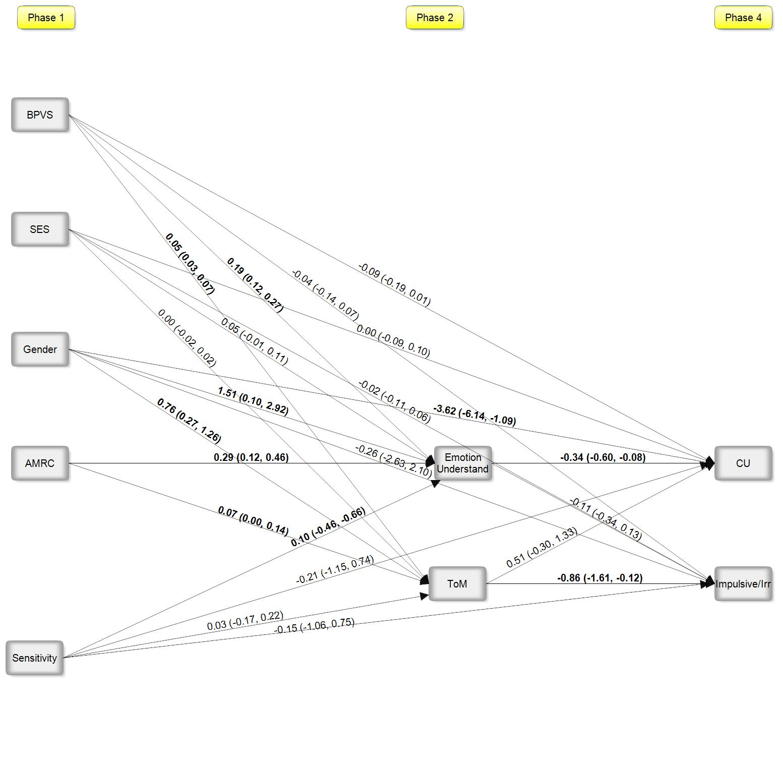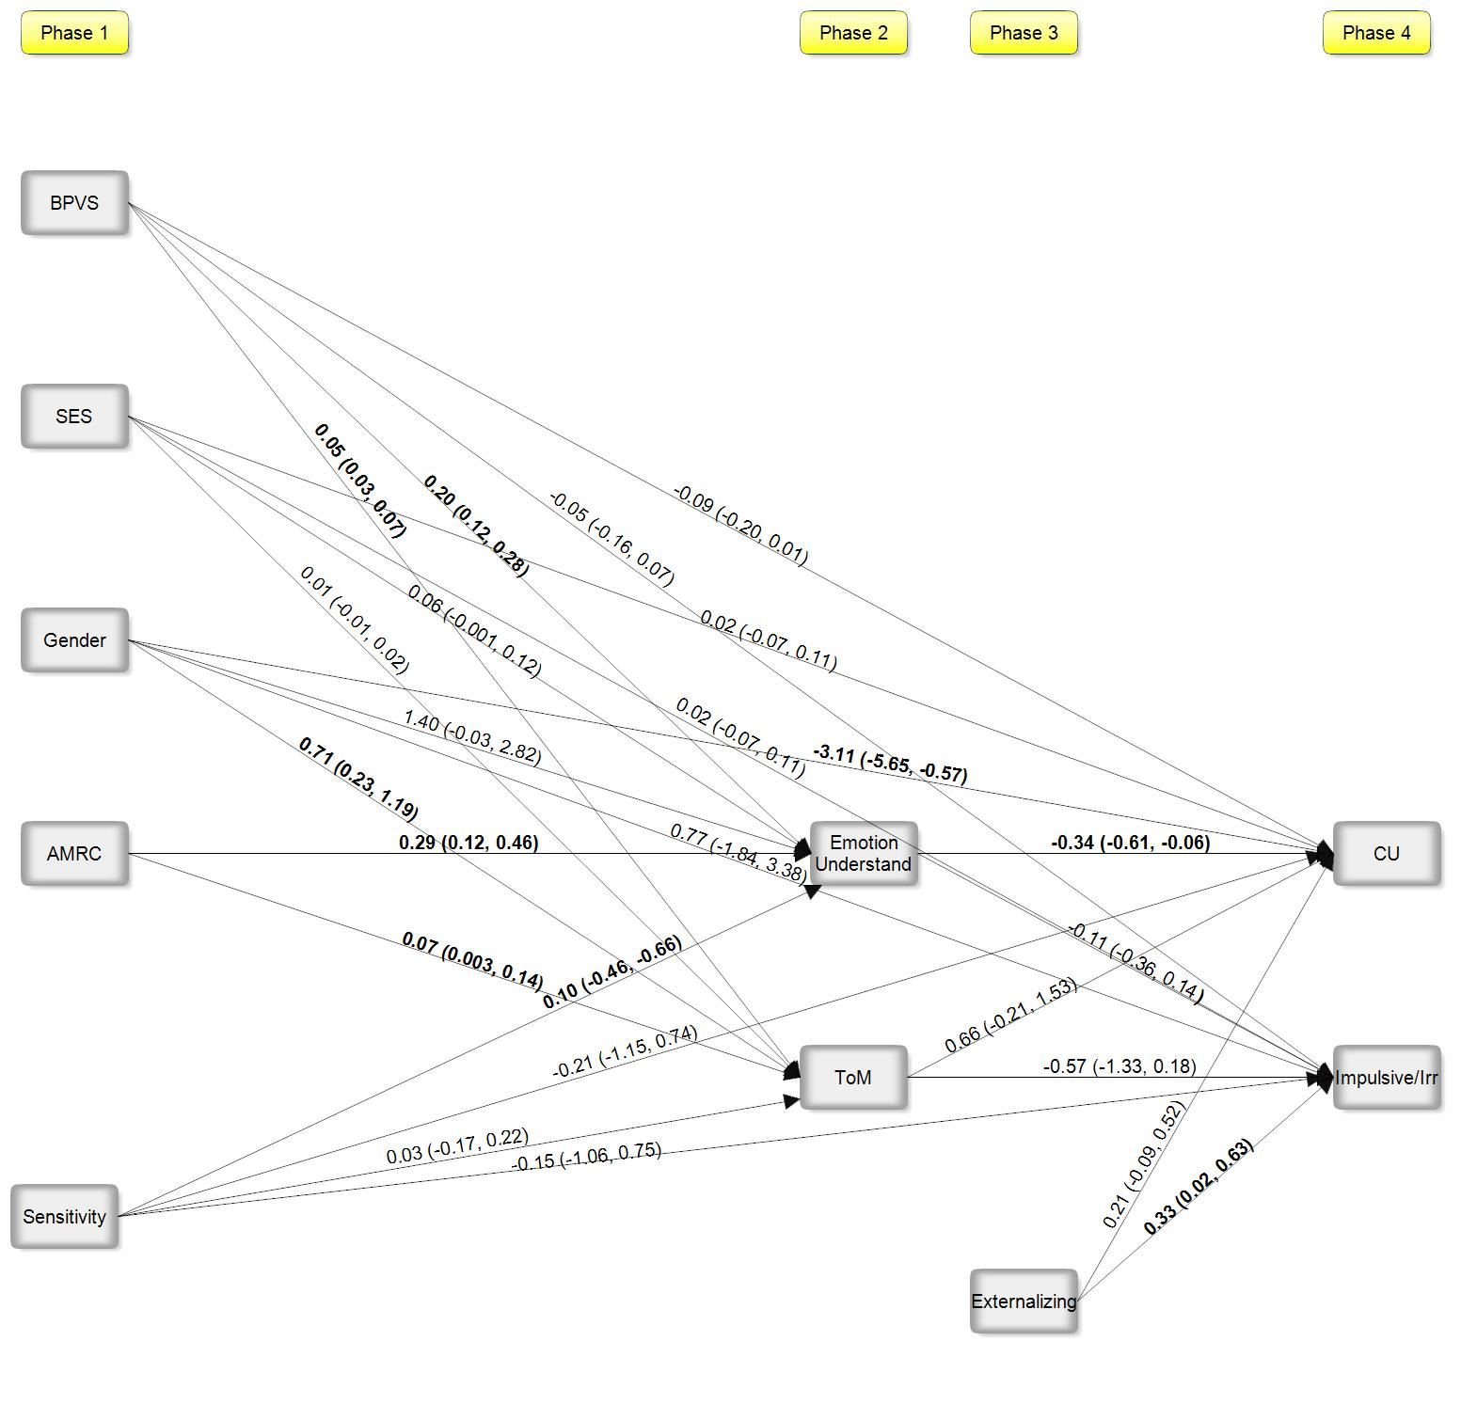
Figure 1. Path Analysis Predicting CU traits and impulsive/irresponsible traits at age 10 years of age.

Note: Bold significant based on absence of zero in the bootstrapped confidence intervals; Gender (0=male; 1=female); CU=Callous-unemotional traits; ToM=Theory of mind; AMRC=Appropriate mind-related comments; BPVS=British Picture Vocabulary Scale; SES=Socio-economic status. Indirect effect: AMRC->Emotional Understand->CU: estimate= -0.10, 95% CI: -0.19, -0.004; AMRC->ToM->Impulsive/Irresponsible: estimate= -0.06, 95% CI: -0.14, 0.02; R² = 0.34*(Emotion understanding); 0.23* (ToM); 0.29* (CU); 0.17* (Impulsive/Irresponsible).

Figure 2. Path Analysis Predicting CU traits and impulsive/irresponsible traits at age 10 years of age, controlling for externalizing behavior.

Note: Bold significant based on absence of zero in the bootstrapped confidence intervals; Gender (0=male; 1=female); CU=Callous-unemotional traits; ToM=Theory of mind; AMRC=Appropriate mind-related comments; BPVS=British Picture Vocabulary Scale; SES=Socio-economic status. Indirect effect: AMRC->Emotional Understand->CU: estimate= -0.10, 95% CI: -0.19, -0.001; R² =0.36*(Emotion understanding); 0.24* (ToM); 0.29* (CU); 0.15* (Impulsive/Irresponsible).

