Assessment of the water supply:demand ratios in a Mediterranean basin under different global change scenarios and mitigation alternatives

Laurie Boithias^{a,}*, Vicenç Acuñaª, Laura Vergoñósª, Guy Ziv^{b}, Rafael Marcéª, Sergi Sabater^{a,c}

ª Catalan Institute for Water Research, Emili Grahit 101, Scientific and Technological Park of the University of Girona, 17003 Girona, Spain
^{b} The Natural Capital Project, Woods Institute for the Environment, 371 Serra Mall, Stanford University, Stanford, CA, 94305-5020, USA
^{c} Institute of Aquatic Ecology, University of Girona, 17071 Girona, Spain
* Corresponding author: L. Boithias, Catalan Institute for Water Research, Emili Grahit 101, Scientific and Technological Park of the University of Girona, 17003 Girona, Spain. Tel: +34 972 18 33 80; Fax: +34 972 18 32 48 (l.boithias@gmail.com).

Abstract
Spatial differences in the supply and demand of ecosystem services such as water provisioning often imply that the demand for ecosystem services cannot be fulfilled at the local scale, but it can be fulfilled at larger scales (regional, continental). Differences in the supply:demand (S:D) ratio for a given service result in different values, and these differences might be assessed with monetary or non-monetary metrics. Water scarcity occurs where and when water resources are not enough to meet all demands, and this affects equally the service of water provisioning and the ecosystem needs. In this study we assess the value of water in a Mediterranean basin under different global change (i.e. both climate and anthropogenic changes) and mitigation scenarios, with a non-monetary metric: the S:D ratio. We computed water balances across the Ebro basin (North-East Spain) with the spatially explicit InVEST model. We highlight the spatial and temporal mismatches existing across a single hydrological basin regarding water provisioning and its consumption, considering or not, the environmental demand (environmental flow). The study shows that water scarcity is commonly a local issue (sub-basin to region), but that all demands are met at the largest considered spatial scale (basin). This was not the case in the worst-case scenario (increasing demands and decreasing supply), as the S:D ratio at the basin scale was near 1, indicating that serious problems of water scarcity might occur in the near future even at the basin scale. The analysis of possible mitigation scenarios reveals that the impact of global change may be counteracted by the decrease of irrigated areas. Furthermore, the comparison between a non-monetary (S:D ratio) and a monetary (water price) valuation metrics reveals that the S:D ratio provides similar values and might be therefore used as a spatially explicit metric to valuate the ecosystem service water provisioning.

Key words
Supply:demand ratio; Ecosystem service assessment; Water scarcity; Water pricing; Climate change mitigation; Ebro basin.

Introduction
Among all provisioning ecosystem services, supply of clean water has the highest value (Costanza et al., 1997). Its value is even higher in situations of water scarcity, that is where and when there is not enough water resources to meet all demands, including those needed for ecosystems to function effectively (Brisbane Declaration, 2007; Meijer et al., 2012; Rolls et al., 2012). Unlike drought, which describes a natural hazard due to climate variability, water scarcity is typically a management issue related to the long-term unsustainable use of water resources, i.e. more water is being used than that structurally available (Barceló and Sabater, 2010; Van Loon et al., 2012). Water scarcity is common in semi-arid regions, such as the Mediterranean (López-Moreno et al., 2010), but it also occurs in other temperate regions when resources are over-committed (Stahl et al., 2010). Overall, water scarcity depends on both water availability and consumption (supply and demand), and is a fundamental economic problem of having humans with unlimited wants in a world of limited resources (Fisher et al., 2009; Paetzold et al., 2010; Syrbe and Walz, 2012; TEEB, 2010). Supply and demand are defined in this study according to Burkhard et al. (2012): the supply of ecosystem services refers to the capacity of a particular area to provide a specific bundle of ecosystem goods and services within a given time period that is available for human enjoyment; the demand for ecosystem services is the sum of all ecosystem goods and services currently consumed or used in a particular area over the same time period.
As human population densities increase, there is often a spatial mismatch between the places where humans use services derived from ecosystems and the locations of the ecosystems that produce these services (Brauman et al., 2007; Kroll et al., 2012). This spatial mismatch between service production and the enjoyment of its benefit is a common feature within ecosystem services assessment (Fisher et al., 2009; Hein et al., 2006; Verburg et al., 2012; Willaarts et al., 2012). Furthermore, spatial differences in the supply and demand of services may imply that the demand for ecosystem services cannot be fulfilled at the spatial scale at which management decisions take place (Hein et al., 2006).
The balance between water supply and demand therefore needs to be defined in space and time, as the results might differ depending on the considered spatial and temporal extensions (Syrbe and Walz, 2012). For example, water scarcity might be identified at the seasonal scale when demand is much higher than supplied or stored water, but not at the annual scale, as wetter seasons might counteract dry seasons (Wada et al., 2011) or reservoirs may recover their water reserves. The same applies for space, as the balance between supply and demand might change considerably depending on the considered area in a heterogeneous basin. These changes in space and time can be expressed by the supply:demand (S:D) ratio. This metric summarizes the balance between the maximal potential service provisioning of the ecosystem service with the actual use of the service (Vörösmarty et al., 2000) within a particular time period. Thus, S:D ratios above unity imply that not all the provisioned water is used, while ratios below unity imply that not all the demand can be satisfied. Therefore, the S:D ratio can also be used as a water scarcity index.
At large scale, the water supply mainly depends on climatic factors that cannot be influenced by management, whereas the role of management and policies are important on the demand side (Curran and de Sherbinin, 2004). Freshwater policies are mainly focused on decreasing the demand by improving efficient water use, adjusting land-uses to water availability, or setting water pricing. In Europe, the Water Framework Directive (WFD) (EC, 2000) calls for the full recovery of costs, including environmental and resource costs, in accordance with the “polluter pays principle”, as one of the tools of an adequate and sustainable water resource management system at a river basin level. The actual price of water in a given area, when not subsidised, would be based on the law of supply and demand following market valuation rules (McDonald, 2009; Sagoff, 2011; Sutton and Costanza, 2002). However, water provisioning, just like most ecosystem services, is traditionally public goods. The price of its consumption is regulated, and includes the costs to build and maintain infrastructures that store and divert water to meet different human activities demand in various times and places (Quiroga et al., 2011).
Monetary valuation of ecosystem services, in particular water supply, can be a powerful tool for assessment and policy-making because it provides a common metric with which to make comparisons (Brauman et al., 2007; Everard, 2004; TEEB, 2010). Among the first examples of such efforts is the global monetary valuation done by Costanza et al. (1997) for a wide range of ecosystem services. However, this exercise was shown to be complex and not always efficient (Moran and Dann, 2008; Spangenberg and Settele, 2010; TEEB, 2010). The uncertainty in monetary valuation of many ecosystem services at the landscape scale stresses the need for a non-monetary valuation of ecosystem services in biophysical service units (e.g. cubic meters of water per year) (e.g. Burkhard et al., 2009; Kroll et al., 2012). Although biophysical service units are often unsuited for comparison between services and for trade-off assessment (De Groot et al., 2010), the relative indices, such as the S:D ratio have been widely used to value goods, as well as ecosystem services.
Global change, namely climate change and anthropogenic changes (Pronk, 2002), is expected to have dramatic impacts on global water availability for human uses (Foley et al., 2005). By 2030, half of the European river basins are expected to be affected by water scarcity (EC, 2012). The Mediterranean basin is one of the most vulnerable regions to climate change (Calbó, 2010; Schröter et al., 2005), and several studies have shown that it is already facing the impacts of climate change on water yields (García-Ruiz et al., 2011; López-Moreno et al., 2010; Ludwig et al., 2011). In the Iberian Peninsula, demand for water in different watersheds range between 55% and 224% of water supply (Sabater et al., 2009). Climate change scenarios in that area predict extended droughts (García-Ruiz et al., 2011; Lehner et al., 2006; López-Moreno et al., 2010), that likely will impact ecosystem services such as water provisioning for agriculture, industry or human consumption (Burkhard et al., 2012; De Groot et al., 2010; TEEB, 2010). In the meanwhile, economic growth, and subsequent urbanisation, industrialisation and agriculture intensification, can substantially increase water demand (Farley et al., 2005; Gallart and Llorens, 2004), even outweighing the effects of climate change (Buytaert and De Bièvre, 2012; Vörösmarty et al., 2000).
To date, few approaches exist that deal with the spatial and temporal dependencies between ecosystem service and demand (Seppelt et al., 2011). In our multi-scale approach, we use a non-monetary metric, namely the supply:demand (S:D) ratio, to estimate the value of the service water provisioning. We applied the InVEST (Integrated Valuation of Ecosystem Services and Tradeoffs - Tallis et al., 2011) annual water yield model to the Ebro river basin. Our objectives were to (1) characterize the effect of the considered spatial scale on water scarcity, and define the scale at which water scarcity could be more pronounced; (2) assess the sensitivity of water supply to climate extremes; (3) assess the effect of mitigation land use policies by changing the extension of irrigated agriculture on water scarcity; (4) assess the relationship between the S:D ratio values and the current water prices.

Material and methods

Study area
The Ebro River basin has a drainage size of 85,362 km². It is situated mostly in North-Eastern Spain (98.9% of the basin area), and partially in southern areas of France and Andorra (1.1% of the basin area). Altitude ranges between 0 m along the Mediterranean coast to 3,404 m in the Pyrenees (Fig. 1). The climate is Mediterranean with continental characteristics in most of the catchment, which becomes semi-arid in the center of the valley (CHE, 2011). The western side (Pyrenees and Iberian mountains) has an oceanic climate. Mean annual precipitation in the catchment is 622 mm (averaged 1920–2000) with high monthly and annual variability. The rainfall mostly occurs in spring and autumn. It is irregularly distributed in the catchment, ranging from 900 mm yr⁻¹ in the Atlantic headwaters to 500 mm yr⁻¹ in the southern Mediterranean zone (Fig. 2(a)). Extreme values of 3,000 mm yr⁻¹ in the Pyrenees and <100 mm yr⁻¹ in the central plain have been recorded (Sabater et al., 2009). In the most arid parts of the valley the water deficit is >900 mm (Cuadrat et al., 2007) regarding the evapotranspiration needs. Table 1 shows the average climate conditions in the Ebro basin (1991–2010), and values for wet (1994, 1995, 1998, 2001) and dry years (1996, 1997, 2003, 2008). Across the basin, climate change models predict that (1) precipitation will decrease in most of the territory (up to –20%) and irrigation demand increases (Iglesias et al., 2007), and that (2) temperature is projected to increase (+1.5ºC to +3.6ºC in the 2050s). The likelihood of droughts and the variability of precipitation – in time, space, and intensity – will increase and directly influence water resources availability (Quiroga et al., 2011).
Historical flow records at the Ebro River mouth show a decrease of nearly 40% in mean annual flow in the last 50 years, resulting from a decrease in precipitation, and an increase in water consumption for evapotranspiration (irrigation and afforestation) (Sabater et al., 2009). The mean annual discharge is 13,410 hm³ (Sabater et al., 2009). The environmental flow requirements, i.e. the ecological minimum flow, defined by the water authority (CHE, 2011), range from 3 hm³ yr⁻¹ at the Ebro source to about 3,000 hm³ yr⁻¹ at its delta. Dams store 8,360 hm³ of water, and pipes and channels divert 290 hm³ to adjacent basins (Nervión, Besaya, and Francolí) (CHE, 2011; MMA, 2000).
Water withdrawal for agricultural, domestic, industrial, hydroelectric and nuclear plants accounts for 50,000 hm³ yr⁻¹ (CHE, 2005). The water used for hydroelectricity amounts 38,000 hm³ yr⁻¹ and that for refrigeration of thermal and nuclear power plants is 3,100 hm³ yr⁻¹ (CHE, 2005). The total water demand for domestic uses is 506 hm³ yr⁻¹ and that for industry is 250 hm³ yr⁻¹. Agriculture, cattle breeding and aquaculture require 7,310 hm³ yr⁻¹ (Álvares and Samper, 2009). The non-irrigated agriculture in the Ebro basin represents 37% of the basin’s land use, whereas irrigated agriculture represents 15%. Forests represent 24% and shrublands and grasslands represent 23%. Urban and industrial areas together with water bodies represent about 2% (Corine Land Cover 2006, European Environmental Agency). In the Aragón region, which covers half the Ebro basin, irrigated areas were extended by 260% from 1978 to 2007 (Lasanta and Vicente-Serrano, 2012). Today, about 70% of the permitted irrigable area (9,000 km²) of the Ebro basin is indeed irrigated each year.

Modelling approach for water balance calculation
The supply and demand of ecosystem services assessed at the different spatial and temporal scales requires linking land cover information from remote sensing, land survey and GIS, with data from field monitoring and modeling (Burkhard et al., 2012). We used the distributed InVEST model version 2.2.1 (Tallis et al., 2011) to calculate spatially explicit water balances, to model and map the water provisioning ecosystem services across the landscape, and to elucidate general patterns and changes in ecosystem services caused by changes in climate and land cover at the basin scale. InVEST runs on an annual basis and is intended for a relatively quick assessment of services across the landscape (Vigerstol and Aukema, 2011).

Model background
In InVEST, the annual water yield Y per pixel is calculated according to:
$$Y=\left(1-\frac{AET}{P}\right)∙P$$ | (1)
where AET is the annual evapotranspiration in the pixel with given Land Use / Land Cover (LULC), and P is the annual precipitation on that pixel. The evapotranspiration partition of the water balance $AET/P$ is an approximation of the Budyko curve developed by Zhang et al. (2001):
$$\frac{AET}{P}= \frac{1+ω∙R}{1+ ω∙R+\frac{1}{R}}$$ | (2)
where R is the dimensionless Budyko dryness index per pixel with given LULC, and ω is a modified dimensionless ratio of plant accessible water storage to expected precipitation during the year. The Budyko index R denotes pixels that are potentially arid when R values are greater than one (Budyko, 1974). The index is defined as follows:
$$R= \frac{k∙{ET}_{0}}{P}$$ | (3)
where ET₀ is the reference evapotranspiration per pixel, and k is the plant evapotranspiration coefficient for LULC on the pixel.
The ω ratio is a non-physical parameter to characterize the natural climatic-soil properties, and is defined as follows:
$$ω= Z∙\frac{AWC}{P}$$ | (4)
where AWC is the volumetric (mm) water content available for the plant. The soil texture, effective soil depth and root depth define AWC. The factor Z presents the seasonal rainfall distribution and rainfall depths. In areas of winter rains, Z is expected to be ca. 10, while in humid areas with rain events distributed throughout the year or regions with summer rains, Z is on the order of 1.
In the model, the water balance is completed by subtracting the consumptive use of domestic, industrial and agricultural activities to the water yield. InVEST defines these consumptive use water demand (WD) for each LULC class.

Model inputs
InVEST requires 7 input maps: categorical LULC, precipitation, reference evapotranspiration (ET₀), Plant Water Availability (PWA), soil depth, Digital Elevation Model (DEM), and sub-basins definition. LULC map was based on the Corine Land Cover 2006 and classified 7 classes as: urban, industrial, agriculture with irrigation, agriculture without irrigation, forest, grassland (including shrubland), and water bodies (Fig. 2(b)). Climate data were given by the Spanish Meteorological Agency (AEMET) and by the Spanish Ministry of Public Works (MF, 2009). The annual average data of 197 meteorological stations were used for precipitation interpolation (Fig. 2(a)), whereas 26 stations were used for radiation interpolation (map not shown). Both were used for the calculation of ET₀ with Penman-Monteith equation. The PWA map was obtained after processing soil data from the National Institute for Agronomic Research (INIA, 2008) with SPAW (Saxton and Willey, 2005). Soil depth was based on data of the European Soil Database (2006). The Digital Elevation Model (DEM) was available from the Spanish Ministry of Agriculture, Fishing and Food (2003) at a 77x77 m resolution, and resampled at a 200x200 m resolution due to computing constraints (Fig. 1). Sub-basins were defined based on the WFD water bodies design. Thus, the original water bodies designed by the water authorities as those to implement the WFD were further sub-divided into smaller sub-basins using the DEM, to identify tributary junctions. As a result, 1,755 sub-basins were defined, with surface areas ranging from 0.04 to 463 km², with an average of 49 ± 48 km².
Special attention was paid in building precipitation and evapotranspiration input maps, as those parameters have been described to play a fundamental role in the model outcomes. In fact, a previous study by Sánchez-Canales at al. (2012) concluded that the effect of the Z parameter on the model response was negligible respect to P and ET₀ in the Mediterranean Llobregat basin case-study.

Model calibration
Simulated annual average water yield was compared to observed annual average water yield in 17 gauging stations (Fig. 1) of the Ebro basin. Available water discharge data at the 17 gauging stations were measured daily from 1991 to 2010 by the CHE. Daily discharge data were then calculated as volume per surface unit per year. Simulated water yield at each gauging station was calculated as the sum of the annual water yield of all the upstream sub-basins. Parameters were manually changed for output optimization within a ±10% interval around the default or literature related data (Table 2): the evapotranspiration coefficient (k), the seasonality factor (Z) and the consumptive use water demand (WD) for urban, industrial, and irrigated agriculture LULC classes. The variation of the latter was therefore within the range estimated by the CHE (2011) and the MMA (2000), accounting respectively for 8,185 hm³ yr⁻¹ and 10,378 hm³ yr⁻¹. Determination coefficient R² was calculated at each step of calibration, comparing the water yield on the 17 gauging stations with the simulation points.

Water scarcity and management scale

Quantification of water supply
We defined water supply (S) as the available water for human use. It is the difference between water supply by precipitation (S_{PCP}), water used by pristine vegetation for evapotranspiration (ET_{pristine}), and water needs for fluvial ecosystems, i.e. environmental flow (EF) requirements or environmental demand (CHE, 2011; Meijer et al., 2012):
$$S=S_{PCP}-{ET}_{pristine}- EF$$ | (5)
Therefore, once the water yield was calibrated for actual LULC, the model was run replacing both irrigated and non-irrigated cultivated areas by pristine vegetation such as grassland and shrubland (TEEB, 2010), and this was made by replacing the evapotranspiration coefficient k and root depth. The determination coefficient R² of the water supply against precipitation was calculated at sub-basin scale.

Quantification of water demand
We estimated the water demand (D) as the anthropogenic demand, i.e. the human demand of water for agriculture, urban (i.e. domestic use) and industrial uses (respectively D_{agr}, D_{urb} and D_{ind}):
$${D=D}_{agr}+D_{urb}+D_{ind}$$ | (6)
Human water demand for agriculture is the water required by irrigated and non-irrigated crops compared to pristine vegetation. The total agricultural water demand (D_{agr}) of the two was calculated for each sub-basin as the difference between the water yield when cultivated areas were replaced by grassland areas and water yield with actual crop growing (see details in previous section). D_{agr} therefore included consumptive water use for irrigation. Calibration range of consumptive uses for agricultural, industrial and domestic uses are given in Table 2. The determination coefficient R² of the water demand against the LULC area percentage in each sub-basin was calculated.

Calculation of the S:D ratio
The S:D ratio was calculated for each sub-basin, irrigation community, province and region, as a metric of water scarcity. The S:D was calculated both with and without considering the environmental flow in the supply part. The determination coefficient R² of the water supply against the water demand was calculated at sub-basin scale.

Spatial aggregation
To evaluate the spatial dependencies of supply and demand, outputs at sub-basins scale were merged at four observational scales: irrigation communities, administrative provinces, regions and basin. The S:D ratio was analysed for each aggregation, following the hierarchical approach suggested by Lautenbach et al. (2012). The determination coefficient R² of the S:D ratio against the LULC area percentage was calculated from sub-basin to region scale.

Water scarcity and climate extremes
The sensitivity of water scarcity to precipitation changes was assessed to evaluate the vulnerability of the basin to climate extremes, i.e. the temporal dependencies of supply and demand. The water supply (S) was calculated for three cases of inter-annual average precipitation: 1991–2010, wettest years (1994, 1995, 1998 and 2001) and driest years (1996, 1997, 2003 and 2008 (Table 1 and Fig. 2(a)). Extreme precipitation values for driest years were in the range of possible precipitation predictions under climate change in the Ebro area within a 50-year time frame (Iglesias et al., 2007; Milly et al., 2005). ET₀ maps were built for the corresponding cases of climate extremes. For each precipitation case, the S:D ratio was calculated. We assumed that no change in the consumptive use of water demand for urban, industrial and irrigated agriculture occurred.

Water scarcity and management changes
The sensitivity of water scarcity to LULC changes was assessed to evaluate the impact of possible management options. A 20% increase of irrigated area is predicted within 20 years in the foreseen conditions of agricultural and population patterns (EC, 2003). Therefore, the water demand (D) was calculated for three scenarios of LULC: actual, +20% of irrigated areas, and –20% of irrigated areas (Fig. 2(b)), by adding or removing an adequate buffer around actual irrigated area polygons. For each LULC scenario, the S:D ratio was calculated.
Thus, 9 global change scenarios were obtained by crossing the 3 LULC scenarios to the 3 precipitation cases.

Water pricing for water scarcity
The relationship between the actual water price (defined at the province scale for industrial and household uses) and the S:D ratio for the province aggregation scales (with and without consideration of environmental flow), was estimated for actual irrigated area and by using the average 1991–2010 interannual precipitation conditions (hereafter, the “reference scenario”). The prices include both drinking water and sanitation treatments, but no value added taxes (AEAS and AGA, 2011). The price of water ranges from 0.74 € m⁻³ in the Burgos province to 1.41 € m⁻³ in the provinces of Zaragoza, Teruel and Huesca. Reliable data were not available to assess the relationship with agricultural water prices.

Results

Model calibration
Table 2 shows the values of the calibrated parameters. Predictions range between 28 hm³ yr⁻¹ in Escanilla and 10,457 hm³ yr⁻¹ in Ascó. Respective observations range between 19 hm³ yr⁻¹ and 9,901 hm³ yr⁻¹. The relationship between predictions (y) and observation (x) was y = 1.11·x, with R² of 0.96 (P < 0.05, n = 17). The calibrated model slightly overestimates the water yield, as it does not take into account losses such as water evaporation from the channel, or water diversion to neighbour basins. Although the InVEST model describes the water balance through few simplified equations (Tallis et al., 2011), in which soil properties only rely on soil plant available water content, soil depth and root depth, the simulation of water yield is satisfactory. The total simulated water demand in the Ebro basin is 9,530 hm³ yr⁻¹, a figure that lies in between those estimated by the CHE (2011) and the MMA (2000). The predicted water supply at Ascó under the absence of human uses in the entire basin is 19,926 hm³ yr⁻¹. Finally, the water balance of the basin is 60% green water (water stored in the soil or temporarily on top of the soil or vegetation, available for evapotranspiration) and 40% blue water (fresh surface and groundwater), similar to other Mediterranean basins (Dumont et al., 2012; Willaarts et al., 2012) and global averages (Schiermeier, 2008).

Water scarcity and management scale

Quantification of water supply
The water supply in the model varies with precipitation and land cover type (through the evapotranspiration coefficient). It also varies depending on ET₀ and soil characteristics, producing annual supply values ranging from 200 to 14,011 m³ ha⁻¹ (Fig. 3(a)), with an average of 2,657 m³ ha⁻¹. Water supply is higher in mountainous areas, especially in the Pyrenees. It is lower in the semi-arid central part of the basin. Precipitation and water supply are highly related (R² = 0.78, n = 1,755). Considering the environmental flow, annual water supply values ranges from 0 to 13,540 m³ ha⁻¹, with an average of 2,033 m³ ha⁻¹ (Fig. 3(a)). The determination coefficient between precipitation and supply is high (R² = 0.69, n = 1,755).

Quantification of water demand
Water demand for agricultural, industrial and domestic uses in the Ebro basin ranges between 0 and 13,295 m³ ha⁻¹, with an average of 1,424 m³ ha⁻¹ (Fig. 3(b)). The water demand is the lowest in the mountainous areas, especially at the Pyrenees. The highest demand is in the semi-arid central part of the basin, where irrigated agriculture concentrates. Water demand and the percentage of the sub-basin area used for irrigated agriculture are highly related (R² = 0.82, n = 1,755).

Calculation of the S:D ratio
At the sub-basin scale the supply is negatively correlated to the demand (R² = 0.12, lowering to 0.10 when not including the environmental flow in the supply). At the scale of irrigation community, province and region, the supply becomes positively correlated to the demand, and the respective R² rise to 0.52 (n = 18), 0.60 (n = 19) and 0.91 (n = 11). Considering the environmental flow requirements, the respective R² are 0.41 (n = 18), 0.54 (n = 19) and 0.86 (n = 11). Values of the S:D ratio across the Ebro basin for the different scenarios are illustrated in Fig. 4 and Fig. 5. In the reference scenario, the supply (without consideration of environmental flow) does not meet the annual water demand in 590 sub-basins out of 1,755 (736 considering environmental flow), mostly in the areas of irrigated agriculture.

Spatial aggregation
Aggregating the sub-basins to larger spatial scales smoothes the S:D ratio values differences between spatial entities (Fig. 4). At the regional scale, all the area has an S:D ratio above 1 in the reference scenario (with and without consideration of environmental flow).
The S:D ratio for every spatial entity in the reference scenario was driven by the percentage of area covered by irrigated agriculture, both at the scales of the irrigation community (R² = 0.38, n = 18) and of the region (R² = 0.52, n = 11). The S:D ratio was driven by the percentage of area covered by forest (R² = 0.61, n = 19) at the province scale. Rates and drivers are similar considering environmental flow. The S:D ratio at basin scale is over 1 for the reference scenario (Table 3), with and without environmental flow, and despite the rate of areas with S:D ratios below 1 at smaller spatial scales.

Water scarcity and climate extremes
Water supply rises with precipitation (Fig. 2(a) and Fig. 3(a)). The water supply across the basin during the wettest years is about 57% higher than the 1991–2010 average (precipitations = +23%), whereas it is about 22% less during the driest years (precipitations = –17%). When considering the environmental flow, water supply from the 1991–2010 precipitation average is 23% less than the reference scenario. During the wettest years, the water supply across the basin is about 33% higher than the reference scenario, whereas it is about 43% less during the driest years. The Fig. 4 shows the S:D ratio in the three precipitation cases. During the wettest years, sub-basins with S:D ratio below 1 were 430 out of 1,755, whereas they were 754 during the driest years. Including the environmental flow, sub-basins with S:D ratio below 1 were 516 during the wettest years, whereas they increased up to 957 during the driest years. Despite the many areas of S:D ratio below 1 at smaller scale, the S:D ratio at the basin scale is over 1 with and without consideration of environmental flow during the driest years, and for actual LULC (Table 3).

Water scarcity and management changes
Land use change scenarios show that increasing the irrigated area also raises the demand (Fig. 3 (b)). For the –20% scenario, the water demand across the basin is ca. 17% lower than for actual irrigated area, whereas it is 16% higher for the +20% scenario. The precipitation case in the dry extreme (Fig. 5) shows that for the –20% of irrigated surface area scenario, sub-basins with S:D ratio below 1 were 722 out of 1,755, whereas they increased to 788 for the +20% scenario. Considering the environmental flow, sub-basins with S:D ratio below 1 were 942 for the –20% scenario, whereas they were 985 for the +20% scenario. Despite the many areas of S:D ratio below 1 at smaller scale, the S:D ratio at the basin scale is over 1 for each scenario of LULC, with or without considering environmental flows, even in the driest conditions (Table 3).

Water pricing for water scarcity
Results show that the water price and the S:D ratio are significantly correlated regardless of the consideration or not of the environmental flows (R² = 0.23 and 0.28 respectively, P < 0.05, n = 15) (Fig. 6), meaning that the price decreases when the S:D ratio increases.

Discussion
This study brings together objective insights of possible trends regarding the particular ecosystem service of water supply with its demand. Even though some proxies (e.g. 20-year annual precipitation average without consideration of the actual land use changes done across the basin) have been used, the mapping of the ecosystem service supply and demand allow applying the ecosystem service approach in science as well as in practice (Burkhard et al., 2012).

Water scarcity as a management issue
The study shows areas where water is in excess together with areas where water is in deficit considering the water demand. This highlights the existence of spatial mismatches in ecosystem service provisioning and its demand across a single hydrological basin. This is a rather common feature for ecosystem service assessment, as is shown by Burkhard et al. (2012) for energy supply and demand in the rural-urban region of Leipzig-Halle. The analysis of the different spatial scales highlights that the larger the spatial scale considered to calculate the S:D ratio, more easily approachable can be the problems caused by water scarcity. Water scarcity was only an issue at the province or region levels, but not at the basin level, the current level of management in the Ebro basin.
The vulnerability to climate change of areas where water is in deficit is highlighted by the sensitivity of the S:D ratio (i.e. water scarcity) to climate extremes in those areas. Dry years implied an overall decrease of the S:D ratio from 1.61 to 1.18, whereas wet years implied an increase to 2.78. The driest year case indicates the potential S:D ratio across the Ebro basin in the most likely scenario of climate change, that is that precipitation would decrease within a 50-year time frame (Iglesias et al., 2007). Vulnerability of southern Europe basins to water scarcity has been thoroughly described (Bangash et al., 2013; Marquès et al., 2013; Schröter et al., 2005; Terrado et al., 2013; Weiß and Alcamo, 2011). Our approach does not consider the existence of lower time scales, e.g. monthly changes, that can be significant both with respect to supply (seasonal variations of precipitations) as well as to demand (e.g. irrigation period, summer or winter tourism) (Wada et al., 2011). This can be highly relevant in Mediterranean rivers (Sabater et al., 2009), but in the Ebro basin seasonal water scarcity is mostly regulated by dams and water demand is mostly fulfilled at the annual scale. However, in the case of long-lasting droughts, extending for several years, water storage and transfer infrastructures can appear inadequate to meet the demand without consumption restrictions.
At the annual scale, the effect of a change of precipitation can be compensated by a change in land use. Among water scarcity mitigation measures (Falloon and Betts, 2010; Pfister et al., 2011), the reduction of the irrigated areas at the basin scale (or its shift to crops not requiring irrigation) can be an appropriate measure to counteract the impact of dry conditions (similar to that predicted from climate change). Specifically, in order to preserve similar S:D values as the current ones (1.43), the irrigated area should decrease at least 20% to compensate a 17% precipitation decrease. A conservative increase of the irrigated area of 20% (compared to the predicted increase of up 60% within 20 years (EC, 2003)) is more likely to happen than such a decrease across the Ebro basin. This prevision could be according to the given social-economic demand for irrigated agriculture products (mostly alfalfa (1,173 hm³), corn (871 hm³) and rice (693 hm³) (CHE, 2011)). The most likely scenario (precipitation decrease and irrigation area increase) resulted in a S:D ratio near 1 basin-wide (Table 3). Overall, studies considering both demand and supply seem to be necessary to properly forecast challenges faced by water managers in the near future. Envisioned management actions include the consideration of the S:D as a tool to determine water price, as we discuss below.

The S:D ratio as a management tool for a sustainable use of water
The S:D ratio meets two of the recommendations published by TEEB (2010) for ecosystem assessment: (1) using the ratio allows to determine the service delivery in non-monetary terms, and (2) the ratio is spatially explicit, thus allowing to take into account the spatial heterogeneity of the service flow and of the economic value that can be assigned to them. The value of the S:D ratio actually depends on the considered spatial scale.
Ecosystem service monetary valuation assigns a monetary value to an ecosystem based on the supply of market and non-market ecosystem services, and this is done by identifying the total cost of the service using a readily comparable metric (Costanza et al., 1997; Jenerette et al., 2006). We linked the S:D ratio to the price of water in order to draw an outline of a monetary valuation of the S:D ratio. The price of water is inversely correlated to the S:D ratio, meaning that the price of water actually reflects the balance between the supply and the demand, in spite of an 11% bias due to deductions commanded by the various administrative levels involved in the water provisioning (MMA, 2000). As the S:D ratio, the monetary value of the water provisioning service depends on the considered spatial scale. Therefore, although the spatial and temporal dependencies of water supply and demand are only slightly reflected in actual water price, the trend of the relationship showed that the S:D ratio was a relevant proxy for the full recovery of costs evaluation. In this very first attempt to compare two water provisioning valuation metrics, it appears that the S:D ratio is valuable to be implemented in the price elaboration, at least for industrial and domestic water uses. That way, it better reflects the spatial and temporal scale dependencies, as asked by the WFD. In comparison, the price of water for the full recovery of costs in Spain, as it has been demanded by the WFD, was estimated at 1.43 € m⁻³ (MT Brown et al., 2010) which is in the range of current prices in the Ebro.
The spatially explicit S:D ratio concept could also be implemented for the same purpose in spatially explicit models, such as InVEST, which assumes linear transformations from biophysical to monetary values, ignoring therefore the effect of market fluctuations in terms of production and consumption (S:D) of services. For instance, water supply might experience large fluctuations in space (throughout a basin such the Ebro) and time (along the year or over a decade), therefore determining large differences in the S:D ratio and on its value. The use of the S:D ratio would allow a better valuation of the service water provisioning in such models because of the consideration of the non-linearity caused by the variation of supply and demand over space.
The way ecosystem services are valued affects how a resource is managed over time and thereby affect the stock of that ecosystem resource at any point in time (Brauman et al., 2007; Garmendia et al., 2012). Each sector or organisation is likely to use water in a number of different ways and valuation methods may differ in the type of water use that they value (Moran and Dann, 2008). The S:D ratio is a non-monetary metric that may be applied to several further ecosystem services, thus allowing standardized objective comparisons between ecosystem services, consequently allowing trade-off assessments. Trade-off assessment is essential to provide optimal information to stakeholders (LE Brown et al., 2010; Lautenbach et al., 2012; Lautenbach et al., 2013). In the case of basins where agriculture is the main water user, such as the Ebro basin, it becomes relevant to assess the value of irrigated crop production compared to the value of environmental flow-dependent in-stream ecosystem services. It also becomes relevant to assess the benefit of supplying water to users without consideration of the environmental flow compared to the benefits supplied by other fluvial environmental flow-dependent ecosystem services (Sabater and Tockner, 2010) such as fish production (Rolls et al., 2012; Whittaker, 2005), contaminant dilution (López-Serna et al., 2012) or chemical degradation (Boithias et al., 2011; López-Serna et al., 2012). Water security (Vörösmarty et al., 2010), or the supply of enough water of satisfying quality for the various uses, is actually essential, even more when threatened by global change.

Conclusions
We used the S:D ratio to valuate the ecosystem service of water provisioning, at any point of a Mediterranean river basin and considering different spatial aggregation scales. This study shows that spatial management at larger scales minimize water scarcity local issues. Furthermore, the impact of global change on water scarcity may be counteracted by the decrease of irrigated areas. Worst case scenario of precipitation decrease and irrigation increase resulted in supply:demand (S:D) ratio near 1, indicating that water resource management problems could occur in the near future. The comparison between the S:D ratio and the actual water market prices showed that (1) the value of both the ratio and the water price were depending on the considered spatial scale, and that (2) the ratio was a suitable, spatially explicit, proxy to assess the water price. This approach might therefore help managers to estimate the price of water to assess the full recovery of water provisioning costs, as stated by the Water Framework Directive. The S:D ratio used in this study for water supply can be implemented for the valuation of further ecosystem services, thus allowing to assess trade-offs occurring between ecosystem services.

Acknowledgments
This project was funded by the Spanish Ministry of Science and Innovation through the SCARCE project (Consolider-Ingenio 2010 CSD2009-00065), and by a Marie Curie European Reintegration Grant (PERG07-GA-2010-259219) within the 7th European Community Framework Programme.

References
AEAS, AGA. Tarifas 2010: Precio de los servicios de abastecimiento y saneamiento. Encuesta de tarifa de la Asociación Española de Abastecimientos de Agua y Saneamiento, y de la Asociación Española de Empresas Gestoras de los Servicios de Agua a Poblaciones. 2011.
Álvares D, Samper J. Evaluación de los recursos hídricos de la cuenca hidrográfica del Ebro mediante modelización semi-distribuída con GIS-BALAN. Estudios en la Zona no Saturada del Suelo 2009;Vol IX:8.
Bangash RF, Passuello A, Sanchez-Canales M, Terrado M, López A, Elorza FJ, et al. Ecosystem services in Mediterranean river basin: Climate change impact on water provisioning and erosion control. Sci Total Environ 2013;458-460:246–55.
Barceló D, Sabater S. Water quality and assessment under scarcity: Prospects and challenges in Mediterranean watersheds. J Hydrol 2010;383:1–4.
Boithias L, Sauvage S, Taghavi L, Merlina G, Probst JL, Sánchez Pérez JM. Occurrence of metolachlor and trifluralin losses in the Save river agricultural catchment during floods. J Hazard Mater 2011;196:210–9.
Brauman KA, Daily GC, Duarte TK, Mooney HA. The Nature and Value of Ecosystem Services: An Overview Highlighting Hydrologic Services. Annual Review of Environment and Resources 2007;32:67–98.
Brisbane Declaration. Environmental flows are essential for freshwater ecosystem health and human well-being. 10th International River Symposium, Brisbane, Australia, 3–6 September 2007.
Brown LE, Mitchell G, Holden J, Folkard A, Wright N, Beharry-Borg N, et al. Priority water research questions as determined by UK practitioners and policy makers. Sci Total Environ 2010;409:256–66.
Brown MT, Martínez A, Uche J. Emergy analysis applied to the estimation of the recovery of costs for water services under the European Water Framework Directive. Ecol Model 2010;221:2123–32.
Budyko MI. Climate and Life. In: Van Mieghem J, Hales AL, editors. Volume 18. Academic Press New York and London; 1974.
Burkhard B, Kroll F, Müller F, Windhorst W. Landscapes’ Capacities to Provide Ecosystem Services – a Concept for Land-Cover Based Assessments. Landscape Online 2009;15:1–22.
Burkhard B, Kroll F, Nedkov S, Müller F. Mapping ecosystem service supply, demand and budgets. Ecol Ind 2012;21:17–29.
Buytaert W, De Bièvre B. Water for cities: The impact of climate change and demographic growth in the tropical Andes. Water Resour Res 2012;48:W08503.
Calbó J. Possible climate change scenarios with specific reference to Mediterranean regions. In: Sabater S, Barceló D, editors. Water Scarcity in the Mediterranean. The Handbook of Environmental Chemistry. Springer Verlag, Berlin, Germany; 2010. p. 1–13.
CHE. Confederación Hidrográfica del Ebro : Caracterización de la demarcación y registro de zonas protegidas. Implantación de la DMA. Ministerio de Medio Ambiente. 2005.
CHE. Propuesta de proyecto de plan hidrológico de la cuenca del Ebro. Memoria Versión 3.7. 2011.
Costanza R, d’Arge R, De Groot R, Farber S, Grasso M, Hannon B, et al. The value of the world’s ecosystem services and natural capital. Nature 1997;387:253–60.
Cuadrat JM, Saz MA, Vicente-Serrano SM. Atlas Climático de Aragón. Gobierno de Aragón. 2007.
Curran SR, de Sherbinin A. Completing the picture: the challenges of bringing “consumption” into the population–environment equation. Population Environ 2004;26:107–31.
Dumont A, Salmoral G, Llamas MR. The extended water footprint of the Guadalquivir basin. In: De Stefano L, Llamas MR, editors. Water, Agriculture and the Environment in Spain: can we square the circle? Taylor & Francis; 2012. p. 105–14.
EC. Directive 2000/60/EC of the European Parliament and of the Council of 23 October 2000 establishing a framework for Community action in the field of water policy. Off. J. Eur. Communities L327. 2000.
EC. Reunión Técnica para analizar ciertos aspectos de la proyectada transferencia del Ebro. 16 / 17 octubre 2003. Relación del presidente de la reunión. 2003.
EC. A Blueprint to Safeguard Europe’s Water Resources. European Commission. COM(2012) 673 final. 2012.
Everard M. Investing in sustainable catchments. Sci Total Environ 2004;324:1–24.
Falloon P, Betts R. Climate impacts on European agriculture and water management in the context of adaptation and mitigation–The importance of an integrated approach. Sci Total Environ 2010;408:5667–87.
Farley KA, Jobbágy EG, Jackson RB. Effects of afforestation on water yield: a global synthesis with implications for policy. Global Change Biol. 2005;11:1565–76.
Fisher B, Turner RK, Morling P. Defining and classifying ecosystem services for decision making. Ecol Econ 2009;68:643–53.
Foley JA, DeFries R, Asner GP, Barford C, Bonan G, Carpenter SR, et al. Global Consequences of Land Use. Science 2005;309:570–4.
Gallart F, Llorens P. Observations on land cover changes and water resources in the headwaters of the Ebro catchment, Iberian Peninsula. Phys Chem Earth 2004;29:769–73.
García-Ruiz JM, López-Moreno JI, Vicente-Serrano SM, Lasanta-Martínez T, Beguería S. Mediterranean water resources in a global change scenario. Earth Sci Rev 2011;105:121–39.
Garmendia E, Mariel P, Tamayo I, Aizpuru I, Zabaleta A. Assessing the effect of alternative land uses in the provision of water resources: Evidence and policy implications from southern Europe. Land Use Pol 2012;29:761–70.
De Groot RS, Alkemade R, Braat L, Hein L, Willemen L. Challenges in integrating the concept of ecosystem services and values in landscape planning, management and decision making. Ecol Complex 2010;7:260–72.
Hein L, van Koppen K, de Groot RS, van Ierland EC. Spatial scales, stakeholders and the valuation of ecosystem services. Ecol Econ 2006;57:209–28.
Iglesias A, Garrote L, Flores F, Moneo M. Challenges to Manage the Risk of Water Scarcity and Climate Change in the Mediterranean. Water Resour Manage 2007;21:775–88.
Jenerette GD, Marussich WA, Newell JP. Linking ecological footprints with ecosystem valuation in the provisioning of urban freshwater. Ecol Econ 2006;59:38–47.
Kroll F, Müller F, Haase D, Fohrer N. Rural–urban gradient analysis of ecosystem services supply and demand dynamics. Land Use Policy 2012;29:521–35.
Lasanta T, Vicente-Serrano SM. Complex land cover change processes in semiarid Mediterranean regions: An approach using Landsat images in northeast Spain. Remote Sensing Environ 2012;124:1–14.
Lautenbach S, Maes J, Kattwinkel M, Seppelt R, Strauch M, Scholz M, et al. Mapping water quality-related ecosystem services: concepts and applications for nitrogen retention and pesticide risk reduction. Int J Biodiversity Sci Ecosyst Services Manage 2012;8:35–49.
Lautenbach S, Volk M, Strauch M, Whittaker G, Seppelt R. Optimization-based trade-off analysis of biodiesel crop production for managing an agricultural catchment. Environ Model Soft. 2013;48:98–112.
Lehner B, Döll P, Alcamo J, Henrichs T, Kaspar F. Estimating the Impact of Global Change on Flood and Drought Risks in Europe: A Continental, Integrated Analysis. Climatic Change 2006;75:273–99.
Van Loon AF, Van Huijgevoort MHJ, Van Lanen HAJ. Evaluation of drought propagation in an ensemble mean of large-scale hydrological models. Hydrol Earth Syst Sci 2012;16:4057–78.
López-Moreno JI, Vicente-Serrano SM, Moran-Tejeda E, Zabalza J, Lorenzo-Lacruz J, García-Ruiz JM. Impact of climate evolution and land use changes on water yield in the Ebro basin. Hydrol Earth Syst Sci Discuss 2010;7:2651–81.
López-Serna R, Petrović M, Barceló D. Occurrence and distribution of multi-class pharmaceuticals and their active metabolites and transformation products in the Ebro River basin (NE Spain). Sci Total Environ 2012;440:280–9.
Ludwig R, Roson R, Zografos C, Kallis G. Towards an inter-disciplinary research agenda on climate change, water and security in Southern Europe and neighboring countries. Environ Sci Policy 2011;14:794–803.
Marquès M, Bangash RF, Kumar V, Sharp R, Schuhmacher M. The impact of climate change on water provision under a low flow regime: A case study of the ecosystems services in the Francoli river basin. J Hazard Mater 2013;In Press. http://dx.doi.org/10.1016/j.jhazmat.2013.07.049
McDonald RI. Ecosystem service demand and supply along the urban-to-rural gradient. J Conservation Planning 2009;5:1–14.
Meijer KS, Krogt WNM, Beek E. A New Approach to Incorporating Environmental Flow Requirements in Water Allocation Modeling. Water Resour Manage 2012;26:1271–86.
MF. Ministerio del Fomento : Código técnico de la edificación - Documento Básico HE, Ahorro de energía. 2009.
Milly PCD, Dunne KA, Vecchia AV. Global pattern of trends in streamflow and water availability in a changing climate. Nature 2005;438:347–50.
MMA. Libro Blanco del Agua (Año 2000). Ministerio de Medio Ambiente. Secretaría de Estado de Aguas y Costas. Dirección General de Obras Hidráulicas y Calidad de las Aguas. 2000.
Moran D, Dann S. The economic value of water use: Implications for implementing the Water Framework Directive in Scotland. J Environ Manage 2008;87:484–96.
Paetzold A, Warren PH, Maltby LL. A framework for assessing ecological quality based on ecosystem services. Ecol Complex 2010;7:273–81.
Pfister S, Bayer P, Koehler A, Hellweg S. Projected water consumption in future global agriculture: Scenarios and related impacts. Sci Total Environ 2011;409:4206–16.
Pronk J. The Amsterdam Declaration on Global Change. In: Steffen W, Jäger J. Carson DJ, Bradshaw C, editors. Challenges of a Changing Earth Proceedings of the Global Change Open Science Conference, Amsterdam, The Netherlands, 10–13 July 2001, Global Change - The IGBP Series.: 2002. p. 207–208.
Quiroga S, Garrote L, Iglesias A, Fernández-Haddad Z, Schlickenrieder J, de Lama B, et al. The economic value of drought information for water management under climate change: a case study in the Ebro basin. Nat Hazards Earth Syst Sci 2011;11:643–57.
Rolls RJ, Boulton AJ, Growns IO, Maxwell SE, Ryder DS, Westhorpe DP. Effects of an experimental environmental flow release on the diet of fish in a regulated coastal Australian river. Hydrobiologia 2012;686:195–212.
Sabater S, Feio MJ, Graca MAS, Munoz I, Romaní AM. The Iberian Rivers. In: Tockner K, Robinson Ch, Uhlinger U, editors. Rivers of Europe. Elsevier; 2009. p. 113–49.
Sabater S, Tockner K. Effects of hydrologic alterations on the ecological quality of river ecosystems. In: Sabater S, Barceló D, editors. Water Scarcity in the Mediterranean. The Handbook of Environmental Chemistry. Springer Verlag, Berlin, Germany; 2010. p. 15–39.
Sagoff M. The quantification and valuation of ecosystem services. Ecol Econ 2011;70:497–502.
Sánchez-Canales M, López Benito A, Passuello A, Terrado M, Ziv G, Acuña V, et al. Sensitivity analysis of ecosystem service valuation in a Mediterranean watershed. Sci Total Environ 2012;440:140–153.
Saxton KE, Willey PH. Chapter 17 - The SPAW model for agricultural field and pond hydrologic simulation. In: Frevert DK, Singh PV, editors. Mathematical Modeling of Watershed in Hydrology. CRC Press 2005; 2005. p. 401–35.
Schiermeier Q. Water: A long dry summer. Nature 2008;452:270.
Schröter D, Cramer W, Leemans R, Prentice IC, Araújo MB, Arnell NW, et al. Ecosystem Service Supply and Vulnerability to Global Change in Europe. Science 2005;310:1333–7.
Seppelt R, Dormann CF, Eppink FV, Lautenbach S, Schmidt S. A quantitative review of ecosystem service studies: approaches, shortcomings and the road ahead. J Appl Ecol 2011;48:630–6.
Spangenberg JH, Settele J. Precisely incorrect? Monetising the value of ecosystem services. Ecol Complex 2010;7:327–37.
Stahl K, Hisdal H, Hannaford J, Tallaksen L, Van Lanen H, Sauquet E, et al. Streamflow trends in Europe: evidence from a dataset of near-natural catchments. Hydrol Earth Syst Sci 2010;14:2367–82.
Sutton PC, Costanza R. Global estimates of market and non-market values derived from nighttime satellite imagery, land cover, and ecosystem service valuation. Ecol Econ 2002;41:509–27.
Syrbe R-U, Walz U. Spatial indicators for the assessment of ecosystem services: Providing, benefiting and connecting areas and landscape metrics. Ecol Ind 2012;21:80–8.
Tallis HT, Ricketts T, Guerry AD, Wood SA, Sharp R, Nelson E, et al. InVEST 2.2.0 User’s Guide. The Natural Capital Project, Stanford. The Natural Capital Project, Stanford; 2011.
TEEB. The Economics of Ecosystems and Biodiversity: The Ecological and Economic Foundations. 2010.
Terrado M, Acuña V, Ennaanay D, Tallis H, Sabater S. Impact of climate extremes on hydrological ecosystem services in a heavily humanized Mediterranean basin. Ecol Ind 2013;In Press. http://dx.doi.org/10.1016/j.ecolind.2013.01.016
Verburg PH, Koomen E, Hilferink M, Pérez-Soba M, Lesschen JP. An assessment of the impact of climate adaptation measures to reduce flood risk on ecosystem services. Landscape Ecol 2012;27:473–86.
Vigerstol KL, Aukema JE. A comparison of tools for modeling freshwater ecosystem services. J Environ Manage 2011;92:2403–9.
Vörösmarty CJ, Green P, Salisbury J, Lammers RB. Global Water Resources: Vulnerability from Climate Change and Population Growth. Science 2000;289:284–8.
Vörösmarty CJ, McIntyre PB, Gessner MO, Dudgeon D, Prusevich A, Green P, et al. Global threats to human water security and river biodiversity. Nature 2010;467:555–61.
Wada Y, Van Beek LPH, Viviroli D, Dürr HH, Weingartner R, Bierkens MFP. Global monthly water stress: 2. Water demand and severity of water stress. Water Resour Res 2011;47:W07518.
Weiß M, Alcamo J. A systematic approach to assessing the sensitivity and vulnerability of water availability to climate change in Europe. Water Resour Res 2011;47:W02549.
Whittaker G. Application of SWAT in the evaluation of salmon habitat remediation policy. Hydrol Process. 2005;19:839-48.
Willaarts BA, Volk M, Aguilera PA. Assessing the ecosystem services supplied by freshwater flows in Mediterranean agroecosystems. Agric Water Manage 2012;105:21–31.
Zhang L, Dawes WR, Walker GR. Response of mean annual evapotranspiration to vegetation changes at catchment scale. Water Resour Res 2001;37:701–8.

Tables
Table 1. Average climate conditions in the Ebro basin: average precipitations (PCP, mm y⁻¹), minimal temperature (Tmin, ºC), maximal temperature (Tmax, ºC), radiation (Rad, MJ m⁻² d⁻¹), and respective standard deviations (SD) (AEMET 1991–2010). Values are given from the entire period studied (1991–2010), and separately for wet and dry years for which data were available.
 | Average (1991–2010) |  |  |  | Wet years (1994, 1995, 1998, 2001) |  |  | Dry years (1996, 1997, 2003, 2008)
 | PCP | Tmin | Tmax | Rad* | PCP | Tmin | Tmax | PCP | Tmin | Tmax
Mean | 597 | 7 | 19 | 15 | 737 | 8 | 19 | 496 | 7 | 19
 | Reference |  |  |  | +23% |  |  | –17%
SD | 299 | 2 | 2 | 1 | 330 | 2 | 2 | 295 | 2 | 2
*source: MF (2011)

Table 2. Parameters used for calibration, the calibration range, and the calibrated values of the seasonality constant (Z), the evapotranspiration coefficient (k), and the consumptive use water demand (WD).
Parameter |  | Calibration range | Calibrated value
Z |  | 7–9 | 8.5
k † | Industrial | 1 | 1
(x 0.001) | Urban | 1 | 1
 | Non-irrigated agriculture | 760–950 | 942
 | Irrigated agriculture | 800–1000 | 992
 | Forest | 1000–1250 | 1240
 | Grassland & shrubland | 650–813 | 806
 | Water | 1 | 1
WD‡ | Industrial | 0.423–0.532 | 0.532
(hm³ yr⁻¹) | Urban | 0.176–0.221 | 0.221
 | Irrigated agriculture | 0.195–0.244 | 0.244
†(Tallis et al., 2011)
‡(Álvares and Samper, 2009)

Table 3. Supply:demand (S:D) ratio throughout the Ebro basin. Values are given at basin scale for the 18 combinations of land use changes, precipitation changes, and with the inclusion or not of the environmental flow (EF). All S:D ratios are above 1, indicating that at the basin scale no water scarcity was observable.
 |  | Precipitation
 |  | 1991–2010 |  | Wet (1994, 1995, 1998, 2001) |  | Dry (1996, 1997, 2003, 2008)
Irrigated Area |  | Without EF | With EF | Without EF | With EF | Without EF | With EF
 | Actual | 2.09 | 1.61 | 3.27 | 2.78 | 1.63 | 1.18
 | –20% | 2.53 | 1.95 | 3.96 | 3.37 | 1.98 | 1.43
 | +20% | 1.80 | 1.39 | 2.82 | 2.40 | 1.41 | 1.02

Figures
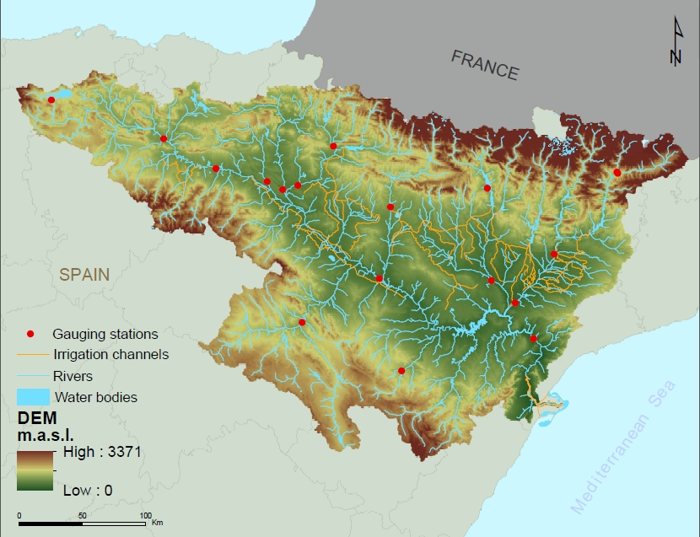
Fig. 1. Digital Elevation Model (DEM) of the Ebro basin (Ministerio de Agricultura, Pesca y Alimentación, 2003). The river network, dams (indicated as water bodies), artificial irrigation channels, and pipes transferring water between sub-basins (CHE 2011) are outlined. The 17 gauging stations (CHE 2011) used in the study are also indicated.

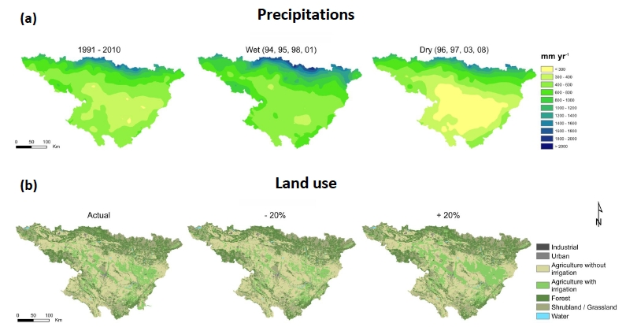
Fig. 2. (a) Annual precipitation averages (mm) in the 1991–2010 average (left), wet conditions (middle), and dry conditions (right). Wet conditions were calculated based on the 4 wettest years during the 1991–2010 period (1994, 1995, 1998, 2001) whereas dry conditions were calculated based on the 4 driest years during the 1991–2010 period (1996, 1997, 2003, 2008); (b) Actual land use and land cover (LULC) map of the Ebro basin (Corine Land Cover 2006) (left). The middle map is the scenario describing the effects of decreasing the irrigated agriculture area by 20%. The right hand side map is the scenario describing the effects of increasing the irrigated agriculture area by 20%.

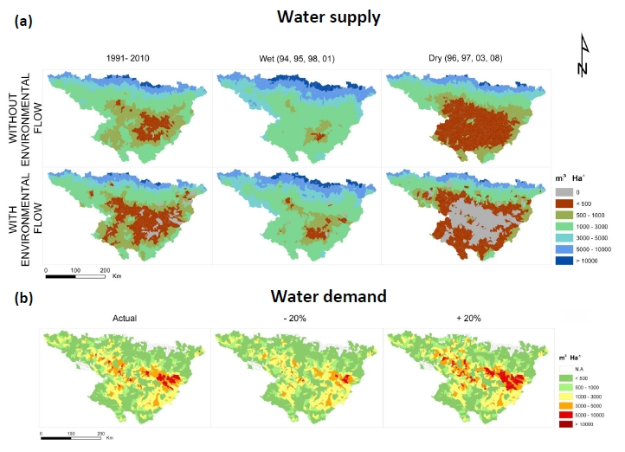
Fig. 3. (a) Interannual average simulated water supply (m³ ha⁻¹) in the Ebro basin under the assumption that agriculture is replaced by pristine vegetation, for three cases of annual precipitation averages: 1991–2010 average, wettest years (1994, 1995, 1998, 2001) and driest years (1996, 1997, 2003, 2008), including or not environmental flow; (b) Interannual average simulated water demand (m³ ha⁻¹) across the Ebro basin for 3 scenarios of irrigated area: actual area, actual area –20% and actual area +20%.
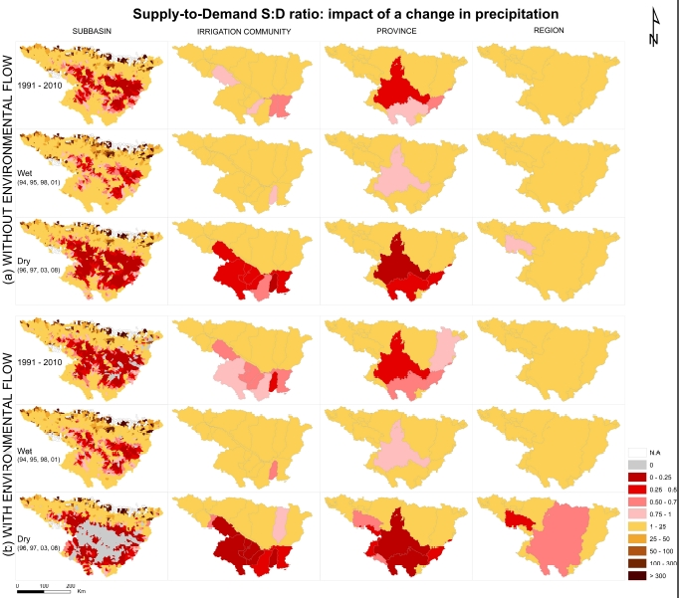
Fig. 4. Interannual average simulated supply:demand (S:D) ratio throughout the Ebro basin for 3 cases of annual precipitation average (1991–2010, Wet (1994, 1995, 1998, 2001), Dry (1996, 1997, 2003, 2008)) and at 4 spatial scales, (a) for supply not considering environmental flow and (b) for supply considering environmental flow. Areas with a S:D below 1 indicate water scarcity at the particular spatial scale.
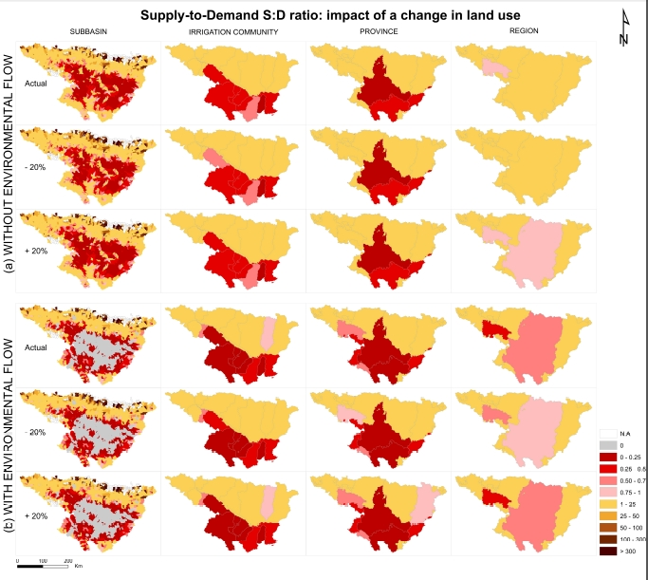
Fig. 5. Interannual average of the simulated supply:demand (S:D) ratio throughout the Ebro basin in the case of a dry climate extreme (annual precipitation average of years 1996, 1997, 2003, and 2008), for 3 scenarios of land use regarding changes in the irrigated area (actual, –20% and +20%) and at 4 different spatial scales, (a) for supply not considering environmental flow and, (b) for supply considering environmental flow.

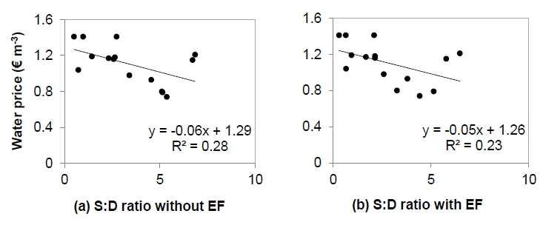
Fig. 6. Relationship between the price (€ m⁻³) of water for industrial and household uses, including both potabilisation and sanitation, and the interannual average simulated supply:demand (S:D) ratio throughout the Ebro basin at the province scale, (a) for supply not considering environmental flow (EF) and (b) for supply considering environmental flow (EF).

