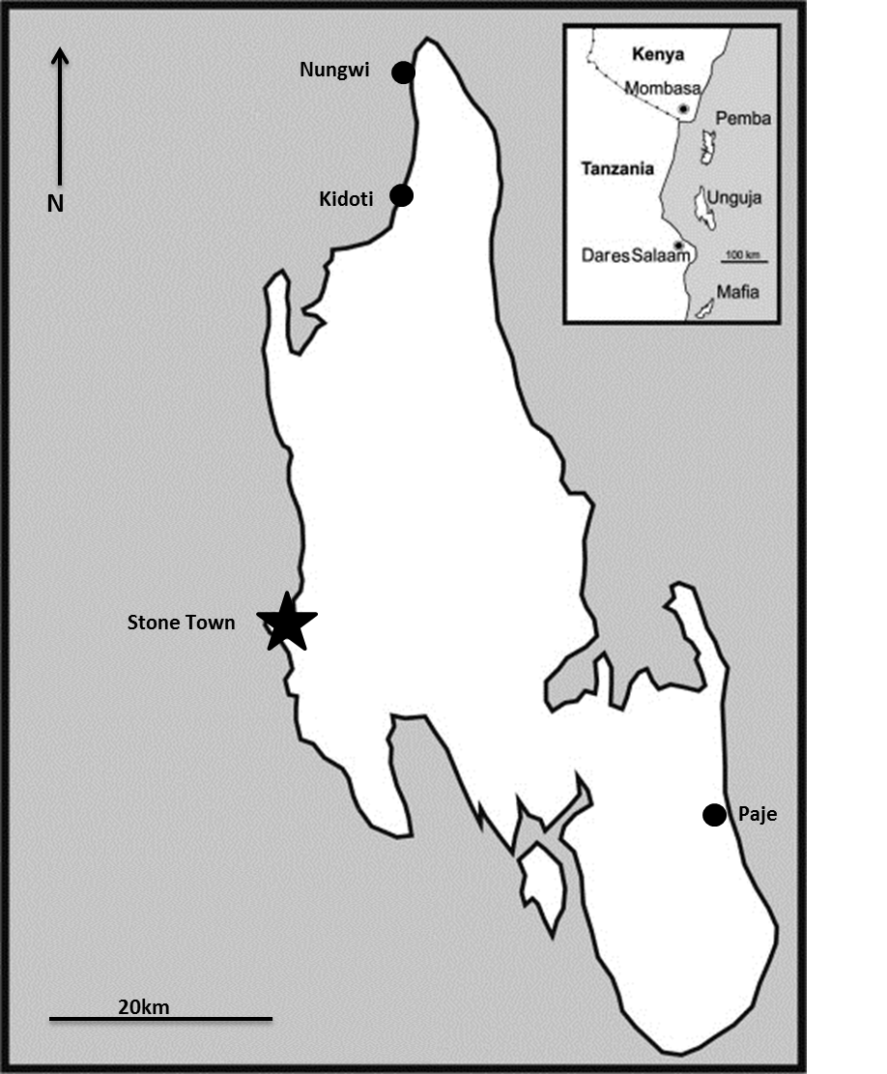
Zanzibar

Mafia

Pemba

Figure 1. Map of the three study sites on Zanzibar

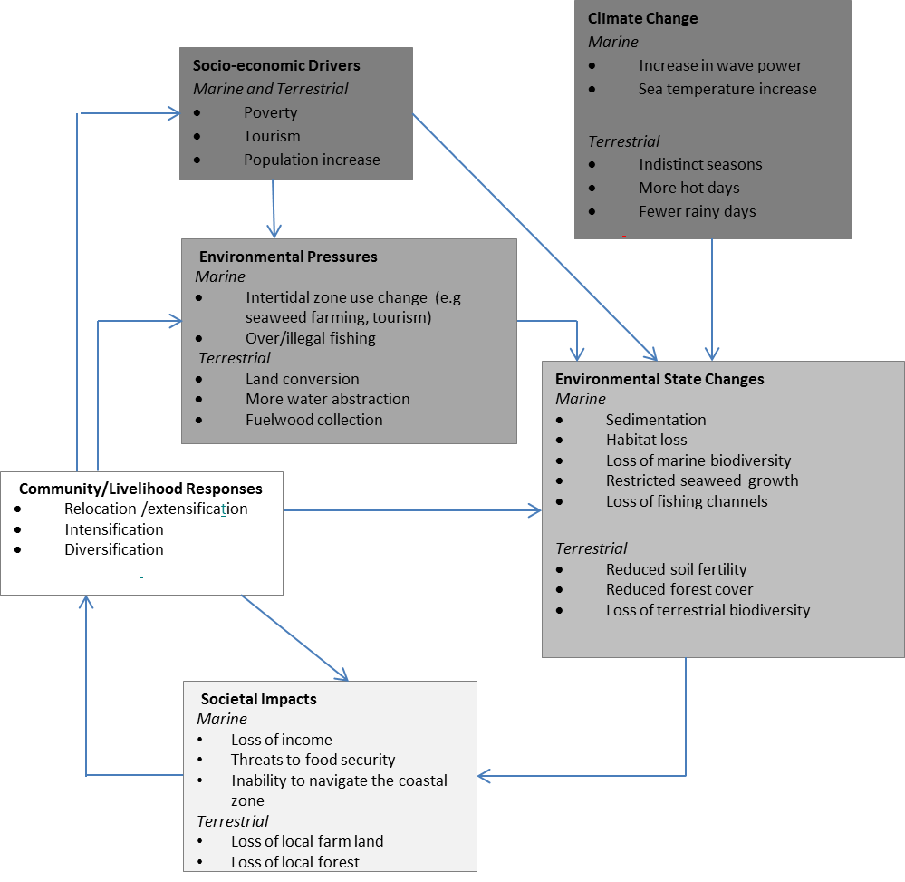

Figure 2. Conceptual diagram of the DPSIR framework as applied to the marine and terrestrial SES in Zanzibar.

- Resource barriers  - Lack of tangible resources e.g. shoes for seaweed farming, tools for farming, own boat etc  - Lack of access to markets  - Lack of land | - Regulatory barriers  - Lack of employment regulation allows foreign labour to dominate service industry  - Poor fishing regulations
- Learning barriers  - Poor educational attainment  - Lack of alternative knowledge  - Lack of outside assistance in terms of knowledge transfer | - Governance barriers  - Inadequate governance of natural resources  - Lack of local institutions to mitigate conflict  - Poor communication between community and government

Figure 3. Barriers to current and future adaptations

