List of Figures
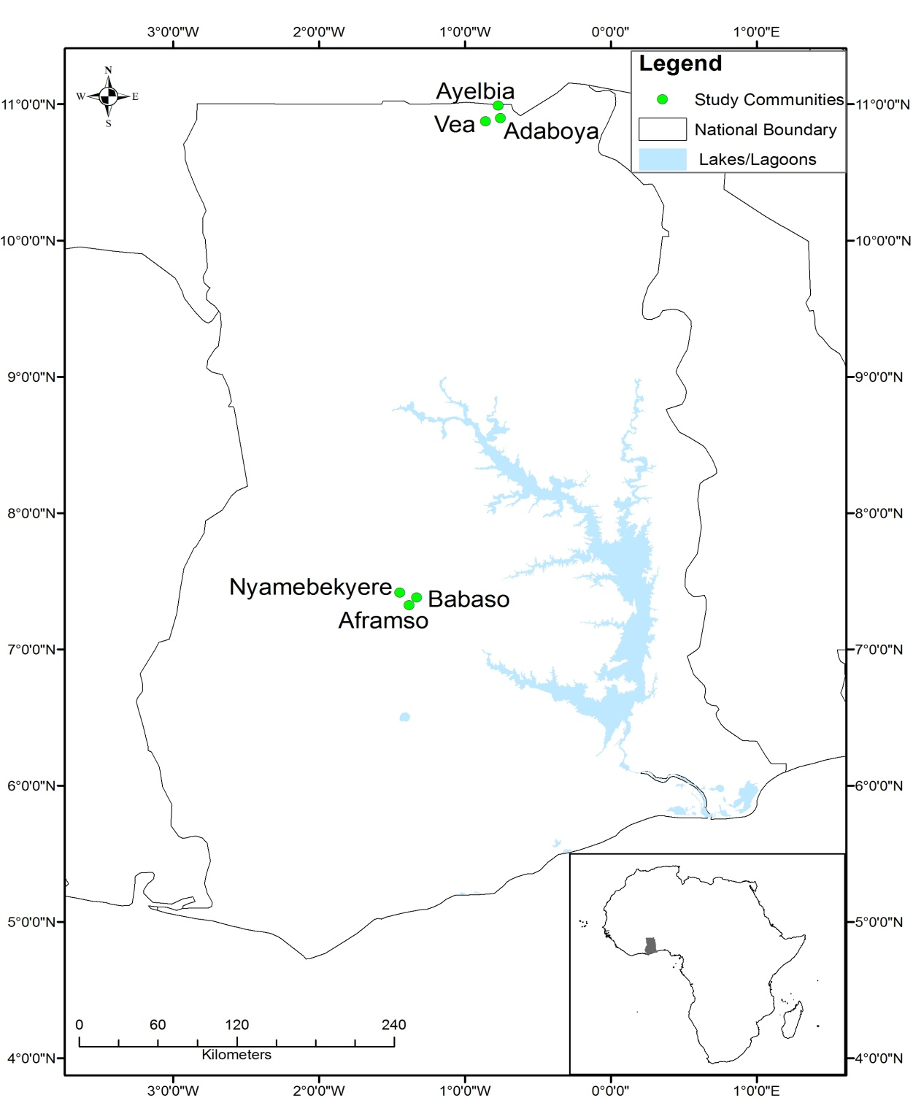
Fig. 1. Ghana showing the study regions

Fig. 2: Vulnerability of the farming communities

Fig. 3. Components contributing to vulnerability of farming communities

Fig. 4: Proportion of households in different vulnerability cluster in study communities

List of Tables
Table1: Indicators of household livelihood vulnerability index collected through a household survey across six communities in Ghana
Component | Indicators | Questions posed during data collection to obtain information on this indicator | Challenges and solutions with collecting this data as experienced in the field
Social assets | No. of groups or associations households belong to | Do you belong to any social groups? Could you please list them in the spaces provided? | Once the definition of a group (and association) was made clear to respondents, there was very little confusion.
Human assets | Educational level | Could you please state the highest education attained? | This was fairly a straightforward question.
 | Health status | Have any member of this household been ill in the last 6 months? | Difficulties related to what constituted illness. Once this was explained as illness needing hospital treatment, there were no problems.
Natural assets | Farm holding size | Could you please state the size of farm holding in acres? | Problems related to landholding but this was resolved as respondents were made to understand that this question related to farm holding under cultivation.
 | Tenure system | By what arrangements do you have access to your farm holding for farming activities? | The only problem related to few farmers who had more than one tenure arrangements. In such cases, the major tenure under which the household cultivates their crops was considered.
Financial assets | Access to credit | Do you have access to credit for your agricultural activities? | Once respondents understood what constituted credit, this question posed no challenges.
 | Ownership of livestock | Do you have livestock or poultry? List the types and numbers of livestock. | This is was straightforward which posed no difficulties.
 | Remittances received | Have you received remittances from family or friends in the last one year? | There were difficulties relating to memory lapses. Hence, the duration was specified to be the last three months to help households recollect.
Physical assets | Irrigation facilities | Do you have access to irrigation facilities for dry season farming? | This was a straightforward question and posed no problem
 | Ownership of radio, television or mobile phone | Could you please list all communication gadgets that you have? These include TV, mobile phone or radios etc. | These were clearly identified things so there was less confusion relating to this question.
Livelihood diversification | Livelihood diversity index | What are your main livelihood activities? Could you rank these in terms of their contribution to household income? | Problem relating to what could be classified as a livelihood. Efforts were made to explain to respondents that this includes all activities they undertake to make a living.

Table 2. Weighting system based on local farmers, extension officers, key informants and experts perceived relative importance of various indicators
Component | Indicator | Times cited as most important | Relative Importance | Weighting (indicators %) | Rank | Weighting (components %)
Social assets | Access to climate information | 11 | 3.86 | 4.00 | 9 | 14.00
 | Membership of social groupings | 23 | 8.07 | 8.00 | 6
 | Availability of extension service | 6 | 2.11 | 2.00 | 11
Human assets | Educational level of the household | 26 | 9.12 | 9.00 | 4 | 11.00
 | Health of the household | 5 | 1.75 | 2.00 | 12
Natural assets | Type of land tenure system | 7 | 2.46 | 2.00 | 10 | 9.00
 | Size of farm holding | 19 | 6.67 | 7.00 | 8
Financial assets | Farmers receiving remittances | 24 | 8.42 | 8.00 | 5 | 27.00
 | Ownership of livestock/poultry | 21 | 7.37 | 7.00 | 7
 | Access to credit facility | 33 | 11.93 | 12.00 | 2
Physical assets | Access to irrigation facilities | 28 | 9.82 | 10.00 | 3 | 10.00
 | Ownership of radios, televison and mobile phones | 0 | 0.00 | 0.00 | 13
Livelihood diversification | Alternative livelihood options | 82 | 28.77 | 29.00 | 1 | 29.00
(N= 270 households, 9 key informants, 3 extension officers, 3 experts) |  | 285 | 100.00 | 100.00 |  | 100.00

Table 3: Oral history narratives with example case study of outlier vulnerable and resilient households
Case 1- Vulnerable household in a resilient community: Ms Amina*, age 55 years, living with 5 children at Nyamebekyere

This household that is perceived by the local community as a poor household is headed by Ms Amina. Born in 1956, Ms Amina, a widow, moved from the Bunkprugu Yooyo district to Nyamebekyere in the 1980s because of the good soil and environmental conditions for farming in this village. During this time, her husband also used to work as a watchman to support the family. They used to cultivate about 8 acres of land and harvested about 50 bags of maize. Ms Amina’s husband died in 2007 and she does not have any reliable source of income for the household. This household cultivates on the average, 3 acres of land and harvests about 15 bags of maize. As a migrant worker, Ms Amina stressed the difficulties in accessing the most fertile lands for agricultural activities. She indicated that she either rents land and in return gives a bag of maize per acre of land to the land owner after harvesting or she cultivates the land in what is locally termed as ‘abanu’ where the land owner gives you land and planting materials and shares the yields equally after harvesting. Without any formal education, Ms. Amina has no alternative source of livelihood apart from farming and she only grows crops. She has no livestock or poultry. To supplement her income, she sometimes works in other people’s farms to earn extra income, which means less time on her own farm. She indicated that she has no money to buy fertilizers to improve soil fertility and hence has to rely solely on animal droppings to enrich the soil. Ms Amina does not belong to any farmers’ associations in the village and does not receive remittances. Ms Amina has observed less rainfall recently compared with when she first moved into this village. According to her the onset of the rains has delayed and the duration of the rains during the farming season is quite uncertain. The household uses different climate adaptation options including changing timing of planting and planting different crops to cope with climate variability in the community. Explaining some the coping strategies, Ms Amina said, “Sometimes I work in other farmer’s farm in exchange for food for my family.” In terms of barriers to climate adaptation, the household highlighted lack of funds, the high cost of improved varieties of crops and land tenure insecurity. Ms Amina said, “It is very difficult for farmers to obtain credit facilities for farming operations in this community. I rely on my limited personal resources to plough the land. I provide all the farm labour myself with the assistance from my children.”
Case 2 - Vulnerable household in a resilient community: Ms Adwoa Owusuwaa*, aged 58, living five children at Aframso

Born in this village, when Ms Owusuwaa started farming, the rains were quite predictable and farmers could appropriately time this for planting their crops. She used to cultivate maize and did not have to rely so much on fertilizers for higher yields as the soil and the rainfall were reliable. According to her, since the late 1980s, the rainfall pattern started to become less reliable. The drought of the 1983 destroyed her maize farm and other cash crops including cocoa that she had planted. She and her husband started growing other crops such as groundnut in the early 1990s. In response to the increasingly erratic rainfall patterns in the community, in the 1990s this household began growing cassava which is drought tolerant. During this period, according to Ms Owusuwaa, the household used to invest part of the money from their crop farming into livestock and poultry. In late 1990s, the household used to receive support in the form of remittances from their elder son who was working as a driver in Accra. In the mid 1990s the household sold all their livestock and poultry to cope with drought related famine. By early 2000, the household had no poultry or livestock. The son who used to send her money has also lost his driving job with the company he used to work with. Currently, the household cultivates only 3 acres of land for maize and rice and sometimes has to rely on friends and family to get food. Without formal education, Ms Owusuwaa has no alternative sources of livelihood apart from farming. Ms Owusuwaa put this bluntly as “I have no alternative sources of livelihood and rely entirely on crop farming to feed my family. This means that any time the rains fail me then my household is in serious trouble in terms of food for the family. This problem is compounded by the fact I receive no remittance from anywhere.” Currently, this household has no livestock or poultry. The household has no bicycle or spraying machine. Also, they have no radio, mobile phone, or television in the house. Neither Ms Owusuwaa nor any of her children in the household belongs to any association in the village. Lack of funds, limited access to and high cost of improved varieties of crops, and lack of farm implements are some of the main barriers confronting the implementation of appropriate climate adaptation by this household.

Case 3 - Resilient household in a vulnerable community: Mr. Abanah*, age 43, living with wife and four children at Vea

Born and growing up at this village, the head of this household, Mr. Abanah is a degree holder. Mr. Abanah has being a professional teacher since 1993 and is the head teacher of the local primary school. This household is considered by the local community to be a rich household. Apart from farming, the household also keeps livestock and poultry. Mr. Abanah is also the Assemblyman for the Vea electoral area and one of the opinion leaders upon whom most of the people in this community rely for decision making concerning this community. Mr. Abanah receives a salary from his teaching profession and sitting allowances when he attends meeting at the assembly. As a strategy, this household invests part of their salary in livestock production by buying livestock from other farmers in the village and surrounding communities during the dry seasons when the price of livestock are generally cheap as farmers need to sell to get money to buy foodstuffs to feed their families. Mr. Abanah indicated that his household sells their livestock when the prices are good. The household has two acres of irrigated land around the Vea irrigation dam and this allows them to cultivate tomatoes during the dry season. The household also owns a motor bicycle, radio, and mobile phone, which they use to listen and access information. Mr. Abanah inherited his farming land from his father and therefore has secure land tenure. The household grows late and early millet, guinea corn, beans and sorghum. Mr. Abanah is a member of the Ghana National Association of Teachers (GNAT) as well as The Roman Catholic Church at Vea. His wife, Ms Bomboi holds Middle School Leaving Certificate and is a petty trader. Since the mid 1990s, this household has changed their cropping patterns and grows improved varieties of crops in response to climate variability. Additionally, the household has changed its timing of planting since the late 19990s and grows different crops at the same time. Importantly, the household is engaging in more non-farm jobs. Lack of institutional support through extension services, limited access to improved varieties of crops and lack of farm implements are some of the major barriers to climate adaptation highlighted by this household.
Case 4 - Resilient household in a resilient community: Mr. Odum*, aged 52 living with 5 children at Nyamebekyere

Headed by Mr. Odum, this household lives in a three bedroom aluminium zinc roofed house and is perceived by the local community as a rich household. Born in 1957 in Mampong, Mr. Odum moved to Nyamebekyere in 1971 with his elder brother. Mr Odum claimed that the rainfall patterns have changed. “When I moved into this village, the rains used to start a bit early in February for planting to be done. But now the rains do not come until late March.” Apart from farming, Mr Odum keeps livestock and poultry. According to him, he has 30 sheep and 25 goats with a number of poultry. Mr. Odum has a Middle School Leaving Certificate. Mr. Odum also works as a farm lands revenue collector which, according to him, brings him extra income. He earns 15% as commission of the total revenue he collects for the stool land administrator in Kumasi. His wife, Ms Mantey who has primary education is also a petty trader who buys foodstuffs from farmers at the Nyamebekyere village and sells them at the Ejura market. The household is able to cultivate 15 acres of land and harvests, on the average, 100 bags of maize, and 25 bags of beans. Mr. Odum and his wife also have three older children who work in different parts of Ghana such as Kumasi, Ejura, and Dunkwa. Mr Odum claims that his household regularly receives remittances from his older children. One of his sons is a teacher at Dunkwa, and another is businessman at Kumasi. Mr Odum said “My sons send us money regularly and this is used to help with our farming activities including ploughing, purchasing fertilizers and other farm inputs. This makes us less vulnerable to drought because we are able to plant on time to avoid the drought during the critical period of maize.” Mr Odum continued “Because of this we are always one of the first households to harvest in this village and this gives us premium prices for our cereals including maize.” Mr Odum is a member of Millennium Development Account, which helps farmers with farm inputs such as fertilizers and seeds. Mr Odum and his wife are members of the local Pentecostal church which serves as informal network for information sharing. Mr. Odum’s wife, Ms Mantey belongs to the Nyamebekyere maize sellers association that helps during funerals. In response to climate variability, Mr Odum claimed to have changed his cropping patterns. ”I now grow the improved varieties of maize such as obaatanpa, dobidi etc that are early maturing”. The major challenges confronting this household in terms of climate adaptation include the lack of and/or high cost of farm inputs, lack of reliable climate adaptation information especially regarding the onset and duration of the rainfall, and lack of institutional support. Elaborating on the barriers to climate adaptation, Mr Odum stated: “We are not able to receive accurate and reliable information from the weather people in terms of the distribution of the rainfall during the farming season and this makes it very difficult for farmers to plane their farming activities.” The household owns a television, radio, and a mobile phone, which they use to communicate and access information on weather forecast.

*Real names have not been used

Table 4: Key characteristics of the outlier and typical households in study communities
Household cluster | Within resilient communities |  | Within vulnerable communities
 | Outlier vulnerable households | Typical households | Outlier resilient households | Typical households
Human assets | Such households do not have any formal education with relatively large household sizes. | Most households have at least primary education. Can be male or female headed households. | Relatively educated households (with at least 6 years of education). | Members of such households have no formal education.
Principal livelihood activities | Crop production on a subsistence basis. May not have livestock or poultry and therefore depend solely on crop farming. | Households have diversified their livelihood sources into non-farm income jobs. Mostly involved in monoculture commercial crop production systems. | Households have at least one member who is in permanent employment or commercial business. These non-farm income jobs are less negatively impacted by climate variability. | Depend mainly on farming, growing crops to feed the household. Crops include sorghum, millet and beans. No form of non-farm jobs for most households.
Natural assets | Majority of households tend to be migrant farmers who are landless and have insecure tenure. Hence, have small farm holding. | Have access to land and tenure security. Have relatively larger farm holding but tend to engage in monoculture commercial cropping patterns because of mechanization. | Households have access to land and secure tenure. Some households have access to irrigation facilities and are able to invest in improved varieties of crops. | Households have relatively small farm holdings with poor soil due to continuous cultivation of land without the addition of suitable soil amendments. Female-headed households have no tenure security.
Poverty levels | Poverty levels are relatively high compared with typical households in such communities. Households have difficulties in accessing credit and do not receive remittances. | Poverty is moderate because of access to non-farm income. May received regular remittances from families and friends working in the cities. | Received income from non-farm jobs which gives such households some form of financial security. | Extremely poor without access to credit. Unable to sell farm produce as a source of support because of small farm holding. Rely on external support during climate-related crisis such as drought.
Social assets | May belong to at most one social grouping. Have no real political power within such community. Social identity includes crop producers. | Highly connected to wide range of social networks. Some households may have access to both bonding and bridging social capital assets. | Have access to bridging social capital in terms of membership of recognised groups. May have political power in the village because of their social status. | Generally, households do not belong to any recognised social grouping. Have no political power in terms of decision making in the village. Mainly crop producers with few livestock keepers.

Aframso, Babaso and Nyamebekyere represented the “resilient” communities whilst Adaboya, Ayelbia and Vea are the “vulnerable” communities.
Key informants included persons who know something special about such villages including opinion leaders such as chiefs, assemblyman, village teachers and youth leaders who are decision makers in these communities.
Experts included academicians and other professionals in NGOs who have specialist knowledge in climate variability and how it affects agricultural productivity in rural agricultural-dependent households.

