**Numerical investigation on the role of discrete element method in combined LBM-IBM-DEM modelling**

#### Hao Zhanga*, Yuanqiang Tanb, Shi Shuc, Xiaodong Niuc, Francesc Xavier Triasa, Dongmin Yangd

#### Hao Lic, Yong Shengd

#### Heat and Mass Transfer Technological Center, Technical University of Catalonia, Terrassa, 08222, Spain

#### School of Mechanical Engineering in Xiangtan University, Hunan, 411105, China

#### School of Mathematics and Computational Science in Xiangtan University, Hunan, 411105, China

#### School of Civil Engineering, University of Leeds, Leeds LS2 9JT, UK

**Abstract**：Particle collisions play a very important role in determining the fluid-particle multiphase flow, and thus it is crucial to treat the particle-particle interaction using a felicitous method in numerical simulations. A novel combined Lattice Boltzmann Method (LBM) - Immersed Boundary Method (IBM) - Discrete Element Method (DEM) scheme is presented in this study with its application to model the sedimentation of 2D circular particles in incompressible Newtonian flows. The hydrodynamic model of the incompressible Newtonian flow is based on the Bhatnagar-Gross-Krook LBM, and a momentum exchange-based IBM is adopted to calculate the fluid-solid interaction force. The kinematics and trajectory of the discrete particles are evaluated by DEM, in which the particle-particle interaction rules are governed by theoretical contact mechanics to enable the direct use of real particle properties. This eliminates the need of artificial parameters and also improves the reliability of the numerical results. By using a more accurate and physical description of particle interaction, a ‘safe zone’ or threshold is also no longer required. Case studies of single particle settling in a cavity, and two particles settling in a channel were carried out, the velocity characteristics of the particle during settling and near the bottom were examined. A numerical example of sedimentation involving 504 particles was finally presented to demonstrate the capability of the combined scheme.

**Key words：Particle collisions, Lattice Boltzmann method, Immersed boundary method, Discrete element method**

1. **Introduction**

Particle-fluid systems are commonly encountered in engineering and environmental applications, however, the understanding of the fundamental physical mechanism involved in these systems are generally insufficient but of high demand. The stochastic nature of the dispersed-phase distribution in a particle-fluid flow makes it much more complex than the single phase flow. Over the last two decades, the Lattice Boltzmann method (LBM) has been widely adopted to simulate particle–fluid interaction problems [1-21] mainly due to the fact that the formulation of LBM is quite simpler than the conventional Computational Fluid Dynamics (CFD) methods. In LBM, the so called fluid density distribution,, is used to represent the fluid elements. The general concept is to compute  with a discrete velocity along the direction at spatial  and temporal space  as they move along the lattice and collide on the lattice node. In the early 1990s, Ladd [1, 2] firstly applied the LBM to simulate the particle–fluid suspension problem, in which the boundary points of the particle would be approximately located at the middle of the link between LBM nodes when the boundary of a solid particle intersects with the lattice link. This treatment educes a distinct simplification in programming however forms a stepwise representation of the solid particles simultaneously. A severe numerical oscillation of the calculated fluid-solid interface force has been observed when the solid particle crosses one lattice grid to another with large velocity. For the sake of overcoming the oscillation, the immersed boundary method (IBM) [22] was introduced into LBM. Since the pioneering work by Feng and Michaelides [3,4], the immersed boundary-lattice Boltzmann method (IB-LBM) has been adopted by several researchers [5-12].

In the context of a particulate flow simulation where the effect of the surrounding fluid cannot be ignored (the effect is sometime not considered when a large density ratio between the solid and fluid is encountered), it is very important to correctly estimate the fluid-solid interaction force in order to capture the essential physical behaviour of the system, because the succeeding motion of solid particles mainly depends on the drag force exerted on them as well as the inter-particle collisions. So far a number of particle fluid interaction schemes have been proposed for IB-LBM. Feng and Michaelidesfirstly used a penalty method to calculate the fluid-solid interaction force [3] and then improved the calculation by using a direct forcing scheme which eliminates the need of determination of the penalty parameter [4]. Niu *et al*. proposed a simpler and more efficient approach to compute the force at the boundary point of solid particles, where the forcing term is simply calculated by the momentum exchange method [5]. The scheme of Niu *et al*. also contains no artificial parameters while keeps the same order of accuracy as the conventional LBM. Peng *et al*. [6] employed a multi-block approach to make their code more efficient by enhancing the grid refinement near the solid body while using relative coarse meshes at further locations. In order to guarantee the no-slip boundary condition, Shu *et al.* [7-10] proposed a series of new concepts of IB-LBM to overcome the drawback that some streamlines may pass through the solid body. The new schemes have been validated by 2D applications such as flow past a circular cylinder [7], flow past an airfoil [8], flow around moving objects [9] and particulate flow simulations [10]. The scheme of Shu *et al.* was further improved by Wu and Shu and expanded to 3D applications [11,12], where a more efficient LBM solver on the non-uniform mesh was developed. Another family of ‘Immersed-like’ boundary methods coupling with LBM was proposed by Noble and Torczynski [13] which is known as Immersed Moving Boundary method (IMB). The basic idea of IMB is to seek a smoother and accurate presentation of solid particles which is similar with IBM to some extent. The IMB-LBM has been employed by a number of researchers to investigate particle-fluid problems [14-21] that will be discussed below.

From the survey of the literature, it can be concluded that the LBM plus a Lagrangian particle tracking method is a promising scheme to simulate particle–fluid interaction problems. However, all the afore-mentioned IB-LBM research works are limited to the small-scale demonstration and may not be applicable for practical engineering problems due to the fact that the description of the collisions of the particles is relatively crude and lack of physical validation. For instance, Feng and Michaelides [3, 4] treated inter-particle and particle-wall collisions using a repulsive force, and Niu *et al*. [5] and Wu and Shu [10] calculated the particle-particle/wall interaction forces using Leonard-Jones potential. The drawback of those collision treatments is that they require many user-defined parameters, and thus a ***trial and error*** or empirical approach is needed in any new configuration even using the same method. Moreover, a ‘safe zone’ or threshold has to be introduced to eliminate the roils produced by the interaction law, and the function of the threshold is to keep the particles away from each other and use a remote force instead of the contact force. As pointed out by Yu and Xu [23], at this stage of development, the difficulty in particle-fluid flow modelling is mainly related to the solid phase rather than the fluid phase. Particle collisions play a very important role in particle-fluid systems especially when the particles are densely packed. Therefore, it is essential to use a felicitous method to treat the particle collisions accurately and efficiently.

Recently the discrete element method (DEM) [24] has been continually adopted to simulate the particulate flows due to its natural advantage to characterize the granular matters. DEM was firstly proposed by Cundall in the 1970s [24]. Dynamic information such as the trajectories of and transient forces exerting on individual particles, which are extremely difficult to obtain by physical experimentation, can be provided in DEM [25]. Due to its excellent capability for handling large number of particles, DEM has been coupled with traditional CFD methods for various engineering applications such as the fluidized bed [26-29], particle transportation [30-32] and complex particle-fluid systems in dense medium cyclone [33-35]. A detailed review of these coupling models is given by Zhu *et al*. [25]. One important feature of the coupled CFD-DEM simulations is that one single fluid cell can contain several solid particles, and the solid-fluid interaction force is calculated based on the local porosity in the cell together with the superficial slip velocity between particle and fluid [36]. Alternatively, the LBM-DEM simulations show a different coupling way that the diameter of each particle can be equal to dozens of lattice units. Cook *et al*. [14] coupled the IMB-LBM with DEM to investigate the fluid-induced erosive failure of a cemented particulate constriction. Han *et al.* [15-19] have successfully used coupled LBM-IMB-DEM to simulate particle transport in turbulent fluid flows and heat transfer in granular materials. Zhang *et al*. [20] carried out a coupled LBM-IMB-DEM simulation to monitor the motion of abrasive particles in Chemical Mechanical Polishing (CMP) process. Wang *et al*. [21] combined a time-driven hard-sphere model and IMB-LBM to simulate a fluidized process. Recently Zhang *et al*. [37] made a new combination of a time-driven hard-sphere model and LBM to simulate a bubbling bed with jet flow, where a so-called Energy-minimization Multi-scale (EMMS) drag model [38] was adopted for the coupling between solid and gas phase. However the EMMS drag model is more like a traditional CFD-DEM combined modelling since the evaluation of the local porosity is still necessary.

In this study, we present a combined LBM-IBM-DEM scheme. Different to other LBM-IMB-DEM research works [14-21], we calculate the fluid-solid interaction force by the IBM as proposed by Niu *et al.* [5]. As mentioned above, this scheme evaluates the momentum-exchange of the particles using two unrelated computational meshes. One is the moving Lagrangian mesh for the solid particle, the other is the stationary Eulerian mesh for the fluid field. Compared with IMB, it is not necessary in IBM to take care of the details of the boundary positions and the intersections of two meshes with the movement of the solid particles. The fluid density distribution functions on particle boundary are interpolated by the Lagrangian polynomicals from the underlying Eulerian mesh. The momentum-exchange based scheme is simpler and more convenient than the other two ways of calculation of the fluid-solid interaction force for IB-LBM [3, 4]. This IB-LBM scheme has been tested by Niu *et al*. [5] in different numerical examples. And as the natural next step of the work initiated by Niu *et al*. [5], the primary objective of this paper is to further enhance the coupling scheme by incorporating DEM. The interaction law between the particles was based on the theoretical contact mechanics thereby it is possible to directly use material properties of the particle in the calculation. A small overlap is allowed between the rigid particles in contact to treat the particle collisions, this kind of collision treatment is also called the soft-particle DEM. Stevens and Hrenya [39] conducted a comparison of soft-particle models to measurements of collision properties during normal impacts and found that utilization of the artificial penalty parameter can cause erroneous system behaviours.

The rest of the paper is organized as follows. To make this paper self-contained, we summarize the mathematics of LBM and IBM in Section 2 together with the introduction of the DEM and fluid-particle interaction force. In Section 3 we carry out a simulation of one particle settling in a cavity and solve the drafting-kissing-tumbling (DKT) problem, followed by a simulation of the sedimentation of a relative larger number of circular particles in a cavity. Finally, results are discussed and some conclusions are made in Section 4.

## **Equations for fluid motion**

* 1. **Lattice Boltzmann model with single-relaxation time collision**

The motion of the incompressible Newtonian flow is numerically evaluated using LBM-D2Q9 model [40]. The discretization of the flow domain is undertaken using square lattices with uniform lattice spacing , those nine lattice velocities defined between the lattice nodes are given by

  (1)

where is termed by the lattice speed. The formulation of the lattice BGK model is

 (2)

where  represents the fluid density distribution function,  stands for the space position vector,  denotes time and  denotes the non-dimensional relaxation time,  denotes the fluid-solid interaction force term which is given in the next section, the equilibrium density distribution function, , can be written as

 (3)

where the value of weights are:  , and .  denotes the macro velocity at each lattice node which can be calculated by

 (4)

the macro fluid density is obtained by

 (5)

* 1. **Immersed boundary method and the hydrodynamics interaction force**

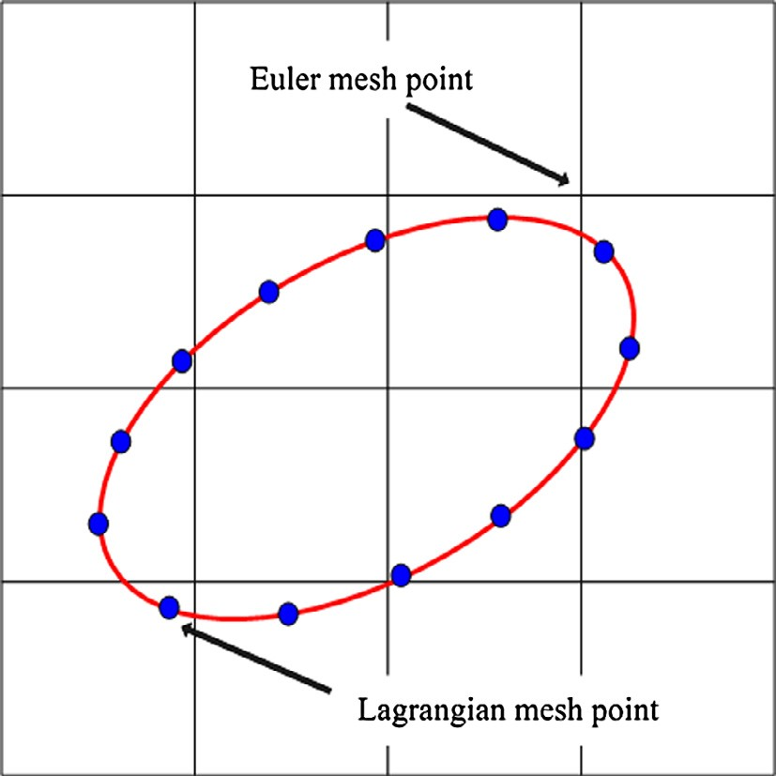

Fig.1 Schematic diagram of the immersed boundary method.

The flow field is covered by the Eulerian square lattices, and the density distribution functions of fluid are defined on the lattice nodes. The existence of the solid particles is represented by another set of meshes, which are intitled as Lagrangian points because the locations of the points change along the movement of the particles as depicted in Fig.1. The fluid density distribution functions on the Lagrangian points are also considered but not directly solved by Eq.2. Using numerical extrapolation from the circumambient fluid points,  on the Lagrangian points at each timestep is approximated

 (6)

where is the coordinates of the Lagrangian boundary points. Here third order polynomials are used for the extrapolation,  and  are the numbers of the Eulerian points used at each direction. Totally nine Eulerian points are used to obtain the value on single Lagrangian point.

To include the effect of the moving solid boundary on the flow field, the fluid density distribution functions on the Lagrangian points should be further modified by the velocity of the solid particle

 (7)

where  represents the opposite direction of ,  is the velocity of the Lagrangian node,  and  denote the translational and angular velocities of the particle,  stands for the coordinate of the particle. Based on the momentum exchange of fluid particles, the force density at the Lagrangian point can be calculated using and

 (8)

In each calculation cycle,  must firstly be evaluated because it is ‘bidirectional’ and it bridges the two phase calculations. The motion of the particles will be influenced by the environmental fluid among being pushed, pulled or rotated. On the contrary the flow field will be of course disturbed by the particles movement. Both of the bidirectional contributions are related to.

The effect on the flow fields from the solid boundary is the body force term  in Eq.(2) where  can be expressed by

 (9)

and

 (10)

 is the arc length of the boundary element. is used to restrict the feedback force to only take effect on the neighbor of interface that is given by

 (11)

with

  (12)

where  is the mesh spacing. It should be stressed that by adding a body force on the flow field, the macro moment flux has to be also modified by the force.

On the other hand, the fluid-solid interaction force density exerted on the solid boundary point can be regarded as the reaction force of:

 (13)

By integrating around the circumference of the solid particle, the total force exerting on the mass center  and the torque  acting on the particle can be obtained as

 (14)

 (15)

* 1. **DEM modeling of the interaction between moving particles**

When the particles collide directly with other particles or the wall, the discrete element method (DEM) [24] is employed to calculate the collision force. Including the hydrodynamic force, the dynamic equations of the particle can be expressed as:

 (16)

where  and  are respectively the mass and the moment of inertia of the particle;  is the acceleration of the particle;  is the angular position;  is the gravitational acceleration;  and are the hydrodynamic force and torque, respectively.  and  are the contact force and torque respectively generated by the direct collisions. In the present work, we calculated the normal force-displacement relationship based on the theory of Hertz [41]. A small overlap  between the contacting particles is allowed to represent the physical deformation that takes place at the interface. For two particles of radii, Young’s modulus  and Poisson’s ratios  (*i*=1,2), the normal force-displacement relationship reads

 (17)

where

 (18)

and

 (19)

The incremental tangential force arising from an incremental tangential displacement depends on the loading history as well as the normal force and is given by Mindlin and Deresiewicz [42].

 (20)

where

 (21)

 is the radius of the contact area.  is the relative tangential incremental surface displacement,  is the coefficient of friction, the value of  and  changes with the loading history. Detailed formulations of these models are referred to [43-45].

In the coupled LBM-IBM-DEM scheme, Feng and Michaelides [3] argued that when the particle collisions are treated via a penetration-allowed method, numerical instability may occur when a strong repulsive force is generated according to large overlap. Therefore a threshold or ‘safe zone’ should be set between the particles’ surfaces to avoid the particle penetration. In our opinion this would depend on the interaction law and the numerical time step adopted in the discrete particle modeling as described below.

1. Different to the work of Feng and Michaelides [3], in which an artificial ‘stiffness’ should be given, the ‘stiffness’ of the particle and wall is fixed as soon as the physical property of the particles are specified in this study. It is described in a more detailed and physical way than the linear one.
2. The time step of LBM, , is based on the mesh resolution of the flow field and the property of the fluid flow. Whereas the time step, , in the discrete particle model is based on the Rayleigh wave speed of force transmission on the surface of elastic bodies

 (22)

where  is the shear modulus and  is the Poisson’s ratio of the particle. Owen *et al*. [19] made an extensive discussion on the determination of the subcycling between  and . Owen *et al*. suggested that “when , both the solution time steps can be simply forced to the less value, . When , a subcyling approach can be taken to allow the execution of a number of consecutive DEM time steps within a single LBM time step, during the DEM subcycling the DEM mapping and hydrodynamic force and torque are not updated.” In this study, it has been found that is significantly less than . For the sake of getting a larger time step of DEM without losing the order of accuracy, the density of the particle is numerically enlarged when we determine  based on Eq.(22). 100 times enlargement on the density leads a 10 times enlargement on . Similar treatments were also found by Sheng *et al*. [46,47] who has shown the advantages. By doing this, we can always choose a time step that ensures . Our numerical experiments show that this artificial scheme works well in general.

**2.4 Computational sequence**

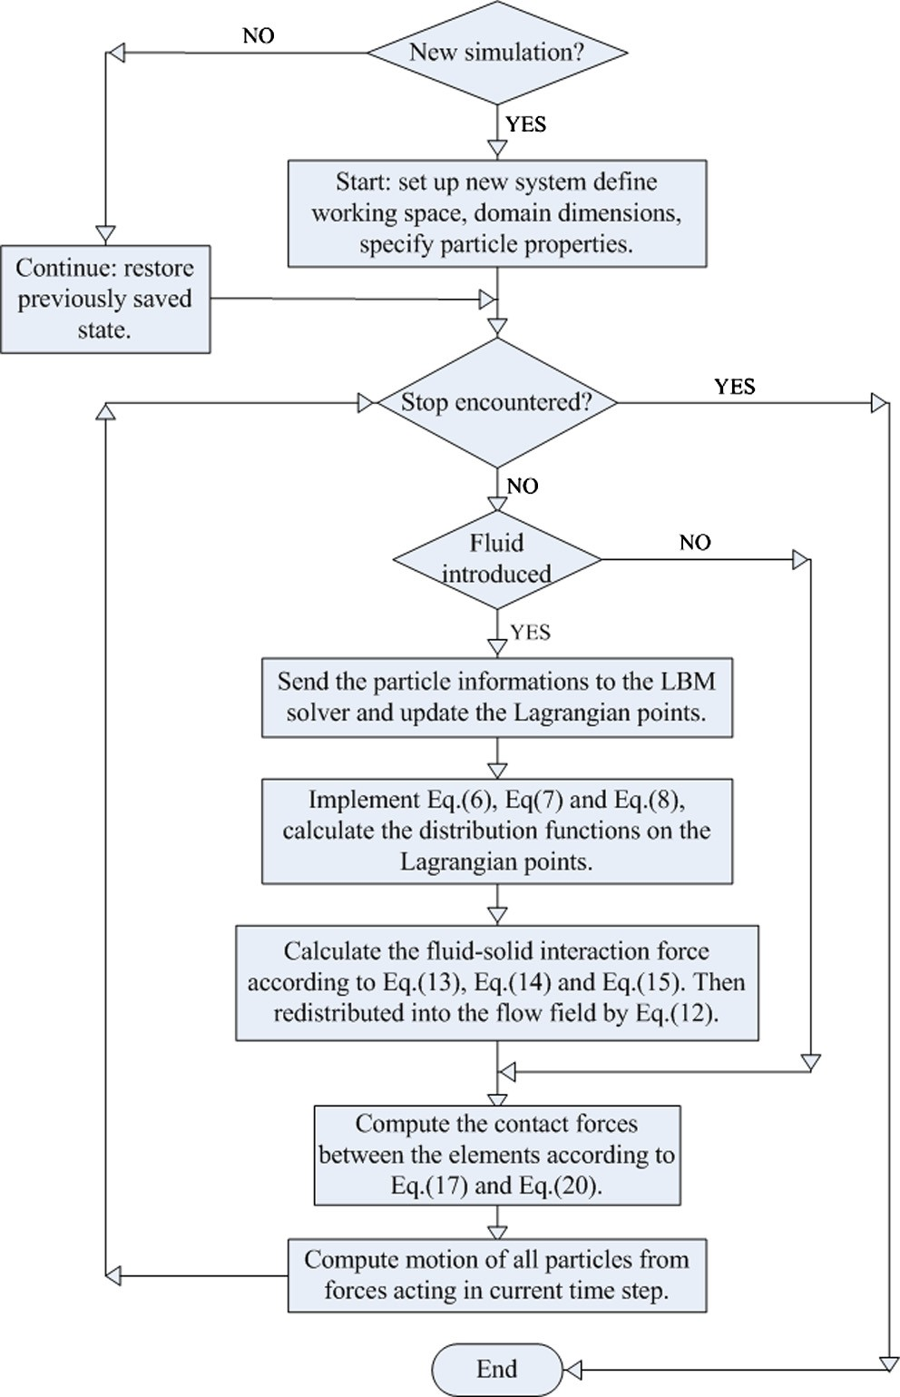

Fig.2 Flow chart for the computational sequence.

A flow chart for the coupling code is shown in Fig.2. In this work, we couple a BGK-LBM fluid solver to a DEM code to provide the fluid-solid interaction force. The program begins with defining the size of working space, the number, initial positions and properties of the particles, the gravity field and physical properties of the fluid flow. All these procedures can be accomplished prior to the main cycle with the data saved in files. A 'relay simulation mode' enables the code to read the files as an initial condition. The 'relay simulation mode' works both on the DEM and LBM parts.

**3. Numerical results and discussions**

**3.1 Sedimentation of single particle in a cavity**

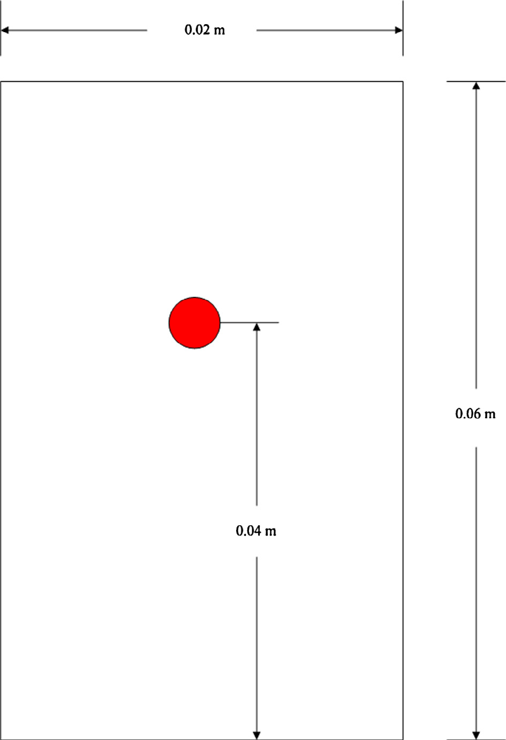

Fig.3 Schematic diagram for a single particle settling in a cavity.

Sedimentation of single particle settling in cavity is presented to validate the LBM-IBM-DEM scheme as well as the timestep treatment discussed in Section.2. The configuration of interest is a rectangular cavity with four solid boundaries as shown in Fig.3. The width is 0.02 *m* and the height is 0.06 *m*. The cavity is filled with stagnant Newtonian fluid with viscosity 0.01  and density 1000 . A computational domain of  is used in the simulations. The relaxation time is , this leads to a physical timestep of 0.0001 *s*. One particle with a diameter 0.0025 *m* and a density 1250  is set at (0.01 *m*, 0.04 *m*). The particle is initially at rest and starts to fall down under the action of the gravity field, .

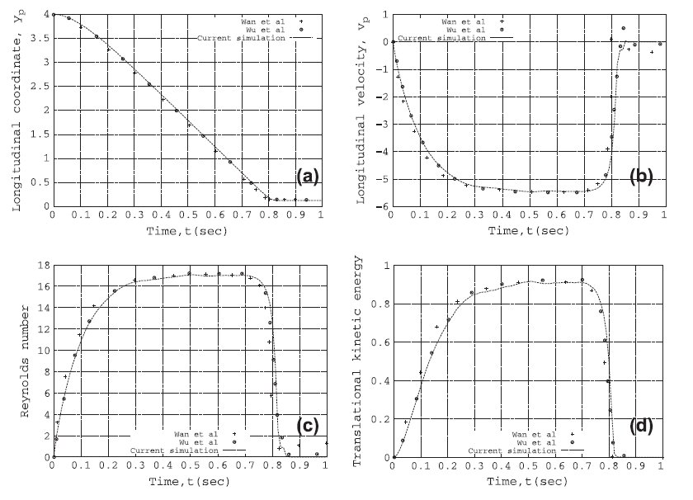

Fig.4 (a) longitudinal coordinate; (b) longitudinal velocity; (c) Reynolds number; (d) translational kinetic energy

In Fig.4, the longitudinal coordinate, longitudinal velocity, Reynolds number and translational kinetic energy of the particle are monitored to compare with those results obtained by Wan and Turek [48] and Wu *et al.* [10] who used other numerical methods. It is shown that all the four quantities are comparable until the particle collides with the bottom. Due to the fact that different discrete particle methods are used, exact agreement may not be expected after the collision.

**3.2 Bouncing motion of particles near bottom**

**Table.1 Properties of particles and fluid**

|  |  |  |  |
| --- | --- | --- | --- |
| Solid phase |  | Fluid phase |  |
| Number of particles | *1* | Viscosity (*kg ·m -1 s -1*) | *1.0 e-2* |
| Density (*kg· m-3*) | *7800* | Density (*kg· m-3*) | *935* |
| Young’s Module (***G****Pa*) | *240* | Cavity height (*m*) | *0.05* |
| Poisson ratio | *0.3* | Cavity width (*m*) | *0.05* |
| Friction coefficient | *0.33* | Lattice height (*m*) | *0.0001* |
| Diameter (*m*) | *0.0003* | Lattice width (*m*) | *0.0001* |

The validation of the presented discrete particle method is accomplished by comparing the results of bouncing motion of spherical particles with the experimental measurements by Gondret *et al*. [49]. To match the experimental conditions the same physical parameters are adopted as in [49]. A stainless steel particle settles from rest at a height 0.00744 m in silicon oil RV10 under gravity, the parameters of the fluid and the particle are listed in Table.1. A computational domain of  is used in the simulations. The relaxation time is  which leads to a physical timestep of 0.00004675 *s*.

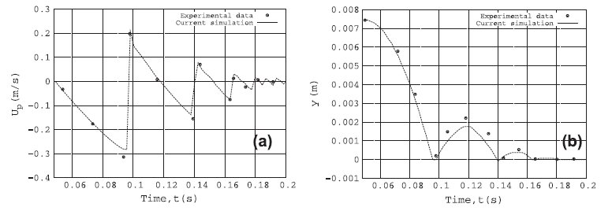

Fig.5 Comparisons by simulations and measurement: (a) longitudinal velocity; (b) longitudinal coordinate;

Fig.5 shows the evolution of the longitudinal coordinate and velocity of the particle with respect to time. It is observed that the simulation results have good consistency with the experimental measurements. The longitudinal velocity of the particle agrees well with the experimental data during settling but is slowed when it approaches the cavity bottom. The slowing leads to a reduction of the rebound height as shown in Fig.5 (b). This discrepancy between numerical result and experimental data near bottom is also reported by Feng and Michaelides in [4]. The reason is considered to be the presence of the bottom wall. Additional simulations in the same configuration but with different particle parameters are conducted, and it is shown that the choice of the physical parameters plays an important role in the accurate simulation of the collision process. The collision time and frequency are very different when the physical parameters are changed. From this point of view, DEM provides more reliable results than other artificial penalty methods.

**3.3 Sedimentation of two particles in a channel**

**Table 2 Properties of particles and fluid**

|  |  |  |  |
| --- | --- | --- | --- |
| Solid phase |  | Fluid phase |  |
| Number of particles | *2* | Viscosity (*kg ·m -1 s -1*) | *1.0 e-4* |
| Density (*kg· m-3*) | *1010* | Density (*kg· m-3*) | *1000* |
| Young’s Module (***G****Pa*) | *68.95* | Channel height (*m*) | *0.08* |
| Poisson ratio | *0.33* | Channel width (*m*) | *0.02* |
| Friction coefficient | *0.33* | Lattice height (*m*) | *0.0001* |
| Diameter (*m*) | *0.002* | Lattice width (*m*) | *0.0001* |

For the movement of particles in Newtonian liquids, the so-called DKT problem has been widely investigated by several researchers [3,5,50,51] for a benchmarking purpose. This case study is performed in this study to check the effect of DEM on the inter-particle collisions. The configuration of the simulation used here is based on the simulation by Niu *et al*. [5]. A 0.02 *m* (width)  0.08 *m* (height) channel is defined with the top and base open, and the no-slip boundary is adopted on the left- and right-hand side boundaries of the channel. Two circular particles, each of diameter 0.002 *m,* are located at (0.000999 *m*, 0.072 *m*) and (0.001 *m*, 0.068 *m*) respectively. The particles fall down under the action of the gravity field. The properties of the particles and the surrounding fluid are given in Table 2. A  computational fluid lattices are used for the simulation. The relaxation time is , and the physical timestep is 0.0005 *s*.

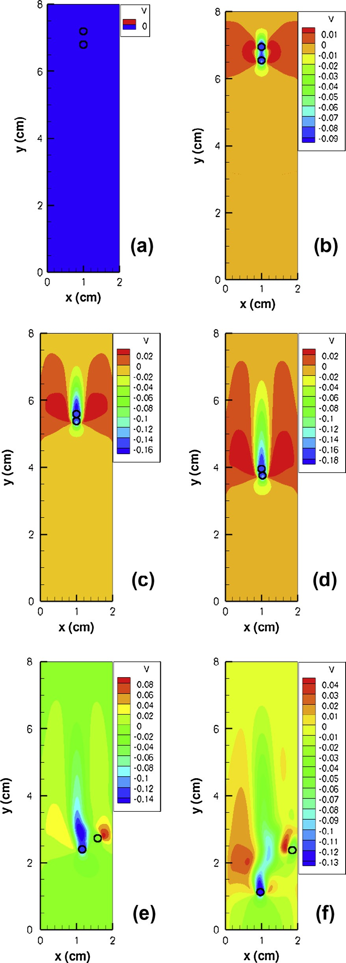

Fig.6 Sedimentation of two circular particles in a channel at different time stages.

(a) 0.0*s*; (b) 0.5*s*; (c) 1.5*s*; (d) 2.5*s*; (e) 3.5*s*; (f) 4.5*s*;

The DKT sequence is illustrated in Fig.6 with contour plots for *v* velocity of fluid at several selected instances. The leading particle creates a wake of low pressure. Since the trailing particle is caught in this wake, it falls faster. After a period of chasing strategy, the trailing particle eventually catches up with the leading one and kisses it. The two kissing particles form a single long body and fall together until separated by hydrodynamic force. As a result, the pair of kissing particles tumbles to a side-by-side configuration before falling without further lateral migrations.

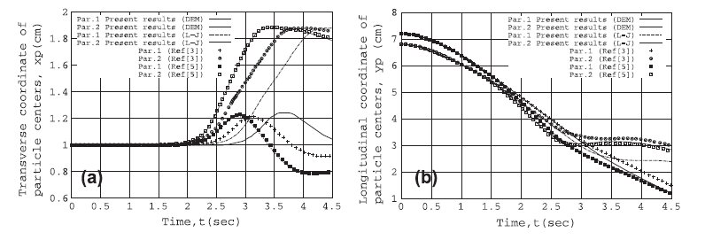

Fig.7 (a) Transverse coordinates of the centers of the two particles; (b) Longitudinal coordinates of the centers of the two particles.

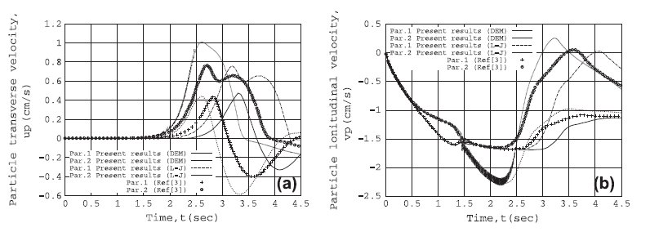

Fig.8 (a) Transverse velocity components of the two particles; (b) Longitudinal velocity components of the two particles.

Quantitative comparisons between current results and those obtained by other numerical studies are given in Fig.7 and Fig.8. For clearer comparisons, an additional simulation using the Lennard-Jones (L-J) potential model (same as Niu *et al*. [5]) is conducted to calculate the repulsive force between the particles. As seen in Fig.7 all the positions and velocities agree very well with each other before the tumbling part of the process. For the discrepancy, different modes of tumbling have been reported in the literature [51]. Fortes *et al*. [52] pointed out that the tumbling process is essentially a breakup of an unstable configuration of the particles positions which is highly influenced by the particle-collision law and the numerical method to handle the fluid flow. It is shown that the LBM-IBM-DEM scheme provides the longest tumbling process. This is due to the adoption of soft-sphere DEM. Fig.9(a) shows the distance between the surfaces of the two particles during the DKT process. The solid line represents the results obtained by LBM-IBM-DEM while the dashdot line represents the results obtained by LBM-IBM-(L-J). A good agreement can be seen before ‘Kissing’ and stay at one certain value with small fluctuation during the tumbling process. The value of the dashdot line is a little bit larger than 0.01 *cm*, namely about one lattice unit. The distance between the two surfaces is due to the adoption of the threshold which keeps the surfaces staying away from each other. The value of the solid line fluctuates around 0 *cm* because the overlap is allowed in soft-sphere DEM. The distance between the particle surfaces can influence that tumbling process, Feng and Michaelides [3] compared the IB-LBM results with those using simple LBM, where a much shorter tumbling process was found in the LBM case. We have found that the physical parameters of the particles do not play a significant role in this process. An ‘invalidation’ of the interpolation scheme may be encountered under a high overlap as shown in Fig.9 (b) because a nine point interpolation scheme was adopted to obtain the fluid density distribution on the Lagrangian polynomicals from the Eulerian meshes.

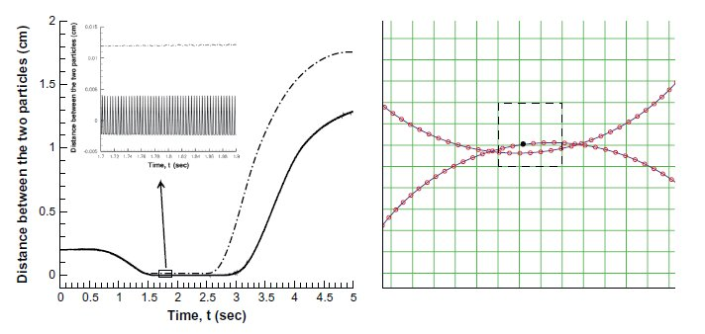

Fig.9 (a) The distance between the surfaces of the two particles (solid:DEM, dashdot:L-J); (b) The interpolation scheme

The transverse and longitudinal velocity components of the two particles are also compared. It is shown in Fig.8 that an artificial model like Lennard-Jones (L-J) potential model may predict a deviant force and velocity (from 1.4s to 2.5*s*), which may be fatal when it is used to handle large number of particles with frequent collisions. From this point of view, DEM does a better job in providing the dynamic information of the particles.

**3.4 Sedimentation of 504 circular particles in a cavity**

**Table 3 Properties of particles and fluid**

|  |  |  |  |
| --- | --- | --- | --- |
| Solid phase |  | Fluid phase |  |
| Number of particles | *504* | Viscosity (*kg ·m -1 s -1*) | *1.0 e-3* |
| Density (*kg· m-3*) | *1010* | Density (*kg· m-3*) | *1000* |
| Young’s Module (***G****Pa*) | *68.95* | Cavity height (*m*) | *0.02* |
| Poisson ratio | *0.33* | Cavity width (*m*) | *0.02* |
| Friction coefficient | *0.33* | Lattice height (*m*) | *0.00004* |
| Diameter (*m*) | *0.000625* | Lattice width (*m*) | *0.00004* |

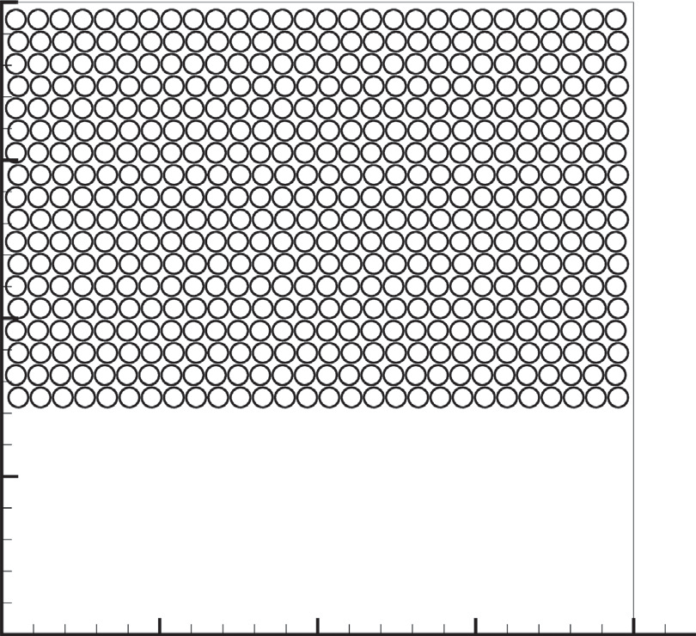

Fig.10 Positions of the 504 particles at time t=0 *s*.

In order to examine the LBM-IBM-DEM scheme for handling system containing large number of inter-particle collisions as well as particle-wall collisions, a simulation of sedimentation of 504 circular particles in a cavity is conducted. The initial setup of the problem is illustrated in Fig.10, which is similar with that used by Feng and Michaelides [3]. The properties of the particles and the surrounding fluid are given in Table 3. 504 circular particles of diameter  *m* are positioned in a closed two-dimensional square cavity of side length  *m*. There are 18 lines of particles, in each line there are 28 particles. The gap between horizontal neighboring particles in each line and between each two neighboring lines is d/8. The gap between the upmost line and the upper wall is 3d/8. The gap between the left wall and the leftmost particle in all the odd-numbered horizontal lines is 2d/8. The gap between the left wall and the leftmost particle in all the even-numbered horizontal lines is 3d/8. The fluid domain is divided into a  square lattice, so the diameter of each particle is equal to 16 lattice units. The criterion for generating the computational grid is based on the result of Feng and Michaelides [3]. It has been shown that the current resolution is fine enough to capture the flow behaviour. The relaxation time is . The no-slip boundary is adopted on the four boundaries of the cavity. Initially the particles and the fluid are stationary and the particles fall down under the action of the gravity field.

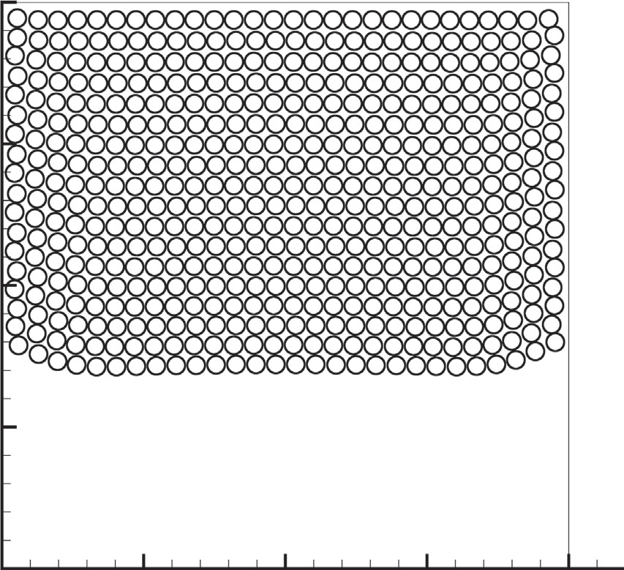

Fig.11 Positions of the 504 particles at time t=1 *s*.

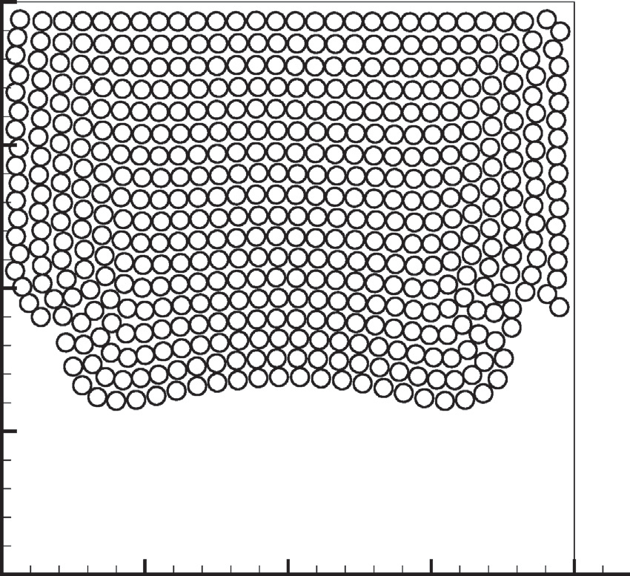

Fig.12 Positions of the 504 particles at time t=2 *s*.

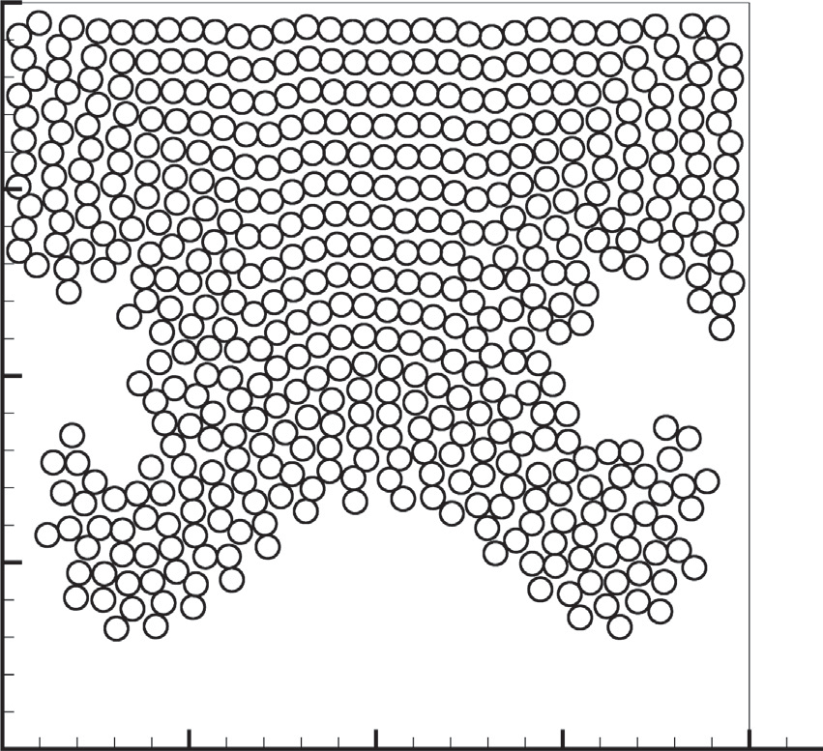

Fig.13 Positions of the 504 particles at time t=3 *s*.

The configuration presented is regarded to behave similarly as two layers of fluids with different densities, it is known that the Rayleigh-Taylor instability of the interface may take place between the two fluids when the lighter fluid is pushing the heavier fluid. This phenomenon has been vividly captured in the simulation results, as shown in Fig.11-13. Initially all the particles start to settle uniformly, the stagnation of the fluid beside the walls hindered the particles nearby. Hence the particles in the center move faster than the particles beside the walls, thus the interface appears to be a parabola curve as depicted in Fig.11. Then two small vortexes are generated beside the two vertical walls respectively, the vortex beside the left boundary rotates clockwise as well as the other rotates anticlockwise. They pull the particles downwards, which further changes the shape of the interface curve (see Fig.12). When the lighter fluid pushes into the particle cluster, two branches are formed each heading for the corners of the cavity (shown in Fig.13). The flow patterns before 3 *s* have a good agreement with those reported by Feng and Michaelides [3].

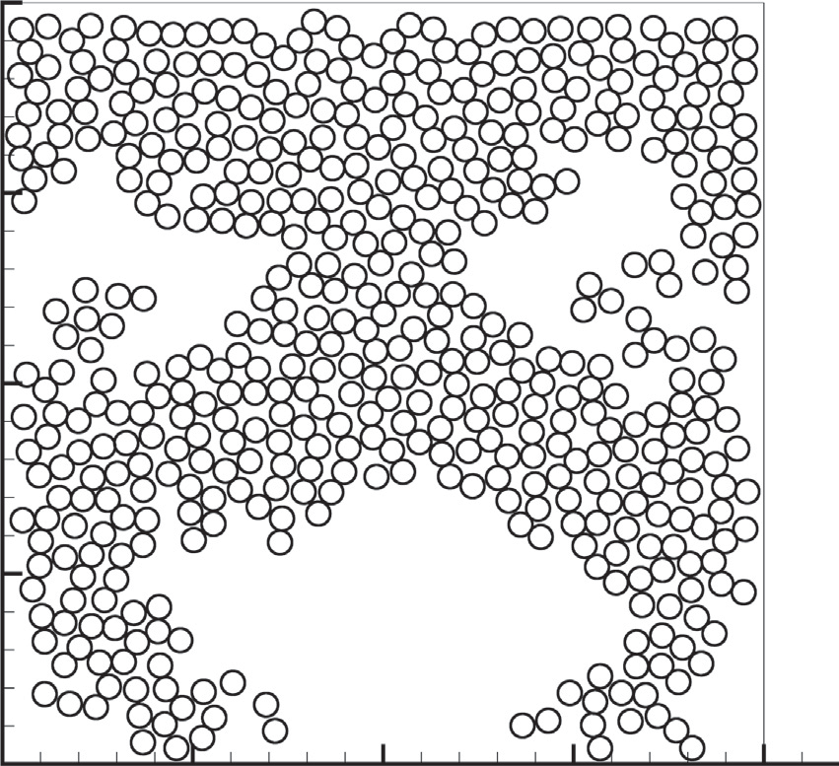

Fig.14 Positions of the 504 particles at time t=4 *s*.

The evolution of the flow pattern shows differences after multi-collisions taking place between the particles and between the particles and walls. At t=4 *s*, the two branches sweep across the cavity corners and head for the perpendicular bisector of the base. The tips of the particle branches move slower than those given by Feng and Michaelides [3]. Due to the fact that both the flow fields are evaluated by LBM with same parameters used, the discrepancy is most probably due to the forcing term and the method that accounts for the collisions. In the study of Feng and Michaelides [3], the friction between the particle-particle and particle-wall were neglected, whereas in this study we calculate this effect according to Mindlin-Deresiewicz theory [42]. It is believed that the particle flows are hindered when they travel around the corner of the box (shown in Fig.14) by the collisions and friction.

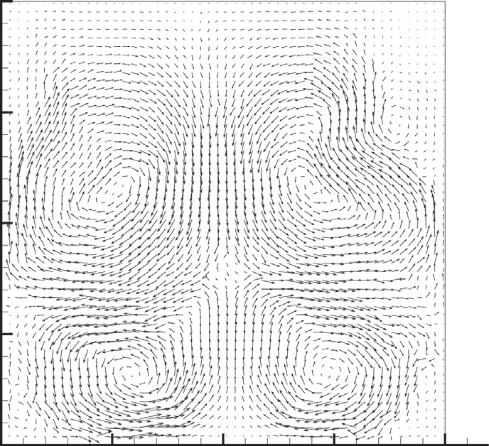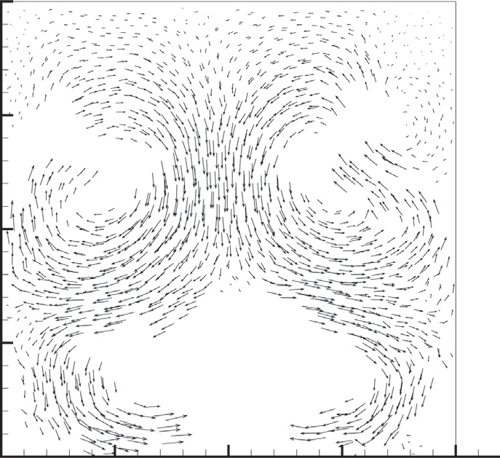

1. (b)

Fig.15 (a) The flow field; (b) Distribution of the particle velocity at time t=4 *s*.

When the two particle branches insert into the lower half of the cavity, another two small vortexes are formed in the circular region surrounded by the two particle arms, as depicted in Fig.15 (a). Subsequently, the two lower vortexes, one at each side of the cavity, grow and start to pull particles downwards, as depicted in Fig.15 (b). At the same time the two upper vortexes tear the particle clusters to blocks and pull the particles beside the walls upwards and the particles in the center downwards into the two vortexes below. As more particles are transferred downwards, the two lower vortexes become the dominant force in the enclosure.

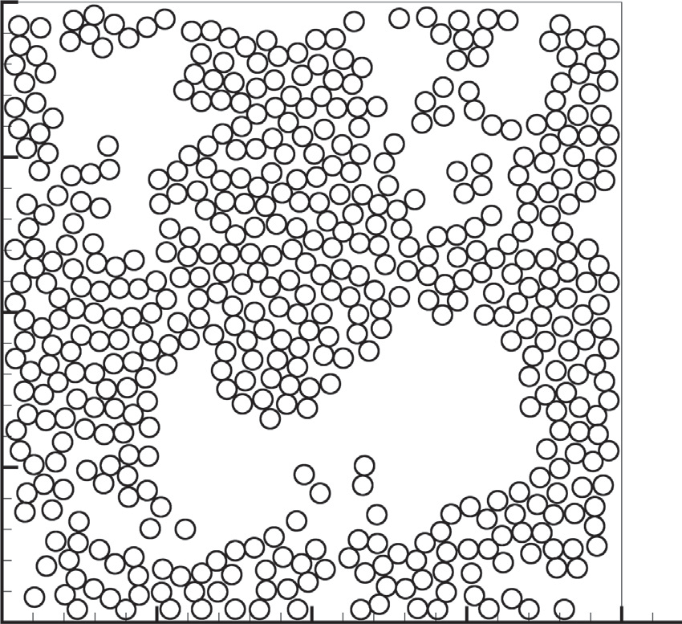

Fig.16 Positions of the 504 particles at time t=5 *s*.

At t=5 *s*, the two particle branches carried by the vortex impact at the perpendicular bisector of the base. The impact shoots the particles up into the circular region and two fluid pockets are formed, as seen in Fig.16. At the same time, some particles in the center are rose but against the falling particles. Frequent collisions between the particles tear those two vortexes at the upper half to small eddies. Some of the small eddies further merge into big ones while others are dissipated. Complex interactions between the particles and fluid take place until all the particles settle at the bottom of the cavity and an equilibrium state is reached.

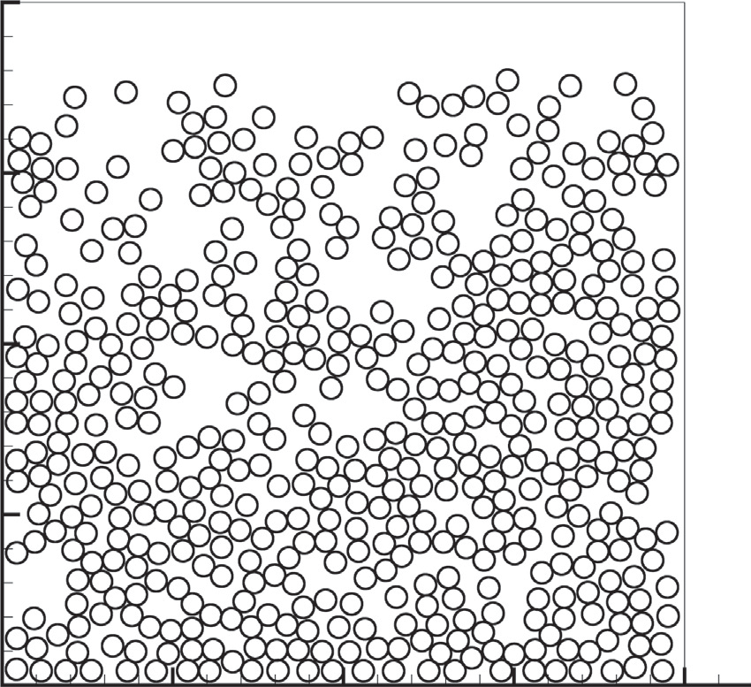

Fig.17 Positions of the 504 particles at time t=8 *s*.

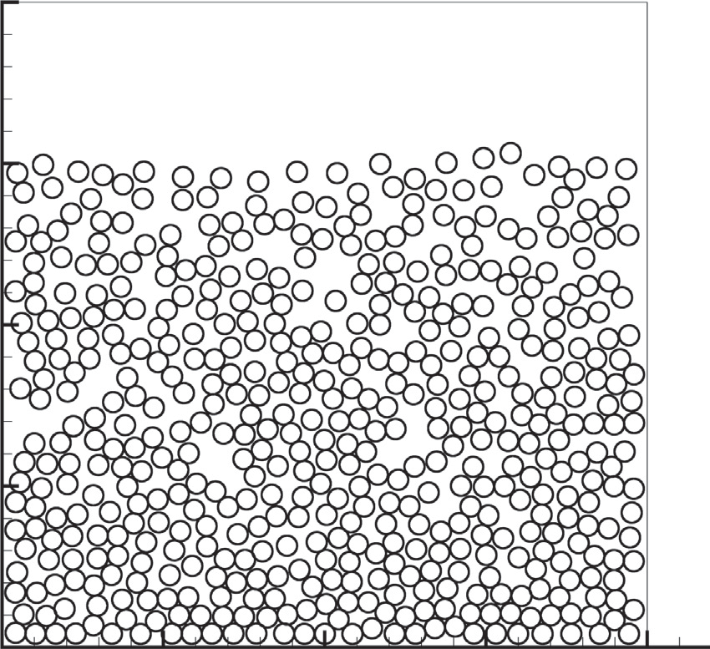

Fig.18 Positions of the 504 particles at time t=12 *s*.

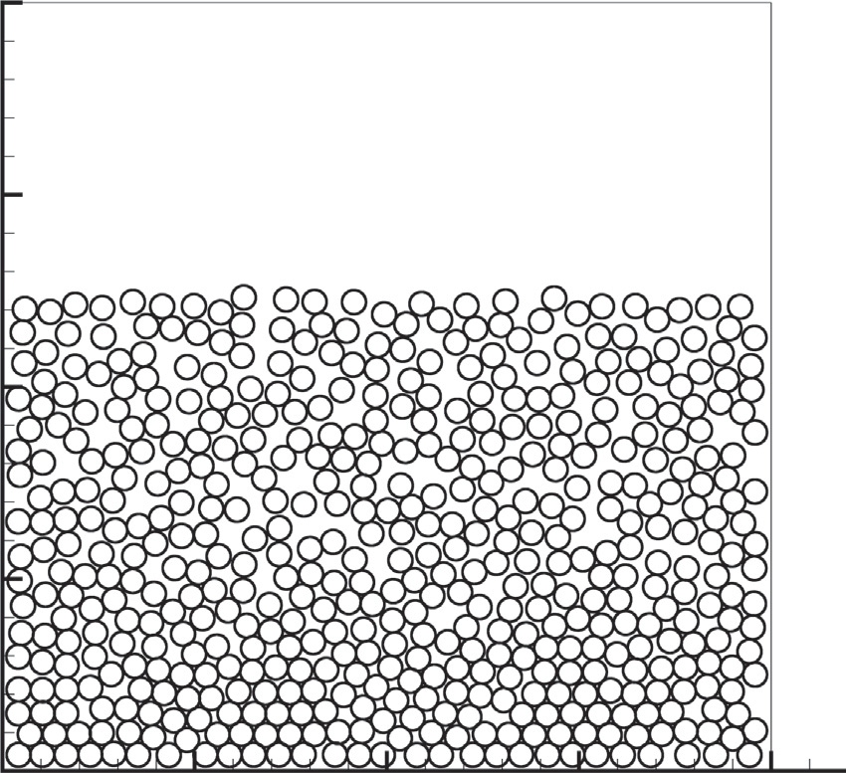

Fig.19 Positions of the 504 particles at time t=24 *s*.

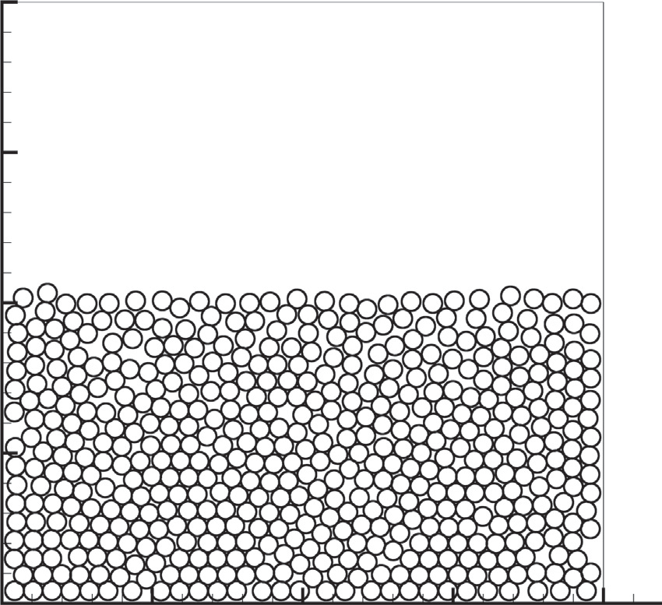

Fig.20 Positions of the 504 particles at time t=48 *s*.

Figs.17, 18, 19 and 20 show the further stages of the settling process, the evolution of the particle bed height has a good agreement with that obtained by Feng and Michaelides [3]. However, main differences are found near the base of the cavity when the particles fall down. The packing is not as orderly as that shown in the results of Feng and Michaelides [3]. Our simulation shows that the evolution of the particle patterns can be markedly influenced by the initial set of the particles. The initial condition adopted here is slightly different with that adopted in [3]. This difference has not made any discrepancy on the particle distribution until t=5 *s* (Fig.16). In [3], the two particle arms seem to be synchronously shot up and then fall down vertically. This gives rise to the generation of two small gaps when t=24 *s*. Whereas as shown in Fig.16 in this study, at t=5 *s* the left branch has more power and beats the right one, the strike shifts the prospective vertical motion into transverse ones. The succeeding results show that the transverse movement does not change the sedimentation speed evidently but does flat the gaps. An exactly same initial set as in [3] has been tried, however a more serious deviation was found. Another reason of all this discrepancy can be due to the interaction law as discussed above. The evidence is that some arched holes are formed at the lowest line of particles, which cannot happen when the surface friction is not taken into account.

1. **Concluding remarks**

This paper presents a novel coupled LBM-IBM-DEM methodology for the numerical simulation of particle-fluid problems. The fluid field is solved by LBM, the hydrodynamic interactions between fluid and particles are realized through the momentum exchange of the particles. The coupling scheme preserves the merits of LBM and IBM by using two unrelated computational meshes, an Eulerian mesh for the flow domain and a Lagrangian mesh for the moving particles. In particular the particle interactions are modeled by the DEM based on contact mechanics. The combined model has been validated by comparing the results with those from previous simulations on the settling of single sphere and the DKT problem, where good agreement was observed. It is observed that the collision scheme and parameters play a very important role in the accurate simulation of particulate flow and the LBM-IBM-DEM scheme can work well when the real physical parameters of the particles were adopted in the simulation. Finally, by conducting a numerical simulation of sedimentation we have shown that the proposed approach is a promising numerical solution for the simulation of particle-fluid interaction problems.

**Acknowledgement**

Hao Zhang would like to acknowledge the FI-AGAUR doctorate scholarship granted by the Secretaria d’Universitats i Recerca (SUR) del Departament d’Economia i Coneixement (ECO) de la Generalitat de Catalunya, and by the European Social Fund. Yuanqiang Tan would like to thank the Aid program for Science and Technology Innovative Research Team in Higher Educational Institutions of Hunan Province [2012] 318. Francesc Xavier Trias would like to thank the financial support by the *Ramon y Cajal* postdoctoral contracts (RYC-2012-11996) by the *Ministerio de Ciencia e Innovacion*. We are thankful to Prof. Mingjun Li and Dr. Haizhuan Yuan (Xiangtan University, China) for their insightful suggestions on the LBM-IBM-DEM code. We also thank the anonymous reviewers for their comments and remarks which helped to improve the quality of this work.

**References**

* 1. Ladd AJC. Numerical simulations of particulate suspensions via a discretized Boltzmann equation Part I. Theoretical foundation. Journal of Fluid Mechanics 1994;271: 285–310.
  2. Ladd AJC. Numerical simulations of particulate suspensions via a discretized Boltzmann equation. Part II. Numerical results. Journal of Fluid Mechanics 1994;271: 311–339.
  3. Feng ZG, Michaelides E. The Immersed Boundary-Lattice Boltzmann Method for Solving Fluid-Particles Interaction Problems. Journal of Computational Physics 2004;195(2):602–628.
  4. Feng ZG, Michaelides E. Proteus: A Direct Forcing Method in the Simulations of Particulate Flow. Journal of Computational Physics 2005;202(1):20–51.
  5. Niu XD, Shu C, Chew YT, Peng Y. A momentum exchange-based immersed boundary-lattice Boltzmann method for simulating in compressible viscous flows. Physics Letters A 2006;354(3):173-182.
  6. Peng Y, Shu C, Chew YT, X.D. Niu XD, Lu XY. Application of multi-block approach in the immersed boundary–lattice Boltzmann method for viscous fluid flows. Journal of Computational Physics 2006;218 (2):460–478.
  7. Shu C, Niu XD, Chew YT. A novel immersed boundary velocity correction–lattice Boltzmann method and its application to simulate flow past a circular cylinder. Journal of Computational Physics 2007;226 (2):1607–1622.
  8. Wu J, Shu C. Implicit velocity correction-based immersed boundary-lattice Boltzmann method and its applications. Journal of Computational Physics 2009;228 (6):1963–1979.
  9. Wu J, Shu C, Zhang YH. Simulation of incompressible viscous flows around moving objects by a variant immersed boundary-Lattice Boltzmann method. International Journal for Numerical Methods in Fluids 2010;62(3) 327–354.
  10. Wu J, Shu C. Particulate Flow Simulation via a Boundary Condition-Enforced Immersed Boundary-Lattice Boltzmann Scheme. Communications in Computational Physics 2010;7:793–812.
  11. Wu J, Shu C. An improved immersed boundary-lattice Boltzmann method for simulating three-dimensional incompressible flows. Journal of Computational Physics 2010;229 (13):5022–5042.
  12. Wu J, Shu C. Simulation of three-dimensional incompressible flows over moving objects by an improved immersed boundary-lattice Boltzmann method. International Journal for Numerical Methods in Fluids 2012;68(8):977–1004.
  13. Noble DR, Torczynski JR. A lattice-Boltzmann method for partially saturated computational cells. International Journal of Modern Physics C 1998;09(08):1189–1201.
  14. Cook BK, Noble DR, Williams JR. A direct simulation method for particle-fluid systems. Engineering Computation 2004;21: 151–168.
  15. Han K, Feng YT, Owen DRJ. Coupled lattice Boltzmann and discrete element modeling of fluid–particle interaction problems. Computers and Structures 2007;85 (11):1080–1088.
  16. Feng YT, Han K, Owen DRJ. Coupled lattice Boltzmann method and discrete element modelling of particle transport in turbulent fluid flows: Computational issues. International Journal for Numerical Methods in Engineering 2007;72(9): 1111–1134.
  17. Feng YT, Han K, Owen DRJ. Combined three-dimensional lattice Boltzmann method and discrete element method for modelling fluid–particle interactions with experimental assessment. International Journal for Numerical Methods in Engineering 2010;81(3):229–245.
  18. Han K, Feng YT, Owen DRJ. Three-dimensional modelling and simulation of magnetorheological fluids. International Journal for Numerical Methods in Engineering 2010;84 (11):1273–1302.
  19. Owen DRJ, Leonardi CR, Feng YT. An efficient framework for fluid–structure interaction using the lattice Boltzmann method and immersed moving boundaries. International Journal for Numerical Methods in Engineering 2011;87 (1-5):66–95.
  20. Zhang H, Tan YQ, Li MJ. A Numerical Simulation of Motion of Particles under the Wafer in CMP. In: International Conference on Computer Science and Soft ware Engineering. Wuhan, China. 2008;3:31-34.
  21. Wang LM, Zhou GF, Wang XW, Xiong QG, Ge W. Direct numerical simulation of particle-fluid systems by combining time-driven hard-sphere model and lattice Boltzmann method. Particuology 2010;8(4):379-382.
  22. Peskin CS. Numerical analysis of blood flow in the heart. Journal of Computational Physics 1977;25(3):220–252.
  23. Yu AB, Xu BH. Particle-scale modelling of gas-solid flow in fluidisation. Journal of Chemical Technology and Biotechnology 2003;78(2-3):111-121.
  24. Cundall PA. A Computer Model for Simulating Progressive Large Scale Movements in Blocky Systems. In: Muller led, ed. Proceedings of the Symposium International Society of Rock Mechanics.Rotterdam: Balkama A A. 1971;1:8-12.
  25. Zhu HP, Zhou ZY, Yang RP, Yu AB. Discrete particle simulation of particulate systems: Theoretical developments. Chemical Engineering Science 2007;62(13):3378-3396.
  26. Tsuji Y, Kawaguchi T, Tanaka T. Discrete particle simulation of two-dimensional ﬂuidized-bed. Powder Technology 1993;77(1):79-87.
  27. Hoomans BPB, Kuipers JAM, Briels WJ, Swaaij WPMV. Discrete particle simulation of bubble and slug formation in a two-dimensional gas-fluidised bed: A hard-sphere approach. Chemical Engineering Science 1996;51(1):99-118.
  28. Xu BH, Yu AB, Numerical simulation of the gas-solid flow in a fluidized bed by combining discrete particle method with computational fluid dynamics. Chemical Engineering Science 1997;52(16):2785-2809.
  29. Kafui KD, Thornton C, Adams MJ. Discrete particle-continuum fluid modeling of gas-solid fluidized beds. Chemical Engineering Science 2002;57(13):2395-2410.
  30. Chu KW, Yu AB. Numerical simulation of the gas-solid flow in three-dimensional pneumatic conveying bends. Industrial Engineering Chemical Research 2008;47(18):7058-7071.
  31. Tan YQ, Zhang H, Yang DM, Jiang SQ, Song JH, Sheng Y. Numerical simulation of concrete pumping process and investigation of wear mechanism of the pipe wall. Tribology International 2012;46(1):137-144.
  32. Zhang H, Tan YQ, Yang DM, Trias FX, Jiang SQ, Sheng Y, Oliva A. Numerical investigation of the location of maximum erosive wear damage in elbow: effect of slurry velocity, bend orientation and angle of elbow. Powder Technology 2012;217(0): 467-476.
  33. Chu KW, Yu AB. Numerical Simulation of complex particle-fluid flows. Powder Technology 2008;179(3):104-114.
  34. Chu KW, Wang B, Yu AB, Vince A. Computational study of the multiphase flow in a dense medium cyclone: Effect of particle density. Chemical Engineering Science 2012;73:123-139.
  35. Chu KW, Wang B, Yu AB, Vince A. Particle scale modeling of the multiphase flow in a dense medium cyclone: Effect of vortex finder outlet pressure. Minerals Engineering 2012;31:46-58.
  36. Felice RD. The voidage function for fluid-particle interaction systems. International Journal on Multiphase Flow 1994;20(1):153-159
  37. Zhang B, Wang LM, Wang XW, Zhang XR, Ge W, Li JH. Discrete particle simulation of bubbling bed with jet flow at a single orifice based on the lattice Boltzmann method. Chinese Science Bulletin 2013;58:158-169.
  38. Li JH, Kwauk M. Particle-fluid two-phase flow: The Energy-minimization Multi-scale Method. Beijing: Metallurgical Indestry Press, 1994.
  39. Stevens AB, Hrenya CM. Comparison of soft-sphere models to measurements of collision properties during normal impacts. Powder Technology 2005;154:99-109
  40. Qian Y, d’Humieres D, Lallemand P. Lattice BGK models for Navier-stokes equation. Europhysics Letters 1992;17(6): 479-484.
  41. Johnson KL. Contact mechanics. Cambridge University Press : Cambridge, 1985.
  42. Mindlin RD, Deresiewicz H, Elastic spheres in contact under varying oblique forces. Journal of Applied Mechanics 1953;20: 327–344.
  43. Thornton C, Yin KK. Impact of elastic spheres with and without adhesion. Powder Technology 1991;65(1) 153-166.
  44. Thornton C, Ning Z. A theoretical model for the stick/bounce behavior of adhesive, elastic-plastic spheres. Powder Technology 1998;99(2) :154-162.
  45. Yue XQ, Zhang H, Luo C, Shu S, Feng CS. Parallelization of a DEM code based on CPU-GPU heterogeneous architecture. Communications in Computer and Information Science 2013;405: 149-159.
  46. Sheng Y, Lawrence CJ, Briscoe BJ. 3D DEM simulation of powder compaction, In: Discrete Element Methods: Numerical Modeling of Discontinua. Geotechnical Special Publication, 2002;117: 305-310.
  47. Sheng Y, Lawrence CJ, Briscoe BJ. Numerical studies of uniaxial powder compaction process by 3D DEM. Engineering Computations 2004;21(2/3/4):304-317.
  48. Wan D, Turek S. Direct numerical simulation of particulate flow via multigrid FEM techniques and the fictitious boundary method. International Journal for Numerical Methods in Fluids 2006;51(5): 531–566.
  49. Gondret P, Lance M, Petit L. Bouncing motion of spherical particles in fluids. Physics of Fluids 2002;13: 643-652.
  50. Hu HH, Patankar NA, Zhu MY. Direct numerical simulations of fluid-solid systems using the arbitrary Lagrangian-Eulerian Technique. Journal of Computational Physics 2001;169(2): 427–462.
  51. Patankar NA, Singh P, Joseph DD, Glowinski R, Pan TW. A new formulation of the distributed Lagrange multiplier/fictitious domain method for particulate flows. International Journal of Multiphase Flow 2000;26(9): 1509-1524.
  52. Fortes AF, Joseph DD, Lundgren TS. Nonlinear mechanics of fluidization of beds of spherical particles, Journal of Fluid Mechanics 1987;177: 467–483.