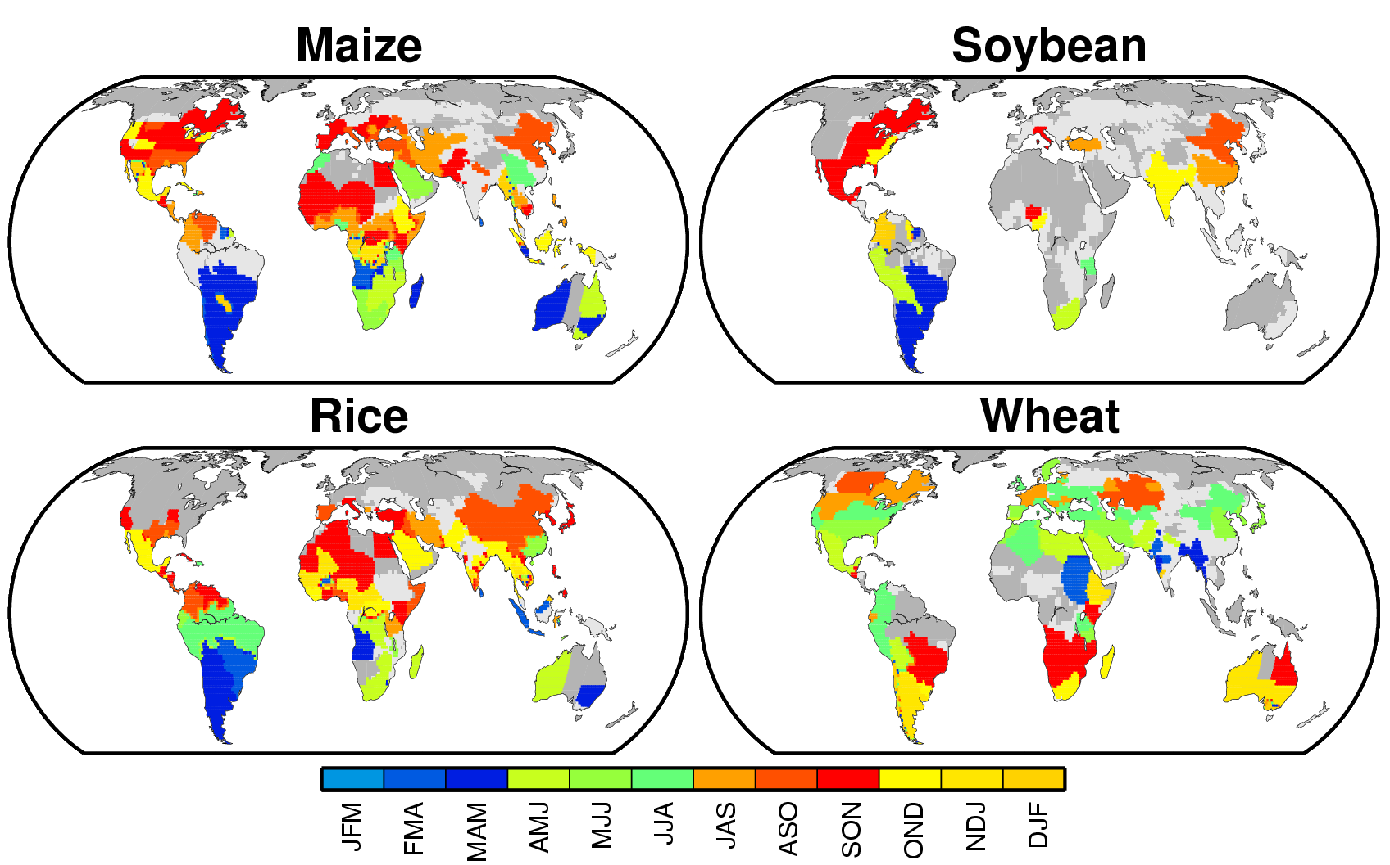
Supplementary Figure 1. Months of the reproductive growth period for four crops. Data for major and secondary cropping systems for maize and rice, winter and spring cropping systems for wheat and a single major cropping system for soybean are presented (only the major or winter cropping system is presented if both systems are used in a grid cell). Light grey indicates that the crop calendar is unavailable, and dark grey designates non-cropland.

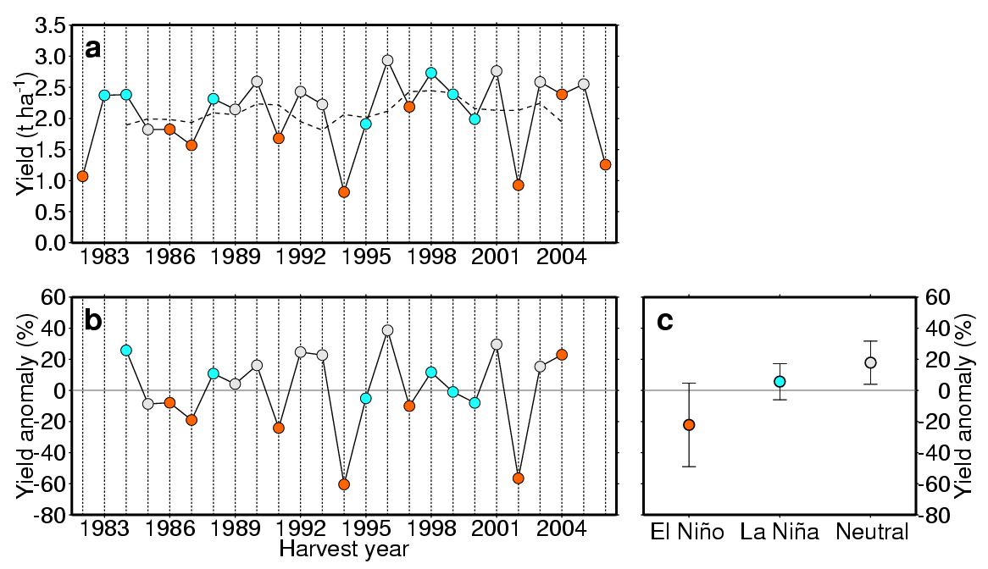
Supplementary Figure 2. a, Yearly time series of wheat yield (solid line) in Goondiwindi, Australia (28.598°S; 150.750°E); orange (blue) symbols indicate the incidence of El Niño (La Niña) during the reproductive growth period of wheat in that location; the dashed line indicates normal yield (five-year running mean); b, percentage yield anomaly; and c, average percentage yield anomaly and one standard deviation (error bar) during each ENSO phase. The sample size used for the calculation of the standard deviation for El Niño, La Niña and neutral years is 7, 6 and 8, respectively.
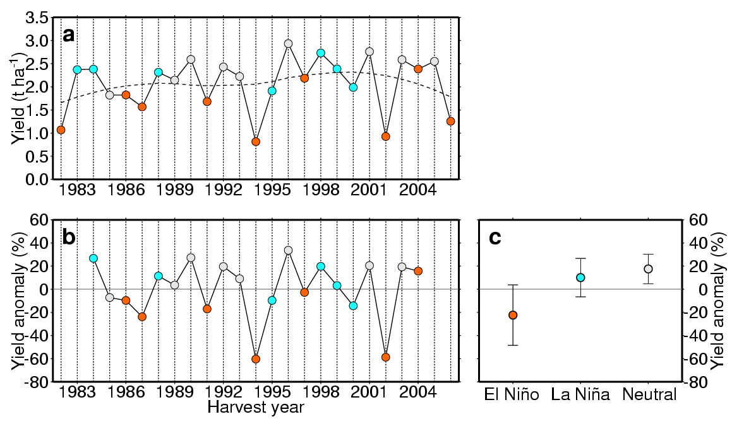
Supplementary Figure 3. a, Yearly time series of wheat yield (solid line) in Goondiwindi, Australia (28.598°S; 150.750°E); orange (blue) symbols indicate the incidence of El Niño (La Niña) during the reproductive growth period of wheat in that location; the dashed line indicates normal yield (local polynomial regression curve); b, percentage yield anomaly; and c, average percentage yield anomaly and one standard deviation (error bar) during each ENSO phase. The sample size used for the calculation of the standard deviation for El Niño, La Niña and neutral years is 7, 6 and 8, respectively.
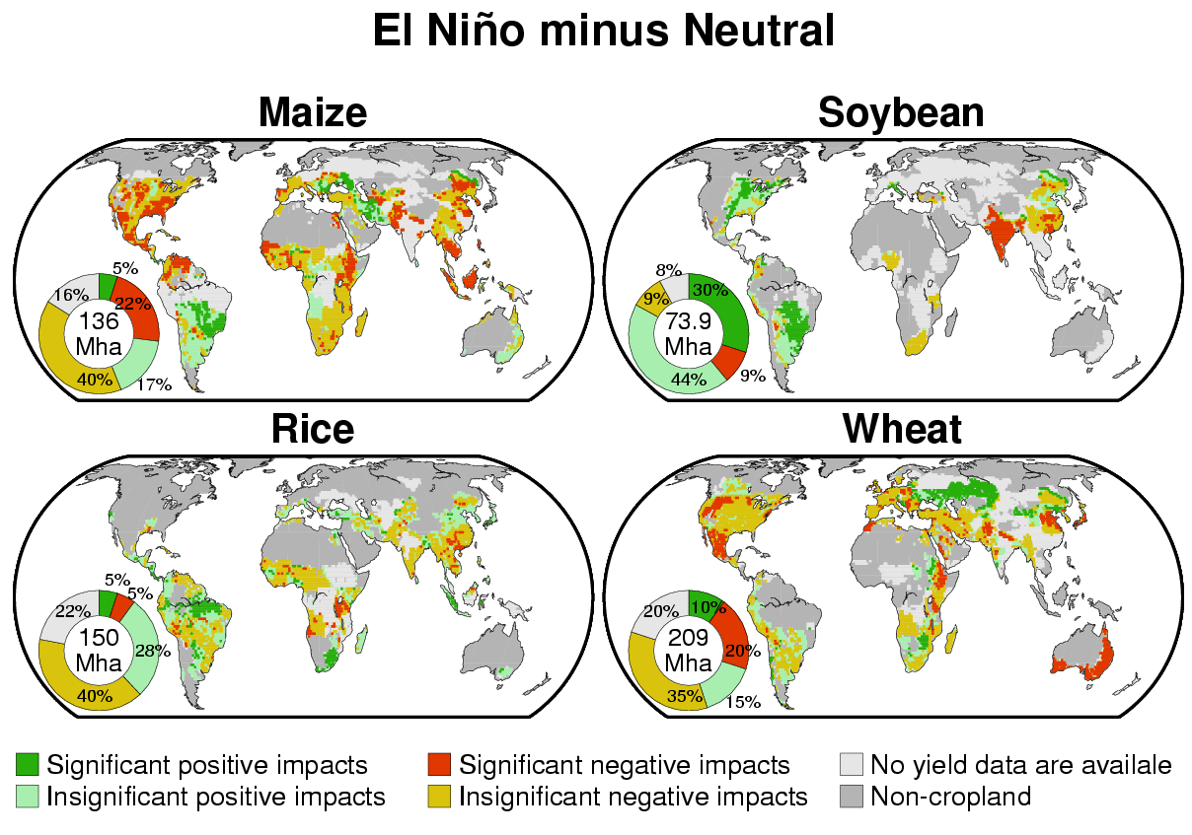
Supplementary Figure 4. Impacts of El Niño on crop yield anomalies for four crops. The local polynomial regression method was used to calculate normal yields. The significance of difference in averaged yield anomaly between El Niño years and neutral years was set to the 10% level (using the bootstrap with iteration of 10,000 times; the sample size is 7 for El Niño and 8 for neutral years). The pie diagrams indicate the percentages of harvested area in the aforementioned areas. All data in the pie diagrams are normalised to the global harvested area in 2000.
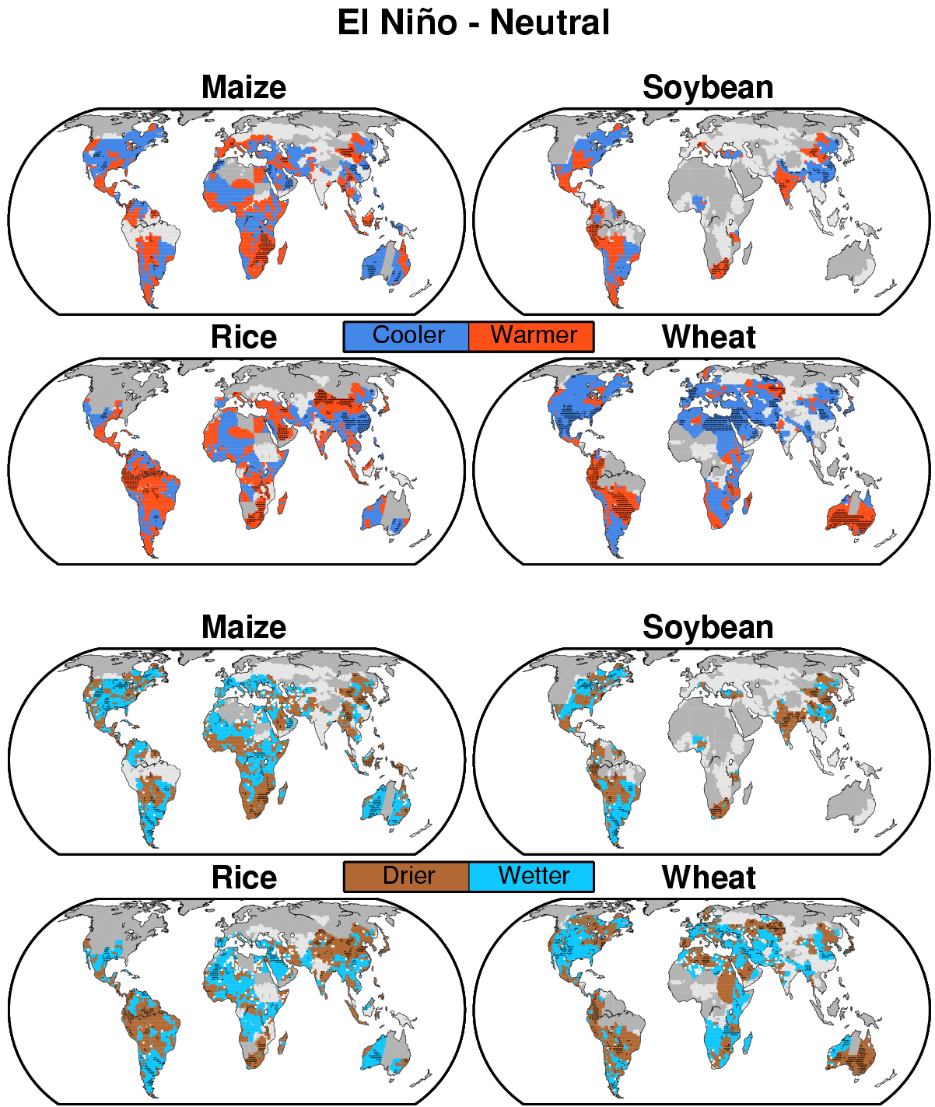
Supplementary Figure 5. Differences between average temperature (upper panels) and soil moisture content (lower panels) over the reproductive growth period in El Niño years and those in neutral years for four crops. In the upper panels, red designates warmer conditions in El Niño years compared with conditions in neutral years and blue designates cooler conditions in El Niño years compared with those in neutral years. In the lower panels, blue designates wetter conditions in El Niño years compared with those in neutral years and brown designates drier conditions in El Niño years compared with those in neutral years. Light grey indicates that the crop calendar is unavailable, dark grey designates non-cropland, and dots indicate that the difference is significant at the 10% level (using the bootstrap with iteration of 10,000 times; the sample size is 7 for El Niño and 8 for neutral years).
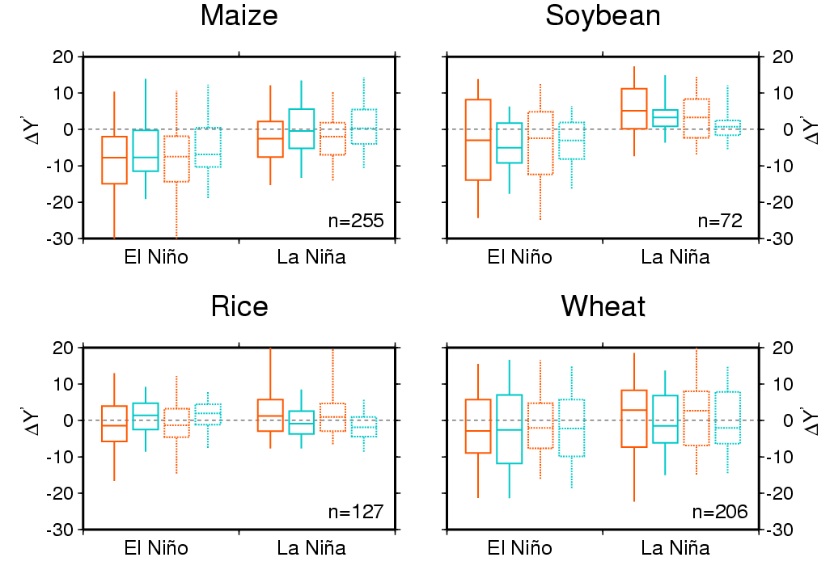
Supplementary Figure 6. Box plots of the grid-cell difference in averaged yield anomalies between El Niño (or La Niña) years and neutral years, , for the irrigated (blue) and rainfed (orange) cropland for four crops. The five-year running mean method (solid line) and local polynomial regression method (dashed line) were separately used to calculate the normal yields. Horizontal line—the median. Lower and upper hinges of a box—the 25% and 50% tiles, respectively. Vertical bar—the 90% interval. The sample size (n) used for the calculation of these statistics is presented in each panel.
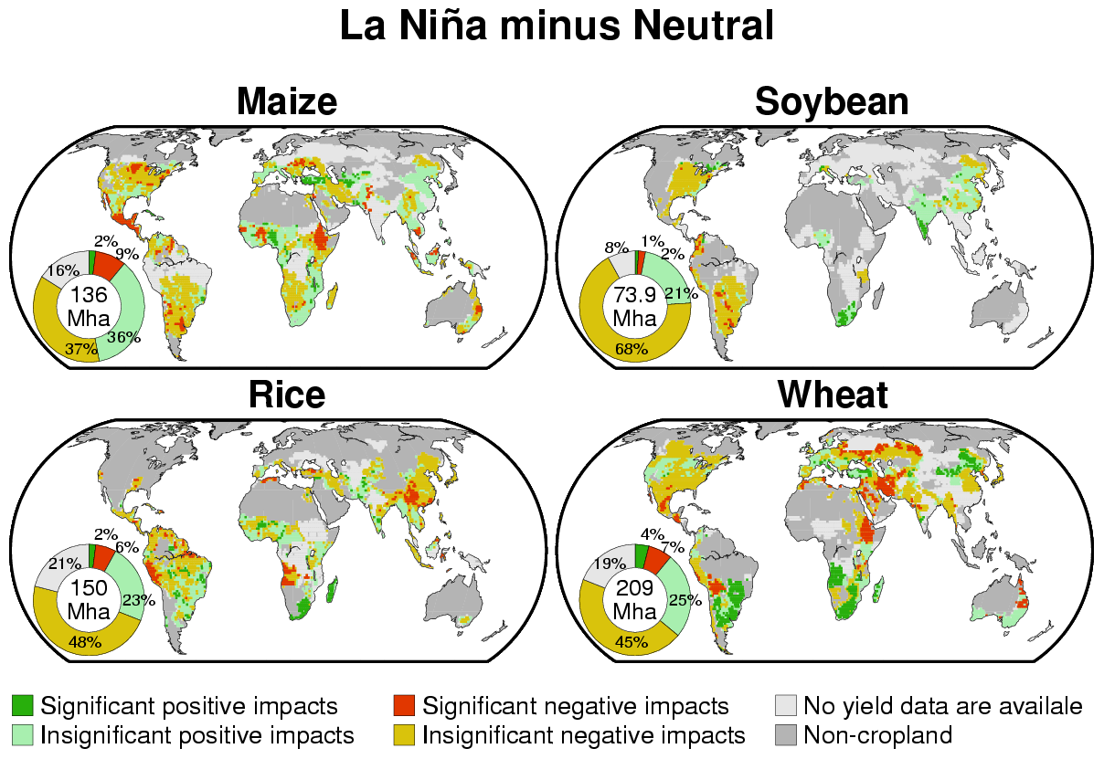
Supplementary Figure 7. Impacts of La Niña on crop yield anomalies for four crops. The local polynomial regression method was used to calculate normal yields. The significance of difference in averaged yield anomaly between La Niña years and neutral years was set to the 10% level (using the bootstrap with iteration of 10,000 times; the sample size is 6 for La Niña and 8 for neutral years). The pie diagrams indicate the percentages of harvested area in the aforementioned areas. All data in the pie diagrams are normalised to the global harvested area in 2000.
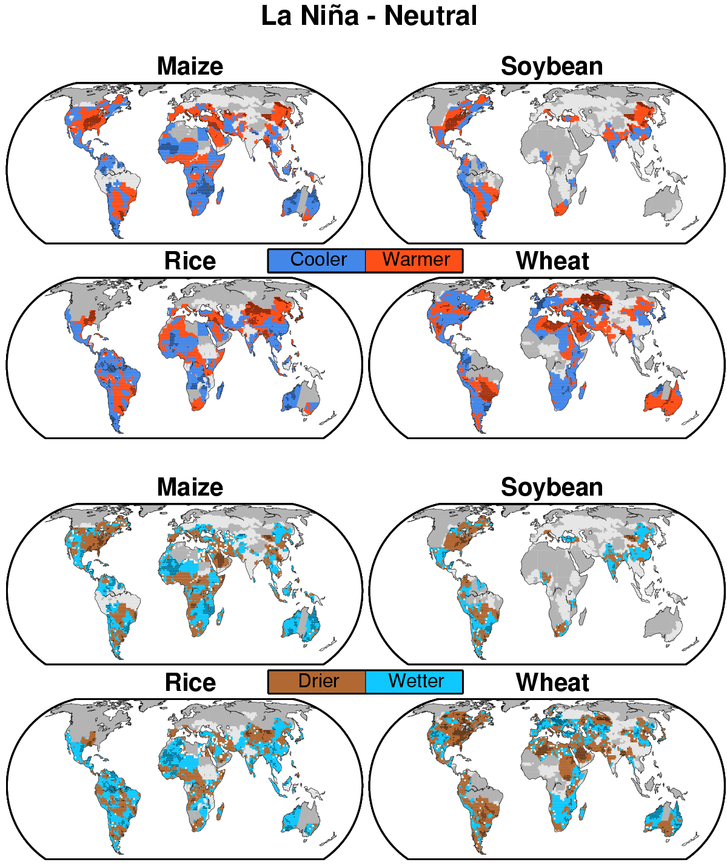
Supplementary Figure 8. Differences between average temperature (upper panels) and soil moisture content (lower panels) over the reproductive growth period in La Niña years and those in neutral years for four crops. In the upper panels, red designates warmer conditions in La Niña years compared with conditions in neutral years and blue designates cooler conditions in La Niña years compared with those in neutral years. In the lower panels, blue designates wetter conditions in La Niña years compared with those in neutral years and brown designates drier conditions in La Niña years compared with those in neutral years. Light grey indicates that the crop calendar is unavailable, dark grey designates non-cropland, and dots indicate that the difference is significant at the 10% level (using the bootstrap with iteration of 10,000 times; the sample size is 6 for La Niña and 8 for neutral years).

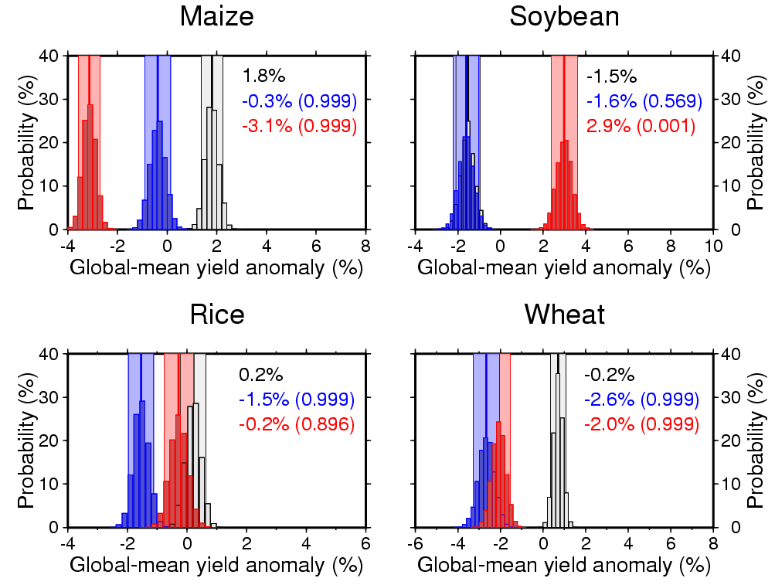
Supplementary Figure 9. Global-mean yield anomalies for four crops during El Niño, La Niña and neutral years. The local polynomial regression method was used to calculate normal yields. Histograms of global-mean yield anomalies (deviations from normal yields) in El Niño years (red), La Niña years (blue) and neutral years (grey). The numbers in each panel are the mean values. The numbers in parentheses indicate the bootstrap probability that the global-mean yield anomaly in El Niño (La Niña) years is lower than that in neutral years. A bootstrap probability value of 0.999 (0.001) indicates a significantly smaller (larger) global-mean yield anomaly in El Niño (La Niña) years compared with that in neutral years at the 0.1% level (using the bootstrap with iteration of 10,000 times).

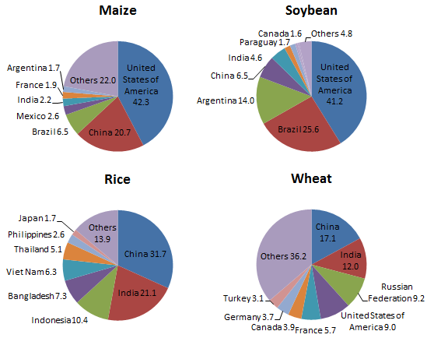
Supplementary Figure 10. Global shares of the production of four crops in 2009 by country. The source of this data is the Food and Agriculture Organization of the United Nations (FAO).
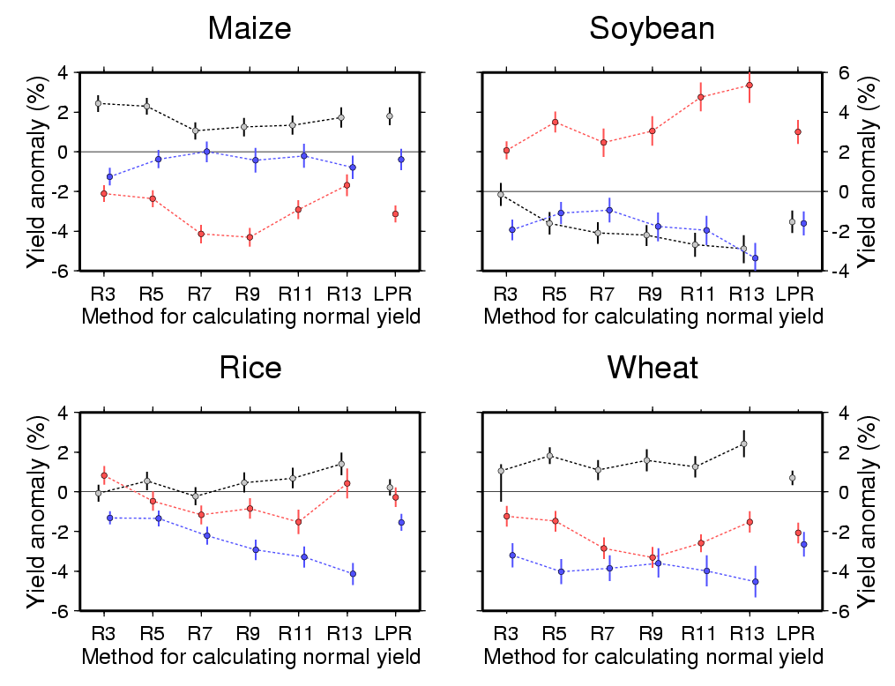
Supplementary Figure 11. Global-mean yield anomalies of four crops for each phase of ENSO (El Niño years, red; La Niña years, blue; and neutral years, grey) calculated relative to different year running mean yields. R3 to R13 indicates the three-year to thirteen-year running mean method with two-year interval. The results from the five-year running mean method (R5) are the same as those presented in Fig. 4. The results from the local polynomial regression method (LPR) are the same as those presented in Supplementary Fig. 9 and shown as the reference. Vertical bar—the 90% interval (using the bootstrap with iteration of 10,000 time; The sample size for El Niño, La Niña and neutral years is 7, 6 and 8, respectively).

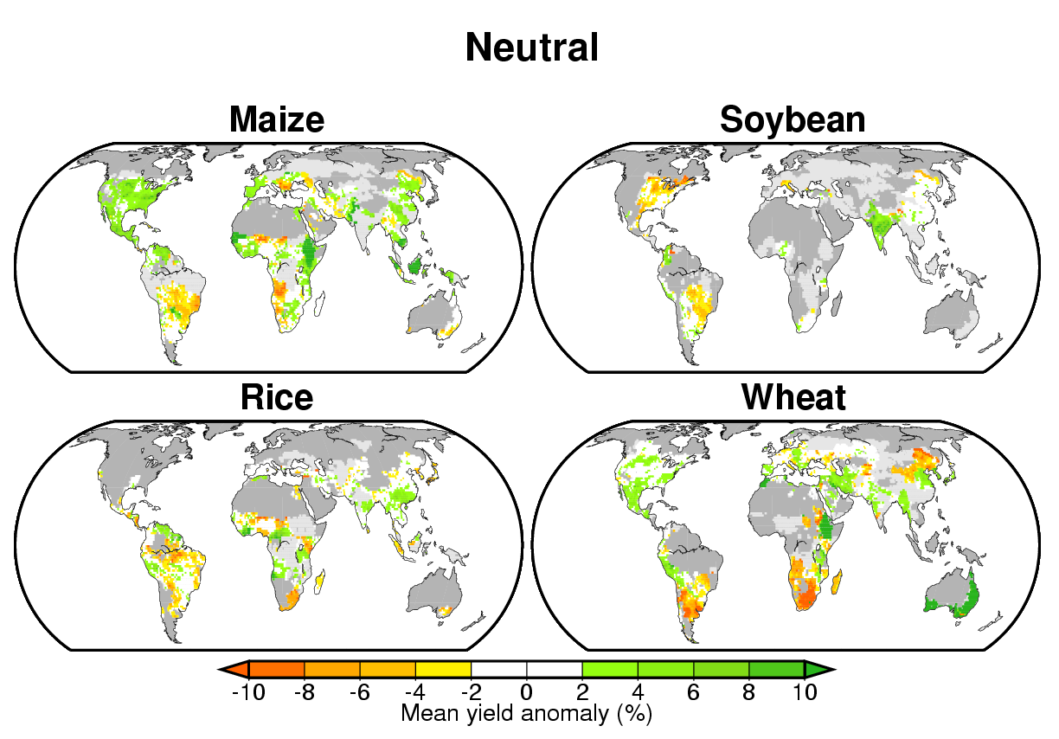
Supplementary Figure 12. Average yield anomalies in neutral years for four crops deviating from normal yields calculated by using the five-year running mean method.
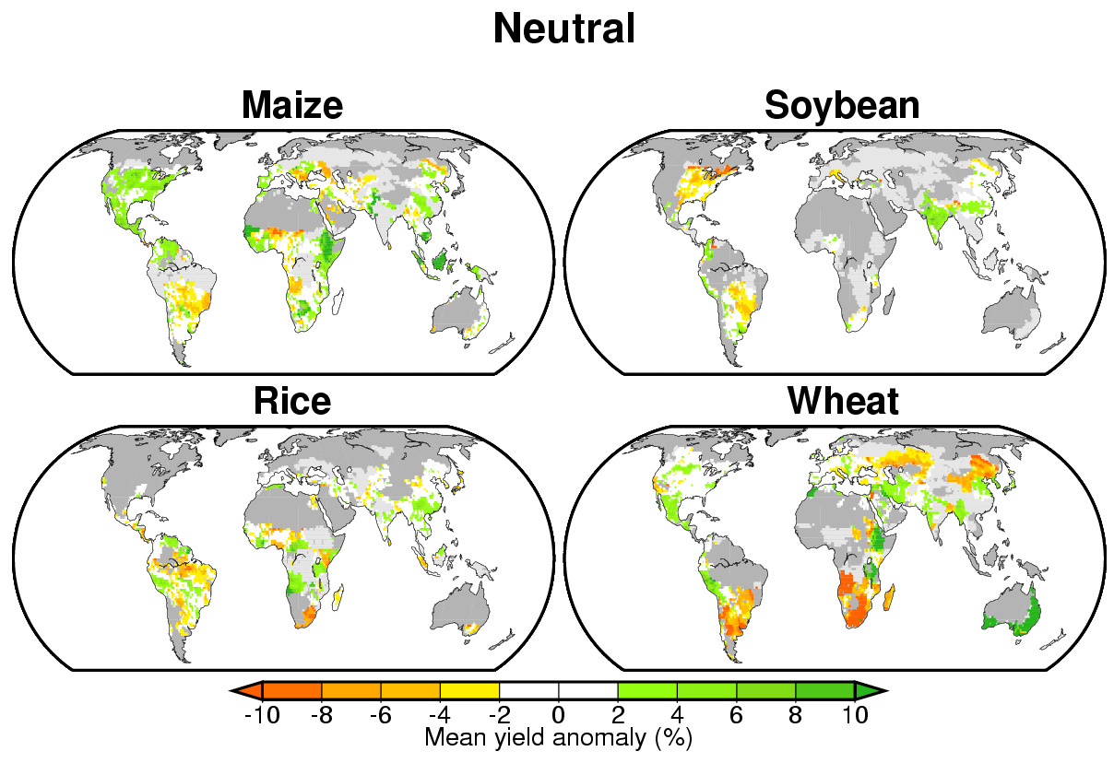
Supplementary Figure 13. Average yield anomalies in neutral years for four crops deviating from normal yields calculated by using the local polynomial regression method.

Supplementary Table 1. A summary of the comparison in the impacts of ENSO on crop yields between this study and previous regional studies. Crops, countries, impacts of ENSO on yields found in this study and those reported in previous studies, years examined in previous studies and references are provided.
Country | This study |  | Previous study |  | Years | Reference²
 | El Niño¹ | La Niña | El Niño | La Niña
Maize
Argentina | +/- | - | + | - | 1950-1994 | Ref. 1
China | - | +/- | - | + | 1961-2001 | Ref. 2
China | - | (+) | - | - | 1956-2006 | Ref. 3
United States | - | - | - | N.A. | 1968-1994 | Ref. 4
United States (Corn Belt) | +/- | - | + | - | 1982-1997 | Ref. 5
Uruguay | + | - | + | - | 1950-1999 | Ref. 6
Zimbabwe | (+) | - | + | - | 1970-1993 | Ref. 7
Soybean
Argentina | + | - | + | - | 1972-1996 | Ref. 8
Rice
Indonesia | +/- | (+)/(-) | (-) | (+) | 1983-2001 | Ref. 9
Uruguay | - | + | - | + | 1972-2003 | Ref. 10
Wheat
Argentina (north) | +/- | +/- | N.A. | - | 1950-1994 | Ref. 1
Argentina (south) | +/- | +/- | + | N.A. | 1950-1994 | Ref. 1
Australia (eastern) | - | - | - | (-) | 1886-1993 | Ref. 11
Brazil (southern) | (-) | (+) | + | - | 1917-1996 | Ref. 11
Canada | +/- | - | +/- | N.A. | 1968-1994 | Ref. 4
China (northeast) | - | - | - | - | 1956-2006 | Ref. 3
United States | - | - | +/- | N.A. | 1968-1994 | Ref. 4
United States (Southeast) | - | - | (+)/(-) | - | 1960-1995 | Ref. 12
¹ “+” and “-” indicates the significant positive and negative impacts on yield, respectively; “(+)” and “(-)” indicates the insignificant positive and negative impacts on yield, respectively; “+/-” indicates that both the significant positive and negative impacts appear in a given area; and “N.A.” indicates the data are not available from references.
² See Supplementary Reference.

Supplementary References
- Travasso, M.I., Magrin, G.O. & Rodríguez, G.R. Relations between sea-surface temperature and crop yields in Argentina. Int. J. Climatol. 23, 1655-1662 (2003).
- Tao, F. et al. Variability in climatology and agricultural production in China in association with the East Asian summer monsoon and El Niño southern oscillation. Clim. Res. 28, 23-30 (2004).
- Liu, Y., Yang, X., Wang, E. & Xue, C. Climate and crop yields impacted by ENSO episodes on the North China Plain: 1956–2006. Reg. Environ. Chang, doi: 10.1007/s10113-013-0455-1 (2013)
- Izaurralde, R.C. et al. Modeled effects of moderate and strong `Los Niños' on crop productivity in North America. Agric. For. Meteorol. 94, 259-268 (1999).
- Wannebo, A. & Rosenzweig, C. Remote sensing of US cornbelt areas sensitive to the El Niño–Southern Oscillation. Intl. J. Remote Sensing 24, 2055–2067 (2003).
- Baethgen, W.E. & Giménez, A. Seasonal climate forecasts and the agricultural Sector of Uruguay. http://iri.columbia.edu/climate/ENSO/societal/example/Baethgen.html#fig1 (2013)
- Cane, M.A., Eshel, G. & Buckland, R.W. Forecasting Zimbabwean maize yield using eastern equatorial Pacific sea surface temperature. Nature 370, 204–205 (1994).
- Podestá, G.P., Messina, C.D., Grondona, M.O. & Magrin, G.O. Associations between grain crop yields in central-eastern Argentina and El Niño–Southern Oscillation. J. Appl. Meteor. 38, 1488–1498 (1999).
- Falcon, W.P. et al. Using climate models to improve Indonesian food security. Bull. Indonesia Econ. St. 40, 355-377 (2004).
- Roel, A. & Baethgen, W.E. Towards the development of a spatial decision support system (SDSS) for the application of climate forecasts in Uruguayan rice production sector. In: Sivakumar, M.V.K. & Hansen, J. (eds.), Climate Prediction and Agriculture: Advances and Challenges, 89-97 (2007).
- Meinke, H. & Stone, R.C. On tactical crop management using seasonal climate forecasts and simulation modelling: a case study for wheat. Sci. agric. 54, 121-129 (1997).
- Hansen, J.W., Hodges, A. W. & Jones, J.W. ENSO influences on agriculture in the southeastern United States. J. Clim. 11, 404–411 (1998).

