Appendix C: Holmstrup (2001) Simulations

Holmstrup (2001) found the growth rate of juveniles and reproduction rate of adults to decline with decreasing soil water potentials. To model the effects of soil water potential (ψ) on individual energy budgets we assume that ψ reduces the ingestion rate parameter (IG_{max}). By reducing individual ingestion rates according to a dose-response curve, growth and reproduction are reduced as less energy (than under optimal soil water conditions) is available for metabolic expenditure. Because of the energy allocation priorities shown in Fig. 1 growth is more reduced than reproduction, a result observed by Holmstrup (2001). We assume the dose-response relationship to take the form:

IG_{max} (ψ) = (IG_{max}) e^{kψ} Eq. C.1
where IG_{max} is the parameter value at a soil water potential of -2 kPa (Table 1) and k takes the value 0.040, which provided the least sum of square fit to growth and reproduction data. The resulting relationship between the parameter value of IG_{max} at different soil water potentials is presented in Fig C.1.

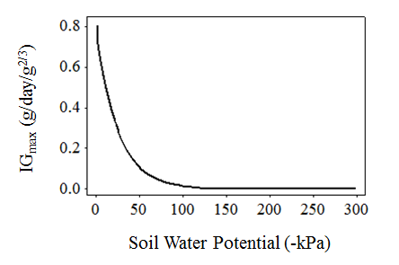
Fig C.1. Modelled dose-response relationship between the ingestion parameter IG_{max} and soil water potential. The curve is specified by equation S3.

To evaluate how well the dose-response in Fig C.1 explains the relationship between soil water potential and individual physiology, we set up the model to replicate the Foulum soil growth and reproduction experiments of Holmstrup (2001). The experimental conditions are outlined in Table C.1.

Table C.1. Experimental conditions used in model simulations for comparison with growth and reproduction data from Holmstrup (2001).
 | Number of Individuals | Initial Mean Individual Mass (g) | Food Resource | SOM (%) | E_{X} (kJ/g) | Food Quantity (g) | T (°C)
Growth | 1 Juvenile | 0.0475 g | 60 g soil + 1 g manure | 4 | 1.09 | 61 | 15
Reproduction | 4 Adults | 1.55 g | 1 kg soil + 5 g manure | 4 | 0.85 | 1005 | 15

Model simulation results when IG_{max} follows the relationship in Eq. C.1 are compared to data from Holmstrup (2001) in Fig C.2. Juvenile biomass and adult cocoon production rates were observed after 28 days exposure to different soil water potentials. Good model fits to the data support our assumptions on how soil water potential alters individual energy budgets.

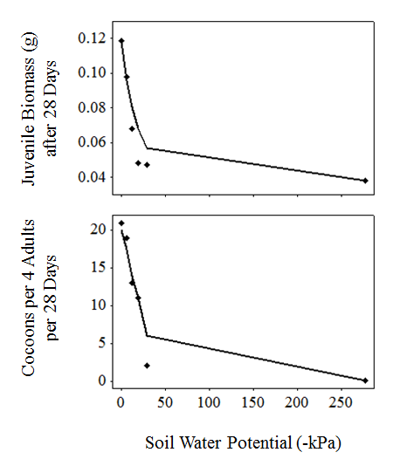
Fig C.2. The effects of soil water potential on juvenile biomass and adult cocoon production. Data (points) from Holmstrup (2001) together with the result of our model simulations (lines).

References
Holmstrup, M., 2001. Sensitivity of life history parameters in the earthworm Aporrectodea caliginosa to small changes in soil water potential. Soil Biol. Biochem. 33, 1217-1223.

