Appendix B: Model Parameterisation

Taxon-specific normalisation constant, B₀
Regression analysis of earthworm data (N=28) by Meehan (2006, p. 881) yielded:

In (maintenance) = 5.70 + 0.71 In(M) – 0.25/𝜅T

in the notation of Fig. 1, where maintenance is measured in J/hour and M in mg. Evaluated at M = 1g and T = 288.15 K (15 °C) gives maintenance = 0.04102 kJ/day. From the equation in Figure 1, B₀ = 0.04102 e ^{0.25/κT} = 968 kJ/day.

Maximum ingestion rate, IG_{max}
In the most comprehensive study of A. caliginosa soil egestion rates Taylor and Taylor (2014) recorded individual gut transit times and gut contents. Gut transit times ranged from 8 to 11.5 hours for individuals weighing 0.21 – 0.708 g. Taking the maximum gut transit time to correspond with the largest individual gives 16.24 hours per g earthworm and thus 1.5 feeding events per day. In the same study A. caliginosa gut contents was recorded by weighing the dry weight of faeces produced during starvation. A mean value of 0.165 g dw faeces was recorded for a mean individual weight of 0.338 g. Using the above values and assuming a dry:wet weight conversion for soil of 1:1.10 the maximum ingestion rate (IG_{max}) is estimated as 0.805 g/day/g. This value is within the range of A. caliginosa ingestion rates reported in the literature, ranging from 0.04 to 1.68 g dry mass g/day (Guild, 1955; Barley, 1959; Curry et al., 1995).

Mass of Cocoon, M_{c} & Mass at Birth, M_{b}
Boström and Lofs-Holmin (1986) and Boström (1987) observed a strong correlation between adult and cocoon mass (Fig. B.1a) and Pedersen and Bjerre (1991) between cocoon mass and hatchling mass at birth (Fig. B.1b) in A. caliginosa. The linear regressions in Fig. B.1a & b are used within the model to predict the parameters mass of cocoon (M_{c}) and mass at birth (M_{b}) from the mass of the reproducing adult.

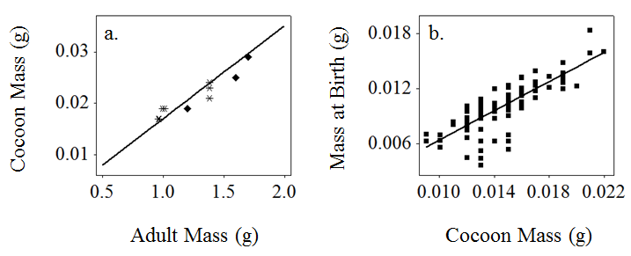
Fig B.1. Linear regressions (lines) used to model relationships between cocoon mass, M_{c}, mass at birth, M_{b}, and adult mass, with data from a) Boström and Lofs-Holmin (1986) (diamond) and Boström (1987) (asterisk) and b) Pedersen and Bjerre (1991) (square).

Growth constant, r_{B}
Sibly et al. (2014) show that the von Bertalanffy growth constant (r_{B}) can be estimated by following:
$$r_{B}=\frac{3}{t_{p}}ln\left\{\frac{1- {\left(\frac{M_{b}}{M_{m}}\right)}^{\frac{1}{3}}}{1- {\left(\frac{M_{p}}{M_{m}}\right)}^{\frac{1}{3}}}\right\}$$

where M_{b} is mass at birth, M_{m} is maximum mass, M_{p} is mass at puberty and t_{p} is time at puberty. Lofs-Holmin (1983) record values for M_{b}, M_{p}, M_{m} and t_{p} for A. caliginosa of 0.025 g, 0.50 g, 2 g and 45 days. These values are used to yield a growth constant value (r_{B}) of 0.049.

Maximum rate of energy allocation to reproduction, r_{m}
Spurgeon et al. (2000) (Table 2, p. 1803) recorded a cocoon production rate of 1.84 per week for A. caliginosa individuals with an average biomass of 0.84 g at 15 °C. This gives a reproduction rate of 0.263 hatchlings individual⁻¹ day⁻¹. The energy costs of producing one cocoon are M_{c} (E_{c} + E_{s}) = 0.174 kJ, where M_{c} is calculated as 0.0164 g from the regression equation in Fig. A1a using an adult mass of 0.84 g. These values give a rate of energy allocation to reproduction of 0.046 kJ/day, and corrected for a 1 g individual gives a r_{m} value of 0.054 kJ/g day⁻¹ (Table 1).

References
Barley, K.P. 1959. The influence of earthworms on soil fertility. II. Consuption of soil and organic matter by the earthworm Allolobophora caliginosa (Savigny). Aust. J. Agr. Res. 10, 179-185.
Boström, U., Lofs-Holmin, A., 1986. Growth of earthworms (Allolobophora caliginosa) fed shoots and roots of barley, meadow fescue and lucerne: Studies in relation to particle size, protein, crude fiber content and toxicity. Pedobiologia 29, 1-12.
Boström, U., 1987. Growth of earthworms (Allolobophora caliginosa) in soil mixed with either barley, lucerne or meadow fescue at various stages of decomposition. Pedobiologia 30, 311-321.
Curry, J.P., Byrne, D., Boyle, K.E., 1995. The earthworm population of a winter cereal field and its effects on soil and nitrogen turnover. Biol. Fert. Soils 19, 166-172.
Guild, W. J. McL., 1955. Earthworms and soil structure, in: Kevan, D.M. (Ed.), Soil Zoology. Butterworths, London, pp. 83-98.
Lofs-Holmin, A., 1983. Reproduction and growth of common arable land and pasture species of earthworms (Lumbricidae) in laboratory cultures. Swedish J. Agr. Res. 13, 31–37.
Meehan, T.D., 2006. Mass and temperature dependence of metabolic rate in litter and soil invertebrates. Physiol. Biochem. Zool. 79, 878-884.
Pedersen, M.B., Bjerre, A., 1991. The relationship between mass of newly hatched individuals and cocoon mass in lumbricid earthworms. Pedobiologia 35, 35-39.
Sibly, R. M., Grady, J. M., Venditti, C., Brown, J. H., 2014. How body mass and lifestyle affect juvenile biomass production in placental mammals. Proc. R. Soc. B. 281: 20132818.
Spurgeon, D.J. Svendsen, C., Rimmer, V.R., Hopkin, S.P., Weeks, J.M., 2000. Relative sensitivity of life-cycle and biomarker responses in four earthworm species exposed to zinc. Environ. Toxicol. Chem. 19, 1800-1808.
Taylor, A.R., Taylor, A.F.S., 2014. Assessing daily egestion rates in earthworms: using fungal spores as a natural soil marker to estimate gut transit time. Biol. Fert. Soils 50, 179-183.

