Time-Resolved Temperature-Jump Infrared Spectroscopy at High Repetition-Rate

G. M. Greetham,^{1,a)} I. P. Clark,¹ B. Young, ¹ R. Fritsch,² L. Minnes,^{1,2} N. T. Hunt³ and M. Towrie¹

¹Central Laser Facility, Science and Technology Facilities Council, Research Complex at Harwell, Rutherford Appleton Laboratory, Harwell, OX11 0QX, UK
²Department of Physics, SUPA, University of Strathclyde, Glasgow, G4 0NG, UK
³Department of Chemistry and York Biomedical Research Institute, University of York, Heslington, York, YO10 5DD, UK

- Author to whom correspondence should be addressed. Electronic mail: greg.greetham@stfc.ac.uk

Time-resolved temperature-jump infrared absorption spectroscopy at 0.5 to 1 kHz repetition-rate is presented. A 1 kHz Nd:YAG laser pumping an optical parametric oscillator, provided > 70 µJ, 3.75 µm pump pulses, which delivered a temperature jump via excitation of the O-D stretch of a D₂O solution. A 10 kHz train of mid-IR probe pulses was used to monitor spectral changes following the temperature jump. Calibration with trifluoroacetic acid solution showed that a temperature jump of 10 K lasting for tens of microseconds was achieved, sufficient to observe fast processes in functionally-relevant biomolecular mechanisms. Modelling of heating profiles across ≤ 10 µm path-length cells and subsequent cooling dynamics are used to describe the initial < 100 ns cooling at the window surface and subsequent, > 10 µs cooling dynamics of the bulk solution.

Introduction
Time-resolved spectroscopies on femtosecond to microsecond timescales are routinely performed using pulsed-laser excitation, followed by pulsed-laser probing of the resultant molecular changes. A wide range of excitation and probing methods exist, typically activating and sampling electronic and vibrational states to probe molecular dynamics. In the present work, we perform time-resolved laser-induced temperature-jump (T-jump) IR absorption spectroscopy, using a laser pulse to rapidly raise the temperature of a sample, followed by probing of the induced non-equilibrium structural dynamics using a broadband mid-IR pulse. T-jump spectroscopy is a useful tool for studying conformational changes of biological molecules in the solution phase. In contrast to other activation methods, the application of a rapid T-jump enables observation of the structural evolution of the biomolecule along its natural potential energy surface following the fast T-jump and subsequent cooling. Early T-jump methods, based on rapid electrical discharge across a low volume sample, were limited to microsecond timescales¹, while laser-induced T-jump experiments provide a route to higher time-resolution². Many laser-induced T-jump experiments now achieve nanosecond-resolution or better, allowing exploration of processes such as protein-folding³⁻⁷. Pulses longer than 100 ps are considered a good choice to generate significant, > 10 K, T-jump magnitude, avoiding non-linear optical effects associated with the use of high peak-power ultrafast pulses. While ultrafast (femtosecond-picosecond) solvent rearrangements can be studied using IR pump-probe techniques such as 2D-IR spectroscopy, the present T-jump experiments target the non-equilibrium nanosecond to millisecond secondary and tertiary structural dynamics of biomolecules. This is an important temporal window, as it has been shown that small peptides and nucleic acid sequences undergo changes in secondary structure on microsecond timescales that are preceded by structural fluctuations for example end fraying of helices on sub-microsecond timescales⁸⁻¹¹. In studies of large protein systems, it has been shown that the response to T-jump initiation includes a fast downhill ‘burst phase’ unfolding event that is followed by slower thermal unfolding⁷. It is argued that the fast initial response to the T-jump is instructive in understanding the roots of the unfolding mechanisms. Thus, access to early steps in unfolding processes is imperative. T-jump experiments using low repetition rate pumping are often lengthy, so by increasing the repetition rate of data acquisition, our approach allows us to focus on these early time processes, obtaining high signal-to-noise in the temporal region where signals are necessarily small.
Previous laser-based T-jump work used high energy (milli-Joule-level) laser systems operating at pulse repetition-rates of 10’s of Hz. One can use an absorbing solute additive, such as a heat-transducing dye, to couple the energy from the laser into heating a solution^{3,5}, but it is preferable to avoid additives, that may interact with the sample of interest. Tuning the T-jump pump laser wavelength to a vibrational transition of a solution can be a non-destructive method without need for an additive. Recent work has been done using nanosecond pulsed, 1 – 2 µm wavelength lasers (Nd:YAG laser-pumped Raman shifters^{12,13} and optical parametric oscillators (OPOs)¹⁴ or direct 2 µm Ho:YAG lasers¹⁵), tuned to excite overtones of H₂O/D₂O vibrations. Rapid (picosecond) vibrational relaxation in solution induces the T-jump, within the nanosecond duration of the pump pulse. 10 K T-jumps are a goal for T-jump experiments, to meaningfully approach a thermally-induced biomolecular folding process.
Here we describe a modification of the traditional T-jump method, focusing on high repetition rate (0.5 kHz) T-jump activation using a custom-built 1 kHz, Nd:YAG-pumped OPO tuned to resonance with strong solvent absorptions in the 2.5 – 4 µm wavelength range. At higher repetitions rate, there is a need for more rapid sample cooling between T-jump events and so a short path length sample is used. The low volume of heated sample has time to recover to its starting temperature, whilst maintaining good signal-to-noise. This short path length cell also meets the requirements associated with pumping strong fundamental absorptions of the sample, namely the avoidance of complete absorption of the pump pulses within the sample volume. Combining high repetition rate pumping with broadband time-resolved multiple IR probing of the sample at 10 kHz¹⁶, further increases the data acquisition rate. Samples of trifluoroacetic acid in D₂O were used to characterize the dynamics of the induced T-jumps. The ability to perform this type of experiment at high repetition will improve signal-to-noise and acquisition rates for experiments focusing on fast dynamics associated with biomolecular transitions, but will also make more elaborate probing methods more accessible. For example, we intend to extend the present method to 2D-IR spectroscopy probing, which can increase data acquisition times by an order of magnitude over simple IR spectroscopy probing. While T-jump 2DIR experiments have been done previously¹⁴, methods to increase the sampling rate are important.
The present approach has recently be applied to the melting of DNA and to probe the early steps in protein domain unfolding^{11,17}, where dynamics were resolved over a few hundred microseconds, demonstrating that this kilohertz pump repetition rate maximizes data acquisition rate and quality.

Experimental
The experiment and data acquisition method is based on our previous time-resolved multiple probe spectroscopy work ^{16,18}, but is briefly described here, with a focus on the significant differences in data acquisition and the T-jump pump laser. Fig. 1 shows the experimental layout, described in this section.
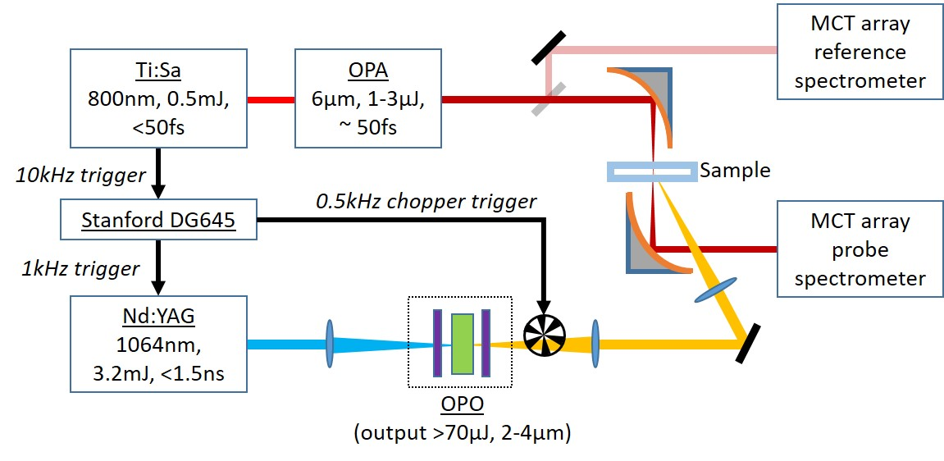
Figure 1. Experimental layout showing laser and trigger configurations for the T-jump IR spectrometer. Chopper inserted for TRMPS/2 configuration (see text).

Broadband mid-IR Spectroscopy Multiple Probing
This time-resolved multiple probe experiment uses a 10 kHz probe laser and a synchronized 1 kHz pump laser, chopped to 500 Hz. The probe laser is a 20 W, titanium-sapphire chirped-pulse-amplifier with a repetition rate of 10 kHz and pulse duration < 50 fs (Coherent). 5 W of the output power was used to drive a home-built BBO-based optical-parametric-amplifier, generating 1 – 3 µJ of broadband (> 300 cm⁻¹), mid-IR (~ 6 µm) probe light. This probe light is focused onto the pumped area of the sample at a spot-size of ~ 50 µm diameter (significantly smaller than the T-jump beam, see next section) and is then spectrally dispersed onto 128-channel MCT-array detectors. < 10 % of the probe beam is split off before the sample and directed to an equivalent spectrograph with a 32-channel MCT-array detector to generate a reference measurement to remove probe light intensity fluctuations. The spectrum of each probe laser shot is recorded, so sequences of probes can be acquired in groups of 20 (20:1 probe to pump repetition rate). For each data acquisition, the timing of the pump pulse relative to an initial probe pulse is fixed and a comb of probe pulses is recorded. The first probe following the pump pulse is recorded as delay of x ns, with the subsequent probe spectra recorded with x + 100 µs, x + 200 µs, x + 300 µs, etc.¹⁶. After averaging for a few seconds, the pump – probe delay is changed, to build up a data set of nanosecond to millisecond measurements. At the 0.5 : 10 kHz, pump : probe repetition rate ratio, we can use the first 19 probe pulses as the time-delay data from 0.0 to 1.9 ms and the final probe pulse (1.9 – 2.0 ms) as the “pump-off” pulse, to calculate normalized difference spectra. We refer to this as the TRMPS (time-resolved multiple probe spectroscopy) method hereafter.
Chopping the pump beam reduces the pump repetition rate and allows a longer sample recovery time (2, rather than 1 ms), but also presents an important noise removal opportunity. Electro-magnetic frequency (EMF) noise from the high voltage Pockels cells switch in the pump laser can interfere with sensitive data acquisition electronics, causing a time-dependent ringing noise to appear in data over nanosecond to microsecond timescales. Mechanical chopping of the beam for pump-on – pump-off differencing allows removal of this noise, as both pump-off and -on measurements experience the same EMF noise. Therefore, we can also process the 20 probe spectra as 10 pump-on followed by 10-pump off, so that each difference spectrum is calculated using probe spectra 1 ms apart (so requiring sample recovery by 1 ms). We refer to this approach as TRMPS/2 method hereafter. A comparison of the TRMPS and TRMPS/2 methods is depicted in fig. 2. The TRMPS method was used here to confirm that there was not significant signal beyond 1 ms, so that the TRMPS/2 processing method could be safely applied. All data presented was acquired using TRMPS/2.
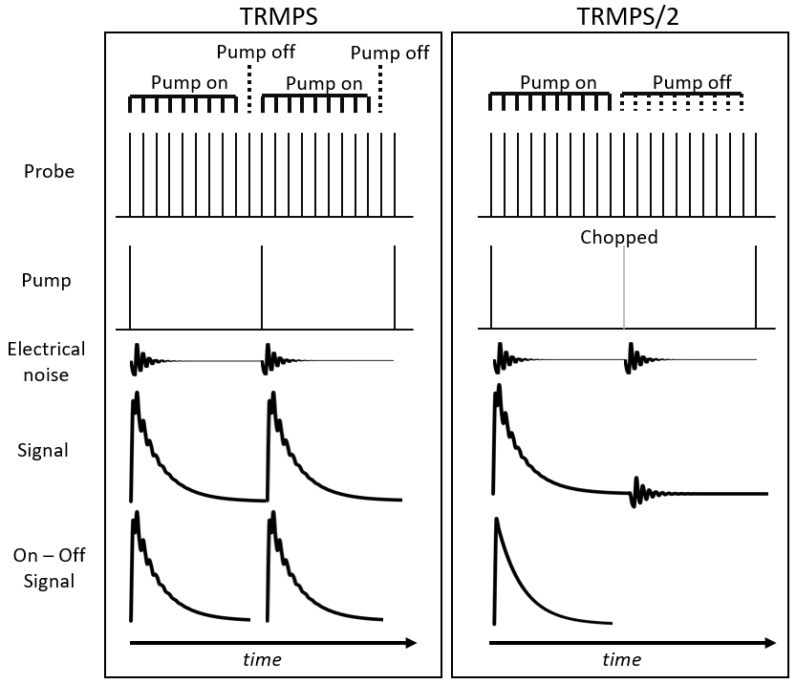
Figure 2. Pulse schemes to illustrate the TRMPS and TRMPS/2 methods (see text), showing how data processing can be applied to remove EMF noise.

Temperature Jump Laser
The pump laser is a home-built Nd:YAG-pumped OPO. The Nd:YAG laser (Bright Solutions Wedge XB, short-pulse Q-switched DPSS laser) generates < 1.5 ns duration pulses with 4 mJ energy at 1 kHz. 3.2 mJ of this energy is focused onto a MgO:PPLN crystal (Covesion MOPO-1.0-2.0) placed within a short (~ 4 cm) singly-resonant OPO cavity. The input mirror (Layertec) is designed to be highly reflective for the signal, while the output coupler (Layertec) reflects both the pump and signal, but allows the idler beam (2 – 4 µm) to exit the cavity. This short, few pass OPO, did not increase the pulse duration significantly, as we observe T-jump rise times of ~ 1.5 ns. In these experiments, 70 - 80 µJ energy pulses at ~ 3.75 µm were generated, to pump the O-D stretch of the D₂O solvent. Wavelength tuning of the pump pulse is possible with adjustment of the PPLN oven temperature (typically around 50 °C) and selection of the PPLN crystal poling (range 29.52 to 31.59 µm), to allow change in absorption of the pump. The OPO can also be wavelength-tuned to a vibrational mode of H₂O, for non-deuterated conditions, to achieve a similar temperature jump. However, IR spectroscopy of biomolecules is commonly performed in D₂O, due to the strong 6 µm absorption of H₂O, which would limit probe light transmission in this spectral region of interest and generate a strong interfering T-jump signal.
At the sample cell path-lengths used, 5 – 10 µm, by tuning the pump pulse wavelength to become resonant with the high frequency wing of the band, full absorption of the T-jump pulse was prevented. Transmission of the pump through the sample was used to measure the pulse energy absorbed across the cell. Here, the pump wavelength was tuned across the O-D stretch absorption, to give ~ 70 % absorption of the pump energy. We present modelling data of the T-jump temporal and spatial profile in the following section. The pump beam was focused to 200 – 300 µm diameter onto the sample area to be probed.
The OPO output was synchronized to the probe laser with adjustable phase using a computer-controlled delay-generator (Stanford DG645), dividing the 10 kHz probe clock down to 1 kHz. This 1 kHz clock triggered the Nd:YAG laser and was used to generate a further divided 500 Hz output to trigger the pump-beam chopper. This 500 Hz signal was sent to the data acquisition system to correctly identify the sequence of the multiple probe pulses (i.e. to know which of the probe pulses immediately follows the pump pulse).

Temperature Jump Calibration and Measurement
To characterize the induced T-jump in terms of magnitude and recovery time, the temperature response of a trifluoroacetic acid (TFA) solution in D₂O was studied. TFA is a small molecule with a strong asymmetric C=O stretching vibrational mode at 1672 cm⁻¹ in D₂O, which is sensitive to the solvent hydrogen-bonding network, providing a system that will rapidly (faster than the nanosecond resolution of the experiment) respond to the temperature change of the sample. FT-IR spectra of a 130 mM sample of TFA in D₂O, path-length 6 µm, were recorded from 20 to 44 °C and are shown in fig. 3 as difference IR spectra as the temperature of the sample is changed. As temperature increases, there is a clear decrease in intensity of the TFA absorption at 1672 cm⁻¹ as the C=O mode shifts to higher frequency. Broadband solvent changes are also observed as temperature increases, as the D₂O (and any HOD/H₂O impurities) responds to the temperature change. These solvent-related effects are subtracted here by polynomial baseline fitting, to reveal the sharp TFA band shown in fig. 3. Broadband solvent signals are often used to calibrate the T-jump magnitude. However, we found that the narrow C=O mode of TFA provided a more reliable measure of the T-jump, removing ambiguity in broad signal changes versus baseline changes caused by thermal effects in the sample. We observed a linear absorbance change of the TFA 1672 cm⁻¹ band with temperature, over the range of calibration measurements performed, 20 – 44 °C. Fig. 3 also shows that the T-jump difference spectra from starting temperatures of 22 and 29 °C reflect the differences seen in the temperature dependent FT-IR measurements very well and are independent of starting temperature, demonstrating the linear response of the spectral change across temperature.
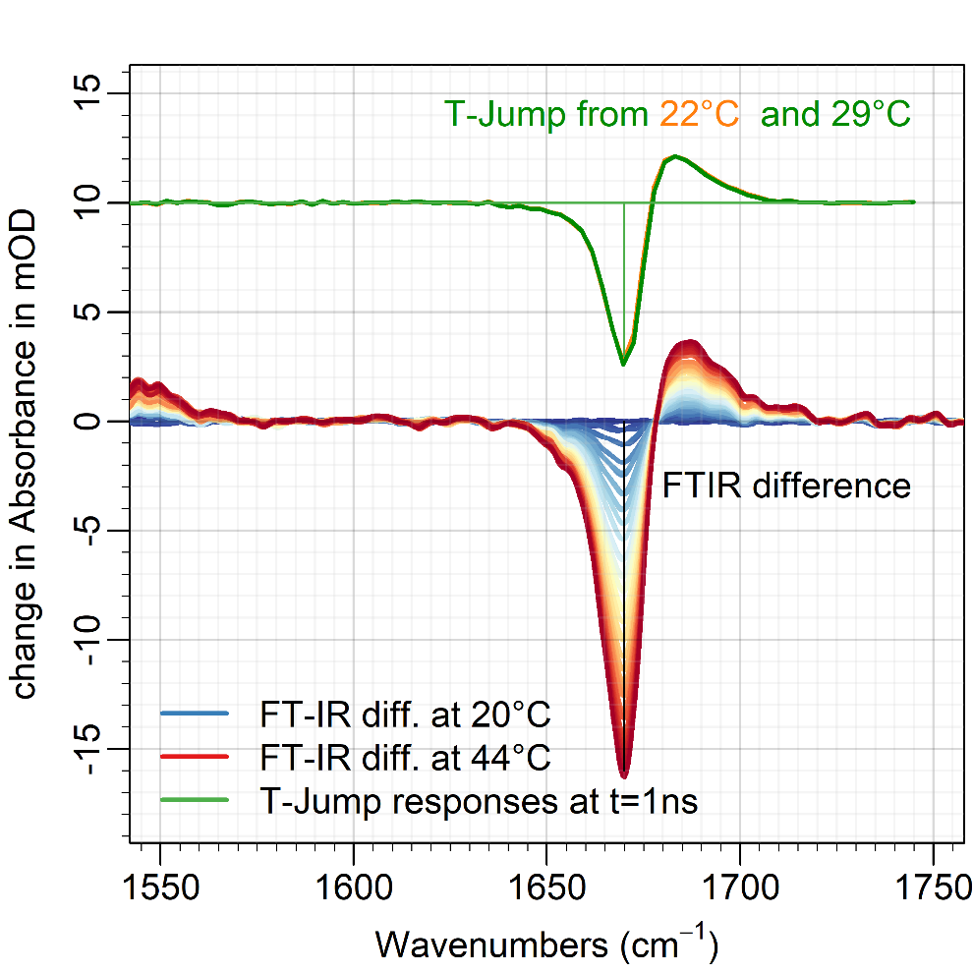
Figure 3. Temperature dependent FTIR difference spectra of 130 mM TFA in D₂O at a path-length of 6 µm, relative to 20 °C (from blue at 20 °C to red at 44 °C). Upper spectra indicate the T-Jump responses of TFA at 2 ns from 22 °C (orange) and 29 °C (green). Broad solvent absorption changes have been background subtracted here.

The temperature dependent FT-IR heating experiments indicate that the negative peak due to the blue-shift of the TFA ground state absorption band at 1672 cm⁻¹ changes absorbance linearly by -0.7 mOD K⁻¹. The largest magnitude changes seen in our time resolved experiments of -7 mOD, therefore indicate an increase in temperatures by ~ 10 K.
T-jump IR probe measurements were made, starting at steady-state temperatures of 22 and 29°C. Their spectral features at 2 ns delay (see fig. 3) are very similar to the FT-IR difference spectra. The kinetic traces of the bands at 1672 cm⁻¹ are shown in fig. 4, with essentially the same kinetics for both initial temperatures. The largest magnitude TFA response, equivalent to the maximum T-jump of 10 K, is reached within 1.5 ns and then relaxes back to zero as a stretched exponential function of the form:
$$∆A\left(t\right)= ∝e^{{-\left(\frac{t}{τ}\right)}^{β}}$$
, with a lifetime of τ = 47 µs (β = 0.48). The exponential relaxation over time is stretched due to inhomogeneous temperature and cooling across the path-length of the sample.
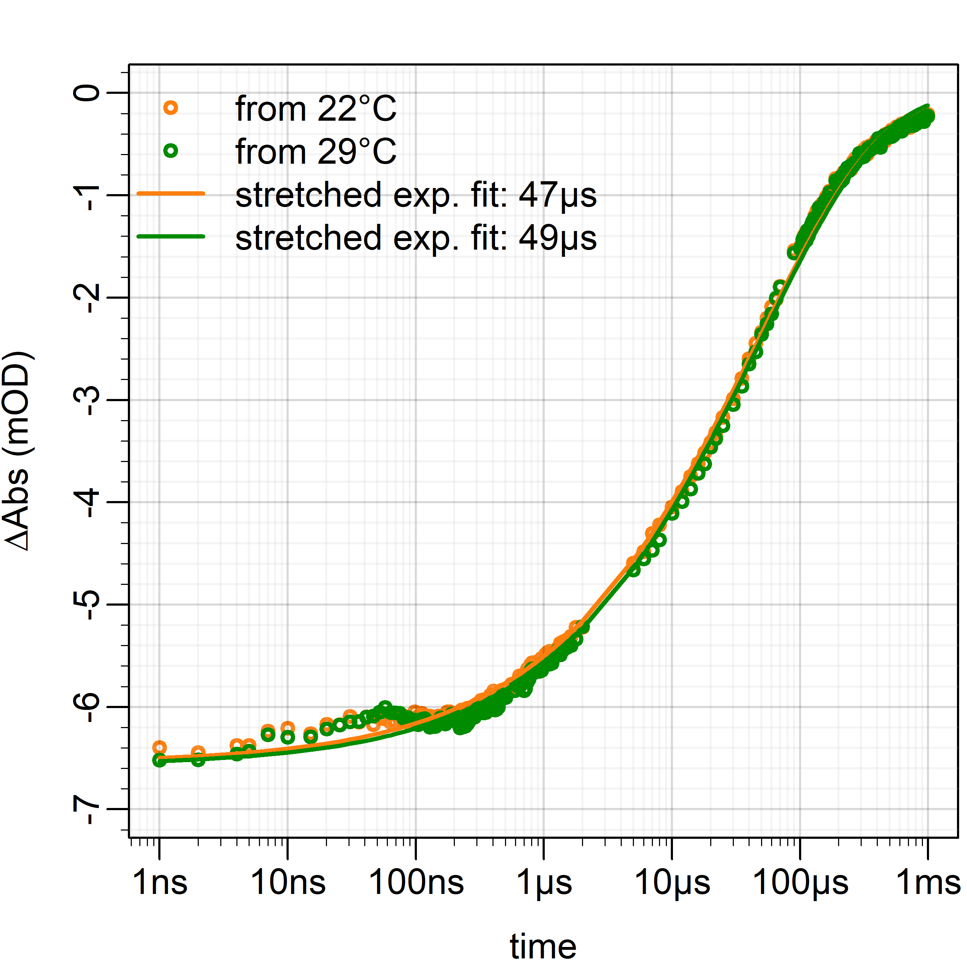
Figure 4. Kinetic traces of T-jump responses of the 1672 cm⁻¹ TFA absorption change over time from 22°C (orange) and 29°C (green). Fitting of a stretched exponential gives a lifetime of 47 µs.

Energy flow modelling and control
It is essential to understand the spatial and temporal profile of the temperature jump produced. Using the measured pump energies, and T-jump calibration data we have performed a series of studies designed to model the heat flow in the sample that will further inform analysis of the extracted biomolecular dynamics.
We apply a simple model of heat flow through a cell, to simulate temperature changes in the sample over time and the effects of changing the cell parameters. The thermal conductivity of water (0.6 Wm⁻¹K⁻¹) is significantly lower than the thermal conductivity of the window material, CaF₂ (9.7 Wm⁻¹K⁻¹), so we focus on a 1-D model of temperature over time, across the cell thickness. In our experiments, the pump beam diameter is ~ 5x that of the probe beam, providing further justification that the change in radial heat distribution through water is much less significant.
Our model divides the cell thickness into discrete slices (65 used here, with the middle 31 making up the sample solution). The initial temperature of each slice is calculated according to the energy it absorbs from the pump and the specific heat capacity. This gives an initial temperature profile across the sample (black trace in fig. 5A and 5B), reflecting the Beer-Lambert law. We then calculate the 1-D energy flow in discrete steps (typically > 5 ns) using Fourier’s law, to calculate the new temperatures for each slice. The first and last slices in the model are held at 0 K change, to reflect that the CaF₂ windows effectively act as heat sinks. To test this assumption, the thickness of the windows in the simulation was doubled. This increased the simulation run time significantly, but only changed the temperature recovery rate by < 2 %.
Temperature profiles across the cells and temperature decay from the model are shown in fig. 5, assuming a 10 µm water sample between CaF₂ windows, absorbing 70 % of the 70 µJ, 300 µm diameter pump beam. Despite the simplicity of this model, the cooling rate and the T-jump magnitude are within a factor of 2 of the experimentally measured values and, interestingly, the feature in our kinetic plots at 50 - 100 ns (see fig. 4) is reproduced. We also observe good agreement for the T-jump decay timescale presented in ref. 14, with a thicker, lower absorbance cell.

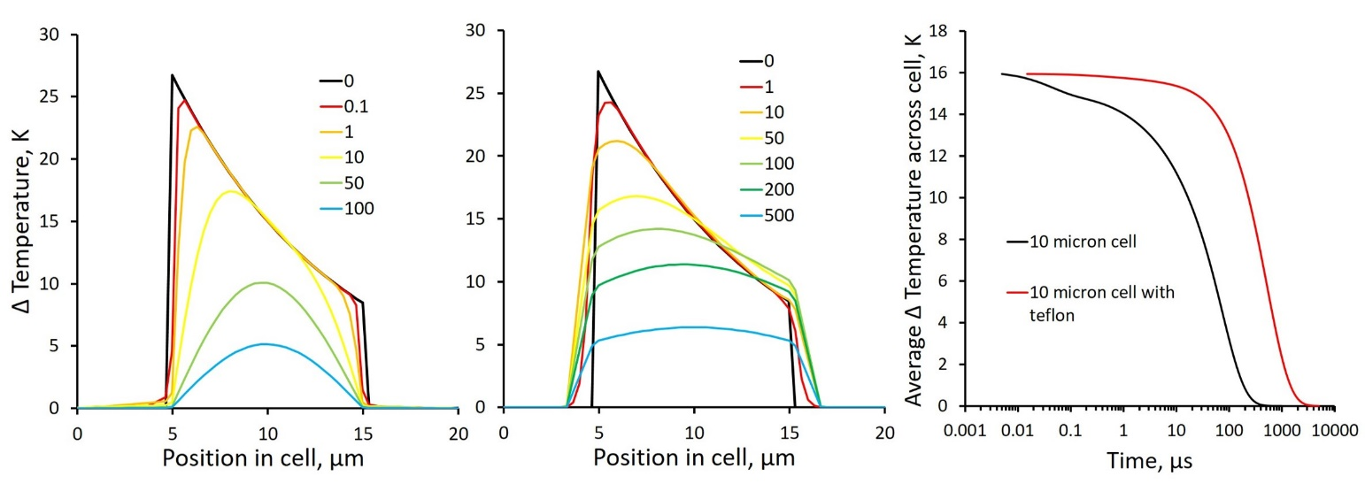
Figure 5. A: Simulated temperature profiles across a cell at different times (times given in µs, in inset). B: as for A, but with PTFE insulator layer between windows and sample. C: Simulated temperature relaxation over time (logarithmic time axis).

Following excitation, the heat loss at the windows results in a significant variation of temperature across the cell, so measurements of absorption change caused by the T-jump are a complex mixture of warm and cool sample. We empirically observe that the T-jump decay rate in the model results is dominated by the path-length, d, as may be expected (see supplementary information, SI.1), given the competition between heat stored in the bulk versus heat losses at the window interfaces. Recovery time was not found to be dependent on the heat put into the solution.
To minimize the temperature variation across the cell, we propose a form of insulation at the window surface. This may be PTFE layers, which have a thermal conductivity of 0.25 Wm⁻¹K⁻¹, and no significant IR absorbance in the regions of interest here (2500 cm⁻¹ pump and 1600 cm⁻¹ probe). This would have a two-fold effect, homogenizing the T-jump across the cell path-length and sustaining the T-jump for longer. We performed some preliminary experiments (see supplementary information SI.2) and modelling on insulated cells with PTFE between the CaF₂ window and the solution. The effect of insulating the sample with PTFE can be modelled by using properties (thermal conductivity, specific heat capacity, etc.) of PTFE for the calculated slices over 2 µm between the CaF₂ and the water. Comparison of the modelled kinetic traces in fig. 5C, shows an order of magnitude longer temperature recovery time with the insulating PTFE layer, as might be expected, and is implied in our preliminary experiments (see SI.2).
A 50 – 100 ns temperature decay feature is visible in fig. 5C. It appears only in the uninsulated cell, suggesting that rapid loss of heat at the window surface could contribute to some early time kinetics of the temperature recovery. A similar feature is observed in our experimental data (see fig. 4). We note that the authors of ref. 14 also observed a feature around 10 – 100 ns in their T-jump experiments, attributed to propagation of a density wave. The feature we observed is a different sign (decrease in temperature over time, rather than increase) and the density wave effect in our thinner cells would occur on shorter timescales, < 10 ns. The effect of cavitation was also considered to explain this observation, but the cavitation we observe in poor samples with nucleation sites at high pump energies resulted in all signals being obscured by large baseline jumps during several microseconds, as the probe was significantly deflected during the events. Therefore, we are confident that our observation in this region can be attributed to the rapid heat loss at the window surface following excitation.
When fitting the modelled data, to a stretched exponential, the stretching exponent, β, tends to 1 in the case of the insulated cells, indicating more mono-exponential behavior, and suggesting a possible improvement to the ability to differentiate cooling kinetics from complex energy landscapes. However, this was less clear in the preliminary experimental data.
Other approaches could be applied for slow heating of the cell with additional quasi-CW lasers (100 ns to several microsecond response) to sustain T-jumps for longer, following the fast, nanosecond rise from the present setup.

Summary
We have described a method for performing T-jump IR absorption spectroscopy experiments at 0.5 to 1 kHz cycling rate. Our approach efficiently couples 70 – 80 µJ pulses into the strongly absorbing O-D stretch of a solution’s D₂O solvent, to achieve 10 K T-jumps lasting for 10’s of microseconds in cells of ≤ 10 µm path-lengths. While our method presents clear benefits in terms of the ability to access fast biomolecular dynamics with high signal-to-noise and sampling rates, it is essential that instrumental issues relating to non-uniformity of the cell heating and subsequent dynamics of the heat loss in the experiment are considered when applying this approach. These have been discussed and modelled, to show the effect of fast < 100 ns cooling at the window surface, followed by > 10 µs cooling of the bulk solution. Variation in temperature across the cell introduces an inhomogeneity into the temperature-induced dynamics, though we note that this is not a situation only experienced by high repetition rate methods and must be considered in all cases. Irrespective, comparison of samples and measurements made on different samples on the same spectrometer¹¹ have shown excellent repeatability and the timescales recovered compare well with previous measurements on similar systems at lower repetition rate^{9,10}.
Running experiments at up to 1 kHz and probing the sample at 10 kHz, allows rapid data collection with high signal-to-noise across several orders of magnitude in timescales. Our first applications of this method to DNA melting and protein domain unfolding are the subjects of refs. 11 and 17. We intend to extend this T-jump method to 2D-IR probing^{6,14}, using pulse-shaping methods,¹⁹ where the requirement to measure 100’s of pump pulse-pair delays for each waiting time make the high repetition-rate of the experiment invaluable. The benefits of running at high repetition rate here will be typically applied to small biomolecules, due to the 1 – 2 ms repetition cycle of this system, limiting the measurable dynamics timescales.

Supplementary material
Supplementary information is provided. This includes data from the T-jump simulation model, correlating cell path-length with temperature recovery time (SI.1), and description, with preliminary data, of our Teflon coated cell experiments (SI.2).

Acknowledgments
We gratefully acknowledge the Science and Technology Facilities Council (STFC) for use of the Central Laser Facility’s ULTRA facility. We would like to thank D. J. Shaw, A. J. Henry and R. J. Taylor of UCB and P. M. Donaldson, E. Gozzard, A. W. Parker and I. V. Sazanovich of STFC for useful discussions on the T-jump applications and technique.

References
- Eigen M, Hammes GG. “Kinetic studies of ADP reactions with the temperature jump method”. J. Am. Chem. Soc. 1960. 82(22): 5951-5952.
- Hoffmann H, Yeager E, Stuehr J. “Laser temperature-jump apparatus for relaxation studies in electrolytic solutions”. Rev. Sci. Instrum. 1968. 39(5): 649-653.
- Phillips CM, Mizutani Y, Hochstrasser RM. “Ultrafast thermally-induced unfolding of RNase-A”. Proc. Natl. Acad. Sci. U. S. A. 1995. 92(16): 7292-7296.
- Callender RH, Dyer RB, Gilmanshin R, Woodruff WH. “Fast events in protein folding: The time evolution of primary processes”. Annu. Rev. Phys. Chem. 1998. 49: 173-202.
- Petty SA, Volk M. “Fast folding dynamics of an alpha-helical peptide with bulky side chains”. Phys. Chem. Chem. Phys. 2004. 6(5): 1022-1030.
- Chung HS, Khalil M, Smith AW, Ganim Z, Tokmakoff A. “Conformational changes during the nanosecond-to-millisecond unfolding of ubiquitin”. Proc. Natl. Acad. Sci. U. S. A. 2005. 102(3): 612-617.
- Chung HS, Ganim Z, Jones KC, Tokmakoff A. “Transient 2D IR spectroscopy of ubiquitin unfolding dynamics”. Proc. Natl. Acad. Sci. U. S. A. 2007. 104(36): 14237-14242.
- Ramajo AP, Petty SA, Starzyk A, Decatur SM, Volk M. “The alpha-helix folds more rapidly at the C-terminus than at the N-terminus”. J. Am. Chem. Soc. 2005. 127(40): 13784-13785.
- Sanstead PJ, Stevenson P, Tokmakoff A. “Sequence-dependent mechanism of DNA oligonucleotide dehybridization resolved through infrared spectroscopy”. J. Am. Chem. Soc. 2016. 138(36): 11792-11801.
- Sanstead PJ, Tokmakoff A. “Direct observation of activated kinetics and downhill dynamics in DNA dehybridization”. J. Phys. Chem. B. 2018. 122(12): 3088-3100.
- Fritzsch R, Greetham GM, Clark IP, Minnes L, Towrie M, Parker AW, Hunt NT. “Monitoring base-specific dynamics during melting of DNA ligand complexes using temperature-jump time-resolved infrared spectroscopy”. J. Phys. Chem. B. 2019. 123(29): 6188-6199.
- Gruebele M, Sabelko J, Ballew R, Ervin J. “Laser temperature jump induced protein refolding”. Acc. Chem. Res. 1998. 31(11): 699-707.
- Krejtschi C, Huang R, Keiderling TA, Hauser K. “Time-resolved temperature-jump infrared spectroscopy of peptides with well-defined secondary structure: A Trpzip β-hairpin variant as an example”. Vib. Spectrosc. 2008. 48(1): 1-7.
- Chung HS, Khalil M, Smith AW, Tokmakoff A. “Transient two-dimensional IR spectrometer for probing nanosecond temperature-jump kinetics”. Rev. Sci. Instrum. 2007. 78(6): 063101.
- Davis CM, Reddish MJ, Dyer RB. “Dual time-resolved temperature-jump fluorescence and infrared spectroscopy for the study of fast protein dynamics”. Spectrochim. Acta, Part A. 2017. 178: 185-191.
- Greetham GM, Sole D, Clark IP, Parker AW, Pollard MR, Towrie M. “Time-resolved multiple probe spectroscopy”. Rev. Sci. Instrum. 2012. 83(10): 103107.
- Minnes L, Greetham GM, Shaw DJ, Clark IP, Fritzsch R, Towrie M, Parker AW, Henry AJ, Taylor RJ, Hunt NT. “Uncovering the early stages of domain melting in calmodulin with ultrafast temperature-jump infrared spectroscopy”. J. Phys. Chem. B. 2019. 123(41): 8733-8739.
- Greetham GM, Donaldson PM, Nation C, Sazanovich IV, Shaw DJ, Parker AW, Towrie M. “A 100 kHz time-resolved multiple-probe femtosecond to second infrared absorption spectrometer”. Appl. Spectrosc. 2016. 70(4): 645-653.
- Shim SH, Strasfeld DB, Ling YL, Zanni MT. “Automated 2D IR spectroscopy using a mid-IR pulse shaper and application of this technology to the human islet amyloid polypeptide”. Proc. Natl. Acad. Sci. U. S. A. 2007. 104(36): 14197-14202.

