**Modelling Consortium for Chemistry of Indoor Environments (MOCCIE): Integrating chemical processes from molecular to room scales**

Manabu Shiraiwa1,*, Nicola Carslaw2, Douglas J. Tobias1, Michael S. Waring3, Donghyun Rim4, Glenn Morrison5, Pascale Lakey1, Magdalena Kruza2, Michael von Domaros1, Bryan Cummings3, Youngbo Won4

1. Department of Chemistry, University of California, Irvine, CA, USA

2. University of York, UK

3. Drexel University, PA, USA

4. Pennsylvania State University, PA, USA

5. University of North Carolina, Chapel Hill, NC, USA

* Correspondence to: m.shiraiwa@uci.edu

Submitted to *Environmental Science: Processes & Impacts*

**Abstract.**

We report on the development of a modelling consortium for chemistry in indoor environments that connects models over a range of spatial and temporal scales, from molecular to room scales and from sub-nanosecond to days, respectively. Our modeling approaches include molecular dynamics (MD) simulations, kinetic process modeling, gas-phase chemistry modeling, organic aerosol modeling, and computational fluid dynamics (CFD) simulations. These models are applied to investigate ozone reactions with skin and clothing, oxidation of volatile organic compounds and formation of secondary organic aerosols, and mass transport and partitioning of indoor species to surfaces. MD simulations provide molecular pictures of limonene adsorption on SiO2 and ozone interactions with the skin lipid squalene, providing kinetic parameters such as surface accommodation coefficient, desorption lifetime, and bulk diffusivity. These parameters then constrain kinetic process models, which resolve mass transport and chemical reactions in gas and condensed phases for analysis of experimental data. A detailed indoor chemical box model is applied to simulate α-pinene ozonolysis with improved representation of gas-particle partitioning. Application of 2D-volatility basis set reveals that OH-induced aging sometimes drives increases in indoor organic aerosol concentrations, due to organic mass functionalization and enhanced partitioning. CFD simulations show that concentrations of ozone and primary product change near the human surface rapidly, indicating non-uniform spatial distributions from the occupant surface to ambient air, while secondary ozone product is relatively well-mixed throughout the room. This development establishes a framework to integrate different modeling tools and experimental measurements, opening up an avenue for development of comprehensive and integrated models with representations of various chemistry in indoor environments.

**1. Introduction.**

The chemistry taking place in buildings is complex, extensive and under studied.1 Many thousands of species can participate in the chemical transformations in indoor air as precursors, intermediates or products.2, 3 This chemistry can form indoor aerosols and alter their composition, while countless different kinds of indoor materials and occupants act as sinks, sources and provide surfaces for chemical transformations.4-8 Increased efforts have been made in indoor measurements by deploying state-of-the-art instruments such as aerosol mass spectrometry, proton transfer reaction mass spectrometry, and chemical ionization mass spectrometry, which were traditionally developed for and applied to outdoor air measurements. 9-14 However, extrapolation of these observations beyond the specific systems or buildings studied is hampered by the vast number of buildings, each comprised of its own unique microenvironments and occupant activities.1, 15 Mathematical models, well vetted by experimental results, can help overcome these limitations and allow for predictions to broader classes of indoor environments.16-21 To fully describe indoor chemistry, the models must be able to span vast time and spatial scales; this, we believe, requires a collaborative network of modelling expertise that itself interacts closely with experimentalists.

There have been many advances in indoor air chemistry, both in terms of indoor measurements and laboratory experiments as well as in model development.22 These advances have provided insight into the complex mechanisms that underpin indoor air chemistry, but have also facilitated model simulations and analysis of indoor chemical processes. Nazaroff and Cass (1986)19 developed an indoor gas-phase chemistry model that also included deposition of reactive species such as ozone. This model was well ahead of its time because it made dynamic predictions of some species that had not yet been measured indoors. Nazaroff and Cass (1989)23 were also the first to develop a model to predict aerosol concentration and fate indoors, considering ventilation, filtration, deposition onto surfaces, direct emission and coagulation. Later investigators have developed increasingly detailed models of gas chemistry, particle composition and indoor secondary organic aerosol (SOA) formation.5, 24-27 Studies like these have identified reactive species, such as organic peroxides, that warrant further experimental attention.24 Models improve aerosol-phase representation by a better understanding of different aerosol fractions by season or region, as well as by exploring whether the assumption of equilibrium is relevant for typical buildings with short residence times and/or large temperature variations.15, 28, 29 In addition, the impacts of the wide variety of indoor sources such as cooking and cleaning on indoor aerosol composition warrant further investigation.

Surfaces are one of the least well understood of the different compartments indoors,1 yet have long been known to be an important source of volatile organic compounds (VOCs)30, 31 and sink of reactive and low-volatility molecules.32-36 Chemistry in hidden spaces (e.g. between walls, in ventilation systems) are also poorly understood partly due to complex surface processes. Recent studies broaden the list of chemicals that participate in surface chemistry and the mechanisms that control those interactions.37 A gas molecule that enters a room has ample opportunities to interact with surfaces before leaving by air exchange.15 For lower volatility molecules, sorption to surfaces can substantially increase their lifetimes and, hence, the opportunity to react with other molecules, potentially altering indoor chemistry and leading to the formation of aldehydes, ketones, carboxylic acids and SOA.2, 38-41 For instance, using a detailed chemical model for indoors 42 showed that aldehyde emissions following ozone deposition onto soft furnishings, painted walls and other internal surfaces could reduce indoor oxidant concentrations and also cause a shift towards the formation of organic nitrates indoors. Different indoor surfaces can be quite variable in their initial reactivity, but aging and soiling of surfaces may make them more similar than different with time.43, 44 Attempts to model the processes characteristic of painted drywall, vinyl flooring, concrete, and carpet have shown that relatively simple models can adequately match experimental results probing primary emissions,45, 46 sorption/desorption47-49 and ozone deposition.18, 50 Several models of the skin exist, focusing on dermal absorption51, 52 and effects of clothing on dermal uptake.53 A skin model was developed that combines physical processes (i.e., reversible adsorption, diffusion) with chemical reactions of ozone with skin lipids.54

It is known that human activities and occupancy in general can alter the composition of indoor contaminants. Cooking emissons increase indoor concentrations of aerosols, oxidants and VOCs.55, 56 Cleaning, in particular, can lead to very high concentrations of indoor air pollutants, with some being so highly reactive that they dominate oxidation pathways indoors, leading to production of reactive gaseous species and also SOA.13, 57 A recent study shows that human skin oils can be chlorinated rapidly via heterogeneous uptake of HOCl, which may potentially lead to irritation of the skin.58 Occupant activities clearly have an impact on indoor chemistry yet models that incorporate these processes are only in the early stages of development.

Human occupants themselves can be a dominant source of volatile organic compounds indoors10-12 and also add to the reactivity of surfaces via desquamation (skin shedding) and transferring skin oils to surfaces.59 The importance of chemistry associated with ‘passive’ (that is, when not cleaning, cooking *etc.*) human occupancy for indoor air quality was first recognized in aircraft cabins.60, 61 The presence of just one or two occupants can significantly affect indoor gas-phase composition and air chemistry.10 Per square meter, skin is far more efficient at removing ozone than most other indoor materials, and the consequent formation of oxidation products such as higher chain aldehydes following ozone-skin interactions can alter the indoor air composition as well as the importance of different chemical pathways.62 This impact on chemical oxidant levels in indoor air, as well as the formation of secondary pollutants, could be particularly important in highly occupied spaces such as classrooms11, 12, 62 or aircraft cabins.63, 64 Computational fluid dynamic models demonstrate that chemistry occurring at human skin and clothing surfaces alter the composition of air very near the body and breathing zone.65, 66 There is a clear need to understand these processes at the molecular level, which controls the release of the oxidation products of squalene and other skin-oil related compounds, to the fate of these products at the building-level.

Indoor chemistry models have provided useful insights thus far, but there has been little concerted effort to coordinate the different types of models into a coherent, dynamic, and revealing whole.15 This effort requires expertise in chemistry, engineering and building science, expertise in modelling approaches that operate across time and space scales and active integration of building and people related factors such as air exchange rate, ventilation strategy, occupant behavior and their activities.

**2. Mission and objectives.**

The Modelling Consortium for Chemistry of Indoor Environments (MOCCIE) was initiated in 2017 within the Chemistry of Indoor Environments (CIE) Program of the Alfred P. Sloan Foundation. MOCCIE brings together modelling experts from a number of different fields to begin to develop comprehensive, integrated physical-chemical models that include a detailed representation of gas-phase, particle-phase, and surface chemistry in indoor environments and how occupants, indoor activities, and buildings influence indoor processes. Such models are used to: 1) assess gaps in our fundamental understanding of indoor chemistry processes; 2) help guide measurements through identification of parameters responsible for model uncertainties, indicating key species to quantify and expected concentrations of species so that experimentalists are aware of the detection limits required for quantification, and improving design of experimental/fieldwork studies; 3) assist in interpretation of data from laboratory and field experiments including the House Observations of Microbial and Environmental Chemistry (HOMEChem) study. Eventually such models can be used to predict when indoor air chemical processes might adversely affect health and wellbeing, to aid in the design and effective operation of buildings, and to inform the evaluation and redesign of consumer products that are used in homes.

MOCCIE combines models that represent the chemistry of indoor environments over a range of spatial and temporal scales, from sub-nanometer to tens of meters and from sub-nanosecond to days, as shown in Fig. 1. For instance, some reactive species (such as OH radicals) exist for only ~1 s indoors, while others can persist for hours (e.g. VOCs) to years (e.g. semi- and low-volatile organic compounds). Similarly, there are large variations in spatial scales. We consider processes taking place within or at the surfaces of materials and human skin, the peri-human environment, the room, zone, or building scale, including the heating, ventilating, and air conditioning (HVAC) system. Our approaches include molecular dynamics (MD) simulations, kinetic process modeling, gas-phase chemistry modeling, thermodynamic modeling, and computational fluid dynamics (CFD) modeling.

Modeling studies are conducted by MOCCIE to explore three relevant and highly important themes for indoor air quality: 1) Impact of reactions of indoor oxidants with skin and clothing on indoor chemistry;2) Impact of VOC chemistry, organic aerosol behavior, and SOA formation on indoor air quality; 3) Mass transport and partitioning of species to indoor surfaces and materials. Interactions of indoor oxidants with skin, cleaning-related emissions of VOCs, and surface interactions are important processes, each strongly affecting chemical composition and distribution in indoor environments. These themes are useful as they encompass the necessary range of spatial and temporal scales that allow us to employ and test all of the models for relevant indoor scenarios. We integrate modelling closely with field measurements and laboratory experiments as detailed in Sect. 4.



**Fig. 1.** The different temporal and spatial scales involved in modelling indoor air chemistry applied to cross-cutting themes (in italic) in the modelling consortium MOCCIE.

**3. Modelling approaches**

**3.1. Molecular dynamics simulations**

Atomistic MD simulations consist of numerically integrating the classical equations of motion (e.g., Newton’s second law of motion) for all of the atoms in the system under consideration. In the majority of MD simulations, the forces on the atoms are derived from the gradient of an empirical potential energy function, or “force field”, that contains terms describing bond stretching, bond angle bending, torsions around rotatable bonds, and van der Waals and electrostatic interactions. In so-called *ab initio* MD simulations, electronic degrees of freedom are explicitly taken into consideration by calculating the forces “on the fly” from the electronic structure, thus enabling the modeling of chemical reactions. Typically spanning length scales of up to tens of nm and time scales of up to a few s, atomistic MD simulations as applied by the Tobias group represent the first step on the staircase linking the broad range of space and time spanned by the MOCCIE (Fig. 1).

MD simulations have been used extensively to gain atomic-scale insights into the composition, morphology, physical and transport properties, and chemical dynamics at gas-particle interfaces of aerosol particles in the outdoor atmosphere. For example, MD simulations revealed that, contrary to longstanding conventional wisdom, certain reactive ions in marine aerosol particles adsorb to the particle-air interface and, hence, are available for surface reactions with gas-phase oxidants.67-70 Additional examples include force field-based MD simulation studies that have provided atomic-scale views of the adsorption, uptake, and desorption of atmospheric gases (e.g., H2O, O3, OH, HO2, H2O2, and HNO3) on water and aqueous solutions,71-75 organic liquids,76 and organic thin films on liquid and solid surfaces.77-80 *Ab initio* MD simulations have been used to gain mechanistic insights into atmospherically relevant electron transfer, proton transfer, and photochemical reactions in the gas phase and at liquid and solid interfaces.81, 82 *Ab initio* MD simulations have also been used recently to investigate the role of acid-base chemistry and water uptake in the formation of new particles in the atmosphere from amine and acid precursors.83-85

**3.2. Kinetic process modeling**

For the description of heterogeneous and multiphase chemistry on the surface and in aerosol particles, the kinetic double-layer model for surface chemistry (K2-SURF)86 and the kinetic multi-layer model for surface and bulk chemistry (KM-SUB)87 have been developed. These models are based on a kinetic model framework with a double-layer surface concept and universally applicable rate equations and parameters for mass transport and chemical reactions at the gas-particle interface.88 The models treat explicitly all steps of mass transport and chemical reaction of semi-volatile species in the gas phase, at the surface and in the condensed phase. These models consist of multiple layers in the condensed phase and exclude assumptions of steady state and homogeneous mixing, which are typically applied in the traditional resistor model approach of multiphase chemistry.89 This kinetic multi-layer modeling approach has been applied to simulate ozone reactions with human skins by treating chemical reactions and mass transport of ozone, skin lipid squalene, and oxidation products at the skin and in the gas phase (KM-SUB-Skin model).54 It enables the spatial and temporal concentration profiles of species in the skin oil and underlying skin layers to be resolved.

The kinetic multilayer model of surface and bulk chemistry of the skin and clothing (KM-SUB-Skin-Clothing) was recently developed, which explicitly resolves mass transport and chemical reactions in the gas phase, in clothing, in the gap between clothing and skin and in the skin (Fig. 2).90 The model includes different layers: a gas phase, a boundary layer, the clothing, the gap between the clothing and skin, a sorption layer, the skin oil, the stratum corneum, the viable epidermis, and a layer of blood vessels. Bulk diffusion of all species was treated based on Fickian diffusion. In the clothing, diffusion was slowed down due to partitioning of chemical species to skin oils and other substances covering the fibers. This treatment was implemented based on human envelope models by Morrison et al. that included 1) improved treatment of skin lipids in dermal uptake of unreactive chemicals53 and 2) clothing, its history and how it releases these chemicals when worn.52, 53 Contact transfer between the upper layer of the skin and the clothing was also included. A simplified squalene ozonolysis mechanism was implemented in the model as well as ozone reactions with other reactive species, such as skin lipids and laundering species, in skin and clothing. Required kinetic parameters included surface accommodation coefficients, desorption lifetimes, gas-phase and bulk diffusion coefficients, partitioning coefficients, contact transfer rates and reaction rate coefficients. Several parameters in the model, such as the surface accommodation coefficient, Henry’s law constant, desorption lifetime, and the bulk diffusion coefficient of ozone in skin oil were constrained by MD simulations. Other parameters in the model were kept consistent with literature values, while unknown parameters were constrained by reproducing experimental measurements.

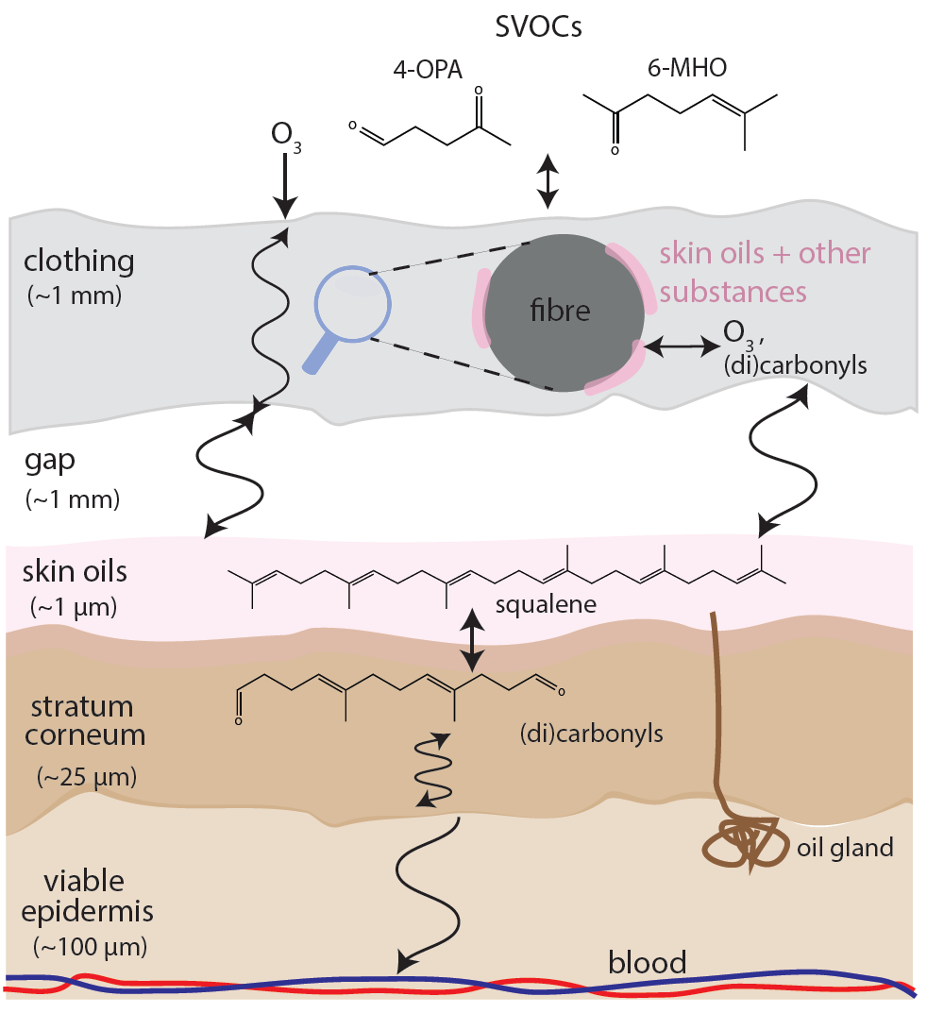

**Fig. 2.** A schematic of the interactions of O3 with skin and clothing.90 O3 can react with skin lipids such as squalene forming volatile and semi-volatile carbonyl products such as 4-OPA and 6-MHO. These products may further react in the gas phase, clothing or skin. O3 and carbonyls can diffuse through clothing, which consists of fibers and air, and partition to oil in the clothing. They can also diffuse across the air gap separating the clothing from the skin, through the skin and into the blood.

**3.3. Gas-phase chemistry modeling**

The Carslaw group has developed a detailed indoor chemical box model (INDCM) to study the chemistry of indoor environments.21, 24, 42, 62, 91, 92 The focus is on the mechanistic details and, as such, the INDCM contains around 20,000 reactions and 5,000 species. The mechanism is based on the near-explicit Master Chemical Mechanism.93, which retains the chemical detail following degradation of VOCs indoors until the final oxidation products of carbon dioxide and water are formed. It is therefore possible to trace the direction of a reaction very precisely from the preliminary emission of a VOC through the production of a myriad of multigenerational products. As well as detailed chemistry, the INDCM also contains terms that describe indoor emissions, deposition to and from surfaces and people, exchange with outdoors and photolysis, the latter from attenuated outdoor sunlight plus indoor lighting. The INDCM can be used to simulate different indoor environments (e.g., home, school, office) and for different outdoor locations (e.g., urban or remote areas).

The INDCM can be used to yield much information about the formation of secondary pollutants indoors, as well as the loss routes for the primary pollutants, However, there are few indoor measurements available to evaluate the model performance. For instance, Carslaw et al. (2012)24 showed that following cleaning, gas-phase limonene-oxidation products were dominated by carbonyls, whilst the SOA composition was dominated by organic nitrates including peroxyacyl nitrates for the conditions studied. Using the INDCM has also produced useful insight into the chemical mechanisms behind cleaning activities and particularly radical reactions,24, 91, 94 the composition of SOA92 and surface chemistry following ozone deposition onto materials and skin.42, 62

**3.4. Thermodynamic models of aerosol composition**

The Waring group developed techniques to model indoor OA behavior, character, and SOA formation. Their work introduced the use of the 2D volatility basis set (2D-VBS)95, 96 within indoor aerosol and gas-phase modeling. This work is part of a larger effort of the Waring group to develop a simulation package titled IMAGES (Indoor Model of Aerosols, Gases, Emissions, and Surfaces), which includes aerosol and gas-phase kinetic and thermodynamic behavior; emission models of varying complexity accounting for indoor point, surface, and human emissions; and sorptive and film interactions of VOC and SVOC with surfaces. Building-specific and indoor emission inputs are cast as probability distributions representing typical U.S. residential and office buildings, facilitating Monte Carlo operations, with information on outdoor aerosol components and criteria pollutants in 16 U.S. cities spanning different climate zones.

The 2D-VBS framework lumps organic material (OM) that partitions thermodynamically between gas and particle phases into bins mapped onto a 2D space representing their volatility by effective saturation concentration (*C*\*, µg m-3) and degree of oxygenation by O:C ratio (or average oxidation state). Once a VBS is mapped, the mass and fraction of compounds in the OA phase can be predicted with equilibrium gas-to-particle partitioning theory.97 Using the 2D-VBS allows for modeling transformations (e.g. functionalization, fragmentation)95, 98, 99 that age the OM in a given set, for instance by reactions with OH in both phases.

This modeling approach not only allows for chemical aging of lumped OM to be simulated, but constraining the O:C of OA provides insight into other characteristics of OA. These include the OA density,100 hygroscopicity,101 and phase state.102, 103 The enthalpy of vaporization of organics is correlated with saturation concentration,104 so resolving organics into the VBS also facilitates strong prediction of the effects of varying temperature on OA volatility and partitioning. Future work will continue to use and expand the 2D-VBS framework in IMAGES to assess and/or include impacts on OA of indoor cleaning; NOX on indoor OA aging; indoor OA phase state, thermodynamic partitioning, and water content; loss of SOA-forming vapors to indoor surfaces; kinetic partitioning; and more complex particle reactions.

**3.5. Computational fluid dynamics (CFD) modeling**

The Rim group has developed a CFD model that simulate surface reactions and gas-phase chain reactions in indoor environments. The CFD model solves time- and space-resolved concentrations iteratively based on heat, momentum, and mass balances in the discretized space with specific convergence criteria.66, 105 The model results reveal non-uniform indoor airflow distribution and transport of oxidants and reactants under different ventilation conditions.106

Fig. 3 shows a CFD model that simulates the perihuman environment where reactive surface and gas phase chemistry lead to ozone reactions. The computational grids and the boundary conditions are treated to predict local velocity gradient near the human body and recirculating indoor airflow with reasonable accuracy.107 Validation of the CFD model has been performed based on vertical velocity profile of the buoyancy-driven plume above the head, considering that accurate simulation of the occupant turbulent plume is critical for predicting mass transfer around the human body.65 The KM-SUB-Skin-Clothing model results (i.e., ozone deposition rates and SVOC emission rates) are inputted into the CFD model. Based on these conditions, the CFD model results provide the detailed effect of thermal stratification near the simulated occupant and reveal spatial distributions and concentration gradients of ozone, primary products, and secondary products.66

To examine the spatial distributions of ozone and ozonolysis products, mass transport equations considering chemical reaction are applied to each cell of the simulation domain.90,108

|  |  |
| --- | --- |
|  | (E1) |

Where $ρ$ is air density, $u_{j}$ is air velocity, $C_{i}$ is the mole fraction of chemical species, $R_{i}$ is the reaction source term, $D_{i}$ is molecular diffusion coefficient, and $S_{i}$ is source term. The model calculated the effects of convection, diffusion (both molecular and turbulent), chemical reaction, and source emissions. In the species transport equation, the chemical reaction source term ($R_{i}$) is modeled as shown below:

|  |  |
| --- | --- |
| $$R_{i}= M_{w,i}\sum_{r=1}^{N_{r}}{{\hat{R}}_{i,r}}$$ | (E2) |

Where $N_{r}$ is the number of chemical species in reaction *r*, $M_{w,i}$ is the molecular weight of ith species and ${\hat{R}}_{i,r}$ is the molar rate of creation and destruction of ith species in reaction *r*. The net source of chemical reactions is calculated as the sum of species, which is generated or reduced by chemical reactions occurring in each cell of the simulation domain.

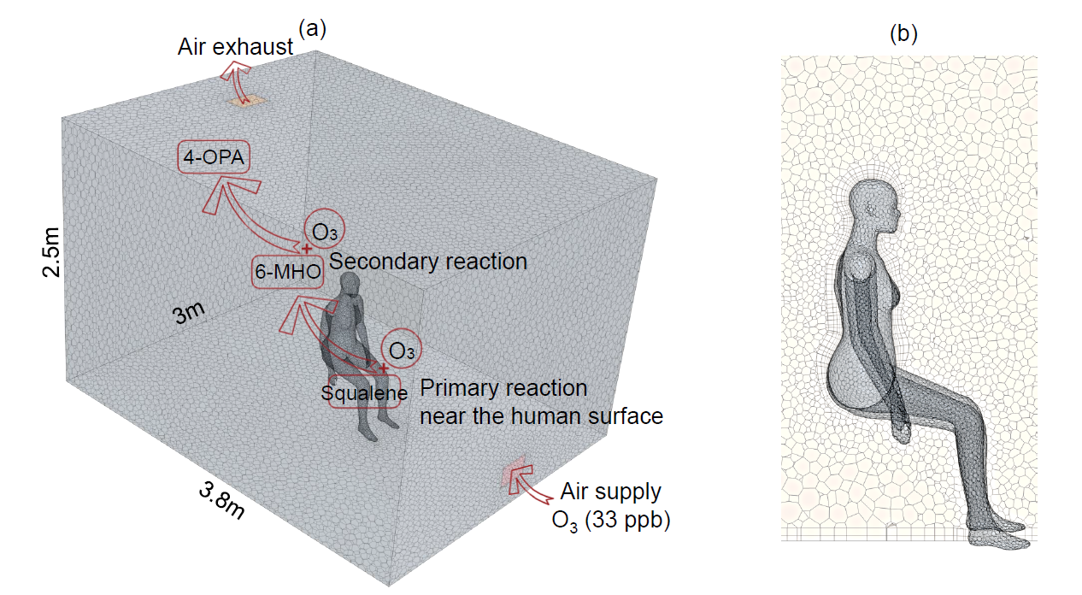

**Fig. 3**. Illustration of the geometry input to the computation fluid dynamics model for (a) chemical reactions near and at the human surface; (b) the computational mesh generated for the heat and mass transfer in the vicinity of the occupant.

**4. Main Results**

**4.1. Ozone-skin-clothing interactions**

Human skin contains a variety of lipids with unsaturated acyl chains109 that readily react with ozone, producing volatile and semi-volatile oxidation products10, 11, 60, 110, 111 The KM-SUB-Skin model contains a number of transport, thermodynamic, and kinetic parameters, some of which are estimated by educated guessing. However, the uncertainty in several of the parameters can be reduced by restraining the parameters with force field-based MD simulations. For example, MD simulations of ozone in squalene (a proxy for skin oil) can be used to estimate the diffusion constant of ozone (Fig. 4a), and simulations of ozone entering the surface of liquid squalene from the gas phase can be used to estimate the surface mass accommodation coefficient, Henry’s law constant, and desorption lifetime of ozone (Fig. 4b).90 In ongoing work, MD simulations are used to calculate corresponding quantities for ozone and volatile squalene oxidation products in a more realistic, multi-component model of skin oil containing triglycerides, wax esters, free fatty acids, cholesterol esters, and squalene.

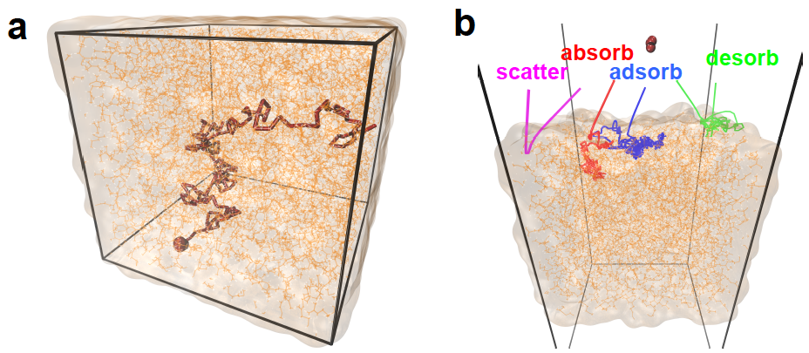

**Fig. 4.** (a) Ozone (red) diffusion in bulk squalene (carbon atoms colored orange, hydrogen atoms white). The diffusion constant of ozone in squalene is calculated from the slope of the ozone mean-squared displacement as a function of time, via the Einstein relation.90 (b) Fates of trajectories of ozone molecules directed at the surface of a slab squalene from the gas phase. The surface mass accommodation coefficient can be calculated from the statistics of fates of hundreds of ozone impingement trajectories, and the desorption lifetime from the statistics of the times that ozone resides on the surface of squalene before desorbing.90 The Henry’s law constant for ozone entering squalene can be calculated using an enhanced sampling method wherein external forces are used to pull the ozone molecule from the gas phase through the squalene-air interface and into the bulk squalene liquid.90, 112 The black lines denote the edges of the simulation cell, which is subjected to three-dimensional periodic boundary conditions.

The KM-SUB-Skin-Clothing model was able to reproduce measurements of gas-phase ozone and squalene ozonolysis products for a wide range of scenarios including clothed people in a room being exposed to ozone10 and both soiled and laundered clothing exposed to different ozone concentrations in different chamber sizes and with different air-exchange rates.63, 64, 113 Using the model, which had been constrained to these measurements, it was possible to demonstrate that soiled clothing could increase carbonyl concentrations indoors to ppb levels, depending on the air-exchange rate and that clothing would scavenge ozone efficiently thereby protecting the skin below it. Outputs from the model, such as the yields of products, were used as inputs in a CFD model, which allowed analysis of spatial distribution of ozone, and primary and secondary carbonyl products throughout a room. The CFD modeling demonstrated that primary product concentrations is elevated in the breathing zone compared to the rest of the room.90 Overall, the novel combination of MD simulations to constrain parameters, the kinetic model, and the CFD simulations resulted in insights into how to improve indoor air quality, reduce exposure and design future experiments.90

Fig. 5 presents spatial concentration distributions of ozone, primary product, and secondary product around the human surface. Ozone concentration is stratified vertically as the ozonized air is drawn up and across the reactive human surface by the thermal plume (Fig. 5a). Ozone concentration decreases with height as ozone in the supplied air is consumed by the reactive surface. This pattern results in breathing zone ozone concentration lower than the ambient room concentration. Due to the ozone interaction with the human surface, the primary product (6-MHO) is generated directly from the human surface (Fig. 5b). This, in turn, causes elevated 6-MHO concentration in the breathing zone, up to twice higher than the ambient air. The 6-MHO reacts with ozone, which create secondary oxidation products (4-OPA) in the ambient air. 4-OPA is relatively well-distributed throughout the room compared to 6-MHO (Fig. 5c).90

A previous study shows that human surface condition (soiled clothing vs. laundered clothing) has a greater impact on consumption of ozone and reaction product formation in the perihuman environment, compared to ventilation strategy or ventilation rate.66 Ozone deposition velocity is in the ranges of 8-10 m h-1 over the modelled air changes per hour (1-10 h-1) for skin oil and soiled clothing; however, it is only ~2 m h-1 for laundered clothing. Therefore, the oxidation product concentrations in the breathing zone will be higher with soiled clothing than laundered clothing.

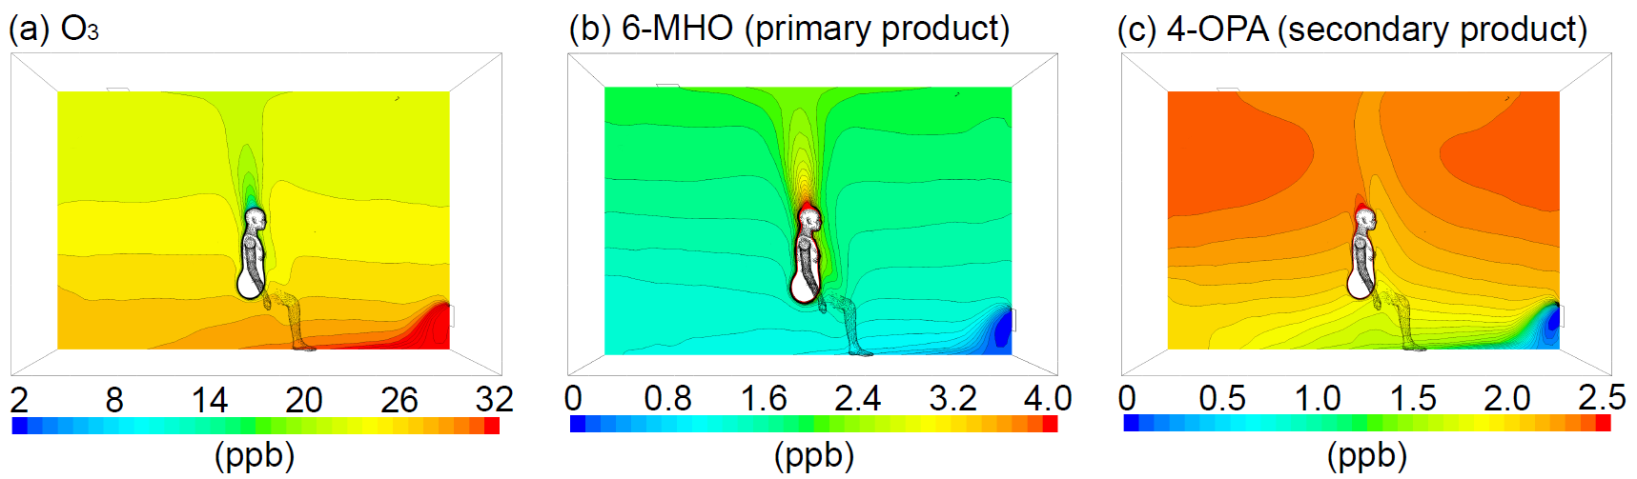

**Fig. 5.** CFD simulation results of spatial distributions and concentration gradients of (a) O3, (b) 6-MHO, and (c) 4-OPA. The simulation room is designed with the same conditions as the previous experiment.10 The volume of the room is 28.5 m3 and air change rate is 1 h-1. The supply ozone concentration is set to 33 ppb. The human surface temperature is 35 °C and the supply air temperature is 25 °C. Based on the KM-SUB-Skin-Clothing model90, the human surface boundary concentrations are 1.5 ppb for ozone, 7.1 ppb for 6-MHO, and 2.6 ppb for 4-OPA under the soiled clothing condition.

**4.2. Gas-phase chemistry and SOA formation**

The main focus of the INDCM development has been on improving the representation of gas-to-particle partitioning and to provide input for constraining the 2D-VBS model. For example, the INDCM has been used to simulate SOA evolution (aging) indoors. Previously, the INDCM considered 48 gas-to-particle partitioning for limonene oxidation products.24 As part of the MOCCIE project, an additional ~300 partitioning reactions have been added to represent SOA formation following α-pinene oxidation. The vapour pressure for each of the partitioning species was calculated at 298 K using the EVAPORATION model114 with the boiling point estimation of Nannoolal et al.115

The model was used to simulate the reaction of 10 ppb of α-pinene with 50 ppb of ozone until all of the α-pinene had been reacted away (~20 hours): the ozone concentration diminished to ~43 ppb over this time. OH was then added at a concentration of ~1×106 cm-3 and the chemical evolution of the resulting mixture was followed for 10 hours. The species were grouped into 14 volatility bins according to their log10*C*\* value.95 The lower numbered bins represent those species that are very condensable and the highest numbered bins contain very volatile species. For instance, bin 14 contains three radical species (methoxy, methyl peroxy and acetyl peroxy radicals), while bin 1 contains a peroxide with 8 carbon atoms, 2 carbonyl groups and 2 hydroxyl groups). We then investigated the evolution of the concentrations in each bin over time (Fig. 6).

Over the 10 hours, the concentrations in each bin vary, depending on the number of species, the volatility, and the concentrations. The highest concentrations were predicted for bins 6-9. Bin 9 is dominated by pinonaldehyde, which was produced when the initial addition of α-pinene to the system reacts with O3. Over the next 10 hours, this reservoir of pinonaldehyde is reduced and transformed to the products that increase in bin 6 over time: most importantly two peroxide species that are formed 2 and 4 steps down the oxidation chain from pinonaldehyde. More work is underway to better understand these transformations under different sets of realistic conditions indoors and how they affect the SOA aging process.



**Fig. 6:** Evolution of the mass concentration [µg m-3] in different volatility bins at 298.15K, over the 10 hours that the -pinene-ozone oxidation mixture ages through reaction with OH. The lower numbered bins represent the most condensable species, whilst the highest numbered bins contain the most volatile species. The legend shows the volatility bin numbers, the number of species in each bin, and the log10*C*\* range for each bin.

The 2D-VBS model was used to simulate whether OA and OM aging reactions by OH indoors can substantially alter OA concentrations,116 since aging (i.e., functionalization or fragmentation in 2D-VBS) alters OM volatility. To do so, OA concentrations and SOA fractions were first modeled in a daylong time-averaged Monte Carlo operation using residential input probability distributions,27 and OA concentrations from simulations that considered aging were compared against those that did not to quantify OA mass increases due to OH aging (Δ*C*OA). Aging had a mostly negligible impact on indoor OA mass loading under the assumptions of the daylong time-averaged Monte Carlo scenarios, where aged OA concentrations were within one percent of the baseline in 93% of simulations (Fig. 7a). Insufficient time-averaged indoor OH concentrations in conjunction with brief residence times typical of indoor air are largely responsible for the small observed Δ*C*OA. Of the cases which experienced more significant Δ*C*OA, the exposure to OH (i.e., the product between residence time and OH concentration) approached 106 h molec cm-3, although these cases failed to produce a Δ*C*OA > 6%.

Because indoor OA tends to be lightly oxidized, functionalization tends to dominate over fragmentation. Consequently, when Δ*C*OA is not negligible, net condensation of gas-phase organics (leading to Δ*C*OA > 0) is more likely to occur than net aerosol evaporation (leading to Δ*C*OA < 0). Moreover, a sufficiently high temperature encourages net condensation after OH aging, because a higher temperature increases the volatility of all OM, thereby increasing the concentration of gases available to condense upon functionalization. Fig. 7a demonstrates the effect of this interplay between OH exposure and indoor temperature on changes to OA mass loading.

Using these insights, two particular cases likely to promote OA concentration increases by OH-induced aging were simulated. The first case was a warm (28 ºC) sunlit room conceived with a steady OH source from photolyzed HONO (emission rate of 10 ppb h-1) and an air exchange rate of 0.2 h-1, with other parameters set to median values as in the Monte Carlo operation, which produced a Δ*C*OA of 20%. The second case (Fig. 7b) simulated a transient cleaning event in a similarly warm room with a similar air exchange rate by setting OH to 106 molec/cm3 for 2 h (OH concentrations of 4×106 cm-3 have been observed while using a limonene-containing cleaner117). At end of the OH-formation pulse, the condensation of functionalized gases alone produced 4.6 μg/m3 of SOA. This accounts for more of the total SOA fraction than fresh SOA production via terpene oxidation (3.5 μg/m3), and produced a Δ*C*OA = 36%. These two cases demonstrate that increases in OA mass loading due to indoor OH-induced aging may be an important aspect to consider under certain conditions.

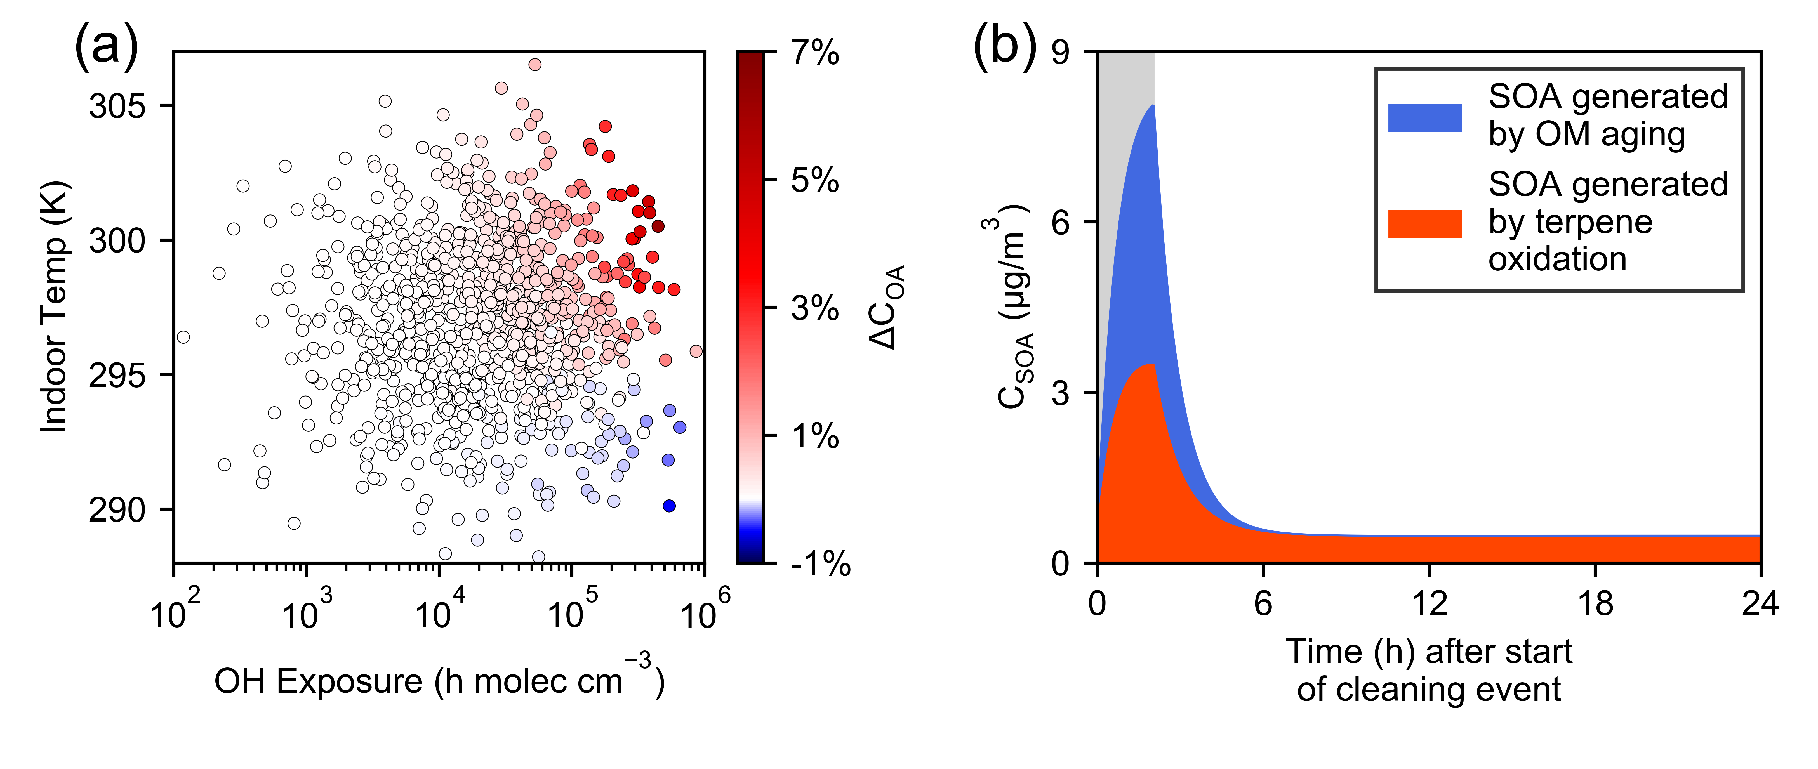

**Fig. 7**. (a) The dependence on OH exposure (*x*-axis) and temperature (*y*-axis) of the difference between aged OA concentration compared to baseline (unaged) OA concentration (Δ*C*OA, marker color) over the daylong time-averaged Monte Carlo set. (b) SOA concentration plotted over 24-hours after start of a high-OH pulse (gray bar, OH = 106 cm-3). At peak concentration, the SOA formed by aging chemistry (condensation of functionalized gaseous OM) is greater than fresh SOA formed from oxidation of terpenes.

**4.3. Surface interactions**

Reports of the applications of MD simulations to processes relevant to indoor air chemistry have recently begun to emerge from MOCCIE. The first two were aimed at elucidating the nature of the interactions between VOCs and glass (silica, SiO2), a common indoor surface. These studies were motivated by the fact that a broad range of organic compounds from a variety of sources are present in the indoor environment.1 and these compounds can form films on indoor surfaces,1, 118 which could influence their reactivity to gas-phase oxidants and the propensity of the oxidation products to form SOA.4, 38, 39, 119

A concerted vibrational spectroscopic and MD simulation study revealed an unexpected mode of interaction between limonene, a common indoor VOC found in cleaning products,119, 120 and the surface of silica.121 Infrared spectra displayed the loss of the silica free O–H stretching band and the growing in of a red-shifted O–H stretching band as the silica surface was exposed to limonene. The latter was tentatively assigned to hydrogen-bonding interaction between the silica surface O–H groups, which is unexpected because limonene is a hydrophobic organic molecule. *Ab initio* MD simulations revealed that the limonene molecule has two predominant configurations on the silica surface (Fig. 8a), and that the silica O–H groups are capable of forming π-hydrogen bonds with the double bonds of limonene in both configurations. Additional spectroscopic measurements and *ab initio* MD simulations showed that silica also forms π-hydrogen bonds with cyclohexene and benzene, but not cyclohexane. Of all the molecules considered, limonene interacted with the silica surface most strongly, via a combination of π-hydrogen bonds and relatively strong dispersion interactions. Overall, this study provided new insights into the nature of the interaction of hydrophobic molecules with hydrophilic surfaces, and paved the way for on-going combined experimental and simulation studies of the interactions of other common indoor VOCs with silica and other prevalent indoor surfaces.

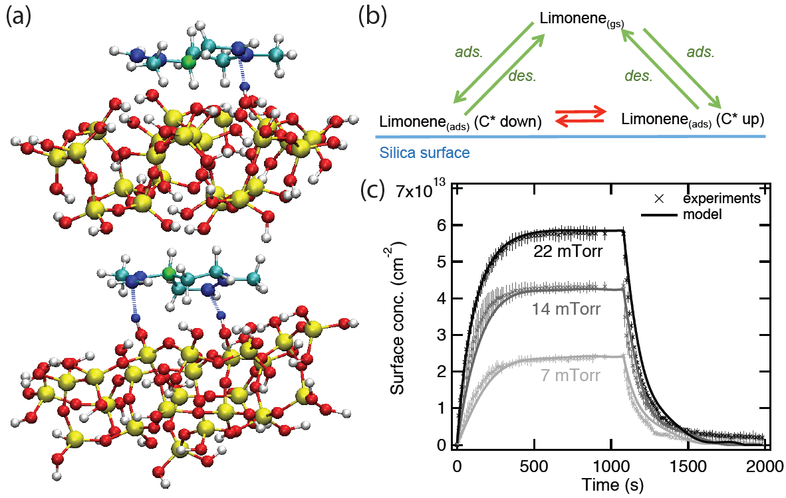

**Fig. 8.** Limonene adsorption on SiO2. (a) π-hydrogen bonding interactions (denoted by dashed lines) of limonene with the surface of hydroxylated silica from an *ab initio* MD simulation.121 The chiral carbon atom of limonene is colored green, the sp2 carbon atoms blue, the sp3 atoms cyan, and the silicon, oxygen, and hydrogen atoms of silica are colored yellow, red, and white, respectively. (b) Schematic of the K2-SURF model, which includes adsorption and desorption as well as inter-conversion of adsorbed limonene of C* down and C* up orientation. (c) Temporal evolution of adsorbed limonene concentrations on SiO2 as a function of time for three different limonene equilibrium pressures, 8 (light grey), 16 (dark grey) and 25 (black) mTorr. Error bars represent the standard deviation between triplicate replicates of the same experiment. Adapted from Ref. 122 with permission from the Royal Society of Chemistry.

The kinetics of reversible adsorption and desorption of limonene on silica were investigated using a novel combination of vibrational spectroscopy, MD simulations, and kinetic modeling.122 IR measurements of the time and pressure dependence of limonene adsorption/desorption were accurately reproduced by a kinetic model (K2-SURF),86 which included mechanistic details of the adsorption process and thermodynamic and kinetic parameters extracted from force field-based MD simulations and electronic structure calculations. Processes included in the K2-SURF model were the adsorption and desorption flux of limonene to the surface, the interconversion of different limoneneconfigurations on the surface and the changing pressure in the reaction cell (Fig. 8b). MD simulations provided input parameters for K2-SURF, which include the surface mass accommodation and the activation energies between different adsorbed limonene configurations. Reassuringly, the limonene desorption enthalpy obtained by fitting the model to the spectroscopic data, ~55 kJ mol–1, was in excellent agreement with the value obtained from the MD simulations. This study established a conceptual framework to integrate experimental measurements with theoretical and kinetic modeling for gaining the quantitative, molecular-scale understanding of the adsorption of gas-phase species on indoor surfaces. This approach could be applied to a range of different indoor species and surfaces and will ultimately be required for a complete description of indoor chemistry.

Given that a large amount of semi-volatile organic compounds (SVOCs) may partition into indoor surfaces,123, 124 multiphase chemical processes on indoor surfaces would have significant impact on the fate of SVOCs in indoor environments. A recent experimental study suggests that the lifetimes for OH heterogeneous oxidation of monolayer-thick indoor organic films will be on the timescale of weeks to months.125 Following up on this work, we recently developed analytical equations to resolve molecular and turbulent diffusion as well as chemistry in indoor boundary layer chemistry. A kinetic multi-layer modeling approach is also applied to account for uptake coefficients of species onto indoor surfaces as well as heterogeneous and multiphase reactions in indoor surface organic films. Cooking activities and subsequent deposition of cooking-emitted aerosols may lead to the formation of surface organic films containing cooking oils and polycyclic aromatic hydrocarbons (PAHs). Our recent modeling study combined with laboratory experiments suggests that the fate of PAHs in organic films is driven by diffusion limitations and phase separation in organic films, controlling the chemical lifetime of PAHs in indoor environments.126 Further work is under way to investigate the role and impact of chemical processes in the boundary layer and surface films on indoor air composition.

**5. Conclusions**

In the development of the modelling consortium for chemistry in indoor environments (MOCCIE), we initiated integration of a variety of models with a range of spatial and temporal scales with the aim of working towards the development of an overarching comprehensive indoor chemistry model. These models are applied to investigate reactions of ozone with skin and clothing, oxidation of volatile organic compounds and behavior and formation of organic aerosols, and mass transport and partitioning of indoor species onto and into surfaces.

Fig. 9 shows interconnections through integration of different models for skin chemistry, bridging a wide range of scales from molecule to building. MD simulations are conducted to provide a molecular picture of ozone interactions with skin lipids, providing kinetic parameters including surface accommodation coefficient, desorption lifetime, Henry’s law constant, and bulk diffusivity. These parameters are directly inputted into the kinetic multi-layer model for surface and bulk chemistry in the skin, which has been coupled with a human envelope clothing model to resolve gas diffusion between and through the clothing, partitioning of SVOCs, as well as chemical reactions of ozone with skin oils on clothes. This model enables the estimation of SVOC emissions following skin-oxidant interactions, which can be used to constrain the INDCM model.

The INDCM model was applied to simulate α-pinene ozonolysis with improved representation of gas-particle partitioning. The simulated SVOC concentrations from the INDCM will inform the 2D-VBS for simulating SOA concentrations. Application of 2D-VBS reveals that functionalization dominates over fragmentation and indoor OH-induced aging could be important for increase in organic aerosol concentrations. Using the ozone deposition rates and SVOC emission rates predicted by the KM-SUB-Skin-Clothing model as the CFD model inputs, the CFD model provides spatial distributions of oxidants and reactants in indoor environments. The results show that ozone is depleted in the human surface boundary layer. The results also reveal that the primary oxidation product is concentrated near the human surface and in the breathing zone, while the secondary oxidation product is relatively well-distributed throughout the room. Note that the connections of different models are bidirectional; for example, the skin model can be used to design MD simulations and CFD modeling can provide an oxidant concentration gradient near the skin or clothing that can be used in skin and human envelope models.

Collaboration with experimentalists is key for the development and application of MOCCIE models. While MOCCIE makes use of available experimental data from the literature, MOCCIE interacts and collaborates closely with experimentalists within the Sloan CIE program and beyond. For example, interconnections of MD simulations and kinetic modeling with experimental results were achieved in the investigations of VOC adsorption onto SiO2 surfaces121, 122 and modelling the HOMEChem data is under way. Our initial studies establish a conceptual framework to bridge different modeling tools and experimental measurements. Our models should be able to inform experiments by guiding measurements through identification of key species and important parameters, making predictions of expected indoor concentrations, and assisting in interpretation of laboratory experiments and field observations. We will continue our efforts to apply this approach to laboratory experiments and indoor field observations with our ambition to develop a comprehensive and integrated model for chemistry in indoor environments.

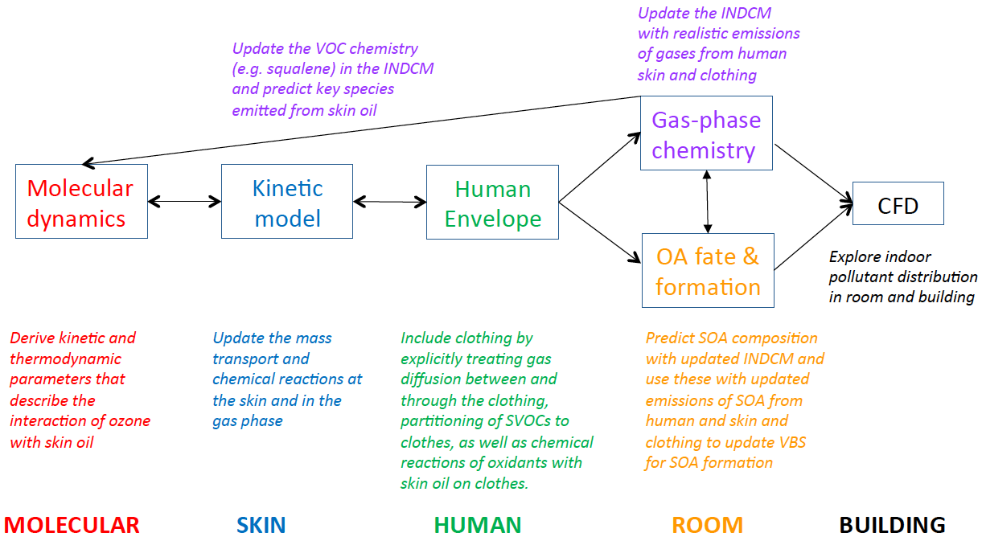

**Fig. 9.** Integration and interconnections of different models in this consortium towards development of a comprehensive indoor chemistry model.

**Acknowledgements.** We are grateful to Dr. Paula Olsiewski and the Alfred P. Sloan Foundation for providing us an opportunity and funding to work on this project (No. G-2017-9796). We thank Vicki Grassian, Jon Abbatt, and Ray Wells for close interactions and collaborations with MOCCIE. DJT acknowledges Krista Parry and Saleh Riahi for their contributions to the project. MvD is supported by a postdoctoral fellowship from the Deutsche Forschungsgemeinschaft (DFG, German Research Foundation, No. 409294855).

**References.**

1. W. W. Nazaroff and A. H. Goldstein, Indoor chemistry: research opportunities and challenges, *Indoor Air*, 2015, **25**, 357-361.

2. C. J. Weschler, Chemistry in indoor environments: 20 years of research, *Indoor Air*, 2011, **21**, 205-218.

3. G. Morrison, Recent advances in indoor chemistry, *Current Sustainable/Renewable Energy Reports*, 2015, **2**, 33-40.

4. C. J. Weschler and H. C. Shields, Indoor ozone/terpene reactions as a source of indoor particles, *Atmos. Environ.*, 1999, **33**, 2301-2312.

5. G. Sarwar, R. Corsi, D. Allen and C. Weschler, The significance of secondary organic aerosol formation and growth in buildings: experimental and computational evidence, *Atmos. Environ.*, 2003, **37**, 1365-1381.

6. G. Bekö, G. Tamas, O. Halas, G. Clausen and C. J. Weschler.

7. Z. Fan, C. J. Weschler, I.-K. Han and J. J. Zhang, Co-formation of hydroperoxides and ultra-fine particles during the reactions of ozone with a complex VOC mixture under simulated indoor conditions, *Atmos. Environ.*, 2005, **39**, 5171-5182.

8. B. C. Singer, B. K. Coleman, H. Destaillats, A. T. Hodgson, M. M. Lunden, C. J. Weschler and W. W. Nazaroff, Indoor secondary pollutants from cleaning product and air freshener use in the presence of ozone, *Atmos. Environ.*, 2006, **40**, 6696-6710.

9. A. M. Johnson, M. S. Waring and P. F. DeCarlo, Real‐time transformation of outdoor aerosol components upon transport indoors measured with aerosol mass spectrometry, *Indoor Air*, 2017, **27**, 230-240.

10. A. Wisthaler and C. J. Weschler, Reactions of ozone with human skin lipids: Sources of carbonyls, dicarbonyls, and hydroxycarbonyls in indoor air, *Proc. Natl. Acad. Sci. U.S.A.*, 2010, **107**, 6568-6575.

11. S. Liu, R. Li, R. J. Wild, C. Warneke, J. A. de Gouw, S. S. Brown, S. L. Miller, J. C. Luongo, J. L. Jimenez and P. J. Ziemann, Contribution of human-related sources to indoor volatile organic compounds in a university classroom, *Indoor Air*, 2016, **26**, 925-938.

12. X. C. Tang, P. K. Misztal, W. W. Nazaroff and A. H. Goldstein, Volatile Organic Compound Emissions from Humans Indoors, *Environ. Sci. Technol.*, 2016, **50**, 12686-12694.

13. J. P. S. Wong, N. Carslaw, R. Zhao, S. Zhou and J. P. D. Abbatt, Observations and impacts of bleach washing on indoor chlorine chemistry, *Indoor Air*, 2017, **27**, 1082-1090.

14. A. M. Avery, M. S. Waring and P. F. Decarlo, Human occupant contribution to secondary aerosol mass in the indoor environment, *Environ. Sci. Processes Impacts*, 2019, 10.1039/C1039EM00097F.

15. G. Morrison, N. Carslaw and M. S. Waring, A Modelling Enterprise for Chemistry of Indoor Environments (CIE), *Indoor Air*, 2017.

16. B. A. Tichenor and M. A. Mason, Organic emissions from consumer products and building materials to the indoor environment, *Japca*, 1988, **38**, 264-268.

17. J. A. Cano-Ruiz, D. Kong, R. B. Balas and W. W. Nazaroff, Removal of reactive gases at indoor surfaces: combining mass transport and surface kinetics, *Atmos. Environ. Part A*, 1993, **27**, 2039-2050.

18. G. C. Morrison and W. W. Nazaroff, The rate of ozone uptake on carpet: mathematical modeling, *Atmos. Environ.*, 2002, **36**, 1749-1756.

19. W. W. Nazaroff and G. R. Cass, Mathematical modeling of chemically reactive pollutants in indoor air, *Environ. Sci. Technol.*, 1986, **20**, 924-934.

20. C. Liu, Y. Zhang and C. J. Weschler, The impact of mass transfer limitations on size distributions of particle associated SVOCs in outdoor and indoor environments, *Sci. Total Environ.*, 2014, **497–498**, 401-411.

21. N. Carslaw, A new detailed chemical model for indoor air pollution, *Atmos. Environ.*, 2007, **41**, 1164-1179.

22. S. Gligorovski and J. P. D. Abbatt, An indoor chemical cocktail, *Science*, 2018, **359**, 632-633.

23. W. W. Nazaroff and G. R. Cass, Mathematical modeling of indoor aerosol dynamics, *Environ. Sci. Technol.*, 1989, **23**, 157-166.

24. N. Carslaw, T. Mota, M. E. Jenkin, M. H. Barley and G. McFiggans, A Significant Role for Nitrate and Peroxide Groups on Indoor Secondary Organic Aerosol, *Environ. Sci. Technol.*, 2012, **46**, 9290-9298.

25. S. Youssefi and M. S. Waring, Predicting secondary organic aerosol formation from terpenoid ozonolysis with varying yields in indoor environments, *Indoor Air*, 2012, **22**, 415-426.

26. G. Sarwar and R. Corsi, The effects of ozone/limonene reactions on indoor secondary organic aerosols, *Atmos. Environ.*, 2007, **41**, 959-973.

27. M. S. Waring, Secondary organic aerosol in residences: predicting its fraction of fine particle mass and determinants of formation strength, *Indoor Air*, 2014, **24**, 376-389.

28. C. Liu, S. Shi, C. Weschler, B. Zhao and Y. Zhang, Analysis of the Dynamic Interaction Between SVOCs and Airborne Particles, *Aerosol Sci. Technol.*, 2012, **47**, 125-136.

29. C. J. Weschler, T. Salthammer and H. Fromme, Partitioning of phthalates among the gas phase, airborne particles and settled dust in indoor environments, *Atmos. Environ.*, 2008, **42**, 1449-1460.

30. B. C. McDonald, J. A. de Gouw, J. B. Gilman, S. H. Jathar, A. Akherati, C. D. Cappa, J. L. Jimenez, J. Lee-Taylor, P. L. Hayes, S. A. McKeen, Y. Y. Cui, S.-W. Kim, D. R. Gentner, G. Isaacman-VanWertz, A. H. Goldstein, R. A. Harley, G. J. Frost, J. M. Roberts, T. B. Ryerson and M. Trainer, Volatile chemical products emerging as largest petrochemical source of urban organic emissions, *Science*, 2018, **359**, 760.

31. S. K. Brown, M. R. Sim, M. J. Abramson and C. N. Gray, Concentrations of volatile organic compounds in indoor air–a review, *Indoor Air*, 1994, **4**, 123-134.

32. G. Morrison, Interfacial chemistry in indoor environments, *Environ. Sci. Technol.*, 2008, **42**, 3495-3499.

33. M. D. Van Loy, W. J. Riley, J. M. Daisey and W. W. Nazaroff, Dynamic Behavior of Semivolatile Organic Compounds in Indoor Air. 2. Nicotine and Phenanthrene with Carpet and Wallboard, *Environ. Sci. Technol.*, 2001, **35**, 560-567.

34. R. H. Sabersky, D. A. Sinema and F. H. Shair, Concentrations, decay rates, and removal of ozone and their relation to establishing clean indoor air, *Environ. Sci. Technol.*, 1973, **7**, 347-353.

35. G. Morrison, H. W. Li, S. Mishra and M. Buechlein, Airborne phthalate partitioning to cotton clothing, *Atmos. Environ.*, 2015, **115**, 149-152.

36. L. A. Wallace, W. R. Ott, C. J. Weschler and A. C. K. Lai, Desorption of SVOCs from heated surfaces in the form of ultrafine particles, *Environ. Sci. Technol.*, 2017, **51**, 1140-1146.

37. D. B. Collins, R. F. Hems, S. Zhou, C. Wang, E. Grignon, M. Alavy, J. A. Siegel and J. P. D. Abbatt, Evidence for Gas–Surface Equilibrium Control of Indoor Nitrous Acid, *Environ. Sci. Technol.*, 2018, **52**, 12419-12427.

38. C. Y. Wang and M. S. Waring, Secondary organic aerosol formation initiated from reactions between ozone and surface-sorbed squalene, *Atmos. Environ.*, 2014, **84**, 222-229.

39. M. S. Waring and J. A. Siegel, Indoor Secondary Organic Aerosol Formation Initiated from Reactions between Ozone and Surface-Sorbed D-Limonene, *Environ. Sci. Technol.*, 2013, **47**, 6341-6348.

40. S. Shu and G. C. Morrison, Rate and reaction probability of the surface reaction between ozone and dihydromyrcenol measured in a bench scale reactor and a room-sized chamber, *Atmos. Environ.*, 2012, **47**, 421-427.

41. M. Springs, J. R. Wells and G. C. Morrison, Reaction rates of ozone and terpenes adsorbed to model indoor surfaces, *Indoor Air*, 2011, **21**, 319-327.

42. M. Kruza, A. C. Lewis, G. Morrison and N. Carslaw, Impact of surface ozone interactions on indoor air chemistry: a modelling study, *Indoor Air*, 2017, **27**, 1001–1011.

43. W. W. Nazaroff, A. J. Gadgil and C. J. Weschler, in *Modeling of Indoor Air Quality and Exposure*, ed. N. L. Nagda, 1993, vol. 1205, pp. 81-104.

44. C. J. Weschler, Ozone in indoor environments: Concentration and chemistry, *Indoor Air*, 2000, **10**, 269-288.

45. S. S. Cox, J. C. Little and A. T. Hodgson, Predicting the emission rate of volatile organic compounds from vinyl flooring, *Environ. Sci. Technol.*, 2002, **36**, 709-714.

46. A. Rackes and M. S. Waring, Do time-averaged, whole-building, effective volatile organic compound (VOC) emissions depend on the air exchange rate? A statistical analysis of trends for 46 VOCs in U.S. offices, *Indoor Air*, 2016, **26**, 642-659.

47. B. A. Tichenor, Z. Guo, J. E. Dunn, L. E. Sparks and M. A. Mason, The interaction of vapour phase organic compounds with indoor sinks, *Indoor Air*, 1991, **1**, 23-35.

48. D. Won, D. M. Sander, C. Y. Shaw and R. L. Corsi, Validation of the surface sink model for sorptive interactions between VOCs and indoor materials, *Atmos. Environ.*, 2001, **35**, 4479-4488.

49. B. C. Singer, K. L. Revzan, T. Hotchi, A. T. Hodgson and N. J. Brown, Sorption of organic gases in a furnished room, *Atmos. Environ.*, 2004, **38**, 2483-2494.

50. E. T. Gall, J. A. Siegel and R. L. Corsi, Modeling ozone removal to indoor materials, including the effects of porosity, pore diameter, and thickness, *Environ. Sci. Technol.*, 2015, **49**, 4398-4406.

51. M. Gong, Y. Zhang and C. J. Weschler, Measurement of Phthalates in Skin Wipes: Estimating Exposure from Dermal Absorption, *Environ. Sci. Technol.*, 2014, **48**, 7428-7435.

52. G. C. Morrison, C. J. Weschler and G. Bekö, Dermal uptake directly from air under transient conditions: advances in modeling and comparisons with experimental results for human subjects, *Indoor Air*, 2016, **26**, 913-924.

53. G. C. Morrison, C. J. Weschler and G. Bekö, Dermal uptake of phthalates from clothing: Comparison of model to human participant results, *Indoor Air*, 2017, **27**, 642–649.

54. P. S. J. Lakey, A. Wisthaler, T. Berkemeier, T. Mikoviny, U. Pöschl and M. Shiraiwa, Chemical kinetics of multiphase reactions between ozone and human skin lipids: Implications for indoor air quality and health effects, *Indoor Air*, 2017, **27**, 816-828.

55. B. C. Singer, R. Z. Pass, W. W. Delp, D. M. Lorenzetti and R. L. Maddalena, Pollutant concentrations and emission rates from natural gas cooking burners without and with range hood exhaust in nine California homes, *Build. Environ.*, 2017, **122**, 215-229.

56. R. Kamens, C.-t. Lee, R. Wiener and D. Leith, A study of characterize indoor particles in three non-smoking homes, *Atmos. Environ. Part A*, 1991, **25**, 939-948.

57. B. C. Singer, H. Destaillats, A. T. Hodgson and W. W. Nazaroff, Cleaning products and air fresheners: emissions and resulting concentrations of glycol ethers and terpenoids, *Indoor Air*, 2006, **16**, 179-191.

58. H. Schwartz-Narbonne, C. Wang, S. Zhou, J. P. D. Abbatt and J. Faust, Heterogeneous Chlorination of Squalene and Oleic Acid, *Environ. Sci. Technol.*, 2019, **53**, 1217-1224.

59. C. J. Weschler, Roles of the human occupant in indoor chemistry, *Indoor Air*, 2016, **26**, 6-24.

60. C. J. Weschler, A. Wisthaler, S. Cowlin, G. Tamas, P. Strom-Tejsen, A. T. Hodgson, H. Destaillats, J. Herrington, J. J. Zhang and W. W. Nazaroff, Ozone-initiated chemistry in an occupied simulated aircraft cabin, *Environ. Sci. Technol.*, 2007, **41**, 6177-6184.

61. G. Tamás, C. J. Weschler, Z. Bakó-Biró, D. P. Wyon and P. Strøm-Tejsen, Factors affecting ozone removal rates in a simulated aircraft cabin environment, *Atmos. Environ.*, 2006, **40**, 6122-6133.

62. M. Kruza and N. Carslaw, How do breath and skin emissions impact indoor air chemistry?, *Indoor Air*, 2019, **0**.

63. B. K. Coleman, H. Destaillats, A. T. Hodgson and W. W. Nazaroff, Ozone consumption and volatile byproduct formation from surface reactions with aircraft cabin materials and clothing fabrics, *Atmos. Environ.*, 2008, **42**, 642-654.

64. A. Wisthaler, G. Tamas, D. P. Wyon, P. Strom-Tejsen, D. Space, J. Beauchamp, A. Hansel, T. D. Mark and C. J. Weschler, Products of ozone-initiated chemistry in a simulated aircraft environment, *Environ. Sci. Technol.*, 2005, **39**, 4823-4832.

65. D. Rim, E. T. Gall, S. Ananth and Y. Won, Ozone reaction with human surfaces: Influences of surface reaction probability and indoor air flow condition, *Build. Environ.*, 2018, **130**, 40-48.

66. D. Rim, A. Novoselec and G. Morrison, The influence of chemical interactions at the human surface on breathing zone levels of reactants and products, *Indoor Air*, 2009, **19**, 324-334.

67. E. M. Knipping, M. J. Lakin, K. L. Foster, P. Jungwirth, D. J. Tobias, R. B. Gerber, D. Dabdub and B. J. Finlayson-Pitts, Experiments and Simulations of Ion-Enhanced Interfacial Chemistry on Aqueous NaCl Aerosols, *Science*, 2000, **288**, 301-306.

68. P. Jungwirth and D. J. Tobias, Molecular Structure of Salt Solutions: A New View of the Interface with Implications for Heterogeneous Atmospheric Chemistry, *J. Phys. Chem. B*, 2001, **105**, 10468-10472.

69. P. Jungwirth and D. J. Tobias, Specific Ion Effects at the Air/Water Interface, *Chem. Rev.*, 2006, **106**, 1259-1281.

70. D. J. Tobias, A. C. Stern, M. Baer, Y. Levin and C. J. Mundy, Simulation and Theory of Ions at Atmospherically Relevant Aqueous Liquid-Air Interfaces, *Annu. Rev. Phys. Chem.*, 2013, **64**, 339-359.

71. M. Roeselova, P. Jungwirth, D. J. Tobias and R. B. Gerber, Impact, Trapping, and Accommodation of Hydroxyl Radical and Ozone at Salt Aerosol Surfaces: a Molecular Dynamics Study, *J. Phys. Chem. B*, 2003, **107**.

72. M. Roeselova, J. Vieceli, L. X. Dang, B. C. Garrett and D. J. Tobias, Hydroxyl Radical at the Air-Water Interface, *J. Am. Chem. Soc.*, 2004, **126**, 16308-16309.

73. R. Vacha, P. Slavicek, M. Mucha, B. J. Finlayson-Pitts and P. Jungwirth, Adsorption of Atmospherically Relevant Gases at the Air/Water Interface: Free Energy Profiles of Aqueous Solvation of N2, O2, O3, H2O, HO2, and H2O2, *J. Phys. Chem. A*, 2004, **108**, 11573-11579.

74. J. Vieceli, M. Roeselova, N. Potter, L. X. Dang, B. C. Garrett and D. J. Tobias, Molecular Dynamics Simulations of Atmospheric Oxidants at the Air/Water Interface: Solvation and Accommodation of OH and O3, *J. Phys. Chem. B*, 2005, **109**, 15876-15892.

75. S. W. Hunt, M. Roeselova, W. Wang, L. M. Wingen, E. M. Knipping, D. J. Tobias, D. Dabdub and B. J. Finlayson-Pitts, Formation of Molecular Bromine from the Reaction of Ozone with Deliquesced NaBr Aerosol: Evidence for Interface Chemistry, *J. Phys. Chem. A*, 2004, **108**, 11559-11572.

76. J. Vieceli, O. L. Ma and D. J. Tobias, Uptake and Collision Dynamics of Gas Phase Ozone at Unsaturated Organic Surfaces, *J. Phys. Chem. A*, 2004, **108**, 5806-5814.

77. Y. Dubowski, J. Vieceli, D. J. Tobias, A. Gomez, A. Lin, S. Nizkorodov, T. M. McIntire and B. J. Finlayson-Pitts, Interaction of Gas-Phase Ozone at 296 K with Unsaturated Self-Assembled Monolayers: A New Look at an Old System, *J. Phys. Chem. A*, 2004, **108**, 10473-10485.

78. S. G. Moussa, T. M. McIntire, M. Szori, M. Roeselova, D. J. Tobias, R. L. Grimm, J. C. Hemminger and B. J. Finlayson-Pitts, Experimental and Theoretical Characterization of Water Uptake on Self-Assembled Monolayers: Understanding the Interaction of Water with Atmospherically Relevant Surfaces, *J. Phys. Chem. A*, 2009, **113**.

79. S. G. Moussa, A. C. Stern, J. D. Raff, C. W. Dilbeck, D. J. Tobias and B. J. Finlayson-Pitts, Experimental and Theoretical Studies of the Interaction of Gas Phase Nitric Acid and Water with a Self-Assembled Monolayer, *Phys. Chem. Chem. Phys.*, 2013, **15**, 448-458.

80. N. Nishino, S. A. Hollingsworth, A. C. Stern, M. Roeselova, D. J. Tobias and B. J. Finlayson-Pitts, Interactions of Gaseous HNO3 and Water with Self-Assembled Monolayers at Various Relative Humidities at Room Temperature, *Phys. Chem. Chem. Phys.*, 2014, **16**, 2558-2567.

81. R. B. Gerber and J. Sebek, Dynamic Simulations of Atmospherically Relevant Molecular Reactions, *Int. Rev. Phys. Chem.*, 2009, **28**, 207-222.

82. R. B. Gerber, M. E. Varner, A. D. Hammerich, S. Riikonen, G. Murdachaew, D. Shemesh and B. J. Finlayson-Pitts, Computational Studies of Atmospherically-Relevant Chemical Reactions, *Acc. Chem. Res.*, 2015, **48**, 399-406.

83. J. Xu, B. J. Finlayson-Pitts and R. B. Gerber, Proton Transfer in Mixed Clusters of Methanesulfonic Acid, Methylamine, and Oxalic Acid: Implications for Atmospheric Particle Formation, *J. Phys. Chem. A*, 2017, **121**, 2377-2385.

84. J. Xu, B. J. Finlayson-Pitts and R. B. Gerber, Nanoparticles Grown from Methanesulfonic Acid and Methylamine: Microscopic Structures and Formation Mechanism, *Phys. Chem. Chem. Phys.*, 2017, **19**, 31949-31957.

85. J. Xu, V. Perraud, B. J. Finlayson-Pitts and R. B. Gerber, Uptake of Water by an Acid-Base Nanoparticle: Theoretical and Experimental Studies of the Methanesulfonic Acid-Methylamin System, *Phys. Chem. Chem. Phys.*, 2018, **20**, 22249-22259.

86. M. Shiraiwa, R. M. Garland and U. Pöschl, Kinetic double-layer model of aerosol surface chemistry and gas-particle interactions (K2-SURF): Degradation of polycyclic aromatic hydrocarbons exposed to O3, NO2, H2O, OH and NO3, *Atmos. Chem. Phys.*, 2009, **9**, 9571-9586.

87. M. Shiraiwa, C. Pfrang and U. Pöschl, Kinetic multi-layer model of aerosol surface and bulk chemistry (KM-SUB): the influence of interfacial transport and bulk diffusion on the oxidation of oleic acid by ozone, *Atmos. Chem. Phys.*, 2010, **10**, 3673-3691.

88. U. Pöschl, Y. Rudich and M. Ammann, Kinetic model framework for aerosol and cloud surface chemistry and gas-particle interactions - Part 1: General equations, parameters, and terminology, *Atmos. Chem. Phys.*, 2007, **7**, 5989-6023.

89. D. R. Worsnop, J. W. Morris, Q. Shi, P. Davidovits and C. E. Kolb, A chemical kinetic model for reactive transformations of aerosol particles, *Geophys. Res. Lett.*, 2002, **29**, 57.

90. P. S. J. Lakey, G. Morrison, Y. Won, K. M. Parry, M. von Domaros, D. J. Tobias, D. Rim and M. Shiraiwa, The impact of clothing on ozone and squalene ozonolysis products in indoor environments, *Commun. Chem.*, 2019, accpeted.

91. N. Carslaw, A mechanistic study of limonene oxidation products and pathways following cleaning activities, *Atmos. Environ.*, 2013, **80**, 507-513.

92. N. Carslaw, M. Ashmore, A. C. Terry and D. C. Carslaw, Crucial Role for Outdoor Chemistry in Ultrafine Particle Formation in Modern Office Buildings, *Environ. Sci. Technol.*, 2015, **49**, 11011-11018.

93. M. E. Jenkin, S. M. Saunders and M. J. Pilling, The tropospheric degradation of volatile organic compounds: a protocol for mechanism development, *Atmos. Environ.*, 1997, **31**, 81-104.

94. A. C. Terry, N. Carslaw, M. Ashmore, S. Dimitroulopoulou and D. C. Carslaw, Occupant exposure to indoor air pollutants in modern European offices: An integrated modelling approach, *Atmos. Environ.*, 2014, **82**, 9-16.

95. N. M. Donahue, S. A. Epstein, S. N. Pandis and A. L. Robinson, A two-dimensional volatility basis set: 1. organic-aerosol mixing thermodynamics, *Atmos. Chem. Phys.*, 2011, **11**, 3303-3318.

96. J. L. Jimenez, M. R. Canagaratna, N. M. Donahue, A. S. H. Prevot, Q. Zhang, J. H. Kroll, P. F. DeCarlo, J. D. Allan, H. Coe, N. L. Ng, A. C. Aiken, K. S. Docherty, I. M. Ulbrich, A. P. Grieshop, A. L. Robinson, J. Duplissy, J. D. Smith, K. R. Wilson, V. A. Lanz, C. Hueglin, Y. L. Sun, J. Tian, A. Laaksonen, T. Raatikainen, J. Rautiainen, P. Vaattovaara, M. Ehn, M. Kulmala, J. M. Tomlinson, D. R. Collins, M. J. Cubison, E. J. Dunlea, J. A. Huffman, T. B. Onasch, M. R. Alfarra, P. I. Williams, K. Bower, Y. Kondo, J. Schneider, F. Drewnick, S. Borrmann, S. Weimer, K. Demerjian, D. Salcedo, L. Cottrell, R. Griffin, A. Takami, T. Miyoshi, S. Hatakeyama, A. Shimono, J. Y. Sun, Y. M. Zhang, K. Dzepina, J. R. Kimmel, D. Sueper, J. T. Jayne, S. C. Herndon, A. M. Trimborn, L. R. Williams, E. C. Wood, A. M. Middlebrook, C. E. Kolb, U. Baltensperger and D. R. Worsnop, Evolution of organic aerosols in the atmosphere, *Science*, 2009, **326**, 1525-1529.

97. J. F. Pankow, An absorption-model of the gas aerosol partitioning involved in the formation of secondary organic aerosol, *Atmos. Environ.*, 1994, **28**, 189-193.

98. N. M. Donahue, K. M. Henry, T. F. Mentel, A. Kiendler-Scharr, C. Spindler, B. Bohn, T. Brauers, H. P. Dorn, H. Fuchs, R. Tillmann, A. Wahner, H. Saathoff, K.-H. Naumann, O. Möhler, T. Leisner, L. Müller, M.-C. Reinnig, T. Hoffmann, K. Salo, M. Hallquist, M. Frosch, M. Bilde, T. Tritscher, P. Barmet, A. P. Praplan, P. F. DeCarlo, J. Dommen, A. S. H. Prévôt and U. Baltensperger, Aging of biogenic secondary organic aerosol via gas-phase OH radical reactions, *Proc. Natl. Acad. Sci. U.S.A.*, 2012, **109**, 13503-13508.

99. J. H. Kroll, N. M. Donahue, J. L. Jimenez, S. H. Kessler, M. R. Canagaratna, K. R. Wilson, K. E. Altieri, L. R. Mazzoleni, A. S. Wozniak, H. Bluhm, E. R. Mysak, J. D. Smith, C. E. Kolb and D. R. Worsnop, Carbon oxidation state as a metric for describing the chemistry of atmospheric organic aerosol, *Nature Chem.*, 2011, **3**, 133-139.

100. M. Kuwata, S. R. Zorn and S. T. Martin, Using elemental ratios to predict the density of organic material composed of carbon, hydrogen, and oxygen, *Environ. Sci. Technol.*, 2012, **46**, 787-794.

101. A. T. Lambe, T. B. Onasch, P. Massoli, D. R. Croasdale, J. P. Wright, A. T. Ahern, L. R. Williams, D. R. Worsnop, W. H. Brune and P. Davidovits, Laboratory studies of the chemical composition and cloud condensation nuclei (CCN) activity of secondary organic aerosol (SOA) and oxidized primary organic aerosol (OPOA), *Atmos. Chem. Phys.*, 2011, **11**, 8913-8928.

102. W. S. W. DeRieux, Y. Li, P. Lin, J. Laskin, A. Laskin, A. K. Bertram, S. A. Nizkorodov and M. Shiraiwa, Predicting the glass transition temperature and viscosity of secondary organic material using molecular composition, *Atmos. Chem. Phys.*, 2018, **18**, 6331-6351.

103. M. Shiraiwa, Y. Li, A. P. Tsimpidi, V. A. Karydis, T. Berkemeier, S. N. Pandis, J. Lelieveld, T. Koop and U. Pöschl, Global distribution of particle phase state in atmospheric secondary organic aerosols, *Nat. Commun.*, 2017, **8**, 15002.

104. S. A. Epstein, I. Riipinen and N. M. Donahue, A Semiempirical Correlation between Enthalpy of Vaporization and Saturation Concentration for Organic Aerosol, *Environ. Sci. Technol.*, 2010, **44**, 743-748.

105. D. N. Sørensen and C. J. Weschler, Modeling-gas phase reactions in indoor environments using computational fluid dynamics, *Atmos. Environ.*, 2002, **36**, 9-18.

106. P. V. Nielsen, Fifty years of CFD for room air distribution, *Build. Environ.*, 2015, **91**, 78-90.

107. M. Peric and S. Ferguson, The advantage of polyhedral meshes, *Dynamics*, 2005, **24**, 45.

108. B. E. Launder and D. B. Spalding, in *Numerical Prediction of Flow, Heat Transfer, Turbulence and Combustion*, Elsevier, 1983, pp. 96-116.

109. N. Nicolaides, Skin lipids - Their biochemical uniqueness, *Science*, 1974, **186**, 19-26.

110. S. Zhou, M. W. Forbes and J. P. D. Abbatt, Kinetics and products from heterogeneous oxidation of squalene with ozone, *Environ. Sci. Technol.*, 2016, **50**, 11688-11697.

111. S. Zhou, M. W. Forbes, Y. Katrib and J. P. D. Abbatt, Rapid oxidation of skin oil by ozone, *Environ. Sci. Technol. Lett.*, 2016, **3**, 170-174.

112. A. Lesage, T. Lefièvre, G. Stoltz and J. Hénin, Smoothed Biasing Forces Yield Unbiased Free Energies with the Extended-System Adaptive Biasing Force Method, *J. Phys. Chem. B*, 2017, **121**, 3676-3685.

113. A. C. Rai, B. Guo, C. H. Lin, J. Zhang, J. Pei and Q. Chen, Ozone reaction with clothing and its initiated VOC emissions in an environmental chamber, *Indoor Air*, 2014, **24**, 49-58.

114. S. Compernolle, K. Ceulemans and J. F. Muller, EVAPORATION: a new vapour pressure estimation methodfor organic molecules including non-additivity and intramolecular interactions, *Atmos. Chem. Phys.*, 2011, **11**, 9431-9450.

115. Y. Nannoolal, J. Rarey and D. Ramjugernath, Estimation of pure component properties - Part 3. Estimation of the vapor pressure of non-electrolyte organic compounds via group contributions and group interactions, *Fluid Phase Equilib.*, 2008, **269**, 117-133.

116. B. Cummings and M. S. Waring, Predicting the importance of oxidative aging on indoor organic aerosol concentrations using the two-dimensional volatility basis set (2D-VBS), *Indoor Air*, 2019.

117. N. Carslaw, L. Fletcher, D. Heard, T. Ingham and H. Walker, Significant OH production under surface cleaning and air cleaning conditions: Impact on indoor air quality, *Indoor Air*, 2017, **27**, 1091-1100.

118. C. J. Weschler and W. W. Nazaroff, Growth of organic films on indoor surfaces, *Indoor Air*, 2017, **27**, 1101-1112.

119. T. Wainman, J. Zhang, C. J. Weschler and P. J. Lioy, Ozone and Limonene in Indoor Air: A Source of Submicron Particle Exposure, *Environ. Health Perspect.*, 2000, **108**, 1139-1145.

120. W. W. Nazaroff and C. J. Weschler, Cleaning Products and Air Fresheners: Exposure to Primary and Secondary Air Pollutants, *Atmos. Environ.*, 2004, **38**, 2841-2865.

121. Y. Fang, S. Riahi, A. T. McDonald, M. Shrestha, D. J. Tobias and V. H. Grassian, What is the Driving Force behind the Adsorption of Hydrophobic Molecules on Hydrophilic Surfaces?, *J. Phys. Chem. Lett.*, 2019, **10**, 468-473.

122. Y. Fang, P. Lakey, S. Riahi, A. McDonald, M. Shrestha, D. J. Tobias, M. Shiraiwa and V. Grassian, A Molecular Picture of Surface Interactions of Organic Compounds on Prevalent Indoor Surfaces: Limonene Adsorption on SiO2, *Chem. Sci.*, 2019, **10**, 2906-2914.

123. C. J. Weschler and W. W. Nazaroff, SVOC partitioning between the gas phase and settled dust indoors, *Atmos. Environ.*, 2010, **44**, 3609-3620.

124. C. J. Weschler and W. W. Nazaroff, SVOC exposure indoors: fresh look at dermal pathways, *Indoor Air*, 2012, **22**, 356-377.

125. R. Alwarda, S. Zhou and J. P. D. Abbatt, Heterogeneous oxidation of indoor surfaces by gas-phase hydroxyl radicals, *Indoor Air*, 2018, **28**, 655-664.

126. S. Zhou, B. Hwang, P. S. J. Lakey, A. Zuend, J. P. D. Abbatt and M. Shiraiwa, Multiphase Reactivity of Polycyclic Aromatic Hydrocarbons is Driven by Diffusion Limitations and Phase Separation, **submitted**.