Title Page
Title
Dynamics of liquid water in the anode flow channels of PEM fuel cells: a numerical parametric study
Authors
Z.X. Chen, D.B. Ingham, M.S. Ismail, L. Ma, K.J. Hughes *, and M. Pourkashanian
Energy 2050, Department of Mechanical Engineering, Faculty of Engineering, University of Sheffield, Sheffield S10 2TN, UK.
* Corresponding author: Tel: + 44 (0) 114 21 57214
Email address: K.J.Hughes@sheffield.ac.uk (K.J. Hughes)

Abstract
A 3D volume of fluid (VOF) model for an anode channel in a PEM fuel cell has been built. The effects of the initial position of the water droplet, its size as well as the wettability of the gas diffusion layer (GDL) are investigated under different operating conditions. It is found that the initial position of the relatively small water droplet in the channel has almost no effect on the pressure drop and the time taken for the liquid water to move out from the channel; however, such effects become more profound as the size of the water droplet increases. Also, when the droplet is placed at the side wall of the channel, then it develops into pockets of water that are mainly located at the upper corners of the channel, thus causing a smaller pressure drop compared to the cases in which the water droplet is placed either on the surface of the GDL or on the top wall of the channel. Furthermore, the hydrogen velocity is found to have a negligible effect on the dynamics of liquid water; however, the pressure drop and removal time are significantly influenced by the hydrogen velocity. Moreover, as the size of the water droplet increases, the pressure drop increases and the time required for the liquid water to move out of the channel decreases. Finally, the pressure drop in the channel decreases and the removal time of the liquid water increases as the contact angle of the GDL decreases.

Keywords: PEM fuel cells; Anode flow channel; VOF model; GDL wettability

1. Introduction
Proton exchange membrane (PEM) fuel cells are promising battery-replacements for some portable devices and vehicles. This is mainly due to their high power density, rapid start-up and low operating temperature [1–3].
However, there are still technical challenges that have to be overcome in order to reach widespread commercialisation of the PEM fuel cell technology [4–8]. One of the key challenges is water management, since it is related to both water flooding and dry-out of the membrane [9,10]. Water flooding increases the concentration losses because it hinders the transport of the reactant from the flow channel to the catalyst layer, while dry-out of the membrane increases the ionic resistance of the membrane, thus leading to possibly unacceptable fuel cell performance.
Over the past decade, water flooding in the gas channels has attracted much attention and this is due to the influential role of the flow channels in transporting the reactants to the reactive sites in the catalyst layers through the gas diffusion layers (GDLs). Liquid water accumulation in the channels may increase the pressure drop along the channel and, if severe, may cause blockage to the flow of the reacting gases, thus decreasing the efficiency of the fuel cell system. Many experimental studies have employed different visualization methods to investigate two-phase flows, e.g. X-ray, Magnetic Resonance Imaging (MRI) and neutron imaging [11–19].
On the other hand, many investigations have chosen numerical methods to study the two-phase flow in the channels. In early studies, the multi-phase mixture (M²) model and the multi-fluid model have been employed to investigate the two-phase flow [20–24]. However these two methods cannot describe the existing form and the motion of the liquid water. In order to track the dynamics of the liquid water, the two-phase flow is investigated by other methods, e.g. the pore-network (PN), Lattice Boltzmann (LB), and the volume of fluid (VOF) methods. More details about these methods can be found in the review paper [25]. The volume of fluid (VOF) method is chosen in this study because it is better at considering the surface tension and wall adhesion effects when compared with the above-mentioned methods. The VOF method has been used to investigate the effects of the channel geometry and its properties (e.g. wettability) on the formation and dynamics of liquid water [26–34]. Further, some researchers have coupled the VOF model with electrochemistry in order to investigate the effects of the dynamics of liquid water on the fuel cell performance [35–37].
All the above studies have focused on flooding in the cathode channel which is commonly-encountered in PEM fuel cells as water is produced at the cathode. However, some visualization experiments have showed that, under some certain operating conditions, e.g. low current densities and high relative humidity, flooding can occur in the anode gas channel [38–40]. In the cathode compartment, liquid water emerges from the GDL pores. Liquid water can be either (i) produced within the anode channel through condensation of water vapour at the walls of the channel where the temperature is lower than that of the GDL surface or (ii) transferred from the cathode side through the membrane by back diffusion and pressure difference [41]. Ge and Wang [42] were the first to present visualization results of the flooding in the anode channel. Their results showed that water was prone to condense on the channel walls rather than inside the hydrophobic GDL. In addition, they found that hydrophilic anode GDLs could alleviate anode channel flooding. Lee and Bae [43] compared water flooding at both the anode and the cathode by employing a transparent fuel cell. They found that flooding at the anode was more significant than that at the cathode and this was attributed to the relatively high rate of back diffusion and low flow rate of hydrogen. Ferreira et al. [44] numerically investigated the two-phase flow in the anode channel by adopting the VOF model. They placed a water droplet on the top wall of the channel at the start of the simulations and subsequently studied the effects of the hydrogen velocity, operating temperature and the channel walls wettability on the droplet. Hou et al. [45] built a VOF model for alkaline membrane fuel cells and investigated the sensitivity of liquid water removal to the geometry of the flow channels at both the anode and cathode sides. However, in their study, a single droplet was placed at the surface of the GDL at the anode side where water is generated in this type of fuel cell.
To the best of the authors’ knowledge, the effects of the initial position of the water droplet and the GDL wettability at the anode have not been investigated. Unlike the cathode channel, the initial position of the water droplets in the anode channel is more unpredictable. Therefore, a 3D VOF model is built in this study to investigate the sensitivity of the dynamics of the liquid water droplet to the initial position in the anode flow channel. Also, the effects of the size of the droplet and the hydrogen velocity are investigated. Further, the effects of the anode GDL wettability on the dynamics of liquid water droplet, average pressure drop and water removal time are investigated. Such investigations are important as they provide insights on how one could design fuel cell components which mitigate water flooding at the anode of the fuel cell.
2. Numerical model
2.1. Numerical method
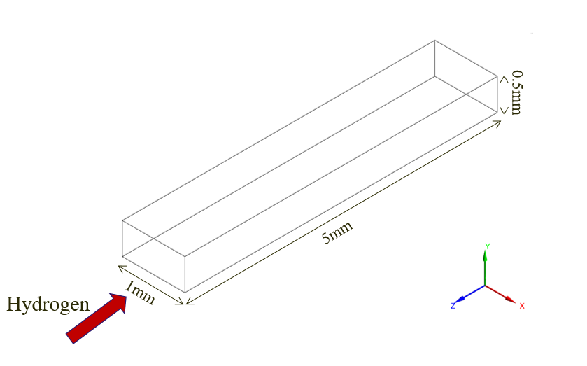
Fig. 1. A schematic diagram of the modelled anode channel.
Fig.1 shows a schematic of the 3D computational domain considered in this study. It contains a straight gas channel with a 1 mm × 0.5 mm rectangular cross section and 5 mm length. The cross sectional area, namely 1 mm × 0.5 mm, of the channel was chosen because it is commonly used in commercial products. Further, the channel length of 5 mm is chosen since it is found to be long enough for the multi-phase flow to be fully developed and to cover all the possible dynamics of the liquid water such as detachment. To this end, modelling the entire channel is unnecessary, especially when bearing in mind that it requires much larger computational time. The bottom surface represents the surface of the GDL while the other sides represent the walls of the flow channel.
The VOF method models two or more immiscible fluids by solving a set of momentum equations and tracking the volume fraction of each phase throughout the domain. In this study, there are two phases in the domain, namely hydrogen gas and liquid water. Subscripts 1 and 2 are used in this study to represent the hydrogen and liquid water, respectively. The sum of the volume fractions is equal to one in each computational cell; therefore, the volume fractions of hydrogenand liquid watercan be obtained by:
(1)
The continuity and momentum equations are as follows:

(2)
(3)
whereis the velocity, is the pressure,andare the volume averaged density and dynamic viscosity, respectively, and are given by:
(4)
(5)
andis the momentum source term. In order to capture the effects of the surface tension, the continuum surface force (CSF) is employed to calculate [46]:
(6)
Where is the surface tension coefficient, and is the surface curvature defined in terms of the divergence of the unit normal:
(7)
(8)
The curvature of the surface near the wall are adjusted in order to reflect the effects of the wall adhesion force. In the cells near the wall, the modified surface normalis given by:
(9)
whereis the contact angle of the wall, and and are the unit vectors normal and tangential to the wall, respectively.
2.2. Initial and boundary conditions
The boundary conditions used for the model are the velocity-inlet for the inlet of the channel and pressure-outlet for the outlet of the channel. Apart from the boundary conditions assigned at the inlet and the outlet of the channel, other surfaces are treated as a “wall” so that different values of the contact angle can be set for each surface. The consumption of hydrogen due to the anodic electrochemical reaction is neglected in the model. This simplification is widely used when modelling two-phase flow in fuel cell channels as this would not affect the dynamics of the liquid water in the channel which is the focus of such studies [30–32]. A 25 cm² PEM fuel cell operating at 0.5 A cm⁻², 80 °C and hydrogen stoichiometric ratio of 1.2 are chosen for the simulation of the base case. These were found to be conditions at which anode flooding occurs [43]. Based on the above conditions, the velocity of the inlet gas, which is a mixture of water vapour and hydrogen, is calculated to be 2 m s⁻¹, and all the physical parameters considered in the model are listed in Table 1. In this study, fully humidified hydrogen is chosen for all simulations as this will most likely cause anode flooding.
The simulations in this study are run using ANSYS FLUENT 18.2. The pressure-based solver is employed in the model. It should be noted that the Reynolds and Bond numbers were found to be small for all simulated cases: less than 10³ and 0.1, respectively. Therefore, the laminar viscous model has been selected and the gravity effect has been neglected.
Table 1. Values of the parameters applied in the simulations. Unless otherwise stated, the values of the
parameters are taken from [44].
Parameter | Value
Temperature | 353 K
Inlet velocity | 2 m s⁻¹
Ambient pressure | 101,325 Pa
Outlet pressure | 0 Pa (gauge)
Gas density | 6.877 × 10⁻² kg m⁻³
Liquid water density | 971.8 kg m⁻³
Gas viscosity | 9.995 × 10⁻⁶ Pa s
Liquid water viscosity | 3.544 × 10⁻⁸ Pa s
Surface tension | 6.267 × 10⁻² N m⁻¹

2.3. Test of grid independency and time-step method
A computational domain consisting of 96,526 cells is employed in this study. Grid independency is tested by decreasing and increasing this number by 20%; the changes in the velocity profile and pressure drop were found to be negligible, thus indicating grid independency. The time step is set to be 10⁻⁶ s and therefore the global Courant number is less than 2. Different time steps, i.e. between 10⁻⁷ s and 10⁻⁵ s, have been also tested in the model, and the time step of 10⁻⁶ s was found to be a suitable trade-off between the accuracy and computational time.
Table 2. The computation cases investigated.
Case | Contact angle (°) |  | Droplet |  |  | Operation condition
 | GDL | Channel walls | Diameter (mm) | Location (mm) | Distance (mm) | Hydrogen velocity  (m/s)
1 | 140 | 45 | 0.5 | Top wall | 1 | 2
2 | 140 | 45 | 0.5 | Side wall | 1 | 2
3 | 140 | 45 | 0.5 | GDL | 1 | 2
4 | 140 | 45 | 0.5 | Top wall | 1 | 1
5 | 140 | 45 | 0.5 | Side wall | 1 | 1
6 | 140 | 45 | 0.5 | GDL | 1 | 1
7 | 140 | 45 | 0.5 | Top wall | 1 | 3
8 | 140 | 45 | 0.5 | Side wall | 1 | 3
9 | 140 | 45 | 0.5 | GDL | 1 | 3
10 | 140 | 45 | 0.5 | Top wall | 3 | 2
11 | 140 | 45 | 0.5 | Side wall | 3 | 2
12 | 140 | 45 | 0.5 | GDL | 3 | 2
13 | 140 | 45 | 1 | Top wall | 1 | 2
14 | 140 | 45 | 1 | GDL | 1 | 2
15 | 10 | 45 | 1 | Top wall | 1 | 2
16 | 30 | 45 | 1 | Top wall | 1 | 2
17 | 45 | 45 | 1 | Top wall | 1 | 2
18 | 60 | 45 | 1 | Top wall | 1 | 2
19 | 90 | 45 | 1 | Top wall | 1 | 2
20 | 120 | 45 | 1 | Top wall | 1 | 2
21 | 170 | 45 | 1 | Top wall | 1 | 2
3. Results and discussion
In this study, the effects of the initial position of the water droplet, its size and the wettability of the GDL surface are investigated. Table 2 shows all the cases investigated, detailing the contact angles for the GDL and walls of the channel, the size of the water droplet, the hydrogen velocity, the position of the water droplet and its distance from the inlet. Case 1 is the baseline case where a hydrophobic GDL and a hydrophilic channel are chosen. Although different sizes were considered for the droplet and the channel, the results for Cases 1,4,7 and 13 were shown to be in good agreement with those of Ferreira et al. [44].
3.1. Effect of the initial position
The same size droplets are placed on the top wall, side wall and GDL surface in order to investigate the sensitivity of the liquid water dynamics to the initial position of the water droplet. The initial position of the water droplet is selected to signify how water flooding is initiated. For example, the case where the droplet is placed on the GDL surface signifies that water flooding is attributed to the water transfer from the cathode to the anode by back diffusion and pressure difference. Fig. 2 shows the water dynamics for the Cases 1-3. It should be noted that the droplet in all the cases is assumed to be a hemisphere. For the baseline case, i.e. Case 1, where the water droplet is placed on the top wall of the channel, it can be observed that the droplet first spreads, thus increasing the contact area, and then it moves to the outlet along the top wall. As will be shown in the next section, the spread of the water droplet increases as the droplet size increases. For Case 2, where the droplet is placed on the side wall, the droplet first spreads to both the top wall and the GDL surface. Since the GDL surface is hydrophobic, liquid water moves away from the GDL and moves to the upper corner of the channel. When all the water has reached the upper corner, the water forms a narrow and long film, and moves to the outlet along the corner. For a droplet placed on the GDL surface, the droplet first detaches from the GDL surface because of the hydrophobic nature of that surface. The droplet then reaches the top wall and flattens as it moves towards the outlet. It can be seen that the difference in the water dynamics between Cases 1 and 3 is small. However in Case 3, the water droplet collides with the top wall; such a collision is, as will be shown in the next section, more profound as the size of water droplet increases.
In order to obtain some quantitative differences between the above cases, Fig. 3(a) presents the average volume fraction of the water and the pressure drop for Cases 1-3 as a function of time. When correlated with time, the average volume fraction of water gives insight into how quickly the liquid water is removed from the channel. As shown in Fig. 3(a), the shortest time to
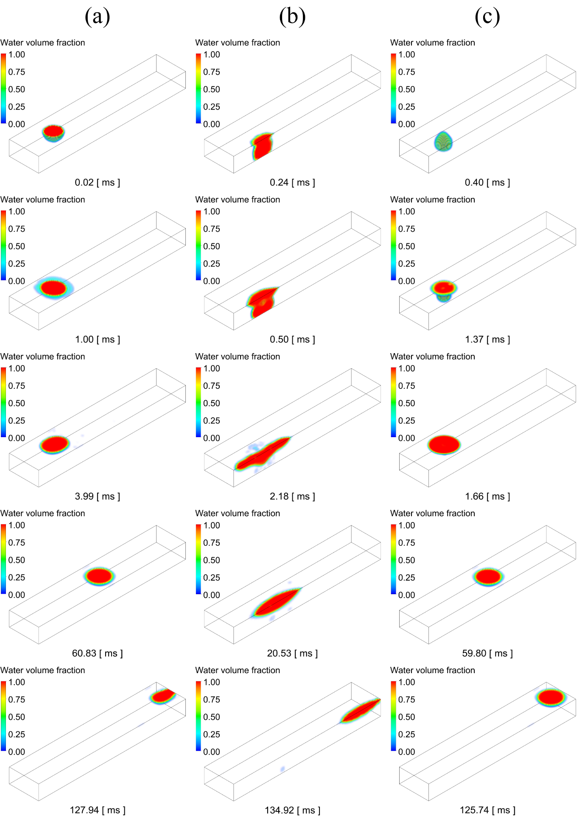

Fig. 2. The dynamics of liquid water droplet for different initial positions: (a) top wall, (b) side wall and (c) GDL surface. The distance from the inlet is 1 mm.
move out of the channel (~130 ms) is taken by the droplet that is initially placed at the top wall of the channel, i.e. Case 1. The droplet on the GDL surface takes a longer time to reach the outlet since it first experiences a detachment from the GDL surface and a collision with the top wall of the channel before forming a film. On the other hand, in these three cases the longest time to move out of the channel is taken by the droplet that is initially placed at the side wall of the channel and this is mainly because of the elongated shape of the forming film. Fig. 3(b) shows the pressure drop for these three cases. The difference in the pressure drop between the case where the droplet is placed on the top wall and the case where the water droplet is placed on the GDL surface is small because the dynamics of the liquid water in both cases is similar. However, in Case 2, where the water droplet is placed at the side wall of the channel, a smaller pressure drop occurs since the forming water film occupies less cross-section area of the channel.
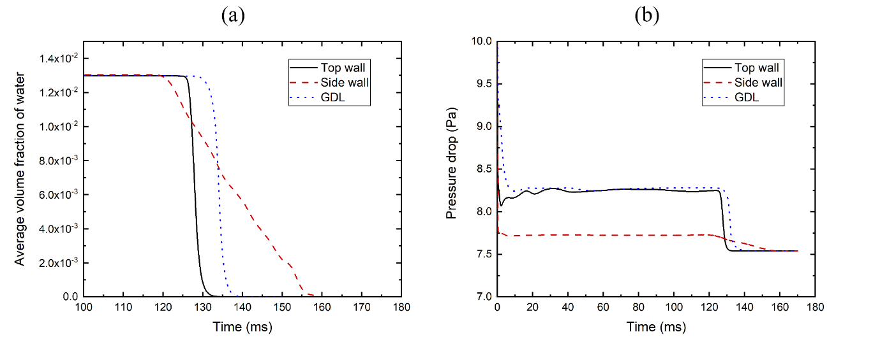
Fig. 3. (a) The average volume fraction of the water and (b) the pressure drop in the channel as functions of time.
In addition to Fig. 3, Fig. 4 shows the cross-section of the channel at the moment when the water film is fully developed and the fraction of liquid water is a maximum. The fractions of liquid water occupying the cross-section is almost the same for Cases 1 and 3, and this explains why the pressure drop is more or less the same for these two cases (see Fig. 3(b)). On the other hand, the fraction of liquid water occupying the cross-section is the lowest for Case 2 and this is in agreement with lowest pressure drop occurring in this case.
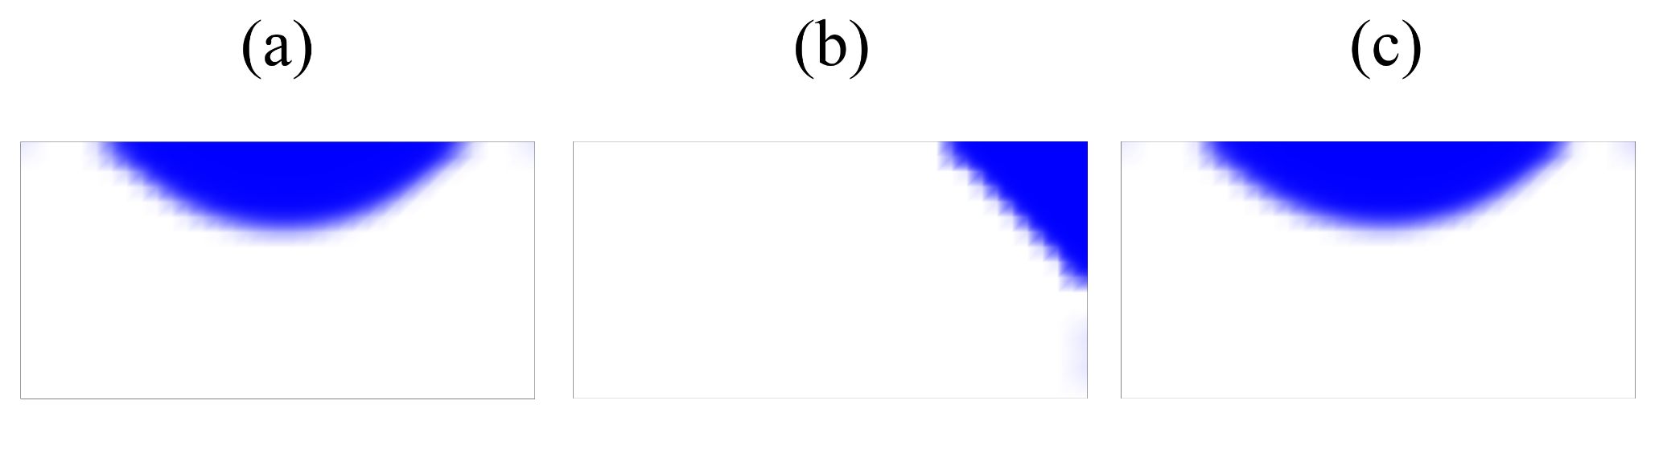
Fig. 4. The cross-section for different initial positions: (a) top wall, (b) side wall and (c) GDL surface.
The effects of the distance of the droplet from the inlet on the dynamics of the liquid water is also investigated by changing it from 1 mm to 3 mm (Cases 10-12). Fig. 5 shows that the dynamics of the liquid water droplets for Cases 10-12 are similar to those of Cases 1-3, thus indicating the negligible effects of the investigated variable, i.e. the distance from the inlet, on the dynamics of liquid water droplets.
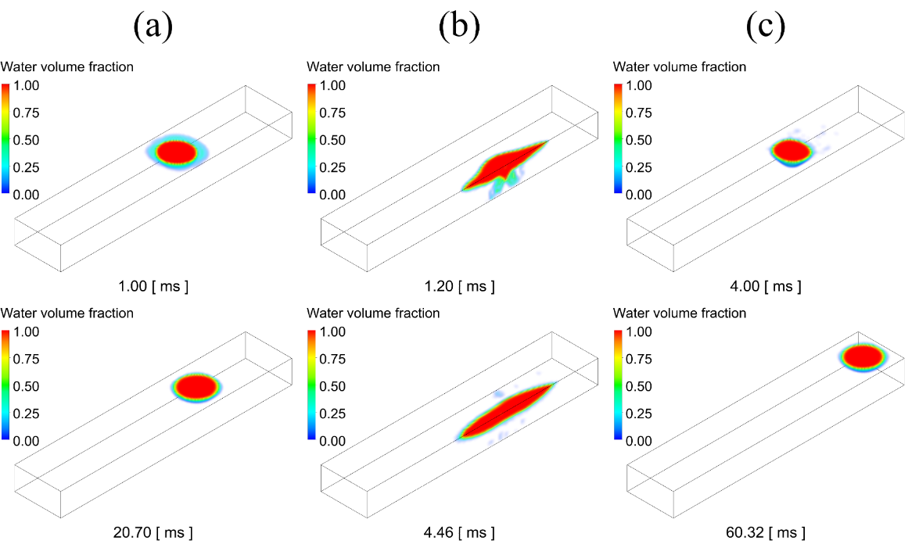
Fig. 5. The water dynamics of the liquid water droplet for different initial positions on: (a) top wall, (b) side wall and (c) GDL surface. The distance of the droplet from the inlet is 3 mm.
3.2. Effect of the operation condition
The velocity of hydrogen has been changed in Cases 4-8 in order to represent different operation conditions; the operating current density dictates the velocity of the reactant gas. It was found that the dynamics of the water was only slightly influenced by the velocity of the hydrogen — the dynamics of the water in these cases was similar to those presented in Fig. 2 and therefore these results have not been presented. However, the hydrogen velocity has a significant effect on the water removal time and pressure drop in the channel; see Fig. 6 which shows the removal time for the water and the average pressure drop in the channel as functions of the hydrogen velocity for the Cases 1-9. The removal time decreases with increasing the hydrogen velocity. One can also observe that the average pressure drop increases as the velocity increases. It should be noted that, under any operation condition, the droplet placed on the side wall causes a smaller pressure drop compared to the cases in which the water droplet is placed either on the surface of the GDL or on the top wall of the channel; however, it requires a longer time to move out of the channel.
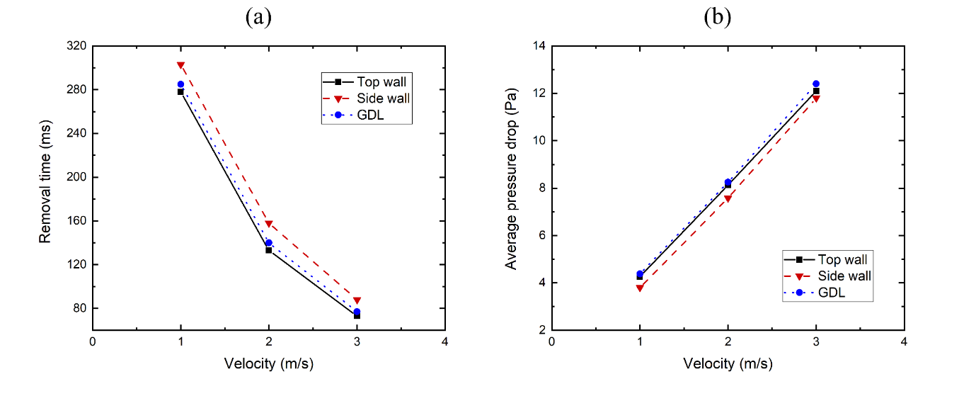
Fig. 6. (a) The removal time of water and (b) the average pressure drop in the channel as functions of the hydrogen velocity.
3.3. Effect of the droplet size
At the anode flow channel, water vapour may condense at different locations in the flow channel, thus forming water droplets. These droplets are likely to coalesce and form larger droplets. Due to this, different sizes of the droplet can be employed to represent different levels of severity of water flooding. Therefore, it is of interest to investigate the sensitivity of the dynamics of the liquid water in the anode flow channel to the size of the water droplet. It should be noted that the dynamics of the large droplet placed at the side wall was found to be more or less the same as that of the small droplet, see Fig. 2(b), and therefore it has not been presented in Fig. 7. In the cases discussed in the previous section, 0.5 mm diameter droplets are employed; however, larger droplets (i.e. 1 mm diameter) are used in Cases 13 and 14 and placed on the top wall and GDL surface, respectively.
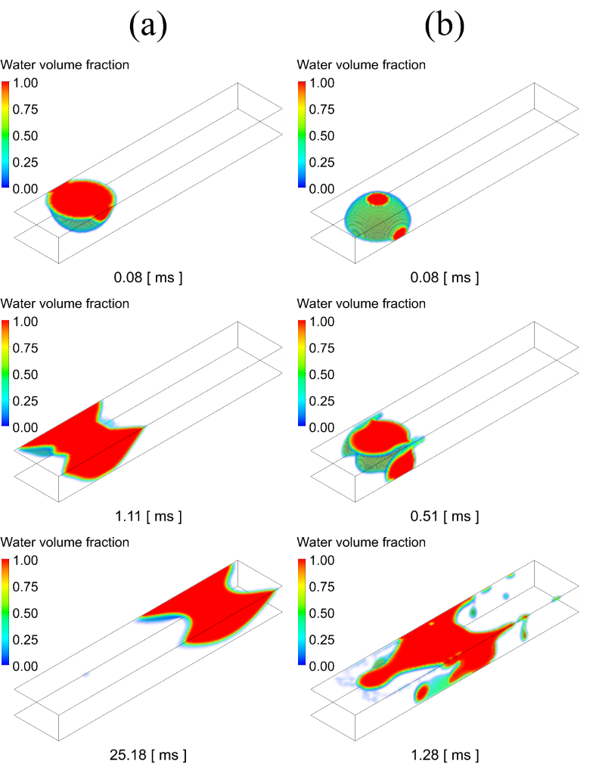
Fig. 7. The water dynamics of 1 mm water droplets placed on: (a) top wall and (b) GDL surface.
Fig. 7 shows the water dynamics for the 1 mm water droplets. Fig. 7(a) shows the water droplet placed at the top wall of the channel, due to its relatively large size and the hydrophilicity of the surfaces of the channel, spreads to the side walls of the channel before moving towards the outlet. For the droplet placed on the GDL surface, see Fig. 7(b), the droplet, due to the hydrophobicity of the GDL, moves towards and collides with the top wall of the channel, thus causing the droplet to flatten and disperse over a large area on the top and side walls of the channels.
Fig. 8(b) shows the pressure drop for the Cases 13 and 14. It can be seen that the pressure drop for the case in which the water droplet is initially placed on the GDL surface, i.e. Case 14, is smaller than that of the case in which the water droplet is initially placed on the top wall (Case 13). This could be attributed to the observation that the extent of the dispersion of the liquid water in Case 14 is higher than that of Case 13.
The larger droplet placed on the top wall of the channel causes a larger pressure drop compared to the corresponding smaller droplet before being removed from the channel; see Fig. 3(b) and Fig. 8(b). Fig. 8(a) displays the average volume fraction of the water as a function of time for the Cases 13 and 14. Compared with the results shown in Fig. 3(a), it can be seen that larger droplets require less time to move out from the channel. In order to explain this, velocity vectors of the gas over the surface of the small droplet in Case 1 and over the surface of the larger droplet in Case 13 are generated.
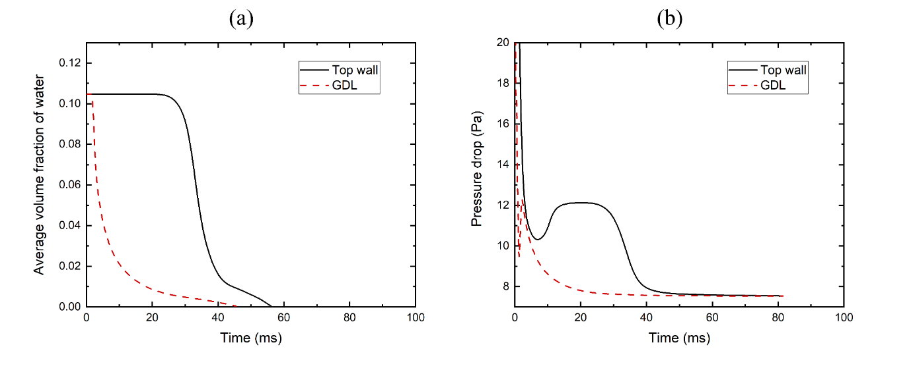
Fig. 8. (a) The average volume fraction of water and (b) the pressure drop in the gas channel as functions of time.
It is clear that the gas velocity values over the surface of the larger droplet are significantly larger than those over the surface of the smaller droplet, see Fig. 9. This is due to the fact that the larger droplet occupies a larger cross-section of the channel, thus resulting in a higher velocity and subsequently a faster removal from the channel.
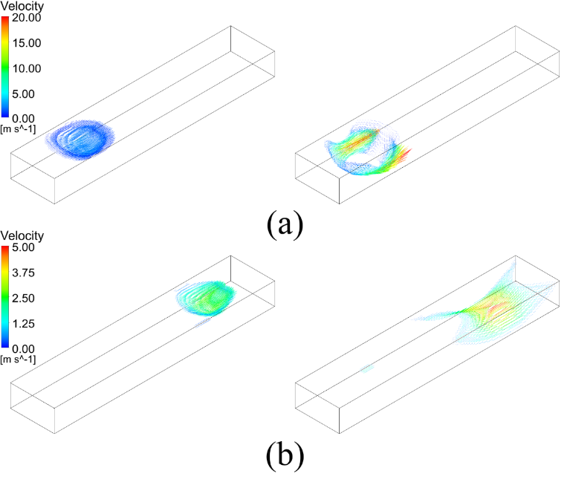
Fig. 9. The velocity profile over the surface of the small droplet (left) and large droplet (right) (a) at the beginning of the simulation and (b) towards the end of the simulation.
3.4. Effect of the GDL wettability
Cases 15 – 21 are investigated in order to study the effect of the GDL wettability on the dynamics of the liquid water. In these cases, a single droplet with a diameter 1 mm is placed on the top wall. The diameter of 1 mm was chosen since the 0.5 mm water droplet placed on the top wall was shown not to contact the GDL surface, see Fig. 2, thus rendering the investigation of the effects of the GDL wettability not possible. The low contact angles in Cases 15-18 represent hydrophilic GDLs which have been recently employed in practical fuel cells as shown in [42].
Fig. 10 shows the water dynamics for three selected cases, namely Cases 15, 16 and 21. The dynamics of the other cases, i.e. Cases 17-20, are not presented since the dynamics of the liquid
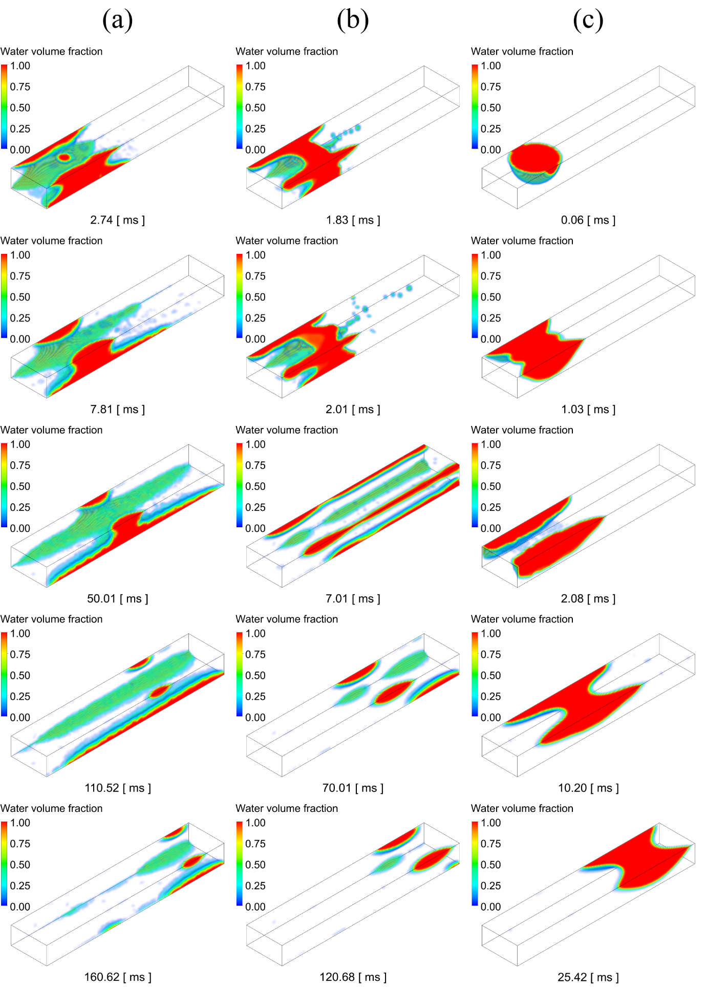
Fig. 10. The water dynamics with different GDL contact angles: (a) 10°, (b) 30° and (c) 170°.
water in these cases were shown to be similar to the above-investigated cases. However their results, along with those of Cases 15, 16 and 21, were used to generate the Fig. 11.
For the case in which the contact angle of the GDL is 10°, the droplet spreads over the GDL surface and, in particular, near the lower corners of the channel and this is, compared to those of the top and sides walls of the channel, clearly due to the super-hydrophilicity of the GDL surface. It should be noted that the strong adhesion force between the liquid water and the surface of the GDL in the above case results in creating elongated pockets of liquid water. In Case 16, as the difference in the contact angles between the walls of the channel (45°) and the GDL (30°) is relatively small, the initial liquid water droplet splits into four portions that are mainly positioned at the four corners of the channel. For the case in which the contact angle of the GDL is 170°, the dynamics of the liquid water is similar to that of the case in which the contact angle of the GDL is 140°, i.e. Fig. 7(a).
Fig. 11(a) shows the time taken for the liquid water to move out from the flow channel as a function of the GDL contact angle. The liquid water requires more time to move out from the channel as the contact angle decreases and this is due to the relatively strong adhesion force between the liquid water and the surface of the GDL. Fig. 11(b) shows the pressure drop averaged over the time taken for the liquid water to move out from the channel. Overall, it can be observed that the pressure drop decreases as the contact angle decreases and this is due to the increasing extent of the spreading of the liquid water over the surfaces of the channel and the GDL with decreasing GDL contact angle; this is in agreement with the previous experimental observations [43]. However the super-hydrophilic GDL, where the contact angle is 10°, increases the pressure drop in the channel. Bearing in mind that the pressure is averaged over the removal time, and this is attributed to the relatively long time taken by the liquid water to move out of the channel for the above case, i.e. the case in which the contact of the GDL is 10°. In commercial fuel cell products, with a more hydrophilic GDL surface, liquid water is more likely to accumulate and form big droplets due to the longer removal time. Although a single droplet in this kind of channel may cause a relatively low pressure droplet (Fig. 11(b)), the big accumulated droplet can lead to an extensive pressure drop and even cause a blockage. So the trade-off between the pressure drop and the removal time should be considered when designing practical products.
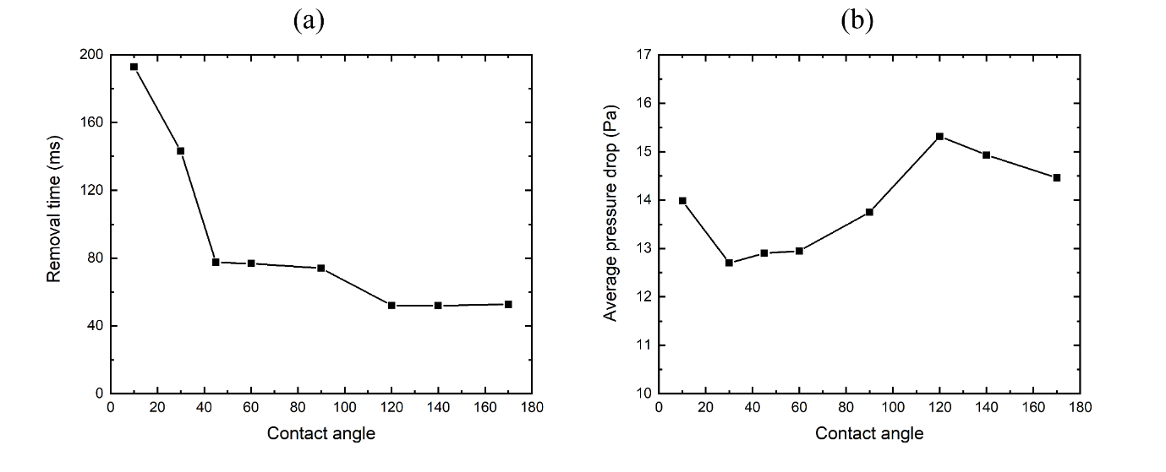
Fig. 11. (a) The removal time for the water and (b) the average pressure drop in the channel as functions of the GDL contact angle.
4. Conclusions
A 3D VOF model has been developed for anode channels in PEM fuel cells. The main purpose of this study is to examine the effects of the initial position of a water droplet, its size and the GDL wettability on the dynamics of the liquid water as it moves out of the flow channel. The findings of the study provide insightful information when designing fuel cells which are vulnerable to water flooding at their anode. The main conclusions are as follows:
- The time taken for the liquid water droplet to move out from the channel and the pressure drop caused are almost insensitive to the initial position of the water droplet in the flow channel.
- The water droplet, initially placed at the surface of a typical hydrophobic GDL, detaches from the GDL surface and collides with the top wall of the channel, thus causing relatively more dispersion of the liquid water. This phenomena becomes more profound as the size of the water droplet increases.
- The droplet that is initially placed on the side wall of the channel develops into elongated pockets of water that is mainly located near the upper corners of the channel. This leads to a smaller pressure drop but more time for the water to move out of the channel compared to the cases in which the water droplet is initially placed on the top wall of the channel or the surface of the GDL.
- The distance between the initial position of the water droplet and the inlet of the channel has almost a negligible effect on the dynamics of liquid water.
- The dynamics of the liquid water is almost independent of the hydrogen velocity; however, the latter has a significant effect on the removal time and the pressure drop in the channel.
- As the water droplet size increases, the velocity profile over the surface of the droplet increases, thus leading to less time required for the liquid water to move out of the channel. However, the pressure drop in the channel increases with increasing droplet size.
- For relatively large droplets, the pressure drop generally decreases with decreasing contact angle of the GDL. However, due to the strong adhesion forces, the time required to clear the channel from liquid water increases with decreasing GDL contact angle.
As a future work, it will be interesting to incorporate the structure of the GDL into the existing model in order to take into account the absorption of liquid water. Also it will be of interest to correlate the VOF model with the electrochemical reaction of the fuel cell, thus enabling the evaluation of the effects of all the parameters investigated in this study on the overall performance of the fuel cell. The inclusion of the formation of water droplets is also of great interest and may be a topic of a future work.
Nomenclature
momentum source term N m⁻³ s⁻¹
surface normal -
pressure Pa
surface tangent -
velocity m s⁻¹
Greek symbols
volume fraction -
contact angle °
surface curvature -
viscosity Pa s
density kg m⁻³
surface tension N m⁻¹

References
[1] A. Chandan, M. Hattenberger, A. El-Kharouf, S. Du, A. Dhir, V. Self, B.G. Pollet, A. Ingram, W. Bujalski, High temperature (HT) polymer electrolyte membrane fuel cells (PEMFC)-A review, J. Power Sources. 231 (2013) 264–278. doi:10.1016/j.jpowsour.2012.11.126.
[2] M.S. Ismail, D.B. Ingham, K.J. Hughes, L. Ma, M. Pourkashanian, An efficient mathematical model for air-breathing PEM fuel cells, Appl. Energy. 135 (2014) 490–503. doi:10.1016/j.apenergy.2014.08.113.
[3] E. Afshari, M. Ziaei-Rad, M.M. Dehkordi, Numerical investigation on a novel zigzag-shaped flow channel design for cooling plates of PEM fuel cells, J. Energy Inst. 90 (2017) 752–763. doi:10.1016/j.joei.2016.07.002.
[4] B.H. Lim, E.H. Majlan, W.R.W. Daud, M.I. Rosli, T. Husaini, Numerical analysis of modified parallel flow field designs for fuel cells, Int. J. Hydrogen Energy. 42 (2017) 9210–9218. doi:10.1016/j.ijhydene.2016.03.189.
[5] M.S. Ismail, D.B. Ingham, L. Ma, K.J. Hughes, M. Pourkashanian, Effects of catalyst agglomerate shape in polymer electrolyte fuel cells investigated by a multi-scale modelling framework, Energy. 122 (2017) 420–430. doi:10.1016/j.energy.2017.01.092.
[6] D.H. Jeon, The impact of rib structure on the water transport behavior in gas diffusion layer of polymer electrolyte membrane fuel cells, J. Energy Inst. (2018) 1–13. doi:10.1016/j.joei.2018.02.007.
[7] W.A.N.W. Mohamed, S.F.A. Talib, I.A. Zakaria, A.M.I. Mamat, W.R.W. Daud, Effect of dynamic load on the temperature profiles and cooling response time of a proton exchange membrane fuel cell, J. Energy Inst. 91 (2018) 349–357. doi:10.1016/j.joei.2017.02.006.
[8] S. Subramaniam, G. Rajaram, K. Palaniswamy, V.R. Jothi, Comparison of perforated and serpentine flow fields on the performance of proton exchange membrane fuel cell, J. Energy Inst. 90 (2017) 363–371. doi:10.1016/j.joei.2016.04.006.
[9] P. Pei, H. Chen, Main factors affecting the lifetime of Proton Exchange Membrane fuel cells in vehicle applications: A review, Appl. Energy. 125 (2014) 60–75. doi:10.1016/j.apenergy.2014.03.048.
[10] R. Banerjee, S.G. Kandlikar, Two-phase flow and thermal transients in proton exchange membrane fuel cells - A critical review, Int. J. Hydrogen Energy. 40 (2015) 3990–4010. doi:10.1016/j.ijhydene.2015.01.126.
[11] M.I. Rosli, D.J. Borman, D.B. Ingham, M.S. Ismail, L. Ma, M. Pourkashanian, Transparent PEM Fuel Cells for Direct Visualization Experiments, J. Fuel Cell Sci. Technol. 7 (2010) 061015. doi:10.1115/1.4001353.
[12] A. Bazylak, Liquid water visualization in PEM fuel cells: A review, Int. J. Hydrogen Energy. 34 (2009) 3845–3857. doi:10.1016/j.ijhydene.2009.02.084.
[13] Z. Dunbar, R.I. Masel, Quantitative MRI study of water distribution during operation of a PEM fuel cell using Teflon®flow fields, J. Power Sources. 171 (2007) 678–687. doi:10.1016/j.jpowsour.2007.06.207.
[14] J.P. Owejan, T.A. Trabold, D.L. Jacobson, M. Arif, S.G. Kandlikar, Effects of flow field and diffusion layer properties on water accumulation in a PEM fuel cell, Int. J. Hydrogen Energy. 32 (2007) 4489–4502. doi:10.1016/j.ijhydene.2007.05.044.
[15] A. Pfrang, D. Veyret, F. Sieker, G. Tsotridis, X-ray computed tomography of gas diffusion layers of PEM fuel cells: Calculation of thermal conductivity, Int. J. Hydrogen Energy. 35 (2010) 3751–3757. doi:10.1016/j.ijhydene.2010.01.085.
[16] R. Satija, D.L. Jacobson, M. Arif, S.A. Werner, In situ neutron imaging technique for evaluation of water management systems in operating PEM fuel cells, J. Power Sources. 129 (2004) 238–245. doi:10.1016/j.jpowsour.2003.11.068.
[17] P.K. Sinha, P. Halleck, C.-Y. Wang, Quantification of Liquid Water Saturation in a PEM Fuel Cell Diffusion Medium Using X-ray Microtomography, Electrochem. Solid-State Lett. 9 (2006) A344. doi:10.1149/1.2203307.
[18] P. Deevanhxay, T. Sasabe, S. Tsushima, S. Hirai, Observation of dynamic liquid water transport in the microporous layer and gas diffusion layer of an operating PEM fuel cell by high-resolution soft X-ray radiography, J. Power Sources. 230 (2013) 38–43. doi:10.1016/j.jpowsour.2012.11.140.
[19] R.M. Aslam, D.B. Ingham, M.S. Ismail, K.J. Hughes, L. Ma, M. Pourkashanian, Simultaneous thermal and visual imaging of liquid water of the PEM fuel cell flow channels, J. Energy Inst. (2018) 1–8. doi:10.1016/j.joei.2018.01.005.
[20] Y. Wang, C.-Y. Wang, A Nonisothermal, Two-Phase Model for Polymer Electrolyte Fuel Cells, J. Electrochem. Soc. 153 (2006) A1193. doi:10.1149/1.2193403.
[21] U. Pasaogullari, P.P. Mukherjee, C.-Y. Wang, K.S. Chen, Anisotropic Heat and Water Transport in a PEFC Cathode Gas Diffusion Layer, J. Electrochem. Soc. 154 (2007) B823. doi:10.1149/1.2745714.
[22] S. Mazumder, J.V. Cole, Rigorous 3-D Mathematical Modeling of PEM Fuel Cells, J. Electrochem. Soc. 150 (2003) A1503. doi:10.1149/1.1615609.
[23] E. Birgersson, M. Noponen, M. Vynnycky, Analysis of a Two-Phase Non-Isothermal Model for a PEFC, J. Electrochem. Soc. 152 (2005) A1021. doi:10.1149/1.1877992.
[24] E. Afshari, S.A. Jazayeri, Analyses of heat and water transport interactions in a proton exchange membrane fuel cell, J. Power Sources. 194 (2009) 423–432. doi:10.1016/j.jpowsour.2009.04.057.
[25] R.B. Ferreira, D.S. Falcão, V.B. Oliveira, A.M.F.R. Pinto, Numerical simulations of two-phase flow in proton exchange membrane fuel cells using the volume of fluid method – A review, J. Power Sources. 277 (2015) 329–342. doi:10.1016/j.jpowsour.2014.11.124.
[26] A.D. Le, B. Zhou, A general model of proton exchange membrane fuel cell, J. Power Sources. 182 (2008) 197–222. doi:10.1016/j.jpowsour.2008.03.047.
[27] A. Theodorakakos, T. Ous, M. Gavaises, J.M. Nouri, N. Nikolopoulos, H. Yanagihara, Dynamics of water droplets detached from porous surfaces of relevance to PEM fuel cells, J. Colloid Interface Sci. 300 (2006) 673–687. doi:10.1016/j.jcis.2006.04.021.
[28] P. Quan, B. Zhou, A. Sobiesiak, Z. Liu, Water behavior in serpentine micro-channel for proton exchange membrane fuel cell cathode, J. Power Sources. 152 (2005) 131–145. doi:10.1016/j.jpowsour.2005.02.075.
[29] C. Fang, C. Hidrovo, F. min Wang, J. Eaton, K. Goodson, 3-D numerical simulation of contact angle hysteresis for microscale two phase flow, Int. J. Multiph. Flow. 34 (2008) 690–705. doi:10.1016/j.ijmultiphaseflow.2007.08.008.
[30] J.G. Carton, V. Lawlor, A.G. Olabi, C. Hochenauer, G. Zauner, Water droplet accumulation and motion in PEM (Proton Exchange Membrane) fuel cell mini-channels, Energy. 39 (2012) 63–73. doi:10.1016/j.energy.2011.10.023.
[31] Y. Cai, T. Yang, P.C. Sui, J. Xiao, A numerical investigation on the effects of water inlet location and channel surface properties on water transport in PEMFC cathode channels, Int. J. Hydrogen Energy. 41 (2016) 16220–16229. doi:10.1016/j.ijhydene.2016.04.241.
[32] A. Bozorgnezhad, M. Shams, H. Kanani, M. Hasheminasab, G. Ahmadi, Two-phase flow and droplet behavior in microchannels of PEM fuel cell, Int. J. Hydrogen Energy. 41 (2016) 19164–19181. doi:10.1016/j.ijhydene.2016.09.043.
[33] A. Bazylak, D. Sinton, N. Djilali, Dynamic water transport and droplet emergence in PEMFC gas diffusion layers, J. Power Sources. 176 (2008) 240–246. doi:10.1016/j.jpowsour.2007.10.066.
[34] M. Andersson, S.B. Beale, U. Reimer, W. Lehnert, D. Stolten, Interface resolving two-phase flow simulations in gas channels relevant for polymer electrolyte fuel cells using the volume of fluid approach, Int. J. Hydrogen Energy. 43 (2018) 2961–2976. doi:10.1016/j.ijhydene.2017.12.129.
[35] L. Chen, T.F. Cao, Z.H. Li, Y.L. He, W.Q. Tao, Numerical investigation of liquid water distribution in the cathode side of proton exchange membrane fuel cell and its effects on cell performance, Int. J. Hydrogen Energy. 37 (2012) 9155–9170. doi:10.1016/j.ijhydene.2012.01.101.
[36] R.B. Ferreira, D.S. Falcão, V.B. Oliveira, A.M.F.R. Pinto, 1D + 3D two-phase flow numerical model of a proton exchange membrane fuel cell, Appl. Energy. 203 (2017) 474–495. doi:10.1016/j.apenergy.2017.06.048.
[37] Y. Ding, X. Bi, D.P. Wilkinson, 3D simulations of the impact of two-phase flow on PEM fuel cell performance, Chem. Eng. Sci. 100 (2013) 445–455. doi:10.1016/j.ces.2012.11.007.
[38] B. Chen, J. Wang, T. Yang, Y. Cai, C. Zhang, S.H. Chan, Y. Yu, Z. Tu, Carbon corrosion and performance degradation mechanism in a proton exchange membrane fuel cell with dead-ended anode and cathode, Energy. 106 (2016) 54–62. doi:10.1016/j.energy.2016.03.045.
[39] J. O’Rourke, M. Ramani, M. Arcak, In situ detection of anode flooding of a PEM fuel cell, Int. J. Hydrogen Energy. 34 (2009) 6765–6770. doi:10.1016/j.ijhydene.2009.06.029.
[40] J.M. Sergi, S.G. Kandlikar, Quantification and characterization of water coverage in PEMFC gas channels using simultaneous anode and cathode visualization and image processing, Int. J. Hydrogen Energy. 36 (2011) 12381–12392. doi:10.1016/j.ijhydene.2011.06.092.
[41] W. Schmittinger, A. Vahidi, A review of the main parameters influencing long-term performance and durability of PEM fuel cells, J. Power Sources. 180 (2008) 1–14. doi:10.1016/j.jpowsour.2008.01.070.
[42] S. Ge, C.-Y. Wang, Liquid Water Formation and Transport in the PEFC Anode, J. Electrochem. Soc. 154 (2007) B998. doi:10.1149/1.2761830.
[43] D. Lee, J. Bae, Visualization of flooding in a single cell and stacks by using a newly-designed transparent PEMFC, Int. J. Hydrogen Energy. 37 (2012) 422–435. doi:10.1016/j.ijhydene.2011.09.073.
[44] R.B. Ferreira, D.S. Falcão, V.B. Oliveira, A.M.F.R. Pinto, Numerical simulations of two-phase flow in an anode gas channel of a proton exchange membrane fuel cell, Energy. 82 (2015) 619–628. doi:10.1016/j.energy.2015.01.071.
[45] Y. Hou, G. Zhang, Y. Qin, Q. Du, K. Jiao, Numerical simulation of gas liquid two-phase flow in anode channel of low-temperature fuel cells, Int. J. Hydrogen Energy. 42 (2017) 3250–3258. doi:10.1016/j.ijhydene.2016.09.219.
[46] J.U. Brackbill, D.B. Kothe, ScienceDirect - Journal of Computational Physics : A continuum method for modeling surface tension, J. Comput. Phys. 335354 (1992). doi:10.1016/0021-9991(92)90240-Y.

