Petrous Bone Diagenesis: A Multi-Analytical Approach

Ioannis Kontopoulos¹, Kirsty Penkman², Graeme D. McAllister³, Niels Lynnerup⁴, Peter B. Damgaard⁵, Henrik B. Hansen⁵, Morten E. Allentoft⁵, and Matthew J. Collins^{1, 5}
- BioArCh, Department of Archaeology, University of York, United Kingdom
- BioArCh, Department of Chemistry, University of York, United Kingdom
- Department of Chemistry, University of York, United Kingdom
- Unit of Forensic Anthropology, Department of Forensic Medicine, University of Copenhagen, Denmark
- Centre for GeoGenetics, Natural History Museum of Denmark, University of Copenhagen, Denmark

Highlights
- The human petrous bone has different histomorphology from other skeletal elements
- No microscopic focal destructions observed in human petrous bones
- Only few merged osteocyte lacunae may indicate some limited microbial presence
- Generalized destruction is linked with decreased levels of endogenous DNA
- Dissolution/recrystallization of bioapatite is linked with loss of endogenous DNA
- Am/P, % N and % C of whole bone are reliable indicators of collagen content

Abstract
The discovery of petrous bone as an excellent repository for ancient biomolecules has been a turning point in biomolecular archaeology, especially in aDNA research, but excessive and uncontrolled sampling could result in loss of this valuable resource for future research. This study reports on the histological (optical microscopy), physical (FTIR-ATR), elemental (CHN) and biochemical (collagen and DNA analysis) preservation of 15 human petrous bones spanning from the c. 2100 BC to 1850 AD. Through the combined application of a number of diagenetic parameters (general histological index; infrared splitting factor; carbonate/phosphate ratio; amide/phosphate ratio; collagen wt. %; % C, % N and C/N of whole bone and collagen; % endogenous DNA), we provide new insights into petrous bone micromorphological characteristics and diagenesis, and new evidence to enhance screening practices for aDNA and collagen analysis.

Keywords: petrous bone; diagenesis; microstructure; bioapatite; collagen; aDNA

1. Introduction
The extraction and analysis of ancient biomolecules preserved within archaeological bone tissue can provide valuable information for studying past populations (Bentley, 2006; Brown and Barnes, 2015; Buckley et al., 2009; Cappellini et al., 2018; Colonese et al., 2015; Hendy et al., 2018; Katzenberg, 2008; Lee-Thorp, 2008; Orlando and Cooper, 2014). However, bone diagenesis leads to the partial or complete loss of the biochemical information (Collins et al., 2002; Kendall et al., 2018; Nielsen-Marsh et al., 2000). The recent discovery that the petrous bone, a massive portion of the endocranial aspect of the temporal bone, is an excellent repository for long term DNA survival presumably due to its high density (Gamba et al., 2014; Hansen et al., 2017; Pinhasi et al., 2015) represents a major breakthrough in ancient DNA (aDNA) research as the expense of genome sequencing can often be prohibitive due to the the low abundance of the endogenous DNA from the target ​(e.g. Green et al., 2010). Collagen extracted from petrous bone has also been identified as a potential indicator of fetal and early years diet (Jørkov et al., 2009) as ossification of the petrous pyramid is mainly completed in utero and during early fetal years (Jeffery and Spoor, 2004; Sørensen, 1994; Sørensen et al., 1992). Similarly, petrous bone can potentially provide information on the geographic area in which individuals had spent their childhood through strontium isotope analysis (Harvig et al., 2014), providing an additional layer of information to the strontium analyses of teeth.
Petrous bone’s sui generis nature is manifested by the three different tissue zones recognised by Doden and Halves (1984): a) an outer periosteal; b) an endosteal that surrounds the canals and cochlear surfaces; and c) an inner periosteal that can replace both the outer periosteal and endosteal tissues. A lack of bone remodelling has also been noted in earlier studies (Doden and Halves, 1984; Frisch et al., 2000; Jeffery and Spoor, 2004) and the increased mineralization (i.e. hardness) in some areas of the petrous bone (Doden and Halves, 1984) compared to other skeletal elements (Currey, 1999; Zioupos et al., 2000) is another unique feature. The outer periosteal tissue is considered less mineralized in vivo and has its collagen fibres arranged parallel to the bone’s surface (Doden and Halves, 1984). Contrariwise, the inner periosteal tissue has randomly oriented collagen fibres (Doden and Halves, 1984) and two different degrees of mineralization (Doden and Halves, 1984) linked to different concentrations of Ca, P, Sr and Mg (Katić et al., 1991).
Here some commonly and successfully applied diagenetic parameters, namely the general histological index (Hollund et al., 2012), infrared splitting factor (Weiner and Bar-Yosef, 1990), carbonate/phosphate ratio (Wright and Schwarcz, 1996), amide/phosphate ratio (Trueman et al., 2004), collagen weight % (van Klinken, 1999), % C, % N and C/N of whole bone and collagen (Brock et al., 2010), and % endogenous DNA (e.g. Hansen et al., 2017), are combined to provide new insights into petrous bone characteristics and diagenesis. This study therefore seeks to understand the factors underpinning the survival and possible resistance of petrous bone to diagenesis, but more importantly explore potential methods to enhance screening practices for aDNA and collagen preservation in petrous bone specimens irrespective of the conditions of the burial environment.

2. Materials and Methods
Fifteen archaeological human petrous bones were used in this study (Table 1) from two contrasting sites, 9 samples from the later historical period in Denmark (c. 1650–1850 AD) and 6 samples from the Bronze Age period in Central Asia (c. 2100–1800 BC). Samples are representative of the b and/or c areas of petrous bone as presented in Pinhasi et al. (2015). Sampling for aDNA analysis preceded sampling for histological, FTIR-ATR, collagen and elemental analyses, thus samples do not derive exactly from the same anatomical location. The genetic results presented here (endogenous DNA content) have been sourced in Hansen et al. (2017). Statistical analysis was carried out using IBM SPSS v.25 and the significance level was set at $p=0.05.$ Regression correlation (R²) of 0-0.19 is regarded as very weak, 0.2-0.39 as weak, 0.40-0.59 as moderate, 0.6-0.79 as strong and 0.8-1 as very strong correlation, but these are rather arbitrary limits and should be considered in the context of the results.

Histology
Sixteen transverse and longitudinal thin sections of c. 200 μm from 10 samples were prepared using an Exact 300 CL diamond band saw. Undecalcified thin sections were mounted onto glass microscope slides using Entellan New (Merck chemicals) for microscopy mounting medium and covered by a glass coverslip, both cleaned with xylene before use. Thin sections were assessed under a Leica DM750 optical microscope using plane-polarized (PPL) and cross-polarized (XPL) transmitted light with total magnification ranging from 40x to 400x. Digital images were captured by a Leica ICC50 HD camera for microscopy imaging with a capture resolution of 2048 x 1536 pixels. The general histological index (GHI) introduced by Hollund et al. (2012) was used as it is analogous to the Oxford histological index (OHI) as described by Millard (2001) but includes generalized destruction, cracking, and staining. A GHI value of 5 represents excellent microstructural preservation similar to modern bone (>95% intact microstructure), whereas a GHI value of 0 indicates poor microstructural preservation (<5% intact microstructure) with almost no original histological features observed.

FTIR
FTIR-ATR measurements were performed in triplicate on 15 human petrous bones and two modern human femora using a Bruker Alpha Platinum [range: 4000-400 cm⁻¹; no. of scans: 144; zero filling factor: 4; resolution: 4 cm⁻¹; mode: absorbance]. Sample preparation and analysis was carried out using Kontopoulos et al. (2018)’s protocol. Bone samples were ground using an agate pestle and mortar following the mechanical cleaning of the outer and inner bone surfaces. About 2-3 mg of bone powder of 20-50 μm particle size were used for each measurement, and after each measurement the crystal plate and the anvil of the pressure applicator were thoroughly cleaned using isopropyl alcohol. Spectra were analysed using OPUS 7.5 software.
The calculations of FTIR indices were conducted as follows: a) infrared splitting factor (IRSF) was assessed after Weiner and Bar-Yosef (1990, p. 191); b) carbonate-to-phosphate (C/P) ratio (Wright and Schwarcz, 1996, p. 936); c) type B carbonate substitutions relative to phosphate (BPI) (Sponheimer and Lee-Thorp, 1999, p. 145); and d) amide-to-phosphate (Am/P) (Trueman et al., 2004, p. 726). The average values of two modern human femora were used as reference throughout (IRSF=3.357±0.007, C/P=0.24±0.003, Am/P=0.182±0.001, BPI=0.482±0.000).

Collagen
Collagen was extracted using a modified Longin (1971) method. The exterior surfaces of bone samples were mechanically cleaned using a scalpel. Bone chunks of 300-500 mg were demineralized in 8 ml 0.6 M HCl at 4∘ C. Samples were agitated twice daily and acid solution was changed every two days. When demineralisation was completed, the supernatant was drained off and samples were rinsed three times with distilled water. Gelatinization was carried out by adding 8 ml pH3 HCl and samples were placed in hot blocks at 80∘ C for 48h. The supernatant liquor which contains the collagen was filtered off by using EzeeTM filters (Evergreen) and was freeze dried for 2 days in pre-weighed plastic tubes.
Extracted collagen was analyzed in duplicate. Tin capsules containing 0.9-1.1 mg of collagen were dropped into an oxygen rich combustion tube held at 1000° C. The tin capsules were ignited and burnt exothermally at 1800°C causing the sample to oxidise. The samples were carried through a layer of chromium oxide and copper oxide which ensure complete oxidation, followed by a layer of silver wool to remove unwanted sulphur and halides. The samples’ gases pass into a second furnace containing copper held at 600°C where excess oxygen was removed and nitrogen oxides were reduced to elemental nitrogen. Any water was removed using a magnesium perchlorate trap. The samples then passed into a gas chromatography (GC) column held at 70°C which separates CO₂ and N₂ from each other. The resultant gases were then introduced into the Sercon 20-22 mass spectrometer where the samples were ionised, and the various masses separated in a magnetic field, focused into Faraday collector arrays and analyzed.

Elemental analysis
Whole bone elemental analysis (% C, % N) was performed on 2-3 mg of bone powder. Samples were run in duplicate on an Exeter Analytical CE-440 elemental analyser, used in conjunction with a Sartorius SE2 analytical balance automated carbon and nitrogen elemental analyser. Samples were weighed into smooth-walled tin capsules, sealed and combusted in O₂ at 975 ⁰C. Combustion products were then analysed by thermal conductivity detectors, against a blank of helium.

3. Results and Discussion

3.1. Histological preservation
Histological analysis provides useful information on the microstructural characteristics of the human petrous bones. The thin sections of the Danish and Central Asian archaeological human petrous bones consist of highly osteocytic woven and lamellar-like tissue (Figure 1a-b). Woven tissue can be seen throughout petrous bone (Figure 1a-d) and its presence may indicate a lack of bone remodelling in specific areas. Osteonic tissue that appears both in the longitudinal and transverse direction (Figure 1c-f) of our specimens is a unique characteristic of the petrous bone, and to our knowledge this is the first report of the presence of osteons in both transverse and longitudinal directions of any skeletal element.
The presence of osteons suggests that bone remodelling can take place in some areas of the inner ear (Doden and Halves, 1984; Frisch et al., 2000; Jeffery and Spoor, 2004; Jørkov et al., 2009). This might be linked to the continual, age dependent and variable changes in the size and organization of the pneumatized spaces observed within the petrous pyramid by Hill (2011). Furthermore, the appearance of osteons in both directions can be explained by the fact that the vascular network of the otic capsule is a termination area for the internal auditory artery (IAA) and a communication area between the IAA and several other arteries (Mazzoni, 1972). Thus the osteons and other vascular canals need to accommodate the various arteries and their branches which travel in various directions.
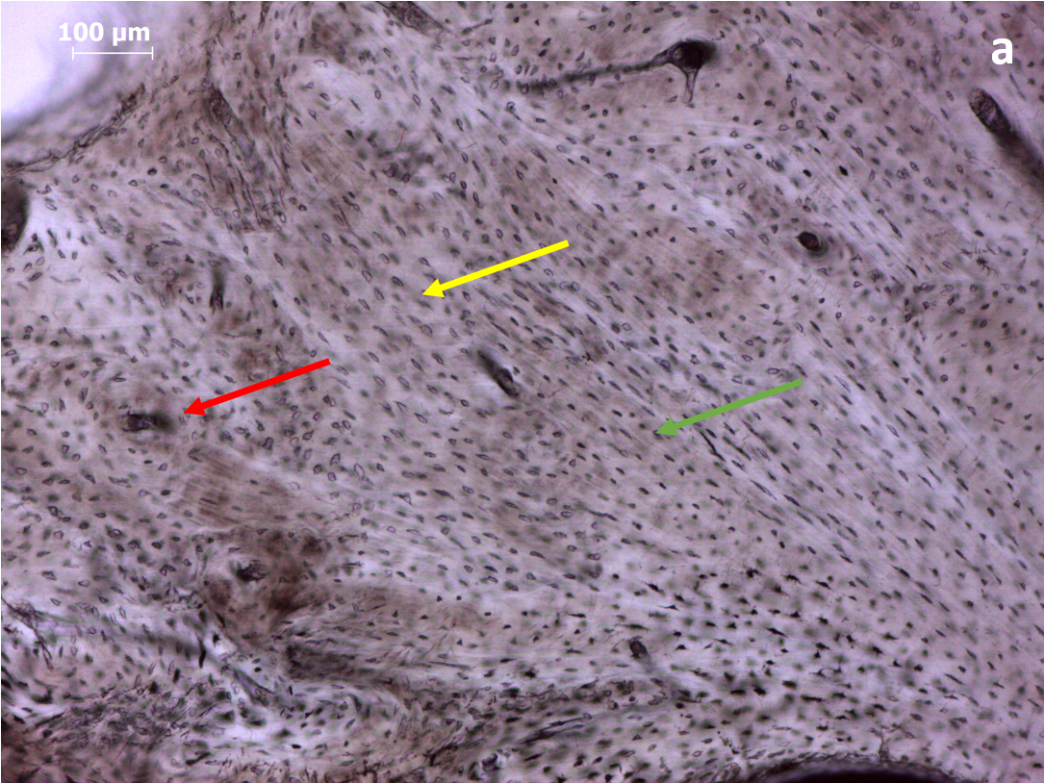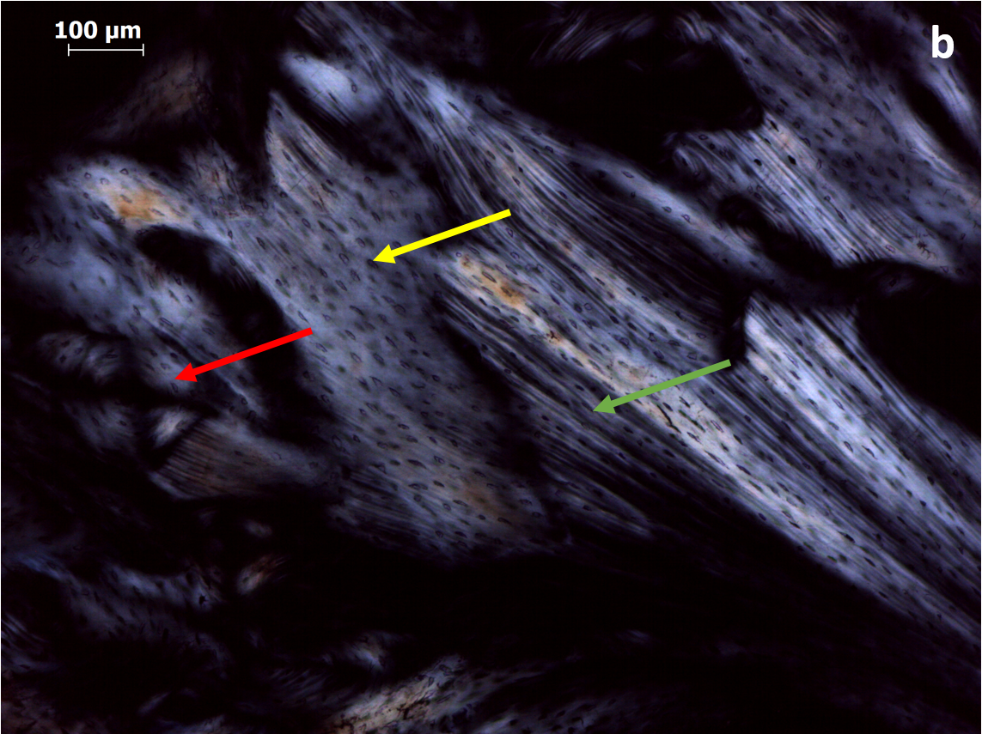
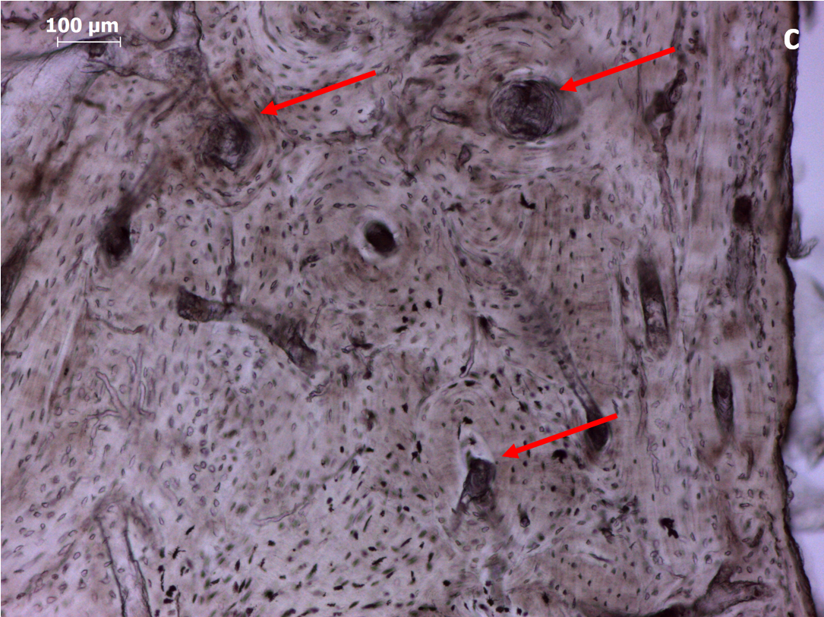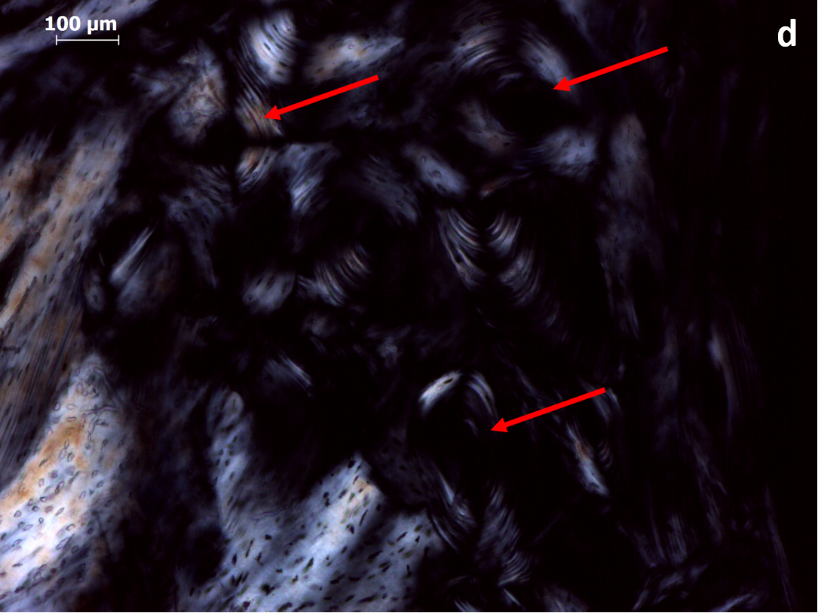
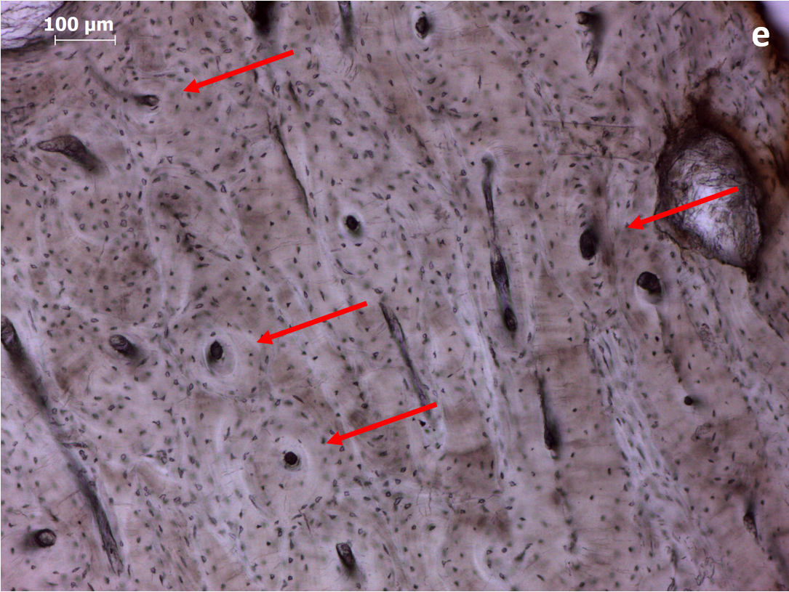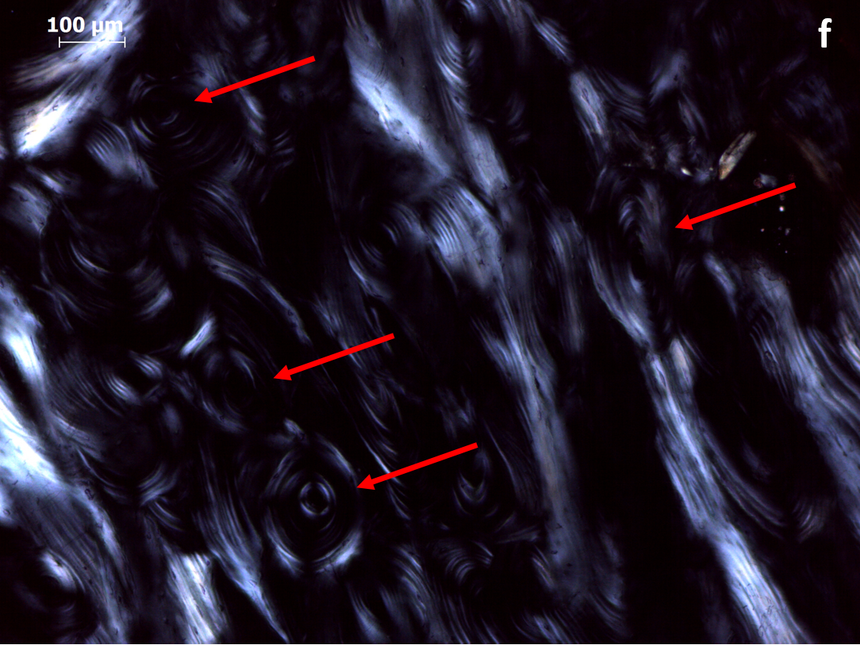
Figure 1. DEN6 Longitudinal PPL (a) and XPL (b) 100x - Petrous bone: Thin section showing an osteon (red arrow), woven tissue (yellow arrow), and lamellar-like tissue (green arrow) in inner periosteal tissue between semi-circular canals.
DEN3 Transverse PPL (c) and XPL (d) 100x - Petrous bone: Image showing the presence of osteons (red arrows) in the outer and inner periosteal tissue.
DEN6 Longitudinal PPL (e) and XPL (f) 100x - Petrous bone: Another image showing the presence of osteons (red arrows) in the outer and inner periosteal tissue, this time in longitudinal section.
In terms of histological preservation, GHI values indicate moderate to good preservation of most specimens (Table 1). Our data also indicate a very strong correlation (Denmark R²=0.81) between GHI and collagen yields (Figure 2a), with less altered bone having more collagen. However, it is difficult to estimate the degree of alterations on a spatial scale larger than the microscopic field of view (here at 40x total magnification the field of view is c. 5 mm). Inter-observer variations cannot be avoided, while section thickness and decalcification can also affect GHI (or OHI) reliability for screening collagen preservation (Caruso et al., 2018). Inter-site variations (thermally older sites will have less collagen, e.g. Kendall et al., 2018 Fig.7) and preservation of microstructure without preservation of collagen content due to hydrolysis can further limit GHI’s use as collagen indicator (Collins et al., 2002; Hedges et al., 1995).
Table 1. Summary of data (GHI: general histological index; IRSF: Infrared splitting factor; C/P: carbonate-to-phosphate; BPI: carbonate type B-to-phosphate index; Am/P: amide-to-phosphate). C/N collagen= % C/% N x atomic weight C/atomic weight N. The samples’ names as presented in Hansen et al. (2017) are provided in parentheses as the genetic data (endogenous DNA content) derives directly from this study.
The symbols next to the GHI values indicate: * samples with transverse thin sections; ** samples with longitudinal thin sections; *** samples with both transverse and longitudinal thin sections.
¹Collagen content estimates calculated using the equation collagen wt. % = 113.13 Am/P + 1.69 presented in Lebon et al. (2016).
Sample | GHI | IRSF | C/P | BPI | Am/P | wt. % C  whole | wt. % N  whole | C/N  whole | % C  Collagen | % N  Collagen | C/N  Collagen | wt. % Collagen | wt. % Collagen Estimates¹ | % endogenous DNA
DEN1 (H1) | 4*** | 3.328  ±0.036 | 0.251  ±0.009 | 0.441  ±0.010 | 0.166  ±0.004 | 11.52 | 3.38 | 3.41 | 42.98 | 15.54 | 3.23 | 14.50 | 20.44 | 54.79
DEN2  (H3) | 2*** | 3.244  ±0.019 | 0.223  ±0.003 | 0.386  ±0.008 | 0.097  ±0.002 | 8.03 | 1.94 | 4.14 | 44.43 | 16.02 | 3.24 | 11.19 | 12.64 | 41.62
DEN3 (H4) | 4* | 3.329  ±0.007 | 0.255  ±0.003 | 0.441  ±0.008 | 0.162  ±0.002 | 11.60 | 3.42 | 3.39 | 43.22 | 15.73 | 3.20 | 17.84 | 20.00 | 34.90
DEN4 (H5) | 2* | 3.965  ±0.109 | 0.106  ±0.015 | 0.220  ±0.018 | 0.053  ±0.008 | 7.83 | 2.22 | 3.54 | 44.08 | 15.95 | 3.22 | 10.71 | 7.73 | 6.97
DEN5 (H6) | 2* | 3.682  ±0.024 | 0.147  ±0.002 | 0.250  ±0.005 | 0.096  ±0.002 | 8.00 | 2.22 | 3.60 | 44.16 | 15.17 | 3.40 | 11.33 | 12.56 | 4.74
DEN6 (H7) | 4*** | 3.333  ±0.017 | 0.225  ±0.008 | 0.412  ±0.020 | 0.140  ±0.006 | 11.11 | 3.29 | 3.37 | 44.65 | 15.91 | 3.27 | 12.91 | 17.54 | 56.34
DEN7 (H8) | 4*** | 3.378  ±0.028 | 0.204  ±0.008 | 0.355  ±0.018 | 0.113  ±0.007 | 9.27 | 2.67 | 3.47 | 44.12 | 15.68 | 3.28 | 15.73 | 14.49 | 43.77
DEN8 (H9) | N/A | 3.271  ±0.019 | 0.180  ±0.001 | 0.323  ±0.003 | 0.080  ±0.000 | 7.75 | 2.03 | 3.82 | 45.20 | 16.06 | 3.28 | 10.80 | 10.79 | 43.22
DEN9 (H10) | 1* | 3.621  ±0.096 | 0.139  ±0.017 | 0.244  ±0.021 | 0.073  ±0.015 | 5.76 | 1.46 | 3.95 | 44.07 | 15.96 | 3.22 | 7.42 | 9.92 | 3.54
CA1 (BA3) | 2*** | 4.277  ±0.085 | 0.101  ±0.003 | 0.204  ±0.003 | 0.083  ±0.004 | 9.62 | 1.46 | 6.59 | 43.40 | 12.89 | 3.25 | 15.26 | 11.03 | 0.12
CA2 (BA4) | 3*** | 3.860  ±0.019 | 0.141  ±0.006 | 0.253  ±0.010 | 0.102  ±0.004 | 9.80 | 2.85 | 3.45 | 44.36 | 11.08 | 3.25 | 17.74 | 13.19 | 5.77
CA3 (BA2) | N/A | 3.763  ±0.020 | 0.190  ±0.007 | 0.323  ±0.016 | 0.142  ±0.006 | 10.72 | 3.23 | 3.32 | 43.83 | 10.98 | 3.26 | 17.29 | 17.74 | 32.01
CA4 (BA5) | N/A | 4.068  ±0.120 | 0.143  ±0.015 | 0.313  ±0.017 | 0.016  ±0.002 | 7.92 | 1.49 | 5.32 | 43.73 | 11.50 | 3.31 | 10.53 | 3.47 | 9.58
CA5 (N/A) | N/A | 4.421  ±0.154 | 0.065  ±0.007 | 0.128  ±0.007 | 0.039  ±0.004 | 6.04 | 1.39 | 4.35 | 42.57 | 12.89 | 3.26 | 13.60 | 6.14 | N/A
CA6  (BA1) | N/A | 3.817  ±0.065 | 0.180  ±0.012 | 0.308  ±0.016 | 0.074  ±0.006 | 7.53 | 1.84 | 4.10 | 42.72 | 11.20 | 3.24 | 13.59 | 10.05 | 0.46

GHI may also be a reliable predictor of DNA preservation as it shows strong correlation in Danish samples with endogenous DNA yields (R²=0.67) (Figure 2b). Changes in crystallinity (IRSF), however, show a weak relationship (R²=0.27) with GHI, which indicates that the localized mineral redeposition during microbial attack (e.g. Hackett, 1981; Pesquero et al., 2015) and the loss of integrity during generalized destruction may not be reflected in average bioapatite (BAp) characteristics of comparatively large sampling areas (Figure 2c).

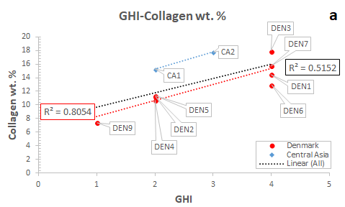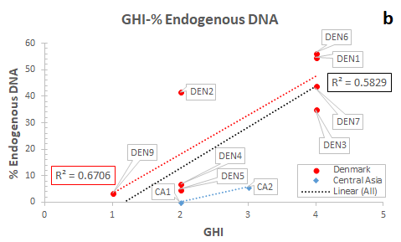
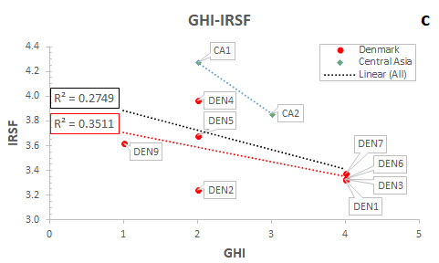
Figure 2. Correlation of GHI with collagen yield (a), endogenous DNA content (b), and BAp crystallinity (c).
Possible microbial activity is only observed in small areas of samples DEN1 and DEN2, although microbially attacked areas may have been missed due to prior sampling for aDNA analysis. The few alterations identified (Figure 3b) show similarities to the early diagenetic stages characteristics (Kontopoulos et al., 2016; i.e. merging of osteocyte lacunae White and Booth, 2014). Such a lack of microbial activity due to high density and protected location of the petrous pyramid has also been assumed to be partly related with decreased endogenous DNA decay (Gamba et al., 2014). However, the microstructure of four of the eight historical samples from Denmark that were histologically examined have amorphous, disintegrated, dark areas of bone (i.e. generalized destruction) with microcracking (Figure 3c-d) that has resulted in a considerable loss of collagen birefringence. Generalized destruction is assumed to be connected with loss of the organic content (Collins et al., 2002; Garland, 1989; Jackes et al., 2001) and the presence of inclusions (Tjelldén et al., 2018).
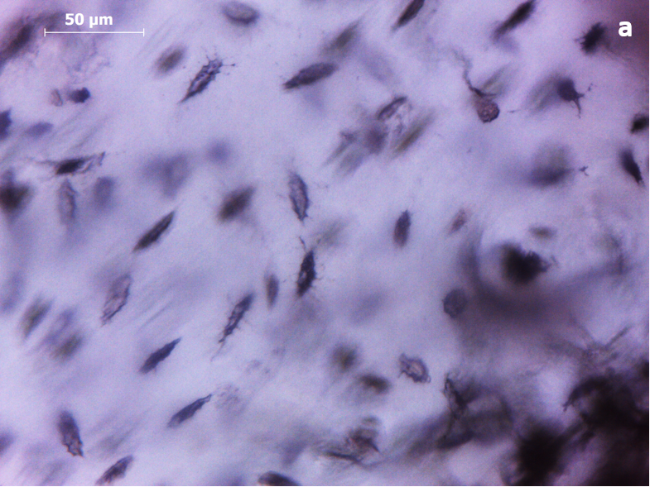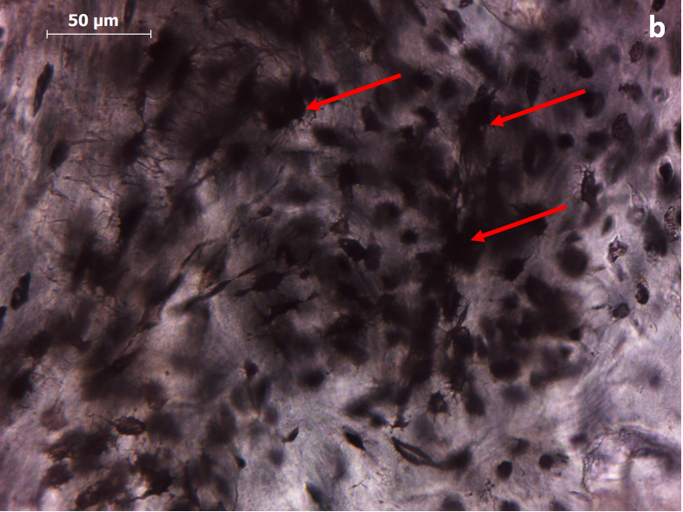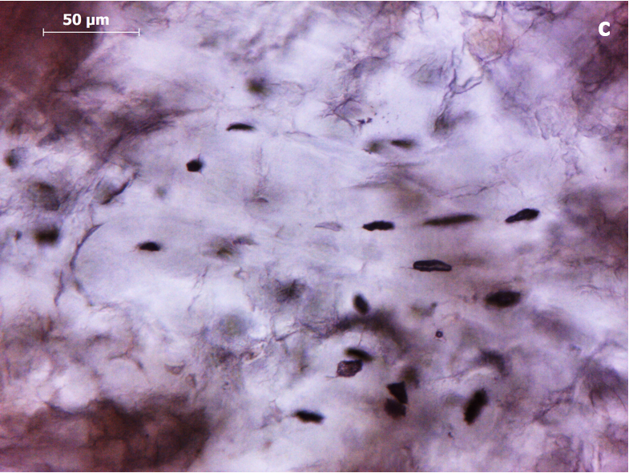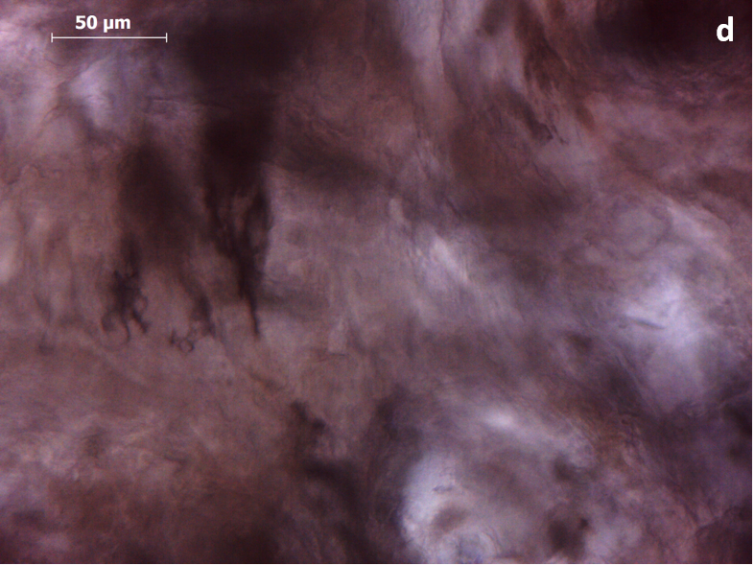
Figure 3. DEN4 Transverse PPL (a) and DEN2 Transverse PPL (b) 400x - Petrous bone: Well-preserved area (a) versus possible microbial activity in (b) that appears as merged osteocyte lacunae (opaque/black holes indicated by red arrows).
DEN4 Transverse PPL (c) and (d) 400x - Petrous bone: Areas displaying degradation due to microcracking (c) that eventually leads to generalized destruction (d) characterized by loss of histological integrity (amorphous) as seen in PPL and a complete loss of collagen birefringence in XPL (dark appearance, hence no image).
Opaque features (inclusions) can be seen within pores of one specimen (Figure 4). Archaeological bone may be filled with detrital or other exogenous material that penetrates the pores (Bodzioch, 2015; Bodzioch and Kowal-Linka, 2012; Garland, 1989). Inclusions can fill up osteocyte lacunae, canaliculi and Haversian canals (Bodzioch, 2015; Hollund et al., 2012; Pfretzschner, 2004; Tjelldén et al., 2018; Turner-Walker, 1999) and can cause micro-cracks (Figure 4) that can accelerate the decay of the already degraded collagen, allowing the ionic exchange between water and bioapatite (Fernandez-Jalvo et al., 2010; Pfretzschner, 2004; Tjelldén et al., 2018).
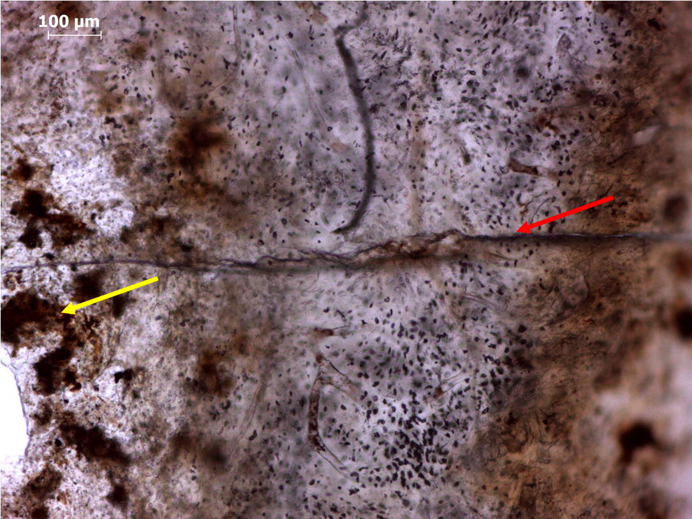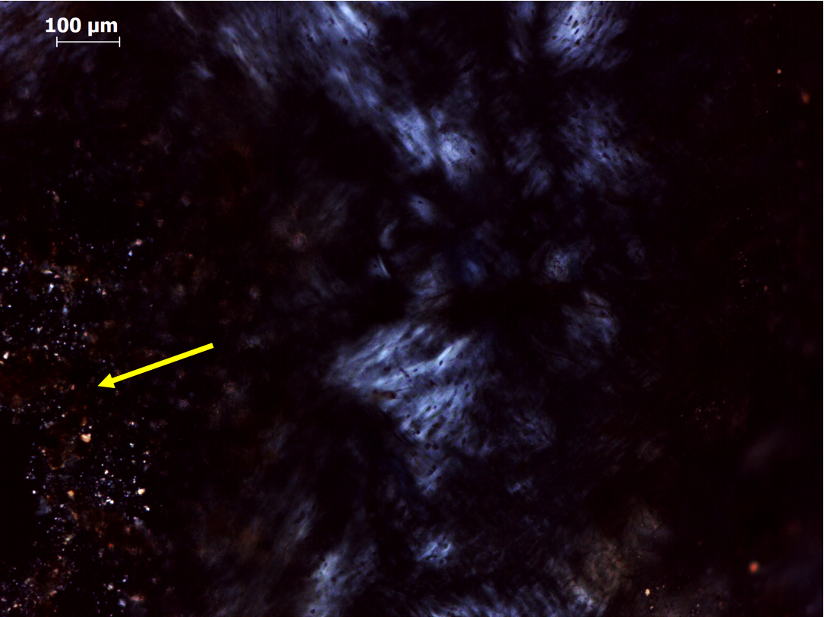
Figure 4. DEN2 Longitudinal PPL (left) and XPL (right) 100x - Petrous bone: Inclusions (yellow arrow) in endosteal tissue close to a fissure (red arrow) that runs from the outer periosteal (red arrow) to the endosteal tissue that surrounds the semicircular canal.
Signs of microcracking (as seen on the walls of Haversian canals or others crossing the osteon boundaries in sample DEN1 (Figure 5)) are related to water uptake (Pfretzschner and Tütken, 2011), as microfissures near or within osteons relate to changes in density, collagen degradation and mineral dissolution (Bell, 1990; Pfretzschner and Tütken, 2011). However, cracking may also be attributed to physical stresses during sample preparation (Dal Sasso et al., 2014; Lander et al., 2014; Turner-Walker, 2012). Brown/orange staining seen in the outer periosteal surfaces of five Danish and two Central Asian specimens (Figure 5) could have been caused by the infiltration of iron oxides (Hollund et al., 2012; Pesquero et al., 2015) or other exogenouss substances that replace the osseous material and can be identified as stained sites with granular appearance (Garland, 1989).
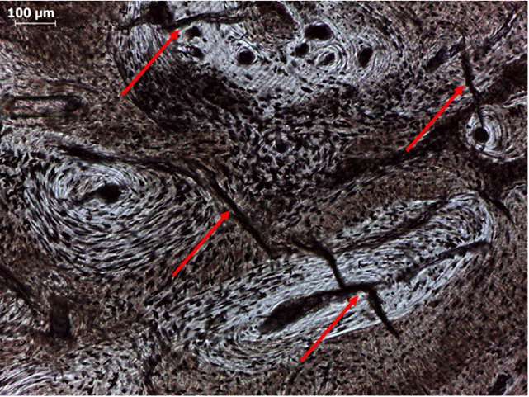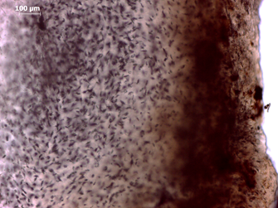
Figure 5. DEN1 Longitudinal PPL 100x - Petrous bone (left): Areas of inner periosteal bone exhibiting microcracking within and around osteons (red arrows).
DEN2 Transverse PPL 100x - Petrous bone (right): Brown staining of the outer periosteal tissue.

3.2. Bioapatite preservation
Changes in bioapatite composition occur as bone mineral is a relatively unstable and disordered form of hydroxyapatite, and this degree of disorder is responsible for the promotion of diagenetic modifications in BAp crystals (Asscher et al., 2011a; Trueman, 2013). Various ions (e.g. HPO₄^{2ˉ}, PO₄^{3ˉ}, CO₃^{2ˉ}, Ca²⁺, Mg²⁺) can be incorporated into the bone-water system, enter the BAp hydrated layer, and subsequently, substitute other ions into the BAp core (Berna et al., 2004; Rey et al., 2009). The conditions of the burial environment (e.g. pH, local hydrology) are responsible for triggering a reorganization/growth of BAp crystals through dissolution (loss of less stable components) and recrystallization (formation of more stable structures) that is necessary for their survival post-mortem (e.g. Berna et al., 2004; Hedges and Millard, 1995; High et al., 2015).
In this study IRSF and C/P display the strong inverse relationship (R²=0.78) reported in other works, with recrystallization driving the loss of carbonate from the apatite (Figure 6). The Danish and Central Asian samples display statistically significant differences both in IRSF values (U=3.000, p=0.003) and carbonate content (U=10.500, p=0.05). The petrous bones from Denmark have a lower average IRSF (IRSF=3.46±0.08) that is only slightly increased compared to modern human bone (IRSF=3.357±0.007), while the petrous bones from Central Asia (IRSF=4.04±0.1) show much stronger modifications. The infrared splitting factor (IRSF) reflects BAp crystal size and structural order/disorder, with the larger and/or more ordered crystals displaying higher IRSF values (e.g. Asscher et al., 2011a, 2011b). Thus, increased IRSF values here indicate an increase in average and/or maximum crystal length. This increase may be due to an increase of the size of the larger crystals at the expense of the smaller ones (i.e. Ostwald ripening), dissolution of the smaller crystals, or both (Kendall et al., 2018; Trueman, 2013; Weiner and Bar-Yosef, 1990).
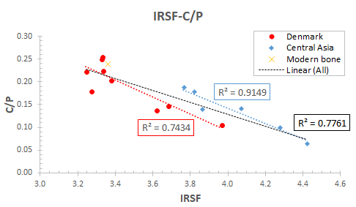
Figure 6. IRSF-to-C/P correlation that denotes site-specific variations. Increased IRSF values indicate an increase in average and/or maximum crystal length.
A loss of CO₃^{2ˉ} content in our samples can be seen both in the Danish (C/P=0.19±0.02) and the Central Asian petrous bones (C/P=0.14±0.02) compared to modern human samples (C/P=0.240±0.003). Similarly to IRSF, the two assemblages exhibit site-specific differences in carbonate content (Figure 6), with the petrous bones from Denmark displaying a loss of about 20% of the initial carbonate, while the Central Asia bones have lost about the 40% of their initial CO₃^{2ˉ}. The main driving factor in diagenetic alteration is the extent to which local conditions alter the mineral phase; the more stable the conditions the less altered is the bone. The longer time of exposure to the conditions of the burial environment for the Central Asian (i.e. Bronze Age) samples could also partly explain their differences in crystallinity and carbonate content. It is, generally, assumed that the longer the bone is exposed to the conditions of the burial environment, the greater is its dependency on external sources of phosphate (i.e. authigenic minerals) and other ions to fill in the pore space initially occupied by the organic component (Figueiredo et al., 2012; Trueman et al., 2004), although this also depends on other environmental factors.
Overall, the decreased CO₃^{2ˉ} content observed in our samples promoted the formation of a more stable mineral phase (i.e. crystal size and lattice perfection) (Salesse et al., 2014). Carbonate ions (4-6 wt. %) can replace OHˉ (type A) or PO₄^{3ˉ} (type B) ions in the bioapatite crystal lattice (LeGeros, 1965; Wopenka and Pasteris, 2005). Type A substitutions take place at high temperatures (900-1000º C) with the exclusion of water, whereas type B substitutions can take place at much lower temperatures (25-100º C) (LeGeros, 1965).
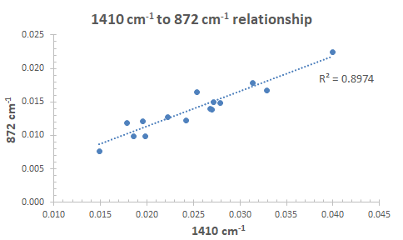
Figure 7. The very strong 1410-to-872 cm⁻¹ peak height correlation indicative of the dominant role of type B carbonate in BAp crystal structure.
Here the peak height at c. 1410 cm⁻¹ displays a very strong linear relationship (R²=0.90) with this at c. 872 cm⁻¹(Figure 7). As both peaks reflect the type B carbonate environment in bioapatite crystals (Rey et al., 1989) it indicates that bone carbonate exchange during crystallinity increase (Figure 6) primarily occurs at the phosphate sites of the crystal lattice (i.e. type B) (LeGeros, 1965; Wopenka and Pasteris, 2005). An exchange of PO₄^{3ˉ} for CO₃^{2ˉ} alters the atomic-level bond spacings and orientations due to the differences in the O-O distances (LeGeros et al., 1969). A substitution of the smaller CO₃^{2ˉ} by the larger PO₄^{3ˉ} increases the unit cell dimensions of BAp crystals and forms more ordered crystal lattices (e.g. LeGeros, 1965; Wopenka and Pasteris, 2005). Consequently, our data prove that type B CO₃^{2ˉ} is indeed the predominant form of carbonate that is replaced by exogenous phosphate or other ions on the sloping faces of BAp crystals (Fleet et al., 2004; LeGeros, 1965; Rey et al., 1989).

3.3. Collagen preservation
All samples exhibit very good collagen preservation, with collagen wt. % ranging from 7.42 to 17.84 (Table 1). Although there are no statistically significant differences (U=18.000, p=0.328) between the two sites, the Danish petrous bones show lower average collagen yields (12.49±1.04) than the Central Asia samples (14.67±1.1), despite being much younger. Collagen yields (wt. %) are commonly used to distinguish well-preserved from poorly-preserved collagen and currently c. 1 wt. % is considered a suitable threshold below which samples should not be used for isotopic and/or radiocarbon dating studies (Brock et al., 2010; Dobberstein et al., 2009; van Klinken, 1999).
A combined use of % C, % N and C/N ratio is assumed to significantly increase the successful screening of bones for collagen (Brock et al., 2012, 2010; Harbeck and Grupe, 2009). Starting with the % N in whole bone, which is c. 3.5 - 5.5 wt. % in modern bone (Baker et al., 1946; Eastoe and Eastoe, 1954), our values range from 1.39 to 3.42 (Table 1). It has been previously shown that % N is a reliable index to screen collagen preservation (Bocherens et al., 2005; Brock et al., 2010). Bocherens et al. (2005) support that a 0.4 % N threshold is adequate for samples in order to be further examined for stable isotopes and/or radiocarbon dating. Similarly, Brock et al. (2010) propose a cut-off point of 0.7 %, although when samples contain > 0.7 % Ν and give collagen yields < 1 wt. %, the nitrogen may be present as short-chain/degraded collagen or polypeptides, non-collagenous proteins, soil contaminants, or conservation treatments (Brock et al., 2012). The Danish and the Central Asian samples show no statistically significant differences (U=14.500, p=0.145), while they both demonstrate strong, site-specific relationships between collagen wt. % and N wt. % (Figure 8a). The higher average % N in the Danish bones (2.51 versus 2.04 for Central Asian), which at the same time display lower collagen yields than the Central Asian bones, is noteworthy and could be possibly due to the presence of non-collagenous proteins in the former. Overall, it seems that our data are in agreement with past studies (e.g. Brock et al., 2012; Lebon et al., 2016) which claim that % N of whole bone can be a relatively good indicator of collagen preservation, although assessment of highly contaminated and/or degraded bones can be problematic.
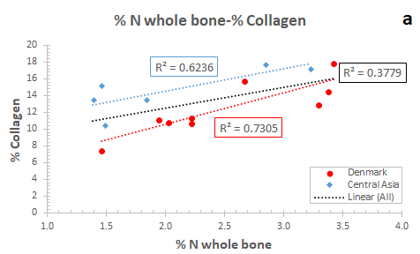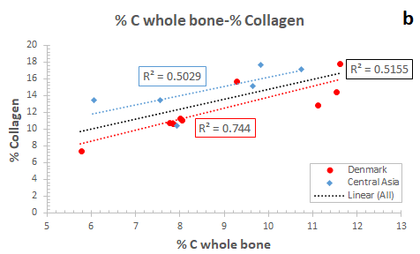
Figure 8. Data showing the reliability of N and C content in whole bone as indicators of collagen preservation.
Values range from 5.76 to 11.60% for the total amount of carbon (Table 1). Archaeological bone usually displays a significant decrease in carbon content compared to modern animal bone that have c. 15 wt. % C (Ambrose, 1990; Sillen and Parkington, 1996; van Klinken, 1999). While the two groups show no statistically significant differences (U=23.000, p=0.689), the samples from Central Asia display a moderate collagen wt. % - C wt. % correlation (R²=0.50) while the petrous bones from Denmark exhibit a much stronger linear relationship (R²=0.74) (Figure 8b). Thus, our data indicate that % C of whole bone can be an equally strong to % N of whole bone predictor of collagen content.
Collagen C/N ratio was also used as a quality indicator for collagen, with values ranging from 3.2 to 3.4 (Table 1) and samples from Denmark displaying no statistically significant differences from these of Central Asia (U=21.500, p=0.529). Values similar to modern bone (i.e. 2.9 to 3.6) are considered representative of good quality collagen, whereas much higher C/N ratios are linked to diagenesis (Ambrose, 1990; DeNiro, 1985; DeNiro and Weiner, 1988; Tuross, 2002). Post-mortem alterations in the carbon and nitrogen contents involve more than one mechanism (microbial attack and hydrolysis) (Ambrose, 1990; Balzer et al., 1997; Harbeck and Grupe, 2009; Turner-Walker, 2008; Tuross, 2002). A preferential loss of the hydrophobic amino acids during collagen hydrolysis and the amino acids with a higher number of carbons in microbial attack can affect the C/N ratio (Balzer et al., 1997; Grupe, 1995; Harbeck and Grupe, 2009; Masters, 1987; Turban-Just and Schramm, 1998; Tuross, 2002). Although the C/N ratios of whole bone powder could provide an alternative solution, the relationship with col. wt. % (Central Asia R²=0.22 and Denmark R²=0.48) does not seem to be sensitive enough to discriminate well- from poorly-preserved samples. Poor correlation between C/N of whole bone and collagen yields has also been reported by Brock et al. (2012) and Lebon et al. (2016).
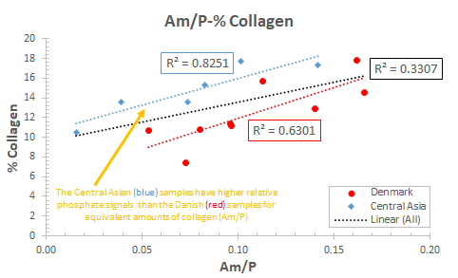
Figure 9. The effect of site-specific variations on the Am/P index. The lower intercept of the more recent (Danish) bones suggests that the phosphate for carbonate exchange (relative phosphate content), and vice versa, can affect the reliability of Am/P as a collagen predictor.
The Am/P ratio can potentially provide valuable information on the relative amount of organic content in bone (Lebon et al., 2016; Trueman et al., 2008a, 2004). A strong to very strong correlation (Central Asia R²=0.83, Denmark R²=0.63) between Am/P and collagen wt. % can be seen in our data for both assemblages (Figure 9). The overall relationship between Am/P and collagen yields (R²=0.33) however is weak, even if there are no statistically significant differences in Am/P values between the two sites (U=14.500, p=0.145), due to changes in BAp crystals’ relative phosphate amounts during dissolution/recrystallization (Figure 9).
The application of the Am/P ratio as a quantitative approach to estimate collagen yields using the Lebon et al. (2016) equation (i.e. collagen wt. % = 113.13 Am/P + 1.69) can potentially provide reliable collagen content estimates (e.g. DEN2, DEN5, DEN8, CA3) with the average offset being -0.84±2.33% (Table 1). However, the collagen content estimates are affected by the relative phosphate content in the samples (Figure 9) that results to poor agreement with collagen yields in other specimens (e.g. DEN1, DEN6, CA4, CA5). The presence of overtones related to structural water (e.g. O-H stretch at 1640-1660 cm⁻¹) can also lead to increased values for specimens that contain less than c. 10 wt. collagen (Lebon et al., 2016; Trueman et al., 2008a). Further limitations include the significant effects of FTIR and collagen sample preparation strategies on Am/P (e.g. Kontopoulos et al., 2018) and collagen yields (e.g. Sealy et al., 2014), respectively.
Finally, our data are in agreement with other studies (e.g. Lebon et al., 2010; Weiner and Bar-Yosef, 1990) that support a lack of correlation between crystallinity (i.e. IRSF) and collagen content (Denmark R²=0.19; Central Asia R²=0.15). This observation might be unexpected as the mineral-organic relationship is considered very strong. The BAp crystals are located between the collagen fibrils (inter-fibrillar spaces) or on the surfaces of collagen fibrils (intra-fibrillar spaces), while their orientation and size are controlled by the fibril structure and organization (Boskey, 2003; Weiner and Price, 1986; Weiner and Traub, 1986). Hence the volume of bone matrix that is filled with collagen in vivo can be replaced post-mortem by exogenous ions until inter-crystallite porosity has been filled (Susini et al., 1988; Trueman et al., 2008b). Similar to IRSF, there is a very weak correlation between C/P and collagen wt. % for samples from Central Asia (R²=0.05), while there is a moderate linear relationship (R²=0.54) for samples from Denmark. We have no good explanation of this difference, which would benefit from a larger study which might explore (for example) the selective leaching of proteins such as osteocalcin and osteonectin which may play a role in limiting the extent of recrystallisation.

3.4. DNA preservation
The survival of DNA in archaeological bone has been linked to mineral preservation as dissolution and recrystallization of BAp crystals leads to considerable loss of DNA (Allentoft et al., 2012; Götherström et al., 2002; Lindahl, 1993; Parsons and Weedn, 2006). Our data demonstrate that IRSF and C/P can be considered reliable predictors of DNA preservation as there is an overall strong inverse relationship (R²=0.69) of crystallinity (IRSF) and an overall strong linear relationship (R²=0.70) of C/P with endogenous DNA yields (Figure 10a-b). When samples are split into three groups based on their endogenous DNA yields (i.e. >10%, 1-10 %, and <1 %) to potentially enhance screening practices, samples with IRSF values similar to modern human bone (i.e. IRSF=3.357±0.007) display >10 % endogenous DNA (Figure 10c). When endogenous DNA yields drop below 10 %, samples display a very strong inverse relationship (R²=0.93) with IRSF that increases to levels over 3.6 (Figure 10c). In tandem, samples with similar to modern bone C/P ratios (C/P=0.24±0.003) contain >10 % endogenous DNA (Figure 10d). When C/P decreases to the c. 0.15-0.18 level, this carbonate loss is accompanied by a significant loss of endogenous DNA to below 10 %, although contrariwise to IRSF, there is no strong correlation with DNA yields (Figure 10d). However, the small number of samples examined in this study does not allow any conclusion to be drawn on the possible thresholds.
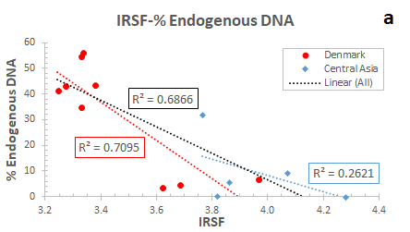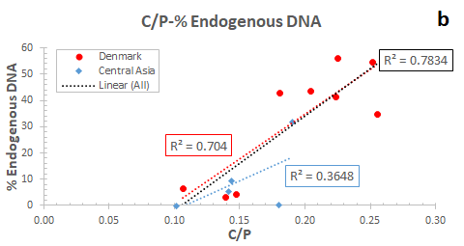
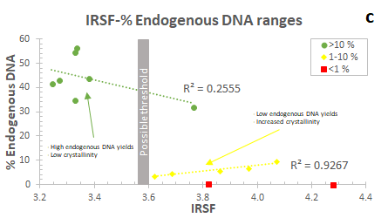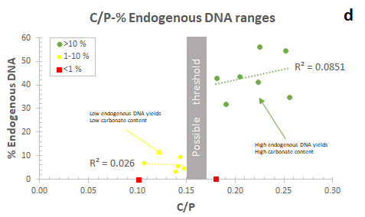
Figure 10. Correlation of crystallinity (a) and carbonate content (b) with endogenous DNA yields, and possible thresholds (c and d). Percentage endogenous DNA between the two sites were almost statistically significant different (U=8.000, p=0.06), and varied between 3.5 % and 56.3 % (average=32.2 %) in the Danish samples, and from 0.1 % to 32 % (average=9.6 %) in the Central Asian specimens.
Overall, the ionic exchanges in bioapatite crystals (phosphate for carbonate substitutions, and vice versa) of archaeological human petrous bone during dissolution/recrystallization can lead to a significant loss of DNA, although DNA molecules can be trapped and survive in archaeological timescales by adsorbing onto the surfaces of the crystals. The adsorption of DNA is controlled by environmental conditions (e.g. temperature, pH, local hydrology) (Grunenwald et al., 2014). At lower temperatures (i.e. 4 °C) the amount of DNA adsorbed onto crystals is significantly less than at higher temperatures (i.e. 22 or 37 °C), while in acidic environments adsorption increases compared to alkaline (Götherström et al., 2002; Grunenwald et al., 2014; Lindahl, 1993; Parsons and Weedn, 2006). Consequently, possible differences in their burial environments are responsible for the variations seen in the relationships between endogenous DNA content, crystallinity and carbonate content in our samples.
Additionally, three of the Danish petrous bones (DEN4, DEN5, DEN9) that exhibit <10 % endogenous DNA also display poor histological preservation, with large areas suffering from generalized destruction. The DNA molecule is particularly prone to the interaction with water, which is also related to generalized destruction and ionic exchange in BAp crystals. Hydrolysis leads to breakage of the polynucleotide strands followed by chain breakage into shorter fragments (Bada et al., 1999; Hofreiter et al., 2001; Lindahl, 1993; Pääbo, 1989) and any variations in long-term DNA fragmentation are assumed to be caused by differences in temperature, pH and local hydrology (Allentoft et al., 2012; Burger et al., 1999; Lindahl, 1993; Lindahl and Nyberg, 1972).
Hydrolysis can cause deamination (i.e. loss of the amino -NH₂ group) and/or depurination (i.e. release the purines) with purines being more susceptible to hydrolysis than pyrimidines (Lindahl, 1993; Lindahl and Nyberg, 1972; Pääbo, 1989). Deamination of cytosine to uracil (C→T miscoding lesion) is the most common pathway and generates a C→T sequence error as the deaminated cytosine (now uracil) binds to adenine (Lindahl, 1993; Pääbo et al., 2004). Here, the increased C→T damage rates (Hansen et al., 2017) confirms such a scenario (0.27±0.04 average C→T mismatch for Denmark and 0.39±0.09 for Central Asia). However, correlation of C→T mismatch with the diagenetic parameters was weak (% DNA-C→T= 0.22; % Collagen-C→T= 0.14; IRSF-C→T= 0.18; C/P-C→T= 0.03; % N-C→T= 0.14; 0.02; % C-C→T= 0.00). While the methyl (-CH₃) group attached to cytosine can make them more susceptible to deamination (Brown and Brown, 2011; Hansen et al., 2001), increased methylation levels were not observed in our samples (see Hansen et al., 2017 for more information).
With regard to the collagen-DNA relationship, the crucial role of collagen loss in DNA degradation has been discussed in past studies (Campos et al., 2012; Götherström et al., 2002; Sosa et al., 2013), but our results demonstrate a lack of relationship between collagen and DNA preservation (Figure 11). As a result, collagen preservation is not always a good measure of endogenous DNA content as samples with good collagen preservation may not yield endogenous DNA, and vice versa.
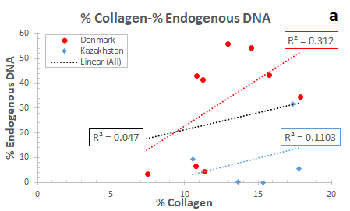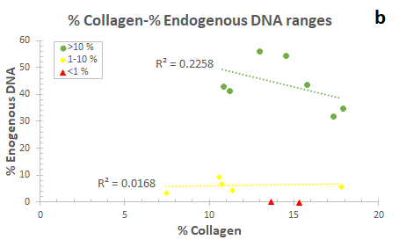
Figure 11. The relationship between collagen content and DNA preservation, indicating that at these levels of bone preservation, % collagen is not always a good indicator for successful aDNA recovery.

4. Conclusion
This study focused on human petrous bone diagenesis with the aim of providing new information which can potentially increase the success rates of some commonly used methods (e.g. histology, FTIR, elemental analysis, collagen wt. %) applied to screen petrous bone for DNA and collagen preservation. The analysis revealed:
- Histomorphology: the present findings confirm that the human petrous bone has unique microstructural characteristics with different types and arrangement of tissues compared to other adult skeletal elements. Woven and lamellar-like tissue distribution in outer periosteal, inner periosteal, and endosteal zones of the petrous pyramid is possibly controlled by the function and mechanical demands of each inner ear region. To our knowledge, this is the first report of the presence of osteons in both transverse and longitudinal sections in any skeletal element. However, it is difficult to arrive at any conclusions with regard to the effects of microstructure on the role of petrous bone as a repository of ancient biomolecules, although it is possible that its combined characteristics (woven tissue, lack of remodelling, protected location) may create microniches that allow DNA survival.
- Diagenesis: a) microscopic focal destructions were not observed in petrous bones. Only few merged osteocyte lacunae can possibly represent some limited microbial activity during early diagenetic stages; b) generalized destruction was linked with decreased levels of endogenous DNA content; c) dissolution and recrystallization of BAp crystals was associated with a significant loss of DNA but not collagen.
- Screening methods: a) GHI can be potentially used for collagen and DNA screening; b) Am/P, % N and % C content in whole bone are reliable indicators of collagen content; c) IRSF and C/P may potentially be used to identify bones with high (>10 %) endogenous DNA content.
Future research should further explore these initial histomorphological findings by examining a series of transverse and longitudinal thin sections to record changes across the entire petrous. That way any issues regarding the role of bioerosion in petrous bone degradation can be answered and susceptible areas can be identified. The potential effects of the burial environment on petrous bone diagenesis may also constitute the object of future studies as these may help pinpoint the critical degradation parameters. Another interesting research approach would also be the comparison of petrous bone with other skeletal elements to understand to what extent their histomorphological or even possible compositional differences increase DNA and collagen chances for postmortem survival in petrous bone. Multi-analytical approaches could provide deeper analyses of particular diagenetic mechanisms, while new proposals of different methods may further enhance screening practices.

Acknowledgements
We are indebted to Prof. Peter Zioupos for the two modern human samples (NHS REC approval 10/H0107/14) which were used as references in this study with the kind permission of the Department of Biology Ethics Committee (BEC) of the University of York. The Danish National Museum is thanked for allowing access to the skeletal material from Holmens Church (Denmark).
MJC was supported by Danish National Research Foundation (DNRF128) and KP from the Leverhulme Trust (PLP-2012-116). IK would like to thank Onassis Foundation (grant no. F ZL 047-1/2015-2016), Leventis Foundation and the Greek Archaeological Committee UK (GACUK).

References
Allentoft, M.E., Collins, M., Harker, D., Haile, J., Oskam, C.L., Hale, M.L., Campos, P.F., Samaniego, J.A., Gilbert, M.T.P., Willerslev, E., Zhang, G., Scofield, R.P., Holdaway, R.N., Bunce, M., 2012. The half-life of DNA in bone: measuring decay kinetics in 158 dated fossils. Proc. Biol. Sci. 279, 4724–4733. https://doi.org/10.1098/rspb.2012.1745
Ambrose, S.H., 1990. Preparation and characterization of bone and tooth collagen for isotopic analysis. J. Archaeol. Sci. 17, 431–451. https://doi.org/10.1016/0305-4403(90)90007-r
Asscher, Y., Regev, L., Weiner, S., Boaretto, E., 2011a. Atomic disorder in fossil tooth and bone mineral: An FTIR study using the grinding curve method. Archeosciences 135–141. https://doi.org/10.4000/archeosciences.3062
Asscher, Y., Weiner, S., Boaretto, E., 2011b. Variations in atomic disorder in biogenic carbonate hydroxyapatite using the infrared spectrum grinding curve method. Adv. Funct. Mater. 21, 3308–3313. https://doi.org/10.1002/adfm.201100266
Bada, J.L., Wang, X.S., Hamilton, H., Ambler, R.P., Finch, P., Grocke, D.R., Eglinton, G., Macko, S.A., 1999. Preservation of key biomolecules in the fossil record: current knowledge and future challenges (and discussion). Philos. Trans. R. Soc. Lond. B Biol. Sci. 354, 77–87.
Baker, S.L., Butterworth, E.C., Langley, F.A., 1946. The calcium and nitrogen content of human bone tissue cleaned by micro-dissection. Biochem. J 40, 391–396.
Balzer, A., Gleixner, G., Grupe, G., Schmidt, H.L., Schramm, S., Turban-Just, S., 1997. In vitro decomposition of bone collagen by soil bacteria: The implications for stable isotope analysis in archaeometry. Archaeometry 39, 415–429.
Bell, L.S., 1990. Palaeopathology and diagenesis: an SEM evaluation of structural changes using backscattered electron imaging. J. Archaeol. Sci. 17, 85–102. https://doi.org/10.1016/0305-4403(90)90016-X
Bentley, A.R., 2006. Strontium Isotopes from the Earth to the Archaeological Skeleton: A Review. J Archaeol Method Theory 13, 135–187. https://doi.org/10.1007/s10816-006-9009-x
Berna, F., Matthews, A., Weiner, S., 2004. Solubilities of bone mineral from archaeological sites: the recrystalization window. J. Archaeol. Sci. 31, 867–882.
Bocherens, H., Drucker, D.G., Billiou, D., Moussa, I., 2005. Une nouvelle approche pour évaluer l’état de conservation de l'os et du collagène pour les mesures isotopiques (detation au radiocarbone, isotopes stables du carbone et de l'azote). Anthropologie 109, 557–567.
Bodzioch, A., 2015. Idealized model of mineral infillings in bones of fossil freshwater animals, on the example of Late Triassic metoposaurs from Krasiejów (Poland). Austin Journal of Earth Sciences 2, 1008.
Bodzioch, A., Kowal-Linka, M., 2012. Unraveling the origin of the Late Triassic multitaxic bone accumulation at Krasiejów (S Poland) by diagenetic analysis. Palaeogeogr. Palaeoclimatol. Palaeoecol. 346–347, 25–36. https://doi.org/10.1016/j.palaeo.2012.05.015
Boskey, A.L., 2003. Bone mineral crystal size. Osteoporos. Int. 14 Suppl 5, S16–20; discussion S20–1. https://doi.org/10.1007/s00198-003-1468-2
Brock, F., Higham, T., Ramsey, C.B., 2010. Pre-screening techniques for identification of samples suitable for radiocarbon dating of poorly preserved bones. J. Archaeol. Sci. 37, 855–865. https://doi.org/10.1016/j.jas.2009.11.015
Brock, F., Wood, R., Higham, T.F.G., Ditchfield, P., Bayliss, A., Ramsey, C.B., 2012. Reliability of nitrogen content (%N) and carbon:nitrogen atomic ratios (C:N) as indicators of collagen preservation Suitable for radiocarbon dating. Radiocarbon 54, 879–886. https://doi.org/10.1017/S0033822200047524
Brown, T.A., Barnes, I.M., 2015. The current and future applications of ancient DNA in Quaternary science. J. Quat. Sci. 30, 144–153. https://doi.org/10.1002/jqs.2770
Brown, T., Brown, K., 2011. Biomolecular archaeology An introduction. Wiley-blackwell, Sussex.
Buckley, M., Collins, M., Thomas-Oates, J., Wilson, J.C., 2009. Species identification by analysis of bone collagen using matrix-assisted laser desorption/ionisation time-of-flight mass spectrometry. Rapid Commun. Mass Spectrom. 23, 3843–3854. https://doi.org/10.1002/rcm.4316
Burger, J., Hummel, S., Herrmann, B., Henke, W., 1999. DNA preservation: A microsatellite-DNA study on ancient skeletal remains. Electrophoresis 20, 1722–1728. https://doi.org/3.0.CO;2-4">10.1002/(SICI)1522-2683(19990101)20:8<1722::AID-ELPS1722>3.0.CO;2-4
Campos, P.F., Craig, O.E., Turner-Walker, G., Peacock, E., Willerslev, E., Gilbert, M.T.P., 2012. DNA in ancient bone - where is it located and how should we extract it? Ann. Anat. 194, 7–16. https://doi.org/10.1016/j.aanat.2011.07.003
Cappellini, E., Prohaska, A., Racimo, F., Welker, F., Pedersen, M.W., Allentoft, M.E., de Barros Damgaard, P., Gutenbrunner, P., Dunne, J., Hammann, S., Roffet-Salque, M., Ilardo, M., Moreno-Mayar, J.V., Wang, Y., Sikora, M., Vinner, L., Cox, J., Evershed, R.P., Willerslev, E., 2018. Ancient biomolecules and evolutionary inference. Annu. Rev. Biochem. https://doi.org/10.1146/annurev-biochem-062917-012002
Caruso, V., Cummaudo, M., Maderna, E., Cappella, A., Caudullo, G., Scarpulla, V., Cattaneo, C., 2018. A comparative analysis of microscopic alterations in modern and ancient undecalcified and decalcified dry bones. Am. J. Phys. Anthropol. 165, 363–369. https://doi.org/10.1002/ajpa.23348
Collins, M.J., Nielsen–Marsh, C.M., Hiller, J., Smith, C.I., Roberts, J.P., Prigodich, R.V., Wess, T.J., Csapò, J., Millard, A.R., Turner–Walker, G., 2002. The survival of organic matter in bone: a review. Archaeometry 44, 383–394. https://doi.org/10.1111/1475-4754.t01-1-00071
Colonese, A.C., Farrell, T., Lucquin, A., Firth, D., Charlton, S., Robson, H.K., Alexander, M., Craig, O.E., 2015. Archaeological bone lipids as palaeodietary markers. Rapid Commun. Mass Spectrom. 29, 611–618. https://doi.org/10.1002/rcm.7144
Currey, J.D., 1999. The design of mineralised hard tissues for their mechanical functions. J. Exp. Biol. 202, 3285–3294.
Dal Sasso, G., Maritan, L., Usai, D., Angelini, I., Artioli, G., 2014. Bone diagenesis at the micro-scale: Bone alteration patterns during multiple burial phases at Al Khiday (Khartoum, Sudan) between the Early Holocene and the II century AD. Palaeogeogr. Palaeoclimatol. Palaeoecol. 416, 30–42. https://doi.org/10.1016/j.palaeo.2014.06.034
DeNiro, M.J., 1985. Postmortem preservation and alteration of in vivo bone collagen isotope ratios in relation to palaeodietary reconstruction. Nature 317, 806–809. https://doi.org/10.1038/317806a0T
DeNiro, M.J., Weiner, S., 1988. Chemical, enzymatic and spectroscopic characterization of “collagen” and other organic fractions from prehistoric bones. Geochim. Cosmochim. Acta 52, 2197–2206. https://doi.org/10.1016/0016-7037(88)90122-6
Dobberstein, R.C., Collins, M., Craig, O., Taylor, G.M., Penkman, K.E.H., Ritz-Timme, S., 2009. Archaeological collagen: Why worry about collagen diagenesis. Archaeol. Anthropol. Sci. 1, 31–42.
Doden, E., Halves, R., 1984. On the functional morphology of the human petrous bone. Am. J. Anat. 169, 451–462. https://doi.org/10.1002/aja.1001690407
Eastoe, J.E., Eastoe, B., 1954. The organic constituents of mammalian compact bone. Biochem. J 57, 453–459.
Fernandez-Jalvo, Y., Andrews, P., Pesquero, D., Smith, C.I., Marin-Monfort, D., Sanchez, B., Geigl, E.M., Alonso, A., 2010. Early bone diagenesis in temperate environments Part I: Surface features and histology. Palaeogeogr. Palaeoclimatol. Palaeoecol. 288, 62–81.
Figueiredo, M.M., Gamelas, J.A.F., Martins, A.G., 2012. Characterization of bone and bone-based graft materials using FTIR spectroscopy, in: Infrared Spectroscopy - Life and Biomedical Sciences. https://doi.org/10.5772/36379
Fleet, M.E., Liu, X., King, P.L., 2004. Accommodation of the carbonate ion in apatite: An FTIR and X-ray structure study of crystals synthesized at 2–4 GPa. Am. Mineral. 89, 1422–1432. https://doi.org/10.2138/am-2004-1009
Frisch, T., Sørensen, M.S., Overgaard, S., Bretlau, P., 2000. Estimation of volume referent bone turnover in the otic capsule after sequential point labeling. Ann. Otol. Rhinol. Laryngol. 109, 33–39. https://doi.org/10.1177/000348940010900106
Gamba, C., Jones, E.R., Teasdale, M.D., McLaughlin, R.L., Gonzalez-Fortes, G., Mattiangeli, V., Domboróczki, L., Kővári, I., Pap, I., Anders, A., Whittle, A., Dani, J., Raczky, P., Higham, T.F.G., Hofreiter, M., Bradley, D.G., Pinhasi, R., 2014. Genome flux and stasis in a five millennium transect of European prehistory. Nat. Commun. 5, 5257. https://doi.org/10.1038/ncomms6257
Garland, A.N., 1989. Microscopical analysis of fossil bone. Appl. Geochem. 4, 215–229. https://doi.org/10.1016/0883-2927(89)90021-8
Götherström, A., Collins, M.J., Angerbjörn, A., Lidén, K., 2002. Bone preservation and DNA amplification. Archaeometry 44, 395–404. https://doi.org/10.1111/1475-4754.00072
Green, R.E., Krause, J., Briggs, A.W., Maricic, T., Stenzel, U., Kircher, M., Patterson, N., Li, H., Zhai, W., Fritz, M.H.-Y., Hansen, N.F., Durand, E.Y., Malaspinas, A.-S., Jensen, J.D., Marques-Bonet, T., Alkan, C., Prüfer, K., Meyer, M., Burbano, H.A., Good, J.M., Schultz, R., Aximu-Petri, A., Butthof, A., Höber, B., Höffner, B., Siegemund, M., Weihmann, A., Nusbaum, C., Lander, E.S., Russ, C., Novod, N., Affourtit, J., Egholm, M., Verna, C., Rudan, P., Brajkovic, D., Kucan, Ž., Gušic, I., Doronichev, V.B., Golovanova, L.V., Lalueza-Fox, C., de la Rasilla, M., Fortea, J., Rosas, A., Schmitz, R.W., Johnson, P.L.F., Eichler, E.E., Falush, D., Birney, E., Mullikin, J.C., Slatkin, M., Nielsen, R., Kelso, J., Lachmann, M., Reich, D., Pääbo, S., 2010. A draft sequence of the Neandertal genome. Science 328, 710–722. https://doi.org/10.1126/science.1188021
Grunenwald, A., Keyser, C., Sautereau, A.M., Crubézy, E., Ludes, B., Drouet, C., 2014. Adsorption of DNA on biomimetic apatites: Toward the understanding of the role of bone and tooth mineral on the preservation of ancient DNA. Appl. Surf. Sci. 292, 867–875. https://doi.org/10.1016/j.apsusc.2013.12.063
Grupe, G., 1995. Preservation of collagen in bone from dry, sandy soil. J. Archaeol. Sci. 22, 193–199.
Hackett, C.J., 1981. Microscopical focal destruction (tunnels) in exhumed human bones. Med. Sci. Law 21, 243–265. https://doi.org/10.1177/002580248102100403
Hansen, A., Willerslev, E., Wiuf, C., Mourier, T., Arctander, P., 2001. Statistical evidence for miscoding lesions in ancient DNA templates. Mol. Biol. Evol. 18, 262–265.
Hansen, H.B., Damgaard, P.B., Margaryan, A., Stenderup, J., Lynnerup, N., Willerslev, E., Allentoft, M.E., 2017. Comparing Ancient DNA Preservation in petrous bone and tooth cementum. PLoS One 12, e0170940. https://doi.org/10.1371/journal.pone.0170940
Harbeck, M., Grupe, G., 2009. Experimental chemical degradation compared to natural diagenetic alteration of collagen: implications for collagen quality indicators for stable isotope analysis. Archaeol. Anthropol. Sci. 1, 43–57. https://doi.org/10.1007/s12520-009-0004-5
Harvig, L., Frei, K.M., Price, T.D., Lynnerup, N., 2014. Strontium isotope signals in cremated petrous portions as indicator for childhood origin. PLoS One 9, e101603. https://doi.org/10.1371/journal.pone.0101603
Hedges, R.E.M., Millard, A.R., 1995. Bones and groundwater: Towards the modelling of diagenetic processes. J. Archaeol. Sci. 22, 155–164. https://doi.org/10.1006/jasc.1995.0017
Hedges, R.E.M., Millard, A.R., Pike, A.W.G., 1995. Measurements and relationships of diagenetic alteration of bone from three archaeological sites. J. Archaeol. Sci. 22, 201–209. https://doi.org/10.1006/jasc.1995.0022
Hendy, J., Welker, F., Demarchi, B., Speller, C., Warinner, C., Collins, M.J., 2018. A guide to ancient protein studies. Nat Ecol Evol 2, 791–799. https://doi.org/10.1038/s41559-018-0510-x
High, K., Milner, N., Panter, I., Penkman, K.E.H., 2015. Apatite for destruction: investigating bone degradation due to high acidity at Star Carr. J. Archaeol. Sci. 59, 159–168. https://doi.org/10.1016/j.jas.2015.04.001
Hill, C.A., 2011. Ontogenetic change in temporal bone pneumatization in humans. Anat. Rec. 294, 1103–1115. https://doi.org/10.1002/ar.21404
Hofreiter, M., Serre, D., Poinar, H.N., Kuch, M., Pääbo, S., 2001. Ancient DNA. Nat. Rev. Genet. 2, 353–359. https://doi.org/10.1038/35072071
Hollund, H.I., Jans, M.M.E., Collins, M.J., Kars, H., Joosten, I., Kars, S.M., 2012. What happened here? Bone hstology as a tool in decoding the postmortem histories of archaeological bone from Castricum, The Netherlands. Int. J. Osteoarchaeol. 22, 537–548. https://doi.org/10.1002/oa.1273
Jackes, M., Sherburne, R., Lubell, D., Barker, C., Wayman, M., 2001. Destruction of microstructure in archaeological bone: a case study from Portugal. International Journal of Osteoarchaeology 11, 415–432.
Jeffery, N., Spoor, F., 2004. Prenatal growth and development of the modern human labyrinth. J. Anat. 204, 71–92. https://doi.org/10.1111/j.1469-7580.2004.00250.x
Jørkov, M.L.S., Heinemeier, J., Lynnerup, N., 2009. The petrous bone-a new sampling site for identifying early dietary patterns in stable isotopic studies. Am. J. Phys. Anthropol. 138, 199–209. https://doi.org/10.1002/ajpa.20919
Katić, V., Vujicić, G., Ivanković, D., Stavljenić, A., Vukicević, S., 1991. Distribution of structural and trace elements in human temporal bone. Biol. Trace Elem. Res. 29, 35–43.
Katzenberg, M.A., 2008. Stable isotope analysis: a tool for studying past diet, demography, and life history, in: Katzenberg, M.A., Saunders, S.R. (Eds.), Biological Anthropology of the Human Skeleton. John Wiley & Sons, pp. 413–441.
Kendall, C., Eriksen, A.M.H., Kontopoulos, I., Collins, M.J., Turner-Walker, G., 2018. Diagenesis of archaeological bone and tooth. Palaeogeogr. Palaeoclimatol. Palaeoecol. 491, 21–37. https://doi.org/10.1016/j.palaeo.2017.11.041
Kontopoulos, I., Nystrom, P., White, L., 2016. Experimental taphonomy: post-mortem microstructural modifications in Sus scrofa domesticus bone. Forensic Sci. Int. 266, 320–328. https://doi.org/10.1016/j.forsciint.2016.06.024
Kontopoulos, I., Presslee, S., Penkman, K., Collins, M.J., 2018. Preparation of bone powder for FTIR-ATR analysis: The particle size effect. Vib. Spectrosc. https://doi.org/10.1016/j.vibspec.2018.09.004
Lander, S.L., Brits, D., Hosie, M., 2014. The effects of freezing, boiling and degreasing on the microstructure of bone. Homo 65, 131–142. https://doi.org/10.1016/j.jchb.2013.09.006
Lebon, M., Reiche, I., Bahain, J.-J., Chadefaux, C., Moigne, A.-M., Fröhlich, F., Sémah, F., Schwarcz, H.P., Falguères, C., 2010. New parameters for the characterization of diagenetic alterations and heat-induced changes of fossil bone mineral using Fourier transform infrared spectrometry. J. Archaeol. Sci. 37, 2265–2276. https://doi.org/10.1016/j.jas.2010.03.024
Lebon, M., Reiche, I., Gallet, X., Bellot-Gurlet, L., Zazzo, A., 2016. Rapid quantification of bone collagen content by ATR-FTIR spectroscopy. Radiocarbon 58, 131–145. https://doi.org/10.1017/RDC.2015.11
Lee-Thorp, J.A., 2008. On isotopes and old bones. Archaeometry 50, 925–950. https://doi.org/10.1111/j.1475-4754.2008.00441.x
LeGeros, R.Z., 1965. Effect of carbonate on the lattice parameters of apatite. Nature 206, 403. https://doi.org/10.1038/206403a0
LeGeros, R.Z., Trautz, O.R., Klein, E., LeGeros, J.P., 1969. Two types of carbonate substitution in the apatite structure. Experientia 25, 5–7. https://doi.org/10.1007/BF01903856
Lindahl, T., 1993. Instability and decay of the primary structure of DNA. Nature 362, 709–715. https://doi.org/10.1038/362709a0
Lindahl, T., Nyberg, B., 1972. Rate of depurination of native deoxyribonucleic acid? Biochemistry 11, 3610–3618.
Longin, R., 1971. New method of collagen extraction for radiocarbon dating. Nature 230, 241–242.
Masters, P.M., 1987. Preferential preservation of noncollagenous protein during bone diagenesis: Implications for chronometric and stable isotopic measurements. Geochim. Cosmochim. Acta 51, 3209–3214. https://doi.org/10.1016/0016-7037(87)90129-3
Mazzoni, A., 1972. Internal auditory artery supply to the petrous bone. Ann. Otol. Rhinol. Laryngol. 81, 13–21. https://doi.org/10.1177/000348947208100103
Millard, A.R., 2001. Deterioration of bone, in: Brothwell, D R & Pollard, A M (Ed.), Handbook of Archaeological Sciences. Wiley, pp. 633–643.
Nielsen-Marsh, C., Gernaey, A., Turner-Walker, G., Hedges, R., Pike, A.W.G., Collins, M., 2000. The chemical degradation of bone, in: Cox, M., Mays, S. (Eds.), Human Osteology: In Archaeology and Forensic Science. Cambridge University Press, pp. 439–454.
Orlando, L., Cooper, A., 2014. Using ancient DNA to understand evolutionary and ecological processes. Annu. Rev. Ecol. Evol. Syst. 45, 573–598. https://doi.org/10.1146/annurev-ecolsys-120213-091712
Pääbo, S., 1989. Ancient DNA: extraction, characterization, molecular cloning, and enzymatic amplification. Proc. Natl. Acad. Sci. U. S. A. 86, 1939–1943.
Pääbo, S., Poinar, H., Serre, D., Jaenicke-Després, V., Hebler, J., Rohland, N., Kuch, M., Krause, J., Vigilant, L., Hofreiter, M., 2004. Genetic analyses from ancient DNA. Annu. Rev. Genet. 38, 645–679. https://doi.org/10.1146/annurev.genet.37.110801.143214
Parsons, T.J., Weedn, V.W., 2006. Preservation and recovery of DNA in postmortem specimens and trace samples, in: Forensic taphonomy: The postmortem fate of human remains. CRC Press.
Pesquero, M.D., Alcalá, L., Bell, L.S., Fernández-Jalvo, Y., 2015. Bacterial origin of iron-rich microspheres in Miocene mammalian fossils. Palaeogeogr. Palaeoclimatol. Palaeoecol. 420, 27–34. https://doi.org/10.1016/j.palaeo.2014.12.006
Pfretzschner, H.-U., 2004. Fossilization of Haversian bone in aquatic environments. C. R. Palevol 3, 605–616. https://doi.org/10.1016/j.crpv.2004.07.006
Pfretzschner, H.-U., Tütken, T., 2011. Rolling bones – Taphonomy of Jurassic dinosaur bones inferred from diagenetic microcracks and mineral infillings. Palaeogeogr. Palaeoclimatol. Palaeoecol. 310, 117–123. https://doi.org/10.1016/j.palaeo.2011.01.026
Pinhasi, R., Fernandes, D., Sirak, K., Novak, M., Connell, S., Alpaslan-Roodenberg, S., Gerritsen, F., Moiseyev, V., Gromov, A., Raczky, P., Anders, A., Pietrusewsky, M., Rollefson, G., Jovanovic, M., Trinhhoang, H., Bar-Oz, G., Oxenham, M., Matsumura, H., Hofreiter, M., 2015. Optimal ancient DNA Yields from the inner ear part of the human petrous bone. PLoS One 10, e0129102. https://doi.org/10.1371/journal.pone.0129102
Rey, C., Collins, B., Goehl, T., Dickson, I.R., Glimcher, M.J., 1989. The carbonate environment in bone mineral: a resolution-enhanced Fourier Transform Infrared Spectroscopy Study. Calcif. Tissue Int. 45, 157–164.
Rey, C., Combes, C., Drouet, C., Glimcher, M.J., 2009. Bone mineral: update on chemical composition and structure. Osteoporos. Int. 20, 1013–1021. https://doi.org/10.1007/s00198-009-0860-y
Salesse, K., Dufour, E., Lebon, M., Wurster, C., Castex, D., Bruzek, J., Zazzo, A., 2014. Variability of bone preservation in a confined environment: The case of the catacomb of Sts Peter and Marcellinus (Rome, Italy). Palaeogeogr. Palaeoclimatol. Palaeoecol. 416, 43–54. https://doi.org/10.1016/j.palaeo.2014.07.021
Sealy, J., Johnson, M., Richards, M., Nehlich, O., 2014. Comparison of two methods of extracting bone collagen for stable carbon and nitrogen isotope analysis: comparing whole bone demineralization with gelatinization and ultrafiltration. J. Archaeol. Sci. 47, 64–69. https://doi.org/10.1016/j.jas.2014.04.011
Sillen, A., Parkington, J., 1996. Diagenesis of bones from Eland’s bay cave. J. Archaeol. Sci. 23, 535–542. https://doi.org/10.1006/jasc.1996.0050
Sørensen, M.S., 1994. Temporal bone dynamics, the hard way. Formation, growth, modeling, repair and quantum type bone remodeling in the otic capsule. Acta Otolaryngol. Suppl. 512, 1–22.
Sørensen, M.S., Bretlau, P., Josrgensen, M.B., 1992. Bone repair in the otic capsule of the rabbit. Acta Otolaryngol. 112, 968–975. https://doi.org/10.3109/00016489209137497
Sosa, C., Vispe, E., Nunez, C., Beata, M., Casalod, Y., Bolea, M., Hedges, R.E.M., Martinez-Jarreta, B., 2013. Association between ancient bone preservation and DNA yield: a multidisciplinary approach. Am. J. Phys. Anthropol. 151, 102–109.
Sponheimer, M., Lee-Thorp, J.A., 1999. Alteration of enamel carbonate environments during fossilization. J. Archaeol. Sci. 26, 143–150. https://doi.org/10.1006/jasc.1998.0293
Susini, A., Baud, C.A., Lacotte, D., 1988. Bone apatite crystals alterations in Neolithic skeletons and their relations to burial practices and soil weathering. Rivista di antropologia 66, 35–38.
Tjelldén, A.K.E., Kristiansen, S.M., Birkedal, H., Jans, M.M.E., 2018. The pattern of human bone dissolution--A histological study of Iron Age warriors from a Danish wetland site. International Journal of Osteoarchaeology.
Trueman, C.N., 2013. Chemical taphonomy of biomineralized tissues. Palaeontology 56, 475–486. https://doi.org/10.1111/pala.12041
Trueman, C.N.G., Behrensmeyer, A.K., Tuross, N., Weiner, S., 2004. Mineralogical and compositional changes in bones exposed on soil surfaces in Amboseli National Park, Kenya: diagenetic mechanisms and the role of sediment pore fluids. J. Archaeol. Sci. 31, 721–739. https://doi.org/10.1016/j.jas.2003.11.003
Trueman, C.N., Palmer, M.R., Field, J., Privat, K., Ludgate, N., Chavagnac, V., Eberth, D.A., Cifelli, R., Rogers, R.R., 2008b. Comparing rates of recrystallisation and the potential for preservation of biomolecules from the distribution of trace elements in fossil bones. C. R. Palevol 7, 145–158. https://doi.org/10.1016/j.crpv.2008.02.006
Trueman, C.N., Privat, K., Field, J., 2008a. Why do crystallinity values fail to predict the extent of diagenetic alteration of bone mineral? Palaeogeogr. Palaeoclimatol. Palaeoecol. 266, 160–167. https://doi.org/10.1016/j.palaeo.2008.03.038
Turban-Just, S., Schramm, S., 1998. Stable carbon and nitrogen isotope ratios of individual amino acids give new insights into bone collagen degradation. Bull. Soc. Geol. Fr. 169, 109–114.
Turner-Walker, G., 2012. Early bioerosion in skeletal tissues: persistence through deep time. Neues Jahrbuch fur Geologie und Paläontologie - Abhandlungen 265, 165–183. https://doi.org/10.1127/0077-7749/2012/0253
Turner-Walker, G., 2008. The chemical and microbial degradation of bones and teeth, in: Pinhasi, R., Mays, S. (Eds.), Advances in Human Palaeopathology. Wiley, West Sussex, pp. 1–29.
Turner-Walker, G., 1999. Pyrite Bone Diagenesis in Terrestrial Sediments. Bulletin of the Geological Society of Norfolk 48, 3–26.
Tuross, N., 2002. Alterations in fossil collagen. Archaeometry 44, 427–434. https://doi.org/10.1111/1475-4754.00075
van Klinken, G.J., 1999. Bone collagen quality indicators for palaeodietary and radiocarbon measurements. J. Archaeol. Sci. 26, 687–695. https://doi.org/10.1006/jasc.1998.0385
Weiner, S., Bar-Yosef, O., 1990. States of preservation of bones from prehistoric sites in the Near East: A survey. J. Archaeol. Sci. 17, 187–196. https://doi.org/10.1016/0305-4403(90)90058-D
Weiner, S., Price, P.A., 1986. Disaggregation of bone into crystals. Calcif. Tissue Int. 39, 365–375.
Weiner, S., Traub, W., 1986. Organization of hydroxyapatite crystals within collagen fibrils. FEBS Lett. 206, 262–266.
White, L., Booth, T.J., 2014. The origin of bacteria responsible for bioerosion to the internal bone microstructure: Results from experimentally-deposited pig carcasses. Forensic Sci. Int. 239, 92–102. https://doi.org/10.1016/j.forsciint.2014.03.024
Wopenka, B., Pasteris, J.D., 2005. A mineralogical perspective on the apatite in bone. Materials Science and Engineering: C 25, 131–143. https://doi.org/10.1016/j.msec.2005.01.008
Wright, L.E., Schwarcz, H.P., 1996. Infrared and isotopic evidence for diagenesis of bone apatite at Dos Pilas, Guatemala: Palaeodietary implications. J. Archaeol. Sci. 23, 933–944.
Zioupos, P., Currey, J.D., Casinos, A., 2000. Exploring the effects of hypermineralisation in bone tissue by using an extreme biological example. Connect. Tissue Res. 4, 229–248.

