Resin swelling in mixed solvents analysed using Hansen solubility parameter space

Yanrui Ran,[a] Fergal Byrne,[a] Ian Ingram[a] and Michael North*[a]

[a] Miss Y. Ran, Dr. F. Byrne, Dr. I. D. V. Ingram, Professor M. North  
Green chemistry Centre of Excellence, Department of Chemistry  
University of York  
Heslington, YO10 5DD, UK  
E-mail: Michael.north@york.ac.uk

Supporting information for this article is given via a link at the end of the document.

**Abstract:** The swelling of resins (Merrifield and HypoGelTM200) in mixtures of two solvents was generally found not to vary linearly with the relative amount of each solvent in the mixture. Hansen solubility parameter (HSP) space could be used to define high, medium and low swelling regions for each resin. The variation of resin swelling with binary solvent composition could then be explained based on the HSP parameters of the two solvents and the way in which the line connecting the points corresponding to the two pure solvents bisected the swelling region for the resin. The applicability of the methodology was demonstrated by showing that an appropriate mixture of two green solvents was more effective for solid phase peptide synthesis on Merrifield resin than use of either individual solvent and could completely replace the use of traditional polar aprotic and chlorinated solvents for this application. It was also shown that the high resin swelling area of Merrifield resin can be used to predict mixtures of green solvents which will dissolve linear, unfunctionalised polystyrene.

Introduction

Solvent is often the largest source of waste associated with chemical production, accounting for up to 80–90% of the total mass used in reactions carried out in batch reactors.[[1]] Many of the most widely used conventional solvents are being found to be toxic. For example, the polar aprotic solvents DMF, DMA and NMP have been classified as substances of highest concern under the EU REACH regulations[[2]] as they are reprotoxic.[[3]] Chlorinated solvents have also come under the REACH spotlight and 1,2-dichloroethane, a known carcinogen, is also classified as a substance of very high concern.[[4]] As a result, there is increasing interest in the development of greener replacements for conventional solvents.[[5]] Any new solvents should be sustainably sourced, non-toxic and have similar properties to the solvent they seek to replace.[[6]] There has been significant progress in the development of green polar aprotic solvents such as compounds **1–4** shown in Figure 1. Ethylene and propylene carbonate **1**,**2**[[7],[8]] are available from carbon dioxide and bioethanol or biopropanol; cyrene (dihydrolevoglucosenone) **3**[[9]] is available from cellulose; and *N*-butylpyrrolidinone **4**[[10]] despite its structural similarity to NMP is classed as non-reprotoxic. In contrast, it is proving much more difficult to develop green and sustainable replacements for chlorinated solvents such as 1,2-dichloroethane, as their high polarizability allows them to interact with solutes of varying polarity.



**Figure 1.** Structures of solvents **1–5**.

One application that is highly dependent on polar aprotic and chlorinated solvents is solid phase organic synthesis (SPOS) as the resins used in SPOS have been designed to swell in these solvents.[[11]] In previous work,[[12]] we investigated the compatibility of 25 green solvents with nine resins used in SPOS, using the ability of the solvent to swell the resin as a measure of its compatibility. This study included modelling of resin–solvent interactions using the Hansen Solubility Parameters in Practice (HSPiP) software. One outcome of the modelling work was a prediction that the ability of a mixture of two solvents to swell a given resin would not be determined simply by the relative amounts of each solvent in the mixture. Rather, for a given pair of solvents, the software predicted that there would be an optimal ratio of the solvents that gave maximum resin swelling. When the resin swelling ability of these predicted optimal solvent ratios was experimentally investigated, three out of nine cases were found to induce higher resin swelling than either solvent by itself and one case gave lower resin swelling than either solvent by itself.

In this work, we build on the above leads to investigate in detail why a binary mixture of solvents can give higher swelling of a resin than either pure solvent and show that an appropriate mixture of two green solvents can have similar properties to undesirable conventional solvents for which no direct green replacement is available. This approach is then validated by successful predictions of green binary solvent mixtures which could be used for both solid phase peptide synthesis and polystyrene dissolution.

Results and Discussion

Two of the nine resins from our previous study were selected for in depth analysis. These were Merrifield resin[[13]] (1% cross-linked polystyrene) functionalized with a Wang linker[[14]] (4-hydroxybenzyl alcohol) and HypoGelTM200[[15]] (polyethylene glycol grafted onto polystyrene) with a carboxylic acid linker. Merrifield resin had previously been predicted and experimentally confirmed to swell to a lesser extent in a mixed solvent (52:48 2-MeTHF: cyclopentyl methyl ether) than in either pure solvent. In contrast, HypoGelTM200 was one of three resins predicted and experimentally confirmed to swell to a greater extent in a mixed solvent (91:9 cyclopentanone: water) than in the pure solvents.[12] In the previous work, only the predicted optimal solvent ratio had been experimentally investigated, so an initial study was carried out investigating the swelling of these two resins in mixtures of the solvents of varying composition (Figure 2 and Figure 3). Resin swelling was measured by the method of Griffith *et al.*[ [16]] exactly as in our previous work[8,12] with all measurements being carried out in triplicate. A solvent which causes resin swelling greater than 4.0 mL g-1 is considered a good solvent; 2.0–4.0 mL g-1 is considered a moderate solvent and less than 2.0 mL g-1 is considered a poor solvent.[16]



**Figure 2.** Swelling of Merrifield resin in mixtures of 2-MeTHF and cyclopentyl methyl ether. The solid line is shown only as a guide to the eye, the dotted line shows the swelling that would be expected if swelling varied linearly with solvent composition.



**Figure 3.** Swelling of HypoGelTM200 resin in mixtures of cyclopentanone and water. Black points correspond to miscible mixtures and red points to immiscible mixtures without separating the two layers. The solid lines are shown only as a guide to the eye, the dotted line shows the swelling that would be expected if swelling varied linearly with solvent composition.

2-MeTHF and cyclopentyl methyl ether are both good solvents for swelling Merrifield resin and Figure 2 (and Figure S3) confirms that this resin swells less well in mixtures of 2-MeTHF and cyclopentyl methyl ether containing 65–90% (v/v) cyclopentyl methyl ether than it does in either pure solvent. Notably though, all mixtures induce swelling greater than 4.0 mL g-1 and so would be considered as good solvents for Merrifield resin.

Cyclopentanone is a good solvent for HypoGelTM200 resin whilst water is a borderline poor/moderate solvent. Figure 3 (and Figure S3) illustrates a complication of this methodology as cyclopentanone and water are not miscible in proportions containing 15-65% (v/v) water. Nevertheless, resin swelling data was obtained for both miscible and immiscible mixtures and showed that mixtures containing up to 60% water swell HypogelTM200 resin at least as well as pure cyclopentanone.

|  |  |  |  |
| --- | --- | --- | --- |
|  | | | |
| **Table 1.** 1H NMR analysis of cyclopentanone:water mixtures before and after swelling of HypoGelTM200 resin. | | | |
| Entry | Initial cyclopentanone to water ratio (v/v)[a] | Before / after swelling of resin | Cyclopentanone to mesitylene ratio[b] |
| 1 | 30:70 | before | 1:1.08 |
| 2 | 30:70 | after | 1:0.88 |
| 3 | 90:10 | before | 1:0.44 |
| 4 | 90:10 | after | 1:0.19 |
| 5 | 70:30 (7.1, 2.8 mL) | before | 3.30:1 (top), 1.05:1 (bottom) |
| 6[c] | 70:30 (5.0, 3.2 mL g-1) | after | 3.43:1 (top), 0.94:1 (bottom) |
| 7 | 60:40 (5.3, 4.5 mL) | before | 3.12:1 (top), 1.95:1 (bottom) |
| 8[c] | 60:40 (4.9, 3.0 mL g-1) | after | 3.54:1 (top), 0.77:1 (bottom) |
| 9 | 50:50 (3.3, 6.6 mL) | before | 2.90:1 (top), 1.42:1 (bottom) |
| 10[c] | 50:50 (5.0, 3.2 mL g-1) | after | 3.50:1 (top), 0.31:1 (bottom) |
| 11 | 40:60 (1.6, 8.2 mL) | before | 3.37:1 (top), 1.36:1 (bottom) |
| 12[c] | 40:60 (5.0, 2.9 mL g-1) | after | 3.27:1 (top), 0.9:1 (bottom) |
| [a] For the immiscible mixtures, the numbers in brackets are the volumes of top and bottom layers). [b] Determined by dividing the mesitylene aromatic CH integral by 3, then summing the integrals for the two cyclopentanone signals between 1.9 and 2.3 ppm and dividing the sum by 8. The amount of mesitylene added as an internal reference was identical for entries 1-2, for entries 3-4 and for entries 5-12. [c] The top and bottom layers were separately used to swell the resin and the data in brackets gives the resin swelling observed with each layer. | | | |
|  | | | |

In view of the large difference in resin swelling ability of cyclopentanone and water, the flatness of the low water percentage region of Figure 3 and the presence of both miscible and immiscible solvent mixtures, this solvent system was analysed in more detail by 1H NMR spectroscopy. Two miscible ratios of cyclopentanone : water (30:70 and 90:10) were initially chosen as they were close to the upper and lower miscibility limits (Figure 3). The concentration of cyclopentanone in the solvent was measured relative to mesitylene (1,3,5-trimethylbenzene) added as an internal standard just before NMR analysis. Each solvent mixture was used to swell HypoGelTM200 resin and the concentration of cyclopentanone in the remaining solvent above the swollen resin determined after it was separated from the resin. The results (Table 1 entries 1–4 and Figure S1) show that in both cases the concentration of cyclopentanone in the excess solvent after the resin had swollen was lower than that in the initial solvent mixture. This indicates that HypoGelTM200 resin is capable of selectively extracting cyclopentanone from a cyclopentanone / water mixture. As a result, the resin swells in a higher ratio of cyclopentanone : water than was initially added and this explains why addition of up to 60% water to cyclopentanone does not result in a decrease in resin swelling (Figure 3).

This analysis was then extended to four immiscible mixtures of cyclopentanone and water (Table 1, entries 5-12). For this study, the top and bottom layers were separated and then used separately to swell HypoGelTM200 resin. The data show that before resin swelling, the top layers always contain a greater proportion of cyclopentanone than the bottom layers and the top layers give high resin swelling (4.9-5.0 mL g-1), whilst the bottom layers only give moderate resin swelling (2.9-3.2 mL g-1). Considering the data for the top layers, entries 5-10 show that for the 70:30, 60:40 and 50:50 mixtures, the concentration of cyclopentanone in the residual solvent after resin swelling increases compared to the concentration before resin swelling, indicating that resin swelling by these solvent mixtures is water limited. In contrast entries 11-12 show that for the 40:60 mixture the concentration of cyclopentanone in the top layer decreases very slightly after resin swelling, indicating that resin swelling by the top layer of this solvent system has just become cyclopentanone limited. For the bottom layers, entries 5-12 show that there is always a decrease in the cyclopentanone concentration after resin swelling, indicating that swelling by the bottom layers is always cyclopentanone limited.

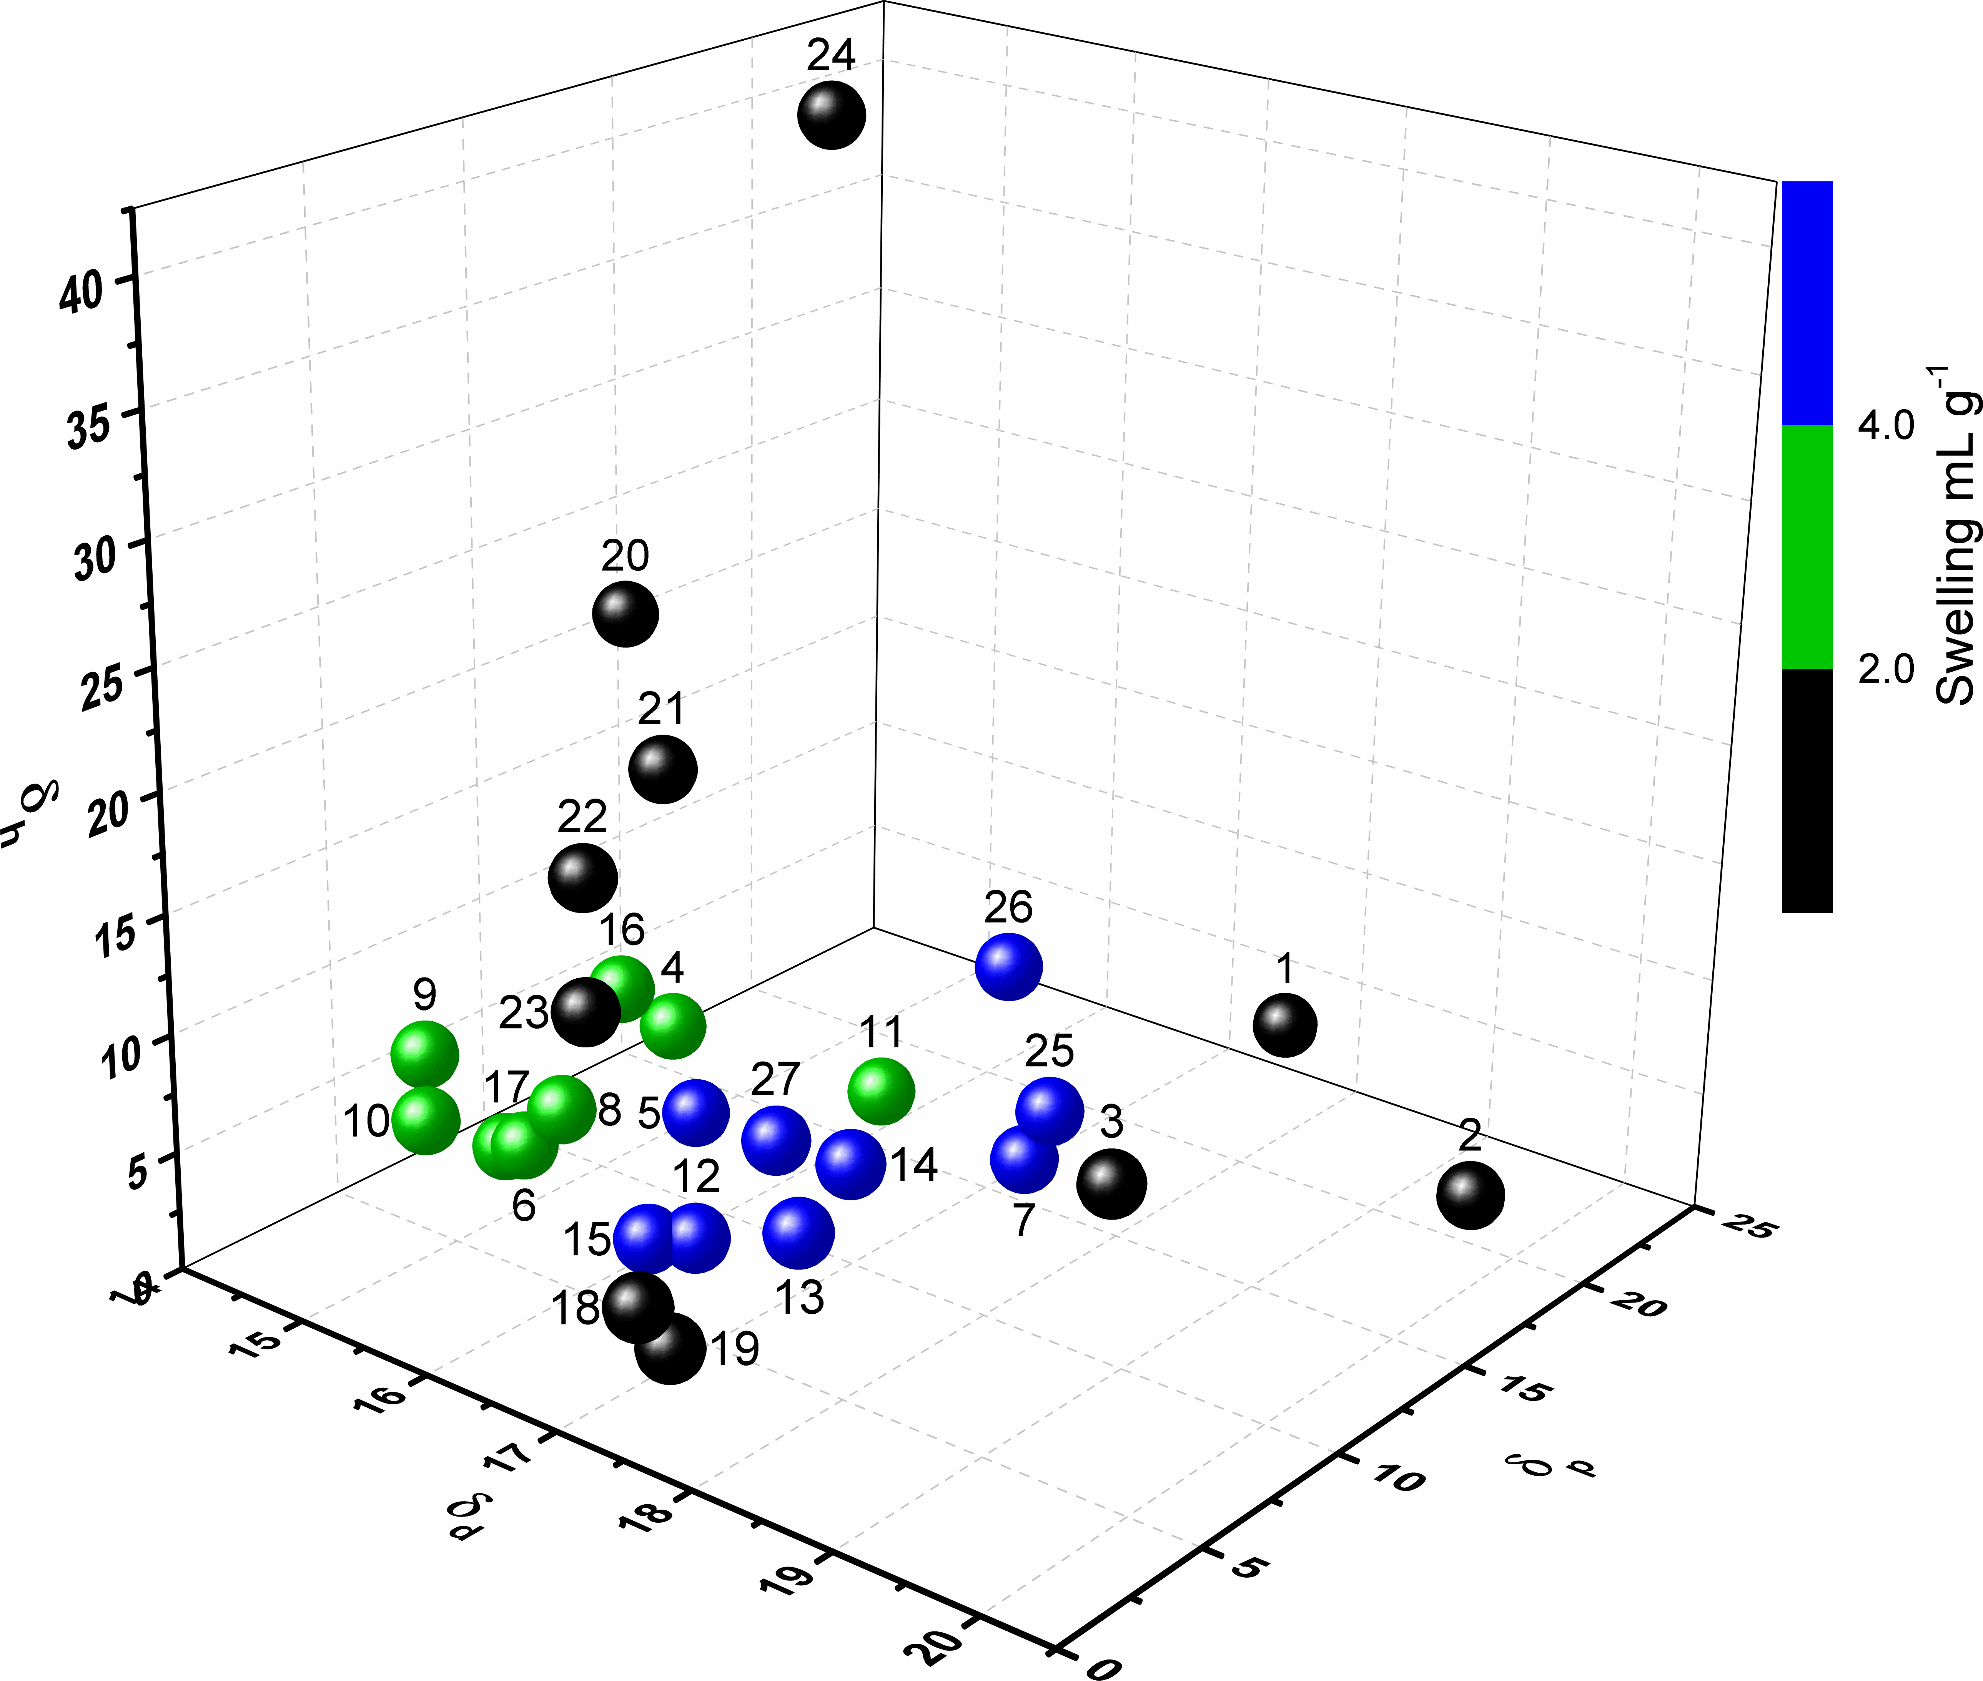

**Figure 4.** HSP space plot showing the swelling of Merrifield resin by 27 solvents.

Having confirmed that resin swelling does not always vary linearly with solvent composition, a modelling approach was used to investigate the phenomenon. The Hansen Solubility Parameters in Practice (HSPiP) software[[17]] uses Hansen solubility parameters (HSPs) to classify solvents according to three factors: d=dispersion energy; h=hydrogen bonding energy; and p=dipolar energy. These three parameters can then be used as the axes of three-dimensional scatter plots to show the position of solvents in HSP space and the points can be colour coded according to how well they swell a resin. This approach was applied to 27 solvents used in our previous work[12] (see Figure S2 for structures and Table S1 for their HSPs) and the results for Merrifield and HypoGelTM200 resins are shown in Figures 4 and 5 respectively.

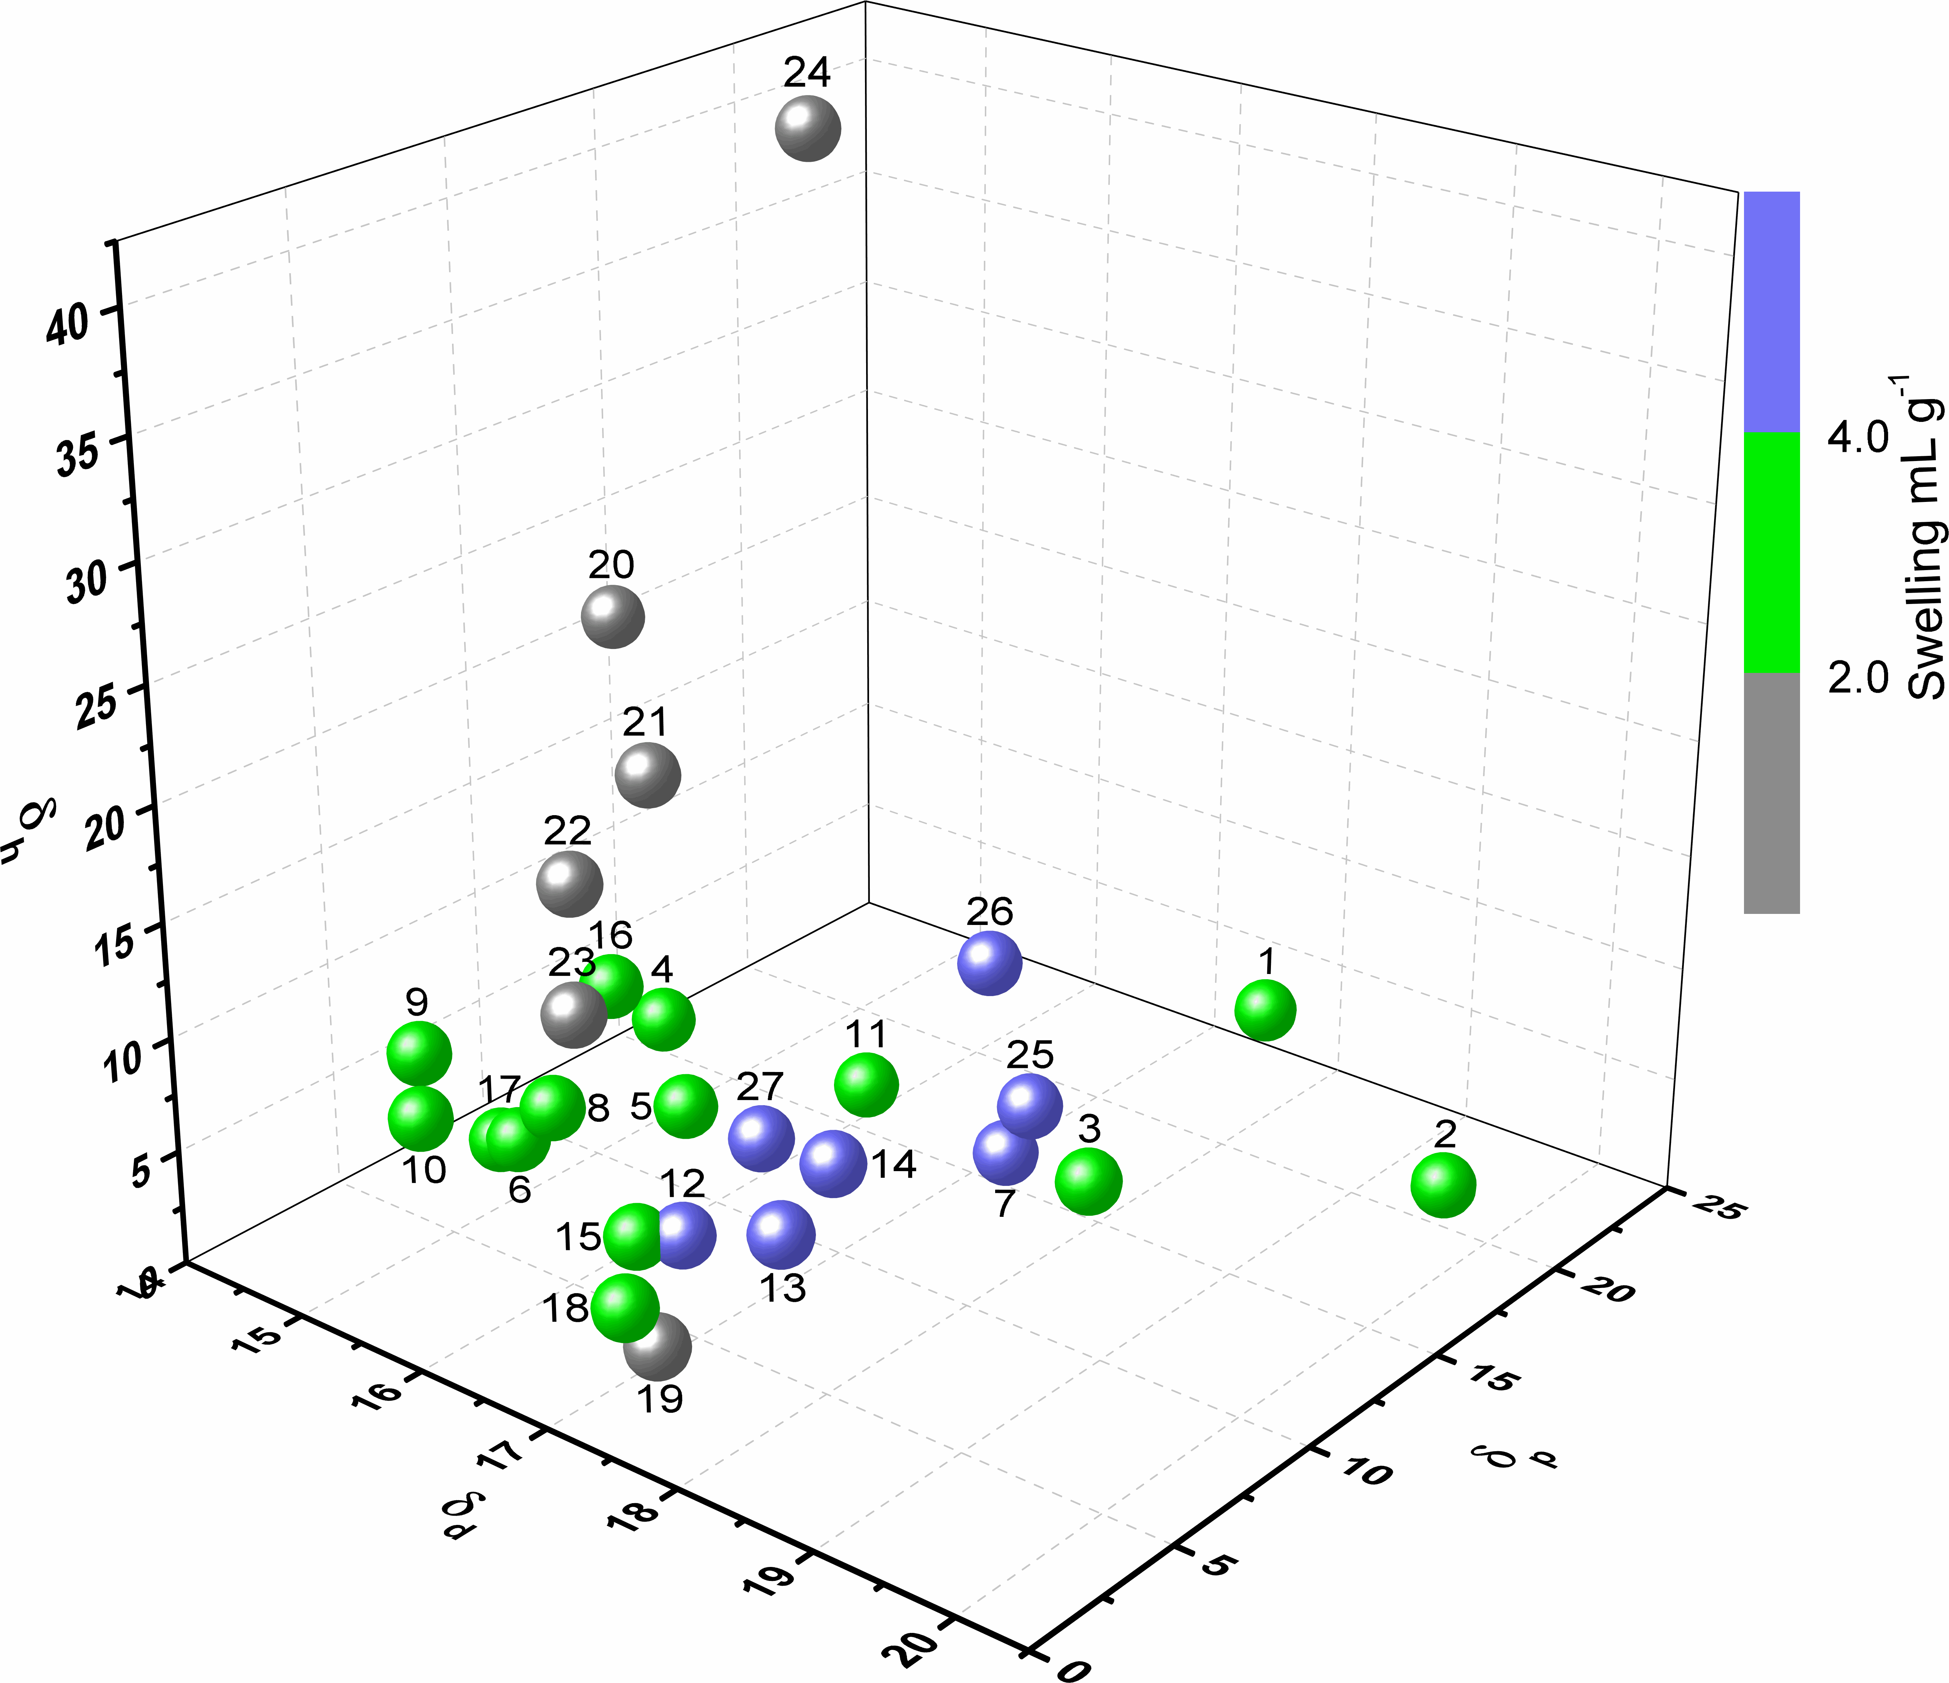

**Figure 5.** HSP space plot showing the swelling of HypoGelTM200 resin by 27 solvents.

Figures 4 and 5 indicate that for both resins the high swelling solvents (represented by blue circles) cluster into a region of HSP space. This suggested an explanation for the non-linear variation of swelling with mixed solvent composition that is apparent in Figures 2 and 3. All binary mixtures of two solvents will lie along the line that connects the two solvents in HSP space. If the two solvents are on opposite sides of the high resin swelling region and the line connecting them passes through the high resin swelling region, then the resin swelling of mixed solvents will be expected to go through a maximum. To visualize this, Figure 6 shows a 2D slice (at a fixed value of h) of 3D-HSP space with a hypothetical high resin swelling region marked out in blue. Line A traces out the HSPs of mixtures of two solvents (a1 and a2) and as this passes through the high resin swelling region, a plot of solvent composition versus resin swelling would be expected to show a maximum value. This corresponds to the situation in Figure 3. In contrast, line B connects two solvents (b1 and b2) which are both within the high resin swelling region, but because of the concave curvature of this region, there are mixtures of b1 and b2 whose HSPs lie outside the high resin swelling region, so a plot of solvent composition versus resin swelling would be expected to show a minimum value. Line C illustrates the situation where one solvent (c1) is within the high resin swelling region, whilst the other (c2) lies outside this region. In this case, a plot of solvent composition versus resin swelling would be expected to increase or decrease, but not go through a maximum. Finally, lines D and E illustrate cases where the two solvents are either both within the high resin swelling region (d1 and d2) or both outside this region (e1 and e2) and the line connecting them stays entirely either within or outside the high resin swelling region. In the case of solvents e1 and e2, a plot of solvent composition versus resin would be expected to show little or no variation. The case of solvents d1 and d2 could be highly variable depending on how the actual resin swelling varies within the high resin swelling area, but all mixtures would be expected to show high resin swelling and this corresponds to the situation shown in Figure 2.



**Figure 6.** 2D slice (at a fixed h) through HSP space showing a hypothetical high swelling region (blue) and various mixtures of two solvents (black lines).

Figures 4 and 5 both suffer from lack of data as only 7-9 pure solvents cause high resin swelling. As a result, the 3D boundaries of the high resin swelling regions are not well defined. However, use of mixtures of solvents would allow far more data points to be added to the HSP space plots for Merrifield and HypoGelTM200 resins, thus allowing the high and moderate resin swelling regions to be more fully defined and allowing the hypothesis illustrated in Figure 6 to be tested. Therefore, eighteen pairs of solvents were selected (Table 2) and the swelling of Merrifield resin in mixtures of each of these solvents investigated. The solvent pairs were chosen based on the HSPs of the parent solvents and the putative resin swelling region shown in Figure 4 so that most were expected to correspond to type A in Figure 6, but with a few examples of types C and D as well. Four solvents (cyclopentanone, propylene carbonate **2**, 1,2-dichlorobenzene and acetonitrile) which lie in different regions of HSP space were used as nexus points with other solvents then chosen so that their mixtures with the nexus point solvents would provide the best mapping of the edges of the high and moderate resin swelling regions.

|  |  |  |
| --- | --- | --- |
| **Table 2.** Solvent pairs used to investigate the swelling of Merrifield resin. | | |
| Solvent 1 | Solvent 2 | Resin swelling trend |
| 2-MeTHF | CPME[a] | Minimum (Figure 2) |
| Cyclopentanone | Methanol | Maximum |
| Cyclopentanone | Ethanol | Maximum |
| Cyclopentanone | Isopropanol | Maximum |
| Cyclopentanone | FurOH[b] | Maximum |
| Cyclopentanone | TMO[c] **5** | Maximum |
| **2** | Ethyl acetate | Maximum |
| **2** | Acetonitrile | Maximum |
| **2** | TMO[c] **5** | Maximum[d] |
| **2** | Acetone | Curved upwards |
| **2** | Isopropyl acetate | Maximum |
| **2** | 1,2-Dichlorobenzene | Curved upwards |
| 1,2-Dichlorobenzene | Dichloromethane | Linear almost flat |
| 1,2-Dichlorobenzene | DMF | Flat |
| 1,2-Dichlorobenzene | Heptane | Curved upwards |
| Acetonitrile | Toluene | Maximum |
| Acetonitrile | Isopropyl acetate | Linear |
| Water | DMF | Special |
| [a] CPME = cyclopentyl methyl ether. [b] FurOH = 2-hydroxymethylfuran. [c] TMO = 2,2,5,5-tetramethyloxolane.[[18]] [d] This pair of solvents were immiscible in some proportions. | | |
|  | | |

All the Merrifield resin swelling data and graphs for these eighteen pairs of solvents are given in the supporting information (Figure S3). For ten of the eighteen solvent pairs, there is a mixture of the two solvents that has higher resin swelling ability than either pure solvent consistent with the two solvents lying on opposite sides of the resin swelling region (analogous to line A in Figure 6). An example of this behaviour is the combination of propylene carbonate **2** and acetonitrile shown in Figure 7. This solvent combination was also used to investigate if homogeneous solvent mixtures would show preferential swelling of the resin in one of the solvents. Therefore, all of the mixtures of **2** and acetonitrile were analysed by GC before and after resin swelling, but no significant changes in the ratio of the two solvents was observed (Figure S4).

Four solvent pairs displayed an upward curve (without a mixture of the solvents having a higher resin swelling ability than the higher swelling of the two solvents) or a linear (non-horizontal) variation of resin swelling with solvent composition. This is consistent with one solvent lying inside the resin swelling area and one outside this area as represented by line C in Figure 6. An example of this is the combination of propylene carbonate **2** and 1,2-dichlorobenzene shown in Figure 7. Two solvent pairs show little or no variation in resin swelling with solvent composition, consistent with both solvents lying within the resin high swelling region (line D in Figure 6). 1,2-Dichlorobenzene and dichloromethane is an example of this behaviour (Figure 7).



**Figure 7.** Swelling of Merrifield resin in mixtures of propylene carbonate **2** and acetonitrile (filled squares); propylene carbonate **2** and 1,2-dichlorobenzene (empty circles); and 1,2-dichlorobenzene and dichloromethane (filled triangles). The solid lines are shown only as a guide to the eye.

Only the combination of 2-MeTHF and cyclopentyl methyl ether had mixed solvents which showed lower resin swelling than either pure solvent (Figure 2). However, 2-MeTHF and cyclopentyl methyl ether have very similar HSP parameters (Figure S3) and all the mixtures gave resin swelling of greater than 5.0 mL g-1. Thus, this is another example of line D and the variations just correspond to fluctuations in the exact amount of resin swelling observed within the high resin swelling region.

The combination of water and DMF was a special case as shown in Figure 8. DMF is a high swelling solvent for Merrifield resin, but addition of even 10% water reduces the swelling of the resin to the same level observed using pure water. DMF is a good hydrogen bond acceptor and water is a hydrogen bond donor and when mixed they form hydrogen bonded complexes.[[19]] This solvent/solvent interaction appears to be stronger than the DMF/Merrified resin interaction as a result of which the DMF is no longer able to swell the resin.

Another interesting case was the mixture of propylene carbonate **2** and 2,2,5,5-tetramethyloxolane (TMO, **5**). This combination of solvents was only miscible when the volume of TMO in the solvent mixture was up to 35%, or at least 90% (Figure S3). However, solvent mixtures in the immiscible region (%TMO=40-80% (v/v)) were also studied and all the results are shown in Figure 9. It is apparent from Figure 9 that all of the immiscible mixtures mimic the miscible 90:10 **5**:**2** (v/v) mixture in their ability to swell Merrifield resin. In contrast to the cyclopentanone-water swelling of HypogelTM200 resin discussed earlier, it is apparent from Figure 9 that the immiscible mixtures of **2** and **5** produce much higher swelling of Merrified resin than either pure solvent.



**Figure 8.** Swelling of Merrifield resin (filled squares) and HypoGelTM200 (empty circles) in mixtures of DMF and water. The lines are shown only as a guide to the eye.



**Figure 9.** Swelling of Merrifield resin in mixtures of propylene carbonate **2** and TMO **5**. Black points correspond to miscible mixtures and red points to immiscible mixtures. The solid lines are shown only as a guide to the eye. The dotted line shows the swelling that would be expected if swelling varied linearly with solvent composition.

To investigate the swelling of Merrified resin by mixtures of **2** and **5** in more detail, the composition of each solvent mixture included in Figure 9 was analysed by gas chromatography (GC). For the immiscible mixtures, the top and bottom layers were analysed separately and all the results are tabulated in Table 3. For all of the immiscible mixtures, the top layer contained 84-86 mol% **5** and 14-16 mol% **2** which matches the molar composition of the 90:10 (v/v) mixture. Correspondingly, the bottom layers of all the immiscible mixtures contained 76-77 mol% **2** and 23-24 mol% **5** which matches the molar composition of the 35:65 (v/v) mixture. This suggested that it was the top layer of the immiscible mixtures which was responsible for the resin swelling. To confirm this interpretation, a 50:50 (v/v) mixture of **5** and **2** was prepared and the two layers separated. Each layer was analysed by GC, then used to swell Merrifield resin and the residual liquid present above the swollen beads reanalysed by GC. These data are also included in Table 3. The top layer showed no change in the composition of the solvent mixture after resin swelling. In contrast, for the bottom layer, the mol% of **5** present was found to decrease and the mol% of **2** present correspondingly increased. Thus, Merrifield resin prefers to swell in a **5:2** mixture which contains more TMO than is present in the bottom layer and which corresponds to that found in the top layer.

|  |  |  |  |  |
| --- | --- | --- | --- | --- |
| **Table 3.** GC analysis of mixtures of propylene carbonate **2** and TMO **5**. | | | | |
| **5** (v%) | **2** (v%) | Layer[a] | **5** (mol%)[b] | **2** (mol%)[b] |
| 10 | 90 | miscible | 6 | 94 |
| 20 | 80 | miscible | 12 | 88 |
| 30 | 70 | miscible | 19 | 81 |
| 35 | 65 | miscible | 22 | 78 |
| 40 | 60 | top (0.8 mL) | 84 | 16 |
| 40 | 60 | bottom (9.2 mL) | 24 | 76 |
| 50 | 50 | top (2.6 mL) | 86 (85,87)[c] | 14 (15,13)[c] |
| 50 | 50 | bottom (7.4 mL) | 23 (22,14)[c] | 77 (78,86)[c] |
| 60 | 40 | top (4.4 mL) | 86 | 14 |
| 60 | 40 | bottom (5.6 mL) | 23 | 77 |
| 70 | 30 | top (6.4 mL) | 86 | 14 |
| 70 | 30 | bottom (3.6 mL) | 23 | 77 |
| 80 | 20 | top (8.1 mL) | 86 | 14 |
| 80 | 20 | bottom (1.9 mL) | 23 | 77 |
| 90 | 10 | miscible | 85 | 15 |
| [a] The numbers in brackets are the volumes of the top and bottom layers (total volume of each mixture = 10 mL). [b] Determined by GC. [c] Numbers in brackets are from an experiment in which the layers were separated and used separately to swell Merrifield resin. The first number is before resin swelling and the second number is the mol% present in the residual liquid after resin swelling. | | | | |
|  | | | | |

A similar approach was adopted to investigate the swelling of HypoGelTM200 resin using the 20 pairs of solvents listed in Table 4 using the same four solvents as nexus points. All the HypoGelTM200 resin swelling data and graphs for these 20 pairs of solvents are given in the supporting information (Figure S5). The combination of water and DMF was again a special case (Figure 8) for the same reasons discussed above for its swelling of Merrified resin. This shows that not even the hydrophilic PEG groups within HypoGelTM200 resin can disrupt the DMF-water hydrogen bonded complexes. For eleven of the 20 solvent pairs, there is a mixture of the two solvents that has higher resin swelling ability than either pure solvent consistent with the two solvents lying on opposite sides of the resin swelling region (analogous to line A in Figure 6). Five solvent pairs displayed an upward curve (without a mixture having better resin swelling ability than either of the two solvents) or a linear (non-horizontal) variation of resin swelling with solvent composition. This is consistent with the situation represented by line C in Figure 6. Mixtures of three solvent pairs showed little or no variation in resin swelling ability with solvent composition. These all corresponded to both solvents lying within the high resin swelling region (line D in Figure 6).

|  |  |  |
| --- | --- | --- |
| **Table 4.** Solvent pairs used to investigate the swelling of HypoGelTM200 resin. | | |
| Solvent 1 | Solvent 2 | Resin swelling trend |
| cyclopentanone | water | Maximum[a]  (Figure 3) |
| Cyclopentanone | FurOH[b] | Linear almost flat |
| Cyclopentanone | TMO[c] **5** | Curved upwards |
| **2** | Diethyl carbonate | Maximum |
| **2** | Ethyl acetate | Maximum |
| **2** | Isobutyl acetate | Maximum |
| **2** | Acetonitrile | Curved upwards |
| **2** | CPME[d] | Maximum |
| **2** | Methanol | Maximum |
| **2** | Ethanol | Maximum |
| **2** | Isopropanol | Maximum |
| **2** | 1,2-Dichlorobenzene | Linear |
| 1,2-Dichlorobenzene | Dichloromethane | Flat |
| 1,2-Dichlorobenzene | DMF | Flat |
| 1,2-Dichlorobenzene | Heptane | Linear |
| Acetonitrile | Toluene | Maximum |
| Acetonitrile | Isopropyl acetate | Maximum |
| Methanol | Isobutyl acetate | Maximum |
| Methanol | Dimethyl isosorbide | Curved upwards |
| Water | DMF | Special |
| [a] This pair of solvents was immiscible in some proportions. [b] FurOH = 2-hydroxymethylfuran. [c] TMO = 2,2,5,5-tetramethyloxolane.[18] [d] CPME = cyclopentyl methyl ether. | | |
|  | | |

The mixed solvents provided far more data points to map out the resin swelling areas of Merrifield and HypogelTM200 resins in HSP space as shown by Figures 10 and 11 respectively. The 3D scatter plots provide a 3D visualisation of the high and medium resin swelling areas. These plots are useful as binary mixtures of two solvents will always lie on a straight line joining the two parent solvents in 3D HSP space. This permits visualisation of which resin swelling regions the line will pass through as shown in Figures S3 and S5 for all solvent mixtures studied with Merrifield and HypogelTM200 resins. The 3D scatter plots also allow predictions to be made as to which mixtures of two solvents will result in high resin swelling. However, these plots are not easy to visualise on a static 2D surface, so alternative ways of presenting the data were also investigated. Teas plots[[20]] provide a way of representing three

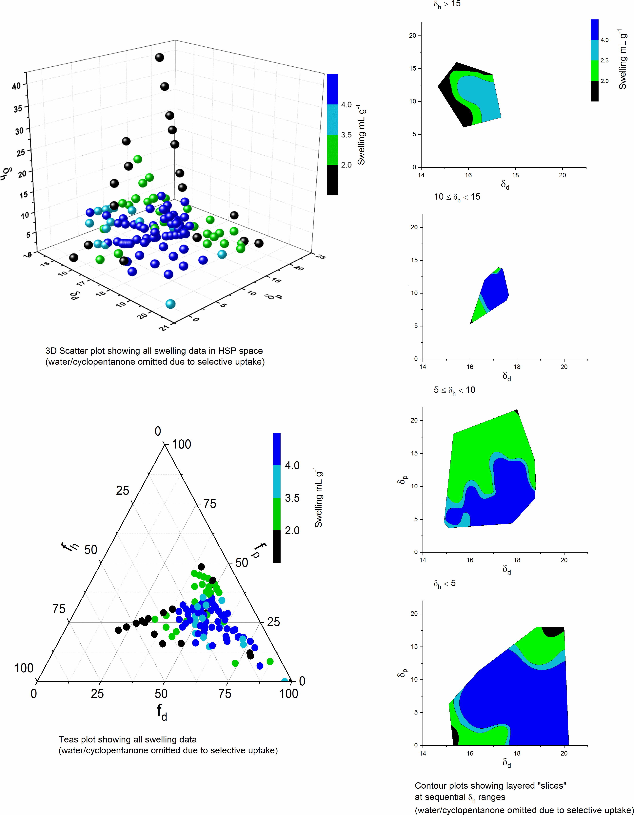

**Figure 10.** Representations of the high and medium resin swelling areas for Merrifield resin. Top left 3D scatter plot; bottom left Teas plot; right hand side slices through the 3D scatter plot parallel to the d-p plane.

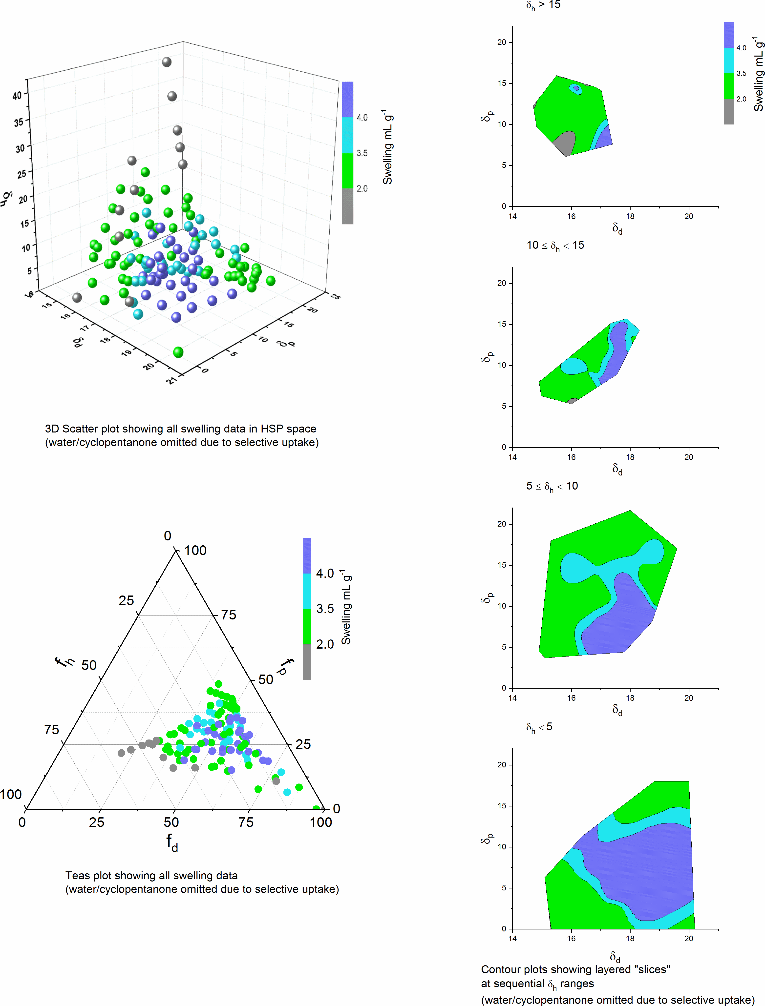

**Figure 11.** Representations of the high and medium resin swelling areas for HypogelTM200 resin. Top left 3D scatter plot; bottom left Teas plot; right hand side slices through the 3D scatter plot parallel to the d-p plane.

orthogonal dimensions in a 2D plot and these are also presented in Figures 10 and 11. Teas plots use fractional parameters (fd, fp and fh) as axis which are related to the HSP parameters (d, p and h) as shown in Equation 1.

fd = d fp = p fh = h Equation 1

        d+p+h     d+p+h     d+p+h

As a result of the use of fractional axis parameters and the 60o angles between axis, Teas plots, whilst being easy to visualise, do distort the resin swelling areas. In some cases with HypogelTM200 resin, this distortion resulted in lower resin swelling points being folded into the high resin swelling area; in these case, 3D scatter plots are also given in Figure S5. Hence, Teas plots should be used with care. A third type of plot is also included in Figures 10 and 11. This consists of slices through the 3D scatter plot corresponding to different ranges of H. These wedding cake type plots provide very good undistorted visualisation of the high and medium resin swelling areas, but the resolution along the h axis is limited by the number of slices (4 for the plots in Figures 10 and 11) and they take up a significant amount of space to display. Another advantage of this type of plot is that the slices can be automatically coloured to clearly identify the high, medium and low resin swelling areas.

Figures 10 and 11 show that for both Merrifield and HypogelTM200 resins, the high resin swelling areas in HSP space are broadly pyramidal. This is particularly apparent in the contour plots as for both resins, the high resin swelling area is largest in the slice corresponding to h<5 and then gets smaller in each subsequent slice. For Merrifield resin, the high resin swelling area ends in the penultimate slice 10<h<15, but for HypogelTM200 resin it extends into the top slice h>15. The plots for each solvent mixture (Figures S3 and S5) also show that each solvent mixture does go through the resin swelling areas that would be expected based on the variation of resin swelling with solvent composition and the analysis outlined in Figure 6.

Figure 12 shows an overlay on a Teas plot of the high resin swelling regions for both Merrifield and HypogelTM200 resins. It is apparent that the majority of the high resin swelling region is common to both resins, consistent with the fact that both have a polystyrene backbone. However, the tail towards very non-polar solvents (fp = 0) that is apparent for Merrifield resin is considerably truncated for HypogelTM200 resin which likely reflects the more polar nature of the PEG component of HypogelTM200 resin. In contrast, the HypogelTM200 resin high swelling region extends to solvents with greater hydrogen bonding ability (represented by fh), which can be attributed to the ability of the PEG chains to act as hydrogen bond acceptors.

The utility of using binary mixtures of solvents to swell resins was demonstrated by their use in solid phase peptide synthesis (SPPS). Peptide synthesis is currently undergoing increased interest as it has been recognised that peptides are both important pharmaceuticals in their own right and lead compounds for peptidomimetic or non-peptidic pharmaceuticals.[[21]] Peptidic pharmaceuticals often exhibit high potency and specificity with few side effects.[[22]] However, SPPS is almost universally carried out on Merrifield resin using DMF or NMP as reaction solvent along wth chlorinated solvents to wash and swell the resin. There are only a small number of reports of the use of other solvents.[[23]] In our previous work on SPPS in green solvents,[8] we had to use crosslinked-PEG based ChemMatrix resin with propylene carbonate **2** as no single green solvent was found which would swell Merrifield resin and be compatible with the chemicals used in SPPS. However, ChemMatrix resin is much more expensive than Merrifield resin and the peptides produced were contaminated with ethylene glycol arising from degradation of the ChemMatrix resin. Therefore, there is an unmet need for green solvents (or a mixture of green solvents) which will allow SPPS to be carried out on Merrifield resin.

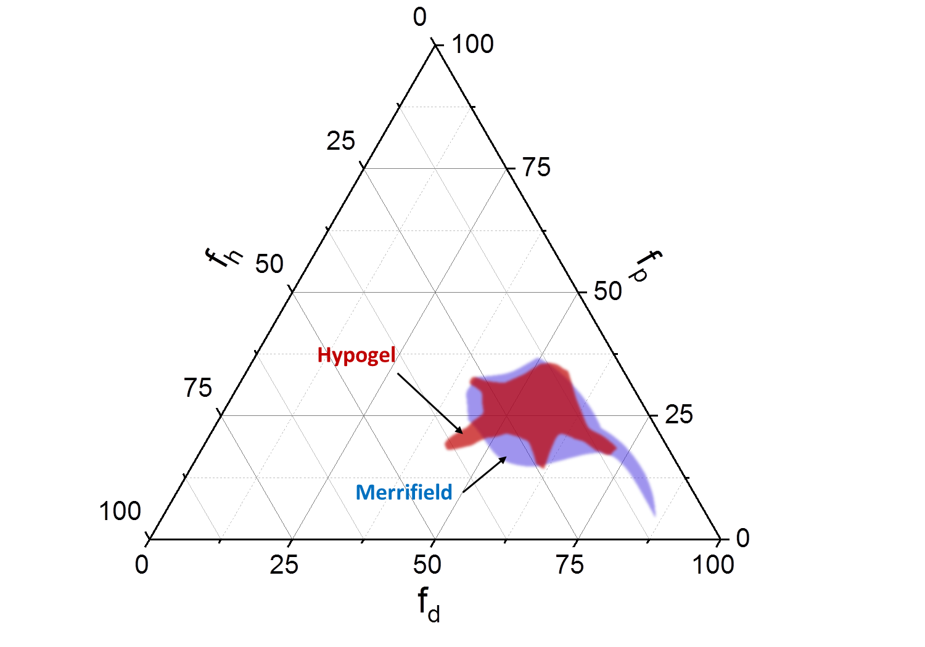

**Figure 12.** Teas plot showing an overlay of the high resin swelling areas for Merrifield and HypogelTM200 resins.

Since propylene carbonate is a green solvent[[24]] which has previously been shown to be suitable for Fmoc-based SPPS on a different resin,[8] the use of mixtures of **2** and other green solvents to replace both DMF/NMP and chlorinated solvents for SPPS on Merrifield resin (with a Wang linker) was investigated. Propylene carbonate is itself a very poor solvent for swelling Merrifield resin (1.8 mL g-1) and we sought to combine it with other green solvents which also gave poor or moderate swelling of Merrifield resin, but which when mixed with **2** would give higher swelling (ca 4 mL g-1). From the data in Table 2 and Figure S3, there were two possibilities. Ethyl acetate is a green solvent[24] and gives moderate swelling of Merrifield resin (3.8 mL g-1). Mixtures of ethyl acetate and **2** which contain at least 80% ethyl acetate swell Merrifield resin to more than 4 mL g-1 with the optimal swelling (4.6 mL g-1) obtained at a 90:10 ethyl acetate to **2** ratio. Hence this ratio was chosen as one solvent to investigate for SPPS.

The second system chosen to study was propylene carbonate **2** and TMO **5**. TMO is a recently reported green replacement for non-polar solvents such as toluene and hexane[18] both of which are suspected carcinogens.[[25]] Both it and propylene carbonate are poor solvents for swelling Merrifield resin (1.8 mL g-1) and these two solvents are only miscible at certain compositions. However, as shown in Figure 9 both miscible and immiscible mixtures of **2** and **5** are capable of swelling Merrifield resin to just under 4 mL g-1. Therefore, it was decided to investigate the use of 10:90, 70:30 and 60:40 mixtures of **2** and **5**. The 10:90 is homogeneous and swells Merrifield resin to almost 4 mL g-1, the 70:30 mixture is also homogeneous but gives a Merrifield resin swelling of only 2.9 mL g-1 and the 60:40 mixture is immiscible but swells Merrifield resin to almost 4 mL g‑1. This gave a total of four solvent mixtures to be studied for SPPS and for comparison, the three parent solvents (**2**, **5** and ethyl acetate) were also included in the study.

|  |  |  |  |
| --- | --- | --- | --- |
|  | | | |
| **Table 5.** HSP’s for solvents used in SPPS. | | | |
| Solvent | δd | δp | δh |
| Propylene carbonate **2** | 20 | 18 | 4.1 |
| NMP | 18 | 12.3 | 7.2 |
| DMF | 17.4 | 13.7 | 11.3 |
| CH2Cl2 | 17 | 7.3 | 7.1 |
| EtOAc | 15.8 | 5.3 | 7.2 |
| TMO **5** | 15.4 | 2.4 | 2.1 |
|  | | | |

Chlorinated solvents are challenging to replace with greener alternatives due to their high polarizability (δd) but low dipolarity (δp) (Table 5). This is very difficult to mimic with other single compounds containing only carbon hydrogen and oxygen.

Propylene carbonate is potentially interesting in this respect due to its very high values for δd and δp. Its δd value is only slightly higher than that of dichloromethane and the polar aprotic solvents DMF and NMP, whilst its δp is very much larger than that of dichloromethane and even significantly larger than that of DMF and NMP. In contrast, ethyl acetate and TMO have lower δd and δp values than dichloromethane, DMF and NMP. Therefore, in this work, we aimed to take advantage of propylene carbonate’s unusually high δd and δp to be able to mimic chlorinated and dipolar aprotic solvents by mixing it with lower polarity TMO **5** or ethyl acetate. This is the first time that such a substitution has been achieved with green solvents.

To assess the suitability of the solvent mixtures for SPPS, the synthesis of the tripeptide H-Leu-Ala-Phe-OH (**6**) was undertaken as shown in Scheme 1. This sequence was also used in our previous work on SPPS in single component green solvents.[8] After each step shown in Scheme 1, the resin was washed three times only with the solvent being used for the synthesis. The final tripeptide (**6**.TFA) was precipitated from cold diethyl ether, dried under vacuum and then analysed by 1H NMR spectroscopy, reverse phase HPLC and high-resolution mass spectrometry. All peptide syntheses were carried out in triplicate to ensure that the results were reproducible.



**Scheme 1.** Methodology used for the solid phase synthesis of tripeptide **6**.

Since propylene carbonate is a component of all the solvent mixtures selected, it was first used as the sole solvent to attempt the synthesis of tripeptide **6**. However, only a very small amount of product was obtained (Table 6, entry 1) and 1H NMR analysis (Figure S6) showed that this was highly impure. HPLC and mass spectrometry (Figure S6) did show that some product was present, but only as a minor component of the solid that was obtained. The almost complete failure of this synthesis was not unexpected given the very low swelling of Merrifield resin in propylene carbonate. In contrast, when ethyl acetate was used as the solvent, 38 times as much product was obtained (Table 6, entry 2) and the 1H NMR and mass spectra and HPLC chromatogram (Figure S7) all showed that tripeptide **6** with high purity had been obtained. When a 90:10 mixture of ethyl acetate and propylene carbonate was used as solvent, tripeptide **6** was obtained in even higher yield Table 6, entry 3) and the spectra and chromatogram again showed that it was formed with high purity (Figure S8). Thus, the results showed that the use of a binary mixture of two green solvents could give better results in SPPS than either pure solvent.

The solvent system of propylene carbonate **2** and TMO **5** was felt to provide a more severe test of the ability of mixed solvents to facilitate SPPS as both **2** and **5** are very poor solvents for swelling Merrifield resin (Figure 9 and Table 6). When the synthesis of tripeptide **6** was undertaken in pure TMO using HOBt/HBTU as coupling agents, no product was obtained (Table 6 entry 4 and Figure S9). Whilst this failed synthesis could be attributed to lack of swelling of the resin, it was also noticed that HOBt and HBTU were totally insoluble in TMO which could have inhibited activation of the amino acids. Therefore, the synthesis was repeated using Oxyma Pure/EDC as coupling agents as both of these species were soluble in TMO. This synthesis also failed to give any yield of tripeptide **6** (Figure S10), indicating that lack of swelling of Merrifield resin was an important reason for the synthesis failing.

|  |  |  |  |
| --- | --- | --- | --- |
|  | | | |
| **Table 6.** Resin swelling and product yields for tripeptide **6**.TFA synthesis in various solvents. | | | |
| Entry | Solvent | Resin swelling  (mL g-1) | Yield of tripeptide **6**.TFA (mg/g resin)[a] |
| 1 | **2** | 1.8 | 8 |
| 2 | EtOAc | 3.8 | 292 |
| 3 | EtOAc:**2** (90:10) | 4.6 | 307 |
| 4 | **5** | 1.8 | 0 |
| 5 | **5**:**2** (90:10) | 3.8 | 124 |
| 6 | **5**:**2** (30:70) | 2.9 | 132 |
| 7 | **5**:**2** (40:60)[b] | 3.8 | 200 |
| [a] Yields are given as mg/g of resin as the loading of Fmoc-Phe on the Merrifield resin was only specified as 0.4-0.8 mmol g-1 so an accurate % yield could not be calculated. All syntheses of peptide **6** were carried out using the same batch of resin. [b] This mixture is immiscible and stays immiscible in the presence of the peptide synthesis reagents. | | | |
|  | | | |

When a miscible and high resin swelling 90:10 mixture of TMO **5** and propylene carbonate **2** was used as solvent, tripeptide **6** was obtained in moderate yield (Table 6, entry 5). The mass spectrum showed that the desired tripeptide was present and the HPLC trace and 1H NMR spectrum showed it to be highly pure (Figure S11). HOBt and HBTU are only slightly soluble in this solvent mixture, which may have resulted in the relatively low yield compared to those obtained in ethyl acetate containing solvents (Table 6, entries 2 and 3). In contrast, HOBt and HBTU were highly soluble in a miscible 30:70 mixture of solvents **5** and **2**, though this solvent mixture gives only moderate swelling of Merrifield resin (Figure 9 and Table 6). This synthesis was also moderately successful, giving a similar yield of tripeptide **6** to that obtained in the 90:10 solvent mixture (Table 6, entry 6 and Figure S12). Finally, the use of an immiscible 40:60 mixture of **5** and **2** was investigated. This mixed solvent gave high swelling of Merrifield resin (Figure 9 and Table 6) and despite its immiscible nature, was also successful for the synthesis of tripeptide **6**. Thus, tripeptide **6** was obtained with high purity (Figure S13) and in 50% higher yield (Table 6, entry 7) than that obtained using the miscible 90;10 or 30:70 ratios of solvents **5** and **2**. The 40:60 mixture of solvents **5** and **2** remained immiscible even in the presence of the various peptide synthesis reagents.

Overall the SPPS results using mixtures of propylene carbonate and either ethyl acetate or TMO clearly illustrate that a mixture of two solvents that gives optimal resin swelling can give better results in SPPS than either pure solvent, even if the mixture is not miscible. The ability to use immiscible solvent mixtures may allow interesting possibilities for further enhancing the greenness of reactions; for example by using reagents which are only soluble in one of the immiscible layers or which give by-products which are selectively soluble in one of the two layers. This could facilitate reaction work-up and solvent recycling.

As a second application for mixtures of green solvents, their ability to dissolve linear unfunctionalised polystyrene was investigated. Polystyrene is a widely used polymer, particularly familiar as the expanded polystyrene foam used as packaging to protect household and electronic goods. Dissolving polystyrene is important to facilitate its recycling.[[26]] Whilst Merrifield resin is polystyrene based, it is crosslinked and functionalised to permit the attachment of an amino acid. Thus, investigating the dissolution of linear unfunctionalised polystyrene would extend the applicability of the resin swelling area data.

|  |  |  |  |  |  |  |  |
| --- | --- | --- | --- | --- | --- | --- | --- |
|  | | | | | | | |
| **Table 7.** Comparison of Merrifield resin swelling and rate of polystyrene dissolution times. | | | | | | | |
| Solvent | Merrifield resin  swelling  (mL g-1) | Dissolution time (min.)[a] | | | | | |
| 30 | 60 | 90 | 120 | >120 | >1440 |
| **2** | 1.8 | - | - | - | - | - | - |
| **3** | 1.8 | - | - | - | - | - | - |
| **5** | 1.8 | - | - | - | - | - | - |
| water | 1.8 | - | - | - | - | - | - |
| methanol | 1.8 | - | - | - | - | - | - |
| ethanol | 1.8 | - | - | - | - | - | - |
| isopropanol | 1.8 | - | - | - | - | - | - |
| heptan-1ol | 1.8 | - | - | - | - | - | - |
| heptane | 1.9 | - | - | - | - | - | - |
| acetonitrile | 2.4 | - | - | - | - | - | - |
| D-limonene | 2.7 | + | + | +++ | +++ | O | O |
| furfuryl alcohol | 3.0 | - | - | - | - | - | - |
| diethyl carbonate | 3.0 | ++ | +++ | O | O | O | O |
| *para*-cymene | 3.2 | ++ | +++ | O | O | O | O |
| acetone | 3.7 | + | ++ | +++ | +++ | ++++ | O |
| dimethyl carbonate | 3.8 | ++ | ++++ | ++++ | ++++ | ++++ | ++++ |
| ethyl acetate | 3.8 | +++ | O | O | O | O | O |
| Isopropyl acetate | 4.2 | +++ | ++++ | O | O | O | O |
| toluene | 5.4 | O | O | O | O | O | O |
| cyclopentanone | 5.8 | +++ | O | O | O | O | O |
| [a] A 20 mg bead of polystyrene was added to 1 mL of solvent at room temperature: - = no dissolution; + = slight dissolution; ++ = about 33% dissolved; +++ =about 50% dissolved; ++++ = mostly dissolved; O = totally dissolved. | | | | | | | |

As shown in Table 7, there is a clear correlation between the ability of a solvent to swell Merrifield resin and the rate at which it will dissolve polystyrene. Thus, none of the solvents that swelled Merrifield resin to less than 2 mL g-1 showed any dissolution of polystyrene at all, even after 24 hours. The solvents that showed moderate resin swelling (2-4 mL g-1) gave mixed results with acetonitrile and furfuryl alcohol giving no dissolution of polystyrene after 24 hours; dimethyl carbonate dissolving most but not all of the polystyrene and the other five solvents in this class completely dissolving the polystyrene on a timescale of 1-24 hours. The three solvents that induced high resin swelling (greater than 4 mL g-1) of Merrifield resin all completely dissolved the polystyrene in 30-90 minutes.

Having analysed the single solvents, propylene carbonate-ethyl acetate and propylene carbonate-TMO mixtures were again chosen to investigate for their ability to dissolve polystyrene and the results are given in Tables 8 and 9. In the case of a 90:10 ethyl acetate to propylene carbonate mixture (Table 8), there was an increase in the rate of dissolution for the mixed solvent compared to either pure solvent, but the increase in rate compared to use of just pure ethyl acetate was moderate. This is probably because ethyl acetate is itself capable of dissolving polystyrene quite rapidly.

|  |  |  |  |  |  |  |  |
| --- | --- | --- | --- | --- | --- | --- | --- |
|  | | | | | | | |
| **Table 8.** Dissolution of polystyrene in propylene carbonate and ethyl acetate. | | | | | | | |
| Solvent | | Merrifield resin swelling  (mL g-1) | | Polystyrene dissolution (minutes) | | | |
| 10 | 20 | 30 | 60 |
| Propylene carbonate **2** | | 1.8 | | - | - | - | - |
| Ethyl acetate | | 3.8 | | a little | 1/3 | 1/2 | total |
| **2**:ethyl acetate (10:90) | | 4.6 | | a little | 1/2 | 2/3 | total |
|  | | | | | | | |
| **Table 9.** Dissolution of polystyrene in propylene carbonate and TMO. | | | | | | | |
| Solvent | Merrifield resin swelling  (mL g-1) | | Polystyrene dissolution (hours) | | | | |
| 5 | | | 24 | |
| Propylene carbonate **2** | 1.8 | | - | | | - | |
| TMO **5** | 1.8 | | - | | | - | |
| **2:5** (70:30) | 2.8 | | 1/3 | | | 2/3 | |
| **2:5** (60:40)[a] | 3.8 | | 2/3 | | | total | |
| [a] This mixture is immiscible before and after dissolving the polystyrene. | | | | | | | |
|  | | | | | | | |

The propylene carbonate-TMO mixtures provided much more definitive results (Table 9). Neither propylene carbonate nor TMO was capable of dissolving polystyrene at all even after 24 hours. However, a miscible 70:30 mixture of these two solvents did dissolve the polystyrene, with one third dissolving after 5 hours and two thirds dissolving after 24 hours. The immiscible 60:40 mixture performed even better with two thirds of the polystyrene dissolved after 5 hours and total dissolution after 24 hours. The solvents remained immiscible even after dissolving the polystyrene. These results correlate very well with the ability of the solvents to swell Merrifield resin.

Conclusions

In this work, we have shown for the first time that by judicial consideration of HSP parameters, mixtures of two green solvents can be used to mimic the properties of conventional solvents such as dichloromethane and DMF, both of which have problematical toxicological properties.

The ability of one- and two-component solvents to swell Merrifield and HypogelTM200 resins was investigated and it is shown that the swelling of the resins does not vary linearly with the mole fraction of the two solvents. By plotting the data on 3D Hansen solubility parameter space, it became apparent that there are high, moderate and low swelling regions for each resin. If the line joining two poor solvents bisects the high resin swelling space, then there will be mixtures of the two poor solvents which behave as high resin swelling solvents and so can mimic conventional solvents such as dichloromethane and DMF which are also high resin swelling solvents. A number of special cases of solvent mixtures were included in the study including those (such as propylene carbonate and TMO) which are only miscible in certain proportions and those (DMF and water) where very strong solvent-solvent interactions mask the solvent-resin interactions.

The applicability of the methodology has been demonstrated in two ways. Firstly, the high resin swelling area of Merrifield resin was used to predict a number of mixtures of two green solvents which would be suitable for use in SPPS. The suitability of these solvents has been experimentally verified by their ability to replace both the chlorinated and polar aprotic and solvents used to swell the resin and dissolve peptide synthesis reagents respectively. Secondly, the same high resin swelling area was used to predict solvents which would dissolve linear, unfunctionalised polystyrene and again the predictions were experimentally verified.

The methodology used here should have wide applicability to many other resins and polymers and can provide a general method for developing greener replacements for undesirable conventional solvents, based on the combination of two (or more) green solvents.

Experimental Section

Gas chromatography was carried out on an Agilent 6890N or Agilent 7890B instrument. For the Agilent 6890N, the following parameters were used: Restek Rxi-5HT column (diameter: 250 µm, length: 30.0 m, film thickness: 0.25µm), constant flow rate of 2 mL min-1 and initial pressure 20.2 psi; oven equilibration time 1 min, initial temperature: 50 °C, ramp rate 30 °C min-1 to 300 °C and final time 5 min; inlet initial temperature 300 °C, pressure: 20.2 psi, split ratio 30:1; split flow 60.0 mL min-1; gas helium, flow-rate 2.0 mL min-1; detector temperature 340 °C, hydrogen flow 35 mL min-1, air flow: 350.0 mL min-1, makeup gas nitrogen; injection volume 1 µL. The Agilent 7890B parameters were the same as the Agilent 6890N except for the parameters of the inlet and detector which were: heater 310 °C; split ratio 50:1; split flow 100 mL min-1; detector temperature 340 °C.

HPLC was carried out on an Agilent 1260 Infinity ‖ system fitted with a C18 column (length: 250 mm, diameter: 4.6 mm, void volume: 60.0%, particle size: 5.0 µm) at a flow rate of 0.4 mL min-1 at 40 °C. The injection volume was 10 µL. The pressure was 600 bar. The eluents were A (water + 0.1% formic acid) and B (acetonitrile + 0.1% formic acid). For the first 5 min, the solvent system was 90% A and 10% B, then 50% A and 50% B for the next 15 minutes.

Electrospray mass spectra (ESI) were recorded on a Bruker compact® time of flight mass spectrometer coupled to an Agilent 1260 Infinity series LC system. 1HNMR spectra were recorded on a JEOL ECS 400MHz spectrometer and were referenced to the residual solvent peak.

For sources and purities of chemicals used see supporting information. Solvent mixtures (total volume = 15 mL) were prepared using a Gilson pipette. The two solvents were then mixed in a 15 mL screw-topped vial and well shaken. Some mixtures, such as cyclopentanone and water, were also sonicated to promote efficient mixing. Ethylene carbonate was melted at 35 °C before mixing with the appropriate co-solvent and gently heated to promote mixing.

**General method for resin swelling**

Resin swelling experiments were carried out using the method developed by Santini *et al*.[16] Resin (0.1 g) was weighed into a 2mL syringe which had been fitted with a polystyrene frit at the bottom (the dead volume of the frit was 0.12 mL). The resin was washed three times with the chosen single solvent or solvent mixture. The target solvent (2 mL) was added and the syringe was sealed with a syringe pressure cap and placed on a roller mixer to rotate for one hour at room temperature. Then, the plunger of the syringe was compressed to remove excess solvent and fully loosened to allow the resin volume to be read. After recording the volume of the resin, the plunger was taken off and the resin was washed three times with CH2Cl2 to remove all target solvent. Next, the resin was dried using vacuum to pull air through it. This process was repeated three times to get the average resin swelling volume. Swelling the resin for times longer than one hour were observed to have no impact on the magnitude of swelling. Resin swelling was calculated using the formula:

Swelling (mL g-1) = Measured volume – Frit volume

Resin weight

Solvents were divided into three categories: swelling below 2 mL g-1 is deemed a bad solvent; from 2–4 mL g-1 is a moderate solvent and higher than 4 mL g-1 is a good solvent.

**General methodology for solid phase peptide synthesis (SPPS)**

Fmoc-Phe-Wang resin (200 mg, loading 0.4-0.8 mmol g-1) was accurately weighed into a 6 mL filtration tube which had a polyethylene frit fixed so that the resin could be prevented from leaking out. The weighed resin was first washed (3x5 mL) with the solvent (or solvent mixture) to be used for the peptide synthesis. Then, a further batch of solvent (5 mL) was added, and a cap for a 6 mL SPE tube and syringe pressure cap were then used to seal the tube. The tube was then put on a roller mixer for 1 hour to swell the resin. For all Fmoc-deprotections, a freshly prepared solution (5 mL) of 20% (v/v) piperidine in synthesis solvent was used for 20 min. For couplings, Fmoc-amino acid (firstly Fmoc-Ala-OH, then Fmoc-Leu-OH) (0.36 mmol, 3.0 eq.), HBTU (137 mg, 0.36 mmol, 3.0 eq.), HOBt (49 mg, 0.36 mmol, 3.0 eq.) and DIPEA (125 μL, 0.72 mmol, 6.0 eq.) were weighed into a 5 mL vial which containing the chosen solvent (3.6 mL) and stirred for 20 min. to pre-activate the amino acid before adding this mixture to the resin. The coupling reaction then occurred at room temperature for 1 h. After each step, the resin was washed with the synthesis solvent (3x5 mL). For the synthesis in propylene carbonate, after the final Fmoc-deprotection, the resin was additionally washed with EOAc (5 mL) to ensure removal of all propylene carbonate. Then, the peptide chain was cleaved from the resin by treatment with 95:2.5:2.5 TFA:TIPS:H2O (5 mL) for 2 h. The solution was then separated from resin by filtration, concentrated in vacuo and the peptide precipitated in cold Et2O. Finally, the peptide was washed with cold Et2O, dried under vacuum and lyophilised.

For peptide synthesis using Oxyma Pure/EDC, the above procedure was followed using Oxyma Pure (51.2 mg, 0.36 mmol, 3.0 eq.) and EDC (63.74 µL, 0.36 mmol, 3.0 eq.) in place of HBTU and HOBt.

**Method for studying polystyrene dissolution**

One pellet of standard polystyrene (20 mg per pellet with a molecular weight of ca 19,200) was added to pure or mixed solvent (1 mL) at room temperature. The degree of dissolution of the pellet was noted after 30, 60, 90 120 and 1440 minutes.

**Keywords:** resin-swelling • solvent • binary-mixture • Hansen solubility parameters • solid phase peptide synthesis

**Entry for the Table of Contents**

|  |  |  |  |  |
| --- | --- | --- | --- | --- |
| FULL PAPER | | | | |
| **All swell that end swell.** 3D Hansen solubility space is used to explain why the ability of binary mixtures of two solvents to swell crosslinked resins does not vary linearly with the solvent mole fractions. The applicability of this methodology to both solid phase peptide synthesis and linear polymer dissolution is demonstrated. |  |  |  | Yanrui Ran, Fergal Byrne, Ian Ingram and Michael North*  Page No. – Page No.  Resin swelling in mixed solvents analysed using Hansen solubility parameter space |
|  |  |

1. [] D. J. C. Constable, C. Jimenez–Gonzalez, R. K. Henderson, *Org. Process Res. Dev.* **2007**, *11*, 133–137.
2. [] European Chemicals Agency, Regulation (EC) No 1907/2006 of the European Parliament and of the Council on the Registration, Evaluation, Authorisation and Restriction of Chemicals (REACH), https://echa.europa.eu/regulations/reach/understanding-reach (accessed November 1, 2018).
3. [] A. Benazzouz, L. Moity, C. Pierlot, M. Sergent, V. Molinier, J.-M. Aubry, *Ind. Eng. Chem. Res.* **2013**, *52*, 16585–16597.
4. [] a) European Chemicals Agency, list of substances included in Annex XIV of REACH (“Authorisation List”), https://echa.europa.eu/authorisation-list (accessed November 1, 2018); b) J. Sherwood, *Angew. Chem. Int. Ed.* **2018**, *57*, 14286–14290.
5. [] M. C. Bryan, P. J. Dunn, D. Entwistle, F. Gallou, S. G. Koenig, J. D. Hayler, M. R. Hickey, S. Hughes, M. E. Kopach, G. Moine, P. Richardson, F. Roschangar, A. Steven, F. J. Weiberth, *Green Chem.* **2018**, *20*, 5082–5103.
6. [] a) C. Capello, U. Fischer, K. Hungerbühler, *Green Chem.* **2007**, *9*, 927–934; b) P. G. Jessop, *Green Chem.* **2011**, *13*, 1391–1398.
7. [] a) B. Schäffner, F. Schäffner, S. P. Verevkin, A. Börner, *Chem. Rev.* **2010**, *110*, 4554–4581; b) M. North, R. Pasquale, *Angew. Chem. Int. Ed.,* **2009**, *48*, 2946–2948; c) M. North, M. Omedes-Pujol, *Tetrahedron Lett.,* **2009**, *50*, 4452–4454; d) M. North, F. Pizzato, P. Villuendas, *ChemSusChem* **2009**, *2*, 862–865; e) M. North, P. Villuendas, *Org. Lett.* **2010**, *12*, 2378–2381; f) W. Clegg, R. W. Harrington, M. North, F. Pizzato, P. Villuendas, *Tetrahedron: Asymmetry* **2010**, *21*, 1262–1271; g) P. Lenden, P. M. Ylioja, C. González-Rodríguez, D. A. Entwistle and M. C. Willis, *Green Chem.* **2011**, *13*, 1980–1982; h) M. Morcillo, M. North, P. Villuendas, *Synthesis* **2011**, 1918–1925; i) C. Beattie, M. North, P. Villuendas, *Molecule*s **2011**, *16*, 3420–3432; j) C. E. P. Galvis, V. V. Kouznetsov, *Org. Biomol. Chem.* **2013**, *11*, 7372­–7386; k) B. Yu, Z.-F Diao, C.-X. Guo, C.-L. Zhong, L.-N. He, Y.-N. Zhao, Q.-W. Song, A.-H. Liu, J.-Q. Wang, *Green Chem.* **2013**, *15*, 2401–2407; l) B. Pieber, C. O. Kappe, *Green Chem.* **2013**, *15*, 320–324; m) H. L. Parker, J. Sherwood, A. J. Hunt, J. H. Clark, *ACS Sustainable Chem. Eng.* **2014**, *2*, 1739–1742; n) P. Neubert, S. Fuchs, A. Behr, *Green Chem.*, **2015**, *17*, 4045-4052; o) J. S. B. Forero, E. M. D. Carvalho, J. J. Junior, F. M. Silva, *Curr. Org. Synth.* **2015**, 102–107.
8. [] S. B.Lawrenson, R. Arav, M. North, *Green Chem.* **2017**, *19*, 1685–1691.
9. [] a) J. Sherwood, M. De bruyn, A. Constantinou, L. Moity, C. R. McElroy, T. J. Farmer, T. Duncan, W. Raverty, A. J. Hunt, J. H. Clark, *Chem. Commun*. **2014**, *50*, 9650–9652; b) J. Zhang, G. B. White, M. D. Ryan, A. J. Hunt, M. J. Katz, *ACS Sustainable Chem. Eng.* **2016**, *4*, 7186−7192; c) K. L. Wilson, A. R. Kennedy, J. Murray, B. Greatrex, C. Jamieson, A. J. B. Watson, *Beilstein J. Org. Chem.* **2016**, *12*, 2005–2011; d) H. J. Salavagione, J. Sherwood, M. De bruyn, V. L. Budarin, G. J. Ellis, J. H. Clark, P. S. Shuttleworth, *Green Chem.* **2017**, *19*, 2550–2560; e) L. Mistry, K. Mapesa, T. W. Bousfield, J. E. Camp, *Green Chem.* **2017**, *19*, 2123–2128; f) K. L. Wilson, J. Murray, C. Jamieson, A. J. B. Watson, *Synlett* **2018**, *29*, 650–654; g) K. L. Wilson, J. Murray, C. Jamieson, A. J. B. Watson, *Org. Biomol. Chem.* **2018**, *16*, 2851–2854.
10. [] a) J. Sherwood, H. L. Parker, K. Moonen, T. J. Farmer, A. J. Hunt, *Green Chem.* **2016**, *18*, 3990–3996; b) J. Lopez, S. Pletscher, A. Aemissegger, C. Bucher, F. Gallou, *Org. Process Res. Dev.* **2018**, *22*, 494−503.
11. [] S. B. Lawrenson, *Pure Appl. Chem.* **2018**, *90*, 157–165
12. [] S. Lawrenson, M. North, F. Peigneguy, A. Routledge, *Green Chem.* **2017**, *19*, 952–962.
13. [] R. B. Merrifield, *J. Am. Chem. Soc.* **1963**, *85*, 2149–2154.
14. [] S.-S. Wang, *J. Am. Chem. Soc.* **1973**, *95*, 1328–1333.
15. [] M. Bagheri, M. Beyermann, M. Dathe, *Antimicrob. Agents Chemother.* **2009**, *53*, 1132–1141.
16. [] R. Santini, M. C. Griffith and M. Qi, *Tetrahedron Lett.* **1998**, *39*, 8951–8954.
17. [] HSPiP software (4th Edition 4.1.04, developed by Abbott, Hansen and Yamamoto): http://www.hansen-solubility.com/index.php?id=11.
18. [] F. Byrne, B. Forier, G. Bossaert, C. Hoebers, T. J. Farmer, J. H. Clark, A. J. Hunt, *Green Chem.* **2017**, *19*, 3671–3678.
19. [] K. Herodes, I. Leito, I. Koppel, M. Rosés, *J. Phys. Org. Chem.* **1999**, *12*, 109–115.
20. [] J. P. Teas, *J. Paint Technol.* **1968**, *40*, 19–25.
21. [] a) Y. Liu, T. Liu, *Curr. Med. Chem.* **2012**, *19*, 3982–3999; b) S. Lohan, G. S. Bisht, *Mini-Rev. Med. Chem.* **2013**, *13*, 1073–1088; c) J. Vabeno, B. E. Haug, M. M. Rosenkilde, *Future Med. Chem.* **2015**, *7*, 1261–1283; d) R. Domalaon, G. G. Zhanel, F. Schweizer, *Curr. Topic. Med. Chem.* **2016**, *16*, 141–155.
22. [] a) J. P. Tam, *Proc. Natl. Acad. Sci.* *USA* **1988**, *85*, 5409–­5413; b) A. A. Kaspar, J. M. Reichert, *Drug Discov. Today* **2013**, *18*, 807–817; c) K. Fosgerau, T. Hoffmann, *Drug Discov. Today* **2015**, *20*, 122–128.
23. [] a) a) R. V. Ulijn, B. Baragaña, P. J. Halling, S. L. Flitsch, *J. Am. Chem. Soc.* **2002**, *124*, 10988–10989; b) R. Haddoub, M. Dauner, F. A. Stefanowicz, V. Barattini, N. Laurent, S. L. Flitsch, *Org. Biomol. Chem.* **2009**, *7*, 665–670; c) G. A. Acosta, M. del Fresno, M. Paradis-Bas, M. Rigau-DeLlobet, S. Côté, M. Royo, F. Albericio, *J. Pept. Sci.* **2009**, *15*, 629–633; d) A. S. Galanis, F. Albericio, M. Grøtli, *Org. Lett.* **2009**, *11*, 4488–4491; e) K. Hojo, A. Hara, H. Kitai, M. Onishi, H. Ichikawa, Y. Fukumori, K. Kawasaki, *Chem. Central J.* **2011**, *5*, 49; f) R. De Marco, A. Tolomelli, A. Greco, L. Gentilucci, *ACS Sustainable Chem. Eng.* **2013**, *1*, 566−569; g) K. Hojo, N. Shinozaki, K. Hidaka, Y. Tsuda, Y. Fukumori, H. Ichikawa, J. D. Wade, *Amino Acids* **2014**, *46*, 2347–2354; h) Y. E. Jad, G. A. Acosta, S. N. Khattab, B. G. de la Torre, T. Govender, H. G. Kruger, A. El-Faham, F. Albericio, *Org. Biomol. Chem.* **2015**, *13*, 2393–2398; i) Y. E. Jad, G. A. Acosta, T. Govender, H. G. Kruger, A. El-Faham, B. G. de la Torre, F. Albericio, *ACS Sust. Chem. Eng.* **2016**, *4*, 6809–6814.
24. [] C. M. Alder, J. D. Hayler, R. K. Henderson, A. M. Redman, L. Shukla, L. E. Shuster, H. F. Sneddon, *Green Chem.* **2016**, *18*, 3879–3890.
25. [] a) [https://echa.europa.eu/substance-information/-/substanceinfo/ 100.003.297](https://echa.europa.eu/substance-information/-/substanceinfo/%20100.003.297); b) <https://echa.europa.eu/substance-information/-/substanceinfo/100.003.435>.
26. [] a) T. Maharana, Y. S. Negi, B. Mohanty, *Polymer-Plastics Technol. Engin.* **2007**, *46*, 729–736; b) M. T. García, I. Gracia, G. Duque, A. de Lucas, J. F. Rodríguez, *Waste Management* **2009**, *29,* 1814–1818; c) P. G. Jessop, L. Kozycz, Z. G. Rahami, D. Schoenmakers, A. R. Boyd, D. Wechsler, A. M. Holland, *Green Chem.* **2011**, *13*, 619–623.