Supplementary Information
Study site
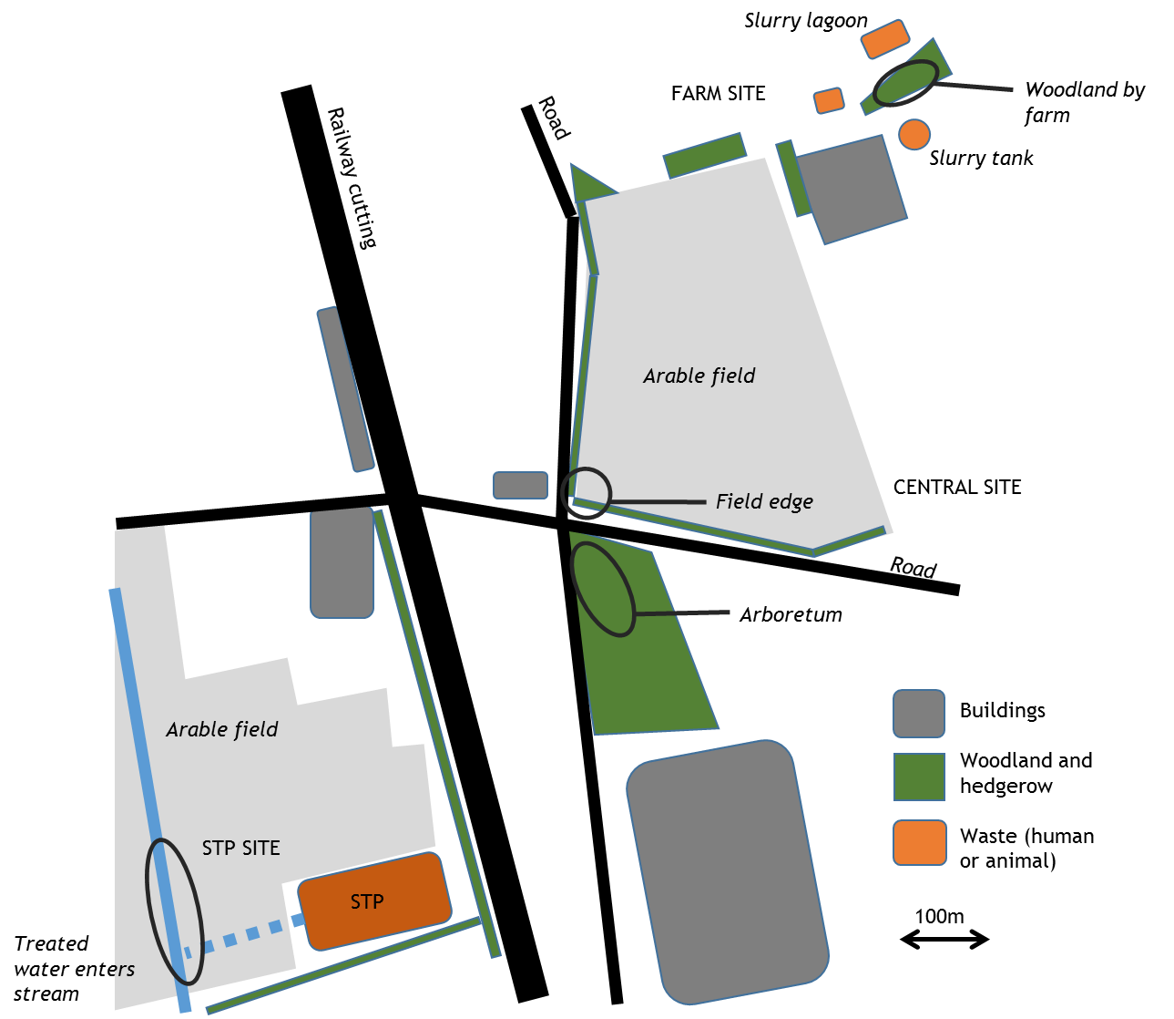
Figure S1: Schematic map showing the three sampling sites: Farm Site consisting of a small woodland by a dairy farm where livestock were treated with antimicrobials and waste flowed into a stream in the woodland; Central Site which consisted of an arboretum and arable field edge with no obvious sources of human or livestock wastes; and STP Site with sources of exposure to the wastes of humans treated with antimicrobials – encompassing the tanks, trickling filters and hedgerows within a sewage treatment plant (STP) and the area around the pipe where the treated effluent flows into a stream. All the remaining land, not coloured in the map, is grass, either grazing or gardens/parkland, often surrounded by hedges.
ERIC-PCR genotyping of E. coli isolates – more detailed methods
Twenty-four resistant E. coli isolates from mammals at each sample site and all the resistant E. coli isolates from birds (total 91 samples) were subjected to ERIC-PCR (Versalovic, et al. 1991; Ibrahim et al. 2016). DNA (diluted 1:100) extracted from the E. coli isolates, 12.5 µl of PCR Master Mix Plus (Qiagen, UK), 5 µM of the each ERIC primer (Table S1), 2 µl of Coral Load Dye (Qiagen, UK) and sterile molecular grade water to 25 µl. The PCR parameters for the ERIC-PCR are found in Table S1 in SI.
Table S1. Primer names, sequences and expected amplicon size and PCR parameters
Primer Name | Genomic target | Sequence (5’ – 3’)
CLR5-F | mcr-1 | CGGTCAGTCCGTTTGTTC
CLR5-R | mcr-1 | CTTGGTCGGTCTGTA
gyrA-F | Gyrase A | CTGAAGCCGGTACACCGT
gyrA-R | Gyrase A | GGATATACACCTTGCCGC
ERIC-F | ERIC sequences | ATGTAAGCTCCTGGGGATTCAC
ERIC-R | ERIC Sequences | AAGTAAGTGACTGGGGTGAGCG

Table S2: The number of faecal samples from which E. coli tested positive or negative. Birds and mammals were analysed separately, with mammals broken down by species. The percentage of samples testing positive for E. coli for each taxa were presented in brackets.
Taxa / Species | Negative | Positive
Birds | 57 | 27 (32.1%)
Mammals | 90 | 235 (72.3%)
Bank Vole | 39 | 86 (68.8%)
Field Vole | 5 | 10 (66.6%)
Woodmouse | 21 | 68 (76.4%)
Unknown mammal | 25 | 71 (74.0%)

Animal welfare and Ethics
Our protocols were subject to ethical review by the University of York and University of Nottingham Animal Welfare and Ethical Review Boards. All personnel involved in capturing and handling birds had appropriate experience and licences from the British Trust for Ornithology. Personnel involved in the capture of small mammals were trained and overseen by a Veterinary Surgeon with many years’ experience of wild mammal ecology (M.A.B.). We followed standard protocols for capturing animals in terms of weather conditions (birds), provision of food in traps (small mammals) and the location of nets and traps to minimise negative welfare impacts. All animals that were caught were released in good health, close to their point of capture.

Foraging ecology of host species
Methods:
In order to investigate the role of ecology in determining AMR exposure and prevalence, we consulted the literature to score each species in terms of their feeding and movement ecology. Where data from multiple studies were available, we prioritised the highest quality data (e.g. from studies of marked species with the largest sample size). All species were scored as to whether they were mainly herbivorous (e.g. bank voles and pigeons) or insectivorous (e.g. blackbirds) during the summer and autumn. In addition, all species were scored as to whether they forage mainly on the ground (e.g. dunnocks) or in the trees and bushes (e.g. bank vole and long tailed tit) as an index of exposure to the terrestrial substrate.
Results:
For the 201 E. coli samples collected from individuals of known species (some small mammals escaped from the traps leaving faecal samples before they could be identified taxonomically), we ran a binomial logistic regression model with AMR ≥1 antibiotic as the response variable and taxa (mammal or bird), foraging mode (ground or trees/bushes) and diet (mainly insectivore or herbivore) as the explanatory factors. The final model explained less than 3% of the variance and was non-significant (χ² (3) = 3.86, p = 0.28) with neither diet nor foraging mode contributing significantly to the model (p > 0.3 in both cases). Taxa was also non-significant in this model p > 0.1).

A second model investigating the role of foraging ecology on MDR was significant (χ²(2) = 18.24, p < 0.0001) but diet and foraging mode were not explanatory variables in the model (p > 0.6). Only taxa was significant with mammalian E. coli isolates showing resistance to more antibiotics than avian E. coli isolates (χ²(1) = 14.94, p < 0.0001).
Discussion:
We did not find significant difference in AMR prevalence between herbivorous and insectivorous species, or between ground and arboreal foraging species. Our coding of foraging was relatively crude and perhaps finer scale scoring system comparing the percentage differences in time spent foraging on the ground or percentage of ground invertebrates or anthropogenically-derived food in the diet would reveal differences in exposure to AMR-contaminated food. Moreover, we sampled a wide diversity of bird species but only a few individuals per species. To better investigate the role of species or foraging ecology on AMR prevalence a much larger sample size per species would be needed.

Table S3: Species sampled during the study.
Species |  | Frequency | Percent | Cumulative Percent
 | Bank Vole | 125 | 30.6 | 30.6
 | Woodmouse | 89 | 21.8 | 52.3
 | Unknown | 96 | 20.5 | 72.9
 | Pigeon | 18 | 4.4 | 77.3
 | Field Vole | 15 | 3.7 | 80.9
 | Long Tailed Tit | 13 | 3.2 | 84.1
 | Robin | 10 | 2.4 | 89.5
 | Chaffinch | 7 | 1.7 | 91.2
 | Blackbird | 6 | 1.5 | 92.7
 | Blue Tit | 5 | 1.2 | 93.9
 | Dunnock | 5 | 1.2 | 95.1
 | Goldcrest | 3 | .7 | 95.8
 | Wren | 3 | .7 | 96.6
 | Goldfinch | 2 | .5 | 97.1
 | Great Tit | 2 | .5 | 97.6
 | Jackdaw | 2 | .5 | 98.0
 | Pied Wagtail | 2 | .5 | 98.5
 | Wood Pigeon | 2 | .5 | 99.0
 | Lesser Whitethroat | 1 | .2 | 99.3
 | Song Thrush | 1 | .2 | 99.5
 | Sparrow | 1 | .2 | 99.8
 | Whitethroat | 1 | .2 | 100.0
 | Total | 409 | 100.0

