Highlights
- Reactive nitrogen accumulates at depth in the Red Soil Critical Zone.
- The majority of reactive nitrogen is stored below 1 m in the deep regolith.
- Land uses play a key role in determining reactive nitrogen accumulation.
- Pattern of nitrate accumulation negatively correlates with porosity variation.
1

1 Reactive nitrogen accumulates beneath 1 m depth
2 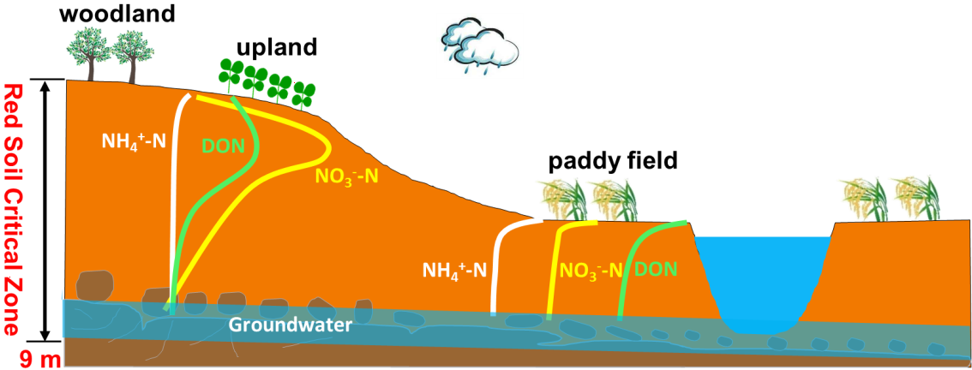
1

- Accumulation of Nitrate and Dissolved Organic Nitrogen at Depth in a Red Soil Critical
- Zone
- Huayong Wuª, Xiaodong Songª, Xiaorui Zhao^{a,b}, Xinhua Pengª, Hu Zhouª, Paul D. Hallett^{c}, Mark
- E. Hodson^{d}, Gan-Lin Zhang^{a,b,}*
- ª State Key Laboratory of Soil and Sustainable Agriculture, Institute of Soil Science, Chinese
- Academy of Sciences, Nanjing 210008, China
- ^{b} University of Chinese Academy of Sciences, Beijing 100049, China
- ^{c} School of Biological Sciences, University of Aberdeen, Aberdeen AB24 3UU, United Kingdom 9 ^{d} Environment Department, University of York, York YO10 5NG, United Kingdom
- ABSTRACT
Nitrate accumulation has been reported in the top 1 m and subsurface soil (> 1 m) across arid to semi-humid regions, but not in humid regions. Nitrate inventories through the whole regolith, referred to collectively as soil and saprolite, in humid regions have received little attention to date, likely due to previously assumed low nitrification rates and large nitrogen (N) losses by severe surface runoff and erosion. In order to understand if and how reactive N exists in the below ground (soil and saprolite) in humid environment, the amount of NO₃⁻-N, NH₄⁺-N and dissolved organic N (DON) present in the regolith to a depth of 9 m in a typical red soil Critical Zone was investigated under different land uses (upland, woodland and paddy field). The Red Soil Critical Zone Observatory is located in the subtropical Jiangxi Province, China, with a mean annual precipitation of 1795 mm and mean annual potential evapotranspiration of 1229 mm. The examined regoliths were acidic, highly weathered, and mainly clay loam in texture. Results showed that on average 92% (827 ± 97 kg N ha⁻¹) of NO₃⁻-N and 82% (521 ± 153 kg N ha⁻¹) of DON were stored at depth (from a depth of 1 m to the bedrock surface) in the upland regolith, while 92% (283 kg N ha⁻¹) of NO₃⁻-N and 78% (820 kg N ha⁻¹) of DON were stored at depth in the woodland regolith. Nitrate N significantly accumulated with depth in the upland regolith from the 1- to 4-m depth interval (p < 0.01), while the inventory (632 ± 75 kg N ha⁻¹) in the top 3-m zone accounted for on average 71% of the total. Dissolved organic N significantly accumulated with depth in the upland regolith from the 0- to 3-m depth interval (p < 0.01), while the inventory (408 ± 75 kg N ha⁻¹) in the top 3-m zone accounted for on average 64% of the total. There was no significant accumulation for NH₄⁺-N throughout the upland regolith (p = 0.35). No substantial accumulation of dissolved N was measured at depth in paddy field regoliths with different cultivation ages. The finding that large reservoirs of reactive N can exist in deep regolith rather than in the routinely investigated solum of subtropical regions shows a missing part of the terrestrial N budget and raises concerns about potential 34 groundwater nitrate pollution.
- Keywords: Nitrate accumulation; Dissolved organic nitrogen; Porosity; Red soil; Critical Zone
- Observatory
37
- 1. Introduction
- Overuse of nitrogen (N) fertilizers and increased deposition of bioavailable N to land have
- adversely affected soil ecosystem functions, water quality and biodiversity around the world
- (Matson et al., 2002; Guo et al., 2010; Liu et al., 2011; Payne et al., 2017). Understanding such
- effects requires quantification of N sources, reservoirs and cycling rates in a holistic approach. Red
- soils, mainly Acrisols, Alisols and Ferralsols according to the World Reference Base for Soil
- Resources (IUSS Working Group WRB, 2015), which cover approximately 22.7% of China’s land 45 surface (He et al., 1983) and about 16% of the world’s ice-free land surface (USDA, 2006) are
- reported to receive large amounts of ammonium-based fertilizer and / or atmospheric N deposition,
- due to intensive human activities in the tropical and subtropical regions (Dentener et al., 2006; Guo 48 et al., 2010; Wang et al., 2017).
- Pathways of N removal from soils to other environments include leaching beyond the root zone
- and potentially into groundwater, plant uptake, ammonia volatilization, denitrification, anaerobic
- ammonium oxidation, and losses by runoff and erosion (Cui et al., 2013; Gu et al., 2015; Shan et
- al., 2016; Xia et al., 2017). A literature analysis on 628 data points of groundwater NO₃⁻-N
- concentrations in China showed that about 15% of samples exceeded the Chinese drinking water
- standard of 20 mg N L⁻¹ for NO₃⁻-N and more than 28% of samples exceeded the USA drinking
- water standard of 10 mg N L⁻¹ for NO₃⁻-N (Gu et al., 2013). With a few exceptions, dissolved organic
- N (DON) concentrations (0.2 to 3.5 mg N L⁻¹) in leachate collected from various cropping systems
- exceeded the allowable concentration of 1.0 mg N L⁻¹ (organic N plus NH₄⁺-N) in drinking water
- in the European Union (van Kessel et al., 2009). This suggests that consideration of soil nitrate and
- DON at depths below the root zone is of vital importance for the quantification and mitigation of
- dissolved N leaching from soils to groundwater. Such deep sampling to study whether or not
- dissolved N accumulates in the deep regolith or leaches out of regolith into groundwater is rarely
- conducted.
- There is growing evidence of large accumulations of residual NO₃⁻-N at different depths in the
- regolith of Chinese semi-arid and semi-humid croplands with calcareous soils, such as in the Loess
- Plateau and the North China Plain (Ju et al., 2006; Zhou et al., 2016). In these areas, total soil NO₃⁻-N
- accumulation to a depth of 4 m ranged from about 450 to > 2000 kg N ha⁻¹ in wheat (Triticum 67 aestivum L.), maize (Zea mays L.), vegetable and orchard fields (Zhou et al., 2016). The
- accumulation of NO₃⁻-N at depth has been attributed to the overuse of N fertilizers and a declining
- groundwater table, together with assumed low levels of denitrification due to the presence of oxygen
- and absence of carbon sources that can act as reductants (Zhou et al., 2016). Nitrate N accumulation
- has also been observed in subsoil zones of arid to semi-arid regions in the western USA and is
- presumed to have accumulated throughout the Holocene (Walvoord et al., 2003). In these regions,
- integration of the NO₃⁻-N profiles from 1 m to the maximum depth sampled (10 to 30 m) yielded
- subsoil NO₃⁻-N inventories varying from 30 to 13600 kg N ha⁻¹. The large NO₃⁻-N inventories were
- ascribed to the environmental conditions of desert subsoils. The scarcities of organic matter, 76 microbial populations and water content in desert subsoils produce aerobic conditions, promote 77 NO₃⁻-N stability and inhibit denitrification.
- In contrast, in humid regions (> 800 mm of rainfall), where highly weathered soils are widely
- distributed and often receive substantial N fertilizers and atmospheric deposition (Guo et al., 2010;
- Wang et al., 2017), the extent to which NO₃⁻-N accumulates in the deep regolith is seldom reported.
- The previously assumed low nitrification rates (De Boer and Kowalchuk, 2001; Li et al., 2018;
- Zhang et al., 2018) and potentially large N losses by severe erosion and runoff of acidic soils (Zhao
- et al., 2013; FAO and ITPS, 2015) suggest that NO₃⁻-N in minimal amounts accumulates in red
- soils. However, a recent modelling study estimated a potentially large nitrate accumulation in the
- vadose zone across the world (Ascott et al., 2017), though no model validation was given regarding
- potential nitrate accumulation in specifically humid (sub)tropics. Furthermore, recent evidence
- confirming that nitrification can occur in acidic soils (He et al., 2012; Li et al., 2018) implied that
- nitrate accumulation may be present in these soil profiles. Therefore, quantification of nitrate storage 89 in the deep regolith in such environment is important and could account for a missing part of the
- terrestrial N budget (Ascott et al., 2016). More experimental observations are needed to test whether
- or not NO₃⁻-N accumulates in the regolith of highly weathered soils in humid regions. Although
- rainfall, fertilization, land use and denitrification processes were shown to determine NO₃⁻-N
- accumulation in arid to semi-humid regions, we still know little about how NO₃⁻-N moves
- downward and accumulates in porous regolith, especially in a humid and warm environment.
- Although the structure, especially pore structure, of the regolith plays a key role in determining
- infiltration and redistribution of water and dissolved N, the relationship between NO₃⁻-N 97 accumulation and regolith porosity is largely unexplored.
- While DON leaching losses from agricultural systems have been studied for more than a century,
- most studies have not determined leaching as a major cause of all N losses (van Kessel et al., 2009;
- Lawes et al., 1881). The DON fraction notably contributes to N leaching losses from forest
- ecosystems (Qualls et al., 2000; Perakis et al., 2002), and may be an important part of all N losses
- from agricultural systems (Murphy et al., 2000). Compared to NO₃⁻-N, DON leaching in agricultural
- soils remains much less understood and has received scant attention. Loss of DON by leaching from
- a diverse set of agricultural systems with soil texture ranging from sandy to clay in Europe, USA,
- Australia, Brazil and Thailand was 12.7 kg N ha⁻¹ yr⁻¹ on average and was estimated to be
- approximately one-third of the losses of NO₃⁻-N (van Kessel et al., 2009). To our knowledge, it is 107 unclear how DON leaches and accumulates in the red-soil regoliths in China.
- The aims of this study were to investigate whether or not dissolved N accumulates at depth in the
- red-soil regolith under different land uses in humid regions of China, and attempt to relate regolith
- porosity to dissolved N accumulation. We hypothesized that dissolved N accumulation is present at 111 depth in the regolith and differs among land uses in humid regions.
112
- 2. Materials and methods
- 2.1. Field site description
- The study sites were located in the Sunjia Red Soil Critical Zone Observatory (CZO), 4 km from
- the Ecological Experimental Station of Red Soil, Chinese Academy of Sciences (28°15′N,
- 116°55′E), Jiangxi Province, China. The CZO is a 50-ha watershed and has been established
- according to CZO protocol (Chorover et al., 2015) by installing comprehensive field observation
- instruments. The main land uses in the CZO includes upland (rain-fed crop land), paddy fields and 120 woodland (Fig. 1a). Peanut (Arachis hypogaea) was the main crop in the upland except for the long121 abandoned upland area associated with drilling site #2 (Fig. 1a and Table 1) with grasses including
- Bermuda grass (Cynodon dactylon), goosegrass (Eleusine indica), green spurge (Euphorbia esula)
- and horseweed (Erigeron canadensis) present. The paddy fields had a double-rice (Oryza sativa L.)
- cropping system and were either young paddy fields that have been cultivated for about 20 years or
- old paddy fields that have been cultivated for more than 100 years. The main tree species in the
- woodland area were camphor (Cinnamomum camphora) and masson pine (Pinus massoniana) that
- were older than 30 years. The CZO has a subtropical monsoon climate with a mean annual
- temperature of 17.8 ºC, mean annual precipitation of 1795 mm and mean annual potential
- evapotranspiration of 1229 mm (1954–1999) (Gao et al., 2016). The CZO is developed from 130 Quaternary red clay and weathered Cretaceous sandstone underlain by sandstone bedrock.
- 2.2. Drilling, sampling and monitoring
- Drilling was conducted at the Red Soil CZO by the local geological survey group of Jiangxi using 133 a hydraulic rotary drill fitted with diamond-impregnated drill bits (130 mm diameter). Eight
134 boreholes covered different land uses including cultivated upland (#1, #4, #5 and #8), long135 abandoned upland (#2), young paddy field (#3), old paddy field (#7) and woodland (#6) (Fig. 1a
- and Table 1). The longitude and latitude data, slope positions, elevations and borehole depths of the
- eight boreholes are listed in Table 1. Drilling for sites #1 to #5 and sites #6 to #8 was carried out in
- April and November 2016, respectively. Due to expense, drilling was conducted in limited locations,
- especially in the paddy field with the heavy equipment, and thus more drillings were conducted on
- the upland accounting for 47% of the total area of the CZO. Nitrate N was expected to most greatly
- accumulate in the upland among studied land uses when considering strong denitrification and
- ammonia volatilization in the paddy field and no direct fertilizer N inputs in the woodland. Therefore, 143 there were four replicate drillings for the upland and no replication in paddy field and woodland.
- The drill core samples were collected from a depth of about 1 m to the depths of the underlying
- bedrock. Core samples were divided into smaller intervals of about 20 cm in length. The drilling
- sites and observations are summarized in Table 1. Samples from 0 to about 1 m were collected from
- hand-dug soil pits because the unconsolidated material at these depths was easily fractured and fell
- out of the drill core tube. Samples from the soil pits were collected at approximately 10-cm intervals.
- The Quaternary red clay, weathered products of sandstone, and sandstone bedrock samples were
- cleaned by removing the outer layer to a depth of 1 cm in order to prevent contamination during
- drilling, and were kept in an ice-filled cooler after collection in the field and during transportation 152 to the laboratory. Photographs of undisturbed regolith core samples are presented in Fig. 1c to 1e.
- Each sample was subsampled for air-dried and field-moist samples for different physicochemical
- property measurements. For micro-Computed Tomography (μ-CT) scanning and bulk density 155 measurements, undisturbed regolith samples were obtained using polyvinyl chloride tubes, 5 cm in
- diameter by 5 cm long, in the 1-m deep soil pits. Below 1 m, the regolith core was cut into blocks
- of size with a few centimetres in three dimensions (Table S1) for μ-CT scanning and bulk density
- measurements.
- During January to December 2017, shallow groundwater samples in the 4- to 6-m depth range
- were collected twice a month for nitrate N measurements from a well set near to drilling site #5, and
- were frozen before nitrate analysis. At the well, the groundwater table was monitored by a HOBO 162 water level data logger (Onset Computer Corporation, USA) at 30-min intervals.
- 2.3. Physicochemical analyses
- Regolith samples were air-dried, ground in an agate mortar with a pestle, sieved through nylon
- meshes with pore sizes of 2 mm and 0.15 mm, and used for pH, total organic carbon (TOC) and
- total N (TN) analyses. Field-moist samples were used for measurements of moisture, dissolved
- organic carbon (DOC), dissolved total N (DTN), nitrate N (NO₃⁻-N) and ammonium N (NH₄⁺-N).
- Sample pH_{H2O} was measured in an aqueous suspension (1:2.5 w/v). The TOC and TN analyses were
- conducted by titration after K₂Cr₂SO₇-H₂SO₄ digestion and a correction factor of 1.08 was used for
- TOC calculation. The C/N ratios were calculated based on measured TOC and TN concentrations.
- Moisture was determined by drying at 105 ºC for 8 h. The DOC concentration, extracted with 0.5
- M K₂SO₄ (1:5 w/v), was measured with a TOC/TN analyzer (multi N/C® 3100, Analytik Jena,
- Germany) (Jones and Willett, 2006). The DTN, NO₃⁻-N and NH₄⁺-N concentrations, extracted with
- 2 M KCl (1:10 w/v), were measured with a Continuous Flow Analyzer (San⁺⁺ System, Skalar, The
- Netherlands) (Jones and Willett, 2006). The DON concentration was calculated as the difference
- between the DTN and dissolved inorganic N (NO₃⁻-N and NH₄⁺-N) concentrations. The 177 groundwater samples were filtered through quantitative filter paper and then nitrate N concentration
- in the groundwater was measured with the Continuous Flow Analyzer. Bulk density of undisturbed
- regolith samples was determined using an oven-drying method and a wax-coating method (Peng et
- al., 2003) and used to calculate the volumetric inventory of dissolved N. Bulk density results are 181 shown in Fig. S1.
- Quality control for TOC and TN measurements was through analysis of certified reference
- materials for agricultural soils (GBW07414 and GBW07415) (Institute of Geophysical and
- Geochemical Exploration, Chinese Academy of Geological Sciences). Quality control for DTN,
- NO₃⁻-N, NH₄⁺-N and DOC analyses was by analysis of certified reference materials for water (GSB
- 07-3168-2014, GSB 07-3166-2014, GSB 07-3164-2014, GSB 07-1967-2005) (Institute for
- Environmental Reference Materials, Ministry of Environmental Protection of China). Measured
- data from the reference materials were within 5% of the certified values. Detection limits of analyses
- were 0.07 g kg⁻¹ for TOC, 0.01 g kg⁻¹ for TN, < 0.04 mg L⁻¹ for DTN, 0.015 mg L⁻¹ for NO₃⁻-N, 190 0.046 mg L⁻¹ for NH₄⁺-N, and 0.4 mg L⁻¹ for DOC.
- 2.4. Quantification of total porosity and macroporosity of regolith
- Total porosity was estimated from the measured bulk density and particle density of the regolith
- using the equation below: total porosity (%) = (1 - BD / ρ) × 100, where BD was the measured bulk
- density (Fig. S1) and ρ was the particle density of the regolith solids which was assumed to be 2.65
- g cm⁻³.
- Macroporosity of the regolith was quantified using μ-CT by the following procedure. Undisturbed
- regolith samples were scanned using an industrial Phoenix Nanotom X-ray μ-CT (GE, Sensing and
- Inspection Technologies, GmbH, Wunstorf, Germany). Samples were scanned at a voltage of 110 199 kV and a current of 100 μA, and the beam-hardening effect was reduced with a 0.2-mm Cu filter.
- Reconstruction was performed using the Datos|x 2.0 software (GE, Sensing and Inspection
- Technologies, GmbH, Wunstorf, Germany) using the filtered back-projection algorithm. Each voxel
- in the generated slices represented a volume of 25 × 25 × 25 μm³. Image processing and visualization
- were performed using the open-source software ImageJ 1.50i (Rasband, 2013). A representative
- region was selected from the central part of the samples to avoid artefacts at the boundary region
- caused by sampling. A three-dimensional median filter was used to reduce noise before image
- segmentation. The global threshold method was used to segment regolith pores and solids and the
- threshold values were chosen based on visual observation. Macroporosity was calculated as the
- percentage of macropore (> 25 μm) volume in the total volume of the selected representative region.
- The sample sizes of the selected representative region are listed in the supplementary data (Table 210 S1). Pore-size distribution was calculated using the BoneJ Thickness in ImageJ (Doube et al., 2010).
- 2.5. Statistical analyses
- Analysis of variance was employed to analyze the statistical significance of physicochemical
- properties, dissolved N concentrations, total porosity, macroporosity, and the upland soil N
- inventories. Multiple comparisons of the mean from the above data were performed using Duncan's 215 multiple range test, and differences were considered significant at p < 0.05.
216
- 3. Results
- 3.1. Stratigraphy of the Red Soil Critical Zone
- The stratigraphy of the Critical Zone consisted of reticulate red clay between uniform red clay
- and weathered sandstone (Fig. 1b), with the regolith thickness as a whole varying between 3.5 and 221 9.0 m depending on slope position within different land uses (Table 1). The uniform (0.12 to 1.95
222 m) and reticulate (1.68 to 6.25 m) red clay together comprised the Quaternary red clay with a 223 thickness of 1.8 to 8.2 m. The weathered sandstone formed a 1.0- to 2.1-m thick layer.
- Variations in TOC, TN, C/N, DOC, pH and moisture content with depth are summarised in Fig.
- 2. Under the different land uses (upland, woodland, and young and old paddy fields), TOC and TN
- concentrations significantly decreased to less than 2.0 and 0.4 g kg ⁻¹, respectively, at depths greater
- than 1.0 m (p < 0.01). The C/N ratios changed from 12.4 to 2.0 with depth. The DOC concentration
- showed a similar pattern to that of TOC, but DOC concentrations were two orders of magnitude
- smaller than those of TOC. The regolith pH varied from 4.1 to 5.8 with depth under different land
- uses. The pH significantly differed in the order of old paddy field > young paddy field > woodland >
- upland in the 0- to 4-m depth interval (p < 0.01), and in the order of old paddy field > woodland >
- young paddy field or upland beneath 4 m (p < 0.01). Moisture content was greater than 20% at 233 almost all depths.
- 3.2. Dissolved N concentrations through the regolith among land uses
- Different depth patterns for NO₃⁻-N, NH₄⁺-N and DON concentrations in the upland, woodland
- and paddy field regoliths are shown in Fig. 3. For upland regoliths, the NO₃⁻-N concentration was
- nearly constant with depth in most cases in the top 1 m, whereas the NO₃⁻-N concentration
- significantly increased in the 1- to 3- or 4-m depth interval (p < 0.01). The maximum NO₃⁻-N 239 concentration was 26 mg kg⁻¹ at a depth of 1.9 m in the upland regolith. Unlike NO₃⁻-N, the NH₄⁺240 N concentration quickly reduced to 1.9 ± 0.9 mg kg⁻¹ (mean ± standard deviation) with depth or
- remained almost invariable in the upland regoliths. The trends of inorganic dissolved N with depth
- were similar between the upland and woodland regoliths. In the upland regoliths (#1, #4, #5 and 243 #8), DON concentration significantly decreased in the top 1 m (p < 0.01) then increased, whereas
244 in the woodland regolith, DON concentration significantly decreased from the 0- to 4-m depth to 245 below 4 m (p < 0.01).
- The paddy field regoliths had different profiles of dissolved N compared to those in the upland
- and woodland regoliths (Fig. 3). In the young paddy fields, NO₃⁻-N and NH₄⁺-N concentrations
- were relatively constant at 1.6 ± 0.8 mg kg⁻¹ and 1.5 ± 0.5 mg kg⁻¹, respectively, whereas the DON
- concentration significantly decreased with depth (p < 0.01). In the old paddy fields, NO₃⁻-N
- concentrations significantly decreased to below the detection limit with depth (p < 0.01). In contrast,
- NH₄⁺-N and DON concentrations in the old paddy fields significantly decreased in the 0- to 0.7-m
- depth interval (p < 0.01), significantly increased in the 0.7- to 0.9-m depth interval (p < 0.01), and
- then significantly decreased to be relatively constant at 0.4 ± 0.3 mg kg⁻¹ and 2.3 ± 1.6 mg kg⁻¹, 254 respectively, in the 0.9- to 5.0-m depth interval (p < 0.01).
- Nitrate N concentrations on average in the upland regoliths (#1, #4, #5 and #8) in the 1- to 4-m
- depth were significantly greater than those in the other land uses (p < 0.01). Nitrate N concentrations
- on average in the woodland regolith in the 1- to 4-m depth were significantly greater than those in
- the paddy field (p < 0.01). Dissolved organic N concentrations on average under woodland and old
- paddy field in the 0- to 4-m depth were significantly greater than those of upland and young paddy
- fields (p < 0.01). There was no difference in NH₄⁺-N concentration among land uses except the 261 difference between old paddy field and woodland.
- 3.3. Dissolved N inventories through the regolith among land uses
- Integration of the dissolved N profiles from soil surface to the bedrock allowed NO₃⁻-N, NH₄⁺-N
- and DON inventories to be calculated (Fig. 4a). In upland regoliths (#1, #4, #5 and 8#), the soil 265 NO₃⁻-N inventory significantly increased from 67 ± 52 kg N ha⁻¹ for the top 1 m to 827 ± 97 kg N
- ha⁻¹ for > 1 m (p < 0.01). The NO₃⁻-N inventory beneath 1 m accounted for 92%, on average, of the
- entire NO₃⁻-N inventory, except for the long-abandoned upland (#2). The soil DON inventory
- significantly increased from 119 ± 58 kg N ha⁻¹ for the top 1 m to 521 ± 153 kg N ha⁻¹ for > 1 m, 269 and the inventory beneath 1 m accounted for 82%, on average, of the total (p < 0.01). The soil NH₄⁺270 N inventory significantly increased from 49 ± 31 kg N ha⁻¹ for the top 1 m to 158 ± 77 kg N ha⁻¹ for
- > 1 m, and the inventory beneath 1 m accounted for 76%, on average, of the total (p = 0.04). There
- was no difference among the three dissolved N inventories for the top 1 m (p = 0.16), whereas
- dissolved N inventories significantly decreased in the order of NO₃⁻-N > DON > NH₄⁺-N for > 1 m
- (p < 0.01). Soil inventories of NO₃⁻-N, DON and NH₄⁺-N accounted for 56, 34 and 10%,
- respectively, of the total beneath 1 m, and accounted for 52, 36 and 12%, respectively, of the total 276 throughout the regolith.
- In woodland regolith, the soil NO₃⁻-N inventory numerically increased from 23 kg N ha⁻¹ for the
- top 1 m to 283 kg N ha⁻¹ for > 1 m, and the inventory below 1 m accounted for 92% of the total. The
- soil DON inventory numerically increased from 228 kg N ha⁻¹ for the top 1 m to 820 kg N ha⁻¹ for >
- 1 m, and the inventory beneath 1 m accounted for 78% of the total. The soil NH₄⁺-N inventory
- numerically increased from 19 kg N ha⁻¹ for the top 1 m to 93 kg N ha⁻¹ for > 1 m, and the inventory 282 beneath 1 m accounted for 92% of the total.
- A similar pattern to that of NH₄⁺-N in the woodland regolith in the top 1 m and beneath 1 m
- occurred for the three types of dissolved N in the young paddy field regolith. In the old paddy field
- regolith, the soil NO₃⁻-N inventory was 18 kg N ha⁻¹ for the top 1 m and less than the detection limit
- for > 1 m. The soil DON inventory numerically decreased from 339 kg N ha⁻¹ for the top 1 m to 168 287 kg N ha⁻¹ for > 1 m. The soil NH₄⁺-N inventory numerically decreased from 68 kg N ha⁻¹ for the top 288 1 m to 36 kg N ha⁻¹ for > 1 m.
- Different depth patterns for NO₃⁻-N, NH₄⁺-N and DON inventories at 1-m depth intervals of
- upland regoliths (#1, #4, #5 and #8) were presented in Fig. 4b. Nitrate N significantly accumulated
- in the subsoil in the 1- to 4-m depth (p < 0.01), while the inventory (632 ± 75 kg N ha⁻¹) in the 3-m
- zone accounted for 71% of the total. Dissolved organic N significantly accumulated in the subsoil
- in the 0- to 3-m depth (p < 0.01), while the inventory (408 ± 75 kg N ha⁻¹) in the 3-m zone accounted
- for 64% of the total. There was no significant accumulation of NH₄⁺-N at depth in the upland 295 regolith (p = 0.35).
- 3.4. Porosity through the regolith among land uses
- In general, total porosity showed a sigmoid curve with depth among land use regoliths (Fig. 5).
- Total porosity varied from 34 to 64% among land use regoliths. Total porosity significantly
- decreased with depth when the zone changed from uniform to reticulate red clay, significantly
- increased with depth at the transition zone from reticulate red clay to weathered sandstone, and then
- significantly decreased with depth at the transition zone from weathered sandstone to sandstone 302 bedrock (p < 0.01).
303 Macroporosity in the woodland regolith was significantly greater than that in the upland and old 304 paddy field regoliths at depths shallower than 3.1 m (p < 0.01) (Fig. 6a and Fig. S2-S5).
- Macroporosity for the different regoliths was typically less than 0.2% at depths below 3.1 m. The
- macroporosity of the upland regolith increased at depths of 2.5 to 3.1 m and 5.6 to 7.0 m due to
- either the presence of root-like cylindrical pores or the change of parent materials from Quaternary
- red clay to the loose weathered sandstone material (Fig. S2-S3). The macroporosity of the woodland 309 regolith varied from 2.0 to 4.7% in the top 2.4 m then significantly decreased at greater depths to an
- average of 0.14% (p < 0.01). The macroporosity of the old paddy field regolith significantly
- decreased to approximately zero from the surface to a depth of 0.7 m (p < 0.01). Pore-size
- distributions were only calculated when macroporosity was greater than 0.4% (Fig. 6b-d). More
- than 86% of the macroporosity was present as pores < 0.425 mm in the upland regolith, and < 0.525
- mm for the surface and < 0.325 mm for the subsurface samples in the woodland regolith. More than
- 91% of the macroporosity was present as pores < 0.225 mm for the two surface samples in the old
- paddy field, while more than 80% of the macroporosity was present as pores < 0.325 mm for the 317 subsurface samples.
318
- 4. Discussion
- 4.1. Differences in NO₃⁻-N accumulation mechanisms among land uses
- Whereas 67 ± 52 kg ha⁻¹ NO₃⁻-N was determined in the upland regolith in the top 1 m in the Red
- Soil CZO, below 1 m the inventory was 827 ± 97 kg N ha⁻¹. Up to 12 times more NO₃⁻-N may be
- present below 1 than above 1 m. This study provided evidence of significant NO₃⁻-N accumulation 324 in upland regoliths (#1, #4, #5 and #8) in the 1- to 4-m depth interval (p < 0.01). The similar NO₃⁻325 N accumulation pattern between the deep sampling in April (#1, #4, and #5) and November (#8)
- 2016 indicated that the accumulated NO₃⁻-N was not transient over at least seven months. Nitrate N
- accumulation in humid regions has previously been ignored, possibly due to formerly assumed low
- nitrification rates (Li et al., 2018; Zhang et al., 2018) and the potentially large N losses by severe
- erosion and surface runoff (Zhao et al., 2013) from red soils with pH less than 5.5 and where urea
- was the main N fertilizer. The NH₄⁺-N concentration in the upland regolith was small and was 1.9 331 ± 0.9 mg kg⁻¹, with a few exceptions (Fig. 3). Nitrogen losses from ammonia volatilization and
- denitrification from an upland red soil in Hunan Province, which is adjacent to Jiangxi Province,
- were shown to be 1.1 to 4.2% and 0.5 to 1.0% of applied synthetic N fertilizer, respectively (Huang
- et al., 2017). It was previously assumed that nitrification rates were low in acidic soils since the
- availability of the ammonia substrate for ammonia monoxygenase enzyme of ammonia-oxidizing
- bacteria (AOB) would be limited and AOB were unable to oxidize ammonium in an inorganic liquid
- medium with pH less than 5.5 (De Boer and Kowalchuk, 2001; Li et al., 2018). However, more
- recent studies have confirmed that nitrification can occur in soils at pH as low as 3.0 (De Boer and
- Kowalchuk, 2001; He et al., 2012). The discovery of ammonia monooxygenase in uncultured
- archaea that were functionally active at low pH pointed to ammonia-oxidizing archaea (AOA) that
- might be responsible for nitrification in the wider range of acidic soils (He et al., 2012; Li et al.,
- 2018). Therefore, in this study, overuse of N fertilizer could result in continuous formation and 343 accumulation of NO₃⁻-N in upland red soils.
- In the Red Soil CZO, the accumulated NO₃⁻-N is easily leachable to the subsoil because of
- intensive rainfall, which often exceeds 200 mm per month in the wet season (March to June) and
- accounts for about 50% of the annual total rainfall (Zepp et al., 2005; Tahir et al., 2016). This partly
- explains how NO₃⁻-N has accumulated at depth in the upland regolith. However, NO₃⁻-N also
- accumulated at depth in the woodland regolith, though to a lesser extent than for the cultivated
- upland, except for upland drill site #2 at the top slope, which received N mainly from natural sources
- according to a survey of local farmers. The natural sources of N that the woodland receives include
- atmospheric deposition and biological N fixation. The woodland receives no direct fertilizer N
- inputs, but the woodland at the toe slope is located at an elevation several metres lower than the 353 surrounding cultivated uplands (Table 1 and Fig. 1), and thus likely receives fertilizer-sourced N
354 through runoff. Consequently, the N coming from surrounding uplands could intensify NO₃⁻-N 355 accumulation at depth in the woodland regolith.
- Compared with upland red soils, denitrification in paddy soils was intensive, whereas NO₃⁻-N
- leaching was minimal (Ju et al., 2009). In paddy soils in the Taihu region where the climate is humid,
- N fates of applied fertilizer N in soils over the rice-growing season were reported to be about 36%
- of applied fertilizer N by denitrification, 12% by ammonia volatilization, 0.3% by leaching, 30% by
- plant uptake and 22% by soil retention in the 1-m depth (Ju et al., 2009). Hence, strong
- denitrification and ammonia volatilization in paddy soils may lead to less accumulation of NO₃⁻-N 362 below paddy fields than below uplands.
- 4.2. Role of porosity in NO₃⁻-N accumulation at depth in the regolith
- Pores, including micropores and macropores, in the regolith are the spaces for storing water and
- air, and macropores may result in preferential flow and thus are important pathways of water and
- solute movement (Zhang et al., 2016). Fig. 6e and Fig. 6f present both total porosity, macroporosity
- and NO₃⁻-N concentrations for typical upland (#1, #8) and woodland (#6) profiles, respectively.
- Nitrate N accumulated at depth in the upland and woodland regoliths likely due to the relatively
- large abundance of water-conducting macroporosity at depths shallower than about 3 m, which was
- then rapidly replaced by far lower macroporosity below 3 m, which limited water penetration. The
- significant decrease of total porosity with depth in the 0- to 3-m depth interval of the upland and
- woodland regoliths may also limit nitrate N movement at depth. Although macroporosity was low
- below 3 m for upland regoliths (#1 and #8), 464 ± 80 kg N ha⁻¹ for NO₃⁻-N were still present,
- suggesting that microporosity plays a role in slow, but steady NO₃⁻-N leaching.
- 4.3. Comparisons of NO₃⁻-N inventories across arid to humid regions
- Published NO₃⁻-N inventories in the top 1 m and subsurface (< 1 m) soils of arid to semi-humid
- regions were compared with those from this study for a humid region in China. The NO₃⁻-N
- inventories on average for the top 4 m in four upland regoliths (#1, #4, #5 and #8) with the peanut
- cropping system were measured to be 691 ± 19 kg N ha⁻¹.This value was greater than that for wheat
- croplands (453 ± 39 kg N ha⁻¹), comparable to that of maize croplands (749 ± 39 kg N ha⁻¹) and
- lower than that for vegetables and orchards (1191 to 2155 kg N ha⁻¹) for regoliths in semi-humid 382 areas of China measured over the same depth (Zhou et al., 2016). These results suggest that NO₃⁻383 N accumulation in these intensive croplands may be widespread. About 70% of NO₃⁻-N was stored
- in the subsoils in the 1- to 4-m depth interval of the semi-humid areas of China (Zhou et al., 2016),
- while 92% of NO₃⁻-N was stored in the subsoils in the 1- to 8-m depth interval in this study. These
- data indicate that the subsoil zone may be an important sink of nitrate globally. Nitrate N inventories
- from a depth of 1 m to bedrock were 283 kg N ha⁻¹ for woodland (#6) and 169 kg N ha⁻¹ for upland
- (drill site #2) compared to the 30 to 13,600 kg N ha⁻¹ reported for regolith from a depth of 1 m to
- the maximum depth (10 to 30 m) sampled in semiarid-to-arid desert soil sites in the western United
- States. The NO₃⁻-N inventories in this study were smaller than those in the desert subsoils in most
- cases. This may be due to the long-term accumulation of naturally sourced NO₃⁻-N throughout the
- Holocene and the slow leaching in the desert soils, together with the fast leaching of NO₃⁻-N to 393 shallow groundwater under the large rainfall experienced in our studied area.
- 4.4. Threats of NO₃⁻-N to groundwater
- Subsoil NO₃⁻-N reservoirs may adversely affect groundwater quality due to leaching (Reynolds396 Vargas et al., 1994, 2006; Reynolds-Vargas and Richter, 1995). Large nitrate levels in drinking 397 water can pose long-term threats to public health and increase risks for methemoglobinemia, birth
- defects and certain cancers (Ward et al., 1996, 2005, 2010; Knobeloch et al., 2000; Brender et al.,
- 2013). Based on groundwater observations in 2017, the median concentration of NO₃⁻-N and the
- depth of the water table of the Red Soil CZO groundwater were measured to be 6.5 mg NO₃⁻-N L⁻¹
- and usually in the 4- to 6-m depth interval, respectively. When considering the large NO₃⁻-N
- inventories in the 1-to 4-m depth interval and shallow groundwater, it is important to integrate N
- nutrient management for food security and environmental quality. Furthermore, nitrate can persist
- in the groundwater and possibly in the deep regolith for decades, and risks of nitrate movement to
- groundwater could exist for a long time even if N fertilizer is not over-applied to soils (Exner et al.,
- 2014). These issues may not only be serious in our studied CZO, in which the regolith is mainly
- comprised of Quaternary red clay, but may also have a great significance in other humid regions
- where similar parent material is widely distributed in the middle and lower reaches of the Yangtze
- River (Hu et al., 2010). The possible NO₃⁻-N accumulation in the upland red soil regoliths derived 410 from other bedrock types, including granite and basalt, in humid regions should also be investigated.
411
- 5. Conclusions
- For the first time, NO₃⁻-N and DON accumulation were reported in the deep regolith of red soil
- under upland and woodland land uses in a humid region in China. Land use types under different
- amounts of N inputs and water regimes strongly affected reactive N inventories at depth in the
- typical red soil Critical Zone. Neglecting large stocks of NO₃⁻-N and DON at depth in the Critical
- Zone may greatly underestimate N inventories and potential risks of reactive N to groundwater.
- Regolith macropores (> 25 μm) most likely contributed to nitrate leaching through the regolith, 419 while low permeability of the deep regolith likely contributed to the accumulation of nitrate.
420
- Appendix A. Supplementary data
- Supplementary data related to this article can be found online.
423
- Acknowledgements
- This study was financially supported by the National Natural Science Foundation of China
- (41571130051; 41501228; 41771251) and by the Frontier Program of the Institute of Soil Science,
- Chinese Academy of Sciences (ISSASIP1625). This research was part of the China-UK Red Soil 428 Critical Zone project co-financed by the Natural Environmental Research Council (NERC:
429 NE/N007611/1; NE/N007484/1) under the Newton Fund scheme. We would like to thank the editor 430 and anonymous reviewers for their thoughtful comments that have greatly improved our manuscript.
431
- References
- Ascott, M.J., Gooddy, D.C., Wang, L., Stuart, M.E., Lewis, M.A., Ward, R.S., Binley, A.M., 2017. 434 Global patterns of nitrate storage in the vadose zone. Nat. Commun. 8, 1416.
435 Ascott, M.J., Wang, L., Stuart, M.E., Ward, R.S., Hart, A., 2016. Quantification of nitrate storage 436 in the vadose (unsaturated) zone: a missing component of terrestrial N budgets. Hydrol. Process.
- 30, 1903–1915.
- Brender, J.D., Weyer, P.J., Romitti, P.A., Mohanty, B.P., Shinde, M.U., Vuong, A.M., Sharkey, J.R.,
- Dwivedi, D., Horel, S.A., Kantamneni, J., Huber, J.C. Jr., Zheng, Q., Werler, M.M., Kelley,
- K.E., Griesenbeck, J.S., Zhan, F.B., Langlois, P.H., Suarez, L., Canfield, M.A., 2013. Prenatal 441 nitrate intake from drinking water and selected birth defects in offspring of participants in the 442 National Birth Defects Prevention Study. Environ. Health Perspect. 121, 1083−1089.
- Chorover, J., Anderson, S., Aufdenkampe, A.K., Bales, R.C., Brantley, S.L., Dietrich, W., Kumar,
- P., Lohse, K.A., McDowell, W., Richter, D., White, T., 2015. Common Critical Zone 445 Observatory (CZO) Infrastructure and Measurements. A Guide Prepared By CZO PIs, May 05,
- 2015.
- Cui, S., Shi, Y., Groffman, P.M., Schlesinger, W.H., Zhu, Y., 2013. Centennial-scale analysis of the
- creation and fate of reactive nitrogen in China (1910-2010). Proc. Natl. Acad. Sci. U. S. A.
- 110, 2052–2057.
- De Boer, W., Kowalchuk, G.A., 2001. Nitrification in acid soils: micro-organisms and mechanisms. 451 Soil Biol. Biochem. 33, 853–866.
- Dentener, F., Stevenson, D., Ellingsen, K., van Noije, T., Schultz, M., Amann, M., Atherton, C.,
- Bell, N., Bergmann, D., Bey, I., Bouwman, L., Butler, T., Cofala, J., Collins, B., Drevet, J.,
- Doherty, R., Eickhout, B., Eskes, H., Fiore, A., Gauss, M., Hauglustaine, D., Horowitz, L.
- Isaksen, I.S.A., Josse, B., Lawrence, M., Krol, M., Lamarque, J.F., Montanaro, V., Müller, J.F.,
- Peuch, V.H., Pitari, G., Pyle, J., Rast, S., Rodriguez, J., Sanderson, M., Savage, N.H., Shindell,
- D., Strahan, S., Szopa, S., Sudo, K., van Dingenen, R., Wild, O., Zeng, G., 2006. The global 458 atmospheric environment for the next generation. Environ. Sci. Technol. 40, 3586–3594.
- Doube, M., Klosowski, M.M., Arganda-Carreras, I., Cordelières, F.P., Dougherty, R.P., Jackson,
- J.S., Schmid, B., Hutchinson, J.R., Shefelbine, S.J., 2010. BoneJ: free and extensible bone 461 image analysis in ImageJ. Bone 47, 1076–1079.
462 Exner, M.E., Hirsh, A.J., Spalding, R.F., 2014. Nebraska’s groundwater legacy: nitrate 463 contamination beneath irrigated cropland. Water Resour. Res. 50, 4474–4489.
- FAO, ITPS, 2015. Status of the World’s Soil Resources (SWSR)-Main Report, Food and
- Agriculture Organization of the United Nations and Intergovernmental Technical Panel on 466 Soils, Rome, Italy.
467 Gao, L., Lv, Y., Wang, D., Muhammad, T., Biswas, A., Peng, X., 2016. Soil water storage prediction 468 at high space-time resolution along an agricultural hillslope. Agr. Water Manag. 165, 122–130. 469 Gu, B., Ge, Y., Chang, S.X., Luo, W., Chang, J., 2013. Nitrate in groundwater of China: sources 470 and driving forces. Global Environ. Change 23, 1112–1121.
471 Gu, B., Ju, X., Chang, J., Ge, Y., Vitousek, P.M., 2015. Integrated reactive nitrogen budgets and 472 future trends in China. Proc. Natl. Acad. Sci. U. S. A. 112, 8792–8797.
- Guo, J., Liu, X., Shen, J., Han, W., Zhang, W., Christie, P., Goulding, K.W.T., Vitousek, P.M.,
- Zhang, F., 2010. Significant acidification in major Chinese croplands. Science 327, 1008–1010.
- He, J.-Z., Hu, H.-W., Zhang, L.-M., 2012. Current insights into the autotrophic thaumarchaeal 476 ammonia oxidation in acidic soils. Soil Biol. Biochem. 55, 146–154.
- He, X., Xie, W., Deng, S., Lu, S., 1983. The problems and achievements about improving use red-
- yellow soil in China. Chin. J. Soil Sci. (2), 1–4. (In Chinese)
- Hu, X., Wei, J., Du, Y., Xu, L., Wang, H., Zhang, G., Ye, W., Zhu, L., 2010. Regional distribution
- of the Quaternary Red Clay with aeolian dust characteristics in subtropical China and its 481 paleoclimatic implications. Geoderma 159, 317–334.
- Huang, J., Duan,Y., Xu, M., Zhai, L., Zhang, X., Wang, B., Zhang, Y., Gao, S., Sun, N., 2017.
- Nitrogen mobility, ammonia volatilization, and estimated leaching loss from long-term manure
- incorporation in red soil. J. Integr. Agr. 16, 2082–2092.
- IUSS Working Group WRB, 2015. World Reference Base for Soil Resources 2014, update 2015,
- International soil classification system for naming soils and creating legends for soil maps.
- World Soil Resources Reports No. 106, Food and Agriculture Organization of the United 488 Nations, Rome, Italy.
489 Jones, D.L., Willett, V.B., 2006. Experimental evaluation of methods to quantify dissolved organic 490 nitrogen (DON) and dissolved organic carbon (DOC) in soil. Soil Biol. Biochem. 38, 991–999.
- Ju, X., Kou, C., Zhang, F., Christie, P., 2006. Nitrogen balance and groundwater nitrate
- contamination: comparison among three intensive cropping systems on the North China Plain. 493 Environ. Pollut. 143, 117–125.
494 Ju, X., Xing, G., Chen, X., Zhang, S., Zhang, L., Liu, X., Cui, Z., Yin, B., Christie, P., Zhu, Z., 495 Zhang, F., 2009. Reducing environmental risk by improving N management in intensive 496 Chinese agricultural systems. Proc. Natl. Acad. Sci. U. S. A. 106, 3041–3046.
497 Knobeloch, L., Salna, B., Hogan, A., Postle, J., Anderson, H., 2000. Blue babies and nitrate498 contaminated well water. Environ. Health Perspect. 108, 675–678.
- Lawes, J.B., Gilbert, J.H., Warington, R., 1881. On the amount and composition of the rain and
- drainage-waters collected at Rothamsted: Part II. The amount and composition of the drainage 501 waters from unmanured fallow land. J. Royal Agric. Soc. Engl. 17, 311–350.
- Li, Y., Chapman, S.J., Nicol, G.W., Yao, H., 2018. Nitrification and nitrifiers in acidic soils. Soil
- Biol. Biochem. 116, 290–301.
- Liu, X., Duan, L., Mo, J., Du, E., Shen, J., Lu, X., Zhang, Y., Zhou, X., He, C., Zhang, F., 2011.
- Nitrogen deposition and its ecological impact in China: an overview. Environ. Pollut. 159,
- 2251–2264.
- Matson, P., Lohse, K.A., Hall, S.J., 2002. The globalization of nitrogen deposition: consequences 508 for terrestrial ecosystems. Ambio 31, 113–119.
509 Murphy, D.V., Macdonald. A.J., Stockdale, E.A., Goulding, K.W.T., Fortune, S., Gaunt, J.L., 510 Poulton, P.R., Wakefield, J.A., Webster, C.P., Wilmer, W.S., 2000. Soluble organic nitrogen 511 in agricultural soils. Biol. Fert. Soils 30, 374–387.
512 Payne, R.J., Dise, N.B., Field, C.D., 2017. Nitrogen deposition and plant biodiversity: past, present, 513 and future. Front. Ecol. Environ. 15, 431–436.
514 Peng, X., Zhang, B., Li, J., Zhao, Q., 2003. Investigation on improving porous medium’s porosity 515 in wax-coated method. Chin. J. Soil Sci. 34, 19–20. (In Chinese)
516 Perakis, S.S., Hedin, L.O., 2002. Nitrogen loss from unpolluted South American forests mainly via 517 dissolved organic compounds. Nature 415, 416–419.
518 Qualls, R.G., Haines, B.L., Swank, W.T., Tyler, S.W., 2000. Soluble organic and inorganic nutrient 519 fluxes in clearcut and mature deciduous forests. Soil Sci. Soc. Am. J. 64, 1068–1077. 520 Rasban, W.S., 2013. ImageJ Version 1.50i, US National Institutes of Health, Bethesda, Maryland, 521 USA, https://imagej.nih.gov/ij/ (accessed on 26 March 2016).
- Reynolds-Vargas, J., Fraile-Merino, J., Hirata, R., 2006. Trends in nitrate concentrations and
- determination of its origin using stable isotopes (¹⁸O and ¹⁵N) in groundwater of the Western 524 Central Valley, Costa Rica. Ambio, 35, 229–236.
525 Reynolds-Vargas, J.S., Richter, D.D., 1995. Nitrate in groundwaters of the Central Valley, Costa 526 Rica. Environ. Int. 21, 71–79.
- Reynolds-Vargas, J.S., Richter, D.D., Bornemisza, E., 1994. Environmental impacts of nitrification
- and nitrate adsorption in fertilized Andisols in the Valle Central of Costa Rica. Soil Sci. 157, 529 289–299.
- Shan, J., Zhao, X., Sheng, R., Xia, Y., Ti, C., Quan, X., Wang, S., Wei, W., Yan, X., 2016.
- Dissimilatory nitrate reduction processes in typical Chinese paddy soils: rates, relative 532 contributions, and influencing factors. Environ. Sci. Technol. 50, 9972–9980.
- Tahir, M., Lv, Y., Gao, L., Hallett, P. D., Peng, X., 2016. Soil water dynamics and availability for
- citrus and peanut along a hillslope at the Sunjia Red Soil Critical Zone Observatory (CZO). 535 Soil Till. Res. 163, 110–118.
- USDA, 2006. USDA Natural Resources Conservation Service Website,
- https://nrcspad.sc.egov.usda.gov/DistributionCenter/pdf.aspx?productID=587.
- van Kessel, C., Clough, T., van Groenigen, J.W., 2009. Dissolved organic nitrogen: an overlooked 539 pathway of nitrogen loss from agricultural systems? J. Environ. Qual. 38, 393–401.
540 Walvoord, M.A., Phillips, F.M., Stonestrom, D.A., Evans, R.D., Hartsough, P.C., Newman, B.D., 541 Striegl, R.G., 2003. A reservoir of nitrate beneath desert soils. Science 302, 1021–1024.
- Wang, R., Goll, D., Balkanski, Y., Hauglustaine, D., Boucher, O., Ciais, P., Janssens, I., Penuelas,
- J., Guenet, B., Sardans, J., Bopp, L., Vuichard, N., Zhou, F., Li, B., Piao, S., Peng, S., Huang,
- Y., Tao, S., 2017. Global forest carbon uptake due to nitrogen and phosphorus deposition from 545 1850-2100. Global Change Biol. 23, 4854–4872.
- Ward, M.H., deKok, T.M., Levallois, P., Brender, J., Gulis, G., Nolan, B.T., VanDerslice, J., 2005.
- Workgroup report: drinking-water nitrate and health-recent findings and research needs. 548 Environ. Health Perspect. 113, 1607−1614.
- Ward, M.H., Kilfoy, B.A., Weyer, P.J., Anderson, K.E., AFolsom, A.R., Cerhan, J.R., 2010. Nitrate
- intake and the risk of thyroid cancer and thyroid disease. Epidemiology 21, 389−395.
- Ward, M.H., Mark, S.D., Cantor, K.P., Weisenburger, D.D., Correa-Villaseñor, A., Zahm, S.H.,
- 1996. Drinking water nitrate and the risk of non-Hodgkin’s lymphoma. Epidemiology 7,
- 465−471.
- Xia, L., Lam, S.K., Yan, X., Chen, D., 2017. How does recycling of livestock manure in
- agroecosystems affect crop productivity, reactive nitrogen losses, and soil carbon balance? 556 Environ. Sci. Technol. 51, 7450–7457.
557 Zepp, H., Tang, J., Zhang, B., 2005. Methodological framework for a multi-scale study on 558 hydrological processes and soil erosion in subtropical Southeast China. Pedosphere 15, 695–
- 706.
- Zhang, J., Cai, Z., Müller, C., 2018. Terrestrial N cycling associated with climate and plant specific 561 N preferences: a review. Eur. J. Soil Sci. 69, 488–501.
- Zhang, Z., Lin, L., Wang, Y., Peng, X., 2016. Temporal change in soil macropores measured using
- tension infiltrometer under different land uses and slope positions in subtropical China. J. Soil.
- Sediment. 16, 854–863.
- Zhao, Q., Huang, G., Ma, Y., 2013. The problems in red soil ecosystem in southern of China and
- its countermeasures. Acta Ecologica Sinica 33, 7615–7622. (In Chinese)
- Zhou, J., Gu, B., Schlesinger, W.H., Ju, X., 2016. Significant accumulation of nitrate in Chinese
- semi-humid croplands. Sci. Rep. 6, 25088.
569
- Table and Figure Captions
- Table 1 Summary of drilling sites and observed horizons in the red soil Critical Zone.
- Fig. 1. Land uses map of the Red Soil Critical Zone Observatory with eight drilling sites (a), digital
- elevation model map with schematic diagram of the stratigraphy determined on drill core samples
- (b), and photographs of undisturbed cores of #6 woodland (c), #8 upland (d) and #7 old paddy field 575 (e) regoliths.
576 Fig. 2. Selected properties of the regoliths among land uses. Error bars represent the standard 577 deviation of the mean.
578 Fig. 3. Dissolved N concentrations through the whole regolith in the upland, woodland and paddy 579 field land uses. Error bars represent the standard deviation of the mean.
- Fig. 4. Comparison of dissolved N inventories at depths between 0-1 m and below 1 m to bedrock
- under different land uses (a), dissolved N inventories at 1-m depth intervals of upland regoliths (#1, 582 #4, #5 and #8) (b). Error bars represent the standard deviation of the mean.
583 Fig. 5. Total porosity through the whole regoliths in the upland (a-e), woodland (f) and paddy field 584 (g and h) land uses.
- Fig. 6. Total macroporosity (a), pore-size distribution (b-d) and the relationship between porosity
- and NO₃⁻-N concentrations (e and f) in the regolith among land uses.

- Table 1
- Summary of drilling sites and observed horizons in the red soil Critical Zone.

Boreholes Latitude Longitude Land uses Slope Elevation Borehole Quaternary red clay (m) Sandstone (m)
 | (N) | (E) |  | position | (m) | depth (m) | uniform red clay | reticulate red clay | weathered horizon | bedrock
#1 | 28.2364º | 116.8954º | upland | middle | 50.3 | 10.40 | 0–0.70 | 0.70–6.20 | 6.20–8.00 | 8.00–>10.40
#2 | 28.2377º | 116.8978º | upland | top | 50.7 | 4.20 | 0–0.12 | 0.12–1.80 | 1.80–3.49 | 3.49–>4.20
#3 | 28.2339º | 116.9008º | young paddy field | middle | 47.5 | 8.50 | 0–1.20 | 1.20–5.20 | 5.20–7.30 | 7.30–>8.50
#4 | 28.2368º | 116.9014º | upland | middle | 49.5 | 8.25 | 0–0.60 | 0.60–4.50 | 4.50–5.95 | 5.95–>8.25
#5 | 28.2350º | 116.8992º | upland | middle | 48.0 | 7.10 | 0–1.40 | 1.40–6.10 | 6.10–7.10 | >7.10
#6 | 28.2326º | 116.8971º | woodland | toe | 45.4 | 30.00 | 0–1.95 | 1.95–8.20 | 8.20–9.00 | 9.00–>30.00
#7 | 28.2334º | 116.8983º | old paddy field | toe | 42.2 | 30.10 | 0–0.90 | 0.90–2.90 | 2.90–5.00 | 5.00–>30.10
#8 | 28.2362º | 116.8955º | upland | middle | 50.0 | 15.80 | 0–0.70 | 0.70–6.00 | 6.00–7.60 | 7.60–>15.80
28

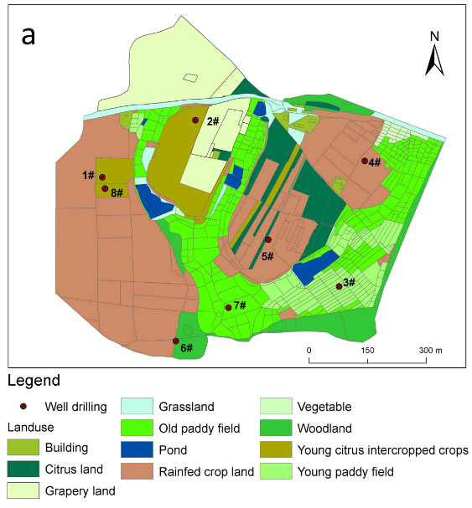
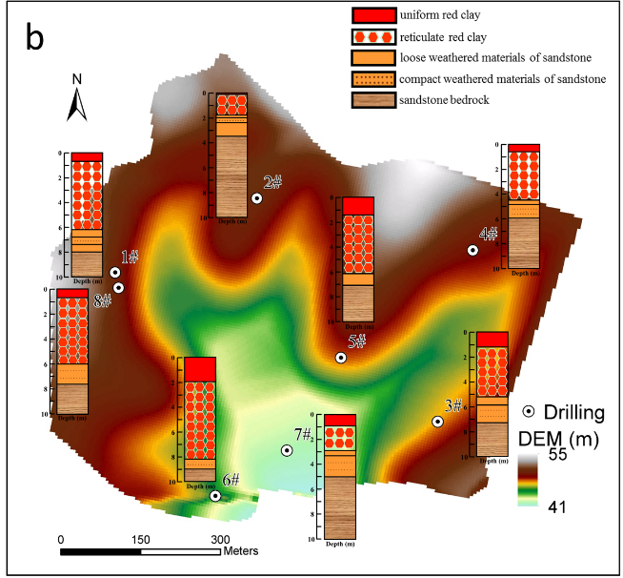
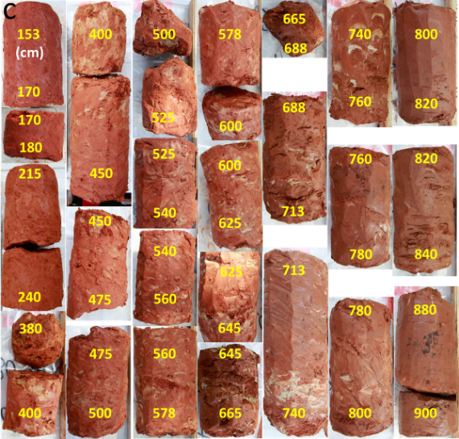
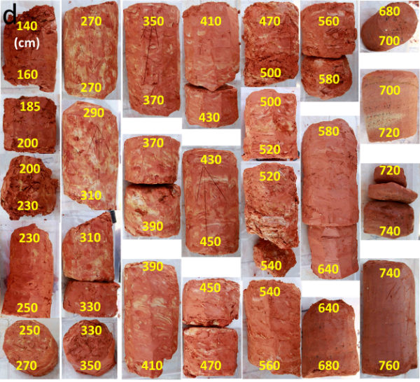
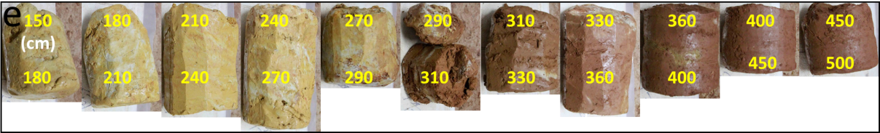
590

591
592
- Fig. 1. Land uses map of the Red Soil Critical Zone Observatory with eight drilling sites (a), digital
- elevation model map with schematic diagram of the stratigraphy determined on drill core samples
- (b), and photographs of undisturbed cores of #6 woodland (c), #8 upland (d) and #7 old paddy field
- (e) regoliths.
597
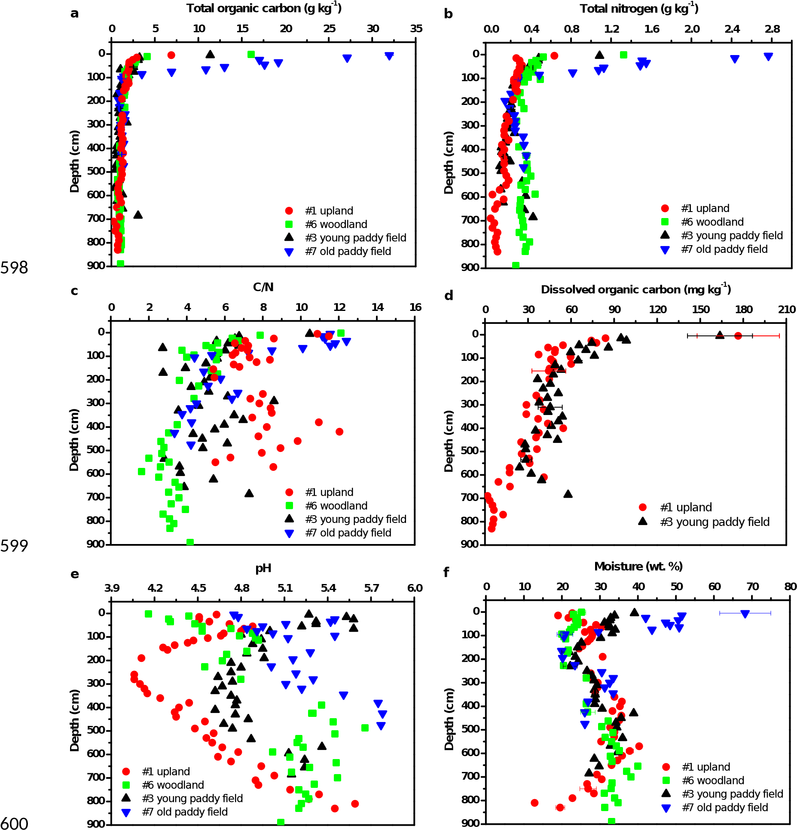
601 Fig. 2. Selected properties of the regoliths among land uses. Error bars represent the standard 602 deviation of the mean.
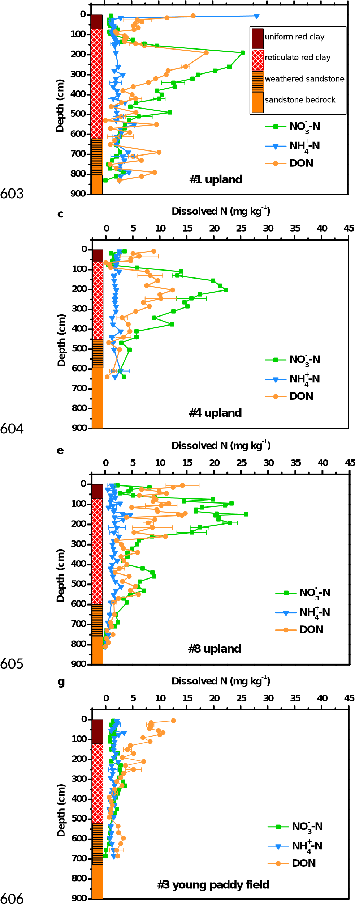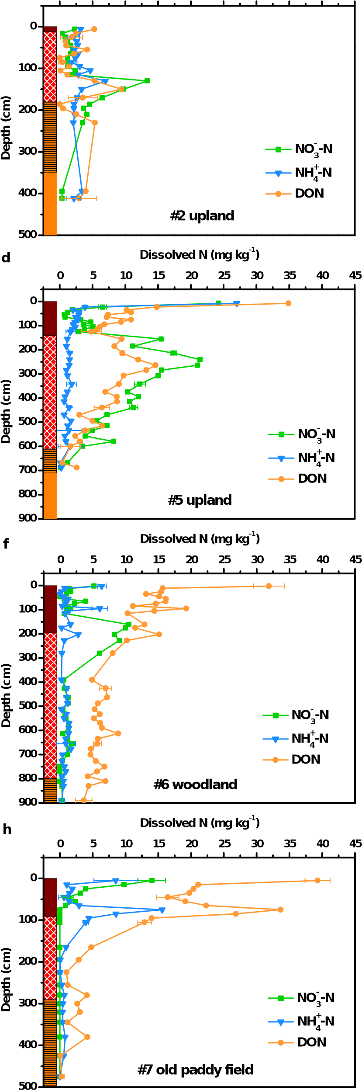
a Dissolved N (mg kg⁻¹)  0 5 10 15 20 25 30 | b Dissolved N (mg kg⁻¹)  35 40 45 0 5 10 15 20 25 30 | 35 40 | 45
607 Fig. 3. Dissolved N concentrations through the whole regolith in the upland, woodland and paddy 608 field land uses. Error bars represent the standard deviation of the mean.
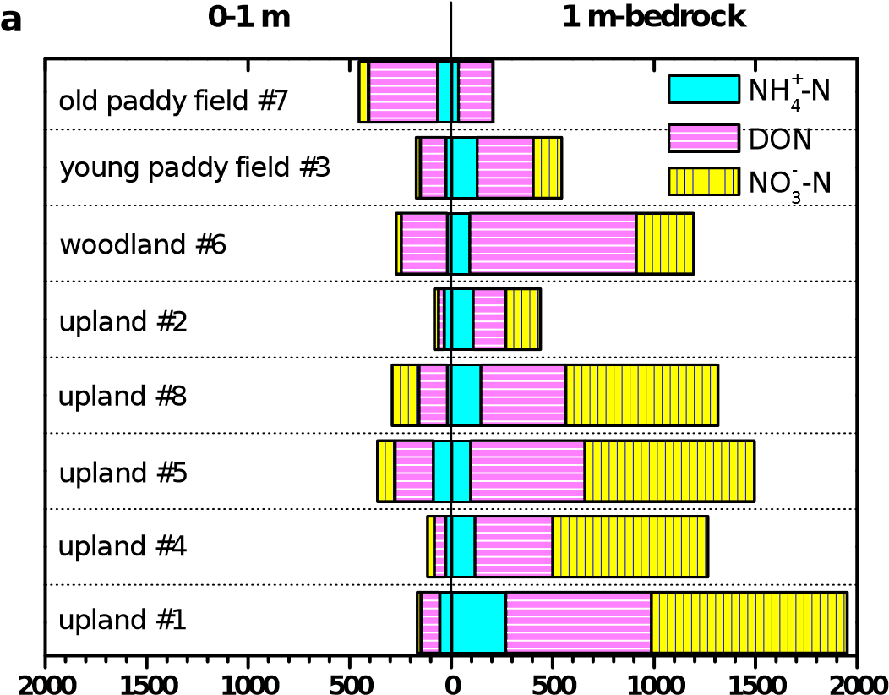
609 Inventory (kg N ha⁻¹)
Inventory (kg N ha⁻¹) b
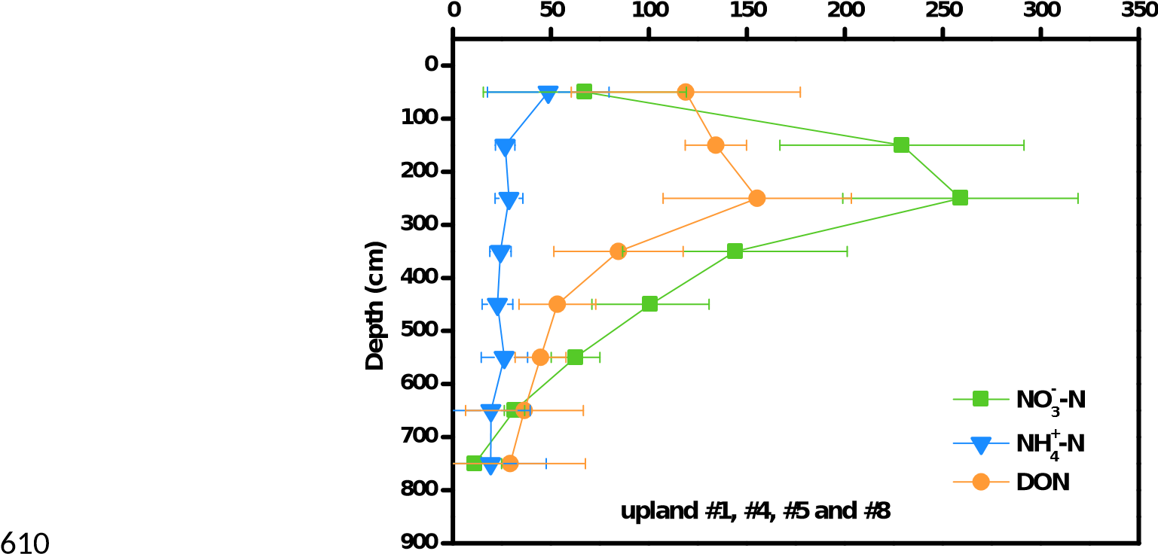
- Fig. 4. Comparison of dissolved N inventories at depths between 0-1 m and below 1 m to bedrock
- under different land uses (a), dissolved N inventories at 1-m depth intervals of upland regoliths (#1,
- #4, #5 and #8) (b). Error bars represent the standard deviation of the mean.

a Total porosity (%)
b
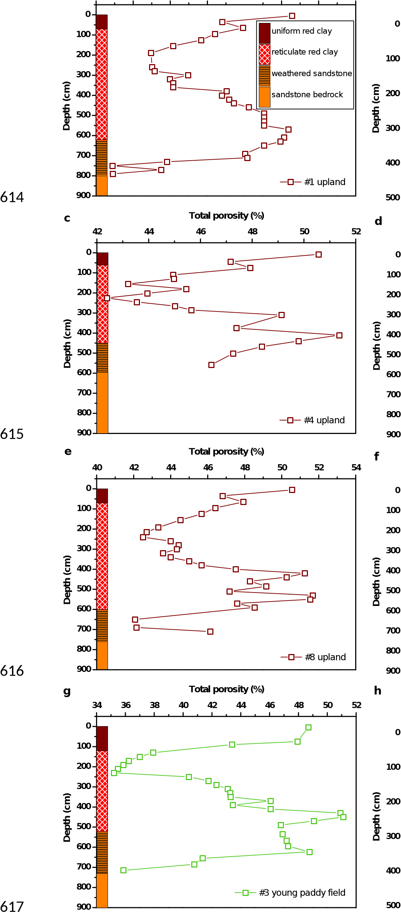
40 42 44 46 48 50 52 54 16
Total porosity (%)
20 24 28 32 36 40 44 48 52

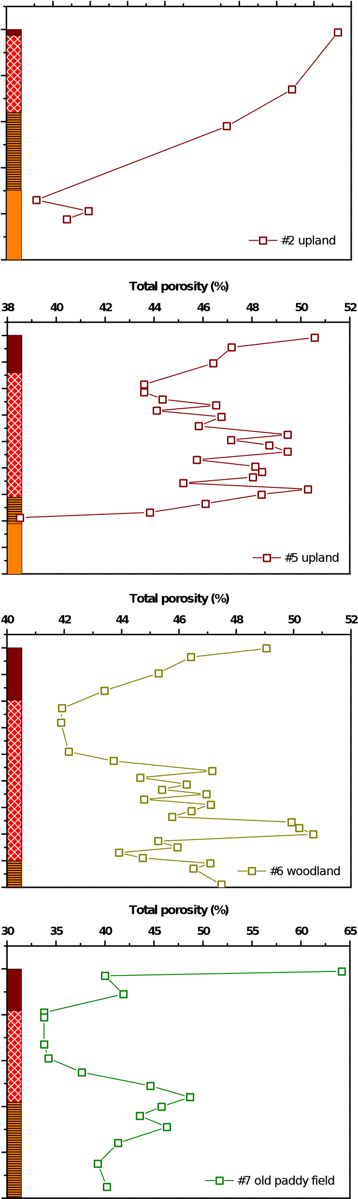
618 Fig. 5. Total porosity through the whole regoliths in the upland (a-e), woodland (f) and paddy field 619 (g and h) land uses.

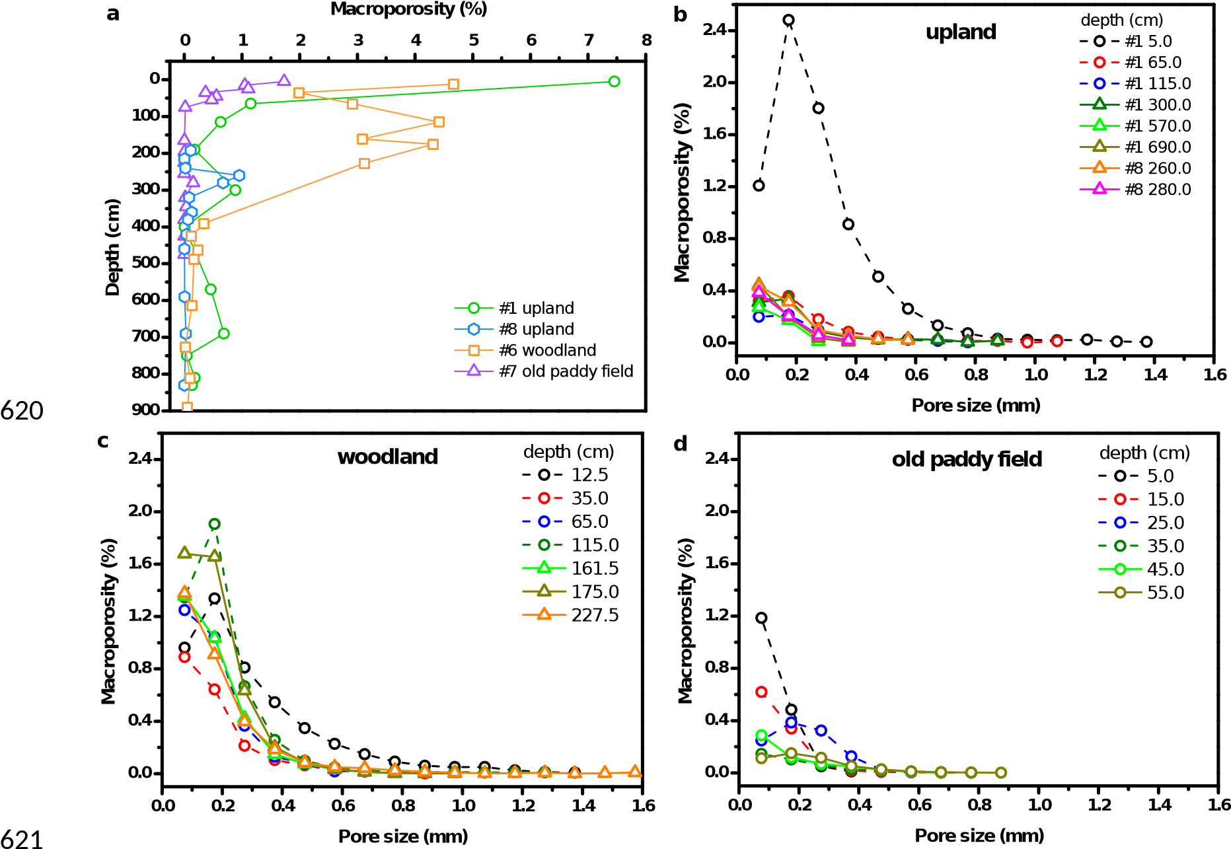
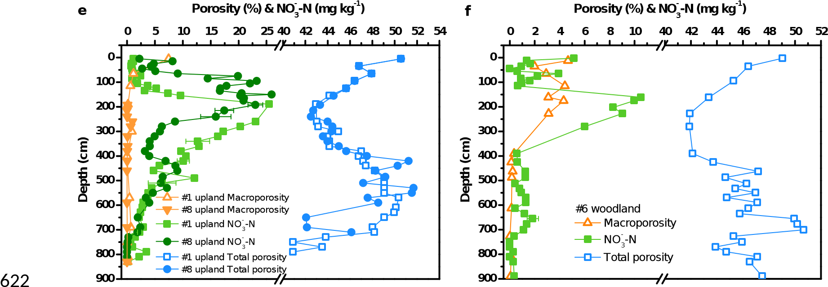
623 Fig. 6. Total macroporosity (a), pore-size distribution (b-d) and the relationship between porosity 624 and NO₃⁻-N concentrations (e and f) in the regolith among land uses.

625 Supplementary data
- Accumulation of Nitrate and Dissolved Organic Nitrogen at Depth in a Red Soil Critical Zone
- Huayong Wuª, Xiaodong Songª, Xiaorui Zhao^{a,b}, Xinhua Pengª, Hu Zhouª, Paul D. Hallett^{c}, Mark 628 E. Hodson^{d}, Gan-Lin Zhang^{a,b,}*
- ª State Key Laboratory of Soil and Sustainable Agriculture, Institute of Soil Science, Chinese
- Academy of Sciences, Nanjing 210008, China
- ^{b} University of Chinese Academy of Sciences, Beijing 100049, China
- ^{c} School of Biological Sciences, University of Aberdeen, Aberdeen AB24 3UU, United Kingdom
- ^{d} Environment Department, University of York, York YO10 5NG, United Kingdom
- Description of supplementary data
- Table S1. Sample sizes of the undisturbed regolith cores used for μ-CT analysis.
- Fig. S1. Bulk density through the whole regoliths with land uses of upland (a-e), woodland (f) and 637 paddy field (g and h).
638 Fig. S2. 3D morphology of undisturbed cores of upland regolith (#1). The white is the pores and the 639 green is the solids.
640 Fig. S3. 3D morphology of undisturbed cores of upland regolith (#8). The white is the pores and the 641 green is the solids.
642 Fig. S4. 3D morphology of undisturbed cores of woodland regolith (#6). The white is the pores and 643 the green is the solids.
- Fig. S5. 3D morphology of undisturbed cores of old paddy field regolith (#7). The white is the pores
- and the green is the solids.
647 Table S1. Sample sizes of the undisturbed regolith cores used for μ-CT analysis.
Land uses | Depth (cm) | Sample sizes
 |  | x (mm) | y (mm) | z (mm)
upland #1 | 0-10 | 30.00 | 24.00 | 46.00
 | 60-70 | 32.32 | 24.75 | 27.50
 | 110-120 | 32.32 | 26.40 | 28.35
 | 180-200 | 14.50 | 14.40 | 4.66
 | 290-310 | 14.83 | 9.84 | 17.28
 | 390-410 | 9.92 | 9.70 | 6.24
 | 560-580 | 13.30 | 7.01 | 21.60
 | 680-700 | 13.41 | 13.02 | 11.82
 | 740-760 | 13.60 | 12.19 | 12.30
upland #8 | 185-200 | 27.00 | 17.00 | 10.00
 | 200-230 | 8.92 | 6.75 | 23.00
 | 230-250 | 15.00 | 15.00 | 11.50
 | 250-270 | 15.50 | 12.50 | 14.00
 | 270-290 | 12.68 | 9.75 | 15.00
 | 310-330 | 27.30 | 27.30 | 32.50
 | 350-370 | 20.00 | 20.00 | 31.25
 | 370-390 | 20.00 | 16.00 | 10.50
 | 410-430 | 12.00 | 12.00 | 17.50
 | 450-470 | 19.00 | 16.00 | 18.75
 | 580-600 | 12.00 | 35.00 | 10.00
 | 680-700 | 35.00 | 30.00 | 18.00
woodland #6 | 5-20 | 25.88 | 22.58 | 28.00
 | 30-40 | 25.88 | 21.90 | 25.00
 | 60-70 | 24.75 | 20.03 | 25.00
 | 110-120 | 28.42 | 24.53 | 43.75
 | 153-170 | 26.72 | 24.75 | 25.00
 | 170-180 | 24.08 | 30.00 | 26.50
 | 215-240 | 26.62 | 23.40 | 43.23
 | 380-400 | 11.62 | 8.33 | 5.40
 | 400-450 | 21.30 | 20.33 | 15.40
 | 450-475 | 21.60 | 21.83 | 30.50
 | 475-500 | 18.45 | 23.62 | 6.25
 | 600-625 | 21.53 | 21.00 | 12.50
 | 713-740 | 29.03 | 25.58 | 30.35
 | 800-820 | 15.23 | 14.40 | 14.00
 | 880-900 | 30.75 | 27.30 | 20.50
old paddy | 0-10 | 33.00 | 26.40 | 28.13
field #7 | 10-20 | 29.50 | 26.50 | 39.50
 | 20-30 | 30.50 | 30.50 | 41.25
 | 30-40 | 34.00 | 30.00 | 42.50
 | 40-50 | 34.50 | 28.00 | 36.75
 | 50-60 | 32.00 | 32.00 | 37.50
 | 60-70 | 26.00 | 23.00 | 28.00
 | 70-80 | 14.48 | 19.28 | 7.50
 | 150-180 | 23.03 | 20.40 | 45.50
 | 180-210 | 23.94 | 30.15 | 59.40
 | 210-240 | 20.33 | 20.03 | 10.50
 | 240-270 | 24.60 | 23.03 | 15.00
 | 270-290 | 24.98 | 12.60 | 7.50
 | 310-330 | 15.00 | 15.00 | 10.00
 | 330-360 | 10.20 | 11.95 | 11.00
 | 360-400 | 26.62 | 25.12 | 18.25
 | 400-450 | 20.70 | 25.05 | 20.00
 | 450-500 | 28.88 | 28.88 | 30.00
648
649
a |  |  |  | Bulk density (g cm⁻³) |  |  | b
 | 1.25 | 1.30 | 1.35 | 1.40 1.45 1.50 | 1.55 | 1.60
Bulk density (g cm⁻³)
1.3 1.4 1.5 1.6 1.7 1.8 1.9 2.0 2.1 2.2
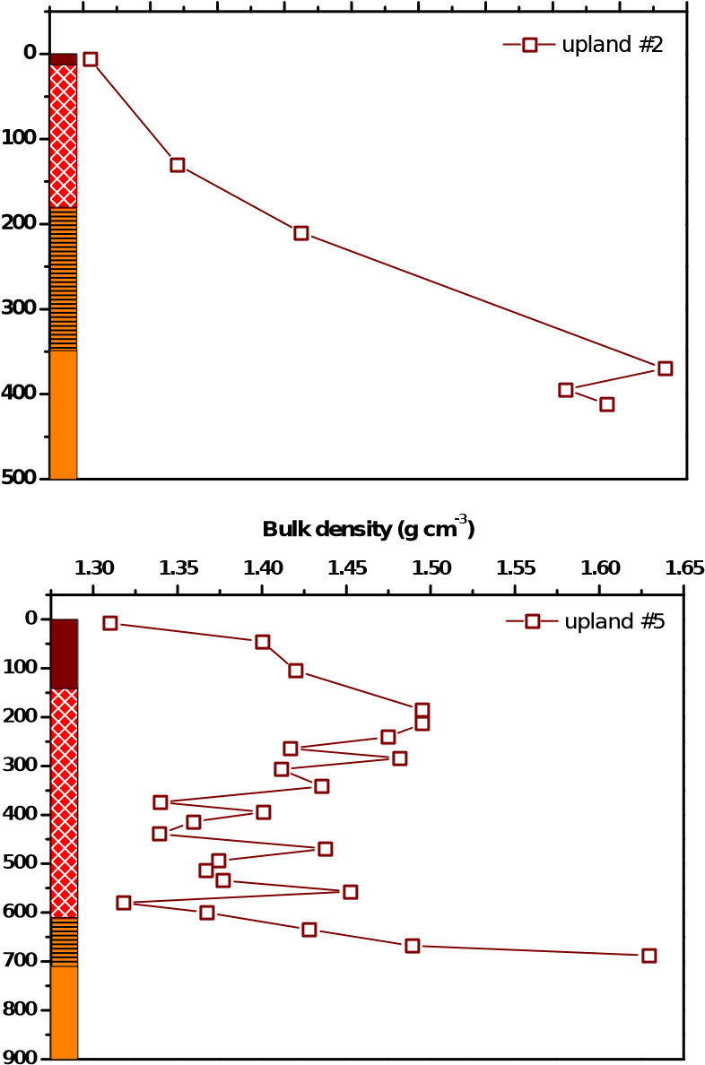
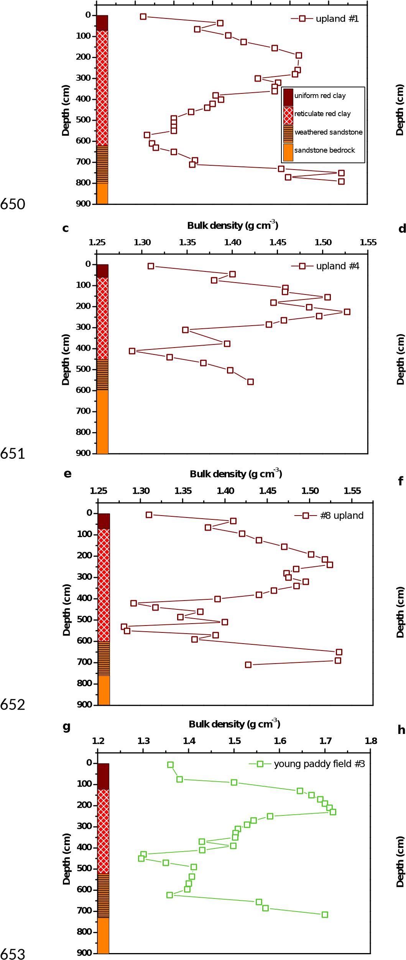
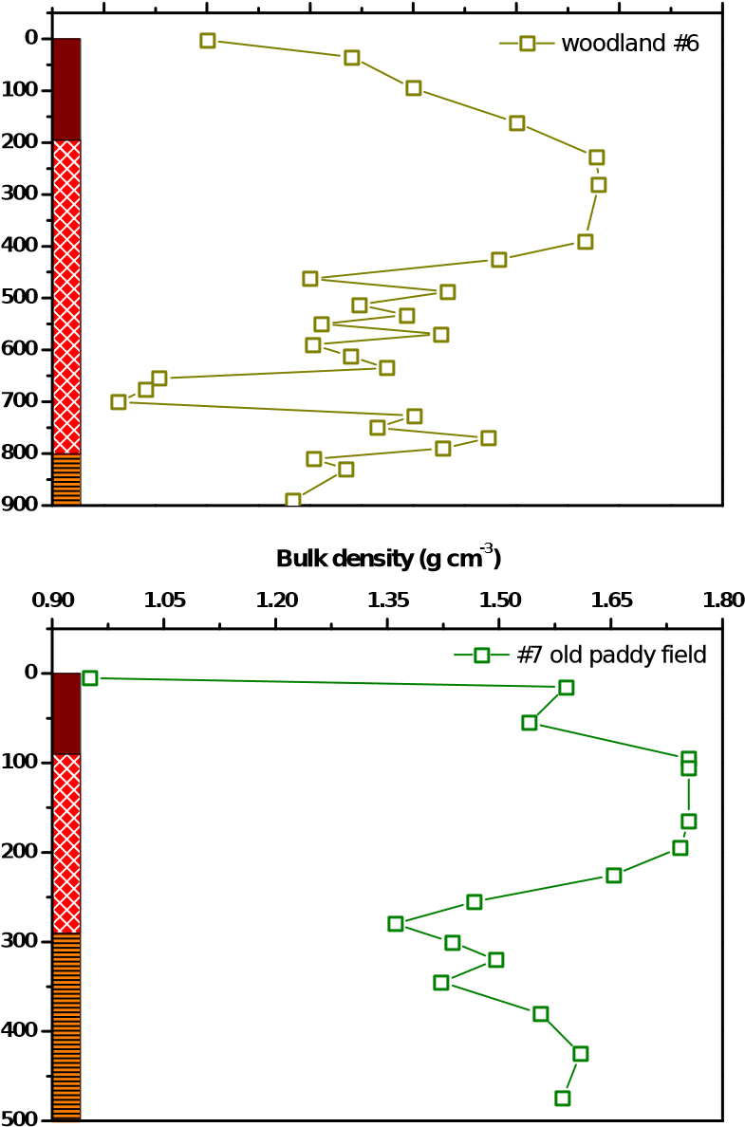
Bulk density (g cm⁻³)
1.30 1.35 1.40 1.45 1.50 1.55 1.60

654 Fig. S1. Bulk density through the whole regoliths with land uses of upland (a-e), woodland (f) and 655 paddy field (g and h).
657 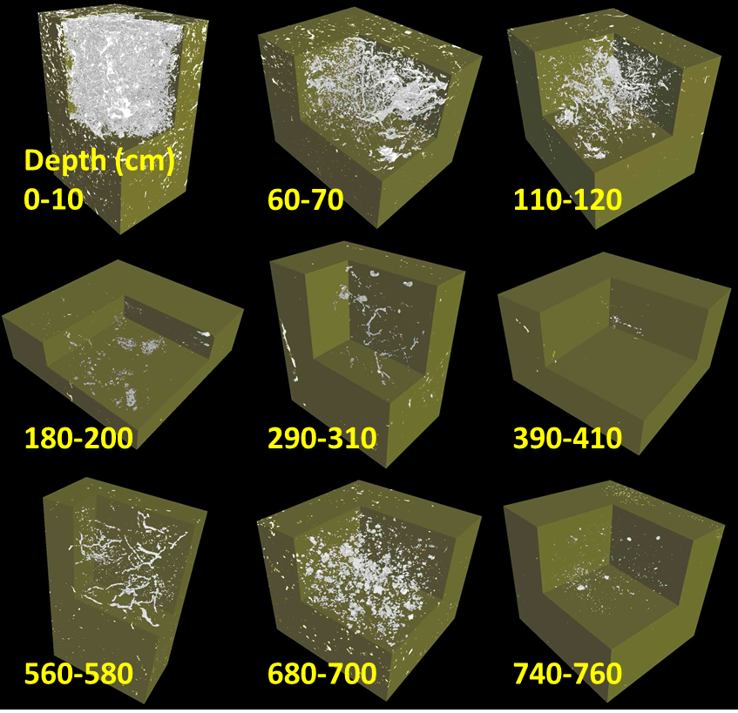
- Fig. S2. 3D morphology of undisturbed cores of upland regolith (#1). The white is the pores and the
- green is the solids.
661 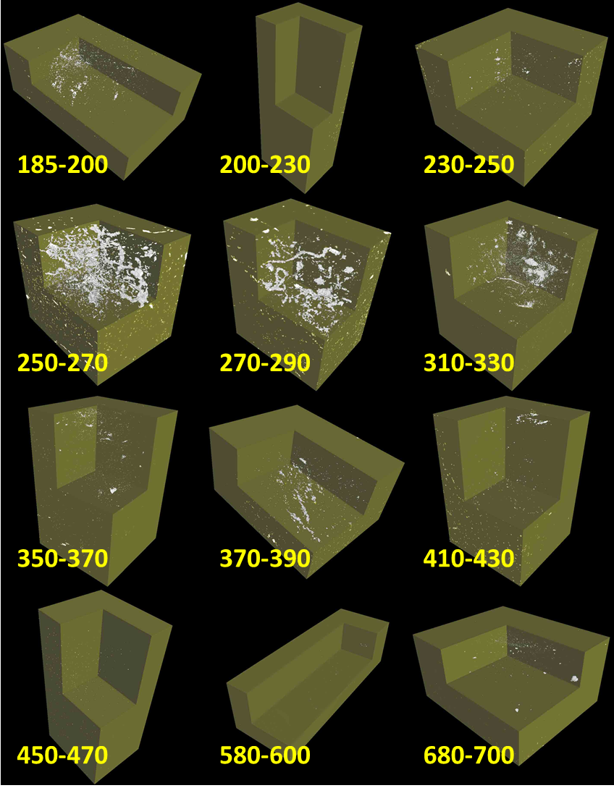
662 Fig. S3. 3D morphology of undisturbed cores of upland regolith (#8). The white is the pores and the 663 green is the solids.
664
665 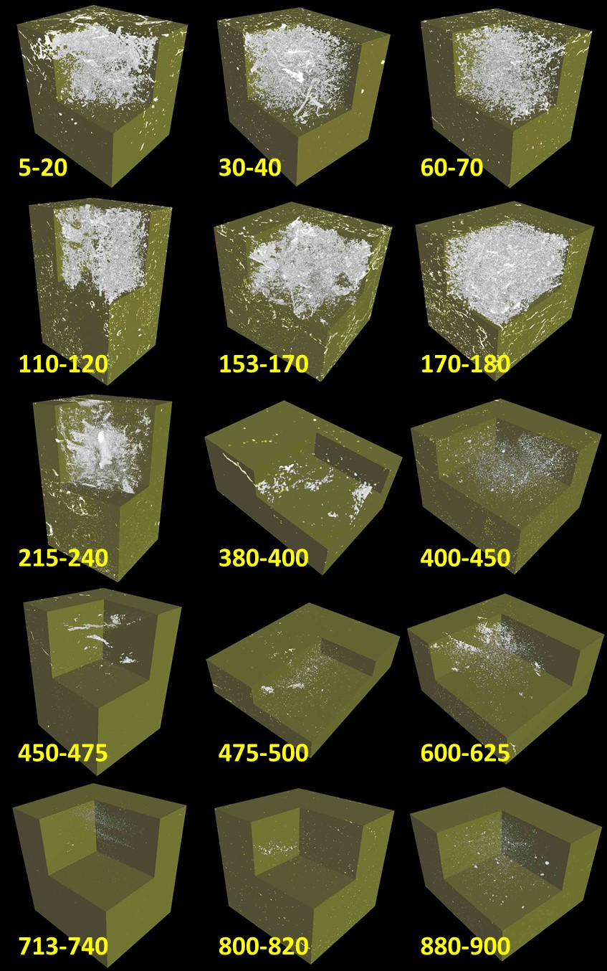
666 Fig. S4. 3D morphology of undisturbed cores of woodland regolith (#6). The white is the pores and 667 the green is the solids.
668
669 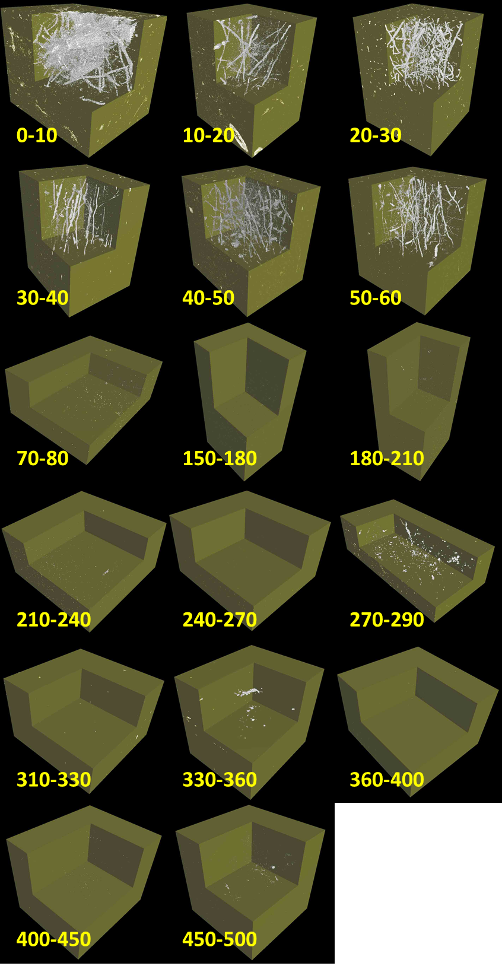
- Fig. S5. 3D morphology of undisturbed cores of old paddy field regolith (#7). The white is the pores
- and the green is the solids.

