**Title:** Measuring site fidelity and homesite-to-pre-spawning site connectivity of Bonefish (*Albula vulpes*): using mark-recapture to inform habitat conservation

R.E. Boucek1, J.P. Lewis1, B.D. Stewart2, Z.R. Jud3, E. Carey4, A.J. Adams1, 5

1Bonefish & Tarpon Trust, 135 San Lorenzo Avenue, Suite 860, Coral Gables, FL 33146

Department of Environment and Geography, University of York, York, United Kingdom

3Florida Oceanographic Society, 890 Northeast Ocean Boulevard, Stuart, FL 34996

4 Bahamas National Trust, P. O. Box N-4105, Bay Street Business Centre, Bay St. East, Nassau, Bahamas

5 Florida Atlantic University Harbor Branch Oceanographic Institute

5600 US 1 North, Fort Pierce, FL 34946

Keywords: mark-recapture, recreational fisheries, conservation, site-fidelity, homesite-to-pre-spawning site connectivity, marine protected area, Bonefish (*Abula vulpes*)

**Abstract**

Effective marine habitat protection requires life history information, including identification of connected adult habitats and spawning sites, and movement information throughout those areas. Here, we implemented a mark-recapture study in the Bahamas Archipelago to estimate patterns of site fidelity, and to determine what homesites are connected to pre-spawning sites of economically important Bonefish (*Albula vulpes*) across multiple islands. We captured over 7,000 Bonefish via seine netting, marked them with dart tags, and relied on fishing guides and anglers to report recaptures on Abaco, Grand Bahama, and Andros. Mark-recapture results from the three islands showed that 60-80% of Bonefish were recaptured within 5 km of their tagging site. Across the three islands, mean distance between mark and recapture was less than 11 km, suggesting space use that is tractable for effective marine reserve implementation. We also found that pre-spawning sites housed individuals from multiple homesites that were separated by distances up to 75 km. With these connections in mind, conserving Bonefish spawning biomass necessitates habitat protection in multiple home areas, along migratory corridors, and at pre-spawn and spawning locations. Our case study illustrates how mark-recapture of a C&R species can be used to identify habitats for protection. Information from this mark-recapture study contributed to the designation of six National Parks aimed at protecting habitats used by Bonefish, as well as other spatially overlapping species.

**Introduction**

Habitat loss and overharvest are the two dominant causes of declines in marine fisheries. Marine reserve networks are one conservation tool that can mitigate the effect of both of these drivers (Green et al. 2015). Marine reserve networks for fish are designed to protect a subset of a population throughout the target species’ life cycle, where reserves are placed on spawning sites, nursery habitats, and important staging and feed grounds (Roberts et al. 2001; Gaines et al. 2010). Because the central focus of marine reserve networks for harvest-oriented fisheries is usually to eliminate harvest within the area designated for protection (i.e. no take reserves), reserve implementation can inspire conflicts between fishers and resource managers, leading to management compromises that limit the effectiveness of the conservation action (Halpern and Warner 2003).

For fisheries that are primarily catch and release (C&R), the use of marine reserve networks has the potential to provide numerous benefits, with relatively minimal angler and stakeholder opposition (Cooke et al. 2006). Assuming best angling practices are followed, and fishing effort is measured (i.e. individuals are not caught multiple times per year), fishing mortality for C&R fisheries is generally negligible relative to natural mortality (Cooke and Suski 2005). With this in mind, habitat degradation functions as the major threat to C&R species, which can be mitigated with marine reserve networks (Adams and Murchie 2015). For those species where catch and release fishing is sustainable, marine reserve networks can be designed to allow some level of fishing, thereby offering habitat protection while reducing stakeholder conflicts, and even fostering collaborations between managers and anglers in the design of reserve networks.

The Bahamas archipelago supports coral reef and shallow water flats (i.e., broad, shallow areas with sand, marl, or seagrass substrate) ecosystems that provide world class fishing and diving opportunities. An important component of the marine-based economy is an economically valuable C&R fishery for Bonefish. The fishery has an annual economic impact exceeding $141 million in The Bahamas, and is of cultural importance (Fedler 2010). Unfortunately, habitats that support Bonefish and other species are under threat from coastal development via commercial enterprises such as ports, marinas, and hotels. With these pressures to transform habitats in mind, developing protection schemes for habitats essential to Bonefish is a priority.

To implement an effective marine reserve network for fish, connected nursery habitats, adult habitats, and spawning sites must be identified (Gaines et al. 2010). To inform decisions on size and geometry of protected areas, information on spatial use and movement within each of these ontogenetically linked habitats is also needed (Grüss et al. 2011; Weeks et al. 2017). Animal movement can be driven by foraging, predator avoidance, personality, life history drivers such as spawning, and abiotic drivers that interact with physiological tolerances, which must be measured to some degree to inform protection schemes (Boucek et al. 2017a, Spiegel et al. 2017). For instance, protected adult habitat must encompass the home ranges (defined as the area an animal uses on a regular basis for its routine activities; Mace et al. 1983) of enough individuals to ensure an effective spawning population (Kramer and Chapman 1999; Green et al .2015). Likewise, both spawning sites and migration pathways to those sites must be conserved to protect both spawning and pre-spawning behaviors (Boucek et al. 2017b).

In this study, we use mark-recapture to provide spatial data on Bonefish to inform conservation efforts focused on habitat protection. We used mark-recapture information to determine: 1) patterns of site fidelity, or the degree to which individuals use and return to the same general home area (Switzer 1993), of adult Bonefish; and 2) the number of observed home areas that contribute individuals to pre-spawning aggregation sites. To ensure a viable spawning population exists at a specific spawning aggregation site, home sites that contribute individuals to that aggregation must be protected (Halpern & Warner 2003). An overall study objective was to define this connectivity between pre-spawning sites and home sites to identify and ultimately protect homesites needed to maintain viable spawning biomass (Fig. 1). During spawning, bonefish stage in large aggregations at pre-spawning sites, while spawning occurs close by at night at depths greater than 50 meters. Bonefish occupy these pre-spawning aggregations for 3 to 5 days, where they are vulnerable to harvest. As such, pre-spawning aggregation sites are priorities for protection.

**Methods**

*Species description*

Bonefishes (*Albula spp.*) are members of a coastal genus that includes 12 species which are found throughout the tropics (Wallace 2015). In many areas throughout their range, Bonefish contribute to lucrative C&R fisheries. In the Caribbean and in The Bahamas, there are four species, with *Albula vulpes* supporting the recreational fishery (Wallace and Tringali 2016). For the remainder of this manuscript, “Bonefish” refers to *A. vulpes* since >98% of Bonefish sampled in the Bahamas were genetically identified as *A. vulpes* (Adams et al. 2008; Wallace and Tringali 2016; Wallace pers. com.). To sustain the fishery, Bonefish require an intact coastal habitat mosaic to support various stages of their lifecycle. At the juvenile stage, Bonefish associate with shallow wind protected habitats, whereas adults prefer more open shallow water sand and seagrass flats habitats (Danylchuk et al. 2007; Haak et al. 2018; Murchie et al. 2013). For reproduction, around the new and full moons from October to May, adults undergo long-distance migrations where they aggregate at pre-spawning sites. Pre-spawning sites are in deeper water (> 2 M), are smaller in area than flats habitats (1< km2), and occur in areas adjacent to, or near water of abyssal depths, that are typically removed from the flats where typically the best Bonefishing occurs. At dusk, bonefish swim to pelagic environments where they spawn at depths greater than 50 M, and spawning bouts are generally less than 8 hours (Danylchuk et al. 2011). Prior to spawning bouts, Bonefish have unique behaviors, that include gulping air, and jumping out of the water (Adams et al. 2018; Danylchuk et al. 2018). Many habitats used throughout Bonefish ontogeny are threatened by anthropogenic degradation, necessitating proactive habitat conservation measures to sustain the species and fishery (Adams et al. 2011). Already, at our current habitat loss rate, an International Union for the Conservation of Nature (IUCN) assessment classified Bonefish as Near Threatened due to habitat loss and fragmentation (particularly mangroves and seagrasses), coastal development and urbanization, declines in water quality, and harvest by commercial, artisanal and recreational fisheries (Adams et al. 2011).

*Study Site Description*

The Bahamas archipelago consists of 3,000 islands and cays, and is located off the southeastern coast of North America, from latitude 21° to 27°. This study took place on the flats surrounding the islands of Grand Bahama Island, Abaco, and Andros (Fig. 2). Adult Bonefish use two general types of habitats that have different life history functions. The first consists of their foraging habitats, referred throughout the manuscript as ‘flats’. Flats habitats in the Bahamas are < 2 meters in depth, with a substrate of sand, and patchy seagrass, algae-covered-limestone, marl, and mangroves. Previous research studying Bonefish movement indicates that adult Bonefish generally show fidelity to specific flats (Larkin 2011). Flats vary in size, though those in this study are relatively large, ranging from 30 km2 to greater than 60 km2. The second habitats of focus are Bonefish pre-spawning sites. At these pre-spawning sites, Bonefish aggregate in the hundreds to thousands, and show behaviors that are not observed on flats habitats (e.g., gulping air; Danylchuk et al. 2011; Adams et al. 2018; Danylchuk et al. 2018). Four pre-spawning sites were used in this study, and meet the criteria of a spawning related aggregation site set by Sadovy De Mitcheson et al. (2008) and are summarized in Adams et al. (2018). The three criteria we use to determine a pre-spawning aggregation include 1) an evaluation of spawning readiness, where gonads are sampled and staged, 2) observed unique pre-spawning behaviors that include bonefish gulping air and jumping out of the water at dusk, and 3) evidence of migration to that site, either through mark-recapture or other tracking technologies.

*Tagging and recaptures*

Bonefish were captured using seine nets or hook-and-line, and tagged with dart tags (PDL, 85mm length, Hallprint, Australia) from March 2009 through September 2017. Tagging efforts were focused on flats that are fished as part of the C&R fishery, which are known to support large populations of adult Bonefish. We also tagged fish outside of Bonefish flats habitats along shoreline areas where fishing guides had revealed to us a seasonal abundance of fast-moving, non-feeding schools of Bonefish associated with fall and winter full moons that they associated with spawning migrations.

Teams of scientists and approximately 200 fishing guides and anglers used seine nets that ranged in length from 15 to 91 m, height of 1.2 m, and mesh size of 3 to 5 cm. From shallow-draft skiffs, guides would sight a school of Bonefish, and the nets were deployed from the skiffs to encircle the school or trap the school in a confined area. Once encircled by the net, individual Bonefish were transferred to rectangular, flow-through plastic tubs prior to tagging. Fish were then briefly removed from the water to be measured (fork length) and tagged (tag inserted under the dorsal fin). After tagging, fish were held in a second net or aerated tubs, and released in small groups or the entire school *en masse* to reduce post-release predation. In addition, fishing guides and anglers who participated in the study captured fish by hook and line, briefly removing the fish from the water to measure and tag before releasing the fish at the site of capture. Printed on the dart tags were alphanumeric codes: three-letter codes identified the island (Abaco (BAN), Andros (BAS), Grand Bahama (BAP & BAL)); five-digit, sequential numbers provided unique identification for each tagged fish. Also printed on the tags were a web URL and phone number to report a recapture. We used the shortest distance by water between tag and recapture locations (Cunjak et al. 2005), as an estimate of movement. We partitioned data into two groups for analysis. The partitioning was informed by the habitat type were mark and recaptures occurred. To achieve our first research objective, we only used information from fish marked on a flat, then recaptured on a flat (94 recapture events). For this analysis, because these marks or recaptures did not occur at a pre-spawning site, we assumed these movements were unrelated to spawning migrations. However, it is possible that some recaptures could have occur while a fish was traveling to, or returning from spawning. The remaining recaptured fish (10 bonefish), were either marked or recaptured at a pre-spawning site. We used these fish to describe pre-spawning aggregation sites and their connectivity to home- flats.

*Bonefish patterns of site fidelity*

To determine if site fidelity was consistent across multiple islands, we calculated mean distance between mark and recaptures for Bonefish tagged on Grand Bahama, Andros, and Abaco. We built 95% confidence intervals around those means from a bootstrapped distribution, resampling distances between tagging and recapture locations, using 1,000 simulations (Program R, mosaic package). If confidence intervals overlapped across islands, we considered those distances between mark and recapture to be similar. We chose this statistical approach because differences among treatments are easy to visualize, and therefore are easier to communicate to a non-science audience. We do acknowledge this approach may slightly increase the chances of type II error. In addition, because fish size and time between mark and recapture can influence distance traveled for some species (Kareiva 1983; Samoilys 1997), we described relationships between distance between mark and recapture and Bonefish size and days at large, with linear regression.

*Number of home sites that contributed individuals to a pre-spawning site*

An important aspect of the study was to determine if Bonefish spawning aggregations are made up of fish from one flat or many flats. We determined if bonefish originated from different flats or at least did not overlap in habitat use, if the distance between their known location on the flat (tag or recapture) and other known locations of bonefish that visited the same aggregation was greater than two times the mean distance between mark recapture for fish at that island. We use this metric because MPAs that protect an area two times greater than the homerange of an individual adequately protect target fish populations from fishing (Kramer and Chapman 1999). With this distance in mind, we feel that 2 times the mean distance of mark and recapture is an adequate approximation of whether fish overlap in habitat use.

Following methods of previous studies that have used mark-recapture to estimate fish movement in and out of aggregations (Luckhurst 1998; Adams et al. 2011) and spawning aggregation catchment areas (Domeier & Spaere 2012), we used mark-recapture to describe pre-spawning sites and homeflat connectivity for four known Bonefish pre-spawning locations (Murchie et al. 2013; Adams unpub. data). In addition to marking and recapturing Bonefish at the known pre-spawning aggregations, we also marked Bonefish at a location that recreational fishing guides indicated lies along a Bonefish migration pathway. This location is 57-km from a known pre-spawning site (site #2), and is not typically inhabited by large numbers of Bonefish except during brief periods associated with fall and winter full moons, when large schools of non-feeding Bonefish have been observed quickly moving through the area during multiple years (Adams personal observation). We consider fish marked at this migration-route site and recaptured elsewhere to be associated with a single pre-spawning site. In a separate telemetry study, 10 Bonefish were acoustically tagged at this location and two were detected at pre-spawning site #2 (Jud unpublished data). Likewise, fishing guide reports and our experience while sampling indicate this migration typically occurs near the full or new moons during spawning season, which are conditions association with Bonefish spawning migrations (Danylchuk et al. 2011).

**Results**

Bonefish site fidelity

Over the course of the study, 7,017 Bonefish were marked with dart tags, of which 105 were recaptured (recapture rate of 1.5%; Tables 1-3). Information on the seasonality of tagging and recaptures can be found in Fig. S1 and S2. Days at large and body size did not describe distance between mark and recaptures (R2 < 0.001; Fig. S3, S4). Most fish that were both marked and recaptured on the flats (82% on Abaco, 60%, Grand Bahama, 75% Andros) were recaptured within 5 km of their tagging site, suggesting high site fidelity within flats habitats (Figure 2). Mean distance between mark and recapture for Bonefish across all three islands was < 11 KM based on bootstrapped distributions (95% C.I.; 2.1 to 18.1 km; Fig. 3).

*Number of home sites that contributed individuals to a pre-spawning site*

Ten Bonefish were either tagged on a flat and recaptured at a pre-spawning site, or tagged at a pre-spawning site and recaptured on a flat (Table 2; Table 3). Using these 10 individuals across the four pre-spawning sites considered in this study, maximum distances traveled between pre-spawning sites and recapture sites per island ranged from 22 km to 80 km (Table 2; Table 3). Across the three pre-spawning sites, both spawning site #1 and spawning site #3 housed individuals from different homeflats. At site #1, the two recaptures that were furthest apart were separated from each other by an over-water distance of 71 km (AN1- AN4; Figure 4a). The two that were closest (AN3-AN4) were separated by 13 KM (2x mean distance between mark and recapture on Andros = 7 KM). The two fish associated with site #2 were both tagged at the migration corridor and recaptured approximately 9 km away from each other, indicating that those two fish likely overlapped in habitat use. For the 3 recaptured Bonefish tagged at pre-spawning site #3, (located on the south side of Grand Bahama) one recapture occurred on the north side of the island, another fish associated with this site was recaptured 6 km away from the pre-spawning site, and the third was recaptured 48 km southeast from the pre-spawning site (Figure 4c). The over-water distance between the single recapture on the Northwest side of the of the island and the Southeast side of the island is 163 km. And, the distance between GB2 and GB3 was 47 KM. Only one of the 10 fish tagged or recaptured at pre-spawning sites, occurred at site #4.

**Discussion**

In this study, we demonstrated that Bonefish exhibit high site fidelity to particular areas of flats, with distances between mark and recapture generally less than 10 km. This high degree of site fidelity makes protecting the primary habitats that adult Bonefish use for foraging possible with moderately sized MPAs (Moffitt et al. 2009). Second, we learned that Bonefish will travel up to 80 km to reach a pre-spawning site, and that pre-spawning sites attract at least one Bonefish from distinct home areas, separated by distances by over 80 km. Thus, protecting spawning biomass for a single pre-spawning site necessitates protecting multiple spatially distinct home areas. As in other studies, the mark-recapture approach used here provided actionable information to inform a marine reserve network designed to protect both connected adult habitats and pre-spawning sites.

Bonefish movement ecology shows use of generally the same areas (high degree of site fidelity) coupled with long distance spawning migrations. Our results from mark recapture could also be interpreted that bonefish are moving only very short distances, or showing a high degree of residency. We think this conclusion is unlikely, based off telemetry studies in Eleuthera (Bahamas). For instance, Murchie et al. (2013) showed with acoustic telemetry that Bonefish can move up to 23 km per day. Thus, Bonefish likely move, but revisit the same areas during their day to day life. These patterns in Bahamian Bonefish movements are consistent with space use patterns observed in the Florida Keys (Humston et al. 2005; Larkin 2011), in Belize (Perez et al., this issue), and other studies in the Bahamas (Haley 2009). Repeatedly visiting the same areas at home sites coupled with distant spawning migrations is a movement regime not specific to Bonefish. For example, Nassau Grouper (*Epinephelus striatus*) during non-spawning season show high site fidelity, yet nearing the full moons in the winter adults will move up to 100 km to spawning sites, and subsequently return to their home range site (Bolden 2000). Likewise, Mutton Snapper (*Lutjanus analis*) in the Dry Tortugas, Florida (USA) occupy generally small home ranges but undergo distant spawning migrations (Feeley et al. 2018).

There are multiple mechanisms that could explain this movement ecology. First, animals may use a relatively small area to build memory of the system, which decreases time spent searching for prey. Likewise, familiarity with a specific area and knowledge of the predation regime decreases predation risk (Powell 2000). An alternative driver is dictated by habitat context. For instance, MPAs of the same area for some reef fish in contiguous habitats are less effective than those for the same species in habitats with discrete habitat boundaries encompassed in the MPA. In contiguous habitats, reef fish space use can expand and thus require more habitat to be protected (Moffit et al. 2009; Farmer & Ault 2011). The reef fish example demonstrates that animals may use a greater area if less discrete habitat boundaries exist. Interestingly, Bonefish in this study were tagged in contiguous shallow waters that extended 60 KM before a habitat boundary (i.e., deep water, a shoreline) occurred. Likewise, based on angler reports, bonefish abundance on flats is spatially structured. It is possible that Bonefish are responding to more inconspicuous habitat features. Else, Bonefish repeatedly visit the same areas to increase foraging efficacy and reduce predation risk.

The disparity between most Bonefish being recaptured within 5 km of the tagging location, and upper estimated mean distance between mark and recapture of 10 km is driven by a few long distance movements that do not appear to be associated with a pre-spawning site. There are multiple explanations for such movements. First, long-distance movements, though rare, could be from individual variation in behavioral types. For instance, in some animal populations, a small percentage of individuals avoid interacting with conspecifics (bold and asocial behavioral type), and are more likely to disperse (Cote et al. 2010). Second, these long-distance movements could be from tropical cyclones such has hurricane Sandy that affected the Bahamas in 2012, that may have passively relocated fish great distances. A bonefish tagged in Miami was recaptured in the Bahamas, Larkin (2011) speculated this could be storm driven. Likewise, angler reports following Hurricane Sandy show that adult Bonefish were being caught off Virginia and New York (U.S.). These bonefish were likely displaced from the storm. In either case, long-distance dispersers can be important for re-colonizing areas that were historically overfished, or affected by disturbance. Third, these outlier mark-recapture distances resulted from Bonefish that were migrating to or from a pre-spawning site (sites used in this study or undocumented sites) even though they were both tagged and recaptured on flats. In this scenario, those movements would have been incorrectly marked as non-spawning movements and increased type II error, and increasing mean distance between mark and recapture.

A common bias with mark-recapture studies is sampling in ways that increase probabilities of recapturing individuals that do not move, which, in turn, leads to an underestimation of space use (Nichols and Pollock 1983). This effect is common in stratified sampling designs that re-sample the same sites, or in schemes when the resampling area is smaller than the capacity for a species to move (Nichols and Pollock 1983; Albanese et al. 2003). In our study, most tagging was done via seine netting. However, nearly all recaptures were reported by professional fishing guides and their clients (anglers) who fish large portions of suitable Bonefish flats habitats within our study region. We conclude that distances between mark and recaptures observed here are an accurate reflection of Bonefish site fidelity and scale of movements on their home flats.

This study would not have been possible without collaborations between the angler community and the scientific community. Bonefish are particularly elusive, bonefish abundances are spatially structured in hard to predict ways, in seemingly contiguous habitat types, and the fish are well camouflaged to their environment. Due to these challenges, finding Bonefish in an efficient manor requires years of experience in the fishery, necessitating cooperative research with the guide and angler community. Our partnership with the guide and angler community is at the highest level of involvement, where researchers, guides, and anglers are integrated into all phases of the research process, including developing research questions ad formulating hypotheses (NRC 2004). We built and maintained these partnerships in similar ways outlined in Johnson and Van Densen (2007). We included stake-holders in the science and management process at the onset, communicated results regularly and to the larger angler community. We especially emphasized the value of ensuring that all sensitive information shared between anglers and scientists were never shared publicly (See Black et al. 2015). The angler community also saw our science being used towards improving the fishery, such as improving catch and release best practices, or by protecting spawning sites and adult habitats. Seeing science turn into conservation helped build our partnership. From this, guides and anglers tagged fish, reported recaptures, shared pre-spawning locations and shared quality Bonefish fishing spots. We do note that cooperative research did have its limitations. For instance, our reported recapture rate here is around 2 percent. The actual recapture rate was higher, but lack of reporting by fishing guides was common, whereby guides would catch a tagged fish and forget to report it or report a recapture without writing down the tag number. We did not track these reporting errors.

This study was used to inform the implementation of six national parks in The Bahamas to protect Bonefish habitats (and thus other species that overlap in habitat use). We first used Fisherman’s Ecological Knowledge (FEK) to identify productive Bonefish flats to designate for protection. Using (FEK) is a common approach to identify habitats suitable for marine reserves. For instance, Decelles et al. (2017) used FEK to identify spawning aggregations sites of Atlantic Cod (*Gadus morhua*) in Georges Bank (U.S.). Using FEK improved the spatial resolution of their scientific surveys, which is helping inform spatial closures aimed at rebuilding the Georges Bank Stock. Second, we estimated Bonefish site fidelity to guide the scale of habitat protection within an area. For instance, Kramer and Chapman (1999) demonstrated that setting a reserve area of 2 times the observed home range size of an individual within a population can reduce exposure of a population to fishing by 95%. Our mark recapture observations show that Bonefish distance between mark and recapture is usually less than 11 km, with actual individual space use likely being smaller. The six new National Parks to conserve productive fishing areas are up to 60 KM long (e.g., the Marls), and thus offer acceptable protection for Bonefish populations.

The larger purpose for these parks is to not only protect the Bonefish fishery, but to use Bonefish as an umbrella species, or as a tool for multi-species and ecosystem protection (Roberge and Angelstam 2004). Under the umbrella species concept, reserve network size and placement are set to protect habitats used by the single focal species, which offers protection for many other species that overlap in habitat use. Umbrella species are often mobile consumers and are charismatic, which increases public support for their conservation. C&R species, like Bonefish, have the utility to be used as an umbrella species (Adams and Murchie 2015). First, similar to choosing charismatic species as umbrella species, C&R species can generate large sums of money for local and regional economies if habitat protection is provided, thus incentivizing governing bodies to take action (Cooke and Cowx 2004; Adams and Murchie 2015). Second, since these species often utilize a number of habitat types throughout their life cycle, a diverse suite of other species can be conserved if habitat protection is given to all ontogenetic stages for one umbrella species (Adams 2017). In this scenario, the new national parks also protect migratory shorebirds, sponges, corals, sea cucumbers, juvenile snappers, as well as many other species. As C&R fishing becomes more popular, the potential of using C&R fisheries as umbrella species for habitat conservation will increase (Reviewed in Adams and Murchie 2015). As such, frameworks to use these fisheries as conservation tools should continue to develop at the same pace as their popularity.

Our next phases of research will focus on understanding the mechanisms that drive individual level spawning site selection, seascape features that are associated with spawning sites, better understanding how habitat context influences Bonefish home range size, and linking nursery and adult habitats. Likewise, we will start measuring the proportional contribution of home areas to pre-spawning sites. For instance, do 90% of bonefish at a single PSA site originate from the same home flat? This information would certainly prioritize protection. This information will help us to continue developing conceptual models for Bonefish habitat protection and further guiding conservation.

**Acknowledgements**

Funding provided by Bonefish & Tarpon Trust, Fisheries Conservation Foundation, Cape Eleuthera Institute. The non-profit institution Bonefish and Tarpon Trust conducted this study, and does not have a formal animal care and safety requirement for research. Despite this, all precautions were taken to ensure fishes survival. Thanks to the following for assistance with mark-recapture fieldwork: Abaco Lodge, Andros South, Bair’s Lodge, Deep Water Cay, H2O Bonefishing, North Riding Point, Black Fly Lodge, Abaco Fly Fishing Guides Association members,

**References**

Adams, A.J., R.K. Wolfe, M.D. Tringali, E. Wallace, and G.T. Kellison (2008) Rethinking

the status of Albula spp. biology in the Caribbean and Western Atlantic. In: J.S. Ault (ed)

Biology And Management of the World Tarpon And Bonefish Fisheries. CRC Press. Boca Raton, FL.

Adams, A., Wolfe, R.K., Barkowski, N. and Overcash, D., (2009) Fidelity to spawning grounds by a catadromous fish, *Centropomus undecimalis*. Marine Ecology Progress Series, *389*, pp.213-222.

Adams, A.J., Hill, J.E. and Samoray, C., (2011) Characteristics of spawning ground fidelity by a diadromous fish: a multi-year perspective. *Environmental Biology of Fishes*, *92*(3), pp.403-411.

Adams AJ, Murchie KJ (2015) Recreational fisheries as conservation tools for mangrove habitats. Pages 43–56 in KJ Murchie and PP Daneshgar, editors. Mangroves as fish habitat. American Fisheries Society, Symposium 83. Bethesda, Maryland.

Adams AJ (2017) Guidelines for evaluating the suitability of catch and release fisheries: Lessons learned from Caribbean flats fisheries. *Fish Res* *186*:672-680.

Adams, A.J., J. Shenker, Z. Jud, J. Lewis, A.J. Danylchuk (2018) Identifying pre-

spawning aggregation sites for a recreationally important fish to inform conservation. Environmental Biology of Fishes.

Albanese, B., Angermeier, P.L. and Gowan, C., (2003) Designing mark–recapture studies to reduce effects of distance weighting on movement distance distributions of stream fishes. *Transactions of the American Fisheries Society*, *132*(5), pp.925-939.

Black, B.D., Adams, A.J. and Bergh, C (2015) Mapping of stakeholder activities and habitats to inform conservation planning for a national marine sanctuary. *Environmental Biology of Fishes*, *98*(11), pp.2213-2221.

Bolden SK (2000) Long-distance movement of a Nassau grouper (*Epinephelus striatus*) to a spawning aggregation in the central Bahamas. Fish Bull 98(3): 642-645.

Boucek, R.E. and Rehage, J.S (2014) Climate extremes drive changes in functional community structure. Global Change Biology, 20(6), pp.1821-1831.

Boucek, R.E., Heithaus, M.R., Santos, R., Stevens, P. and Rehage, J.S., (2017a) Can animal habitat use patterns influence their vulnerability to extreme climate events? An estuarine sportfish case study. Global Change Biology.

Boucek R, Leone E, Walters-Burnsed S, Bickford J, and Lowerre-Barbieri S (2017b) More than just a spawning location: examining fine scale space use of two estuarine fish species at a spawning aggregation site. Front. in Mar. Sci. *4*: 355.

Cooke, S.J., Bunt, C.M., Schreer, J.F. and Wahl, D.H. (2001) Comparison of several techniques for mobility and activity estimates of smallmouth bass in lentic environments. *Journal of Fish Biology*, *58*(2), pp.573-587.

Cooke SJ, Cowx IG (2004) The role of recreational fishing in global fish crises. Biosci 54(9): 857-859.

Cooke, S.J. and Suski, C.D (2005) Do we need species-specific guidelines for catch-and-release recreational angling to effectively conserve diverse fishery resources?. *Biodiversity & Conservation*, *14*(5), pp.1195-1209.

Cooke SJ, Danylchuk AJ, Danylchuk SE, Suski CD, Goldberg TL (2006) Is catch-and-release recreational angling compatible with no-take marine protected areas? **Ocean Coast Manag** 49(5):342-354.

Cote, J., Clobert, J., Brodin, T., Fogarty, S. and Sih, A. (2010) Personality-dependent dispersal: characterization, ontogeny and consequences for spatially structured populations. *Philosophical Transactions of the Royal Society B: Biological Sciences*, *365*(1560), pp.4065-4076.

Cunjak, R.A., Roussel, J.M., Gray, M.A., Dietrich, J.P., Cartwright, D.F., Munkittrick, K.R. and Jardine, T.D. (2005) Using stable isotope analysis with telemetry or mark-recapture data to identify fish movement and foraging. *Oecologia*, *144*(4), pp.636-646.

Danylchuk A, Danylchuk S, Philipp DP, Goldberg TL, Cooke SJ Koppelman J (2007) Ecology and management of Bonefish (*Albula* spp.) in the Bahamian Archipelago. In (J. Ault editor) Biology and Management of the World Tarpon and Bonefish Fisheries. CRC Press, Boca Raton, FL.

Danylchuk, A.J., Cooke, S.J., Goldberg, T.L., Suski, C.D., Murchie, K.J., Danylchuk, S.E., Shultz, A.D., Haak, C.R., Brooks, E.J., Oronti, A. and Koppelman, J.B. (2011) Aggregations and offshore movements as indicators of spawning activity of bonefish (Albula vulpes) in The Bahamas. *Marine biology*, *158*(9), pp.1981-1999.

Danylchuk, A.J., J. Lewis, Z. Jud, J. Shenker, A.J. Adams (2018) Behavioral observations of bonefish during prespawning aggregations in The Bahamas: clues to drive broader conservation efforts. Environmental Biology of Fishes.

DeCelles GR, Martins D, Zemeckis DR, Cadrin SX (2017) Using Fishermen’s Ecological Knowledge to map Atlantic cod spawning grounds on Georges Bank. ICES J Mar Sci, p.fsx031.

Domeier ML, Speare P (2012) Dispersal of Adult Black Marlin (Istiompax indica) from a Great Barrier Reef Spawning Aggregation. PLoS ONE 7(2): e31629. <https://doi.org/10.1371/journal.pone.0031629>

Farmer, N.A. and Ault, J.S (2011) Grouper and snapper movements and habitat use in Dry Tortugas, Florida. *Marine Ecology Progress Series*, *433*, pp.169-184.

Feeley, M.W., Morley, D., Acosta, A., Barbera, P., Hunt, J., Switzer, T. and Burton, M (2018) Spawning migration movements of Mutton Snapper in Tortugas, Florida: Spatial dynamics within a marine reserve network. *Fisheries Research*, *204*, pp.209-223.

Fedler, T (2010) The economic impact of flats fishing in The Bahamas. *The Bahamian Flats Fishing Alliance*, pp.1-20.

Gaines SD, White C, Carr MH, Palumbi SR (2010) Designing marine reserve networks for both conservation and fisheries management. Proc. Natl. Acad. Sci. U.S.A., 107(43): 18286-18293.

Green AL, Maypa, AP, Almany GR, Rhodes KL, Weeks R., Abesamis RA, Gleason MG, Mumby PJ, White AT (2015) Larval dispersal and movement patterns of coral reef ﬁshes, and implications for marine reserve network design. Bio Rev 90: 1215–1247.

Grüss, A., Kaplan, D.M., Guénette, S., Roberts, C.M. and Botsford, L.W (2011) Consequences of adult and juvenile movement for marine protected areas. *Biological Conservation*, *144*(2), pp.692-702.

Haak CR, Power M, Cowles G, Danylchuk A (2018) Hydrodynamic and isotopic niche differentiation between juveniles of two sympatric cryptic bonefishes, Albula vulpes and Albula goreensis in The Bahamas. Envi. Bio. Fish.

Halpern BS, Warner RR (2003) Matching marine reserve design to reserve objectives. Proc. Royal Soc. A 270(1527):1871-1878.

Haley, V (2009) Acoustic telemetry studies of bonefish (Albula vulpes) movement around Andros Island, Bahamas: Implications for species management. *FIU Electronic Theses and Dissertations*, p.140.

Humston, R., Ault, J.S., Larkin, M.F. and Luo, J (2005) Movements and site fidelity of the bonefish Albula vulpes in the northern Florida Keys determined by acoustic telemetry. *Marine Ecology Progress Series*, *291*, pp.237-248.

Johnson, T.R. and van Densen, W.L (2007) Benefits and organization of cooperative research for fisheries management. *ICES Journal of Marine Science*, *64*(4), pp.834-840.

Jørgensen C, Dunlop ES, Frugård O, Fiksen Ø (2008) The evolution of spawning migrations: state dependence and fishing‐induced changes. Ecology 89: 3436-3448.

Kareiva, P.M (1983) Local movement in herbivorous insects: applying a passive diffusion model to mark-recapture field experiments. *Oecologia*, *57*(3), pp.322-327.

Kramer, D.L. and Chapman, M.R (1999) Implications of fish home range size and relocation for marine reserve function. *Environmental biology of Fishes*, *55*(1-2), pp.65-79.

Larkin MF (2011) Assessment of south Florida’s Bonefish stock. Doctoral Dissertation, University of Miami 194 pages

Luckhurst, B.E (1998) Site fidelity and homing behaviour of tagged Red Hind (Epinephelus guttatus) to dawning aggregation sites at Bermuda. Proceedings of the 50th Gulf and Caribbean Fisheries Institute. 750-763

Mace GM, Harvey PH, Clutton-Brock TH (1983) Vertebrate home-range size and energetic requirements. *The ecology of animal movement. Clarendon Press, Oxford, UK*, pp.32-53.

Moffitt EA, Botsford LW, Kaplan DM, O'Farrell MR (2009) Marine reserve networks for species that move within a home range. Eco Apps 19(7): 1835-1847.

Murchie KJ, Cooke SJ, Danylchuk AJ, Danylchuk SE, Goldberg, TL Suski, CD, Philipp, DP (2013) Movement patterns of Bonefish (*Albula vulpes*) in tidal creeks and coastal waters of Eleuthera, The Bahamas. Fish Res 147:404-412.

Nichols, J.D. and Pollock, K.H (1983) Estimation methodology in contemporary small mammal capture-recapture studies. *Journal of Mammalogy*, *64*(2), pp.253-260.

NRC (National Research Council) (2004) Cooperative research in the National Marine Fisheries Service. National Academies Press, Washington, D.C.

Olden JD and Naiman RJ (2010) Incorporating thermal regimes into environmental flows assessments: modifying dam operations to restore freshwater ecosystem integrity. Fresh Bio: 55(1): 86-107

Powell RA (2000) Animal home ranges and territories and home range estimators. Research techniques in animal ecology: controversies and consequences, *1*, p.476.

Refsnider JM and Janzen FJ (2010) Putting eggs in one basket: ecological and evolutionary hypotheses for variation in oviposition-site choice. Annu. Rev. Ecol. Evol. Syst., 41: 39-57.

Roberge JM and Angelstam PER (2004) Usefulness of the umbrella species concept as a conservation tool. Cons Bio 18(1): 76-85.

Roberts CM, Halpern B, Palumbi SR and Warner RR (2001) Designing marine reserve networks why small, isolated protected areas are not enough. Conservation *2*(3): 10-17

Sadovy Y and Domeier M (2005) Are aggregation-fisheries sustainable? Reef fish fisheries as a case study. Coralreefs, *24*(2): 254-262.

Sadovy De Mitcheson YS, Cornish A, Domeier M, Colin PL, Russell M, Lindeman KC (2008) A global baseline for spawning aggregations of reef fishes. Cons Bio 22(5): 1233-1244.

Samoilys, M.A (1997) Movement in a large predatory fish: coral trout, Plectropomus leopardus (Pisces: Serranidae), on Heron Reef, Australia. *Coral Reefs*, *16*(3), pp.151-158.

Spiegel, O., Leu, S.T., Bull, C.M. and Sih, A. (2017) What's your move? Movement as a link between personality and spatial dynamics in animal populations. Ecology letters, 20(1), pp.3-18.

Switzer, P.V (1993) Site fidelity in predictable and unpredictable habitats. *Evolutionary Ecology*, *7*(6), pp.533-555.

Wallace EM (2015) High intraspecific genetic connectivity in the Indo-Pacific Bonefishes: implications for conservation and management. Env. Bio. of Fish 98(11): 2173-2186.

Wallace EM and Tringali MD (2016) Fishery composition and evidence of population structure and hybridization in the Atlantic Bonefish species complex (*Albula spp.).* Mar. Bio*.* *163*(6), pp.1-15.

Weeks R, Green AL, Joseph E, Peterson N and Terk E (2017) Using reef fish movement to inform marine reserve design. Jour App Eco *54*(1): 145-152.

Table 1: A Summary table of fish that were tagged and recaptured on flats, and b) fish tagged or recaptured at pre-spawning sites including numbers of fish tagged, distance traveled, , and mean days at large.

|  |  |  |  |  |  |  |
| --- | --- | --- | --- | --- | --- | --- |
|  | # tagged | # recaptured on flats | Mean distance between mark and recapture (KM) | Lower CI (KM) | Upper CI (KM) | Mean days at large |
| Abaco | 1545 | 31 | 6.3 | 2.1 | 11.7 | 651 |
| Andros | 2572 | 16 | 3.5 | 0.8 | 6.7 | 407 |
| GB | 1320 | 48 | 11.1 | 5.6 | 18.1 | 376 |

|  |  |  |  |  |  |  |
| --- | --- | --- | --- | --- | --- | --- |
| B) | # tagged | # recaptured | Min. distance between mark and recapture (KM) | Mean displacement (KM) | Max. distance between mark and recapture (KM) | Mean days at large |
| Site 1 | 654 | 4 | 23 | 49 | 80 | 586 |
| Site 2 | 605 | 2 | 13 | 17 | 22 | 94 |
| Site 3 | 273 | 3 | 6 | 25 | 48 | 413 |
| Site 4 | 48 | 1 | 57 | 57 | 57 | 757 |
|  |  |  |  |  |  |  | |  |  |

Table 2 Number of fish tagged per island per year.

|  |  |  |  |  |  |  |  |  |  |  |
| --- | --- | --- | --- | --- | --- | --- | --- | --- | --- | --- |
| Tag Location | 2009 | 2010 | 2011 | 2012 | 2013 | 2014 | 2015 | 2016 | 2017 | Total |
| Abaco | 115 | 612 | 358 | 159 | 524 | 10 | 372 | 0 | 0 | 2150 |
| Andros | 31 | 73 | 41 | 0 | 707 | 3 | 962 | 1263 | 146 | 3226 |
| Grand Bahama | 2 | 49 | 183 | 145 | 951 | 132 | 107 | 56 | 16 | 1641 |
| Total | 148 | 734 | 582 | 304 | 2182 | 145 | 1441 | 1319 | 162 | 7017 |

Table 3 Demographic information on the 10 fish tagged or recaptured at a pre-spawning location

|  |  |  |  |  |  |  |  |  |
| --- | --- | --- | --- | --- | --- | --- | --- | --- |
| **Fish ID** | **Tag Location** | **Tag site** | **Tag Date** | **Fork Length (mm)** | **Recapture location** | **Recapture Date** | **Distance from tag site (km)** |  |
| AN1 | ANDROS | PSA #1 | 27/01/15 | 545 | Homeflat | 18/02/2018 | 55 |  |
| AN2 | ANDROS | PSA #1 | 27/01/15 | 455 | Homeflat | 29/10/2016 | 80 |  |
| AN3 | ANDROS | PSA #1 | 27/01/15 | 385 | Homeflat | 11/02/2016 | 36 |  |
| AN4 | ANDROS | PSA #1 | 27/01/15 | 405 | Homeflat | 28/01/2015 | 23 |  |
| AB1 | Abaco | PSA #2 | 23/11/12 | 457 | Homeflat | 04/01/2013 | 22 |  |
| AB2 | Abaco | PSA #2 | 23/11/12 | 451 | Homeflat | 16/04/2013 | 13 |  |
| GB3 | Grand Bahama | PSA #3 | 11/09/12 | 540 | Homeflat | 16/04/2013 | 48.3 |  |
| GB1 | Grand Bahama | PSA #3 | 01/01/14 | 490 | Homeflat | 15/05/2016 | 35 |  |
| GB2 | Grand Bahama | Home flat | 28/08/13 | 425 | PSA #3 | 02/01/2014 | 1.8 |  |
| GB1-1 | Grand Bahama | Home flat | 06/11/13 | 520 | PSA# 4 | 10/11/2013 | 2.4 |  |
|  |  |  |  |  |  |  |  |  |

Figure Legends

Fig 1 Conceptualization of Bonefish spatial ecology. Solid polygons reperesent home areas that contribute indivduals to pre-spawning aggregations (dashed circles), and spawning aggregations. Arrows represent migration corridors. Homesites, migration corridors, and pre-spawning sites are priorities for habitat protection and MPA designation.

Fig 2 Map of the study region showing the islands where the study occurred.

Fig 3 Histogram of Bonefish distance between mark and recapture for Bonefish marked and recaptured on a flathabitat. Thus, these fish are assumed to be not moving to or away from pre-spawning sites or spawning migrations: A) Abaco, B) Grand Bahama, and C) Andros.

Fig 4 Distance between mark and recapture for Bonefish marked and recaptured on a flat habitat. Thus, these fish are assumed to be not moving to or away from pre-spawning sites or spawning migrations. Error bars represent 95% CI.

Fig 5 Pre-spawning sites and homesite connections for the three (of four total) pre-spawning sites where more than one Bonefish was recaptured: A) Andros, B) Abaco, C) Grand Bahama. Since spawning site #4 only had one fish marked and recaptured there, it was not shown here. Open circles represent recapture location, black circles represent pre-spawning sites, and grey circles represent migration the corridor site. Dashed lines indicate over-water distance of the locations of bonefish tagged or recaptured on the flats separated by the furthest distance. Labels in grey correspond to table 3.

Figure 1)

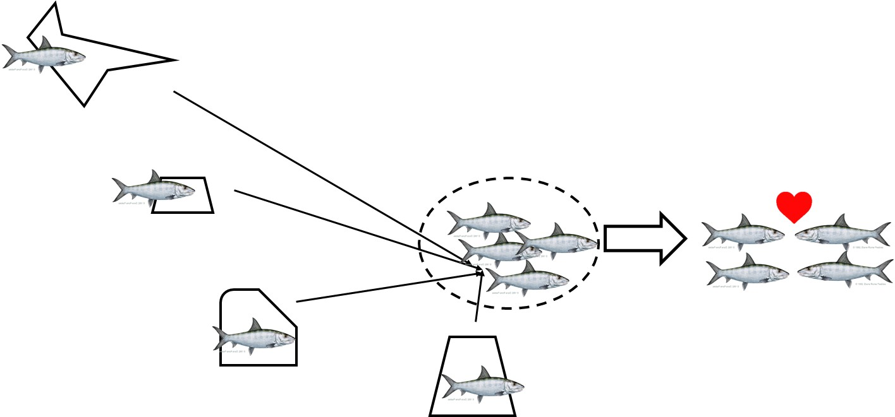

Figure 2

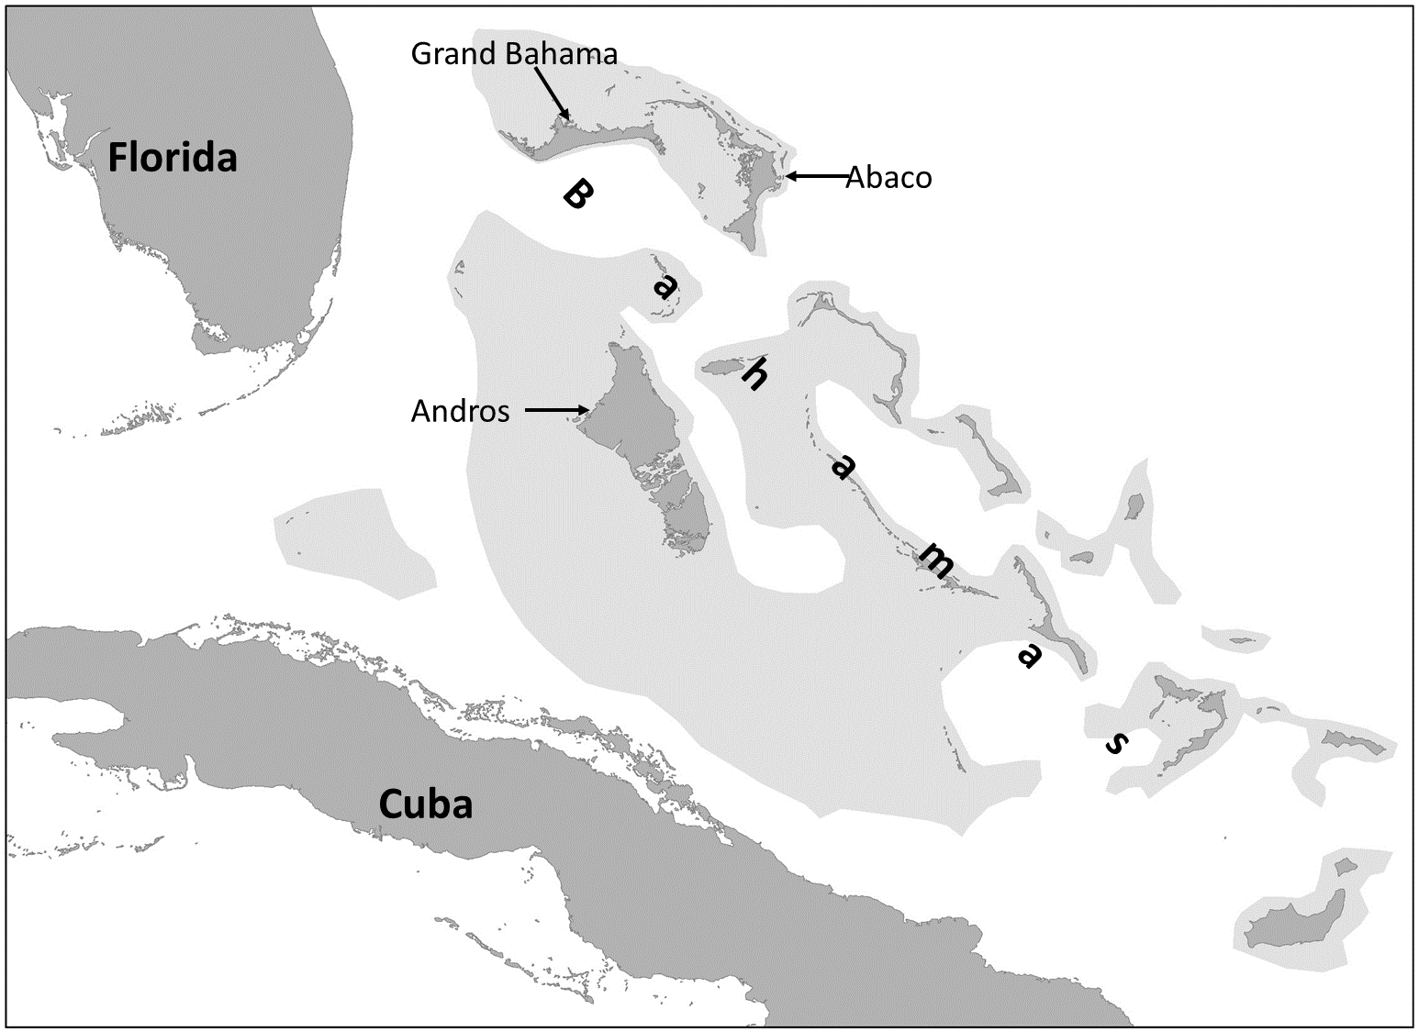

Figure 3



Figure 4



Figure 5

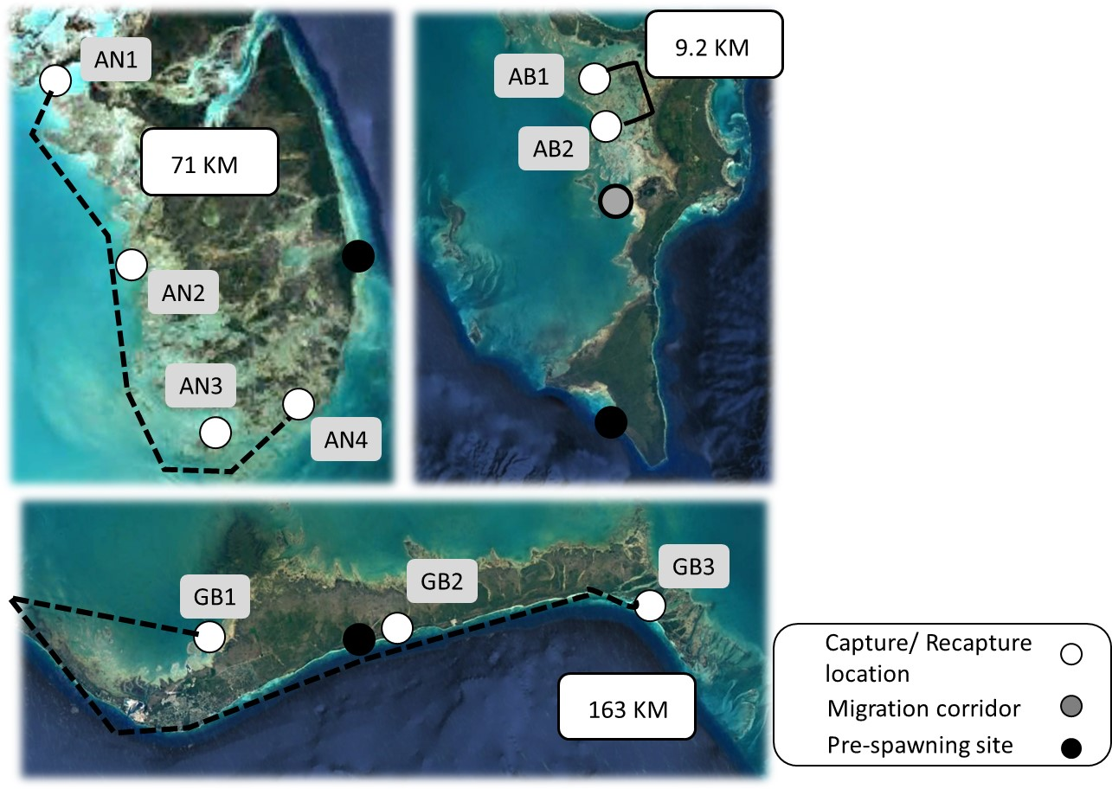

Supplemental Figure 1) Histogram showing when tags were deployed across the three study islands



Supplemental figure 2 Histogram showing the time of year recaptures occurred



Scatterplot showing distance between mark and recapture locations versus body size for all recaptured fish. Blue dots highlight those fish that were assumed to be captured or recaptured during a spawning migration.



Supplemental Figure 2) Scatterplot showing distance between mark and recapture locations versus days between mark and recapture for all Bonefish in this study. Blue dots highlight those fish that were assumed to be captured or recaptured during a spawning migration.

