Roles of heating and helicity in ultrafast all-optical magnetization switching in TbFeCo

Xianyang Lu,^{1,2} Xiao Zou,¹ Denise Hinzke,³ Tao Liu,⁴ Tuyuan Cheng,⁵ Jing Wu,^{1, 2, *} Thomas A. Ostler,^{6, 7} Jianwang Cai,^{4, *} Ulrich Nowak,³ Roy W. Chantrell,¹ Ya Zhai,^{5, 8} and Yongbing Xu^{2, 5, *}
¹Department of Physics, University of York, York, YO10 5DD, UK
²York-Nanjing International Joint Center in Spintronics, School of Electronic Science and Engineering, Nanjing University, Nanjing, 210093, China
³Fachbereich Physik, Universität Konstanz, 78457 Konstanz, Germany
⁴Institute of Physics, Chinese Academy of Sciences, Beijing 100190, China
⁵Spintronics and Nanodevice Laboratory, Department of Electronics, University of York, York, YO10 5DD, UK
⁶Faculty of Arts, Computing, Engineering and Sciences, Sheffield Hallam University, Sheffield, S1 1WB, UK
⁷Département de Physique, L’Université de Liège, B-4000 Liège, Belgium
⁸Department of Physics, Southeast University, Nanjing, 210096, China

Using the time-resolved magneto-optical Kerr effect (TR-MOKE) method, helicity-dependent all-optical magnetization switching (HD-AOS) is observed in ferrimagnetic TbFeCo films. Our results reveal the individual roles of the thermal and nonthermal effects after single circularly polarized laser pulse. The evolution of this ultrafast switching occurs over different time scales and a defined magnetization reversal time of 460 fs is shown - the fastest ever observed. Micromagnetic simulations based on a single macro-spin model, taking into account both heating and the inverse Faraday effect, are performed that reproduce HD-AOS demonstrating a linear path for magnetization reversal.

*Email addresses: ybxu@nju.edu.cn and jing.wu@york.ac.uk and jwcai@iphy.ac.cn
Since the demonstration of magnetization reversal by a single femtosecond laser pulse in 2007¹, the field of all-optical switching (AOS) has been extensively studied both theoretically and experimentally. AOS in the ferrimagnetic alloy, GdFeCo (the initially investigated material for AOS), has been shown to reverse through a purely thermal effect²⁻⁵ where the dynamics proceed via a transient ferromagnetic-like state^{6, 7}. Very recently, ultrafast electronic heat currents have been shown experimentally to be sufficient to switch the magnetization in this same material^{8, 9}, which provides further evidence of the thermal origins of AOS in GdFeCo¹⁰. Consequently, AOS in GdFeCo is almost independent of the laser helicity of the laser pulse, which is named helicity-independent AOS (HI-AOS).
On the other hand, there are many examples of AOS observed in other materials, that are strongly helicity dependent, e.g. ferromagnetic Co/Pt multilaysers¹¹, FePt nanoparticles¹², synthetic ferrimagnetic heterostructures¹³ and Tb-based ferrimagnets¹⁴⁻¹⁶. For these materials, there is a one-to-one correspondence of the helicity of the laser light controls and the magnetization orientation, deemed helicity dependent AOS (HD-AOS). A dependence on helicity was observed in GdFeCo for single pulses applied to the alloy for a narrow range of fluence ¹⁷, which was quantitatively explained as arising from magnetic circular dichroism (MCD)¹⁸. Besides the purely thermal effect and MCD¹⁹, many mechanisms have been proposed to explain the observed AOS, e.g. inverse Faraday effect (IFE)^{1, 20-22}, stimulated Raman scattering^{23, 24}, sublattice exchange relaxation²⁵, ultrafast exchange scattering²⁶, and optical spin pumping²⁷. However, the underlying physics of HD-AOS in a larger variety of materials is still unclear, especially of the roles of the helicity and thermal effects of the laser pulse. Several experimental criteria and models have been proposed to interpret HD-AOS. A so-called low-remanence criterion was reported whereby HD-AOS is only obtained below a magnetization remanence threshold of 220 emu/cm³ for several materials¹⁵. Recently, a domain size criterion for the observation of HD-AOS has been proposed, whereby the laser spot size should be smaller than the equilibrium size of magnetic domains forming during the cooling process after laser irradiation²⁸. Meanwhile, using a time-dependent anomalous Hall effect technique, HD-AOS has been demonstrated to consist of a steplike helicity-independent multiple-domain formation followed by a helicity-dependent remagnetization²⁹. There have been several models of optical switching presented in the literature, as well as differing measurements with different conclusions as to the importance of the thermal or nonthermal effects ^{4, 17, 19, 30, 31}. In this context, one intuitive question is: can the contributions of both thermal and nonthermal effects be quantified simultaneously during a single circularly polarized laser pulse? The ultrafast laser-induced demagnetization is well-known to have a thermal aspect ³², however, there will inevitably be some conbtribution from both thermal and nonthermal effects during one single laser pulse. However, in all the Kerr or Faraday image detections, it is impossible to measure both of these two effects because only the final static magnetization states are observed – one requires access to temporal information.
To explore the roles of the thermal and nonthermal effects in HD-AOS, and the time scales in this process, we used laser pump-probe technique, also known as time-resolved magneto-Kerr effect measurement ³³ (details in Supplemental Materials), to measure the transient magnetization change after a single laser pulse acting on TbFeCo. The transient reflectivity change is simultaneously monitored. TbFeCo is a similar ferrimagnet compared to GdFeCo as the Tb sublattice is antiferromagnetically coupled with the FeCo sublattice ^{30, 34, 35}, forming a ferrimagnetic structure. However, because of the large difference between the spin-orbit coupling of Tb and Gd ³⁶, Gd- and Tb- based alloys show different spin dynamics as well as distinct switching mechanisms ^{37, 38}.
In order to separate thermal and nonthermal contributions, time domain measurements are performed, varying the laser pump fluence and helicity, whilst keeping the direction of the external magnetic field fixed in the direction almost parallel to the direction of the induced magnetization due to the σ ⁻ helicity pulses (and nearly anti-parallel in the σ ⁺ case). The transient Kerr rotation obtained under different laser fluences with different laser helicities are shown in Fig. 2(a-c). Between the two lower laser fluences (2.8 and 5 mJ/cm²), the dynamic responses are very similar, except that the amplitude is increased with the laser fluence. The two curves taken with different laser helicity converge after around 240 fs time delay, suggesting that only thermal effects exist for these laser fluences because the thermal effects are insensitive to the laser helicity while the nonthermal effect is³¹. The peaks around zero delay are the so-called specular inverse Faraday effect (SIFE) and specular optical Kerr effect (SOKE) contributions ³⁹, as detailed in Fig. S1 in the Supplemental Materials. However, as the laser fluence is increased to 9 mJ/cm², the two curves taken with different laser helicity no longer converge. The curve excited by laser pulses of σ ⁺ polarization (a helicity that induces an effective field opposite to the external magnetic field) switches further away from the initial magnetisation direction compared to the curve excited by σ ⁻ polarised laser pulses. This extra switching starts at around t₃ = 240 fs, indicating the onset of the nonthermal effect. The time evolution of the reflectivity has also been investigated indicating a peak electron temperature at approximately t₁ = 70 fs. There is no obvious laser helicity dependence in the reflectivity which can be seen from the data taken at 9 mJ/cm² as shown in Fig. 2(d). In this case, the absorptions of light are at the same level as well as the electron temperature profiles which means there is no significant MCD effect. The oscillations with a high frequency of 42 GHz shown in both the transient Kerr rotation and reflectivity data have no magnetic field dependence. Therefore, it may be originated from a laser-induced strain-wave in the amorphous films (details in Supplemental Materials).
The thermal and nonthermal effects on the magnetization can be separated by analysing respectively the sum and difference of the experimental data under different laser helicities. Therefore, the data sets in Fig. 2(a-c) have been analysed accordingly and are presented in Fig. 3(a-b). The difference data in Fig. 3(a) shows the time evolution of the nonthermal effect. For the two cases with lower laser fluence, the time evolution of the two difference data overlaps and goes back to its original state immediately after the SIFE/SOKE peak, giving no indication of any nonthermal effect. As the pump fluence is increased to 9 mJ/cm², the difference signal does not return to the original state immediately. Instead it keeps increasing to its maximum magnitude at around t₄ = 460 fs time delay, showing that the magnetization has partially switched in some regions of the irradiated area to a different magnetization state. This demonstrates unambiguously a helicity-dependent switching in TbFeCo triggered at close to t₃ = 240 fs and magnetization re-orientation at approximately t₄ = 460 fs after circularly polarized laser excitation.
Fig. 3(b) presents the time evolution of the directly measured heat-driven dynamics excited by a linearly polarized laser of the same energy, along with the data obtained by taking the sum of the σ ⁺ and σ ⁻ cases for three different laser fluences. All three pairs of time domain Kerr rotation data reach maxima around t₂ = 160 fs, indicating the time scale of the quenching of the magnetic order. Two pairs of time domain data taken at lower laser fluence overlap with each other extremely well since the SIFE/SOKE changes phase between σ ⁺ and σ ⁻ helicity and are thus cancelled out by the sum operation. The pair taken at 9 mJ/cm² start to diverge from each other immediately after the maximum demagnetization with the sum data deviating further from the initial magnetization state, indicating the onset of the helicity-dependent switching excited by σ ⁺ pump pulses, which are more profound than those excited by the σ ⁻. This is expected, since the helicity-dependent switching induced by two different laser helicities are different in phase as well as in magnitude, depending on the instantaneous magnetization state, and also supported by our theoretical calculations shown below. The peak amplitude of the thermal and reflectivity data is plotted as a function of the pump laser fluence in Fig. 3(c), together with the amplitude of the nonthermal data at 460 fs time delay. Fig. 3(c) shows that the electron temperature is proportional to the laser fluence; the sample is nearly totally demagnetized at 9 mJ/cm² which is consistent with the condition required for helicity-dependent switching ²⁹; there is no sign of helicity-dependent switching for the data taken at lower pump fluence. Note that 9 mJ/cm² is the highest pump fluence, which can be applied without damaging the sample surface, and helicity-dependent switching is only observed at this highest pump fluence. The whole ultrafast process induced at a pump fluence of 9mJ/cm² is schematically summarized in Fig. 3(d). The electron temperature reaches its maximum at 70 fs time delay and the magnetic order is largely quenched by 160 fs. The onset of helicity-dependent switching takes place within 240 fs and a new magnetization direction is defined by 460 fs.
To understand the observed time domain results of HD-AOS, two main effects are considered, namely the MCD ¹⁸ and the IFE ²⁰. MCD leads to a different absorption of the two circular helicities in the different domains and it is excluded because from the transient reflectivity curves, no difference is observed with respect to the laser helicity. In Ref. ¹², the magnetization induced through the IFE effect was directly calculated for the case of FePt with ab-initio methods ⁴⁰. In our simulations, due to a lack of ab-initio calculations for the considered TbFeCo alloy, this temporal change of the magnetization caused by the IFE is assumed to be due to an effective magnetic field ^{17, 41}. Our simulations are based on a single macro-spin model whereby we solve the Landau-Lifshitz-Bloch (LLB) equation numerically ⁴²⁻⁴⁶. The LLB equation takes into account transient changes in the length of the magnetization required to describe the heating from the laser pulse. All our methods are described in detail in Ref. ⁴⁴ and also summarized in the Supplemental Materials. The results of these simulations are shown in Figs. 4(a-d) for different peak electron temperatures T_{e}, corresponding to different laser fluences, as summarised in Fig 4(e-f). The figure focuses on the change in the reduced magnetization (M/M_{s}) along the easy-axis at short time-scales. Starting at room temperature, the reduced magnetization at equilibrium is around 0.8. Complete demagnetization can be achieved within 300 fs and magnetization reversal can be triggered on the sub-picosecond time-scale for higher T_{e}. The theoretical model reproduces the sub-picosecond reversal observed experimentally and confirms the above interpretation of the experimental data. Above all, the reversal occurs only above a critical temperature corresponding to that of the linear reversal model; reversal on this timescale cannot occur via precessional mechanisms, which occur on the nanosecond timescale. Therefore, the peak electron temperature plays a significant role in HD-AOS. In Ref. ⁴⁷ an analytical formula was derived for the minimal pulse time (in terms of a rectangular field and temperature pulse), which is needed to switch the sign of the magnetization (see Eq. S2 in the Supplemental Materials). It is illustrated in Fig. 3(g). We noticed that in the simulations the switching times are slightly larger than with the analytical formula. This is due to the fact that for the analytical formula a rectangular temperature and field pulse is assumed, while in the simulations more realistic profiles are calculated. We also note that the simulations further predict a rapid increase of the magnetization in a negative sense after reversal, whereas the experimental data indicate that the magnetization recovers towards the original value. We attribute this to the simplified nature of the calculations, which are based on a single spin, whereas the experimental sample has a large-scale domain structure, though quantitative agreement is not the aim here. While the reversal of the magnetization via the linear reversal mechanism is unlikely to be affected by the domain structure, it is reasonable to expect that the magnetization measured by the probe beam after the pulse cannot be simulated within the current single spin model. Furthermore, multi-macrospin calculations would most likely still not be comparable with experimental measurements as the size of the probe beam is still many micrometres and likely beyond the size of this type of simulation. It should also be noticed that, compared to the current single macrospin simulations leading to a linear reversal mechanism, an atomistic spins approach would possibly give a different picture, as therewould be more degrees of freedom for the atomic spins to relax.
In summary, the HD-AOS is unambiguously demonstrated in a TbFeCo film by one single circularly polarized laser pulse. The thermal and nonthermal effects are seen to have different time scales, respectively. High pump fluences are required to observe laser helicity effects, which is consistent with other reported works ^{28, 29}. Note that the effect of heat accumulation is not excluded in our measurements, but the 1 kHz laser repetition rate is much lower than the repetition rate used in Ref. ¹⁵ which shows no significant accumulative heat. Besides, the relaxation time of transient reflectivity response is quite small in our measurements, so the effect of accumulative heat should not play a role. The interplay between laser heating and helicity is stimulated by a single laser pulse. The whole process of magnetization switching contains four periods; peak electron temperature achieved; the system becomes fully demagnetized; magnetization switching is triggered; and a new magnetization direction is defined. Furthermore, from our measurements we can see that, on the sub-picosecond time-scales, there is a magnetization switching time within 460 fs – the fastest among the reported times in the literature ^{17, 41, 48, 49}. Very recently, a theoretical study by means of first-principles and model simulation shows a magnetization switching time of 218 fs ~ 609 fs⁵⁰, which is in good agreement with our findings. This sub-picosecond switching is reproduced using a single macro-spin model based on the stochastic Landau-Lifschitz-Bloch equation, confirming the linear reversal mechanism without spin precession in all-optically induced magnetization switching in TbFeCo. Also, the simulations suggest that that heating the electron system to a critical temperature may play an important role in this kind of magnetization reversal. Above all, the finding of ultrafast helicity-dependent all-optical magnetization switching in a high anisotropy system triggered by a single laser pulse brings all-optical magnetic recording a major step closer to high data rate and high data density applications.

Acknowledgements:
This work was supported in part by the National Basic Research Program of China (No. 2014CB921101), National Key Research and Development Program of China (No. 2016YFA0300803), the National Natural Science Foundation of China (No. 61427812, 11574137, 11774160), Jiangsu Shuangchuang Programme and the Natural Science Foundation of Jiangsu Province of China (No. BK20140054 ). T. A. Ostler also gratefully acknowledges the support of the Marie Curie incoming BeIPD-COFUND fellowship program at the University of Liège.

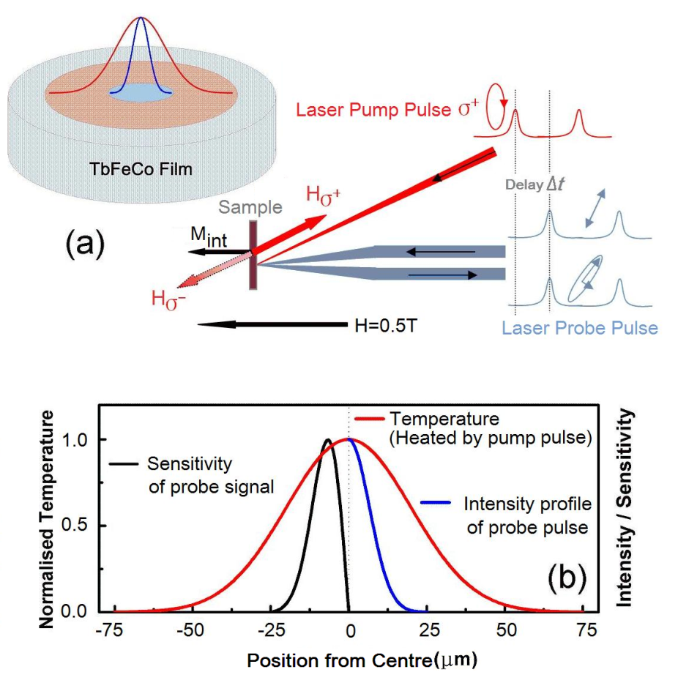

Figure 1. (a) a schematic diagram of the experimental set-up with a bias field H = 0.5 T. H_{σ+} represents the effective field of the pump pulse with σ+ polarization (red line) due to the IFE. (b) the normalized radial sensitivity of the Kerr rotation (only left half shown for clarity) and temperature distribution across the pump spot together with the intensity profile of the probe spot (only right half shown for clarity).

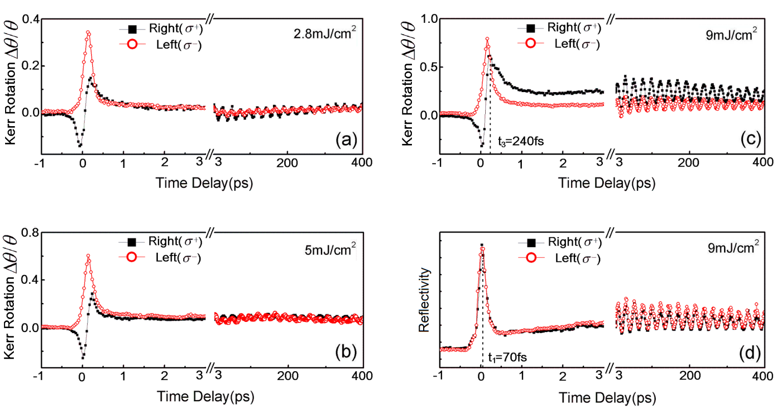
Figure 2. (a) and (b) show the time domain Kerr rotation taken under a pump fluence of 2.8 and 5 mJ/cm² , respectively. (c) presents the time domain Kerr rotation obtained under pump fluence 9 mJ/cm². At about 240 fs time delay, the curve excited by pump pulses of σ+ polarization (black solid squares) starts to switch further away from the initial magnetization direction compared with the curve excited by σ- polarized (red hollow dots) pump pulses. (d) shows the time domain reflectivity data at 9 mJ/cm² for both σ⁺ and σ⁻⁻ polarization. The two curves overlap with the peak at t₁ = 70 fs, indicating the maximal electron temperature.
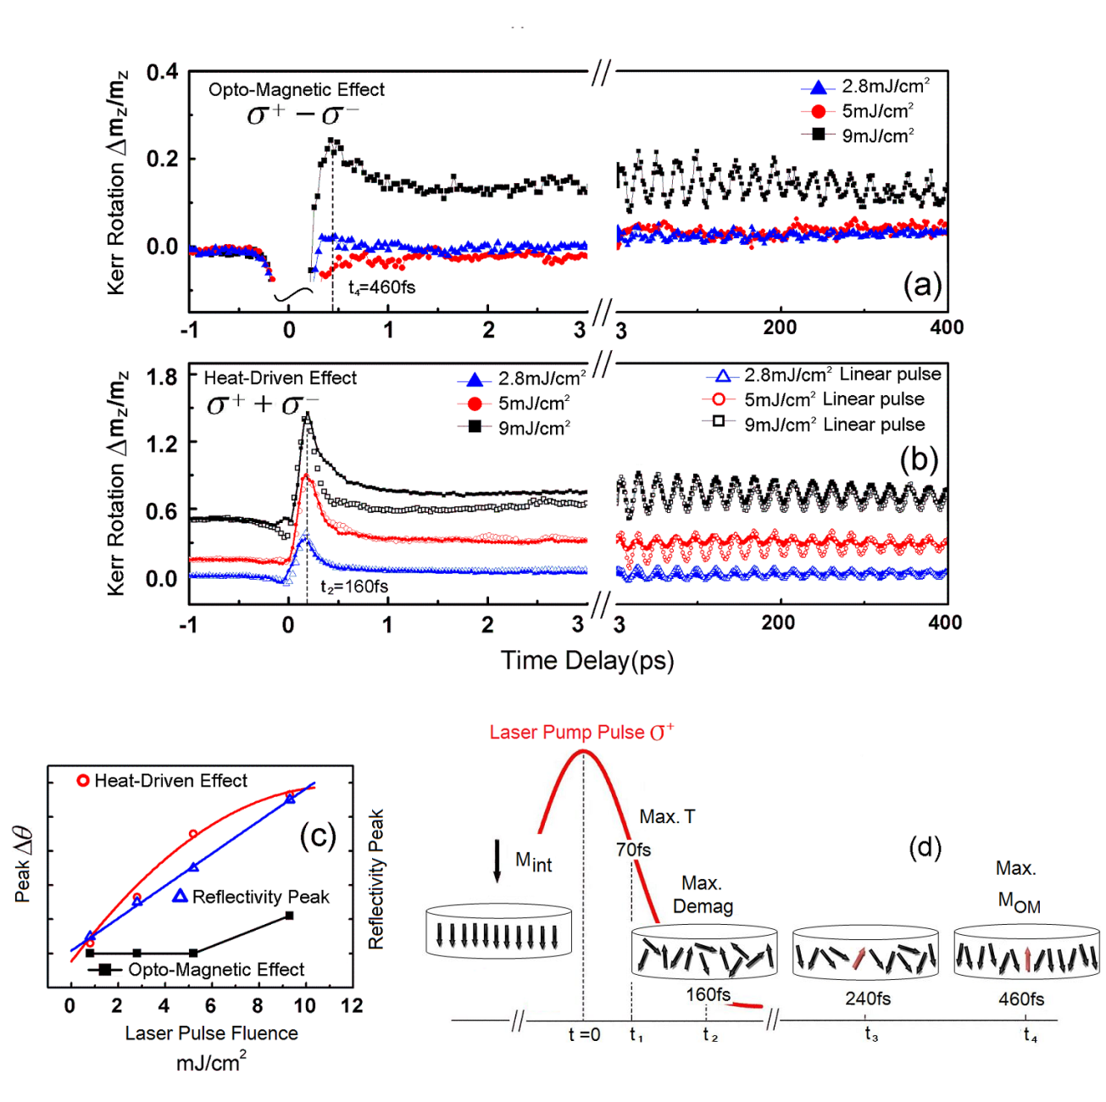
Figure 3. (a) shows the difference between the σ⁺ and σ– pump pulses as a function of time. (b) The three solid curves show the sum of the σ⁺ and σ– pump pulses with time. The hollowed curves are time domain responses excited by the linearly polarized laser pulse at the same pump fluences. (c) The peak amplitude of the heat-driven effect (red circles), of the reflectivity (blue triangles), and of the nonthermal effect (black squares) at a delay time of 460 fs as a function of the pump fluence. (d) Shows a schematic diagram of the ultrafast process induced at 9 mJ/cm² pump fluence.

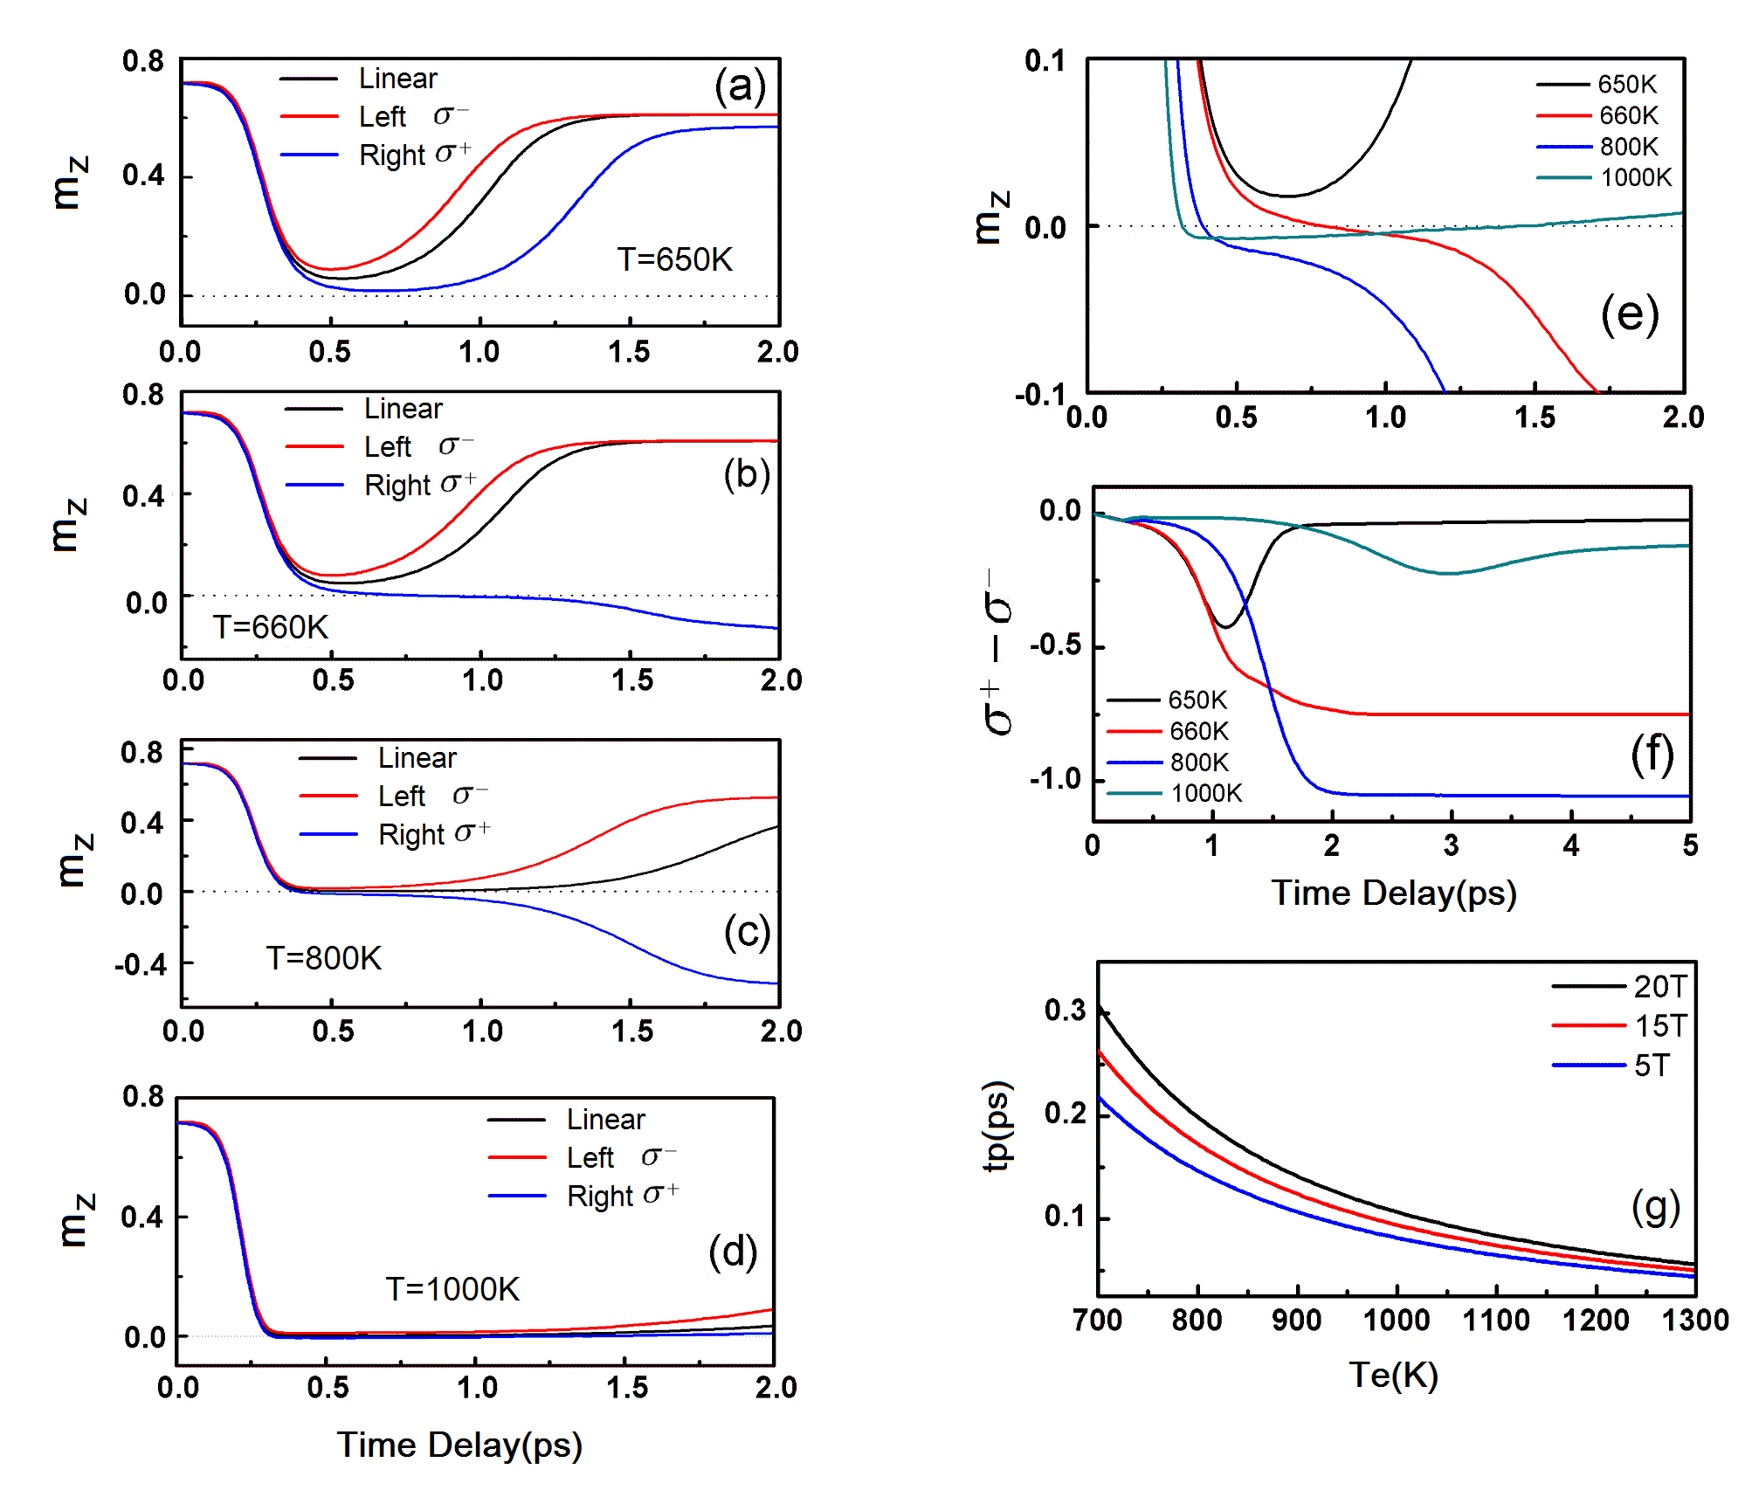
Figure 4. (a-d) Simulated magnetic response for increasing peak electron temperatures showing the onset of magnetisation reversal. Reversal occurs at around 660 K, where the linear reversal mechanism sets in. At higher temperatures (d) the magnetisation is destroyed after reversal. (e) magnetic response for different values of the peak electron temperature. (f) shows the difference in the response to the difference helicities. Optically induced reversal is demonstrated at 660 and 800 K. The onset of reversal depends critically on the onset of linear reversal. The response time calculated from Eq. S2 demonstrates that the predicted reversal takes place on the sub-picosecond tiemscale, consistent with the experimental results. (g) Minimal field and temperature pulse time needed to trigger a magnetization reversal taken from Eq. S2.

1. C. Stanciu, F. Hansteen, A. Kimel, A. Kirilyuk, A. Tsukamoto, A. Itoh and T. Rasing, Physical Review Letters 99 (4), 047601 (2007).
2. J.-Y. Chen, L. He, J.-P. Wang and M. Li, Physical Review Applied 7 (2), 021001 (2017).
3. T. A. Ostler, J. Barker, R. F. Evans, R. W. Chantrell, U. Atxitia, O. Chubykalo-Fesenko, S. El Moussaoui, L. Le Guyader, E. Mengotti, L. J. Heyderman, F. Nolting, A. Tsukamoto, A. Itoh, D. Afanasiev, B. A. Ivanov, A. M. Kalashnikova, K. Vahaplar, J. Mentink, A. Kirilyuk, T. Rasing and A. V. Kimel, Nature communications 3, 666 (2012).
4. A. Kirilyuk, A. V. Kimel and T. Rasing, Reports on progress in physics. Physical Society 76 (2), 026501 (2013).
5. R. Chimata, L. Isaeva, K. Kádas, A. Bergman, B. Sanyal, J. H. Mentink, M. I. Katsnelson, T. Rasing, A. Kirilyuk, A. Kimel, O. Eriksson and M. Pereiro, Physical Review B 92 (9) (2015).
6. I. Radu, K. Vahaplar, C. Stamm, T. Kachel, N. Pontius, H. A. Durr, T. A. Ostler, J. Barker, R. F. Evans, R. W. Chantrell, A. Tsukamoto, A. Itoh, A. Kirilyuk, T. Rasing and A. V. Kimel, Nature 472 (7342), 205-208 (2011).
7. S. Wienholdt, D. Hinzke, K. Carva, P. M. Oppeneer and U. Nowak, Physical Review B 88 (2) (2013).
8. R. B. Wilson, J. Gorchon, Y. Yang, C.-H. Lambert, S. Salahuddin and J. Bokor, Physical Review B 95 (18) (2017).
9. Y. Xu, M. Deb, G. Malinowski, M. Hehn, W. Zhao and S. Mangin, Adv Mater (2017).
10. U. Atxitia, T. A. Ostler, R. W. Chantrell and O. Chubykalo-Fesenko, Applied Physics Letters 107 (19) (2015).
11. C. H. Lambert, S. Mangin, B. S. Varaprasad, Y. K. Takahashi, M. Hehn, M. Cinchetti, G. Malinowski, K. Hono, Y. Fainman, M. Aeschlimann and E. E. Fullerton, Science 345 (6202), 1337-1340 (2014).
12. R. John, M. Berritta, D. Hinzke, C. Muller, T. Santos, H. Ulrichs, P. Nieves, J. Walowski, R. Mondal, O. Chubykalo-Fesenko, J. McCord, P. M. Oppeneer, U. Nowak and M. Munzenberg, Scientific reports 7 (1), 4114 (2017).
13. S. Mangin, M. Gottwald, C. H. Lambert, D. Steil, V. Uhlir, L. Pang, M. Hehn, S. Alebrand, M. Cinchetti, G. Malinowski, Y. Fainman, M. Aeschlimann and E. E. Fullerton, Nature materials 13 (3), 286-292 (2014).
14. A. Hassdenteufel, B. Hebler, C. Schubert, A. Liebig, M. Teich, M. Helm, M. Aeschlimann, M. Albrecht and R. Bratschitsch, Advanced Materials 25 (22), 3122-3128 (2013).
15. A. Hassdenteufel, J. Schmidt, C. Schubert, B. Hebler, M. Helm, M. Albrecht and R. Bratschitsch, Physical Review B 91 (10) (2015).
16. T. Y. Cheng, J. Wu, M. Willcox, T. Liu, J. W. Cai, R. W. Chantrell and Y. B. Xu, IEEE Transactions on Magnetics 48 (11), 3387-3389 (2012).
17. K. Vahaplar, A. M. Kalashnikova, A. V. Kimel, S. Gerlach, D. Hinzke, U. Nowak, R. Chantrell, A. Tsukamoto, A. Itoh, A. Kirilyuk and T. Rasing, Physical Review B 85 (10) (2012).
18. A. R. Khorsand, M. Savoini, A. Kirilyuk, A. V. Kimel, A. Tsukamoto, A. Itoh and T. Rasing, Physical Review Letters 108 (12) (2012).
19. J. Gorchon, Y. Yang and J. Bokor, Physical Review B 94 (2) (2016).
20. T. D. Cornelissen, R. Córdoba and B. Koopmans, Applied Physics Letters 108 (14) (2016).
21. C. D. Stanciu, F. Hansteen, A. V. Kimel, A. Tsukamoto, A. Itoh, A. Kirilyuk and T. Rasing, Phys Rev Lett 98 (20), 207401 (2007).
22. A. V. Kimel, A. Kirilyuk, P. A. Usachev, R. V. Pisarev, A. M. Balbashov and T. Rasing, Nature 435 (7042), 655-657 (2005).
23. V. N. Gridnev, Physical Review B 77 (9) (2008).
24. D. Popova, A. Bringer and S. Blügel, Physical Review B 85 (9) (2012).
25. J. H. Mentink, J. Hellsvik, D. V. Afanasiev, B. A. Ivanov, A. Kirilyuk, A. V. Kimel, O. Eriksson, M. I. Katsnelson and T. Rasing, Physical Review Letters 108 (5) (2012).
26. A. Baral and H. C. Schneider, Physical Review B 91 (10) (2015).
27. V. N. Gridnev, Physical Review B 88 (1) (2013).
28. M. S. El Hadri, M. Hehn, P. Pirro, C.-H. Lambert, G. Malinowski, E. E. Fullerton and S. Mangin, Physical Review B 94 (6) (2016).
29. M. S. El Hadri, P. Pirro, C. H. Lambert, S. Petit-Watelot, Y. Quessab, M. Hehn, F. Montaigne, G. Malinowski and S. Mangin, Physical Review B 94 (6) (2016).
30. R. Moreno, T. A. Ostler, R. W. Chantrell and O. Chubykalo-Fesenko, Physical Review B 96 (1) (2017).
31. A. Kirilyuk, A. V. Kimel and T. Rasing, Rev Mod Phys 82 (3), 2731-2784 (2010).
32. E. Beaurepaire, J. Merle, A. Daunois and J. Bigot, Phys Rev Lett 76 (22), 4250-4253 (1996).
33. B. Liu, X. Z. Ruan, Z. Y. Wu, H. Q. Tu, J. Du, J. Wu, X. Y. Lu, L. He, R. Zhang and Y. B. Xu, Applied Physics Letters 109 (4), 042401 (2016).
34. S. Alebrand, M. Gottwald, M. Hehn, D. Steil, M. Cinchetti, D. Lacour, E. E. Fullerton, M. Aeschlimann and S. p. Mangin, Applied Physics Letters 101 (16), 162408 (2012).
35. A. Hassdenteufel, C. Schubert, B. Hebler, H. Schultheiss, J. Fassbender, M. Albrecht and R. Bratschitsch, Optics express 22 (8), 10017-10025 (2014).
36. M. Wietstruk, A. Melnikov, C. Stamm, T. Kachel, N. Pontius, M. Sultan, C. Gahl, M. Weinelt, H. A. Dürr and U. Bovensiepen, Physical Review Letters 106 (12) (2011).
37. A. Khorsand, M. Savoini, A. Kirilyuk, A. Kimel, A. Tsukamoto, A. Itoh and T. Rasing, Physical Review Letters 110 (10) (2013).
38. C. Bunce, J. Wu, G. Ju, B. Lu, D. Hinzke, N. Kazantseva, U. Nowak and R. W. Chantrell, Physical Review B 81 (17) (2010).
39. F. Dalla Longa, J. Kohlhepp, W. de Jonge and B. Koopmans, Physical Review B 75 (22) (2007).
40. M. Battiato, G. Barbalinardo and P. M. Oppeneer, Physical Review B 89 (1) (2014).
41. K. Vahaplar, A. Kalashnikova, A. Kimel, D. Hinzke, U. Nowak, R. Chantrell, A. Tsukamoto, A. Itoh, A. Kirilyuk and T. Rasing, Physical Review Letters 103 (11) (2009).
42. D. Garanin and O. Chubykalo-Fesenko, Physical Review B 70 (21) (2004).
43. U. Atxitia, O. Chubykalo-Fesenko, N. Kazantseva, D. Hinzke, U. Nowak and R. W. Chantrell, Applied Physics Letters 91 (23), 232507 (2007).
44. N. Kazantseva, D. Hinzke, U. Nowak, R. Chantrell, U. Atxitia and O. Chubykalo-Fesenko, Physical Review B 77 (18) (2008).
45. T. A. Ostler, M. O. A. Ellis, D. Hinzke and U. Nowak, Physical Review B 90 (9) (2014).
46. U. Atxitia, D. Hinzke and U. Nowak, Journal of Physics D: Applied Physics 50 (3) (2017).
47. N. Kazantseva, D. Hinzke, R. W. Chantrell and U. Nowak, EPL (Europhysics Letters) 86 (2), 27006 (2009).
48. L. Le Guyader, M. Savoini, S. El Moussaoui, M. Buzzi, A. Tsukamoto, A. Itoh, A. Kirilyuk, T. Rasing, A. V. Kimel and F. Nolting, Nature communications 6, 5839 (2015).
49. T. Ogasawara, N. Iwata, Y. Murakami, H. Okamoto and Y. Tokura, Applied Physics Letters 94 (16), 162507 (2009).
50. G. P. Zhang, Z. Babyak, Y. Xue, Y. H. Bai and T. F. George, Physical Review B 96 (13) (2017).

