Received 00th January 20xx,
- Univ. Grenoble Alpes, CEA, CNRS, IBS, F-38000 Grenoble, France. E-mail: anne.volbeda@ibs.fr
- CEA-Grenoble/INAC/SyMMES/CAMPE, UMR SyMMES 5819 (CEA-CNRS-UGA), 17 Ave des Martyrs, F-38054 Grenoble, France. E-mail: jean-marie.mouesca@cea.fr
- Univ Oxford, Dept Chem, S Parks Rd, Oxford OX1 3QR, UK.
- Present address: School of Biological and Chemical Sciences, Queen Mary Univ. of London, Mile End Road, London E1 4NS, UK.
- Present address: Univ York, Dept Chem, Heslington, York, YO10 5DD, UK.
† Electronic Supplementary Information (ESI) available: EPR characterization, structure determination, DFT methods and redox potential calculations. See DOI: 10.1039/x0xx00000x
Accepted 00th January 20xx
DOI: 10.1039/x0xx00000x
www.rsc.org/
X-ray structural, functional and computational studies of the O₂-sensitive E. coli hydrogenase-1 C19G variant reveal an unusual [4Fe-4S] cluster.
A. Volbeda,*ª J. M. Mouesca,*^{b} C. Darnault,ª M.M. Roessler,^{cd} A. Parkin,^{ce} F. A. Armstrong^{c} and J. C. Fontecilla-Campsª
The crystal structure of the Escherichia coli O₂-sensitive C19G [NiFe]-hydrogenase-1 variant shows that the mutation results in a novel FeS cluster, proximal to the Ni-Fe active site. While the native O₂-tolerant enzyme proximal cluster can transfer two electrons to that site, the modified cluster exhibits a single EPR-detectable redox transition, which causes its oxygen sensitivity. Our computational studies on the electron transfer processes help to explain how the structural and redox properties of the novel FeS cluster modulate the observed phenotype.
Understanding the response of hydrogenases to oxygen is essential for the development of potential biotechnological applications such as the generation of H₂ from solar energy or the oxidation of H₂ in bio-fuel cells.¹ The characteristic feature of a group of heterodimeric [NiFe]-hydrogenases capable of oxidizing hydrogen under air is the presence of two supernumerary cysteines in their small subunit.^{2,3,4} In these O₂-tolerant enzymes, the [4Fe-4S-4Sγ] Proximal Cluster (PC) to the Ni-Fe active site of O₂-sensitive enzymes (Sγ indicates a thiolate Cys ligand) is replaced by a [4Fe-3S-6Sγ] PC, with the two supernumerary cysteines being additional ligands to the cluster.^{5,6,7,8} Unlike its [4Fe-4S-4Sγ] counterpart, which can only transfer one electron, the [4Fe-3S-6Sγ] cluster can undergo two one-electron oxidations within a narrow potential range, from a formal -3 charged reduced (PC_{red}) to a formal -2 oxidized (PC_{ox}) and a formal -1 superoxidized (PC_{sox}) state. The latter contains an unusual Fe-N(peptide) bond.^{6,7,9} By coupling these two oxidations with two electrons residing at the Ni-Fe site in its active state,¹⁰ O₂-tolerant hydrogenases can carry out the four-electron reduction of active site-bound O₂ to harmless water.¹⁻⁹ A high-potential medial [3Fe-4S] cluster¹¹ and a quaternary structure allowing electron transfer between hydrogenase heterodimers also contribute to O₂-tolerance.^{12,13}
Escherichia coli hydrogenase-1 (EcHyd1) is one of the best characterized O₂-tolerant enzymes.¹⁴ Studies focused on the supernumerary cysteines Cys19 and Cys120 have shown that O₂-tolerance depends mostly on Cys19.⁴ An EPR study of the O₂-sensitive C19G variant (v-) indicated that no paramagnetic v-PC_{red} state was detectable upon reduction. Conversely, at high potential a strong EPR signal could be assigned to the equivalent of a PC_{sox} state, here called v-PC_{"sox"}, although it was more complex than in the wild type (wt) enzyme.⁴
Here we report spectroscopic, structural and computational studies of the C19G variant that explain both its modified cluster redox properties and the resulting loss of O₂-tolerance. From an EPR redox titration (ESI Fig. S1†) we determined a midpoint potential of +0.24V for the v-PC_{"ox"}/PC_{"sox"} redox couple (ESI section 1 and Fig. S2†),‡ very close to the value of +0.23V previously reported for the wt-PC_{ox}/PC_{sox} couple.¹⁵ The variant and wt enzyme show the same Ni EPR signals.
We crystallized the C19G variant under anaerobic conditions in the presence of its cognate cytochrome b (ESI Fig. S3†) and obtained anisotropic X-ray diffraction data to a maximum resolution of 2.5 Å (ESI Table S1†). A reliable atomic model could be obtained by electron density averaging of the four hydrogenase heterodimers in the asymmetric unit (Fig. 1A, ESI section 2†).§ F_{obs}-F_{calc} difference and model-omit electron density maps confirm the C19G small subunit mutation and indicate the replacement of the C19 thiolate by S²⁻, forming an unprecedented [4Fe-4S-5Sγ] cluster. The positions of the other cluster atoms and Fe ligands are close to those observed in the H₂-reduced [4Fe-3S-6Sγ] wt-PC_{red} state of EcHyd1,⁷ with Fe3 still bound to the supernumerary Cys120, which shields the cluster from bulk solvent (Fig. 1B, ESI Fig. S4A†). Like the wt [4Fe-3S-6Sγ] cluster, the new [4Fe-4S-5Sγ] cluster differs significantly from the cuboid-shaped PC of O₂-sensitive hydrogenases (ESI Fig. S4B†).¹⁶ The latter have a glycine at position 120 and a water molecule replaces the C120Sγ atom in an otherwise almost identical protein environment (Fig. 1C-D).
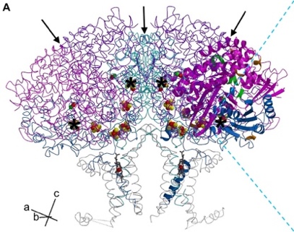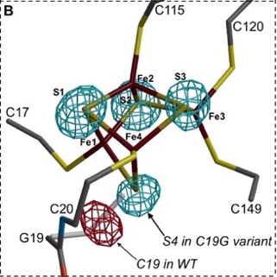
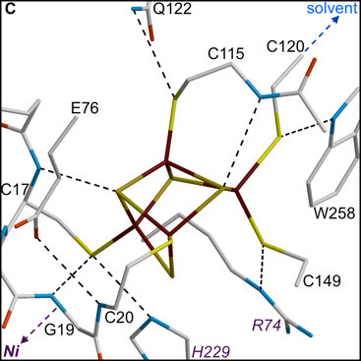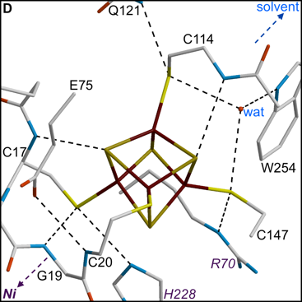
Figure 1. Crystal structure of the EcHyd1 C19G variant. A. Fold of the S₄L₄B₂ hydrogenase complex. The polypeptide chain of large (L), (small (S) and cytochrome b (B) subunits is shown in pink, blue and grey, respectively, one SL heterodimer is depicted with ribbons; black arrows indicate three local twofold symmetry operations and black asterisks highlight proximal cluster (PC) positions. The direction of the a, b and c cell axes is shown in the lower left corner. B. Zoom on the new [4Fe-4S-5Sγ] cluster. The red mesh indicates a negative peak, shown at a -8 σ level in a 4-fold density averaged F_{obs}-F_{calc} map calculated with phase information from a model including Cys19. The blue mesh, shown at the 20 σ level, corresponds to a 4-fold density averaged omit F_{obs}-F_{calc} map calculated with phase information from a C19G model excluding the inorganic S atoms. Note that S4 replaces the missing thiolate group of Cys19. C. Protein environment of the [4Fe-4S-5Sγ] PC observed in the present study with putative H-bonds shown as dashed lines. D. Similar protein environment of the cuboid-shaped O₂-sensitive D. fructosovorans [NiFe]-hydrogenase [4Fe-4S-4Sγ] PC (pdb code 4UQL). Used atom colour codes are: Ni green, Fe red-brown, S yellow, O red, N blue and C grey. Large subunit residues are labelled in pink.
The presence of strong electron density corresponding to a Ni-Fe bridging ligand (ESI Fig. S4C†) in the variant is characteristic of an oxidized state which could be v-PC_{"ox"}, v-PC_{"sox"} or a mixture of the two. In a similar anaerobically grown wt enzyme crystal there was a mixture of states assigned to wt-PC_{ox} and wt-PC_{sox} with an O(H) ligand bridging the two metals at the active site.⁶ In order to shed light on the modified physiological properties of the C19G variant we performed a computational study to compare the oxidation states of the novel [4Fe-4S-5Sγ] cluster (Fig. 1B and ESI Fig. S4A†) with those of the [4Fe-3S-6Sγ] proximal cluster of the wt enzyme.
Here we will call the three PC states of wt EcHyd1 described by X-ray crystallography (ESI Fig. S4D-F†) wt-PC_{red}-X, wt-PC_{ox}-X and wt-PC_{sox}-X.⁷ The wt-PC_{red}-X and wt-PC_{ox}-X structures are similar, but that of wt-PC_{sox}-X is quite different, as also observed in the crystal structures of two other O₂-tolerant [NiFe]-hydrogenases.^{6,9} In this superoxidized state, one of the cluster Fe ions binds to the deprotonated main chain N atom of Cys20. Since this N atom must be protonated in wt-PC_{ox}-X, this state has the same overall charge as wt-PC_{sox}-X, the one proton loss compensating for the one-electron oxidation. Because the superoxidation potential depends on whether (or when) proton transfer takes place,^{17,18} comparison of measured and calculated midpoint potentials for different PC models may provide mechanistic information.
The midpoint potential E° for a redox couple can be calculated from the free energy difference between the corresponding oxidized and reduced states (ESI section 3 and Scheme S1†). E° depends on (i) the interaction of the two states with the protein matrix and solvent,^{19,20} and (ii) their intrinsic electronic structures, which, in turn, depend on the different arrangements of the spins of the four Fe ions in the broken symmetry (BS) states that can be constructed. Among the large number of possible states, we only investigated BS13 and BS12 which, according to previous studies,^{7,21,22} are lowest in energy. Density functional theory (DFT) was used to obtain geometry-optimized cluster models in different oxidation/protonation states in water (w). In addition, we developed a semi-empirical (se) approach to account for specific PC interactions with the protein matrix, which involved introducing two calibration parameters (x and y):
E°_{DFT}(se) = E°_{DFT}(w) + [x∆E_{env}(w) + y]/F (1)
∆E_{env}(w), first used to calculate E°_{DFT}(w) (ESI Table S3)†, provides a suitable starting point for the difference in cluster solvation energy (in eV) between oxidized and reduced states in a polarizable water environment. A similar approach is used in semi-empirical pKa calculations.²³ This term is next corrected by a factor here called x that is used to lower the dielectric constant from pure water (ε_{w}) to a (water/protein) medium of average ε_{av} (Eq. S3)†, with (1+x) being proportional to (1-1/ε_{av}). Conversely, the shift parameter y takes into account hydrogen bonding and other electrostatic interactions¹⁹ and F is equal to one elementary charge unit. The two calibration parameters x and y were optimized to reproduce (-3/-2) and (-2/-1) [4Fe-4S-4Sγ] redox potentials as measured for ferredoxin (ESI section 4.1†).
We started our calculations using simplified wt-PC-X models with a [4Fe-3S-6Sγ] cluster in different oxidation states, replacing all cysteines by S-ethyl thiolates and including the peptide bond between Cys19 and Cys20. Corresponding geometry-optimized models are named wt-pc_{red}-NH, wt-pc_{ox}-NH and wt-pc_{sox}-NFe (ESI Scheme S2†), where NH designates the normal amide N-H group of the peptide bond and NFe indicates a N-Fe bond; v- is used in the case of the C19G variant (Fig. 2 and ESI Fig. S5†). Two additional, possibly transient states, named wt-pc_{ox}-NFe and wt-pc_{sox}-NH correspond to a deprotonated wt-pc_{ox}-NH-derived intermediate, and a protonated superoxidized intermediate, respectively. Due to the replacement of the Cys19Sγ⁻ thiolate by S²⁻ in the variant (Fig. 1B), there is an extra negative charge in all v-PC models.
Structural differences between geometry-optimized models with a peptide N-H bond are relatively small (Fig. 2) and these models remain close to their corresponding PC-X counterparts. Deprotonation of the wt-pc_{ox}-NH model leads to the formation of a N-Fe bond after geometry optimization. However, removal of the NH proton from the v-pc_{"ox"}-NH model causes a drastic rearrangement of the Gly19-Cys20 peptide group away from the cluster, which would be sterically impossible in the protein. Conversely, the one-electron reduction of the v-pc_{"sox"}-NFe model produces a stable v-pc_{"ox"}-NFe state.
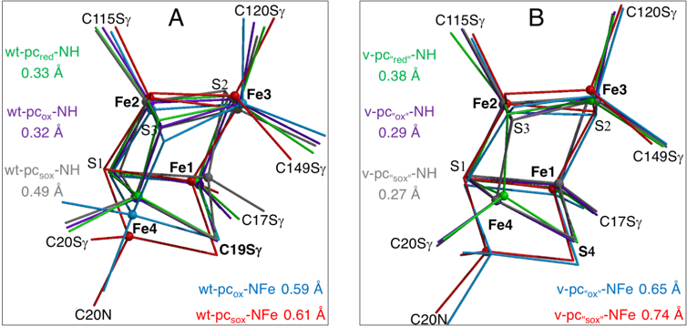
Figure 2. Superposition of differently coloured geometry-optimized PC core models (see also ESI Fig. S5†). Small spheres highlight Fe ions and thin lines indicate the positions of directly bound labelled atoms. Root mean square deviations to (A) wt-PC_{ox}-X and (B) v-PC-X structures are shown in Å (see text for used nomenclature).
The results of our E° calculations (ESI sections 4.2-4.4†) are summarized in Fig. 3. First, for the vertical wt-pc_{red}-NH/pc_{ox}-NH and wt-pc_{ox}-NFe/pc_{sox}-NFe redox couples we obtain E°_{DFT}(se) values of +0.06 and +0.27V, respectively, each within 50 mV of the E°'s of +0.03 and +0.23V experimentally measured at pH 6 for oxidation and superoxidation, respectively.¹⁵ Because x and y in eq. (1) are anti-correlated (ESI section 4.1†), errors in one of them tend to be cancelled by errors in the other and we obtain very similar results with calibrations based on slightly different experimentally measured potentials (ESI section 4.2†). Nevertheless, the wt-pc_{ox}-NFe species will not be formed within the protein if proton and electron transfer are coupled (CPET). In that case, the measured E° of 0.23V should rather correspond to the wt-pc_{ox}-NH/pc_{sox}-NFe redox couple (diagonal green arrow in the top of Fig. 3). In order to calculate an E°_{DFT}(se) for the latter couple, the ∆G° for the horizontal wt-pc_{ox}-NH/pc_{ox}-NFe transition must be included. However, since we do not know the identity of the proton acceptor (base) in the protein, this cannot be easily done (see also ESI section 4.3†). At this point, we can only state that the O₂ tolerance of the wt enzyme suggests that the deprotonation reaction should be favourable or close to neutral in free energy.
Superoxidation of wt-pc_{ox}-NH without deprotonation gives a much higher E°_{DFT}(se) of +0.62V (crossed vertical red arrow in Fig. 3). In a recent DFT study of the related O₂-tolerant Ralstonia eutropha [NiFe]-hydrogenase,²¹ a reaction path from wt-pc_{red}-NH to wt-pc_{sox}-NFe was proposed with simultaneous transfer of two electrons followed by deprotonation. However, that mechanism is not compatible with the experimental results, which clearly show two one-electron transfer steps.^{2,3,4} Another proposed superoxidation mechanism involves a complex cluster rearrangement, equivalent to an internal proton transfer from Cys20NH to an inorganic sulfide in the sox state.²⁴ However, keeping the proton at the PC increases the overall PC_{sox} charge by +1 relative to the wt-pc_{ox}-NFe model discussed above, resulting in a much too high E°_{DFT}(se) value when compared to experiment (see ESI section 4.3†).
We obtain significantly different E°_{DFT}(se)'s for the C19G variant (ESI section 4.4†). Because it carries one extra negative charge relative to wt, the v-pc_{"red"}-NH/pc_{"ox"}-NH redox potential is shifted by about -0.7V (Fig. 3). This results in an E°_{DFT}(se) of -0.62V that is too negative to be readily accessible, which explains why no paramagnetic PC_{red} state was detected for this variant³ (ESI Fig. S1†). We calculate an E°_{DFT}(se) of +0.23V for the v-pc_{"ox"}-NH/v-pc_{"sox"}-NH couple, within the error margin (±15mV) of the experimental value of +0.240V obtained for the v-PC_{"ox"}/PC_{"sox"} couple (ESI section 1†). Because the optimized v-pc_{"ox"}-NH and v-pc_{"sox"}-NH structures are quite similar, both could be present in the v-PC-X crystal structure. Conversely, in agreement with their different EPR spectra (Fig. 7 in ref. 3), the modelled wt-pc_{sox}-NFe and v-pc_{"sox"}-NH states have significantly different structures. In fact, in terms of overall charge, the (-3/-2) v-PC_{"ox"}/PC_{"sox"} couple is equivalent to the wt-PC_{red}/PC_{ox} couple. Although a coupled electron and proton transfer leading to v-pc_{"sox"}-NFe cannot be excluded, such a state is not observed in the crystal structure of the C19G variant, supporting the assignment of the experimentally obtained superoxidation potential to a v-PC_{"ox"}/PC_{"sox"} redox couple with a normal peptide N-H bond.
In this communication, we have characterized the structure of a novel non-cuboid [4Fe-4S-5Sγ] cluster with five cysteine ligands and compared its redox properties with those of previously studied cluster types in the same [NiFe]-hydrogenase protein environment. A standard cuboid-shaped [4Fe-4S-4Sγ] cluster is, for symmetry reasons, significantly stabilized by electron spin delocalisation within mixed valence Fe pairs (400±50 mV per delocalized pair). This mechanism is responsible for ≈0.8 of the 1.14 V difference reported for the cuboid [4Fe-4S-4Sγ] cluster (-3/-2) and (-2/-1) redox couples of Clostridium pasteurianum ferredoxin¹⁹ (ESI Table S3†). Our previous work anticipated that this stabilization would be absent in the various [4Fe-3S-6Sγ] cluster states of wt EcHyd1, due to their structural asymmetry.²⁵ This is confirmed by our calculations (ESI Table S4†).
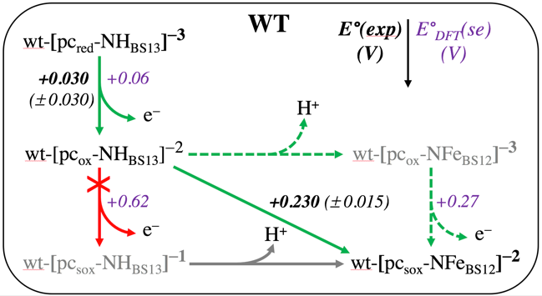
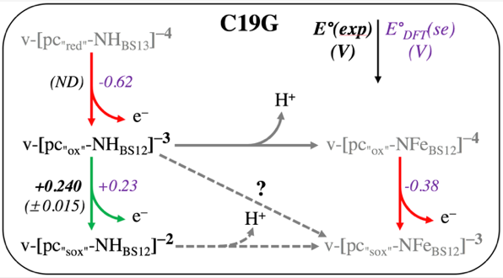
Figure 3. Chemical relationships between geometry-optimized PC models (see also Fig. 2). Top: wt EcHyd1, bottom: C19G variant. Lowest energy BS states and total cluster charges are indicated. Green vertical arrows indicate reactions for which the calculated E°_{DFT}(se) values (shown in pink) are similar to the measured E°(exp) redox potentials (shown in black). A diagonal arrow denotes coupled proton and electron transfer. A question mark is added at this diagonal for the variant because there is no crystallographic evidence for the existence of a v-pc_{"sox"}-NFe state.
We have also shown that both the wt-pc_{red}-NH/pc_{ox}-NH and the putative wt-pc_{ox}-NFe/pc_{sox}-NFe transition can be considered as (-3/-2) redox couples, for which we obtain a small ∆E°_{DFT}(se) of 0.20V. If, as it seems more likely, the N-Fe bond is only formed in the superoxidized state, the wt-pc_{ox}-NH/pc_{sox}-NFe transition involves CPET, necessitating the addition of a correction term for the deprotonation reaction (Fig. 3). However, that study is outside the scope of this paper (see ESI section 4.3†). For the cuboid [4Fe-4S-4Sγ] PC of D. fructosovorans [NiFe]-hydrogenase the effects of electron spin delocalisation explain the more negative E° of -0.340V that is measured for its (-3/-2) couple.²⁶ Concerning the corresponding [4Fe-4S-5Sγ] redox couples of the EcHyd1 C19G variant we show that, due to their extra negative charge, the E°'s are shifted to much lower values and therefore no v-pc_{"red"}-NH state is formed. At the [4Fe-4S] core level, the v-pc_{"ox"}-NH/ pc_{"sox"}-NH high potential redox process is reminiscent of the equivalent one in the High-Potential Iron Protein (HiPIP) couple first described 45 years ago.²⁷ Because the variant PC can only deliver one electron to the active site, the formation of reactive oxygen species that will oxidize thiolate ligands^{28,29} cannot be prevented explaining the loss of O₂-tolerance and enzyme deactivation.
In this study, we have calculated and compared the redox potentials of the different non-cuboid PC forms of EcHyd1 and the cuboid PC found in O₂-sensitive [NiFe]-hydrogenases by combining their intrinsic structural properties with a simple semi-empirical approach that takes into consideration their very similar protein environment. The redox potentials obtained by this method for one-electron transfers are in fairly good agreement with measured values indicating its validity and possible application to other similar problems.
AV, JMM and JCFC thank the CEA, the CNRS and the Université Grenoble Alpes for institutional funding. AV and JCFC thank the European Synchrotron Radiation Facility for access to beamline ID23-1. MMR, AP and FAA thank… Part of this work was supported by the grants FRISBI (ANR-10-INSB-05-02) and GRAL (ANR-10-LABX-49-01) within the Grenoble Partnership for Structural Biology. We further thank Dr. P. Amara for helpful discussions and for critical reading of the manuscript.

Notes and references
‡ see also the thesis “EPR Investigations of Iron-Sulfur Cluster Relays in Enzymes” by MM Roessler, University of Oxford, 2011.
§ Coordinates and structure factors for the EcHyd1 C19G variant have been deposited in the Protein Data Bank (code XXXX).

- B. Friedrich, J. Fritsch and O. Lenz, Curr. Opin. Biotechnol., 2011, 22, 358–364.
- M.-E. Pandelia, W. Nitschke, P. Infossi, M.-T. Giudici-Orticoni, E. Bill and W. Lubitz, Proc. Natl. Acad. Sci. U. S. A., 2011, 108, 6097–6102.
- T. Goris, A. F. Wait, M. Saggu, J. Fritsch, N. Heidary, M. Stein, I. Zebger, F. Lendzian, F. A. Armstrong, B. Friedrich and O. Lenz, Nat. Chem. Biol., 2011, 7, 310–318.
- M. J. Lukey, M. M. Roessler, A. Parkin, R. M. Evans, R. A. Davies, O. Lenz, B. Friedrich, F. Sargent and F. A. Armstrong, J. Am. Chem. Soc., 2011, 133, 16881–16892.
- J. Fritsch, P. Scheerer, S. Frielingsdorf, S. Kroschinsky, B. Friedrich, O. Lenz and C. M. T. Spahn, Nature, 2011, 479, 249–252.
- Y. Shomura, K.-S. Yoon, H. Nishihara and Y. Higuchi, Nature, 2011, 479, 253–256.
- A. Volbeda, P. Amara, C. Darnault, J.-M. Mouesca, A. Parkin, M. M. Roessler, F. A. Armstrong and J. C. Fontecilla-Camps, Proc. Natl. Acad. Sci. U. S. A., 2012, 109, 5305–5310.
- L. Bowman, L. Flanagan, P. K. Fyfe, A. Parkin, W. N. Hunter and F. Sargent, Biochem. J., 2014, 458, 449–458.
- S. Frielingsdorf, J. Fritsch, A. Schmidt, M. Hammer, J. Löwenstein, E. Siebert, V. Pelmenschikov, T. Jaenicke, J. Kalms, Y. Rippers, F. Lendzian, I. Zebger, C. Teutloff, M. Kaupp, R. Bittl, P. Hildebrandt, B. Friedrich, O. Lenz and P. Scheerer, Nat. Chem. Biol., 2014, 10, 378–385.
- B. J. Murphy, R. Hidalgo, M. M. Roessler, R. M. Evans, P. A. Ash, W. K. Myers, K. A. Vincent and F. A. Armstrong, J. Am. Chem. Soc., 2015, 137, 8484–8489.
- R. M. Evans, A. Parkin, M. M. Roessler, B. J. Murphy, H. Adamson, M. J. Lukey, F. Sargent, A. Volbeda, J. C. Fontecilla-Camps and F. A. Armstrong, J. Am. Chem. Soc., 2013, 135, 2694–2707.
- A. Volbeda, C. Darnault, A. Parkin, F. Sargent, F. A. Armstrong and J. C. Fontecilla-Camps, Structure, 2013, 21, 184–190.
- P. Wulff, C. Thomas, F. Sargent and F. A. Armstrong, J. Biol. Inorg. Chem., 2016, 21, 121–134.
- P. A. Ash, R. Hidalgo and K. A. Vincent, ACS Catal., 2017, 7, 2471–2485.
- M. M. Roessler, R. M. Evans, R. A. Davies, J. Harmer and F. A. Armstrong, J. Am. Chem. Soc., 2012, 134, 15581–15594.
- A. Volbeda, M. H. Charon, C. Piras, E. C. Hatchikian, M. Frey and J. C. Fontecilla-Camps, Nature, 1995, 373, 580–587.
- J. J. Warren, T. A. Tronic and J. M. Mayer, Chem. Rev., 2010, 110, 6961–7001.
- C. Costentin, M. Robert and J.-M. Savéant, Chem. Rev., 2010, 110, PR1–40.
- B. S. Perrin and T. Ichiye, Proteins, 2010, 78, 2798–2808.
- J. M. Mouesca and B. Lamotte, Coord. Chem. Rev., 1998, 178, 1573–1614.
- V. Pelmenschikov and M. Kaupp, J. Am. Chem. Soc., 2013, 135, 11809–11823.
- S. G. Tabrizi, V. Pelmenschikov, L. Noodleman and M. Kaupp, J. Chem. Theory Comput., 2016, 12, 174–187.
- M. H. M. Olsson, C. R. Søndergaard, M. Rostkowski and J. H. Jensen, J. Chem. Theory Comput., 2011, 7, 525–537.
- I. Dance, Dalton Trans. Camb. Engl. 2003, 2015, 44, 4707–4717.
- J.-M. Mouesca, J. C. Fontecilla-Camps and P. Amara, Angew. Chem. Int. Ed Engl., 2013, 52, 2002–2006.
- M. Rousset, Y. Montet, B. Guigliarelli, N. Forget, M. Asso, P. Bertrand, J. C. Fontecilla-Camps and E. C. Hatchikian, Proc. Natl. Acad. Sci. U. S. A., 1998, 95, 11625–11630.
- C. W. Carter, J. Kraut, S. T. Freer, R. A. Alden, L. C. Sieker, E. Adman and L. H. Jensen, Proc. Natl. Acad. Sci. U. S. A., 1972, 69, 3526–3529.
- A. Volbeda, L. Martin, E. Barbier, O. Gutiérrez-Sanz, A. L. De Lacey, P.-P. Liebgott, S. Dementin, M. Rousset and J. C. Fontecilla-Camps, J. Biol. Inorg. Chem., 2015, 20, 11–22.
- R. M. Evans, E. J. Brooke, S. A. M. Wehlin, E. Nomerotskaia, F. Sargent, S. B. Carr, S. E. V. Phillips and F. A. Armstrong, Nat. Chem. Biol., 2016, 12, 46–50.

