SYSTEMATIC REVIEW AND META-ANALYSIS INVESTIGATING THE EFFICACY AND SAFETY OF PROBIOTICS IN PEOPLE WITH CANCER

Authors:
H. Hassan ^{1, 2}, M. Rompola ^{1, 2}, A.W. Glaser ^{1, 2}, S. E. Kinsey ^{1, 2}, R. S. Phillips ^{1, 3}
Affiliations:
¹ Department of Paediatric Haematology and Oncology, Leeds Teaching Hospital NHS Trust, Leeds, UK
² Leeds Institute of Cancer and Pathology, University of Leeds, Leeds, UK
³ Centre for Reviews and Dissemination, University of York, York, UK
Full address for correspondence:
Dr Hadeel Hassan
Leeds Institute of Cancer and Pathology, University of Leeds, Leeds, LS2 9JT, UK
Telephone: +44 (0)113 343 2596
Email address: hadeelhassan@doctors.org.uk
Abstract

BACKGROUND/OBJECTIVES: Probiotics are living microorganisms that confer a health benefit on the host when administered. This systematic review and meta-analysis investigates the efficacy and safety of probiotics in adult and paediatric patients diagnosed with cancer.
Methods: A systematic review and meta-analysis was undertaken (PROSPERO registration: CRD42016050252). Randomised controlled trials (RCT), identified through screening multiple databases were included for analysis of efficacy. Non-randomised controlled-trials and case reports were included for safety analysis. Outcomes included the reduction in the incidence and severity of diarrhoea, and adverse events. Where possible, data were combined for meta-analysis using a random-effects model. Planned sub-group analyses were not possible through marked heterogeneity of study characteristics.
RESULTS: Twenty one studies (N = 2,982 participants) were included for assessment of efficacy. Probiotics may reduce the incidence of diarrhoea in patients with cancer [odds ratio (OR) = 0.52, 95% confidence interval (CI) 0.34-0.78, 95% prediction interval (PI) 0.3-0.92, I-sq 36.9%, 5 studies] and the duration of pyrexia [standardized mean difference 0.39 days, 95% CI 0.35-0.43, I-sq 0.01%, 5 studies]. Twenty five studies (N = 2,242) were included in the safety analysis. Five case reports showed probiotic-related bacteraemia/fungaemia/positive blood cultures. Definitions and reporting of adverse events were variable and inconsistent.
CONCLUSIONS: There remain insufficient studies to assess the true effect of probiotics in people with cancer. Meta-analysis suggests probiotics may be beneficial but further studies are still required. Improved reporting of outcomes and adverse events in clinical trials are required to improve accuracy and confidence of conclusions drawn in future updates.

Introduction

Probiotics are defined as “live micro-organisms which, when administered in adequate amounts, confer a health benefit on the host” according to the World Health Organisation and United Nations Food and Agriculture Organization (FAO) [1]. The most common strains belong to the genera Lactococcus and Bifidobacterium [2]. Health benefits attributed to probiotics include the reduction of the severity of antibiotic associated diarrhoea in paediatric patients[3], necrotising enterocolitis in premature infants [4] and the incidence of radiation-induced diarrhoea [5].
Chemotherapy and radiotherapy induced diarrhoea is a common adverse event. Radiotherapy is believed to potentially alter bacterial flora and affect the intestinal motility and vascular permeability of mucosal cells [6]. Chemotherapy is thought to alter the composition of intestinal flora and therefore affect the metabolism of intestinal enzymes which is vital for gut integrity. Changes to the gut flora may impact the gut defence barrier, immune function and absorption of vital nutrients [7]. It is estimated that 20-45% of all chemotherapy patients experience severe diarrhoea [8]. Radiotherapy or chemotherapy induced diarrhoea may interrupt or even stop treatment, impair quality of life and prolong hospital stay of patients with cancer, thus may potentially increase health economic burdens [9].
There have been multiple studies investigating the role of probiotics in reducing chemotherapy and radiotherapy associated diarrhoea. A rigorous systematic review and meta-analysis investigating the efficacy and safety of use of probiotics in people with cancer was undertaken by Redman et al [10]. When the search was initially undertaken in 2013, 10 trials were not included as they were still recruiting participants. These trials were therefore included in the current review, whilst undertaking a new data base search (figure 1).
This review, therefore, aims to update the Redman et al [10] systematic review and meta-analysis including the identified ongoing studies, to explore the previously noted heterogeneity and the assessment of safety.

Methods
This review was undertaken following a pre-specified protocol registered on PROSPERO (the international register of systematic reviews): CRD42016050252 October 2016 [11].
Inclusion criteria
Designs of studies eligible for efficacy analysis included randomised-controlled trials of people diagnosed with cancer who received probiotics as an intervention. Outcomes assessed included antibiotic-associated diarrhoea, gastrointestinal infection, mucositis, or any adverse event. Non-randomised studies and case reports were also included within the safety analysis.
Identification of trials
Database searches of Medline, Embase and Allied and Complementary Medicine (AMED) without language limitations were undertaken with the following search strategy:
((cancer OR malignancy OR malignant OR oncology OR oncological OR transplant OR leukaemia tumour OR tumour OR chemotherapy OR radiotherapy) AND (probiotic OR lactobacillus OR saccharomyces)) AND (infection OR sepsis OR diarrhoea OR fungal))
A simplified search strategy was used for the following search engines: the Cochrane Central Register of Controlled Trials, Literatura Latino-Americana e do Caribe em Ciências da Saúde, Database of Abstracts of Reviews of Effects, American Society of Clinical Oncology, International Society of Paediatric Oncology, Multinational Association of Supportive Care in Cancer, International Cancer Research Portfolio, National Cancer Institute Clinical Trials, National Cancer Research Institute, Current Controlled Trials and Centerwatch.
Study selection
Study selection and data extraction was conducted in 2 stages:
- Two reviewers independently assessed the title and abstract of the studies for possible inclusion (H.H, M.R). Inclusion or exclusion was verified by assessing the full-text of potentially included studies.
Discrepancies between the raters were addressed and those unresolved were referred to an independent assessor (R.P).
- Data was extracted by a researcher using a standardised form (H.H) which was independently checked by a second person (M.R). When further information was required, the author of the paper was contacted.
The study selection process and data extraction was piloted using a sample of 100 papers in order to check that the correct papers would be identified, interpreted, and analysed. The pilot study was used to refine the inclusion criteria to ensure that it could be applied consistently and that correct data were extracted.
Risk of bias and quality assessment of included studies
The Cochrane risk of bias tool was used to assess the risk of bias of included RCTs [12].
The Loke method was used to assess the quality of studies investigating adverse effects [13]. Items were identified as “unclear risk of bias” when relevant information was not specified in the studies.
Data synthesis
Where possible, comparable data were pooled using the Mantel-Haenszel methods for dichotomous data and inverse variance models for continuous data as recommended in “Systematic reviews: CRD's guidance for undertaking reviews in health care” [14]. This was undertaken using random-effect meta-analyses to supply average estimate of effects, with their associated 95% confidence interval (CI) and 95% prediction intervals (PI). Prediction intervals demonstrate the certainty, or uncertainty of findings in future studies taking into account the observed heterogeneity [15]. Results were displayed in forest plots. I-sq was used to evaluate between-study heterogeneity. An I-sq of >50% was deemed to represent significant heterogeneity [14]. Funnel plots were planned to be used to assess for bias, however there were insufficient data to undertake this. Analysis was undertaken using the metafor package in R-studio [16] .
Subgroup analysis
It was not possible to undertake any subgroup analysis due to marked heterogeneity of included studies. Subgroup analyses were intended to assess age, type of probiotics, mode of delivery, radiotherapy, and chemotherapy interventions.

Results
We identified 8015 unique articles, of which 98 were selected for full-text review, with 10 RCTs and 8 additional safety papers identified from the previous review (see Figure 1). This resulted in a total of 21 studies included for the efficacy analysis and 25 studies for the safety analysis. Indications for excluding articles following full text review are summarised in figure 1.
Efficacy analysis
Supplementary file 1 summarises characteristics of the RCTs included in the efficacy analysis. Studies were conducted in 14 different countries of which China was the most common. Eleven studies included surgical interventions, 9 studies included radiotherapy and 7 studies included chemotherapy interventions. Sixteen studies used probiotics with more than one strain of bacteria and 11 studies included 3 or more strains of bacteria. Eighteen studies included Lactobacillus strains of which there were 12 different species. Fifteen studies included Bifidobacterum strains of which there were 7 different species. Only 2 of the 21 studies included paediatric patients.
Risk of bias assessment
Findings of the risk of bias assessment (supplementary file 2 and figure 2) identified that most items were assessed as unclear (up to 45% in each domain) due a lack of reporting of methods in both published protocols and reports. Highest risk of bias was noted when assessing performance bias (29%). Most of the studies reported as high risk specified that participants, but not personnel, were blinded to the intervention delivered which could potentially affect how randomisation is delivered. Lowest risk of bias was found when investigating attrition bias and sequence generation (62% and 52% respectively); most studies clearly specified methods used.
Meta-analysis
Pooled analysis demonstrated that probiotics reduced the incidence of diarrhoea in patients with cancer [odds ratio (OR) = 0.52, 95% confidence interval (CI) 0.34-0.78, 95% PI 0.30-0.92, I-sq 36.9%, 5 studies, figure 3], and duration of pyrexia [standardized mean difference 0.39 days, 95% CI 0.35-0.43, I-sq 0.01%, 5 studies , figure 4 ]. Probiotics may also reduce the severity of diarrhoea, for example CTC grade 2 diarrhoea [OR=0.67, 95% CI 0.15-2.98, PI 0.07-6.55, I-sq 76.9%, 3 studies], grade 3 and 4 diarrhoea [OR=0.51, 95% CI 0.12-2.2, PI 0.03-9.08, I-sq 92.5%, 4 studies, figure 5], the incidence of septicaemia [OR=0.39, 95% CI 0.13-1.17, PI 0.05-3.05, I-sq 76.4%, 5 studies], and central line infections [OR=0.50, 95% CI 0.15-1.71, PI 0.09-2.7, I-sq 62.9%, 3 studies] but these results are very heterogenous and uncertain. Due to the marked heterogeneity of reporting in included studies we were unable to perform subgroup analysis on intervention, strain, dose of probiotic, and age.
Safety of probiotics
Demographics of the 25 studies (N = 2,242) included in the safety analysis which are summarised in supplementary file 3. An estimated 237 AEs occurred in those consuming probiotics and 314 AEs in those not consuming probiotics. However, the majority of studies did not specify how AEs were reported, for example, it is unclear whether two separate AEs recorded as ‘sepsis’ or ‘pneumonia’ occurred independently, or from the same episode . No deaths attributed to probiotics were identified in this review. In the initial review 2 deaths were reported in probiotic groups, but these were not attributed to the intervention delivered. Five case reports were identified during the initial review of probiotic associated infections and no further case reports, or probiotic associated infections were identified, with one cohort study explicitly reporting an absence of probiotic associated infection.
Loke method for quality assessment for the reporting of adverse events
Quality assessment of studies included for safety analysis are reported in supplementary file 4. As described in the initial review definitions of adverse events were inconsistently reported. Some were defined according to CTCAE or NCI-CTC, others did not state how the definition was decided.
Discussion
This review found 10 new RCTs and 8 further studies reporting AEs of probiotics in people with cancer giving a total of 21 studies for efficacy analysis and 25 studies for safety analysis. There was marked heterogeneity of the strain, dose, and duration of probiotic used and age, cancers and anti-cancer therapies under study. It was not possible to undertake subgroup analysis to explore between-study heterogeneity further.

Risk of bias assessment of trials
Domains of risk of bias (supplementary file 2 and figure 2) were mostly reported as unclear due to limited reporting of methods undertaken. Highest risk was identified when assessing selection and detection bias. Whilst aspects of these biases may not be relevant, e.g. whether participants were blinded to the episodes of diarrhoea, most studies did not report sufficient information about methods undertaken, e.g. whether personnel were blinded from allocation of randomisation. This may undermine the randomisation process resulting in biased and inflated effect estimates. Selection bias can be reduced by implementing blinding. Accuracy of the assessment of bias could be improved by clearer reporting in studies and protocols. Reporting of studies can be improved by using the Consolidated Standards of Reporting trials (CONSORT) checklist [17]. This is an evidence-based set of recommendations for the reporting of RCTs enhancing transparency in the appraisal of studies, and therefore, potentially reducing bias.

Quality assessment for the reporting of adverse events
The Loke method [13] for the quality assessment of safety of probiotics (supplementary file 4), identified that studies are still unclear on definitions, measure and reporting of adverse events. Definitions of adverse events may vary according to country and health care provisions.
Currently, no consistent definitions are used in the reporting of adverse events and other outcomes. Uniformity of outcome reporting can be improved by using the Core Outcome Measures in Effectiveness Trials (COMET) initiative [18] in which a standardised set of outcomes (i.e. adverse events) represent the minimum factors reported in clinical trials. We were unable to perform subgroup analysis due to the number of studies using different strains and doses of probiotics, age groups, treatment and reporting of different outcomes. Using the proposed COMET initiative to agree on a standardised set of outcomes would improve accuracy when undertaking further updates, potentially reducing between-study heterogeneity.

Efficacy of probiotics
There remain insufficient studies to assess the true effect of probiotics in people with cancer. Meta-analysis suggests probiotics may be beneficial, but further studies are still required, particularly in children. The meta-analysis was unclear if probiotic can reduce the severity of grade 2 diarrhoea [OR=0.67, 95% CI 0.15-2.98, PI 0.07-6.55, I-sq 76.9%, 3 studies] or grade 3 and 4 diarrhoea [OR=0.51, 95% CI 0.12-2.2, PI 0.03-9.08, I-sq 92.5%, 4 studies], demonstrated by 95% confidence intervals which cross 1, the point of no significant average effect. Prediction intervals are also wide, suggesting that future studies investigating different probiotics in different settings may demonstrate benefit, disadvantage, or not demonstrate any statistically significant difference. Pooled analysis did demonstrate that those treated in the probiotic group had a reduced incidence of diarrhoea [odds ratio (OR) = 0.52, 95% confidence interval (CI) 0.34-0.78, PI 0.3-0.92, I-sq 36.9%, 5 studies] and reduced duration of pyrexia [standardized mean difference 0.39 days, 95% CI 0.35-0.43, I-sq 0.01%, 5 studies ]. It was unclear if probiotics can reduce the incidence of septicaemia [OR=0.39, 95% CI 0.13-1.17, PI 0.05-3.05, I-sq 76.4%, 5 studies] or central line infections [OR=0.5, 95% CI 0.15-1.71, PI 0.09-2.7, I-sq 62.9%, 3 studies].
Marked heterogeneity was demonstrated by the high I-sq results and wide prediction intervals. Prediction intervals represent an estimate of where the effect will fall in future observations. Wide prediction intervals, therefore, demonstrate a greater variability of estimated treatment effects in future studies. This could be attributed to clinical diversity e.g. the use of differing strains and doses of probiotics, cancer diagnoses and interventions delivered, methodological diversity e.g. differing study designs and statistical heterogeneity e.g. the varying outcome effects reported in studies.
There were insufficient data reported in the studies identified to undertake a pooled analysis of daily bowel movements, use of anti-diarrhoeal medication and faecal bacteriological comparison. It was not possible to undertake any subgroup analysis due to the marked variability of study designs, probiotic strain dose, age and outcomes reported and the small numbers of studies in each subgroup. Again, using the COMET initiative to create a standardised set of outcomes would enable more accurate meta-analysis and therefore potentially more accurate conclusions.
It is not possible to recommend the use of probiotics for clinical practice, due to the heterogeneity and sample sizes of identified studies. Further quality RCTs will help guide future recommendations.

Safety analysis
Twenty five studies (N = 2,242) were included in the safety analysis. It is unclear how many individuals sustained adverse events as reporting varied between studies. Some studies reported on individual events rather than people sustaining an adverse event and it is unclear how this may overlap (for example, some studies reported on the incidence of septicaemia, incidence of pneumonia and urinary tract infections making it difficult to identify the number of individuals, or indeed if the same episode of illness was counted in two categories). An estimated 237 AEs occurred in those consuming probiotics and 314 AEs in those not consuming probiotics. Of the 8 studies identified during this review, there were no deaths attributed to probiotics. In the initial review, 2 deaths were reported in probiotic groups, but this was not attributed to the intervention. There were 5 case reports identified during the initial review of probiotic associated infections. Some studies did not report on bacterial isolates from positive blood cultures identified (in both probiotic and control groups). Therefore, it cannot be concluded with confidence that there were no probiotic-associated infections, or that adverse events sustained cannot be attributed to probiotics consumed due to the heterogeneity of malignancies or treatment regimens delivered As adverse events were also not clearly, or uniformly defined in identified studies, it cannot be determined if all relevant data were appropriately identified, recorded or documented. As previously explained, this could be improved using methods such as the COMET initiative in future studies.

Conclusion
This systematic review demonstrates that there is still insufficient evidence to conclude that probiotics are effective and safe in people with cancer. Meta-analysis showed that probiotics reduce the incidence of diarrhoea, duration of pyrexia and may reduce incidence of septicaemia and central line infection. However, these results should be interpreted cautiously because of the heterogeneous nature of included studies and the lack of studies with a clear low risk of bias. It was not possible to perform subgroup analysis, particularly in children, in order to investigate this further. Probiotics may be a rare source of infection but no deaths have been attributed to their consumption. However, the variability in the definitions used and in the reporting of adverse events mean that confident conclusions cannot be drawn. Further harmonisation of reporting of clinical trials using strategies such as the COMET initiative and CONSORT checklist would enable greater precision and confidence in conclusions drawn.
Figure 1: Summary of screening process.
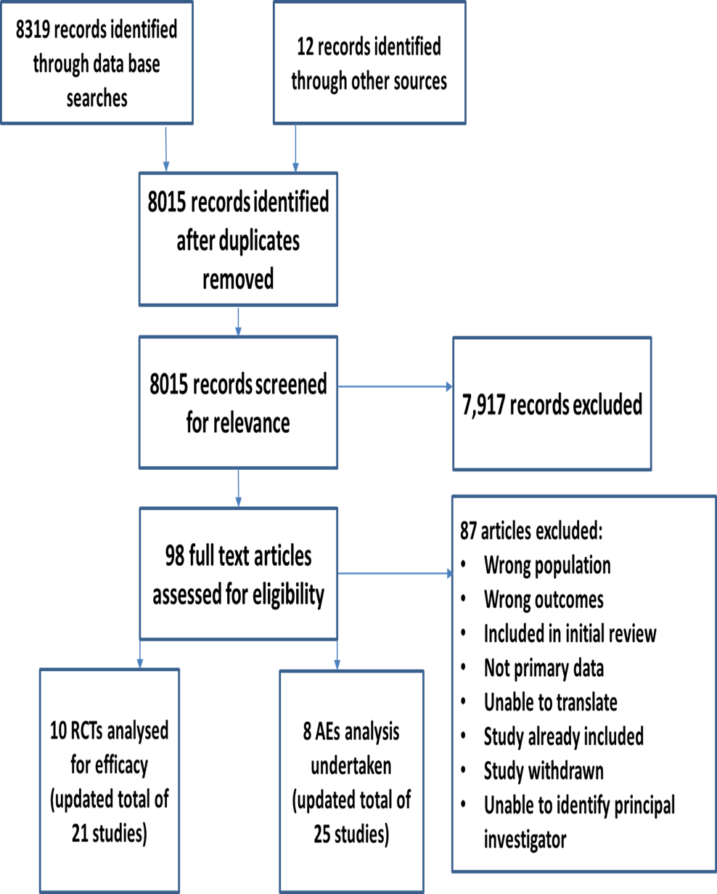

Figure 2:
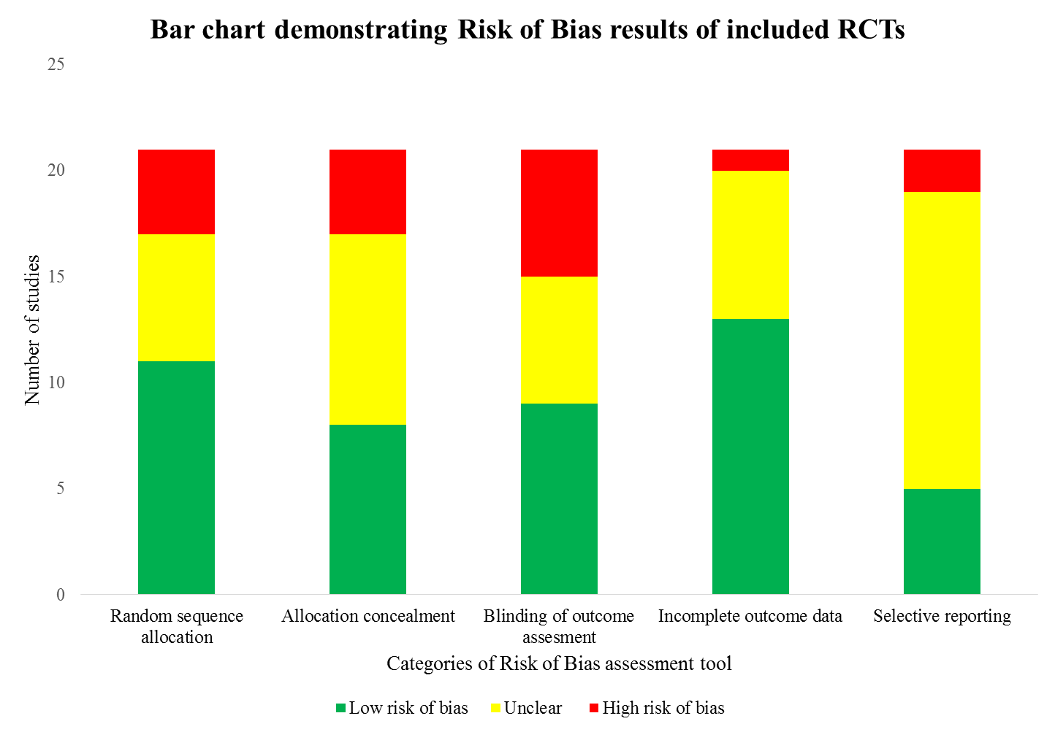
Figure 3: Forest plot of incidence of diarrhoea
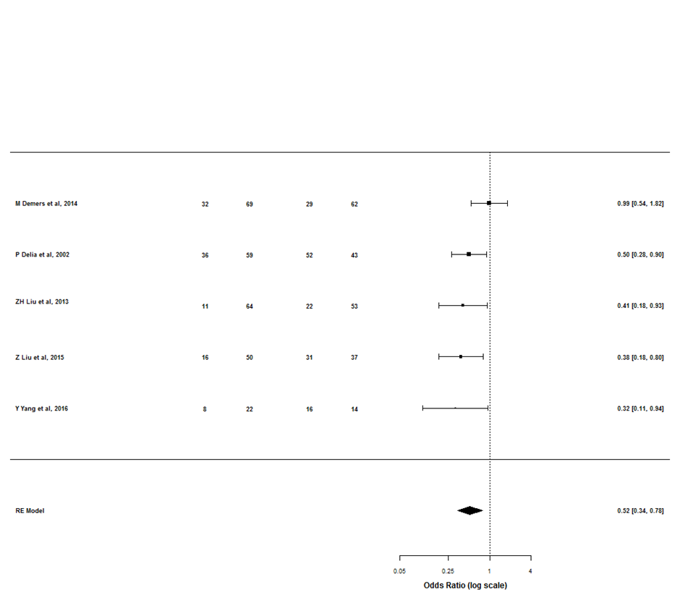
Favours probiotic Favours control

Figure 4: Forest plot of duration of pyrexia (days)

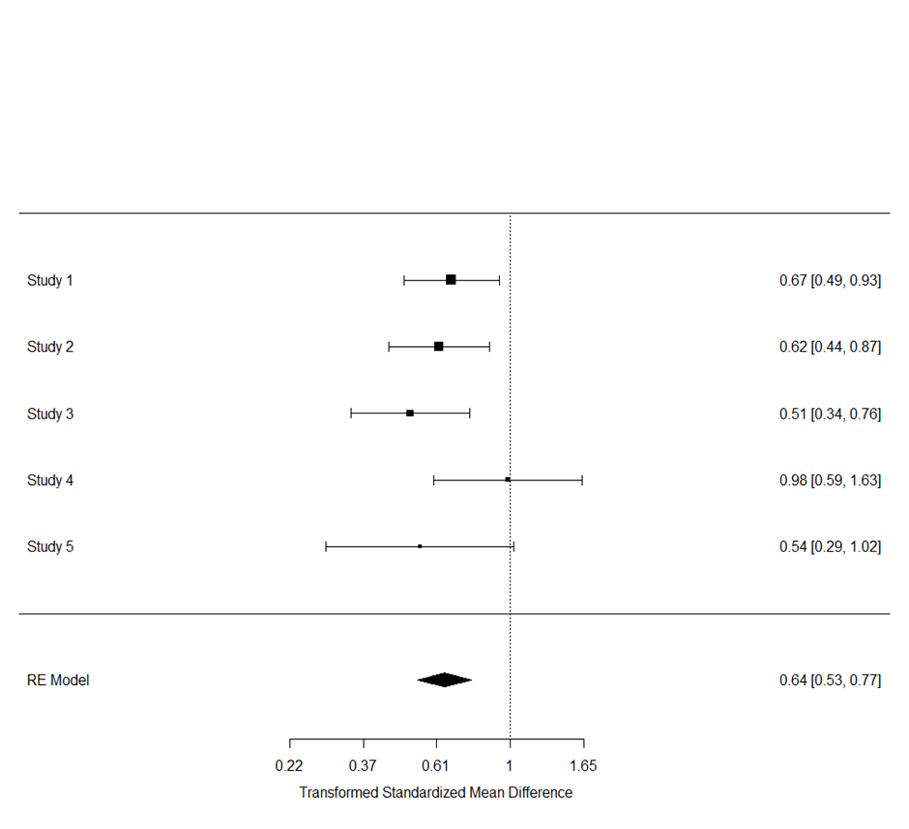
Favours probiotic Favours control
Figure 5: Forest plot of grade ≥3 diarrhoea

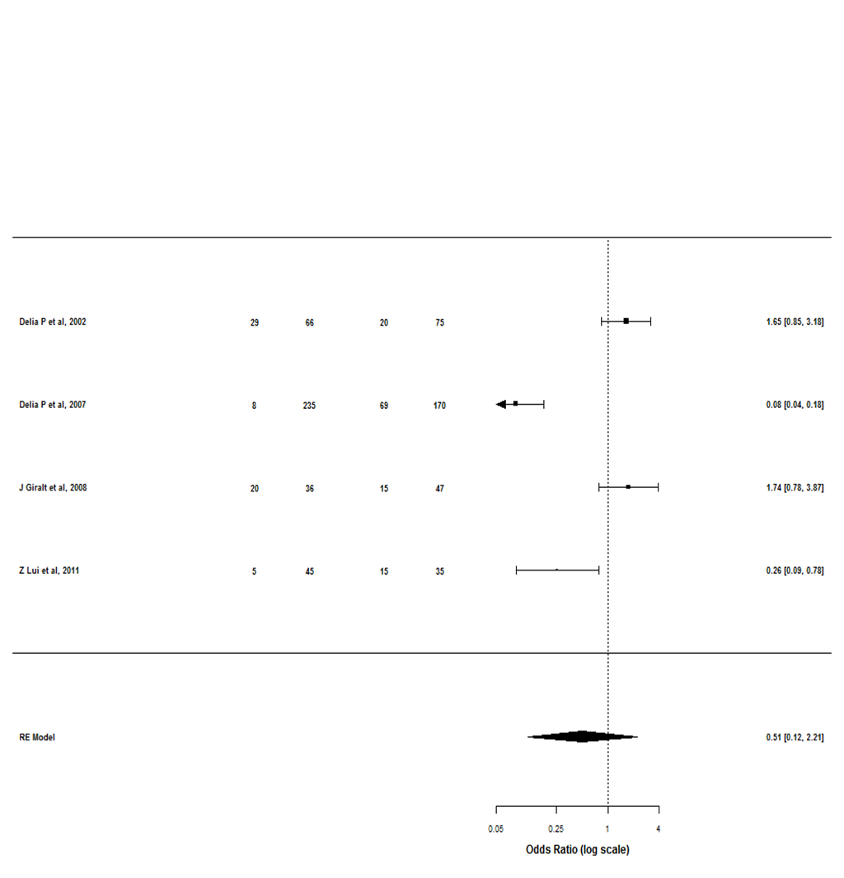
Favours probiotic Favours control

References
1. Schlundt, J. Report of a Joint FAO/WHO Expert Consultation on Evaluation of Health and Nutritional Properties of Probiotics in Food Including Powder Milk with Live Lactic Acid Bacteria. FAO / WHO. 2012 October 2012; Available from: https://web.archive.org/web/20121022161702/http://www.who.int/foodsafety/publications/fs_management/en/probiotics.pdf.
2. Holzapfel, W.H., et al., Taxonomy and important features of probiotic microorganisms in food and nutrition. Am J Clin Nutr, 2001. 73(2 Suppl): p. 365s-373s.
3. Goldenberg, J.Z., et al., Probiotics for the prevention of pediatric antibiotic-associated diarrhea. Cochrane Database Syst Rev, 2015. 22(12).
4. Pammi, M. and G. Suresh, Enteral lactoferrin supplementation for prevention of sepsis and necrotizing enterocolitis in preterm infants. Cochrane Database Syst Rev, 2017. 28(6).
5. Liu, M.M., et al., Probiotics for prevention of radiation-induced diarrhea: A meta-analysis of randomized controlled trials. PLoS ONE, 2017. 12(6).
6. Salminen, E., et al., Preservation of intestinal integrity during radiotherapy using live Lactobacillus acidophilus cultures. Clin Radiol, 1988. 39(4): p. 435-7.
7. Guarner, F. and J.R. Malagelada, Role of bacteria in experimental colitis. Best Pract Res Clin Gastroenterol, 2003. 17(5): p. 793-804.
8. Arbuckle, R.B., S.L. Huber, and C. Zacker, The consequences of diarrhea occurring during chemotherapy for colorectal cancer: a retrospective study. Oncologist, 2000. 5(3): p. 250-9.
9. Dranitsaris, G., J. Maroun, and A. Shah, Estimating the cost of illness in colorectal cancer patients who were hospitalized for severe chemotherapy-induced diarrhea. Can J Gastroenterol, 2005. 19(2): p. 83-7.
10. Redman, M.G., E.J. Ward, and R.S. Phillips, The efficacy and safety of probiotics in people with cancer: a systematic review. Ann Oncol, 2014. 25(10): p. 1919-29.
11. H Hassan, M.R., Bob Phillips, The efficacy and safety of probiotics in people with cancer: an updated systematic review and meta-analysis, 2016: PROSPERO
12. Higgins, J.P., et al., The Cochrane Collaboration's tool for assessing risk of bias in randomised trials. Bmj, 2011. 343: p. d5928.
13. Loke, Y.K., D. Price, and A. Herxheimer, Systematic reviews of adverse effects: framework for a structured approach. BMC Med Res Methodol, 2007. 7: p. 32.
14. Dissemination, C.f.R.a., Systematic Reviews: CRD's guidance for undertaking reviews in health care 2008, University of York: CRD.
15. Higgins, J.P., S.G. Thompson, and D.J. Spiegelhalter, A re-evaluation of random-effects meta-analysis. J R Stat Soc Ser A Stat Soc, 2009. 172(1): p. 137-159.
16. Team, R., RStudio: Integrated Development for R. RStudio, Inc., 2015.
17. The CONSORT Statement. 2016; Available from: http://www.consort-statement.org/.
18. COMET intitiative. [cited 2017; Available from: http://www.comet-initiative.org/.
19. Higgins, J.P.T., et al., The Cochrane Collaboration’s tool for assessing risk of bias in randomised trials. BMJ, 2011. 343.

