The discovery of Mesolithic red deer at Skipsea Withow [H1]

Sheila Cadman
Wansford, Driffield, East Yorkshire
SheilaCad@yahoo.co.uk

Sheila Cadman is a local historian and amateur archaeologist who is particularly interested in the prehistory of East and North Yorkshire. She is also an archivist at Londesborough Lodge, Scarborough working on and cataloguing material from Star Carr.

Becky Knight
Department of Archaeology, The Kings Manor, University of York, York, YO1 7EP
becky.knight@york.ac.uk

Becky Knight is an expert in zooarchaeology and completed a Masters in this subject in 2012, specialising on small mammals from cave sites in Yorkshire for her dissertation. She is currently a research technician on the ERC funded POSTGLACIAL project at the University of York and has been working on the faunal remains from the sites of Star Carr and Flixton Island.

Ben Elliott
Department of Archaeology, The Kings Manor, University of York, York, YO1 7EP
ben.elliott@york.ac.uk

Ben Elliott specialises in prehistoric bone and antler technology, completing a PhD on British Mesolithic antler working in 2013. He is currently employed as a post-doctoral research associate on the SoundTracks project (in partnership with Creswell Heritage Trust and the British Library) and as a project archivist and osseous technology specialist on the POSTGLACIAL project.

Tim Schadla-Hall
Institute of Archaeology, 31-34 Gordon Square, London WC1H 0PY UK
t.schadla-hall@ucl.ac.uk

Tim Schadla-Hall is a Reader in Public Archaeology at the Institute of Archaeology. He worked in the Vale of Pickering from the 1970s, first at Seamer Carr and then in the 1980s he established the Vale of Pickering Research Trust which mapped the extent of Lake Flixton and discovered a number of new Late Palaeolithic and Early Mesolithic sites around the edge of the palaeo-lake. He also specialises in Public archaeology, post-mediaeval houses, politics and archaeology and museums.

Harry K. Robson
Department of Archaeology, The Kings Manor, University of York, York, YO1 7EP
harry.robson@york.ac.uk

Harry Robson in a British Academy Postdoctoral Fellow in the Department of Archaeology at the University of York. He is particularly interested in the exploitation of freshwater and marine resource exploitation during the Mesolithic and Neolithic periods, and is currently undertaking research on the use of pottery across the transition to agriculture using a range of molecular and isotopic techniques to determine culinary practices.

Nicky Milner
Department of Archaeology, The Kings Manor, University of York, York, YO1 7EP
nicky.milner@york.ac.uk,

Nicky Milner is a Professor in Prehistory at the University of York. She is principal investigator of the ERC funded POSTGLACIAL project, which has involved excavating the Early Mesolithic site of Star Carr and the Late Palaeolithic site of Flixton Island. She was also a co-director of the excavations at Howick, Northumberland and at Baylet shell midden in Ireland.

Abstract [H2]

Skipsea Withow is well known for producing a barbed point and faunal remains, thought to date to the Early Mesolithic period, over a century ago. More recently bones were recovered from the eroding cliff face and have been analysed. Although it was considered that they might be elk (Alces alces) due to their large size, it was demonstrated that they are red deer (Cervus elaphus). Further examination suggested that they represent two individuals of slightly different ages. They have been dated to the Early Mesolithic period and the dates overlap with those obtained from the well-known site of Star Carr, located further north in the Vale of Pickering. It is considered unlikely that the red deer bones from Skipsea Withow represent two natural deaths on the edge of the mere and it is possible that they are the remains of humanly deposited bones; a practice seen at Star Carr.

Keywords: Skipsea Withow, red deer, Mesolithic, Preboreal, Star Carr, barbed point

Introduction [H2]

The history of collecting archaeological material from peat deposits eroding at the low cliffs of Skipsea, East Yorkshire, dates back to the early 20th century. In September 1903, Mr B. Moffitt recovered a uniserial barbed point from an area known as Skipsea Withow. Skipsea Withow is the site of a former mere, actively eroding away at the face of the Skipsea cliffs (Figure 1). It forms part of an extensive series of meres within the Holderness region, which featured several areas of open water until the relatively recent past (Van De Noort and Ellis 1995) (Figure 2). The earliest reports on Moffitt’s excavations contain references to a sequence of silt overlain by peat; the silt layer containing the barbed point itself and the preserved remains of red deer, reindeer (Ragnifer tarandus) and northern pike (Esox lucius). The overlying peat deposits contained the semi-articulated remains of an elk (Armstrong 1922).

[Figure 1 about here]

[Figure 2 about here]

Discussions of Mesolithic activity at Skipsea Withow have been largely focused on the bone barbed point, with its initial publication being greeted with a heated debate over its authenticity which was at least partly the result of the antipathy that Tom Sheppard (curator of Hull Museum) had towards Moffitt and his sons (Sitch and Jacobi 1999). After prolonged consideration, the Royal Anthropological Institute assembled a panel of experts to review the arguments, and concluded that there was no evidence to suggest that the artefact was a forgery (Read, Woodward, and Kendall 1923). Subsequent discussions of the find have compared them to similar uniserial barbed points distributed along the East Coast of Britain and stressed their typological affinities to Maglemosian barbed points of the Southern Scandinavian Early Mesolithic (Armstrong 1923; Godwin and Godwin 1933; Clark and Godwin 1956; Jacobi 1976; Wymer, Jacobi, and Rose 1975; Sheldrick, Lowe, and Reynier 1997). The Skipsea Withow barbed point forms part of a larger collection of Late Palaeolithic/Early Mesolithic barbed points of bone and antler that have been recovered from the wetlands of Hornsea, Skipsea and Brandesburton, which have sparked collective comparisons with the large assemblage of artefacts from Star Carr (Davis-King 1980; Radley 1969; Wymer, Jacobi, and Rose 1975).

Analysis of the fauna from Skipsea Withow has been somewhat limited and this may be linked to the accessibility of the material. The animal remains were originally displayed at the family's Cottage in Atwick, before being passed over to Hornsea Library following Beaumont Mofitt’s death (T. Manby pers. comms). The current whereabouts of this material is unknown and this somewhat fractured history of curation may have played a role in suppressing academic discussions of the animal bones.

In absence of the animal remains, discussions of the palaeoenvironmental context of the Moffitt finds has instead hinged upon multi-spectra sedimentological analyses. Godwin and Godwin (1933) used the Skipsea Withow peat sequence to pioneer the use of pollen dating in an attempt to link the Skipsea barbed point to those from the Southern Scandinavian Maglemosian sites on the basis of similar environmental conditions. However, their ascription of these peat deposits as “Late Boreal” was subsequently challenged by Gilbertson (1984) who undertook a programme of plant macrofossil, pollen, sediment and stratigraphic analysis at the site. This established a more secure depositional sequence for the site which began during the Windermere Interstadial and which encompassed fluctuations in water level and climate change right through to the present day. Within this model of the environmental history of Skipsea Withow, the fauna and artefacts recovered by Moffitt were deposited within Early Holocene organic brown silts, at a time of high lake water levels and associated with a radiocarbon measurement of 9650-9250 cal BC (SRR-1944, 9880±60, 95% probability). More recent survey work at Skipsea has demonstrated a wide distribution of Mesolithic surface finds across the region and suggests a persistent exploitation of the Skipsea wetland environments throughout the period (Van De Noort and Ellis 1995).

Discovery of new bones [H2]

In September 2012, a small assemblage of animal bones was found by SC eroding out of the cliffs at Skipsea. They were found within blue-grey clay deposits beneath a thick layer of peat. The broken rib bones were anatomically aligned. Large pieces of wood and roundwood with a smaller diameter were also observed within the peat (Figure 3). The discovery was reported to the Humber Field Archaeology Unit in Hull; however, due to the short notice a team were not able to mobilise in time before high-tide. They therefore advised the finder to remove them before they were lost to the sea. These remains were shown to TSH who had excavated peat deposits in the Vale of Pickering, including at Star Carr and Seamer, and who suggested they were looked at by BK and NM at the University of York. This paper sets out the results of bone analysis and radiocarbon dating.

[Figure 3 about here]

Results [H2]

Faunal remains [H3]
A number of specimens show signs of taphonomic modification, such as exposure and weathering (Figs 4 and 5). Several of the bones have numerous cracks and splits, as well as some delamination of the cortical bone, which suggests the remains were exposed to the elements for a period of time before they were discovered. All of the remains, in varying degrees, have pock marks or areas of pitting on their surfaces which suggests that water erosion of these elements may also have occurred. Due to the fact that the bones had to be removed from heavy clay in a rescue situation, there is some recent damage and breakage. There was no clear ancient human modification evidence such as cut marks or butchering; however, it is possible that ephemeral evidence such as cut or score marks may have been obscured by the weathering and water erosion damage.

[Figure 4 about here]

[Figure 5 about here]

In total, 42 specimens of animal bones, including small fragments, were recovered. A range of elements were present from every area of the body apart from the cranium (Figure 6). Some of the elements were almost complete but with small amounts of damage and others were only represented by a few fragments (Table 1). Two fragments could not be identified to species or element as they were too small and did not retain enough detail to aid identification. The ribs were broadly identified as originating from a species of large mammal. The majority of the remains that could be sided were identified as being from the right side of the body; however, two fragments of mandible, two fragments of scapula and one rib originated from the left side.

[Figure 6 about here]

[Table 1 about here]

From the bone assemblage it was only possible to identify an MNI of 1; however, by examining the developmental stages of epiphyseal fusion and tooth development it was possible to identify two individuals: one large red deer and a younger, smaller individual. This has been noted from the examination of vertebrae, two of which had unfused epiphyses which are missing from the assemblage (Figure 7). The vertebral epiphyses are some of the last to fuse and this tends to occur between c.35-42 months/c.2.9-3.5 years (Purdue 1983). This suggests that one individual is a young adult.

[Figure 7 about here]

It was possible to age the other individual using the partial mandible. All of the teeth present were fully developed adult permanent teeth, of c.38-42 months/3.2-3.5 years (Brown and Chapman 1991). In terms of the tooth wear, they all appear to be at stage (E) in Brown and Chapman’s (1991) system which equates to approximately 50 months/4.2 years. By combining this data an estimate of between 3.5-4.2 years of age can be reached.

In sum, individual 1 has been aged to between 2.9-3.5 years and individual 2 between 3.5-4.2 years of age. Although both of these remains could indicate animals of 3.5 years old (and therefore the same animal), it is argued that the size and development differences between the surviving vertebrae is sufficient to support the notion for two individuals. While it is normal for there to be a size difference between the proximal vertebra (cervical) and the mid-distal vertebra (thoracic and lumbar), the size differential is significant (Figure 8).

[Figure 8 about here]

Although the older individual is still fairly young, the general size and robustness of the elements are noteworthy. Having analysed the Mesolithic faunal remains from the most recent excavations at Star Carr, a site that is of similar age to the Skipsea Withow assemblage, the size of the Skipsea red deer are clearly larger than the largest, most complete examples from Star Carr in terms of tibia, ulna and radii (Table 2, Figure 9) (Knight, Milner, O’Connor et al. 2018). One explanation for this difference could be sexual dimorphism as male red deer tend to be significantly larger than their female counterparts. Due to the preservation issues and modified nature of the Star Carr material it has been impossible to clearly identify the sex of the remains and there is not enough of the Skipsea Withow material to be able to do so. The other possibility is that the variation could be related to differences in the habitats and environments of these animals.

[Table 2 about here]

[Figure 9 about here]

Dating [H3]

A piece of bone from a right tibia was removed for AMS radiocarbon dating and sent to the SUERC Radiocarbon Laboratory in Glasgow. The results are presented in Table 3 and Figure 10. These dates clearly overlap with the dates which have been taken for Star Carr (Bayliss et al. 2018).

[Table 3 about here]

[Figure 10 about here]

Discussion [H2]

The small assemblage rescued from the cliffs at Skipsea Withow is a very interesting and important collection of material: there are only a handful of sites in Britain that contain faunal remains of this period, Star Carr being the most well-known, and this is also true for Northwest Europe (Sørensen, Lübke, and Gross 2018). Any new finds provide a new insight into the ecology, environment and archaeology of the period.

The faunal remains from Skipsea Withow are not associated with archaeological remains such as flint tools and do not exhibit cut marks; however, given that there appear to be two animals it makes it less likely that they represent natural deaths within the mere. At Star Carr there is extensive evidence for deposition of animal bones along the lake edge, particularly of red deer (Knight, Milner, Taylor et al. 2018) and this practice has also been observed in Denmark and Germany in the Early Mesolithic (Sørensen, Lübke, and Gross 2018). The possibility that they are linked to a human presence also comes in the form of the barbed point found over a century ago.

The animals themselves are very large and robust and appear to be even larger than those found at Star Carr, even though the sites overlap in terms of the radiocarbon results. There is the possibility that this can be explained by sexual dimorphism, though given the number of antlers found at Star Carr, it is unlikely that the largest deer at Star Carr are not represented by males. Other explanations for the large size of the Skipsea Withow red deer may be caused by environmental factors: wide open plains with an abundance of food and few predators could account for an animal’s ability to reach an older and more robust size.

In relation to these size observations, it is also important to question whether the ‘elk’ bones originally found at Skipsea Withow (Armstrong 1922) were actually elk. Initially we thought that the recently discovered bones might be elk due to their size and so the same assumption might have been made in the early 1900s. Until the original assemblage is relocated it is impossible to say.

As assemblages of this age and preservation standard are rare, it is important to monitor this section of the cliff to try to collect more of the assemblage if further erosion occurs and more material is exposed. If other remains are found, it will hopefully be possible to gather more information about other species, the environment, and human-animal interactions from this area.

This latest find underlines just how many isolated discoveries of both well preserved faunal and archaeological material have been made over the last century without any coherent attempt to develop a clear strategy for recovery. It underlines the potential for further targeted investigation of what Sheppard referred to as the meres of Holderness which would provide further understanding of Early Mesolithic activity and the environment in Northwest Europe. The fact that some of these potential find spots are under threat of erosion further strengthens the need for further research.

Acknowledgements [H2]
Thanks go to Terry O’Connor for giving a second opinion on the faunal analysis, particularly in terms of identifying two individuals. We are very grateful to Alex Bayliss for help in selecting bone for radiocarbon dating and drilling out a sample and to Gordon Cook at SUERC for his help. This work was part funded from the European Research Council (ERC) under the European Union’s Seventh Framework Programme (FP7/2007-2013) under grant agreement No 283938 (POSTGLACIAL).

Bibliography [H2]

Armstrong, L. 1922. “Two East Yorkshire Bone Harpoons.” Man 75: 130–31.

Armstrong, L. 1923. “The Maglemose Remains of Holderness and Their Baltic Counterparts.” Prehistoric Society of East Anglia 4 (1): 57–70.

Bayliss, A., B. Taylor, C. Bronk Ramsey, E. Dunbar, B. Kromer, M. Bamforth, C. Conneller et al. 2018. “Dating the archaeology and environment of the Star Carr embayment”. In Star Carr, Volume 2: studies in technology, subsistence and environment, edited by Milner, N., C. Conneller and B. Taylor, 33-112. York: White Rose University Press. DOI: https://doi.org/10.22599/book2.c.

Brown, W.A.B and N.G. Chapman 1991. “The dentition of red deer (Cervus elaphus): a scoring scheme to assess age from wear of permanent molariform teeth”. Journal of Zoology 224: 519-36.

Clark, G., and H. Godwin. 1956. “A Maglemosian Site at Brandesburton, Holderness, Yorkshire.” Proceedings of the Prehistoric Society 22: 6–22.

Davis-King, S. 1980. “A Note on New Barbed Points from Brandesburton, North Humberside.” Archaeological Journal 137: 22–26.

Gilbertson, D. D. 1984. “Early Neolithic Utilisation and Management of Alder Carr at Skipsea Withow Mere, Holderness.” Yorkshire Archaeological Journal 56 (1): 17-22.

Godwin, H., and M. Godwin. 1933. “British Maglemosian Harpoon Sites.” Antiquity 7: 36–48.

Jacobi, R. M. 1976. “Britain Inside and Outside Mesolithic Europe.” Proceedings of the Prehistoric Society 42: 67–84.

Knight, R., N. Milner, T. O’Conner, B. Elliot, H. K. Robson, M. Buckley, P. Witkowski et al. 2018. “Faunal remains: results by species”. In Star Carr, Volume 2: studies in technology, subsistence and environment, edited by Milner, N., C. Conneller and B. Taylor, 195-254. York: White Rose University Press. DOI: https://doi.org/10.22599/book2.i.

Knight, B., N. Milner, B. Taylor, B. Elliot, and T. O’Connor 2018. “Assembling animals”. In Star Carr, Volume 1: a persistent place in a changing world, edited by Milner, N., C. Conneller and B. Taylor, 123-156. White Rose University Press: York. DOI: https://doi.org/10.22599/book1.g.

Purdue, J. R. 1983. “Epiphyseal closure in white-tailed deer”. The Journal of Wildlife Management 47 (4): 1207-13.

Radley, J. 1969. “A Note on Four Maglemosian Bone Points from Brandesburton, and a Flint Site at Brigham, Yorkshire.” Journal of the Royal Society of Antiquaries of Ireland. Royal Society of Antiquaries of Ireland 49 (2): 377–78.

Read, C. H., A. Smith Woodward and P. F. Kendall. 1923. “On Two Bone Harpoons from Hornsea, E. Yorks.” Man 23: 49–50.

Sheldrick, C., J. Lowe, and M. J. Reynier. 1997. “Palaeolithic Barbed Point from Gransmoor, East Yorkshire, England.” Proceedings of the Prehistoric Society 63: 359–70.

Sitch, B.J. and R. Jacobi 1999. “The great Holderness Harpoon Controversy”, Yorkshire Archaeological Journal 71: 1-22.

Sørensen, M., H. Lübke and D. Gross 2018. “The Early Mesolithic in Southern Scandinavia and Northern Germany”. In Star Carr, Volume 2: studies in technology, subsistence and environment, edited by Milner, N., C. Conneller and B. Taylor, 305-330. York: White Rose University Press. DOI: https://doi.org/10.22599/book1.l.

Wymer, J., R. Jacobi, and J. Rose. 1975. “Late Devensian and Early Flandrian Barbed Points from Sproughton, Suffolk.” Proceedings of the Prehistoric Society 41: 235–41.

Figure captions
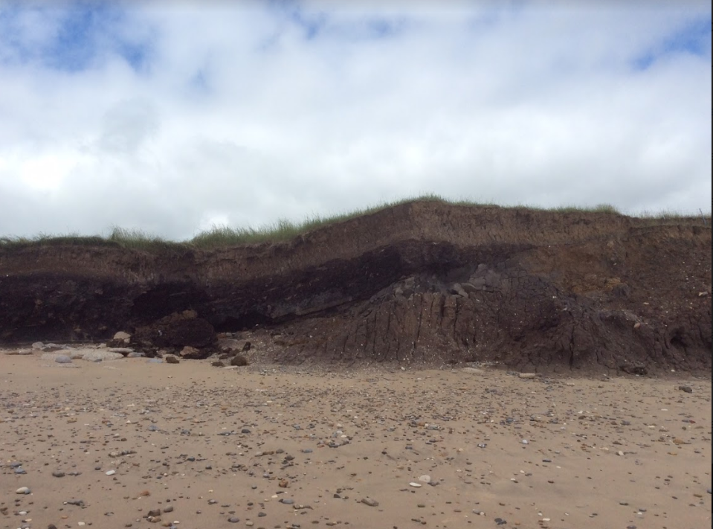

Figure 1: The dark brown lens beneath the lighter brown sediment at the top represents what was formerly a mere (Photograph: Nicky Milner).

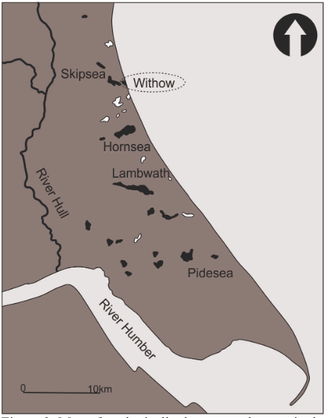

Figure 2: Map of geologically documented meres in the Holderness region. Meres defined by both historical and geological evidence in black, meres defined only by geological evidence in white (redrawn by Ben Elliot; after Sheppard 1957).

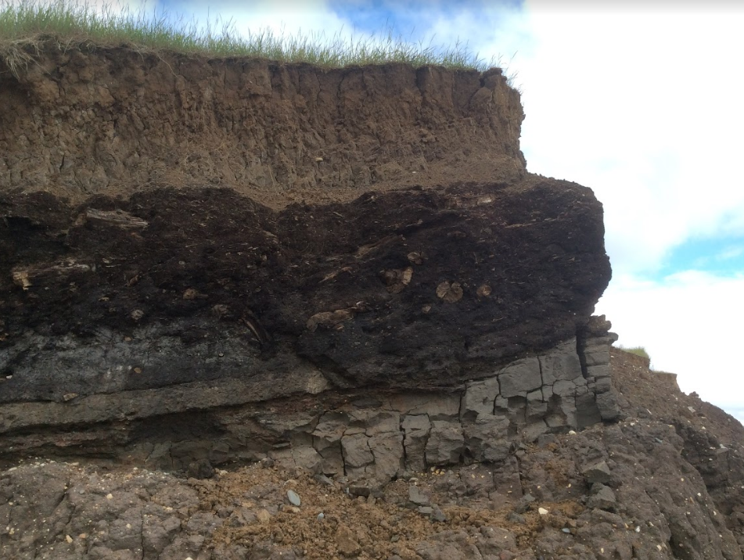
Figure 3: Photograph of the peat and clay deposits on the exposed cliff face with pieces of wood within the peat (Photograph: Nicky Milner).

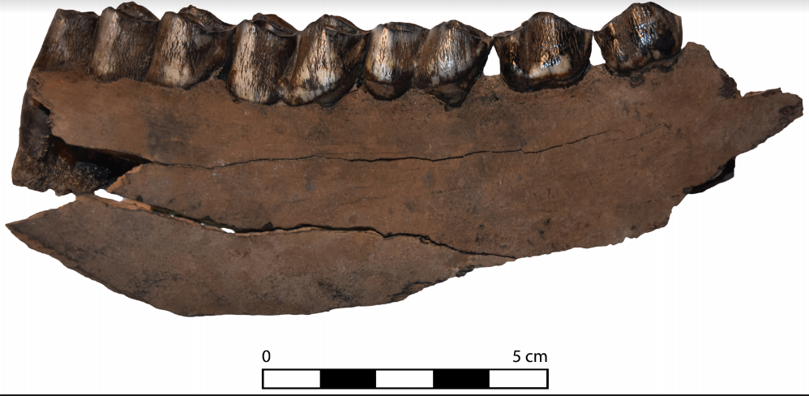
Figure 4: Example of weathering and exposure creating cracks and splits in the cortical bone and uneven dry bone breaks at both ends (photograph: Becky Knight).

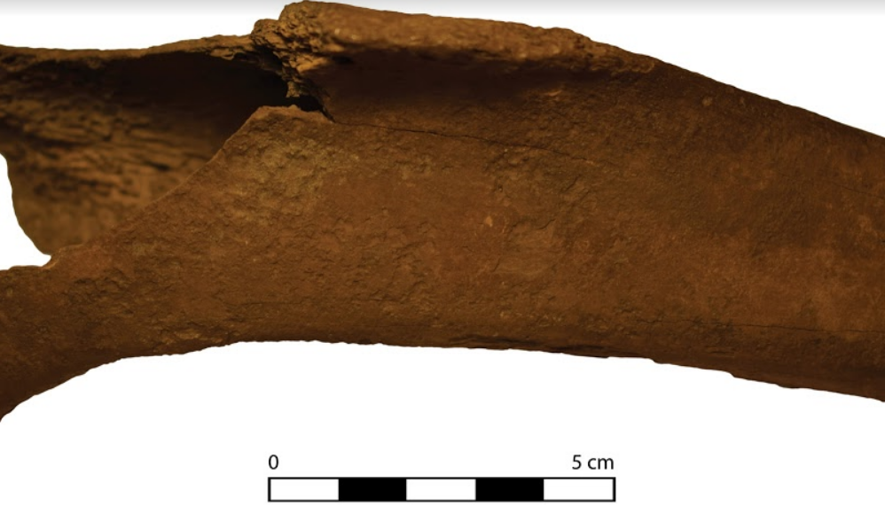
Figure 5: Example of the water erosion evidence, which includes pitted and undulating bone surfaces, on the proximal tibia (Photograph: Becky Knight).

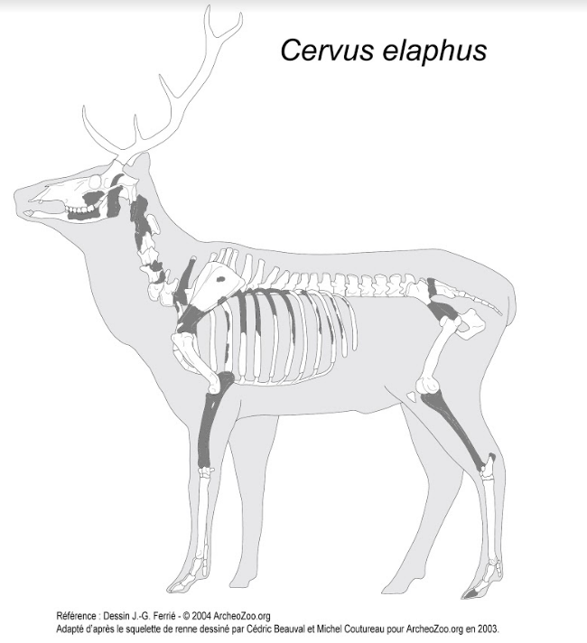
Figure 6: Representation of all of the red deer remains recovered from Skipsea Withow.

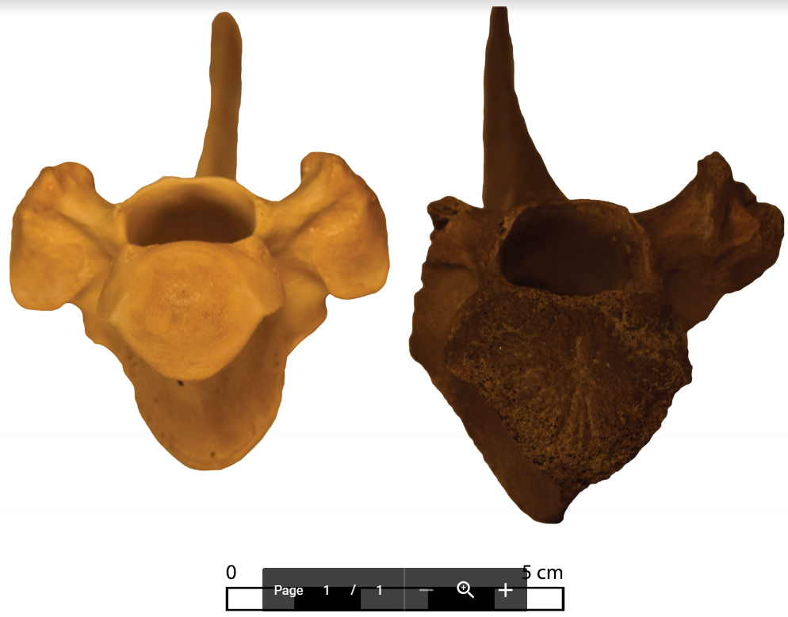
Figure 7: Photo illustrating the completely unfused nature of one of the vertebral bodies for individual 2 beside a fused vertebral body from the University of York zooarchaeological reference collection (Photograph: Becky Knight).

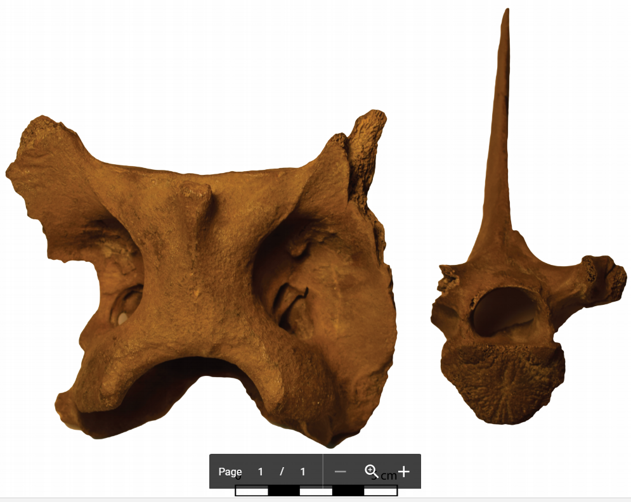
Figure 8: Size difference between the axis vertebra (right) and the thoracic vertebra with the unfused vertebral body epiphysis (left) (Photograph: Becky Knight).

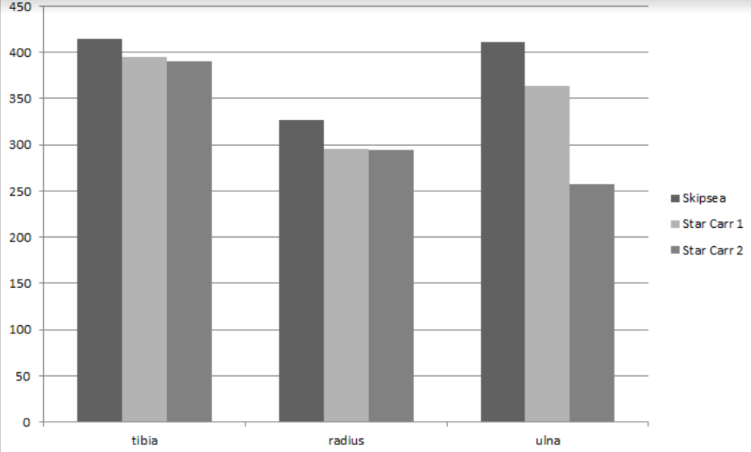
Figure 9: Plots of length from the 3 animals from 3 long bones.

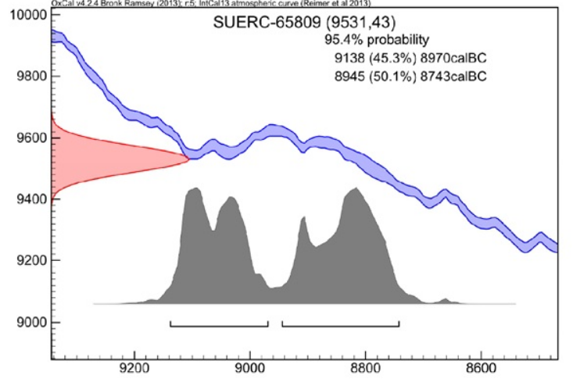
Figure 10: Probability distribution of the radiocarbon date.

Tables

 | L | R | Unsided
Ribs | 1 | 5 | 9
Vertebra |  |  | 8
Mandible | 2 | 2
Maxilla |  | 1
Sternum |  |  | 1
Scapula | 2 |  | 1
Radius |  | 1
Ulna |  | 1 | 1
Tibia |  | 1
Pelvis |  | 1
Sacrum |  |  | 1
Calcaneus |  | 1
3rd phalanx |  |  | 1
Unidentified |  |  | 2

Table 1: A table illustrating the NISP (Number of Individual Specimens) for each element of red deer found at Skipsea Withow.

Site | Finds No. | Species | Element | Metrics
Skipsea Withow | RK105 | Red deer | Tibia | LG: 415mm  BP: -  BD: 54mm
Star Carr | 103610 | Red deer | Tibia | LG: 395.4mm  BP: 77.5mm  BD: 54.2mm
Star Carr | 103639 | Red deer | Tibia | LG: 390.4mm  BP: 77.5mm  BD: 55mm
Skipsea Withow | RK111 | Red deer | Radius | LG: 327mm  BP: 65mm  BD: 57mm
Star Carr | 103423 | Red deer | Radius | LG: 295mm  BP: 60.1mm  BD: 46.2mm
Star Carr | 108594 | Red deer | Radius | LG: 294mm  BP: 60.2mm  BD: 50.7mm
Skipsea Withow | RK110 | Red deer | Ulna | LG: 411mm  BPC: 34mm  LO: 89mm
Star Carr | 103424 | Red deer | Ulna | LG: 364mm  BPC: 31.2mm  LO: 81.4mm
Star Carr | 103640 | Red deer | Ulna | LG: 257.5mm  BPC: 30.7mm  LO: 75.3mm
Table 2: Comparison of the metric measurements taken from complete red deer elements from Skipsea and Star Carr. (LG = total length, BP = width of proximal epiphysis, BG = width of distal epiphysis).

Code | δ13C | C/N ratio | Radiocarbon Age BP | Cal. BC
SUERC-65809 (GU39990) | -23.3 ‰ | 3.3 | 9531 ± 43 | 9138-8970 (45.3%)  8945-8743 (50.1%)
Table 3: Dates taken on the red deer bone found at Skipsea Withow.

