Figure 2. Forest plot of weighted standardised mean differences and a pooled measure of effect of induction on regulation of negative affect
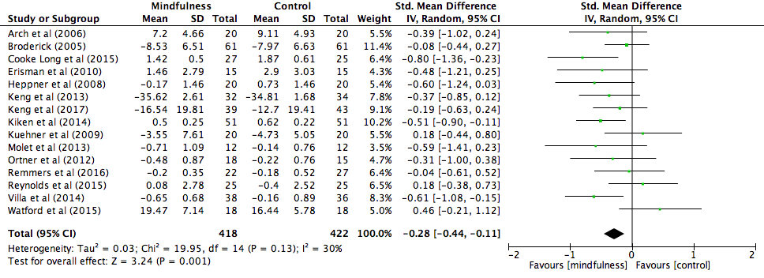

Note. Where a study design had two comparison groups the least active was entered as the comparison group

