From molecules to clay pot cooking at the Archaic-Woodland transition: A glimpse from two sites in the middle St. Lawrence valley, QC

Karine Taché (corresponding author)
Department of Anthropology, CUNY Queens College and Graduate Center
65-30 Kissena Blvd, Queens, NY 11367, USA
karine.tache@qc.cuny.edu
718-997-2893 (office) or 718-844-1593 (cell phone)

Adrian Burke
Department of Anthropology, Université de Montréal
3150 Jean-Brillant, Montréal H3T 1N8, Canada
adrian.burke@umontreal.ca

Oliver Craig
Department of Archaeology, BioArCh, University of York
Heslington, York YO10 5DD, UK
oliver.craig@york.ac.uk

ABSTRACT. The Archaic-Woodland transition is noted for the rise of social complexity, establishment of long-distance exchange networks, and the adoption of pottery technology. The inhabitants of the Middle St. Lawrence valley witnessed and participated in these fundamental changes. This article combines organic residue analyses and ethnohistorical data to better understand the use of Vinette 1 pottery at Batiscan and Parc des Pins, two archaeological sites in the Middle St. Lawrence valley (QC). Results suggest aquatic resources and degraded animal fats as the main sources of organic residues preserved in Vinette 1 vessels from these localities, with little contribution from plants. The methodology employed allowed the identification of substances and culinary practices which would have been impossible to detect otherwise, thereby providing new insights into the uses of ceramic containers poorly preserved and lacking clear archaeological contexts.

RÉSUMÉ, Dans le nord-est américain, la période de transition entre l’Archaïque et le Sylvicole a vu l’émergence d’une plus grande complexité sociale, la création de vastes réseaux d’interaction, et l’adoption de la poterie. Les habitants de la moyenne vallée du Saint-Laurent ont été témoins et ont participé à ces importants changements. Dans cet article, nous combinons analyses de résidus organiques et données ethnohistoriques afin de mieux comprendre l’utilisation de la poterie Vinette 1 aux sites de Batiscan et de Parc des Pins, tous deux situés dans la moyenne vallée du Saint-Laurent, QC. Nos résultats indiquent que les principales sources de résidus conservés dans les vases Vinette 1 associés à ces sites sont des ressources aquatiques et des graisses animales, avec très peu de contribution de produits végétaux. La méthodologie utilisée a permis d'identifier des substances et des pratiques culinaires impossibles à détecter autrement, fournissant ainsi de nouvelles connaissances sur des vestiges céramiques mal conservés provenant de contextes archéologiques ambigus.

Following the end of the last glaciation, hunter-gatherer groups of northeastern North America adapted to progressively warmer and more diverse environments. Their efficiency and success in exploiting woodland resources culminated at the end of the Archaic period in more restricted hunting and foraging territories. The Terminal Archaic-Early Woodland period (ca. 3,500-2,500 BP) is a period of important social transformations in northeastern North America. The inhabitants of the middle St. Lawrence valley, like their neighbors, witnessed and participated in such fundamental changes as the increased regionalization and complexity of hunter-gatherer groups, the emergence of new elaborate mortuary practices, and the creation of long distance interaction networks (Claasen 2015; Ellis and Ferris 1990; Emerson et al. 2009; Farnsworth and Emerson 1986; Sassaman 2010; Taché 2011). The innovation of pottery not only co-occurred with, but may have played a role in, these broader developments which featured seasonal gatherings, collective feasting and a new articulation of social relations (Taché and Craig 2015).
This study shifts the focus from a macro-regional to a local level of analysis to see how specific communities made choices within a dynamic cultural and natural landscape. More specifically, we use organic residue analysis of archaeological ceramics to have a direct look at subsistence and culinary practices at Batiscan and Parc des Pins, two archaeological sites in the middle St. Lawrence valley (Figure 1). In doing so, we hope to provide some contextualization to the broader trends documented during the Archaic-Woodland transition in northeastern North America.

Background
The site of Batiscan, named after the town located a few kilometers northeast, is a sandy butte 1.6 kilometers from the north shore of the St. Lawrence River (QC, Canada). In 1927, artefacts were collected from the surface of the site by W.J. Wintemberg but the main excavation work was conducted in 1962 by the Sherbrooke Archaeological Society. The major excavated portion of the site is situated on a 9-15 m high terrace bordering the St. Lawrence River floodplain. Wind erosion exposed various parts of the site and excavations focused on two sandy knolls that probably formed a single elongated ridge at the time of occupation. About 295 m² were excavated, revealing three refuse pits, five hearths, and material culture typical of the Meadowood Interaction Sphere, a widespread cultural manifestation of the Early Woodland period in northeastern North America. Artifacts associated with the Meadowood Interaction Sphere from Batiscan include Vinette 1 pottery, carefully thinned side-notched projectile points and bifacial scrapers made of Onondaga chert, as well as five ritually killed quartzite bifaces, one native copper awl, and nearly 200 native copper beads associated with a human cremation. The site extends over a minimum of 2,500 m², which makes it a large habitation site by Early Woodland standards. The sealing of the Early Woodland component under a layer of sterile fluvial deposit was previously interpreted as an indication of a short-lived occupation (Lévesque et al. 1964), but recent AMS radiocarbon dates obtained on organic residues adhering to three distinct pottery vessels from Batiscan suggest a longer occupation, or several short occupations between 3100 and 2400 years B.P. (Taché and Hart 2013). Vinette 1 sherds have been found in relatively high abundance at the site of Batiscan. In a previous analysis of this ceramic collection, 87 rim and 855 body sherds were thought to represent approximately 30 distinct vessels (Taché 2005).

Discovered in the 1970s (Ribes and Marois 1975), the Parc des Pins site borders the west bank of the Godefroy river and is located on a 10 m high terrace on the southern shore of the St. Lawrence river. The recovery of diagnostic artefacts associated with the end of the Archaic and the beginning of the Early Woodland period, including Vinette I potsherds, suggest an occupation dating between ca. 3,500 and 2,400 B.P. Evidence of occupation has been identified over at least 240 m² and it is very likely that the site extends further south, beyond the area covered by the recent surveys and excavations (Burke and Taché 2011; Burke and Fournier 2012, 2013). Parc des Pins yielded nine pottery sherds interpreted to be from Vinette 1 vessels on typological grounds. The very small size and fragility of most fragments, however, limit the amount of information one can gain from a traditional typological analysis of this assemblage. Alternatively, the chemical compounds trapped within the walls of these small pothserds hold great potential for documenting the use(s) of these containers.

The precise context of the Vinette 1 pottery sherds recovered at the site of Batiscan has been lost due to shortcomings in field recording at the time of the excavations. Very little is known of the subsistence activities of the groups that occupied this site, other than a mention in the site report concerning the discovery and excavation of four hearths and three refuse pits, one of which was apparently about 2 m long and contained a 60 cm thick shell layer (Lévesque et al. 1964:4). The report also contains a very succinct list of animal species identified from bone fragments: black bear, moose, beaver and turtle, the latter two species composing the bulk of the identifiable bones (Lévesque et al. 1964:43). Unfortunately, these faunal remains appear to have been lost or misplaced since their initial analysis, as they are not included in the Batiscan collection available for study (Taché 2011). On the other hand, while a portion of the Parc des Pins site was carefully surveyed by a team from the Université de Montréal between 2009 and 2011, only nine unidentifiable bone fragments (including eight calcined) and one dried fragment of nut gland or fruit are potentially associated with the Vinette 1 pottery fragments found at the site. The bone and the nut/fruit fragments all come from the lower layers where the pottery was found (30 cm–70 cm) and cannot represent contamination from later historic occupations. Unfortunately, little information can be gained from these small and for the most part unidentifiable remains, and no feature or other contextual information that could provide further information about subsistence activities were recovered during this field intervention. The large size of the Batiscan site, the multiple reoccupations attested to by radiocarbon dates, the diversity and unusually large size of its artifact assemblage, and the remains of ceremonial activities suggest that Early Woodland communities used this locality multiple times as a semi-sedentary base camp. Artefactual densities and site dimensions reconstructed from test pit data suggest a different scenario for the neighbouring site of Parc des Pins, which appears to have been the locus of a relatively short-term, seasonal occupation in Terminal Archaic-Early Woodland times.

Materials and Methods
Over the past few decades, the application of innovative approaches in organic residue analysis has revolutionized the study of ancient diets and culinary practices. It has been applied to a wide range of materials including stone tools, metal artefacts, and sediments, but most progress has been made in relation to the molecular and isotopic analysis of ceramic cooking pots (Evershed et al. 1992, 1999). In this study, biomolecular and isotopic analyses of organic residues were conducted using well established protocols.
For elemental analysis-bulk isotope ratio mass spectrometry (EA-IRMS), crushed surface residues (≈1 mg) were analyzed exactly as previously reported (Craig et al. 2007).
For lipid analysis of visible residues, each foodcrust sample (≈10–20 mg scraped from the potsherd surface) was solvent-extracted by ultrasonication with dichloromethane:methanol (2:1vol/vol; 3×2ml, 15 min). The solvent was removed from the foodcrust and evaporated under a gentle stream of N2 to obtain the total lipid extract (TLE). An aliquot of each TLE was silylated with BSTFA, dissolved in hexane and analyzed by GC-MS. Fatty acid methyl esters (FAMEs) were prepared from another aliquot of the TLE through treatment with BF3-Methanol complex (14%w/v;70◦C, 1 hour). FAMEs were extracted with hexane (3×1 ml) and analyzed by GCMS and by GC-combustion-isotope ratio MS (GC-C-IRMS).
For lipid analysis of absorbed residues, each ceramic sample (≈1-2 g drilled from the potsherd interior surface; Figure 2) was weighed and lipids were extracted by direct methylation with acidified methanol. Methanol (4 ml) was added and homogenized with the ceramic powder, the mixture was ultrasonicated for 15 minutes and then acidified with concentrated sulphuric acid (800μL). The acidified suspension was heated in sealed tubes for four hours at 70◦C and then cooled, and lipids were extracted with n-hexane (3×2 ml) and analysed by GC-MS and GC-CIRMS. Instruments and instrument conditions for GCMS and GC-C-IRMS were exactly as previously reported (Craig et al. 2012). These methods were applied to 14 Vinette 1 vessels from Batiscan (n=7 vessels represented by nine ceramic samples) and Parc des Pins (n=7 vessels represented by 12 ceramic samples; Table 1).

Results
Bulk stable isotope analysis
Bulk stable carbon and nitrogen isotope values of carbonized interior surface deposits were obtained on three samples from the Parc des Pins site (CcFb4-1-F, CcFb4-2-F, and CcFb4-3-F) and one sample from Batiscan (CcFb1-1-F) (Figure 3). In all cases, the C:N ratios are lower than 12 (average of 9.15), which is generally consistent with protein-rich foods rather than plants (Kunikita et al. 2013). When compared with values obtained on Vinette 1 pottery sherds from other sites distributed across northeastern North America (Taché and Craig 2015), sherds from Parc des Pins are seen to occupy an intermediate position between values that are more enriched in 13C and 15N, consistent with isotopically heavier aquatic food sources, and values that are more depleted in 13C and 15N, typically associated with the incorporation of terrestrial food sources. The single sample from the Batiscan site, on the other hand, falls within the range of values typically associated with the incorporation of terrestrial food sources, but the detection of aquatic biomarkers in absorbed residues from the same vessel calls for an explanation. It is possible that this vessel contained isotopically depleted aquatic resources, such as Atlantic tomcods (Taché and Craig 2015, Supplementary Material), or that surface and absorbed residues come from different food sources mixed/processed sequentially in this vessel. It should also be noted that surface residues are heterogeneous and therefore incorporate isotope values associated with different classes of biomolecules, which may vary considerably. For example, a protein-rich residue would be much more enriched in carbon-13 compared to a lipid-rich residue even if both derived from the same organism (Craig et al. 2007:137). Finally, surface residues may have been thermally altered, degraded and variously contaminated both before and after deposition.

Single-compound isotope analysis
GC-combustion-isotope ratio MS (GC-C-IRMS) analysis was carried out on four samples from Parc des Pins and seven samples from Batiscan to investigate further the source of lipids recovered from the assemblage (Figure 4). By comparing the δ13C values of the most abundant n-alkanoic acids preserved in potsherds (i.e. octadecanoic (C18:0) and hexadecanoic (C16:0) acids) with corresponding values from authentic reference fats and oils, more specific identifications can sometimes be achieved (Dudd et al. 1999; Craig et al. 2012, 2013). Notably, reference fats from marine fish and marine mammals are consistently enriched in 13C compared with those from freshwater and terrestrial organisms. Additionally, C18:0 acids in ruminant animals are generally depleted in 13C by c. 1–6‰ compared with C16:0 and, with the exception of Rangifer tarandus (caribou), which feeds partially on 13C-enriched lichens, the values are tightly constrained. The carbon isotopic composition of fats from non-ruminant animals and freshwater fish, however, are harder to discriminate using this technique. Freshwater fish (including diadromous and estuarine species) and animals that feed on freshwater organisms exhibit a broad range of values, reflecting environmental variation in primary sources of carbon (Taché and Craig 2015). This hampers the interpretation of several samples from Parc des Pins and Batiscan, which appear to have been used to process/store freshwater resources and/or non-ruminant fats. Notable exceptions are four samples from Batiscan (CcFb1-2, CcFb1-3 CcFb1-4, and CcFb1-6) with lower δ13C values of C18:0 compared to C16:0 (∆13C <_1‰), which is consistent with ruminant meat as the main source of lipids. Among them, three vessels (CcFb1-3 CcFb1-4, and CcFb1-6) also yielded aquatic biomarkers (see below), suggesting that fish and terrestrial meat were mixed or processed sequentially in these vessels.

Lipid analysis
Samples CcFb4-1-I, CcFb4-2-I, and CcFb4-4-I from Parc des Pins all yielded very similar lipid signatures (Figure 5). The identification in all three of phytanic acid and positional isomers of ω-(o-alkylphenyl)alkanoic acids containing either 18 or 20 carbon atoms suggest that these vessels were involved in the processing of aquatic resources (Hansel et al. 2004; Taché and Craig 2015). The presence of ω-(o-alkylphenyl)alkanoic acids is also indicative of organic residues exposed to temperatures exceeding 270ºC in an anoxic environment (Evershed et al. 2008). The absence of aquatic biomarkers in samples CcFb4-3-I, CcFb4-6-I, together with the high proportion of octadecanoic (C18:0) acid, suggest degraded animal fats as the main source of these residues.
Sample CcFb4-5 also lacks aquatic biomarkers, but its lipid profile is otherwise consistent with the processing of aquatic resources. This interpretation is further supported by the fact that samples CcFb4-4-I (with aquatic biomarkers) and CcFb4-5-I (without aquatic biomarkers) were later found to be two fragments of the same pottery sherd. Samples CcFb4-8-I and CcFb4-9-I, two fragments of the same sherd, have unusually high proportions of C18:1, a pattern consistent with the processing of plant and/or aquatic resources. However, lipid profiles typical of plant oils are also generally characterized by high C16:0/C18:0 ratios (i.e. >2), abundance of C12:0 and C14:0 fatty acids, and n-alkanes in the carbon-chain range C20:0 to C35:0 (Dunne et al. 2016). None of these chemical signatures match the lipid profiles of samples CcFb4-8-I and CcFb4-9-I, or any other lipid profile from the Parc des Pins and Batiscan sites as a matter of fact. Samples CcFb4-8-I and CcFb4-9-I were therefore likely involved in the processing of aquatic resources despite an absence of aquatic biomarkers. We have demonstrated elsewhere that an absence of aquatic biomarkers does not necessarily mean that aquatic resources were not processed in the pots (Craig and Taché 2015). Pottery samples with low lipid yields, for example, are unlikely to have detectable amounts of aquatic biomarkers since the latter are usually found in low or trace amounts. Sample CcFb4-7-I is more difficult to interpret. The presence of cholesterol puts the source of this residue as animal, but the absence of aquatic biomarkers or other clear indicators in terms of fatty acid ratios prevents further interpretation.

The presence of complete or partial sets of aquatic biomarkers in five Vinette 1 vessels (CcFb1-1, CcFb1-3, CcFb1-4, CcFb1-5, CcFb1-6) from Batiscan indicate that a majority of the ceramic containers from that site were involved in the processing of aquatic resources (Figure 6). Two vessels that yielded only a partial set of aquatic biomarkers (CcFb1-3 and CcFb1-5) also yielded dehydroabietic acid, a biomarker for pine resin. In one of the latter samples (CcFb1-3), the abundance of C_{12:0} and C_{14:0} fatty acids, the presence of n-alkanes in the carbon-chain range C_{20:0} to C_{29:0}, and the detection of stigmasterol by-products further support the contribution of plant resources to the residue. The presence of stigmasterol and cholesterol by-products in samples CcFb1-2 and CcFb1-7 suggest a contribution from both animal and plant sources in these vessels. The presence of dehydroabietic acid in sample CcFb1-7 further indicates the presence of pine resin, which may have contributed to the low lipid yield of this sample, if resin was used to seal ceramics (Reber and Hart 2008). The absence of aquatic biomarkers and the relatively low lipid yields of these two samples prevent further precision regarding the animal sources of these residues based on lipid analysis alone.

Discussion
The following discussion combines the molecular and isotopic data described in the previous section with information obtained from ethnohistoric and ethnographic documents to outline potential uses of Vinette 1 pottery at the Parc des Pins and Batiscan sites, where the scarcity of plant and animal remains as well as features prevents more traditional reconstructions of subsistence strategies and culinary practices. The focus here is on early literary sources describing how clay containers were used to process wild food resources among Indians of North America. We acknowledge that the most appropriate analogies for Late Archaic/Early Woodland communities of northeastern North America are likely to be provided by the study of Algonquian groups who lived a semi-sedentary lifestyle and relied mostly on the hunting, fishing, and gathering of wild resources. This said, an examination of the role clay vessels played in the occasional preparation of wild resources among Iroquoian groups (e.g., Hurons) is also included here. Indeed, it is likely that at least some level of continuity persisted in the way ceramic containers were employed to process wild resources, even after the introduction of domesticated crops, especially if such usage was specialized (e.g., for the production of fish oil) or highly ritualized (e.g., in feasts).

The use of ethnohistorical data in North American archaeology is not new but consensus regarding their correct usage remains to be defined. Wylie (2002) argues for multiple lines of evidence in establishing and assessing strength of fit for analogical inference. Here we are reproducing a large number of ethnohistorical mentions, in the language they were originally written and using the original spelling. By doing so, we wanted to be faithful to and highlight the richness of this body of literature which is often difficult to paraphrase. But most importantly, the integral reproduction of these quotes serve to demonstrate the level of descriptive details and redundancy we sought in ethnohistorical documents before using them as supporting arguments.

Ethnohistoric and ethnographic sources consulted for this study are not used as direct analogs for past human behaviors, but rather as a starting point to identify, with proper evaluation, relevant variables and relationships to reconstruct past behaviors (Binford 2001; Lovis and Hart 2015:568; Speth 2010:24). It should also be mentioned that while the focus here is on the preparation of food products in clay containers, the fabrication of non-food products such as fish glue (Denys 1672:382-384), glue made from deer sinew (Smith 1907:65) and pine pitch may also have benefited from prolonged boiling and direct heating in waterproof containers (but see Reber and Hart 2008 for arguments against pine pitch processing in Vinette 1 pottery).

Aquatic resources
A majority (64%, n=9) of the organic residues analyzed from Batiscan (n=5) and Parc des Pins (n=4) attest to the processing of freshwater aquatic resources in Early Woodland ceramic vessels (Table 2), confirming wider trends we have observed in residues across northeastern North America (Taché and Craig 2015). Based on such results, it was previously argued that pottery initially developed in this region to process aquatic organisms at episodic social gatherings during periods of high resource abundance. Such cooperation increased harvesting efficiency and allowed the production of food surpluses, which could then be traded or brought back into each community’s home territory (Jackson 1991). It was further suggested that fish oil was produced during these episodic gatherings and that ceramic containers were used in its preparation.

Historically, fishing expeditions lasting up to a month or more and composed of distinct groups, each with its own leaders, are known to have taken place among the Hurons. Moreover, cooperation in the exploitation of aquatic resources is known to have taken place between the communities participating to such expeditions (Sagard 1632:317-318). The most important of these seasonal gatherings took place in the autumn to the islands in Georgian Bay to catch whitefish (in Huron, assihendo) that concentrated there at that time of year (Trigger 1969:30). On these occasions, some of the whitefish were boiled to extract oil from them:

Quelques fois on reservoit des plus gros & gras Assihendos qu’ils faisaient fort boüillir & consommer en de grandes chaudieres pour en tirer l’huile, qu’ils amassoient avec une cueilllier par-dessus le boüillon, & la serraient en des bouteilles qui ressembloient à nos calbasses: cette huile est aussi douce & agreable que beurre fraiz, aussi est-elle tiree d’un tres-bon poisson, qui est incogneu aux Canadiens, & encore plus icy. [Sagard 1632: 254]

The hypothesis that early pottery in northeastern North America was predominantly employed in the cooperative harvesting of aquatic resources and fish oil production also accounts for the low frequency of Vinette 1 vessels in archaeological sites where this type of pottery has been found. Indeed, since large quantities of fish yield limited amounts of oil, only a few ceramic containers would have been required. Nevertheless, four vessels from Batiscan and two from Parc des Pins also attest to the processing of terrestrial animals, either alone or mixed/sequentially processed with aquatic resources or plants (Table 2).

Terrestrial animals
When examining the ethnohistoric literature to identify potential uses of Vinette 1 pottery, we must keep in mind that the quantity of ceramic containers recovered from Late Archaic/Early Woodland contexts is significantly lower than in subsequent time periods, typically representing no more than a handful of pots per site (Taché 2005). One could hardly imagine, therefore, that Vinette 1 pots were used to prepare daily meals of meat or fish broths, in the same way that more recent ceramic containers, and eventually metal kettles, were used to prepare sagamité, for example (e.g., Carr 1895:27).

After eliminating ethnohistoric mentions of food boiling involving maize or other cultivars as a primary ingredient, we are left with a limited amount of potential analogies for the use(s) of Vinette 1 pottery by pre-agricultural groups in northeastern North America. One such analogy can be found in the rendering of bone grease, a culinary tradition widespread among First Nation populations of northeastern North America and recorded in ethnohistoric and ethnographic accounts from the 17th century onward. The rendering of bone grease by fracturing and boiling primarily the long bones (femurs and tibia) of wild terrestrial ruminants, such as caribou or moose, would have required prolonged boiling (e.g., from a few hours to a whole day – Saint-Germain 1997:154) while necessitating no more than a few containers. This is coherent with the low frequency at which Vinette 1 pots are typically found on Late Archaic /Early Woodland archaeological sites. In a description of the natural resources of the coastal area of Acadia from the Penobscot River to Gaspé Peninsula and of Mi’kmaq lifeways, Nicolas Denys provides one of the earliest accounts of bone broth preparation in the region:

Le travail des femmes efloit d'aller chercher la befte après qu'elle eftoit tuée, l’écorcher, la couper par morceaux pour la faire cuire: pour cet effet elles faifoient rougir les roches, les mettoient & oftoient de la chaudiere , amaffoient tous les os des orignaux , les piloient avec des pierres fur une autre bien large, les reduifoient en poudre, puis les mettoient en leur chaudière & les faifoient bien boüillir, ce qui rendoit une graifle qui venoit fur l’eau, qu'ils amaffoient avec une cuillier de bois, & Ies faifoient tant boüillir qu’à la fin les os ne rendoient plus rien ,en forte que des os d'un orignac fans compter la moüelle, ils en tiroient cinq à fîx livres de graiffe blanche comme nege , ferme comme de la cire; c'étoit dequoy ils faifoient toute leur provifion pour vivre allant à la chaffe; nous l’appellons du beurre d'Orignac, &, eux du Cacamo. [Denys 1672:411]

In addition to bone grease rendering, the preparation of bone broths, often consumed as beverages (LeJeune 1858:36) and stews necessitating pots or kettles and incorporating cervid parts have also been recorded among Algonquian groups, including the Innu:

(…) puis me tournant de l'autre costé, i'apperceus vne grande marmite remplie de langues et de mulles d'orignac, qui rendoient vne fort bonne odeur; ces viandes les plus délicates de la beste estoient préparées pour ses gens. [LeJeune 1858(1639):20]

Admittedly, the preparation of bone broths has also been documented among communities devoid of pottery, including the Mi’kmaq Indians figuring in Nicolas Denys’ accounts. This Algonquian group used stone boiling in stumps of fallen trees, which of course prevented the flexibility of moving containers around:

[…] cette chaudière eftoit de bois, faite comme une grande auge ou timbre de pierre: pour la faire ils prenoient le pied d'un gros arbre qui étoit tombé, ils ne le tranchoient point n'aynt pas d'outils propres pour cela; de les porter il n'y avoit pas de moyen; ils en avoient fait quafi en tous les endroits où ils alloient. [Denys 1672:359]

Other means of preparing bone broth without pottery include the use of pit features, or above ground through stone boiling in rawhide bags, baskets, or bark vessels (Binford 1978:159; McClellan 1975:210; Wissler 1910:45). Once introduced, however, transportable and watertight containers allowing the prolonged simmering of bone broth through direct heating could have easily become the favored option. Again, a quote from Nicolas Denys illustrates this change of preference:

A prefent elles font encore de mefme, mais elles ont de bonnes haches, des coufteaux plus commodes à leur travail, des chaudières faciles à porter, qui eft une grande commodité pour elles n’eftant plus fujettes d'aller aux lieux où eftoient les chaudieres de bois, dont on n'en void plus à prefent, en ayant entierement perdu l’ufage. [Denys 1972:372]

Similarly, it is likely that following its initial introduction, the benefits of ceramic containers to render grease and oils from a variety of other food sources would have been recognized by Late Archaic/Early Woodland communities of northeastern North America. The preparation of bone broth from large cervidae (e.g., deer, elk, and/or moose) could account for the identification of ruminant fats in four vessels from Batiscan, based on single compound isotope values. The significant proportion of ruminant fats in vessels from Batiscan contrast with what has been observed elsewhere in northeastern North America and may point to a regionally distinct use of early pottery at this site. Interestingly, Batiscan is located close to the northernmost distribution range of the Vinette 1 pottery type, where moose occur in greater abundance than in regions further south.

One of the two vessels containing animal fats from Parc des Pins has isotope values typical of non-ruminant terrestrial animals or fowl. No isotope value was obtained for the second vessel, preventing any further precision as to the type of terrestrial animals represented. In these cases, it is possible that ceramic pots were used to prepare non-ruminant terrestrial animals/fowl (e.g., bear, beaver, geese) as part of small-scale gatherings or feasts (e.g., Comeau 1909:87; Sagard 1632:145). The act of cooking and consuming these species with novel ceramic containers could have been largely symbolic, while on more ordinary occasions the same species would have been cooked and consumed using other means, as Champlain observed among the Innu (at a feast where Algonquins and Maliseets were also present) and the Hurons, respectively:

Après qu’il eut acheué ſa harangue, nous ſortiſmes de ſa cabanne, & eux commencerent à faire leur tabagie ou feſtin, qu’ils font auec des chairs d’orignac, qui eſt comme bœuf, d’ours, de loups marins & caſtors, qui ſont les viandes les plus ordinaires qu’ils ont, & du gibier en quantité. Ils auoient huict ou dix chaudieres pleines de viandes, au milieu de la ditte cabane, & eſtoient eſloignées les vnes des autres quelques ſix pas, &chacune a ſon feu. [Champlain 1870, II, p.7-8]

Ils en donnent & deſpartent à chacun vn plat, auec vné cuillerée de la dite graiſſe, ce qu'ils ont de couſtume de ſaire aux ſeſtins & non pas ordinairement. [Champlain 1870, IV, p.77]

Plant and nut resources
Traditionally the invention of pottery was linked to the adoption of agriculture and the need to process the grains of cultivated cereals. After it became widely recognized that pottery first began to be used by pre-agricultural communities in North America, these early ceramic containers were tentatively linked to the rendering of high-energy oils from hard to process/inedible seeds and nuts (e.g., Ozker 1982). Like fish, nuts and seeds can provide essential oils relatively difficult to obtain otherwise in the environment via prolonged boiling (Rice 1999:33). Moreover, acorns specifically require processing to remove tannin, which can be done by boiling or soaking with wood ash lye, leaching in sand, or boiling and letting stand in cold water for several days (Howe 1988:96; Lafitau 1724, vol.3:83; Powell 1981:84;). Historically, plant oils were derived primarily from acorns, butternuts, hickory nuts, walnuts, and sunflower seeds (Beverley 1705:17-18; Bressany 1852:72; Champlain 1870, IV:30; Harriot 1590:9, 18-19; Heckewelder 1819:194; Merrill 1949:41; Parker 1910:100-102; Sagard 1632:141; Smith 1907:53-54). It is possible that seeds and nuts only began to be used in the production of plant oil after being domesticated or managed wild (Bartram 1794:38). To extract plant oils, the nut meats or seeds were bruised or crushed and boiled for long periods of time. Boiling brings clear and sweet oil to the surface, which could then be skimmed off and stored to be later served as butter or dipping sauce.

However, data obtained from organic analysis of Vinette 1 pottery and modern nut samples (Taché and Craig 2015) demonstrate that nuts or other plants were not significantly processed in early pottery from northeastern North America, despite the benefits that clay containers would have had in the production of plant oils as described historically. This observation applies to the samples from Parc-des-Pins and Batiscan. Indeed, despite the identification of plant biomarkers in four vessels from Batiscan, both the lipid profiles and isotopic signatures associated with these containers suggest that plants were in fact minor components in the the mixing or sequential processing of plants with other food sources (Table 2), with the possible exception of sherd sample CcFb1-3.

Among the vessels with plant biomarkers, three contain additional biomarkers for pine resin, which may point to the use of coniferous resin as a sealant to make clay containers impermeable (Reber and Hart 2008) or as a food preservation agent (McGovern et al. 1996). It might be argued that the presence of pine resin in Vinette 1 vessels from Batiscan and Parc des Pins is due to pine pitch processing (Eerkens 2002). As was the case in Reber and Hart’s (2008) study, however, the presence of dehydroabietic acid but not retene or other aromatic compounds suggests that resins were exposed to heat, but not the high temperatures associated with boiling for pitch. The practice of sealing containers may have influenced the behaviors of lipids in various ways, possibly preventing the absorption of all or some chemical compounds. The presence of lipids from non-plant resources within the potsherds that yielded pine resin biomarkers, however, questions the usefulness of this technique in blocking the interior pores of a pot, unless pine resin was applied later in the uselife of the vessel. Experimental studies involving the processing of different food sources in ceramic vessels sealed with coniferous resin is needed to further explore these questions.

Conclusion
The earliest form of pottery produced in northeastern North America is referred to as Vinette 1 pottery by archaeologists, after the site in upper NY State where this type of pottery was first documented (Ritchie and MacNeish 1949). These containers were first used at the beginning of the Early Woodland period or slightly earlier (Taché and Hart 2013). Based on the morphological and technological attributes of these pots, and the common presence of carbonized deposits sticking to their interior walls, it has long been assumed that at least some of them were used to cook food over open fires (Linton 1944). But precisely what were the incentives behind this innovation remains to this day quite elusive.

The transition toward broad-spectrum economies and an increased reliance on wild resources more amenable to intensive mass harvesting and processing, such as nuts, small seeds or shellfish, has been evoked to explain the innovation of pottery by hunter-gatherer communities (Goodyear 1988; Ozker 1982; Rice 1999). Yet the production of these resources does not absolutely require pottery, and in fact they were all exploited in pre-ceramic contexts, or more recently by hunter-gatherer groups lacking pottery (Taché et al. 2008). The small number of Vinette 1 vessels at any one site (Taché 2005) and the absence of a significant shift in environmental conditions also suggest that the initial production and use of ceramic containers were not solely linked to some functional demand for new resources or an intensified exploitation of existing resources. Other important social developments occurred at about the same time that ceramic containers were adopted in the Northeast including increased social complexity, the emergence of elaborate mortuary practices, and the creation of long distance interaction networks that ensured the circulation of prestige items (Claasen 2015; Ellis and Ferris 1990; Emerson et al. 2009; Farnsworth and Emerson 19865; Sassaman 2010; Taché 2011). So rather than a sine qua non for extracting nutrients from specific resources, the invention of pottery may best be understood as part of broader developments featuring seasonal gatherings and a new articulation of social relations.

In this study, lipid residues have been successfully extracted from 14 Vinette 1 vessels recovered from Batiscan and Parc des Pins, two terminal Archaic-Early Woodland sites in the middle St. Lawrence valley. Molecular and isotopic characterization of these artifacts allowed the identification of substances and culinary practices which would have been impossible to detect otherwise. Data reported here are consistent with broader regional trends and suggest that Vinette 1 pottery was used predominantly in the preparation of fish oil, an increasingly high valued ingredient and trade item among Early Woodland communities (Taché and Craig 2015). However, a number of samples from Batiscan and Parc des Pins yielded chemical profiles incompatible with aquatic resources and likely reflecting the processing of ruminant and non-ruminant terrestrial animals. One potential analogy for this minor (and perhaps regionally specific) use of early pottery can be found in the production of bone grease, a labor-intensive culinary tradition widespread among First Nation populations of northeastern North America and documented historically from the 17th century onward. Ceramic pots with lipid profiles typical of animal fats may also have been used to prepare greasy soups as part of small-scale feasts. The serving and consumption of bear grease, notably, is placed in very high esteem by a big number of North American Indigenous groups. In sum, while a majority of the vessels analyzed across northeastern North America point to fish oil as being the main commodity produced in Vinette 1 pottery (Taché and Craig 2015), a closer look at the variability expressed at the Batiscan and Parc des Pins sites in the middle St. Lawrence valley suggests that other types of grease and oil might also have been produced.

Certain food items are marked as salient symbols of group identity (Dietler 2007). Historically and most likely in pre-colonial times also, indigenous groups of northeastern North America who relied on wild resources considered fat as the true notion of what food is meant to be, and, a meal without fat was just not considered a real meal (Saint-Germain 2002). One would thereby expect that these groups developed strategies to seek fat and that this quest influenced not only hunting strategies, but also culinary techniques, cuisine, and food storage technologies. Culinary traditions are made of rules and one of the most important one among hunting tribes of northeastern North America is to avoid the wastage of fat, which is thought to contain the spirit of the animal (Bouchard 1982; Honigmann 1961). Among these communities, the rendering of grease and oil following strict rules was, and in many cases still is, an important element of many feasts. This important culinary technique is also ritualized in the form of myths to insure its continuity (Saint-Germain 2002).

The unifying feature of early pottery in northeastern North America could thus be that it was used to produce highly-valued, labour-intensive fats and oils to trade in the newly established interaction networks, or to serve in small-scale feasts. In this scenario, the innovation of pottery would have facilitated the processing of an ingredient already considered to be as the very essence of food and long held in high esteem among Indigenous populations. As such, it is easy to imagine how this new technology was incorporated within culinary traditions, one of the most conservative and persistent aspect of culture (Dietler 2007).

In their quest to better understand ancient relationships between humans and their environments, archaeologists rely heavily upon archaeological evidence of food selection, preparation and use. Yet due to various preservation and recovery biases, organic residue analysis is often the only way of identifying the presence of specific resources in the archaeological record. Here, the good preservation of organic residues absorbed in Vinette 1 pottery allowed us to significantly improve our understanding of human-environment relationships and culinary practices in Late Archaic-Early Woodland times. Furthermore, the application of innovative techniques in organic residue analyses provides an alternative means to study small and often ill-preserved pottery fragments to understand their use, thereby moving beyond pottery as a typological marker and exploring the economic and social context of this important technology. Increasing the number of vessels tested and analyzing vessels from well-defined contexts will help to expand the interpretations based on the results reported here.

Acknowledgments. We thank Andre Gledhill and Anu Thompson for assistance with bulk IRMS analysis and GC-C-IRMS analysis, respectively, and Alexandre Lucquin for assistance in the analysis of modern nut samples. The Ministère de la culture et des communications du Québec, the Musée québécois de culture populaire, the Canadian Museum of History and the Université de Montréal provided pottery samples from Batiscan and Parc des Pins sites. The Ministère de l’Energie et des Resources naturelles du Québec, the Club des producteurs de noix comestibles du Québec and several anonymous individuals provided modern reference samples. Financial support for fieldwork at the Parc des Pins and Batiscan sites and sample shipping costs was provided through funding to Burke by the Social Sciences and Humanities Council of Canada (grant#410-2009-1958). The Marie Skłodowska-Curie actions (grant#273392) and the Social Sciences and Humanities Council of Canada (grant#756-2011-0321) provided funding support to Taché to conduct organic residue analysis of Vinette 1 pottery.

References cited
Bartram, William
1794 Travels through North and South Carolina, Georgia, East and West Florida, the Cherokee country, the extensive territories of the Muscogulges or Creek confederacy, and the country of the Chactaws. London, reprinted for J. Johnson.

Beverley, Robert
1705 The History and Present State of Virginia. Printed for R. Parker, London.

Binford, Lewis R.
1978 Nunamiut Ethnoarchaeology. Academic Press, New York.

2001 Constructing Frames of Reference. An Analytical Method for Archaeological Theory Building Using Hunter-Gatherer and Environmental Data Sets. University of California Press, Berkeley.

Bouchard, Serge
1982 Chroniques de chasse d’un Montagnais de Mingan, Mathieu Mestokosho. Québec, Ministère des Affaires Culturelles.

Bressany, R.P. François-Joseph
1852 Relation Abrégée de Quelques Missions des Pères de la Compagnie de Jésus dans la Nouvelle-France par Bressany, traduit de l’italien […] par le R.P.F. Martin de la même Compagnie. John Lovell, Montréal.

Burke, Adrian, and Karine Taché
2011 Sondages archéologiques sur sept sites dans les municipalités de Bécancour, Champlain, Batiscan et Ste-Anne-de-la-Pérade, 30 mai au 12 juin 2010. Unpublished manuscript on file, Ministère de la culture, des Communications et de la Condition féminine du Québec, Québec.

Burke, Adrian, and Marie Fournier
2012 Fouilles archéologiques sur les sites CbFc-3 et CbFd-4, municipalité de Bécancour, 29 août au 14 septembre 2011. Unpublished manuscript on file, Ministère de la culture, des Communications et de la Condition féminine du Québec, Québec.

Burke, Adrian, and Marie Fournier
2013 Fouilles archéologiques sur les sites CbFc-3 et CbFd-4, municipalité de Bécancour, 15 au 28 juillet 2012. Unpublished manuscript on file, Ministère de la culture, des Communications et de la Condition féminine du Québec, Québec.

Carr, Lucien
1895 The Food of Certain American Indians and their Methods of Preparing It. Charles Hamilton Printer, Worcester.

Champlain, Samuel de
1870(1613) Les Voyages du Sieur de Champlain, ed. C.-H. Laverdière under the title Œuvres de Champlain, Québec, 5 volumes.

1880 Voyages of Samuel de Champlain, vol.1, translated from the French by Charles Pomeroy Otis. Prince Society, Boston.

1907 Voyages of Samuel de Champlain 1604-1618, ed. W.L. Grant. Charles Scribner’s Sons, New York.

Claassen, Cheryl
2015 Beliefs and Rituals in Archaic Eastern North America. An Interpretive Guide. University of Alabama Press, Tuscaloosa, Alabama.

Comeau, Napoléon-Alexandre
1909 Life and Sport on the Lower St. Lawrence and Gulf. Daily telegraph printing house, Quebec.

Craig, Oliver E., Marcus Forster, Søren H. Andersen, Eva Koch, Philippe Crombé, Nicky J. Milner, Ben Stern, Geoff N. Bailey, and Carl P. Heron
2007 Molecular and isotopic demonstration of the processing of aquatic products in northern European prehistoric pottery. Archaeometry 49:135–52.

Craig, Oliver E., Richard B. Allen, Anu Thompson, Rhiannon E. Stevens, Valerie J. Steele, and Carl P. Heron
2012 Distinguishing wild ruminant lipids by gas chromatography/combustion/isotope ratio mass spectrometry. Rapid Communications in Mass Spectrometry 26:2359–64.

Craig, Oliver E., Hayley Saul, Alexandre Lucquin, Yastami Nishida, Karine Taché, Leon Clarke, Anu Thompson, David T. Altoft, Junzo Uchiyama, Mayumi Ajimoto, Kevin Gibbs, Sven Isaksson, Carl P. Heron, and Peter Jordan
2013 Earliest evidence for pottery use. Nature 496:351–54.

Denys, Nicolas
1672 Histoire Naturelle des Peuples, des Animaux, des Arbres & Plantes de l'Amérique Septentrionale & de ses Divers Climats; Tome 2. Chez Claude Barbin.

1908 (1672) The Description and Natural History of the Coasts of North America (Acadia) (ed. W.F. Ganong). The Champlain Society, Toronto.

Dietler, Michael
2007 Culinary encounters: food, identity, and colonialism. In The Archaeology of Food and Identity, edited by Katherine C. Twiss, pp. 218‐242. Center for Archaeological Investigations, Occasional Paper No 34, Southern Illinois University, Carbondale.

Dudd, Stephanie N., Richard P. Evershed, and Alex M. Gibson
1999 Evidence for varying patterns of exploitation of animal products in different prehistoric pottery traditions based on lipids preserved in surface and absorbed residues. Journal of Archaeological Science 26:1473–82.

Dunne, Julie, Anna Maria Mercuri, Richard P. Evershed, Silvia Bruni, and Savino diLernia
2016 Earliest direct evidence of plant processing in prehistoric Saharan pottery. Nature Plants 3:16194.

Eerkens, Jelmer
2002 The preservation and identification of piñon resin by GC-MS in pottery from the western Great Basin. Archaeometry 44(1):95-105.

Ellis, Christopher J., and Neal Ferris (editors)
1990 The Archaeology of Southern Ontario to A.D. 1650, Occasional Publication of the London Chapter, No. 5. Ontario Archaeological Association.

Emerson, Thomas E., Dale L. McElrath, and Andrew C. Fortier (editors)
2009 Archaic Societies. Diversity and Complexity across the Midcontinent. SUNY Press, Albany, New York.

Evershed, Richard P., Carl Heron, Stephanie Charters, and L. John Goad
1992 Chemical analysis of organic residues in ancient pottery: methodological guidelines and applications. In Organic Residues in Archaeology: Their Identification and Analysis, edited by Robert White and Hazelle Page, pp. 11-26. UKIC Archaeology Section, London.

Evershed, Richard P., Stephanie N. Dudd, Stephanie Charters, Hazel Mottram, Andrew W. Stott, Anthony Raven, Pim F. van Bergen, and Helen A. Bland
1999 Lipids as carriers of anthropogenic signals from prehistory. Philosophical Transactions of the Royal Society of London 354:19-31.

Evershed, Richard P., Mark S. Copley, Luke Dickson, and Fabricio A. Hansel
2008 Experimental evidence for the processing of marine animal products and other commodities containing polyunsaturated fatty acids in pottery vessels. Archaeometry 50(1):101-113.

Farnsworth, Kenneth B., and Thomas E. Emerson (editors)
1986 Early Woodland Archaeology. Kampsville Seminars in Archaeology, Vol. 2, Center for American Archaeology, Illinois.

Goodyear, Albert C.
1988 On the study of technological change. Current Anthropology 29:320–23.

Hansel, Fabricio A., Mark S. Copley, Luiz A.S Madureira, and Richard P. Evershed
2004 Thermally produced ω-(o-alkylphenyl)alkanoic acids provide evidence for the processing of marine products in archaeological pottery vessels, Tetrahedron Letters 45(14):2999–3002.

Harriot, Thomas
1590 A Briefe and True Report of the New Found Land of Virginia. Dover Publications, Inc., New York.

Heckewelder, Rev. John
1819 An Account of the History, Manners, and Customs of the Indian Nations Who Once Inhabited Pennsylvania and the Neighboring States. Fascimile Reprint, Heritage Books, Inc., Bowie, Maryland, 1990.

Honigmann, John J.
1961 Foodways in a Muskeg community. An anthropological report on the Attawapiskat Indians. Department of Northern Affairs and National Resources, Ottawa.

Howe, Dennis E.
1988 The Beaver Meadow Brook site: prehistory on the west bank at Sewall's Falls, Concord, New Hampshire. The New Hamphsire Archaeologist 29(1):49-107.

Jackson, H. Edwin
1991 The trade fair in hunter-gatherer interactions: the role of intersocietal trade in the evolution of Poverty Point culture. In Between Bands and States, edited by S.A. Gregg, pp. 265–86. Southern Illinois UniversityPress, Carbondale.

Kunikita, Dai, Igor Shevkomud, Kunio Yoshida, Shizuo Onuki, Toshiro Yamahara, and Hiroyuki Matsuzaki
2013 Dating charred remains on pottery and analyzing food habits in the Early Neolithic period in Northeast Asia. Radiocarbon 55(2–3):1334–1340.

Lafitau, Joseph-François
1724 Moeurs des Sauvages Amériquains, Comparées aux Mœurs des Premiers Temps. 2 volumes. Saugrain l’Aîné, Paris.

Lejeune, Paul
1858(1634) Relation de ce qui s'est passé de plus remarquable dans les missions des Pères de la compagnie de Jésus en la Nouvelle-France en l’année 1634. Ouvrage publié sous les auspices du Gouvernement canadien. Québec, Augustin Côté, éditeur-imprimeur près de l'Archevêché. Vol. I

1899(1634) Relation of what occurred in New France on the Great River St. Lawrence, in the year one thousand six hundred thirty-four. In The Jesuit Relations and Allied Documents, vol. 6-7, edited by Reuben Gold Thwaites. The Burrowes Brothers Company, Cleveland.

1858(1639) Relation de ce qui s'est passé de plus remarquable dans les missions des Pères de la compagnie de Jésus en la Nouvelle-France en l’année 1639. Ouvrage publié sous les auspices du Gouvernement canadien. Québec, Augustin Côté, éditeur-imprimeur près de l'Archevêché. Vol. I

1899(1639) Relation of what occurred in New France in the year 1638. In The Jesuit Relations and Allied Documents, vol. 16, edited by Reuben Gold Thwaites. The Burrowes Brothers Company, Cleveland.

Lévesque, René, R., F. Fitz Osborne, and James V. Wright
1964 Le Gisement de Batiscan: Notes sur des Vestiges Laissés par une Peuplade de Culture Sylvicole Inférieure dans la Vallée du Saint-Laurent. Musée national du Canada, Études Anthropologiques, No.6, Ottawa.

Linton, Ralph
1944 North American Cooking Pots. American Antiquity 9:369–380.

Lovis, William A., and John P. Hart
2015 Fishing for dog food: ethnographic and ethnohistoric insights on the freshwater reservoir in Northeastern North America. Radiocarbon 57(4):557–570.

McClellan, Catharine
1975 My Old People Say: An Ethnographic Survey of Southern Yukon Territory. Publications in Ethnology 6. National Museum of Man, National Museums of Canada, Ottawa.

McGovern, Patrick E, Donald L. Glusker, Lawrence J. Exner, Mary M. Voigt
1996 Neolithic resinated wine. Nature 381(6582):480-481.

Merrill, Arch
1949. Land of the Senecas. Stratford Press, Inc., New York.

Ozker, Doreen
1982 An Early Woodland Community at the Schultz Site 20SA2 in the Saginaw Valley and the Nature of the Early Woodland Adaptation in the Great Lakes Region. Anthropological papers / Museum of Anthropology, University of Michigan; no. 70. Regents of the University of Michigan Museum of Anthropology, Ann Arbor.

Parker, Arthur C.
1910 Iroquois Uses of Maize and Other Food Plants. In Parker on the Iroquois. Syracuse University Press, Syracuse, 1968.

Powell, Bernard W.
1981 Carbonized Seed Remains from Prehistoric Sites in Connecticut. Man in the Northeast 21:75-85.

Reber, Eleanora A., and John P. Hart
2008 Pine resins and pottery sealing: analysis of absorbed and visible pottery residues from central New York State. Archaeometry 50(6):999-1017.

Ribes, René, and Roger Marois
1975 Indices de Manifestations Culturelles de l’Archaïque: La Région de Trois-Rivières. National Museum of Man Mercury Series. Archaeological Survey of Canada Paper No.41, Ottawa.

Rice, Prudence M.
1999 On the origins of pottery. Journal of Archaeological Method and Theory 6(1):1-54.

Ritchie, William A., and Richard S. MacNeish
1949 The pre-Iroquoian pottery of New York State. American Antiquity 15:97–124.

Sagard, Gabriel
1632 Le Grand Voyage du Pays des Hurons. Denys Moreau, Paris.

1939(1632) The Long Journey to the Country of the Hurons (ed. G. M. Wrong, translated by H.H. Langton). The Champlain Society, Toronto.

Saint-Germain, Claire
1997 The production of bone broth: a study in nutritional exploitation. Anthropozoologica 25-26:153-156.

2002 Animal fat in the cultural world of the Native Peoples of Northeastern America. In The Zooarchaeology of Milk and Fats, edited by Jacqui Mulville and Alan K. Outram, pp. 107-113. Proceedings of the 9th ICAZ Conference, Durham.

Sassaman, Kenneth E.
2010 The Eastern Archaic, Historicized. Issues in Eastern Woodland Archaeology, AltaMira Press, Maryland.

Skibo, James M., Mary E. Malainey, and Eric C. Drake
2009 Stone boiling, fire-cracked rock, and nut-oil: exploring the origins of pottery making on Grand Island. The Wisconsin Archaeologist 90(1-2):43-60.

Smith, John
1907 The General History of Virginia, New England & The Summer Isles Together with The True Travels, Adventures and Observations, and A Sea Grammar, Vol. 2. James MacLehose and Sons, Glasgow.

Speth, John
2010 The Paleoanthropology and Archaeology of Big-Game Hunting. Protein, Fat, or Politics? Interdisciplinary Contributions to Archaeology. Springer, New York.

Taché, Karine
2005 Explaining Vinette 1 pottery variability: the view from the Batiscan site, Québec. Canadian Journal of Archaeology 29:165–233.

2011 Structure and Regional Diversity of the Meadowood Interaction Sphere. University of Michigan Museum of Anthropology, Memoir No. 48, Ann Arbor.

Taché, Karine, and John P. Hart
2013 Chronometric hygiene of radiocarbon databases for early durable cooking vessel technologies in northeastern North America. American Antiquity 78:359–72.

Taché, Karine, and Oliver E. Craig
2015 Cooperative harvesting of aquatic resources triggered the beginning of pottery production in Northeastern North America. Antiquity 89(343):177-190.

Taché, Karine, Daniel White, and Sarah Seelen
2008 Potential functions of Vinette I pottery. Complementary use of archaeological and pyrolysis GC/MS data. Archaeology of Eastern North America 36:63-90.

Trigger, Bruce G.
1969 The Huron: Farmers of the North. Holt, Rinehart and Winston, Inc., Fort Worth.

Wissler, Clark
1910 Material Culture of the Blackfoot Indians. Anthropological Papers of the American Museum of Natural History 5, pt. 1. AMS Press, New York.

Wylie, Alison
2002 Thinking from Things: Essays in the Philosophy of Archaeology. University of California Press, Berkeley.
List of figures
Figure 1. Location of Parc des Pins and Batiscan sites
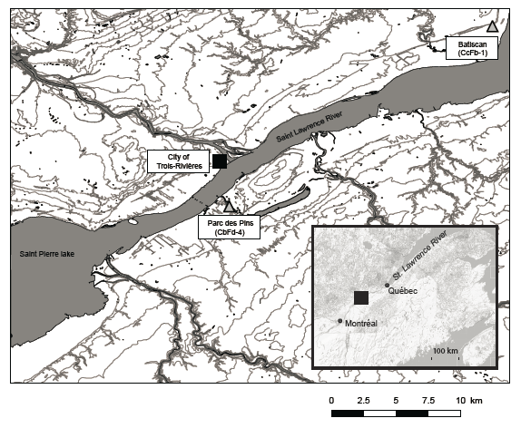

Figure 2. Exterior and interior surface (before and after sampling) of Vinette 1 potsherd from Batiscan.
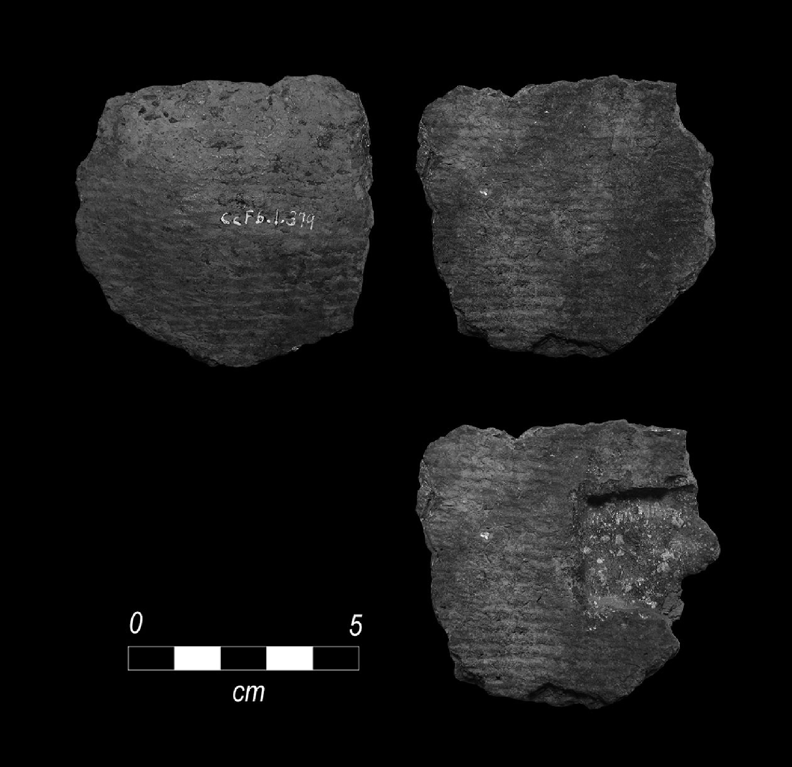

Figure 3. Bulk stable carbon and nitrogen isotope values of Vinette 1 pottery interior surface deposits from coastal (open circles) and inland/riverine sites (filled circles) based on data from Taché and Craig (2015). Exterior deposits (star symbols) and the median and ranges (2σ) of experimentally charred aquatic and terrestrial animals (Craig et al. 2013) are also shown. Parc des Pins samples CcFb4-1-F, CcFb4-2-F, and CcFb4-3-F are shown by the double circle symbols numbered 1, 2, and 3, respectively. Batiscan sample CcFb1-1-F is shown by the triangle inside circle symbol.
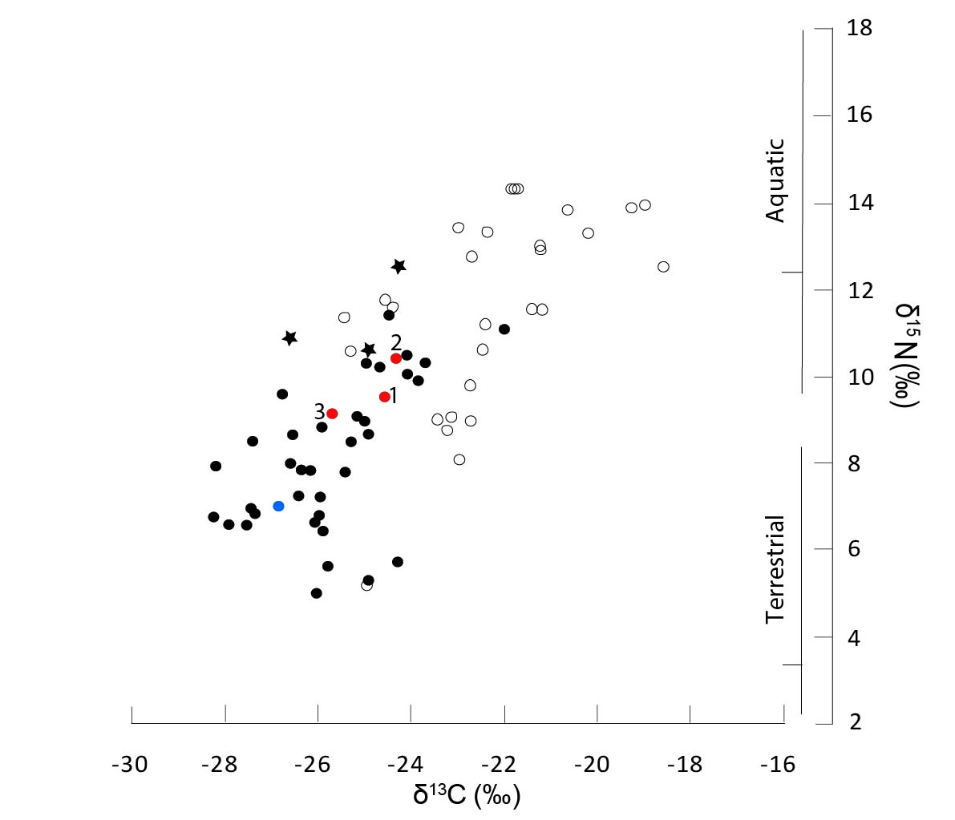
Figure 4. Plot of the δ¹³C values of C_{16:0} and C_{18:0} fatty acids extracted from Vinette 1 pottery from coastal (open circles) and inland/riverine sites (filled circles) based on data from Taché and Craig (2015). Extracts from surface deposits are represented by squares. Parc des Pins samples CcFb4-1-I, CcFb4-2-I, CcFb4-4-I, and CcFb4-9-I are shown by the double circle symbols numbered 1, 2, 4, and 9, respectively. Batiscan samples CcFb1-1-I to CcFb1-7-I are shown by the triangle inside circle symbols numbered 1 to 7, respectively. These are compared with reference fats from wild ruminant (n=19), freshwater (n=24), and marine (n=22) organisms plotted as confidence ellipses (1σ; Stastica v.7). Additional North American modern fat samples from wild herbivorous, omnivorous and piscivorous animals (n=8) are indicated separately (open diamonds).
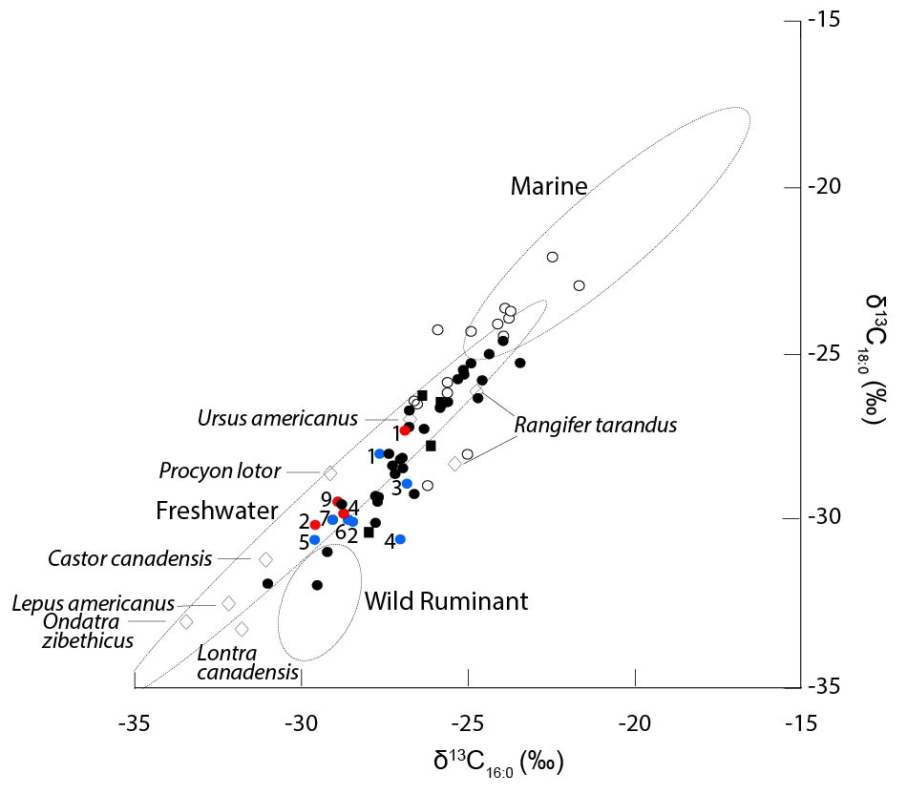

Figure 5. Examples of partial gas chromatograms of lipid extracts from Parc des Pins. A. Degraded aquatic oil from sample CcFb4-1. The partial m/z 105 ion chromatogram (inset) shows ω-(o-alkylphenyl)alkanoic acids with 18 (+) and 20 (*) carbon atoms B. Degraded terrestrial animal fat from sample CcFb4-3; C. Possible degraded aquatic oil with unusually high proportion of C18:1 from CcFb4-8. Cn:x are fatty acids with carbon length n and number of unsaturations x; DCx are α,ω-dicarboxylic acids with carbon length x; br are branched-chain acids; ALx=alkanes with carbon length x, phy=phytanic acid, P are plasticizer contaminants; IS is the internal standard (n-hexatriacontane).
Figure 6. Examples of partial gas chromatograms of lipid extracts from Batiscan. A. Degraded aquatic oil from sample CcFb1-1. The partial m/z 105 ion chromatogram (inset) shows ω-(o-alkylphenyl)alkanoic acids with 16 (#), 18 (+), and 20 (*) carbon atoms B. Mixture of degraded ruminant fat, degraded aquatic oil and degraded plant oil (pine resin) from sample CcFb41-3 C. Mixture of degraded ruminant fat and degraded aquatic oil from CcFb1-4. Cn:x are fatty acids with carbon length n and number of unsaturations x; DCx are α,ω-dicarboxylic acids with carbon length x; br are branched-chain acids; ALx=alkanes with carbon length x, phy=phytanic acid, TMTD=4,8,12-trimethyltridecanoic acid, ODA= dehydroabietic acid, P are plasticizer contaminants; IS is the internal standard (n-hexatriacontane)
Table 1. Charred deposits and ceramic samples selected for bulk isotope analysis, and lipid analysis by GCMS
GC-c-IRMS. FA (Cx:y)=fatty acids with carbon length x and number of unsaturations y, br=branched chain acids, DCx=α,ω-dicarboxylic acids with carbon length x, ALx=alkanes with carbon length x, pri=pristanic acid, phy=phytanic acid, TMTD=4,8,12-trimethyltridecanoic acid, APFA (Cn)=ω-(o-alkylphenyl) alkanoic acids with carbon length n, ODA= dehydroabietic acid, cholest=cholesterol and cholesterol by-products, stig=stigmasterol. F=interior foodcrust sample, I=interior ceramic sample, E=exterior ceramic sample. tr=trace. Lipid concentrations are expressed in ug mg⁻¹ for carbonised deposits, and in ug g⁻¹ for interior and exterior ceramic samples. In the column P/A of aquatic biomarkers, two ticks indicate complete sets of biomarkers and one tick indicates partial sets of biomarkers. Each line groups potsherds from the same vessel.
Sites | SampleID | Lipid analysis |  |  |  |  | Bulk isotope analysis |  |  | GC-c-IRMS
 |  | Lipid conc. | Compound detected | Aquatic Biomarker  (P/A) | C16/  C18 | δ15N |  | δ13C | C:N |  | C16:0 δ13C (‰) | C18:0 δ13C (‰)
Batiscan | CcFb1-1-F | <0.5 |  |  |  | 6.96 |  | -26.86 | 11.70
 | CcFb1-1-I | 402.84 | FA(C_{9:0-26:0(tr)} C_{18:1} C_{15,17,19br}), AL(C_{15-18,20}) APFA(C₁₄₋₂₀), TMTD, phy, cholest | P(√√) | 1.70 |  |  |  |  |  | -27.71 | -27.92
 | CcFb1-2-I | 65.48 | FA(C_{14:0-28:0} C_{16:1-18:1} C_{15-17br}), AL(C₁₇₋₂₃), DC(C_{9,11,14}), stig, cholest | A | 1.18 |  |  |  |  |  | -28.56 | -29.97
 | CcFb1-3-I | 215.76 | FA(C_{10:0-26:0} C_{16:1-18:1} C_{15-17,25,26br}), AL(C₁₇₋₂₉), DC(C₉₋₁₃), ODA, stig, cholest | A | 1.87 |  |  |  |  |  | -26.90 | -28.84
 | CcFb1-3-E | 167.04 | FA(C_{9:0-28:0} C_{16:1-18:1} C_{13-17,25br}), AL(C_{15-18,20,22-27}), DC(C₇₋₁₄), TMTD, pri, phy | P(√) | 1.81
 | CcFb1-4-I | 229.94 | FA(C_{12:0-28:0(tr)} C_{18:1} C_{15-18br}), AL(C₁₇₋₂₃), DC(C_{11,16}), APFA(C₁₈₋₂₂), phy, cholest | P(√√) | 1.35 |  |  |  |  |  | -27.09 | -30.52
 | CcFb1-5-I | 141.56 | FA(C_{14:0-26:0} C_{18:1} C_{15-17br}), AL(C₁₆₋₂₄), APFA(C₁₈), phy, ODA, cholest | P(√) | 1.26 |  |  |  |  |  | -29.69 | -30.54
 | CcFb1-6-I | 471.38 | FA(C_{12:0-26:0} C_{18:1} C_{15-19br}), AL(C_{16-20,24-27}), DC(C₉₋₁₄), APFA(C_{16(tr),18-22(tr)}), phy, cholest | P(√√) | 0.81 |  |  |  |  |  | -28.67 | -29.93
 | CcFb1-7-I | 57.00 | FA(C_{14:0-26:0(tr),} C _{18:1}), AL(C₁₆₋₂₅), ODA, stig, cholest | A | 1.61 |  |  |  |  |  | -29.12 | -29.92
Parc  des  Pins | CcFb4-1-F | <0.5 |  |  |  | 9.50 |  | -24.58 | 8.40
 | CcFb4-1-I | 302.70 | FA(C_{14:0-26:0} C_{18:1,20:1} C_{15-19br}), DC(C_{8-11,16,18}), APFA(C_{18,20}), phy, cholest | P(√√) | 1.35 |  |  |  |  |  | -26.98 | -27.24
 | CcFb4-2-F | <0.5 |  |  |  | 10.39 |  | -24.36 | 8.40
 | CcFb4-2-I | 84.77 | FA(C_{14:0-24:0} C_{16:1,18:1} C_{15-19br}), DC(C₉), APFA(C_{18,20(tr)}), phy, cholest | P(√√) | 1.78 |  |  |  |  |  | -29.67 | -30.07
 | CcFb4-3-F | <0.5 |  |  |  | 9.12 |  | -25.71 | 8.10
 | CcFb4-3-I | 12.77 | FA(C_{16:0-26:0(tr)} C_{18:1} C_{17br}) | A | 0.71
 | CcFb4-4-I | 87.47 | FA(C_{14:0-24:0} C_{18:1-20:1} C_{15-17br}), DC(C₉₋₁₆), APFA(C₁₈), phy, cholest | A | 1.55 |  |  |  |  |  | -28.82 | -29.75
 | CcFb4-5-I | 23.85 | FA(C_{9:0-26:0} C_{16:1-20:1} C_{15-19br}), DC(C_{8-11,18,22}) | A | 1.01
 | CcFb4-6-I | 9.88 | FA(C_{14:0-24:0} C_{18:1} C_{15-17br}) | A | 0.86
 | CcFb4-7-I | 27.36 | FA(C_{15:0-28:0} C_{16:1,18:1,18:2} C_{15-17,19br}), DC(C_{16,18,20,22}), cholest | A | 0.92
 | CcFb4-8-I | 31.45 | FA(C_{12:0-26:0} C_{16:1,18:1,18:2} C_{15-18br}) | A | 1.25
 | CcFb4-9-I | 15.46 | FA(C_{15:0-26:0(tr)} C_{16:1,18:1} C_{16,17br}) | A | 1.11 |  |  |  |  |  | -28.98 | -29.40

Table 2. Interpretations of the residues based on a combination techniques in organic residues analysis
Sites | Vessel #/Sample ID | Bulk isotope analysis (IRMS) | Single compound isotope analysis (GC-c-IRMS) | Lipid analysis (GCMS) | Overall interpretation
Batiscan | 1: CcFb1-F/CcFb1-1-I | Degraded animal fat | Degraded non-ruminant fat and/or freshwater oil | Degraded aquatic oil | Freshwater aquatic
 | 2: CcFb1-2-I | N/A | Degraded ruminant fat | Plant and animal sources | Terrestrial ruminant and plant
 | 3: CcFb1-3-I/CcFb4-3-E | N/A | Degraded ruminant fat | Degraded aquatic oil and pine resin | Terrestrial ruminant, freshwater aquatic and pine resin
 | 4: CcFb1-4-I | N/A | Degraded ruminant fat | Degraded aquatic oil | Terrestrial ruminant and freshwater aquatic
 | 5: CcFb1-5-I | N/A | Degraded non-ruminant fat and/or freshwater oil | Degraded aquatic oil and pine resin | Freshwater aquatic and pine resin
 | 6: CcFb1-6-I | N/A | Degraded ruminant fat | Degraded aquatic oil | Terrestrial ruminant and freshwater aquatic
 | 7: CcFb1-7-I | N/A | Degraded non-ruminant fat and/or freshwater oil | Plant and animal sources, pine resin | Animal (terrestrial or aquatic) and plant (pine resin)
Parc-des-Pins | 1: CcFb4-1-F/CcFb1-1-I | Degraded animal fat and/or aquatic oil | Degraded non-ruminant fat and/or freshwater oil | Degraded aquatic oil | Freshwater aquatic
 | 2: CcFb4-2-F/CcFb4-2-I | Degraded animal fat and/or aquatic oil | Degraded non-ruminant fat and/or freshwater oil | Degraded aquatic oil | Freshwater aquatic
 | 3: CcFb4-3-F/CcFb4-3-I | Degraded animal fat and/or aquatic oil | N/A | Degraded animal fat | Terrestrial non-ruminant
 | 4: CcFb4-4-I/ CcFb4-5-I | N/A | Degraded non-ruminant fat and/or freshwater oil | Degraded aquatic oil | Freshwater aquatic
 | 5: CcFb4-6-I | N/A | N/A | Degraded animal fat | Terrestrial animal
 | 6: CcFb4-7-I | N/A | N/A | Animal/aquatic | Animal/aquatic
 | 7: CcFb4-8-I/CcFb4-9-I | N/A | Degraded non-ruminant fat and/or freshwater oil | Degraded aquatic oil | Freshwater aquatic

Sagard also mentions that the gourds used to store fish oil were obtained from a great distance, probably from the south (Trigger 1969:36)
Sometimes they put aside the biggest and fattest Assihendos, and set them to boil away in great kettles in order to get the oil from them, which they skim off from the top of the boiling mass with a spoon and put into bottles like our calabashes. This oil is as sweet and nice as fresh butter, moreover it comes from a very good fish unfamiliar to the Canadians and even less known over here [in France]. [Sagard 1939(1632):185]
The work of the women was to go fetch the animal after it was killed, to skin it, and cut it into pieces for cooking. To accomplish this they made the rocks red hot, placed them in and took them out of the kettle, collected all the bones of the Moose, pounded them with rocks upon another of larger size, (and) reduced them to a powder; then they placed them in their kettle, and made them boil well. This brought out a grease which rose to the top of the water, and they collected it with a wooden spoon. They kept the bones boiling until they yielded nothing more, and with such success that from the bones of one Moose, without counting the marrow, they obtained five to six pounds of grease as white as snow, and firm as wax. It was this which they used as their entire provision for living when they went hunting. We call it Moose butter; and they Cacamo. [Denys 1908(1672):422-423]
Then, turning to the other side, I saw a large pot filled with the tongues and upper lips of moose, which gave out a delicious smell. These, the most delicate parts of the animal, were being cooked for his people. [LeJeune 1899(1639):79]
This kettle was of wood, made like a huge feeding-trough or stone watering-trough. To make it they took the butt of a huge tree which had fallen; they did not cut it down, not having tools fitted for that, nor had they the means to transport it; they had them ready-made in nearly all the places to which they went. [Denys 1908(1672):401]
At the present time they still do it in the same way, but they have good axes, knives more convenient for their work, and kettles easy to carry. This is a great convenience for them, as they are not obliged to go to the places where were their kettles of wood, of which one never sees any at present, as they have entirely abandoned the use of them. [Denys 1908(1672):406]
After he had finished his address, we went out of his cabin, and they began to celebrate their ‘tabagie’ or banquet, at which they have elk's meat, which is similar to beef, also that of the bear, seal and beaver, these being their ordinary meats, including also quantities of fowl. They had eight or ten boilers full of meats, in the middle of this cabin, separated some six feet from each other, each one having its own fire. [Champlain 1880:237]
They give to each one a portion, together with a spoonful of fat. This dish they are accustomed to prepare for banquets, but they do not generally make it. [Champlain 1907:316]
This observation may not apply to the Western Great Lakes region, where organic residue analysis in early pottery strongly suggested nut oil processing (Skibo et al. 2009).

