**Large exchange bias induced by polycrystalline Mn3Ga antiferromagnetic films with controlled layer thickness**

Haokaifeng Wu,1 Iori Sudoh,2 Ruihan Xu,3 Wenshuo Si,3 C. A. F. Vaz,4 Jun-young Kim,1 Gonzalo Vallejo-Fernandez 1 and Atsufumi Hirohata 5,*

1 *Department of Physics, University of York, Heslington, York YO10 5DD, U.K.*

2 *Department of Materials Science and Technology, Nagaoka University of Technology, Nagaoka 940-2188, Japan*

3 *Department of Electronic Engineering, City University of Hong Kong, 83 Tat Chee Avenue, Kowloon, Hong Kong, P.R. China*

*4 Swiss Light Source, Paul Scherrer Institut, 5232 Villigen PSI, Switzerland*

5 *Department of Electronic Engineering, University of York, Heslington, York YO10 5DD, U.K.*

**Abstract**

Polycrystalline Mn3Ga layers with thickness in the range from 6-20 nm were deposited at room temperature by a high target utilisation sputtering. To investigate the onset of exchange-bias, a ferromagnetic Co0.6Fe0.4 layer (3.3-9 nm thick) capped with 5 nm Ta, were subsequently deposited. X-ray diffraction measurements confirm the presence of Mn3Ga (0002) and (0004) peaks characteristic of the *D*019 antiferromagnetic structure. The 6 nm thick Mn3Ga film shows the largest exchange bias of 430 Oe at 120 K with a blocking temperature of 225 K. The blocking temperature is found to decrease with increasing Mn3Ga thickness. These results in combination with X-ray reflectivity measurements confirm that the quality of the Mn3Ga/Co0.6Fe0.4 interface controls the exchange bias, with the sharp interface with the 6-nm-thick Mn3Ga inducing the largest exchange bias. The magneto-crystalline anisotropy for 6 nm thick Mn3Ga thin film sample is calculated to be $9×{10}^{4}J/m^{3}.$ Such a binary antiferromagnetic Heusler alloy is compatible with the current memory fabrication process and hence has a great potential for antiferromagnetic spintronics.

Spintronic devices have been playing an important role in magnetic storage and memory applications for the last 20 years. For such a trend to continue, it is critical to develop new magnetic materials, in particular, in the context of antiferromagnetic spintronics, materials with high Curie temperatures, large spin polarizations, and low saturation magnetizations. One of the most unique magnetic elements is manganese. Elemental Mn is not ferromagnetic, despite having a *d* band that is more than half full. Of all the elements, the unit cell of the stable cubic α-Mn phase is the largest and most intricate. The unit cell of α -Mn is made up of 48 atoms distributed over four inequivalent sites, each site resulting in different magnetic moments ranging between 0.5 B and 2.8 B. Below 90 K, Mn orders in various antiferromagnetic and ferromagnetic structures [1, 2]. However, when combined in binary or ternary compounds, it leads to the emergence of a vast range of magnetic properties, including room temperature magnetism, such as the ferromagnetic Cu2MnAl Heusler alloy with *T*c = 603 K, discovered by Friedrich Heusler in 1903 [3, 4], long before the development of quantum mechanics.

As a binary Heusler alloy, many studies have been carried out experimentally and theoretically to reveal magnetic properties of Mn3Ga alloys. It is possible to stabilise the bulk [5, 6] and thin films of Mn3Ga (in an experimental context) as *ε*-Mn3Ga. This phase is antiferromagnetic with a hexagonal *D*019 crystal structure which has a noncollinear triangular magnetic structure with antiferromagnetic behaviour [5, 7]. This is comparable to the triangular magnetic state of a conventional IrMn3 antiferromagnet [8]. In the triangular antiferromagnetic structure three magnetic moments point in three different directions which causes the net magnetization to be zero [9]. *ε*-Mn3Ga has been reported to have a high Néel temperature of 470 K [5]. Mn3Ga also forms a tetragonal phase of *τ-*Mn3Ga with the *D*022 structure [10]. This ferrimagnetic Mn3Ga is reported to possess a large uniaxial anisotropy of 1106 J/m3 [12] and high Curie temperature of around 770 K [10]. Bulk- and thin-film forms of the hexagonal material can be annealed to realise the *τ*-Mn3Ga phase [11]. The Mn3Ga tetragonal phase has been grown epitaxially on different substrates [13–15]. Both magnetisation and anisotropy are reported to be dependent upon the Mn3-*x*Ga1+*x* alloy stoichiometry and the surrounding conditions of the Mn3Ga films [13, 15]. In this paper, we report on the thickness dependence of the antiferromagnetic/compensated ferrimagnetic behaviour in polycrystalline Mn3Ga films. Mn3Ga is reported to have the above properties thus it is important and promising for spintronics application.

The samples for this study were grown on Si(001) substrates at room temperature with a Ta (5 nm) and Pt (35 nm) as a seed layer and were capped with a Ta layer (5 nm) using a PlasmaQuest high target utilisation sputtering (HiTUS) system with a base pressure of 510-5 Pa. The plasma was generated by a radio frequency (RF) field of 13.56 Hz in an Ar atmosphere of 310-1 Pa [17]. Platinum was used as a seed layer due to its good lattice match to Mn3Ga [8, 19]. The (0001) plane of Mn3Ga aligns the (111) plane of Pt with a small lattice mismatch of 2%, as shown in Figure 1. In order to confirm the film composition, we carried out energy dispersive X-ray (EDX) measurements on a sample area of $5×5 {mm}^{2}$ and our results indicate the stoichiometry of our films to be Mn2.8Ga1.2, which is close to the nominal composition of antiferromagnetic Mn3Ga. The thickness of Mn3Ga is varied in the range from 3 to 20 nm [16]. A ferromagnetic Co0.6Fe0.4 layer (3.3-9 nm) was deposited onto the Mn3Ga layer in order to study the onset of an exchange bias induced at the Mn3Ga/Co0.6Fe0.4 interfaces induced by the antiferromagnetic Mn3Ga.

Fig. 1 (a) projection of D019 hexagonal Mn3Ga along (0001) plane, (b) schematic diagram of Mn3Ga unit cell, (c) schematic diagram of cubic Pt along (111) plane and (d) schematic diagram of the Mn3Ga film deposited.

(d)

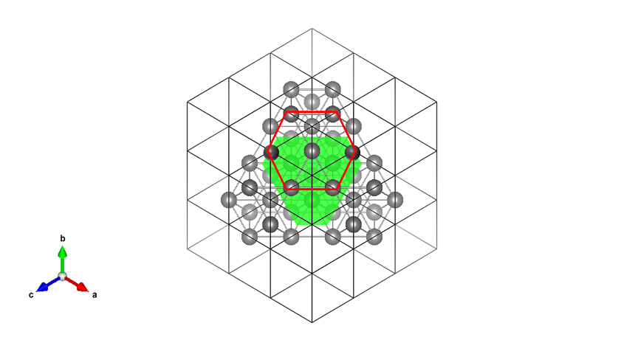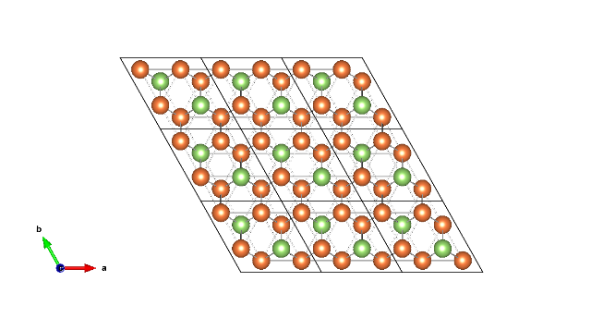

(a)

(b)

(c)

**Ta 5 nm**

**Si Sub**

**Pt 35 nm**

**Mn3Ga 3-20 nm**

**CoFe 0 or 3.3 nm**

**Ta 5 nm**

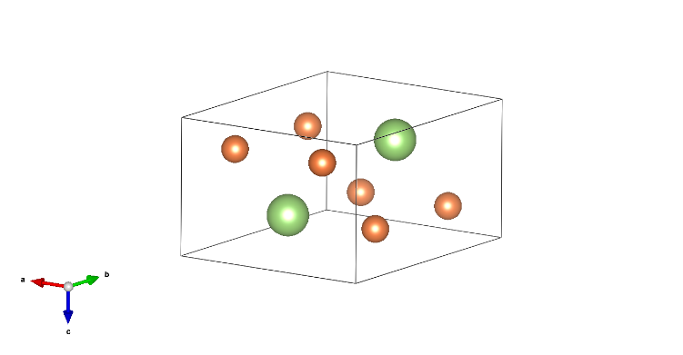

[001]

[100]

[010]

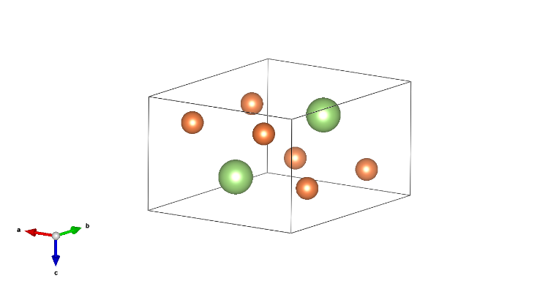

[010]

[100]

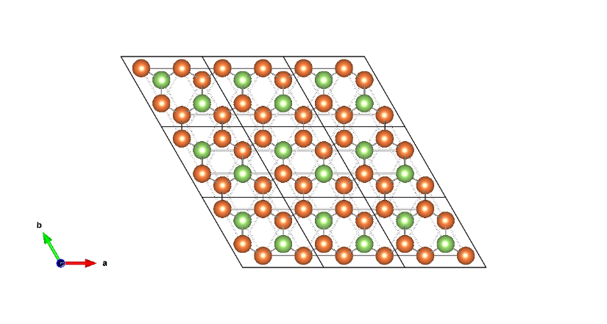

[001]

[100]

[010]



The samples are first characterised by X-ray diffraction (XRD) in order to confirm the crystal structure of the Mn3Ga layers. A Rigaku SmartLab X-ray diffractometer was used in this study. This apparatus employs the use of a high intensity 9 kW rotating anode X-ray generator. It operates with a voltage of 45 kV and a current of 200 mA. A Cu target was used as the X-ray source. The samples are measured in air. $θ$-2 $θ$ XRD scans indicate the variation in the degree of the crystallisation with respect to different thicknesses of the Mn3Ga layers from 3 nm to 20 nm as shown in Fig. 2. The XRD spectra show that, as the thickness of Mn3Ga layer increases, the (0002) and (0004) peaks become more intense and sharper. This is because thicker Mn3Ga layer provide a stronger signal. The 20 nm thick Mn3Ga film shows a clear (0002) peak at 41.3 $°$ as shown in Fig. 2. When the Mn3Ga layer thickness is reduced to 6 nm the signal is too weak to distinguish the (0002) peak from the Pt (111) peak. A pole figure scan is required for this purpose, shown in Fig. 2(c) for the 20 nm Mn3Ga film. From the pole figure scan for the 6-nm-thick Mn3Ga film, the central peak confirms the presence of Mn3Ga (0002) peak at 41.3o, corresponding to the hexagonal *D*019 phase. According to the distance from the outer ring to the centre spot, the in-plane rotation angle alpha is found to be 19.0o which indicates the outer ring represents the Pt (111) with polycrystalline nature. It should be noted that the central Mn­3Ga (0002) peak is well separated from that of the Pt (111). The Mn3Ga layer is reported to be stabilised in a hexagonal *D*019 crystal structure *ε*-Mn3Ga with antiferromagnetic behaviour. The lattice parameters of the Mn3Ga films in the *D*019 and *D*022 phases are listed in Table 1. From the XRD scan, it is proved that the sample has purely *D*019 antiferromagnetic phase.

Table 1. Comparison between the *D*019 and *D*022 phases of Mn3Ga.

|  |  |  |
| --- | --- | --- |
| Structure | Hexagonal *D*019 | Tetragonal *D*022 |
| Magnetism | Antiferromagnetic | Ferrimagnetic |
| Lattice parameter | *a* = 0.540, *c* = 0.436 nm [22] | *a* = 0.391, *c* = 0.712 nm [22] |
| 2*θ* observed | 41.30o (0002)  89.9o (0004) | N/A |

Fig. 2 (a) XRD spectra for the Mn3Ga samples with different thicknesses (CoFe thickness of 3.3 nm). (b) XRD intensities around the (0001) line. (c) Pole figure scan at 41.45o for the 20-nm-thick Mn3Ga film.

(c)

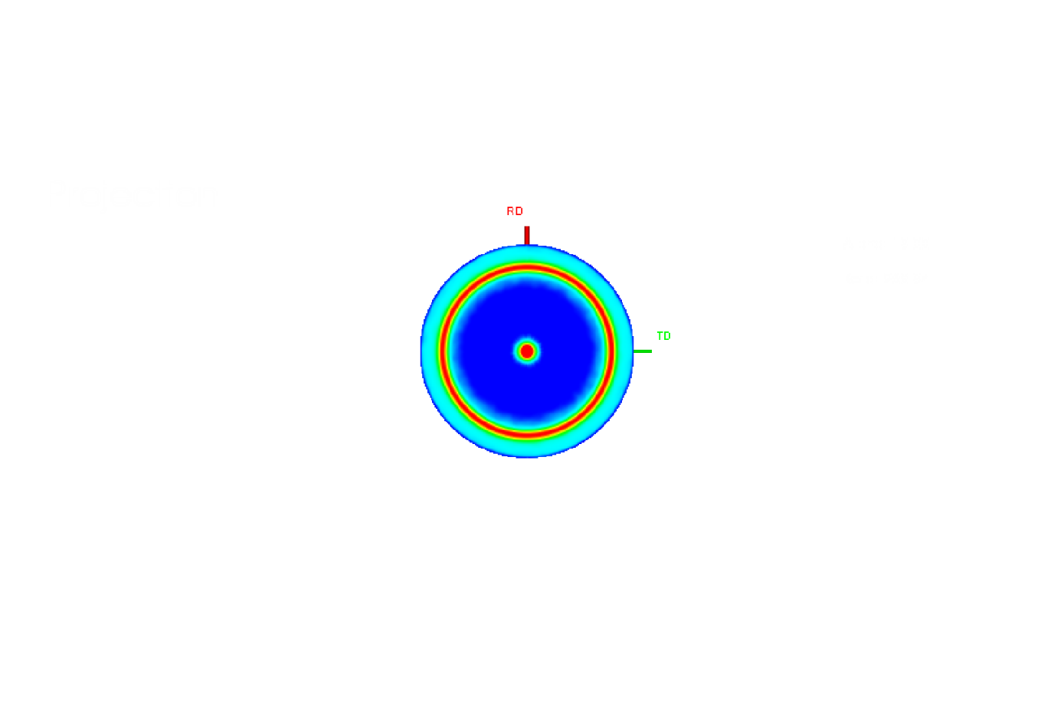

X-ray reflectivity (XRR) measurements carried out for the 6-nm-thick-Mn3Ga film confirm the presence of sharp interface between the Mn3Ga and FeCo layers as shown in Fig. 3. Using the GenX software to fit the data, the estimated thicknesses are: Ta (6.0±0.4 nm)/Pt (34±2 nm)/Mn3Ga (5.8±0.9 nm)/CoFe (4±1 nm)/Ta (4±1 nm).



Figure. 3 XRR scan for 6-nm-thick Mn3­Ga/3.3-nm-thick CoFe film

The magnetic characteristics of the samples are measured using a vibrating sample magnetometer (VSM). The 20-nm-thick Mn3Ga film without the CoFe ferromagnetic layer shows no magnetization. This result suggests that the film is antiferromagnetic. The magnetization curves for the Mn3Ga/Co0.6Fe0.4 samples measured at 120 K after cooling under an applied magnetic field of 20 kOe are shown in Fig. 4. As can be seen, all *M-H* curves are shifted horizontally, which demonstrates the presence of exchange-bias in the system. The 6-nm-thick Mn3Ga film shows the largest exchange bias of 430 Oe at 120 K. The saturation magnetization of the Mn3Ga/Co0.6Fe0.4 sample, 1300100 emu/cm3, arises from the 3.3-nm-thick ferromagnetic Co0.6Fe0.4 layer, since the individual Mn3Ga layer shows no magnetization between 100 and 300 K. Hence the observed magnetization can be attributed to that of the Co0.6Fe0.4 layer, which this is very close to the bulk value for Co0.6Fe0.4 (1450 emu/cm3) [21]. For the 10- and 20-nm-thick films, the exchange bias is measured to be 299 and 270 Oe, respectively. By increasing the Mn3Ga thickness, the exchange bias is found to decrease. Such effect can be due to a combinations of factors: on the one hand, at small thicknesses, one may expect a larger epitaxial strain, which may lead to an increased magnetocrystalline anisotropy in the Mn3Ga; at larger thicknesses, strain relaxation sets in, leading to rougher interfaces and a possible reduction in the anisotropy, hence to a smaller exchange bias. For a fixed Mn3Ga thickness (6 nm), we find that, as the thickness of CoFe increase from 3.3 nm to 9 nm, the exchange bias decreases significantly from 430 Oe to 130 Oe, as seen in Fig. 4(b). This is in agreement with other studies, where a thin ferromagnetic layer attached to an AF layer with good crystalline ordering maximises the interfacial exchange coupling [23].



Fig. 4, (a) Magnetization curves for the polycrystalline Mn3Ga/Co0.6Fe0.4 (3.3 nm) films versus Mn3Ga thicknesses of 6 (blue line), 10 (red line) and 20 nm (black line) measured at 120 K. (b) Magnetization curves for the polycrystalline Mn3Ga (6 nm)/Co0.6Fe0.4 films CoFe thicknesses of 3.3 (black line), 6 (red line) and 9 nm (blue line) measured at 120 K

In order to determine the blocking temperature (*T*B), *i.e.*, the point at which the exchange bias vanishes, the activation temperature must be considered. This is usually carried out by raising the activation temperature until the loop shift becomes zero. A single grain has unique *T*B in polycrystalline systems. Figure 5 illustrates *T*B measured using the York protocol [17]. In order to ensure that no magnetic history affects the measurements, the sample temperature is set to *T*SET = 500 K (lower than *T*N) for 90 minutes under an external field of 20 kOe, then cooled to *T*NA = 100 K. The external field is then reversed to negative 20 kOe, and the samples are then thermally activated at a temperature between 100 K and 350 K for 30 minutes. The magnetisation curves are then taken at 100 K. The result of a sequence of such measurement for the 6-nm-thick Mn3Ga sample is shown in Fig 5. The data clearly shows the evolution of the loop shift from a negative magnetic field shift of -420 Oe to positive field value of 500 Oe by increasing the activation temperature from 100 K to 350 K. The loop shift is caused by the reorientation of the magnetisation of the Mn3Ga/CoFe with the individual Mn3Ga grains due to the thermal activation in a negative field. By increasing the activation temperature, the magnetisation in smaller grains can be reversed [19]. Therefore, the temperature where the exchange bias becomes zero represents the equilibrium state between the total volume of the grains aligned along the initial magnetic field and that of the grains reversed by the thermal energy induced by the increase in temperature. This is the definition of the median blocking temperature of an antiferromagnetic material. For 6-nm-thick Mn3Ga sample, <*T*B> is estimated to be 225 K.

Fig. 5, Magnetization curves for the 6-nm-thick Mn3Ga/Co0.6Fe0.4 film for different activation temperatures between 100 K and 350 K.



Fig. 6, Temperature dependence of exchange bias determined for the Mn3Ga/Co0.6Fe0.4 films with the Mn3Ga thickness of 6, 10 and 20 nm.

Figure 6 shows that the exchange bias varied monotonically as a function of the thermally activating temperature. Interestingly, the blocking temperature is found to decrease when the Mn3Ga thickness is increased, from 235 K for the 10-nm-thick film to 175 K for the 20-nm-thick film. This is attributed to the larger epitaxial strain to the Pt buffer layer and a smoother interface at smaller Mn3Ga thicknesses. These results indicate that the quality of the Mn3Ga/Co0.6Fe0.4 interface controls the exchange. For the 6-nm-thick Mn3Ga, we find a reduction in the blocking temperature, which we attribute to a reduction in the total magnetic anisotropy of the Mn3Ga due to the reduced thickness [18]. Nevertheless, the 6-nm-thick Mn3Ga induces the largest exchange bias of 430 Oe at 120 K.

It is worth noting that there is a large difference between the Néel temperature and blocking temperature of Mn3Ga, which might be related to the weak anisotropy and a small grain size. To ascertain the role of the grain size, we carried out transmission electron microscopy (TEM) grain size analyses (JEOL JEM-2011 TEM). A Lanthanum hexaboride (LaB6) filament is fitted at the top of the apparatus which is operated under high vacuum of 10-8 Pa. More than 500 individual grain particle was measured which follows a lognormal distribution shown in Fig. 7. The mean grain size was obtained to be 13.2 nm with 0.4 standard deviation.

(a)

(b)



**50nm**

Fig. 7, (a) Plan-view TEM image for grain size analysis for 6 nm thick Mn3Ga thin film sample. (b) Grain size distribution for 6 nm thick Mn3Ga thin film sample.

For the case when the sample is thermally stable at the temperature of measurement and has been fully set, the magnetocrystalline anisotropy can estimated using the expression:

$K_{AF}\left(<T_{B}>\right)=\frac{ln\left(1800f_{0}\right)kT_{B}}{<V>}$ (1)

where $K_{AF}$ indicates the magneto-crystalline anisotropy, $T_{B}$ is the median blocking temperature, $f_{0}$ is an attempt frequency generally taken to be 109 s-1 and V is the median grain volume. In our report the anisotropy value was calculated to be $9×{10}^{4}J/m^{3}$. For comparing, the value for IrMn is more than 2 times of magnitude higher. This leads to lower the blocking temperature of Mn3Ga sample.

In addition, x-ray photoemission electron microscopy (XPEEM) measurements were carried out at the SIM beamline at the Paul Scherrer Institut (PSI). In this technique, fully polarised x-ray light illuminates homogeneously the sample, and high resolution images of the local photomitted electron intensity of the sample, proportional to the x-ray absorption, are recorded. Using circularly polarised light and the x-ray circular magnetic dichroic effect and the elemental sensitivity of x-rays, separate magnetic contrast images of different layers can be obtained sequentially on the very same region of the sample. Magnetic contrast images of a Mn3Ga/CoFe sample were obtained at the Co and Mn L3 edges were taken at 150 K to probe the CoFe and Mn3Ga layer simultaneously. As shown in the Fig. 8, we find a strong magnetic contrast in the CoFe layer, as expected for such a ferromagnetic material. The different black and white regions correspond to areas with opposite magnetisation, showing the presence of a multi-domain state. When probing the Mn L3 edge, we find the presence of a clear magnetic contrast which correlates exactly to that of the CoFe layer, showing the presence of a spin-polarised Mn3Ga layer at the interface.

Mn edge

Co edge

XMCD

XMCD



Figure. 8, Magnetic contrast image of Mn3Ga (?? nm)/CoFe (?? nm) sample taken at the Co edge and Mn edge at 150 K.

A schematic diagram of the interface with spin structures are shown in Fig 9. This indicates possible formation of an uncompensated Mn3Ga spin layer in the vicinity of the interface against the CoFe layer in these films since they exhibit a small saturation magnetisation. This also agrees with the large exchange-bias effects observed in this system.

AF

F

Figure. 9, A schematic diagram of the interface with spin structures.

Since the spectra were taken with circularly-polarised light, they do contain magnetic information, and if magnetic domains are present, one can detect the local spectra at each domain and can obtain some contrast in the XMCD images. Figures 10(a) and (b) shows the XAS spectra taken at the Mn and Co edge with right (C+) and left (C-) circular polarisations. The subtraction of these two signals provide XMCD spectra as shown in Figs. 10(c) and (d). For the Co spectrum, one can clearly see the domain structure using right-circularly-polarised light at L3 and L2 edges as shown in Fig. 10(e). An example of spectra at C+ and C- for the regions marked with a blue circle is given in Fig. 10(c). For the Mn spectrum, the domain structure is also available at the L3 edge and the corresponding XMCD spectrum can also be observed. In the Mn3Ga (?? nm)/CoFe (?? nm)/cap (?? nm) orbital and spin magnetic moments of Mn and Co can therefore be estimated from XMCD spectra using the Sum Rules [24]. The orbital and spin moments of Co are estimated to be (0.299 $±$ 0.005) $μ_{B}$ and (1.268 $±$ 0.005) $μ_{B}$ respectively. The total moment of Co is calculated to be (1.567 $±$ 0.005) $μ_{B}$ which agrees with the theoretical value of 1.60 $μ_{B}$ [Ref.]. The orbital and spin moments of Mn are also estimated to be (0.270 $±$ 0.005) $μ_{B}$ and (0.320 $±$ 0.005) $μ_{B}$ respectively. The total moment of Mn is calculated to be (0.590 $±$ 0.005) $μ_{B}$ which is within the literature magnetic moment of Mn (0.5-2.8) $μ_{B}$ [Ref.]. These estimated values represent those in the vicinity of Mn3Ga/COFe interface, confirming that the quality of these layers is not affected by their neighbouring layers.

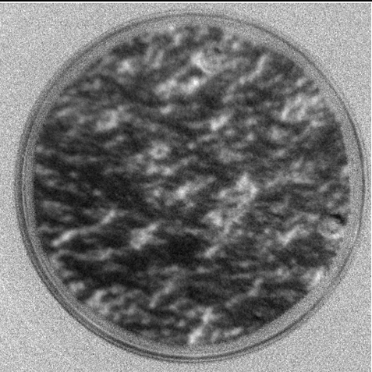

Co L3

e

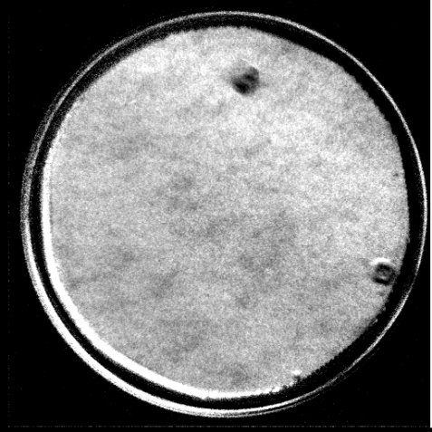

Mn L3

f

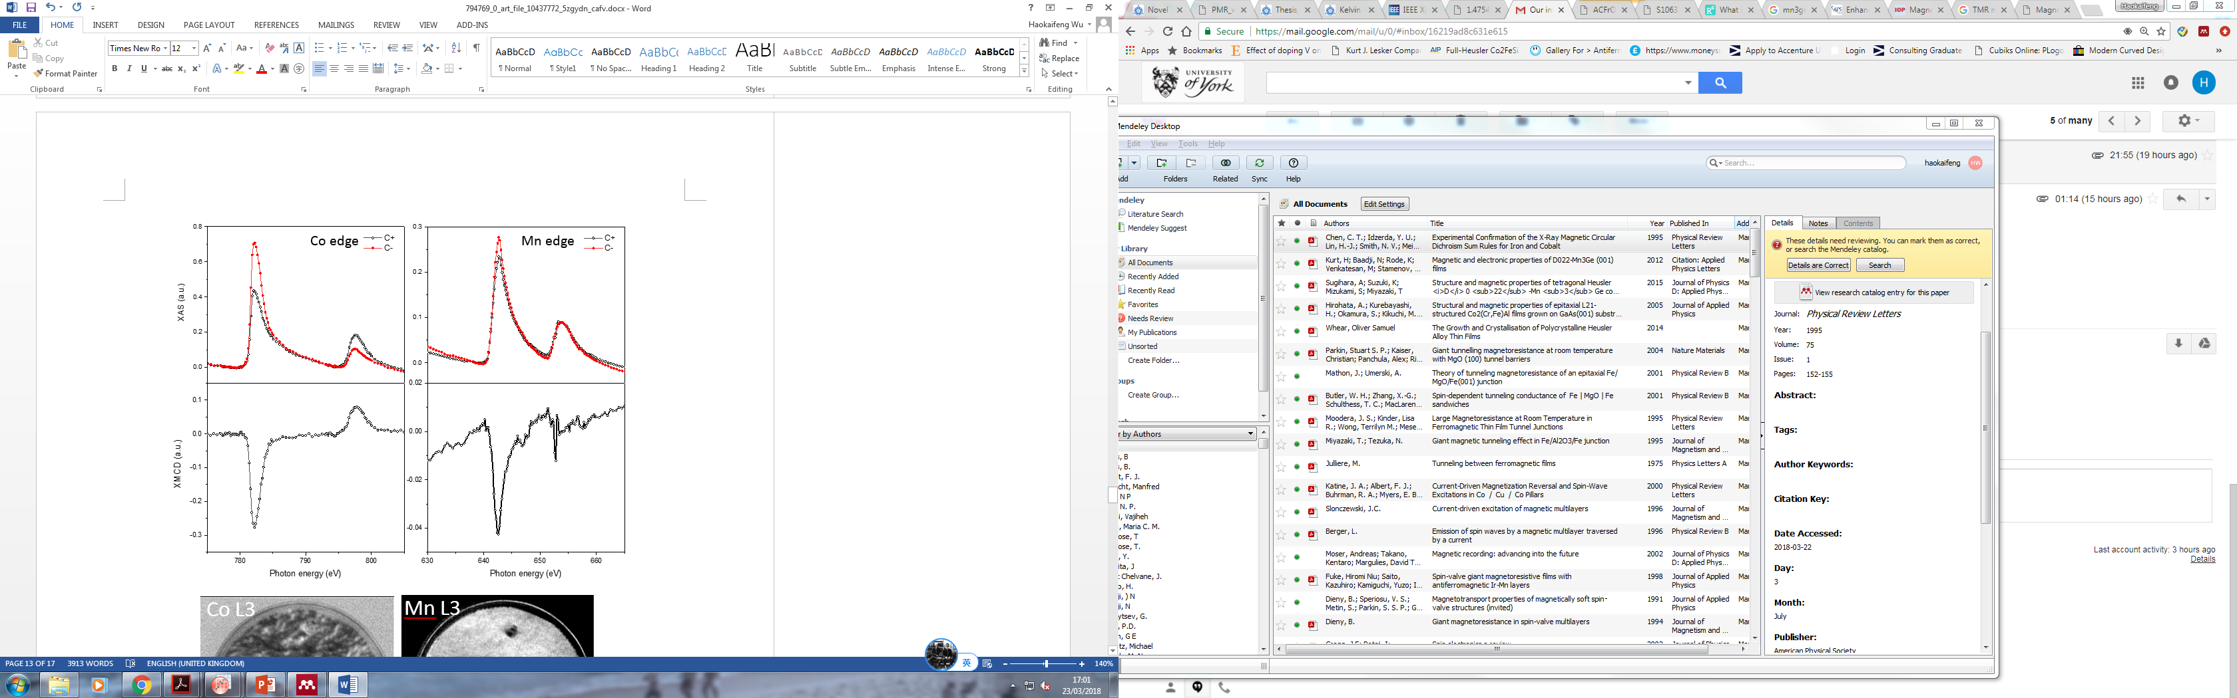

a

b

c

d

Figure. 10, (a) and (b) XAS and (c) and (d) XMCD spectra of the Co and Mn edges in Mn3Ga (?? nm)/CoFe (?? nm) sample, respectively. The corresponding XMCD images of (e) Co L3 and (f) Mn L3 edges.

**Conclusion**

Polycrystalline Mn3Ga films grown by high target utilisation sputtering system are confirmed to crystallise in the *D*019 antiferromagnetic hexagonal structure. By coupling to a CoFe layer, we observe the presence of large exchange-bias fields, of up to 430 Oe at 120 K for a 3.3 nm ferromagnetic CoFe layer is deposited on the top of a 6 nm Mn3Ga layer. The blocking temperature for 6-nm-thick Mn3Ga is found to be 225 K. The blocking temperature of Mn3Ga decreases as the thickness of Mn3Ga layer increases. The value of the exchange bias and the blocking temperature can be further increased by substituting some of the Mn and/or Ga atoms with the other elements as reported by Nayak *et al.* [20], which warrants the possibility of Mn3Ga being used in a future antiferromagnetic spintronic devices. .

**Acknowledgement**

We would like to thank RCUK (EP-M02458X/1) for funding this work. Special thanks go to Professor Kevin O’Grady for continues supporting during the research. Part of this work was performed at the Surface/Interface: Microscopy (SIM) beamline of the Swiss Light Source, Paul Scherrer Institut, Villigen, Switzerland.

**Reference**

1. J. M. D. Coey, Magnetism and Magnetic Materials, Cambridge University Press, Cambridges, (2010).
2. V. Sliwko, P. Mohn and K. Schwarz, The electronic and magnetic structures of alpha - and beta -manganese. *J. Phys. Condens. Matter* **6**, 6557–6564 (1994).
3. F. Heusler, Mangan-Aluminium-Kupferlegierungen. *Verh. DPG* **5**, 219 (1903).
4. F. Heusler, W. Starck and E. Haupt, *Verh. DPG* **5**, 220 (1903).
5. E. Krén and G. Kádár, Neutron diffraction study of Mn3Ga. *Solid State Commun.* **8**, 1653–1655 (1970).
6. H. Niida, T. Hori, Y. Yamaguchi and Y. Nakagawa, Crystal distortion and weak ferromagnetism of Mn3+*δ*Ga1− *x*Ge*x* alloys. *J. Appl. Phys.* **73**, 5692–5694 (1993).
7. H. Kurt, K Rode, H. Tokuc, P. Stamenov, M. Venkatesan and J. M. D. Coey, Exchange-biased magnetic tunnel junctions with antiferromagnetic ε-Mn3Ga. *Appl. Phys. Lett.* **101**, 232402 (2012).
8. L. Szunyogh, B. Lazarovits, L. Udvardi, J. Jackson and U. Nowak, Giant magnetic anisotropy of the bulk antiferromagnets IrMn and IrMn3 from first principles. *Phys. Rev. B* **79**, 20403 (2009).
9. D. Zhang, B. Yan, S. Wu, J. K $\ddot{u}$ bler, G. Kreiner, S. Parklin and C. Felser, First-principles study of the structural stability of cubic, tetragonal and hexagonal phases in Mn3Z (Z=Ga, Sn and Ge) Heusler compounds. *J. Phys. Condens. Matter* **25**, 206006 (2013).
10. J. Winterlik, B. Balke, G. H. Fecher, C. Felser, M. C. M. Alves, F. Bernardi and J. Morais, Structural, electronic, and magnetic properties of tetragonal Mn3−*x*Ga: Experiments and first-principles calculations. *Phys. Rev. B* **77**, 54406 (2008).
11. S. Khmelevskyi, A. V. Ruban and P. Mohn, Magnetic ordering and exchange interactions in structural modifications of Mn3Ga alloys: Interplay of frustration, atomic order, and off-stoichiometry. *Phys. Rev. B* **93**, 152-155 (2016).
12. H.-W. Bang, W. Yoo, Y. Choi, C.-Y. You, J. Hong, J. Dolin $\check{s}$ ek and M.-H. Jung, Perpendicular magnetic anisotropy properties of tetragonal Mn3Ga films under various deposition conditions. *Curr. Appl. Phys.* **16**, 63–67 (2016).
13. S. Mizukami, F. Wu, A. Sakuma, J. Walowski, D. Watanabe, T. Kubota, X. Zhang, H. Naganuma, M, Oogane and Y. Ando *et al.*, Long-lived ultrafast spin precession in manganese alloys films with a large perpendicular magnetic anisotropy. *Phys. Rev. Lett.* **106**, 117201 (2011).
14. L. Zhu and J. Zhao, Perpendicularly magnetized Mn*x*Ga films: promising materials for future spintronic devices, magnetic recording and permanent magnets. *Appl. Phys. A* **111**, 379–387 (2013).
15. S. Mizukami, T. Kobuta, F. Wu, X. Zhang, T. Miyazaki, H. Naganuma, M. Oogane, A. Sakuma ans Y. Ando, Composition dependence of magnetic properties in perpendicularly magnetized epitaxial thin films of Mn-Ga alloys. *Phys. Rev. B* **85**, 14416 (2012).
16. N. Fukatani, K. Inagaki, T. Miyawaki, K. Ueda and H. Asano, Structural and magnetic properties in Heusler-type ferromagnet/antiferromagnet bilayers. *J. Appl. Phys.* **113**, 17C103 (2013).
17. J. Sagar, L. R. Fleet, M. Walsh, L. Lari, E. D. Boyes, O. Whear, T. Huminiuc, A. Vick and A. Hirohata, Over 50% reduction in the formation energy of Co-based Heusler alloy films by two-dimensional crystallisation. *Appl. Phys. Lett.* **105**, 32401 (2014).
18. K. O’Grady, L. E. Fernandez-Outon and G. Vallejo-Fernandez, A new paradigm for exchange bias in polycrystalline thin films. *J. Magn. Magn. Mater.* **322**, 883–899 (2010).
19. H. Kurt, K. Rode, M. Venkatesan, P. Stamenov and J. M. D. Coey, Mn3−*x*Ga (0≤x≤1): Multifunctional thin film materials for spintronics and magnetic recording. *Phys. Status Solidi* **248**, 2338–2344 (2011).
20. A. K. Nayak, M. Nicklas, S. Chadov, P. Khuntia, C. Shekhar, A. Kalache, M. Banitz, Y. Skourski, V. K. Guduru and A. Puri, Design of compensated ferrimagnetic Heusler alloys for giant tunable exchange bias. *Nat. Mater.* **14**, 679–684 (2015).
21. G. C. Hadjipanayis, NATO advanced study institute on magnetic storage systems beyond 2000. Kluwer Academic Publishers, 534, 2001.
22. S. Khmelevskyi, A. V. Ruban and P. Mohn, Magnetic ordering and exchange interactions in structural modifications of Mn3Ga alloys: Interplay of frustration, atomic order, and off-stoichiometry. *Phys. Rev. B* **93**, 184404 (2016).
23. C. N. T. Yu, A. Vick, N. Inami, K. Ono, W. Frost and A. Hirohata, Exchange bias induced at a Co2FeAl0.5Si0.5/Cr interface. *J. Phys. D: Appl. Phys.* **50**, 125004 (2017).
24. C. T. Chen，Y. U. Idzerda, J. H. Lin, N. V. Smith, G. Meigs, E. Chaban, G. H. Ho, E. Pellegrin, F. Sette, Experimental Confirmation of the X-Ray Magnetic Circular Dichroism Sum Rules for Iron and Cobalt. *Phys. Rev. Lett.* **75,** 152–155 (1995).