Cross-sectioning photovoltaic polymer blends with advanced gas-ion microscopy
Robert C Masters¹; Yiwei Zhang², Yangbo Zhou³, Robbie O’Connell³, Hongzhou Zhang³, David G Lidzey², Cornelia Rodenburg¹
1. Department of Materials Science and Engineering, University of Sheffield, Mappin Street, Sheffield S1 3JD
2. Department of Physics and Astronomy, University of SHeffield, Hounsfield Road, Sheffield, S3 7RH
3. School of Physics and CRANN, Trinity College Dublin, DUblin 2, Ireland

Introduction
The gas-ion microscope has promised a revolution in nanofabrication and imaging capabilities since its emergence around 10 years ago[1].
He⁺ and Ne⁺ gas-ion beams offer superior nanofabrication precision in comparison to conventional metal-ion focused ion beam (FIB) tools[2], [3]. By milling with light elements, nanoscale sample modification can be performed more accurately, with reduced damage from beam heating and without artefacts from implanted metal ions. This is crucial when working with beam sensitive samples, such as biological materials or polymers. Further, the imaging performance of the Helium ion microscope is competitive with the state of the art in scanning electron microscopy (SEM) thanks to a sub-nanometre spot size and the strong secondary electron imaging signal generated by He⁺ ions[4].
In practice, these advantages unlock a range of novel applications for the gas-ion microscope in nanoscale fabrication and material analysis[1]. He⁺ and Ne⁺ FIBs have already enabled breakthroughs across multiple disciplines, for example in processing and analysing biological specimens[5], fabricating plasmonic devices[6] and controlling the nanostructure and properties of 2-dimensional materials[7]. Typically, applications of the He⁺ and Ne⁺ FIB in nanofabrication are limited to instances where only a small mass of material must be manipulated; this is a result of the relatively low sputter yield of light gas ions. Gas-ion FIBs are therefore ideally suited to characterising light materials, such as soft, thinned or 2-dimensional materials.
Organic photovoltaics (OPV) is one field greatly in need of new characterisation tools. By generating solar energy from a polymer film, OPV technology has vast potential to enable a wealth of novel, low-cost and exciting solar power applications, including lightweight solar cells printed on flexible plastic[8] and solar energy coatings[9]. However, the technology remains under development due to the high complexity of OPV materials, typically polymer blends exhibiting nanoscale phase separation[10]. The performance of an OPV device is highly dependent on its nanostructure, especially through the film thickness as this is the direction of charge transport.
Techniques for imaging the cross-sectional morphology of OPV polymer blends are required to deepen understanding of OPV devices and help develop the next generation of the technology. Prior to this work, we have shown how helium-ion microscope images can reveal this morphology for some material systems[11]. However, to date the transmission electron microscope (TEM) remains the most effective tool for imaging the cross-section of OPV films directly and in high resolution[12]. A Ga⁺ FIB is typically used to prepare the cross-sectional samples for TEM imaging, however the Ga⁺ FIB is poorly-suited to cross-sectioning a polymer film.
The energy deposited by a Ga⁺ beam is highly concentrated, resulting in beam heating and other damage that destroys features of interest in fragile samples. A ~10nm-thick damage layer is observed on any OPV film surface milled or polished by a Ga⁺ FIB[12]. This layer prevents imaging of Ga⁺-prepared cross-sections in the SEM or helium-ion microscope, and places a severe restriction on the quality of cross-sectional data available from TEM images. TEM image contrast is projected through damage layers, which can complicate interpretation of TEM data and limit the useful thickness of a cross-sectional lift-out.
In this work, we present gas ion nanofabrication and microscopy as an alternative. We first cryo-cleave an OPV film in liquid nitrogen to produce a simple cross-sectional sample, and then perform low-damage milling with He⁺ and Ne⁺ FIBs to remove cleaving artefacts and generate an ultra-high-quality cross-section for imaging. We ultimately demonstrate a cross-sectioning method that is perfectly suited to the preparation and characterisation of OPV films and other soft materials.

Materials and Methods

Material preparation
Films of PffBT4T-2OD:PC₇₀BM, a modern high-performance polymer system for OPV, were processed on to Si substrates as described in [11]. A 50nm-thick layer of PEDOT:PSS was spin-cast on to the top of some films to act as a protective capping layer. The films were then cryo-cleaved under liquid nitrogen and immediately inserted in to the microscope vacuum chamber for processing and imaging.

Gas-ion polishing and imaging process
A Zeiss Orion Nanofab was used for all ion-milling and imaging procedures. The instrument features an interchangeable gas ion source; He⁺ and Ne⁺ beams were tested in milling experiments, whereas all imaging was performed with the He⁺ beam for optimal resolution and reduced beam damage.
The cryo-cleaved edge of the film was polished with the selected ion beam to remove cleaving artefacts and give a flat surface for imaging (Figure 1). 1-2 µm strips of the edge were milled with a 30 kV beam, 1pA beam current and 10 µs dwell time.
For Ne⁺ processing, optimal processing was achieved with a 60 nm-deep milling area overlapping the sample edge (see Figure 1). Milling was performed with a 20 ms time delay between subsequent milling points, with a total dose of 1500 ions.nm⁻².
For He⁺ processing, it was found that a two-step mill produced optimal results (Figure 1); an initial lower-dose mill (50 nm-deep) was used to etch away large cleaving artefacts, and a second higher-dose process was used to polish 30 nm in to the remaining edge. This was used primarily as a measure to prevent drift affecting the polishing process. Milling was performed with a 2 ms time delay between subsequent points. The first step used a dose of 10000 ions.nm⁻², the second used ~15000 ions.nm⁻².

Plasma treatment
After the polishing process, samples were treated with a brief, high-power plasma etch to remove remaining damage layers. Treatment was performed for 20s in a Fischionne 1020 system, with a 25:75 O₂:Ar gas mixture. This same process was applied in initial attempts to remove cleaving artefacts (Figure 2).

Results and discussion

Ion polishing: smoothing the rough edges
Immediately following a cryo-cleave, the film cross-section can be observed as in Figure
2. Interpretation of the image is difficult as large cleaving artefacts are present in the cross-section. Plasma etching the sample immediately following the cryo-cleave improves the situation somewhat, however a large surface roughness is still present, indicating that cleaving artefacts remain.
Gas-ion beams are ideally suited for the task of removing cleaving artefacts from a pre-prepared cross-section, as the amount of material that must be etched is relatively low. Simulations in the modelling software SRIM (Figure 3) demonstrate that the atomic displacements caused by a He⁺ or Ne⁺ beam in a PffBT4T-2OD film at 30kV are far less concentrated than with Ga⁺. Whilst this results in slower etching, unwanted sample damage is also less concentrated, and melting effects from beam heating are similarly reduced. Further, the implantation of metal ions in the sample is avoided, and the density of polymer materials tends to be low enough that implanted gas ions can escape without forming microbubbles if sufficient care is taken[13].
In Figure 4, images of cross-sections immediately following an ion-beam polish are presented. For both He⁺ and Ne⁺, a flat cross-section is observed and the cleaving artefacts have been removed. However, no morphological features are observed at the cross-section surface, indicating that a damage layer still forms after gas ion irradiation.

Unwanted effects: deposition and bubbling
Careful optimisation of the total ion dose and dose rate used for gas-ion polishing is required to obtain flat cross-sections. To minimise beam damage, our optimised parameters described in the methods represent the smallest possible total dose received by the sample at which a flat cross-section was still formed for both He⁺ and Ne⁺. In the case of He⁺, we found that if the dose rate was too low, the beam formed a deposition layer rather than etching the sample (Figure 5). The effect was most prominent if the microscope chamber was contaminated after performing multiple etching procedures. Therefore, it is likely that this layer resulted from the re-deposition of previously etched material. The optimised parameters listed in the Methods section represent the lowest dose rate at which deposition was not observed in a chamber at base pressure.
On the other hand, for both He⁺ and Ne⁺ we found that too high a dose rate caused excessive gas implantation and bubble formation in the silicon substrate. This effect is also depicted in Figure 5. This effect was most notable if drift occurred during the milling process, with the irradiated area shifting inwards across the sample and away from the sample edge as a result. This effect deposited gas away from the cross-sectional surface where it could easily escape, increasing the likelihood of bubbling.

Etching away the damage
Given the low energy deposition of gas ion irradiation, the damage layer formed in the polishing process is thin enough to be removed by a brief (20s) plasma exposure. By etching away the damaged material, the morphological features beneath are revealed[11]. In Figure 6, film cross-sections imaged following an ion polish and subsequent plasma etch are presented. In both He⁺- and Ne⁺-polished films, morphological features are observed, indicating that any damage layer formed on the surface of gas-ion polished cross-sections are relatively thin.

Helium or Neon?
However, it is clear that at the top of the film (as aligned in Figure 6), morphological features have been lost. The effect is most notable in the Ne⁺-polished sample (Figure 6b), where only features in the bottom half of the film are visible. Further plasma etching does not reveal any further morphological features before artefacts resulting from excessive plasma exposure appear.
This effect is very likely due to beam damage being most concentrated near the top of the sample during the polishing process (Figure 3); as the beam passes deeper in to the sample, its energy is dissipated over a wider volume. From the comparison of He⁺ and Ne⁺-polished films, it is clear that for this particular application, He⁺-ion polishing is more suitable as more morphological features are preserved.
It should be noted however that Ne⁺ polishing may be the better choice if one desires to cross-section a full OPV device using our method. The increased thickness of a full device and inclusion of metal contact layers may require the greater sputter yield of the Ne⁺ beam for an effective polish. Further, the unwanted effects depicted in Figure 5 are reduced significantly when using a Ne⁺ beam due to the higher sputter rate in comparison to He⁺. No deposition was observed when polishing with Ne⁺, and the lower dose required for Ne⁺ polishing (see Methods section) reduces the chance of bubble formation.

Capping it off
The concentration of beam damage near the top of the film is a common effect in conventional FIB milling, often mitigated by the deposition of a capping layer on top of the milled region prior to processing. The ion microscope used for this work did not have the gas-injection system necessary for deposition, and as such we cast an additional, 50 nm-thick polymer layer on to the blend film to act as a capping layer. We used PEDOT:PSS for this purpose as its water solvent does not affect the PffBT4T-2OD layer.
The full cross-sectional morphology of the blend film was revealed (Figure 7) by subjecting the capped sample to the same He⁺ ion-beam polishing and plasma treatment as described above. This figure is the first published cross-sectional image of this particular blend system, and reveals the crucial nature of phase-separation through the depth of the film. The impressive imaging power of the helium-ion microscope is evident here, enabling clear observation of nanoscale features. Crucially, this image does not show projection artefacts that would make comparable images from the TEM harder to interpret. Formed from a surface-sensitive secondary electron signal, it shows a precise, 2-dimensional ‘slice’ of the cross-sectional morphology.
As shown in Figure 7, the cross-sectional morphology was segmented in to two phases in FIJI using the ‘Trainable WEKA Segmentation’ plugin. This is a powerful tool that applies machine learning principles to classify image features, and in Figure 7 it has been applied to accurately segment the image in to well-defined phases. Combining an advanced gas-ion fabrication and imaging technique with powerful analysis tools such as this can provide crucial, quantitative information regarding the cross-sectional morphology of OPV films.

Summary and conclusions
By applying the state-of-the-art in modern gas-ion nanofabrication and microscopy, we have demonstrated that it is possible to cross-section and image a beam-sensitive polymer sample whilst preserving the nanoscale fine structure. This offers a new way of obtaining crucial information on the cross-sectional morphology of organic photovoltaic films.
There are important implications beyond this specific application, however. Obtaining cross-sectional images of any micro-or nanoscale soft material can be a challenge, where cryo-sectioning may leave artefacts of a similar scale to the features of interest, and conventional Ga⁺ FIB methods destroy sample features. The methodology presented here may represent a new way to preserve nanoscale sample features for imaging when other methods fail.
Looking forwards, the reduced damage from gas-ion milling offers exciting potential for researchers working on soft matter. This even includes improving the quality of TEM data, by allowing for further thinning and removal of metal impurities from Ga⁺-prepared samples[14]. Further development of the cross-sectioning methods described here may enable serial sectioning of samples at ever higher resolutions, to acquire nanoscale sample information in 3 dimensions.
We hope that examples like this help to maintain the exciting pace of development in a field showing real promise amongst soft materials.

References
[1] N. Stehling et al., “New Perspectives on Nano-engineering by Secondary Electron Spectroscopy in the Helium Ion and Scanning Electron Microscope,” MRS Commun., In press, 2018.
[2] M. G. Stanford, B. B. Lewis, K. Mahady, J. D. Fowlkes, and P. D. Rack, “Review Article: Advanced nanoscale patterning and material synthesis with gas field helium and neon ion beams,” J. Vac. Sci. Technol. B, Nanotechnol. Microelectron. Mater. Process. Meas. Phenom., vol. 35, no. 3, p. 30802, 2017.
[3] B. W. Ward, J. A. Notte, and N. P. Economou, “Helium ion microscope: A new tool for nanoscale microscopy and metrology,” J. Vac. Sci. Technol. B Microelectron. Nanom. Struct., vol. 24, no. 6, p. 2871, 2006.
[4] D. C. Joy and B. J. Griffin, “Is microanalysis possible in the helium ion microscope?,” Microsc. Microanal., vol. 17, no. 4, pp. 643–9, Aug. 2011.
[5] M. S. Joens et al., “Helium Ion Microscopy (HIM) for the imaging of biological samples at sub-nanometer resolution.,” Sci. Rep., vol. 3, p. 3514, Jan. 2013.
[6] H. Kollmann et al., “Toward plasmonics with nanometer precision: Nonlinear optics of helium-ion milled gold nanoantennas,” Nano Lett., vol. 14, no. 8, pp. 4778–4784, 2014.
[7] D. S. Fox et al., “Nanopatterning and Electrical Tuning of MoS 2 Layers with a Subnanometer Helium Ion Beam,” Nano Lett., vol. 15, no. 8, pp. 5307–5313, Aug. 2015.
[8] R. Søndergaard, M. Hösel, D. Angmo, T. T. Larsen-Olsen, and F. C. Krebs, “Roll-to-roll fabrication of polymer solar cells,” Mater. Today, vol. 15, no. 1–2, pp. 36–49, Jan. 2012.
[9] K.-S. Chen, J.-F. Salinas, H.-L. Yip, L. Huo, J. Hou, and A. K.-Y. Jen, “Semi-transparent polymer solar cells with 6% PCE, 25% average visible transmittance and a color rendering index close to 100 for power generating window applications,” Energy Environ. Sci., vol. 5, no. 11, p. 9551, 2012.
[10] J. Nelson, “Polymer:fullerene bulk heterojunction solar cells,” Mater. Today, vol. 14, no. 10, pp. 462–470, Oct. 2011.
[11] R. C. Masters et al., “Novel organic photovoltaic polymer blends: A rapid, 3-dimensional morphology analysis using backscattered electron imaging in the scanning electron microscope,” Sol. Energy Mater. Sol. Cells, vol. 160, pp. 182–192, Feb. 2017.
[12] M. Pfannmöller et al., “Quantitative Tomography of Organic Photovoltaic Blends at the Nanoscale,” Nano Lett., vol. 15, no. 10, pp. 6634–6642, Oct. 2015.
[13] L. Rzeznik, Y. Fleming, T. Wirtz, and P. Philipp, “Experimental and simulation-based investigation of He, Ne and Ar irradiation of polymers for ion microscopy,” Beilstein J. Nanotechnol., vol. 7, pp. 1113–1128, 2016.
[14] D. Fox, Y. Chen, C. C. Faulkner, and H. Zhang, “Nano-structuring, surface and bulk modification with a focused helium ion beam.,” Beilstein J. Nanotechnol., vol. 3, pp. 579–85, Jan. 2012.

Figures
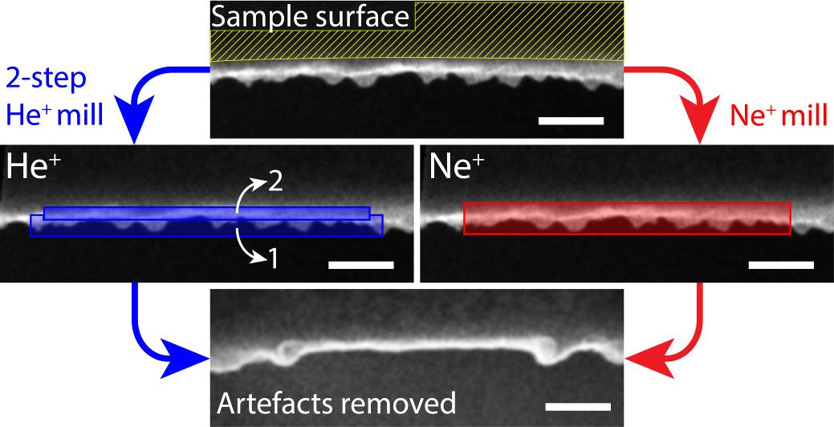
Figure 1: Top-down view of the polishing process. Scale bars are 200 nm.
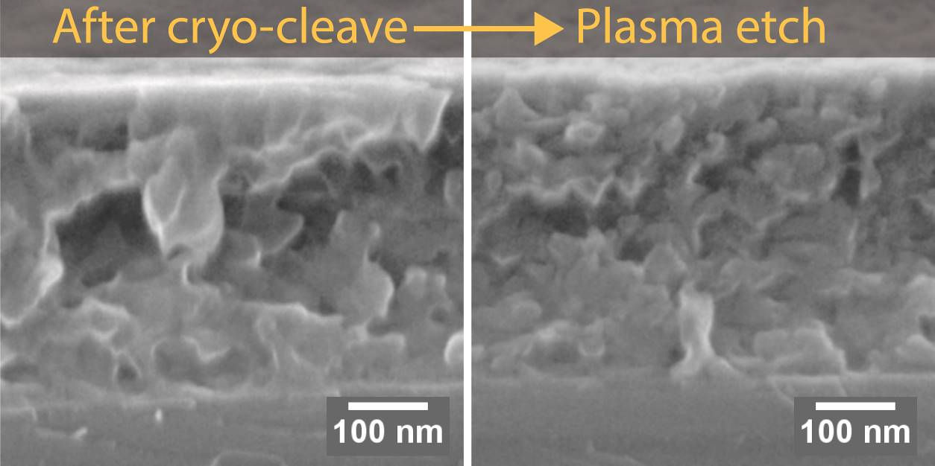
Figure 2: PffBT4T-2OD:PC₇₀BM film imaged in the helium-ion microscope immediately following a cryo-cleave, and following a cryo-cleave and subsequent plasma treatment.
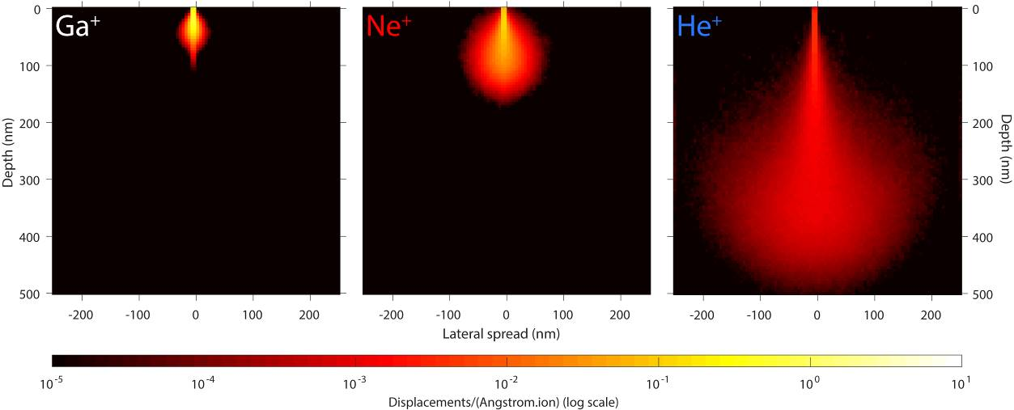
Figure 3: SRIM models of atomic displacements in PffBT4T-2OD resulting from a 30 keV Ga⁺, Ne⁺, and He⁺ ion beam. Note the colour scale is logarithmic.
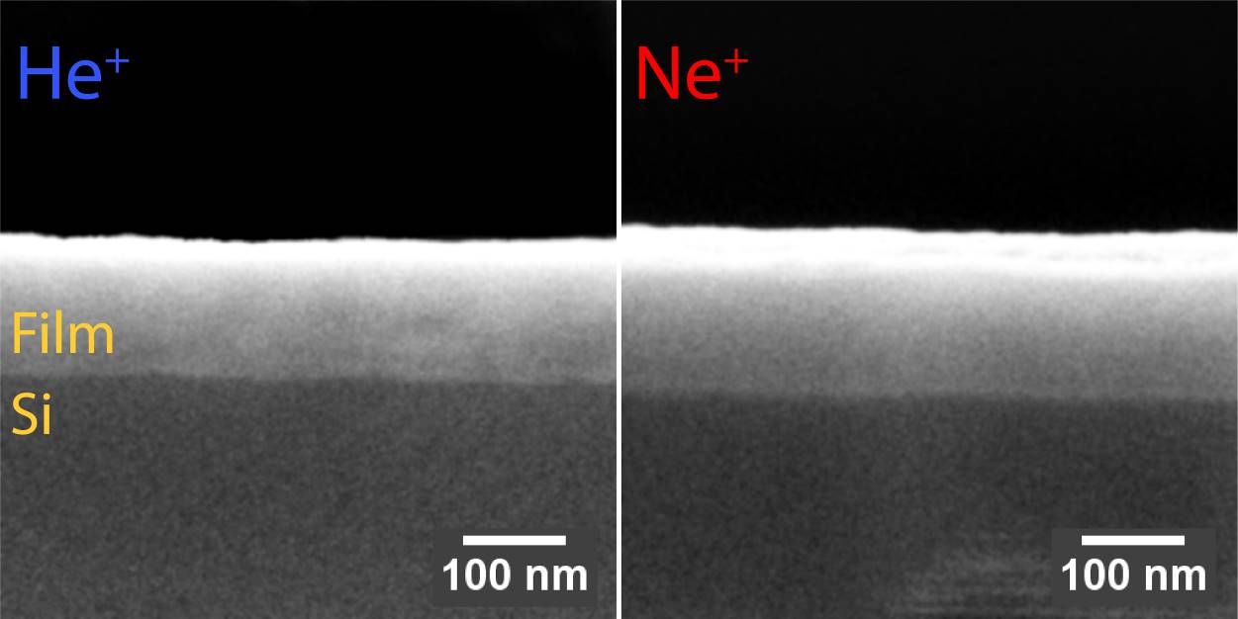
Figure 4: Effects of He⁺ and Ne⁺ ion beam polish on PffBT4T-2OD:PC₇₀BM film cross-section. Note these films were processed differently to those in Figures 2 and 7, and are therefore thinner. The effects are representative however.
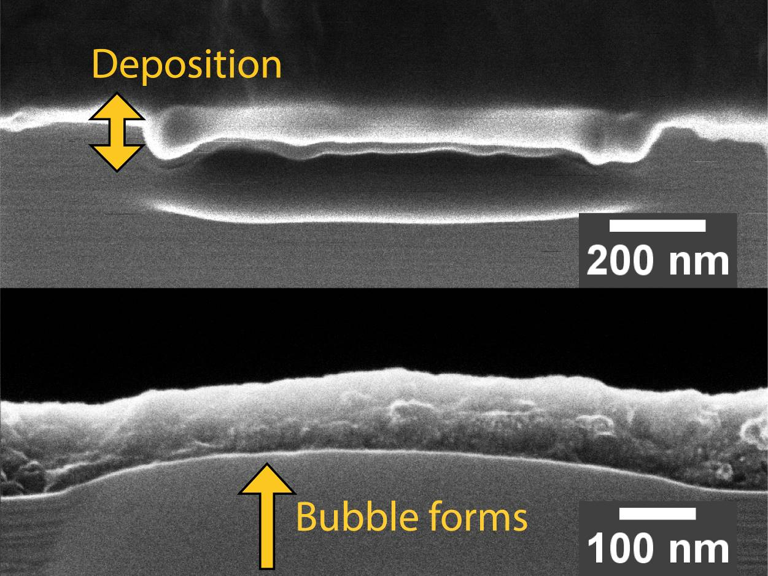
Figure 5: Gas-ion milling artefacts that can be observed following a sub-optimal polishing process: re-deposition of etched material with low He⁺ dose rate, and bubble formation from large dose rates.
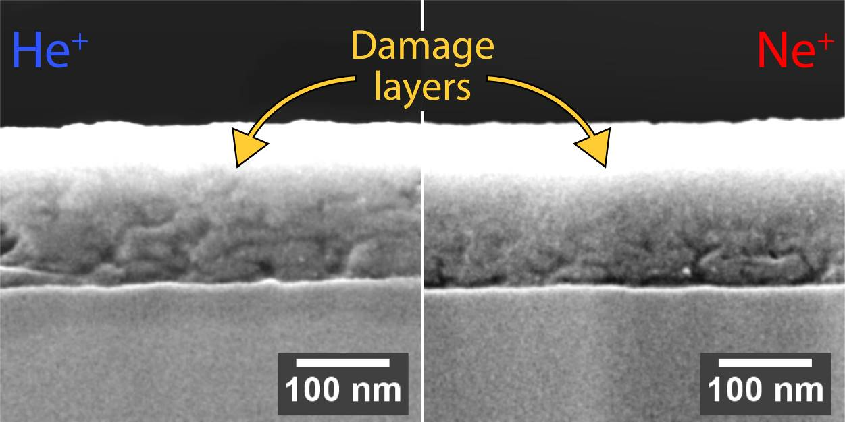
Figure 6: PffBT4T-2OD:PC₇₀BM film after He⁺ polish and Ne⁺ polish, and subsequent plasma etch. Note these films were processed differently to those in Figures 2 and 7, and are therefore thinner. The effects are representative however.
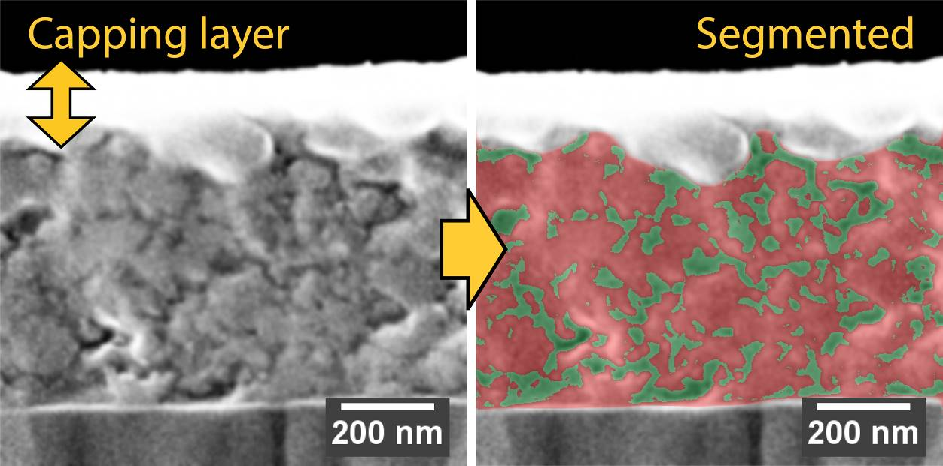
Figure 7: PffBT4T-2OD:PC₇₀BM film capped with PEDOT:PSS, following He⁺ polish and subsequent plasma etch. The phase-separated morphology is visible, and has been segmented in FIJI to help visualise the nature of phase separation in the cross-section.

Biography
Rob Masters works as a postdoc in the Department of Materials Science at the University of Sheffield, having recently completed his PhD in the same department. He works in the group of Dr Cornelia Rodenburg, developing novel ways of characterising organic and polymeric materials in the scanning electron microscope. During his PhD, he worked on characterising materials for organic photovoltaics, applying the state-of-the-art in modern SEM technology to gain new insights in to complex, nanostructured materials. Today, his primary focus is in advancing methods and applications for secondary electron spectroscopy in order to investigate various material and electronic properties of samples in the SEM.

Abstract

Focused ion beams (FIBs) are commonly used to prepare samples for cross-sectional imaging in the electron microscope. When working with polymeric or other soft materials, however, conventional metal-ion FIBs can cause significant sample damage and destroy features of interest. In this work, we demonstrate how He⁺ and Ne⁺ gas-ion beams can be used as a more suitable alternative by fabricating and imaging high quality cross-sections of polymer films used for organic photovoltaics. We first cryo-cleave polymer films before using a gas-ion beam to fabricate a high-quality cross-sectional sample, and reveal nanostructure in the film cross-section after a brief plasma treatment. We discuss some of the practical nuances of the technique and compare the relative strengths of He⁺ and Ne⁺ beams for nanofabrication. Finally, we image the cross-section with the He⁺ beam, demonstrating the impressive capabilities of the gas-ion microscope as a combined tool for nanofabrication and imaging.

Acknowledgements
This work was supported by EPSRC grants EP/J017361/1, EP/M025020/1 and EP/N008065/1. The Royal Society funded a collaboration between the University of Sheffield and Trinity College Dublin (IE140211). RM and Y. Zhang thank the University of Sheffield for providing PhD scholarships. We would also like to thank Danny Fox and Pierce Maguire at the Advanced Microscopy Lab, TCD for providing technical and practical assistance with the Nanofab ion microscope.

Corresponding Author Details
Robert Masters,
Department of Materials Science and Engineering, University of Sheffield,
Kroto Research Institute,
Broad Lane,
Sheffield,
S3 7HQ

Email: r.masters@sheffield.ac.uk

