Natural product recovery from bilberry (Vaccinium myrtillus L.) presscake via microwave hydrolysis
Long Zhou, † Yann Lie, † Hannah Briers, † Jiajun Fan, † Javier Remón,† Josefina Nyström,‡ Vitaliy Budarin, † Duncan Macquarrie, Con Robert McElroy*†
†Green Chemistry Centre of Excellence, Department of Chemistry, University of York, York, YO10 5DD, England. email: rob.mcelroy@york.ac.uk
‡Swedish University of Agricultural Sciences, Forest biomaterials and technologies, 90183 Umeå, Sweden
KEYWORDS: Bilberry, Microwave, Hydrolysis, Waste recycling

Abstract: Bilberry presscake, a by-product from juice production, contains abundant polysaccharides that can be recovered by thermal treatment. In this research, microwave hydrolysis and extraction were carried out using only water as the processing medium, thus ensuring all products (mainly saccharides) are suitable for food grade status applications. This research aims to propose an approach to fulfil multiple chemicals recovery, including anthocyanins, saccharides, proteins and even inorganic salts. Statistical analysis suggested the conversion of bilberry presscake was accurately predictable (R² of 0.986 ) from conditions. Of the variables temperature, holding time and solid content, the solid content affects conversion most significantly. A 30-min microwave hydrolysis gives mono-/di- saccharides with a high total yield of 24.9 %, which is more than three times of the yield of a 24 h Soxhlet extraction (7.1 %). The yield of rhamnose is particularly high (10.8 %), most likely as a result of pectin degradation on microwave irradiation. In addition to the lab scale research, pilot scale microwave extractions are carried out with high conversion (especially glucose 4.4 %, xylose 4.0 % and pectin 6.3 %), suggesting the feasibility of low-temperature (95 °C) microwave hydrolysis of bilberry presscake for industrial application. With this preliminary study, it is believed microwave hydrolysis offers an efficient and green approach to convert bilberry presscake into value-added products for food industry and biorefinery.
Introduction
Bilberries (Vaccinium myrtillus L.) are a significant wild fruit harvested for numerous applications including cold pressing to produce bilberry juice¹. There is intense interest in the health benefits of fresh berry fruit and related products due to their high antioxidant capacity, impact on vision and potential cancer suppression, all of which highly correlate to the content of anthocyanin and other phenolic compounds.^{2,3} Bilberries are one of the richest dietary sources of anthocyanins,⁴ thus bilberry juice is often used as a major constituent of functional food and beverages.⁵ However a by-product of juice production is bilberry presscake, a currently under-utilised resource rich in dietary fibre.⁶ The presence of cellulose, hemicellulose (mostly xyloglucan) and pectin in the presscake,^{7,8,9} make it a promising feedstock for use in the food industry. Additionally, as the presscake retains the fruit skins and remains highly coloured, it contains high levels of anthocyanins, which can be extracted and further processed into healthcare products.¹⁰
Previous studies looking to exploit bilberry presscake mainly focused on the recovery of anthocyanins. Ethanol, acetone and their water mixtures are widely used for the extraction of anthocyanins.^{11,12,13,14,15} In addition, supercritical carbon dioxide with ethanol as a polar modifier has been investigated as a more environmentally friendly alternative with food grade status, to extract anthocyanins from bilberry presscake.^{10,15,16} Fidaleo et al¹³ demonstrated that common food products such as yogurt and condensed milk can be easily fortified with phenolic extracts from bilberry presscake via ethanol extraction. Aaby et al.¹¹ reported that bilberry presscake contained high concentrations of anthocyanins (458 mg 100 g⁻¹) that could be effectively extracted by water.
Compared with the extraction of anthocyanins, the recovery of saccharides offered another path for utilisation of bilberry presscake. As efforts to optimise cold press conditions to give greater anthocyanin content in the juice are constantly underway, the anthocyanin content in bilberry presscake will decrease greatly in the future, however polysaccharide loading will still remain high.^{7–9} These polysaccharides can degrade into mono- and di-saccharide with thermal treatment. According to Aura⁶ and Hilz⁸, bilberry presscake produced abundant glucose, xylose and mannose via hydrolysis by using concentrated sulfuric acid (72 wt%). Thus, the extraction of saccharide appears to be a feasible, economical and promising approach for the valorisation of bilberry presscake. However, to the best of our knowledge, there is still no mature technology and systematic research to convert bilberry presscake into mono-/di-saccharide which is suitable for food grade status applications.
Compared with conventional thermal treatment, microwave-assisted treatment has the characteristics of high efficiency and selectivity, making it an efficient tool in biomass processing and solid waste recycling.^{17–19} It has dramatic effect on the reaction kinetics²⁰ and reduces overall reaction time substantially.²¹ Several researches have demonstrated the excellent performance of microwave thermal treatment in recovery of chemicals (mainly anthocyanins) from fresh berry fruit and berry pomace.^{22,23,24} According to our previous studies, polysaccharide could be effectively degraded via microwave-assisted hydrolysis using diluted acid¹⁷ or even just water.¹⁹ Thus, microwave hydrolysis is expected to offer an effective approach to obtain low molecular weight chemicals from bilberry presscake.
In this research, microwave thermal hydrolysis is, for the first time, used in saccharide recovery from bilberry presscake. Rather than focusing only on anthocyanins, the main aim of this study is to design a novel, efficient approach to obtain various value-added products (saccharides, anthocyanins, proteins and even inorganic salts) from bilberry presscake via microwave treatment. Instead of conventional approaches using organic solvents or mineral acids, water, the greenest solvent, is used for the depolymerisation and chemicals recovery of bilberry presscake, making the extracts more suitable for food applications. Statistical analysis using a Box-Behnken design is carried out to optimise the conditions to achieve maximum conversion. Furthermore, in this study, pilot scale microwave extraction is also carried out to compare with lab scale result and discuss the feasibility of industrial application of this study.
Materials and Method
Materials. The bilberry presscake was provided by The Swedish University of Agricultural Sciences. The raw material was placed in an oven at 70 °C for 3 days until a constant weight was obtained (70% mass loss through removal of water). The dried bilberry presscake (DBP) contained bilberry fruit (average diameter 1 cm), leaves, stems and bilberry seeds. No further processing was performed on all materials employed in lab scale trials. For pilot scale extraction, bilberry presscake was processed as received without drying (wet bilberry presscake, WBP) but with maceration using a robot coupe blixer 4vv to form a slurry with a maximum particle size of 4 mm diameter.
Glucose, fructose, rhamnose, formic acid and furfural were purchased from Sigma-Aldrich. Levoglucosan and 5-hydroxymethylfurfural (HMF) were purchased from Carbosynth. Xylose was purchased from VWR. Cellobiose was purchased from Fluorochem. Lactic acid was purchased from Wardle. Acetic acid was purchased from Alfa Aesar. Levoglucosenone was purchased from Dextra.
Acetone, ethanol and heptane were purchased from VWR chemicals. Deionised water was obtained from an internal source in the lab.
Experimental. A CEM Mars 6 microwave reactor (CEM, USA) was used for the experiments. Dried bilberry presscake (DBP) was combined with deionised water (60 mL) at different ratios in microwave vessels prior to microwave hydrolysis. The experimental conditions are outlined in Table 1. (Trial 9r-12r are repeat experiments). Samples were heated to their target temperature, with a set ramping time of 5 min (variable ramping rate).
Table 1 Experimental parameters for microwave hydrolysis of bilberry presscake and the conversion (wt%)
Trial | Temp  (°C) | Holding time  (min) | Solids  (%) | Conversion  (wt%)*
1 | 80 | 0 | 1 | 14.8
2 | 140 | 0 | 1 | 32.7
3 | 80 | 30 | 1 | 35.6
4 | 140 | 30 | 1 | 44.2
5 | 80 | 0 | 10 | 13.1
6 | 140 | 0 | 10 | 22.9
7 | 80 | 30 | 10 | 21.5
8 | 140 | 30 | 10 | 30.0
9r | 110 | 15 | 5.5 | 26.9
10r | 110 | 15 | 5.5 | 33.0
11r | 110 | 15 | 5.5 | 32.7
12r | 110 | 15 | 5.5 | 31.0
*equations supporting this data can be found further on in the paper
Following each trial, the samples were filtered to obtain the solid residue and liquid phase for further analysis. The solid residue was weighed (after drying at 105 °C) to calculate the conversion as follows:
M_{r} =m₁/m₀ ×100%
M_{c} =100%-M_{r}
M_{r}, residue mass, wt%
M_{c}, conversion, wt%
m₁, residue mass, g
m₀, mass of the original feedstock, g
The optimum conditions for microwave hydrolysis of bilberry waste presscake to produce a high yield of hydrolysate was investigated according to a Box-Behnken design with 15 runs (3 centre points) as Table 2 and Table 3 (the conditions different from those in Table 1):
Table 2 The factors and the levels of Box-Behnken design
Factor | Level
 | -1 | 0 | 1
A: temp (°C) | 80 | 110 | 140
B: Time (min) | 0 | 15 | 30
C: solid content (%) | 1 | 5.5 | 10
Table 3 Box-Behnken design and the conversion (response value)
 | Parameters |  |  | Conversion
Trial | Temp,  °C (A) | Holding time,  min (B) | Solid,  % (C) | Tested  value, wt% | Calculated  value, wt%
13 | 80 | 0 | 5.5 | 22.2 | 20.9
14 | 80 | 30 | 5.5 | 27.3 | 27.5
15* | 80 | 15 | 1.0 | 34.9 | 34.9
16 | 80 | 15 | 10.0 | 22.2 | 23.9
17 | 110 | 0 | 1.0 | 33.3 | 34.3
18 | 110 | 30 | 1.0 | 46.8 | 47.1
19 | 110 | 0 | 10.0 | 25.7 | 25.0
20 | 110 | 30 | 10.0 | 26.5 | 25.2
21 | 110 | 15 | 5.5 | 33.0 | 32.1
22 | 110 | 15 | 5.5 | 32.7 | 32.1
23 | 110 | 15 | 5.5 | 31.0 | 32.1
24 | 140 | 0 | 5.5 | 31.3 | 32.3
25 | 140 | 30 | 5.5 | 38.2 | 38.8
26 | 140 | 15 | 1.0 | 52.3 | 50.9
27* | 140 | 15 | 10.0 | 30.3 | 30.6
* Pressure and temperature traces can be found in Fig. S3
Soxhlet extraction was carried out using a 250 mL round bottom flask (RBF) heated with a heating plate set at 20 ºC above the solvent boiling point. The Soxhlet apparatus was directly connected to the RBF and a water-cooled condenser (Figure S1). 6 g of the DBP was loaded in a cellulose thimble and carefully placed in the soxhlet extraction chamber. 150 mL of the selected solvent was charged in the RBF with a magnetic stirrer. The system was then assembled and heated for 4 hours (corresponding to roughly 4 to 5 cycles depending on the solvent). In the case of the water extraction the system was left for 24 hours. The samples were filtered to obtain the solid residue and liquid phase for further analysis.
The pilot scale trials were carried out using a modified pyrolysis microwave (Sairem Labotron Pyro, 60K Pyro). The modifications included removal of the existing feed hopper and auger and disconnection of the char collector followed by the installation of a non-metallic double diaphragm pump, stainless steel separation vessel and new hopper and hoses. For each trial, 5 kg of bilberry press-cake (the equivalent of 1.5 kg of dried bilberry press-cake per run) was defrosted, macerated in a robot coupe blixer 4vv and mixed with a total of 12 L de-ionised water to form a slurry with a maximum particle size of 4 mm diameter (chosen due to the solids handling capability of the pump). The slurry was charged in to the microwave and then recirculated for 10 minutes, at 230 L min⁻¹ to ensure a homogeneous mixture. The trials were carried out in triplicate. Microwave power was applied, initially at 1kW for microwave leakage tests to be carried out and then, following safety testing, at 6kW until the target temperature of 95 ⁰C was reached. The bilberry press-cake/water slurry was recirculated at 95 ºC for 60 minutes – 400 mL samples were taken at 30 minute and 60 minute time points from the three trials (Trials P1-30, P1-60, P2-30, P2-60, P3-30, P4-60, respectively).
The elemental analysis (C, H and N content) was obtained from the analytical services offered by Department of Chemistry, University of York, run on an Exeter Analytical Inc. CE-440 analyser (USA).
Thermogravimetric (TG) analysis was performed using a Netzsch STA 409 analyser (Germany). The following parameters were applied: temperature ramp rate 20 K/min, final temperature 600 °C, carrier gas 50 mL / min pure nitrogen.
FTIR data was obtained using a Perkin Elmer FTIR/FTNIR Spectrum 400 analyser (USA). The spectra were acquired between 700 cm⁻¹ and 4000 cm⁻¹ with resolution of 2 cm⁻¹ and scan time of 64 s.
A Jasco V-550 UV/Vis Spectrophotometer was used for anthocyanins content analysis. It is reported^{25,26,27} that the absorbance of solution at 530 nm is directly in proportion to the concentration of anthocyanins. Therefore, in this research the absorbance at 530 nm is used to roughly reflect the anthocyanin content.
The mono-, di-saccharides and organic acids of the aqueous phase were analysed using an Agilent 1260 Infinity HPLC (USA) equipped with an Agilent Hi-Plex H (300 x 7.7 mm, 8 µm particle size) column. For levoglucosan, glucose, fructose, xylose, cellobiose, rhamnose and organic acids (lactic, formic, acetic acids), the mobile phase of 0.005 M H₂S0₄, isocratic (no gradient), flow-rate of 0.4 mL min⁻¹, column temperature of 60 °C, refractive index detector at 55 °C, total run time of 35 minutes, injection volume of 5 µL was used. For analysis of furfural, levoglucosenone and 5-HMF, the following parameters were used: ACE C18 (250 x 4.6 mm, 5 µm particle size) column, mobile phase of Acetonitrile: Water (25:75), isocratic (no gradient), flow-rate of 0.8 mL min⁻¹, column temperature of 30 °C, DAD detector at 220 nm, total run time of 22 minutes, injection volume of 5 µL. External standards were prepared for both methods at five concentrations (0.5, 0.75, 1.0, 1.5, 2.0 mg mL⁻¹).
Liquid State ¹³C NMR spectroscopy results were obtained from Centre for Magnetic Resonance, University of York, using a JEOL ECS 400 NMR Spectrometer (Japan). 5 ml of the hydrolysate was filled in a vial to be dried using rotary evaporator. After drying, 2 ml D₂O was added to the vial to prepare the sample for NMR analysis. Number of scans was 8192.
To determine the pectin content in hydrolysate of pilot scale trial (Trial P2-60), 100 mL processed mixture was taken to record the mass. After filtration, the filtrate was taken and twice the volume of ethanol added to precipitate pectin. The mixture was kept at room temperature for 24 h. Then the solid was filtered, washed with hot ethanol and dried. This residue was weighed to calculate pectin yield.
Results and discussion
Optimisation of microwave extraction. The conversions are listed in Table 3. Notably, high temperature, long extraction time and low solid content all benefit conversion. According to Table 3, the following variance analysis was made in Table 4:
Table 4 The variance analysis using Box-Behnken design
Source | Sum of Squares | Df | Mean Square | F Value | p-value Prob > F
Model | 953.70 | 9 | 105.97 | 42.85 | 0.0003
A | 258.90 | 1 | 258.90 | 104.70 | 0.0002
B | 85.54 | 1 | 85.54 | 34.59 | 0.0020
C | 491.57 | 1 | 491.57 | 198.79 | < 0.0001
AB | 0.85 | 1 | 0.85 | 0.34 | 0.5839
AC | 21.86 | 1 | 21.86 | 8.84 | 0.0311
BC | 39.82 | 1 | 39.82 | 16.10 | 0.0102
A² | 0.34 | 1 | 0.34 | 0.14 | 0.7243
B² | 17.43 | 1 | 17.43 | 7.05 | 0.0451
C² | 33.22 | 1 | 33.22 | 13.44 | 0.0145
Residual | 12.36 | 5 | 2.47
Lack of Fit | 10.04 | 3 | 3.35 | 2.88 | 0.2685
Pure Error | 2.33 | 2 | 1.16
Cor Total | 966.06 | 14
The P value of lack of fit was 0.2685>0.05, showing the lacking sources were not significant. The P value of model was 0.0003<0.05, indicating the model was of high significance. The P values of source A (temperature), B (holding time) and C (solid content) were very low, this indicated that the microwave hydrolysis temperature, holding time and solids content all had significant influence. According to the P values, the influences ranked as: solid content>temperature>extraction time. Most sources had P value lower than 0.05, except AB and A², so the variance analysis was optimised by excluding AB and A² in Table S1. The P value of model (<0.0001) was further lowered, showing the model was more significant after optimisation. A quadratic regression equation was made based on Table S1:
Conversion %
=5.5323+0.2849A+0.7617B-0.7784C-0.0173AC-0.0467BC-0.0096B²+0.1493C²
A: temperature
B: extraction time
C: solid content
Equation 1 - Quadratic regression equation
The high R² of this equation at 0.986%, indicates the degree of error to be minimal. Using the above equation, the calculated conversions are presented in Table 3, showing the predicted and observed conversions to be very similar. Based on statistical software, within the range of the three factors, the following conditions theoretically should produce the highest conversion (55.21%): temperature 140 °C, extraction time 30 min, solid ratio 1 %.
Soxhlet Extraction. The Soxhlet extraction results are presented in Table 5. Notably, the polarity of solvent could affect the extraction significantly. More highly polar solvents benefited the extraction of DBP, suggesting that DBP contains less fatty acids, wax esters or oil (usually extractable with low polarity solvent) but more sugars, pigments and phenols (extracted with high polarity solvent). Within 4 h, ethanol extraction could achieve the highest conversion among all organic solvents, whereas heptane, with the lowest polarity, achieved the least. A 24 h Soxhlet extraction using deionised water (Trial SW) was carried out to compare with extraction via microwave hydrolysis. A longer extraction time with water was required to give the same number of fresh solvent cycles as compared to ethanol, acetone and heptane.
Table 5 Soxhlet Extraction of DBP using different solvents
Solvent | Polarity²⁸ | Conversion, wt%*
Acetone | 0.355 | 2.8
Ethanol | 0.654 | 6.2
Heptane | 0.012 | 1.8
Water (Trial SW) | 1.000 | 30.5
* Conversion calculated as in Table 1&3
Microwave extraction. The conversions of microwave trials are listed in Table 1. As suggested in condition optimisation, solid content could affect the conversion significantly. For example, with the same treatment temperature and time, the conversion was still low at 30.0 wt% in Trial 8, whereas it was 44.2 wt% in Trial 4. This indicated that under lab scale conditions without pre-treatments, DBP cannot adequately mix with water, hindering the hydrolysis of the DBP. In addition to solid content, increasing temperature and hydrolysis duration can also increase conversion, which is consistent with condition optimisation.
Comparing Table 1, and Table 5, it is easy to observe that microwave hydrolysis provides a more efficient approach for DBP hydrolysis than conventional methods. In Trial 4, a 30 min microwave extraction converted 44.2% of feedstock into water soluble compounds, whereas in Trial SW, a 24 h Soxhlet extraction only converted 30.5%, proving microwave hydrolysis is an effective method in waste recycling of DBP. In turn, this fast processing by microwave should result in reduced energy consumption, as has been previously demonstrated in various applications. ^{29–32}

Elemental analysis. The Table 6 shows the elemental content of DPB and the processed residues. DBP contains ~40 wt% of other elements in addition to C, H and N, which were expected to be oxygen and a considerable amount of trace elements, especially K, Ca, P, Mg and Mn.^{33,34} Trace elements exist in biomass mainly in the form of inorganic salts, of which the concentrations are the highest in peel for fruits.^{35,36,37} These inorganic salts would preferentially be solubilised in the aqueous phase during the microwave hydrolysis. This observation is most obvious when insufficient mixing of solvent and feedstock occurs, resulting in a lower content of other elements in Trial 5-12r than in Trial 1-4. The higher solid content in Trial 5-12r resulted in a greater degree of compounds from the surface of the DBP being hydrolysed as compared to those from within the fruit. This hypothesis is in agreement with condition optimisation that showed solid content had significant influence on DBP microwave extraction. Therefore, to carry out extraction with high solid contents, pre-processing to homogenise before hydrolysis or more vigorous agitation are necessary to ensure adequate mixing of DBP with the solvent.
Table 6 Element contents of feedstock and residue
 | C, wt% | H, wt% | N, wt% | Other, wt%
DBP | 52.20 | 6.69 | 2.03 | 39.08
1 | 51.36 | 6.27 | 1.97 | 40.40
2 | 52.12 | 6.21 | 2.27 | 39.40
3 | 52.81 | 6.64 | 2.19 | 38.36
4 | 52.04 | 6.31 | 1.39 | 40.26
5 | 54.04 | 6.62 | 2.06 | 37.28
6 | 53.28 | 6.68 | 2.18 | 37.86
7 | 54.08 | 6.52 | 1.64 | 37.76
8 | 54.59 | 6.50 | 2.11 | 36.80
9r | 53.72 | 6.51 | 2.20 | 37.57
10r | 55.22 | 6.71 | 2.27 | 35.80
11r | 56.48 | 7.22 | 2.41 | 33.89
12r | 54.02 | 6.65 | 1.90 | 37.43
Thermal gravity analysis. The differential thermal gravity (DTG) curves of DBP and processed residues are shown in Figure 1. The major peaks of all curves appeared between 350-370 °C, which possibly corresponds to the decomposition of cellulose,^{17,38,39} illustrating after hydrolysis, the processed residues were still polysaccharide-rich materials that can be potentially converted into mono-/di- saccharides using more intensive conditions. The peaks above 400 °C correspond to the degradation of lignin.³⁹ As lignin is very recalcitrant to thermal treatment,¹⁷ the low temperatures applied in this research (80-140 °C), would result in little or no lignin depolymerisation.
As is shown in Figure 1a, hydrolysis temperature and extraction time could slightly influence the processed residues. The curve of Trial 1 is similar to that of DBP, suggesting minimal hydrolysis take places at low temperature (80 °C) and short holding time (0 min). This is in agreement with the very low conversion of 14.8% obtained in Trial 1. When the hydrolysis temperature was increased to 140 °C (Trial 2), the DTG trace showed two distinct changes (Figure 1a). Firstly, between 100 °C and 270 °C, the mass loss rate was lower than DBP, suggesting that the more easily degradable compounds were significantly less abundant in the solid residue post processing. These thermally labile compounds are likely to be anthocyanins,⁴⁰ pectin,⁴¹ oligosaccharide⁴² and some fatty acids. Secondly, from 270 °C to 390 °C, the DTG curve had a sharper peak compared with that of Trial 1, indicating that polysaccharides are the main component in residue., As stated above the peak between 350-370 °C corresponds to the degradation of polysaccharide. These changes were even more apparent in the DTG curve of the residue from Trial 4 (Figure 1a), indicating a longer hydrolysis time (30 min) could further enhance the conversion of DBP to water soluble compounds. Figure 1b shows the influence of solid content on processed residues. Where a lower solid content was used (1 wt%, Trial 4), the residue contained more polysaccharide and less easily degradable compounds than when a higher solids content of 10 wt% was applied (Trial 8). As such, DTG analysis suggests that hydrolysis employing a longer duration, higher temperature and lower solid content results in a greater degree of water-soluble compounds obtained from DBP. However, even using the best condition (Trial 4) the large quantities of polysaccharide remained within the solid residue, depolymerisation of which should be possible with treatment employing more intense conditions.

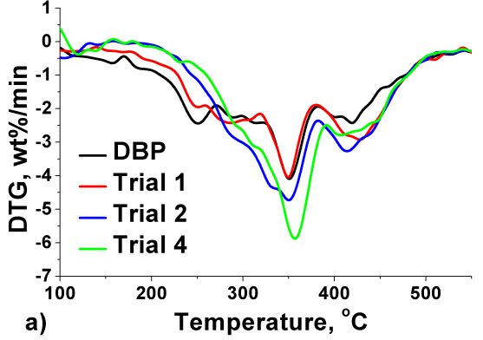
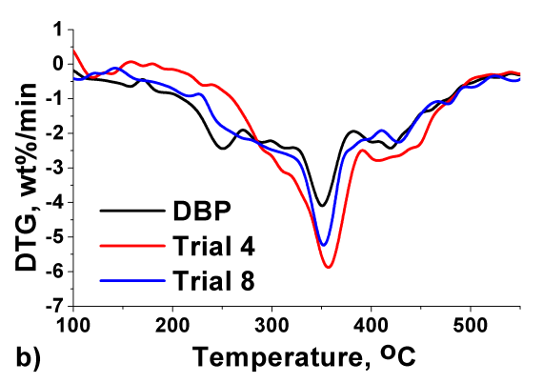
Figure 1 The DTG curves of DBP and processed residues in different conditions. a) different temperature and time; b) different solid content.
FTIR. The FTIR spectra of feedstock and processed residues (Figure 2) show no significant difference before and after hydrolysis. The peaks at 1025 cm⁻¹, 2923 cm⁻¹ and 3329 cm⁻¹ are attributed to C-O, C-H and O-H vibration respectively^{18,43,44} which are all typical peaks of polysaccharide.⁴⁴ These strong peaks suggested the processed residues after hydrolysis still contained abundant polysaccharides, consistent with the differential thermal gravity analysis. The peak at 1616, 1516 and 1461 cm⁻¹ were attributed to aromatic ring,^{45,46,47} possibly from lignin.
The peak at 1745 cm⁻¹ is attributed to carbonyl groups,⁴⁸ suggesting the presence of organic acids. Of note is the difference of the carbonyl peak between the control Trial SW where it is very sharp and the microwaves Trials 1-4, 8, where it is less prominent, suggesting microwave hydrolysis extracts more organic acids, thus, lowering the content in the resulting residue. This hypothesis was confirmed by HPLC analysis that showed hydrolysate of microwave trials contained more organic acids than conventional extractions. The peak is stronger in all residues as compared to DBP, which could be due to production of organic acids during hydrolysis.
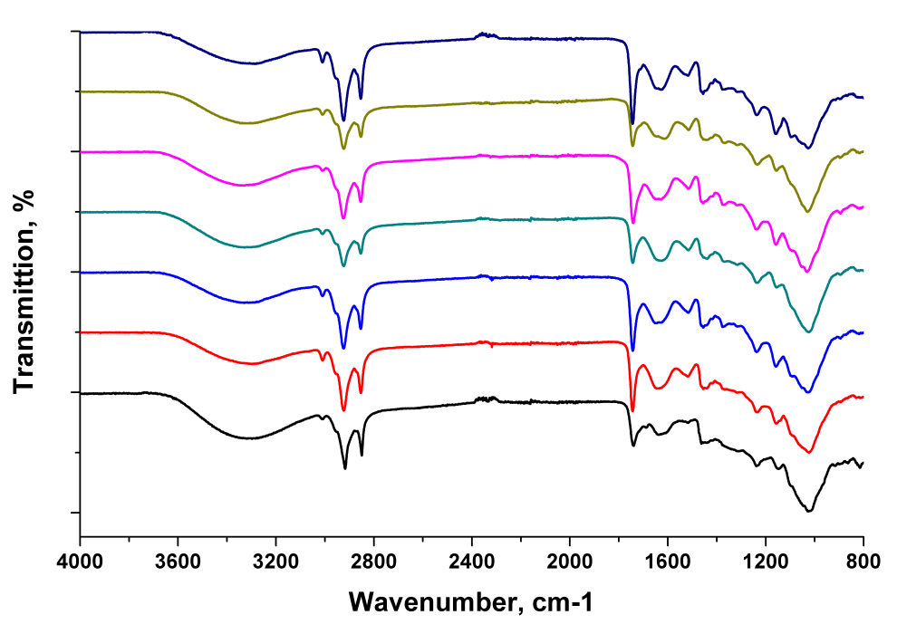
Figure 2 FTIR spectra of DBP and the processed residues
2923
3329
1745
1461
1025
Trial SW
Trial 8
Trial 4
Trial 3
Trial 2
Trial 1
DBP
UV/Vis. The aqueous phase (‘hydrolysate’) post processing was investigated using UV/Vis spectroscopy, HPLC and ¹³C NMR. Figure 3 shows the absorbance of hydrolysate at 530 nm, which is directly in proportion to the concentration of anthocyanins. The absorbance of hydrolysates of Trial 2 & 3 were much higher than that of Trial 1, indicating that increasing hydrolysis temperature or time results in greater extraction of anthocyanins. However, there was a significant decrease of absorbance in Trial 4. This is very likely caused by degradation of anthocyanins due to the overly intensive conditions. The literature suggests that anthocyanins readily convert to colourless derivatives and subsequently to insoluble brown pigments.⁴⁰ This was observed in this research: the hydrolysate of Trial 1-3 was a clear purple (with intensity of colour increasing from Trial 1 to 3), whereas the solution of Trial 4 was cloudy caused by the degradation of anthocyanins.
It is worth noting anthocyanins are water-soluble. A certain volume of anthocyanins is already transferred to juice during cold press. As already stated, improving cold press techniques in the future aims to increase the anthocyanins content in juice, thus lowering the content in the presscake. For fresh bilberry, the anthocyanins content is roughly 3-4 mg g⁻¹,^{49,50} and would require additional methodologies to isolate, which is outside the scope of this work. Furthermore, in this research it was found the best conditions for high conversion is not in favour of extraction of anthocyanins because of severe decomposition. A two-step hydrolysis could possibly be designed to extract both anthocyanins and saccharide, with mild conditions to extract the former and a second intensive step to give the latter. However, considering the low content of anthocyanins in DBP, this research mainly focused on the conversion of saccharides with a view towards feasibility, economy, efficiency and energy-saving.
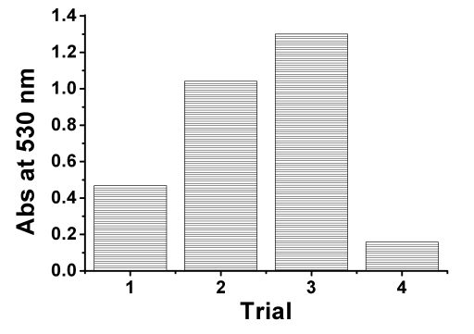
Figure 3 Absorbance of hydrolysate at 530 nm of UV/Vis spectroscopy of different trials
HPLC. Table S2 and Figure 4 showed the concentrations and yields of mono-, di-saccharide, organic acids and furan compounds in the hydrolysate. Of note, the repeated runs Trial 9r-12r were very consistent, showing good reproducibility. Table S2 indicates that the yields were much higher in 1 % solid content trials than that of 10 % trials, in keeping with previous observations. However, higher water content results in lower concentrations, perhaps making it less attractive in further applications. The yield and concentration increased with higher temperatures and extended holding times during hydrolysis. Overall, Trial 4 resulted in the highest yields (also the highest conversion as shown in Table 1) for the individual compounds analysed by HPLC - with rhamnose (10.8 wt%), acetic acid (7.5 wt%), formic acid (6.4 wt%) and levoglucosenone (5.4 wt%) yields being particularly high. As a contrast, the yields were much lower in Trial SW, with glucose (2.3 wt%), xylose (2.1 wt%), formic acid (1.3 wt%), acetic acid (1.2 wt%) as high yield compounds. Notably, a 30-min microwave hydrolysis could extract 24.9% of saccharides from DBP, more than 3 times of that in Soxhlet extraction for 24 h (7.1%). Fan has pointed out that polysaccharides can be depolymerised via microwave-assisted hydrolysis using just water,¹⁹ which can explain the high yields of mono-/di- saccharide yields obtained in this research.
Of note, the yield of rhamnose was much higher in all microwave trials (4.7-10.8 %) than Trial SW (1.0 wt%). This was perhaps due to the degradation of pectin, as rhamnose is in the backbone of some types of pectin, including rhamnogalacturonan I pectin (RG-I) and rhamnogalacturonan II pectin (RG-II). Compared with conventional heating, microwave hydrolysis appeared to cause more degradation of pectin, resulting in an extremely high yield of rhamnose. Rhamnose is a monosugar with a sweet taste but cannot (or only can partly) be metabolised by human⁵¹, thus, it can be hopefully used as a low calorie sweetener. Rhamnose is also a widely accepted clinical test for the determination of intestinal permeability.⁵² Therefore, rhamnose, considering the high yield, appears to be the most useful and profitable extractive in microwave processing of bilberry presscake in this research.
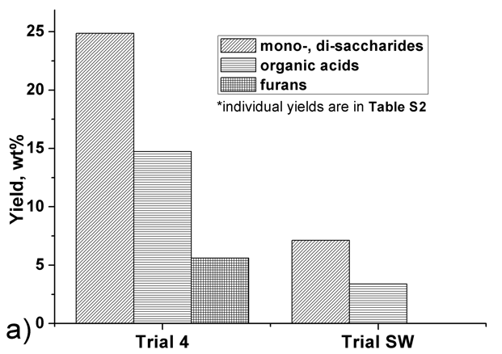
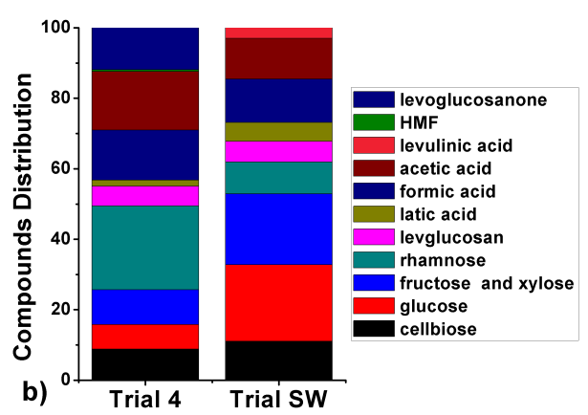
Figure 4 The compounds yield and distribution of hydrolysate
In addition to saccharides, the yields of organic acids and furans in Trial 4 were both higher than those of Trial SW. In Trial 4, the high yield of formic acid and acetic acid are 6.42% and 7.52% respectively. This is consistent with FTIR analysis that indicated microwave hydrolysis could extract more organic acids than conventional thermal treatment. Microwave heating is based on the high frequency rotation of polar molecules. Therefore, compounds containing polar groups are more rapidly heated during microwave irradiation.¹⁸ The carboxylic acid functionality is highly polar, hence the increase in yields of these compounds under microwave conditions. Additionally, the degradation of monosaccharides can also result in the production of organic acids.¹⁹ The high yield of organic acids in turn increases furan yields. This is as furans, such as HMF, are formed in acidic environments via dehydration of saccharides. Compared with microwave trials, the concentration of furans in the hydrolysate of Trial SW was much lower.
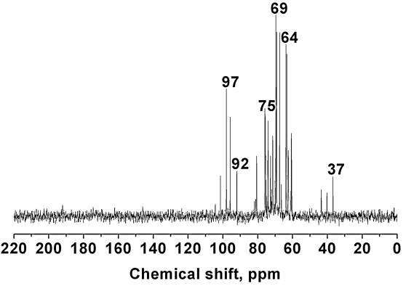
Figure 5 ¹³C NMR spectrum of hydrolysate (Trial 8)
Liquid phase ¹³C NMR. Figure 5 shows the liquid ¹³C NMR spectrum of the hydrolysate. The major peaks of resonances between 60 ppm to 105 ppm are attributed to C-O bonds, indicating saccharides were the major compounds in the hydrolysate, for example the C2, C3, C4, C5, C6 (60-80 ppm) and C1 (90-105 ppm) carbons of glucose.⁵³ ⁵⁴ ⁵⁵ The peaks between 35-45 ppm are likely to be attributed to carbon bound to nitrogen, which is consistent with elemental analysis, Table 6, which indicated DBP contained nitrogen (2.03%). This in turn suggests DBP contains nearly 13% protein using a 6.25 nitrogen to protein conversion factor.⁵⁶ ⁵⁷ The ¹³C NMR suggested these proteins could potentially be extracted directly or extracted after degradation from the feedstock via microwave hydrolysis.
According to HPLC results, formic acid and acetic acid were the two main products in the liquid phase, however the peaks of carboxyl groups (appears between 160-180 ppm) were missing in the spectrum. This is perhaps because that these acids (bp 100-101 °C formic acid, 117-118 °C acetic acid) were removed via volatilisation in rotary evaporator when preparing the NMR samples.
Based on the systematic analyses above, a possible progress during microwave hydrolysis is presented in Scheme 1. Depending on the hydrolysis conditions, microwave processing of bilberry presscake can be roughly divided into four stages:
Stage I: The outer portions of the fruit, which contains abundant mineral elements and anthocyanins, is most easily solubilised and inorganic salts and pigments are extracted first. Due to the existence of anthocyanins and the weak acidic environment of the hydrolysate, the solution at this stage is clear and purple. Most organic compounds are still contained within the residue.
Stage II: The solid residue from Stage Ⅰ, releases mono-/di-saccharides, pectin and protein into the solution. Monosaccharides (especially glucose and xylose as suggested in the literature^{6,8}) are the main extractives as the results of degradation of polysaccharides. The mass of residue is relatively stable (40-60 wt% of original mass). Decomposition of anthocyanins already in the hydrolysate results in the aqueous phase darkening and becoming cloudy.
Stage III: Rhamnose is released as a product from pectin degradation (Scheme 2). Saccharides degrade to form organic acids, also giving rise to the formation of furans. Nitrogen containing compounds, presumably as a result of proteolysis, are detected in the hydrolysate.
Stage IV: The insoluble residue (~40 % of original mass, mainly cellulose and lignin) theoretically decomposes under more intensive conditions (not investigated in this research) and the conversion of saccharides into organic acids and furans continues.
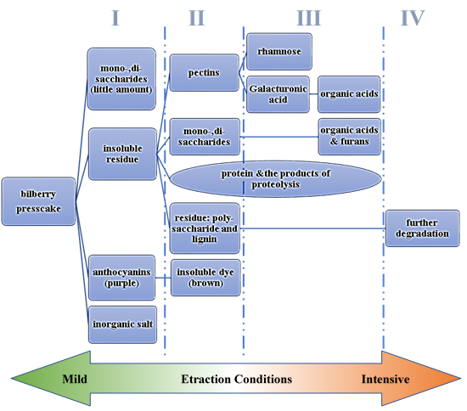
Scheme 1 Bilberry extraction progress (four stages depending on the conditions)
Scheme 2 The degradation of pectin
Pilot scale trials. It is worth noting the ‘extraction conditions’ in Scheme 1 are a combination of solid content, temperature and time, among which solid content has the most significant influence according to condition optimisation. This is because in lab scale trials, DPB and water were simply loaded into microwave without any pre-treatment and with a large particle size (10 mm), resulting in insufficient mixing of solvent and feedstock. However, in pilot scale trials, pre-treatments (as described in Experimental session) were carried out to give a pumpable slurry with a maximum particle size of 4 mm, also ensuring a more homogeneous mixture. With sufficient mixing, high conversion is hopefully achievable at relatively low temperatures (<100 °C), which will reduce capital expenditure (CapEx) in terms of equipment due to lower heat and pressure tolerances. The conversions are presented in Table S3. The average conversion was 57.55% after 30 minutes of microwave processing at 95 °C; this then increased slightly (but not significantly) to 59.49 % after 60 minutes which indicates that longer hold times may not be advantageous. Because of the use of pre-treatment, milder conditions gave higher conversions for pilot scale trials as compared to those of lab-scale trials (Table 1 & 3).
The HPLC results are presented in Table S4 and a comparison with lab-scale trial (Trial 4) is shown in Figure 6, where it is easy to see for pilot-scale trial the yields of rhamnose, organic acids and furans are lower. According to Scheme 1, this indicates Trial 4 is at Stage III, whereas the pilot scale trial is at Stage II, i.e. with little degradation of pectin or monosaccharides. This is probably due to the lower temperature applied. This is confirmed by the pectin yield in Trial P2-60 being 6.3%. This high yield suggests pectin is perhaps one of main extractives in addition to monosaccharides, especially when low temperature is used.
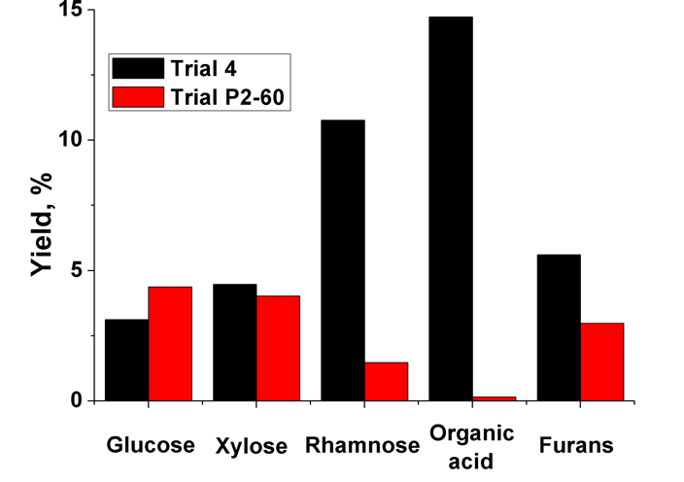
Figure 6 Chemical yields: lab scale vs pilot scale trials
Conclusion and Future work
Microwave hydrolysis offers a powerful tool for chemicals recovery from bilberry presscake. Unlike conventional methods that used organic solvent, in this research water is used in microwave hydrolysis to ensure all extracts are suitable for food grade status applications. Using a Box-Behnken design, a quadratic regression equation with high accuracy was made to predict the conversions. Among the three factors, (temperature, time, solid content) solids content has the most significant influence on conversion. Within the condition ranges of this research, the highest theoretical conversion obtainable is 55.21%.
Microwave extraction shows significant advantages compared with conventional extraction (Soxhlet extraction). A 30-min microwave hydrolysis could achieve high conversion of 44.2%, where for a 24 h Soxhlet extraction only 30.5% was obtained. This indicates a clear advantage in efficiency for microwave thermal hydrolysis. Microwave hydrolysis is effective in extracting mono-/di- saccharides (the highest yield of 24.9%), with rhamnose yield being particularly high (10.7%), which is perhaps caused by the degradation of pectin on microwave irradiation. Thus, rhamnose, considering its high yield, appears to be the most attractive and profitable extractive in microwave processing of bilberry presscake, with potential applications as a sweetener,⁵⁸ determining intestinal permeability⁵⁹ and in home and personal care.⁶⁰
Based on systematic analysis of lab scale experiments, for the first time a scheme is proposed to divide the extraction progress into four stages depending on conditions from mild to intensive. For Stage I-III, the main extractives are: Stage I, anthocyanins, inorganic salts; Stage II, mono-/di-saccharides, pectin; Stage III, rhamnose, organic acids and furans. The residue (40-50 wt% of original mass) of Stage II & III contains abundant polysaccharides/cellulose and lignin that hopefully can be degraded with further treatment (Stage IV). Compounds containing nitrogen are detected in the extractives, which is very likely to be protein and its degradable products. The scheme suggests that, with further optimisation, including multi-step hydrolysis, it is possible to isolate fractions rich in various value-added products from bilberry presscake.
Pilot scale microwave extractions were carried out at low temperature (95 °C) due to a modified pyrolysis microwave being employed which has to operate at atmospheric pressure. Due to the pre-treatments, higher conversions are achieved than those of lab scale trials, with major products (average yield over 3 runs) of glucose (3.8%), xylose (3.9%) and pectin (6.3%). The yield of rhamnose is lower than lab-scale extraction due to the low temperature unable to decompose pectin.
Greater correlation between lab and pilot scale work is required in future research, this includes a detailed investigation into pre-treatment with regard to the effect of drying and a 10 mm particle size as compared to wet maceration and a 4 mm particle size on conversion and selectivity. Additionally, large scale microwave hydrolysis at higher temperature and pressure is needed to provide like for like comparisons.
ASSOCIATED CONTENT
Supporting Information.
Soxhlet extraction diagram; Optimised variance analysis; the concentration and yield of compounds in hydrolysate of lab-scale and pilot scale trials; Conversion for pilot scale trials
AUTHOR INFORMATION
Corresponding Author
*Con Robert McElroy, email: rob.mcelroy@york.ac.uk
Funding Sources
This research has been funded by the Industrial Biotechnology Catalyst (Innovate UK, BBSRC, EPSRC) to support the translation, development and commercialisation of innovative Industrial Biotechnology processes (EP/N013522/1) and the EPSRC research grant no. EP/K014773/1
This research has been funded by the Industry Nordic project 20200296 under Interreg Botnia-Atlantica 2014–2020, EU regional support.
ACKNOWLEDGMENT
The liquid NMR results were achieved at Centre of Magnetic Resonance, Department of Chemistry, University of York. The element results were achieved at Analytical Service in Department of Chemistry, University of York. Thanks for the help. Thanks to Biorenewables Development Centre (Department of Chemistry, University of York) for help with the pilot scale extraction.

REFERENCES
(1) Simmonds, M.; Preedy, V. R. Nutritional Composition of Fruit Cultivars; Academic Press, 2015.
(2) Lee, J.; Durst, R. W.; Wrolstad, R. E. Impact of juice processing on blueberry anthocyanins and polyphenolics: comparison of two pretreatments. J. Food Sci. 2002, 67 (5), 1660–1667, DOI:10.1111/j.1365-2621.2002.tb08701.x
(3) Katsube, N.; Iwashita, K.; Tsushida, T.; Yamaki, K.; Kobori, M. Induction of apoptosis in cancer cells by bilberry (Vaccinium myrtillus) and the anthocyanins. J. Agric. Food Chem. 2003, 51 (1), 68–75, DOI: 10.1021/jf025781x
(4) Ziberna, L.; Lunder, M.; Moze, S.; Vanzo, A.; Tramer, F.; Passamonti, S.; Drevensek, G. Acute cardioprotective and cardiotoxic effects of bilberry anthocyanins in ischemia–reperfusion injury: beyond concentration-dependent antioxidant activity. Cardiovasc. Toxicol. 2010, 10 (4), 283–294, DOI: 10.1007/s12012-010-9091-x
(5) Konić-Ristić, A.; Šavikin, K.; Zdunić, G.; Janković, T.; Juranic, Z.; Menković, N.; Stanković, I. Biological activity and chemical composition of different berry juices. Food Chem. 2011, 125 (4), 1412–1417, DOI: 10.1016/j.foodchem.2010.10.018
(6) Aura, A.-M.; Holopainen-Mantila, U.; Sibakov, J.; Kössö, T.; Mokkila, M.; Kaisa, P. Bilberry and bilberry press cake as sources of dietary fibre. Food Nutr. Res. 2015, 59 (1), 28367, DOI: 10.3402/fnr.v59.28367
(7) Hilz, H.; Lille, M.; Poutanen, K.; Schols, H. A.; Voragen, A. G. J. Combined enzymatic and high-pressure processing affect cell wall polysaccharides in berries. J. Agric. Food Chem. 2006, 54 (4), 1322–1328, DOI: 10.1021/jf052401+
(8) Hilz, H.; Bakx, E. J.; Schols, H. A.; Voragen, A. G. J. Cell wall polysaccharides in black currants and bilberries—characterisation in berries, juice, and press cake. Carbohydr. Polym. 2005, 59 (4), 477–488, DOI:10.1016/j.carbpol.2004.11.002
(9) Jaakola, L.; Pirttilä, A. M.; Halonen, M.; Hohtola, A. Isolation of high quality RNA from bilberry (Vaccinium myrtillus L.) fruit. Mol. Biotechnol. 2001, 19 (2), 201–203, DOI: 1073–6085/2001/19:2/199–201/$10.75
(10) Kerbstadt, S.; Eliasson, L.; Mustafa, A.; Ahrné, L. Effect of novel drying techniques on the extraction of anthocyanins from bilberry press cake using supercritical carbon dioxide. Innov. Food Sci. Emerg. Technol. 2015, 29, 209–214, DOI: 10.1016/j.ifset.2015.02.002
(11) Aaby, K.; Grimmer, S.; Holtung, L. Extraction of phenolic compounds from bilberry (Vaccinium myrtillus L.) press residue: Effects on phenolic composition and cell proliferation. LWT-Food Sci. Technol. 2013, 54 (1), 257–264, DOI: 10.1016/j.lwt.2013.05.031
(12) Fidaleo, M.; Lavecchia, R.; Zuorro, A. Extraction of Bioactive Polyphenols with High Antioxidant Activity from Bilberry (Vacciniummyrtillus L.) Processing Waste. Orient. J. Chem. 2016, 32 (2), 759–767, DOI: 10.13005/ojc/320201
(13) Fidaleo, M.; Lavecchia, R.; Maffei, G.; Zuorro, A. Phenolic extracts from bilberry (Vaccinium myrtillus L.) residues as new functional food ingredients. Int. J. Appl. Eng. Res. 2015, 10 (16), 36222–36225.
(14) Lavecchia, R.; Medici, F.; Piga, L.; Zuorro, A. Factorial Design Analysis of the Recovery of Flavonoids from Bilberry Fruit By-Products. Int. J. Appl. Eng. Res. 2015, 10 (23), 43555–43559.
(15) Adami, R.; Salvo, G.; Meneses, M.; Järvenpää, E.; Huopalahti, R.; Sesti Osséo, L.; Reverchon, E. Innovative treatment of bilberry by-products for a selective recovery of anthocyanin compounds. In Proceedings of the 10th conference on supercritical fluids and their applications, 29.4.-6.5. 2013 Naples, Italy; 2013.
(16) Eliasson, L.; Labrosse, L.; Ahrné, L. Effect of drying technique and particle size of bilberry press cake on the extraction efficiency of anthocyanins by pressurized carbon dioxide extraction. LWT-Food Sci. Technol. 2017, DOI: 10.1016/j.lwt.2017.03.030
(17) Zhou, L.; Santomauro, F.; Fan, J.; Macquarrie, D. J.; Clark, J.; Chuck, C. J.; Budarin, V. L. Fast microwave-assisted acidolysis, a new biorefinery approach for a zero-waste utilisation of lignocellulosic biomass to produce high quality lignin and fermentable saccharides. Faraday Discuss. 2017, DOI: 10.1039/C7FD00102A
(18) Zhou, L.; Budarin, V.; Fan, J.; Sloan, R.; Macquarrie, D. Efficient Method of Lignin Isolation Using Microwave-Assisted Acidolysis and Characterization of the Residual Lignin. ACS Sustain. Chem. Eng. 2017, 5 (5), 3768–3774, DOI: 10.1021/acssuschemeng.6b02545
(19) Fan, J.; De Bruyn, M.; Budarin, V. L.; Gronnow, M. J.; Shuttleworth, P. S.; Breeden, S.; Macquarrie, D. J.; Clark, J. H. Direct microwave-assisted hydrothermal depolymerization of cellulose. J. Am. Chem. Soc. 2013, 135 (32), 11728–11731, DOI: 10.1021/ja4056273
(20) Clark, J. H.; Budarin, V.; Deswarte, F. E. I.; Hardy, J. J. E.; Kerton, F. M.; Hunt, A. J.; Luque, R.; Macquarrie, D. J.; Milkowski, K.; Rodriguez, A.; et al. Green chemistry and the biorefinery: A partnership for a sustainable future. Green Chem. 2006, 8 (April 2016), 853–860, DOI: 10.1039/B604483M
(21) Li, H.; Qu, Y.; Yang, Y.; Chang, S.; Xu, J. Microwave irradiation - A green and efficient way to pretreat biomass. Bioresource Technology. 2016, pp 34–41, DOI: 10.1016/j.biortech.2015.08.099
(22) Struck, S.; Plaza, M.; Turner, C.; Rohm, H. Berry pomace–a review of processing and chemical analysis of its polyphenols. Int. J. Food Sci. Technol. 2016, 51 (6), 1305–1318, DOI: 10.1111/ijfs.13112
(23) Perino-Issartier, S.; Abert-Vian, M.; Chemat, F. Solvent free microwave-assisted extraction of antioxidants from sea buckthorn (Hippophae rhamnoides) food by-products. Food Bioprocess Technol. 2011, 4 (6), 1020–1028, DOI: 10.1007/s11947-010-0438-x
(24) Pap, N.; Beszédes, S.; Pongrácz, E.; Myllykoski, L.; Gábor, M.; Gyimes, E.; Hodúr, C.; Keiski, R. L. Microwave-assisted extraction of anthocyanins from black currant marc. Food Bioprocess Technol. 2013, 6 (10), 2666–2674, DOI: 10.1007/s11947-012-0964-9
(25) Madhavi, D. L.; Bomser, J.; Smith, M. A. L.; Singletary, K. Isolation of bioactive constituents from Vaccinium myrtillus (bilberry) fruits and cell cultures. Plant Sci. 1998, 131 (1), 95–103, DOI: 10.1016/S0168-9452(97)00241-0
(26) Nyman, N. A.; Kumpulainen, J. T. Determination of anthocyanidins in berries and red wine by high-performance liquid chromatography. J. Agric. Food Chem. 2001, 49 (9), 4183–4187, DOI: 10.1021/jf010572i
(27) Cooney, J. M.; Jensen, D. J.; McGhie, T. K. LC‐MS identification of anthocyanins in boysenberry extract and anthocyanin metabolites in human urine following dosing. J. Sci. Food Agric. 2004, 84 (3), 237–245, DOI: 10.1002/jsfa.1645
(28) Reichardt, C.; Welton, T. Solvents and solvent effects in organic chemistry; John Wiley & Sons, 2011.
(29) Menéndez, J. A.; Arenillas, A.; Fidalgo, B.; Fernández, Y.; Zubizarreta, L.; Calvo, E. G.; Bermúdez, J. M. Microwave heating processes involving carbon materials. Fuel Process. Technol. 2010, 91 (1), 1–8, DOI: 10.1016/j.fuproc.2009.08.021
(30) Zhou, J.; Shi, C.; Mei, B.; Yuan, R.; Fu, Z. Research on the technology and the mechanical properties of the microwave processing of polymer. J. Mater. Process. Technol. 2003, 137 (1), 156–158, DOI: 10.1016/S0924-0136(02)01082-8
(31) Ferhat, M. A.; Meklati, B. Y.; Smadja, J.; Chemat, F. An improved microwave Clevenger apparatus for distillation of essential oils from orange peel. J. Chromatogr. A 2006, 1112 (1), 121–126, DOI: 10.1016/j.chroma.2005.12.030
(32) Farhat, A.; Ginies, C.; Romdhane, M.; Chemat, F. Eco-friendly and cleaner process for isolation of essential oil using microwave energy: experimental and theoretical study. J. Chromatogr. A 2009, 1216 (26), 5077–5085, DOI: 10.1016/j.chroma.2009.04.084
(33) Skesters, A.; Kleiner, D.; Blázovics, A.; May, Z.; Kurucz, D.; Szentmihályi, K. Mineral element content and antioxidant capacity of some Latvian berries. Eur. Chem. Bull. 2013, 3 (1), 98–101, DOI: 10.17628/ecb.2014.3.98-101
(34) Elisabetta, B.; Flavia, G.; Paolo, F.; Giorgio, L.; Attilio, S. G.; Fiorella, L. S.; Juri, N. Nutritional profile and productivity of bilberry (Vaccinium myrtillus L.) in different habitats of a protected area of the eastern Italian Alps. J. Food Sci. 2013, 78 (5), DOI: 10.1111/1750-3841.12120
(35) Schupp, J. R.; Fallahi, E.; Chun, I.-J. Effect of particle film on fruit sunburn, maturity and quality ofFuji’andHoneycrisp’apples. Horttechnology 2002, 12 (1), 87–90, 10.17660/ActaHortic.2004.636.70.
(36) Ekholm, P.; Reinivuo, H.; Mattila, P.; Pakkala, H.; Koponen, J.; Happonen, A.; Hellström, J.; Ovaskainen, M.-L. Changes in the mineral and trace element contents of cereals, fruits and vegetables in Finland. J. Food Compos. Anal. 2007, 20 (6), 487–495, DOI: 10.1016/j.jfca.2007.02.007
(37) Colla, G.; Roupahel, Y.; Cardarelli, M.; Rea, E. Effect of salinity on yield, fruit quality, leaf gas exchange, and mineral composition of grafted watermelon plants. HortScience 2006, 41 (3), 622–627.
(38) Wang, G.; Li, W.; Li, B.; Chen, H. TG study on pyrolysis of biomass and its three components under syngas. Fuel 2008, 87 (4–5), 552–558, DOI: 10.1016/j.fuel.2007.02.032
(39) Biagini, E.; Barontini, F.; Tognotti, L. Devolatilization of biomass fuels and biomass components studied by TG/FTIR technique. Ind. Eng. Chem. Res. 2006, 45 (13), 4486–4493, DOI: 10.1021/ie0514049
(40) Wang, W.-D.; Xu, S.-Y. Degradation kinetics of anthocyanins in blackberry juice and concentrate. J. Food Eng. 2007, 82 (3), 271–275, DOI: 10.1016/j.jfoodeng.2007.01.018
(41) Einhorn-Stoll, U.; Kunzek, H.; Dongowski, G. Thermal analysis of chemically and mechanically modified pectins. Food Hydrocoll. 2007, 21 (7), 1101–1112, DOI: 10.1016/j.foodhyd.2006.08.004
(42) Khan, T.; Khan, H.; Park, J. K. Physical properties of a single sugar α-linked glucuronic acid-based oligosaccharide produced by a Gluconacetobacter hansenii strain. Process Biochem. 2007, 42 (2), 252–257, DOI: 10.1016/j.procbio.2006.08.006
(43) David, I.; Stefanut, M. N.; Cata, A.; Ienascu, I.; Pop, R.; Tanasie, C.; Balcu, I. Study of anthocyanins from Vaccinium myrtillus L. frozen fruits. J. Agroaliment. Process. Technol. 2009, 15 (3), 348–352.
(44) Ciolacu, D.; Ciolacu, F.; Popa, V. I. Amorphous cellulose—structure and characterization. Cellul. Chem. Technol. 2011, 45 (1), 13.
(45) Chen, J.-Y.; Shimizu, Y.; Takai, M.; Hayashi, J. A method for isolation of milled-wood lignin involving solvent swelling prior to enzyme treatment. Wood Sci. Technol. 1995, 29 (4), 295–306, DOI: 10.1007/BF00202089
(46) Huang, Y.; Wang, L.; Chao, Y.; Nawawi, D. S.; Akiyama, T.; Yokoyama, T.; Matsumoto, Y. Analysis of lignin aromatic structure in wood based on the IR spectrum. J. Wood Chem. Technol. 2012, 32 (4), 294–303, DOI: 10.1080/02773813.2012.666316
(47) Kline, L. M.; Hayes, D. G.; Womac, A. R.; Labbé, N. Simplified determination of lignin content in hard and soft woods via UV-spectrophotometric analysis of biomass dissolved in ionic liquids. BioResources 2010, 5 (3), 1366–1383.
(48) Degen, I. A. Tables of characteristic group frequencies for the interpretation of infrared and Raman spectra; Acolyte Publ, 1997.
(49) Prior, R. L.; Cao, G.; Martin, A.; Sofic, E.; McEwen, J.; O’Brien, C.; Lischner, N.; Ehlenfeldt, M.; Kalt, W.; Krewer, G. Antioxidant capacity as influenced by total phenolic and anthocyanin content, maturity, and variety of Vaccinium species. J. Agric. Food Chem. 1998, 46 (7), 2686–2693, DOI: 10.1021/jf980145d
(50) Kalt, W.; McDonald, J. E.; Ricker, R. D.; Lu, X. Anthocyanin content and profile within and among blueberry species. Can. J. Plant Sci. 1999, 79 (4), 617–623, DOI: 10.4141/P99-009
(51) Malagon, I.; Onkenhout, W.; Klok, M.; van der Poel, P. F. H.; Bovill, J. G.; Hazekamp, M. G. Rhamnose and rhamnitol in dual sugar permeability tests. J. Pediatr. Gastroenterol. Nutr. 2006, 43 (2), 265–266, DOI: 10.1097/01.mpg.0000226379.41365.62
(52) Hallemeesch, M. M.; Lamers, W. H.; Soeters, P. B.; Deutz, N. E. P. Increased lactulose/rhamnose ratio during fluid load is caused by increased urinary lactulose excretion. Am. J. Physiol. Liver Physiol. 2000, 278 (1), G83–G88, DOI: 10.1152/ajpgi.2000.278.1.G83
(53) Markham, K. R.; Ternai, B.; Stanley, R.; Geiger, H.; Mabry, T. J. Carbon-13 NMR studies of flavonoids—III: Naturally occurring flavonoid glycosides and their acylated derivatives. Tetrahedron 1978, 34 (9), 1389–1397, DOI: 10.1016/0040-4020(78)88336-7
(54) Reuben, J.; Conner, H. T. Analysis of the carbon-13 NMR spectrum of hydrolyzed O-(carboxymethyl) cellulose: Monomer composition and substitution patterns. Carbohydr. Res. 1983, 115, 1–13, DOI: 10.1016/0008-6215(83)88129-4
(55) Fulcrand, H.; Benabdeljalil, C.; Rigaud, J.; Cheynier, V.; Moutounet, M. A new class of wine pigments generated by reaction between pyruvic acid and grape anthocyanins. Phytochemistry 1998, 47 (7), 1401–1407, DOI: 10.1016/S0031-9422(97)00772-3
(56) Mariotti, F.; Tomé, D.; Mirand, P. P. Converting nitrogen into protein—beyond 6.25 and Jones’ factors. Crit. Rev. Food Sci. Nutr. 2008, 48 (2), 177–184, DOI: 10.1080/10408390701279749
(57) Kyriazakis, I.; Oldham, J. D. Diet selection in sheep: the ability of growing lambs to select a diet that meets their crude protein (nitrogen× 6.25) requirements. Br. J. Nutr. 1993, 69 (3), 617–629, DOI: 10.1079/BJN19930064
(58) Leclercq-Foucart, J.; Forget, P. P.; Van Cutsem, J. L. Lactulose-rhamnose intestinal permeability in children with cystic fibrosis. J. Pediatr. Gastroenterol. Nutr. 1987, 6 (1), 66–70.
(59) Robert, L.; Labat-Robert, J.; Robert, A.-M. Physiology of skin aging. Clin. Plast. Surg. 2012, 39 (1), 1–8, DOI: 10.1016/j.cps.2011.09.006
(60) Illmann, S.; Davidek, T.; Gouézec, E.; Rytz, A.; Schuchmann, H. P.; Blank, I. Generation of 4-hydroxy-2, 5-dimethyl-3 (2 H)-furanone from rhamnose as affected by reaction parameters: experimental design approach. J. Agric. Food Chem. 2009, 57 (7), 2889–2895, DOI: 10.1021/jf803776k

