Key properties towards citrus nanostructured cellulose processing: A rigorous DoE study of the Hy-MASS concept

Avtar S. Matharu[a]*, Eduardo M. de Melo[a], Javier Remón[a], Shuting Wang[a], Alima Abdulina[a] and Eero Kontturi[b]

[a] Dr. A. S. Matharu, E. M. de Melo, Dr. J. Remon, S. Wang and A. Abdulina  
Department of Chemistry  
University of York  
Heslington, YO10 5DD, York, UK  
E-mail: avtar.matharu@york.ac.uk

[b] Dr. E. Kontturi  
Department of Bioproducts and Biosystems, School of Chemical Engineering  
Aalto University  
Espoo, 00076, Finland.

Supporting information for this article is given via a link at the end of the document

**Abstract:** A detailed design of experiment (DoE) study to investigate cause-effect interaction of three process variables: temperature (120-200 °C), holding time (0-30 min) and concentration (1.4-5.0 wt.%), on processing of citrus cellulosic matter using acid-free microwave-assisted selective scissoring (Hy-MASS) is reported. Analysis of variance (ANOVA) showed that post microwave processing, yield of cellulosic matter (25-72 %), decomposition temperature (345-373 °C) and crystallinity index (34-67%) were strongly affected by temperature. SEM and TEM analyses showed that the isolated cellulosic matter was heterogeneous comprising a mixture of micro- and nano-fibres more akin to microfibrillated cellulose (MFC) at low processing temperatures and tending towards aggregated cellulose nanofibrils (CNF) and cellulose nanocrystals (CNC) at higher temperatures. The water holding capacity of the processed cellulosic matter (15-27 g H2O·g-1) was higher than the original feedstock or previously reported values. The average molecular weight of the cellulosic matter (113.6-1095.9 kg·mol-1) decreased significantly by a factor of 10 above 180 °C, invoking significant scissoring of the cellulosic chains. The process energy input and costs varied between 0.142-0.624 kWh and 13-373 €/kg, respectively, and were found to be strongly dependent of the reaction time.

Introduction

Nanocellulose comprises cellulose in the form of nano-dimensional, anisotropic structures either as filaments, fibres or rods.[1] Since 2007, new sources of and sustainable production methods leading to nanocellulose have gained considerable interest because of its versatility in many applications.[2,3] For example, nanocellulose is used in food,[4] electronics,[5] composites,[6] hydrocolloids,[7,8] and biomedical materials.[9] The market for nanocellulose is expected to grow 19% by 2019.[10,11]

According to TAPPI W13021,[12] nanocellulose is a subset of nano-objects which ultimately stem from a larger family known as cellulose nanomaterials (**Figure 1**). The primary wood-derived nanocellulose materials are: i. cellulose nano-objects comprising cellulose nanofibrils (CNF/NFC) and cellulose nanocrystals (CNC/NCC), and: ii. cellulose nanostructured materials comprising cellulose microfibrils (CMF/MFC) and cellulose microcrystals (CMC/MCC). MFC are heterogeneous and consist of a mixture of nanofibrils, larger fibres and cellular fragments derived from the deconstruction of the hierarchical structure of cellulose fibres.[13]

CNCs are conventionally produced by acid-catalysed hydrolysis of (bleached) wood pulp or cotton linters, whereas, CNFs are produced by mechanical processing, for example, high-pressure homogenisers, ultrasonication and microfluidisers.[1,14] In order to reduce energy consumption, pre-treatment of the pulp via either oxidation (*e.g.* TEMPO-catalysed oxidation) or enzymatic treatment or a combination of both is often common practice; energy consumption can be reduced from 12,000-70,000 kWh t-1‑ (with no pre-treatment) to 500 kWh t-1 when treated with TEMPO (carboxylation)[2].

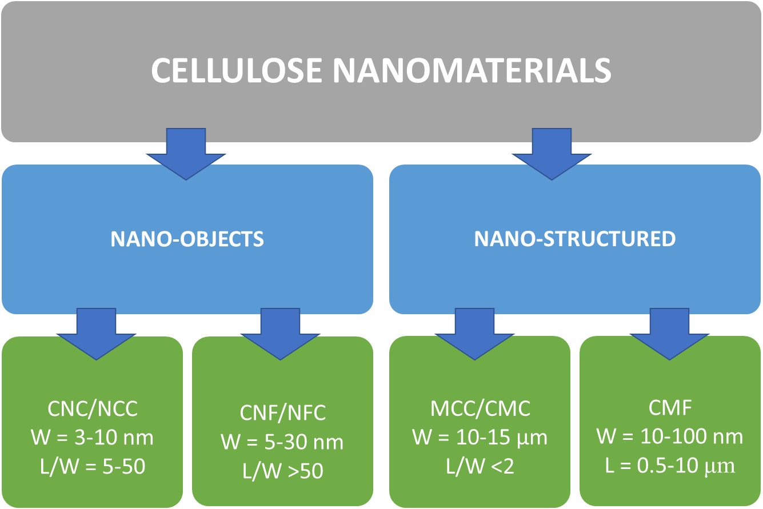

Figure 1: Standard terms for cellulose nanomaterials (TAPPI W13021). Adapted from Kargarzadeh *et al*., 2017 [12]. CNC/NCC = cellulose nanocrystals, CNF/NFC = cellulose nanofibrils, MCC/CMC = cellulose microcrystals, CMF/MFC = cellulose microfibrils, W = width, L = length, L/W = aspect ratio.

Recently, Graveson and English[15] reported a low-energy method for producing nanocellulose using organic and inorganic swelling agents (morpholine, piperidine, metal halides/hydroxides) prior to mechanical processing. In contrast, Nelson *et al*.[16] reported a process involving pre-treatment with an ethanolic-aqueous acid (SO2) solution in order to fractionate the lignocellulosic biomass followed by mechanical treatment to isolate nanocellulose fibrils and crystals. The total energy consumption of the mechanical process was found to be less than 1000 kWh/ton. Chen *et al*.[17] reported sustainable nanocellulose production using recyclable organic acids, e.g., dicarboxylic acids, rather than harsh mineral acids and the use of *para*-toluenesulfonic acid as an acid hydrotrope.[18] The latter produced a water insoluble carbohydrate-rich solid fraction which, with or without dialysis, could be used to produce lignin containing CNF (LCNF) by using mechanical fibrillation alone.

In search of new sources of non-wood/forestry cellulosic feedstocks, waste orange peel represents an interesting high-volume resource. Orange peel waste is widely available (16 Mtons/year worldwide)[19] and a relatively cheap (*ca.* €5/tonne), parenchyma cell-rich unavoidable food supply chain resource. In addition, the low lignin content of orange peel (~7.5 wt.%)[20] together with its high concentration of uronic acids containing polysaccharides (pectin and hemicellulose)[20] makes “defibrillation” or deconstruction of the cellulosic matrix more facile.[2] Although nanocellulose production from citrus biomass has been reported in the literature,[21,22] the works conducted to date are mainly based on conventional methodologies relying on mechanical, chemical and/or enzymatic treatments. For example, Mariño *et al*.[21] reported pre-treatment of orange peels with NaOH (4%, 120 °C, 20 min) followed by either enzymatic treatment (5 mg/g, 45 °C, 48 h) and then bleach (2% NaClO2, 120 °C, 20 min) or with bleach (NaClO2) alone, to afford nanoelluloses, which after being subjected to a final ultrasonication step (30 min) yielded CNF.

Recently, we reported an acid-free (and enzymatic-free) hydrothermal microwave-assisted method to produce mesoporous (nano)cellulose fibrils and crystals from orange peel residues coined the Hy-MASS concept.[23] Our Hy-MASS methodology has several advances to the conventional procedures reported for nanocellulose production. For example, citrus waste biomass is a significantly cheaper raw material than the often-applied wood pulp, and we do not use energy intensive equipment like homogenizers. Moreover, the use of hazardous chemicals is omitted in Hy-MASS. Here, we present a fundamental treatise on the effect of Hy-MASS reaction conditions on the yield and a number of key physical and chemical properties of the resulting cellulosic matter produced. In particular, we address the effect of the temperature (120-200 °C), solid concentration (1.4-5.0 wt.%) and reaction time (0-30 min) as well as all the possible interactions between these three variables during microwave-assisted hydrothermal decomposition; analysing how and to what extent the operating conditions influence isolated cellulosic yield, which in this paper refers to a mixture of both, nano-objects (CNF and CNC) and nanostructures (MFC), relevant physical and chemical properties (cellulose thermal stability, molecular weight and dispersity, water holding capacity, and degree of crystallinity), and processing energy consumption and costs. The experiments conducted were according to a full factorial 2-level-3-factor Box Wilson Face Centred experimental design and were analysed by means of an analysis of variance (ANOVA). An understanding of the effects of operating conditions and all possible interactions between these variables is expected to provide new insights into the production of renewable cellulosic materials from citrus feedstocks.

Results and Discussion

Selected SEM and their corresponding TEM images of isolated cellulosic materials are shown in **Figure 2**. The images show a mixture of fibrils and crystals with average widths within the nano-scale (4-30 nm). The former predominantly occurs at operating temperatures <180oC irrespective of concentration or time, whilst crystal formation is clearly evidenced at 200oC. The increase of average width of the fibrils with increasing processing temperature observed in **Figure 2** is probably due to aggregation effects, since inherent surface charge stabilizers like pectin and hemicellulose (which prevents aggregation)[2,12] decomposes above 140 °C, leading to a higher degree of aggregation on the fibrils/crystals produced between 160 and 200 °C. In addition, it must be borne in mind that as SEM images were generated from the dried material (and not from their suspensions), a high degree of aggregation is observed on the material.

The DoE and its results are summarised in **Table 1**. The relative influence of operating variables on isolated yield of cellulosic matter and physicochemical properties according to an ANOVA analysis and the cause effect Pareto principle are shown in **Table 2**.

## The effect of operating conditions on isolated cellulosic yield

The isolated cellulosic matter yield varied between 72% (low temperature) and 25% (high temperature) and was commensurate with increasing propensity for cellular hydrolysis of orange peel residues. The cause-effect Pareto test **(Table 2**) revealed that temperature (48% importance), as an operating variable, exerted the greatest influence on cellulosic matter yield, followed by solid concentration (13% importance) and reaction time (11% importance). The relative coefficients for these variables indicate that an increase in temperature (and, to a lesser extent, reaction time) decreases (negative term) cellulosic yield, while an increase in solid concentration has a small(er) contribution to the overall increase (positive term) in isolated cellulose yield. Additionally, significant interactions between the variables also take place (*eg*. TC and Ct), although these have far less influence on isolated cellulosic matter yield.

**Table 1.** Design of experiment variables: T (temperature), solid concentration (C) and holding time (t) and effect on key physical and chemical properties of isolated cellulosic matter.

|  |  |  |  |  |  |  |  |  |  |  |  |  |
| --- | --- | --- | --- | --- | --- | --- | --- | --- | --- | --- | --- | --- |
| **Run** | **T**  **[°C]** | | **C**  **[%]** | **t**  **[min]** | **Yield**  **[%]** | **Td**  **[°C]** | **Crl**  **[%]** | **WHC**  **[g H2O/g]** | **Mw**  **[kg/mol]** | **Đ** | **Energy**  **[kWh]** | **Cost**  **[€/kg]** |
| 1 | | 120 | 1.4 | 0 | 67.7 | 344.7 | 34.2 | 24.3 | 973.4 | 18.8 | 0.164 | 35 |
| 2 | | 200 | 1.4 | 0 | 37.1 | 372.6 | 55.2 | 24.6 | 351.7 | 6.2 | 0.23 | 95 |
| 3 | | 120 | 5 | 0 | 71.6 | 346.8 | 37.5 | 18.3 | 969.3 | 19.4 | 0.142 | 13 |
| 4 | | 200 | 5 | 0 | 32.6 | 356.7 | 58.9 | 21.7 | 284.8 | 6.7 | 0.217 | 44 |
| 5 | | 120 | 1.4 | 30 | 47.6 | 354.7 | 41.5 | 26.7 | 1060.1 | 18.2 | 0.49 | 148 |
| 6 | | 200 | 1.4 | 30 | 25.2 | 355.8 | 66.6 | 14.7 | 113.6 | 2.8 | 0.624 | 373 |
| 7 | | 120 | 5 | 30 | 71.9 | 345.7 | 37.3 | 19.6 | 1056.5 | 18.9 | 0.435 | 40 |
| 8 | | 200 | 5 | 30 | 32.1 | 371.5 | 58.6 | 22.3 | 150.6 | 4 | 0.601 | 119 |
| 9-12 | | 160 | 3.2 | 15 | 47.50  ±3.75 | 358.0  ±3.2 | 42.8  ±1.5 | 25.13  ±0.31 | 997.4  ±47.5 | 16  ±1.2 | 0.36  ±0.01 | 63  ±5 |
| 13 | | 120 | 3.2 | 15 | 62.8 | 358.3 | 33.6 | 24.7 | 1095.9 | 21.7 | 0.327 | 43 |
| 14 | | 200 | 3.2 | 15 | 30.4 | 369.5 | 60.3 | 23.4 | 244.6 | 5.2 | 0.42 | 112 |
| 15 | | 160 | 1.4 | 15 | 39.4 | 367.1 | 42.5 | 25.9 | 888.8 | 14.7 | 0.367 | 149 |
| 16 | | 160 | 5 | 15 | 52.8 | 353.5 | 38.9 | 23.3 | 966.2 | 18.8 | 0.34 | 36 |
| 17 | | 160 | 3.2 | 0 | 55.9 | 353.6 | 36.6 | 26.8 | 1044.9 | 17.2 | 0.176 | 24 |
| 18 | | 160 | 3.2 | 30 | 49.2 | 356.1 | 39.9 | 27.2 | 1028.9 | 15.9 | 0.524 | 97 |

**Table 2.** Relative influence of the operating conditions on isolated cellulose yield and selected physical and chemical properties according to the ANOVA analysis.

|  |  |  |  |  |  |  |  |  |  |  |  |  |  |  |  |  |
| --- | --- | --- | --- | --- | --- | --- | --- | --- | --- | --- | --- | --- | --- | --- | --- | --- |
| **Response** | **R2** | **Ind.** | **T** | **C** | **t** | **TC** | **Ct** | **Tt** | **TCt** | **T2** | **C2** | **t2** | **T2C** | **T2t** | **TC2** | **T2t2** |
| Yield  [%] | 0.98 | 46.9 | -16.4 | 4.4 | -3.9 | -3.2 | 4.0 | n.s. | n.s. | n.s. | n.s. | 5.6 | n.s. | n.s. | n.s. | -4.3 |
|  | (48) | (13) | (11) | (8) | (10) |  |  |  |  | (4) |  |  |  | (5) |
|  | (18) | (10) | (3) | (14) |  | (10) | (4) |  | (4) | (4) | (12) | (13) | (1) | (5) |
|  | (32) | (8) | (4) | (7) |  | (13) | (3) | (7) | (1) |  | (9) | (11) | (1) | (4) |
|  | (57) | (8) | (4) |  |  | (9) |  |  | (13) |  |  | (4) | (5) |  |
| Td  [°C] | 0.92 | 359.2 | 7.6 | -6.8 | n.s. | n.s. | 2.6 | n.s. | 5.34 | 3.1 | n.s. | -5.9 | 5.9 | n.s. | n.s. | n.s. |
|  | (34) | (9) |  |  | (10) |  | (21) | (1) |  | (15) | (11) |  |  |  |
| Crl  [%] | 0.98 | 42.2 | 11.5 | n.s. | 2.2 | n.s. | -2.4 | n.s. | n.s. | 4.8 | n.s. | -3.9 | n.s. | n.s. | n.s. | 5.7 |
|  | (51) |  | (9) |  | (9) |  |  | (21) |  | (2) |  |  |  | (7) |
| WHC  [g H2O/g] | 0.99 | 25.0 | -0.7 | -1.1 | n.s. | 2.2 | 1.2 | -1.6 | 1.45 | -0.9 | n.s. | 2.1 | n.s. | -0.7 | n.s. | -4.6 |
|  | (6) | (9) |  | (17) | (9) | (12) | (11) | (19) |  | (1) |  | (5) |  | (11) |
| Mw  [kg/mol] | 0.99 | 1·106 | -4·105 | n.s. | n.s. | n.s. | n.s. | -7·104 | n.s. | -3·105 | -7·104 | n.s. | n.s. | n.s. | n.s. | n.s. |
|  | (54) |  |  |  |  | (8) |  | (33) | (5) |  |  |  |  |  |
| Đ | 0.99 | 16.5 | -8.3 | -2.1 | -0.9 | n.s. | n.s. | -0.6 | n.s. | -3.0 | n.s. | n.s. | -1.7 | n.s. | 1.3 | -1.6 |
|  | (51) | (5) | (6) |  |  | (4) |  | (20) |  |  | (5) |  | (4) | (4) |
| Energy  [kWh] | 0.99 | 0.4 | 0.05 | -0.01 | 0.17 | 5·10-3 | -5·10-3 | 0.02 | n.s. | 0.01 | n.s. | -0.001 | n.s. | n.s. | n.s. | n.s. |
|  | (19) | (5) | (62) | (2) | (2) | (6) |  | (2) |  | (2) |  |  |  |  |
| Cost  [€/kg] | 0.99 | 74.0 | 34.5 | -54.8 | 36.5 | -21.9 | n.s | 26.6 | -14.6 | n.s. | 18.5 | -13.5 | n.s. | 25.1 | 14.9 | 29.4 |
|  | (16) | (19) | (19) | (7) |  | (8) | (3) |  | (8) | (1) |  | (3) | (2) | (3) |

**N.S**: Non-significant with 95% confidence. Response = Ind. + Coefficient T·T + Coefficient C·C + Coefficient t·t + Coefficient TC·T·C + Coefficient Tt·T·t + Coefficient TCt · T·C·t Coefficient T2·T2 + Coefficient C2·C2 + Coefficient t2·t2+ Coefficient T2C·T2·C + Coefficient T2t·T2·t + Coefficient TC2·T·C2 + Coefficient T2t2·T2·t2. n.s: Non-significant with 95% confidence. Response = Ind. + Coefficient T·T + Coefficient C·C + Coefficient t·t + Coefficient TC·T·C + Coefficient Tt·T·t + Coefficient TCt · T·C·t Coefficient T2·T2 + Coefficient C2·C2 + Coefficient t2·t2+ Coefficient T2C·T2·C + Coefficient T2t·T2·t + Coefficient TC2·T·C2 + Coefficient T2t2·T2·t2. T = temperature, C = concentration, t = holding time.

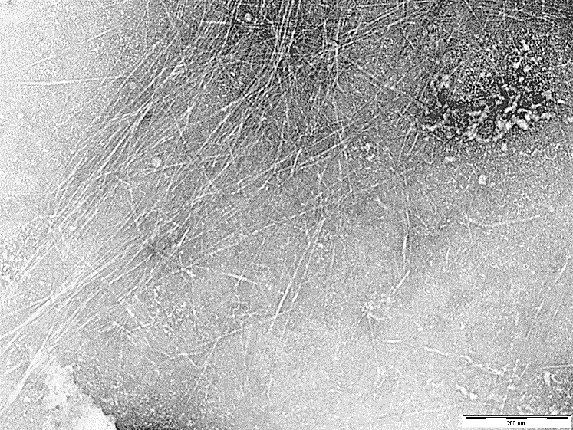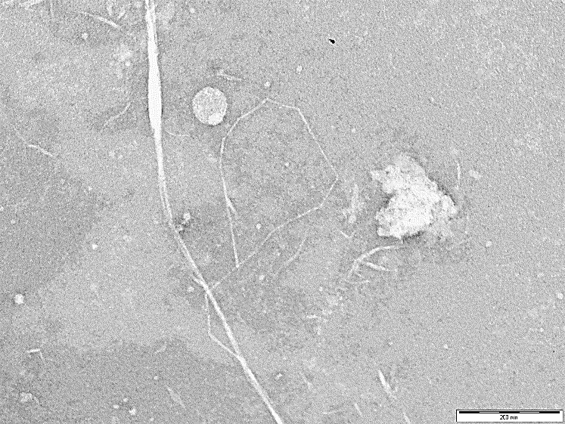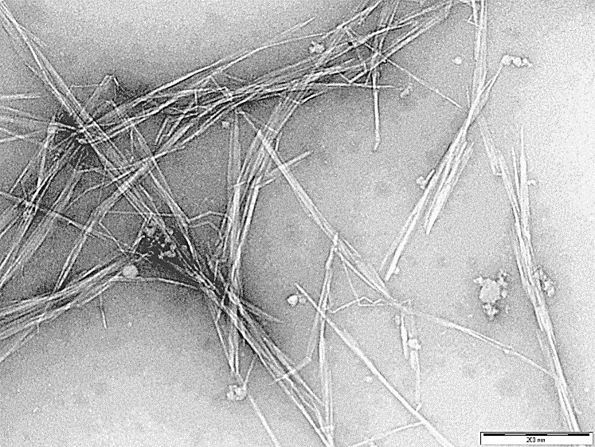

**Run-13**

**Run-10**

**Run-8**

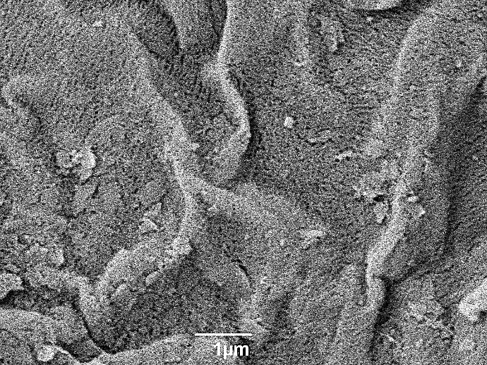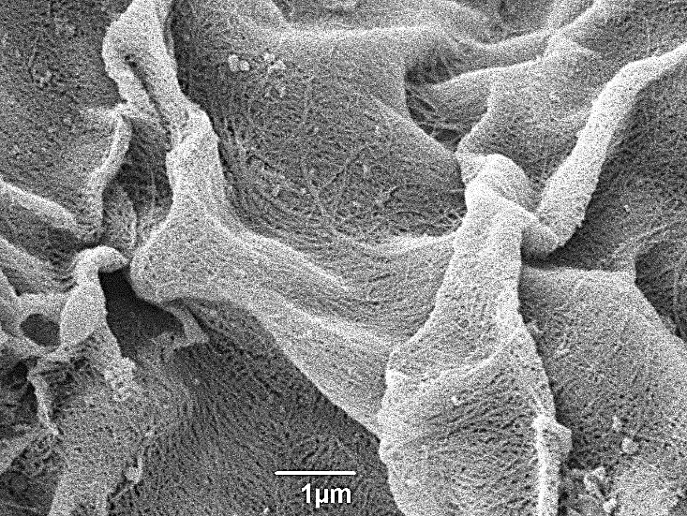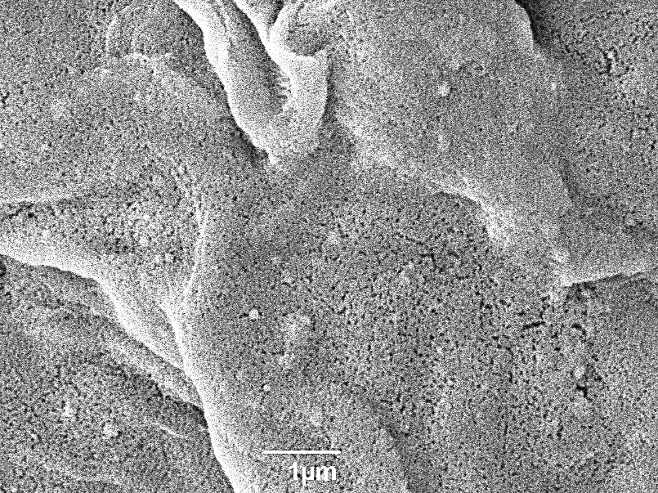

Figure 2. Selected examples of TEM and SEM (insets) images of the produced cellulosic material. TEM scale bar = 200 nm, SEM scale bar = 1 µm. Average widths of the cellulose fibrils/crystals were calculated using *FIJI-Image J* open-source software (available at: <https://imagej.net/Downloads>). SD = standard deviation (n=10). **N.B.:** It is important to note that the cellulosic materials shown here are unrefined and may contain a small fraction of fibrils aggregates larger than 100 nm wide, however, eventual homogenization or centrifugation are able to remove them.

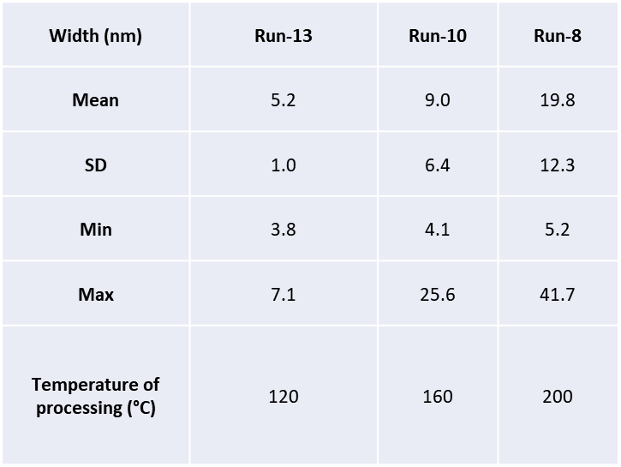

**Figure 3** shows that an increase in reaction temperature from 120 to 200 °C decreases isolated cellulosic matter yield regardless of other operating conditions. The mass loss is consistent with the positive effect that temperature exerts on progressive removal of amorphous matter from the cellulosic matrix. Pectinaceous matter is removed at lower temperatures (120-160 °C), while at higher temperatures (200 °C) depolymerisation of amorphous cellulose and hemicellulose occurs yielding soluble oligo- and mono-saccharides as hydrolysate.[23,24] Although the hydrolysate was not the focus of this paper, nevertheless, its chemical composition based on HPLC analysis, is given in the SI (**S2)**. Utilisation of the hydrolysate would be beneficial within a biorefinery concept as the products (sugars and sugar acids such as glucose, rhamnose and galacturonic acid) can be used as intermediates for further downstream processing or production of biofuels and chemicals.

**Figure 3.** Influence of temperature (°C) on cellulosic matter yield (%) at solid concentrations of 1.4 and 5 wt.% and reaction times of 0 min (a) and 30 min (b). Bars are LSD intervals with 95% confidence.



In addition, the small influence of solid concentration on isolated yield depended on temperature and reaction time. While an increase in solid concentration from 1.4 to 5 wt.% did not exert a significant effect on isolated cellulosic yield at 0 min. reaction time, it did significantly affect isolated cellulosic yield at 30 min. In this case, the effect of solid concentration depends on temperature; an increase in yield occurs at low temperature rather than at high temperature. Since temperature exerts the highest influence on isolated cellulosic yield it can mask the effect of solid concentration at t = 0 min. Conversely, as reaction time increased, the effect of solid concentration became more significant, i.e., at t = 30 min., an increase in solid concentration leads to an increase in isolated cellulose yield which may be due to an increase in the amorphous matter/microwave power-density ratio. The high solid content renders microwaves less efficient in solubilising pectinaceous and (hemi)cellulosic matter.

**Figure 3** also shows that the effect of reaction time is significantly dependent on solid concentration, displaying two different trends regardless of temperature: *i*. at low solid concentration (1.4 wt.%), an increase in reaction time decreases isolated cellulose yield across the entire temperature interval, and; *ii*. at high solid concentration (5 wt.%), an increase in reaction time does not significantly influence isolated cellulose yield. Thus, it can be concluded that these two different trends have a kinetic origin, *i.e*., at high solid concentration, an increase in reaction time from 0 to 30 min is insufficient to positively enhance kinetics of the leaching process to any significant extent, and, conversely, at a low solid concentration a positive kinetic effect is detected as reaction time leads to a decrease in isolated cellulose yield.

## The effect of operating conditions on isolated cellulose thermal stability and crystallinity

The degradation temperature (Td) and crystallinity index (CrI) of isolated cellulosic residues varied between 345-373 °C and 34-67%, respectively. The cause-effect Pareto analysis revealed temperature as the highest influencing factor on both properties, exerting a positive effect (positive term in the codec model). The degradation temperature was influenced by several interactions between temperature, solid concentration and reaction time. As shown in **Figure 4**,the effect of temperature on cellulosic Td depended on solid concentration and reaction time. At short reaction time (0 min), two different outcomes for degradation temperature were observed depending on solid concentration. At low solid concentration (1.4 wt.%), an increase in reaction temperature from 120 to 200 °C leads to a sharp increase in Td. Conversely, a progressive increase in solid concentration diminishes the positive effect of temperature and, therefore, this same increase in temperature does not have a significant influence on the Td at high solid concentration (5 wt.%), most likely due a decrease in microwave efficiency as discussed earlier. Interestingly, this effect was only noticeable for isolated cellulose yield for long reaction times probably due the positive effect of reaction time compensating for the negative effect of solid concentration.



**Figure 4.** Influence of the temperature on the degradation rate temperature of cellulose (Td) and crystallinity index using a solid concentration of 1.4 and 5 wt.% for a reaction time of 0 min (a and c) and 30 min (c and d). Bars are LSD intervals with 95% confidence.

An increase in reaction time from 0 to 30 minutes resulted in different outcomes for Td depending on the solid concentration. At low solid concentration (1.4 wt.%) and relatively long reaction time (30 min.), the effect of temperature is insignificant. However, at high solid concentration (5 wt.%), Td significantly increased as reaction temperature was raised from 160 to 200 °C. For low solid concentrations, the negligible effect of temperature on Td is postulated as a compensatory effect between the two trends. Firstly, an increase in temperature leads to an increase in the microwave efficiency aiding to enhanced dissolution of residual amorphous matter. This effect increases the relative amount of crystalline (nano)cellulose in the isolated cellulosic matter and therefore shifts Td to higher values. Secondly, the increase in Td could also be due to the relative contribution of a greater amount of recalcitrant calcium salts (mostly calcium oxalate, CaC2O4) in the isolated cellulosic material at high temperatures. The presence of calcium salts in plant cell walls and vacuoles is well known.[25,26],[23]

The effect of reaction time on Td is further explored by comparing **Figure 4a** with **4b**, which shows dependency on solid concentration and temperature. Reaction time exerts the greatest effect on Td between 160 and 200 °C. Two different trends were noted dependent on solid concentration. At low solid concentration (1.4 wt.%), increasing reaction time from 0 to 30 min decreased Td, whereas, at high solid concentration (5.0 wt.%) an increase in Td is observed.

**Figure 4c** and **4d** show that the crystallinity index (CrI) is mainly affected by reaction temperature as predicated by the Pareto analysis. Regardless of either solid concentration or reaction time, temperature exerts an insignificant influence on CrI between 120 and 160 °C. However, increasing the temperature from 160 to 200 °C leads to a substantial increase in CrI. From 120 to 160 °C the selective removal of pectinaceous matter and other cellular components takes place along the fibre direction (longitudinal scissoring) with little impact on CrI. However, above 180 °C the interaction between microwaves and the amorphous regions of lignocellulosic biomass becomes significant leading to removal of strongly bonded hemicelluloses, lignin and amorphous regions of cellulose chains (transversal scissoring). This interaction is supported by a proton transfer mechanism[24,27,28] which promotes the hydrolysis of amorphous matter by “selective scissoring”[23] thus increasing crystallinity in the sample. However, care must be taken not to over-interpret this data as the diffraction response is heavily texture-dependent which may change due to microwave treatment.



**Figure 5.** Influence of the temperature on the water holding capacity when using a solid concentration of 1.4 and 5 wt.% for a reaction time of 0 min (a) and 30 min (b). Bars are LSD intervals with 95% confidence.

The effect of concentration depends on reaction time. At short reaction times, an increase in solid concentration (1.4-5.0 wt.%) slightly decreases CrI, which is opposite at long reaction times (30 min.). The comparison between **Figure 4c** and **4d** shows an increase in reaction time slightly increases CrI at low solid concentration, whilst a decrease in CrI occurs at high solid concentration.

## Effect of operating conditions on water holding capacity

The water holding capacity (WHC) for the isolated cellulosic matter varied between 15 and 27 g H2O·g-1 depending on the operating conditions used. Our WHC values were higher or similar to those values reported in the literature (when the same methodology was used in the analysis).[29] WHC was highly influenced by temperature (both linear and quadratic effects) and the interactions between this variable with the concentration and the reaction time are plotted in **Figure 5**. Temperature exerts a positive influence on WHC for cellulosic samples isolated between 120 and 150 °C. A further increase in temperature to 200 °C led to a substantial reduction in WHC. The WHC is assumed to be related to the nanostructure within the isolated cellulose.[23] Nanocellulose crystals and crystallites are derived from crystalline regions of elementary fibrils where cellulose chains are strongly bound by a structured network of hydrogen and van der Waals bonds. The hydration capacity of crystals is much lower than that of fibrils, which are proposed to better retain water due to the presence of amorphous regions or crystallite defects.[30,31] As explained earlier, an increase in temperature between 120 and 160oC did not significantly modify the overall crystallinity of the material, thus significantly increasing the water holding capacity of the solid. A further increase in temperature to 200 °C resulted in a sharp increase in CrI and, consequently a decrease in WHC.

The effect of concentration was dependent on reaction time and *vice versa*. At short reaction time (0 min), an increase in the solid concentration significantly reduced WHC. Conversely, at long reaction time (30 min), the same decrease in WHC was observed between 120 and 150 °C, whilst the opposite trend occurred between 150 and 200 °C; *i.e*. an increase in solid concentration results in an increase in WHC,

## Effect of operating conditions on molecular weight and dispersity

The average molecular weight (Mw) and dispersity (Đ) of isolated cellulosic matter varied from *ca*. 110 to 1100 kg·mol-1 and from 3 to 22, respectively. The average molecular weight was strongly affected by temperature (both linear and quadratic effects) with a relative importance of 87%. Temperature also greatly influences the Đ (71%). This latter was also affected by some interactions of temperature with solid concentration and reaction time. **Figure 6** shows the effect of operating variables and interactions detected with an ANOVA analysis.

With respect to molecular weight, **Figure 6a** and **6b** show that regardless of either solid concentration or reaction time, the molecular weight significantly decreases with increasing the temperature. From 120 to approximately 150 °C, temperature did not have a significant effect. However, increasing temperature to 200 °C resulted in a sharp decrease in the molecular weight. As predicted by the Pareto analysis, the effect of solid concentration on this property is very weak; *i.e*. an increase in solid concentration from 1.4 to 5 wt.% does not greatly modify the molecular weight. In addition, comparison between **Figure 6a** and **6b** shows how the effect of reaction time depends on temperature due to a significant interaction occurring between these two variables. For the temperature range of 120-150 °C, an increase in reaction time from 0 to 30 min leads to a positive effect (increase) of the molecular weight. On the other hand, this time increment has a negative effect (decrease) on molecular weight between 150 and 200 °C. This is believed to result from the selective scissoring of the amorphous matter within the cellulosic matrix as described earlier. Through this process, the propensity of cellulose nanofibers and cellulose nanocrystals increases. [23]

With respect to dispersity, an increase in temperature from 120 to 200 °C also decreased dispersity (**Figure 6c** and **6d**). However, this effect was also dependent on solid concentration. For a low solid concentration (1.4 wt.%), the reduction in dispersity with respect to temperature occurred between 140 and 200 °C, regardless of the reaction time. Whereas, an increase in solid concentration increased the temperature required to produce a significant decrease in the dispersity. At a solid concentration of 5 wt.%, dispersity did not vary between 120 and 150 °C and decreased as the temperature was raised to 200 °C. In addition, as the result of the different evolution of the dispersity with respect to temperature and depending on solid concentration, an increase in solid concentration from 1.4 to 5 wt.% significantly rises the dispersity of the material between 140 and 170 °C. The effect of reaction time on dispersity was relatively weak and depended on temperature. While the reaction time does not significantly influence this variable between 120 and 160 °C, a small negative effect (decrease in Đ) occurs between 160 and 200 °C when the reaction time augments from 0 to 30 min (**Figure 6c** and **6d**, respectively).

## Energetic and economic assessments

The energy input required for production of isolated cellulosic matter varied between 0.142 and 0.624 kWh (**Figure 7**). The statistical analysis of the results indicates that energy consumption is strongly affected by reaction time (importance level, 62%) and temperature (importance level, 19%) (**Table 2**). The coefficients of these variables show that an increase in both variables increases energy consumption. Therefore, for energy saving purposes, it is better to use the shortest reaction time as possible, although higher temperatures have to be used. The relative importance of solid concentration is much weaker (5%) due to the relative low solid concentration used in the experiments (1.4–5.0 wt.%). In addition, several interactions between the operating variables also occur. **Figure 7a** and **7b** show the effect of operating variables and interactions on energy input. The third order interaction, Temperature-time-concentration (T·t·C), is not statistically significant; therefore, the effect of the operating variables can be explained in groups of second order interactions. **Figure 7a** shows that, regardless of the other operating conditions, an increase in reaction temperature increases energy consumption as more energy is required to heat the feed to high temperatures. Energy input decreases with increasing solid concentration, indicating that the feedstock is a good microwave absorber and therefore, energy is released in form of heat during the microwave treatment. With respect to the reaction time, an increase between 0 and 30 minutes leads to a sharply linear increase in energy consumption (**Figure 7b**).

To gain a deeper insight in to the economics of this process, the cost of this microwave process has been estimated. **Table 1** shows the energy cost calculated as €/kg of solid assuming an energy price of 0.16 €/kWh. The energy cost varies between 13 and 373 €/kg isolated cellulosic matter produced. Although our materials are still unrefined, these values are similar to those reported by de Assis *et al*.[11] (2.25 and 205.73 €/kg) for nanocellulose produced by means of oxidation, soft acid hydrolysis, enzymatic treatment and mechanical beating. It is important to re-iterate that our process relies on microwave processing alone without use of oxidants, acids and/or bleaching agents. The statistical analysis revealed that the three operating variables have a similar relative importance on economics, however their effects are different. While an increase in temperature and reaction time leads to an increase in isolated cellulosic matter production cost, an increase in solid concentration decreases the production cost of this material. **Figure 7c** and **7d** show the effects of operating variables and interactions on the cost of producing our cellulosic matter.

Regardless of the other operating conditions, an increase in temperature increases production cost, as more energy is needed. This economic increase is substantially marked between 160 and 200 °C. Within this temperature interval the yield of cellulosic material decreases, and the energy requirement increases, thus, leading to a sharp increase in the economic cost per kg of material produced. An increase in reaction time from 0 to 30 min produced a substantial increase in production cost due to the sharp augment in the energy requirement of the process; this increase being more marked between 160 and 200 °C. An increase in solid concentration led to a small decrease in production cost. This is a consequence of decreases occurring for both yield of cellulosic matter and energy input when the solid concentration increases. From an energetic and economic cost saving perspective, short reaction times must be used. In particular, it is possible to achieve a production cost lower than 100 €/kg using temperatures up to 200 °C and reaction times between 0 (for 1.4 wt.%) and 15 (for 5.0 wt.%) minutes. Within this interval the yields and physicochemical properties of the isolated cellulosic matter can be customised for different applications without substantially compromising the energetic and economic aspects of the process.



**Figure 6.** Influence of the temperature on the degradation molecular weight (Mw) and dispersity (Đ) using a solid concentration of 1.4 and 5 wt.% for a reaction time of 0 min (a and c) and 30 min (c and d). Bars are LSD intervals with 95% confidence.

**Figure 7.** Interaction plots between the temperature and concentration (a) and reaction time and temperature (b) for the energy input. Economic cost for cellulosic matter production using reaction times of 0 (c) and 30 (d) minutes. Bars are LSD intervals with 95% confidence.



Conclusions

This work addresses the *Hydrothermal Microwave-Assisted Selective Scissoring* (Hy-MASS) of orange peel residues for the deconstruction of (ligno)cellulosic matter as an effect, via a rigorous design of experiment study and two-way analysis of variance (ANOVA) of the results. Three variables were studied: reaction temperature (120-200°C); reaction time (0-30 min), and; solid concentration (1.4-5 wt.%), on the process. The most important conclusions obtained from this work are summarised as follows:

*1.* The statistical analysis of the results revealed that operating conditions have a significant influence on yield of isolated cellulosic matter with temperature exerting the greatest influence. Increasing temperature significantly decreases isolated cellulosic matter yield due to progressive removal of pectinaceous and (hemi)cellulosic amorphous matter present in the feedstock. Increasing solid concentration from 1.4 to 5.0 wt.% leads to a substantial decrease in efficiency of the process which also hinders removal of amorphous matter. Whilst, an increase in reaction time is beneficial for concentrated solid suspensions (5.0 wt.%), as time can compensate for the lower microwave energy efficiency; thermal decomposition of the material occurs when low solid concentrations and long reaction times are used.

*2.* The degradation temperature (Td) and crystallinity index (CrI) of the isolated cellulosic matter varied between 345-373 °C and 34-67%, respectively. These variables are strongly affected by reaction temperature. An increase in reaction temperature results in an increase in CrI and Td.

*3.* The statistical analysis of the most important physical and chemical properties of the isolated material revealed that they are strongly influenced by temperature, whereas, the effects of reaction time and solid concentration were less important. In particular, the water holding capacity and the molecular weight varied by 15 and 27 g H2O·g-1 and 110 and 1100 kg·mol-1, respectively. Temperatures between 150-160 °C maximise the water holding capacity of the isolated material (27 g H2O·g-1), thus producing a biomaterial with a much higher hydration capacity than that of the original feedstock.

*4.* The energy input varied between 0.142 and 0.624 kWh, which resulted in an energy cost ranging between 13 and 373 €/kg of cellulosic matter produced. Reaction time exerts the highest influence on energy requirements of the process; an increase from 0 to 30 min dramatically increases the energy requirement and economic cost of the process. Although our material is still unrefine, and more akin to microfibrillated cellulose at low temperatures but tending towards nano-objects (NFC and NCC) at higher temperatures, it may be considered sustainably-beneficial. It does not require auxillary chemicals, reagents and costly mechanical processes to be produced, which have negative environmental and economic implications in terms of effluent treatment costs and safety. Using orange peel residues diverts waste from landfill, *does more with less*, and fosters the principles of circular economy commensurate with global sustainable development goals, in particular SDG 12: sustainable consumption and production patterns.[32] Thus, from a holistic point of view our material may be considered to be economically competitive (<100 €/kg solid material) as precursor for refined nano-objects as it is highly tuneable, i.e., its physical and chemical properties can be tailored based on temperature, reaction and solid concentration. Our process is still at bench-scale and its competitivess (<100 €/kg solid material) is expected to increase in line with the economies of scale principle. According to Bian *et al*.[18] small quantities of CNC and CNF were sold from $550 (not for profit, produced by the USDA Forest Products Laboratory) to $1400 kg−1 (by commercial vendors for profit) and $110 (pure mechanical processing) to $3300 kg−1 (TEMPO oxidation treatment, produced by the USDA Forest Products Laboratory), respectively.

Experimental Section

**Materials and Microwave Hydrothermal Treatment**

Orange peel waste (OPW) was obtained from sweet oranges and depectinated as outlined in SI (**S1**). All other experimental details are described in the SI.

**Experimental Plan, Response Variables and Data Analysis**

The experiments (see **Table 1**) were planned with a 2-level-3-factor Box-Wilson Central Composite Face Centred design (CCF,α: ± 1). This corresponds to a full 2k factorial design, where k indicates the number of factors studied (in this case 3 operating variables: temperature, concentration and reaction time) and 2k represents the number of runs (in this case 8), enlarged with 6 axial experiments to study non-linear effects and interactions according to the CCF design. In addition, three replicates at the centre point (centre of the variation interval of each factor) were undertaken to evaluate experimental error. This experimental design is suitable not only for studying the influence of each variable (linear and quadratic effects) but also for understanding possible interactions between variables.

The effect of operating conditions on microwave-assisted hydrothermal treatment (MHT) of orange peel residues was evaluated using different response variables, namely: isolated cellulosic matter yield (%); maximum degradation temperature (Td) of cellulose as determined by TGA (°C); crystallinity index (CrI) calculated by powder XRD (%); water holding capacity (WHC, g water g-1 sample) and; average molecular weight calculated by GPC. In addition, the effect of the operating conditions on the energy input (kWh) and process cost (Euros/kg of solid produced) was also addressed. Energy and cost were measured by using a power meter (Energenie® ENE007). Full experimental and instrumental details are given in the supplementary information (SI).

The results were analysed with an analysis of variance (ANOVA) with 95% confidence level. In addition, the cause-effect Pareto principle was used to calculate the relative importance of the operating variables with respect to response variables. The higher the Pareto percentage of an operating variable, the greater is its influence on the response variable. In these analyses the lower and upper limits of all the factors (temperature, solid concentration and reaction time) were normalised from -1 to 1 (codec factors). This codification permits all factors to vary within the same interval and helps to investigate their influence in comparable terms. Interaction plots have been developed from the statistical analyses conducted by means of the ANOVA test. In the interaction plots, the evolution of the response variables is plotted along with the LSD values obtained from Fisher’s least significant difference (LSD) test. To ensure significant differences between any pairs of data or the within the evolution of a response variable, the LSD bars must not overlap.

Acknowledgements

The authors would like to thank CNPq - *Conselho Nacional de Desenvolvimento Cientifico e Tecnologico* (Brazil), for scholarly funding Eduardo Melo to undertake research at University of York, UK and EPSRC for funding “Whole systems understanding of unavoidable food supply chain wastes for re-nutrition”, (EP/P008771/1).

**Keywords:** nanocellulose production and costs • acid-free microwave hydrothermal treatment • Box-Wilson DoE

[1] W. Y. Hamad, *Cellulose Nanocrystals: Properties, Production and Applications*, John Wiley & Sons, Chichester, UK, **2017**.

[2] D. Klemm, F. Kramer, S. Moritz, T. Lindström, M. Ankerfors, D. Gray, A. Dorris, *Angew. Chemie Int. Ed.* **2011**, *50*, 5438–5466.

[3] Internet, “Nanocellulose for tires: something new in performance and sustainability : Biofuels Digest,” can be found under https://goo.gl/47VeNO, **2017**. Accessed on 22/01/2018.

[4] G. Ström, C. Öhgren, M. Ankerfors, *Nanocellulose as an Additive in Foodstuff*, **2013**.

[5] H. Zhu, Z. Fang, C. Preston, Y. Li, L. Hu, *Energy Environ. Sci.* **2014**, *7*, 269–287.

[6] I. Siró, D. Plackett, *Cellulose* **2010**, *17*, 459–494.

[7] K. J. De France, T. Hoare, E. D. Cranston, *Chem. Mater.* **2017**, *29*, 4609–4631.

[8] H. Sehaqui, Q. Zhou, L. A. Berglund, *Compos. Sci. Technol.* **2011**, *71*, 1593–1599.

[9] C. Salas, T. Nypelö, C. Rodriguez-Abreu, C. Carrillo, O. J. Rojas, *Curr. Opin. Colloid Interface Sci.* **2014**, *19*, 383–396.

[10] Internet, “Nanocellulose State of the Industry,” can be found under https://goo.gl/Tzz2WV, **2015**. Accessed on 22/01/2018.

[11] C. A. de Assis, C. Houtman, R. Phillips, E. M. T. Bilek, O. J. Rojas, L. Pal, M. S. Peresin, H. Jameel, R. Gonzalez, *Biofuels, Bioprod. Biorefining* **2017**, *11*, 682–700.

[12] H. Kargarzadeh, M. Ioelovich, I. Ahmad, S. Thomas, A. Dufresne, in *Handb. Nanocellulose Cellul. Nanocomposites*, Wiley-VCH Verlag GmbH & Co. KGaA, Weinheim, Germany, **2017**, pp. 1–49.

[13] G. Chinga-Carrasco, *Nanoscale Res. Lett.* **2011**, *6*, 417.

[14] A. Dufresne, *Mater. Today* **2013**, *16*, 220–227.

[15] I. Graveson, R. English, *Low Energy Method for the Preparation of Non-Derivatized Nanocellulose*, **2015**, US20150158955 A1.

[16] K. Nelson, T. Retsina, V. Pylkkanen, R. O’Connor, *Processes and Apparatus for Producing Nanocellulose , and Compositions and Products Produced Therefrom*, **2015**, US9187865 B2.

[17] L. Chen, J. Y. Zhu, C. Baez, P. Kitin, T. Elder, *Green Chem.* **2016**, *18*, 3835–3843.

[18] H. Bian, L. Chen, R. Gleisner, H. Dai, J. Y. Zhu, *Green Chem.* **2017**, *19*, 3370–3379.

[19] A. S. Matharu, E. M. de Melo, J. A. Houghton, *Bioresour. Technol.* **2016**, *215*, 123–130.

[20] L. A. Pfaltzgraff, M. De bruyn, E. C. Cooper, V. Budarin, J. H. Clark, *Green Chem.* **2013**, *15*, 307.

[21] M. Mariño, L. Lopes da Silva, N. Durán, L. Tasic, *Molecules* **2015**, *20*, 5908–5923.

[22] A. García, A. Gandini, J. Labidi, N. Belgacem, J. Bras, *Ind. Crops Prod.* **2016**, *93*, 26–38.

[23] E. M. de Melo, J. H. Clark, A. S. Matharu, *Green Chem.* **2017**, *19*, 3408–3417.

[24] J. Fan, M. De bruyn, V. L. Budarin, M. J. Gronnow, P. S. Shuttleworth, S. Breeden, D. J. Macquarrie, J. H. Clark, *J. Am. Chem. Soc.* **2013**, *135*, 11728–11731.

[25] J. A. Perez-Pimienta, H. M. Poggi-Varaldo, T. Ponce-Noyola, A. C. Ramos-Valdivia, J. A. Chavez-Carvayar, V. Stavila, B. A. Simmons, *Biomass and Bioenergy* **2016**, *91*, 48–55.

[26] M. Hajir, R. Graf, W. Tremel, *Chem. Commun.* **2014**, *50*, 6534.

[27] Y.-M. Kim, H. W. Lee, S. Kim, C. Watanabe, Y.-K. Park, *BioEnergy Res.* **2015**, *8*, 431–439.

[28] K. Werner, L. Pommer, M. Broström, *J. Anal. Appl. Pyrolysis* **2014**, *110*, 130–137.

[29] N. F. Mat Zain, S. M. Yusop, I. Ahmad, *J. Nutr. Food Sci.* **2014**, *5*, 10–13.

[30] P. J. Van Soest, in *Nutr. Ecol. Rumin.*, Cornell University Press, **1994**, pp. 140–155.

[31] S. S. Cho, M. L. Dreher, *Handbook of Dietary Fiber*, **2001**.

[32] United Nations, *Transforming Our World: The 2030 Agenda for Sustainable Development*, New York, **2015**.

**Entry for the Table of Contents** (Please choose one layout)

Layout 1:

|  |  |  |  |  |
| --- | --- | --- | --- | --- |
| FULL PAPER | | | | |
| A detailed design of experiment (DoE) study to investigate cause-effect interaction of three process variables: temperature (120-200 °C), holding time (0-30 min) and concentration (1.4-5.0 wt.%), on processing of citrus cellulosic matter using acid-free microwave-assisted selective scissoring (Hy-MASS) is reported. |  | *Box-Wilson* DoE  CELLULOSIC MATTER  DoE |  | Avtar S. Matharu*, Eduardo M. de Melo, Javier Remón, Shuting Wang, Alima Abdulina and Eero Kontturi  Page No. – Page No.  Title |
|  |  |

|  |  |  |
| --- | --- | --- |
|  |  |  |