Effective Altruism

A Verse Essay

JT Welsch
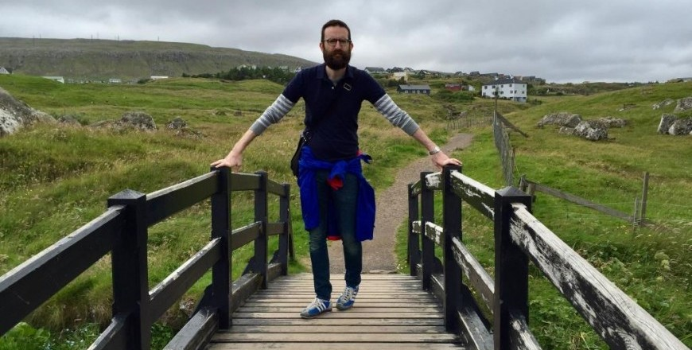

Headnote on the Form:
In his 1980 essay, ‘Language: The Poet as Master and Servant,’ the American poet David Young is deeply critical of what he regards as a ‘fatal discursiveness’ in some modern poetry. ‘Perhaps the verse essay is a respectable and legitimate genre,’ he concedes, ‘but I wish it wouldn’t be confused with lyric poetry.’ I admit I wish it would. Historically speaking, Raymond Williams might call the verse essay a ‘residual’ form, in so far as it offers a mode through which ‘certain experiences, meanings, and values which cannot be expressed or substantially verified in terms of the dominant culture are nevertheless lived and practised.’ Although the genre’s popularity has suffered since rising steadily from Horace and Lucretius to an eighteenth-century heyday led by Pope, plenty of contemporary poets work with an urgent sense of essayistic purpose. Andrea Brady’s Wildfire (Krupskaya, 2010), Heather Phillipson’s Not an Essay (Penned in the Margins, 2012), GC Waldrep’s Testament (BOA, 2015), and Tyehimba Jess’s recently Pulitzer Prize-winning Olio (Wave, 2016) are just a few of many book-length experiments that combine research, inquiry, and argumentation in personal, ‘academic,’ and ‘poetic’ registers to thrilling effect. On the other hand, the tweet-thread and other new forms of online commentary increasingly employ accretive structures and strategies of concision that seem more germane to verse than prose. From either angle, the verse essay haunts the crumbling divide between creative and critical activity.
Taking this less as an excuse for self-contentedly didactic writing than as a space for making/being to jostle into asking/thinking, it helps to remember that the ‘essay’ part of verse essay just means ‘attempt’, and that the best essays are already charged by the same potential empathy as the best lyrics—in the precariousness of their ‘I’, an openness toward their reader, and the performance of perspectives that admit their limitations. With good reason, the notion of poetry ‘exploring’ certain subjects or themes has become a default for book blurbs. Readers seem more responsive than ever to the idea that poetry might be full of ideas—though less interested in poses of authority than in new ways of being involved in the investigation. In his entry for the wider category of ‘verse epistle’ in The Encyclopedia of British Literature, 1660-1789, Bill Overton notes that the classical Horatian verse essay is actually ‘closer to conversation than lecture, a conversation in which, although there is only one speaker, constant attention is paid to the implied presence of an addressee’. Suddenly, a direct line appears through Frank O’Hara’s great dictum—‘The poem is at last between two persons instead of two pages.’ Mary Ruefle, in a 2016 interview discussing her prose collection My Private Property, takes a reverse position on poetry, while still acknowledging the interpersonal dimension when working across forms:
Poems are my inner life, take it or leave it. I don’t particularly care what the reader thinks because I’m just not invested in other people’s responses to my inner life. With discourse, with prose, it’s much scarier. There’s something built into its very nature—it’s more open and external, and it’s in exchange with another.
Although I only wish I shared Ruefle’s take-it-or-leave-it distance with poetry, her contrary (but not contradictory) emphasis on vulnerability and exchange in ‘discourse’ has been, along with the genre-shrugging openness of My Private Property, a model to me while struggling with the piece that follows.

Effective Altruism
1.
we were debating an article about doing small things
to make a difference helping those around you in
practical ways as a way to combat more abstract despair
faced with figures & news from Syria or somewhere
on the other side of the world charity you joked

begins at home you also found it dubious before
I had a chance you brought up effective altruism
from a different debate last spring a different article
I remember because I’d pulled the old reading chair
into the garden & made a joke about it on Instagram

two sides of the same coin I said either way doing
what you can to feel good about what you’re doing
I waited in the shower while you dried off admitting
that I sympathised or understood sometimes I said
I try to imagine someone just like me same age

same everything in every respect values politics
the belief that all crime especially corporate crime
should be punished by education or not punished
but courses & exams in relevant subjects depending
on the crime prisons converted into universities

reading & essays assigned for smaller offences
a truly cashless society in which any income or
inheritance in excess of say three hundred thousand
pounds or dollars or euros per year is automatically
transferred to the state in order to maintain this

2.
justice system along with free elective education
for all for life along with ecologically sustainable
public transport & energy all health services
all cultural production including but not limited
to TV film music visual arts performing arts

literary arts free public gyms heavily subsidised
technology both in development & personal use
free internet free smartphones smart public housing
smart food smart clothes made by childsized
robots nothing I’m saying isn’t already possible

I’m trying to imagine someone who believes all this
but has a different job can’t point to their job & say
well I teach well I write I make art so you know
I’m not just in it for you know the job is putting
others before myself my students my readers

craft is care you know I can’t bear complaints
that academia is becoming a service industry
I try to imagine someone who believes everything
I have the flexible time to do the work rationalising
but therefore can’t take their goodness for granted

who worries as I do occasionally they might
be part of the problem beyond that worry
what do they do to feel they are giving back
like what if they work in an office with no direct
customer interaction no one’s survival or wellbeing

3.
dependent on their labour what if they derive
no profound pleasure from it like it’s just a job
what if the alienation I feel only occasionally
defines them when we were young I told my
sister I already felt a sense of responsibility

I said if I don’t write the things I’m going
to write mostly music at that time who will
a deep sense like a duty the unique contribution
I would make however great or small I needed
to believe I would find it impossible to do

any job that didn’t give me an absolute sense
of individual purpose I guess it was the first time
this had occurred to me our mother overheard us
we were in the breakfast room & I can see her
saying don’t you think everyone thinks that

don’t you think a surgeon thinks in the moment
if I don’t help this person who will & I’m sure
I said right back my point was any other surgeon
could do the same that person’s heart transplant
or whatever isn’t a unique accomplishment

then my sister died last summer & I can’t think
what she said or might have thought at the time
stupid boys with their grand sense of importance
in the universe she wanted to be a teacher but
sort of lost her way in uni dated jerks changed

4.
her degree to public relations working in bars hotels
& mostly telesales for companies specialising in surge
protectors or security cameras for a while before 2008
she sold subprime mortgages over the phone & told
us how bad she felt trying to convince these people

they would be able to convert their doublewides
but I know she was good at it good commission
enough to live on for the few months between jobs
each time she ended up in hospital or rehab & refused
to go back for shame or something we never knew

then another friend of a friend would know of some
guy who needed someone I don’t know if she searched
or applied for any of them something always turned
up & who am I to judge when drunk she always said
don’t judge me I’m not I’d say but let’s go home

I’m the good brother in these stories there really
aren’t many once I moved as far away as possible
for uni then further for further degrees & to teach
writing & what a privilege to make art of one’s shame
to be effectively rewarded for your self centredness

if that’s what art is or that’s what this is if this is art
what a privilege to make something of time spent
thinking all this to no end but the poem only you
are capable of writing I’m trying to imagine a person
like me & realise I’m imagining my sister who I know

5.
had those beliefs the animal rights stuff she flooded
Facebook with in her manic times or a despair that
seemed bound up in the world that politician who
was shot last week she said in our last conversation
it breaks my heart she read the news she had argued

with her neighbour about Trump after Orlando
I have no faith in humans she said yeah me neither
I said & made no attempt to cheer her up for I too
feel the darkness of the world don’t I deeply singular
poet that I am don’t I experience darkness endowed

with a more lively sensibility or comprehensive soul
as Wordsworth probably said to his own poor sister
is that not my job my duty my commission to keep
pushing subprime epiphanies onto those who neither
need nor want the utopia I’m selling in which we are

all creative & fulfilled by our socalled creative labour
I was trying to imagine someone to whom I could
relate in every sense except the satisfaction of being
a writer / a teacher / a man speaking to men [sic]
or whatever the assumption that any of these are

inherently good what without these would I need
to feel useful to feel I had served that I had been
effective in my time here that I had helped anyone
but myself as if charity begins in poems I didn’t help
my sister I tried I tell myself I tried I tell this to you
Copyright © 2017 Honest Ulsterman
Verbal Arts Centre
Stable Lane and Mall Wall, Bishop
Street Within, Londonderry, BT48 6PU

