BRANDS USING HISTORICAL REFERENCES: A CONSUMERS’ PERSPECTIVE
Pecot Fabien, The University of York, UK
De Barnier Virginie, Aix-Marseille University, France

Accepted for publication in the Journal of Brand Management

Abstract
While existing literature on brand heritage focuses on corporate perspectives, this paper investigates the gap between intended and perceived heritage. Two sequential qualitative studies were performed: the preliminary study is based on observation and enables the selection of 27 fast moving consumer brands using historical references that are explicit for consumers; the main study is composed of 25 semi-structured interviews of consumers in order to analyse their interpretations. Results show that consumers know little about parent companies behind brands. However, they imagine that companies are seeking a compromise between an ideal tradition and a necessary modernity. Finally, they also distinguish different strategies in the management of temporality. Results outline the critical role of the consumers and enable to distinguish two types of brands – familiar and aristocratic ones – and to formulate two distinct sets of recommendations for them based on the use of historical references.

Keywords: Corporate Brand heritage, historical references, Fast-moving consumer goods, Positioning, Past, Band Management

Introduction
Lindt, “maître chocolatier suisse depuis 1845” (“Swiss chocolate master since 1845”), is a chocolate manufacturer using historical references in its marketing mix as an expression of its corporate heritage identity. But what do consumers perceive and remember from this message? Do they relate historical references to corporate identity?
At a conceptual level, this question first resonates with recent interrogations about the dynamics between corporate brand heritage and heritage branding orientation, defined as an organisational trait upon which managers build a positioning strategy (Santos et al., 2016). The second interrogation deals with consumers’ interpretation of heritage branding (Balmer and Chen, 2015; Rindell et al., 2015; Rose et al., 2016), and particularly with the use of historical references. Heritage branding orientation aims to facilitate consumers’ interpretation of the corporate heritage identity (Santos et al., 2016). Existing research focuses on detailed case study and only investigate consumers’ interpretation of companies for which the implementation of corporate heritage identity has been assessed (Balmer and Chen, 2015; Rindell et al., 2015). To the best of our knowledge, no research takes what is accessible to consumers as a starting point to investigate their interpretation of the corporate heritage brand.
Building on existing literature on corporate heritage brands (Balmer, 2011; Balmer and Burghausen, 2015; Urde et al., 2007), on heritage branding (Santos et al., 2016), and on consumers’ interpretation of brand heritage (Rindell et al., 2015; Santos et al., 2016), this paper looks at consumers’ interpretation of Fast Moving Consumer Goods (FMCG) brands making use of historical references in the marketing mix. A first qualitative study based on observation enables to identify 27 FMCG brands using explicit historical references. A second qualitative study made of 25 semi-structured interviews shows that consumers 1) have little to no knowledge about the organisations behind the product brands, 2) imagine that these companies are managed in a sort of compromise articulating traditional and mainstream production system and ownership structure, 3) perceive different nuances in the management of temporality with implications on the brand’s positioning.
Results contribute to the research on corporate heritage brand and on heritage branding orientation by outlining the gap between the corporate and the consumer perspectives on brand heritage. On a theoretical level, they remind that in the absence of a formal corporate brand communication, consumers rely on alternative cues to interpret corporate heritage. They also suggest a dual interpretation of the past which in marketing terms shows that using historical references can be articulated with different strategies combining a brand’s adaptability and its stability. Based on these results, we provide brand managers with a guide for strategic decision-making based on the use of brand heritage. We also encourage them to increase corporate communications so as to address consumers’ scepticism about the genuineness of their heritage orientation. Consumers’ memory and brand relics can serve in this communication strategy.

Related Literature
This paper looks at brand managers’ use of the past from a consumer perspective. As such it engages with and builds on two streams of literature. First, it addresses the dynamics between the corporate and the product brand perspectives. Then, it considers the consumer perspective over this marketing phenomenon.

Corporate and product brand heritage
Marketing scholarship distinguishes the foundational concepts of past, history or heritage, and their instrumental counterparts designating the way the past is used as a resource in marketing (Burghausen and Balmer, 2014b). More specifically, they differentiate seven instrumental modes to referring to the past at a corporate level: past, memory, history, tradition, nostalgia, provenance, and heritage (Burghausen and Balmer, 2014b). Corporate memory operates as a bridge between the corporate past and the three primary instrumental modes of representing the past (history, heritage, and traditions). Corporate nostalgia and provenance are secondary modes. As for the representations, the concept of heritage is distinct from history (Urde et al., 2007), and retro (Wiedmann et al., 2011). Marketing scholars refer to heritage in a variety of meanings: as the temporality of a construct, as mental associations based on historical references, as a cultural or institutional legacy, as collective memory, as a company’s provenance or roots, to denote the longevity, or as a synonym of the past (Balmer and Burghausen, 2015). In a strict corporate perspective, corporate heritage is defined as “all the traits and aspects of an organisation that link its past, present, and future in a meaningful and relevant way” (Burghausen and Balmer, 2014b, p.394). This link between the different time strata, called omni-temporality, is a cornerstone of corporate heritage (Balmer, 2011).
There are two internal perspectives on this marketing phenomenon: one looks at the corporate brand level while the other focuses on the product brand level. The former implies a holistic approach of the company. It considers the whole organisation as a brand as well as its multiple stakeholders (Balmer and Gray, 2003). The latter focuses on the marketing function and mostly consider the interactions between the product brand managers and its consumers.
Most of existing work on heritage and brands falls into the corporate perspective. Scholars define a category of brands called corporate Heritage Brands. They use their corporate heritage as a central aspect of their proposition value (Balmer, 2011; Urde et al., 2007). These corporations share five characteristics: longevity, track records, core values, the use of symbols and an organisational belief that history is important (Urde et al., 2007). These traits remain relevant over time to internal and external stakeholders. These corporate brands are different from brands with a heritage which may have a rich past but do not implement it as heritage at an organisational level (Urde et al., 2007).
As for the management at a corporate level, Urde and colleagues’ pioneer article defines the common principles of corporate heritage brands’ management (Urde et al., 2007). This is later extended by the definition of a corporate heritage identity as the institutional traits remaining meaningful and invariant over time (Balmer, 2011). Further work looks at how corporate heritage is constructed and managed over time (Burghausen and Balmer, 2015; Miller, 2014), and how top managers communicate it to different internal stakeholders (Blombäck and Brunninge, 2009; Burghausen and Balmer, 2014a). For example, the literature clarifies the foundational concepts (Balmer, 2013; Burghausen and Balmer, 2014b), and also look at the specificities of corporate heritage management (Burghausen and Balmer, 2015), on the construction of corporate heritage
Recent research looks at the phenomenon from a product brand perspective. Unlike prior work at a corporate level, they focus on middle management activities such as marketing mix (Balmer, 2010). Some focuses on the role of brand heritage in international expansions (Hakala et al., 2011; Hudson, 2011), or brand revival (Dion and Mazzalovo, 2016; Hudson, 2011; Santos et al., 2016). Others consider brand heritage as mental associations based on historical references i.e. as the way managers operationalise brand heritage in the distinct facets of the marketing mix: in retail (Dion and Arnould, 2011; Dion and Borraz, 2015; Joy et al., 2014), or in public relations (Martino and Lovari, 2016).
While most scholars focus on a single level of analysis, Santos et al. (2016) look at the dynamics between the corporate and the product brand levels. They define heritage branding orientation as the organisational disposition upon which managers build their marketing strategies in order to bridge the gap between the corporate and the product brand emphasis. The present research follows this direction and adds the perspective of the consumer.

Nascent research on consumers’ interpretation of heritage cues
So far, little research engages in a consumer perspective although it appears as a critical point, mostly at a product brand level, but also from an organisational perspective as consumers are important stakeholders. There are two perspectives on this phenomenon. First, researchers look at corporate associations defined as perceptual cognitive constructs (Brown et al., 2006).They have three antecedents: consumers hold a specific understanding about corporate brands based on the corporate communication or their reflection through third parties, the product characteristics, or their beliefs about businesses (Brown, 1998). Indeed, at a product brand level brand heritage can strengthen the relationship with the consumers, its attachment and trust to the brand (Rose et al., 2016). Another perspective look at historical references defined as representational use of the past in discursive form that consumers interpret and make sense of (Balmer and Burghausen, 2015; Blombäck and Brunninge, 2009). Building on this view, further research shows that consumers also have their own image of the corporate heritage which potentially differs from the company’s perspective (Rindell et al., 2015). Also, given that not all organisations communicate their corporate brand (Balmer and Gray, 2003), symbols are considered the elements that are the most accessible to consumers (Hakala et al., 2011). Conceptually, the symbols can be defined as historical references used at a product brand level to induce the existence of a corporate heritage (Balmer and Burghausen, 2015). Actually, prior experimental research operationalise brand heritage through symbols communicating the other dimensions of the corporate heritage: longevity, values, track records and the importance of history (Rose et al., 2016). Theoretically, historical references (or symbols) engage with the dynamics between the corporate brand they aim to make accessible, the product brand making them accessible, and the consumers interpreting them. Symbols are therefore the focus of this research.

Focus of the present research
The present research focuses on corporate heritage elements that are made accessible to the consumers through the product brand managers’ actions. We acknowledge the fact that some product brands have no direct relation with a corporate brand. While every company has a corporate identity, not all organisations have a corporate brand (Balmer and Gray, 2003). However, existing research finds that the implementation of a corporate heritage identity almost always induces the presence of historical references in the marketing mix. But is the presence of historical references on a product always to be interpreted as a clue for corporate heritage identity? Blombäck and Brunninge (2009) suggest that the use of historical references in the communication also affects internal audiences. Nevertheless, the literature also acknowledges the use of “faux heritage” in communication (Hudson and Balmer, 2013), and of retro associations (Brown et al., 2003) which do not require a particular implementation of heritage identity at a corporate level. There could be differences between the consumers’ perceived heritage and the company’s deliberated heritage, their qualitative exploration can inform the management of the corporate heritage identity.
Figure 1 is a visual representation of our original approach. Most of the existing literature summarised above focuses on a single level approach (represented by the circles, either at a corporate or at a brand level). Some look at cross-level perspectives (represented by the arrows): from the corporate brand to the product brand level and vice versa (arrow number 1, eg. Hudson, 2011; Santos et al., 2016), from the product brand to the consumer level (arrow number 2, eg. Rose et al., 2016; Wiedmann et al., 2011), or from the corporate brand to consumer level (arrow number 3, eg. Balmer and Chen, 2015). The fourth arrow represents our approach, it starts from the product brand level (what marketing managers do) regardless of the organisation they belong to, then it looks at consumers’ interpretations of the organisation.
Figure 1 - Focus of the research
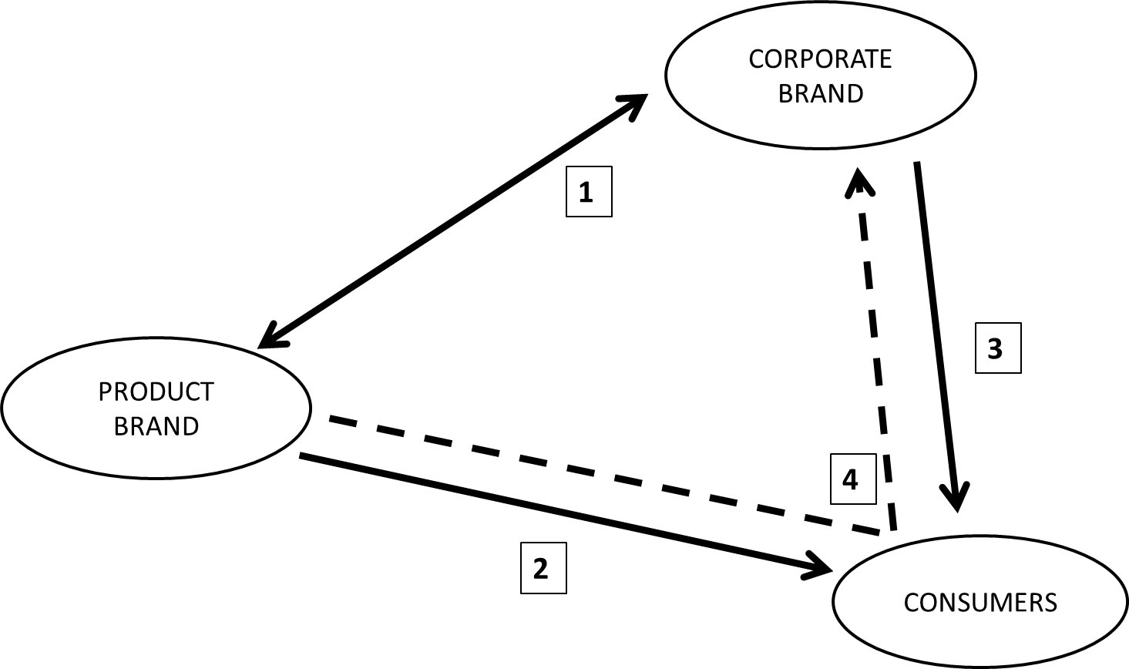
As such, it takes historical references as a starting point for consumers to comment. These historical references are material, textual or visual cues that managers make deliberately available for the consumers to interpret and to make sense of. These cues can be in some cases a partial reflection of the corporate heritage identity that marketing managers communicate to the consumers via the marketing mix. It other cases, they can be mere marketing instruments reflecting a product manager’s own strategy with little to no relation with the corporate brand strategy (Balmer and Gray, 2003). We acknowledge this possibility and we come back to it in the discussion section but we do not want to impose our views on the consumers a priori as we seek to study their interpretation.

Methodology
In order to gain a detailed understanding of the interpretation of brands using historical references from a consumers’ perspective, a qualitative approach in two steps was chosen. As it is consumer centric, it focuses on what consumers see and know. The selection of brands is based on cues consumers have access to on the pack or on the internet. Contrary to existing corporate centric approaches, we do not use internal data consumers would not have access to. This research has two sequential qualitative studies. The first study aims to identify FMCG brands using historical references explicitly on their brands’ packs or site. The second study is a series of semi-structured interviews aiming to collect consumers’ interpretation of these brands and the organisations they belong to, and particularly of their management (Figure 2).
Figure 2 - Design of the research
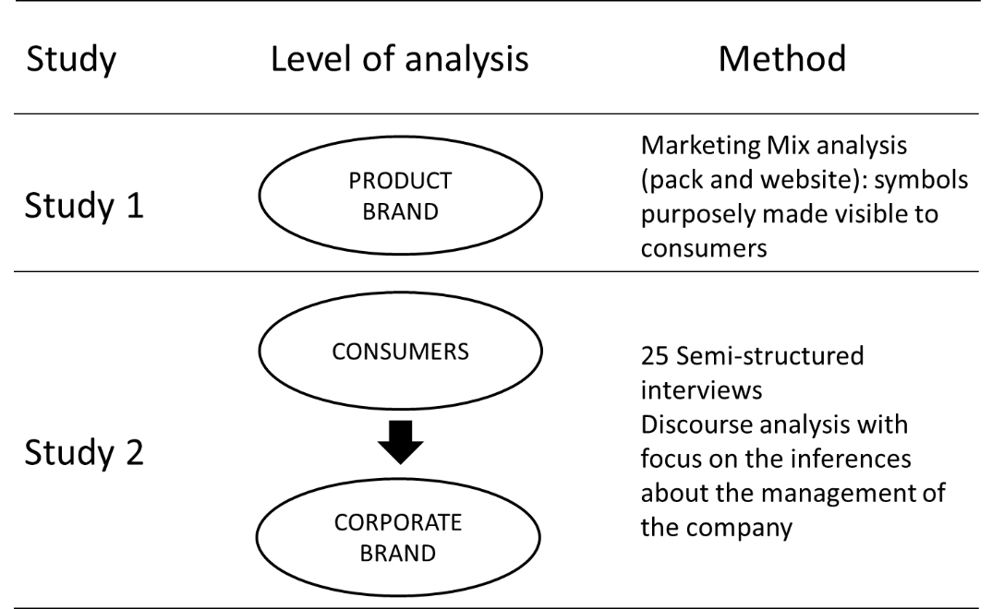

Preliminary study: Selection of Brands using historical references
Existing research provides methods to identify corporate heritage brands based on in-depth case study (Burghausen and Balmer, 2014a) which is not adapted to our objective and focus. In manner consistent with Hakala et al. (2011) and with experiments inducing heritage for fake brands (Rose et al., 2016), we focus on symbols and more particularly on historical references. The objective of the preliminary study is to select brands using historical references that will be later used as stimuli for the main study. Brand heritage is intuitively associated with luxury, spirits, and to product categories with a rather high implication (Hudson, 2011; Hudson et al., 2016; Wiedmann et al., 2011). However, this research takes a slightly different approach and looks across a wide range of FMCG. This approach focusing on FMCG which seeks to make the most of their heritage (Alexander, 2009) reduces the biases related to a particular product category. Observations aim to identify brands that clearly use historical references in their marketing mix. We used two cues for the marketing mix: the packaging and the websites, both available to consumers. These two cues are not exhaustive but are suitable for our focus. All FMCG use packaging which expresses the brand identity (Underwood, 2003) and serve to mythologise the brand (Kniazeva and Belk, 2007). We wanted to add a second cue to only select brands with a consistent use of historical references. An interesting alternative cue would have been advertising, particularly because it tends to have a strong impact on consumers. However, many FMCG brands do not have recent adverts if any. It would have been very restrictive. In contrast, all brands have a website accessible to all consumers and where adverts can also be found. We therefore selected packaging and website as the two cues.
Packaging observations took place in two supermarkets of approximately 1500m², belonging to different corporate groups (Monoprix and Carrefour) located in the centre of a major French city.
The first step of the preliminary study consisted of the observation of all packaged goods sold in these supermarkets by the two experts. Only spirits were excluded from the study as almost all spirit brands use historical references unlike all other categories.
Experts adapted Urde et al.’s five criteria for corporate brand heritage (2007) (mention of track records, longevity, core values, symbols and importance of the firm’s history) to code historical references on the packaging. Table 1 and Figure 3 show an example of how these criteria were adapted to code De Cecco’s pasta brand. Historical references do not directly mention the current corporate brand which is not surprising for FMCG. However, they sometimes reflect the history of the company beyond the product (see Table 1 for De Cecco) and this is even stronger for smaller companies (e.g. La Mère Poulard, De Cecco, Gillot, Briochin…) when the product brand represents most of the company’s activity. This observation led to the selection of fifty-seven brands.
Table 1 - Coding: Operationalisation of existing criteria
Criteria | Operationalisation taking De Cecco as an example
Track records | Mention of achievements in order to recall track records to the consumer (e.g. “we have been…”, “based on a 130-year-old recipe”).
Longevity | Mention of the “established” date on the packaging: either in the logo, or in an explicative text (e.g. De Cecco’s logo is associated with the mention “Dal 1886”: “Since 1886”, the same date is reminded in a short text).
Core values | Mention one or more values the brand has stood for historically, or is committed standing for in the future (e.g. a short text entitled “From father to son” uses the following expressions: “important responsibility”, “making pasta without compromise”).
Use of symbols | Use of a symbol or image of times gone by (e.g.: De Cecco is written in a vintage font; and below De Cecco’s logo is a picture of a peasant woman carrying two wheat bundles in a wheat field).
Firm history is important to the identity | Provide a short summary of the company’s history (e.g. “From father to son. Since 1886 we have been carrying on an important responsibility: our tradition of making pasta, without compromise, that we refine each single day and that allows us to bring the authentic pleasure of Italian cuisine all over the world”).

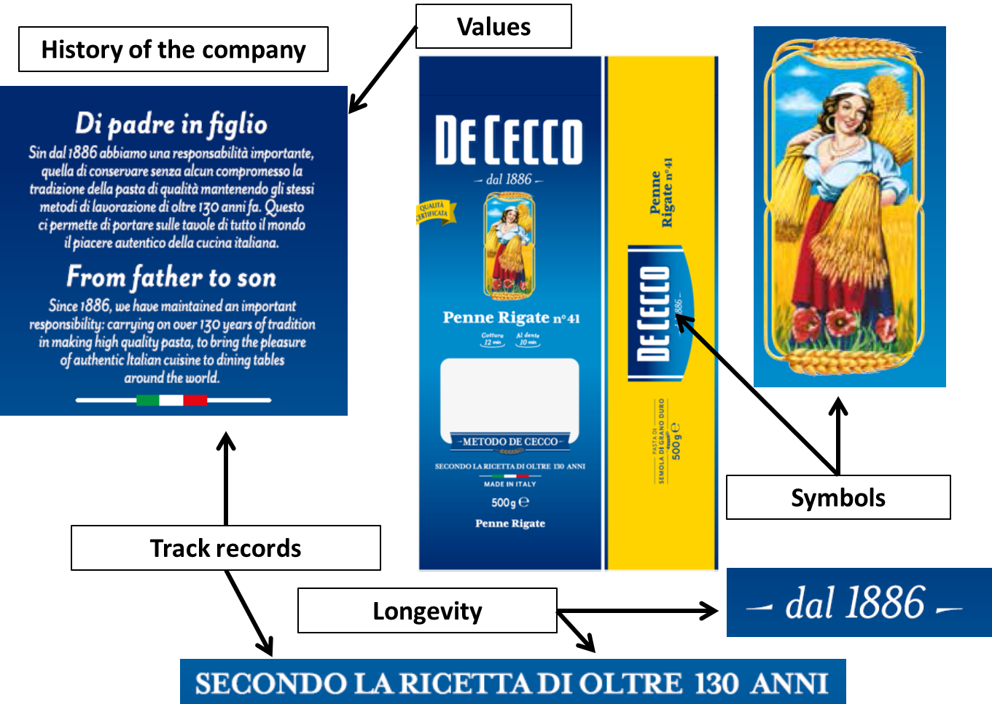
Figure 3 - Visual Examples From De Cecco Packaging
The second step of the preliminary study consisted of the reduction of the selected brands to those with a consistent strategy on the packaging and online on the brand’s site. The authors analysed all 57 brands’ websites. As an example of how the websites were analysed, Monsavon website (A Unilever-owned beauty care brand) displays the founding date is reminded repeatedly throughout the site in different sections, the website has a company history or background section and a “values and commitments” section (“Histoire” and “Valeurs et engagements” in French), the history of the brand is told with emphasis on the track records and use of old black and white posters. As for the packaging, the websites showcase historical references in relation with the product brands and to a smaller extent to the corporate brands. Again, this is not the case for product brands belonging to large conglomerates such as Unilever (e.g. Alsa, Monsavon…).
In total, the preliminary study led to the selection of 27 brands with consistent use of historical references on both the packaging and the website (15 in food, 5 in beverages, 5 in health & beauty, and 2 in home care). For each of Urde et al. (2007) criteria, we propose an adaptation of what could be used by an external consumer to assess the existence of brand heritage at a corporate level. We acknowledge all of these 27 brands do not qualify as corporate heritage brands defined by Balmer and Burghausen (2015) but they all use historical references which is consistent with the objectives of the research.

The main study: Semi-structured interviews
One of the authors conducted semi-structured interviews with individuals in charge of grocery shopping in their household. Nine male and sixteen female with diverse occupations were interviewed, ranging from 24 to 73 years old, thirteen living in a major French city, nine in suburbs, and three in rural areas so as to capture a wide range of views (Table 2). Theoretical saturation was achieved after 25 interviews (Glaser and Strauss, 2009).

Table 2 - Structure of the sample
Name | Gender | Age | Occupation | Selected brands
Laurent | Male | 26 | Urban planner | Lindt
Estelle | Female | 30 | Librerian | Lepetit
Justine | Female | 28 | Journalist | Badoit, Saint-Michel
Bob | Male | 27 | Student | La Mère Poulard
Grace | Female | 33 | Body-Designer | Twinnings
Nadia | Female | 34 | Social worker | Carapelli
Elodie | Female | 38 | Translator | De Cecco, Jordans, Lindt
Olivier | Male | 29 | Translator | Lindt, Connétable, La Mère Poulard
Sandrine | Female | 39 | Urban planner | Badoit, Schweppes
Guillaume | Male | 28 | Nurse | Maille, Saint-Michel
Lisa | Female | 32 | Cultural publicist | Badoit, Lindt
Carolina | Female | 31 | Product manager | Carapelli, De Cecco
Annie | Female | 57 | Lab technician | Maille, Saint-Michel
Monique | Female | 60 | Secretary | Lindt, Alsa
Germain | Male | 44 | Teacher | Schweppes
Eric | Male | 50 | Teacher | Heinz
Ludovic | Male | 24 | Student | Alsa, Eau Ecarlate
Véronique | Female | 49 | Social Worker | Dop, Briochin, Eau Ecarlate
Corinne | Female | 53 | Secretary | Carapelli, Alsa
Sylvie | Female | 69 | Retired (former accountant) | Eau Ecarlate
Marie | Female | 73 | Retired (former radiologist assistant) | Carapelli, De Cecco, Connétable, Eau Ecarlate, Lepetit, Maille, Twinings
Delphine | Female | 35 | Secretary | Saint-Michel, Cadum, Heinz, Badoit
Alexandre | Male | 26 | Engineer | Gillot, Maille
Christian | Male | 56 | Postman | Lepetit, Alsa
Amélie | Female | 39 | Social worker | De Cecco

On average, interviews lasted for 44 minutes; they were recorded and fully transcribed. The interview guide aims to generate detailed descriptions of the heritage brands each informant knew the best, as well as perceptual elements about the brands’ temporality. In practice, it has four phases.
- Selection. Informants were first introduced with the 27 brands and sequentially asked to eliminate all unknown brands from the set, to eliminate those they never buy, and finally to pick, within the remaining brands, the one, two or three brands they consider to be the most familiar with and loyal to.
- Description. Consumers were asked to describe the first brand they had selected. Follow-up questions included memories, places, people, and images associated with the brand, with particular attention to any unexpected information brought by the informants.
- Personification. Consumers were asked to imagine the brand as a person and describe his or her direct environment.
If the informants had selected a second or a third brand, the second and third phases were repeated.
- When informants had not already raised and detailed their interpretation of the brands’ temporality in the second phase of the interview, we introduced it the following question: “Would you say this brand emphasises its past?”, follow-up questions included their justification for this strategy, the cues supporting their interpretation, their position towards this strategy and served to expand the interpretation of heritage branding to other product categories.
The analysis of the transcript focuses on the inferences consumers make about the management of the brands they perceive to use historical references. After a first impressionistic reading of the transcripts, a second reading focused on the descriptions of the brand management. As a result, a series of 21 keywords were identified so as to carry out a more systematic analysis based on the unity of meaning (Bardin, 2007). These 21 keywords cover the management, the production, and the marketing of the product.
Table 3 - Key words used in the systematic analysis
Advertising  Artisanal  Company  Employee  Entrepreneur  Fabrication  Factory | Family  Founder  Goodies  Group  Hand-made  Industrial  Job | Know-how  Manager  Offices  Price  Production  Retailer  Supermarket

Findings
The analysis of the transcripts provides three main findings. First, consumers have limited knowledge of the corporations behind the FMCG they buy. Then, results show that consumers imagine brands have to build a compromise between tradition and modernity. Finally, it reveals that consumers perceive different degrees in the management of temporality.
A corporate heritage implementation is hard to perceive
Four main themes emerge from the interviews: uncertainty, little interest, personal experience, and brand relics. The first important finding is that consumers have little knowledge and interest about FMCG brands and their parent companies. When they describe the companies behind the brands, they use expressions such as “I don’t know,” “perhaps,” or “I have no idea.” For instance, they are not sure about the production system, or the ownership. They assume more than they know and some justify this lack of knowledge by the little interest they have in finding out.
Two of the informants describe different tactics to assess their interpretation: one is based on personal memories, and the other on the existence of relics related to the brand.
Table 4 - Quotes illustrating limited corporate knowledge
Themes | Quote
Uncertainty | “I think this is a brand which may have existed for a long time, this is a product we imagine to be more traditional, based on traditional recipes, at least in my own perception… A product which may use fewer chemicals, which may be better for our health in the long run. Maybe it is more artisanal, or at least it gives this impression, that it’s less industrial. By the way, maybe it’s all fake, but that’s the impression I have” (Elodie).
 | “It is a family business do I guess the boss must be a little bit like IKEA’s, he thinks about its own image, maybe more than others… Now, maybe they were bought, it used to be a family business back in the days but maybe now it’s not anymore, I don’t know” (Eric)
Little interest | “I do not think this is a question we ask ourselves when we are in a supermarket [if a brand has a heritage], however, this is a question we ask ourselves if we go to a smaller shop” (Lisa),
“Maybe all these products belong to the same company… I don’t know, this is just my view but… maybe the same company has many products… there are not a lot of companies on the detergent sector you know.
Question: so you don’t know if Eau Ecarlate has remained in the same company?
No, I have not been interested in the matter”(Sylvie)
Personal experience | [Question: do you think some brands cheat about their past?]  “I don’t know, I don’t really watch adverts, I have no idea, it’s possible… See, I’m kind of an old lady now so if they exaggerate too much about the past, I do remember. If a brand claims to have existed for a long time and I have never seen it, it raises questions in my mind. Maybe a younger person could be fooled but with me it’s more difficult. There are brands my mother used, my grandmother used, so I know it’s old” (Annie)
Brand relics | [Question: how do you know they are older brands?]  “First, there are tons of adverts from the 60s, people even buy them to decorate their home. And all the goodies you find in the bars, the parasols, these kinds of things, the marketing in France! Like Coke’s Christmas special, all these old stuff!  [Question: These old stuff?]  They sort of build the brand. We have been around for a long time: look!” (Eric)

A perceived compromise between tradition and modernity
Despite their lack of knowledge and interest, they still imagine how these brands are managed while remaining suspicious. Four main themes emerge: sense of memory, transmission, modern-day production systems, and critical role of supermarkets. These themes reveal a tension between two extremes: the ideal of a family business based on artisanal productions, and the likeliness of a large industrial multinational able to supply large retailers. Most of them imagine that these brands belong to companies seeking a compromise: companies building on a sense of memory and a willingness to perpetuate quality, but still adapting to modern-day production systems and supplying huge quantities to supermarkets. Some of their descriptions resemble criteria listed in the literature such as the unremitting managerial tenacity and the institutional trait consistency.
Table 5 - Quotes illustrating the compromise
Themes | Quotes
Sense of memory | “First do what you know and then export it, adapt it to marketing, to globalisation, no problem, we need to live in our times but… still have a sense of memory. […] Even if it were a new company opening today, they would have investigated about what we used to know, and how we used to do” (Alexandre)
Transmission | “I think it makes sense to know that the company had been founded in whatever, because there’s a real tradition having been perpetuated, know-how… even if it’s not from father to son, but from one worker to another, we imagine that the founder did not transmit the company to whoever.” (Alexandre)
Modern days production system | “Before, I would have imagined a sort of rustic producer; I mean in a rustic artisanal way. But now, this producer would have adapted to its epoch, he would produce in a more automated way but still keeping this spirit of authenticity.” (Guillaume)
“Now, do they still make it in the same way? I would be surprised ! But either way, they want to project this image of traditional fabrication.
Question: You would be surprised?
It is not possible! The costs are so… there is such a fierce competition that they modified their processes to be profitable. Nobody makes ketchup like they used to 50 years ago, it is not possible”. (Eric)
The critical role of supermarkets | “For me it still is a big company, even if it reminds me of small farmers and all that, and it makes me smile but actually I also think it must be a production process looking like any other industrial cheese. So…  At worst it was a little farmer who once sold its recipe to a big corporation, which kept the name but did whatever they wanted to do. But I have a hard time thinking it remains… The fact that it is sold in a supermarket (she shakes her head to say no)”. (Estelle)
“But there is something wrong with the mass retail and the respect of a manufacture tradition… I mean, in 2015, it is no secrecy that every item sold in supermarkets are made in factories producing tons of things and that… the hand made thing is only for TV adverts!
There is something wrong, it’s like this date would be a label of legitimacy. It says OK we are now in an era of mass production but we have been here for a long time so there is still an exceptional recipe, something that makes us special.” (Lisa)

The use of historical references leads to two distinct perceived positioning strategies
However, consumers perceive different degrees in the management of temporality with implications for brands’ perceived positioning. Indeed, some brands are perceived to be truly omni-temporal and to be consumer-oriented, while others are perceived as past and more product-oriented.
For instance, Olivier (29) describes differently Lindt (chocolate) and La Mère Poulard (biscuits). Lindt (1845) is actually older than La Mère Poulard (1888), both packaging and website showcase the brand heritage but Lindt does appear innovative to Olivier: “Apart from this (the mention of the date), I don’t see what would make reference to the past. For me, it’s more a brand oriented towards… I mean, a brand that really tries to innovate by launching novelties, yes, it’s more of that kind than a brand that constantly recalls its origins, its experience etc..” As opposed to La Mère Poulard: “The brand image I have is one of a brand that has been around for ages and makes reference to its tradition of baking biscuits […] a brand which has been around for a long time, which still bakes in the same way because they found their recipe.”
Similar differences exist with other informants. Guillaume (28) with Saint-Michel (biscuits) and Maille (mustard), Delphine (35) with Saint-Michel or Heinz (ketchup) and Cadum (soap), or Sandrine (39) when comparing Badoit (mineral water) and Schweppes (soft drink): “That thing of the long living taste, this sort of culture of taste that is transmitted, I perceive it more in Badoit than Schweppes. Schweppes, even if it starts to be a bit old… it’s not that old is it?, well it looks more of a 20th century kind of thing, something of younger culture than Badoit. Badoit seems to be rooted in the 19th century, although it might not be true.”
This difference in terms of interpretation does not mean that temporality is actually managed differently at a corporate level. It may outline the difference between a genuine corporate heritage brand and a brand with a heritage. It could also illustrate a degree of heritage implementation in the marketing mix.
One perceived management of temporality is characterised by more flexibility and adaptation. When consumers understand a brand as such, they describe a brand belonging to the present or future as much as to the past, committed to meet customers’ new needs, sometimes creating new trends. Informants relate their longevity to the ability to take risks by launching new products; they also acknowledge their adaptation to modern days’ production systems which does not seem to be a problem (Table 6).
These brands are considered as familiar brands. Three main themes characterise these familiar brands: 1) Consumer orientation: They are aware of and adapt to consumers’ new needs; 2) Pioneer spirit: Longevity allow them to take risks, launch new trends; 3) Flexibility: Adaptation to Modern Production System.
Table 6 - Characteristics of familiar heritage brands
Characteristics | Quotes
Consumer orientation: They are aware of and adapt to consumers’ new needs | “I bought it because it was an organic muesli […] they had many different varieties and it was organic. Now I don’t know if everything is organic but I keep buying it and I still have the feeling it’s a rather better quality” (Elodie, 38)  Briochin: “they have updated themselves, now you have the bathroom special, you have… originally there was only one product! I know because my cousin told me all about Briochin” (Veronique, 49)
Pioneer spirit: Longevity allow them to take risks, launch new trends | “I was going to say professionalism… This tradition, this know-how typically allows them to have such a large range of products. So they can try, they’re solid enough to take risks launching flavours of a different kind” (Laurent, 26)  “Plenty of products have been released by the brand, typically these disposable wipes. Well, this way they fit with current trends, they launch a trend in a way… Eau Ecarlate tries to meet consumers’ needs by launching new products” (Ludovic, 24)
Flexibility: Adaptation to Modern Production System | If Maille was a person, “it would be someone who has adapted to his epoch, someone who has automated the production but still sticking to its authentic spirit […] you can see this in the different sorts of products, the normal mustard, the mustard with granules…” (Guillaume, 28)  “Every two or three years we can see the little “new recipe” label, so there’s always a renewed recipe […] I think they must have cooks, or they must adapt, I mean the raw material they use for their powders must change so they need to switch to new providers” (Ludovic, 24)

Here, the historical references mainly bring values to the brand through the track records. Consumers have a strong relationship with the brand, based on its ability to answer their changing needs continuously. This echoes to the phenomenon of relative invariance: identities seem to remain the same but the meanings attached may change (Balmer, 2011); and also to previous results found in the luxury sector (Veg-Sala and Roux, 2014). As such, it represents a case of perceived corporate heritage. This articulation of innovation and tradition seems particularly suitable for brands competing on relatively highly innovative product categories. In this sample, for shampoo or stain remover brands that must cope with brands launching many innovative products, brand heritage is a distinctive asset (Urde et al., 2007) as long as an updated version of the past is proposed.
In contrast with the familiar brands, consumers perceive the use of historical references as a sign of worshipping the past. Five characteristics build on this interpretation: safeguards, product orientation, passion, year on year improvement and special occasion. They describe brands being strongly rooted in the past and sometimes opposed to present times. Informants report little to no customer orientation: the brand pushes the same product they have always produced on the market but is not making any effort to understand if consumers’ needs have changed. They are said to let passion rather than profit drive the business, and they are associated with special occasions (Table 7). We call them aristocratic brands.
Table 7 - Characteristics of aristocratic heritage brands
Characteristics | Quotes
Safeguard:  Opposed to current times | “the problem with novelties is that you always need 5 or 10 years to acknowledge all negative impacts of a product, so right now you don’t know. It’s a kind of crash-test, when they release a new product, we feel like we’re kind of doing the crash tests” (Ludovic, 24)  “It has to be related to my grandparents’ generation […] that epoch before the generalised industrialisation of food, back when we were still cooking at home…” (Amelie, 39)
Product orientation | “we propose something: if you like it, good because we won’t change if you don’t. Because our objective is not to make money, it’s to propose a certain know-how […] Yeah, they’re selfish! It relates to the fact they are not really interested in what people may expect, they’re focused, when I think about this brand, I have the feeling they’re concentrated on what they can get from the passion of their job” (Bob, 27)  “These brands do less special offers, buy 3 get 4 kind of thing. It might be silly but this sort of thing doesn’t help on the brand image […] Ferrari would never do this, say, we buy your old car €1000, no they would never do this because if you’re buying a Ferrari you’re not supposed to wonder how you’re going to pay” (Alexandre, 26)
Passion Over Profit | “I imagine someone in a non… I’m going to say something stupid, but someone who’s not looking for profit, someone who does that for his passion for olives, for love” (Nadia, 34)
Year on year improvement | “This is typically the product that is very simple and has been improved in Italy for generations where they have developed this very traditional and simple thing” (Elodie, 38)
For special occasions | “I think it’s related to rather festive occasions, exceptional occasions. If you bring Badoit… It isn’t daily water, it’s a water bottle for special events” (Sandrine, 39)

Here, the historical references add value to the brand through the core values associated with it. One value is authenticity, influenced by perception of passion driving the business rather than profit (Cova and Cova, 2002). Another value is the maintenance in a changing world, the promise that no matter what the brand will remain the same. To a certain extent, these brands also appear as supermarkets’ luxury brands (see the comparison with Ferrari): prestigious in their rather utilitarian product categories (biscuits, cheese, olive oil, pasta, sardine cans…). As opposed to the first register generating interpretations of familiarity, that one makes the brand appear rather aristocratic: desirable, prestigious and distant at the same time. This positioning appears relevant for brands in categories in which stability and traditional know-how is associated with added-value such as food.

Discussion
These findings interrogate existing knowledge about corporate heritage brands and heritage branding orientation. More specifically, they inform consumers’ interpretation of heritage organisations, of the specificities of corporate heritage management, and of the management of temporality.
Perceived corporate heritage orientation
Our results address the dynamic between the organisational level, the brand management level, and the consumer level. We find that consumers have little knowledge of the companies standing behind the product brands. They cannot go beyond speculations and even claim to have very little interest in finding out. It is of particularly interest as all interviews were conducted with brands consumers declare to buy on a regular basis, so potentially those they are the most likely to be interested in. This lack of interest could be a particularity of FMCG, or it could be related to consumers’ implication consumers with these categories. As stated above, existing research tend to focus on products with a rather high implication for which consumers have arguably more interest in having information about the company. More importantly, these results outline the relative weakness or even absence of corporate brands in FMCG. The organisations remain discrete although prior research shows that corporate associations influence the beliefs and attitudes towards product brands (Brown and Dacin, 1997). Consumers generally seek to reduce the informational asymmetry with the producers (Erdem and Swait, 1998). Their stated lack of interest could be interpreted as fatalism or habits on a market where they are used to receive very scarce information about the organisations. For those product brands belonging to genuine corporate heritage brands, our findings support Santos et al. (2016) claim for making the use of their heritage as it could be an answer to consumers’ scepticism. In absence of corporate communication, suspicious consumers report to assess brand longevity referring to alternative sources. One possibility is their own memory. It relates to and confirms the role of track records (Urde et al., 2007), ceaseless multigenerational utility (Balmer, 2011), and image heritage (Rindell, 2013). One informant also raises the role of brand relics: branded artefacts from prior times which has remained on the market (e.g. a poster from the 1960s). Prior research suggests the importance of materiality to embody the corporate heritage in a product (Santos et al., 2016). For our respondent, the relics objectify the heritage as they make it more tangible. They also provide evidence for the company’s claims of longevity. The use of such relics is complex as it usually involves various stakeholders such as former suppliers (e.g. advertising agency), in addition, it cannot prove the organisation is currently concerned with its heritage. However, it brings tangible elements in a world of intangible values and can be of particular efficiency for managers engaging in a rebranding based on the corporate heritage (Hudson, 2011) to emphasise on their new intentions.

The management of tradition and modernity

Despite their little knowledge of the companies behind the product, consumers still hold corporate associations. As suggested by the literature, we find that consumers deduce corporate associations from the characteristics of the products or using beliefs they hold about businesses in general (Brown, 1998). Our results contribute to the existing work reporting how corporate heritage brands are managed internally. Burghausen and Balmer (2014a) show that corporate heritage identities are implemented internally through three interrelated patterns: “the conflation of past and present, the conflation of old and new, and the conflation of traditional and modern” (p.2318). One year later, the same authors find that the management of corporate heritage brands is related to a particular mindset whose characteristics are: continuance, belongingness, self, heritage, responsibility and potency (Burghausen and Balmer, 2015). Our results offer an external stakeholders’ perspective on the matter. In the interviews, consumers report about how they imagine the companies to be managed and it clearly goes beyond the product. Indeed, they share their views on the culture of the organisations, the ownership, their production system and their values or covenant. The result of their imagination is very much aligned with the triple conflation found by Burghausen and Balmer inside corporate heritage brands. In other words, consumers fail to differentiate the product brands which could be related to a genuine corporate heritage brand from the others.
The lack of information proactively shared by the organisations themselves reinforces the importance of the alternative cues such as the presence of historical references. This marketing “trick” can easily be disconnected from a corporate heritage identity. The little engagement on corporate branding from part of the FMCG companies certainly plays in favour of those who do not have any corporate heritage but it also maintains consumers’ suspicion over the whole categories. From our perspective, genuine corporate heritage brands operating on FMCG markets have underexploited assets they could use to differentiate themselves from the others. Their corporate heritage and their specific management style should help them to be more efficient and to increase their credibility or legitimacy to use historical references (Burghausen and Balmer, 2015). It raises the question of the corporate communication towards consumers which is discussed later in the managerial recommendations.

Degrees of omni-temporality
The literature on corporate heritage shows that corporate heritage brands are not stuck in the past but that they carefully articulate the past, the present and the future (Balmer, 2011). Assessing this careful articulation requires access to internal data and often observation of the managerial practices (Burghausen and Balmer, 2014a). Most consumers are not aware of this and our results show they deduce a certain degree of omni-temporality based on the information they have access to. We find that using historical references does not always lead to a interpretation of omni-temporality. Our informants describe two distinct positions: familiar brands with an emphasis on adaptability (i.e. the present and future), aristocratic brands with an emphasis on longevity (i.e. the past). Both strategies are implemented at a product brand level and lead to different outcomes although they all relate to existing research on the concept of brand authenticity, and particularly to the distinction between indexicality and iconicity (Grayson & Martinec, 2004; Napoli et al., 2014). This duality is not surprising given that western societies have two competing visions of a reference to the past. Lowenthal (2015) summarises different philosophical developments on time and suggest dialectic between ancient and modern: between those who think the past is a source of unbeatable models; and others who see it as a source of inspiration only gaining value if updated. In a marketing context, this echoes with the distinction between “repro” and “retro” (Brown, 1999). “Repro” stands for reproduction and designates products representing the past more or less as it was, while “Retro” (retrospection) designates products combining an old-style form and updated content. A dominant idea in marketing is that consumers always seek updated versions (Brown et al., 2003; Weindruch, 2016), however, our results tend to nuance this idea. Consistently with the literature in history (Lowenthal, 2015) and in politics about the conservative ideology (Femia, 2012; Hawley, 2016; Huntington, 1957), the marketing research on heritage should also consider the possibility that some individuals are reluctant to change and will be attracted to brands looking past-oriented.

Conclusion
Theoretical implications
This research contributes to the existing work on the management of the corporate brand identity (Balmer and Gray, 2003; Balmer and Burghausen, 2015). In the context of FMCG, our results show that consumer imagine how the company is managed in the absence of formal corporate communication. To feed their imagination, they rely on alternative cues such as corporate image heritage (Rindell et al., 2015). In addition, this original approach based on consumers’ interpretation of product brands outlines the role of historical references in shaping the corporate identity in the absence of corporate communication. It refines existing knowledge on the interstice between product and corporate brands. While Santos et al. (2016) show how corporate brand heritage can shape a product brand positioning; our research shows that consumers understand how a company manages its heritage through their product brands’ positioning. Altogether, our results encourage corporate heritage brands to engage in corporate communication towards their consumers to actively take part in the management of their corporate image.
We contribute to the research on the status of the omni-temporal trait by introducing different degrees of perception. Our results show that external stakeholder perceive a brand’s omni-temporality in gradual terms. From a conceptual perspective, it implies to think about this trait as a continuum ranging from a strong anchoring on one time period (past, present or future) to a strong conflation between the three periods. From a methodological perspective, studies surveying stakeholders could operationalise the omni-temporality trait as a continuous variable rather than a dichotomous one to render this gradual aspect in the perception.
Managerial recommendations
We can formulate three recommendations to brand managers: on the importance of corporate communications, on the use of consumers’ memory and of brand relics, and on the distinct positioning they can achieve while using historical references.
Managers in charge of corporate heritage brands operating on FMCG markets should not assume that consumers are aware of their originality. As many brand managers use similar historical references, consumers become suspicious. There is a risk for genuine corporate heritage brands to be under evaluated while being considered as any other brand claiming to have a heritage. Given the little spontaneous interest consumers have in getting to know the companies, managers should increase their corporate heritage communication to reach to their consumers. Balmer (2013) introduces and details the concept of total corporate heritage communication and provides examples of actions that managers could use as starting points.
In their corporate communication strategies, managers can use consumers’ memory and brand relics to strengthen their case. Asking consumers about their memories with the brand as we did in the interviews help connect the brand with the self-narrative and could strengthen the emotional bond between the brand and its consumers (Ardelet et al., 2015). Social media can be an interesting tool to generate brand content based on consumers’ memory and to refresh track records. Working on a temporary exhibition or the opening of a brand museum is an opportunity to identify, collect, and promote brand relics while involving former and current stakeholders, including consumers. For instance, one can imagine asking consumers to lend branded artefacts for a collaborative exhibition.
Finally, in addition to the management of corporate heritage, this paper also engages with the mere use of historical references. Based on our results, we can distinguish two positioning strategies. One strategy uses historical references to construct a familiar brand while the other leads to the construction of an aristocratic brand.
In the first positioning, historical references are associated with an updated version of the past and cue familiarity based on the brand’s track records. In the second positioning, historical references are associated with a worshipped version of the past, consumer perceive the brand as aristocratic through values of authenticity, exclusivity, permanence and distance. Table 8 presents a guide for brand management and decision-making. Both strategies are compatible with the use of historical references, however, they differ on the “how” these references are used.

Table 8 - Guide for strategic decision-making based upon brand heritage
Target  positioning | Familiar Brand | Aristocratic Brand
Orientation | Consumer orientation | Product orientation
Personality | Brand as a partner | Brand as a landmark
Advert creative themes | Pioneer spirit  Adaptability of the brand  Founder’s creativity and inventions | Vicarious and collective nostalgia  Continuity of the brand  Tribute to the founder  Passion over profit  Special occasions
Innovations | Breakthrough  Launch new trends and usages | Incremental improvement of the original products
Expected outcomes | Track records  Solidity  Trust | Longevity  Authenticity  Attachment

Further research
We see three avenues for further research building on this work. First, in addition to our focus on discursive materials (historical references), it would be interested to look at the phenomenon from a psychological perspective. Indeed, research on corporate association engages with CSR and corporate ability (Brown and Dacin, 2007) but overlooks corporate heritage. Further empirical research could replicate our approach within this framework.
Another promising avenue could investigate consumers’ perception of historical references in a quantitative approach. Comparing corporate heritage brands to corporate brands with a heritage, both using historical references, could extend our results using a larger sample of brands and product categories. The informational asymmetry tends to increase the importance of signals (Erdem and Swait, 1998) as the multiple historical references and as a consequence reduce the effect of corporate heritage.
Finally, marketing academics could focus on managers’ ability to stimulate consumers’ memory in a way that is favourable to the brand. There is here potential to bridge the gap between the research on brand heritage and on nostalgia.

On behalf of all authors, the corresponding author states that there is no conflict of interest.

REFERENCES
Alexander, N. (2009). Brand authentication: creating and maintaining brand auras. European Journal of Marketing, 43(3/4), 551–562.
Ardelet, C., Slavich, B., and de Kerviler, G. (2015). Self-referencing narratives to predict consumers’ preferences in the luxury industry: A longitudinal study. Journal of Business Research, 68(9), 2037–2044.
Balmer, J. (2010). Explicating corporate brands and their management: Reflections and directions from 1995. Journal of Brand Management, 18(3), 180-196.
Balmer, J. (2011). Corporate heritage identities, corporate heritage brands and the multiple heritage identities of the British Monarchy. European Journal of Marketing, 45(9/10), 1380–1398.
Balmer, J. (2013). Corporate heritage, corporate heritage marketing, and total corporate heritage communications: What are they? What of them? Corporate Communications: An International Journal, 18(3), 290–326.
Balmer, J and Gray, E. (2003). Corporate brands: what are they? What of them?. European journal of marketing, 37(7/8), 972-997.
Balmer, J., and Burghausen, M. (2015). Introducing organisational heritage : Linking corporate heritage , organisational identity and organisational memory, Journal of Brand Management, 22(5), 385–411.
Balmer, J., and Chen, W. (2015). Corporate heritage brands in China. Consumer engagement with China’s most celebrated corporate heritage brand – Tong Ren Tang: 同仁堂. Journal of Brand Management, 22(3), 194–210.
Bardin, L. (2007). L’analyse de contenu. Presses Universitaires de France.
Blombäck, A., and Brunninge, O. (2009). Corporate identity manifested through historical references. Corporate Communications: An International Journal, 14(4), 404–419.
Brown, S. (1999). Retro-marketing : yesterday’s tomorrows , today ! Marketing Intelligence & Planning, 17(7), 363–376.
Brown, T. (1998). Corporate associations in marketing: Antecedents and consequences. Corporate Reputation Review, 1(3), 215-233.
Brown, T., and Dacin, P. (1997). The company and the product: Corporate associations and consumer product responses. Journal of Marketing, 61(1), 68-84.
Brown, T., Dacin, P., Pratt, M., and Whetten, D. (2006). Identity, intended image, construed image, and reputation: An interdisciplinary framework and suggested terminology. Journal of the academy of marketing science, 34(2), 99-106.
Brown, S., Kozinets, R. V., and Sherry, J. F. (2003). Teaching Old Brands New Tricks: Retro Branding and the Revival of Brand Meaning. Journal of Marketing, 67(3), 19–33.
Burghausen, M., and Balmer, J. (2014a). Corporate heritage identity management and the multi-modal implementation of a corporate heritage identity. Journal of Business Research, 67(11), 2311–2323.
Burghausen, M., and Balmer, J. (2014b). Repertoires of the corporate past: explanation and framework. Introducing an integrated and dynamic perspective. Corporate Communications: An International Journal, 19(4), 384–402.
Burghausen, M., and Balmer, J. (2015). Corporate heritage identity stewardship: a corporate marketing perspective. European Journal of Marketing, 49(1/2), 22–61.
Cova, V., and Cova, B. (2002). Les particules expérientielles de la quête d’authenticité du consommateur. Décisions Marketing, (28), 33–42.
Dion, D., and Arnould, E. (2011). Retail Luxury Strategy: Assembling Charisma through Art and Magic. Journal of Retailing, 87(4), 502–520.
Dion, D., and Borraz, S. (2015). Managing heritage brands: A study of the sacralization of heritage stores in the luxury industry. Journal of Retailing and Consumer Services, 22(january), 77–84.
Dion, D., and Mazzalovo, G. (2016). Reviving sleeping beauty brands by rearticulating brand heritage. Journal of Business Research.
Erdem, T., and Swait, J. (1998). Brand Equity as a Signaling Phenomenon. Journal of Consumer Psychology, 7(2), 131–157.
Femia, J. V. (2012). The Antinomies of Conservative Thought. Political Studies Review, 10, 221–237.
Glaser, B. G., and Strauss, A. L. . (2009). The discovery of grounded theory: Strategies for qualitative research. Transaction publishers.
Grayson, K., and Martinec, R. (2004). Consumer perceptions of iconicity and indexicality and their influence on assessments of authentic market offerings. Journal of consumer research, 31(2), 296-312.
Hakala, U., Lätti, S., and Sandberg, B. (2011). Operationalising brand heritage and cultural heritage. Journal of Product & Brand Management, 20(6), 447–456.
Hawley, G. (2016). Against Capitalism, Christianity, and America: The European New Right. In Right-wing Critics of American Conservatism (pp. 207–242). Lawrence: University Press of Kansas.
Hudson, B. (2011). Brand heritage and the renaissance of Cunard. European Journal of Marketing, 45(9/10), 1538–1556.
Hudson, B., and Balmer, J. (2013). Corporate Heritage Brands: Mead’s Theory of the Past. Corporate Communications: An International Journal, 18(3), 347–361.
Hudson, B., Pecot, F., Mir, P., and de Barnier, V. (2016). Managing temporality to enhance luxury: Brand heritage at Dom Perignon. In Monaco Symposium on luxury.
Huntington, S. P. (1957). Conservatism as an Ideology. The American Political Science Review, 51(2), 454–473.
Joy, A., Wang, J. J., Chan, T. S., Sherry, J. F., and Cui, G. (2014). M(Art)worlds: Consumer perceptions of how luxury brand stores become art institutions. Journal of Retailing, 90(3), 347–364.
Kniazeva, M., and Belk, R. W. (2007). Packaging as Vehicle for Mythologizing the Brand. Consumption Markets & Culture, 10(1), 51–69.
Lowenthal, D. (2015). The Past is a Foreign Country - Revisited. Cambridge: Cambridge University Press.
Martino, V., and Lovari, A. (2016). When the past makes news: Cultivating media relations through brand heritage. Public Relations Review, 42(4), 539–547.
Miller, D. (2014). Brand-building and the elements of success: Discoveries using historical analyses. Qualitative Market Research: An International Journal, 17(2), 92–111.
Napoli, J., Dickinson, S., Beverland, M., and Farrelly, F. (2014). Measuring consumer-based brand authenticity. Journal of Business Research, 67(6), 1090-1098.
Rindell, A. (2013). Time in corporate images: introducing image heritage and image-in-use. Qualitative Market Research: An International Journal, 16(2), 197–213.
Rindell, A., Santos, F. P., and de Lima, A. P. (2015). Two sides of a coin: Connecting corporate brand heritage to consumers’ corporate image heritage. Journal of Brand Management, 22(5), 467–484.
Rose, G. M., Merchant, A., Orth, U. R., and Horstmann, F. (2016). Emphasizing brand heritage: Does it work? And how? Journal of Business Research, 69(2), 936–943.
Santos, F. P., Burghausen, M., and Balmer, J. (2016). Heritage branding orientation: The case of Ach. Brito and the dynamics between corporate and product heritage brands. Journal of Brand Management, 23(1), 67–88.
Underwood, R. L. (2003). The communicative power of product packaging: creating brand identity via lived and mediated experience. Journal of Marketing Theory and Practice, 11(1), 62.
Urde, M., Greyser, S. A., and Balmer, J. (2007). Corporate brands with a heritage. Journal of Brand Management, 15(1), 4–19.
Veg-Sala, N., and Roux, E. (2014). A semiotic analysis of the extendibility of luxury brands. Journal of Product & Brand Management, 23(2), 103–113.
Wiedmann, K.-P., Hennigs, N., Schmidt, S., and Wuestefeld, T. (2011). Drivers and Outcomes of Brand Heritage: Consumers’ Perception of Heritage Brands in the Automotive Industry. The Journal of Marketing Theory and Practice, 19(2), 205–220.

